Teacher Training Policies and the Social Inclusion of Deaf Pupils in Basic Education in Burkina Faso: A Conceptual and Documentary Analysis

Abstract
Aim: To examine how teacher-training policies may shape the social inclusion of deaf pupils in basic education in Burkina Faso and to develop propositions for subsequent institutional research.
Study design: A conceptual and documentary analysis drawing on the social model of disability, stigma theory, Deaf studies, inclusive-education research, selected peer-reviewed studies and relevant legal instruments.
Setting and methods: The analysis concerns the policy and educational context of Burkina Faso. It draws on a purposive, non-systematic reading of published scholarship and identifiable international and national policy instruments; it does not analyse school records or collect primary participant data. CEFISE-BENAJA in Ouagadougou is identified as a prospective site for a later case study.
Findings: A three-level framework distinguishes macro-level rules and policy definitions, meso-level training and school arrangements, and micro-level classroom interactions. Four mechanisms are proposed: communicative inaccessibility, deficit-oriented framing, limited participation of Deaf adults, and disconnection between training and implementation. These are analytically derived propositions rather than effects demonstrated in Burkina Faso. Law No. 012-2010/AN places inclusive education within initial and continuing teacher-training obligations, but compliance and classroom outcomes cannot be inferred from the legal text.
Conclusion: Teacher preparation can be examined through the alignment of accessible communication, inclusive professional knowledge, Deaf participation, and institutional support. Context-sensitive, participatory empirical investigation is required to assess how these pathways operate in practice.
Keywords: deaf education; inclusive education; teacher preparation; disability sociology; sign language; Burkina Faso

1. Introduction
The Salamanca Statement and the Convention on the Rights of Persons with Disabilities (CRPD) establish international frameworks for educational inclusion and equal participation (UNESCO, 1994; United Nations, 2006). However, admission to a school and meaningful participation in its academic and social life are not equivalent. In deaf education, communication accessibility, participation in classroom discourse and relationships with hearing and deaf peers are particularly relevant dimensions of school membership. Antia et al. (2002) distinguish sustained membership from mere placement in inclusive settings, while Xie et al. (2014) document barriers to peer interaction across published studies. These findings provide a rationale for examining the social processes of inclusion rather than treating enrolment alone as evidence of success.
Teacher preparation provides a plausible link between formal educational commitments and classroom practice. Training may influence communication repertoires, curricular adaptation, expectations and collaboration; these influences are also shaped by deployment, language resources, leadership and the wider school environment (Ainscow, 2005; Avramidis & Norwich, 2002). Evidence from Ghana suggests that teacher knowledge, practical preparation and institutional resources are relevant to inclusive education, although findings from neighbouring countries cannot be assumed to describe conditions in Burkina Faso (Chitiyo et al., 2024; Oppong et al., 2024).
Although the relevant legal instruments establish commitments to inclusive education, the selected literature and policy documents do not establish how teacher-training requirements translate into accessible classroom participation for deaf pupils in Burkina Faso. This unresolved relationship between policy provisions, professional preparation and pupils’ experiences warrants a context-specific analytical framework and subsequent institutional investigation.
This article asks how teacher-training policies may contribute to the social inclusion of deaf pupils in basic education in Burkina Faso. It has three objectives: to integrate sociological and Deaf-studies perspectives into an analytical model; to relate that model to identifiable international and national provisions; and to formulate investigable mechanisms and indicators for prospective research. Its contribution is an explicit policy–institution–interaction framework oriented towards teacher preparation and deaf pupils’ social membership. It does not claim to establish causal effects or to evaluate the performance of any named institution.

1.1. Disability, social arrangements and stigma
The social model of disability directs attention to barriers created by institutions and environments rather than attributing disadvantage solely to impairment (Oliver, 1990). In education, communicative inaccessibility may arise when teaching, assessment or interaction depends on modalities that are unavailable or insufficiently accessible to a pupil. This account should not erase differences in hearing profiles, language histories, personal preferences or use of hearing technologies. An inclusive approach requires assessment of individual language and communication needs rather than a single prescribed instructional mode (Knoors & Marschark, 2012).
Goffman’s (1963) account of stigma offers a complementary explanation for how expectations and social positioning may restrict participation. In a classroom, stigma could be examined through lowered expectations expressed by teachers, repeated exclusion from collaborative activities or the positioning of pupils as passive recipients of assistance. These are possible observational indicators, not findings about schools in Burkina Faso. Structural exclusion and interpersonal stigma are analytically distinct but may interact in pupils’ daily experiences.

1.2. Deaf people, sign languages and cultural participation
Deaf studies draws attention to linguistic identities, shared histories and cultural participation alongside audiological understandings of deafness. Woodward (1972) provided an early sociolinguistic contribution; later scholarship developed accounts of Deaf culture and Deafhood (Ladd, 2003; Padden & Humphries, 2005). In this article, “Deaf” refers to a linguistic or cultural identity where that meaning is intended, whereas “deaf” is used more broadly. This distinction is not imposed on individuals, whose identities and preferred modes of communication vary.
Sign languages are not interchangeable across countries and communities. The forms of signing used by pupils, teachers and families in Burkina Faso must therefore be established in context rather than inferred from studies of American, South African or other sign languages. Language planning for deaf learners must also consider differences in early linguistic access and the potential roles of signed, spoken and written languages (Knoors & Marschark, 2012). The sociological concern is whether educational arrangements recognise pupils’ communicative and cultural resources, including their opportunities to participate in decisions affecting them.

1.3. Inclusive education and teacher preparation
Inclusive education involves presence, participation and access to learning, and depends on more than individual teachers’ dispositions. School cultures, professional collaboration, resource allocation and system-level support can shape local practice (Ainscow, 2005). A review of teachers’ attitudes towards inclusion found that the availability of human and material support was associated with attitudes towards inclusion, although the review was not specific to deaf education (Avramidis & Norwich, 2002).
Deaf-specific evidence further identifies the importance of language access and responsive interaction. In a small comparative study of four teachers and nine pupils in the United States, Holcomb et al. (2025) observed differences in opportunities for classroom interaction across teachers using different communication approaches. A South African documentary case study likewise highlights the need to consider sign-language proficiency and curriculum adaptation in teacher education, although its context differs from Burkina Faso (du Plessis, 2025). Together, these studies warrant examination of teacher preparation for accessible communication without establishing that a particular training model will be effective in every setting.

1.4. International and national policy context
Article 24 of the CRPD recognises inclusive education and addresses reasonable accommodation, access to appropriate languages and modes of communication, the linguistic identity of deaf communities, and the preparation of teachers and other professionals (United Nations, 2006). The Committee on the Rights of Persons with Disabilities (2016) elaborates the distinction between physical placement and substantively inclusive provision. These instruments offer normative criteria for examining teacher preparation, not direct evidence of implementation in a particular education system.
In Burkina Faso, Law No. 013-2007/AN establishes a general framework for education (Burkina Faso, 2007). More directly relevant to disability inclusion, Law No. 012-2010/AN concerns the protection and promotion of the rights of persons with disabilities. Its Article 12 requires institutions providing initial and continuing training for teachers and literacy instructors to take inclusive education into account within their programmes; Article 13 addresses accessibility and appropriate equipment in educational institutions (Burkina Faso, 2010). These requirements support analysis of the relationship between legal expectations, training curricula and school provision. They do not, by themselves, establish the extent to which individual training programmes comply or whether pupils experience meaningful inclusion.
Regional scholarship provides comparative rather than country-specific evidence. Oppong et al. (2024) examined the policy–practice relationship in deaf early childhood education in Ghana, including interprofessional coordination and resource challenges. Their findings indicate issues to investigate in Burkina Faso but do not support direct claims about its schools. A sociological policy analysis should therefore distinguish what laws prescribe, what institutional documents state, and what would require direct observation or testimony to verify.

2. Materials and Methods

2.1. Study design and scope
This study presents a focused conceptual and documentary analysis. The unit of analysis is the proposed relationship among educational policy, teacher preparation and the school participation of deaf pupils. No sampling of pupils, interviews, questionnaires, observations, institutional training records or statistical datasets was conducted. The output consists of analytically derived categories, hypothesised mechanisms and an empirical research agenda; it is not a systematic review or an evaluation of programme effectiveness.

2.2. Documentary sources and analytical procedure
The documentary basis consists of identifiable international instruments (UNESCO, 1994; United Nations, 2006), the interpretive guidance of the Committee on the Rights of Persons with Disabilities (2016), two national laws (Burkina Faso, 2007, 2010), foundational sociological and Deaf-studies publications, and selected peer-reviewed literature on teacher preparation, communication, peer membership and institutional implementation. The scholarly sources were selected purposively for their direct relevance to these constructs; they include theoretical contributions, reviews, comparative studies and research from Ghana and other settings. This is a selective, non-exhaustive source base rather than a database-derived systematic corpus. Consequently, no reproducible search string, screening flow or formal risk-of-bias grading is claimed.
The interpretive procedure is organised in four steps. First, the rights and policy documents are read for the responsibilities and institutional arrangements relevant to deaf education and teacher preparation. Second, concepts derived from the social model of disability, stigma theory, Deaf studies and inclusive-education research identify potential barriers and participation processes. Third, those concepts are mapped to macro-level policy formulation, meso-level training and school organisation, and micro-level interaction. Fourth, the resulting relationships are expressed as four mechanisms and linked to prospective sources of evidence. The analysis distinguishes propositions derived from theory from findings reported by cited studies and avoids treating cross-contextual comparisons as observations in Burkina Faso.

2.3. Analytical definitions
Social inclusion is understood as more than institutional placement: it includes accessible participation in classroom communication, opportunities to contribute to teaching and assessment activities, peer relationships, and a sense of membership in the class (Antia et al., 2002; Xie et al., 2014). Teacher preparedness refers to capacities and support relevant to these dimensions, including appropriate language and communication competence, pedagogical adaptation, reflective expectations and collaboration with Deaf professionals and families. Policy implementation refers to the relationship between formal provisions and their actual incorporation into training syllabuses, staffing, placement and supervisory arrangements. These are proposed constructs whose indicators would require validation and contextual adaptation before empirical use.

2.4. Prospective institutional case and ethics
CEFISE-BENAJA in Ouagadougou is identified as a prospective setting because the organisation publicly describes inclusive schooling, sign-language instruction, workshops for education personnel and a specialised school for primary teachers (CEFISE-BENAJA, n.d.). This institutional description is a first-party source, not independent evidence of specific trainee competencies, programme coverage or outcomes. Its relevance to the proposed research therefore rests on a potentially informative link between deaf-inclusive education and professional preparation; the precise training streams and feasibility of access would need confirmation before fieldwork.
The documentary analysis did not involve recruitment or the collection of identifiable data from human participants. A future case study involving teachers, trainees, Deaf adults, pupils or families would require research ethics review under applicable institutional and national procedures, accessible consent processes, and safeguards for children. Where appropriate, guardian permission and pupil assent should be obtained; interviews and other materials should be made accessible through participants’ preferred communication modes. No approval for such a future study is asserted here.

3. Results and Discussion
The findings comprise a conceptual model and four mechanisms derived from an examination of scholarly and policy sources. They are offered as propositions for further investigation rather than estimates of prevalence, observed institutional practices or established causal relationships.

3.1. An analytical framework with three levels
At the macro level, legal obligations, definitions of disability and training standards establish the formal terms of educational inclusion. The meso level comprises teacher-education institutions, school organisation, deployment and professional support. At the micro level, teacher–pupil and peer interaction determines whether access to curricular discussion and participation is practicable. The levels are interdependent: schools interpret rules through available resources, and classroom experience can, in principle, inform institutional and policy decisions. Figure 1 summarises these analytically distinct but potentially reciprocal relationships; its arrows are conceptual, not inferred from field measurements.
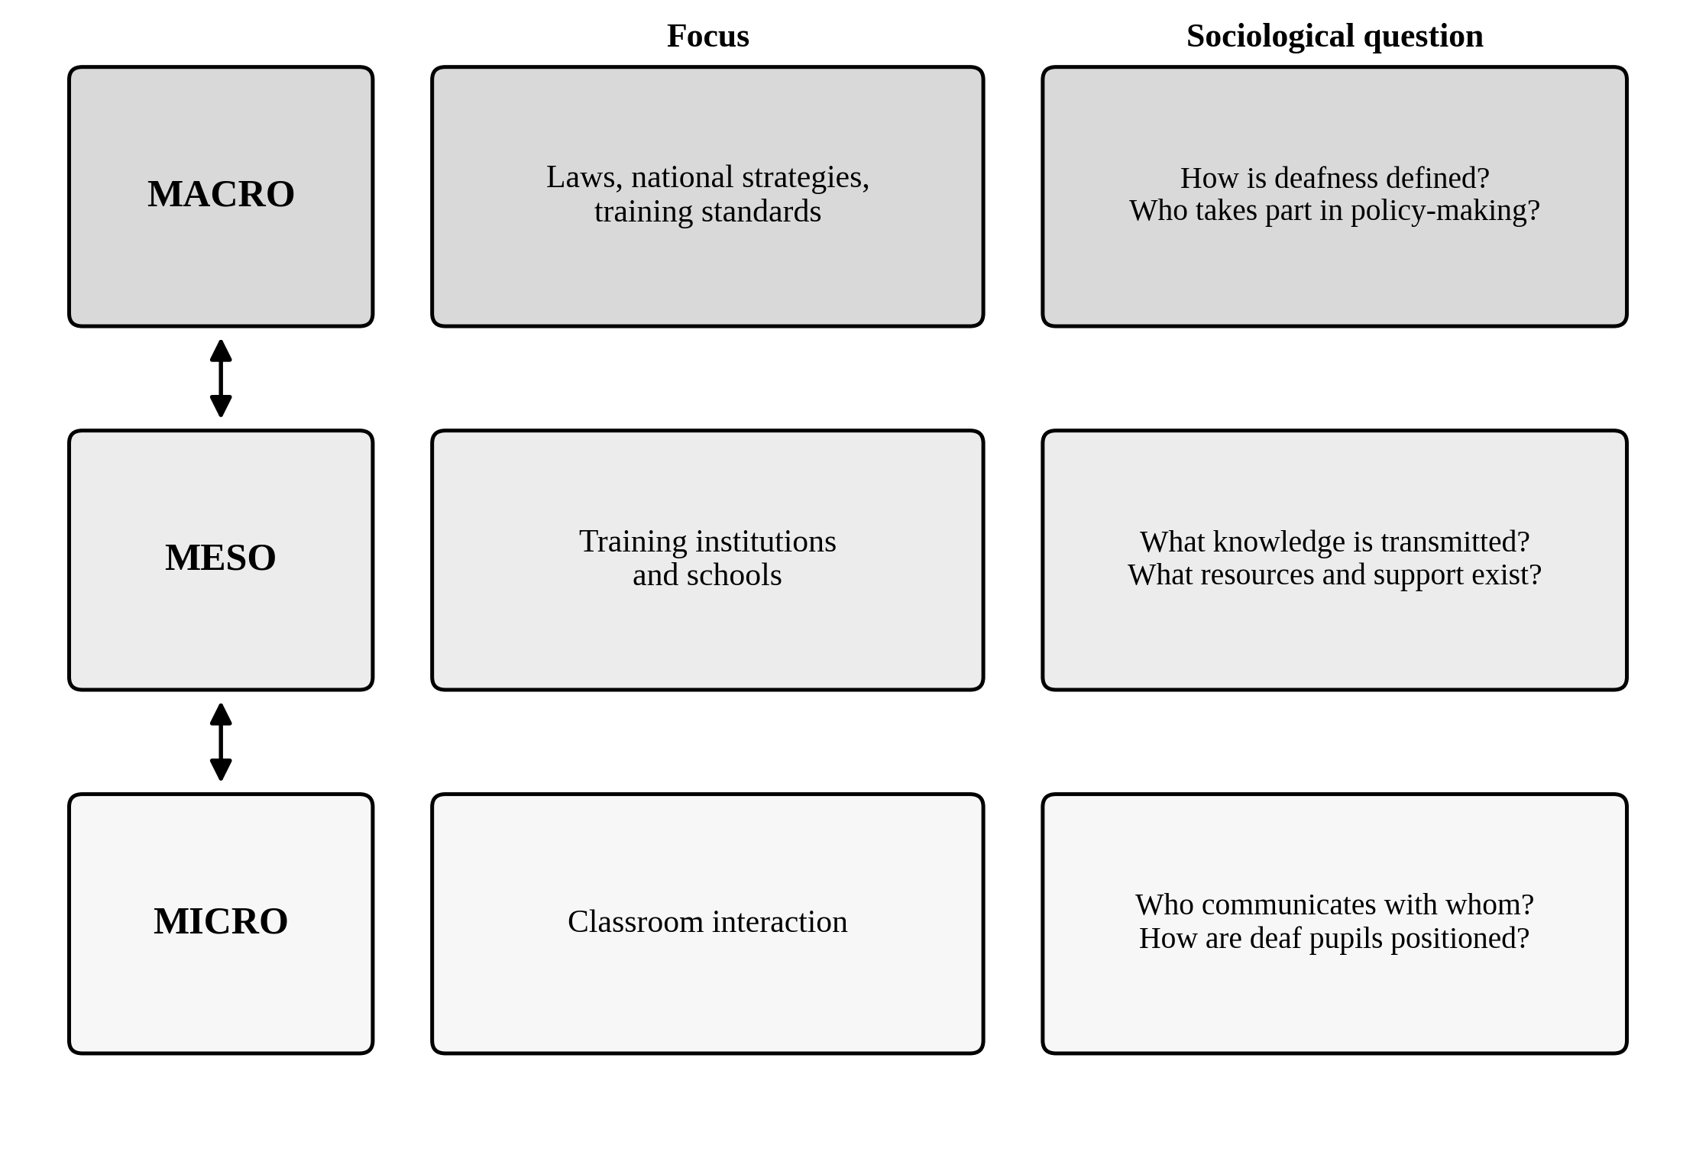
Figure 1. Three levels of analysis of teacher-training policy and the inclusion of deaf pupils.
Note. The links among levels indicate proposed interdependence. The diagram does not represent measured relationships.
Table 1 translates the three levels into questions and illustrative indicators. At the macro level, policy content can be examined directly; at the meso level, the relevant evidence would include training syllabuses and professional support; and at the micro level, classroom participation would require observation and accessible pupil accounts. The indicators are not validated scales or evidence of existing practice.
Table 1. Analytical framework for studying training policy and the inclusion of deaf pupils
Level | Focus | Sociological question | Possible indicators
Macro | Laws, national strategies and training standards | How are deafness and inclusion defined? Who participates in policy decisions? | Policy wording; inclusive-training requirements; recognition of sign languages and Deaf representation
Meso | Training institutions and schools | What competencies are taught? How are teachers assigned and supported? | Syllabuses; language training; trainer profiles; practicum; deployment and continuing support
Micro | Classroom interaction | Who can communicate and participate, and under what conditions? | Accessible exchanges; pupil participation; peer relationships; adapted assessment; pupil accounts

3.2. Four proposed mechanisms of inclusion and exclusion
The framework yields four plausible pathways through which teacher-preparation policy might affect pupils’ experiences: a communication gap, deficit-oriented framing of deafness, limited participation of Deaf adults and an implementation gap. Figure 2 displays the hypothesised relationship between training policy and social inclusion. The arrows represent questions for empirical testing; alternative explanations include variation in pupils’ language histories, family circumstances, school resources and peer relationships.
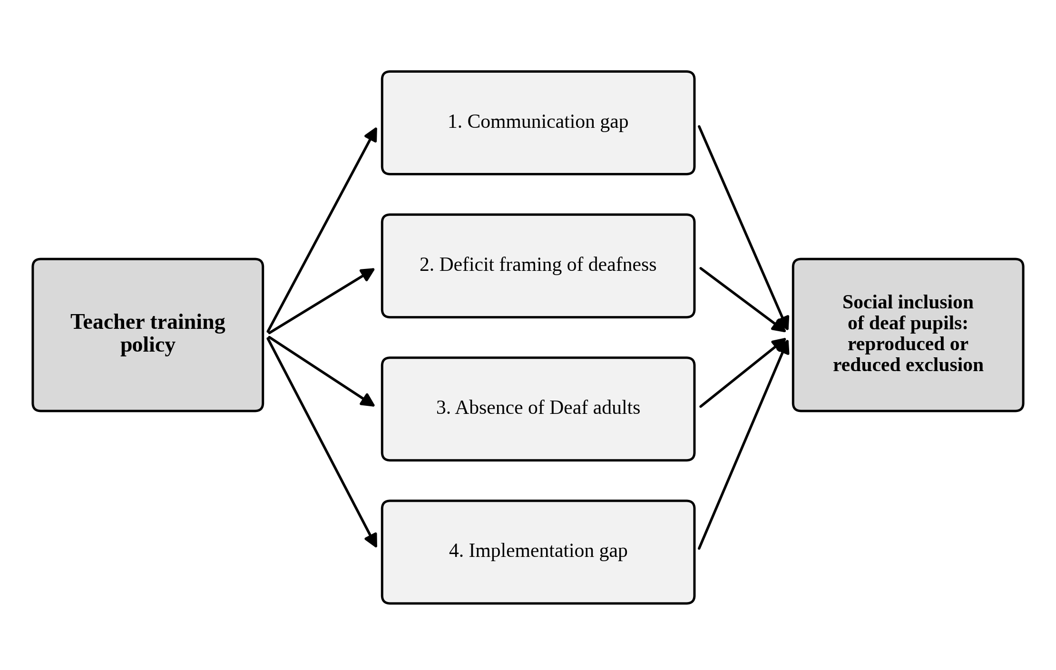
Figure 2. Four hypothesised mechanisms linking teacher-training policy and the social inclusion of deaf pupils.
Note. The four mechanisms are analytical propositions requiring context-specific empirical testing; the arrows do not establish causation.

3.2.1. Communicative inaccessibility
If training does not equip teachers to use accessible forms of communication suited to their pupils, opportunities for classroom dialogue and assessment may be constrained. Evidence from an observational study of a small group of US classrooms indicates that teachers’ communication practices may vary with language approach and pupils’ opportunities to respond (Holcomb et al., 2025). A review of inclusive settings also documents difficulties in deaf and hard-of-hearing pupils’ interactions with hearing peers (Xie et al., 2014). These findings justify inquiry into communication access, but they do not identify the language practices or outcomes of teachers in Burkina Faso. A testable proposition is that teachers with demonstrably accessible communication repertoires, when given comparable support, will be associated with greater opportunities for pupil participation.

3.2.2. Deficit-oriented framing and expectations
A programme that discusses deafness only as an individual limitation may leave insufficient space for linguistic and cultural perspectives. Goffman’s (1963) analysis of stigma and the account of Deaf culture developed by Padden and Humphries (2005) offer contrasting ways of examining professional assumptions. In a South African study, du Plessis (2025) identified tensions among teacher-education policy, linguistic access and deficit views of signed language. This evidence suggests questions about how training content frames pupils’ capabilities, but not that any specified Burkinabè programme currently reproduces stigma. The corresponding proposition is that more pluralistic training content may be associated with higher expectations and greater recognition of pupils’ preferred modes of participation.

3.2.3. Participation of Deaf adults
Deaf professionals can contribute lived linguistic and cultural knowledge to training and educational decisions. Interviews with Deaf adults in Ghana identified potential roles in the leadership and delivery of early support, while also showing the importance of locally grounded capacity and partnership (Fobi et al., 2023). This is relevant comparative evidence, although it does not test the effect of employing Deaf educators in Burkina Faso’s basic schools. Future analysis should establish whether Deaf adults participate in training design, delivery or mentoring, and examine how their involvement relates to trainee knowledge and classroom practice. Their absence should not be presumed without institutional evidence.

3.2.4. Policy–implementation disconnection
A policy requirement may have limited practical influence if training content is not enacted, trained teachers are not placed where their competencies can be used, or follow-up support is unavailable. Inclusive-education research highlights the significance of school-level organisation and resources (Ainscow, 2005; Avramidis & Norwich, 2002). In Ghana, studies of teacher preparedness and deaf education report practical and institutional considerations relevant to implementation (Chitiyo et al., 2024; Oppong et al., 2024). Under Burkina Faso’s Article 12 training obligation, an empirical study could compare statutory expectations with curricula, teacher assignments and classroom provision; such a comparison is not available in the present analysis.
Table 2 summarises how each mechanism might be recognised and the training-policy response it suggests. These responses indicate directions for policy analysis and programme design, not intervention effects established by this study. Multiple mechanisms may operate simultaneously and should not be treated as mutually exclusive explanations.
Table 2. Mechanisms through which teacher-training policy may reproduce or reduce exclusion
Mechanism | Possible process | Implication for training policy
Communication gap | Inaccessible instruction or peer interaction may constrain participation. | Develop and assess appropriate sign-language and other accessible communication competencies.
Deficit framing | One-sided understandings of deafness may influence expectations and treatment. | Integrate rights-based, linguistic and cultural perspectives with individual support needs.
Limited Deaf participation | Training may omit Deaf expertise or opportunities for representation. | Consider paid and substantive participation by Deaf professionals in design and delivery.
Implementation gap | Training, deployment and classroom support may be disconnected. | Coordinate curricula, placement, accessible resources, supervision and continuing development.

3.3. Implications for policy and prospective empirical research
The legal and theoretical analysis supports the examination of four interconnected policy domains: accessible communication preparation, recognition of Deaf linguistic and cultural perspectives, participation by Deaf professionals, and practical support beyond pre-service instruction. CRPD Article 24(3)–(4) expressly addresses sign language and appropriate communication as well as the recruitment and preparation of qualified educational staff (United Nations, 2006). Burkina Faso’s Law No. 012-2010/AN establishes the more general national obligation to incorporate inclusive education into initial and continuing teacher training. The specific form, language and intensity of training should reflect documented pupil needs, local language practices and available expertise rather than an assumed universal template.
A future institutional case study could combine document analysis with interviews, observation and accessible consultation with pupils and families. A purposive selection of trainers, trainees, teachers and Deaf professionals across distinct roles would allow comparison of policy language, curriculum delivery and reported experience. Where permission is obtained, classroom observation could document opportunities to respond, accessible interactions, assessment adaptations and peer participation. Triangulation across these sources could identify discrepancies without presuming that documentary compliance leads automatically to successful inclusion. Figure 3 presents the four complementary strands of the proposed CEFISE-BENAJA case-study design; it does not indicate that recruitment or observation has occurred.
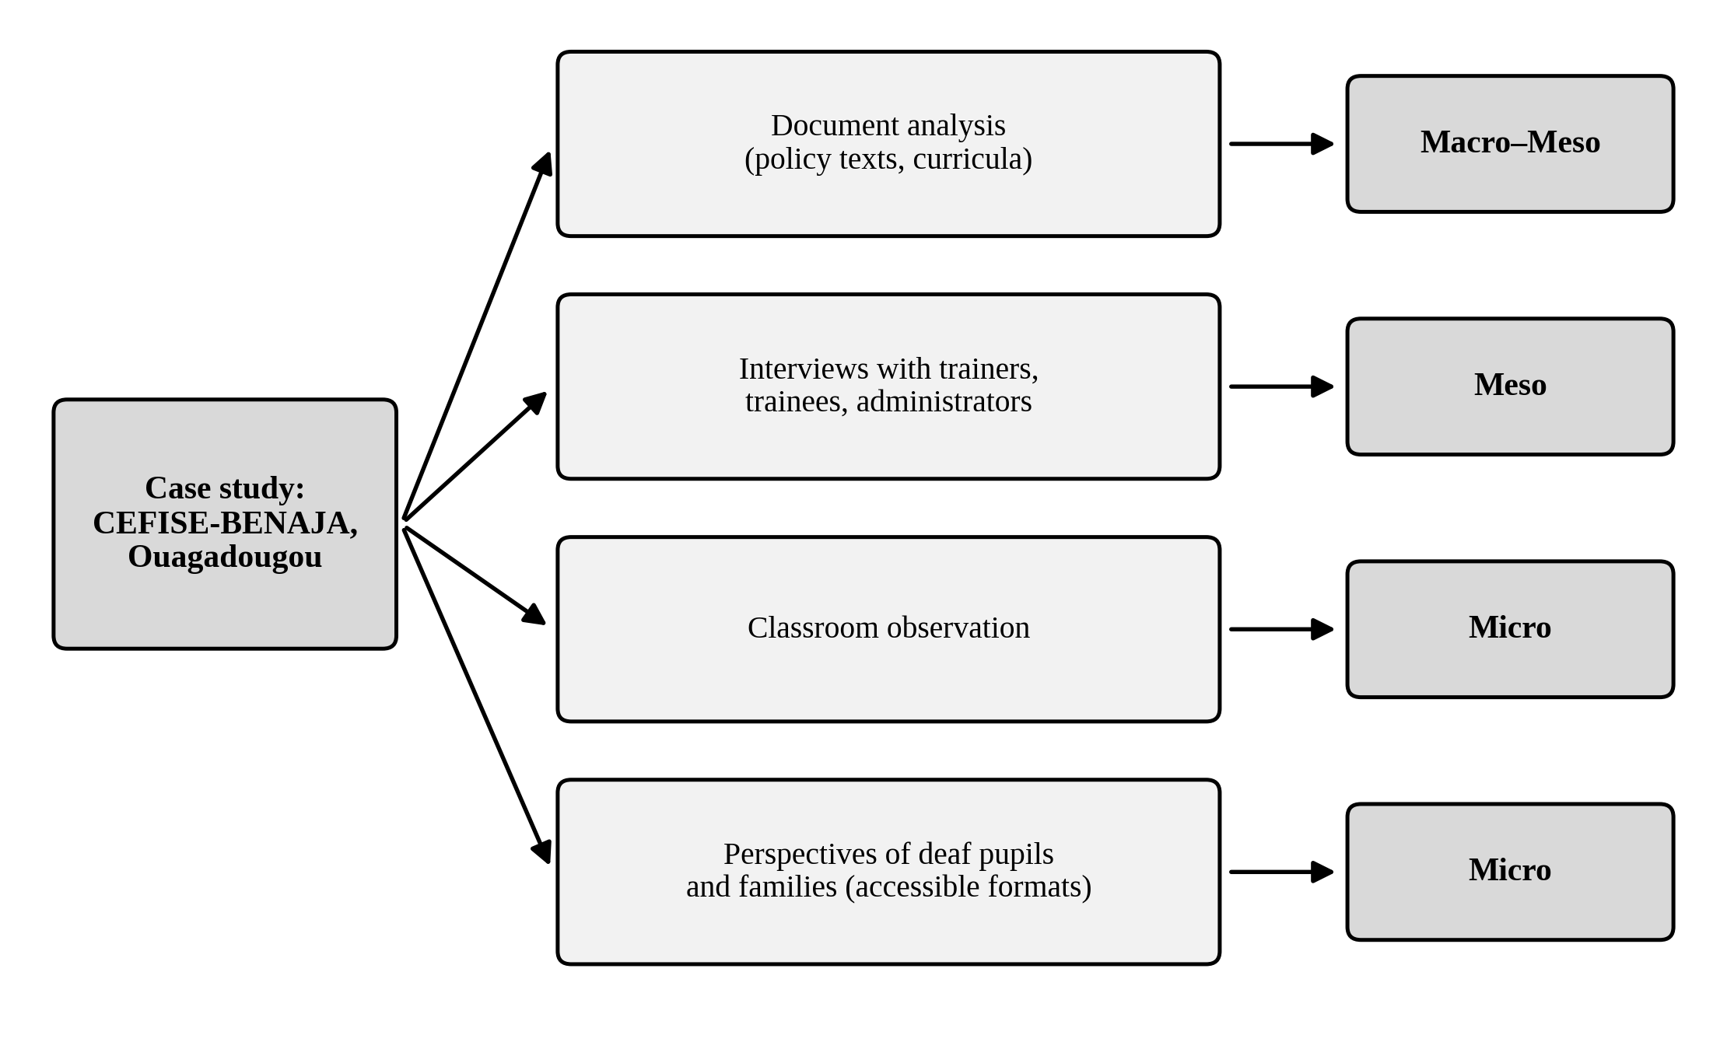
Figure 3. Proposed multi-source case-study design for CEFISE-BENAJA in Ouagadougou.
Note. The four strands are proposed complementary sources for future inquiry. All activities involving participants would require appropriate permission and accessible ethical procedures.
Table 3 specifies the prospective sources of data and the analytical levels to which they could contribute. The combination would permit examination of the same issue from different perspectives, but sample composition, instrument design, language facilitation and permissions would need to be settled through an approved protocol before implementation.
Table 3. Proposed data sources and analytical levels for the case study
Proposed data source | Level | Illustrative focus
Policy and curriculum documents | Macro–meso | Legal obligations; curricula; content on signed and accessible communication; role of Deaf perspectives.
Interviews with trainers, trainees and administrators | Meso | Competencies taught; trainer expertise; practicum; assignment, support and resource constraints.
Classroom observation | Micro | Teacher–pupil communication; opportunities to respond; adapted assessment; peer interactions.
Accessible perspectives of deaf pupils and families | Micro | Experienced communication access, social membership, preferences and participation.

3.4. Limitations of the analysis
This analysis is selective and conceptual rather than a comprehensive evidence synthesis. The documentary sources were selected for their theoretical and legal relevance, without a systematic search or formal appraisal of all potentially relevant studies. Several supporting studies were conducted in Ghana, South Africa or the United States; their applicability to Burkina Faso is therefore uncertain. The publicly available description of CEFISE-BENAJA identifies a potentially relevant institution but cannot validate its training outcomes or school-level implementation. Most importantly, no observations or participant accounts were collected in Burkina Faso. The macro–meso–micro framework and proposed mechanisms consequently require empirical assessment, including attention to alternative explanations and variation among deaf pupils.

4. Conclusion
The social inclusion of deaf pupils is best examined as a question of accessible participation and school membership rather than formal placement alone. A framework connecting policy requirements, teacher preparation and classroom interactions offers a way to investigate this relationship in Burkina Faso. The national legal context includes an explicit obligation to incorporate inclusive education into teacher-training programmes, while published Deaf-education research suggests communication, professional expectations, Deaf participation and institutional support as potentially relevant pathways. The proposed mechanisms remain hypotheses, and no assessment of their operation at CEFISE-BENAJA or elsewhere in Burkina Faso is claimed. Empirical work with Deaf participants and relevant educational institutions would be needed to evaluate these relationships and identify contextually appropriate responses.

Acknowledgements
The author has no acknowledgements to declare.

Author contributions
The sole author conceived the study, developed the analytical framework, prepared the manuscript, and approved its content.
Declaration of AI Use
This manuscript was prepared through the intellectual contributions of the author(s) to the study design, data analysis, interpretation of results, and scholarly content. Grammarly and ChatGPT were used solely to assist with grammatical refinement and reference formatting during manuscript revision. The author(s) accept full responsibility for the accuracy, integrity, and final content of the manuscript.

References
Ainscow, M. (2005). Developing inclusive education systems: What are the levers for change? Journal of Educational Change, 6(2), 109–124. https://doi.org/10.1007/s10833-005-1298-4
Antia, S. D., Stinson, M. S., & Gaustad, M. G. (2002). Developing membership in the education of deaf and hard-of-hearing students in inclusive settings. The Journal of Deaf Studies and Deaf Education, 7(3), 214–229. https://doi.org/10.1093/deafed/7.3.214
Avramidis, E., & Norwich, B. (2002). Teachers’ attitudes towards integration/inclusion: A review of the literature. European Journal of Special Needs Education, 17(2), 129–147. https://doi.org/10.1080/08856250210129056
Burkina Faso. (2007). Loi n° 013-2007/AN du 30 juillet 2007 portant loi d’orientation de l’éducation [Law No. 013-2007/AN on the orientation of education]. https://www.education.gov.bf/fileadmin/user_upload/cahier_1_textes_fondamentaux_du_systeme_educatif_c.pdf
Burkina Faso. (2010). Loi n° 012-2010/AN du 1er avril 2010 portant protection et promotion des droits des personnes handicapées [Law No. 012-2010/AN on the protection and promotion of the rights of persons with disabilities]. https://social.desa.un.org/sites/default/files/migrated/15/2019/11/Burkina-Faso_Law-on-the-protection-and-promotion-of-disabled-persons.pdf
CEFISE-BENAJA. (n.d.). Education. https://www.cefise.org/education/
Chitiyo, J., Brobbey, G., & Asare, K. B. (2024). Teacher attitudes and perceptions of inclusive education: A case of Ghana. Journal of International Special Needs Education, 27(1), 23–35. https://doi.org/10.9782/JISNE-D-23-00008
Committee on the Rights of Persons with Disabilities. (2016). General comment No. 4 (2016) on the right to inclusive education (CRPD/C/GC/4). United Nations. https://digitallibrary.un.org/record/1313836
du Plessis, C. L. (2025). Deaf students and South African Sign Language (SASL) in teacher training: Avoiding a Procrustean “BEd”. Journal for Language Teaching, 59(1), Article 6682. https://doi.org/10.56285/jltVol59iss1a6682
Fobi, D., Swanwick, R., Asomaning, D., & Doku, R. (2023). Promoting Deaf-adults’ participation in early care and education of deaf children. The Journal of Deaf Studies and Deaf Education, 28(2), 136–145. https://doi.org/10.1093/deafed/enac040
Goffman, E. (1963). Stigma: Notes on the management of spoiled identity. Prentice-Hall. https://catalog.mercyhurst.edu/bib/37827
Holcomb, L., Dostal, H., & Wolbers, K. (2025). A comparative study of how teachers communicate in deaf education classrooms. The Journal of Deaf Studies and Deaf Education, 30(1), 80–93. https://doi.org/10.1093/jdsade/enae043
Knoors, H., & Marschark, M. (2012). Language planning for the 21st century: Revisiting bilingual language policy for deaf children. The Journal of Deaf Studies and Deaf Education, 17(3), 291–305. https://doi.org/10.1093/deafed/ens018
Ladd, P. (2003). Understanding Deaf culture: In search of Deafhood. Multilingual Matters. https://doi.org/10.21832/9781853595479
Oliver, M. (1990). The politics of disablement. Macmillan. https://doi.org/10.1007/978-1-349-20895-1
Oppong, A. M., Swanwick, R., & Fobi, D. (2024). Educational inclusion of deaf children: Current policy, practices, and future possibilities. The Journal of Deaf Studies and Deaf Education, 29(1), 72–80. https://doi.org/10.1093/deafed/enad033
Padden, C. A., & Humphries, T. L. (2005). Inside Deaf culture. Harvard University Press. https://doi.org/10.4159/9780674041752
UNESCO. (1994). The Salamanca statement and framework for action on special needs education. https://unesdoc.unesco.org/ark:/48223/pf0000098427
United Nations. (2006). Convention on the rights of persons with disabilities (A/RES/61/106). https://digitallibrary.un.org/record/588742
Woodward, J. C. (1972). Implications for sociolinguistic research among the Deaf. Sign Language Studies, 1, 1–7. https://doi.org/10.1353/sls.1972.0004
Xie, Y.-H., Potměšil, M., & Peters, B. (2014). Children who are deaf or hard of hearing in inclusive educational settings: A literature review on interactions with peers. The Journal of Deaf Studies and Deaf Education, 19(4), 423–437. https://doi.org/10.1093/deafed/enu017

