Order-Divisor Graphs of $Γ_{1}$-Nonderanged Permutation Groups: Structure and Invariants
Abstract. For each prime $p≥5$, the $Γ_{1}$-nonderanged permutation group $G_{p}^{Γ_{1}}=\{ω_{1},…,ω_{p-1}\}$, with multiplication $ω_{i}ω_{j}=ω_{ij mod p}$, is cyclic of order $n=p-1$. Its order-divisor graph has the group elements as vertices, with distinct vertices adjacent precisely when their orders differ and one order divides the other. In view of the established divisor-class construction for cyclic groups, this graph is an independent-set expansion of the divisibility-comparability graph on the divisors of $n$. We express this description in the permutation indexing, obtain formulas for the degrees and number of edges, and determine connectivity, regularity, diameter, radius, girth, center, and periphery. In particular, the identity is always universal; the unique involution is also universal exactly when $p-1$ is a power of $2$. The graph is complete multipartite precisely when $p-1=2^{k}$ ($k≥2$) or $p-1=2q$ for an odd prime $q$. Explicit matrices and graph drawings for $p=5,7,11$, together with direct enumeration for all 107 primes $5≤p<600$, illustrate and check the specializations.
Keywords: order-divisor graph; $Γ_{1}$-nonderanged permutation group; cyclic group; divisor comparability; eccentricity; center; complete multipartite graph.
2020 Mathematics Subject Classification: 05C25; 05C12; 20D60.

1. Introduction
Permutation groups encode symmetries as bijections and provide a natural link between algebra and combinatorics (Beaumont & Peterson, 1955; Dixon & Mortimer, 1996). Graphs associated with group elements are useful for expressing algebraic properties in combinatorial terms. A relevant construction is the order-divisor graph $OD\left(G\right)$, introduced by Rehman et al. (2018), whose vertex set is the finite group $G$ and in which distinct elements of different orders are adjacent if one order divides the other. This definition is not the same as the subgroup-based order-divisor graph considered by Chalapathi and Kiran Kumar (2017), in which vertices are subgroups and adjacency is determined by subgroup orders. The latter construction is also studied by Garba et al. (2021). Other distinct order-related constructions include the order-prime-divisor graph (Sen et al., 2021) and the order-divisor-power graph (Ejima et al., 2025).
The cyclic-group setting has an established structural theory. Rehman et al. (2018, Theorem 21) identify the element-based order-divisor graph of a cyclic group with an expansion of the comparability graph of its divisor lattice. Liu and Ma (2020) investigate structural properties and multipartite classifications. Choosuwan et al. (2024, Theorem 4.3) extend the divisor-class construction to generalized order-divisor graphs, with the ordinary graph recovered by setting the parameter $k=1$. Consequently, the divisor-class expansion itself is not specific to the permutation group considered here. The interest of the present setting is its explicit translation into the canonical permutation labels $ω_{i}$, including the behavior of the unique involution, the center and periphery, and the arithmetic restrictions arising from $n=p-1$.
The $Γ_{1}$-nonderanged permutation group has been considered in studies of representations (Aminu et al., 2016), Young tableaux (Garba et al., 2017), direct and skew sums (Aremu et al., 2018), restricted bijections (Aremu et al., 2019), permutation statistics (Magami & Ibrahim, 2021; Ibrahim et al., 2022), and algebraic extensions and constructions (Suleiman et al., 2020; Yusuf & Ejima, 2023). Graphs formed using other relations on these permutations include permutation graphs (Jaiyeola et al., 2025), an inverse graph (Yusuf et al., 2025), and a power graph (Yusuf & Umar, 2025). These graph models have distinct adjacency conditions and need not share their invariants.
The objective is to give a self-contained account of $OD\left(G_{p}^{Γ_{1}}\right)$ for prime $p≥5$ in the original permutation notation. In addition to the known cyclic-group expansion, we develop explicit degree and edge calculations, identify the universal elements and eccentricity classes, give the prime-indexed complete multipartite criterion, and compare the resulting structures with the power graph of the same permutation group. Calculations for small primes and systematic direct enumeration provide concrete checks of the formulas.

2. Preliminaries
Throughout, $p≥5$ is prime, $n=p-1$ is even, $D\left(n\right)$ is the set of positive divisors of $n$, and $φ$ denotes Euler’s totient function. All graphs are finite, simple, and undirected, using standard terminology (Bondy & Murty, 2008).
Definition 2.1 ($Γ_{1}$-nonderanged permutation group; Aminu et al., 2016). For $1≤i≤p-1$, define the permutation $ω_{i}$ of $\{1,…,p\}$ by its one-line notation
$$ω_{i}=\left(1, 1+i, 1+2i, …, 1+\left(p-1\right)i\right) (mod p),$$
where residues are represented by $\{1,…,p\}$. The group $G_{p}^{Γ_{1}}=\{ω_{1},…,ω_{p-1}\}$ has multiplication $ω_{i}ω_{j}=ω_{ij mod p}$.
Example 2.2. For $p=5$, the one-line permutations are $ω_{1}=12345$, $ω_{2}=13524$, $ω_{3}=14253$, and $ω_{4}=15432$.
Definition 2.3 (Order-divisor graph; Rehman et al., 2018). For a finite group $G$, let $o\left(a\right)$ denote the order of $a∈G$. The graph $OD\left(G\right)$ has vertex set $G$ and, for distinct $a,b∈G$,
$$a∼b ⇔ o\left(a\right)≠o\left(b\right) \text{and} \left(o\left(a\right)∣o\left(b\right) \text{or} o\left(b\right)∣o\left(a\right)\right).$$
Definition 2.4 (Graph invariants). The degree $deg\left(v\right)$ is the number of neighbors of $v$. The distance $d\left(u,v\right)$ is the minimum length of a $u$–$v$ path, and the eccentricity is $ecc\left(v\right)=\max_{u}d\left(u,v\right)$. The radius and diameter are the minimum and maximum eccentricity, respectively. The girth is the length of a shortest cycle. Vertices attaining the radius form the center, while those attaining the diameter form the periphery. A graph is complete multipartite when its vertices can be partitioned into independent sets with every cross-part pair adjacent.
Lemma 2.5. The correspondence $ω_{i}↦i (mod p)$ is an isomorphism from $G_{p}^{Γ_{1}}$ onto the multiplicative group ${\left(Z/pZ\right)}^{×}$. Consequently:
- $G_{p}^{Γ_{1}}$ is cyclic of order $n$, and $o\left(ω_{i}\right)$ is the least positive integer $r$ such that $i^{r}≡1 (mod p)$;
- for each $d∣n$, the class
$$C_{d}=\{ω∈G_{p}^{Γ_{1}}:o\left(ω\right)=d\}$$
has $\left|C_{d}\right|=φ\left(d\right)$, and d∣n​φd=n;
- $C_{1}=\{ω_{1}\}$, $C_{2}=\{ω_{p-1}\}$, and $\left|C_{n}\right|=φ\left(n\right)≥2$.
Proof. The correspondence preserves multiplication and is bijective. The multiplicative group of a finite prime field is cyclic, so (a) follows. A cyclic group has $φ\left(d\right)$ elements of order $d$ for every $d∣n$, giving (b). The identity and the unique element of order $2$ correspond to $1$ and $-1≡p-1 (mod p)$. Since $n≥4$ is even, $φ\left(n\right)≥2$, proving (c). $▫$

3. Mathematical construction and computational procedure

3.1. Construction from multiplicative orders
For the elements $ω_{i}$, compute $r_{i}=o\left(ω_{i}\right)$ as the multiplicative order of $i$ modulo $p$. The symmetric adjacency matrix $A_{p}={\left(a_{ij}\right)}_{1≤i,j≤p-1}$ is determined by
$$a_{ij}=\left\{\begin{matrix}1, & i≠j, r_{i}≠r_{j}, \text{and }\left(r_{i}∣r_{j}\text{ or }r_{j}∣r_{i}\right), \\ 0, & \text{otherwise}.\end{matrix}\right.$$
Because adjacency depends only on element orders, the matrix can also be constructed by grouping vertices according to $C_{d}$. This permits calculations using only the divisor set $D\left(n\right)$ and its totient weights.

3.2. Algorithm 3.1
Input: a prime $p≥5$.
- Enumerate the residues $i=1,…,p-1$, representing vertices $ω_{i}$.
- Determine $r_{i}$ by finding the least $r≥1$ for which $i^{r}≡1 (mod p)$.
- For each unordered pair $1≤i<j≤p-1$, insert the edge $ω_{i}ω_{j}$ exactly when the condition in (3.1) holds.
- Compute the degree sequence, edge count, shortest-path distances, eccentricities, center, periphery, and shortest cycle from the resulting adjacency relation.

3.3. Arithmetic and verification
Theoretical results below are established by direct proofs and do not depend on computation. A deterministic Python implementation of Algorithm 3.1, using integer arithmetic and the standard library, independently enumerates each of the 107 primes $5≤p<600$. The implementation compares vertex degrees against the divisor-class formula, verifies the degrees of the identity, involution and generators, checks the center, and tests the claimed radius, diameter and girth. Distances and shortest cycles are additionally checked by breadth-first search for the smaller cases $p≤37$; for larger cases the universal identity vertex and an explicit triangle give the corresponding graph invariants. The accompanying file 2936_Order_Divisor_Verification.py provides the complete reproducible procedure. The computation is a check of the established formulas, not a substitute for proofs.

4. Results and discussion

4.1. Divisor-class structure and degrees
For a cyclic group, the independent-set expansion described by Rehman et al. (2018, Theorem 21) and the $k=1$ case of Choosuwan et al. (2024, Theorem 4.3) apply directly by Lemma 2.5. The following statement formulates this structure and its counting consequences in the $Γ_{1}$-permutation notation.
Theorem 4.1 (Divisor-class structure). Let $p≥5$ be prime, $n=p-1$, and $C_{d}=\{ω:o\left(ω\right)=d\}$ for $d∣n$. Then:
- the classes $C_{d}$ partition $G_{p}^{Γ_{1}}$, and each is independent with $\left|C_{d}\right|=φ\left(d\right)$;
- if $d≠e$, all vertices of $C_{d}$ are adjacent to all vertices of $C_{e}$ if $d∣e$ or $e∣d$, and there are no edges between these classes otherwise;
- for $ω∈C_{d}$,
degω=e∣n, e≠de∣d or d∣e​φe=d-φd+d∣e∣ne>d​φe;
- the edge count is
EODGpΓ1=d,e∣nd<e, d∣e​φdφe.
Proof. Parts (a) and (b) follow from Lemma 2.5 and Definition 2.3. Counting all vertices in the classes comparable to $C_{d}$, except $C_{d}$ itself, gives the first expression in (4.1). The identity e∣d​φe=d yields its second expression. Every edge belongs to exactly one unordered pair of distinct comparable classes; $C_{d}$ and $C_{e}$ contribute $φ\left(d\right)φ\left(e\right)$ edges when $d<e$ and $d∣e$. Summing these contributions proves (4.2). $▫$
Corollary 4.2 (Distinguished degrees). Write $m$ for the largest odd divisor of $n$. Then
$$deg\left(ω_{1}\right)=n-1=p-2, deg\left(ω_{p-1}\right)=n-m, deg\left(ω\right)=n-φ\left(n\right) \left(ω∈C_{n}\right).$$
Proof. The identity is adjacent to every other vertex. A generator is adjacent to precisely the vertices outside its own order class. The involution is adjacent to the identity and to every other element of even order, but to no nonidentity element of odd order. Exactly $m$ elements have odd order, giving $n-m$ neighbors. $▫$

4.2. Connectivity, universal vertices and degree bounds
Proposition 4.3 (Connectivity). The graph $OD\left(G_{p}^{Γ_{1}}\right)$ is connected for every prime $p≥5$.
Proof. Since $o\left(ω_{1}\right)=1$ divides every other element order, $ω_{1}$ is adjacent to every other vertex. Thus every pair of vertices is joined by a path of length at most two. $▫$
Theorem 4.4 (Universal vertices and maximum degree). A vertex is adjacent to every other vertex if and only if it is $ω_{1}$, or it is $ω_{p-1}$ and $n$ is a power of $2$. In particular,
$$Δ\left(OD\left(G_{p}^{Γ_{1}}\right)\right)=n-1=p-2,$$
with equality only at $ω_{1}$, except that $ω_{p-1}$ also has degree $n-1$ when $n=2^{k}$.
Proof. The identity is universal. If $ω∈C_{d}$ with $d≥3$, then $φ\left(d\right)≥2$ and $ω$ has a distinct nonneighbor in $C_{d}$. The only remaining candidate is the unique involution, whose degree is $n-m$ by Corollary 4.2. This equals $n-1$ precisely when $m=1$, equivalently when $n$ is a power of $2$. $▫$
Proposition 4.5 (Noncompleteness). The graph $OD\left(G_{p}^{Γ_{1}}\right)$ is not complete.
Proof. There are $φ\left(n\right)≥2$ generators, and any two distinct generators have the same order and hence are nonadjacent. $▫$
Theorem 4.6 (Nonregularity and minimum degree). The graph is not regular. Moreover,
$$δ\left(OD\left(G_{p}^{Γ_{1}}\right)\right)≥2, δ=2⇔p=5, δ≥3 \text{for }p≥7.$$
Proof. The identity has degree $n-1$, whereas every generator has degree $n-φ\left(n\right)≤n-2$. Thus the graph is not regular. A vertex of order $d$ satisfying $1<d<n$ is adjacent to the identity and all $φ\left(n\right)≥2$ generators, so its degree is at least $3$. For a generator, $deg=n-φ\left(n\right)≥n/2$ because $n$ is even. This is at least $3$ when $n≥6$. For $p=5$ ($n=4$), the two generators have degree $2$, establishing the exceptional case. $▫$

4.3. Distance invariants
Theorem 4.7 (Diameter, radius and girth). For every prime $p≥5$,
$$diam\left(OD\left(G_{p}^{Γ_{1}}\right)\right)=2, rad\left(OD\left(G_{p}^{Γ_{1}}\right)\right)=1, girth\left(OD\left(G_{p}^{Γ_{1}}\right)\right)=3.$$
Proof. All distances are at most $2$ because the identity is universal. The graph is not complete, so at least one pair is at distance $2$; consequently the diameter is $2$. The eccentricity of the identity is $1$, which is the least possible for this nontrivial graph. Finally, if $ω∈C_{n}$, the three distinct vertices $ω_{1}$, $ω_{p-1}$ and $ω$ have orders $1,2,n$ with $1∣2∣n$. They form a triangle, so the girth is $3$. $▫$

4.4. Center and periphery
Theorem 4.8 (Center and periphery). Let $Z$ and $P$ denote the center and periphery of $OD\left(G_{p}^{Γ_{1}}\right)$. Then
$$\left(Z,P\right)=\left\{\begin{matrix}\left(\{ω_{1},ω_{p-1}\}, G_{p}^{Γ_{1}}\backslash \{ω_{1},ω_{p-1}\}\right), & p-1=2^{k}, \\ \left(\{ω_{1}\}, G_{p}^{Γ_{1}}\backslash \{ω_{1}\}\right), & \text{otherwise}.\end{matrix}\right.$$
Proof. By Theorem 4.7, the radius is $1$ and the diameter is $2$. A vertex has eccentricity $1$ precisely when it is universal. Theorem 4.4 identifies all universal vertices. Every remaining vertex has eccentricity $2$, since it is not universal but is at distance at most $2$ from all vertices. $▫$
Remark 4.9. For prime $p≥5$, the condition $p-1=2^{k}$ is equivalent to $p$ being a Fermat prime. Examples are $p=5,17,257,65537$. For such primes the graph has exactly two central vertices. The conclusions do not assume that infinitely many Fermat primes exist.

4.5. Complete multipartite structure
Rehman et al. (2018) describe cyclic prime-power and semiprime order-divisor graphs, while Liu and Ma (2020) and Choosuwan et al. (2024) provide related multipartite results. In the present prime-indexed family, the full criterion can be stated directly as a condition on $p-1$.
Proposition 4.10. The graph $OD\left(G_{p}^{Γ_{1}}\right)$ is complete multipartite if and only if
$$p-1=2^{k} \left(k≥2\right), \text{or} p-1=2q \left(q \text{an odd prime}\right).$$
In these cases,
$$OD\left(G_{p}^{Γ_{1}}\right)≅\left\{\begin{matrix}K_{1,1,2,4,…,2^{k-1}}, & p-1=2^{k}, \\ K_{1,q-1,q}, & p-1=2q.\end{matrix}\right.$$
Proof. If $n=2^{k}$, all divisors form the chain $1∣2∣4∣⋯∣2^{k}$, so the order classes constitute the independent parts of a complete multipartite graph. Their sizes are $φ\left(1\right),φ\left(2\right),…,φ\left(2^{k}\right)=1,1,2,…,2^{k-1}$.
If $n=2q$ with $q$ an odd prime, its divisors are $1,2,q,2q$. The only incomparable pair is $\left(2,q\right)$; hence $C_{2}∪C_{q}$, $C_{2q}$ and $C_{1}$ form three independent parts of sizes $q,q-1,1$, respectively, with all edges between different parts present.
Conversely, in a complete multipartite graph nonadjacency among distinct vertices is transitive. Write $n=2^{a}m$, where $a≥1$ and $m$ is odd. If $m>1$ and $a≥2$, choose an odd prime $q∣m$ and vertices $x∈C_{2}$, $y∈C_{q}$, and $z∈C_{4}$. Then $x≁y$ and $y≁z$, yet $x∼z$, a contradiction. If $a=1$ and $m$ is composite, choose an odd prime $q∣m$ with $q<m$ and vertices $x∈C_{q}$, $y∈C_{2}$ and $z∈C_{m}$. Again $x≁y$ and $y≁z$, while $x∼z$. Thus either $m=1$, giving $n=2^{a}$, or $a=1$ and $m$ is prime, giving $n=2q$. $▫$

4.6. Illustrative examples
The orders of the indexed permutations determine every entry in the corresponding adjacency matrix. Table 1 lists the orders and order classes for $p=5$, $7$ and $11$, permitting direct reproduction of each example.
Table 1. Orders and order classes of $G_{p}^{Γ_{1}}$ for $p=5,7,11$.
$$p$$ | Order $d$: elements of that order | Order classes
$$5$$ | $$1:ω_{1}; 2:ω_{4}; 4:ω_{2},ω_{3}$$ | $C_{1}=\{ω_{1}\}$; $C_{2}=\{ω_{4}\}$; $C_{4}=\{ω_{2},ω_{3}\}$
$$7$$ | $$1:ω_{1}; 2:ω_{6}; 3:ω_{2},ω_{4}; 6:ω_{3},ω_{5}$$ | $C_{1}=\{ω_{1}\}$; $C_{2}=\{ω_{6}\}$; $C_{3}=\{ω_{2},ω_{4}\}$; $C_{6}=\{ω_{3},ω_{5}\}$
$$11$$ | $$1:ω_{1}; 2:ω_{10}; 5:ω_{3},ω_{4},ω_{5},ω_{9}; 10:ω_{2},ω_{6},ω_{7},ω_{8}$$ | $C_{1}=\{ω_{1}\}$; $C_{2}=\{ω_{10}\}$; $C_{5}=\{ω_{3},ω_{4},ω_{5},ω_{9}\}$; $C_{10}=\{ω_{2},ω_{6},ω_{7},ω_{8}\}$
Example 4.11 ($p=5$). With vertex order $ω_{1},ω_{2},ω_{3},ω_{4}$, the adjacency matrix is
$$A_{5}=\left(\begin{matrix}0 & 1 & 1 & 1 \\ 1 & 0 & 0 & 1 \\ 1 & 0 & 0 & 1 \\ 1 & 1 & 1 & 0\end{matrix}\right).$$
Here $\left|E\right|=5$ and the degree sequence is $\left(3,2,2,3\right)$. The partition $\{ω_{1}\}$, $\{ω_{4}\}$, $\{ω_{2},ω_{3}\}$ realizes $K_{1,1,2}$, as shown in Figure 1. Both $ω_{1}$ and $ω_{4}$ are central, while $ω_{2}$ and $ω_{3}$ are peripheral.
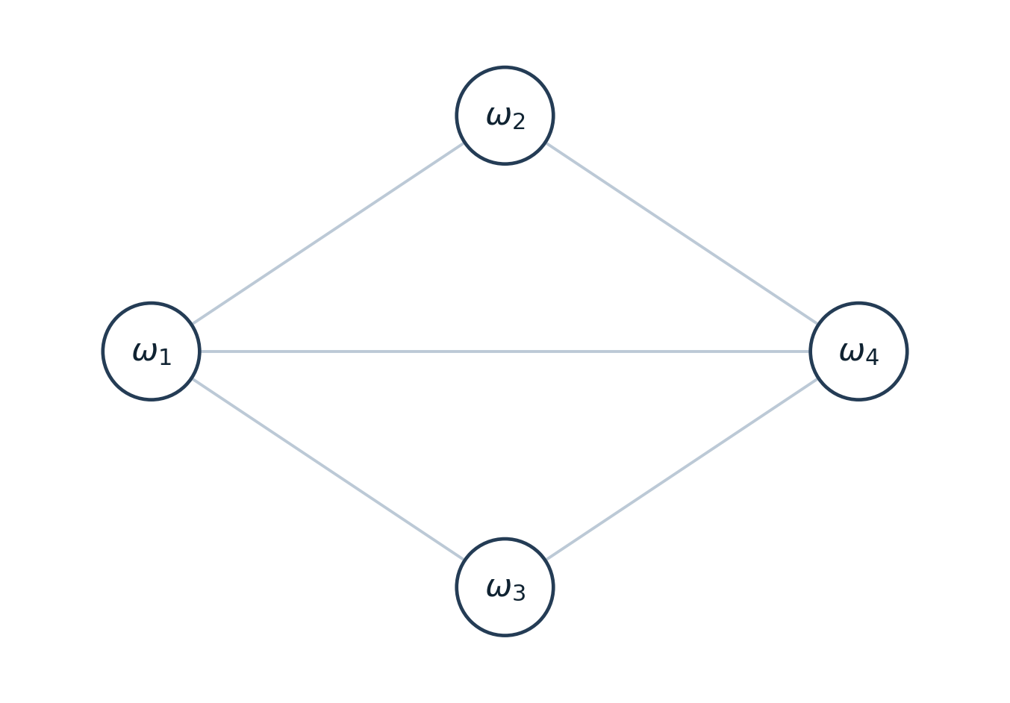
Figure 1. Order-divisor graph for $p=5$, isomorphic to $K_{1,1,2}$.
Example 4.12 ($p=7$). In the vertex order $ω_{1},…,ω_{6}$,
$$A_{7}=\left(\begin{matrix}0 & 1 & 1 & 1 & 1 & 1 \\ 1 & 0 & 1 & 0 & 1 & 0 \\ 1 & 1 & 0 & 1 & 0 & 1 \\ 1 & 0 & 1 & 0 & 1 & 0 \\ 1 & 1 & 0 & 1 & 0 & 1 \\ 1 & 0 & 1 & 0 & 1 & 0\end{matrix}\right).$$
The graph has $11$ edges and degree sequence $\left(5,3,4,3,4,3\right)$. Its multipartite parts $\{ω_{1}\}$, $\{ω_{3},ω_{5}\}$ and $\{ω_{2},ω_{4},ω_{6}\}$ have sizes $1,2,3$, respectively. Figure 2 displays this $K_{1,2,3}$ structure; dashed lines denote the edges incident with the identity, and solid lines denote all other edges. The identity is the sole central vertex.
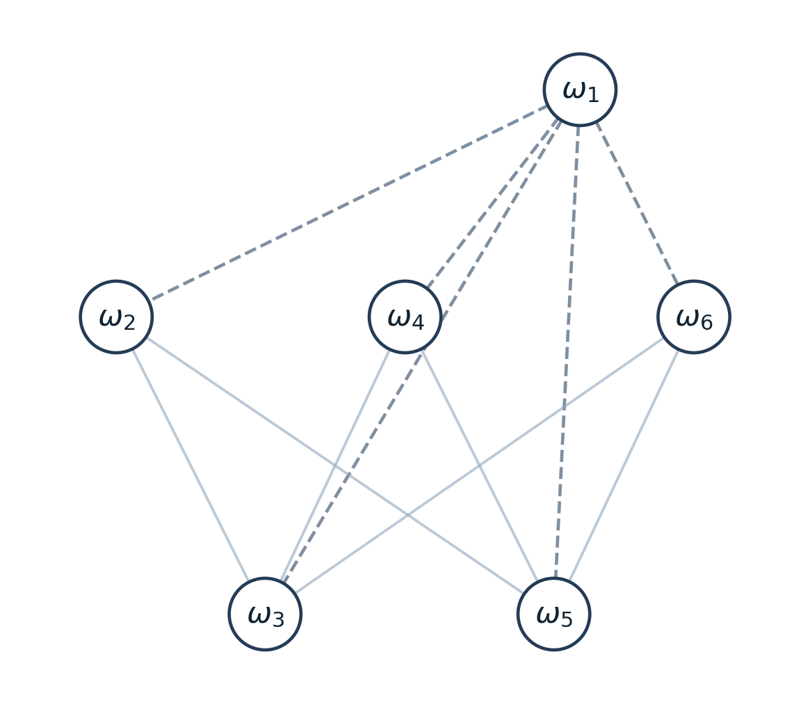
Figure 2. Order-divisor graph for $p=7$, isomorphic to $K_{1,2,3}$; dashed edges are incident with $ω_{1}$.
Example 4.13 ($p=11$). In the vertex order $ω_{1},…,ω_{10}$,
$$A_{11}=\left(\begin{matrix}0 & 1 & 1 & 1 & 1 & 1 & 1 & 1 & 1 & 1 \\ 1 & 0 & 1 & 1 & 1 & 0 & 0 & 0 & 1 & 1 \\ 1 & 1 & 0 & 0 & 0 & 1 & 1 & 1 & 0 & 0 \\ 1 & 1 & 0 & 0 & 0 & 1 & 1 & 1 & 0 & 0 \\ 1 & 1 & 0 & 0 & 0 & 1 & 1 & 1 & 0 & 0 \\ 1 & 0 & 1 & 1 & 1 & 0 & 0 & 0 & 1 & 1 \\ 1 & 0 & 1 & 1 & 1 & 0 & 0 & 0 & 1 & 1 \\ 1 & 0 & 1 & 1 & 1 & 0 & 0 & 0 & 1 & 1 \\ 1 & 1 & 0 & 0 & 0 & 1 & 1 & 1 & 0 & 0 \\ 1 & 1 & 0 & 0 & 0 & 1 & 1 & 1 & 0 & 0\end{matrix}\right).$$
The identity supplies nine edges. Every one of the five vertices of orders $2$ or $5$ is adjacent to each of the four vertices of order $10$, adding $20$ edges and yielding $\left|E\right|=29$. The degrees are $9$ at the identity, $6$ at the elements of order $10$, and $5$ at the elements of orders $2$ and $5$. Figure 3 shows the three parts $\{ω_{1}\}$, $\{ω_{2},ω_{6},ω_{7},ω_{8}\}$, and $\{ω_{10},ω_{3},ω_{4},ω_{5},ω_{9}\}$, which give $K_{1,4,5}$. Dashed edges join the identity to every other vertex. Only the identity is central.
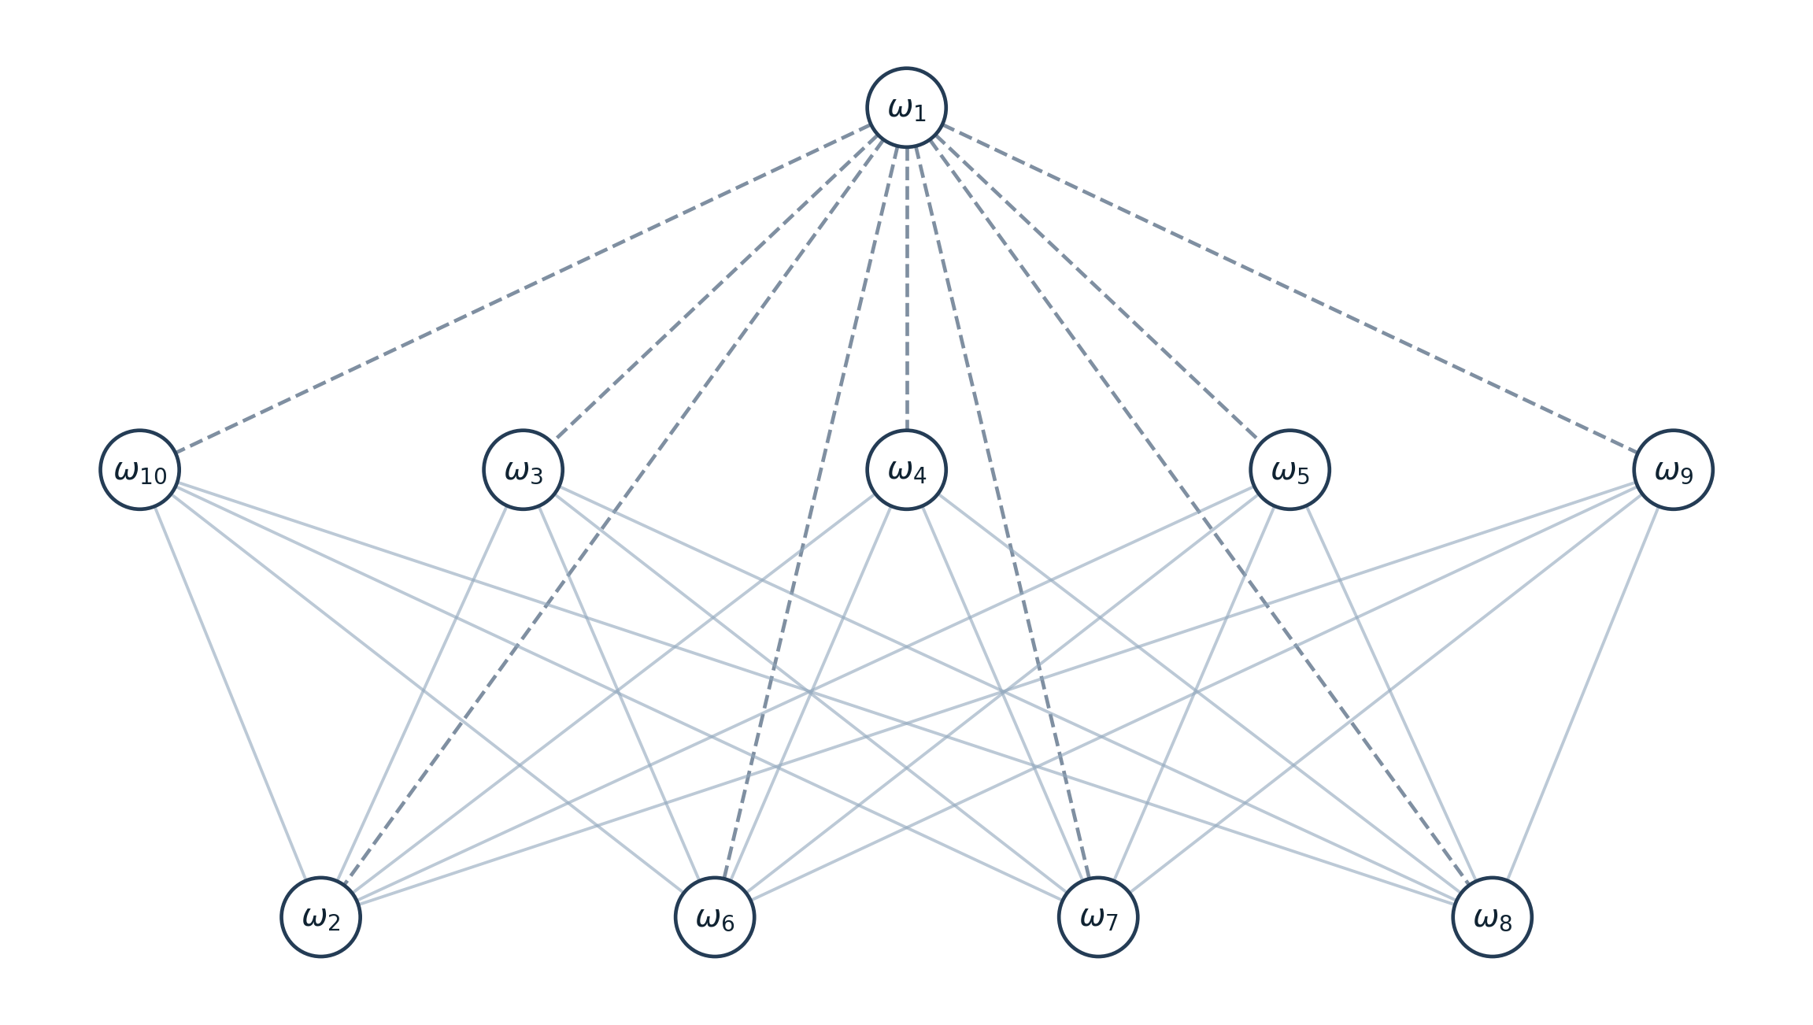
Figure 3. Order-divisor graph for $p=11$, isomorphic to $K_{1,4,5}$; dashed edges are incident with $ω_{1}$.

4.7. Summary and computational verification
The divisor-class construction gives the invariant identities assembled in Table 2, including the dependence of the center on the odd part $m$ of $n=p-1$. In particular, the table separates properties common to all primes from those governed by the factorization of $p-1$.
Table 2. Properties of $OD\left(G_{p}^{Γ_{1}}\right)$ for prime $p≥5$, with $n=p-1$ and $m$ the largest odd divisor of $n$.
Property | Value or description
Number of vertices | $$n=p-1$$
Number of edges | d∣e∣n, d<e​φdφe
Connected / complete / regular | Yes / No / No
Diameter / radius / girth | $2$ / $1$ / $3$
Maximum degree | $Δ=p-2$; attained at $ω_{1}$, and also at $ω_{p-1}$ if $n=2^{k}$
Minimum degree | $δ=2$ when $p=5$; $δ≥3$ when $p≥7$
Identity / involution / generator degrees | $n-1$ / $n-m$ / $n-φ\left(n\right)$
Center | $\{ω_{1},ω_{p-1}\}$ when $n=2^{k}$; $\{ω_{1}\}$ otherwise
Periphery | $G_{p}^{Γ_{1}}$ minus the center
Eccentricities | $1$ on the center and $2$ elsewhere
Complete multipartite condition | $n=2^{k}$ or $n=2q$ for an odd prime $q$
Table 3 presents the numerical invariants calculated from the explicit adjacency relation. The cases $p=5,17,257$ have two central vertices because $p-1$ is a power of $2$; in contrast, examples such as $p=13,19,29$ do not satisfy the complete multipartite criterion. All entries agree with Equations (4.1)–(4.9).
Table 3. Order-divisor graph invariants for selected primes. Here $\left|Z\right|$ is the number of central vertices; “No” in the Structure column denotes a graph that is not complete multipartite.
$$p$$ | $$\left|V\right|$$ | $$\left|E\right|$$ | $$δ$$ | $$Δ$$ | Diam. | Rad. | Girth | $$\left|Z\right|$$ | Structure
5 | 4 | 5 | 2 | 3 | 2 | 1 | 3 | 2 | $$K_{1,1,2}$$
7 | 6 | 11 | 3 | 5 | 2 | 1 | 3 | 1 | $$K_{1,2,3}$$
11 | 10 | 29 | 5 | 9 | 2 | 1 | 3 | 1 | $$K_{1,4,5}$$
13 | 12 | 47 | 6 | 11 | 2 | 1 | 3 | 1 | No
17 | 16 | 85 | 8 | 15 | 2 | 1 | 3 | 2 | $$K_{1,1,2,4,8}$$
19 | 18 | 101 | 9 | 17 | 2 | 1 | 3 | 1 | No
23 | 22 | 131 | 11 | 21 | 2 | 1 | 3 | 1 | $$K_{1,10,11}$$
29 | 28 | 251 | 14 | 27 | 2 | 1 | 3 | 1 | No
31 | 30 | 271 | 12 | 29 | 2 | 1 | 3 | 1 | No
37 | 36 | 425 | 18 | 35 | 2 | 1 | 3 | 1 | No
257 | 256 | 21,845 | 128 | 255 | 2 | 1 | 3 | 2 | $$K_{1,1,2,…,128}$$

4.8. Discussion
The graph depends only on the order structure of $G_{p}^{Γ_{1}}$, which is isomorphic to the cyclic group $C_{p-1}$. The divisor-class viewpoint explains why the identity makes every graph connected with radius $1$, why two generators prevent completeness, and why a triangle is present for each $p≥5$. These are consequences of the cyclic setting rather than properties intrinsic to the one-line permutation representation. The order-class decomposition has clear precedents in Rehman et al. (2018) and Choosuwan et al. (2024); the contribution of the permutation-specific analysis lies in explicitly linking the graph invariants to the residue labels, especially $ω_{p-1}$, and stating the associated arithmetic criteria in terms of the indexing prime.
The degree distribution and complete multipartite status are more sensitive to the divisors of $p-1$. For $p-1=2^{k}$, every divisor is comparable and the involution is universal. For $p-1=2q$ with an odd prime $q$, the only incomparable order classes are $C_{2}$ and $C_{q}$, which merge into a single independent multipartite part. If the odd part is composite or a higher power of $2$ occurs with an odd prime factor, the incomparable-order obstruction in Proposition 4.10 prevents complete multipartiteness.
These order-divisor graphs should also be distinguished from the power graphs of the same group. Yusuf and Umar (2025) report that the latter has diameter $1$ when $p=5$, whereas the order-divisor graph has diameter $2$ even then because distinct generators are not adjacent. Although maximum degree $p-2$ and girth $3$ occur in both constructions, their adjacency relations and center behavior are not identical. No causal or empirical inference is implied by these deterministic graph calculations.

5. Conclusions
For primes $p≥5$, the $Γ_{1}$-nonderanged permutation group has a cyclic order-divisor graph determined by the divisor classes of $p-1$. The established cyclic-group expansion yields the order-class description, and the permutation-indexed calculations give explicit degrees, edge counts, and center and periphery. The graph is connected, noncomplete, and nonregular, with diameter $2$, radius $1$, girth $3$, and maximum degree $p-2$. Its minimum degree equals $2$ only for $p=5$ and is at least $3$ otherwise. The identity $ω_{1}$ is always central, and the involution $ω_{p-1}$ is central exactly when $p-1$ is a power of $2$. Complete multipartiteness occurs precisely for $p-1=2^{k}$ or $p-1=2q$, with $q$ an odd prime. The displayed examples and deterministic computations agree with these conclusions. Further work may consider spectral invariants, graph automorphisms, and related constructions for composite moduli.

Competing interests
The author declares that no competing interests exist.

Declaration of AI-assisted preparation
Grammarly and ChatGPT assisted with language, bibliographic presentation, and mathematical typesetting. Mathematical statements, computations, interpretations, and the final content remain the responsibility of the author(s).

References

References
Aminu, I. A., Ojonugwa, E., & Aremu, K. O. (2016). On the representations of Γ₁-nonderanged permutation group gₚ. Advances in Pure Mathematics, 6(9), 608–614. https://doi.org/10.4236/apm.2016.69049
Aremu, K. O., Buoro, S., Garba, A. I., & Ibrahim, A. H. (2018). On the direct and skew sums of Γ₁-non deranged permutations. Punjab University Journal of Mathematics, 50(3), 43–51. https://pu.edu.pk/images/journal/maths/PDF/Paper-4_50_3_2018.pdf
Aremu, K. O., Garba, A. I., Ibrahim, M., & Buoro, S. (2019). Restricted bijections on the Gamma₁ non deranged permutation group. Asian Journal of Mathematics and Computer Research, 25(8), 462–477. https://ikprress.org/index.php/AJOMCOR/article/view/4200
Beaumont, R. A., & Peterson, R. P. (1955). Set-transitive permutation groups. Canadian Journal of Mathematics, 7, 35–42. https://doi.org/10.4153/CJM-1955-005-x
Bondy, J. A., & Murty, U. S. R. (2008). Graph theory (Graduate Texts in Mathematics, Vol. 244). Springer. https://doi.org/10.1007/978-1-84628-970-5
Chalapathi, T., & Kiran Kumar, R. V. M. S. S. (2017). Order divisor graphs of finite groups. Malaya Journal of Matematik, 5(2), 464–474. https://doi.org/10.26637/mjm502/025
Choosuwan, P., Sangsawang, P., Matwangsang, C., Thongsupol, S., & Sirisuk, S. (2024). Generalized order divisor graphs of finite group. International Journal of Group Theory, 13(1), 31–45. https://doi.org/10.22108/IJGT.2022.133091.1787
Dixon, J. D., & Mortimer, B. (1996). Permutation groups (Graduate Texts in Mathematics, Vol. 163). Springer. https://doi.org/10.1007/978-1-4612-0731-3
Ejima, O., Aremu, K. O., & Yusuf, A. (2025). The order divisor-power graph of finite groups. Analele Științifice ale Universității Alexandru Ioan Cuza din Iași. Matematică, 71(2), 133–143. https://doi.org/10.47743/anstim.2025.00010
Garba, A. I., Ejima, O., & Aremu, K. O. (2021). Vertex relations of order divisor graphs of subgroups of finite groups. Journal of the Nigerian Mathematical Society, 39(3), 315–322. https://jnms.ictp.it/jnms/index.php/jnms/article/view/583
Garba, I. A., Ejima, O., Aremu, K. O., & Usman, H. (2017). Nonstandard young tableaux of non-deranged permutation group. Global Journal of Mathematical Analysis, 5(1), 21–23. https://doi.org/10.14419/gjma.v5i1.6632
Ibrahim, A. A., Ibrahim, M., & Ibrahim, B. A. (2022). Embracing sum using ascent block of Γ₁-non deranged permutation. International Journal of Advances in Engineering and Management, 4(5), 272–277. https://doi.org/10.35629/5252-0405272277
Jaiyeola, S. B., Suleiman, A., Tasiu, A. R., Ahmad, R., & Aremu, K. O. (2025). Some graph properties of Γ₁-nonderanged permutation graphs. FUDMA Journal of Sciences, 9(6), 182–185. https://doi.org/10.33003/fjs-2025-0906-3546
Liu, X., & Ma, X. (2020). The order divisor graph of a finite group. Comptes Rendus de l'Académie Bulgare des Sciences, 73(3), 339–347. https://doi.org/10.7546/crabs.2020.03.06
Magami, M. S., & Ibrahim, M. (2021). Admissible inversion on Γ₁ non-deranged permutations. Asian Research Journal of Mathematics, 17(8), 44–53. https://doi.org/10.9734/arjom/2021/v17i830322
Rehman, S. U., Baig, A. Q., Imran, M., & Khan, Z. U. (2018). Order divisor graphs of finite groups. Analele Științifice ale Universității Ovidius Constanța. Seria Matematică, 26(3), 29–40. https://doi.org/10.2478/auom-2018-0031
Sen, M. K., Maity, S. K., & Das, S. (2021). On order prime divisor graphs of finite groups. Discussiones Mathematicae – General Algebra and Applications, 41(2), 419–437. https://doi.org/10.7151/dmgaa.1372
Suleiman, I., Garba, A. I., & Mustafa, A. (2020). On some non-deranged permutation: A new method of construction. International Journal of Research – GRANTHAALAYAH, 8(3), 309–314. https://doi.org/10.29121/granthaalayah.v8.i3.2020.162
Yusuf, A., Abdulrahman, S., & Umar, A. (2025). A study on inverse graph representation of Gamma 1 nonderanged permutation group. Asian Journal of Pure and Applied Mathematics, 7(1), 827–841. https://doi.org/10.56557/ajpam/2025/v7i1245
Yusuf, A., & Ejima, O. (2023). Some properties of an extended Γ₁-non deranged permutation group. FUDMA Journal of Sciences, 7(3), 332–336. https://doi.org/10.33003/fjs-2023-0703-2031
Yusuf, A., & Umar, A. (2025). On power graph representation of Γ₁-nonderanged permutation group. UMYU Scientifica, 4(1), 53–61. https://doi.org/10.56919/usci.2541.006

