Autoimmune Haemolytic Anaemia Associated With Profound Hypogammaglobulinemia and Suspected Common Variable Immunodeficiency: A Case Report
Abstract
Background: Autoimmune cytopenias can precede recognition of primary antibody deficiencies, but acquired causes of reduced immunoglobulins must be distinguished from common variable immunodeficiency (CVID).
Case presentation: A 42-year-old woman with insulin-treated diabetes, severe rheumatic mitral regurgitation, and atrial fibrillation had a history of direct antiglobulin test-positive autoimmune haemolytic anaemia (AIHA) dating from 2018. Initial episodes improved after corticosteroids and azathioprine. Approximately seven years later, she presented with clinically severe anaemia described as poorly responsive to high-dose corticosteroids. Serum protein electrophoresis repeatedly demonstrated a low gamma-globulin component, with reported values of 1.4–4 g/L across four assessments. IgG, IgA, and IgM were described as reduced, and the CD19-positive B-cell count was 3 cells/mm³. The clinical history included recurrent tonsillitis, erysipelas complicated by necrotising fasciitis, and herpes zoster. After assessment, azathioprine was discontinued, corticosteroids were tapered, and antibiotic prophylaxis was initiated; immunoglobulin replacement was considered. Class-specific immunoglobulin concentrations, functional antibody responses, and post-treatment outcomes were not provided, preventing definitive differentiation of CVID from secondary hypogammaglobulinemia.
Conclusion: This case illustrates the value of evaluating antibody deficiency when AIHA coexists with recurrent infections and hypogammaglobulinemia. CVID should remain a diagnostic consideration rather than a definitive classification until accepted criteria are documented and secondary causes are sufficiently assessed.
Keywords: autoimmune haemolytic anaemia; common variable immunodeficiency; hypogammaglobulinemia; autoimmune cytopenia; B-cell lymphopenia; secondary immunodeficiency.
Introduction
Common variable immunodeficiency (CVID) comprises heterogeneous primary antibody deficiencies characterised by reduced serum immunoglobulin concentrations and impaired antibody function, together with variable susceptibility to infection, autoimmunity, and inflammatory complications (Bonilla et al., 2016; Seidel et al., 2019). A diagnosis of CVID requires more than detection of hypogammaglobulinemia: diagnostic frameworks also emphasise appropriate immunological characterisation and exclusion of secondary causes of reduced immunoglobulin levels (Bonilla et al., 2016; Otani et al., 2022).
Autoimmune haematological disorders, including autoimmune haemolytic anaemia (AIHA), are recognised manifestations of CVID and may precede its diagnosis. Both cohort-based and clinical literature support the importance of autoimmune cytopenias as possible early presentations of antibody deficiency (Cunningham-Rundles, 2008; Cunningham-Rundles et al., 2024; Sève et al., 2008). Because treatment of AIHA often involves immunosuppressants, interpreting subsequent hypogammaglobulinemia can be particularly challenging. However, the association between AIHA and CVID cannot by itself establish whether the hypogammaglobulinaemia in a previously immunosuppressed patient is primary or secondary. The present case describes recurrent AIHA followed by recognition of substantial hypogammaglobulinemia and marked peripheral B-cell lymphopenia, with attention to the limits of diagnostic attribution.
Case Presentation
Clinical history
A 42-year-old woman had insulin-treated diabetes mellitus, severe mitral regurgitation attributed to previous rheumatic fever, and atrial fibrillation. She had received care for AIHA since 2018. The original diagnosis was based on a positive direct antiglobulin (Coombs) test together with clinical and biological findings described as compatible with haemolysis. Earlier episodes reportedly improved with high-dose systemic corticosteroids and azathioprine. The case record does not provide the initial haemoglobin concentration, absolute reticulocyte count, bilirubin, lactate dehydrogenase, haptoglobin, antibody specificity, or treatment doses.
Approximately seven years after the initial AIHA diagnosis, anaemia recurred and was described as severe and poorly tolerated despite high-dose corticosteroid therapy. There was no reported clinical or laboratory evidence of active bleeding. The haemoglobin nadir, contemporaneous markers of haemolysis, vital signs, transfusion requirements, and formal criteria used to define corticosteroid resistance are not documented in the available clinical account. The reported severity and treatment response therefore cannot be independently quantified.
Investigations and clinical differential
Antinuclear and anti–double-stranded DNA antibody tests were negative. No schistocytes or circulating blasts were identified on the peripheral blood smear, and a bone marrow biopsy reportedly did not demonstrate tumour infiltration. Investigations for hemoglobinopathy and thyroid dysfunction were described as unrevealing, without specific results. Testing for HIV, hepatitis C virus, and syphilis was negative, as was an interferon-gamma release (QuantiFERON) test. No clinical tumour syndrome was reported. These assessments reduced concern for selected alternative diagnoses but did not constitute comprehensive exclusion of every potential cause of anaemia or hypogammaglobulinemia.
Serum protein electrophoresis was reported to demonstrate pronounced hypogammaglobulinemia on four occasions, with values ranging from 1.4 to 4 g/L. Because these findings were reported in connection with serum protein electrophoresis, the range should not be equated with an individual quantitative IgG, IgA, or IgM concentration. All three immunoglobulin classes were described as decreased, but separate concentrations, laboratory reference intervals, and sample dates were not given. The peripheral CD19-positive B-cell count was 3 cells/mm³, consistent with marked B-cell lymphopenia in the reported sample. The contemporaneous absolute lymphocyte count and more detailed B- and T-cell immunophenotypes were not provided. Genetic testing was not undertaken.
The patient described recurrent tonsillitis, associated historically with rheumatic fever, as well as erysipelas complicated by necrotising fasciitis and an episode of intercostal herpes zoster. The temporal relationship of these infections to immunosuppressive treatment and their microbiological documentation were not specified. This infectious history, together with hypogammaglobulinemia and low circulating B-cell numbers, raised concern for an underlying antibody deficiency.
The diagnosis of CVID was considered in the clinical assessment. However, vaccine-specific antibody responses, switched-memory B-cell measurements, a sufficiently detailed assessment of profound T-cell deficiency, and systematic investigation of acquired causes of hypogammaglobulinemia were not documented. In particular, prior corticosteroid and azathioprine exposure complicates attribution of the immunological findings to primary CVID.
Clinical course and management
Azathioprine was discontinued and corticosteroids were gradually tapered. Antibiotic prophylaxis was initiated, and immunoglobulin replacement therapy was considered. The specific prophylactic regimen, response of anaemia and immunoglobulin concentrations after modification of immunosuppression, occurrence of subsequent infections, and duration of follow-up were not described. There is no documented initiation of immunoglobulin replacement or rituximab in this patient.
The sequence of major events is presented in Table 1. The chronology distinguishes patient-reported historical events, the later clinical relapse, the available immunological findings, and the management actions for which records are described.
Table 1. Clinical chronology and principal reported findings
Period | Clinical event | Finding or action
2018 | AIHA recognized | Direct antiglobulin test positive; biological and clinical hemolysis reported.
Initial AIHA episodes | Immunosuppressive treatment | Clinical improvement reported with high-dose corticosteroids and azathioprine.
Approximately seven years later | Relapsing anemia | Severe, poorly tolerated anemia reported despite high-dose corticosteroids; no active bleeding identified.
During diagnostic assessment | Immune evaluation | Electrophoretic gamma-globulin findings 1.4–4 g/L on four occasions; IgG/IgA/IgM reportedly decreased; CD19+ count 3 cells/mm³.
Following assessment | Management changes | Azathioprine withdrawn; corticosteroids tapered; antibiotic prophylaxis initiated; immunoglobulin replacement considered.
Note. Individual quantitative immunoglobulin and hemolysis measurements, investigation dates, and follow-up results are not specified in the clinical account. DAT = direct antiglobulin test.
Discussion
Clinical interpretation and diagnostic uncertainty
The conjunction of recurrent AIHA, severe reported hypogammaglobulinemia, very low circulating CD19-positive B cells, and substantial infections is clinically compatible with an antibody-deficiency phenotype. AIHA is an established autoimmune complication of CVID: a French case–control investigation described 18 affected individuals and documented that autoimmune haemolysis can precede recognition of CVID (Sève et al., 2008). More recent clinical synthesis likewise identifies autoimmune cytopenias among the presentations that should prompt consideration of CVID (Cunningham-Rundles et al., 2024). This relationship is an association and does not by itself demonstrate that CVID caused the haemolysis in an individual patient.
The reported findings do not, however, establish that this patient meets a complete contemporary case definition of CVID. International consensus criteria emphasise reduced immunoglobulin concentrations, impaired antibody function and exclusion of alternative explanations, while ESID definitions incorporate immunological and clinical requirements that cannot be inferred solely from a low electrophoretic gamma-globulin fraction (Bonilla et al., 2016; Seidel et al., 2019). Dated quantitative IgG and IgA measurements and, where clinically appropriate, functional vaccine-antibody evaluation or suitable B-cell subset data are necessary to assess diagnostic classification. The particularly low CD19-positive count also warrants consideration of the broader differential for pronounced B-cell depletion.
Secondary hypogammaglobulinemia is an important competing diagnosis in this case. Long-term immunosuppression can affect immunoglobulin production, and recurrent infections may be influenced by immunosuppressive therapy and comorbid disease as well as intrinsic immune defects. Evaluation of potential causes—including immunosuppressive exposures, protein loss, and relevant haematological disorders—is central to the interpretation of reduced immunoglobulins (Otani et al., 2022). Although some haematological, autoimmune, and infectious screens were described as negative, their scope cannot exclude all acquired aetiologies. These observations support consideration of CVID without establishing a definitive diagnosis.
Autoimmunity and immune dysregulation
The association of autoimmunity with CVID is biologically plausible despite low serum immunoglobulin levels. Autoimmune cytopenias are among the characteristic noninfectious complications reported in CVID cohorts, reflecting immune dysregulation beyond a simple quantitative antibody deficiency (Agarwal & Cunningham-Rundles, 2019; Cunningham-Rundles, 2008). B-cell tolerance defects have been described in some patients with CVID and autoimmune manifestations, including expansion of autoreactive B-cell populations (Richardson et al., 2019). Differences in regulatory lymphocyte function and inflammatory signalling are also proposed contributors, but individual mechanisms vary across heterogeneous CVID phenotypes (Agarwal & Cunningham-Rundles, 2019).
No patient-specific B-cell autoreactivity testing, regulatory T-cell or follicular helper T-cell analysis, cytokine profiling, splenic immunological studies, or genetic investigation was undertaken in the case as reported. These processes should therefore be regarded as possible explanatory pathways from published research rather than mechanisms established in this patient. Molecular diagnoses may account for some CVID-like immune-dysregulation presentations, underscoring the importance of avoiding etiological certainty without further characterisation (Cunningham-Rundles et al., 2024).
Therapeutic implications and reporting limitations
Corticosteroids are commonly used in AIHA, while subsequent treatment depends on the type of haemolysis, disease course, treatment response, and patient-specific risks (Jäger et al., 2020). For patients with confirmed CVID, immunoglobulin replacement is considered primarily to address clinically significant antibody deficiency and susceptibility to infection; it should not be presented as an established treatment for the autoimmune haemolytic episode itself. In refractory CVID-associated immune cytopenias, rituximab has been described in a retrospective multicentre cohort, but decisions require careful assessment of infection risk and the underlying immune phenotype (Agarwal & Cunningham-Rundles, 2019; Gobert et al., 2011). Neither rituximab nor immunoglobulin replacement was documented as having been given to the patient in this case.
The case is limited by unavailable numerical haemolysis indices, separate immunoglobulin measurements, detailed functional antibody testing, treatment doses, and post-treatment outcomes. These gaps preclude independent confirmation of the severity of the recurrent AIHA and definitive classification of the antibody-deficiency syndrome. Its principal clinical lesson is the need for integrated haematological and immunological assessment, including review of medication-related secondary causes, rather than the assertion of a proven causal mechanism.
Figure 1 summarizes the recorded progression from AIHA to immunological evaluation and management. It depicts CVID as a diagnostic possibility, distinguishes measured or reported findings from mechanistic concepts drawn from the literature, and separates actions actually taken from treatment only considered.
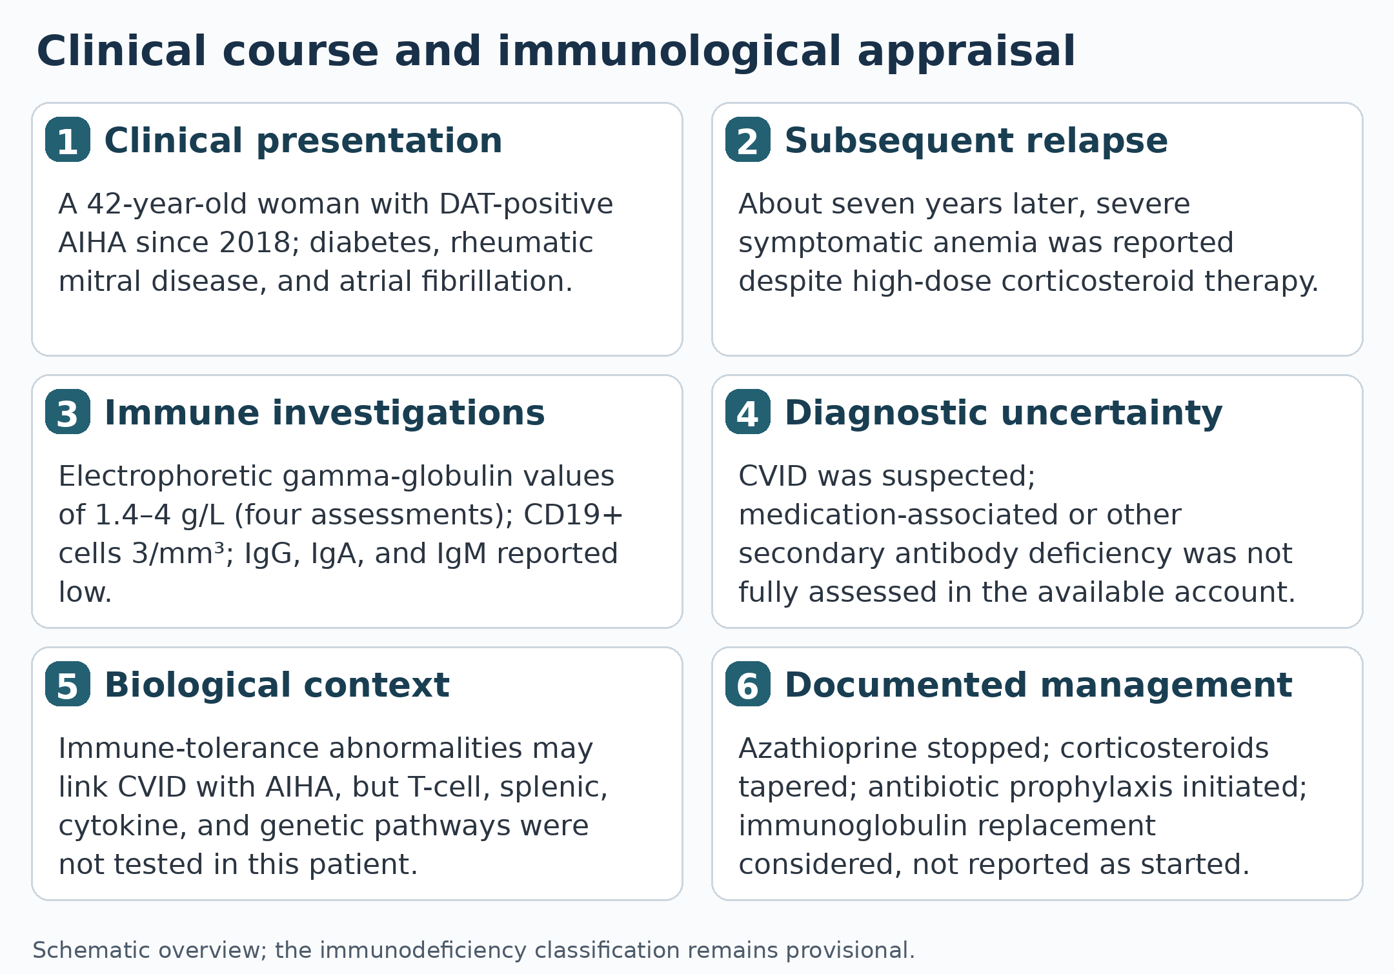
Figure 1. Schematic overview of the clinical presentation, diagnostic evaluation, uncertainty regarding CVID classification, and management. Mechanistic pathways are literature-based concepts and were not evaluated in the patient.
Conclusion
Autoimmune haemolytic anaemia may be an early clinical signal of an antibody-deficiency disorder, particularly when recurrent infections and hypogammaglobulinemia coexist. In this patient, repeated low gamma-globulin findings and marked B-cell lymphopenia prompted consideration of CVID, but missing class-specific immunoglobulin measurements, functional antibody data, and evaluation for secondary causes limit diagnostic certainty. A careful haematological and immunological assessment is required to distinguish primary CVID from acquired hypogammaglobulinemia and to guide treatment decisions.
Declarations
Ethics approval
Not applicable.
Consent for publication
Written informed consent for publication was obtained from the patient. Patient confidentiality has been maintained.
Conflict of interest
The author declares no conflict of interest.
Declaration of artificial intelligence assistance
Grammarly and ChatGPT were used to assist with language and manuscript editing. Responsibility for the accuracy and integrity of the clinical content and references remains with the author(s).
References
Agarwal, S., & Cunningham-Rundles, C. (2019). Autoimmunity in common variable immunodeficiency. Annals of Allergy, Asthma & Immunology, 123(5), 454–460. https://doi.org/10.1016/j.anai.2019.07.014
Bonilla, F. A., Barlan, I., Chapel, H., Costa-Carvalho, B. T., Cunningham-Rundles, C., de la Morena, M. T., Espinosa-Rosales, F. J., Hammarström, L., Nonoyama, S., Quinti, I., Routes, J. M., Tang, M. L. K., & Warnatz, K. (2016). International consensus document (ICON): Common variable immunodeficiency disorders. The Journal of Allergy and Clinical Immunology: In Practice, 4(1), 38–59. https://doi.org/10.1016/j.jaip.2015.07.025
Cunningham-Rundles, C. (2008). Autoimmune manifestations in common variable immunodeficiency. Journal of Clinical Immunology, 28(Suppl. 1), S42–S45. https://doi.org/10.1007/s10875-008-9182-7
Cunningham-Rundles, C., Casanova, J.-L., & Boisson, B. (2024). Common variable immunodeficiency: Autoimmune cytopenias and advances in molecular diagnosis. Hematology (American Society of Hematology Education Program), 2024(1), 137–142. https://doi.org/10.1182/hematology.2024000538
Gobert, D., Bussel, J. B., Cunningham-Rundles, C., Galicier, L., Dechartres, A., Berezne, A., Bonnotte, B., DeRevel, T., Auzary, C., Jaussaud, R., Larroche, C., LeQuellec, A., Ruivard, M., Sève, P., Smail, A., Viallard, J.-F., Godeau, B., Hermine, O., & Michel, M. (2011). Efficacy and safety of rituximab in common variable immunodeficiency-associated immune cytopenias: A retrospective multicentre study on 33 patients. British Journal of Haematology, 155(4), 498–508. https://doi.org/10.1111/j.1365-2141.2011.08880.x
Jäger, U., Barcellini, W., Broome, C. M., Gertz, M. A., Hill, A., Hill, Q. A., Jilma, B., Kuter, D. J., Michel, M., Montillo, M., Röth, A., Zeerleder, S. S., & Berentsen, S. (2020). Diagnosis and treatment of autoimmune hemolytic anemia in adults: Recommendations from the first international consensus meeting. Blood Reviews, 41, Article 100648. https://doi.org/10.1016/j.blre.2019.100648
Otani, I. M., Lehman, H. K., Jongco, A. M., Tsao, L. R., Azar, A. E., Tarrant, T. K., Engel, E., Walter, J. E., Truong, T. Q., Khan, D. A., Ballow, M., Cunningham-Rundles, C., Lu, H., Kwan, M., & Barmettler, S. (2022). Practical guidance for the diagnosis and management of secondary hypogammaglobulinemia: A work group report of the AAAAI Primary Immunodeficiency and Altered Immune Response Committees. Journal of Allergy and Clinical Immunology, 149(5), 1525–1560. https://doi.org/10.1016/j.jaci.2022.01.025
Richardson, C. T., Slack, M. A., Dhillon, G., Marcus, C. Z., Barnard, J., Palanichamy, A., Sanz, I., Looney, R. J., & Anolik, J. H. (2019). Failure of B cell tolerance in CVID. Frontiers in Immunology, 10, Article 2881. https://doi.org/10.3389/fimmu.2019.02881
Seidel, M. G., Kindle, G., Gathmann, B., Quinti, I., Buckland, M., van Montfrans, J., Scheible, R., Rusch, S., Gasteiger, L. M., Grimbacher, B., Mahlaoui, N., & Ehl, S. (2019). The European Society for Immunodeficiencies (ESID) registry working definitions for the clinical diagnosis of inborn errors of immunity. The Journal of Allergy and Clinical Immunology: In Practice, 7(6), 1763–1770. https://doi.org/10.1016/j.jaip.2019.02.004
Sève, P., Bourdillon, L., Sarrot-Reynauld, F., Ruivard, M., Jaussaud, R., Bouhour, D., Bonotte, B., Gardembas, M., Poindron, V., Thiercelin, M.-F., Broussolle, C., & Oksenhendler, E. (2008). Autoimmune hemolytic anemia and common variable immunodeficiency: A case-control study of 18 patients. Medicine, 87(3), 177–184. https://doi.org/10.1097/MD.0b013e31817a90ba

