Manufacturing Decarbonisation in ASEAN after the Adoption of Community Vision 2045: A Comparative Policy Analysis

Abstract
The ASEAN Community Vision 2045 and the ASEAN Plan of Action for Energy Cooperation 2026-2030 place sustainability alongside regional economic integration, but the implications for manufacturing depend on national policy design and implementation. This qualitative comparative policy analysis examines policy readiness in six manufacturing-relevant ASEAN economies—Indonesia, Malaysia, the Philippines, Singapore, Thailand and Viet Nam—using regional frameworks, country-level carbon-pricing information, European Union Carbon Border Adjustment Mechanism (CBAM) rules and relevant research available through 23 October 2026. The assessment distinguishes implemented, pilot and proposed measures and evaluates strategic ambition, institutional implementation and structural constraints. Singapore applies a carbon tax of S$45 per tonne of carbon dioxide equivalent in 2026-2027; Indonesia has a power-sector emissions trading system and a separate carbon exchange; Viet Nam has established a pilot emissions trading framework; Thailand embeds a carbon price in petroleum excise; and Malaysian and Philippine national proposals are at different development stages. The ASEAN Power Grid and conceptual cross-border renewable-energy certificate initiatives support regional cooperation, although these mechanisms do not, by themselves, establish manufacturing emissions reductions. Exposure to CBAM depends on products, emissions intensity and monitoring capabilities, and should not be equated with export shares alone. The findings point to the value of interoperable measurement and verification, credible industrial investment support, and distribution-sensitive transition policy. The study identifies institutional arrangements and policy options rather than estimating sector-wide emissions savings or causal policy effects.
Keywords: ASEAN Community Vision 2045; manufacturing decarbonisation; carbon pricing; carbon border adjustment mechanism; policy coordination; industrial transition; monitoring, reporting and verification

1. Introduction
The ASEAN Community Vision 2045, adopted at the 46th ASEAN Summit in Kuala Lumpur on 26 May 2025, places sustainable growth and institutional resilience within the region's long-term integration agenda (ASEAN Secretariat, 2025a, 2025b). This agenda raises a specific industrial policy question: how can manufacturing producers respond to climate-related requirements while maintaining productive capacity, employment opportunities and integration into international markets? Manufacturing decarbonisation entails changes in both purchased electricity and production processes; therefore, electricity policy, investment incentives and the measurement of facility-level emissions need to be considered together (Bataille, 2020).
ASEAN now comprises 11 member states following Timor-Leste's admission in October 2025 (ASEAN Secretariat, 2025c). This analysis focuses purposively on six economies with substantial or policy-relevant manufacturing activity and contrasting instruments: Indonesia, Malaysia, the Philippines, Singapore, Thailand and Viet Nam. These cases enable a comparison of policy types, not a ranking of all ASEAN members. The cases do not represent the industrial circumstances of Brunei Darussalam, Cambodia, Lao PDR, Myanmar or Timor-Leste.
Trade-related pressures add another governance dimension. The European Union's CBAM definitive regime began on 1 January 2026 for covered goods; the sale of certificates relating to 2026 imports begins in 2027. Its principal direct compliance obligations fall on qualifying EU importers, while manufacturing exporters may need to furnish reliable embedded-emissions data (European Commission, n.d.-a, n.d.-b). A comparative assessment must therefore distinguish the existence of a regulatory mechanism from the magnitude of the costs eventually borne by individual ASEAN facilities (Keen et al., 2022; Mehling et al., 2019).
Figure 1 outlines the interacting channels through which regional direction, national instruments and trade or distributional conditions can influence industrial technology choices. The relationships are conceptual and do not represent measured causal effects; their central implication is that carbon prices alone cannot substitute for credible monitoring systems, infrastructure and investment support (Rogge & Reichardt, 2016).
Figure 1. Policy channels connecting ASEAN regional objectives to manufacturing decarbonisation
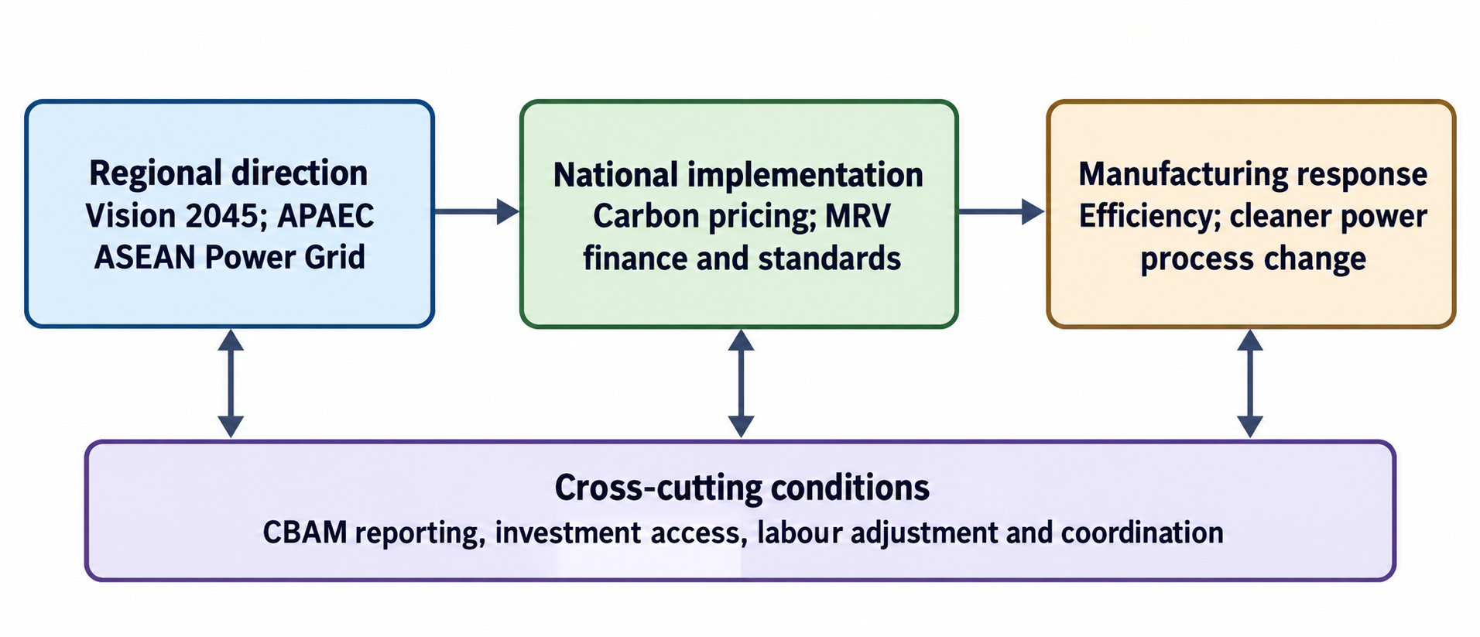
Note. Conceptual synthesis of the policy-mix framework of Rogge and Reichardt (2016), with industrial applications discussed by Bataille (2020). Arrows denote analytical relationships, not measured effects.
Regional policy commitments, national carbon-pricing instruments and trade-related requirements operate at different governance levels, yet their implementation stages and relevance to manufacturing cannot be compared directly without a common analytical framework. This study addresses this analytical gap by distinguishing regulatory status, institutional arrangements and cross-border constraints across six selected economies.
The research question is: How do the documented policy instruments and implementation arrangements of selected ASEAN economies differ in their preparedness to support manufacturing decarbonisation, and what cross-border or industrial constraints remain? The contribution is a temporally explicit comparison of regulatory status, implementation arrangements and policy coherence, rather than an estimated carbon-reduction scenario.

2. Literature and policy context

2.1. Regional ambition and policy coherence
ASEAN 2045: Our Shared Future and the related Community Vision articulate development objectives that include climate resilience, environmental sustainability and economic integration (ASEAN Secretariat, 2025a, 2025b). The ASEAN Plan of Action for Energy Cooperation (APAEC) 2026-2030, endorsed in October 2025, sets aspirational regional goals for 2030: renewable energy shares of 30% in total primary energy supply and 45% in installed power capacity, alongside a 40% reduction in energy intensity relative to 2005 (APAEC Drafting Committee, 2025). These are regional energy-system targets, not national manufacturing emissions caps.
The policy-mix literature distinguishes instrument consistency, policy-process coherence and credibility; the announcement of multiple instruments does not ensure that their requirements reinforce one another (Rogge & Reichardt, 2016). For energy-intensive manufacturers, the relevant interactions include electricity availability, grid access, carbon reporting, financing and competitiveness policies. ASEAN Power Grid discussions on technical and regulatory coordination provide an institutional setting for these interactions (ASEAN Centre for Energy, 2026).

2.2. Carbon pricing and industrial transition
Carbon taxes and emissions trading systems can provide economic signals for abatement, but their industrial implications vary with coverage, price level, allocation rules and enforcement. Complementary measures can be necessary where cleaner production involves high upfront costs or infrastructure constraints (Bataille, 2020). Industrial pathways include energy efficiency, electrification, material substitution, altered production processes and, in selected applications, carbon capture. The feasibility of each option depends on the industrial subsector and country-specific conditions; none provides a universal route across all manufacturing activities.

2.3. Carbon border adjustment and reporting
Border carbon adjustment is intended to address differences in domestic carbon constraints and associated leakage concerns. The effectiveness and distributional consequences of such arrangements depend on product coverage, embedded-emissions measurement, carbon-price recognition and administrative design (Keen et al., 2022; Mehling et al., 2019). Tan et al. (2025) analyse CBAM implications for selected ASEAN economies using a model of trade and renewable-energy investment. Their results concern scenarios and sectoral exposure, not observed adjustments for individual exporters. Under the European Commission's framework, the practical relevance of accurate emissions reporting should be distinguished from a claim that every exported product is subject to identical costs (European Commission, n.d.-a).

2.4. Finance, renewable-energy attributes and distributional considerations
The ASEAN Catalytic Green Finance Facility, an ASEAN Infrastructure Fund initiative managed by the Asian Development Bank, supports the preparation and financing of eligible sovereign or sovereign-guaranteed green infrastructure (Asian Development Bank, n.d.). It can indirectly support the enabling environment for industrial electrification, but is not automatically an enterprise-level manufacturing credit programme. Separately, the ASEAN Centre for Energy (2025) presents technical notes for a conceptual cross-border renewable-energy certificate (REC) framework within the Brunei Darussalam-Indonesia-Malaysia-Philippines East ASEAN Growth Area. This is a framework-development effort rather than evidence that a unified ASEAN REC market is already operational.
The concept of a just transition draws attention to the distribution of costs, benefits and opportunities associated with structural economic change (Newell & Mulvaney, 2013). Industrial adjustment may create labour and place-based risks, although documentary descriptions of decarbonisation policies do not themselves establish the size or direction of employment outcomes in ASEAN.

3. Methodology

3.1. Research design and source selection
The study uses qualitative documentary policy analysis, which treats legislation, official policy descriptions and institutional publications as documents whose authorship, purpose, currency and implementation context must be assessed (Bowen, 2009). The documentary corpus comprises publicly identifiable ASEAN and national policy sources, international agency instrument factsheets, CBAM administrative guidance, project announcements and selected peer-reviewed studies. Material was selected purposively when it described (a) regional policy direction, (b) an instrument relevant to manufacturing or industrial electricity, (c) implementation status in at least one selected economy, or (d) a trade, finance or social constraint affecting policy application. Primary institutional information was preferred for dates and regulatory status; academic articles were used for conceptual or technology-related claims. Newspaper and industry summaries were used only for narrowly attributed information.
The comparative status cut-off is 23 October 2026. Statements describing measures as implemented, pilot, announced or under consideration refer to evidence available by that date. Dynamic online instruments may evolve thereafter. This is not a systematic review of every ASEAN document or a bibliometric synthesis; no probabilistic sampling, emissions inventory or country-level causal estimation was performed.

3.2. Analytical framework and comparison rules
Documents were compared across three dimensions. Policy ambition captures formal goals, planned coverage and declared objectives. Implementation capacity captures effective legal status, administration, market or tax operations, monitoring, reporting and verification (MRV), and electricity or finance infrastructure. Structural constraints capture industrial capital needs, unequal facility capabilities, cross-border compatibility and potential distributional implications. To avoid conflating stages, measures were classified as implemented, pilot framework, announced or under development, and under consideration. An operating trading venue was not taken as evidence that every credit traded constituted compliance under an ETS.
Monetary values were reported in their original currencies rather than converted to United States dollars without a dated exchange rate. Where two figures describe different quantities - such as a project tranche and its total interconnection capacity - their definitions were kept separate. Comparative visualisation was restricted to values directly attributable to cited sources or to transparent qualitative classifications. No cross-country manufacturing emissions totals were estimated because the available documents did not provide an internally comparable country-by-sector inventory.
The classifications reflect the documented legal status, design and implementation arrangements of the respective policy instruments and should not be interpreted as normative assessments of the performance or commitment of individual national governments.

3.3. Interpretation and limitations
The unit of analysis is the publicly documented policy instrument, not the individual firm or an observed emissions outcome. National data quality and update schedules are unequal; announced mechanisms can change before enactment, and operational maturity cannot be inferred from legal status alone. Six purposively selected economies do not represent all ASEAN members. Institutional and industry reports offer important contemporaneous information but have different evidentiary purposes from peer-reviewed empirical studies. These limitations preclude causal claims about actual emissions reductions, labour displacement or aggregate CBAM adjustment costs.

4. Results

4.1. Regional policy instruments and electricity cooperation
Table 1 summarises five regional instruments or initiatives and distinguishes strategic commitments from operational arrangements. Vision 2045 and APAEC provide direction, while the ASEAN Power Grid Enhanced Memorandum of Understanding and LTMS-PIP provide more specific institutional or electricity-trade mechanisms. The REC initiative remains conceptual at the regional framework level (APAEC Drafting Committee, 2025; ASEAN Centre for Energy, 2025, 2026; Electricity Generating Authority of Thailand, 2026).
Table 1. Regional frameworks relevant to manufacturing decarbonisation
Instrument | Scope / status | Manufacturing relevance
ASEAN Community Vision 2045 | Adopted May 2025; strategic regional vision | Sustainability and economic integration objectives (ASEAN Secretariat, 2025b).
APAEC 2026-2030 | Endorsed October 2025; regional energy plan | 2030 RE and energy-intensity goals; just and inclusive transition (APAEC Drafting Committee, 2025).
ASEAN Power Grid Enhanced MoU | Regional framework; task-force coordination in 2026 | Policy, regulatory and technical cooperation for power trade (ASEAN Centre for Energy, 2026).
LTMS-PIP Phase 2 | Energy wheeling agreement, January 2026 | Up to 100 MW Lao PDR-to-Singapore component; project total up to 200 MW (Electricity Generating Authority of Thailand, 2026).
BIMP-EAGA regional REC concept | Technical framework development, May 2025 | Prospective harmonisation of renewable-electricity attributes; not a unified operating market (ASEAN Centre for Energy, 2025).
The distinction between energy traded from Lao PDR and the project-wide capacity of LTMS-PIP 2.0 is made explicit in Figure 2. The 100 MW Lao PDR-to-Singapore component belongs within the up-to-200 MW total after the second-phase agreement and must not be added again to it. These are reported project capacities, not independently measured manufacturing renewable-energy use (Electricity Generating Authority of Thailand, 2026).
Figure 2. Reported LTMS-PIP electricity-trade capacity at successive project stages
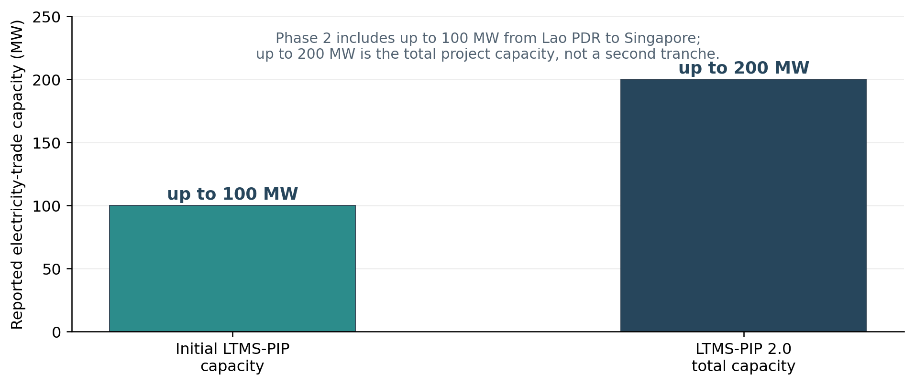
Note. Values are reported upper limits from the Electricity Generating Authority of Thailand (2026). The 100 MW Lao PDR component is included in, not additional to, the up-to-200 MW project total.
A workshop facilitated by the ASEAN Centre for Energy in April 2026 advanced the terms of reference for policy, regulatory and technical ASEAN Power Grid task forces (ASEAN Centre for Energy, 2026). This is evidence of coordination activity; it does not establish that all cross-border access arrangements or regional power-market rules are already harmonised.

4.2. Carbon-pricing status in the six economies
Table 2 shows that the cases differ substantially in instrument type and policy maturity. Singapore's tax applies to covered large-emitting facilities at S$45/tCO2e for 2026-2027 (National Climate Change Secretariat, 2026). Indonesia's emissions trading arrangements cover the power sector, while the reported IDXCarbon exchange turnover concerns transactions in carbon units and must be analysed separately (Muhamad, 2026; World Bank, n.d.). Viet Nam has an established pilot ETS framework with power, steel and cement coverage, but the existence of that framework does not establish an observed market-clearing price (International Carbon Action Partnership, n.d.).
Thailand incorporated a carbon-pricing element, at THB200/tCO2e, into petroleum excise in 2025 rather than imposing the equivalent of Singapore's facility-level industrial tax (Organisation for Economic Co-operation and Development, 2025). Malaysia's carbon tax is described as under development and its ETS as under consideration; the Philippine proposals remain in legislative deliberation, and no enacted national compliance price can be inferred from those proposals (Gass et al., 2026; World Bank, n.d.).
Table 2. Carbon-pricing instruments and readiness in selected ASEAN economies as at 23 October 2026
Economy | Instrument | Policy status | Price / sectoral qualification
Indonesia | Power-sector ETS; IDXCarbon exchange | ETS implemented from 2023; exchange operates separately | ETS power-sector coverage; Jan-Jul 2026 exchange: 165,200 tCO2e, Rp6.88 billion, not ETS allowance turnover (Muhamad, 2026; World Bank, n.d.).
Malaysia | Planned carbon tax; ETS policy | Tax under development; ETS under consideration | Iron, steel and energy named in announcement; no confirmed enacted national rate (World Bank, n.d.).
Philippines | Proposed ETS / hybrid legislative mechanisms | Six carbon-pricing bills considered | No enacted nationwide compliance price demonstrated (Gass et al., 2026).
Singapore | Carbon tax on covered facilities | Implemented since 2019 | S$45/tCO2e in 2026-2027; statutory coverage of large emitters (National Climate Change Secretariat, 2026).
Thailand | Carbon component in petroleum excise; proposed ETS | Fuel-excise mechanism in effect; ETS contemplated | THB200/tCO2e embedded in existing oil excise; not a general industrial ETS price (Organisation for Economic Co-operation and Development, 2025).
Viet Nam | Pilot ETS for power, steel and cement | Pilot framework effective; market operations developing | Allowances in pilot allocated free; no observed market price supplied (International Carbon Action Partnership, n.d.).
Note. Instrument stage is not a measured ranking of emissions outcomes. Currency units are nominal local denominations; carbon exchange activity is not equivalent to ETS compliance transactions.
Two quantitative details merit separate treatment. Singapore's S$45 rate is expressed in Singapore dollars and therefore cannot be written as US$45 without conversion. Indonesia's reported 165,200 tCO2e traded and Rp6.88 billion in turnover for January-July 2026 refer to IDXCarbon market activity, not a national average compliance carbon price (Muhamad, 2026).

4.3. CBAM exposure and manufacturing trade
The EU CBAM concerns specified carbon-intensive products and places particular value on reliable product and facility emissions information. Its definitive regime began in 2026, while certificates corresponding to 2026 imports are purchasable from February 2027 (European Commission, n.d.-a, n.d.-b). The exposure of an ASEAN economy consequently depends on its mix of covered exports to the EU, emissions embodied in those products and the applicable reporting and carbon-pricing rules (Keen et al., 2022; Tan et al., 2025).
Figure 3 presents reported shares of each selected economy's metal-product exports directed to the EU. Viet Nam has the largest share under this particular measure (18.8%), followed by Malaysia (6.6%), Thailand (4.3%), Indonesia (3.6%) and the Philippines (1.2%). The percentages describe one trade-exposure dimension, not carbon intensity, estimated CBAM charges or a comparable burden on every manufacturer (Chirasirisuwan, 2026; Tan et al., 2025).
Figure 3. Metal-product export orientation toward the European Union in five ASEAN economies
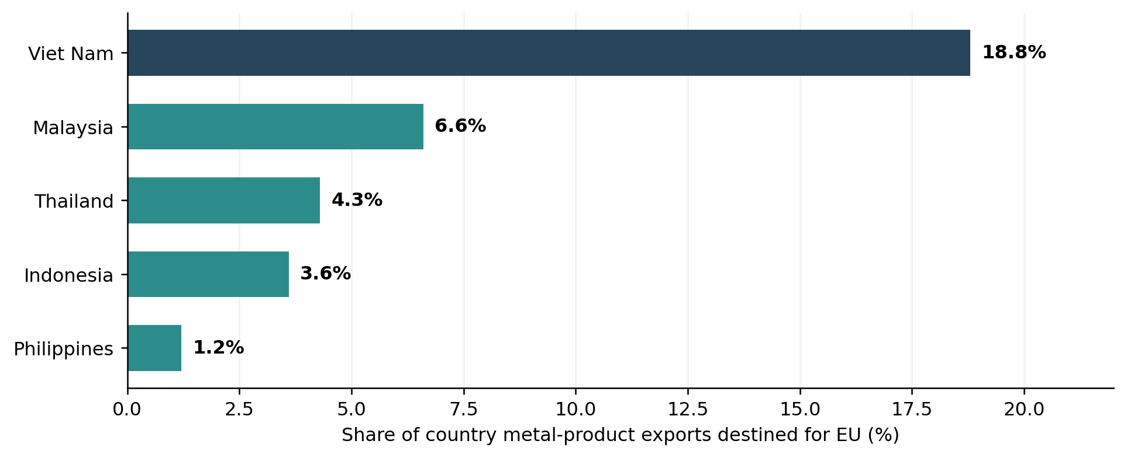
Note. Shares reported by Chirasirisuwan (2026), with context from the sectoral CBAM study of Tan et al. (2025). These values are product-group export shares, not facility emissions or modelled CBAM liabilities.
Tan et al. (2025) examine potential green-investment and trade adjustments under specified model assumptions and note that responses differ by economy and sector. Such scenarios are informative but should not be interpreted as measured 2026 production losses. For steel and other covered products, reliable MRV can improve the credibility of reported embedded emissions, while physical mitigation requires investment in production technologies as well as cleaner energy sources (Bataille, 2020; Ramboll, 2026).

4.4. Sector pathways and sequencing of policy implementation
Policy milestones matter for the feasibility of sectoral investment decisions. Figure 4 contrasts implemented tax or power-sector mechanisms with pilot and proposed frameworks in the six cases. Singapore's tax, Indonesia's power-sector ETS and Thailand's petroleum-excise measure have different points of regulation; Viet Nam's pilot is sector-specific; Malaysian and Philippine proposals remain distinct from enacted compliance instruments (Gass et al., 2026; International Carbon Action Partnership, n.d.; National Climate Change Secretariat, 2026; Organisation for Economic Co-operation and Development, 2025; World Bank, n.d.).
Figure 4. Policy milestones and maturity of selected carbon-pricing arrangements, 2019-2026
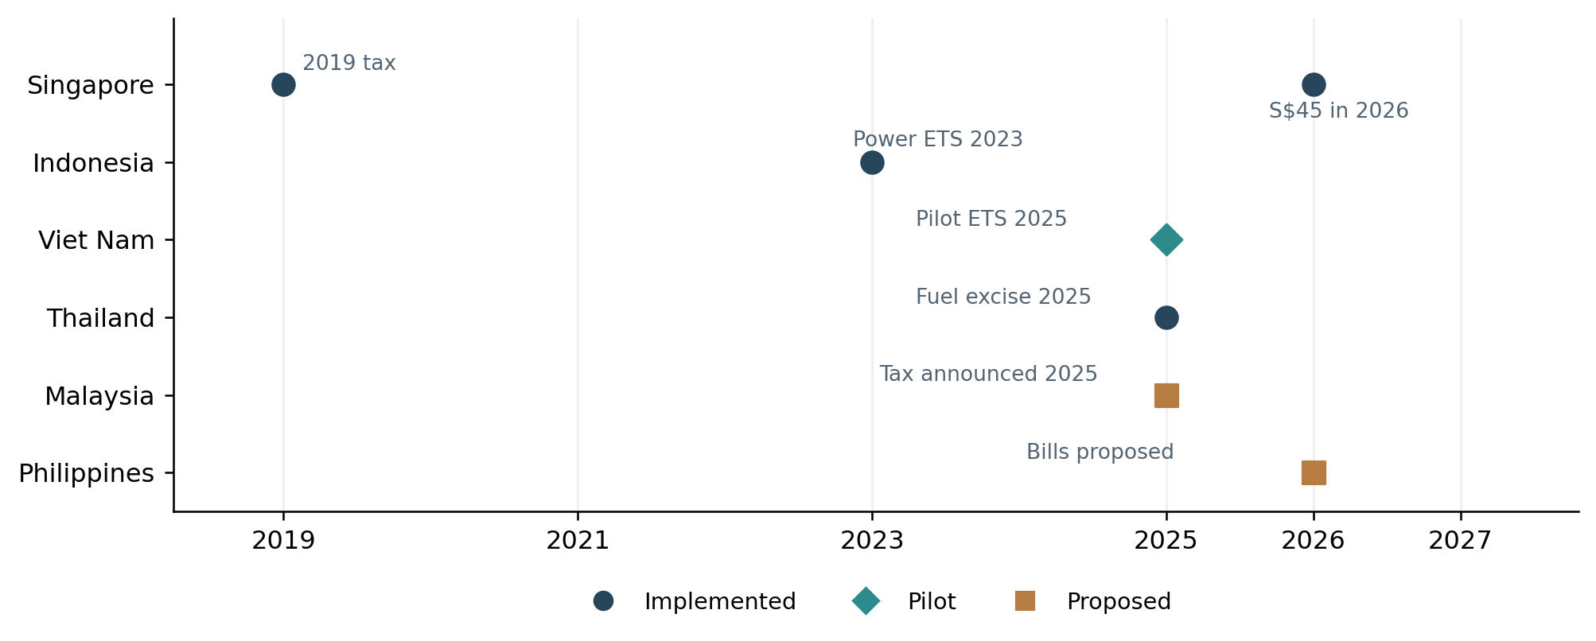
Note. Sources: Gass et al. (2026); International Carbon Action Partnership (n.d.); National Climate Change Secretariat (2026); Organisation for Economic Co-operation and Development (2025); World Bank (n.d.). Proposed milestones do not indicate enactment.
Table 3 sets out technology options and the associated enabling policies across five manufacturing groups. Steel decarbonisation may require replacing or adapting high-emitting routes, while cement involves process emissions beyond purchased power. Nickel processing, electronics and automotive manufacturing each raise distinct electricity, material and supply-chain considerations. These are literature-supported option classes rather than estimates of achievable reductions at individual ASEAN plants (Bataille, 2020; Ramboll, 2026).
Table 3. Indicative industrial pathways and associated policy requirements
Industry | Potential pathway | Main constraint | Relevant policy support
Steel | Direct-reduced iron/electric arc furnaces; scrap-based production; selective carbon capture | Capital turnover, ore quality, power quality and cost | Stable clean electricity, emissions accounting, targeted transition finance (Bataille, 2020; Ramboll, 2026).
Cement | Clinker substitution, thermal efficiency, alternative fuels, carbon capture where viable | Process CO2 emissions and material standards | Standards, demonstration finance and plant-level MRV (Bataille, 2020).
Nickel processing | Process efficiency, energy substitution and lower-emission power | High-temperature processes, energy supply and technology specificity | Technology assessment and verified emissions benchmarks (Bataille, 2020).
Electronics | Energy efficiency and renewable-electricity procurement | Complex purchased-power and supplier reporting | Credible energy-attribute accounting and supplier capacity support (ASEAN Centre for Energy, 2025).
Automotive | Plant electrification and lower-emission materials | Supplier heterogeneity and infrastructure availability | Electricity access, product standards and supply-chain information (Bataille, 2020).
Note. Pathways are conditional technical options, not universal investment prescriptions or measured country-level abatement outcomes.

4.5. Finance and social implementation
The ASEAN Catalytic Green Finance Facility can help develop renewable-energy and other eligible infrastructure for which public-sector project preparation and financing are relevant. Because eligibility is primarily sovereign or sovereign-guaranteed, enterprise-level decarbonisation finance would require additional industrial instruments or intermediary arrangements (Asian Development Bank, n.d.). This division of roles is important when translating infrastructure financing into potential industrial investment capacity.
APAEC explicitly identifies a just and inclusive energy transition as a regional theme (APAEC Drafting Committee, 2025). In manufacturing, possible needs include retraining, worker consultation and support for regions with concentrated energy-intensive plants. These are governance considerations identified in just-transition scholarship and are not observations of displacement caused by the policies evaluated here (Newell & Mulvaney, 2013).

5. Discussion

5.1. Policy alignment and institutional interoperability
The comparison suggests that the principal regional coordination challenge is not the absence of policy statements but differences in instrument scope, enforcement stage and reporting practice. A policy mix can be difficult for firms to interpret when carbon-pricing obligations, electricity procurement arrangements and product-level emissions requirements are established by different institutions (Rogge & Reichardt, 2016). Shared MRV terminology, credible recognition of emissions information and transparent categorisation of market instruments are practical areas for coordination, without presupposing an immediately unified ASEAN carbon market.
The ASEAN Power Grid provides one potential route to improving low-emission electricity access. Nevertheless, an agreement governing cross-border electricity trade does not guarantee that a given manufacturer can procure additional renewable electricity on commercially viable terms. Contracting, grid access, scheduling, environmental-attribute accounting and national regulatory rules must also be considered (ASEAN Centre for Energy, 2025, 2026).

5.2. Trade exposure is not a direct measure of adjustment cost
The five-country metal-export comparison identifies relative dependence on EU markets for a defined product group, while CBAM obligations are tied to covered products and embodied emissions. Consequently, Viet Nam's high export share in Figure 3 cannot alone establish that its producers face the highest carbon-related cost, just as Indonesia's process-related emissions concerns cannot be reduced to its smaller export percentage. Sector composition, production route, emissions verification and any recognised carbon price all matter (Keen et al., 2022; Tan et al., 2025).
Investment responses should therefore be differentiated by industry and by facility-level circumstances. In some settings, electricity efficiency and procurement may be feasible early actions; in process-emission-intensive sectors, fuel, material or production-route changes may be necessary for deeper reductions (Bataille, 2020). Claims of particular savings or payback periods require plant-level engineering and financial evidence that is beyond this documentary assessment.

5.3. Financial and distributional design
Implementation requires capital and institutional capacity as well as formally stated ambition. Sovereign infrastructure finance can remove some enabling barriers, but firms may still require loan guarantees, demonstration support or regulatory certainty appropriate to their circumstances. A policy that shifts industrial costs without parallel access to investment or workforce adjustment measures may create distributional risks; neither their magnitude nor the eventual direction of labour-market effects can be established from the policy documents alone (Asian Development Bank, n.d.; Newell & Mulvaney, 2013).

5.4. Study boundaries
The comparison documents policy architecture rather than verifying country-specific manufacturing emissions inventories. It deliberately avoids aggregate sector totals for which a harmonised time series, scope definition and source-level calculations were not available. Evidence from six economies should not be generalised to all 11 ASEAN member states, and statutory dates do not reliably indicate the actual pace of firm-level compliance. Further research would benefit from facility-level emissions data, consistent industrial classifications and longitudinal analysis of investment and employment outcomes.

6. Conclusion
The ASEAN Community Vision 2045 and APAEC 2026-2030 establish a regional framework within which industrial decarbonisation can be pursued. The six-country comparison shows meaningful variation in carbon-pricing design and implementation maturity: a facility-based tax in Singapore, a power-sector ETS and separate carbon exchange in Indonesia, a pilot ETS framework in Viet Nam, fuel-excise carbon pricing in Thailand, and still-developing national proposals in Malaysia and the Philippines. These differences matter for manufacturers because the associated coverage, reporting obligations and economic signals are not interchangeable.
Three policy priorities follow from the documentary evidence. First, ASEAN cooperation could concentrate on credible and interoperable MRV definitions and clear identification of each instrument's legal status before considering more ambitious market integration. Second, industrial strategies could connect low-emission electricity and infrastructure investment with subsector-specific technological needs and appropriately designed enterprise finance. Third, policy evaluation should include labour-market and distributional indicators alongside measured emissions and competitiveness outcomes. Regional coordination can support these objectives, but its effectiveness will require empirical assessment rather than inference from policy announcements alone.

References
APAEC Drafting Committee. (2025). ASEAN plan of action for energy cooperation (APAEC) 2026–2030. ASEAN Centre for Energy. https://aebf.aseanenergy.org/publications/asean-plan-of-action-for-energy-cooperation-apaec-2026-2030
ASEAN Centre for Energy. (2025). Technical notes of conceptual regional REC framework for BIMP-EAGA countries. https://aebf.aseanenergy.org/publications/technical-notes-of-conceptual-regional-rec-framework-for-bimp-eaga-countries
ASEAN Centre for Energy. (2026, May 4). ACE facilitates APG enhanced MOU operationalisation through workshop with APG task forces. https://aebf.aseanenergy.org/articles/ace-facilitates-apg-enhanced-mou-operationalisation-through-workshop-with-apg-task-forces
ASEAN Secretariat. (2025a). ASEAN 2045: Our shared future. https://asean.org/book/asean-2045-our-shared-future/
ASEAN Secretariat. (2025b, May 26). ASEAN Community Vision 2045: Resilient, innovative, dynamic, and people-centred ASEAN. https://asean.org/asean-community-vision-2045-resilient-innovative-dynamic-and-people-centred-asean/
ASEAN Secretariat. (2025c, October 26). Forging a new era: Timor-Leste admitted into ASEAN. https://asean.org/forging-a-new-era-timor-leste-admitted-into-asean/
Asian Development Bank. (n.d.). Overview: ASEAN Catalytic Green Finance Facility (ACGF). https://www.adb.org/what-we-do/funds/asean-catalytic-green-finance-facility/overview
Bataille, C. G. F. (2020). Physical and policy pathways to net-zero emissions industry. WIREs Climate Change, 11(2), Article e633. https://doi.org/10.1002/wcc.633
Bowen, G. A. (2009). Document analysis as a qualitative research method. Qualitative Research Journal, 9(2), 27–40. https://doi.org/10.3316/QRJ0902027
Chirasirisuwan, P. (2026, September 1). Non-tariff measures: Impacts and challenges on ASEAN. Krungsri Research.
Electricity Generating Authority of Thailand. (2026, January 14). EDL, EGAT, and TNB advance ASEAN Power Grid through energy wheeling agreement Phase 2 under LTMS-PIP 2.0. https://www.egat.co.th/home/en/20260114e/
European Commission. (n.d.-a). CBAM definitive regime. https://taxation-customs.ec.europa.eu/carbon-border-adjustment-mechanism/cbam-definitive-regime_en
European Commission. (n.d.-b). Price of CBAM certificates. https://taxation-customs.ec.europa.eu/carbon-border-adjustment-mechanism/price-cbam-certificates_en
Gass, P., Cordon-Navarro, F. J., Manley, D., Duong, M., Dünnenberger, S., Munda, J. L., & Adrian, G. (2026, June 29). Carbon pricing in the Philippines: Legislative pathways for effective, efficient, and just climate action. International Institute for Sustainable Development. https://www.iisd.org/publications/report/carbon-pricing-philippines
International Carbon Action Partnership. (n.d.). Vietnam. https://icapcarbonaction.com/en/ets/vietnam
Keen, M., Parry, I., & Roaf, J. (2022). Border carbon adjustments: Rationale, design and impact. Fiscal Studies, 43(3), 209–234. https://doi.org/10.1111/1475-5890.12307
Mehling, M. A., van Asselt, H., Das, K., Droege, S., & Verkuijl, C. (2019). Designing border carbon adjustments for enhanced climate action. American Journal of International Law, 113(3), 433–481. https://doi.org/10.1017/ajil.2019.22
Muhamad, N. (2026, September 8). Transaksi bursa karbon Indonesia tembus Rp6,8 miliar hingga Juli 2026. Databoks.
National Climate Change Secretariat. (2026, July 9). Carbon tax. https://www.nccs.gov.sg/singapores-climate-action/mitigation-efforts/carbontax/
Newell, P., & Mulvaney, D. (2013). The political economy of the ‘just transition’. The Geographical Journal, 179(2), 132–140. https://doi.org/10.1111/geoj.12008
Organisation for Economic Co-operation and Development. (2025). OECD economic surveys: Thailand 2025. OECD Publishing. https://doi.org/10.1787/426b9bc0-en
Ramboll. (2026, June 3). ASEAN steel at a crossroads: Carbon, trade and the reality of CBAM.
Rogge, K. S., & Reichardt, K. (2016). Policy mixes for sustainability transitions: An extended concept and framework for analysis. Research Policy, 45(8), 1620–1635. https://doi.org/10.1016/j.respol.2016.04.004
Tan, A., Foo, S. Y., Zhai, F., & Khut, V. (2025). Navigating carbon regulations and green investment in BRI partner countries in ASEAN (Working Paper No. WP/25-04). ASEAN+3 Macroeconomic Research Office. https://www.amro-asia.org/navigating-carbon-regulations-and-green-investment-in-bri-partner-countries-in-asean
World Bank. (n.d.). Carbon pricing dashboard. Retrieved October 23, 2026, from https://carbonpricingdashboard.worldbank.org/

