Teacher Training Policies and the Social Inclusion of Deaf Pupils in Basic Education in Burkina Faso: A Sociological Analysis

Abstract
Aims: To examine how teacher training policies shape the social inclusion of deaf pupils in basic education in Burkina Faso, and to propose an analytical framework that can guide empirical research.
Study design: Conceptual and documentary analysis grounded in the sociology of disability, the theory of stigma, and the study of Deaf communities as linguistic and cultural minorities.
Place and Duration of Study: Burkina Faso (conceptual study). The training centre CEFISE-BENAJA, Ouagadougou, is proposed as the site of the empirical follow-up; no field data are reported here.
Methodology: The framework was built by synthesising the relevant literature and by reading the international and national policy texts on inclusive education. No data were collected from human participants.
Results: The analysis argues that the inclusion of deaf pupils depends less on their formal admission to school than on the conditions in which teachers are prepared to communicate with, teach, and assess them. It yields a three-level framework (policy, institutions, and classroom interaction) and four mechanisms through which training policies may reproduce or reduce exclusion: the communication gap, the deficit framing of deafness, the absence of Deaf adults, and the implementation gap. These mechanisms are formulated as hypotheses to be tested empirically.
Conclusion: Teacher training for inclusive education should include explicit training in sign language and accessible communication, integrate social and cultural perspectives on deafness, involve Deaf professionals, and be linked to deployment, supervision, and resource provision. The case of CEFISE-BENAJA is the next step for empirical investigation.
Keywords: deafness; inclusive education; teacher training; education policy; stigma; Burkina Faso

1. Introduction
Since the Salamanca Statement (UNESCO, 1994) and the adoption of the Convention on the Rights of Persons with Disabilities (United Nations, 2006), inclusive education has become a dominant reference in national education policies, including in sub-Saharan Africa. Yet the formal recognition of the right to education does not, by itself, guarantee that learners with disabilities participate and succeed in ordinary schools. For deaf pupils, the gap between legal principle and lived school experience is especially visible, because schooling is organised around spoken language, and access to the curriculum depends on communication.
This article adopts a sociological perspective on a question that is often treated as technical: How do teacher training policies shape the social inclusion of deaf pupils in basic education? Teachers are the point at which education policy becomes face-to-face interaction. What they know, believe, and are able to do in the classroom determines whether a deaf pupil is a full member of the class or a physically present but socially marginal one (Avramidis & Norwich, 2002). Training policies therefore deserve to be analysed not only as administrative instruments but as social mechanisms that distribute opportunities and, sometimes, reproduce exclusion.
The article has three aims: (a) to build a conceptual framework drawing on the sociology of disability and the study of Deaf communities; (b) to situate teacher training for the inclusion of deaf pupils within the international and national policy context of Burkina Faso; and (c) to propose an analytical model that can guide empirical research, notably a case study of the training centre CEFISE-BENAJA in Ouagadougou.

1.1 Disability as a social construction and the problem of stigma
The social model of disability holds that disadvantage arises not from impairment alone but from the way social arrangements fail to accommodate it (Oliver, 1990). Applied to deafness, this implies that the barrier is not the absence of hearing but the absence of accessible communication in schools. Goffman's (1963) concept of stigma complements this view: persons perceived as departing from a norm risk being reduced, in the eyes of others, to a discredited attribute. In classrooms, stigma may take the form of lowered expectations, assumptions about cognitive ability, or the treatment of deaf pupils as a problem to be managed.

1.2 Deaf people as a linguistic and cultural minority
A second tradition frames deaf people not primarily through loss but as members of linguistic and cultural communities organised around sign languages. The distinction between audiological deafness and Deaf identity, introduced in sociolinguistic research (Woodward, 1972), and the later work on Deaf culture (Padden & Humphries, 2005) and on "Deafhood" (Ladd, 2003) invite educators to see sign language as a legitimate language of instruction and Deaf adults as holders of expertise. These two traditions are in tension, since one stresses removing barriers within mainstream settings and the other values distinct community spaces and language, but both converge on the importance of communication access and of respect for deaf pupils' identity.

1.3 Inclusive education and teacher preparation
Research on inclusive systems suggests that change depends on a set of levers: policies, school cultures, leadership, resources, and, centrally, the capacity of teachers (Ainscow, 2005). Teacher attitudes toward inclusion are influenced by the training, support, and resources they receive (Avramidis & Norwich, 2002). For deaf pupils, a general "introduction to inclusion" is insufficient: teachers also need specific competences in communication, assessment adaptation, and collaboration with specialised professionals.

1.4 Policy context
Burkina Faso is committed to inclusive education through international instruments, notably the Convention on the Rights of Persons with Disabilities, and through its national legal framework for education, including the education orientation law (Burkina Faso, 2007). These texts affirm the right of children with disabilities to education and favour their integration into the education system. However, a normative commitment must be translated into operational provisions: training curricula, the recruitment and deployment of teachers, specialised resources, and monitoring mechanisms. It is at this level of translation that sociological analysis is most useful, because it can show how institutional arrangements, professional routines, and resource constraints transform an inclusive principle into an everyday practice, which may be more or less inclusive than the principle intended.
In Ouagadougou, the CEFISE-BENAJA is the site proposed for an in-depth case study of teacher training for the education of deaf pupils. As an institutional case, it offers an opportunity to examine how training policy is interpreted and enacted by trainers, trainees, and administrators.

2. Material and Methods / Methodology

2.1 Study design
This is a conceptual and documentary study. It does not report primary data; it develops an analytical framework and a set of hypotheses intended to guide later empirical work.

2.2 Sources and analytical approach
The framework was built by synthesising three bodies of literature: the sociology of disability and the theory of stigma, Deaf studies, and research on inclusive education and teacher preparation. This synthesis was combined with a reading of the international and national policy texts that frame inclusive education in Burkina Faso (UNESCO, 1994; United Nations, 2006; Burkina Faso, 2007). The combined reading was used to identify the levels of analysis and the mechanisms through which teacher training policy may affect the inclusion of deaf pupils.

2.3 Case site and ethical considerations
The training centre CEFISE-BENAJA in Ouagadougou is proposed as the site for the empirical follow-up; the present article reports no data from it. Because the study is based on documentary and conceptual analysis and involved no data collection with human participants, no ethical approval or consent procedure was required.

3. Results and Discussion
Because the study is conceptual, its results are the analytical framework and the four mechanisms that this framework generates. They are presented below and discussed in the light of the literature.

3.1 An analytical framework: three levels of analysis
We propose to analyse the relationship between training policy and the inclusion of deaf pupils at three interdependent levels. The macro level concerns the policy texts and the discourse that frames deafness. The meso level concerns the institutions that deliver training and the schools that receive trained teachers. The micro level concerns interactions in the classroom. Fig. 1 presents the three levels, and Table 1 summarises the framework and its possible indicators.
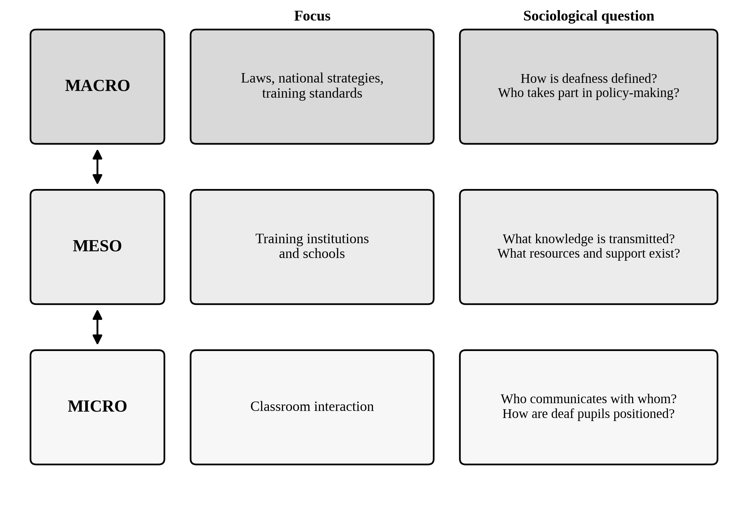
Fig. 1. Three levels of analysis of teacher training policy and the inclusion of deaf pupils.
Double-headed arrows indicate that the three levels are interdependent.
Table 1. Analytical framework for studying training policy and the inclusion of deaf pupils
Level | Focus | Sociological question | Possible indicatorsª
Macro | Laws, national strategies, training standards | How is deafness defined (deficit, difference, disability)? Who participates in policy-making? | Content of policy texts; presence of sign language and Deaf representation in policy
Meso | Training institutions and schools | What knowledge is transmitted and legitimised? What resources and support exist? | Curriculum content; trainer profiles; hours of practical training; follow-up in schools
Micro | Classroom interaction | Who communicates with whom, and how? How are deaf pupils positioned among peers? | Communication modes; participation; adapted assessment; peer relations
The framework is the author's own proposal; the indicators are possible examples and are not exhaustive.

3.2 How training policies may reproduce or reduce exclusion
Drawing on the framework, we identify four mechanisms through which training policies may affect the inclusion of deaf pupils. These should be treated as hypotheses to be tested empirically. Fig. 2 shows how the mechanisms link training policy to inclusion, and Table 2 summarises each mechanism together with the training-policy response it implies.
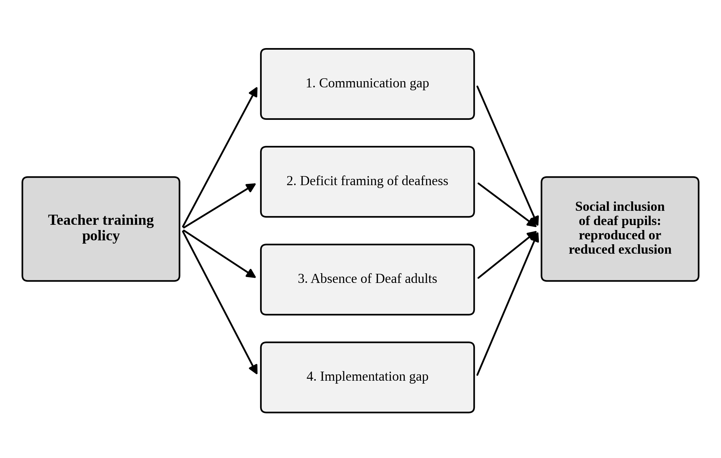
Fig. 2. Four mechanisms linking teacher training policy to the social inclusion of deaf pupils.
The four mechanisms are hypotheses to be tested empirically, not established findings.

3.2.1 The communication gap
If training does not give teachers a working knowledge of sign language or of other accessible communication strategies, the deaf pupil remains dependent on lip-reading, residual hearing, or peers, which severely limits participation. Training that mentions deafness without building communication competence risks producing declarative inclusion without practical access.

3.2.2 The deficit framing of deafness
Training content centred on pathology, rehabilitation, and "handicap" may reinforce the stigma described by Goffman (1963) and lead teachers to hold lower expectations. Content that also presents deaf people as a linguistic and cultural community (Padden & Humphries, 2005) can encourage a more positive professional stance.

3.2.3 The absence of Deaf adults
When Deaf adults are not involved as trainers, mentors, or classroom partners, trainees lose access to role models and to first-hand knowledge of Deaf experience. Their absence also reproduces, at the institutional level, the marginal position of deaf people in decision-making.

3.2.4 The implementation gap
Even well-designed training may have limited effect if trained teachers are not assigned to classes with deaf pupils, if class sizes are large, or if there is no pedagogical support. Training policy must therefore be evaluated together with deployment and support policies.
Table 2. Mechanisms through which training policy may reproduce or reduce exclusion
Mechanism | How it may operate | Training-policy response impliedª
Communication gap | Without working knowledge of sign language or other accessible strategies, pupils depend on lip-reading, residual hearing, or peers; inclusion remains declarative. | Explicit and sufficient training in sign language and accessible communication
Deficit framing of deafness | Content centred on pathology, rehabilitation, and "handicap" may reinforce stigma and lower teachers' expectations. | Integration of social and cultural perspectives that present deaf people as a linguistic and cultural community
Absence of Deaf adults | Trainees lack role models and first-hand knowledge of Deaf experience; the marginal position of deaf people in decision-making is reproduced. | Involvement of Deaf professionals as trainers, mentors, or classroom partners
Implementation gap | Training has limited effect if trained teachers are not assigned to classes with deaf pupils, if classes are large, or if pedagogical support is lacking. | Links between training and deployment, supervision, and resource provision
The mechanisms are hypotheses to be tested empirically.

3.3 Implications for policy and research
For policy, the analysis suggests that teacher training for inclusive education should (a) include explicit and sufficient training in sign language and accessible communication; (b) integrate the social and cultural perspectives on deafness; (c) involve Deaf professionals; and (d) be linked to deployment, supervision, and resource provision. For research, the framework calls for studies that combine document analysis, interviews with trainers, trainees, and administrators, classroom observation, and, where possible, the perspectives of deaf pupils and their families. Fig. 3 and Table 3 outline the corresponding design for the proposed case study. Data collection should itself be accessible, using sign language interpretation and visual materials, so that deaf participants are not merely objects of study.
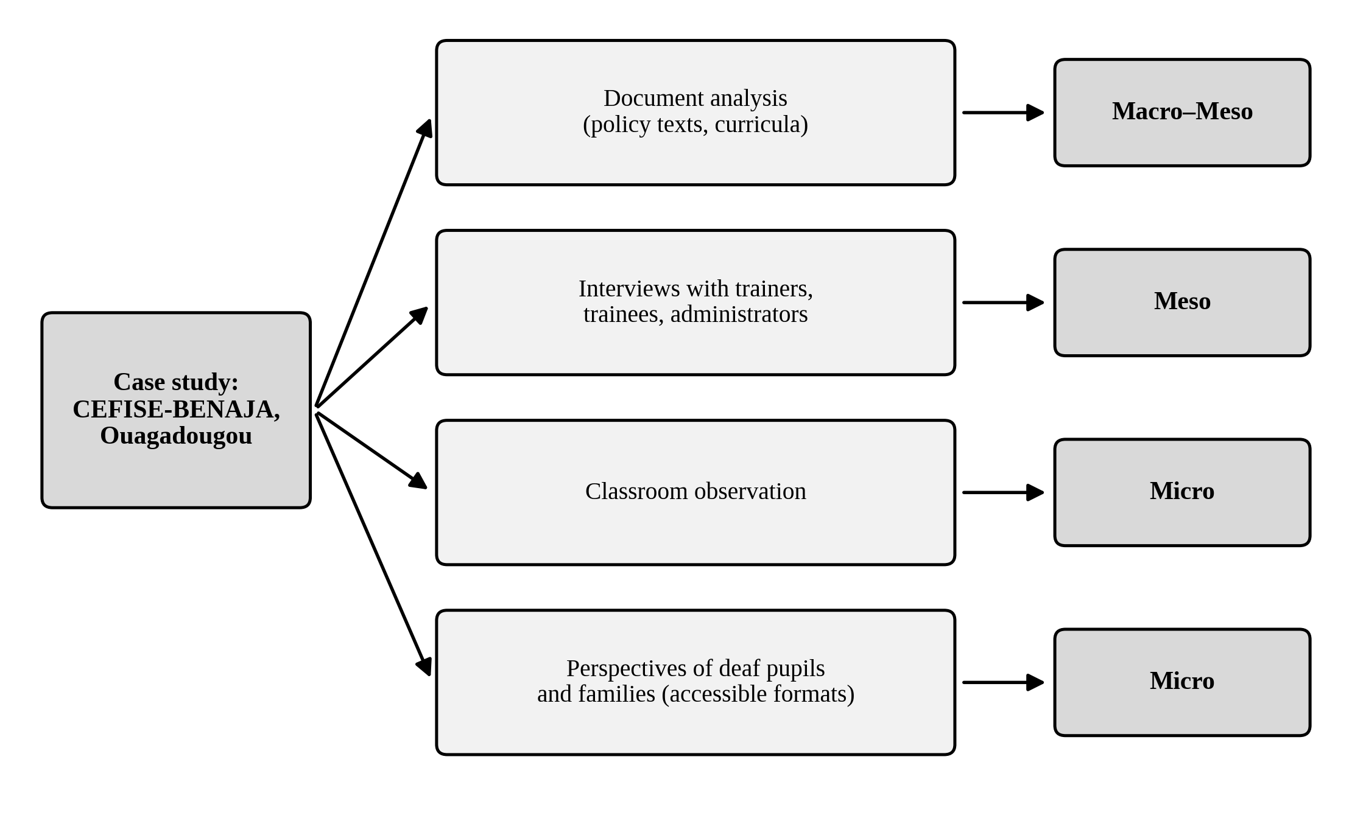
Fig. 3. Proposed research design for the CEFISE-BENAJA case study.
Data collection should use sign language interpretation and visual materials.
Table 3. Proposed data sources for the case study and the levels they address
Data source | Level | Possible focusª
Document analysis (policy texts, curricula) | Macro-Meso | Definition of deafness; place of sign language and Deaf representation; curriculum content
Interviews with trainers, trainees, and administrators | Meso | Knowledge transmitted and legitimised; trainer profiles; resources and support; follow-up in schools
Classroom observation | Micro | Communication modes; participation; adapted assessment; peer relations
Perspectives of deaf pupils and their families | Micro | Positioning among peers; experience of communication and participation
Data collection should be accessible, using sign language interpretation and visual materials.

4. Conclusion
The inclusion of deaf pupils in basic education is a social process that is produced in, and through, the training and deployment of teachers. By distinguishing macro, meso, and micro levels, this article offers a framework for examining how training policy can either reduce or reproduce exclusion. Its application to the case of CEFISE-BENAJA in Ouagadougou is the next step, and may contribute to a better understanding of inclusive education for deaf learners in West African contexts.

Competing Interests
The author declares that no competing interests exist.

Consent
This article is based on documentary and conceptual analysis and involved no human participants.

Ethical Approval
The study involved no data collection with human participants.

Declaration of AI Use

This manuscript was prepared through the intellectual contributions of the author(s) to the study design, data analysis, interpretation of results, and scholarly content. Grammarly and ChatGPT were used solely to assist with grammatical refinement and reference formatting during manuscript revision. The author(s) accept full responsibility for the accuracy, integrity, and final content of the manuscript.

References
1. UNESCO. (1994). The Salamanca statement and framework for action on special needs education. Paris: UNESCO.
2. United Nations. (2006). Convention on the rights of persons with disabilities. New York: United Nations.
3. Avramidis, E., & Norwich, B. (2002). Teachers' attitudes towards integration/inclusion: A review of the literature. European Journal of Special Needs Education, 17(2), 129-147. https://doi.org/10.1080/08856250210129056
4. Oliver, M. (1990). The politics of disablement. London: Macmillan.
5. Goffman, E. (1963). Stigma: Notes on the management of spoiled identity. Englewood Cliffs, NJ: Prentice-Hall.
6. Woodward, J. (1972). Implications for sociolinguistic research among the Deaf. Sign Language Studies, 1(1), 1-7.
7. Padden, C., & Humphries, T. (2005). Inside Deaf culture. Cambridge, MA: Harvard University Press.
8. Ladd, P. (2003). Understanding Deaf culture: In search of Deafhood. Clevedon: Multilingual Matters.
9. Ainscow, M. (2005). Developing inclusive education systems: What are the levers for change? Journal of Educational Change, 6(2), 109-124. https://doi.org/10.1007/s10833-005-1298-4
10. Burkina Faso. (2007). Loi n° 013-2007/AN portant loi d'orientation de l'éducation [Law no. 013-2007/AN on the orientation of education]. Ouagadougou: Assemblée nationale.

