Case report

Autoimmune hemolytic anemia as the revealing manifestation of common variable immunodeficiency: A Case report

Abstract:
Introduction: Common variable immunodeficiency (CVID) is the most common primary immunodeficiency and is characterized by impaired immunoglobulin production, particularly reduced IgG levels. Although recurrent infections are the main clinical manifestation, autoimmune disorders are also frequently reported and may occasionally be the first indication of the disease. Autoimmune hemolytic anemia (AIHA) is among the most important autoimmune complications and may sometimes precede the diagnosis of CVID.
Case Report: We report the case of a 42-year-old woman with insulin-treated diabetes mellitus, severe rheumatic mitral regurgitation, atrial fibrillation, and AIHA diagnosed in 2018. The initial episodes were successfully controlled with high-dose corticosteroids and azathioprine. Seven years later, she developed severe, poorly tolerated anemia that became refractory to high-dose corticosteroid therapy. Extensive investigations excluded connective tissue disease, thrombotic microangiopathy, hematological malignancy, hemoglobinopathy, thyroid dysfunction, and several infectious causes. Serum protein electrophoresis demonstrated profound and persistent hypogammaglobulinemia, associated with marked B-cell lymphopenia and reduced levels of IgG, IgA, and IgM. A history of recurrent severe infections, including recurrent tonsillitis complicated by rheumatic fever, necrotizing fasciitis, and herpes zoster, further supported the diagnosis of CVID. Azathioprine was discontinued, corticosteroids were gradually tapered, and antibiotic prophylaxis was initiated. Immunoglobulin replacement therapy was considered.
Discussion: The association between CVID and AIHA highlights the complex interplay between immunodeficiency and autoimmunity. Impaired B-cell tolerance, defective regulatory T-cell function, an imbalance between regulatory and follicular helper T cells, and abnormalities within the splenic microenvironment may contribute to the persistence of autoreactive B cells and pathogenic autoantibody production. Chronic inflammatory pathways may further sustain this immune dysregulation.
Conclusion: AIHA may be an initial or revealing manifestation of CVID. In patients with autoimmune cytopenia, particularly when associated with recurrent severe infections or unexplained hypogammaglobulinemia, underlying immunodeficiency should be considered. Early recognition of this association is important for appropriate management of both the autoimmune complication and the underlying immune disorder.
Keywords:
Common variable immunodeficiency; autoimmune hemolytic anemia; hypogammaglobulinemia; autoimmune cytopenia; immune dysregulation; B-cell tolerance; immunoglobulin replacement therapy.

Introduction:
Common variable immunodeficiency (CVID) is a primary immunodeficiency characterized by impaired immunoglobulin production. It is the most frequent primary immunodeficiency and mainly affects humoral immunity. Biologically, it is marked by severe hypogammaglobulinemia with reduced IgG levels, associated with decreased IgA and, more rarely, IgM. Clinically, this leads to recurrent infections (respiratory and gastrointestinal), often associated with autoimmune disorders, which may sometimes represent the initial manifestation of the disease. Among these, autoimmune cytopenias, particularly autoimmune hemolytic anemia (AIHA), occupy a prominent place.
The occurrence of AIHA as the inaugural manifestation of CVID illustrates the complexity of the interactions between immunodeficiency and autoimmune dysregulation. This atypical presentation may delay the diagnosis of CVID and expose patients to potentially severe complications in the absence of appropriate management. Early recognition of this association is therefore essential to guide immunological investigations and initiate appropriate treatment.

Case Presentation:
A 42-year-old woman with diabetes mellitus on insulin therapy, with good glycemic control, was followed for severe mitral regurgitation secondary to rheumatic fever and atrial fibrillation. She had been followed since 2018 for autoimmune hemolytic anemia, evidenced by clinical and biological signs of hemolysis associated with a positive direct Coombs test. Initial disease flares responded well to high-dose systemic corticosteroid therapy combined with azathioprine, with satisfactory clinical and biological improvement.
Seven years later, the patient presented with severe, poorly tolerated anemia that became corticosteroid-resistant despite high doses, with no clinical or biological evidence of active bleeding. Extensive etiological investigations ruled out connective tissue disease (negative antinuclear and anti–double-stranded DNA antibodies), thrombotic microangiopathy (absence of schistocytes), hematologic malignancy (no blasts on blood smear and no tumor infiltration on bone marrow biopsy), as well as hemoglobinopathy or thyroid dysfunction. Infectious workup was negative (HIV, HCV, syphilis serologies and Quantiferon test). No tumor syndrome was identified.
Serum protein electrophoresis revealed profound hypogammaglobulinemia, confirmed on four occasions, with levels ranging from 1.4 to 4 g/L, associated with marked B-cell lymphopenia (CD19 count of 3 cells/mm³) and a concomitant decrease in all three immunoglobulin classes (IgG, IgA, and IgM). Genetic testing was not performed. From an infectious standpoint, the patient reported a history of recurrent and severe infections, including recurrent tonsillitis complicated by rheumatic fever, erysipelas complicated by necrotizing fasciitis, and an episode of intercostal herpes zoster.
After discontinuation of azathioprine and gradual tapering of corticosteroids, the overall clinical, biological, and immunological findings supported the diagnosis of common variable immunodeficiency. Antibiotic prophylaxis was initiated, and the patient was considered a candidate for immunoglobulin replacement therapy.
Discussion:
The association between autoimmune hemolytic anemia and common variable immunodeficiency paradigmatically illustrates the immunodysregulatory nature of CVID, long considered merely a state of hypogammaglobulinemia. Despite quantitative and qualitative defects in immunoglobulin production, patients with CVID frequently develop autoimmune manifestations, particularly autoimmune cytopenias such as AIHA, immune thrombocytopenic purpura, and Evans syndrome. This paradoxical coexistence suggests that AIHA in CVID results primarily from a failure of immune tolerance rather than nonspecific immune hyperactivity.
B-cell abnormalities play a central role in the pathophysiology of this association. Several studies have shown that CVID patients with autoimmune cytopenias exhibit defective negative selection of autoreactive B cells in the bone marrow, as well as impaired peripheral tolerance mechanisms. These defects promote the persistence of autoreactive B-cell clones capable of producing autoantibodies directed against erythrocyte antigens. Such cells exhibit a lower activation threshold and resistance to apoptosis, contributing to the production of pathogenic autoantibodies despite global hypogammaglobulinemia.
T lymphocytes also play a critical role in this immune dysregulation. Several studies have demonstrated a quantitative and functional deficiency of regulatory T cells (Tregs) in CVID patients with autoimmune manifestations. This deficiency is associated with an imbalance favoring follicular helper T cells (Tfh), which produce interleukin-21 and promote excessive, uncontrolled stimulation of autoreactive B cells. This disruption of the Treg/Tfh balance contributes to the loss of peripheral tolerance and sustained autoantibody production responsible for AIHA.
The splenic microenvironment represents another key element in the pathophysiology. In CVID patients with AIHA, splenomegaly and lymphoid hyperplasia are common, reflecting disorganization of secondary lymphoid structures. The spleen becomes both a major site of autoantibody production and the principal effector organ for the destruction of opsonized red blood cells. Enhanced activation of splenic macrophages, with overexpression of Fcγ receptors, amplifies hemolysis and contributes to the often chronic or refractory nature of AIHA in this context.
A chronic low-grade inflammatory state, characteristic of CVID complicated by autoimmunity, also contributes to this pathophysiology. Persistent elevation of pro-inflammatory cytokines such as TNF-α, IFN-γ, and particularly BAFF (B-cell activating factor) promotes the survival of autoreactive B cells and limits their physiological elimination. Elevated BAFF levels have been correlated with the occurrence and severity of autoimmune cytopenias in CVID patients, suggesting a direct role of this pathway in AIHA pathogenesis.
Finally, recent genetic data have identified, in some patients with a CVID phenotype associated with AIHA, molecular abnormalities affecting key genes involved in immune regulation, such as TNFRSF13B (TACI), ICOS, LRBA, or CTLA-4. These findings support the hypothesis that AIHA associated with CVID belongs to a continuum of immunodysregulation syndromes rather than being a simple secondary complication.
Conclusion:
Autoimmune hemolytic anemia in the setting of CVID results from a complex interaction between intrinsic B-cell abnormalities, defects in T-cell regulation, a pathological splenic microenvironment, and chronic inflammatory context. This pathophysiological understanding supports a therapeutic approach targeting not only the autoimmune cytopenia itself but also the underlying immune dysregulation, favoring immunomodulatory strategies such as intravenous immunoglobulins and rituximab, while avoiding splenectomy whenever possible.
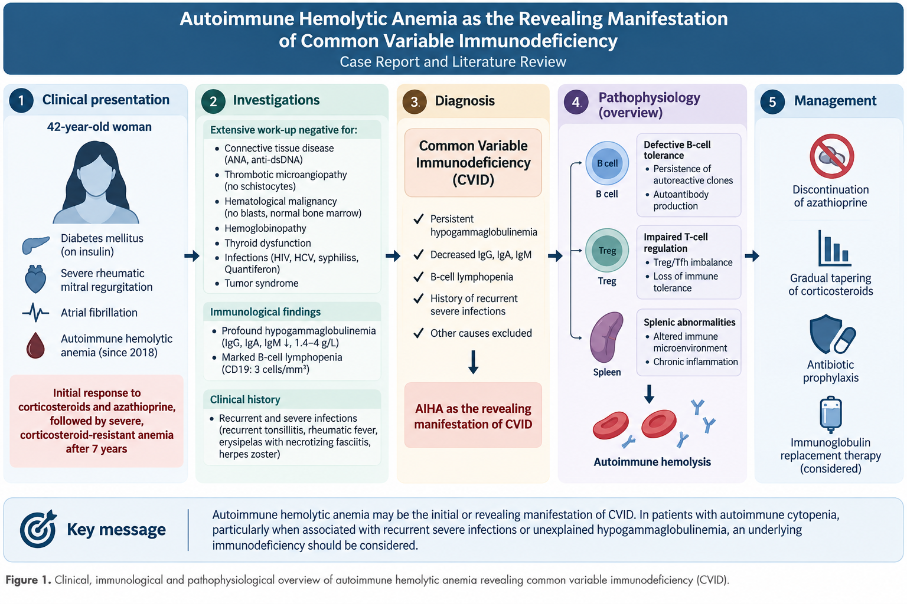
Conflit of interest:
The author declares no conflit of interest. The manuscript has not been submitted for publication in other journal.
Ethics approval:
Not applicable
Ethical concern and informed consent:
Patient confidentiality has been fully maintained, no identifying information is exposed, and written informed consent was obtained from the patient

Declaration of AI Use

This manuscript was prepared through the intellectual contributions of the author(s) to the study design, data analysis, interpretation of results, and scholarly content. Grammarly and ChatGPT were used solely to assist with grammatical refinement and reference formatting during manuscript revision. The author(s) accept full responsibility for the accuracy, integrity, and final content of the manuscript.

References:
- Pescador Ruschel MA, Penney SW. Common Variable Immunodeficiency. StatPearls Publishing; 2025.
- Chambéry E, Kolopp-Sarda MN, Malcus C. Common variable immunodeficiencies: definition, physiopathology and biological diagnosis. Revue Francophone des Laboratoires. 2023;549:38–46.
- Quinti I, Cinetto F, Milito C. Common Variable Immunodeficiency (CVID) in the Third Age. Front Immunol. 2020;11:1147.
- Richardson CT et al. Failure of B Cell Tolerance in CVID. Front Immunol. 2019;10:2881.
- Sève P, Broussolle C, Pavic M. Primary immunodeficiencies and autoimmune cytopenias. La Revue de Médecine Interne. 2013;34(3):148–153.
- Cunningham-Rundles C. Autoimmune manifestations in common variable immune deficiency. J Clin Immunol. 2008;28 Suppl 1:S42–S50.

