Decarbonization in the ASEAN Manufacturing Sector Post-Vision 2025: A Policy Analysis

Abstract
The adoption of the ASEAN Community Vision 2045 in May 2025 marks a critical juncture for regional decarbonization efforts, positioning environmental sustainability as a cross-cutting priority alongside economic integration. This paper examines the policy landscape for decarbonizing the manufacturing sector across ASEAN member states in the post-Vision 2045 era, addressing a central research question: What is the state of policy readiness for manufacturing decarbonization across ASEAN, and what structural barriers constrain effective implementation? Through a qualitative policy analysis combining document review and comparative assessment, the study examines regional frameworks, national carbon pricing instruments, and external trade pressures, including the European Union's Carbon Border Adjustment Mechanism (CBAM). The findings reveal a fragmented policy architecture characterized by divergent national timelines—Singapore's carbon tax rising to USD 45 per tonne in 2026, Indonesia's emissions trading system operational but with limited transaction volumes, Malaysia's carbon tax pending implementation, and the Philippines still in legislative development stages. Regional initiatives such as the ASEAN Power Grid and Renewable Energy Certificate frameworks demonstrate promise, yet implementation remains constrained by sovereignty concerns, infrastructural gaps, and uneven institutional capacity. The analysis identifies three priorities for policy development: strengthening regional coordination architecture for carbon pricing and monitoring, reporting, and verification (MRV) systems; deploying green finance at scale to de-risk industrial decarbonization investments; and operationalizing just transition principles specifically for industrial policy. The paper concludes that effective decarbonization of ASEAN manufacturing requires not merely policy proliferation but policy coherence—aligning carbon pricing, green finance, technology transfer, and just transition mechanisms into a unified regional strategy. Without such coherence, Vision 2045's sustainability aspirations risk remaining aspirational, and ASEAN manufacturers face escalating adjustment costs as global trade increasingly penalizes carbon-intensive production.

Keywords: ASEAN Community Vision 2045, manufacturing decarbonization, carbon pricing, CBAM, just transition, green finance, MRV systems, regional policy coordination, Southeast Asia, industrial policy
1. Introduction
The ASEAN Community Vision 2045, formally adopted at the 46th ASEAN Summit in Kuala Lumpur in May 2025, establishes an ambitious strategic framework that positions the region as a developed economy and the fourth largest in the world by 2045 (ASEAN Secretariat, 2025a). This vision explicitly integrates environmental sustainability and climate change as cross-cutting priorities, recognizing that economic growth must be decoupled from environmental degradation (ASEAN Secretariat, 2025a). For the manufacturing sector—which accounts for a substantial share of ASEAN's GDP, employment, and greenhouse gas emissions—this creates both a mandate and a challenge: how to decarbonize industrial production while sustaining competitiveness and inclusive growth.
The decarbonization imperative is not solely a regional aspiration. External pressures, particularly the European Union's Carbon Border Adjustment Mechanism (CBAM), are reshaping the calculus for ASEAN manufacturers (AMRO, 2025). CBAM's full implementation phase began in 2026, creating immediate compliance costs for exporters of carbon-intensive goods such as steel, aluminium, and cement (Ramboll, 2026). For ASEAN economies with high export exposure to the EU—particularly Vietnam, Indonesia, and Malaysia—the adjustment burden is substantial (AMRO, 2025). Simultaneously, multinational corporations and financial institutions are imposing supply chain decarbonization requirements that cascade through ASEAN's industrial base (Ramboll, 2026).
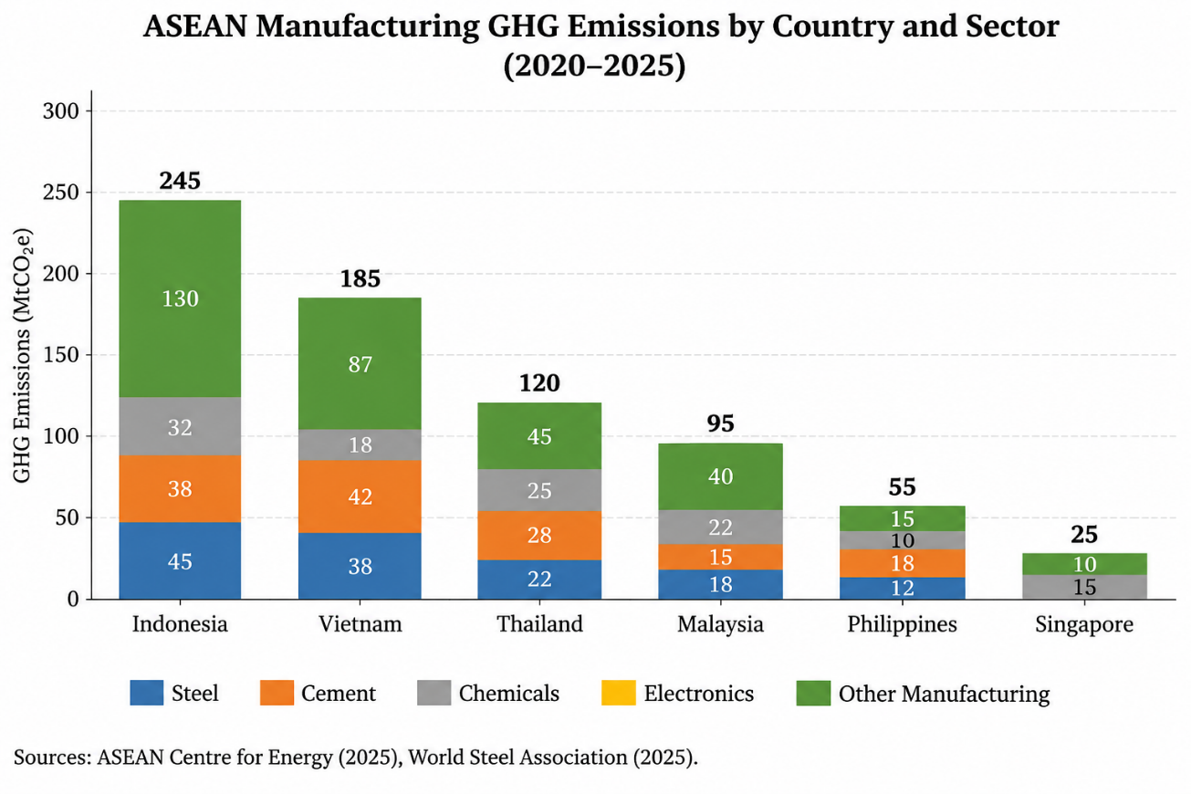
Figure 1: ASEAN Manufacturing GHG Emissions by Country and Sector (2020-2025)
The policy responses to these pressures have been diverse and, in many respects, fragmented. Indonesia has launched an emissions trading system for coal-fired power plants and is developing mechanisms for industrial sectors (Databoks, 2026). Malaysia has announced carbon tax plans targeting energy and steel sectors by 2026 (Kementerian Sumber Asli dan Kelestarian Alam, 2025). Singapore has maintained a carbon tax since 2019, with rates rising to $45 per tonne of CO2 equivalent for 2026 and beyond (Singapore Statutes Online, 2026). Vietnam has articulated net-zero commitments but faces implementation challenges. The Philippines remains in early stages of carbon pricing development, with six proposed bills under consideration (IISD, 2026).
This paper addresses a central research question: What is the state of policy readiness for manufacturing decarbonization across ASEAN in the post-Vision 2045 era, and what structural barriers constrain effective implementation? The analysis proceeds through a systematic review of regional frameworks, national policy instruments, and external drivers, culminating in a comparative assessment and policy recommendations.
2. Literature Review
2.1 Regional Policy Architecture
The ASEAN Community Vision 2045 represents the latest iteration of regional integration efforts, building upon the Vision 2025 framework while deepening commitments to sustainability and climate action. The vision's economic pillar envisions "a single and future-ready economy, anchored on sustainable growth and good governance, empowered by advanced technologies" (ASEAN Secretariat, 2025a). Climate change, environmental degradation, biodiversity loss, and transition to a green economy are explicitly identified among the megatrends requiring effective and innovative responses (ASEAN Secretariat, 2025b).
The ASEAN Plan of Action for Energy Cooperation (APAEC) 2026-2030, endorsed at the 43rd ASEAN Ministers on Energy Meeting in October 2025, embeds "just and inclusive energy transition" as a core regional theme, marking the first explicit integration of social equity dimensions into the energy planning framework (ASEAN Centre for Energy, 2025). The APAEC sets ambitious collective targets: achieving 30% share of renewable energy in total primary energy supply, 45% share of renewable energy in installed power capacity, and 40% reduction in energy intensity compared to 2005 baseline by 2030 (ASEAN Centre for Energy, 2025). These targets directly implicate the manufacturing sector, given its significant energy consumption.
The ASEAN Power Grid (APG) initiative represents the most concrete regional infrastructure project supporting manufacturing decarbonization (ASEAN Centre for Energy, 2026b). The Enhanced Memorandum of Understanding on the APG, endorsed at the 43rd AMEM, provides a foundational framework for advancing multilateral power trade in Southeast Asia (ASEAN Centre for Energy, 2026b). The Lao PDR-Thailand-Malaysia-Singapore Power Integration Project (LTMS-PIP) Phase 2, with its Energy Wheeling Agreement signed in January 2026, demonstrates operational progress toward cross-border electricity trading, enabling renewable energy supply of up to 100 MW from Lao PDR to Singapore (EGAT, 2026).

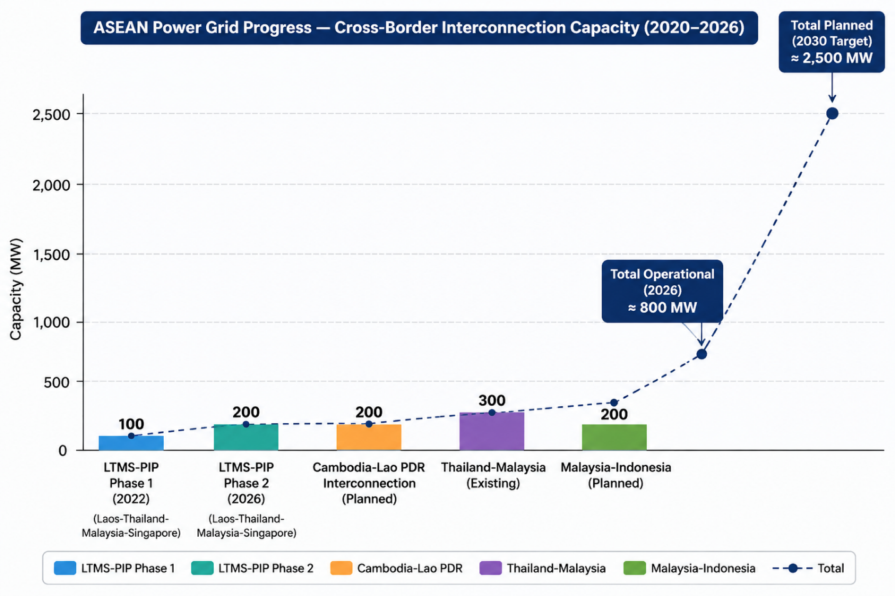
Figure 2: ASEAN Power Grid Progress — Cross-Border Interconnection Capacity (2020-2026).
2.2 National Carbon Pricing Instruments
Carbon pricing has emerged as a central policy tool across ASEAN, though with significant variation in design and ambition. Indonesia's Emissions Trading System, initially covering coal-fired power plants, represents the region's most advanced cap-and-trade mechanism (Databoks, 2026). The Indonesia Carbon Exchange (IDX Carbon) was launched in September 2023, and by July 2026 had traded 165.2 thousand tonnes of CO2 equivalent with a total transaction value of Rp 6.88 billion (Databoks, 2026). However, the Financial Services Authority (OJK) has acknowledged that transaction volumes remain small compared to European and Chinese markets, attributing this to the absence of a carbon tax, emissions quota provisions, and lack of integration between primary and secondary markets (detikFinance, 2026).
Malaysia's carbon pricing framework is expected to commence in 2026, with a carbon tax targeting the iron, steel, and energy industries announced in Budget 2026 (Kementerian Sumber Asli dan Kelestarian Alam, 2025). The proposed National Climate Change Bill establishes the legal foundation for a mandatory Monitoring, Reporting, and Verification (MRV) system and a national carbon registry (World Bank, 2026). The 13th Malaysia Plan (2026-2030) has outlined the implementation of an Emissions Trading Scheme as a mechanism to facilitate carbon trading and strengthen the green economy (Kementerian Sumber Asli dan Kelestarian Alam, 2025).
The Philippines is developing a mixed emissions trading and carbon pricing system, with six proposed carbon pricing bills currently before the House of Representatives (IISD, 2026). The proposed frameworks include hybrid schemes where enterprises exceeding emissions allowances can comply through investing in their own decarbonization, supporting external projects, paying into a fund, or trading allowances (IISD, 2026). However, implementation timelines remain uncertain, and institutional capacity for MRV systems is less developed than in Indonesia or Malaysia.
Singapore's carbon tax, established under the Carbon Pricing Act 2018, has risen from $5 per tonne in 2023 to $25 per tonne for 2024-2025, and $45 per tonne for 2026 and beyond (Singapore Statutes Online, 2026). This represents the most ambitious carbon pricing trajectory in the region.
2.3 External Trade Pressures
The EU CBAM functions as a powerful external driver of ASEAN carbon policy. Research by AMRO (2025) indicates that Vietnam has the highest dependence on metal exports to the EU among major ASEAN economies, at 18.8% of total exports in the affected product group, followed by Malaysia (6.6%), Thailand (4.3%), Indonesia (3.6%), and the Philippines (1.2%). However, when adjustment costs are considered—reflecting the carbon intensity of production processes—Indonesia emerges as the most affected economy due to its carbon-intensive upstream smelting activities (AMRO, 2025).
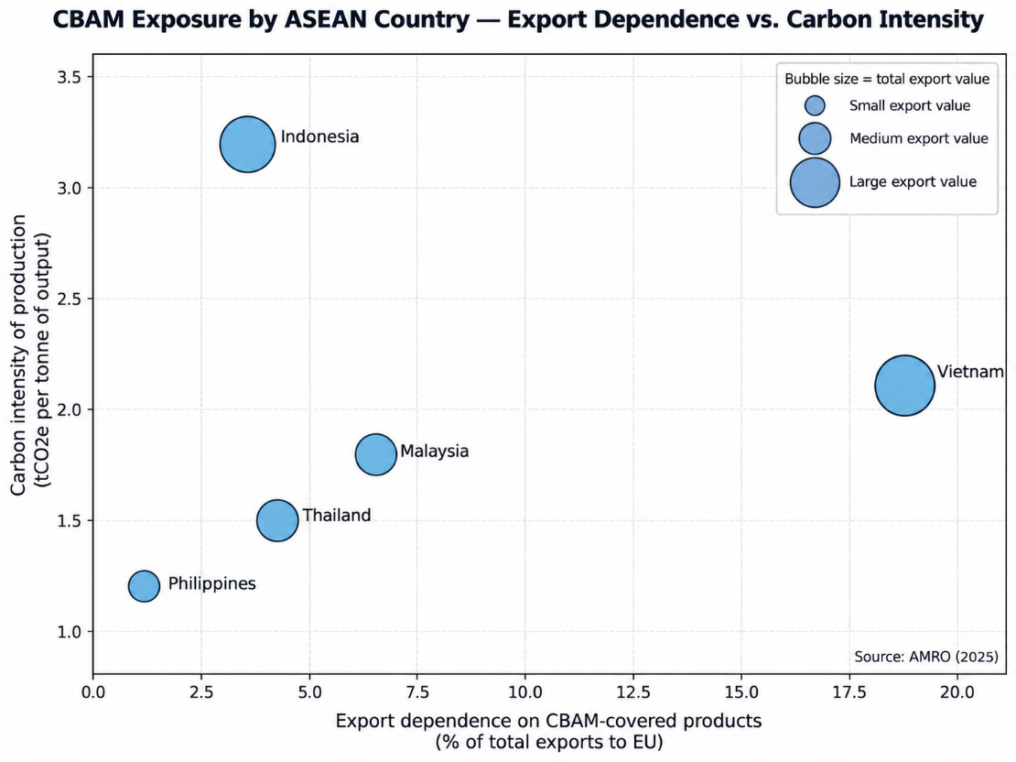
Figure 3: CBAM Exposure by ASEAN Country — Export Dependence vs. Carbon Intensity.
The steel sector exemplifies the CBAM challenge. ASEAN's steel industry has grown predominantly through blast furnace-basic oxygen furnace (BF-BOF) technology, which remains the most carbon-intensive production route (Ramboll, 2026). As CBAM enters full implementation, ASEAN producers face structurally higher emissions compared to low-carbon benchmarks, translating directly into additional costs when exporting to the EU (Ramboll, 2026). The absence of robust MRV systems and limited domestic carbon pricing means many producers risk defaulting to conservative emissions assumptions, which can significantly inflate their CBAM liabilities (Ramboll, 2026).
Modelling of green investment impacts suggests that even substantial increases in renewable generation capacity would reduce carbon content of BRI partner country exports by less than 1% for most ASEAN economies, except the Philippines and Cambodia (AMRO, 2025). This finding indicates that CBAM exposure cannot be resolved through clean electricity supply alone; industrial process transformation is essential.
2.4 Green Finance and Investment Mechanisms
The ASEAN energy sector has seen the emergence of several financing mechanisms relevant to manufacturing decarbonization. The ASEAN Catalytic Green Finance Facility provides loans and in-kind contributions for renewable energy and energy efficiency projects across all member states (ASEAN Centre for Energy, 2025). The ASEAN Power Grid Financing Initiative, supported by the Asian Development Bank and World Bank, targets cross-border electricity interconnection projects (ASEAN Centre for Energy, 2026b). Renewable Energy Certificates have been established as a regional instrument, with the BIMP-EAGA subregion serving as a pilot area (ASEAN Centre for Energy, 2025).
However, the scale of green finance deployment remains inadequate relative to investment needs. The AMRO (2025) study emphasizes that ASEAN policymakers are increasingly focused on scaling up green finance through measures such as public guarantees for climate-related loans, public-private partnerships for emerging technology projects, and promoting green credit policies. Regional cooperation, including the establishment of a unified carbon trading platform, is identified as essential for enhancing ASEAN's ability to meet its climate commitments while driving investment in sustainable infrastructure (AMRO, 2025).
3. Methodology
3.1 Research Design
This study employs a qualitative policy analysis approach combining document review and comparative assessment. The methodology is designed to capture both the formal policy architecture and the implementation dynamics that shape decarbonization outcomes across ASEAN's diverse political economies.
3.2 Data Sources
The analysis draws upon three categories of sources:
Primary regional documents: The ASEAN Community Vision 2045 and associated strategic plans (ASEAN Secretariat, 2025a, 2025b), the ASEAN Plan of Action for Energy Cooperation 2026-2030 (ASEAN Centre for Energy, 2025), and ASEAN Power Grid-related agreements and progress reports (ASEAN Centre for Energy, 2026a, 2026b).
National policy documents: Indonesia's ETS regulations and carbon exchange data (Databoks, 2026; detikFinance, 2026), Malaysia's carbon tax and ETS framework (Kementerian Sumber Asli dan Kelestarian Alam, 2025; World Bank, 2026), Singapore's Carbon Pricing Act (Singapore Statutes Online, 2026), and the Philippines' proposed carbon pricing legislation (IISD, 2026).
Analytical and research reports: AMRO's assessment of CBAM exposure (AMRO, 2025), industry analyses of steel sector decarbonization challenges (Ramboll, 2026), and policy analyses from international organizations (World Bank, 2026).
3.3 Analytical Framework
The analysis is structured around three dimensions derived from the policy literature on decarbonization governance:
Policy ambition: The formal targets, commitments, and strategic objectives articulated in regional and national frameworks. This dimension assesses whether policy signals are sufficiently clear and credible to guide investment decisions.
Implementation capacity: The institutional, financial, and technical resources available for translating policy ambition into measurable emissions reductions. This includes MRV systems, carbon market infrastructure, and green finance mechanisms.
Structural constraints: The political, economic, and social factors that inhibit policy effectiveness, including sovereignty concerns, path dependencies in fossil fuel infrastructure, and distributional tensions between decarbonization imperatives and industrial competitiveness.
3.4 Limitations
This study is limited by the absence of comprehensive, comparable emissions data for ASEAN manufacturing sectors and by the rapid evolution of policy landscapes. The analysis reflects the state of policy development as of late 2026 and should be understood as a snapshot of a dynamic process rather than a definitive assessment.
4. Results
4.1 Regional Policy Landscape
The ASEAN Community Vision 2045 establishes decarbonization as a cross-cutting imperative integrated across the political-security, economic, and socio-cultural pillars (ASEAN Secretariat, 2025a). The vision emphasizes ASEAN's role as "a major player in the global economy and the fourth largest economy in the world," anchored on "sustainable growth and good governance" (ASEAN Secretariat, 2025a). This framing positions decarbonization not as a constraint on growth but as integral to achieving the region's economic aspirations.
The ASEAN Power Grid initiative represents the most concrete regional infrastructure project supporting manufacturing decarbonization (ASEAN Centre for Energy, 2026b). The Enhanced MOU on the APG, operationalized through workshops in April 2026, has established three task forces—Policy, Regulatory, and Technical—to address barriers to multilateral power trade (ASEAN Centre for Energy, 2026b). The LTMS-PIP Phase 2, signed in January 2026, demonstrates operational progress, enabling renewable energy supply of up to 100 MW from Lao PDR to Singapore through Thailand and Malaysia (EGAT, 2026).
Table 1: Regional Policy Instruments for Manufacturing Decarbonization
Instrument | Coverage | Status | Relevance to Manufacturing
ASEAN Community Vision 2045 | All member states | Adopted May 2025 | Strategic framework; integrates climate across pillars (ASEAN Secretariat, 2025a)
APAEC 2026-2030 | Energy sector | Endorsed October 2025 | 30% RE in TPES; just transition principles (ASEAN Centre for Energy, 2025)
ASEAN Power Grid Enhanced MOU | Cross-border electricity | Operationalized 2026 | Multilateral power trade framework (ASEAN Centre for Energy, 2026b)
LTMS-PIP Phase 2 | Lao PDR-Thailand-Malaysia-Singapore | Signed January 2026 | 200 MW cross-border renewable energy trade (EGAT, 2026)
ASEAN REC Framework | Renewable certificates | Pilot phase (BIMP-EAGA) | Enables verified renewable electricity claims (ASEAN Centre for Energy, 2025)
4.2 National Carbon Pricing Readiness
Carbon pricing instruments exhibit significant variation across ASEAN member states in terms of design, coverage, and implementation stage. Indonesia has progressed furthest in developing an operational ETS, though transaction volumes remain limited relative to global peers (Databoks, 2026). The OJK has identified the absence of a carbon tax, emissions quota provisions, and lack of integration between primary and secondary markets as key factors constraining market development (detikFinance, 2026).
Malaysia's carbon tax framework, targeting iron, steel, and energy industries from 2026, represents a significant step toward industrial carbon pricing (Kementerian Sumber Asli dan Kelestarian Alam, 2025). The World Bank's Partnership for Market Implementation is supporting Malaysia's development of policy and market design frameworks, national registry development, and alignment with international standards (World Bank, 2026).
The Philippines' proposed carbon pricing legislation includes hybrid schemes that blend elements of carbon taxes and emissions trading (IISD, 2026). The International Institute for Sustainable Development has identified several areas where legislative refinement could strengthen the proposed frameworks, including narrowing initial sector coverage to high-emitting industries and ensuring transparent revenue use (IISD, 2026).

Table 2: Carbon Pricing Readiness Assessment by Country
Country | Instrument | Sectoral Coverage | Rate/Mechanism | Implementation Status
Indonesia | ETS (IDX Carbon) | Power; expansion planned | Market-determined | Operational since 2023; Rp 6.88 billion traded Jan-Jul 2026 (Databoks, 2026)
Malaysia | Carbon tax + ETS | Iron, steel, energy (initial) | RM15/tCO2e (proposed) | Legislation pending; 2026 target (Kementerian Sumber Asli dan Kelestarian Alam, 2025)
Philippines | Mixed ETS/carbon pricing | Under design | ~USD 20 (PHP 1,170) | Six bills under consideration (IISD, 2026)
Singapore | Carbon tax | Economy-wide | $45/tCO2e (2026) | Operational since 2019 (Singapore Statutes Online, 2026)
Vietnam | No operational carbon price | N/A | N/A | Policy development stage
Thailand | No operational carbon price | N/A | N/A | Policy development stage
4.3 Decarbonization Pathways by Industry
The steel sector, as a CBAM-covered industry and significant emissions source, exemplifies the complexity of industrial decarbonization in ASEAN. The region's steel industry has grown predominantly through BF-BOF technology, which remains the most carbon-intensive route (Ramboll, 2026). A significant share of new capacity under development continues to follow this pathway, raising the risk of long-term "carbon lock-in" for assets expected to operate well into mid-century (Ramboll, 2026).
The absence of robust MRV systems and limited domestic carbon pricing means many producers risk defaulting to conservative emissions assumptions, which can significantly inflate their CBAM liabilities (Ramboll, 2026). For exporters, the issue is no longer just cost competitiveness; it is the ability to credibly measure, verify, and disclose emissions under an increasingly stringent regulatory framework (Ramboll, 2026).
Nickel processing, strategically important for Indonesia's industrial policy and global battery supply chains, faces distinct challenges. Lateritic nickel processing generates high carbon dioxide emissions, and decarbonization requires both process innovation and clean energy supply. Indonesia has identified carbon trading as a potential incentive mechanism, but the sector's inclusion in the ETS remains pending.
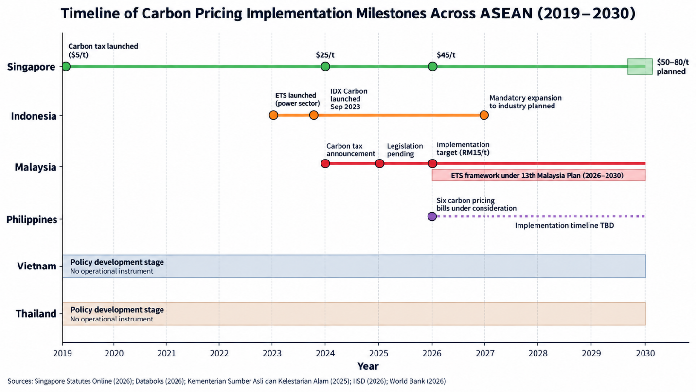
Figure 4: Timeline of Carbon Pricing Implementation Milestones Across ASEAN (2019-2030).
Table 3: Decarbonization Pathways and Constraints by Industry
Industry | Primary Technology Pathway | Key Constraint | Policy Support Required
Steel | DRI-EAF conversion; CCUS for BF-BOF | High capital cost; carbon lock-in risk (Ramboll, 2026) | Carbon contracts; green finance; MRV systems
Nickel processing | Process electrification; renewable power | Emissions intensity; energy access | ETS inclusion; carbon trading incentives
Electronics | Renewable electricity procurement; energy efficiency | Supply chain scope 3 accounting | REC framework; MRV harmonization
Automotive | Electrification; lightweight materials | Supplier capability; charging infrastructure | Demand-side incentives; industrial policy alignment
Cement | Alternative fuels; clinker substitution | Process emissions; limited alternatives | CCUS deployment; standards development
4.4 External Trade Pressures and Adjustment Costs
The CBAM adjustment burden varies significantly across ASEAN economies. Vietnam's high dependence on metal exports to the EU creates substantial exposure, though its intermediate and finished product focus moderates adjustment costs relative to Indonesia's upstream smelting activities (AMRO, 2025). Malaysia's steel industry, while significant, benefits from ongoing policy efforts toward carbon-neutral production.
Modelling of green investment impacts suggests that even substantial increases in renewable generation capacity would reduce carbon content of BRI partner country exports by less than 1% for most ASEAN economies, except the Philippines and Cambodia (AMRO, 2025). This finding indicates that CBAM exposure cannot be resolved through clean electricity supply alone; industrial process transformation is essential.
The AMRO (2025) study emphasizes that the presence of carbon barriers like CBAM can either act as a catalyst for green investment or pose a threat to the competitiveness of sectors that fail to decarbonize rapidly. For ASEAN, the challenge is to ensure that external pressure drives rather than constrains the transition to sustainable industrial practices.
5. Discussion
5.1 The Coherence Gap in Regional Policy
The analysis reveals a fundamental tension in ASEAN's decarbonization governance: while regional frameworks articulate ambitious visions and identify priority areas, the translation of these commitments into binding, coordinated policy instruments remains incomplete. The ASEAN Community Vision 2045 provides strategic direction but lacks enforcement mechanisms (ASEAN Secretariat, 2025a). The APAEC 2026-2030 embeds just transition principles but focuses primarily on the energy sector rather than industrial decarbonization writ large (ASEAN Centre for Energy, 2025).
The ASEAN Power Grid exemplifies both the promise and the limitations of regional cooperation. Cross-border electricity interconnection could significantly enhance the availability of clean power for manufacturing, yet progress has been deliberate and incremental (ASEAN Centre for Energy, 2026b). The operationalization of the Enhanced MOU through task forces represents meaningful institutional development, but the region remains characterized by "unidirectional power trading arrangements" with movement toward multilateral trade requiring dedicated regulatory and technical frameworks (ASEAN Centre for Energy, 2026b).
5.2 National Divergence and Regional Coordination
The comparative analysis of carbon pricing readiness reveals significant divergence across member states. Singapore has the most ambitious carbon tax trajectory, rising to $45 per tonne in 2026 (Singapore Statutes Online, 2026). Indonesia has the most developed ETS infrastructure but limited transaction volumes (detikFinance, 2026). Malaysia is on the cusp of implementing carbon pricing for industrial sectors (Kementerian Sumber Asli dan Kelestarian Alam, 2025). The Philippines remains in legislative development stages (IISD, 2026).
This divergence creates challenges for regional coordination, as manufacturers operating across multiple jurisdictions face inconsistent carbon price signals and compliance requirements. The absence of a unified regional carbon market, despite recommendations from policy analysts, reflects both the political sensitivity of ceding fiscal authority and the practical difficulties of harmonizing MRV systems across diverse institutional contexts (AMRO, 2025).
5.3 The Just Transition Imperative
The integration of just and inclusive energy transition principles into APAEC 2026-2030 represents a significant conceptual advance (ASEAN Centre for Energy, 2025). The theme "Advancing Regional Cooperation in Ensuring Energy Security and Accelerating Decarbonisation for a Just and Inclusive Energy Transition" signals recognition that decarbonization must address distributional concerns (Philippine Information Agency, 2026).
However, operationalization remains nascent. For the manufacturing sector specifically, decarbonization poses distributional challenges. Energy-intensive industries facing carbon costs may reduce employment or relocate production, with disproportionate impacts on regions dependent on these industries. The absence of clear just transition frameworks for industrial policy—as distinct from energy sector policy—represents a significant gap.
5.4 External Pressure as Catalyst and Constraint
CBAM and similar external measures function paradoxically: they accelerate the introduction of carbon pricing and MRV systems, yet also create competitive pressures that may constrain the fiscal space for green investment (AMRO, 2025). The finding that green investment alone would produce minimal reductions in export carbon content underscores the need for integrated industrial policy that addresses process emissions, not merely electricity supply (AMRO, 2025).
The strategic response to CBAM should not be defensive adaptation but proactive transformation. ASEAN's critical mineral resources, growing solar photovoltaic and electric vehicle manufacturing capacity, and potential for green hydrogen production position the region to capture value in decarbonized global supply chains (AMRO, 2025). Realizing this potential requires industrial policies that align decarbonization with competitiveness, rather than treating them as trade-offs.

6. Conclusion
The post-Vision 2045 policy landscape for ASEAN manufacturing decarbonization is characterized by ambition without adequate implementation mechanisms, and fragmentation without effective coordination. Regional frameworks articulate the right objectives but lack the institutional teeth to drive convergence. National carbon pricing instruments are emerging but remain limited in coverage and ambition. External pressures from CBAM and corporate supply chain requirements are catalyzing policy development but also creating adjustment burdens that require careful management.
Three priorities emerge for policy development:
First, strengthen the regional coordination architecture for carbon pricing and MRV. The divergence in national systems creates inefficiencies and undermines the credibility of ASEAN's decarbonization commitment. A phased approach to harmonization—beginning with mutual recognition of MRV standards and progressing toward linked carbon markets—could build confidence while respecting national sovereignty.
Second, deploy green finance at scale. The gap between investment needs and available capital is substantial. Public guarantees, blended finance structures, and targeted credit facilities are necessary to de-risk industrial decarbonization investments, particularly for small and medium-sized enterprises that dominate ASEAN's manufacturing base (AMRO, 2025).
Third, operationalize just transition principles for industrial policy. The energy sector's just transition framework provides a foundation, but manufacturing-specific challenges—including employment displacement, regional economic diversification, and skills transformation—require dedicated policy attention.
The decarbonization of ASEAN manufacturing is not merely an environmental imperative. It is a competitiveness strategy, a condition for continued access to premium export markets, and a foundation for the region's ambition to be a global industrial hub in an era of climate-constrained trade. The policy choices made in the next five years will determine whether Vision 2045's sustainability aspirations are realized or remain aspirational.

Declaration of AI Use

This manuscript was prepared through the intellectual contributions of the author(s) to the study design, data analysis, interpretation of results, and scholarly content. Grammarly and ChatGPT were used solely to assist with grammatical refinement and reference formatting during manuscript revision. The author(s) accept full responsibility for the accuracy, integrity, and final content of the manuscript.

7. References
AMRO. (2025). Navigating carbon regulations and green investment in BRI partner countries in ASEAN (Working Paper WP/25-04). ASEAN+3 Macroeconomic Research Office.
ASEAN Centre for Energy. (2025). ASEAN Plan of Action for Energy Cooperation (APAEC) 2026-2030. ASEAN Centre for Energy.
ASEAN Centre for Energy. (2026a). The 2nd Steering Committee Meeting of Feasibility Study of Cambodia – Lao PDR Cross-Border Power Interconnection. ASEAN Centre for Energy.
ASEAN Centre for Energy. (2026b). ACE facilitates APG Enhanced MOU operationalisation through workshop with APG Task Forces. ASEAN Centre for Energy.
ASEAN Secretariat. (2025a). ASEAN Community Vision 2045. ASEAN Secretariat.
ASEAN Secretariat. (2025b). ASEAN 2045: Our shared future. ASEAN Secretariat.
Databoks. (2026, September 7). Transaksi bursa karbon Indonesia tembus Rp6,8 miliar hingga Juli 2026. Katadata.
detikFinance. (2026, May 21). OJK akui transaksi bursa karbon RI kecil, kalah dari Eropa-China.
Electricity Generating Authority of Thailand. (2026, January 14). EDL, EGAT, and TNB advance ASEAN Power Grid through Energy Wheeling Agreement Phase 2 under LTMS-PIP 2.0.
International Institute for Sustainable Development. (2026). Carbon pricing in the Philippines: Legislative pathways for effective, efficient, and just climate action. IISD.
Kementerian Sumber Asli dan Kelestarian Alam. (2025). Parliamentary reply on carbon pricing mechanisms. Ministry of Natural Resources and Environmental Sustainability, Malaysia.
Philippine Information Agency. (2026, October 8). Energy Secretary Garin opens 44th AMEM with call to turn ASEAN energy cooperation into greater security, resilience.
Ramboll. (2026, June 2). ASEAN steel at a crossroads: Carbon, trade and the reality of CBAM. Ramboll.
Singapore Statutes Online. (2026). Carbon Pricing Act 2018. Attorney-General's Chambers.
World Bank. (2026). Compliance mechanism factsheet: Malaysia ETS. World Bank Carbon Pricing Dashboard.
World Steel Association. (2025). Regional decarbonisation roadmap: ASEAN-6. World Steel Association.

