A Hybrid ANN–Non-linear SVM Approach for Credit Card Fraud Detection: A Comparative Analysis

Abstract
Credit card fraud detection is a highly imbalanced classification problem in which overall accuracy can remain high even when a model fails to detect a substantial proportion of fraudulent transactions. This study evaluates artificial neural network (ANN), linear support vector machine (SVM), non-linear SVM, and a weighted ANN–non-linear SVM ensemble on the widely used public European credit-card transaction dataset containing 284,807 transactions, of which 492 are fraudulent. The dataset was partitioned using a 70:30 training–test design. Feature standardisation was based on the training data, and Synthetic Minority Over-sampling Technique (SMOTE) was confined to the training data to limit information leakage. The hybrid model combines the calibrated probability outputs of the ANN and non-linear SVM using weights of 0.6 and 0.4, respectively. Performance was assessed using precision, recall, F1-score, accuracy, ROC-AUC, and computational time, with particular emphasis on minority-class detection. The recorded aggregate results show that the hybrid model achieved precision of 0.89, recall of 0.75, F1-score of 0.81, accuracy of 0.99, and ROC-AUC of 0.94. The ANN achieved 0.88 precision, 0.71 recall, 0.78 F1-score, and ROC-AUC of 0.92; the non-linear SVM achieved 0.84, 0.66, 0.74, and 0.90, respectively; and the linear SVM produced the weakest minority-class performance. These results indicate a modest descriptive advantage for the weighted hybrid on this dataset and split, particularly for recall and F1-score. Because the dataset is historical, anonymised, and highly imbalanced, and because the evaluation is based on aggregate metrics without paired row-level predictions, the findings should be interpreted as benchmark evidence rather than proof of deployment-level superiority. Repeated validation, precision–recall analysis, temporal evaluation, and testing on contemporary institutional data are priorities for future work.
Keywords: credit card fraud; artificial neural network; support vector machine; ensemble learning; SMOTE; class imbalance

1. INTRODUCTION
Digital payment systems generate large volumes of transactions that must be screened rapidly for potentially fraudulent activity. Fraud detection is well suited to data-driven classification because transaction histories can contain statistical patterns that distinguish suspicious events from routine activity; however, the task is unusually difficult because confirmed fraud is rare, labels may be delayed, and fraud strategies evolve over time (Dal Pozzolo et al., 2014; Cherif et al., 2023). Machine-learning approaches therefore need to be assessed not only by overall correctness but also by their ability to identify the minority fraud class without producing an operationally unmanageable number of false alerts.
Class imbalance is central to this problem. In the public benchmark used in the present study, only 492 of 284,807 transactions are labelled as fraudulent, representing approximately 0.172% of all observations (Liu, 2022). Under such imbalance, a classifier can achieve apparently impressive accuracy while detecting only a few fraud cases. Research on imbalanced learning consequently emphasises class-sensitive training strategies and minority-focused metrics such as precision, recall, F1-score, and the precision–recall curve (He & Garcia, 2009; Saito & Rehmsmeier, 2015). SMOTE is one widely used strategy because it creates synthetic minority examples in feature space rather than simply duplicating rare cases (Chawla et al., 2002).
Support vector machines and neural networks offer different inductive biases. SVMs seek separating hyperplanes with strong margin properties and can represent non-linear decision boundaries through kernel-based transformations (Cortes & Vapnik, 1995). Artificial neural networks can learn flexible non-linear functions directly from input features and are therefore attractive when the relationship between predictors and fraud risk is complex. Neither model family, however, eliminates the difficulties created by rare events, changing distributions, probability calibration, or the operational cost asymmetry between missed fraud and false alerts (Dal Pozzolo et al., 2014; Hashemi et al., 2023).
Ensemble learning attempts to exploit complementary model behaviour. Prior work has shown that combining classifiers can improve fraud-detection performance when the component models make partially different errors (Randhawa et al., 2018; Mim et al., 2024). Recent work has also investigated direct ANN–SVM combinations with resampling on the same widely used public transaction dataset, demonstrating that the ANN–SVM design space is already established rather than entirely unexplored (Ndama et al., 2024). The present study contributes a comparative evaluation of ANN, linear SVM, non-linear SVM, and a simple weighted ANN–non-linear SVM ensemble under a common workflow and set of evaluation measures.
The objective is to examine whether combining the complementary probabilistic outputs of ANN and non-linear SVM improves minority-class detection relative to the individual models while keeping computational cost transparent. The study focuses on three questions: (1) how do ANN, linear SVM, and non-linear SVM compare on precision, recall, F1-score, accuracy, and ROC-AUC; (2) does a 0.6/0.4 ANN–non-linear SVM weighted ensemble improve the recorded recall and F1-score; and (3) what computational trade-off accompanies the hybrid model? The analysis is benchmark-oriented; performance on this two-day historical European dataset does not establish effectiveness in a live banking environment.

2. RELATED WORK

2.1 Credit Card Fraud Detection and Imbalanced Learning
Early comparative work established that credit-card fraud detection is sensitive to model choice, sampling design, and the severe rarity of fraudulent transactions. Bhattacharyya et al. (2011) compared several data-mining approaches and demonstrated that evaluation choices materially affect apparent performance. Awoyemi et al. (2017) likewise compared conventional classifiers on skewed credit-card data and emphasised the influence of sampling on model effectiveness. From a broader imbalanced-learning perspective, He and Garcia (2009) showed why majority-dominated accuracy is often inadequate, while Saito and Rehmsmeier (2015) demonstrated that precision–recall analysis can be more informative than ROC analysis when positive events are rare.
Fraud detection also differs from static textbook classification because transaction streams change. Dal Pozzolo et al. (2014) identified imbalance, non-stationarity, and assessment design as recurring practical difficulties, and later work addressed delayed labels and concept drift explicitly (Dal Pozzolo, Boracchi, et al., 2015). These considerations mean that a model that performs well on a fixed historical benchmark should be interpreted as a benchmark result, not as evidence that performance will remain stable after deployment.

2.2 Ensemble, SVM, and Neural Approaches
Ensemble methods are attractive because fraud classifiers frequently differ in their error profiles. Randhawa et al. (2018) evaluated AdaBoost and majority-voting strategies and reported the practical value of combining multiple learners. Rtayli and Enneya (2020) integrated SVM-based feature selection, SMOTE, and hyperparameter optimisation, illustrating how sampling and model selection interact in credit-card fraud detection. Hashemi et al. (2023) further showed that modern fraud-detection pipelines benefit from systematic model comparison and careful treatment of imbalanced banking data.
Recent research has moved toward richer ensembles and representation learning. Mim et al. (2024) proposed a soft-voting ensemble and evaluated several sampling strategies. Chen et al. (2024) combined intelligent sampling with self-supervised representation learning on real-world data, explicitly considering practical issues such as dynamic thresholds and concept drift. Ahmed et al. (2025) combined ensemble learning with hybrid data sampling, reinforcing the continuing importance of balancing strategies for rare-event detection.
Direct ANN–SVM hybridisation is also represented in the recent literature. Ndama et al. (2024) combined ANN and SVM with SMOTE on the same 284,807-transaction benchmark and reported gains from a hybrid design. Accordingly, the contribution of this study lies in the transparent comparison of linear and non-linear SVM variants with ANN and a simple weighted ANN–non-linear SVM combination under a common evaluation framework.

2.3 Research Gap and Positioning of the Present Study
The literature demonstrates that there is no universal fraud classifier that is optimal across datasets, sampling schemes, operational thresholds, and time periods. Recent studies increasingly use complex ensembles, deep sequential models, or multi-stage sampling methods (Chen et al., 2024; Ahmed et al., 2025), while systematic reviews and comparative analyses continue to identify imbalance, feature representation, evaluation design, and real-time adaptation as unresolved issues (Ali et al., 2022; Bin Sulaiman et al., 2022; Cherif et al., 2023; Aslam & Hussain, 2024). A comparatively simple hybrid remains useful when the objective is to determine whether complementary decision functions improve minority-class detection without introducing a large multi-model stack. Table 1 summarises a set of verified studies used to position the present work.
Table 1. Selected verified studies relevant to the present ANN–SVM comparison
Study | Approach | Imbalance / evaluation emphasis | Relevance to present study
Bhattacharyya et al. (2011) | Comparative data-mining classifiers | Comparative evaluation on fraud data | Foundational comparator study
Randhawa et al. (2018) | AdaBoost and majority voting | Ensemble robustness and fraud detection | Supports classifier combination
Rtayli & Enneya (2020) | SVM-RFE, SMOTE, hyperparameter optimization | Imbalance handling and SVM optimization | Supports SVM + resampling design
Hashemi et al. (2023) | Multiple ML techniques for banking fraud | Model comparison on banking data | Contemporary ML benchmark context
Mim et al. (2024) | Soft-voting ensemble | Oversampling, undersampling, hybrid sampling | Recent ensemble evidence
Ndama et al. (2024) | ANN + SVM hybrid with SMOTE | Direct ANN–SVM hybridization | Closest methodological comparator
Chen et al. (2024) | Intelligent sampling + self-supervised learning | Noise, imbalance, concept drift | Highlights deployment-oriented extensions
Ahmed et al. (2025) | Ensemble ML + SMOTE-ENN | Hybrid data sampling | Recent ensemble and sampling benchmark

2.4 Operational and Generalisability Considerations
Public benchmarks are valuable for reproducibility, but they do not contain the full context available to a payment processor. The present dataset contains anonymised principal components together with Time and Amount; it does not expose merchant identity, card-present status, device attributes, geography, customer history, or the original semantic meaning of V1–V28 (Liu, 2022). Consequently, the experiment cannot establish which business attributes drive a prediction, and it cannot directly test behavioural, device-level, or network features.
Operational deployment also introduces temporal change and latency constraints. Concept drift can reduce the usefulness of models trained on historical fraud patterns (Dal Pozzolo, Boracchi, et al., 2015), while probability estimates can be distorted by resampling unless calibration and threshold selection are handled carefully (Dal Pozzolo, Caelen, et al., 2015). These issues motivate conservative interpretation of benchmark metrics and support reporting computational cost separately from claims about live transaction latency.

3. METHODOLOGY

3.1 Study Design
The study follows a supervised comparative design using a common public transaction dataset. The analytical sequence comprises dataset partitioning, training-derived standardisation, minority-class resampling on the training data, fitting of three base classifiers, construction of the weighted hybrid, and evaluation on a held-out test set. The workflow is shown in Figure 1.
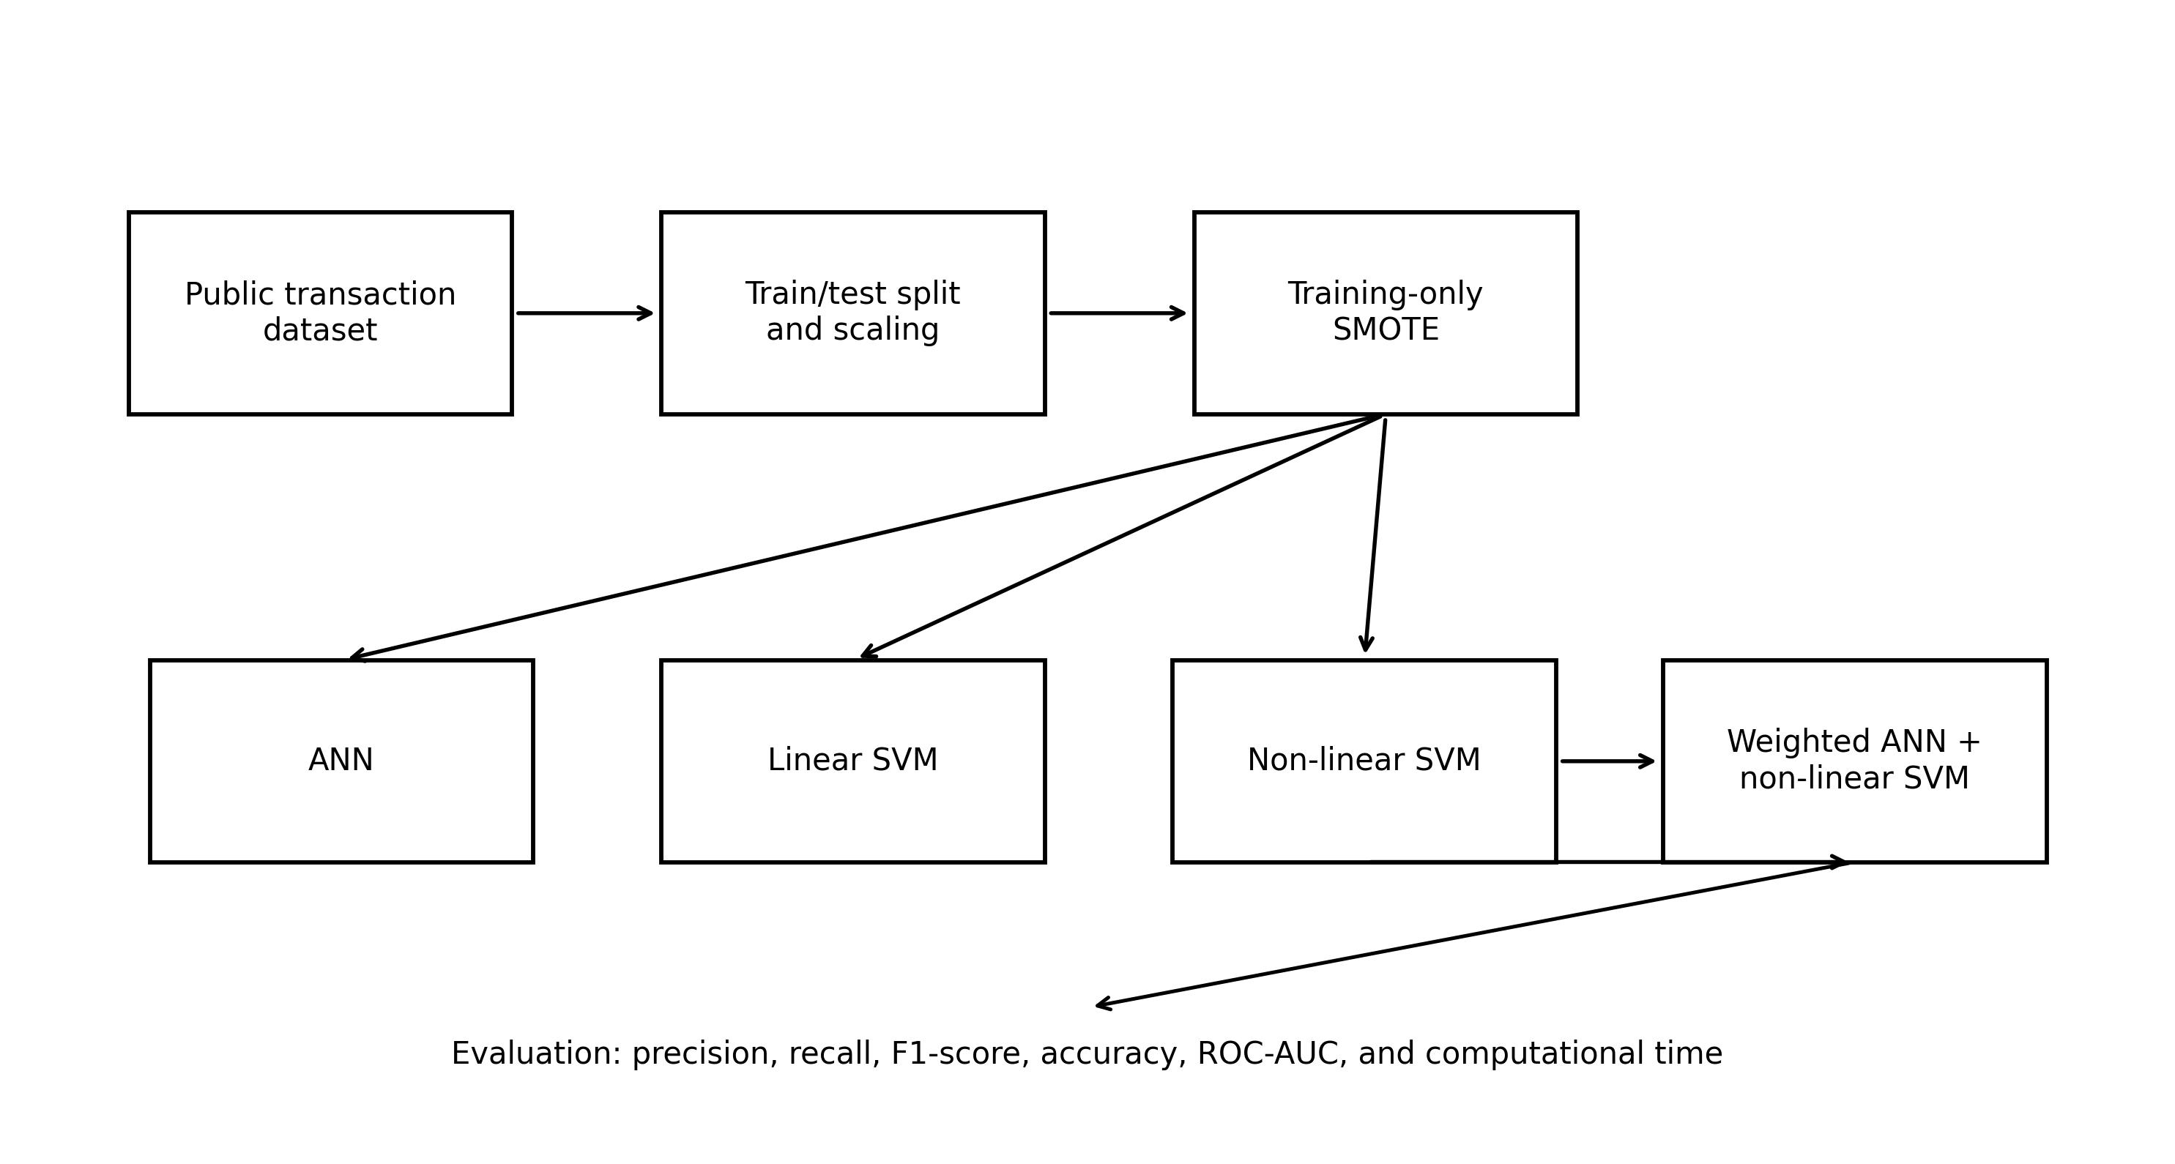
Figure 1. Study workflow for base-model and hybrid evaluation.

3.2 Dataset, Sample Frame, and Data Governance
The dataset contains 284,807 anonymised credit-card transactions made by European cardholders over two days. It includes 492 fraudulent transactions and 284,315 legitimate transactions, corresponding to a fraud prevalence of approximately 0.172% (Liu, 2022). The predictor space consists of Time, Amount, and 28 anonymised principal-component variables (V1–V28); Class is the binary response. Table 2 lists the variables without inferring undisclosed meanings for the PCA components.
Table 2. Variables in the public credit-card transaction dataset
Variable(s) | Data type | Description
V1–V28 | Continuous | Anonymized principal-component variables supplied with the public dataset; original feature semantics are not disclosed.
Time | Continuous | Seconds elapsed between each transaction and the first transaction in the dataset.
Amount | Continuous | Transaction amount.
Class | Binary | Outcome label: 0 = legitimate transaction; 1 = fraudulent transaction.

The analysis uses only publicly available, anonymised secondary data. No participant recruitment, direct human interaction, or access to personally identifiable information was involved. The dataset is cited through its public archival record and was used only for methodological benchmarking.

3.3 Train–Test Partition, Scaling, and Class-Imbalance Handling
The dataset was divided using a 70:30 training–test design, producing 199,365 training observations and 85,442 held-out test observations. Auditable row-level split identifiers are unavailable; therefore, the exact class counts for the holdout partition cannot be verified. Accuracy is consequently interpreted cautiously under the extreme class imbalance.
Feature standardisation was performed using training-set statistics and the resulting transformation was applied to the held-out test set. Parameters derived from the test data were not used in model fitting. This ordering was intended to reduce information leakage from the held-out evaluation partition, because leakage of information across model-development and evaluation stages can produce optimistically biased performance estimates and reduce reproducibility (Kapoor & Narayanan, 2023).
SMOTE was used only on the training data to increase minority-class representation. For a minority observation xi and a selected minority-class neighbour xj, a synthetic point can be expressed as x* = xi + λ(xj − xi), where λ is sampled between 0 and 1 (Chawla et al., 2002). The test set was not oversampled. Resampling only within training data is important because synthetic observations must not contaminate the final performance assessment.

3.4 Artificial Neural Network
The ANN component is a feed-forward binary classifier in which standardised input features are propagated through hidden layers using rectified linear unit (ReLU) activation, followed by a sigmoid output that represents a fraud probability. The conceptual structure is shown in Figure 2. Neural models are attractive for this task because they can represent non-linear interactions among the anonymised predictors, although their flexibility increases the importance of regularisation and validation.
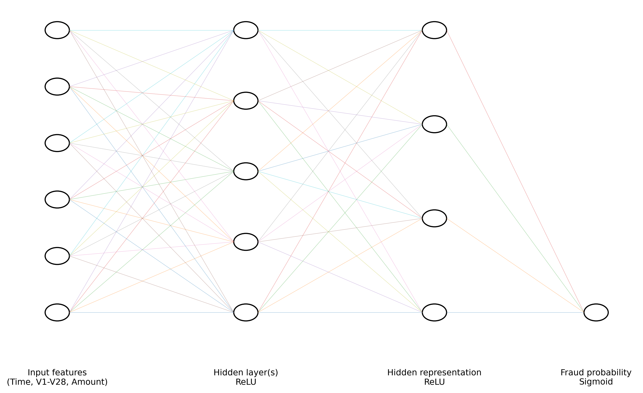
Figure 2. Conceptual feed-forward ANN used for binary fraud classification.

3.5 Linear and Non-linear Support Vector Machines
The linear SVM provides a comparatively simple margin-based baseline, whereas the non-linear SVM allows a curved decision boundary in transformed feature space. SVMs are designed to maximise separation between classes while controlling classification error, and non-linear mappings can capture relationships that are not separable by a single linear hyperplane (Cortes & Vapnik, 1995). For ensemble use, the non-linear SVM output was treated as a calibrated probability-like score rather than an unscaled margin. Probability calibration is especially important when training distributions are modified by resampling (Dal Pozzolo, Caelen, et al., 2015).

3.6 Input Representation and Leakage Control
Figure 3 summarises the input path used by the ANN and SVM models. The anonymised variables, Time, and Amount enter a scaling transformation estimated from the training partition. SMOTE is applied only on the training side of the workflow, whereas the test observations pass through the learned scaling transformation without synthetic resampling.
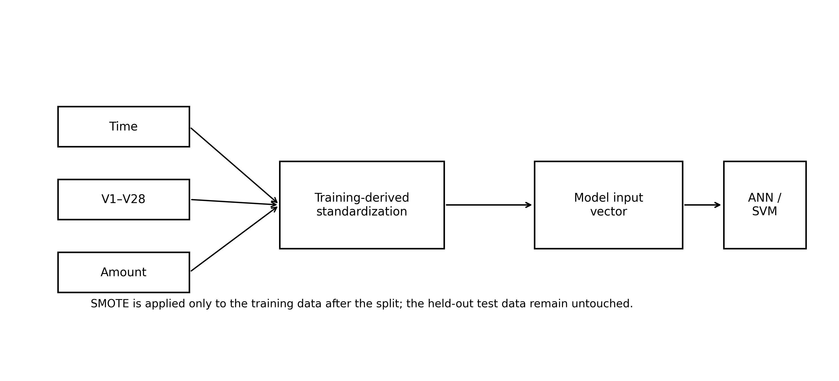
Figure 3. Input representation, standardization, and training-only resampling workflow.

3.7 Weighted Hybrid Model
The proposed hybrid combines the ANN and non-linear SVM probability outputs by weighted averaging. Let pANN denote the ANN fraud probability and pSVM denote the calibrated non-linear SVM probability. The combined score is:
pH = 0.6 pANN + 0.4 pSVM
A transaction is classified as fraud when pH ≥ 0.5. The weighting gives slightly more influence to the ANN while retaining the non-linear margin information supplied by the SVM. The weighting represents a simple ensemble mechanism and is considered study-specific rather than universally optimal across datasets.

3.8 Model Selection and Evaluation Criteria
Candidate settings were evaluated using grid-based hyperparameter search with cross-validation on training data, prioritising F1-score and ROC-AUC rather than raw accuracy. The final comparative assessment used precision, recall, F1-score, accuracy, and ROC-AUC. Recall is operationally important because a false negative corresponds to a missed fraud case, while precision describes how many flagged transactions are actually fraudulent. The F1-score summarises their balance. Accuracy is reported for completeness but receives less interpretive weight because the legitimate class dominates the dataset (He & Garcia, 2009; Saito & Rehmsmeier, 2015).
The comparative analysis is based on aggregate model-performance metrics. Because auditable row-level prediction vectors are unavailable, confusion-matrix counts and paired hypothesis tests cannot be verified and are therefore not reported.

4. RESULTS AND DISCUSSION

4.1 Artificial Neural Network Results
The ANN achieved a precision of 0.88, a recall of 0.71, an F1-score of 0.78, an accuracy of 0.99, and a ROC-AUC of 0.92. The precision–recall profile in Figure 4 shows that the ANN maintained relatively high precision while recovering approximately seven tenths of the fraud class according to the recorded recall. The result is useful as a non-linear neural baseline, but the recall indicates that minority-class sensitivity remained incomplete.
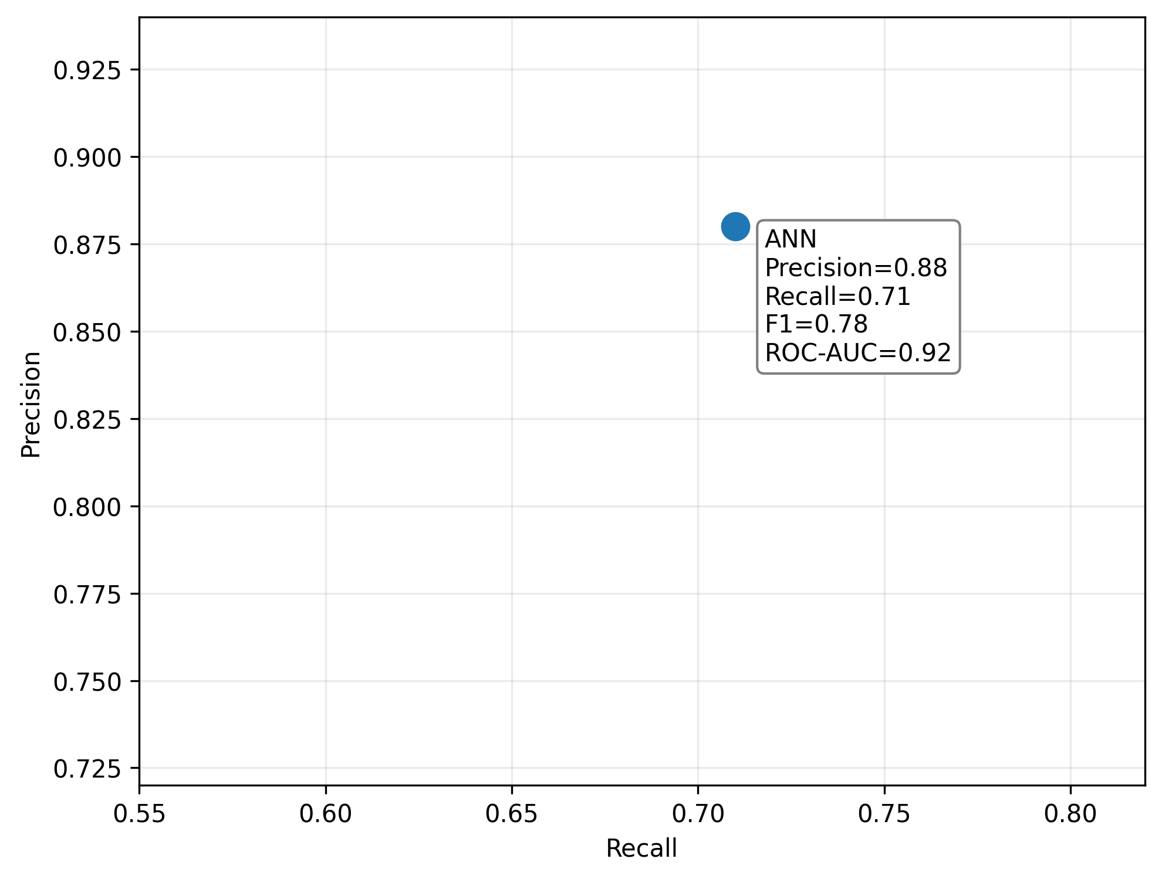
Figure 4. Precision–recall profile of the ANN model.
Figure 5 presents the ANN metrics together. The near-unity accuracy is visually dominant, but the lower recall and F1-score are more informative when assessing the minority-class objective. This pattern is expected in rare-event classification, where accuracy can remain high even when a meaningful share of positive cases is missed (Saito & Rehmsmeier, 2015).
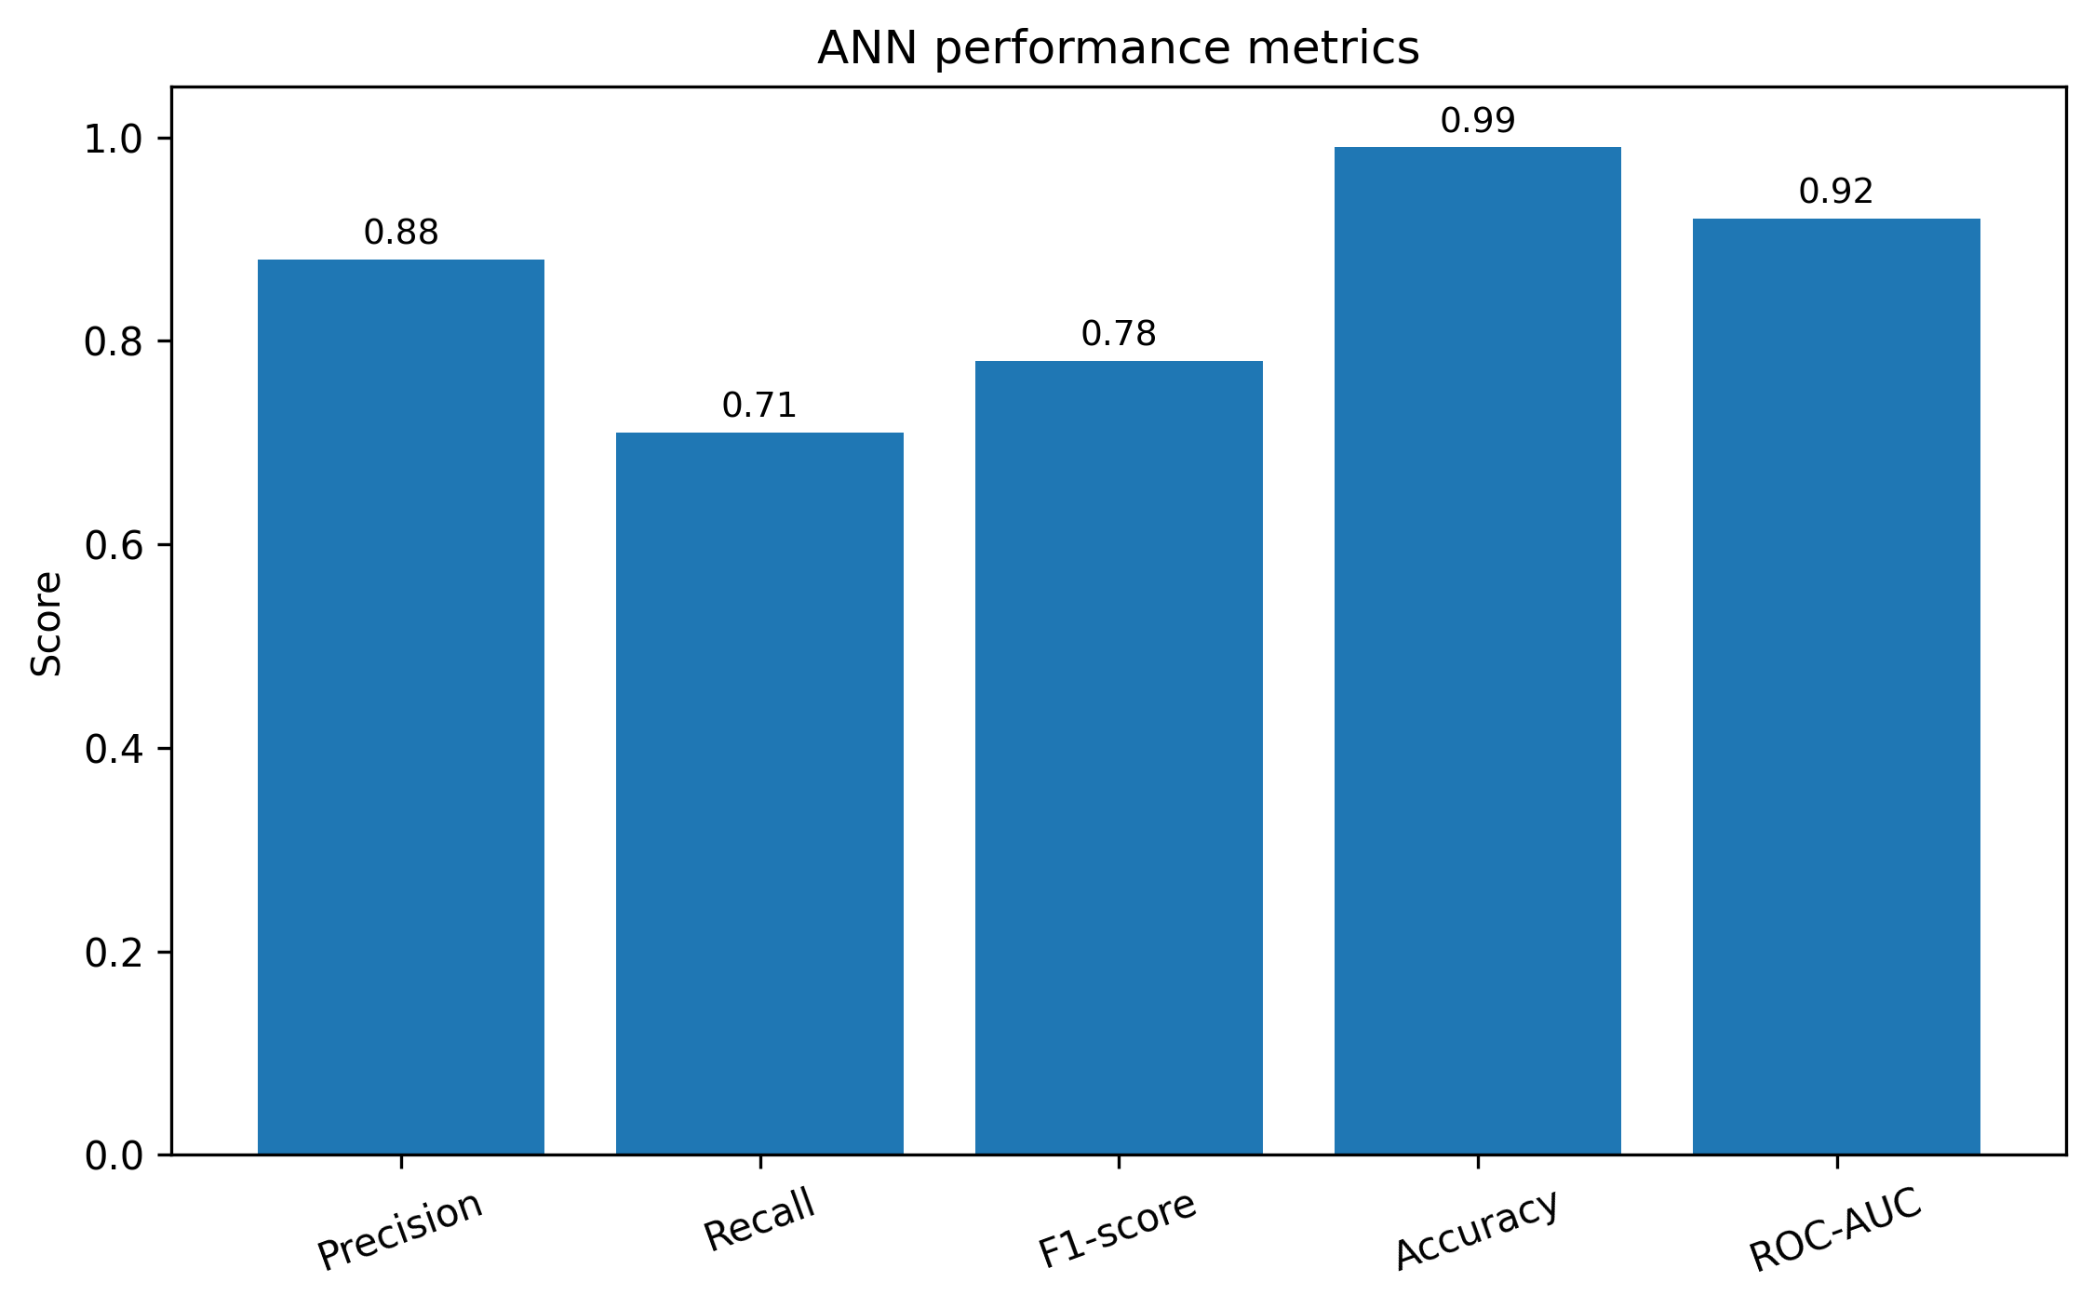
Figure 5. Performance metrics of the ANN model.

4.2 Linear SVM Results
The linear SVM produced a precision of 0.79, a recall of 0.65, an F1-score of 0.71, an accuracy of 0.999, and a ROC-AUC of 0.89. Figure 6 shows that this model occupied the weakest precision–recall position among the four evaluated approaches. The result suggests that a strictly linear decision boundary was less effective for the fraud-class structure represented by the anonymised predictors.
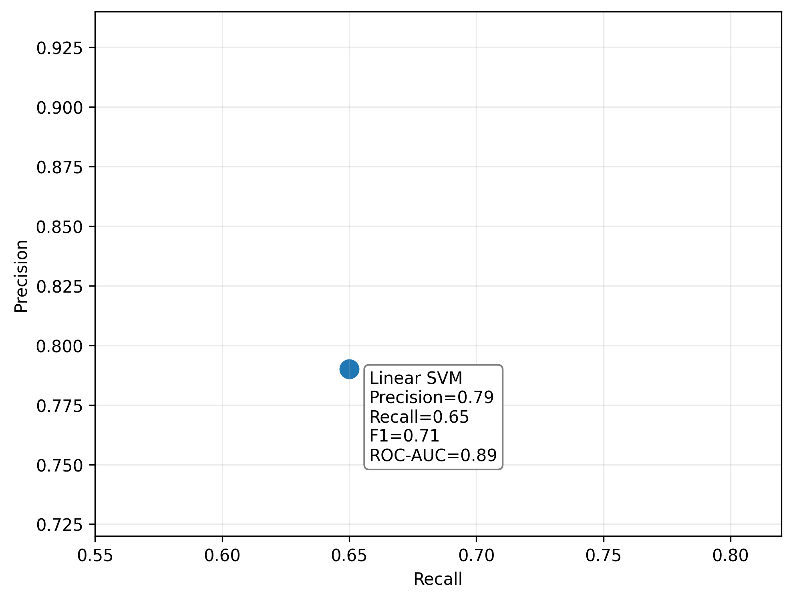
Figure 6. Precision–recall profile of the linear SVM model.
As summarised in Figure 7, the very high accuracy of the linear SVM contrasts with its lower recall and F1-score. This discrepancy illustrates why model selection based solely on accuracy would be inappropriate for the present dataset.
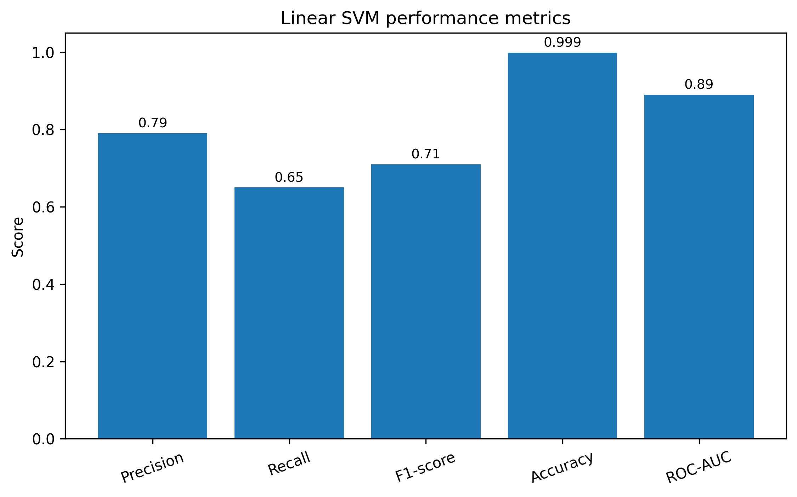
Figure 7. Performance metrics of the linear SVM model.

4.3 Non-linear SVM Results
The non-linear SVM achieved a precision of 0.84, a recall of 0.66, an F1-score of 0.74, an accuracy of 0.99, and a ROC-AUC of 0.90. Figure 8 shows a modest precision improvement over the linear SVM, consistent with the possibility that non-linear boundaries capture fraud structure not represented by a single linear separator. Recall, however, remained below the ANN value.
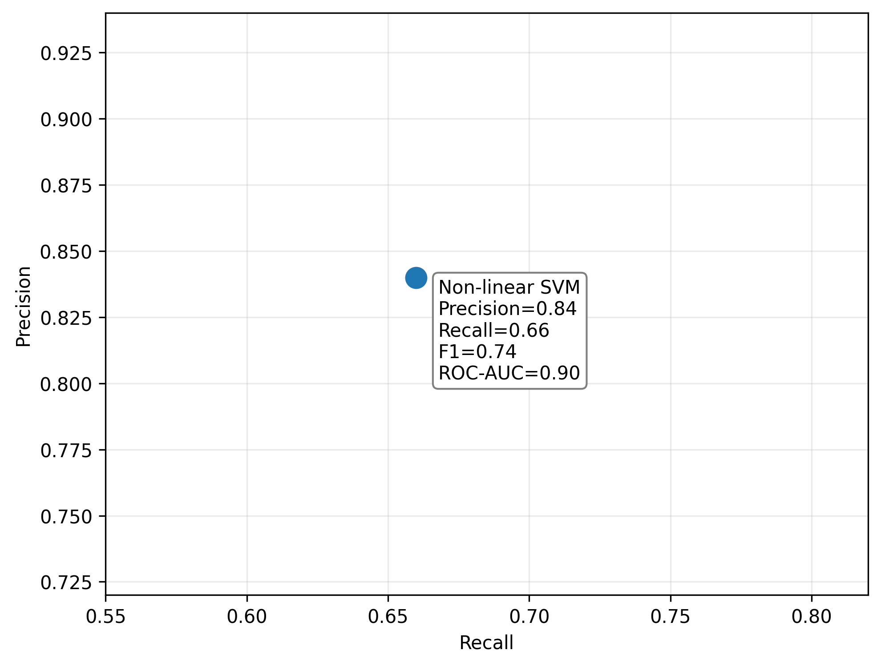
Figure 8. Precision–recall profile of the non-linear SVM model.
Figure 9 summarises the non-linear SVM metrics. Its overall profile falls between the linear SVM and ANN, supporting its use as a complementary ensemble component rather than as the strongest standalone classifier in this experiment.
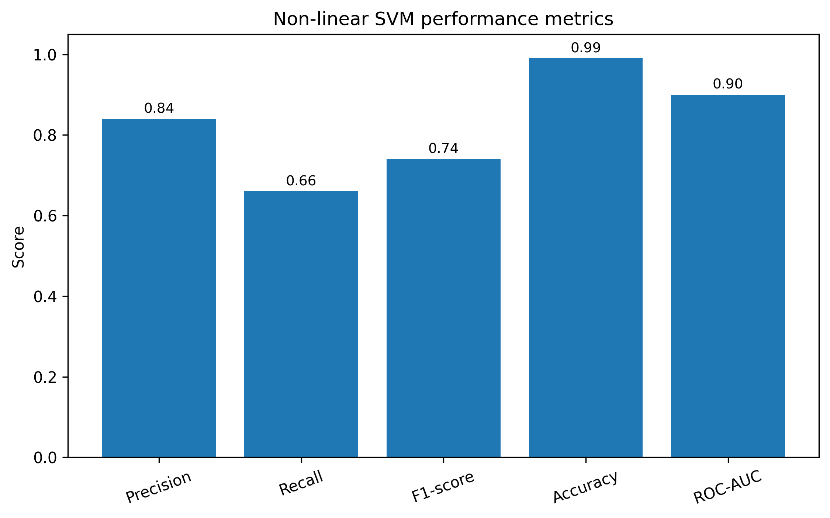
Figure 9. Performance metrics of the non-linear SVM model.

4.4 Hybrid ANN–Non-linear SVM Results
The weighted hybrid produced the strongest recorded aggregate minority-class performance. Before presenting the hybrid figures, Table 3 summarises the metrics used for interpretation. Precision was 0.89, recall was 0.75, the F1-score was 0.81, accuracy was 0.99, and ROC-AUC was 0.94. These values represent descriptive benchmark performance on the stated split and should not be interpreted as statistically significant superiority in the absence of paired prediction data.
Table 3. Hybrid model evaluation metrics
Metric | Score | Interpretation
Precision | 0.89 | High proportion of flagged transactions are fraud according to the recorded aggregate metric.
Recall | 0.75 | The highest recorded fraud-class sensitivity among the four evaluated models.
F1-score | 0.81 | Best recorded balance between precision and recall in the comparison.
Accuracy | 0.99 | High overall correctness, interpreted cautiously because of class imbalance.
ROC-AUC | 0.94 | Highest recorded ranking/discrimination metric among the compared models.

Figure 10 places the hybrid in precision–recall space. Relative to the ANN, recall increased from 0.71 to 0.75 while precision increased slightly from 0.88 to 0.89. The joint change raised the recorded F1-score from 0.78 to 0.81.
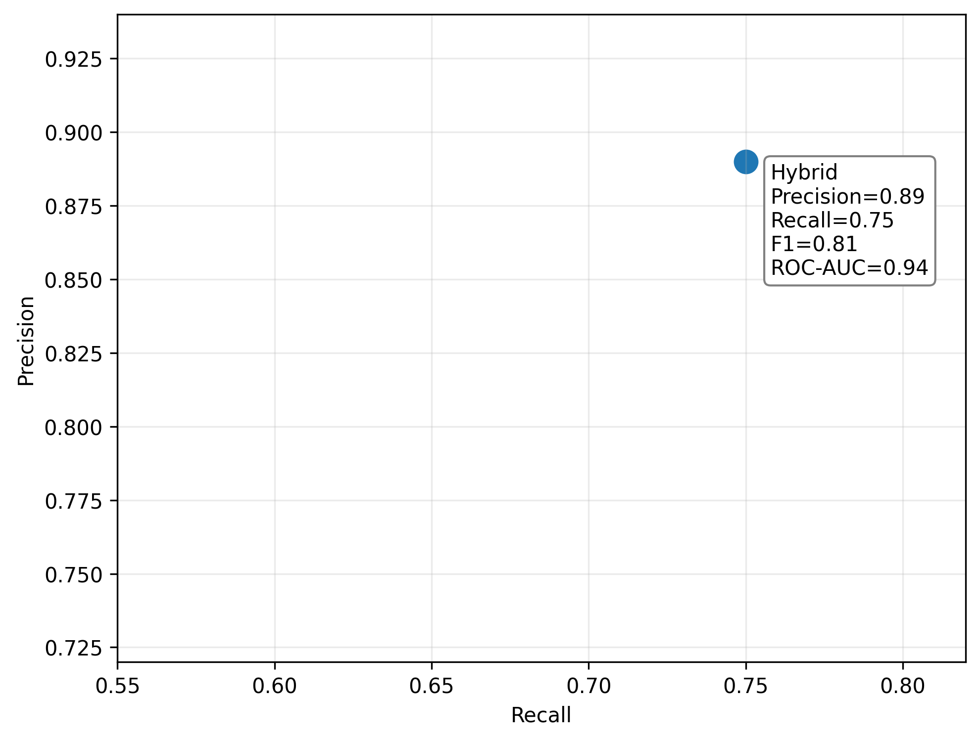
Figure 10. Precision–recall profile of the hybrid ANN–non-linear SVM model.
Figure 11 shows the full metric profile of the hybrid. The most relevant observation is not the 0.99 accuracy, which is expected to be high under extreme imbalance, but the combination of 0.75 recall, 0.89 precision, and 0.81 F1-score.
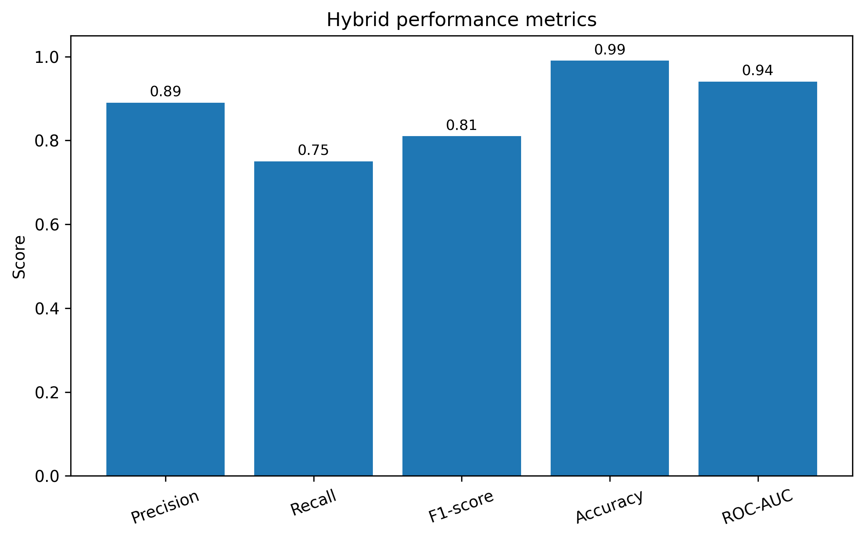
Figure 11. Performance metrics of the hybrid ANN–non-linear SVM model.

4.5 Comparative Analysis
Table 4 compares all four models using only aggregate metrics that are internally consistent across the manuscript and the recorded computational times. The hybrid has the highest precision, recall, F1-score, and ROC-AUC; the ANN ranks second on these minority-sensitive metrics. The linear SVM is fastest but provides the weakest recall and F1-score.
Table 4. Comparative performance and computational time of the evaluated models
Metric | Hybrid | ANN | Linear SVM | Non-linear SVM
Precision | 0.89 | 0.88 | 0.79 | 0.84
Recall | 0.75 | 0.71 | 0.65 | 0.66
F1-score | 0.81 | 0.78 | 0.71 | 0.74
Accuracy | 0.99 | 0.99 | 0.999 | 0.99
ROC-AUC | 0.94 | 0.92 | 0.89 | 0.90
Training time (s) | 210 | 120 | 30 | 90
Test-set batch time (s) | 9 | 5 | 2 | 4

Figure 12 visualises the four minority-sensitive comparison metrics. The hybrid advantage is modest rather than substantial: relative to the ANN, precision increases by 0.01, recall by 0.04, F1-score by 0.03, and ROC-AUC by 0.02. These differences indicate a modest performance advantage of the hybrid relative to the ANN.
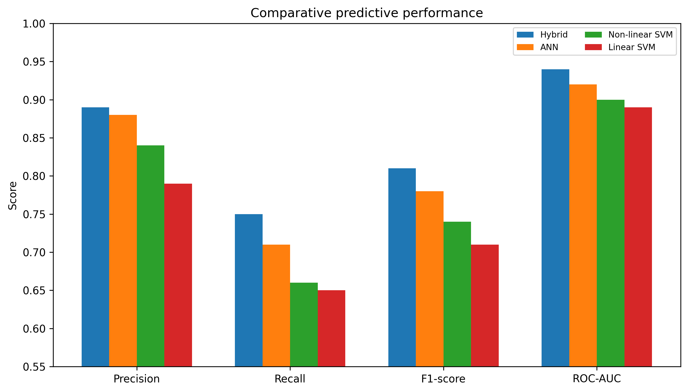
Figure 12. Comparative precision, recall, F1-score, and ROC-AUC of the four models.
Computational cost moves in the opposite direction. Figure 13 shows that the hybrid required 210 seconds for training and 9 seconds to score the full test set, compared with 120/5 seconds for ANN, 90/4 seconds for non-linear SVM, and 30/2 seconds for linear SVM. Thus, the hybrid trades additional computation for improved recorded minority-class metrics.
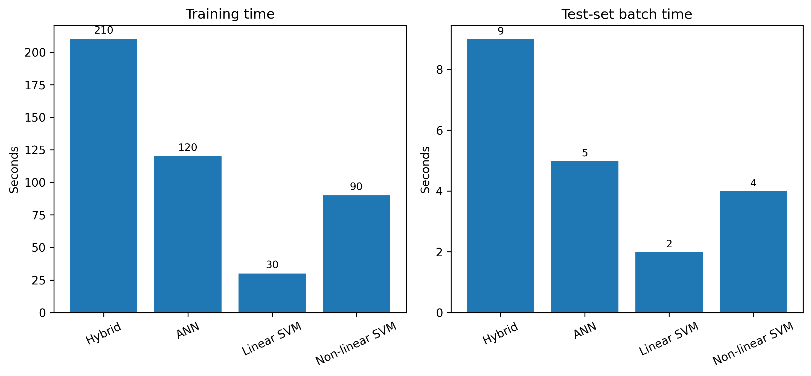
Figure 13. Comparative training and test-set batch times of the four models.

4.6 Interpretation in Relation to Previous Research
The direction of the ensemble result is consistent with literature showing that combinations of complementary classifiers can improve fraud detection. Randhawa et al. (2018) reported benefits from ensemble voting, while Mim et al. (2024) found that soft voting combined with data-balancing strategies can outperform individual classifiers. The present hybrid is simpler than those frameworks, but its recorded increase in recall and F1-score relative to the individual ANN and SVM components is consistent with the broader ensemble rationale.
The direct comparison with Ndama et al. (2024) is especially important because that study also combines ANN and SVM with SMOTE on the same widely used benchmark. Cross-paper metric comparisons should nevertheless be avoided unless train/test partitions, resampling, thresholds, and architectures are identical. The appropriate conclusion is therefore not that the present weighting is globally superior, but that an ANN–SVM combination again appears capable of producing useful benchmark performance under extreme imbalance.
The results also reinforce the evaluation cautions emphasised in imbalanced-learning research. The linear SVM records near-perfect accuracy while producing the lowest recall and F1-score, illustrating the limited decision value of accuracy alone in rare-event settings (He & Garcia, 2009; Saito & Rehmsmeier, 2015). Future evaluations should report precision–recall AUC in addition to ROC-AUC and should include uncertainty across repeated or temporal splits.

4.7 Computational Efficiency and Deployment Implications
The 9-second hybrid test time for 85,442 observations corresponds to an average batch throughput of approximately 9,493 transactions per second, or about 105 microseconds per observation when total batch time is divided by the number of test transactions. This arithmetic should not be interpreted as measured online latency. Batch scoring excludes network transmission, feature retrieval, queueing, model warm-up, database access, authentication logic, and other payment-system components. Consequently, the experiment supports a statement about batch computational efficiency, not a guarantee of real-time production performance.

4.8 Limitations and Future Research
The study has several limitations. First, it uses a single historical public dataset covering only two days of European cardholder transactions. The anonymised PCA features prevent semantic interpretation and omit many variables available to contemporary fraud systems. Second, the evaluation is based on one recorded 70:30 holdout design and aggregate performance metrics; repeated stratified or temporal validation and paired row-level predictions were not available for inferential comparison. Third, because SMOTE generates additional minority-class observations through interpolation between existing minority instances, oversampling may alter characteristics of the minority-class distribution; accordingly, performance obtained after synthetic oversampling should be interpreted with appropriate caution (Elreedy et al., 2024). Fourth, computational times were measured as model-level batch times rather than end-to-end transaction latency.
Future work should retain prediction vectors and split identifiers, report precision–recall AUC and confidence intervals, compare calibration and threshold-selection strategies, and evaluate repeated and time-ordered splits. Contemporary institutional datasets are needed to assess transfer under changing fraud patterns, while privacy-preserving multi-institution learning may help broaden pattern coverage without centralising raw customer data. More interpretable features and explainability analyses would also be valuable for analyst review and governance. Recent research on intelligent sampling, self-supervised representations, and hybrid sampling provides promising directions for such extensions (Chen et al., 2024; Ahmed et al., 2025).

5. CONCLUSION
This study compared ANN, linear SVM, non-linear SVM, and a weighted ANN–non-linear SVM ensemble for credit-card fraud detection on a severely imbalanced public benchmark. The aggregate results show that the hybrid produced the highest recorded precision (0.89), recall (0.75), F1-score (0.81), and ROC-AUC (0.94), while requiring more computation than the standalone models. Relative to the ANN, the improvement was modest but directionally favourable, especially for recall and F1-score. The findings support the practical value of combining complementary non-linear classifiers, but they do not establish universal or statistically significant superiority. Because accuracy is inflated by the dominant legitimate class, minority-sensitive measures should remain central to interpretation. Validation on repeated or temporal splits, preservation of row-level predictions, precision–recall analysis, calibration assessment, and evaluation on contemporary transaction streams are required before operational deployment claims can be made.

DATA AVAILABILITY
The study uses the public Credit Card Fraud Detection dataset archived on Zenodo and originally distributed through the ULB/Kaggle benchmark ecosystem. The archival record is available at https://doi.org/10.5281/zenodo.7395559 (Liu, 2022).

ETHICS AND RESPONSIBLE DATA USE
The analysis was limited to publicly available anonymized secondary transaction data. No direct interaction with human participants occurred, and no personally identifiable information was available to the analysis. The study was conducted as a methodological benchmark using the variables released with the public dataset.

COMPETING INTERESTS
The authors declare no known competing financial or non-financial interests that could have influenced the work reported in this article.
Declaration of AI Use
This manuscript was prepared through the intellectual contributions of the author(s) to the study design, data analysis, interpretation of results, and scholarly content. Grammarly and ChatGPT were used solely to assist with grammatical refinement and reference formatting during manuscript revision. The author(s) accept full responsibility for the accuracy, integrity, and final content of the manuscript.

REFERENCES
Ahmed, K. H., Axelsson, S., Li, Y., & Makki Sagheer, A. (2025). A credit card fraud detection approach based on ensemble machine learning classifier with hybrid data sampling. Machine Learning with Applications, 20, Article 100675. https://doi.org/10.1016/j.mlwa.2025.100675
Ali, A., Abd Razak, S., Othman, S. H., Eisa, T. A. E., Al-Dhaqm, A., Nasser, M., Elhassan, T., Elshafie, H., & Saif, A. (2022). Financial fraud detection based on machine learning: A systematic literature review. Applied Sciences, 12(19), Article 9637. https://doi.org/10.3390/app12199637
Aslam, A., & Hussain, A. (2024). A performance analysis of machine learning techniques for credit card fraud detection. Journal on Artificial Intelligence, 6(1), 1–21. https://doi.org/10.32604/jai.2024.047226
Awoyemi, J. O., Adetunmbi, A. O., & Oluwadare, S. A. (2017). Credit card fraud detection using machine learning techniques: A comparative analysis. In 2017 International Conference on Computing Networking and Informatics (ICCNI) (pp. 1–9). IEEE. https://doi.org/10.1109/ICCNI.2017.8123782
Bhattacharyya, S., Jha, S., Tharakunnel, K., & Westland, J. C. (2011). Data mining for credit card fraud: A comparative study. Decision Support Systems, 50(3), 602–613. https://doi.org/10.1016/j.dss.2010.08.008
Bin Sulaiman, R., Schetinin, V., & Sant, P. (2022). Review of machine learning approach on credit card fraud detection. Human-Centric Intelligent Systems, 2(1–2), 55–68. https://doi.org/10.1007/s44230-022-00004-0
Chawla, N. V., Bowyer, K. W., Hall, L. O., & Kegelmeyer, W. P. (2002). SMOTE: Synthetic minority over-sampling technique. Journal of Artificial Intelligence Research, 16, 321–357. https://doi.org/10.1613/jair.953
Chen, C.-T., Lee, C., Huang, S.-H., & Peng, W.-C. (2024). Credit card fraud detection via intelligent sampling and self-supervised learning. ACM Transactions on Intelligent Systems and Technology, 15(2), Article 35, 1–29. https://doi.org/10.1145/3641283
Cherif, A., Badhib, A., Ammar, H., Alshehri, S., Kalkatawi, M., & Imine, A. (2023). Credit card fraud detection in the era of disruptive technologies: A systematic review. Journal of King Saud University – Computer and Information Sciences, 35(1), 145–174. https://doi.org/10.1016/j.jksuci.2022.11.008
Cortes, C., & Vapnik, V. (1995). Support-vector networks. Machine Learning, 20(3), 273–297. https://doi.org/10.1007/BF00994018
Dal Pozzolo, A., Caelen, O., Le Borgne, Y.-A., Waterschoot, S., & Bontempi, G. (2014). Learned lessons in credit card fraud detection from a practitioner perspective. Expert Systems with Applications, 41(10), 4915–4928. https://doi.org/10.1016/j.eswa.2014.02.026
Dal Pozzolo, A., Boracchi, G., Caelen, O., Alippi, C., & Bontempi, G. (2015). Credit card fraud detection and concept-drift adaptation with delayed supervised information. In 2015 International Joint Conference on Neural Networks (IJCNN) (pp. 1–8). IEEE. https://doi.org/10.1109/IJCNN.2015.7280527
Dal Pozzolo, A., Caelen, O., Johnson, R. A., & Bontempi, G. (2015). Calibrating probability with undersampling for unbalanced classification. In 2015 IEEE Symposium Series on Computational Intelligence (SSCI) (pp. 159–166). IEEE. https://doi.org/10.1109/SSCI.2015.33
Elreedy, D., Atiya, A. F., & Kamalov, F. (2024). A theoretical distribution analysis of synthetic minority oversampling technique (SMOTE) for imbalanced learning. Machine Learning, 113, 4903–4923. https://doi.org/10.1007/s10994-022-06296-4
Hashemi, S. K., Mirtaheri, S. L., & Greco, S. (2023). Fraud detection in banking data by machine learning techniques. IEEE Access, 11, 3034–3043. https://doi.org/10.1109/ACCESS.2022.3232287
He, H., & Garcia, E. A. (2009). Learning from imbalanced data. IEEE Transactions on Knowledge and Data Engineering, 21(9), 1263–1284. https://doi.org/10.1109/TKDE.2008.239
Kapoor, S., & Narayanan, A. (2023). Leakage and the reproducibility crisis in machine-learning-based science. Patterns, 4(9), Article 100804. https://doi.org/10.1016/j.patter.2023.100804
Liu, L. (2022). Credit card fraud detection [Data set]. Zenodo. https://doi.org/10.5281/zenodo.7395559
Mim, M. A., Majadi, N., & Mazumder, P. (2024). A soft voting ensemble learning approach for credit card fraud detection. Heliyon, 10(3), Article e25466. https://doi.org/10.1016/j.heliyon.2024.e25466
Ndama, O., Bensassi, I., & En-Naimi, E. M. (2024). Innovative credit card fraud detection: A hybrid model combining artificial neural networks and support vector machines. IAES International Journal of Artificial Intelligence, 13(3), 2674–2682. https://doi.org/10.11591/ijai.v13.i3.pp2674-2682
Randhawa, K., Loo, C. K., Seera, M., Lim, C. P., & Nandi, A. K. (2018). Credit card fraud detection using AdaBoost and majority voting. IEEE Access, 6, 14277–14284. https://doi.org/10.1109/ACCESS.2018.2806420
Rtayli, N., & Enneya, N. (2020). Enhanced credit card fraud detection based on SVM-recursive feature elimination and hyper-parameters optimization. Journal of Information Security and Applications, 55, Article 102596. https://doi.org/10.1016/j.jisa.2020.102596
Saito, T., & Rehmsmeier, M. (2015). The precision-recall plot is more informative than the ROC plot when evaluating binary classifiers on imbalanced datasets. PLOS ONE, 10(3), Article e0118432. https://doi.org/10.1371/journal.pone.0118432

