CASE REPORT

Infected Urachal Sinus with Urachal Cyst Following Umbilical Polypectomy in an Infant: A Rare Case Report and Review of Literature

ABSTRACT
Urachal vestiges are exceedingly uncommon congenital malformations that result from partial failure of obliteration of the primitive embryonic urachus. Among urachal anomalies, an infected urachal sinus with an underlying urachal cyst is sufficiently uncommon to be misidentified in infancy and childhood. This case report describes a 1-year-old female infant with a one-month history of recurrent episodic purulent umbilical discharge, erythema of the overlying skin, periumbilical tenderness, and a history of umbilical polypectomy at 5 months of age. High-resolution abdominal ultrasonography revealed an approximately 1.4 cm linear, blind-ending sinus tract arising from the umbilicus and extending directly to an infected intra-urachal remnant, with an approximately 2.2×1.9×1.4 cm hypoechoic fluid collection of approximately 3.4 mL along the urachovesical tract, without communication with the urinary tract. Exploratory infraumbilical laparotomy confirmed a urachal cyst containing purulent material with a discharging sinus tract. The cyst, sinus tract, and fibrous umbilical remnant were excised en bloc. A transfixion ligature at the bladder base was performed using polydioxanone (PDS 5-0). Pus culture yielded Proteus mirabilis, which was multidrug-resistant but remained sensitive to carbapenems and piperacillin/tazobactam. Treatment with intravenous meropenem and metronidazole resulted in complete resolution without wound infection. A high index of suspicion for an infected urachal sinus and other urachal anomalies, together with precise preoperative ultrasonographic evaluation and close follow-up, is warranted in children with persistent or recurrent atypical paediatric umbilical lesions.
Keywords: Urachal cyst; Umbilical sinus; Congenital urachal remnant; Umbilical polyp; Proteus mirabilis; Paediatric laparotomy; Ultrasonography.

1. INTRODUCTION
The urachus, or median umbilical ligament, is a midline tubular embryonic structure that usually extends from the anterosuperior apex of the maturing fetal bladder to the allantois at the level of the umbilicus (Begg, 1930). In normal human embryogenesis, obliteration and fibrotic degeneration of the urachal lumen progress between the fourth and fifth months of intrauterine life, resulting in a cord-like, non-functional fibrotic structure that lies extraperitoneally in the space of Retzius (prevesical space), bounded anteriorly by the transversalis fascia and posteriorly by the parietal peritoneum (Choi et al., 2006). Failure of anatomical obliteration and luminal regression of the urachus may lead to congenital urachal anomalies. These are rare clinical conditions, occurring in approximately 1/5,000–1/8,000 live births, with a significant 2:1 male-to-female predominance (Gleason et al., 2015). Urachal anomalies are traditionally categorised into five types according to the pattern of incomplete obliteration: (a) patent urachus (approximately 50%), with total continuity of the lumen between the urachus and the umbilical cord and leakage of urine; (b) urachal cyst (approximately 30%), in which both the umbilical and vesical openings are occluded while the middle part remains isolated as a secretory, mucous-filled cystic cavity; (c) urachal sinus (approximately 15%), in which only the umbilical part remains patent, forming a blind-ending canal opening at the umbilicus; (d) vesicourachal diverticulum (3%–5%), in which the vesical end remains open as a wide diverticulum arising from the bladder dome; and (e) alternating sinus-cyst urachal configurations. Urachal anomalies may also present as a urachal sinus with an underlying urachal cyst, creating a chronically infected and draining cavity (Blichert-Toft & Nielsen, 1971; Cilento et al., 1998). Other rare presentations include a urachal sinus communicating with an underlying urachal cyst (To et al., 2017). Non-patent urachal anomalies may remain asymptomatic throughout infancy and adolescence until secondary bacterial infection develops (Galati et al., 2008). When infected, a previously 'quiet' urachal remnant may become an acute or subacute suppurative process, causing persistent seropurulent or purulent umbilical discharge, local inflammation, periumbilical tenderness, and intra-abdominal mass formation (Ashley et al., 2007). Paediatric umbilical lesions may initially be misdiagnosed or mismanaged as benign superficial conditions, including omphalitis, stitch abscess, umbilical granuloma, and umbilical polyp (Snyder, 2007). Repeated superficial procedures without preprocedural ultrasonographic evaluation of deeper components, such as superficial trimming, topical silver nitrate application, or simple polypectomy, may obscure deep congenital communications and contribute to recurrence (Upadhyay & Kukkady, 2003). Persistent urachal tissue may remain clinically relevant beyond childhood, with reported outcomes ranging from benign remnant lesions to rare urachal neoplasia in adulthood (Dey et al., 2019). Recent paediatric cohort evidence indicates that infection and a cystic ultrasonographic appearance are associated with a greater likelihood of surgical excision, reinforcing the importance of integrating symptoms with imaging findings in management decisions (Abdulfattah et al., 2025). Contemporary practice nevertheless remains heterogeneous, with paediatric urology and general surgery services using both conservative and operative strategies for urachal anomalies (Gelikman et al., 2024).
Despite these advances, detailed reports of an infected umbilical urachal sinus communicating with an underlying urachal cyst in an infant with a history of prior superficial umbilical polypectomy remain limited, especially when sonographic, microbiological, operative, and short-term follow-up findings are documented together.
Objective
The objective of this paper is to present an unusual paediatric case of a urachal cyst associated with an infected urachal sinus in a 1-year-old girl with a history of umbilical polypectomy, together with the diagnostic, microbiological, and surgical findings and a review of the literature.
2. CASE REPORT
2.1 Patient Profile and Clinical Presentation
A one-year-old female infant was brought to the Department of Paediatric Surgery, S.S Institute of Medical Sciences & Research Center (SSIMS & RC), Davangere, Karnataka, India, with a one-month history of intermittent purulent discharge from the umbilical region. The discharge had recurred approximately every 2 days for an extended period and gradually changed from clear serosanguineous fluid to thick, foul-smelling purulent material, accompanied by erythema, mild swelling, and tenderness of the periumbilical skin. The child had an episode of low-grade fever 2 weeks earlier, which subsided after symptomatic antipyretic treatment. No active umbilical bleeding, gross haematuria, faecal or bilious discharge, or oliguria was documented. The child was otherwise active and playful.
2.2 Past Medical and Surgical History
The infant was born at full term by LSCS, weighing 2.15 kg, after an uneventful antenatal and natal period. She did not require NICU admission, and developmental milestones were reported as age-appropriate: gross motor—standing without support and ambulating on stairs; fine motor—pincer grip and independent feeding with a spoon; communication—meaningful two-word sentences; and social development—at par. Immunisations were up to date according to the national immunisation programme. The history included an umbilical polyp that was removed by superficial polypectomy at 5 months of age on 18/12/2025. Thereafter, the infant had recurrent episodes of umbilical discharge and erythema, with previous empirical diagnoses of stitch abscess and omphalitis. Symptomatic treatment included 5% povidone-iodine washes, Betadine powder, and antibiotic syrup for stitch abscess and omphalitis (Taxim-O 100 mg) for 3 days during outpatient visits on 20/02/2026, 23/02/2026, and finally 29/04/2026.
2.3 Physical Examination and Vitals
On general physical examination at admission (04/07/2026), the child was active, awake, alert, and playful. The infant weighed 8.2 kg, and the vital signs were stable and unremarkable: heart rate 122 beats/min and regular; respiratory rate 36 breaths/min and unlaboured; oxygen saturation 98%; and axillary temperature 98.4. On auscultation, vesicular breath sounds were clear and non-wheezing bilaterally. S1 and S2 were audible, with no murmurs, and the cardiac rhythm was regular. Oral examination revealed asymptomatic ankyloglossia. Local examination of the abdomen showed a central umbilical sinus opening with cream-coloured purulent discharge and no active bleeding. The periumbilical skin showed mild circular erythema. The abdomen was soft on palpation, with no organomegaly or signs of generalised peritonitis. However, deep palpation revealed an ill-defined, deep-seated swelling in the midline just below the umbilicus, along the mid-urachovesical axis. No cough impulse or reducible hernia was present.
2.4 Laboratory Investigations
Haematological investigations showed mild microcytic hypochromic anaemia with reactive leucocytosis: Hb was 10.6 g/dL, PCV was 31.8%, and TLC was 15,960, with 18% neutrophils and 76% lymphocytes (representing the physiological lymphocytic preponderance of infancy with toxic granulation). The RBC count was 5.1 million/cumm, MCV was 64.8 fL, MCH was 20.8 pg, MCHC was 32.1 g/dL, RDW-CV was 17.3%, and the platelet count was 5x10 5 /cumm. Coagulation studies showed a bleeding time of 2.40 minutes and a clotting time of 3.20 minutes. Biochemical tests showed normal renal function and electrolyte balance: serum urea, 7.9 mg/dL; serum creatinine, 0.22 mg/dL; serum sodium, 135.5 mmol/L; serum potassium, 4.82 mmol/L; and serum chloride, 102.46 mmol/L. Viral screening for HIV and hepatitis B surface antigen (HBsAg) using chemiluminescence immunoassay (CLIA) was non-reactive.
Parameter | Patient Value | Reference Range | Clinical Significance
Haemoglobin (Hb) | 10.6 g/dL | 11.1 – 14.1 g/dL | Mild microcytic hypochromic anemia
Total Leukocyte Count (TLC) | 15,960 cells/cumm | 4,000 – 16,000 cells/cumm | High-normal / reactive leukocytosis
Differential: Neutrophils | 18 % | 15 – 46 % | Within pediatric reference range
Differential: Lymphocytes | 76 % | 20 – 45 % | Physiological infantile lymphocytosis
RBC Count | 5.1 x 10^6 /cumm | 3.4 – 5.2 x 10^6 /cumm | Normal red cell mass
Packed Cell Volume (PCV) | 31.8 % | 40.0 – 54.0 % | Reduced haematocrit
MCV / MCH / MCHC | 64.8 fL / 20.8 pg / 32.1% | 76-96 fL / 23-31 pg / 32-36% | Microcytosis and hypochromia
Platelet Count | 5.00 x 10^5 /cumm | 1.5 – 5.5 x 10^5 /cumm | Normal platelet count
Bleeding Time (BT) | 2 min 40 sec | 2 – 7 min | Normal primary hemostasis
Clotting Time (CT) | 3 min 20 sec | 3 – 9 min | Normal intrinsic coagulation
Serum Urea | 7.9 mg/dL | 10.8 – 38.4 mg/dL | Adequate hydration / normal metabolism
Serum Creatinine | 0.22 mg/dL | 0.15 – 0.37 mg/dL | Normal infantile renal function
Serum Sodium (Na+) | 135.5 mmol/L | 133 – 152 mmol/L | Eunatremic
Serum Potassium (K+) | 4.82 mmol/L | 3.5 – 5.5 mmol/L | Eukalemic
Serum Chloride (Cl-) | 102.46 mmol/L | 96 – 106 mmol/L | Normal chloride concentration
HIV & HBsAg (CLIA) | Non-Reactive | Non-Reactive | Negative viral screen
Table 1: Baseline Haematological and Biochemical Investigations of the Patient.
2.5 Radiological Imaging
The ultrasound (USG) study of the abdomen and pelvis dated 06/07/2026 was the only anatomical guide available for reference. The liver, gallbladder, portal vein, spleen (6.2 cm), pancreas, and both kidneys, including their parenchymal echotexture, were unremarkable; there was no pelvicalyceal dilatation or renal calculus (right kidney, 5.0 x 3.0 cm; left kidney, 5.5 x 3.2 cm). Evaluation of the midline anterior abdominal wall showed a discrete, linear, blind-ending sinus tract measuring approximately 1.4 cm, extending from the umbilical cutaneous opening directly to an ill-defined, hypoechoic, thick-walled cystic collection along the urachovesical region (Figures 1 and 2). The urachal cyst measured 2.2 x 1.9 x 1.4 cm, with an estimated volume of 3.4 cc. The cyst terminated blindly above the anterosuperior dome of the bladder, with no patent fistulous communication with the bladder lumen (Figures 1 and 2). No free fluid or other peritoneal collection was identified.

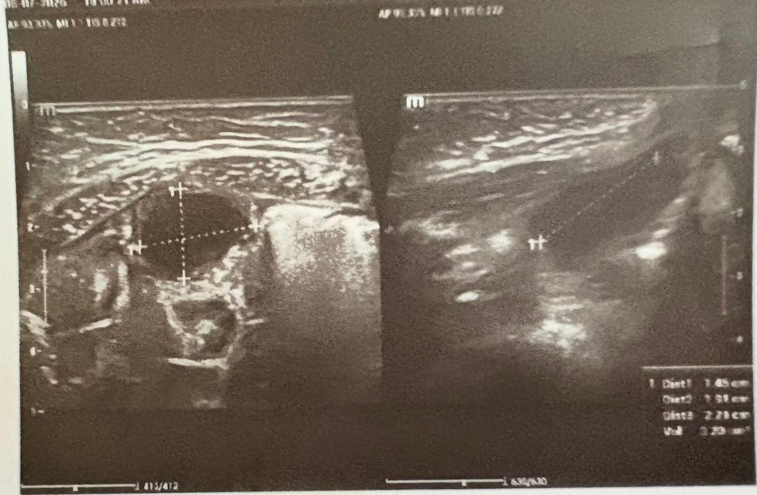
Figure 1-: Targeted ultrasound with calipers showing urachal cyst and sinus dimensions. (Left) Transverse view displaying an infected urachal cyst presenting as a rounded, hypoechoic to anechoic fluid collection with thickened, hyperemic walls and internal low-level debris. (Right) Longitudinal scan demonstrating the linear, tubular urachal sinus tract extending toward the deep margin of the umbilicus.
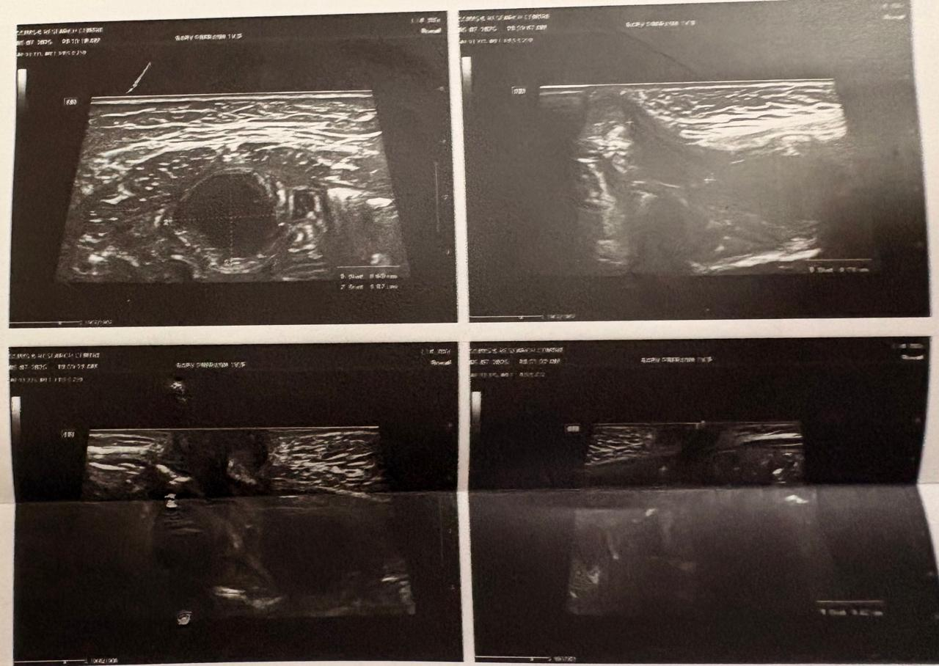
Figure 2: High-resolution ultrasonography of the infraumbilical anterior abdominal wall. Transverse and longitudinal grey-scale ultrasound scans demonstrating an infected urachal remnant complex. The images show a well-defined, thick-walled midline cystic lesion (urachal cyst) deep to the rectus abdominis muscle with fine internal echoes, communicating superiorly with a blind-ending tubular tract extending to the umbilicus (urachal sinus).
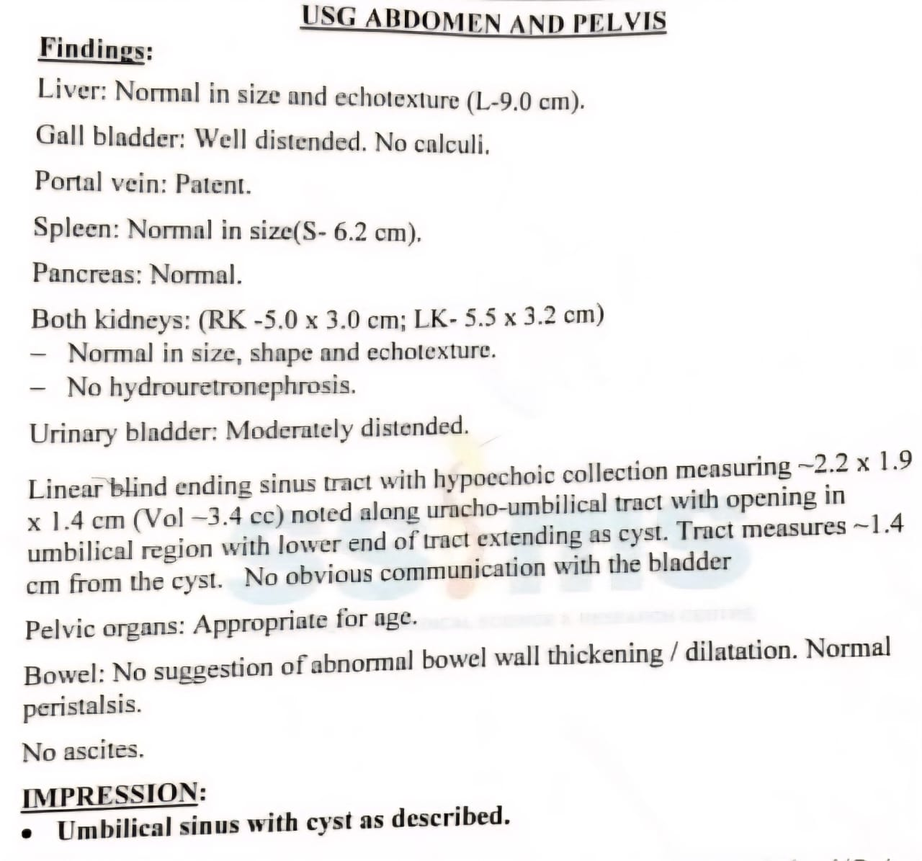
Figure 3: High-resolution pelvic ultrasonography demonstration showing the midline hypoechoic urachal cyst (measuring ~2.2 x 1.9 x 1.4 cm, volume ~3.4 cc) communicating with an umbilical sinus tract.

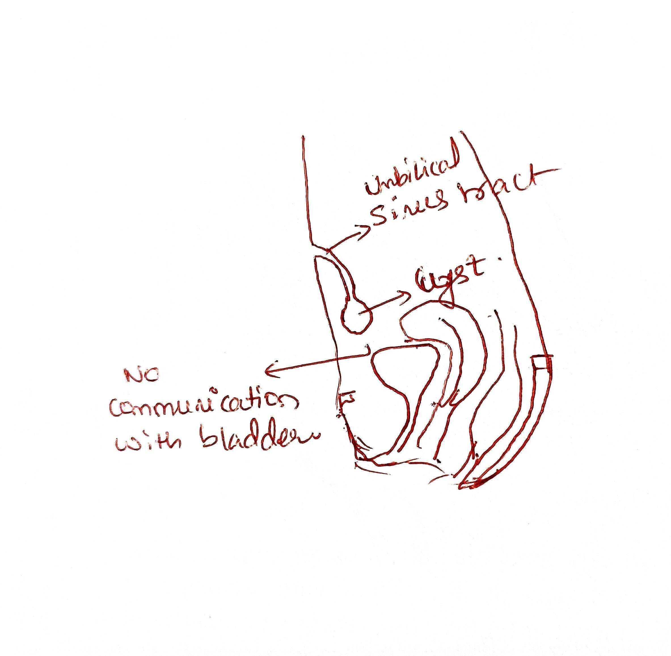
Figure 4: Clinical-anatomical schematic illustration drafted during surgical evaluation, highlighting the umbilical sinus tract opening at the skin, the infected urachal cyst, and its blind termination without intravesical communication.
2.6 Surgical Technique and Intraoperative Findings
On 07/07/2026, the patient underwent elective exploratory laparotomy with excision after perioperative paediatric anaesthesia clearance (ASA PS grade 1). Anaesthesia was induced with general endotracheal intubation using an uncuffed 4.5 mm ET (endotracheal tube) positioned at 12 cm. Anaesthesia was maintained with oxygen, N 2 O, isoflurane, and vecuronium. Under strict sterile technique, an ultrasound-guided caudal epidural block was placed through the sacral hiatus using a 23 G hypodermic needle, with 6 mL of 0.25% bupivacaine, providing excellent regional perioperative analgesia. The patient was positioned supine, and the operative field was appropriately prepared and draped. A 5 cm straight midline infraumbilical vertical incision was made from the inferior border of the umbilicus and extended caudally. The umbilical sinus tract was meticulously dissected and traced subcutaneously. A midline linear opening of the anterior rectus sheath and linea alba provided access to the peritoneal space (space of Retzius). Careful dissection revealed a chronically inflamed, thick-walled, suppurative urachal cyst containing active pus in the prevesical plane; the cyst and umbilical sinus tract were mobilised en bloc. Caudal dissection of the mass revealed a blind fibrous cord that appeared to join the bladder dome through a small pinpoint tract. However, there was no evidence of mucous prolapse into the cyst, and the pinpoint tract at its bladder end was transfixion-ligated close to the bladder surface in the muscular plane with polydioxanone (PDS 5-0). The umbilical sinus tract, surrounding extraperitoneal tissue, and cyst were therefore excised en bloc. Pus was drained and sent for microbiological work-up. The rectus sheath was closed in anatomical layers using continuous PDS and interrupted Prolene sutures, and the skin was closed with subcuticular Prolene (3-0) sutures. Ankyloglossia release, although not indicated for the case, was performed as an ancillary procedure. The total operative time was 1 hour 15 minutes, and the approximate blood loss was 10 mL; intraoperative recovery was uneventful.
2.7 Microbiological Profile and Postoperative Course
An intraoperative pus culture from this case, processed using the Vitek-2 automated microbiology system (bioMerieux), identified Proteus mirabilis with 99% confidence. Antibiotic susceptibility testing showed multidrug resistance, with resistance to ceftazidime (MIC >=64 mcg/mL), cefepime (MIC 8 mcg/mL, SDD), ciprofloxacin (MIC >=4 mcg/mL), levofloxacin (MIC >=8 mcg/mL), minocycline (MIC >=32 mcg/mL), colistin (MIC >=16 mcg/mL, intrinsic), and trimethoprim/sulfamethoxazole (MIC >=320 mcg/mL); intermediate susceptibility to amikacin (MIC 16 mcg/mL); and susceptibility to all carbapenem-class drugs, piperacillin/tazobactam (MIC <=4 mcg/mL), cefoperazone/sulbactam (MIC <=8 mcg/mL), aztreonam (MIC 4 mcg/mL), and meropenem (MIC <=0.25 mcg/mL).
Antimicrobial Agent | MIC (mcg/mL) | Interpretation | Therapeutic Decision
Meropenem | <= 0.25 | Susceptible (S) | Initiated postoperatively (Day 11 onwards)
Piperacillin / Tazobactam | <= 4.0 | Susceptible (S) | Effective alternative option
Cefoperazone / Sulbactam | <= 8.0 | Susceptible (S) | Effective beta-lactamase inhibitor combination
Aztreonam | 4.0 | Susceptible (S) | Monobactam sensitive
Fosfomycin | <= 16.0 | Susceptible (S) | Sensitive
Amikacin | 16.0 | Intermediate (I) | Administered empirically, then discontinued
Gentamicin | 4.0 | Intermediate (I) | Not recommended
Ceftazidime | >= 64.0 | Resistant (R) | Resistant 3rd gen cephalosporin
Cefepime | 8.0 | SDD (Dose-Dependent) | Avoided due to high MIC
Ciprofloxacin | >= 4.0 | Resistant (R) | Fluoroquinolone resistance
Levofloxacin | >= 8.0 | Resistant (R) | Fluoroquinolone resistance
Minocycline | >= 32.0 | Resistant (R) | Tetracycline resistance
Trimethoprim / Sulfamethoxazole | >= 320.0 | Resistant (R) | Folate pathway inhibitor resistance
Colistin | >= 16.0 | Resistant (R) | Intrinsic non-susceptibility (Proteus spp.)
Table 2: Antimicrobial Susceptibility Testing (VITEK-2) for Proteus mirabilis Isolated from Urachal Abscess Pus.
Continuous intraoperative IV fentanyl infusion (1 mcg/kg/hr), postoperative IV ondansetron, and rectal paracetamol suppositories (80 mg) were administered. Initial empirical IV antibiotic coverage with ceftriaxone 250 mg IV BD, amikacin 90 mg IV OD, and IV metronidazole 15 mg TID was continued in the PICU for 24 hours. After the culture and S.F. confirmed MDR Proteus mirabilis on POD 5, treatment was changed to targeted intravenous meropenem 150 mg TID, and ceftriaxone and amikacin were discontinued. Oral syrup and liquid feeds were started successfully on POD 2 and maintained. The wound dressing remained clean on the first postoperative day, without soakage, discharge, or redness, and the wound margins were healthy. The IV bladder catheter was removed on POD 6, with regular s.v. and no problems. Recovery remained uneventful, and the patient was discharged in excellent condition on oral cefixime and paracetamol syrup. Follow-up at 2 and 6 weeks postoperatively showed a well-healed umbilicus without discharge.
3. DISCUSSION
A congenital urachal anomaly develops because of incomplete regression of the cloacal allantois into a fibrous cord extending from the anterior abdominal wall to the bladder vertex (Naiditch et al., 2013). Our patient's unusual presentation, with an infected urachal sinus communicating with an underlying prevesical urachal cyst, represents a combination reported to account for less than 5% of childhood urachal abnormalities (Lipskar et al., 2010). A notable feature of this case was the initial removal of a lesion described as an 'umbilical polyp', followed by persistent infection and recurrent purulent umbilical discharge over the subsequent 7 months; complicated urachal cysts have also been reported in paediatric patients (Kamel et al., 2023). Umbilical pathology is common in young children, who may present with granulomas, omphalitis, polyps, and stitch abscesses. Granulomas typically present as pink tissue not covered by squamous epithelium and usually respond to topical silver nitrate, whereas polyps are epithelialised remnants of embryonic tissues, either the ductus omphalomesentericus (vitelline duct) or urachus (Kutin et al., 1979; Pacilli et al., 2007). Excision of an umbilical polyp or a discharging nodule without cross-sectional ultrasonography or high-frequency US may leave a deep cystic and/or tubular continuity within the abdominal wall, where bacteria can become trapped and lead to purulent abdominal wall abscesses (Kim et al., 2021). High-resolution ultrasonography is therefore an important imaging modality for suspected urachal anomalies in childhood because it is non-invasive, does not use ionising radiation, and provides high-resolution visualisation of the anterior abdominal wall soft tissues (Robert et al., 1996). In a paediatric series, the sensitivity was 79% and specificity 30%, allowing precise delineation of cyst size and contents, wall thickness, and the longitudinal course of the urachal remnant between the umbilicus and bladder apex (Widni et al., 2010). Consistent with diagnostic algorithms that use ultrasound in the evaluation of urachal anomalies (Yiee et al., 2007), pelvic ultrasonography demonstrated a 1.4 cm blind-ending umbilical sinus tract extending along the urachovesical tract to a 2.2×1.9×1.4 cm hypoechoic collection (volume 3.4 cc), providing an anatomical guide for definitive surgical resection. In otherwise uncomplicated paediatric cases, computed tomography (CT) or magnetic resonance imaging (MRI) is rarely indicated and is generally reserved for suspected extraperitoneal rupture or extensive peritonitis, or for excluding possible subsequent malignant change, such as urachal adenocarcinoma, in adults (Yu et al., 2001). The aetiological organisms in infected urachal anomalies most often include cutaneous commensals, such as Staphylococcus aureus and Streptococcus pyogenes, and Gram-negative enterobacteria, such as Escherichia coli and Klebsiella pneumoniae, which may ascend through the umbilical opening, or spread through retrograde lymphatics (Newman et al., 1986). The intraoperative culture specimen in our patient grew Proteus mirabilis, a multidrug-resistant strain showing resistance to third- and fourth-generation cephalosporins, fluoroquinolones, trimethoprim/sulfamethoxazole, and intrinsic resistance to colistin. This organism has also been reported in infected urachal remnants and cysts (Tazi et al., 2012; Linklater & Shook, 2007). Proteus mirabilis produces urease, creating a highly alkaline environment conducive to biofilm formation and the persistence of purulent collections within congenital blind-ending structures (Armbruster et al., 2018). In this case, a culture-guided course of IV meropenem with intravenous metronidazole resulted in rapid resolution and prevented extension of infection into deeper spaces. Symptomatic urachal cysts and sinuses have been reported to require surgical excision for complete treatment (McCollum et al., 2003). Although oral antibiotic treatment can be associated with recurrence rates exceeding 30-40%, simple incision, drainage and packing, or incomplete excision may be associated with chronic discharge, secondary sinus tracts, and a longer-term increased risk of malignancy in adulthood (Nogueras-Ocaña et al., 2014). The surgical approach involves complete en bloc excision of the tract, pyogenic sac, and remnants of the fibrous urachal structure down to the bladder dome, with a transfixing stitch placed at the superior bladder dome (Little et al., 2005). Although laparoscopic or robot-assisted approaches have become increasingly used, in young infants, open transumbilical midline exploration has been described as a cost-effective and relatively quick approach that provides direct access for clean extraperitoneal dissection without breaching the peritoneal cavity (Cadeddu et al., 2000; Patrzyk et al., 2010).
4. CONCLUSION
This case shows a deep urachal cyst communicating through an infected urachal sinus that may be mistakenly interpreted as a recurrent umbilical polyp, stitch abscess, or refractory omphalitis after superficial resection. Paediatricians managing patients with intermittent, recurrent, or prolonged umbilical discharge should maintain a high index of suspicion. High-resolution ultrasonographic assessment of the abdominal wall and pelvis should be performed before any superficial surgical removal or cautery. En bloc surgery, with thorough bladder-dome ligation of the cyst, sinus, and apex, has been the modality of choice for definitive treatment of a urachal cyst. Antibiotic coverage directed towards the identified pathogenic organism provided complete resolution in this case.
5. ETHICAL APPROVAL AND CONSENT
Institutional approval from the institutional ethics committee of S.S. Institute of Medical Sciences & Research centre was granted prior to study. Written consent from the legal guardians (parents) of the patient for publication of this case report and associated photographs and radiography were obtained
- LIMITATION
Limitations of this case report include its single-patient, single-centre design, which limits the generalisability of the clinical course, treatment, and microbiological features to the broader paediatric population with urachal anomalies. Information on previous interventions, including superficial polypectomy at 5 months of age and previously presumed OMPSs during intermittent clinic visits, was derived from retrospectively charted and parent-reported information, with gaps in earlier records, and may therefore be subject to selection and recall bias. Preoperative assessment relied on ultrasonography without advanced cross-sectional imaging, such as contrast-enhanced CT or MRI, which may have limited detection of subtle deep fistulous tracts and prevesical fascial planes. Detailed histological characterisation of the epithelial lining of the cyst and sinus and its correlation with the intraoperative findings were not presented to the extent that would be ideal. Early wound healing and immediate postoperative complications were assessed at 2 and 6 weeks; however, the patient was not evaluated beyond 6 weeks, so definitive conclusions regarding longer-term urinary function, adhesions, or recurrent abdominal infection cannot be made.

Declaration of AI Use

This manuscript was prepared through the intellectual contributions of the author(s) to the study design, data analysis, interpretation of results, and scholarly content. Grammarly and ChatGPT were used solely to assist with grammatical refinement and reference formatting during manuscript revision. The author(s) accept full responsibility for the accuracy, integrity, and final content of the manuscript.

COMPETING INTERESTS:
Authors have declared that they have no known competing financial interests OR non-financial interests OR personal relationships that could have appeared to influence the work reported in this paper.

9. REFERENCES
Abdulfattah, S., Nadeem, I., Parikh, Y., Shaikh, S., Saxena, S., Aghababian, A., Fischer, K., Mittal, S., Srinivasan, A. K., & Shukla, A. R. (2025). Management of urachal anomalies in children: Insights from a retrospective cohort study. World Journal of Pediatric Surgery, 8(1), e000977. https://doi.org/10.1136/wjps-2024-000977
Armbruster, C. E., Mobley, H. L. T., & Pearson, M. M. (2018). Pathogenesis of Proteus mirabilis infection. EcoSal Plus, 8(1). https://doi.org/10.1128/ecosalplus.ESP-0009-2017
Ashley, R. A., Inman, B. A., Routh, J. C., Rohlinger, A. L., Husmann, D. A., & Kramer, S. A. (2007). Urachal anomalies: A longitudinal study of urachal remnants in children and adults. The Journal of Urology, 178(4 Pt 2), 1615–1618. https://doi.org/10.1016/j.juro.2007.03.194
Begg, R. C. (1930). The urachus: Its anatomy, histology, and development. Journal of Anatomy, 64(Pt 2), 170–183. https://pmc.ncbi.nlm.nih.gov/articles/PMC1250190/
Blichert-Toft, M., & Nielsen, O. V. (1971). Diseases of the urachus simulating intra-abdominal disorders. The American Journal of Surgery, 122(1), 123–128. https://doi.org/10.1016/0002-9610(71)90365-5
Cadeddu, J. A., Boyle, K. E., Fabrizio, M. D., Schulam, P. G., & Kavoussi, L. R. (2000). Laparoscopic management of urachal cysts in adulthood. The Journal of Urology, 164(5), 1526–1528. https://doi.org/10.1016/S0022-5347(05)67020-6
Choi, Y. J., Kim, J. M., Ahn, S. Y., Oh, J.-T., Han, S. W., & Lee, J. S. (2006). Urachal anomalies in children: A single center experience. Yonsei Medical Journal, 47(6), 782–786. https://doi.org/10.3349/ymj.2006.47.6.782
Cilento, B. G., Jr., Bauer, S. B., Retik, A. B., Peters, C. A., & Atala, A. (1998). Urachal anomalies: Defining the best diagnostic modality. Urology, 52(1), 120–122. https://doi.org/10.1016/S0090-4295(98)00161-7
Dey, I., Roy, C., & Das, T. K. (2019). A late presenting urachal remnant tumour: Rare adenocarcinoma originated from developmental defect. International Journal of Medical and Pharmaceutical Case Reports, 12(1), 1–8. https://doi.org/10.9734/IJMPCR/2019/v12i130096
To, K.-W., Naidu, L., & Bilolikar, H. (2017). Urachal sinus leading to pyourachus presenting as recurrent periumbilical sepsis in an infant. BMJ Case Reports, 2017, bcr-2017-222187. https://doi.org/10.1136/bcr-2017-222187
Galati, V., Donovan, B., Ramji, F., Campbell, J., Kropp, B. P., & Frimberger, D. (2008). Management of urachal remnants in early childhood. The Journal of Urology, 180(4 Suppl), 1824–1827. https://doi.org/10.1016/j.juro.2008.03.105
Gelikman, D. G., Ibanez, K. R., Ghattas, Y. S., Craver, E. C., Casas-Melley, A. T., Ellsworth, P., & Seth, A. (2024). Management of urachal anomalies in pediatric patients: A comparison of treatment strategies between pediatric urology and general surgery. Journal of Pediatric Urology, 20(1), 75.e1–75.e8. https://doi.org/10.1016/j.jpurol.2023.09.013
Gleason, J. M., Bowlin, P. R., Bagli, D. J., Lorenzo, A. J., Hassouna, T., Koyle, M. A., & Farhat, W. A. (2015). A comprehensive review of pediatric urachal anomalies and predictive analysis for adult urachal adenocarcinoma. The Journal of Urology, 193(2), 632–636. https://doi.org/10.1016/j.juro.2014.09.004
Linklater, D. R., & Shook, J. E. (2007). Images in emergency medicine: Infected urachal cyst. Annals of Emergency Medicine, 50(2), 199, 210. https://doi.org/10.1016/j.annemergmed.2007.01.011
Kamel, K., Nasr, H., Tawfik, S., Azzam, A., Elsaid, M., Qinawy, M., Kamal, A., & Taher, H. (2023). Complicated urachal cyst in two pediatric patients: A case report. BMC Pediatrics, 23(1), 147. https://doi.org/10.1186/s12887-023-03962-x
Kutin, N. D., Allen, J. E., & Jewett, T. C. (1979). The umbilical polyp. Journal of Pediatric Surgery, 14(6), 741–744. https://doi.org/10.1016/S0022-3468(79)80257-2
Lipskar, A. M., Glick, R. D., Rosen, N. G., Layliev, J., Hong, A. R., Dolgin, S. E., & Soffer, S. Z. (2010). Nonoperative management of symptomatic urachal anomalies. Journal of Pediatric Surgery, 45(5), 1016–1019. https://doi.org/10.1016/j.jpedsurg.2010.02.031
Little, D. C., Shah, S. R., St Peter, S. D., Calkins, C. M., Murphy, J. P., Gatti, J. M., Gittes, G. K., Sharp, R. J., Andrews, W. S., Holcomb, G. W., III, Ostlie, D. J., & Snyder, C. L. (2005). Urachal anomalies in children: The vanishing relevance of the preoperative voiding cystourethrogram. Journal of Pediatric Surgery, 40(12), 1874–1876. https://doi.org/10.1016/j.jpedsurg.2005.08.029
McCollum, M. O., MacNeily, A. E., & Blair, G. K. (2003). Surgical implications of urachal remnants: Presentation and management. Journal of Pediatric Surgery, 38(5), 798–803. https://doi.org/10.1016/jpsu.2003.50170
Naiditch, J. A., Radhakrishnan, J., & Chin, A. C. (2013). Current diagnosis and management of urachal remnants. Journal of Pediatric Surgery, 48(10), 2148–2152. https://doi.org/10.1016/j.jpedsurg.2013.02.069
Newman, B. M., Karp, M. P., Jewett, T. C., & Cooney, D. R. (1986). Advances in the management of infected urachal cysts. Journal of Pediatric Surgery, 21(12), 1051–1054. https://doi.org/10.1016/0022-3468(86)90006-0
Nogueras-Ocaña, M., Rodríguez-Belmonte, R., Uberos-Fernández, J., Jiménez-Pacheco, A., Merino-Salas, S., & Zuluaga-Gómez, A. (2014). Urachal anomalies in children: Surgical or conservative treatment? Journal of Pediatric Urology, 10(3), 522–526. https://doi.org/10.1016/j.jpurol.2013.11.010
Tazi, F., Ahsaini, M., Khalouk, A., Mellas, S., Stuurman-Wieringa, R. E., Elfassi, M. J., & Farih, M. H. (2012). Abscess of urachal remnants presenting with acute abdomen: A case series. Journal of Medical Case Reports, 6, 226. https://doi.org/10.1186/1752-1947-6-226
Pacilli, M., Sebire, N. J., Maritsi, D., Kiely, E. M., Drake, D. P., Curry, J. I., & Pierro, A. (2007). Umbilical polyp in infants and children. European Journal of Pediatric Surgery, 17(6), 397–399. https://doi.org/10.1055/s-2007-989220
Patrzyk, M., Glitsch, A., Schreiber, A., von Bernstorff, W., & Heidecke, C.-D. (2010). Single-incision laparoscopic surgery as an option for the laparoscopic resection of an urachal fistula: First description of the surgical technique. Surgical Endoscopy, 24(9), 2339–2342. https://doi.org/10.1007/s00464-010-0922-4
Robert, Y., Hennequin-Delerue, C., Chaillet, D., Dubrulle, F., Biserte, J., & Lemaitre, L. (1996). Urachal remnants: Sonographic assessment. Journal of Clinical Ultrasound, 24(7), 339–344. https://doi.org/10.1002/(SICI)1097-0096(199609)24:7%3C339::AID-JCU2%3E3.0.CO;2-C
Snyder, C. L. (2007). Current management of umbilical abnormalities and related anomalies. Seminars in Pediatric Surgery, 16(1), 41–49. https://doi.org/10.1053/j.sempedsurg.2006.10.006
Kim, D. H., Lee, H. J., Kim, J. Y., & Jung, H. R. (2021). Differential diagnosis of umbilical polyps and granulomas in children: Sonographic and pathologic correlations. Ultrasonography, 40(2), 248–255. https://doi.org/10.14366/usg.20020
Upadhyay, V., & Kukkady, A. (2003). Urachal remnants: An enigma. European Journal of Pediatric Surgery, 13(6), 372–376. https://doi.org/10.1055/s-2003-44725
Widni, E. E., Höllwarth, M. E., & Haxhija, E. Q. (2010). The impact of preoperative ultrasound on correct diagnosis of urachal remnants in children. Journal of Pediatric Surgery, 45(7), 1433–1437. https://doi.org/10.1016/j.jpedsurg.2010.01.001
Yiee, J. H., Garcia, N., Baker, L. A., Barber, R., Snodgrass, W. T., & Wilcox, D. T. (2007). A diagnostic algorithm for urachal anomalies. Journal of Pediatric Urology, 3(6), 500–504. https://doi.org/10.1016/j.jpurol.2007.07.010
Yu, J. S., Kim, K. W., Lee, H. J., Lee, Y. J., Yoon, C. S., & Kim, M. J. (2001). Urachal remnant diseases: Spectrum of CT and US findings. RadioGraphics, 21(2), 451–461. https://doi.org/10.1148/radiographics.21.2.g01mr02451

