A Comparative Analysis of Continuous-Time Markov Chain, Logistic Regression and F-Distribution-Based Inference in Modelling Share Price Movement Dynamics of Fidelity Bank Plc
Abstract
This study examines the dynamics of the share price of Fidelity Bank Plc through three complementary statistical tools: a continuous-time Markov chain (CTMC), logistic regression and inference based on Snedecor’s F-distribution. The analysis uses the matrix of transition counts among three price-movement states (decrease, increase and no change) reported for closing prices from 1 April 2016 to 23 March 2022, comprising 1,481 transitions. The transition probability matrix is estimated by maximum likelihood, with exact Clopper–Pearson limits computed from F quantiles, and a valid CTMC generator is obtained as the matrix logarithm of the estimated matrix. Decreases and unchanged prices were persistent (the probabilities of remaining in the same state were 0.675 and 0.637, respectively), whereas increases were less persistent (0.460). The stationary distribution was 0.415, 0.178 and 0.407 for decrease, increase and no change; the mean sojourn times were 3.08, 1.85 and 2.75 observations. A chi-square test rejected independence of consecutive states (χ²(4) = 450.97, p < 0.001; Cramér’s V = 0.390). Logistic regression showed that the odds of a price change were 5.28 times higher (95% CI 4.21–6.61) after a price change than after an unchanged price, and that the direction of a move tended to repeat that of the preceding move. The results describe persistence in price-movement activity and direction; they do not measure the magnitude of volatility, which requires dated return series.
Keywords: continuous-time Markov chain; logistic regression; F-distribution; exact confidence intervals; share price movement; Fidelity Bank Plc; Nigerian Exchange

1. Introduction
Share price dynamics are central to investment decisions, portfolio construction and risk management. In emerging markets such as Nigeria, bank equities are exposed to macroeconomic and market-wide shocks, and the persistence of price movements over successive trading days is of interest to investors and analysts alike. A large body of work in econometrics models the time-varying conditional variance of returns through autoregressive conditional heteroscedasticity (ARCH; Engle, 1982) and generalised ARCH (GARCH; Bollerslev, 1986) specifications. Applications to Nigerian data include GARCH-type and score-driven models of the All-Share Index, among which the Beta-t-EGARCH specification predicted volatility better than IGARCH-t (Yaya et al., 2016). A second strand treats financial series as switching between latent regimes governed by a Markov chain (Hamilton, 1989); regime-switching models capture abrupt changes in market behaviour and the tendency of a new regime to persist for several periods (Ang & Timmermann, 2012). For Nigeria, a three-regime Markov-switching autoregressive model of the All-Share Index provided evidence of regime-switching behaviour (Adejumo et al., 2020).
A third strand applies finite-state Markov chains directly to observed price-movement states. Mettle et al. (2014) developed a methodology for share prices of the Ghana Stock Exchange based on transition probability matrices, limiting distributions and expected return times. Raheem and Ezepue (2016) fitted a three-state Markov model to the daily returns of a Nigerian bank and estimated the expected durations of rising, falling and stable states. Ayo and Uwabor (2021) applied Markov modelling to seven oil and gas firms listed on the Nigerian Stock Exchange, and Manasseh et al. (2022) studied Markov dependence and steady-state behaviour of the Nigerian share price index over 1985–2019. For the two banks considered in the present article, Osu et al. (2024) proposed a first-order, time-homogeneous Markov chain for closing prices from 1 April 2016 to 23 March 2022, defining three states (increase, decrease and steady) and reporting transition matrices and equilibrium behaviour. Related applications combining Markov chains with principal component analysis were reported for Access Bank (Chigozie et al., 2023), for Access Bank and Fidelity Bank (Bishop et al., 2024) and for Fidelity Bank (Amadi et al., 2024). Agwuegbo et al. (2010) examined the daily behaviour of Nigerian stock market prices within a random-walk framework, which provides a natural benchmark of independence against which Markov dependence can be assessed.
The Markov-chain studies cited above mainly report point estimates of transition matrices. Four aspects receive less attention: (a) the sampling uncertainty of the transition probabilities, (b) a formal test of whether consecutive states are dependent, (c) a continuous-time representation with holding-time and long-run characteristics, and (d) a regression framework that relates the state of the previous observation to the odds of the next movement. The present article addresses these aspects for Fidelity Bank Plc. Its objectives are (i) to estimate the transition probability matrix of the three price-movement states with exact confidence limits derived from the F-distribution; (ii) to construct a CTMC representation and derive its stationary distribution, sojourn times and multi-step transition probabilities; (iii) to test the null hypothesis that consecutive states are independent against the alternative of first-order Markov dependence; and (iv) to use logistic regression to quantify the persistence of price-movement activity and direction. The three tools are complementary: the CTMC summarises the dynamics, the F-based intervals quantify precision, and logistic regression expresses persistence as odds ratios that can be compared across conditions.
The scope of the analysis is deliberately delimited. The states describe whether the closing price decreased, increased or was unchanged; they do not describe the size of the movement. Consequently, the results concern the persistence of price-movement activity and direction and should not be read as estimates of return volatility in the conditional-variance sense.

2. Data and Methods

2.1 Data
The data are the counts of transitions between three states of the closing share price of Fidelity Bank Plc: decrease (R), increase (I) and no change (N). The counts were reported by Amadi et al. (2024) for daily closing prices from the Nigerian Stock Exchange and are derived from the closing-price series of Osu et al. (2024), which spans 1 April 2016 to 23 March 2022. Let $n_{ij}$ denote the number of times the state at one observation was $i$ and the state at the next observation was $j$, for $i,j∈\{R,I,N\}$. The counts are displayed in Table 1.
Two consistency checks support the use of these counts. First, the row totals and column totals coincide (615, 263 and 603), as expected for the transition counts of a single observed chain, whose row and column totals can differ by at most one. Second, the first row of the combined Access–Fidelity matrix reported by Osu et al. (2024), 825, 142 and 264, equals the sum of the first rows of the Access Bank matrix (410, 80 and 126; Chigozie et al., 2023) and of the Fidelity Bank matrix used here (415, 62 and 138). The individual price series and their calendar dates are not part of the reported data; consequently, the analysis is confined to the transition structure of the three states.

2.2 Discrete-time and continuous-time Markov chain
Let $\{X_{n}\}$ be a stochastic process on the state space $S=\{R,I,N\}$. It is a time-homogeneous first-order Markov chain if
$$P\left(X_{n+1}=j∣X_{n}=i,X_{n-1},…,X_{0}\right)=P\left(X_{n+1}=j∣X_{n}=i\right)=p_{ij}, \left(1\right)$$
for all $n≥0$ and $i,j∈S$ (Norris, 1997). Conditional on the initial state, the likelihood factorises into independent multinomial contributions from the rows of the count matrix, and the maximum-likelihood estimator of the transition probabilities is
pij=nijni⋅, ni⋅=j∈S​nij, 2
with asymptotic distribution theory given by Anderson and Goodman (1957) and Billingsley (1961).
Proposition 1. If $p_{ij}>0$ for all $i,j∈S$, the chain is irreducible and aperiodic on a finite state space. It is therefore positive recurrent, has a unique stationary distribution $π=\left(π_{R},π_{I},π_{N}\right)$ that satisfies
πP=π, i∈S​πi=1, 3
with $π_{i}>0$ for every $i$, and $P^{n}$ converges geometrically to the matrix whose rows all equal $π$, at a rate governed by the second largest eigenvalue modulus of $P$.
Proof. Because every entry of $P$ is positive, each state is reachable from every other state in one step, so the chain is irreducible, and $p_{ii}>0$ implies aperiodicity. An irreducible chain on a finite state space is positive recurrent and has a unique strictly positive stationary distribution, and an aperiodic one converges to it geometrically (Norris, 1997, Chapter 1). ∎
All entries of the estimated matrix are positive (Section 3.2), so Proposition 1 applies. In particular, no state is transient and no state has zero long-run probability.
The data are recorded at successive observation times, so the discrete-time chain is the natural model for them. A continuous-time representation is obtained by seeking a generator $Q=\left(q_{ij}\right)$ such that the transition probabilities over one unit of time equal the estimated matrix,
$$P\left(t\right)=e^{Qt}=\sum_{k=0}^{∞}{\frac{{\left(Qt\right)}^{k}}{k!}}, P\left(1\right)=\hat{P}, \left(4\right)$$
where $q_{ij}≥0$ for $i≠j$ and qii=-j≠i​qij. The matrix $P\left(t\right)$ satisfies the Kolmogorov forward equation $dP\left(t\right)/dt=P\left(t\right)Q$ with $P\left(0\right)=I$. A valid generator need not exist for an empirically estimated matrix and, when it exists, need not be unique (Israel et al., 2001). If $\hat{P}$ has real, positive and distinct eigenvalues, its principal matrix logarithm $\hat{Q}=log\hat{P}$ is real and satisfies $e^{\hat{Q}}=\hat{P}$; it is a valid generator provided its off-diagonal entries are non-negative, which is verified in Section 3.3. Because the eigenvalues of $\hat{Q}$ are the logarithms of those of $\hat{P}$, the left eigenvector of $\hat{P}$ for eigenvalue one is the left null vector of $\hat{Q}$, so that $π\hat{Q}=0$ and the stationary distribution of the CTMC coincides with that of the discrete-time chain.
In state $i$, the CTMC waits an exponentially distributed holding time with rate $q_{i}=-q_{ii}$ and mean $1/q_{i}$, and then moves to state $j≠i$ with probability $q_{ij}/q_{i}$. The discrete-time chain observed at successive times has a geometric sojourn time $S_{i}$ (the number of consecutive observations spent in state $i$) with
$$E\left(S_{i}\right)=\frac{1}{1-p_{ii}}, Var\left(S_{i}\right)=\frac{p_{ii}}{{\left(1-p_{ii}\right)}^{2}}, \left(5\right)$$
and the mean recurrence time of state $i$ is $1/π_{i}$. Mean first-passage times between states are obtained by solving the standard linear systems for the chain (Norris, 1997).

2.3 F-distribution-based exact inference and tests of dependence
For each row $i$, $n_{ij}$ is binomial with $n_{i⋅}$ trials and success probability $p_{ij}$. Let $x=n_{ij}$ and $m=n_{i⋅}$. The exact two-sided $100\left(1-α\right)\%$ confidence limits of Clopper and Pearson (1934) can be written in terms of quantiles $F_{q}\left(ν_{1},ν_{2}\right)$ of Snedecor’s F-distribution with $ν_{1}$ and $ν_{2}$ degrees of freedom:
$$p_{L}=\frac{x}{x+\left(m-x+1\right) F_{1-α/2}\left(2\left(m-x+1\right), 2x\right)}, \left(6a\right)$$
$$p_{U}=\frac{\left(x+1\right) F_{1-α/2}\left(2\left(x+1\right), 2\left(m-x\right)\right)}{\left(m-x\right)+\left(x+1\right) F_{1-α/2}\left(2\left(x+1\right), 2\left(m-x\right)\right)}. \left(6b\right)$$
The limits are $p_{L}=0$ if $x=0$ and $p_{U}=1$ if $x=m$. They were verified to agree, to at least nine decimal places, with the equivalent beta-quantile form. Because each row of the estimated matrix has several hundred observations, the intervals are informative, and their exactness protects the coverage without relying on a normal approximation.
To test whether consecutive states are dependent, the null hypothesis that the next state is independent of the current state (a zero-order chain) is tested against a first-order chain using the contingency-table statistics of Anderson and Goodman (1957). With expected counts $e_{ij}=n_{i⋅}n_{⋅j}/n$, where n=i,j​nij, the Pearson and likelihood-ratio statistics are
X2=i,j​nij-eij2eij, G2=2i,j​nijlnnijeij, 7
each is asymptotically chi-square distributed with $\left(3-1\right)\left(3-1\right)=4$ degrees of freedom under the null hypothesis. The strength of association is summarised by Cramér’s $V=\sqrt{X^{2}/\{n\left(min\left(r,c\right)-1\right)\}}$ with $r=c=3$. Pairwise homogeneity of two rows is assessed with the corresponding $2×3$ chi-square statistic (2 degrees of freedom), and the three pairwise tests are evaluated at the Bonferroni-adjusted level $0.05/3$.

2.4 Logistic regression
Logistic regression is applied to the grouped transition counts. For a group defined by the state at the current observation, let $y$ be the number of transitions with the outcome of interest among $m$ transitions. With covariate vector $x$, the model is
$$logitP\left(Y=1∣x\right)=ln\frac{P\left(Y=1∣x\right)}{1-P\left(Y=1∣x\right)}=β_{0}+β^{⊤}x, \left(8\right)$$
and $e^{β_{k}}$ is the odds ratio associated with the covariate. Parameters were estimated by maximum likelihood for grouped binomial data using iteratively reweighted least squares (Agresti, 2013). Wald intervals are $exp\left({\hat{β}}_{k}±1.96 {SE}_{k}\right)$, and nested models were compared by likelihood-ratio statistics. Conditional on the initial state, the likelihood of a first-order Markov chain is the product of row-wise multinomial likelihoods, so that regression on the transition counts is a valid conditional-likelihood analysis of the chain (Anderson & Goodman, 1957). Three models were fitted. Model A relates the odds that the next observation is a price change (R or I, versus N) to whether the current observation is a price change. Model A2 uses the three current states, with R as the reference category. Model B relates the odds that a price change is a decrease rather than an increase to the current state, with R as the reference category.

3. Results and Discussion

3.1 Observed transitions
Table 1 presents the observed transition counts, and Figure 1 shows them as a surface over the current and next states. The total number of transitions is 1,481. The marginal frequencies of the states were 615 decreases (41.5%), 263 increases (17.8%) and 603 unchanged prices (40.7%). The largest counts lie on the main diagonal for R (415) and N (384), which indicates that the state at one observation tends to be repeated at the next.
Table 1. Observed transition counts among the price-movement states of Fidelity Bank Plc
Current state | Next: R | Next: I | Next: N | Row total
R (decrease) | 415 | 62 | 138 | 615
I (increase) | 61 | 121 | 81 | 263
N (no change) | 139 | 80 | 384 | 603
Column total | 615 | 263 | 603 | 1,481
Note. R = price decreased; I = price increased; N = price unchanged. Counts are taken from Amadi et al. (2024); the underlying closing prices span 1 April 2016 to 23 March 2022 (Osu et al., 2024).
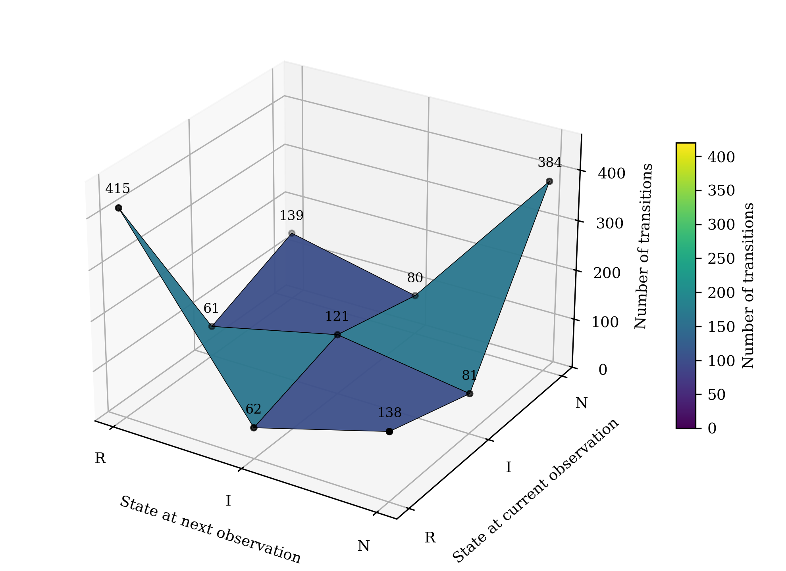
Figure 1. Surface view of the observed transition counts between the price-movement states of Fidelity Bank Plc shares. R = decrease, I = increase, N = no change. Each vertex corresponds to one entry of Table 1.
Figure 1 shows two ridges, one at the R→R transition and one at the N→N transition, and a much lower level for transitions into the increase state. The surface joins only nine values, so it is a visual summary of Table 1 and not a fitted function.

3.2 Transition probabilities and exact confidence limits
Table 2 gives the maximum-likelihood estimates of Equation (2) with 95% exact confidence limits obtained from Equations (6a) and (6b), and Figure 2 displays the estimated matrix. The estimated matrix is
$$\hat{P}=\left(\begin{matrix}0.6748 & 0.1008 & 0.2244 \\ 0.2319 & 0.4601 & 0.3080 \\ 0.2305 & 0.1327 & 0.6368\end{matrix}\right), \left(9\right)$$
and its rows reproduce the fractions of the counts in Table 1. All entries are positive, so Proposition 1 applies.
Table 2. Estimated transition probabilities with 95% exact (Clopper–Pearson) confidence limits
Current state | Next: R | Next: I | Next: N
R | 0.675 (0.636, 0.712) | 0.101 (0.078, 0.127) | 0.224 (0.192, 0.260)
I | 0.232 (0.182, 0.288) | 0.460 (0.399, 0.522) | 0.308 (0.253, 0.368)
N | 0.231 (0.198, 0.266) | 0.133 (0.107, 0.162) | 0.637 (0.597, 0.675)
Note. Values are estimates with 95% confidence limits in parentheses, computed from F quantiles as in Equations (6a) and (6b). Row sizes are 615 (R), 263 (I) and 603 (N).
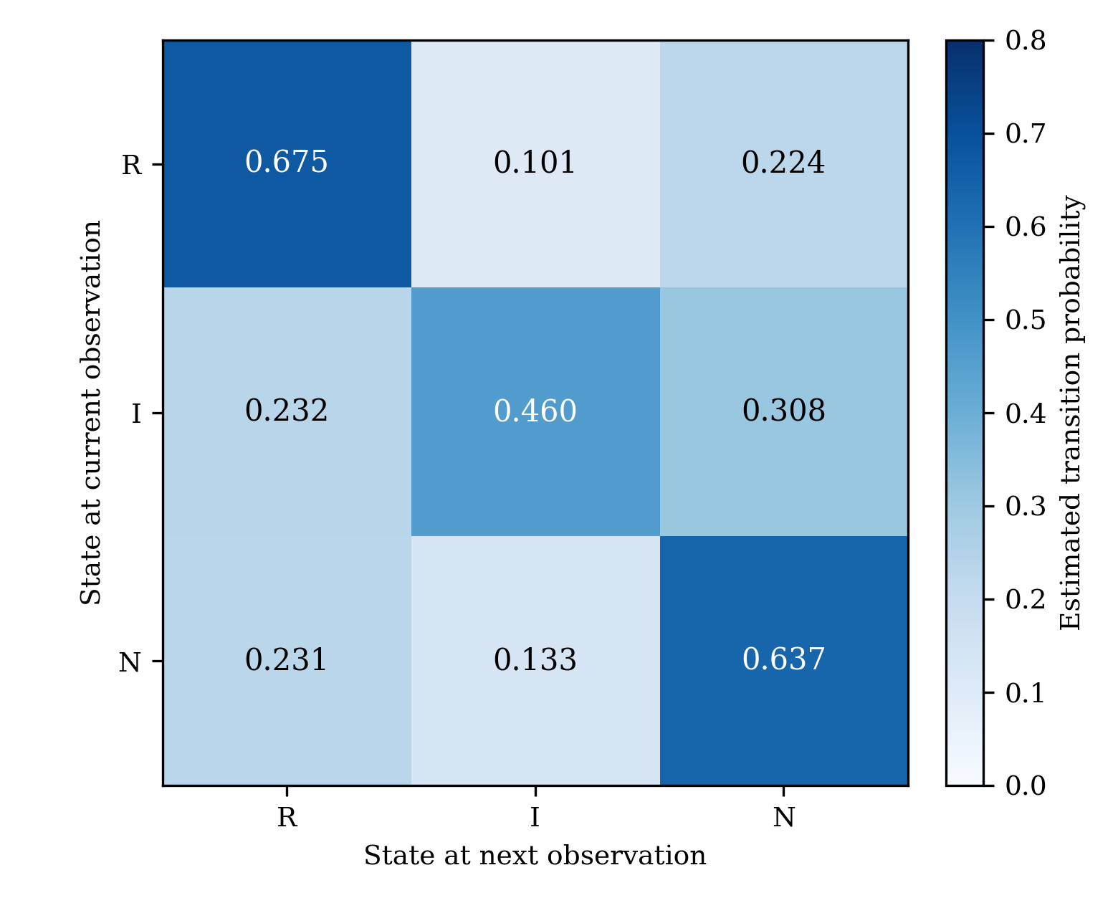
Figure 2. Heat map of the estimated one-step transition probability matrix. Darker cells indicate higher probabilities.
Same-state persistence is high for decreases (0.675; 95% CI 0.636–0.712) and for unchanged prices (0.637; 0.597–0.675) and lower for increases (0.460; 0.399–0.522). The interval for the persistence of decreases does not overlap that for increases, so the data support the statement that decreases were more persistent than increases. After an increase or an unchanged price, the probability of a decrease at the next observation was nearly identical (0.232 and 0.231), while after a decrease the probability of an increase was only 0.101 (0.078–0.127). Direct reversals from a decrease to an increase were therefore uncommon.

3.3 Continuous-time representation
The eigenvalues of $\hat{P}$ are 1, 0.444 and 0.328; they are real, positive and distinct, so the principal logarithm of $\hat{P}$ is real. It equals
$$\hat{Q}=log\hat{P}=\left(\begin{matrix}-0.475 & 0.150 & 0.325 \\ 0.340 & -0.884 & 0.544 \\ 0.336 & 0.233 & -0.569\end{matrix}\right), \left(10\right)$$
with time measured in observation intervals. All off-diagonal entries are non-negative (the smallest is 0.150) and the row sums are zero, so $\hat{Q}$ is a valid generator, and a numerical check gave $e^{\hat{Q}}=\hat{P}$ to machine precision and $π\hat{Q}=0$. The exit rates are ${\hat{q}}_{R}=0.475$, ${\hat{q}}_{I}=0.884$ and ${\hat{q}}_{N}=0.569$, corresponding to mean holding times of 2.11, 1.13 and 1.76 observation intervals. As noted in Section 2.2, a generator consistent with a given transition matrix is not necessarily unique (Israel et al., 2001), and holding times in continuous time cannot be verified against data recorded at discrete times. They should therefore be read as model-based summaries implied by the chosen generator. The quantities that are directly observable are those of the discrete-time chain, reported in Table 4.
Table 3 gives the three-step-ahead transition probabilities from each starting state. For integer time $t$, $e^{\hat{Q}t}={\hat{P}}^{t}$, so the same values are obtained from the continuous-time and discrete-time formulations.
Table 3. Scenario analysis: three-step-ahead transition probabilities
Scenario | Starting state | Probability at step 3 (R / I / N) | Interpretation
Downward momentum | R | 0.466 / 0.163 / 0.371 | The probability of a decrease remains above the long-run value (0.415) three steps after a decrease.
Upward move | I | 0.379 / 0.212 / 0.408 | Three steps after an increase, the probability of a decrease is below the long-run value and that of an increase is above it.
Quiet market | N | 0.379 / 0.177 / 0.444 | Three steps after an unchanged price, the probability of a decrease is below the long-run value and that of no change is above it.
Note. Long-run probabilities (R / I / N): 0.415 / 0.178 / 0.407. After ten steps, all three rows agree with the long-run values to within 0.001.
The influence of the starting state fades quickly. The second-largest eigenvalue of $\hat{P}$ is 0.444, so the departure from the stationary distribution shrinks by roughly this factor at each step, and after ten steps the rows of ${\hat{P}}^{10}$ agree with the stationary distribution to three decimal places. Persistence of the price-movement states is therefore short-lived in the sense that the memory of the chain is measured in a few observations.

3.4 Stationary distribution and sojourn times
Table 4 reports the stationary distribution and sojourn-time characteristics implied by Equations (3) and (5). The stationary distribution (0.415, 0.178, 0.407) equals the empirical marginal distribution of the states, as it must when row and column totals coincide.
Table 4. Stationary probabilities and sojourn-time characteristics by state
State | Row size | p̂_{ii} | Mean sojourn | Variance of sojourn | π̂_{i} | Mean recurrence time
R | 615 | 0.675 | 3.08 | 6.38 | 0.415 | 2.41
I | 263 | 0.460 | 1.85 | 1.58 | 0.178 | 5.63
N | 603 | 0.637 | 2.75 | 4.83 | 0.407 | 2.46
Note. Sojourn time is the number of consecutive observations spent in a state. Times are expressed in observation intervals.
A run of decreases lasts on average 3.08 observations, compared with 1.85 for increases and 2.75 for unchanged prices. Increases are the least frequent state and recur, on average, only about once every 5.6 observations. Mean first-passage times show the same asymmetry: from a decrease, the mean time to the first increase is 8.85 observations, compared with 4.21 to the first unchanged price, and from an unchanged price the mean time to the first increase is 8.37 observations. Raheem and Ezepue (2016) reported maximum expected run lengths of about four observations for positive and negative return states of a different Nigerian bank over 2005–2012. The order of magnitude of the run lengths found here is similar, although the data, period and state definitions differ and the comparison is only qualitative.

3.5 Tests of dependence between consecutive states
Table 5 shows that the null hypothesis of independence between consecutive states is rejected decisively. The Pearson statistic is $X^{2}=450.97$ and the likelihood-ratio statistic $G^{2}=415.65$, each with 4 degrees of freedom, and both correspond to $p<0.001$. Cramér’s $V$ is 0.390, which indicates a moderate to strong association. The standardised residuals are large and positive on the diagonal (9.99, 10.87 and 8.84 for R, I and N) and negative off it, so the dependence arises mainly from the repetition of the current state. All three pairwise comparisons of rows are also significant at the Bonferroni-adjusted level, which shows that the distribution of the next state differs according to whether the current state is R, I or N.
Table 5. Chi-square tests of independence and homogeneity of the transition distributions
Test | Statistic | df | p | Effect size
Independence of consecutive states, Pearson X² | 450.97 | 4 | < 0.001 | V = 0.390
Independence of consecutive states, likelihood ratio G² | 415.65 | 4 | < 0.001
Homogeneity of rows R and I | 185.88 | 2 | < 0.001
Homogeneity of rows R and N | 255.62 | 2 | < 0.001
Homogeneity of rows I and N | 121.46 | 2 | < 0.001
Note. V = Cramér’s V. Pairwise tests were assessed at the Bonferroni-adjusted level 0.05/3.
This result is inconsistent with independence of consecutive states and supports first-order dependence over a zero-order chain, in the sense of the tests of Anderson and Goodman (1957). It concerns the states defined by the direction of the price change, including the unchanged state. It should not be read as a test of the random-walk hypothesis for returns, which involves the magnitude of returns and calendar-dated data (Agwuegbo et al., 2010).

3.6 Logistic regression
Table 6 reports the logistic models. In Model A, the odds that the next observation was a price change were 0.57 (95% CI 0.48–0.67) when the current price was unchanged and were multiplied by 5.28 (95% CI 4.21–6.61; Wald $z$ = 14.45, $p<0.001$) when the current observation was itself a price change. The likelihood-ratio statistic against the null model was 225.18 (1 degree of freedom, $p<0.001$). Price-changing observations therefore cluster: a change is followed by another change considerably more often than an unchanged price is followed by a change. For price activity, this is analogous to the persistence that conditional-variance models describe for return magnitudes (Engle, 1982; Bollerslev, 1986), although the present analysis does not measure the size of price changes.
Model A2 shows that the activity effect is not uniform across the two price-changing states. Relative to a previous decrease, the odds of a subsequent price change were lower after an increase (odds ratio 0.65; 95% CI 0.47–0.90; $p$ = 0.009) and much lower after an unchanged price (odds ratio 0.165; 0.128–0.212). The likelihood-ratio statistic for Model A2 against the null was 231.88 (2 degrees of freedom, $p<0.001$).
Model B addresses direction. Among price changes that followed a decrease, the odds of another decrease (rather than an increase) were 6.69 (95% CI 5.13–8.74), equivalent to a probability of 0.870. After an increase, the odds fell to 0.075 times that value (95% CI 0.050–0.113), and after an unchanged price, they fell to 0.260 times that value (0.177–0.381). Direction therefore tends to repeat: 87.0% of price changes following a decrease were decreases, 66.5% of price changes following an increase were increases and 63.5% of price changes following an unchanged price were decreases. The likelihood-ratio statistic for Model B against the null was 183.77 (2 degrees of freedom, $p<0.001$).
Table 6. Logistic regression analysis of price-movement activity and direction
Model and predictor | β̂ | SE | Odds ratio | 95% CI | z | p
Model A (outcome: price change vs no change)
Intercept (previous state N; odds) | −0.562 | 0.085 | 0.570 | 0.483–0.673 | −6.63 | < 0.001
Previous state R or I | 1.663 | 0.115 | 5.276 | 4.210–6.612 | 14.45 | < 0.001
Model A2 (outcome: price change vs no change)
Intercept (previous state R; odds) | 1.240 | 0.097 | 3.457 | 2.860–4.177 | 12.83 | < 0.001
Previous state I | −0.431 | 0.165 | 0.650 | 0.471–0.898 | −2.61 | 0.009
Previous state N | −1.802 | 0.129 | 0.165 | 0.128–0.212 | −14.02 | < 0.001
Model B (outcome: decrease vs increase, among price changes)
Intercept (previous state R; odds) | 1.901 | 0.136 | 6.694 | 5.126–8.741 | 13.96 | < 0.001
Previous state I | −2.586 | 0.208 | 0.075 | 0.050–0.113 | −12.44 | < 0.001
Previous state N | −1.349 | 0.196 | 0.260 | 0.177–0.381 | −6.90 | < 0.001
Note. Odds ratios for intercepts are odds. Wald 95% confidence intervals are used. Likelihood-ratio statistics against the null model: Model A, 225.18 (df = 1); Model A2, 231.88 (df = 2); Model B, 183.77 (df = 2); all p < 0.001.

3.7 Comparison of the three approaches and their implications
The three tools provide different but consistent information. The CTMC and its discrete-time counterpart describe the dynamics in a compact form: state-specific persistence, the speed at which the memory of the starting state disappears, and the long-run composition of the sequence. The F-distribution-based exact limits quantify the precision of these quantities and show that the differences in persistence between decreases and increases are larger than the sampling variability. Logistic regression expresses the same dependence as odds ratios, distinguishing persistence of activity (Model A) from persistence of direction (Model B) and providing effect sizes with interval estimates. The chi-square tests confirm formally that the dependence is not attributable to chance.
The estimated transition matrix coincides with the Fidelity Bank matrix that underlies the earlier Markov analyses of the same price series (Osu et al., 2024; Amadi et al., 2024), which is expected because the same counts are used. The additional results are the exact intervals, the continuous-time representation, the tests and the regression models. For a decision-maker, the main implication is descriptive: a decrease was, over the study period, more likely to be followed by a further decrease than by an increase or an unchanged price, and the influence of the current state disappears within a few observations. These are statements about the frequency of price-movement states and do not constitute a forecast of returns or a trading rule.

3.8 Limitations and directions for future research
Several limitations should be noted. First, the analysis uses aggregated transition counts; the dated price series and the magnitudes of the changes are not available in the reported data, so return volatility in the conditional-variance sense could not be estimated and GARCH-type or Markov-switching benchmarks (Engle, 1982; Bollerslev, 1986; Hamilton, 1989) could not be fitted. Second, the time-homogeneity of the transition probabilities over the six-year period and the adequacy of a first-order chain compared with higher-order dependence cannot be tested without the ordered sequence, although the tests of Anderson and Goodman (1957) are available for that purpose when the sequence is at hand. Third, the definition of the states does not distinguish small from large price changes, and the unchanged state may partly reflect the trading conditions of the stock. Fourth, the continuous-time generator obtained by the matrix logarithm is one of several possible generators consistent with the daily matrix (Israel et al., 2001). Future research should use the dated daily closing prices of Fidelity Bank and other listed banks to define regimes from return magnitudes, to test time-homogeneity, to compare the Markov-chain results with GARCH-type and regime-switching models, and to evaluate out-of-sample performance.

4. Conclusion
This article analysed the price-movement dynamics of Fidelity Bank Plc using the matrix of transition counts among decrease, increase and no-change states for closing prices between 1 April 2016 and 23 March 2022. The estimated transition matrix showed strong persistence of decreases (0.675) and unchanged prices (0.637) and weaker persistence of increases (0.460), with exact 95% intervals that separate the persistence of decreases from that of increases. The continuous-time representation gave a valid generator whose stationary distribution (0.415, 0.178, 0.407) equals the empirical distribution of the states, and the influence of the starting state vanished within about ten observations. Independence of consecutive states was rejected (χ²(4) = 450.97, p < 0.001; Cramér’s V = 0.390), and logistic regression showed that price changes clustered (odds ratio 5.28; 95% CI 4.21–6.61) and that their direction tended to repeat. The results characterise the persistence of price-movement activity and direction, and they should be complemented by analyses of dated return series to assess volatility in its usual sense.

Data Availability Statement
The transition counts analysed in this study are reported in Table 1 and in Amadi et al. (2024). The underlying closing prices are described by Osu et al. (2024) as covering 1 April 2016 to 23 March 2022 for Fidelity Bank Plc and Access Bank Plc.

References
Adejumo, O. A., Albert, S., & Asemota, O. J. (2020). Markov regime-switching autoregressive model of stock market returns in Nigeria. CBN Journal of Applied Statistics, 11(2), 65–83. https://doi.org/10.33429/Cjas.11220.3/8
Agresti, A. (2013). Categorical data analysis (3rd ed.). Wiley.
Agwuegbo, S. O. N., Adewole, A. P., & Maduegbuna, A. N. (2010). A random walk model for stock market prices. Journal of Mathematics and Statistics, 6(3), 342–346. https://doi.org/10.3844/jmssp.2010.342.346
Amadi, I. U., Howard, C., & Azor, P. A. (2024). Robust methods of assessing Fidelity Bank share price movements in Nigeria stock market. GPH-International Journal of Mathematics, 7(4), 1–13. https://doi.org/10.5281/zenodo.11151690
Anderson, T. W., & Goodman, L. A. (1957). Statistical inference about Markov chains. The Annals of Mathematical Statistics, 28(1), 89–110. https://doi.org/10.1214/aoms/1177707039
Ang, A., & Timmermann, A. (2012). Regime changes and financial markets. Annual Review of Financial Economics, 4, 313–337. https://doi.org/10.1146/annurev-financial-110311-101808
Ayo, A. S., & Uwabor, E. S. (2021). Markovian approach to stock price modelling in the Nigerian oil and gas sector. CBN Journal of Applied Statistics, 12(1), 23–43. https://doi.org/10.33429/Cjas.12121.2/6
Billingsley, P. (1961). Statistical methods in Markov chains. The Annals of Mathematical Statistics, 32(1), 12–40. https://doi.org/10.1214/aoms/1177705136
Bishop, D. A. W., Amadi, I. U., & Isobeye, G. (2024). The influence of Markov chain and properties of principal component solutions in the analysis of share price movements for stock market. Journal of Entrepreneurial and Business Diversity, 2(3), 303–312. https://doi.org/10.38142/jebd.v2i3.131
Bollerslev, T. (1986). Generalized autoregressive conditional heteroskedasticity. Journal of Econometrics, 31(3), 307–327. https://doi.org/10.1016/0304-4076(86)90063-1
Clopper, C. J., & Pearson, E. S. (1934). The use of confidence or fiducial limits illustrated in the case of the binomial. Biometrika, 26(4), 404–413. https://doi.org/10.1093/biomet/26.4.404
Engle, R. F. (1982). Autoregressive conditional heteroscedasticity with estimates of the variance of United Kingdom inflation. Econometrica, 50(4), 987–1007. https://doi.org/10.2307/1912773
Hamilton, J. D. (1989). A new approach to the economic analysis of nonstationary time series and the business cycle. Econometrica, 57(2), 357–384. https://doi.org/10.2307/1912559
Israel, R. B., Rosenthal, J. S., & Wei, J. Z. (2001). Finding generators for Markov chains via empirical transition matrices, with applications to credit ratings. Mathematical Finance, 11(2), 245–265. https://doi.org/10.1111/1467-9965.00114
Manasseh, C. O., Iroha, N. M., Okere, K. I., Nwakoby, I. C., Okanya, O. C., Nwonye, N., Odidi, O., & Inyiama, O. I. (2022). Application of Markov chain to share price movement in Nigeria (1985–2019). Future Business Journal, 8, Article 59. https://doi.org/10.1186/s43093-022-00168-y
Mettle, F. O., Quaye, E. N. B., & Laryea, R. A. (2014). A methodology for stochastic analysis of share prices as Markov chains with finite states. SpringerPlus, 3, Article 657. https://doi.org/10.1186/2193-1801-3-657
Norris, J. R. (1997). Markov chains. Cambridge University Press. https://doi.org/10.1017/CBO9780511810633
Chigozie, O., Ele, C. B., & Uchenna, A. I. (2023). Generalized methods on Access Bank share price changes and variations in Nigeria stock market. Journal of Entrepreneurial and Business Diversity, 1(4), 151–159. https://doi.org/10.38142/jebd.v1i4.108
Osu, B. O., Emenyonu, S. C., Ogbogbo, C. P., & Olunkwa, C. (2024). Markov models on share price movements in Nigeria stock market capitalization. Journal of Statistics Applications & Probability, 13(1), 357–368. https://doi.org/10.18576/jsap/130124
Raheem, M. A., & Ezepue, P. O. (2016). A three-state Markov model for predicting movements of asset returns of a Nigerian bank. CBN Journal of Applied Statistics, 7(2), 77–99. https://doi.org/10.33429/2476-8472.1132
Yaya, O. S., Bada, A. S., & Atoi, N. V. (2016). Volatility in the Nigerian stock market: Empirical application of Beta-t-GARCH variants. CBN Journal of Applied Statistics, 7(2), 27–48. https://doi.org/10.33429/2476-8472.1130

