Bilateral Fingerprint and Toeprint Ridge Characteristics among Ijaw and Ibibio Adults in Southern Nigeria: A Descriptive Cross-Sectional Study

Abstract
Background: Bilateral friction-ridge measurements may provide descriptive information about digit-specific variation, but population-specific data that include both fingers and toes remain limited for adults from the Niger Delta region of Nigeria. Objective: To describe left- and right-sided fingerprint and toeprint ridge-count means and image-derived ridge-density measures separately in Ijaw and Ibibio adult samples. Methods: A community-based cross-sectional sample comprised 565 participants aged 18–40 years: 250 Ijaw adults (120 males and 130 females) and 315 Ibibio adults (150 males and 165 females). Bilateral impressions were acquired using a flatbed scanner and examined digitally. For each sex-by-population subgroup, mean values for corresponding digits and arithmetic left-minus-right mean differences were summarised. Results: The largest displayed fingerprint ridge-count difference was in the Ijaw male thumbs (left 12.52; right 14.81; difference −2.29 ridges). Ibibio male little-finger ridge counts were 13.16 on the left and 14.62 on the right (difference −1.46). In contrast, the corresponding mean index-finger density indices among Ibibio males were 14.13 and 14.38, respectively (difference −0.25). Toeprint mean differences were generally smaller than the largest finger ridge-count differences, although their size varied by digit and subgroup. Conclusions: These descriptive summaries document digit-specific left–right variation in the examined samples. Without calibrated ridge-density measurement and participant-level paired-difference analysis, the observations do not establish equivalence, statistical asymmetry, between-population contrasts, or identification performance.
Keywords: Dermatoglyphics; fingerprint; toeprint; ridge count; ridge-density index; left–right variation

1. Introduction
Friction ridges on the fingers and plantar surfaces develop early in life and provide anatomical features widely studied in dermatoglyphics and forensic identification. Broad pattern classes—arches, loops, and whorls—describe recognisable configurations, whereas ridge counts and local ridge-density measures provide quantitative descriptions of the print surface. Their practical interpretation depends on the quality and reproducibility of image acquisition, anatomical landmarks, measurement location, and reporting methods (Bécue et al., 2020; Bécue & Champod, 2023; Sudha et al., 2021).
A ridge count is commonly obtained by enumerating the ridges crossing a line between specified pattern landmarks. In contrast, ridge density represents a count over a defined area and is sensitive to how that area is positioned and scaled. Gutiérrez-Redomero et al. (2014) highlighted the importance of standardised counting locations and acquisition procedures when comparing fingerprint ridge density. Studies of sex-related variation have similarly used explicitly defined sampling areas rather than assuming that measurements from different procedures are interchangeable (Kaur et al., 2020; Krishan et al., 2015; Rivaldería et al., 2016).
Left–right comparison adds another dimension to dermatoglyphic description. Corresponding digits may share a broad pattern category while having different ridge counts or local ridge-density values. Importantly, a difference between group means is not the same as an individual-level asymmetry measure. Analyses of directional and fluctuating asymmetry require suitable individual paired data, measurement-error evaluation, and explicitly defined estimands (Graham et al., 2010). A descriptive comparison of side-specific means can characterise the sample but cannot demonstrate statistical equivalence or developmental stability.
Several Nigerian studies have described population-specific dermatoglyphic features. Anyanwu (2020) documented variations among Esan participants, and Ojigho et al. (2020) assessed fingerprint-pattern characteristics in Delta State. Atiku et al. (2024) compared fingerprint-pattern distributions in Fulani and Higgi groups. Ominde et al. (2021) examined finger-toe ridge-count correlations in Anioma participants, illustrating why upper- and lower-limb impressions warrant separate evaluation. Those studies address related traits but do not directly provide bilateral numerical summaries for both fingerprints and toeprints in the two adult samples considered here.
The objective of the present study was therefore to describe the left- and right-sided mean ridge counts and image-derived ridge-density indices of corresponding fingers and toes among recruited Ijaw and Ibibio adults, stratified by sex. The analysis is restricted to these digit-specific descriptive comparisons; it does not estimate ethnic identity, sex-classification accuracy, finger-toe correlations, or the magnitude of individual fluctuating asymmetry.

2. Materials and Methods

2.1 Study design, setting, and participants
A descriptive cross-sectional study was conducted among adults in Bayelsa and Akwa Ibom States, southern Nigeria. Individuals identifying as Ijaw were recruited in Bayelsa State, and those identifying as Ibibio were recruited in Akwa Ibom State. Recruitment took place at community centres, educational institutions, and other public venues within selected local government areas. The states and recruitment venues were selected for access to the populations of interest; eligible individuals were approached in sequence. The resulting sample was venue-based and should not be interpreted as a population-probability sample.
The study included 565 consenting adults between 18 and 40 years of age: 120 Ijaw males, 130 Ijaw females, 150 Ibibio males, and 165 Ibibio females. Participants self-reported their population affiliation. Eligibility required clearly recordable prints and the absence of physical conditions expected to interfere substantially with ridge assessment. Individuals with amputations, major scars, burns, deformities, significant finger or toe trauma, or impressions unsuitable for reliable inspection were excluded. A brief visual examination of the digits was performed before image capture.

2.2 Impression acquisition and anatomical coding
A Canon PIXMA E3370 multifunction flatbed scanner connected to an HP 650 G1 laptop was used to acquire impressions of the fingers and toes. Scanner surfaces and the relevant digits were cleaned with alcohol wipes before contact. Participants placed their hands flat on the scanner and, while seated, positioned the feet to permit toe impression acquisition. The images were managed digitally and examined using graphics software; quantitative measures were subsequently summarised in IBM SPSS Statistics version 25.
A paired-digit code distinguished anatomical side and position. RD¹–RD⁵ denoted right-hand digits, LD¹–LD⁵ the matching left-hand digits, RT¹–RT⁵ right-foot toes, and LT¹–LT⁵ corresponding left-foot toes. Digit 1 refers to the thumb or hallux, and digit 5 to the little finger or fifth toe. Figure 1 shows the hand-digit positions, thereby identifying which left and right finger measurements were paired for description.
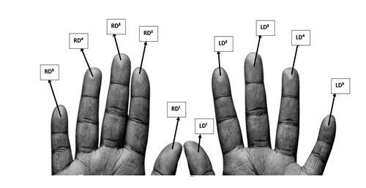
Figure 1. Anatomical coding of right- and left-hand digits .
The corresponding toe-digit coding is illustrated in Figure 2. Using the same ordinal position on both feet permitted digit-specific left–right tabulation without combining measurements from different toes.
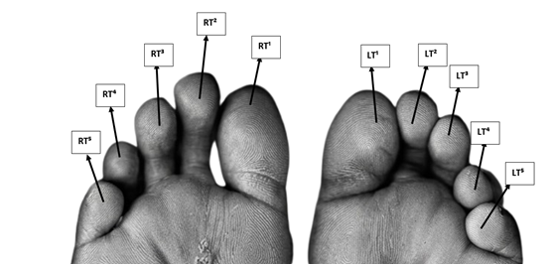
Figure 2. Anatomical coding of right- and left-foot toes .

2.3 Ridge count and image-based density measurement
Digit images were displayed on a standard-sized software canvas for visual inspection. For ridge count (RC), a line was placed between the visible pattern core and a triradius, and the ridges intersecting the line were counted. Figure 3 illustrates a line-based ridge-count extraction. The tabulated results were not stratified by arch, loop or whorl pattern, and interpretation is limited to digit-specific ridge-count measurements (Ominde et al., 2021).
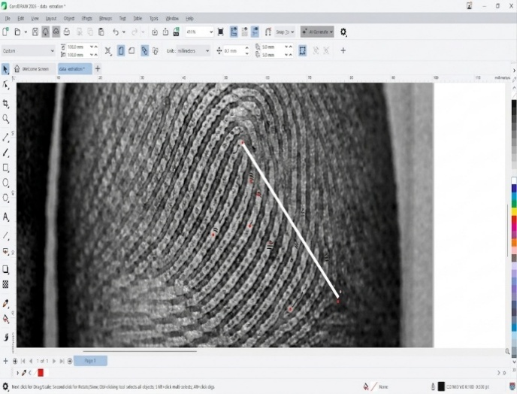
Figure 3. Example of a line used to obtain a core-to-triradius ridge count.
An image-based square was positioned over a selected region of clear ridges, generally near the pattern centre, and the visible ridges within the square were counted. Figure 4 illustrates this extraction region. The square overlay measured a nominal 25 × 25 mm on the digital canvas, but a validated conversion between the displayed dimensions and physical ridge-area dimensions was not established. Accordingly, the tabulated ridge-density (RD) values are described as image-derived indices, rather than as standardised numbers of ridges per physical square millimetre. Published methods that use a physically standardised 5 × 5 mm area therefore provide methodological context rather than direct numerical comparators (Gutiérrez-Redomero et al., 2014; Kaur et al., 2020; Krishan et al., 2015).
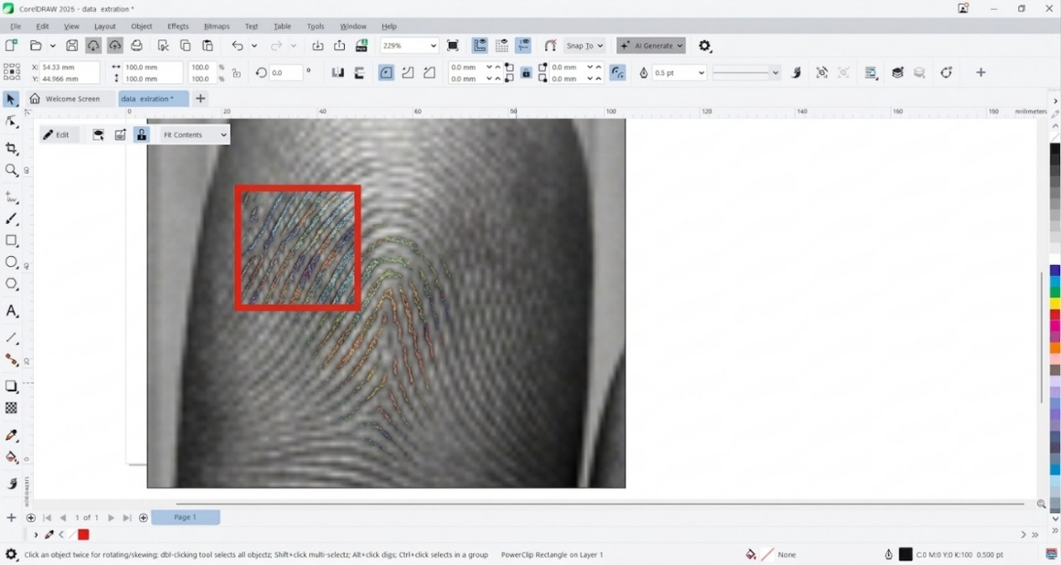
Figure 4. Software-based square region used for image-derived ridge-density extraction.

2.4 Data handling and descriptive analysis
For each sex-by-population subgroup, left-side and right-side means were tabulated for five finger ridge counts, five finger density indices, five toe ridge counts, and five toe density indices. The present summaries describe those values and calculate their arithmetic difference as left mean minus right mean. A negative difference means that the displayed right-side mean exceeds the left-side mean. Differences were calculated from the two-decimal mean values and are presented to the same precision. The participant is the intended unit of bilateral pairing; however, paired differences, within-person covariances, and validated measurement-error estimates are not available in the summary tables. Consequently, no confidence intervals, equivalence tests, multiplicity-adjusted p-values, or subgroup inferential comparisons are presented.
Ridge-count means represent average counted ridge intersections. The density-index means represent average ridge counts within the study-specific software square. These two numerical scales should not be compared as if they represented the same anatomical quantity, nor should observed between-subgroup mean differences be interpreted as adjusted population or sex effects.

3. Results

3.1 Sample composition
The 565 participants comprised 270 males (47.8%) and 295 females (52.2%). Ibibio participants numbered 315 (150 males and 165 females); the Ijaw sample numbered 250 (120 males and 130 females). Relative to the complete sample, the four subgroups represented approximately 26.5%, 29.2%, 21.2%, and 23.0%, respectively. Figure 5 displays the distribution by sex and population affiliation; the proportions are descriptive of recruitment, rather than estimates of population prevalence.
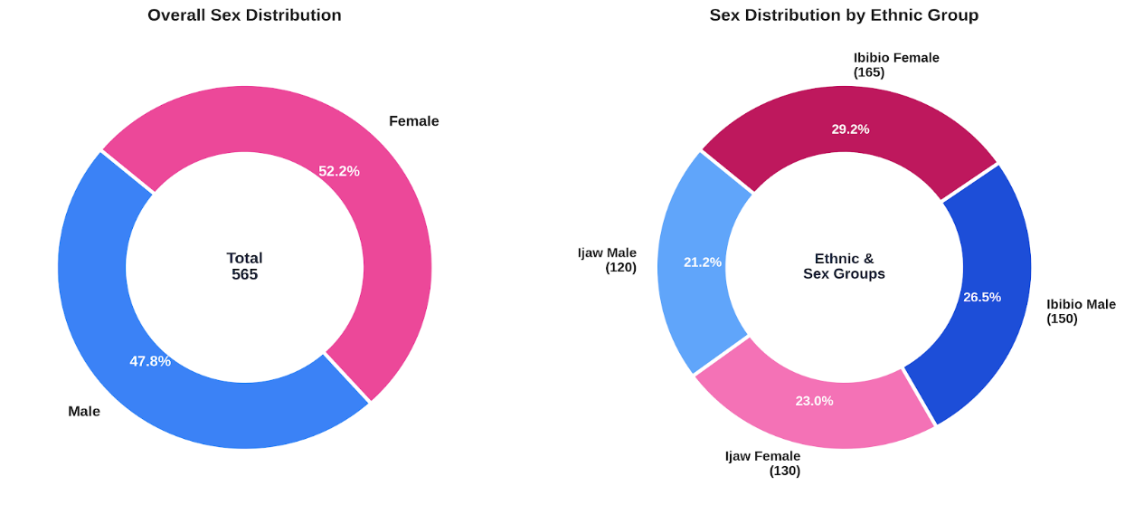
Figure 5. Sex distribution and population-affiliation distribution of the 565 participants.

3.2 Ibibio female participants
The 165 Ibibio female participants had closely spaced left- and right-side mean values for many digit-specific measurements (Table 1). For example, the index-finger ridge-count means were 16.99 on the left and 16.97 on the right (left–right difference +0.02), and the corresponding ring-finger means were both 17.74. The third-finger ridge-count difference was −0.40, while the fifth-toe ridge-count difference was −0.38. These are descriptive contrasts of means rather than measures of within-person agreement.
Table 1
Bilateral mean ridge count and image-derived ridge-density measures among Ibibio female participants (n = 165)
Paired digit / variable | Left mean | Right mean | Left − right
LD¹RC / RD¹RC | 15.95 | 15.83 | +0.12
LD¹RD / RD¹RD | 17.79 | 17.82 | -0.03
LD²RC / RD²RC | 16.99 | 16.97 | +0.02
LD²RD / RD²RD | 17.77 | 17.77 | +0.00
LD³RC / RD³RC | 16.13 | 16.53 | -0.40
LD³RD / RD³RD | 17.64 | 17.80 | -0.16
LD⁴RC / RD⁴RC | 17.74 | 17.74 | +0.00
LD⁴RD / RD⁴RD | 17.84 | 17.84 | +0.00
LD⁵RC / RD⁵RC | 15.66 | 15.46 | +0.20
LD⁵RD / RD⁵RD | 17.81 | 17.82 | -0.01
LT¹RC / RT¹RC | 14.41 | 14.54 | -0.13
LT¹RD / RT¹RD | 16.78 | 16.68 | +0.10
LT²RC / RT²RC | 15.24 | 15.03 | +0.21
LT²RD / RT²RD | 16.89 | 16.86 | +0.03
LT³RC / RT³RC | 14.92 | 14.78 | +0.14
LT³RD / RT³RD | 16.79 | 16.88 | -0.09
LT⁴RC / RT⁴RC | 14.42 | 14.51 | -0.09
LT⁴RD / RT⁴RD | 16.74 | 16.83 | -0.09
LT⁵RC / RT⁵RC | 13.51 | 13.89 | -0.38
LT⁵RD / RT⁵RD | 16.66 | 16.81 | -0.15
RC = ridge count (ridges); RD = image-derived ridge-density index (count within the displayed square); digit superscripts 1–5 identify thumb/hallux through little finger/fifth toe. Values are subgroup means; differences were calculated from the displayed two-decimal means. Inferential tests are not presented.

3.3 Ibibio male participants
Among the 150 Ibibio males, the largest absolute finger ridge-count mean difference appeared at the little finger (left 13.16; right 14.62; difference −1.46). Index-finger image-derived ridge-density indices were 14.13 and 14.38 (difference −0.25). For the toes, the second-toe ridge-count means were 14.84 on the left and 13.82 on the right (difference +1.02). Table 2 provides all 20 corresponding left–right means and their arithmetic differences.
Table 2
Bilateral mean ridge count and image-derived ridge-density measures among Ibibio male participants (n = 150)
Paired digit / variable | Left mean | Right mean | Left − right
LD¹RC / RD¹RC | 15.08 | 14.94 | +0.14
LD¹RD / RD¹RD | 14.26 | 14.21 | +0.05
LD²RC / RD²RC | 15.41 | 15.11 | +0.30
LD²RD / RD²RD | 14.13 | 14.38 | -0.25
LD³RC / RD³RC | 15.83 | 15.74 | +0.09
LD³RD / RD³RD | 14.31 | 14.32 | -0.01
LD⁴RC / RD⁴RC | 16.34 | 15.39 | +0.95
LD⁴RD / RD⁴RD | 14.28 | 14.11 | +0.17
LD⁵RC / RD⁵RC | 13.16 | 14.62 | -1.46
LD⁵RD / RD⁵RD | 14.34 | 14.31 | +0.03
LT¹RC / RT¹RC | 13.46 | 13.13 | +0.33
LT¹RD / RT¹RD | 13.26 | 13.33 | -0.07
LT²RC / RT²RC | 14.84 | 13.82 | +1.02
LT²RD / RT²RD | 13.30 | 13.24 | +0.06
LT³RC / RT³RC | 14.28 | 14.03 | +0.25
LT³RD / RT³RD | 13.24 | 13.29 | -0.05
LT⁴RC / RT⁴RC | 12.74 | 12.64 | +0.10
LT⁴RD / RT⁴RD | 13.34 | 13.27 | +0.07
LT⁵RC / RT⁵RC | 13.45 | 12.45 | +1.00
LT⁵RD / RT⁵RD | 13.18 | 13.25 | -0.07
RC = ridge count (ridges); RD = image-derived ridge-density index (count within the displayed square); digit superscripts 1–5 identify thumb/hallux through little finger/fifth toe. Values are subgroup means; differences were calculated from the displayed two-decimal means. Inferential tests are not presented.

3.4 Ijaw female participants
In the 130 Ijaw females, the mean thumb ridge count was 15.70 on the left and 16.52 on the right (difference −0.82). The mean second-finger ridge counts were 17.41 and 17.91 (difference −0.50), and the largest absolute toe ridge-count difference occurred in the fourth toes (+0.50). Table 3 details the corresponding finger and toe values.
Table 3
Bilateral mean ridge count and image-derived ridge-density measures among Ijaw female participants (n = 130)
Paired digit / variable | Left mean | Right mean | Left − right
LD¹RC / RD¹RC | 15.70 | 16.52 | -0.82
LD¹RD / RD¹RD | 16.49 | 16.51 | -0.02
LD²RC / RD²RC | 17.41 | 17.91 | -0.50
LD²RD / RD²RD | 16.66 | 16.52 | +0.14
LD³RC / RD³RC | 17.69 | 17.76 | -0.07
LD³RD / RD³RD | 16.39 | 16.59 | -0.20
LD⁴RC / RD⁴RC | 17.48 | 17.06 | +0.42
LD⁴RD / RD⁴RD | 16.58 | 16.52 | +0.06
LD⁵RC / RD⁵RC | 16.02 | 15.83 | +0.19
LD⁵RD / RD⁵RD | 16.57 | 16.48 | +0.09
LT¹RC / RT¹RC | 14.26 | 14.34 | -0.08
LT¹RD / RT¹RD | 15.47 | 15.56 | -0.09
LT²RC / RT²RC | 15.41 | 15.34 | +0.07
LT²RD / RT²RD | 15.40 | 15.46 | -0.06
LT³RC / RT³RC | 14.38 | 14.83 | -0.45
LT³RD / RT³RD | 15.38 | 15.35 | +0.03
LT⁴RC / RT⁴RC | 14.63 | 14.13 | +0.50
LT⁴RD / RT⁴RD | 15.45 | 15.43 | +0.02
LT⁵RC / RT⁵RC | 14.08 | 13.61 | +0.47
LT⁵RD / RT⁵RD | 15.56 | 15.46 | +0.10
RC = ridge count (ridges); RD = image-derived ridge-density index (count within the displayed square); digit superscripts 1–5 identify thumb/hallux through little finger/fifth toe. Values are subgroup means; differences were calculated from the displayed two-decimal means. Inferential tests are not presented.

3.5 Ijaw male participants
Among the 120 Ijaw males, the largest absolute mean difference was observed for thumb ridge count (left 12.52; right 14.81; difference −2.29). The third-finger ridge-count means were 15.18 and 13.57 (difference +1.61). The maximum absolute difference among toe ridge-count means was +0.62 for the second toe. The complete numerical profile is shown in Table 4; these values characterise the selected sample and do not identify a statistically established side effect.
Table 4
Bilateral mean ridge count and image-derived ridge-density measures among Ijaw male participants (n = 120)
Paired digit / variable | Left mean | Right mean | Left − right
LD¹RC / RD¹RC | 12.52 | 14.81 | -2.29
LD¹RD / RD¹RD | 12.99 | 12.99 | +0.00
LD²RC / RD²RC | 13.90 | 13.41 | +0.49
LD²RD / RD²RD | 13.04 | 12.96 | +0.08
LD³RC / RD³RC | 15.18 | 13.57 | +1.61
LD³RD / RD³RD | 13.11 | 13.03 | +0.08
LD⁴RC / RD⁴RC | 12.88 | 13.09 | -0.21
LD⁴RD / RD⁴RD | 13.03 | 12.91 | +0.12
LD⁵RC / RD⁵RC | 13.68 | 12.77 | +0.91
LD⁵RD / RD⁵RD | 12.95 | 12.98 | -0.03
LT¹RC / RT¹RC | 11.03 | 10.49 | +0.54
LT¹RD / RT¹RD | 11.92 | 12.10 | -0.18
LT²RC / RT²RC | 13.04 | 12.42 | +0.62
LT²RD / RT²RD | 12.09 | 12.06 | +0.03
LT³RC / RT³RC | 11.49 | 12.03 | -0.54
LT³RD / RT³RD | 12.08 | 11.95 | +0.13
LT⁴RC / RT⁴RC | 11.68 | 11.74 | -0.06
LT⁴RD / RT⁴RD | 11.96 | 11.99 | -0.03
LT⁵RC / RT⁵RC | 11.91 | 11.40 | +0.51
LT⁵RD / RT⁵RD | 12.03 | 12.00 | +0.03
RC = ridge count (ridges); RD = image-derived ridge-density index (count within the displayed square); digit superscripts 1–5 identify thumb/hallux through little finger/fifth toe. Values are subgroup means; differences were calculated from the displayed two-decimal means. Inferential tests are not presented.

4. Discussion
The descriptive results show that corresponding left- and right-side fingerprint and toeprint means vary by digit, metric, and recruited subgroup. Differences were generally smaller for the image-derived density indices than for the ridge-count means when expressed on their respective recorded scales, although the two metrics have different definitions and cannot be compared directly as magnitudes of biological asymmetry. The largest tabulated difference in ridge-count means occurred in the thumbs of Ijaw males; other pronounced numerical contrasts were seen in selected fingers and toes, particularly in Ibibio males. These patterns provide descriptive information on the current sample, not formal evidence that a given digit, sex, or population is inherently more asymmetric.
A crucial interpretive distinction is that a side-specific mean difference does not measure the distribution of individual left–right differences. Two mean values can be similar even when substantial individual-level differences exist in opposing directions; conversely, a nonzero mean difference may reflect relatively small and consistently signed differences. Detailed inference about directional asymmetry, fluctuating asymmetry, or agreement requires individual paired observations and appropriate measures of their variation (Graham et al., 2010). Without those observations, neither statistical significance nor statistical equivalence can be established by comparing marginal means alone.
The inclusion of toeprints is useful in a descriptive context because lower-limb ridges are less commonly investigated alongside fingerprint measurements in regional samples. Ominde et al. (2021) assessed finger–toe relationships in an Anioma sample, whereas the present results concern side-specific means for each toe rather than correlations between toes and fingers. It would therefore be inappropriate to infer cross-modal prediction, forensic match accuracy, or substitution of toeprints for fingerprints from the present analysis. Such applications would require validation against known identification outcomes, together with calibrated and reproducible measurement procedures (Bécue et al., 2020; Bécue & Champod, 2023).
Population-specific description is nevertheless relevant when interpreting dermatoglyphic traits. Nigerian investigations among Esan, Delta State, Fulani, and Higgi samples have reported variation in pattern frequencies and ridge-related traits under their respective collection procedures (Anyanwu, 2020; Atiku et al., 2024; Ojigho et al., 2020). Direct numerical comparison is limited when instruments, physical calibration, image processing, sampling, and measurement definitions are not harmonised. Published ridge-density studies show that count location and the area covered by a ridge-density square are consequential, even when the broad anatomical character being studied is the same (Gutiérrez-Redomero et al., 2014; Kaur et al., 2020; Rivaldería et al., 2016).
The recruitment procedure also places limits on interpretation. Ijaw participants were recruited in Bayelsa State and Ibibio participants in Akwa Ibom State; recruitment was sequential at selected venues rather than probability-based across all members of either population. Geographic residence, recruitment site, occupation, and other unmeasured participant characteristics could influence sample composition. Further, the four sex-by-population tables should not be used to claim a sex difference or population effect unless those contrasts are directly estimated with appropriate controls.
Local ridge-density indices are particularly sensitive to the image-to-physical-distance relationship. The acquisition protocol identifies the scanner and software-based counting workflow, but does not establish a traceable pixel-to-mm calibration, capture resolution, or observer reproducibility assessment. A square drawn on a scaled digital page does not necessarily represent an equivalent physical area on every finger or toe. Accordingly, the density measures are best viewed as internal descriptive indices; their external comparability and metric validity remain restricted. Future investigations can improve validity by applying a calibrated measurement area, consistent anatomical regions, repeated measurements, and quantified intra- and inter-observer variation (Gutiérrez-Redomero et al., 2014; Krishan et al., 2015).

5. Limitations and Future Research
The study is limited to adults aged 18–40 years who were recruited from selected venues in two Nigerian states. Self-reported population affiliation and nonprobability recruitment preclude population-representative estimates. Original individual paired observations, joint distributions, and measurement repeatability statistics are not included in the summarised analytical dataset. Reported left- and right-side means consequently support descriptive comparisons only; formal inference about the direction or magnitude of individual asymmetry, subgroup differences, statistical equivalence, and toe–finger correlation remains unsupported.
The ridge-density counts were obtained using a software-defined image region without fully documented calibration to physical print area. The image-derived index must not be equated with conventional counts per 25 mm², and its use across different images or research settings needs methodological validation. The absence of separate categorical pattern data prevents a descriptive comparison of arches, loops, and whorls. Future studies should include calibrated scanning, stated image-quality thresholds, pattern-specific landmark rules, complete denominators, documented observation reliability, individual paired difference distributions and prespecified analyses of multiplicity and subgroup contrasts. Biometric-data handling practices should also be detailed to permit evaluation of security and consent.

6. Conclusion
In this venue-based cross-sectional sample of 565 Ijaw and Ibibio adults, digit-specific left- and right-side means for fingerprint and toeprint ridge counts and image-derived density indices were not identical across all corresponding digits. The largest displayed fingerprint ridge-count mean difference occurred for the thumb among Ijaw males (−2.29 ridges), with other differences occurring in selected finger and toe measures. These results constitute descriptive reference observations for the examined participants. They do not establish statistically significant asymmetry, bilateral equivalence, population- or sex-related effects, or the forensic identification utility of toeprints. Reproducible physical-area calibration and participant-level paired analysis are necessary for stronger inference.

Ethics approval and consent
Ethical approval was obtained from the Research Ethics Committee of Delta State University, Abraka. Written informed consent was obtained from all participants before data collection. Participation was voluntary, and participants were informed that they could withdraw without penalty. Personal identifiers were not included in the analytical dataset, and the collected information was handled confidentially.

References
Anyanwu, L. C. (2020). Variations of finger dermatoglyphics among the Esan ethnic group of Edo State, Nigeria. International Journal of Modern Anthropology, 2(14), 275–289. https://doi.org/10.4314/ijma.v2i14.3
Atiku, I. A., Tanko, M., Adamu, L. H., Rayyan, M. K., & Danborno, B. (2024). Fingerprint pattern of Fulani and Higgi ethnic groups in Michika LGA, Adamawa State, Nigeria. Dutse Journal of Pure and Applied Sciences, 10(1a), 241–248. https://doi.org/10.4314/dujopas.v10i1a.24
Bécue, A., & Champod, C. (2023). Interpol review of fingermarks and other body impressions (2019–2022). Forensic Science International: Synergy, 6, Article 100304. https://doi.org/10.1016/j.fsisyn.2022.100304
Bécue, A., Eldridge, H., & Champod, C. (2020). Interpol review of fingermarks and other body impressions 2016–2019. Forensic Science International: Synergy, 2, 442–480. https://doi.org/10.1016/j.fsisyn.2020.01.013
Graham, J. H., Raz, S., Hel-Or, H., & Nevo, E. (2010). Fluctuating asymmetry: Methods, theory, and applications. Symmetry, 2(2), 466–540. https://doi.org/10.3390/sym2020466
Gutiérrez-Redomero, E., Rivaldería, N., Alonso-Rodríguez, C., & Sánchez-Andrés, Á. (2014). Assessment of the methodology for estimating ridge density in fingerprints and its forensic application. Science & Justice, 54(3), 199–207. https://doi.org/10.1016/j.scijus.2013.11.004
Kaur, M., Kaur, M., & Yangchan, J. (2020). Identification of sex using discriminant function analysis of fingerprint ridge density at three topological areas among North Indian population. Anthropological Review, 83(4), 349–361. https://doi.org/10.2478/anre-2020-0025
Krishan, K., Kanchan, T., Pathania, A., Sharma, R., & DiMaggio, J. A. (2015). Variability of footprint ridge density and its use in estimation of sex in forensic examinations. Medicine, Science and the Law, 55(4), 284–290. https://doi.org/10.1177/0025802414557880
Ojigho, J. E., Oladipo, G. S., & Oyakhire, M. O. (2020). A study of fingerprints in Delta State, Nigeria. Journal of Anatomical Sciences, 11(2), 107–112. https://www.asn-ng.com/journal/article/1602891900
Ominde, B. S., Jaiyeoba-Ojigho, E. J., & Igbigbi, P. S. (2021). Analysis of finger and toe prints and their corresponding correlations in the Anioma people of Nigeria. Journal of Forensic Science and Medicine, 7(2), 39–46. https://doi.org/10.4103/jfsm.jfsm_48_20
Rivaldería, N., Sánchez-Andrés, Á., Alonso-Rodríguez, C., Dipierri, J. E., & Gutiérrez-Redomero, E. (2016). Fingerprint ridge density in the Argentinean population and its application to sex inference: A comparative study. HOMO, 67(1), 65–84. https://doi.org/10.1016/j.jchb.2015.09.004
Sudha, P. I., Singh, J., & Sodhi, G. S. (2021). The dermal ridges as the infallible signature of skin: An overview. Indian Journal of Dermatology, 66(6), 649–653. https://doi.org/10.4103/ijd.ijd_1123_20

