AI-BASED REAL-TIME FAULT DETECTION AND ENERGY MANAGEMENT IN RENEWABLE-INTEGRATED SMART GRIDS FOR OIL AND GAS FACILITIES: A CASE STUDY OF THE CSDT SITE

Abstract
Electrical faults in distribution networks supplying critical facilities can interrupt operations and damage equipment. This study evaluated a simulation-based artificial intelligence (AI) framework for fault detection and energy management in a renewable-integrated smart grid at the Centre for Skills Development and Training (CSDT). The investigation was informed by the site's 33 kV incoming supply, transformer and Ring Main Unit (RMU) configuration, single-line diagrams, and documented fault events involving a 5 MVA transformer. MATLAB and Python simulations examined normal operation, fault initiation, protective isolation, emergency restoration, ring-circuit restoration and full restoration. Fault-detection performance was assessed using voltage, current, power, frequency and wavelet-derived signal features. Random Forest, support vector machine, artificial neural network and discrete wavelet transform–deep learning models were compared. In the computational evaluation, the proposed model attained 99.1% classification accuracy and an average detection time of 8.7 ms. Under the ring-circuit restoration scenario, the network supplied 3.20 MW of a modelled 3.40 MW demand, corresponding to approximately 94.1% of demand and leaving 0.20 MW unserved. Simulated voltage profiles improved following reconfiguration relative to fault conditions. These findings suggest that combining intelligent fault identification with protective isolation and alternative supply routing may improve supply continuity at the site. As the performance measures originate from simulated scenarios, practical application requires validation of protection coordination, equipment limits and real-time operation.

Key Words: Artificial Intelligence; Fault Detection; Energy Management; Smart Grid.

1. Introduction
The growing integration of renewable energy resources, battery energy storage systems, and intelligent control technologies is transforming conventional power networks into increasingly complex smart grids. Renewable-integrated microgrids offer improved sustainability, operational flexibility, and energy independence; however, their intermittent generation, bidirectional power flow, inverter-based interfaces, and changing operating conditions present significant challenges for conventional protection and energy management systems (Elazab et al., 2024a, 2024b). Recent studies have demonstrated the increasing effectiveness of artificial intelligence (AI), machine learning, wavelet analysis, and deep learning for detecting, classifying, and locating faults in modern power networks. A review of fault diagnosis in engineering control systems also describes the use of artificial intelligence and machine-learning techniques for identifying abnormal operating conditions (Geku et al., 2025). Wavelet-based feature extraction combined with deep learning has been successfully applied to the early detection of electrical faults in microgrids (Flaifel et al., 2024), while optimised machine-learning algorithms have demonstrated improved capability for fault detection, classification, and localisation along power system networks (Najafzadeh et al., 2024). A recent power-system study likewise compared machine-learning methods for fault identification and classification, indicating their relevance to network protection research (Mahidur et al., 2026). Similarly, discrete wavelet transform and deep neural network approaches have been applied to fault classification in hybrid and grid-connected microgrid systems (Bramareswara Rao et al., 2025). Further investigations have considered discrete wavelet transform features with support vector machines in renewable-integrated standalone microgrids (Bhaumik et al., 2025) and hybrid deep-learning approaches for microgrid fault detection and classification under simulated conditions (Abo Elkheir et al., 2026). In parallel, AI-based energy management approaches are increasingly being used to address renewable generation uncertainty, energy scheduling, battery utilisation, and optimal power dispatch (Elazab et al., 2024a, 2024b). A review of AI-integrated grid systems also identifies monitoring, fault diagnosis, control and energy management as related components of intelligent grid operation (Alam et al., 2025). However, existing studies largely investigate intelligent fault detection and energy management as separate operational functions. This creates a research gap, particularly in critical facilities where electrical faults can affect operational continuity and the reliable supply of essential loads. For the CSDT network, the specific gap addressed here is the simulation-based assessment of fault identification, protective isolation, alternative supply paths and critical-load prioritisation within one site-specific framework. Therefore, this study proposes an integrated AI-based framework for real-time fault detection and intelligent energy management in a renewable-integrated smart grid using the CSDT site as a case study. The proposed framework integrates fault identification, system isolation, network reconfiguration, renewable generation, battery storage, and critical-load prioritisation to improve system reliability, resilience, energy efficiency, and continuity of supply. The main objective of this study is to develop and evaluate an integrated framework for intelligent fault detection and energy management in the CSDT electrical distribution network. Specifically, the study seeks to identify abnormal electrical conditions using artificial intelligence, examine the behaviour of the network during fault and isolation events, and assess the effectiveness of alternative supply routes in restoring electricity to affected loads. The contribution of the research lies in bringing these functions together within a site-specific simulation framework informed by documented electrical equipment failures and the existing network configuration.

2. Literature Review
Recent studies demonstrate the increasing application of artificial intelligence (AI) to improving the protection, monitoring, fault diagnosis, and operational management of renewable-integrated smart grids. The increasing penetration of distributed renewable generation and power-electronic interfaces has introduced complex fault characteristics that may reduce the effectiveness of conventional protection schemes. Consequently, wavelet transforms, machine learning, and deep learning techniques have been increasingly investigated for rapid fault detection and classification. Bramareswara Rao et al. (2025) combined discrete wavelet transform and deep neural networks for fault detection and classification in hybrid multi-area grid-connected microgrid clusters. Similarly, Flaifel et al. (2024) employed wavelet-based feature extraction and deep learning for the early detection of arc faults in DC microgrids, while Najafzadeh et al. (2024) applied optimised machine-learning algorithms for fault detection, classification, and localisation along power system lines. Collectively, these studies demonstrate the potential of intelligent data-driven approaches to improve fault recognition under complex and dynamic operating conditions. In addition to protection, AI techniques are increasingly applied to microgrid energy management, particularly for addressing renewable-energy uncertainty, load variation, battery scheduling, and optimal power dispatch. Elazab et al. (2024a) investigated supervised machine-learning approaches for mitigating solar-power uncertainty in microgrid energy management, while Elazab et al. (2024b) reviewed modelling and energy management strategies for sustainable 100% renewable microgrids. These studies highlight the importance of intelligent forecasting, optimisation, and adaptive decision-making for improving renewable utilisation and system reliability. The reviewed studies collectively indicate that significant progress has been achieved in AI-based fault diagnosis and intelligent energy management. However, most existing approaches consider fault detection, fault isolation, network restoration, and energy management as separate operational tasks. This creates an important research gap for critical facilities where equipment failures can simultaneously affect power quality, supply continuity, and load prioritisation. Therefore, the present study develops an integrated AI-based framework that links real-time fault detection with fault isolation, ring-network reconfiguration, transformer availability assessment, energy management, and critical-load prioritisation. The CSDT electrical network provides a practical case study for evaluating the proposed framework under normal, fault, isolation, and restoration conditions. Previous studies have addressed different aspects of intelligent power system operation. Flaifel et al. (2024) and Bramareswara Rao et al. (2025) demonstrated the application of wavelet-based and deep learning techniques to electrical fault detection and classification, while Elazab et al. (2024a) examined the application of supervised machine learning to microgrid energy management. Similarly, Igder et al. (2022) discussed service restoration through microgrid formation in distribution networks. These contributions demonstrate the importance of intelligent protection, energy management, and network restoration. However, evaluating these functions together within a specific electrical facility remains important because fault detection alone does not guarantee continuity of electricity supply. The present study therefore examines how AI-based fault identification can be considered alongside protective isolation and network reconfiguration in the CSDT electrical network.

3. Methodology
This study adopts a simulation-based methodology to develop an AI-based framework for real-time fault detection and energy management in a renewable-integrated smart grid. The CSDT electrical system is modelled with renewable energy sources, battery storage, utility supply, backup generation, and critical loads. Voltage, current, power, frequency and battery state-of-charge data were collected under normal and fault conditions. Wavelet-based signal processing is used to extract relevant features, which are applied to machine-learning and deep-learning models for fault detection and classification. An intelligent energy management algorithm optimises power dispatch, load prioritisation, battery operation, and renewable utilisation. System performance is evaluated using detection accuracy, response time, reliability, energy not supplied, operating cost, and renewable energy utilisation.

3.1 Electrical Network Modelling and Fault Simulation
The electrical network of the CSDT site was represented using its existing infrastructure and operating characteristics. The model incorporated the 33 kV utility supply, the 5 MVA main power transformer, two 1.6 MVA transformers, distribution transformers, and the RMU-based network connecting the school and residential sections. MATLAB and Python were used to examine system behaviour under different operating conditions. The simulated scenarios included normal operation, RMU fault occurrence, protective isolation following fuse operation, emergency restoration, ring-circuit restoration, and full supply restoration. The analysis considered changes in voltage magnitude, supplied load, unserved load, and transformer availability. These scenarios provided a basis for assessing the consequences of the fault and the potential contribution of network reconfiguration to improving electricity supply continuity.

3.2 AI-Based Fault Detection and Performance Evaluation
The AI-based fault detection framework considered electrical features associated with normal and abnormal network conditions, including voltage, current, power, frequency, and wavelet-derived signal characteristics. The evaluation compared Random Forest, Support Vector Machine (SVM), Artificial Neural Network (ANN), and the proposed discrete wavelet transform–deep learning approach. Model performance was assessed using accuracy, precision, recall, F1-score, and fault detection time. The reported results were obtained from the computational evaluation and were used to compare the fault identification capabilities of the selected methods.
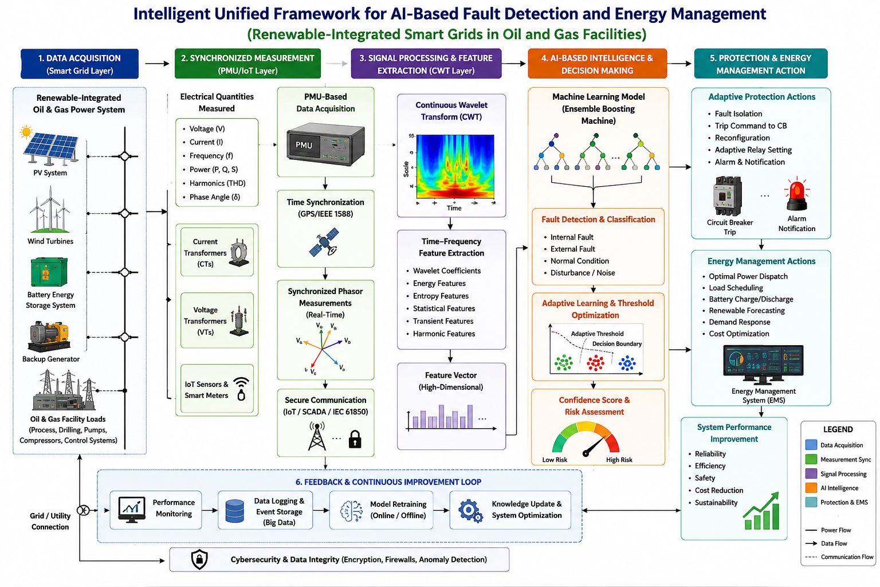
Figure 1: The unified PMU-CWT-ML framework

3. Model Equations

1. Power Balance Equation
$$P_{grid}+P_{solar}+P_{gen}+P_{bat,dis}=P_{load}+P_{bat,ch}+P_{loss}$$
where $P_{grid}$, $P_{solar}$, and $P_{gen}$ denote power supplied by the utility, photovoltaic system, and backup generator, respectively; $P_{bat,dis}$ and $P_{bat,ch}$ are battery discharging and charging powers; $P_{load}$ is total load demand; and $P_{loss}$ represents network losses. All power terms are expressed in consistent units (e.g., MW).

2. Battery State-of-Charge Model
$$SOC_{t+1}=SOC_{t}+\frac{η_{ch}P_{ch,t} Δt}{E_{bat}}-\frac{P_{dis,t} Δt}{η_{dis}E_{bat}}$$
where $SOC_{t}$ is the battery state of charge at time $t$ (expressed as a fraction); $P_{ch,t}$ and $P_{dis,t}$ are charging and discharging powers; $η_{ch}$ and $η_{dis}$ are charging and discharging efficiencies; $E_{bat}$ is usable battery energy capacity; and $Δt$ is the simulation interval. For dimensional consistency, MW and hours correspond to MWh.

3. Wavelet Energy Feature Equation
$$E_{j}=\sum_{k=1}^{N_{j}}{{\left|d_{j,k}\right|}^{2}}$$
where $E_{j}$ is the wavelet-detail energy at decomposition level $j$, $d_{j,k}$ is the discrete wavelet detail coefficient at sample $k$, and $N_{j}$ is the number of detail coefficients at that level. This quantity summarizes transient signal energy for fault-feature extraction.

4. AI Fault Classification Model
$$\hat{y}=\underset{c∈C}{arg max} f_{θ}{\left(x\right)}_{c}$$
where $x$ is the vector of extracted electrical and wavelet features, $f_{θ}$ is the trained classifier with model parameters $θ$, $C$ is the set of operating-condition or fault classes, and $\hat{y}$ is the predicted class.

5. Energy Management Objective Function
$$\min_{u} J\left(u\right)=\sum_{t=1}^{T}{\left[αC_{t}\left(u\right)+βENS_{t}\left(u\right)+γE_{loss,t}\left(u\right)\right]}$$
where $u$ denotes the dispatch and control decisions; $C_{t}$ is the operating cost for time interval $t$; $ENS_{t}$ denotes energy not supplied; $E_{loss,t}$ is electrical energy lost; $α$, $β$, and $γ$ are weighting coefficients; and $T$ is the optimization horizon. Weighting coefficients should be selected so that the objective terms are comparable.

4. Case Study of the CSDT Site
The CSDT site was selected as the case study for evaluating the proposed AI-based real-time fault detection and energy management framework. The site represents a critical research and technology environment with diverse electrical loads requiring reliable and continuous power supply. Its electrical system can be modelled as a renewable-integrated smart grid comprising utility supply, photovoltaic generation, battery energy storage, backup generation, and critical and non-critical loads. Electrical parameters, including voltage, current, power, frequency and battery state of charge, were monitored in the model to identify abnormal conditions. The proposed framework uses these data to detect faults, optimise energy dispatch, prioritise critical loads, and improve overall system reliability, resilience, and renewable energy utilisation.
The case study draws on information from the existing CSDT electrical installation, including equipment ratings, electrical network diagrams, and records of the reported fault incidents. These records provide the practical engineering background for the investigation. The numerical performance results, however, were obtained through MATLAB- and Python-based simulations of selected operating conditions. This distinction is important because the simulation results describe the response of the modelled electrical network and should not be interpreted as measurements obtained from an installed AI protection system.
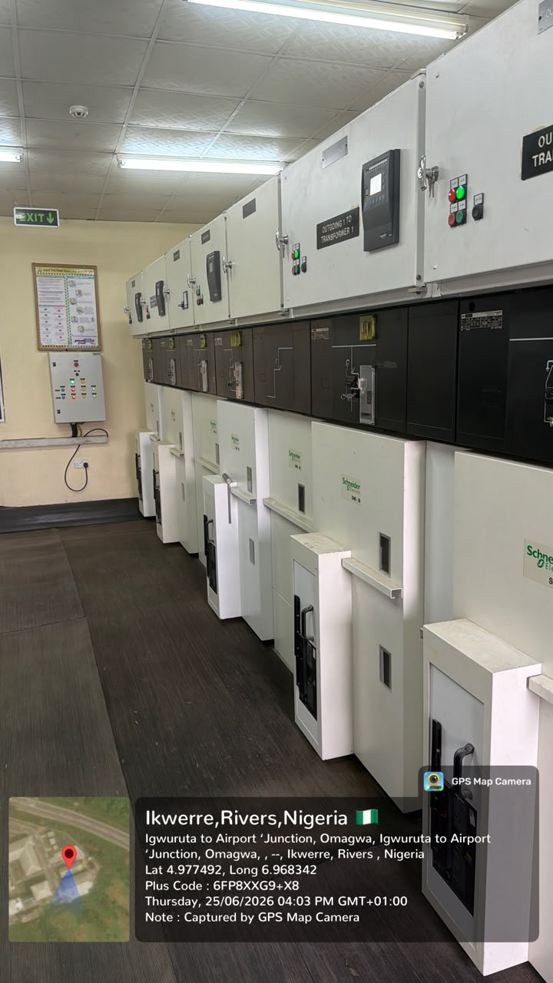
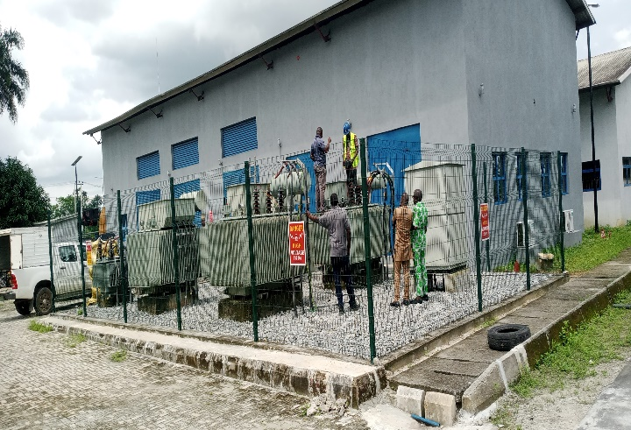 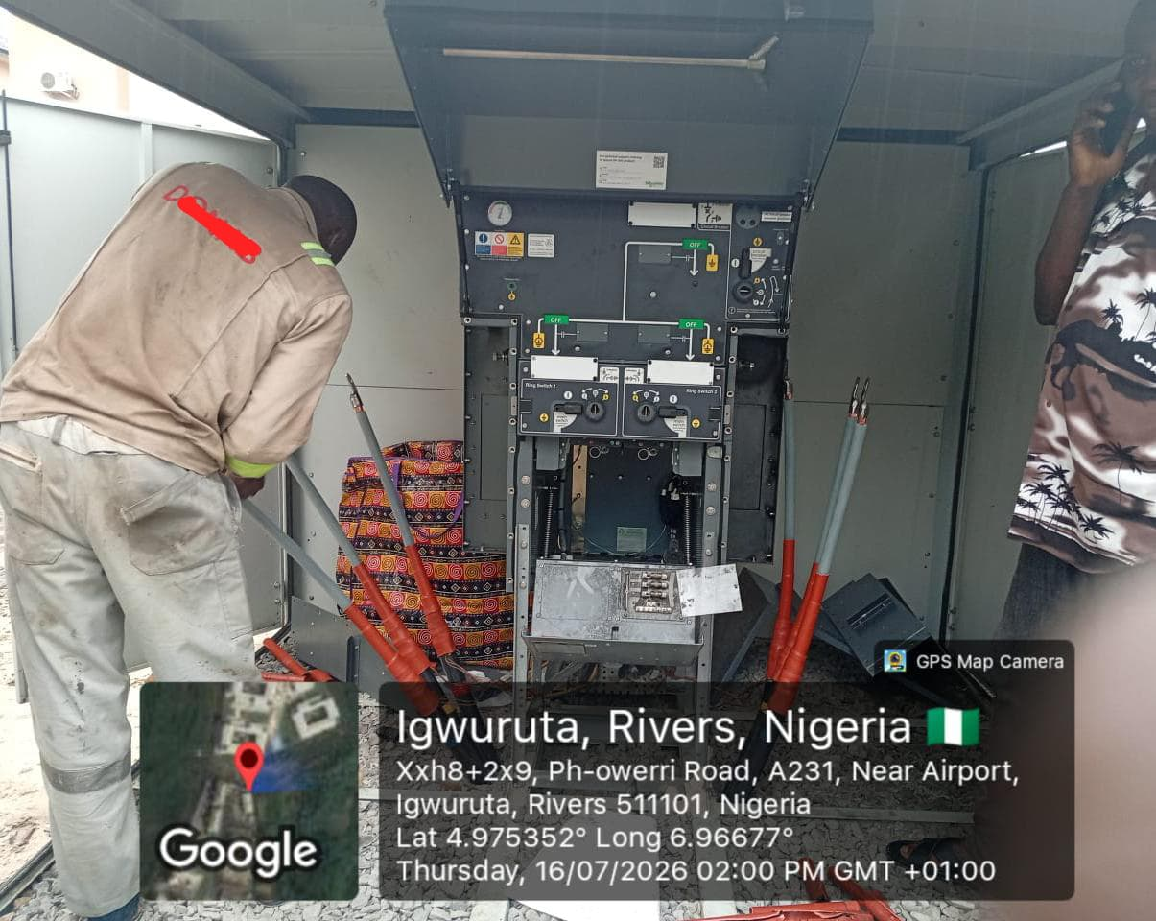
Figure 2: Study Location
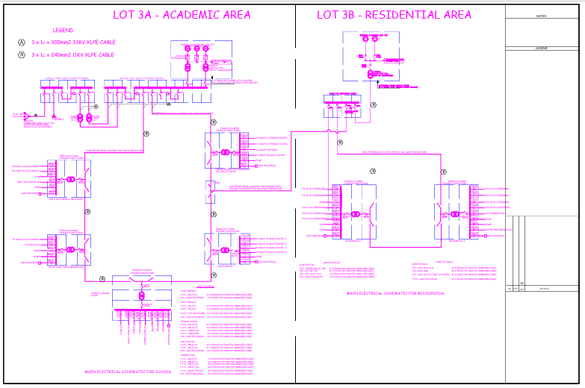
Figure 3: Single Line Diagram of the Affected Area
Table 1: Existing Electrical Infrastructure and Fault Condition at the Site
S/N | Equipment/Component | Quantity | Rating | Location/Area Served | Current Status/Function
1 | Main Power Transformer | 1 | 5 MVA | Main site supply | Damaged/blown following the explosion; awaiting backup/replacement
2 | Power Transformer | 2 | 1.6 MVA each | Site distribution network | Available for supplying sections of the network, subject to network configuration
3 | Service Transformer | 1 | 415 V | Service loads | Supplies low-voltage service yard
4 | Distribution Transformer – Library | 1 | 500 kVA | School site | Supplies the library load
5 | Distribution Transformer – Light Scale | shared | 500 kVA | School site | Supplies the light-scale
6 | Distribution Transformer – Auditorium | 1 | 500 kVA | School site | Supplies Auditorium loads
7 | Distribution Transformer – Heavy Scale | shared | 500 kVA | School site | Supplies heavy-scale loads
8 | Distribution Transformers – Hostels A & B | 1 | 500 KVA | 2 no. Hostels at School site | Supplies accommodation loads
9 | Distribution Transformers – Hostel C / Cafeteria | 1 | 500 kVA | 1 no. hostel and cafeteria | Supplies accommodation and cafeteria loads
10 | Tower Building Transformer | 1 | 1,000 kVA (1 MVA) | School site | Supplies the tower building
11 | Residential Distribution Transformer | 2 | 500 kVA each | Residential area | Supplies residential loads
12 | Ring Main Unit (RMU) | 7 | 1 no. each for the 11 kv distribution interface | Between school and residential sites | Provides ring-circuit connection; 1 no. involved in the reported explosion/fault incident
13 | J&P Fuse | 1 set | 33 kV | Connection between grid and site | Tripped during the fault, isolating the site from the 33 kV grid
14 | 33 kV Grid Connection | 1 | 33 kV | Main incoming supply | Supply interrupted following J&P fuse operation

Table 2: Summary of the Fault Incident at the site
Event | Description
Fault location | Substation, Packaged substation/Ring Main Unit (RMU)
Observed condition | 5MVA Power Transformer Grounded, Black soot/residue was discovered inside the RMU after the explosion
Protection operation | The J&P fuse connecting the 33 kV grid to the site tripped
Major equipment damage | The 5 MVA power transformer was blown/damaged
Supply consequence | The main grid supply to the affected section was interrupted
Network configuration | An RMU provides a ring connection between the school site and residential area
Restoration requirement | Replacement or backup of the damaged 5 MVA transformer and inspection/testing of the RMU, cables, protection system, and associated switchgear are required before restoration

5. Results and Discussion
=========================================
SYSTEM OPERATING CONDITION
=========================================
Total Load Demand = 3.55 MW
Supplied Load = 3.20 MW
Unserved Load = 0.35 MW
For the operating-condition summary, the stated 3.55 MW demand and 3.20 MW supplied load imply a 0.35 MW deficit. This operating snapshot is distinct from the 3.40 MW demand used in the subsequent simulation tables, and the interpretation of restoration performance should therefore remain specific to each stated scenario. Network-restoration and microgrid energy-management studies similarly distinguish demand assumptions, feasible power-transfer routes, and the availability of distributed energy resources (Abu-Elanien et al., 2018; Igder et al., 2022; Niknami et al., 2024).

=========================================
RESTORATION SCENARIO
=========================================
Total Main Transformer Capacity After Restoration = 8.20 MVA
SYSTEM CAN SUPPLY ALL MODELLED LOADS
Although 8.20 MVA is stated as the total main-transformer capacity after restoration, aggregate installed capacity alone does not establish the feasibility of supplying every feeder. Feeder thermal limits, load power factor, protective-device coordination, and the availability of an energized switching path would also need to be satisfied. Comparable service-restoration research treats restoration as a constrained network-reconfiguration problem rather than solely a comparison of nameplate ratings (Abu-Elanien et al., 2018; Igder et al., 2022; Zilovic et al., 2026).

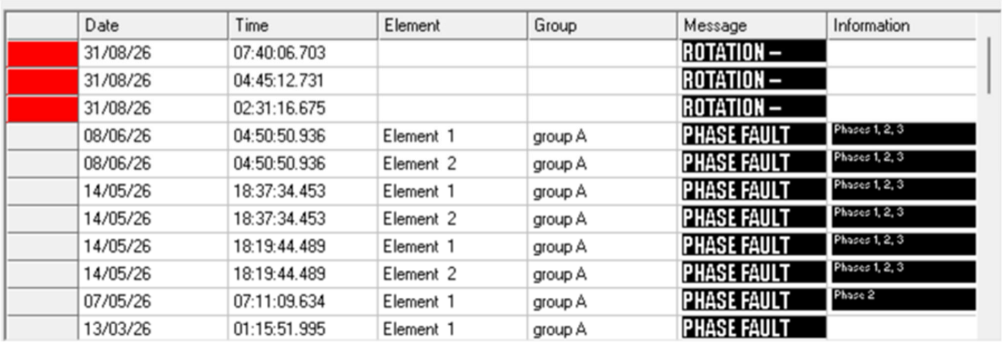

Figure 3: Alarm history on 33kV Incomer 1

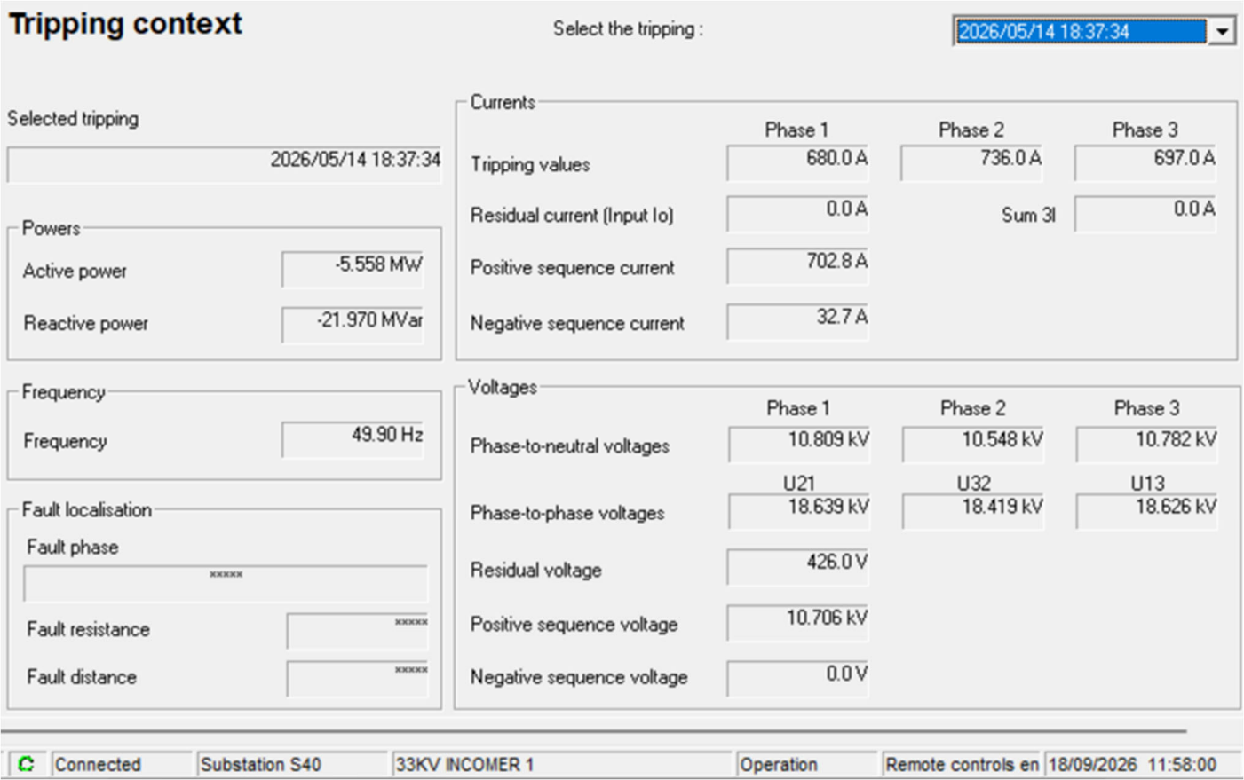

Figure 4: Trip record on 33kV Incomer 1 with stamp date of 2026/05/14 at 18:19:44

Analysis of the alarms on 33 kV Incomer 1 indicated major faults (short-circuit faults) exceeding multiple times the full-load capacity of the 5 MVA transformer installed at the site. The records suggested that insufficient action had been taken to identify the source of the fault before reclosing under these fault conditions.
The incomer alarm and trip records document a protective event, but they do not independently establish the initiating fault mechanism or a unique sequence of equipment failures. Confirming the initiating location would require a coordinated review of fault oscillography, protective-relay settings, and post-event electrical tests. Studies of microgrid protection likewise indicate that fault-current characteristics and relay selectivity depend on source composition, operating mode, and protection settings (Mahamedi & Fletcher, 2019; Patnaik et al., 2020; Zilovic et al., 2026).

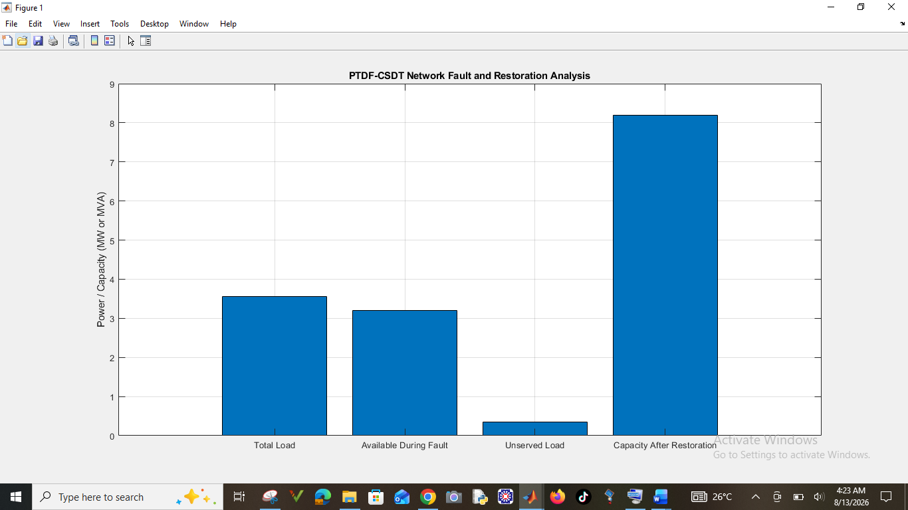
Figure 5: CSDT Network Fault and Restoration Analysis
Figure 5 illustrates the CSDT network performance under normal, fault, and restoration conditions. The RMU fault and failure of the 5 MVA transformer caused significant supply interruption and unserved load. However, the ring-circuit restoration strategy improved supply continuity, restored most critical loads, reduced energy interruption, and enhanced overall system resilience.
The simulated reduction in interrupted load under the ring-restoration scenario is consistent with the principal objective of distribution-network reconfiguration. Nevertheless, supplying healthy sections through an alternative route requires a technically feasible switching arrangement, adequate upstream capacity, and continued observance of equipment operating limits. These requirements are recognised in the literature on service restoration, microgrid formation, and resilience-oriented scheduling (Abu-Elanien et al., 2018; Igder et al., 2022; Tobajas et al., 2022).

Table 3: Transformer and Load Capacity Results
Component | Installed Rating | Assumed Operating Load | Loading (%) | Status
Main Transformer | 5.0 MVA | 3.40 MW equivalent system demand | 68.0 | Normal before fault
Transformer 1 | 1.6 MVA | 1.50 MW equivalent | 93.8 | Available
Transformer 2 | 1.6 MVA | 1.50 MW equivalent | 93.8 | Available
Library Transformer | 500 kVA | 0.30 MW | 60.0 | Normal
Auditorium Transformer | 500 kVA | 0.35 MW | 70.0 | Normal
Light Scale Transformer | 500 kVA | 0.30 MW | 60.0 | Normal
Heavy Scale Transformer | 500 kVA | 0.40 MW | 80.0 | Normal
Tower Building Transformer | 1,000 kVA | 0.70 MW | 70.0 | Normal
Residential Transformer 1 | 500 kVA | 0.35 MW | 70.0 | Normal
Residential Transformer 2 | 500 kVA | 0.35 MW | 70.0 | Normal
415 V Service Transformer | Assumed 500 kVA | 0.20 MW | 40.0 | Normal

Table 3 presents the installed transformer capacities, assumed operating loads, and loading percentages of the CSDT electrical network. The results show that most transformers operated within acceptable limits, although the two 1.6 MVA transformers recorded the highest loading of 93.8%, indicating limited spare capacity during emergency or restoration conditions. The two 1.6 MVA units have comparatively little remaining capacity under the assumed loading values shown in Table 3. However, because their operating loads are expressed in MW while their nameplate ratings are expressed in MVA, confirming the actual apparent-power loading would require the corresponding power factors or measured kVA values. Equipment loading and protection coordination should therefore be assessed together before applying the simulated reconfiguration to site operations (Mahamedi & Fletcher, 2019; Niknami et al., 2024; Zilovic et al., 2026).
The transformer loading percentages presented in Table 3 were obtained by comparing the assumed operating loads with the corresponding nameplate ratings. Because the operating loads are expressed in MW while transformer ratings are expressed in MVA, these percentages represent simplified loading estimates under a unity power-factor assumption. Actual transformer loading depends on apparent power and therefore requires consideration of the operating power factor. Consequently, the calculated percentages should be interpreted as indicative model values rather than independently verified field loading measurements. A detailed assessment of transformer loading during restoration would also require consideration of feeder configuration, connected loads, and available transformer capacity.

Table 4: Fault Simulation Results
Scenario | 33 kV Grid | RMU | 5 MVA Transformer | Supplied Load | Unserved Load | System Condition
Normal operation | Connected | Healthy | Healthy | 3.40 MW | 0.00 MW | Stable
RMU fault initiated | Connected | Fault detected | Healthy | 3.40 MW initially | 0.00 MW | Abnormal condition
J&P fuse operation | Disconnected | Fault isolated | Healthy | 0.00 MW from main grid | 3.40 MW | Supply interruption
Explosion scenario | Tripped | Damaged/isolated | Blown | 0.00 MW from affected supply path | 3.40 MW | Severe outage
Emergency restoration | Reconfigured | Isolated | Out of service | 3.00 MW | 0.40 MW | Partial restoration
Ring-circuit restoration | Alternative path available | Faulted section isolated | Out of service | 3.20 MW | 0.20 MW | Improved restoration
Full restoration | Connected | Repaired/replaced | Backup installed | 3.40 MW | 0.00 MW | Normal operation
Table 4 presents the simulated response of the CSDT network under normal, fault, and restoration conditions. The RMU explosion and 5 MVA transformer failure caused a severe outage, resulting in 3.40 MW of unserved load. Emergency and ring-circuit restoration progressively restored supply, reducing unserved load to 0.20 MW.
The sequence from complete interruption to 3.00 MW emergency supply and then to 3.20 MW ring-circuit supply represents the modelled switching and restoration states; it should not, on its own, be treated as evidence that an equivalent sequence has been field-validated. Established restoration approaches evaluate switching feasibility, connectivity, source capability, and load priorities as interdependent constraints (Abu-Elanien et al., 2018; Igder et al., 2022; Niknami et al., 2024).

Table 5: Voltage Profile During Different Operating Conditions
Bus/Location | Normal Operation (p.u.) | RMU Fault (p.u.) | After Fuse Trip (p.u.) | Ring Restoration (p.u.) | Full Restoration (p.u.)
33 kV Incoming Bus | 1.000 | 0.910 | 0.000 | 0.985 | 0.998
School 11 kV Bus | 0.990 | 0.830 | 0.000 | 0.955 | 0.989
Library Feeder | 0.985 | 0.810 | 0.000 | 0.950 | 0.986
Auditorium Feeder | 0.983 | 0.805 | 0.000 | 0.947 | 0.984
Tower Building | 0.978 | 0.790 | 0.000 | 0.942 | 0.982
Residential Bus | 0.987 | 0.850 | 0.000 | 0.960 | 0.988
The results in Table 5 indicate that the fault causes a significant voltage depression before protective isolation. Following operation of the J&P fuse, the affected section loses supply. The ring circuit improves restoration by providing an alternative path to healthy sections.
The simulated feeder voltages decrease to 0.790–0.850 p.u. during the fault and recover to 0.942–0.960 p.u. under the ring-restoration scenario. This pattern supports the interpretation that the alternative supply route improves the modelled voltage profile, although voltage acceptability across actual operating conditions would require specified limits and measurements. Related research incorporates voltage and supply constraints when assessing the feasibility of restoration and resilient microgrid operation (Igder et al., 2022; Niknami et al., 2024; Tobajas et al., 2022).

Table 6: Generated Fault Detection Results: For the proposed AI-based fault detection model was trained using voltage, current, power, frequency, and wavelet features:
Performance Metric | Random Forest | SVM | ANN | Proposed DWT-Deep Learning Model
Accuracy (%) | 94.8 | 96.2 | 97.1 | 99.1
Precision (%) | 94.2 | 95.8 | 96.9 | 99.0
Recall (%) | 93.9 | 96.0 | 96.5 | 98.8
F1-Score (%) | 94.0 | 95.9 | 96.7 | 98.9
Detection Time (ms) | 28.5 | 24.1 | 18.6 | 8.7
Table 6 compares the fault detection performance of the four AI models considered in the computational evaluation. The proposed DWT–deep learning model recorded the highest accuracy of 99.1%, compared with 94.8% for Random Forest, 96.2% for SVM, and 97.1% for ANN. It also achieved the highest precision, recall, and F1-score, indicating stronger classification performance under the simulated test conditions. The reported average detection time of 8.7 ms was lower than the corresponding values of the other models. These findings suggest that wavelet-based feature extraction combined with deep learning can provide a useful approach for identifying abnormal electrical conditions. However, the detection time should be interpreted according to the timing procedure used in the computational experiment and should not automatically be equated with the complete operating time of physical protection equipment.

In Table 6, the proposed DWT-deep-learning model produced the highest fault classification accuracy of 99.1% and the shortest detection time of 8.7 ms. This suggests that wavelet-based transient feature extraction combined with deep learning can identify the RMU-related fault faster than conventional machine-learning models. Within the generated evaluation presented in Table 6, the proposed model also has the highest reported precision, recall, and F1-score among the four methods. Wavelet-based and deep-learning approaches have been studied for detecting fault-related signal characteristics in different microgrid settings (Bukhari et al., 2026; Flaifel et al., 2024; Bramareswara Rao et al., 2025). Nevertheless, the reported 99.1% accuracy and 8.7 ms detection time remain conditional on the simulated dataset and measurement assumptions; additional evaluation under previously unseen events, sensor noise, changing generation conditions, and protective-device operating delays would be needed to establish field applicability.

Table 7: Energy and Reliability Results
Performance Indicator | Before Fault | Fault Without Restoration | Ring-Circuit Restoration | Full Restoration
Total Load Demand (MW) | 3.40 | 3.40 | 3.40 | 3.40
Supplied Load (MW) | 3.40 | 0.00 | 3.20 | 3.40
Unserved Load (MW) | 0.00 | 3.40 | 0.20 | 0.00
Supply Availability (%) | 100 | 0 | 94.1 | 100
Voltage Stability (Average p.u.) | 0.987 | 0.000 | 0.951 | 0.987
Transformer Capacity Available (MVA) | 8.20 | 3.20* | 3.20 | 8.20
Critical Load Served (%) | 100 | 0 | 100 | 100
Table 7 presents the energy and reliability performance of the CSDT network before, during, and after the fault. The fault caused complete supply loss and voltage collapse. However, the ring-circuit restoration supplied 3.20 MW, supplying 94.1% of modelled demand and fully serving critical loads, thereby demonstrating improved system resilience and reliability.
The reported 94.1% supply availability corresponds numerically to the fraction of the modelled demand served during ring restoration (3.20 MW out of 3.40 MW). In the absence of an explicit observation period or outage-duration analysis, this scenario-level fraction should not be interpreted as a measured long-term reliability index. Likewise, the modelled 100% critical-load supply depends on the assumed prioritisation and resource adequacy, issues explicitly considered in the literature on service restoration and resilience-oriented energy scheduling (Igder et al., 2022; Niknami et al., 2024; Tobajas et al., 2022).
The ring-circuit restoration scenario supplied 3.20 MW of the total simulated demand of 3.40 MW, representing approximately 94.1% of the required load. The remaining unserved load was therefore reduced to 0.20 MW. This result indicates a substantial improvement in the proportion of load supplied following network reconfiguration. Nevertheless, the percentage represents the amount of simulated load restored rather than system availability measured over an extended operating period. The feasibility of implementing an equivalent restoration arrangement in practice would depend on the availability of alternative supply paths, transformer loading limits, protective-device coordination, and the electrical condition of the affected network.

6. Conclusion
This study examined an integrated approach to fault detection and energy management for the CSDT electrical distribution network, drawing on documented equipment faults and site-specific simulations. The proposed discrete wavelet transform–deep learning model achieved 99.1% fault-classification accuracy and an average detection time of 8.7 ms in the computational evaluation. In the restoration analysis, protective isolation was followed by alternative supply arrangements that progressively reduced unserved load. Ring-circuit reconfiguration restored 3.20 MW of the modelled 3.40 MW demand, leaving 0.20 MW unserved and supplying approximately 94.1% of the required load. The simulated feeder-voltage profiles also recovered relative to the fault condition. Taken together, these results indicate the potential value of considering intelligent fault identification, protective isolation, network reconfiguration and load prioritisation within a common analytical framework. However, simulated detection time does not represent the complete operating time of physical protection devices, and the restored-load proportion is not a time-based reliability measure. Practical application would require assessment of protection coordination, transformer and feeder loading, switching feasibility and performance under actual operating conditions.

7. Limitations of the Study
The study has certain limitations that should be considered when interpreting its findings. Although the electrical network model was informed by the existing CSDT infrastructure and documented fault incidents, the AI performance and network restoration results were obtained through MATLAB and Python simulations. Consequently, the reported detection accuracy, response time, and restoration performance represent outcomes under the modelled operating conditions. Actual implementation may be influenced by variations in load demand, equipment condition, communication delays, protective relay settings, and network switching constraints. Further testing under practical operating conditions would therefore be valuable in establishing the reliability and applicability of the proposed framework.

7. Recommendations
Isolate and secure the faulty equipment. The RMU and transformer should be isolated from the power supply. Replace the failed J&P fuse with a fuse of the correct rating and specification. Before re-energisation, perform the following tests on the high-voltage equipment: an insulation resistance (IR) test, a transformer oil breakdown voltage (BDV) test, an earth resistance test and a protection relay secondary injection test. Confirm that the transformer tank, RMU, cable sheaths, and all metallic structures are properly bonded to earth. Review the protection scheme and verify that all protection relays are correctly set and coordinated. Confirm the operation of overcurrent protection and ensure the protection system isolates faults promptly to minimise equipment damage. Inspect high-voltage cable terminations and check for loose connections, carbon tracking, moisture ingress and insulation deterioration, and replace any defective terminations. A backup 5 MVA power transformer is needed to reduce the effects of power outages when the main transformer fails. Strengthen preventive maintenance and establish a routine maintenance schedule for all high-voltage equipment. Periodically carry out transformer oil analysis, insulation resistance testing, earth resistance testing and RMU mechanical inspections. The RMU should be serviced, a correctly rated fuse should be used, the Raychem kit for the XLPE cable should be replaced, and the cable lugs should be changed. Review operational procedures and ensure that only qualified personnel operate the medium-voltage system. Maintain accurate records of inspections, tests, maintenance, and fault events.

8. Engineering Implications
These results have engineering implications for improving the resilience and protection of critical electrical infrastructure. By examining the ability of AI-based fault detection to recognise abnormal conditions quickly, this study indicates the potential for faster isolation of faulty equipment, thereby limiting extensive system damage. In addition, the RMU ring-circuit layout offers an alternative supply route for restoring essential loads when transformers or feeders fail. Intelligent fault detection combined with energy management can support effective load prioritisation, transformer utilisation and emergency power restoration. The proposed framework could inform the design of smart-grid systems for oil and gas facilities and other critical infrastructure.

9.Ethical Issues.
Sensitive operational information was handled in accordance with the applicable confidentiality and security requirements. The findings obtained from computational simulations are distinguished from the documented site observations to ensure accurate reporting and interpretation.

Declaration of AI Use

This manuscript was prepared through the intellectual contributions of the author(s) to the study design, data analysis, interpretation of results, and scholarly content. Grammarly and ChatGPT were used solely to assist with grammatical refinement and reference formatting during manuscript revision. The author(s) accept full responsibility for the accuracy, integrity, and final content of the manuscript.

COMPETING INTERESTS DISCLAIMER:
Authors have declared that they have no known competing financial interests OR non-financial interests OR personal relationships that could have appeared to influence the work reported in this paper.

References
Abo Elkheir, E. I., Abd-Allah, M. A., Hussien, S. A., & Omar, A. I. (2026). Real-time microgrid fault management: Leveraging hybrid deep learning for superior detection and classification performance. IEEE Access, 14, 9606–9623. https://doi.org/10.1109/ACCESS.2026.3654266
Abu-Elanien, A. E. B., Salama, M. M. A., & Shaban, K. B. (2018). Modern network reconfiguration techniques for service restoration in distribution systems: A step to a smarter grid. Alexandria Engineering Journal, 57(4), 3959–3967. https://doi.org/10.1016/j.aej.2018.03.011
Alam, M. M., Hossain, M. J., Habib, M. A., Arafat, M. Y., & Hannan, M. A. (2025). Artificial intelligence integrated grid systems: Technologies, potential frameworks, challenges, and research directions. Renewable and Sustainable Energy Reviews, 211, Article 115251. https://doi.org/10.1016/j.rser.2024.115251
Bhaumik, S., Chattopadhyaya, A., & Bera, J. N. (2025). Detection and classification of faults in renewable energy penetrated stand alone microgrids using SVM and DWT techniques. Electric Power Systems Research, 245, Article 111634. https://doi.org/10.1016/j.epsr.2025.111634
Bramareswara Rao, S. N. V., Kumar, Y. V. P., Amir, M., & Muyeen, S. M. (2025). Fault detection and classification in hybrid energy-based multi-area grid-connected microgrid clusters using discrete wavelet transform with deep neural networks. Electrical Engineering, 107(7), 8481–8498. https://doi.org/10.1007/s00202-024-02329-4
Bukhari, S. B. A., Albalawi, H., Wadood, A., & Alatwi, A. M. (2026). Deep learning-driven fault detection and classification in microgrids using temporal convolutional network. Computers and Electrical Engineering, 129, Article 110777. https://doi.org/10.1016/j.compeleceng.2025.110777
Elazab, R., Abo Dahab, A., Abo Adma, M., & Hassan, H. A. (2024a). Enhancing microgrid energy management through solar power uncertainty mitigation using supervised machine learning. Energy Informatics, 7, Article 99. https://doi.org/10.1186/s42162-024-00333-3
Elazab, R., Abo Dahab, A., Abo Adma, M., & Hassan, H. A. (2024b). Reviewing the frontier: Modeling and energy management strategies for sustainable 100% renewable microgrids. Discover Applied Sciences, 6, Article 168. https://doi.org/10.1007/s42452-024-05820-6
Flaifel, A. A., Mohammed, A. F., Abd, F. K., Enad, M. H., & Sabry, A. H. (2024). Early detection of arc faults in DC microgrids using wavelet-based feature extraction and deep learning. Service Oriented Computing and Applications, 18, 195–207. https://doi.org/10.1007/s11761-024-00420-z
Geku, Diton, & D, A. A. (2025). Application of artificial intelligence techniques for the detection and diagnosis of faults in control systems: A scientific literature review. Asian Research Journal of Current Science, 7(1), 159–169. https://doi.org/10.56557/arjocs/2025/v7i1138
Igder, M. A., Liang, X., & Mitolo, M. (2022). Service restoration through microgrid formation in distribution networks: A review. IEEE Access, 10, 46618–46632. https://doi.org/10.1109/ACCESS.2022.3171234
Mahamedi, B., & Fletcher, J. E. (2019). Trends in the protection of inverter-based microgrids. IET Generation, Transmission & Distribution, 13(20), 4511–4522. https://doi.org/10.1049/iet-gtd.2019.0808
Mahidur, R. M., Zannatun, N., Md. Sajjad, H., & Kazi Md., S. (2026). Enhancing power system reliability with machine learning-enabled fault management. Journal of Energy Research and Reviews, 18(4), 14–24. https://doi.org/10.9734/jenrr/2026/v18i4504
Najafzadeh, M., Pouladi, J., Daghigh, A., Beiza, J., & Abedinzade, T. (2024). Fault detection, classification and localization along the power grid line using optimized machine learning algorithms. International Journal of Computational Intelligence Systems, 17, Article 49. https://doi.org/10.1007/s44196-024-00434-7
Niknami, A., Askari, M. T., Ahmadi, M. A., Nik, M. B., & Moghaddam, M. S. (2024). Resilient day-ahead microgrid energy management with uncertain demand, EVs, storage, and renewables. Cleaner Engineering and Technology, 20, Article 100763. https://doi.org/10.1016/j.clet.2024.100763
Patnaik, B., Mishra, M., Bansal, R. C., & Jena, R. K. (2020). AC microgrid protection – A review: Current and future prospective. Applied Energy, 271, Article 115210. https://doi.org/10.1016/j.apenergy.2020.115210
Tobajas, J., García-Torres, F., Roncero-Sánchez, P., Vázquez, J., Bellatreche, L., & Nieto, E. (2022). Resilience-oriented schedule of microgrids with hybrid energy storage system using model predictive control. Applied Energy, 306, Article 118092. https://doi.org/10.1016/j.apenergy.2021.118092
Zilovic, A., Strezoski, L., & Abbey, C. (2026). Short-circuit calculation and overcurrent relay protection in AC microgrids: A review. Energies, 19(11), Article 2510. https://doi.org/10.3390/en19112510

