Experimental Evaluation of Calorific Value, Combustion Behavior, and Energy Efficiency of Rice Husk Briquettes for Agro-Processing

Abstract
Rice husk is a residue of rice milling that can be densified into solid fuel for small-scale agro-processing. This study examines the potential of rice husk briquettes (RHB) as an alternative fuel for cassava processing. Rice husks were compressed using a screw-press extrusion system, and their energy performance was evaluated by calorimetry and combustion testing. An Adobe SMART Stove was used for practical cassava-flaking tests. The briquettes had calorific values of 14.79–15.56 MJ/kg, operational temperatures of 615–710 °C and a reported combustion efficiency of 70%, compared with 16.2 MJ/kg, 850 °C and 80% for fuelwood. In cassava-flaking trials using 5 kg of sieved cassava per test, the reported processing time was 15 min for both fuels, while fuel consumption was 3 kg for the briquettes and 5 kg for fuelwood. Because the two fuels were tested in different stove arrangements, the fuel-consumption difference cannot be attributed to fuel properties alone. The results nevertheless demonstrate the technical potential of densified rice husk as a solid fuel for rural agro-processing and provide a basis for further controlled comparisons.
Keywords: Rice husk briquettes, Biomass energy, Calorific value, Combustion efficiency; Cassava processing, Agro-waste valorization; Sustainable fuel.

INTRODUCTION
Cassava (Manihot esculenta) processing plays a crucial role in many tropical and subtropical regions, where the crop serves not only as a major staple food but also as an important source of income for rural households (Borku, 2025). The transformation of cassava roots into products such as cassava flakes (gari) involves several processing stages, including peeling, grating, dewatering, sieving, and roasting or flaking (Ngoualem Kégah & Ndjouenkeu, 2023; TAAT Clearinghouse, 2022). Among these steps, flaking is one of the most energy-demanding processes because it requires a steady and reliable heat supply to properly gelatinise and dry the cassava mash (Hans et al., 2023). In most rural communities, this heat is traditionally generated using biomass fuels such as firewood or charcoal.
However, the heavy reliance on firewood for cassava flaking presents serious environmental and socio-economic challenges. Continuous harvesting of fuelwood contributes to deforestation, biodiversity loss, and unsustainable land use (Girma & Shimeles, 2025). In addition, burning firewood releases greenhouse gases and particulate matter that contribute to climate change and air pollution (Łaska & Ige, 2023). The smoke produced during the flaking process also poses health risks to processors, especially women who are predominantly involved in small-scale cassava processing activities (Adeshina, 2024; Adeniyi et al., 2024; Agoh et al., 2024). These challenges highlight the need to explore cleaner, more sustainable energy alternatives for cassava processing (Abass, 2023).
In recent years, growing attention has been directed toward the use of agricultural residues as renewable biomass energy sources (Benti et al., 2021). One such residue is rice husk, a by-product of rice milling that accounts for about 20% of the harvested rice grain (Chavan et al., 2024; Chieng & Kuan, 2022). Large quantities of rice husk are generated globally each year and are often treated as waste or disposed of through open burning, which contributes to environmental pollution (Kesari & Jamal, 2017; Singh et al., 2021). Nevertheless, rice husk contains considerable energy potential and can be converted into briquettes through densification processes, thereby improving its fuel quality and usability (Sithole et al., 2023; Suryaningsih et al., 2018; Vijaya et al., 2025; Yunusa et al., 2025). A review of agricultural biomass residues in Nigeria also identifies rice husk among materials with potential for bioenergy generation and other value-added uses (Giwa et al., 2025).
Rice husk briquettes (RHB) are compacted biomass fuels with higher energy density, improved combustion characteristics, and easier handling compared with loose agricultural residues (Ali et al., 2024; Ondari et al., 2025; Yank et al., 2016). Because they are renewable and widely available, RHB have gained attention as a promising alternative fuel for thermal applications in agro-processing industries (Kapoor & Sillanpää, 2025; Vishnu Priyan et al., 2024). Their use in cassava flaking could reduce dependence on firewood, lower environmental impacts, and promote more sustainable energy use within rural agricultural value chains (Mwape, 2025; Tshimungu et al., 2026). Experimental research on rice husk–bagasse briquettes has demonstrated that formulation, binder type, and compaction pressure affect their measured thermal and physical properties (Daniel et al., 2020). Densification experiments involving rice husk and wood shavings have likewise documented the effects of feedstock composition and operating conditions on briquette characteristics (Kamdem et al., 2025).
The use of different biomass fuels in food processing applications offers advantages such as renewability and environmental sustainability (Gheidan et al., 2021; Kataya et al., 2023). However, challenges related to fuel-property characterisation and potential competition with food production need to be addressed to ensure the efficient and sustainable integration of biomass energy into food processing operations (Khalil & DanielRos, 2025; Mignogna et al., 2024). A fixed-bed combustion study of oil-enriched carbonised rice husk briquettes further examined the influence of particle size and air-mass flux on ignition and burning behaviour (Diallo et al., 2025).
Although earlier studies have characterised rice husk briquettes and related biomass fuels, the literature discussed here does not directly examine screw-press rice husk briquettes in the cassava-flaking arrangement evaluated in the present study. The application-specific question is therefore how the briquettes perform in calorimetry and combustion tests and during cassava flaking, alongside a fuelwood treatment. Because the two fuels are assessed in different stove arrangements, the processing comparison describes the tested fuel–stove configurations rather than isolating the effect of fuel type.
Therefore, this study focuses on producing briquettes from rice husk and evaluating their thermal performance by determining the heat energy output generated during combustion. The study also examines the feasibility of integrating rice husk briquettes as an alternative energy source for cassava flaking. By converting agricultural waste into a useful energy resource, this research aims to improve energy efficiency, promote sustainable cassava processing, and contribute to environmental protection and rural economic development.

METHODOLOGY

Experimental Design and Study Location
This study used an experimental approach to evaluate the performance of rice husk briquettes as an alternative fuel for cassava processing. Rice husk was obtained from a local rice-milling centre in Wukari, Taraba State, Nigeria. The cassava used for the processing trials was the TMS 30572 variety, harvested at approximately 9 months of age. The rice husk was manually sorted to remove stones, foreign matter and other visible impurities, then spread in a clean open area and sun-dried for three days. Moisture loss during preparation was monitored gravimetrically. For oven-based moisture determination, representative samples were dried at 105 °C to constant mass. The dried samples were allowed to cool for 24 h before weighing and testing. Mass was measured with a digital analytical balance (Mettler Toledo, 0.0001 g sensitivity).

Rice Husk Briquette Production
Briquette production was carried out using a screw-press extruder-type briquetting machine (Figure 1) powered by a 7.5 hp, 380 V electric motor operating at about 970 rpm and fitted with three 5 kW heating coils. The heating coils maintained die-barrel temperatures between 300 and 330 °C, which softened the natural lignin in the rice husk and promoted particle binding as the material passed through the die. The resulting briquettes were produced in hexagonal form, cooled for 24 h and stored in a ventilated, moisture-free room.
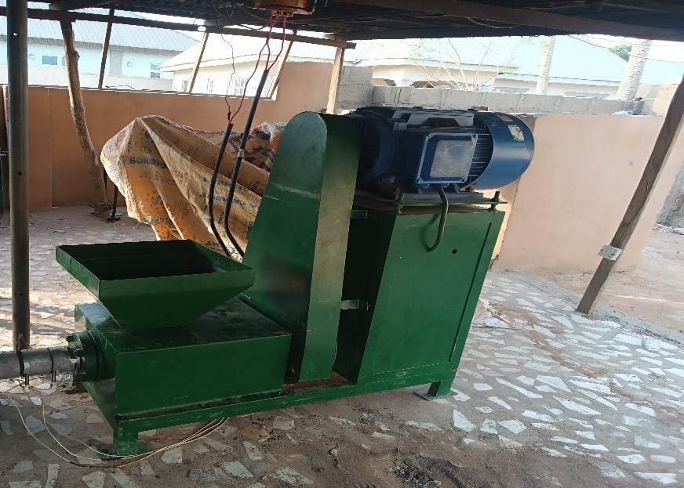
Figure 1: Screw press extruder-type briquetting machine used for rice husk briquette production.

Calorific Value and Combustion Monitoring
Calorific values were determined with an IKA C 2000 oxygen bomb calorimeter using dried samples and the instrument's combustion-calorimetry procedure. Operational temperature, DC current and burning time were monitored separately in a forced-air combustion arrangement consisting of a DC power supply, an ammeter, a blower and a K-type thermocouple. The ammeter recorded the DC current supplied to the blower, while a stopwatch was used to record burning time.

Adobe SMART Stove and Cassava-Flaking Test
An Adobe SMART Stove (Figure 2) was designed and built specifically for this research. The stove had a double-wall structure of locally produced adobe bricks, with outer and inner footprints of approximately 1.12 m × 1.12 m and 0.97 m × 0.97 m, respectively, separated by a 12.7 cm gap filled with a dry clay–sand mixture to trap heat and reduce heat loss. The inner combustion chamber was lined with galvanised metal sheeting and contained a mild-steel grate, a removable ash tray and a metal chimney; a cast-iron plate served as the cooking surface. A 12 V DC fan installed at the air inlet supplied forced air to the combustion chamber and was powered by a photovoltaic system to keep the entire system running on renewable energy. The fan speed could be adjusted using a variable resistor, giving control over the burning rate and cooking temperature.
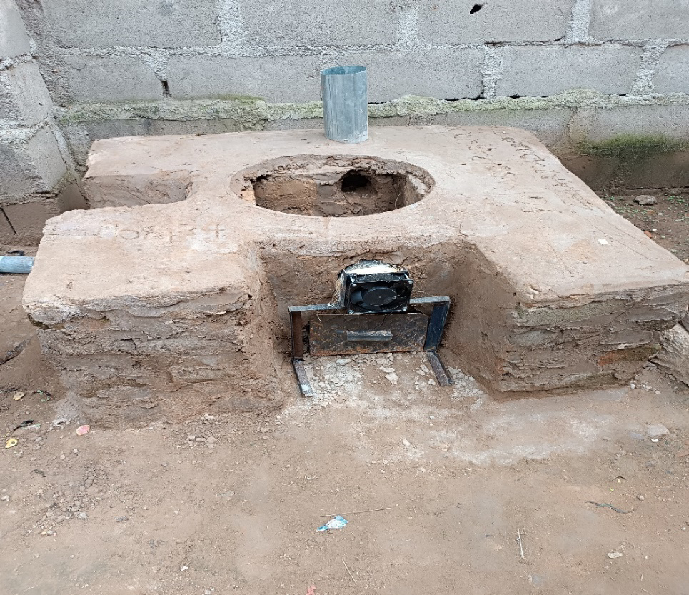
Figure 2: The completed Adobe SMART Stove, showing the double-wall adobe structure, the DC fan at the air inlet and the chimney.
To evaluate performance under practical processing conditions, fresh cassava roots of the TMS 30572 variety were weighed, peeled, washed with water from a solar-powered water pump, grated, dewatered and sieved to obtain a uniform mash. Each fuel test used 5 kg of sieved cassava. For the rice husk briquette treatment, the cassava was fried into flakes in the Adobe SMART Stove. For comparison, fuelwood was tested in an open setup representing the traditional processing arrangement. Fuel mass consumed, processing time and final product mass were recorded for each test. Each experimental condition was repeated five times. Data were entered and analysed using IBM SPSS Statistics, with descriptive statistics reported as mean ± standard deviation. Where inferential comparisons were appropriate, statistical significance was assessed at P < 0.05.

RESULTS AND DISCUSSION
Production of the rice husk briquettes, determination of their heat energy output, and comparison of their energy efficiency with traditional fuelwood in cassava processing were carried out as described in the Methodology section. Data were collected on energy input, processing time and product quantity to assess the benefits of using rice husk briquettes in place of traditional fuel.

Physical Characteristics of the Rice Husk Briquettes
The results of the briquette production are presented in Table 1.
Table 1: Rice Husk Briquette Production
Parameter | Sample
Initial rice husk weight(Kg) | 1.25
Pressure applied $Nm^{-2}$) | 6×${10}^{9}Nm^{-2}$
Briquette weight (Kg) | 1.0

The results presented in Table 1 show the mass conversion of 1.25 kg of rice husk into briquettes at an applied pressure of 6x10⁹ Nm⁻². The initial weight of rice husk used in the experiment was 1.25 kg.
The applied pressure gave a briquette weight of 1.0 kg. This shows that approximately 80% (1.0/1.25 × 100%) of the initial rice husk weight was retained in the briquette form, a mass loss of about 20%. The application of pressure is necessary for the process as it compacts the loose rice husk particles into solid briquettes, and the magnitude of pressure required depends on the cohesiveness and density of the material. The mass loss is attributed to moisture loss during heating and to fine particles that did not compact effectively, which is consistent with the literature (Saeed et al., 2021). Because the husk was sun-dried and not oven-dried, the loss reflects moisture and fines together and is not an absolute moisture content.

Calorific Value and Combustion Behaviour
The heat energy output of the rice husk briquettes is shown in Table 2, which lists the calorific value, burning time, operational temperature and the DC current supplied to the blower that regulated the air supply to the combustion chamber.

Table 2: Heat Energy Output Determination of Rice Husk Briquettes (five repeated experimental conditions)
Rice Husk Briquettes (kg) | Calorific Value (MJ/kg) | Burning Time (min) | Operational Temperature (°C) | Current(I) DC (A)
5 | 14.79 | 15 ± 2 | 615 ± 60 | 1.5
5 | 14.83 | 13 ± 2 | 630 ± 62 | 1.8
5 | 15.10 | 13 ± 2 | 655 ± 65 | 2.3
5 | 15.12 | 12 ± 2 | 682 ± 68 | 2.5
5 | 15.56 | 12 ± 2 | 710 ± 70 | 2.7

Table 2 presents the calorific values of the rice husk briquettes, which ranged from 14.79 to 15.56 MJ/kg, with a small increase across the trials. The calorific value was determined by bomb calorimetry, whereas the operational temperature and DC current were recorded in a separate forced-air combustion arrangement; the trend of calorific value with these operating parameters is therefore an association and should not be taken to mean that the operating conditions changed the intrinsic energy content of the fuel. The values are lower than, but of the same order as, those reported for rice husk briquettes in previous studies (Yank et al., 2016; Saeed et al., 2021). The highest value obtained (15.56 MJ/kg) is about 12% lower than the 17.688 MJ/kg reported by Saeed et al. (2021) for rice husk briquettes produced at controlled moisture content with a kraft lignin binder. Such differences can be attributed to feedstock composition, moisture condition, binder and production conditions, as well as the fixed carbon and volatile matter content of the fuel, since the calorific value of a solid fuel depends largely on its carbon content and proximate composition.
As observed in Table 2, the burning time decreased slightly from 15 ± 2 minutes to 12 ± 2 minutes as the operational temperature and the DC current supplied to the blower increased. This suggests that a higher air supply and temperature accelerate the combustion process and shorten the burning time. However, the burning times of adjacent trials overlap within their stated uncertainty (± 2 min), so this trend should be regarded as indicative.
Figure 3 shows an inverse relationship between the calorific value of the briquettes and their burning time: briquettes with higher calorific values burned for a shorter time. The present measurements do not independently establish the fuel-property mechanism responsible for this relationship. A shorter burning time is often associated with a higher volatile matter content, because volatiles such as tars and other hydrocarbons are combustible and have a low flash point. Ignition time was not measured in this study, but according to Sani et al. (2020), briquettes with a short ignition time raise safety concerns during storage because the risk of ignition and fire is increased; caution must therefore be taken to keep briquettes free from sparks and extreme heat. The longest burning time, 15 ± 2 minutes, may be influenced by factors such as the duration of initial combustion, adhesion between briquette particles, and ventilation during and after combustion.

Figure 3. Relationship between calorific value and burning time of rice husk briquettes
Table 2 shows a progressive increase in operational temperature from 615 ± 60 °C to 710 ± 70 °C. The mean operational temperature was approximately 658 °C. The temperature increase coincided with an increase in DC current from 1.5 to 2.7 A. This is consistent with the operation of the forced-air system: increasing the electrical drive to the blower increased air movement through the combustion chamber, which supported combustion and raised the measured temperature. Because airflow rate was not measured directly, the DC current should be regarded as a control indicator rather than a direct airflow measurement. A K-type thermocouple was used for temperature measurement.
From Table 2, the smallest measured calorific value was 14.79 MJ/kg, while the highest was 15.56 MJ/kg. These values were obtained from the bomb-calorimetry measurements and should be interpreted primarily as fuel-property measurements rather than consequences of the operating temperature. Differences among briquette samples may reflect variation in feedstock composition, moisture condition and densification history; however, these factors were not independently quantified in the present experiment. Figure 4 further shows that increasing DC current was associated with increasing operational temperature because the blower supplied progressively stronger forced air to the combustion chamber. The trend therefore supports the use of blower control as an operational means of regulating combustion intensity within the tested range.

Figure 4. Relationship between operational temperature and DC current supplied to the blower

Comparative Thermal Performance of Rice Husk Briquettes and Fuelwood
Table 3: Heat Energy Output Determination between fuelwood and rice husk briquettes
Parameter | Rice Husk Briquette | Fuelwood
Sample Weight (kg) | 1 | 1
Calorific Value (MJ/kg) | 14.8 | 16.2
Burning Time (min) | 15 | 15
Maximum Temperature Achieved (°C) | 780 | 850
Combustion Efficiency (%) | 70 | 80

Table 3 compares the heat energy output of fuelwood and rice husk briquettes, which allows the performance of the two energy sources to be evaluated. Fuelwood showed a slightly higher calorific value (16.2 MJ/kg) than the rice husk briquettes (14.8 MJ/kg), indicating that it can release more energy per unit mass; however, the difference is modest (about 9%), which suggests that rice husk briquettes are a competitive alternative. Both fuels had the same burning time of 15 minutes, showing similar combustion durations under comparable conditions, so the briquettes can match fuelwood in sustaining heat over time. The rice husk briquettes attained a maximum temperature of 780 °C while fuelwood reached 850 °C, so fuelwood gave a slightly higher heat intensity; nevertheless, the briquettes reached temperatures sufficient for most heating applications, including cooking. The combustion efficiency of the rice husk briquettes was 70%, compared with 80% for fuelwood. The higher efficiency of fuelwood may be related to its composition and higher energy density. However, the efficiency of the rice husk briquettes (70%) is encouraging, considering that they are produced from a renewable agricultural by-product.
Table 4: Cassava Processing Comparison
Parameter | Rice Husk Briquette | Fuelwood
Initial Cassava Weight (kg) after sieving | 5 | 5
Processing Time (min) (i.e frying time) | 15 | 15
Fuel Consumption (kg) | 3 | 5
Final Product Weight (kg) | Not available | Not available

Table 4 compares the performance of rice husk briquettes and fuelwood in cassava flaking. Both methods used 5 kg of sieved cassava per test. The reported frying time was 15 minutes for both fuels. Rice husk briquettes consumed 3 kg of fuel compared with 5 kg for fuelwood, a 40% lower fuel consumption by mass. This difference should not be interpreted as a 40% improvement in energy efficiency because the fuels have different calorific values and were tested in different stove arrangements (the Adobe SMART Stove for briquettes and an open fuelwood setup). The final-product mass is not recalculated here because the available source data in the manuscript were based on the earlier 2 kg cassava test and therefore cannot be transferred to the revised 5 kg test without the original raw measurements.

CONCLUSION
The findings indicate that rice husk briquettes can provide a practical alternative fuel for cassava processing under the conditions tested. The briquettes had calorific values of 14.79–15.56 MJ/kg and produced operational temperatures of 615–710 °C in the forced-air combustion system. In the cassava-flaking trial, the briquettes and fuelwood produced the same reported processing time of 15 min, while the reported fuel consumption was 3 kg and 5 kg, respectively. Because the two fuels were tested in different stove arrangements, the observed fuel-consumption difference should not be interpreted as a fuel-only efficiency advantage. Nevertheless, the results demonstrate the technical potential of rice husk densification for converting an agricultural residue into a usable solid fuel for rural agro-processing.

Limitations
The briquettes and fuelwood were tested in different stove arrangements, so differences in fuel consumption cannot be assigned to fuel type alone. Blower current was recorded, but the corresponding airflow rate was not measured directly. These limitations restrict comparisons of practical energy efficiency and indicate the need for matched test conditions and more complete measurements.

Declaration of AI Use

This manuscript was prepared through the intellectual contributions of the author(s) to the study design, data analysis, interpretation of results, and scholarly content. Grammarly and ChatGPT were used solely to assist with grammatical refinement and reference formatting during manuscript revision. The author(s) accept full responsibility for the accuracy, integrity, and final content of the manuscript.

References

Adeniyi, V., Akangbe, J., Kolawole, A., & Okonta, O. (2024). Comparison of occupational and environmental health hazards associated with the use of improved and conventional cassava processing technologies in Nigeria. In 2024 International Conference on Science, Engineering and Business for Driving Sustainable Development Goals (SEB4SDG). IEEE. https://doi.org/10.1109/SEB4SDG60871.2024.10630379
Adeshina, O. O. (2024). Exposure to air pollution and lung function among cassava grits (Gari) processors in Ghana [Doctor of Public Health thesis, London School of Hygiene & Tropical Medicine]. https://researchonline.lshtm.ac.uk/4672588/1/2024_PHP_DrPH_Adeshina_O.pdf
Agoh, E. C., Ogwu, M. C., Chukwuemeka, O. S., & Ekeledo, P. I. (2024). Environmental and human health effects of cassava processing and processing waste. In M. C. Ogwu, S. C. Izah, A. A. Cunha Alves, & S. C. Babu (Eds.), Sustainable cassava: Strategies from production through waste management (pp. 203–219). Academic Press. https://doi.org/10.1016/B978-0-443-21747-0.00001-1
Ali, A., Kumari, M., Manisha, Tiwari, S., Kumar, M., Chhabra, D., & Sahdev, R. K. (2024). Insight into the biomass-based briquette generation from agro-residues: Challenges, perspectives, and innovations. BioEnergy Research, 17(2), 816–856. https://doi.org/10.1007/s12155-023-10712-5
Mwape, M. C., Parmar, A., Roman, F., Emmambux, N. M., Azouma, Y. O., & Hensel, O. (2025). Life cycle sustainability assessment of staple food processing: A double and dynamic materiality approach. Sustainable Production and Consumption, 56, 343–363. https://doi.org/10.1016/j.spc.2025.04.002
Benti, N. E., Gurmesa, G. S., Argaw, T., Aneseyee, A. B., Gunta, S., Kassahun, G. B., Aga, G. S., & Asfaw, A. A. (2021). The current status, challenges and prospects of using biomass energy in Ethiopia. Biotechnology for Biofuels, 14(1), Article 209. https://doi.org/10.1186/s13068-021-02060-3
Borku, A. W. (2025). Cassava (Manihot esculenta Crantz): Its nutritional composition insights for future research and development in Ethiopia. Discover Sustainability, 6, Article 404. https://doi.org/10.1007/s43621-025-00996-2
Chavan, S., Mitra, D., & Ray, A. (2024). Harnessing rice husks: Bioethanol production for sustainable future. Current Research in Microbial Sciences, 7, Article 100298. https://doi.org/10.1016/j.crmicr.2024.100298
Chieng, S., & Kuan, S. H. (2022). Harnessing bioenergy and high value-added products from rice residues: A review. Biomass Conversion and Biorefinery, 12, 3547–3571. https://doi.org/10.1007/s13399-020-00891-y
Daniel, K. K., Siagi, Z. O., & Ogola, J. O. (2020). Effect of formulation, binder and compaction pressure of rice husk-bagasse briquettes on thermal and physical properties. Journal of Scientific Research and Reports, 26(10), 38–53. https://doi.org/10.9734/jsrr/2020/v26i1030320
Diallo, M. I., Kiplimo, R., Tanui, J. K., & Oketch, P. O. (2025). Optimization of combustion characteristics of carbonized rice husk briquettes fuel enriched with Croton megalocarpus oil in fixed bed reactor. Engineering Reports, 7(7), Article e70267. https://doi.org/10.1002/eng2.70267
Gheidan, A. A., Wahid, M. A., Munir, F. A., & Opia, A. C. (2021). Feasibility study of bio-fuel as a sustainable product of biomass: An overview of its fundamentals, application and environmental impact. Journal of Advanced Research in Fluid Mechanics and Thermal Sciences, 88(2), 106–122. https://doi.org/10.37934/arfmts.88.2.106122
Girma, G. A., & Shimeles, A. (2025). Woodfuel production and its implication in driving deforestation in the drylands of Ethiopia. Indonesian Green Technology Journal, 14(2). https://doi.org/10.21776/ub.igtj.2025.014.02.05
Giwa, A. L., Okoli, I. C., & Obikaonu, H. O. (2025). Valorization of agricultural biomass wastes in Nigeria with focus on banana pseudo-stem, empty palm bunch and rice husk. Asian Journal of Research and Review in Agriculture, 7(1), 260–275. https://doi.org/10.56557/ajrra/2025/v7i1176
Hans, M., Lugani, Y., Chandel, A. K., Rai, R., & Kumar, S. (2023). Production of first- and second-generation ethanol for use in alcohol-based hand sanitizers and disinfectants in India. Biomass Conversion and Biorefinery, 13(9), 7423–7440. https://doi.org/10.1007/s13399-021-01553-3
Abass, A. B., Awoyale, W., Sulyok, M., & Alamu, E. O. (2017). Occurrence of regulated mycotoxins and other microbial metabolites in dried cassava products from Nigeria. Toxins, 9(7), Article 207. https://doi.org/10.3390/toxins9070207
Kamdem, B. M., Lemaire, R., & Nikiema, J. (2025). Insight into the production factors influencing the physicochemical properties of densified briquettes comprising wood shavings and rice husk. Industrial Crops and Products, 223, Article 120134. https://doi.org/10.1016/j.indcrop.2024.120134
Kapoor, R. T., & Sillanpää, M. (Eds.). (2025). Biomass-based green technology for circular economy. CRC Press. https://doi.org/10.1201/9781003500469
Kataya, G., Cornu, D., Bechelany, M., Hijazi, A., & Issa, M. (2023). Biomass waste conversion technologies and its application for sustainable environmental development—A review. Agronomy, 13(11), Article 2833. https://doi.org/10.3390/agronomy13112833
Kesari, K. K., & Jamal, Q. M. S. (2017). Review processing, properties and applications of agricultural solid waste: Effect of an open burning in environmental toxicology. In K. K. Kesari (Ed.), Perspectives in environmental toxicology (pp. 161–181). Springer. https://doi.org/10.1007/978-3-319-46248-6_8
Khalil, I. A., & DanielRos, M. (2025). Biomass energy: Pathways, potentials, and challenges for a sustainable energy future. Energy Conversions, 4. https://energyconversions.org/index.php/ecm/article/download/39/39
Łaska, G., & Ige, A. R. (2023). A review: Assessment of domestic solid fuel sources in Nigeria. Energies, 16(12), Article 4722. https://doi.org/10.3390/en16124722
Mignogna, D., Szabó, M., Ceci, P., & Avino, P. (2024). Biomass energy and biofuels: Perspective, potentials, and challenges in the energy transition. Sustainability, 16(16), Article 7036. https://doi.org/10.3390/su16167036
Ngoualem Kégah, F., & Ndjouenkeu, R. (2023). Gari, a cassava (Manihot esculenta Crantz) derived product: Review on its quality and their determinants. Journal of Food Quality, 2023, Article 7238309. https://doi.org/10.1155/2023/7238309
Ondari, B. O., Kimutai, S., & Mukubwa, E. (2025). Combustion characteristics of briquettes of different feed-stock of agricultural wastes: A review. International Journal of Research and Innovation in Applied Science, 10(6), 1654–1662. https://doi.org/10.51584/IJRIAS.2025.100600124
Saeed, A. A. H., Yub Harun, N., Bilad, M. R., Afzal, M. T., Parvez, A. M., Roslan, F. A. S., Abdul Rahim, S., Vinayagam, V. D., & Afolabi, H. K. (2021). Moisture content impact on properties of briquette produced from rice husk waste. Sustainability, 13(6), Article 3069. https://doi.org/10.3390/su13063069
Sani, J., Abubakar, T., & Mawoli, M. (2020). Comparative studies of physical and combustion characteristics of rice husk briquettes produced using different binding agents. International Journal of Research -GRANTHAALAYAH, 7(7), 183–190. https://doi.org/10.29121/granthaalayah.v7.i7.2019.746
Singh, G., Gupta, M. K., Chaurasiya, S., Sharma, V. S., & Pimenov, D. Y. (2021). Rice straw burning: A review on its global prevalence and the sustainable alternatives for its effective mitigation. Environmental Science and Pollution Research, 28, 32125–32155. https://doi.org/10.1007/s11356-021-14163-3
Sithole, T., Pahla, G., Mashifana, T., Mamvura, T., Dragoi, E. N., Saravanan, A., & Sadeghifar, H. (2023). A review of the combined torrefaction and densification technology as a source of renewable energy. Alexandria Engineering Journal, 82, 330–341. https://doi.org/10.1016/j.aej.2023.09.080
Suryaningsih, S., Nurhilal, O., Yuliah, Y., & Salsabila, E. (2018). Fabrication and characterization of rice husk charcoal bio briquettes. AIP Conference Proceedings, 1927(1), Article 030044. https://doi.org/10.1063/1.5021237
TAAT Clearinghouse. (2022). Cassava processing technology toolkit catalogue (Clearinghouse Technical Report Series 013) [Version 1; not peer reviewed]. Gates Open Research, 6, Article 92. https://doi.org/10.21955/gatesopenres.1116887.1
Tshimungu, T. B., Isah, M. E., & Ishii, K. (2026). Harnessing cassava-based ethanol for rural communities: A conditional circular pathway to reduce biomass dependence in rural Congo. Energy for Sustainable Development, 93, Article 101982. https://doi.org/10.1016/j.esd.2026.101982
Vijaya, Idrishi, R., Singh, S., & Islam, M. (2025). Processing of rice husk and its applications. In M. Jawaid & B. Parmar (Eds.), Rice husk biomass: Processing, properties and applications (pp. 1–26). Springer. https://doi.org/10.1007/978-981-96-1082-2_1
Vishnu Priyan, V., Sathasivam, J., Kumar, A., & Narayanasamy, S. (2024). Valorisation of agricultural waste into a low-cost adsorbent: Perspective of reutilization. In R. Neelancherry, B. Gao, & A. Wisniewski Jr. (Eds.), Agricultural waste to value-added products: Bioproducts and its applications (pp. 125–149). Springer. https://doi.org/10.1007/978-981-97-2535-9_6
Yank, A., Ngadi, M., & Kok, R. (2016). Physical properties of rice husk and bran briquettes under low pressure densification for rural applications. Biomass and Bioenergy, 84, 22–30. https://doi.org/10.1016/j.biombioe.2015.09.015
Yunusa, S. U., Mensah, E., Narra, S., Saleh, A., & Preko, K. (2025). Strategies for improving the quality of low-pressured rice husk briquette: A mini-review. In M.-M. Narra & S. Narra (Eds.), African green transition through innovative pathways (pp. 65–80). Springer. https://doi.org/10.1007/978-3-031-87043-9_4

