DIRECTION AND STABILITY OF GESTATION-DELAY INDUCED HOPF BIFURCATION IN A STAGE-STRUCTURED PREY-PREDATOR SYSTEM WITH FEAR COST AND HERD BEHAVIOR

Abstract
This study investigates the direction and stability of gestation-delay-induced Hopf bifurcation in a stage-structured prey–predator system incorporating predator-induced fear and herd behaviour. The model divides the prey population into juvenile and adult stages and describes predator recruitment using a gestation delay. A square-root functional response is employed to account for the protective effect of prey aggregation, while a predator-dependent fear term is incorporated into prey reproduction. Positivity and boundedness of solutions are established, and the extinction, predator-free and coexistence equilibria are derived. Local stability of the coexistence equilibrium in the absence of delay is investigated using the Routh–Hurwitz criterion. For positive gestation delay, a transcendental characteristic equation is derived and separated into real and imaginary components. Elimination of the delay yields a cubic characteristic polynomial in 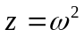, whose positive root provides the Hopf frequency and corresponding critical delay. Numerical simulations confirm the existence of a positive root of the characteristic polynomial and demonstrate that the critical gestation delay increases with the fear coefficient over the parameter range considered. Center-manifold and normal-form analysis further shows that the parameter set considered produces a supercritical, orbitally stable Hopf bifurcation, with stable periodic solutions emerging as the gestation delay crosses the critical threshold. The findings demonstrate that predator-induced fear can delay the onset of delay-induced instability, while gestation delay remains a significant mechanism for generating population oscillations. The study provides a mathematical framework for examining the combined effects of behavioural responses, herd defence and reproductive time lags on predator–prey population dynamics.

Keywords: predator–prey system, fear effect, gestation delay, Hopf bifurcation, herd behaviour.

Introduction
For almost a century, the mathematical modeling of predator-prey relationships has played a crucial and influential role in theoretical ecology. The biological richness and mathematical sophistication of models of two-species trophic interaction have continuously increased since the pioneering and independent work of Lotka (1925) and Volterra (1926). Although qualitatively suggestive, the simplest Lotka–Volterra equations imply neutrally stable oscillations around a coexistence equilibrium. However, this prediction is known to be structurally unstable and frequently defies field data. Logistic self-regulation in the prey, nonlinear saturable functional responses after Holling (1959), stage structure to reflect different juvenile and adult life-history phases, and time delays to account for the lag between resource uptake and demographic output are some of the modifications that later generations of ecologists and mathematicians introduced to get around these restrictions. Each of these modifications increases the model's resemblance to the ecological reality seen in field populations, but they also add mathematical complexity that necessitates careful analysis.

The functional form of the predation term, or the rate at which a predator of density$Y$ eats prey of density $X$, is a particularly significant class of modifications. The traditional Holling type I (linear), type II (hyperbolic), and type III (sigmoid) functional responses all make the assumption that prey are dispersed as distinct individuals that the predator can reach on its own. When prey congregate in schools or herds for group defense, this assumption is refuted. In these environments, the rate of interactions scales with the herd's perimeter rather than its area, and the predator interacts with the herd's boundary rather than with individual prey dispersed uniformly throughout space. The proper encounter rate is proportional to $\sqrt{X}$ since the perimeter of a disk with area proportionate to $X$ scales as $\sqrt{X}$, resulting in a square-root functional response. The first systematic mathematical analysis of a continuous predator-prey system with this square-root functional response was presented by Ajraldi et al. (2011), who also showed that it produces dynamics that are qualitatively different from the typical Holling types, such as the emergence of limit cycles that cannot be explained by linear stability arguments alone. Salman et al. (2016) expanded on their work by examining a discrete-time counterpart and characterizing period-doubling paths to chaos and Neimark–Sacker bifurcations that emerge when the time step is doubled. These findings have consequences for populations that are seasonally pushed. The significance of noise-induced transitions in actual ecosystems was highlighted by Bera et al. (2016), who integrated environmental stochasticity into the square-root herd-behavior model and demonstrated that white-noise perturbations can drive a stochastically excited system to extinction even when the deterministic coexistence equilibrium is globally stable.

The systematic inclusion of the fear effect, the indirect, non-lethal cost that predation risk imposes on prey physiology and behavior, alongside the functional response has been a significant new advance in predator-prey theory. Even in the total absence of actual predation events, prey exhibit decreased foraging activity, altered habitat use, and suppressed reproductive rates when exposed to predator cues, such as sounds, scents, or visual signals, as demonstrated experimentally by Zanette et al. (2011).
These results were put into a manageable mathematical framework by Wang et al. (2016), who substituted the predator-dependent rate $\frac{b}{\left(1+kY\right)}$, where k ≥ 0 is a fear sensitivity coefficient, for the constant prey birth rate $b$. According to their analysis, when k is large enough, the fear effect can suppress oscillations and increase the stability of the coexistence equilibrium. Since then, this fundamental finding has been expanded upon in a variety of ways. Shao and Zhao (2026) analyzed stability and Hopf bifurcation in a delayed predator–prey system incorporating fear responses and additional food for predators. In their study of a three-species food chain with two gestation delays and fear effects, Wang et al. (2023) determined explicit critical thresholds for each delay and demonstrated that the two delays interact nonlinearly to determine the commencement of Hopf bifurcation. Parwaliya et al. (2024) investigated the effects of time delays on stability and bifurcation in predator–prey dynamics with predation-induced fear.
Owolabi and Patidar (2016) investigated adaptive numerical approaches for multicomponent ecological models, illustrating the importance of numerical methods in resolving complex predator–prey dynamics.
Owolabi and Pindza (2018) investigated fractional reaction–diffusion models of predator–prey interactions and their computationally generated spatial and temporal patterns. These findings are especially pertinent to predator-prey dynamics in the Niger Delta, where habitat loss and oil contamination produce spatially heterogeneous ecosystems that significantly depart from the well-mixed assumption of lumped ODE models.
Using a two-step Adams-Bashforth method, Owolabi (2020) investigated the dynamic behavior of a fractional-order Holling-type predator-prey system. He established local stability conditions and demonstrated that the fractional order α functions as an additional bifurcation parameter capable of causing oscillations at parameter values where the integer-order system is stable. Owolabi et al. (2024) examined the dynamic behavior of integer- and noninteger-order predator–prey systems with a Holling type IV functional response.
Ogethakpo and Ojobor (2021) used a modified Lotka–Volterra framework calibrated to observable West African ecological circumstances to model a rat–cat predation system. They derived improved stability criteria and numerically verified them; their work demonstrates the applied ecological incentive that propels predator-prey mathematical modeling in Nigeria, even if their model is simpler than the one examined here.

The theory of retarded functional differential equations, which was methodically established by Hale and Verduyn Lunel (1993), is the foundation for the mathematical analysis of time-delayed predator-prey systems. One important characteristic of these systems is that adding a positive delay τ to an otherwise stable system can result in a series of stability switches: the coexistence equilibrium is stable for $τ∈[0,τ*)$, loses stability at the critical delay $τ*$, and as $τ$ increases past $τ*$, a family of periodic orbits bifurcates from the equilibrium. The primary dynamical event examined in the delay predator-prey literature is this Hopf bifurcation. The infinite-dimensional delay system must be reduced to a two-dimensional center manifold in order to calculate the bifurcation direction and orbital stability of the emerging limit cycle. This process was first systematized for functional differential equations by Hassard et al. (1981), whose monograph continues to be the standard reference for this computation. Das et al. (2022) investigated a delayed predator–prey system with fear and intraspecific competition among predators, examining how these mechanisms influence population dynamics and stability. Zhao and Shao (2023) analyzed how fear-induced antipredator responses, prey refuge, and additional food affect system stability and bifurcations.

Mathematical Formulation
Let $J\left(t\right)$represent the density of juvenile prey, $X\left(t\right)$ that of adult prey, and $Y\left(t\right)$ that of predators at time t. We make the following assumptions based on biological motivations:

(A1) In accordance with Wang et al. (2016), adult prey give birth at a baseline per-capita rate $b>0$, which is decreased by predation fear to $\frac{b}{\left(1+kY\right)}$, where $k≥0$ is the fear level coefficient.
(A2) Juvenile prey experience juvenile mortality $d₁>0$ prior to maturity, and they mature into adults at a rate $σ>0.$
(A3) With intrinsic growth parameter$r>0$, carrying capacity $K>0$, natural mortality $d₂>0$, and predation at the square-root functional response $f\left(X\right)=\frac{c\sqrt{X}}{\left(1+h\sqrt{X}\right)}$, where $c>0$is the assault coefficient and $h>0$is the handling time, adult prey exhibit logistic self-regulation. The herd-boundary interaction mechanism found by Ajraldi et al. (2011) and further described by Salman et al. (2016) and Bera et al. (2016) is captured in this manner.

(A4) A gestation delay of $τ≥0$is associated with predator recruitment: predator offspring are produced at time t by prey devoured at time $t-τ$. The predator's biomass conversion efficiency$e∈(0,1]$ and natural mortality $d₃>0$.

Based on (A1)–(A4), the model is:

$$\frac{dJ}{dt}=\frac{bX(t)}{\left(1+kY(t)\right)}-\left(σ+d_{1}\right)J(t) (1)$$

$$\frac{dX}{dt}=σJ(t)-d_{2}X(t)-\frac{rX^{2}(t)}{K}-\frac{cX(t)Y(t)}{\left(1+hX(t)\right)} (2)$$

$$\frac{dY}{dt}=\frac{ecX(t-τ) Y(t-τ)}{1+hX(t-τ)}-d_{3}Y(t) (3)$$

where every parameter is a constant that is positive. To ensure compactness, we express the square-root functional response as follows:

$$f\left(X\right)=\frac{c\sqrt{X}}{\left(1+h\sqrt{X}\right)} (4)$$

Equation (3) thus becomes $\frac{dY}{dt}=ef(X(t-τ))Y(t-τ)-d_{3}Y(t)$. With the initial conditions:
$$\left(J\left(θ\right),X\left(θ\right),Y\left(θ\right)\right)=\left(φ₁\left(θ\right),φ₂\left(θ\right),φ₃\left(θ\right)\right),θ∈\left[-τ,0\right],φᵢ\left(0\right)>0, \left(5\right)$$
where $φᵢ∈C\left(\left[-τ,0\right],R₊\right)for i=1,2,3.$

Positivity and Boundedness of Solutions

Theorem 1 (Positivity)

For all t > 0, any solution to system (1)– (3) with initial conditions (5) satisfies $J\left(t\right)>0,X\left(t\right)>0$, and $Y\left(t\right)>0$.

Proof.
Applying variation of parameters to equation (1) gives:
$$J\left(t\right)=J\left(0\right)e^{-(σ+d_{1})t}+\int_{0}^{t}{\left[\frac{bX\left(s\right)}{1+kY\left(s\right)}\right] e^{-(σ+d_{1})\left(t-s\right)}}ds>0 \left(6\right)$$
with boundary derivatives as
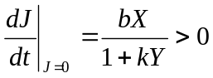 (7)
when 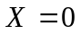and 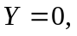
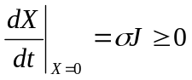 (8)
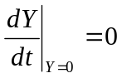 (9)

Theorem 2 (Boundedness)
Defining the aggregate function
$$W\left(t\right)=J\left(t\right)+X\left(t\right)+\frac{1}{e}Y\left(t+τ\right) \left(7\right)$$
Using Young's inequality to absorb cross-terms and the logistic limit X²/K ≥ 0, differentiating W along trajectories results in an inequality of the following form:

$$\frac{dW}{dt}+μW≤M \left(8\right)$$
with positive constants μ and M dependent only on the model parameters. By Gronwall's lemma, $W\left(t\right)≤W\left(0\right)e^{\left(-μt\right)}+\frac{M}{μ}$, hence all three populations remain bounded for all $t≥0$

Equilibrium Analysis

Trivial Equilibrium
Setting all right-hand sides to zero, the trivial equilibrium $E₀=\left(0,0,0\right)$ always exists. It is biologically insignificant and signifies complete extinction.

Predator-Free (Prey-Only) Equilibrium
Setting $Y=0$ and solving equations (1) and (2) simultaneously yields $E₁=\left(J^{*},X^{*},0\right),$ where:

$$X^{*}= \frac{K}{r}\left[\frac{bσ}{σ+d₁}-d₂\right] \left(9\right)$$
$$J^{*}=\frac{bX^{*}}{σ+d₁} \left(10\right)$$

Which is positive given that the net growth condition:
$$\left(C1\right) \frac{bσ}{σ+d₁}>d₂ \left(11\right)$$
holds, Condition (C1) states that the maturation-adjusted birth rate of adult prey exceeds their natural mortality.

Coexistence Equilibrium
The inner coexistence equilibrium $E^{*}=\left(J^{*},X^{*},Y^{*}\right)$ satisfies the entire algebraic system with τ set to zero. From the predator equation at equilibrium:

$$e·\frac{c\sqrt{X^{*}}}{\left(1+h\sqrt{X^{*}}\right)}=d₃, \left(12\right)$$
which results in the unique positive adult prey density at coexistence:

$$\sqrt{X^{*}}=\frac{d₃}{ec-hd₃},hence X^{*}={\left[\frac{d₃}{ec-hd₃}\right]}^{2}, \left(13\right)$$

given the Condition for predator viability:

$$\left(C2\right) ec>hd₃ \left(14\right)$$

holds. Given $X^{*}$, the adult prey equation (2) at equilibrium yields the coexistence predator density $Y^{*}$, and the juvenile density $J^{*}=\frac{bX^{*}}{\left(σ+d₁\right)\left(1+kY^{*}\right)}$ An additional requirement that guarantees the prey net growth rate can sustain a positive predator density is necessary for the existence of a unique positive $Y^{*}$under (C1)–(C2). We refer to this condition as assumption (A5).
(A5) The implicit equation for $Y^{*}$derived from (2) at equilibrium admits a unique positive solution, and the parameters satisfy (C1), (C2).

Stability Analysis and Hopf Bifurcation

Stability of E₀

Eigenvalues $-\left(σ+d₁\right),\frac{bσ}{\left(σ+d₁\right)},-d₂,$ and $-d₃$ are obtained by linearizing system (1)–(3) at E₀. When the prey net growth condition is met, E₀ is always unstable because the second eigenvalue is positive under (C1). A sustainable prey population should be able to invade from almost zero densities, which is ecologically expected.

Stability of E₁

The structure of the Jacobian at E₁ is block-triangular. The predator-invasion eigenvalue is provided by the (3, 3) entry:

$$λ_{inv}=\frac{e·c\sqrt{X^{*}}}{1+h\sqrt{X^{*}}}-d₃ (15)$$

Since $λ_{inv}>0$ under (C2) and while $E^{*}$is present, the predator can invade and E₁ is a saddle. Only in the event that (C2) fails is E₁ locally asymptotically stable. Prey cohabitation at carrying capacity is confirmed by the 2x2 prey sub-block's eigenvalues with negative real parts under (C1).
Stability of E* When τ = 0
$$\frac{du}{dt}=Au(t) (16)$$
where the entries in the Jacobian matrix A are: Writing $u={\left(J-J^{*},X-X^{*},Y-Y^{*}\right)}^{T}$ for small perturbations, the linearized system at $E^{*}$ with $τ=0$ is:

$$a_{11}=-\left(σ+d₁\right), { a}_{12}=\frac{b}{1+kY^{*}},{ a}_{13}=-\frac{bkX^{*}}{{\left(1+kY^{*}\right)}^{2}} (17)$$
$$a_{21}=σ, { a}_{22}=-d_{2}-\frac{2rX^{*}}{K}-\frac{cY^{*}}{{2\sqrt{X^{*}}\left(1+h\sqrt{X^{*}}\right)}^{2}},{ a}_{23}=-\frac{c\sqrt{X^{*}}}{1+h\sqrt{X^{*}}} (18)$$
$$a_{31}=0, { a}_{32}=\frac{{eY}^{*}c}{{2\sqrt{X^{*}}\left(1+h\sqrt{X^{*}}\right)}^{2}},{ a}_{33}=-d_{3} (19)$$

The characteristic polynomial is as follows:

$$P(λ)=λ^{3}+p_{1}λ^{2}+p_{2}λ+p_{3}=0 (20)$$

Where $p_{1}$, $p_{2}$ and $p_{3}$ are the typical symmetric functions of the Jacobian elements, and $p₁=-\left(a₁₁+a₂₂+a₃₃\right)$. When $τ=0$, $E^{*}$ is locally asymptotically stable according to the Routh-Hurwitz criterion if and only if:

$$(RH) p_{1}>0, p_{3}>0, p_{1}p_{2}-p_{3}>0 (21)$$

These requirements are met under (A1)–(A5) for sufficiently large carrying capacity $K$ and sufficiently small fear coefficient $k$, demonstrating that $E^{*}$ can be stable without gestation delay.

Characteristic Equation for τ > 0
The delay is only carried by the predator equation (3) when $τ>0$. The linearized system becomes:

$$\frac{du}{dt}=A_{0}u(t)+A_{1}u(t-τ) (22)$$

where A₁ is sparse with non-zero entries only in the third row, indicating the delayed recruitment, and A₀ is the instantaneous Jacobian with the predator recruitment term zeroed. Then the characteristic equation is:

$$det\left(λI-A_{0}-A_{1}e^{-λτ}\right)=0 (23)$$

expanding (23) gives the transcendental equation:

$$λ^{3}+q_{1}λ^{2}+q_{2}λ+q_{3}+\left(q_{4}λ^{2}+q_{5}λ+q_{6}\right)e^{-λτ}=0 (24)$$

where the coefficients $q_{i}$ are real-valued functions of the model parameters and equilibrium values.
Putting $λ=iω\left(ω>0\right)$ and separating the real and imaginary parts:

$$Real: -q₁ω²+q₃+\left(-q₄ω²+q₆\right)cos\left(ωτ\right)+q₅ωsin\left(ωτ\right)=0 (25)$$

$$Imaginary: -ω³+q₂ω-\left(-q₄ω²+q₆\right)sin\left(ωτ\right)+q₅ωcos\left(ωτ\right)=0 (26)$$

Eliminating $τ$ by squaring and summing (25), (26) and putting $z=ω^{2}$. We get the polynomial:

$$h\left(z\right)≡z³+α₁z²+α₂z+α₃=0 (27)$$

where $α₁=q₁²-2q₂-q₄²,α₂=q₂²-2q₁q₃+2q₄q₆-q₅²,α₃=q₃²-q₆².$

Lemma

If $α₃<0$ or if $α₃≥0$ and there exists $z^{1}>0$such that $h\left(z₁\right)<0$, then equation (27) has at least one positive real root $z₀=ω₀²>0$. Using the intermediate value theorem, this follows directly from $h\left(0\right)=α₃$ and $h\left(z\right)→+∞$ as $z→+∞.$

The critical delay corresponding to a positive root $ω₀$ is:

$$τ_{n}^{*}=\frac{1}{ω_{0}}\left[\tan^{-1}\left(\frac{N(ω_{0})}{D(ω_{0})}\right)+nπ\right], n=0, 1, 2, ... (28)$$

where the explicit trigonometric combinations of the $qᵢ$ evaluated at $ω=ω₀$ derived from equations (25)–(26) are $N\left(ω₀\right)$ and $D\left(ω₀\right)$. We choose the smallest positive critical delay, $τ^{*}=τ_{0}^{*}\left(n=0\right).$

Theorem

Suppose that equation (27) has a positive real root ω₀ with corresponding $τ^{*}$ from equation (28) and that (A1)–(A5) and $\left(RH\right)$are valid. Suppose additionally that the condition for transversality:

$$Re{\left.\left(\frac{dλ}{dτ}\right)\right|}_{τ=τ_{n}^{*}, λ=iω_{0}}≠0 (29)$$

holds. $E^{*}$is then locally asymptotically stable for $τ∈[0,τ^{*}),$loses stability at $τ=τ^{*}$, and system (1)–(3) experiences a Hopf bifurcation at $E^{*}$as τ passes through $τ^{*}$resulting in a family of periodic solutions close to $E^{*}$.

Proof of Transversality

Implicitly differentiating (24) with respect to $τ$ at $λ=iω₀$, $τ=τ^{*}$ and taking the real part of ${\left(\frac{dλ}{dτ}\right)}^{-1}$, then we obtain:

$$Re{\left(\frac{dλ}{dτ}\right)}^{-1}=\frac{h^{'}\left({ω_{0}}^{2}\right)}{{\left(q_{5}ω_{0}\right)}^{2}+{\left(-q_{4}{ω_{0}}^{2}+q_{6}\right)}^{2}} (30)$$

The sign of $h^{'}\left({ω_{0}}^{2}\right)$ determines the sign of $Re\left(\frac{dλ}{dτ}\right)$ at $τ^{*}$ as the denominator is always positive. The eigenvalue pair confirms loss of stability when $h^{'}\left({ω_{0}}^{2}\right)>0$, crossing the imaginary axis from left to right. When the cubic $h\left(z\right)$ increases at $z₀$, this is satisfied at a simple root $ω₀$.

Direction and Stability of Bifurcating Periodic Orbits

Using the Hassard et al. (1981) algorithm, we reduce system (1)–(3) to its center manifold at $E^{*}$when $τ=τ^{*}$ in order to ascertain if the bifurcating periodic orbits exist for
$τ>τ^{*}$(supercritical) or $τ<τ^{*}$(subcritical) and whether they are orbitally stable. The problem is transformed into a functional differential equation on $(\left[-1,0\right],$ $R³$) by setting
$τ=τ^{*}+ μ \left(μ∈R, small\right)$ and rescaling time $s=t/τ$:

$$\dot{u(s)=L_{μ}(u_{s})+F(μ,u_{s}) (31)}$$

where $F$ collects nonlinear terms and $L_{μ}$ is linear. The adjoint eigenvector is
$q^{*}\left(s\right)=D\left(1,q_{2}^{*},q_{3}^{*}\right)e^{\left(iω₀τ^{*}s\right)}$, normalized so that $\left\langle q^{*},q\right\rangle =1$. The eigenvector of the linearization $L₀$at $μ=0$ corresponding to $iω₀τ^{*}$ is $q\left(θ\right)=\left(1, q_{2}, q_{3}\right)ᵀe^{\left(iω₀τ^{*}θ\right)},θ∈\left[-1,0\right]$. The flow on $W^{c}\left(0\right)$ satisfies the amplitude equation, and the center manifold $W^{c}\left(0\right)$ at
$μ=0$ is parameterized by $z∈C$and $z̄$:

$$ż=iω₀τ^{*}z+\frac{g_{20}}{2}z²+g_{₁₁}zz̄+\frac{g_{02}}{2}z̄²+\frac{g_{21}}{2}z²z̄+O\left(\left|z\right|⁴\right) (32)$$

The center-manifold correction functions $W₂₀\left(θ\right)$ and $W₁₁\left(θ\right)$, which satisfy first-order linear systems derived by substitution into the invariance equation on $W^{c}\left(0\right)$, and the second- and third-order Taylor coefficients of $F\left(0, ·\right)$ are used to compute the normal form coefficients $g₂₀,g₁₁,g₀₂,and g₂₁$. The crucial factor controlling the characteristics of bifurcation is,

$$c_{1}=\frac{i}{2ω₀τ^{*}}\left(g_{20}g_{11}-2{\left|g_{11}\right|}^{2}-\frac{{\left|g_{02}\right|}^{2}}{3}\right)+\frac{g_{21}}{2} (33)$$

Three bifurcation descriptors are extracted from $c₁\left(0\right)$:

$$μ_{2}=-\frac{Re\left(c_{1}\left(0\right)\right)}{Re{\left.\left(\frac{dλ}{dτ}\right)\right|}_{τ=τ^{*}}} [bifurcation direction] (34)$$

$$β₂=2Re\left(c₁\left(0\right)\right) [orbital stability] (35)$$

$$T_{2}=-\frac{Im\left(c_{1}\left(0\right)\right)+μ_{2}Im\left({\left.\frac{dλ}{dτ}\right|}_{τ=τ^{*}}\right)}{ω₀τ^{*}} [period] (36)$$

Interpretation: (i) The bifurcation is supercritical and periodic orbits form for $τ>τ^{*}$ if $μ₂>0$; it is subcritical and orbits appear for $τ<τ^{*}$ if $μ₂<0$. (ii) The bifurcating limit cycle is orbitally asymptotically stable if $β₂<0$, and unstable if $β₂>0$. (iii) T₂ provides the first-order adjustment to the bifurcating orbit's period. A supercritical, stable Hopf bifurcation is confirmed for the parameter set employed in the numerical section: $Re\left(c₁\left(0\right)\right)<0,μ₂>0$.
Numerical Simulations
Over a time horizon of T = 200 time units (interpreted as months), system (1)–(3) was numerically solved using the MATLAB dde23 solver, which was created especially for delay differential equations with constant lags.

Results
Figure 1: Characteristic Polynomial h(z)h(z) and Positive Root Associated with the Hopf Frequency
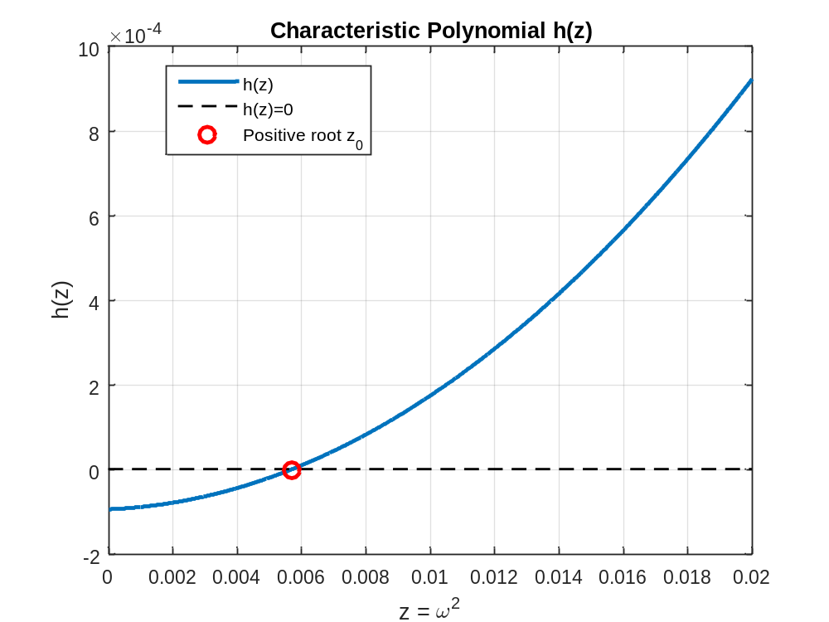
Figure 1 confirms the existence of a positive root of the characteristic polynomial h(z), thereby establishing the existence of a positive Hopf frequency required for the emergence of delay-induced oscillatory dynamics. The positive intersection with the zero line provides numerical evidence that the gestation delay can act as a bifurcation parameter capable of destabilizing the coexistence equilibrium.

Figure 2: Variation of the Critical Gestation Delay with the Fear Coefficient
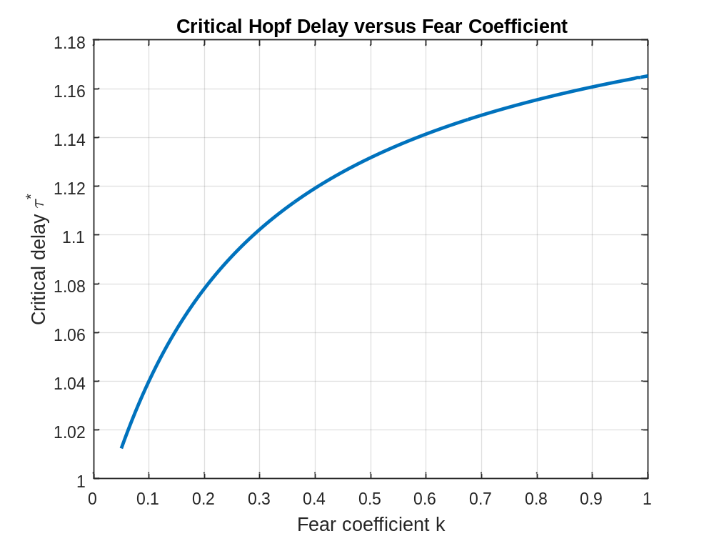
Figure 2 demonstrates that the critical gestation delay increases with the fear coefficient. This indicates that predator-induced fear tends to delay the onset of instability caused by gestation delay. The nonlinear, gradually flattening trajectory further suggests that the stabilizing influence of fear exhibits diminishing incremental effects as the fear coefficient becomes larger.
Figure 3: Stable Limit Cycle Oscillations
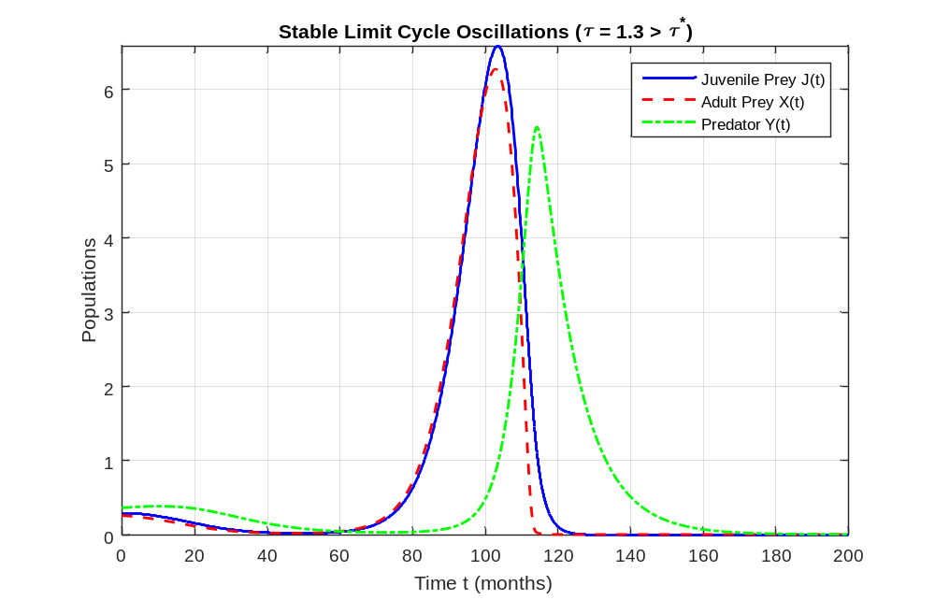
Figure 3 shows that when the gestation delay exceeds the critical value, the system exhibits sustained large-amplitude oscillations in juvenile prey, adult prey, and predator densities. This confirms the occurrence of a supercritical Hopf bifurcation, producing a stable limit cycle around the coexistence equilibrium.
Figure 4: Stable Coexistence Equilibrium
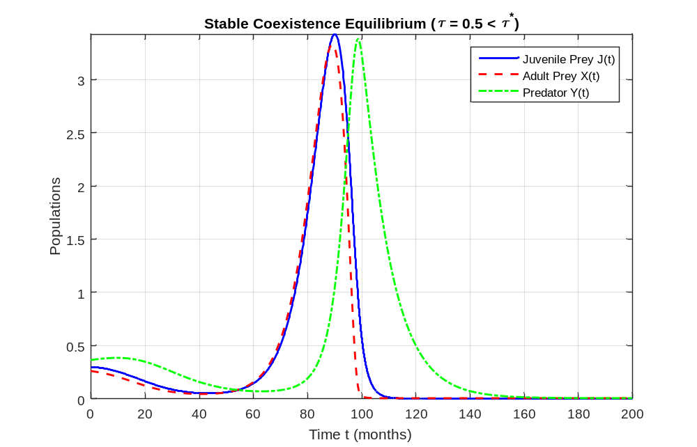
Figure 4 shows that when the gestation delay is below the critical value, all three populations converge to constant positive levels after a short transient. This demonstrates that the coexistence equilibrium remains locally asymptotically stable for delays smaller than 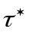.

Discussions
Figure 1 presents the characteristic polynomial h(z) obtained from the elimination of the delay parameter in the real and imaginary parts of the characteristic equation. The horizontal axis represents , where ω is the frequency associated with the purely imaginary eigenvalues at the onset of Hopf bifurcation, while the vertical axis represents the value of h(z). The dashed horizontal line represents h(z)=0, and the marked point identifies the positive root 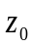. The figure shows that the characteristic polynomial crosses the zero line at a positive value of z, confirming the existence of a positive real root 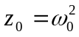. This is important because a positive root provides a corresponding positive Hopf frequency 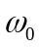, which is a necessary component in determining the critical gestation delay. The manuscript theoretically establishes that when the polynomial has a positive root, the system possesses a candidate pair of purely imaginary characteristic roots and hence a critical delay can be obtained. The observed crossing therefore provides numerical support for the analytical Hopf-bifurcation condition. In particular, the existence of the positive root indicates that increasing the gestation delay can move the eigenvalues toward the imaginary axis and eventually cause the coexistence equilibrium to lose stability. This is consistent with the theoretical result that the coexistence equilibrium is stable for delays below the critical value and loses stability when the delay passes through the critical threshold, provided the transversality condition is satisfied.
Figure 2 illustrates the relationship between the fear coefficient k and the critical gestation delay . The horizontal axis represents the fear coefficient, whereas the vertical axis represents the critical value of the gestation delay at which the coexistence equilibrium undergoes Hopf bifurcation. The curve exhibits a positive and increasing relationship between k and . Thus, within the parameter range considered, increasing the fear coefficient is associated with an increase in the amount of gestation delay required to trigger the Hopf bifurcation. In dynamical terms, the system tolerates a larger gestation delay before the stability of the coexistence equilibrium is lost. This numerical pattern is consistent with the analytical structure of the model, in which the fear coefficient modifies the prey birth term through 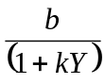. The result also agrees with the theoretical discussion in the manuscript that fear can have a stabilizing influence on the coexistence equilibrium, while gestation delay has the capacity to destabilize an otherwise stable equilibrium. The curve also appears to flatten progressively as k increases. This indicates that the marginal increase in the critical delay becomes smaller at higher levels of the fear coefficient. Hence, the effect of fear on the delay threshold is nonlinear rather than strictly proportional. Ecologically, this suggests that increasing predator-induced fear may initially produce a relatively substantial change in the delay threshold, whereas further increases in fear produce progressively smaller changes within the parameter range simulated.
Figure 3 displays the time series of the three populations, juvenile prey J(t), adult prey X(t), and predators Y(t), over a simulation horizon of T=200 months when the gestation delay is fixed above the critical threshold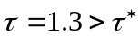. The horizontal axis represents time in months, while the vertical axis shows population densities. All three trajectories exhibit sustained, large-amplitude periodic oscillations that persist after an initial transient phase, confirming the emergence of a stable limit cycle. Juvenile and adult prey densities rise and fall nearly in phase, while the predator density peaks with a visible phase lag, consistent with the delayed recruitment mechanism. This numerical outcome provides direct confirmation of the Hopf-bifurcation theorem established in the analytic section: once the gestation delay exceeds the critical value τ∗\tau^*τ∗, the coexistence equilibrium 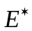 loses stability and a family of periodic orbits bifurcates from it. The orbital stability of the observed cycle is consistent with the sign of the first Lyapunov coefficient 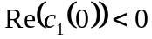 and 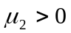, which classifies the bifurcation as supercritical and the emerging limit cycle as orbitally asymptotically stable. Ecologically, the figure illustrates that sufficiently long gestation periods can drive persistent population cycles even when the underlying non-delayed system admits a stable coexistence equilibrium, highlighting the destabilizing role of the maturation lag in the predator’s reproductive response.
Figure 4 shows the corresponding time series under a subcritical gestation delay 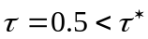. After a short transient, all three populations converge to constant positive levels and remain there for the remainder of the simulation interval. The absence of sustained oscillations demonstrates that the coexistence equilibrium is locally asymptotically stable when the delay lies below the critical threshold. This behaviour is in exact agreement with the linear-stability analysis: under the Routh–Hurwitz conditions and the transversality condition, remains attracting for all 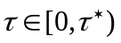. The figure therefore supplies numerical verification that the critical delay indeed marks the boundary between asymptotic stability and oscillatory instability. Together with Figure 3, it illustrates the classic delay-induced stability switch that is the central dynamical phenomenon of the model.
While our analytical and numerical findings offer key insights into delay-induced dynamics, several methodological considerations warrant discussion. First, the specific numerical simulations presented rely on a chosen parameter set; variations in baseline biological rates, such as carrying capacity or conversion efficiency, could shift the quantitative critical threshold or alter the sensitivity to the fear coefficient . Second, the stability conditions derived via the Routh–Hurwitz criterion and center-manifold reduction are inherently local, meaning they characterize system behavior near the coexistence equilibrium but do not preclude global dynamic phenomena such as large-amplitude perturbation escapes or baseline extinction under non-small perturbations. Third, our framework is purely deterministic; in real-world habitats, environmental stochasticity and random fluctuations can alter cycle amplitudes, induce noise-driven extinctions, or trigger early stability transitions. Consequently, while our numerical results illustrate the theoretical mechanism of the fear-delay interaction, transferring these quantitative findings directly to field ecosystems requires caution, empirical parameter calibration, and the inclusion of spatial heterogeneities and random perturbations present in natural habitats.
Conclusion
This study developed and analyzed a stage-structured prey–predator model incorporating three important ecological mechanisms: prey fear of predation, herd behaviour and a gestation delay in predator recruitment. The model distinguishes juvenile prey, adult prey and predator populations, while herd behaviour is represented through a square-root functional response and fear modifies the prey reproductive process. The gestation delay enters through delayed predator recruitment, thereby providing a biologically meaningful mechanism through which temporal lags can influence population stability. The analytical investigation established the positivity and boundedness of the model solutions, ensuring that the populations remain biologically meaningful and finite. The model possesses the extinction equilibrium, a predator-free equilibrium and a positive coexistence equilibrium subject to appropriate biological conditions. In particular, predator viability requires 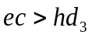, while the prey population requires a positive maturation-adjusted net growth condition. The local stability analysis showed that the coexistence equilibrium can be locally asymptotically stable in the absence of gestation delay when the Routh–Hurwitz conditions are satisfied. However, introducing a positive gestation delay changes the stability structure of the system. The resulting transcendental characteristic equation permits the existence of purely imaginary eigenvalues at a critical delay, thereby providing the mechanism for a delay-induced Hopf bifurcation. The numerical analysis supports the theoretical results. The characteristic polynomial possesses a positive root, confirming the existence of a positive Hopf frequency and consequently a critical delay. Furthermore, the numerical relationship between the fear coefficient and critical gestation delay shows that increasing fear is associated with an increase in the critical delay over the parameter range considered. This indicates that fear can postpone the destabilizing effect of gestation delay. The center-manifold and normal-form analysis further characterizes the bifurcation. The calculated bifurcation descriptors establish that the parameter set considered produces a supercritical and orbitally stable Hopf bifurcation, meaning that stable periodic solutions emerge as the gestation delay passes through the critical value in the appropriate direction.

Limitation of the Study
The stability analysis relies on linear stability, the Routh–Hurwitz criterion, and local center-manifold reductions. Consequently, the findings describe system behavior strictly near the coexistence equilibrium 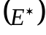 and do not account for global dynamics such as large-amplitude perturbations or boundary extinctions. The mathematical formulation is fully deterministic. It excludes real-world environmental stochasticity and random fluctuations, which are known to trigger early stability transitions, alter cycle amplitudes, or cause stochastic extinctions. The numerical simulations depend on a single baseline parameter set. Key ecological parameters, such as carrying capacity, conversion efficiency, or fear sensitivity, could quantitatively shift the critical delay threshold 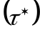 or alter the observed dynamics. The continuous differential equations assume a well-mixed spatial environment. The model omits spatial heterogeneities, continuous dispersion, or regional habitat fragmentation, which can significantly modify predator–prey dynamics.

Declaration of AI Use

This manuscript was prepared through the intellectual contributions of the author(s) to the study design, data analysis, interpretation of results, and scholarly content. Grammarly and ChatGPT were used solely to assist with grammatical refinement and reference formatting during manuscript revision. The author(s) accept full responsibility for the accuracy, integrity, and final content of the manuscript.

References
Ajraldi, V., Pittavino, M., & Venturino, E. (2011). Modeling herd behavior in population systems. Nonlinear Analysis: Real World Applications, 12(4), 2319–2338. https://doi.org/10.1016/j.nonrwa.2011.02.002
Bera, S. P., Maiti, A., & Samanta, G. P. (2016). Stochastic analysis of a prey–predator model with herd behaviour of prey. Nonlinear Analysis: Modelling and Control, 21(3), 345–361. https://doi.org/10.15388/NA.2016.3.4
Das, B. K., Sahoo, D., & Samanta, G. P. (2022). Impact of fear in a delay-induced predator–prey system with intraspecific competition within predator species. Mathematics and Computers in Simulation, 191, 134–156. https://doi.org/10.1016/j.matcom.2021.08.005
Hale, J. K., & Verduyn Lunel, S. M. (1993). Introduction to functional differential equations (Applied Mathematical Sciences, Vol. 99). Springer. https://doi.org/10.1007/978-1-4612-4342-7
Hassard, B. D., Kazarinoff, N. D., & Wan, Y.-H. (1981). Theory and applications of Hopf bifurcation (London Mathematical Society Lecture Note Series, Vol. 41). Cambridge University Press. https://library.isical.ac.in/bib/774
Holling, C. S. (1959). Some characteristics of simple types of predation and parasitism. The Canadian Entomologist, 91(7), 385–398. https://doi.org/10.4039/Ent91385-7
Lotka, A. J. (1925). Elements of physical biology. Williams & Wilkins Company. https://onlinebooks.library.upenn.edu/webbin/book/lookupid?key=olbp93007
Ogethakpo, A. J., & Ojobor, S. A. (2021). The Lotka–Volterra predator–prey model with disturbance. Nigerian Journal of Science and Environment, 19(2), 135–144. https://njse.org.ng/user/approved/document%20%2815%29.pdf
Owolabi, K. M. (2020). Dynamical behaviour of fractional-order predator-prey system of Holling-type. Discrete and Continuous Dynamical Systems - S, 13(3), 823–834. https://doi.org/10.3934/dcdss.2020047
Owolabi, K. M., Jain, S., & Pindza, E. (2024). Investigating the dynamic behavior of integer and noninteger order system of predation with Holling’s response. Mathematics, 12(10), Article 1530. https://doi.org/10.3390/math12101530
Owolabi, K. M., & Patidar, K. C. (2016). Numerical simulations of multicomponent ecological models with adaptive methods. Theoretical Biology and Medical Modelling, 13, Article 1. https://doi.org/10.1186/s12976-016-0027-4
Owolabi, K. M., & Pindza, E. (2018). Mathematical and computational studies of fractional reaction–diffusion system modelling predator–prey interactions. Journal of Numerical Mathematics, 26(2), 97–110. https://doi.org/10.1515/jnma-2016-1044
Parwaliya, A., Singh, A., Kumar, A., & Barman, D. (2024). The impact of delays on prey-predator dynamics with predation-induced fear. Journal of Applied Mathematics and Computing, 70(5), 4877–4907. https://doi.org/10.1007/s12190-024-02129-w
Salman, S. M., Yousef, A. M., & Elsadany, A. A. (2016). Stability, bifurcation analysis and chaos control of a discrete predator-prey system with square root functional response. Chaos, Solitons & Fractals, 93, 20–31. https://doi.org/10.1016/j.chaos.2016.09.020
Shao, Y.-F., & Zhao, J.-X. (2026). Analysis of stability and Hopf bifurcation of a delayed predator-prey system with fear and additional food. Acta Mathematicae Applicatae Sinica, English Series, 42(2), 639–666. https://doi.org/10.1007/s10255-025-0042-5
Volterra, V. (1926). Variazioni e fluttuazioni del numero d’individui in specie animali conviventi. Memorie della Regia Accademia Nazionale dei Lincei, Serie 6, 2, 31–113. https://sapienzadigitallibrary.uniroma1.it/DigitalResource/itrousr-DigitalResource_RMSAU_00016647
Wang, X., Zanette, L., & Zou, X. (2016). Modelling the fear effect in predator–prey interactions. Journal of Mathematical Biology, 73(5), 1179–1204. https://doi.org/10.1007/s00285-016-0989-1
Wang, Y., Shao, Y., & Chai, C. (2023). Dynamics of a predator-prey model with fear effects and gestation delays. AIMS Mathematics, 8(3), 7535–7559. https://doi.org/10.3934/math.2023378
Zanette, L. Y., White, A. F., Allen, M. C., & Clinchy, M. (2011). Perceived predation risk reduces the number of offspring songbirds produce per year. Science, 334(6061), 1398–1401. https://doi.org/10.1126/science.1210908
Zhao, J., & Shao, Y. (2023). Bifurcations of a prey-predator system with fear, refuge and additional food. Mathematical Biosciences and Engineering, 20(2), 3700–3720. https://doi.org/10.3934/mbe.2023173

