CASE REPORT

Infected Urachal Sinus with Urachal Cyst Following Umbilical Polypectomy in an Infant: A Rare Case Report and Review of Literature

ABSTRACT
Urachal vestiges are exceedingly uncommon congenital malformations which occur in cases where there is partial lack of obliteration of the primitive embryonic urachus. Among urachal anomalies an infected urachal sinus with underlying urachal cyst is so infrequent that it may be wrongly identified in infancy and childhood cases. This case report addresses a 1-year old female infant with a month history of recurrent episodic purulent umbilical discharge, erythematous overlying skin, tender periumbilical region, and history of prior umbilical polypectomy at 5 months of age. An high-resolution sonogram performed abdominally & abdominally revealed a circa 1.4 cm linear blindly-ending sinus tract emerging from the umbilicus and directly entering infected intra-urachal urachal vestige(voided collection with approximately 2.2×1.9×1.4 cm hypoechoic and approximately 3.4 ml collection of fluid positioned along the course of urachovesical duct and communicating without the urinary tract). Exploratory infraumbilical laparotomy confirmed findings of a urachal cyst containing purulent material along with discharging sinus tract and following that the cyst, sinus tract along with the fibrous umbilical remnant was en bloc removed. Tranfixion ligature at the bladder base was performed using polydioxanone (PDS 5-0). Culture of the pus yielded Proteus mirabilis which was multi drug resistance with a maintained sensitivity toward carbepenams and Piperacillin and Tazobactam combinations, and was treated appropriately with Intravenous meropenem along with metronidazole which led to complete resolution with no wound infection. It will thus be wise to harbor higher suspicion to include the possibility of an infected urachal sinus along with other urachal variations and to keep an account of a precise pre-intraoperative sonographic report in case of persistent recurrent atypicial paediatric umbilical lesion, and also have a close follow up of the abdominal & pelvic sonogram in a follow-up period.
Keywords: Urachal cyst; Umbilical sinus; Congenital urachal remnant; Umbilical polyp; Proteus mirabilis; Pediatric laparotomy; Ultrasonography.

1. INTRODUCTION
The urachus, or median umbilical ligament, is the midline and tubular embryonic structure that usually bridges the anterosuperior apex of the maturing bladder of the fetus and the allantois at the level of the umbilicus [1]. In normal human embryogenesis, obliteration and fibrotic degeneration of the lumen of the urachus progresses between the fourth and fifth months of intrauterine life and results in the urachus forming a cord-like, non-functional fibrotic structure that lies extraperitoneally in the Retzius space (prevesical space) bounded by the transversalis fascia anteriorly and the peritoneum parietes posteriorly [2]. Failure of anatomical obliteration and failure of lumen regression of the urachus may lead to congenital urachal anomalies. They are rarely encountered clinical conditions encountered approximately in 1/5,000–1/8,000 of live births with significant 2:1 male-female bias [3]. Urachal anomalies are traditionally categorized into five types based on the way they represent the incompleteness of obliterating: (a) Patent Urachus (approx. 50%)-total continuity of the lumen between the urachus and the umbilical cord, with leakage of urine (b) Urachal Cyst (approx. 30%)-when both the umbilical and vesical openings of the urachus are occluded but its middle part isolated as a secretory, mucous and cystic cavity, and (c) Urachal Sinus (approx. 15%)-when only the umbilical part does not occlude, forming a blind-ending canal opening at the umbilicus and (d) Vesicourachal Diverticulum (3%–5%)-where the vesical end of the urachus remains open in the form of a wide diverticulum arising at the dome of the bladder, and (e) alternating sinus-cyst urachal configurations. The former cases may also appear a urachal sinus with underling urachal cyst which makes for a chronically infected and draining cavity [4, 5]. There may be also other rare presentations such as that Urachal sinus communicating into an underling urachal cyst.[6]Non-patent urachal anomalies are asymptomatic and silent throughout infancy and adolescence with no clinical signs or symptoms until secondary bacterial infection develops [7]. If infected, a 'quiet' urachal remnant can become an 'active' acute or subacute suppurative process causing persistent seropurulent/purulent discharge from umbilicus, local inflammation and tenderness of periumbilical area and intra-abdominal mass formation (8). Pediatric umbilical lesions are often misdiagnosed or mismanaged initially as benign superficial umbilical conditions, which include omphalitis, stitch abscess, umbilical granuloma and umbilical polyp (9). Repeated superficial procedures without preprocedural sonographic examination of deep component, e.g., Superficial trimming and removal by topical silver nitrate application or by simple polypectomy, will mask deep congenital communications so as to cause recurrence (10). In this paper, we presented a striking unusual pediatric case with urachal cyst combined with infected urachal sinus, which was managed in an 1-year-old girl with a history of umbilical polypectomy, the findings on diagnosis and microbiological study, surgery treatment, and literature review.
2. CASE REPORT
2.1 Patient Profile and Clinical Presentation
A One-year-old female baby, brought to Department of Paediatric Surgery, S.S Institute of Medical Sciences & Research Center (SSIMS & RC) Davangere, Karnataka India, with the complaint of intermittent continuous purulent discharge from umbilical region since one month. The discharge used to appear intermittently, which had a periodicity of 2 days since a long time and changing from clear serosanguinous discharge gradually from it to thick purulent matter with offensive smell from it accompanied with reddening and soft swelling and tenderness around skin of umbilical region. Child had some spike of low-grade fever two weeks back, subsided over symptomatic antipyretic medication. No active bleeding from umbilical discharge nor gross hematuria was heard in the umbilical discharge nor any fecal/bilious discharge nor oliguria was documented. The child otherwise is active and playful.
2.2 Past Medical and Surgical History
Was born at full-term by LSCS weighing 2.15kg following an uneventful antenatal and natal period. The infant did not have NICU admission and all milestones were at per-gross: Standing without support and ambulation of stairs and fine: Pincer grip and feeding with a spoon independently, communication: 2 word meaningful sentence, and social: at par. Infant's immunizations were all in pace as per national immunization program. History revealed a surgical history of an umbilical polyp which was removed at 5months of age on 18/12/2025 by superficial polypectomy. The infant had recurrent episode of discharge and erythema from the umbilicus with previous episodic episodes of empirical diagnosis of Stitch Abscess and Omphalitis followed by symptomatic treatment with 5% povidone-iodine washes, betadine powder, antibiotic syrup for Stitch Abscess and Omphalitis (Syrup Taxim-O 100mg) for 3days on 20/02/2026, 23/02/2026 and finally on 29/04/2026 during his out-patient visits.
2.3 Physical Examination and Vitals
On general physical examination at admission (07-04-06) the child was active, awake, alert, playing on examination. The weight of the baby at admission was 8.2kg and his vital signs were all stable and unremarkable: heart rate at 122 beats per min and regular, respiration 36 breaths per min and unlabored; air saturation at 98%; axillary temperature at 98.4. At examination the vesicular breath sounds were clear and non-wheezing to auscultation in both lung fields; S1 and S2 were clear and audible with no murmurs, heart sounds were heard at regular rhythm with all chest and heart sounds normal.. The mouth examination found that anterior the baby was tongue-tied asymptomatically. On local examination of the abdomen, there was an opening of the central umbilical sinus leaking cream-colored, purulent discharge, without any active bleeding or discharge of any blood. The skin around the umbilicus was reddened in a circular fashion and had mild in duration. Abdomen was soft on palpation, without any organomegaly, without any signs of generalize peritonitis. Though, an ill-defined deep seated swelling noted on deep palpation in the umbilical mid line, on the region just below the umbilicus and below the mid of urachovesical axis. It had no cough impulse, or reducible hernia was noted.
2.4 Laboratory Investigations
The hematological results obtained were mild microcytic hypochromic anemia with profound reactive leucocytosis: Hb was 10.6g/dL, PCV was 31.8% and TLC was 15,960 with the cell counts as follows 18% neutrophils and 76% lymphocytes (This represents the Physiological lymphocytic preponderance of infancy with toxic granulation) ; RBC count was 5.1 million/cumm, MCV was 64.8fL, MCH was 20.8pg, MCHC was 32.1g/dL and RDW-CV was 17.3%, platelet count were 5x10 5 /cumm. Coagulation study were: Bleeding time were 2.40 minutes while clotting time were 3.20 minutes. Biochemical tests showed: normal renal function, with Normal electrolytic balance: Serum urea: 7.9 mg/dL; Serum creatinine: 0.22 mg/dL, Serum sodium:135.5 mmol/L; Serum potassium:4.82 mmol/L and serum chloride: 102.46 mmol/L. The viral screening for both HIV and Hepatitis B surface antigen (HBsAg) using chemiluminescence immunoassay (CLIA) were non reactive.
Parameter | Patient Value | Reference Range | Clinical Significance
Haemoglobin (Hb) | 10.6 g/dL | 11.1 – 14.1 g/dL | Mild microcytic hypochromic anemia
Total Leukocyte Count (TLC) | 15,960 cells/cumm | 4,000 – 16,000 cells/cumm | High-normal / reactive leukocytosis
Differential: Neutrophils | 18 % | 15 – 46 % | Within pediatric reference range
Differential: Lymphocytes | 76 % | 20 – 45 % | Physiological infantile lymphocytosis
RBC Count | 5.1 x 10^6 /cumm | 3.4 – 5.2 x 10^6 /cumm | Normal red cell mass
Packed Cell Volume (PCV) | 31.8 % | 40.0 – 54.0 % | Reduced haematocrit
MCV / MCH / MCHC | 64.8 fL / 20.8 pg / 32.1% | 76-96 fL / 23-31 pg / 32-36% | Microcytosis and hypochromia
Platelet Count | 5.00 x 10^5 /cumm | 1.5 – 5.5 x 10^5 /cumm | Normal platelet count
Bleeding Time (BT) | 2 min 40 sec | 2 – 7 min | Normal primary hemostasis
Clotting Time (CT) | 3 min 20 sec | 3 – 9 min | Normal intrinsic coagulation
Serum Urea | 7.9 mg/dL | 10.8 – 38.4 mg/dL | Adequate hydration / normal metabolism
Serum Creatinine | 0.22 mg/dL | 0.15 – 0.37 mg/dL | Normal infantile renal function
Serum Sodium (Na+) | 135.5 mmol/L | 133 – 152 mmol/L | Eunatremic
Serum Potassium (K+) | 4.82 mmol/L | 3.5 – 5.5 mmol/L | Eukalemic
Serum Chloride (Cl-) | 102.46 mmol/L | 96 – 106 mmol/L | Normal chloride concentration
HIV & HBsAg (CLIA) | Non-Reactive | Non-Reactive | Negative viral screen
Table 1: Baseline Haematological and Biochemical Investigations of the Patient.
2.5 Radiological Imaging
The ultrasound (USG) study of abdomen and pelvis of 6 th July, 2006 is the only anatomical guide for reference. Liver, gallbladder, portal vein, spleen (6.2cm), pancreas and kidneys bilaterally with parenchymal echo texture were unremarkable; there was no pelvicalyceal dilatation and no stones (kidneys of right 5.0 x 3.0cms & left 5.5 x 3.2cms respectively). Evaluation of mid line anterior abdominal wall along shows a discrete, linear, blind ending sinus tract (of about 1.4 cm) extending from the umbilical cutaneous rind extending directly to an ill defined hypoechoic, thick walled cystic collection which is located along the urachesovesical area (Figure 1,2). The urachal cyst measures 2.2 x 1.9 x 1.4cm with estimated volume of 3.4 cc. The cyst terminates blindly above the anterosuperior dome of the bladder showing no communicating patent fistulous tract opening to the bladder lumen (Figure 1, 2). There is no free fluid or other collection in the peritoneum.

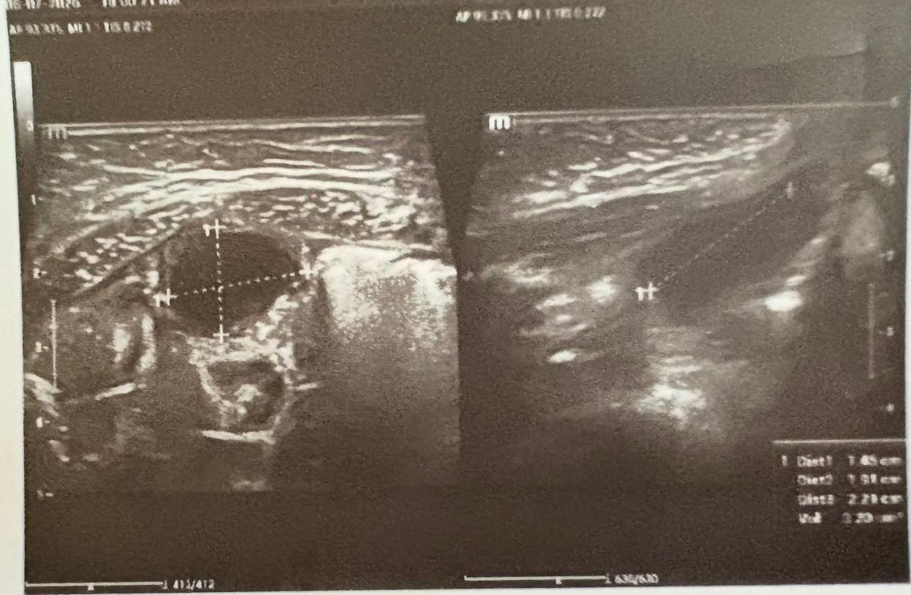
Figure 1-: Targeted ultrasound with calipers showing urachal cyst and sinus dimensions. (Left) Transverse view displaying an infected urachal cyst presenting as a rounded, hypoechoic to anechoic fluid collection with thickened, hyperemic walls and internal low-level debris. (Right) Longitudinal scan demonstrating the linear, tubular urachal sinus tract extending toward the deep margin of the umbilicus.
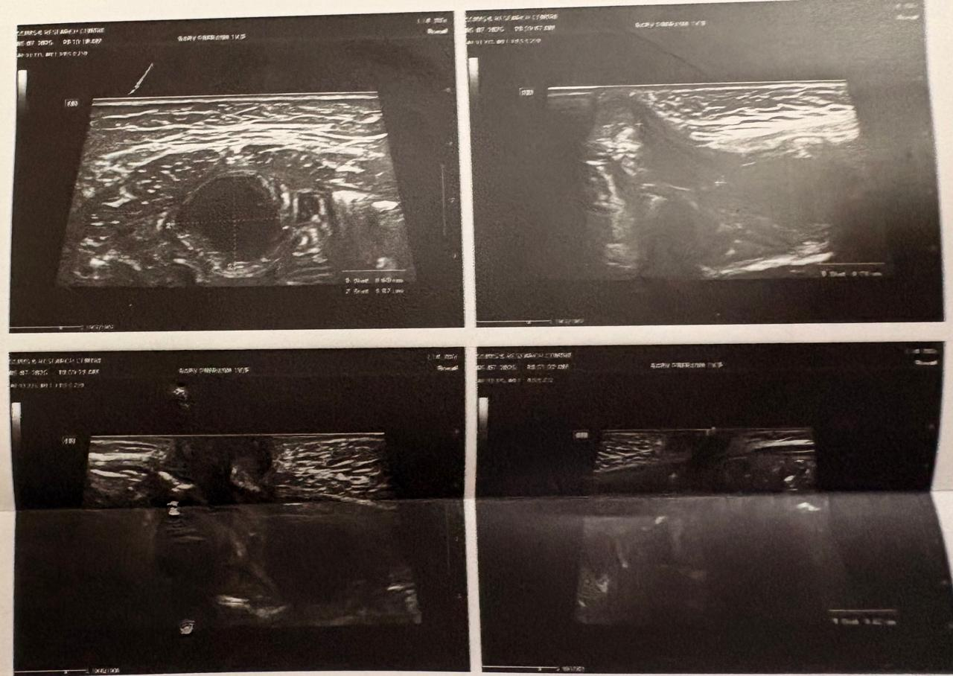
Figure 2: High-resolution ultrasonography of the infraumbilical anterior abdominal wall. Transverse and longitudinal grey-scale ultrasound scans demonstrating an infected urachal remnant complex. The images show a well-defined, thick-walled midline cystic lesion (urachal cyst) deep to the rectus abdominis muscle with fine internal echoes, communicating superiorly with a blind-ending tubular tract extending to the umbilicus (urachal sinus).
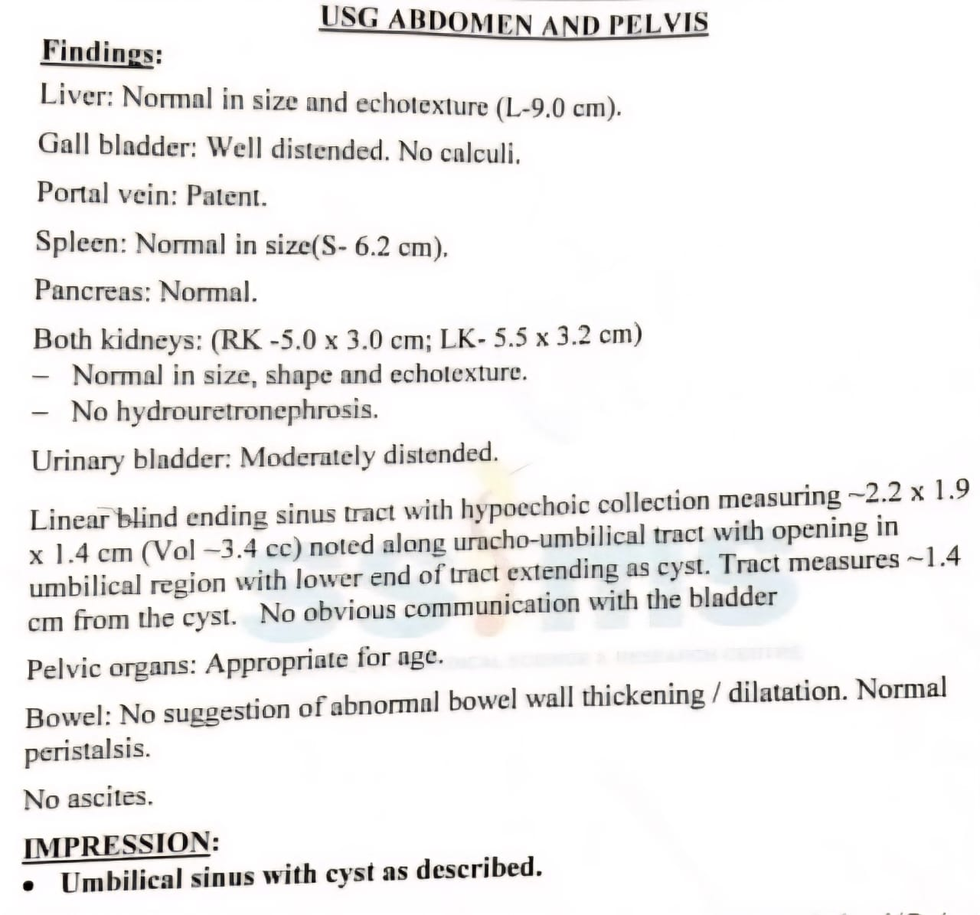
Figure 3: High-resolution pelvic ultrasonography demonstration showing the midline hypoechoic urachal cyst (measuring ~2.2 x 1.9 x 1.4 cm, volume ~3.4 cc) communicating with an umbilical sinus tract.

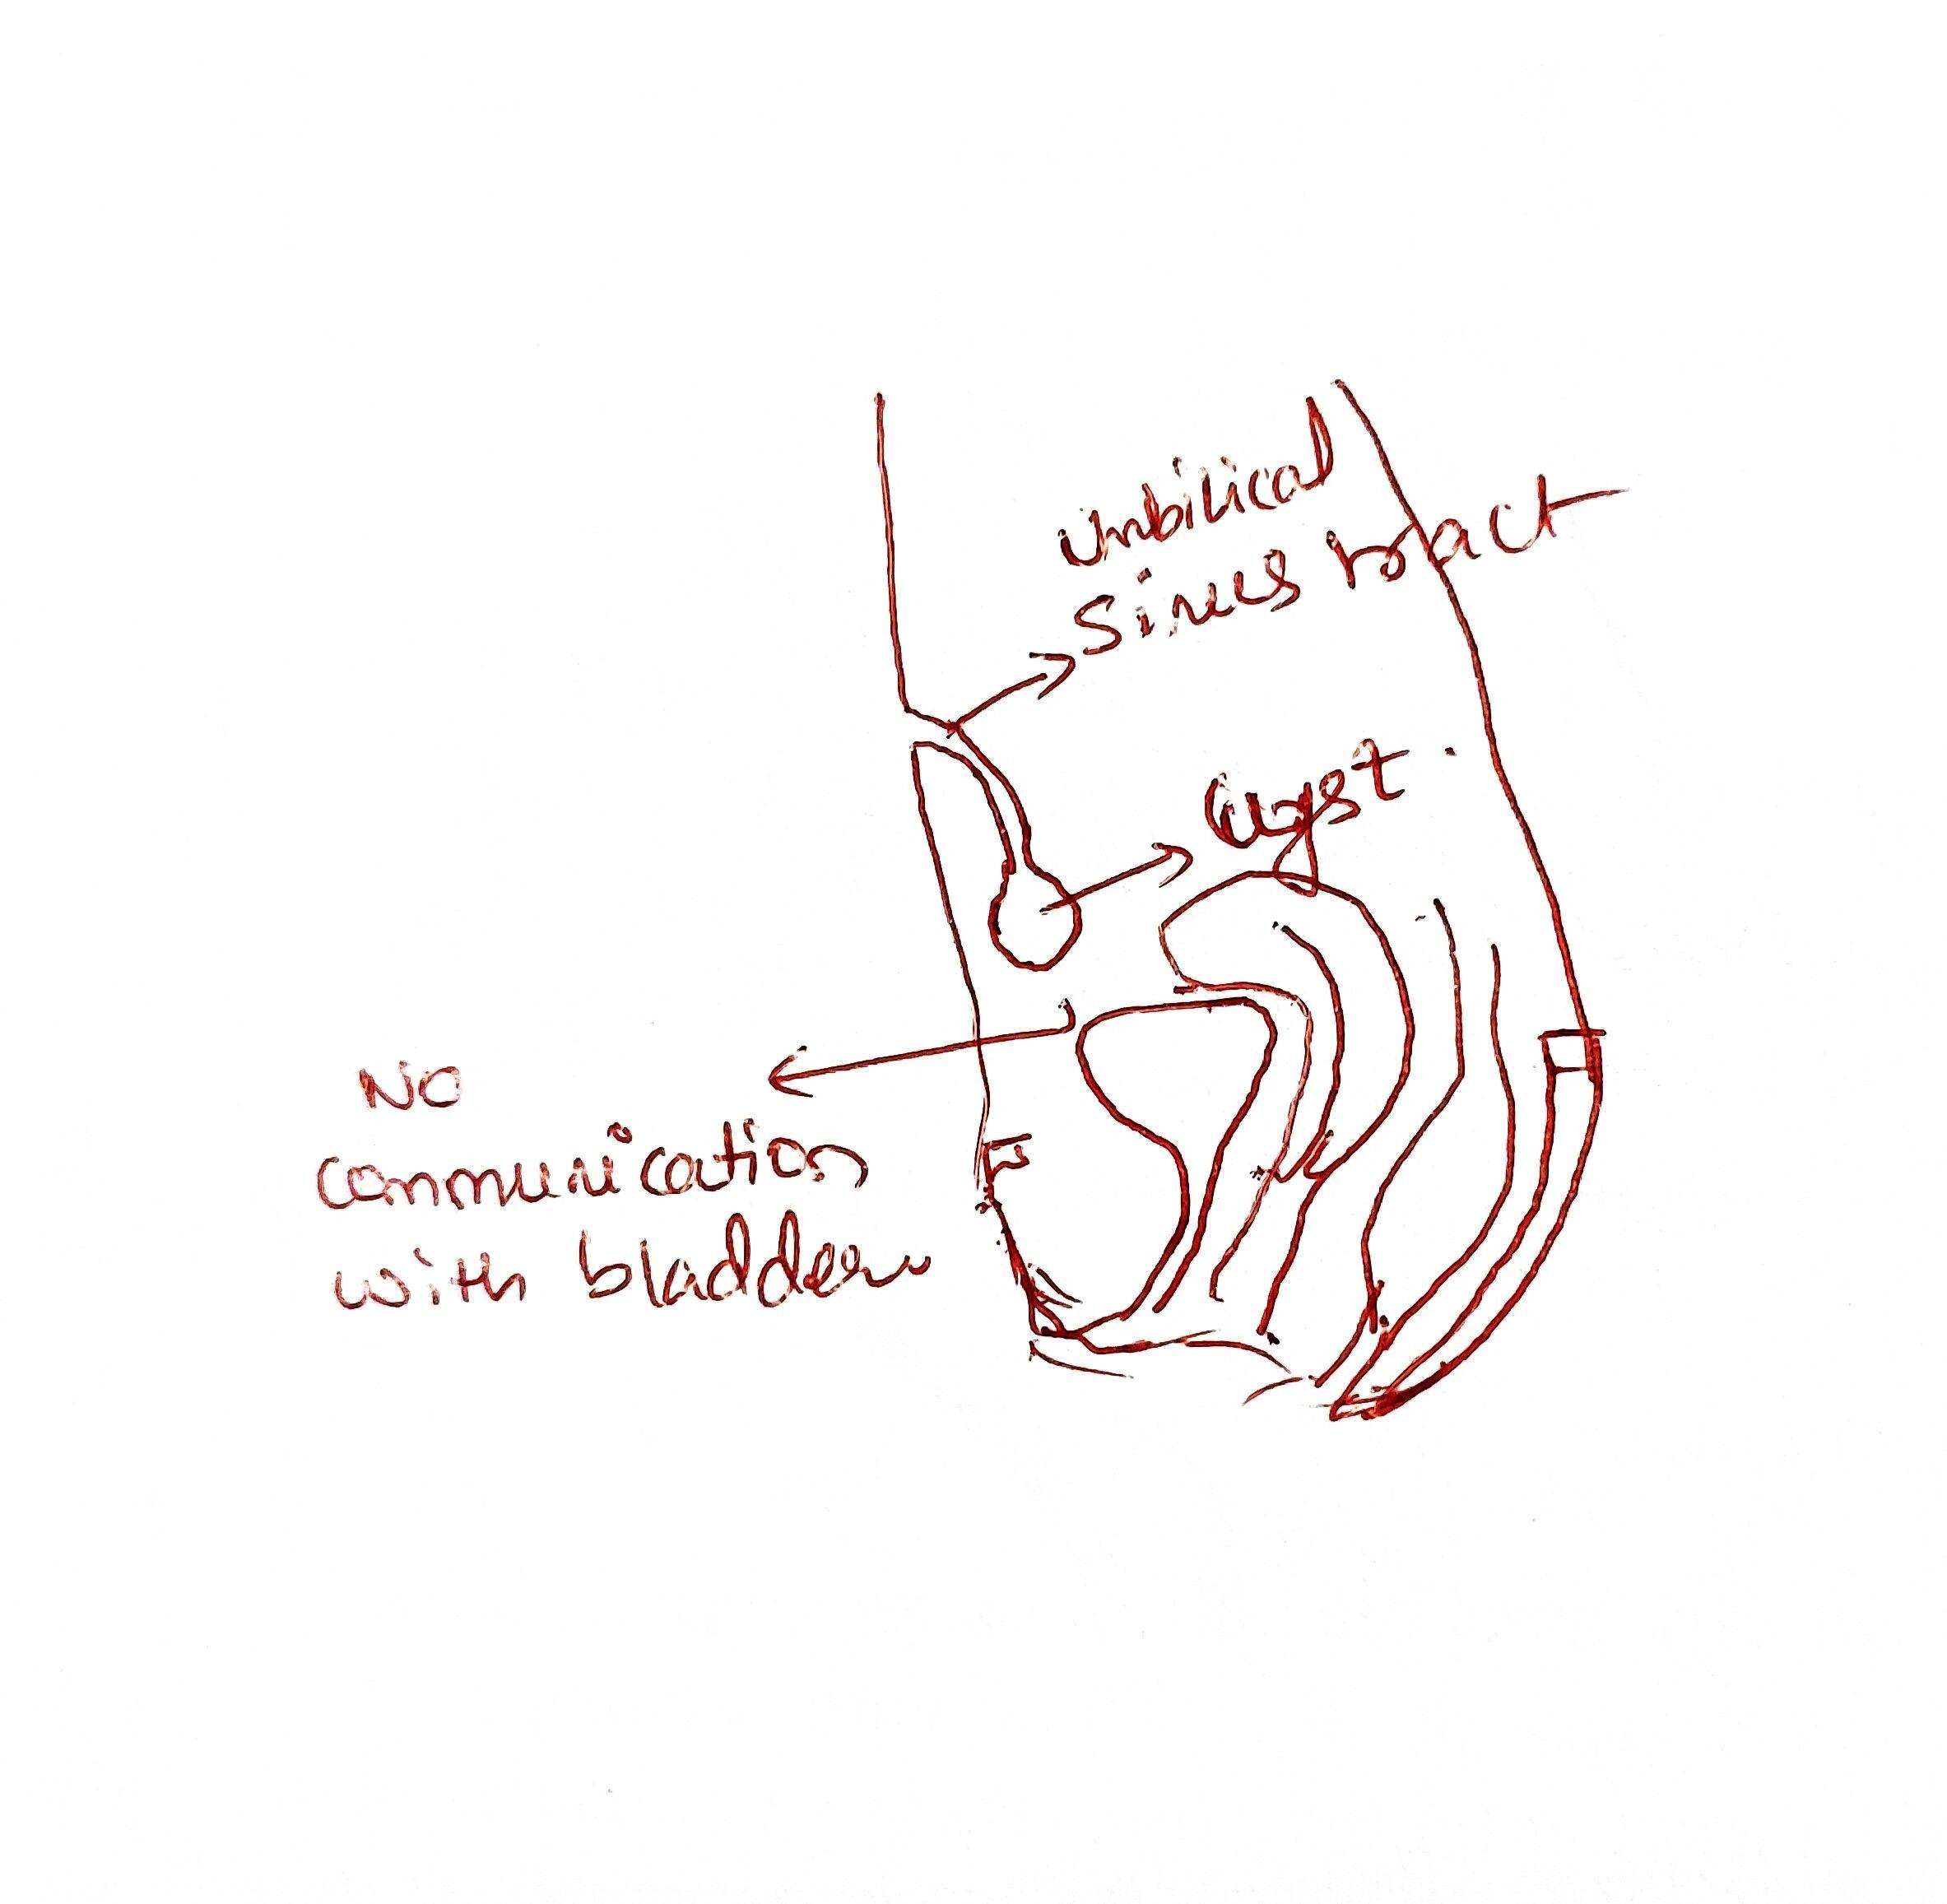
Figure 4: Clinical-anatomical schematic illustration drafted during surgical evaluation, highlighting the umbilical sinus tract opening at the skin, the infected urachal cyst, and its blind termination without intravesical communication.
2.6 Surgical Technique and Intraoperative Findings
On 7/7/2006 the patient was taken in for elective exploratory laparotomy with excision, with per-operative pediatric anesthesia clearance (ASA PS grade 1). Anesthesia induced with general endotracheal incubation, with uncuffed, 4.5 mm, ET (endotracheal tube) tube at 12 cm. Anesthesia is maintained on oxygen, N 2 O, isoflurane, and vecuronium neuromuscular. Under stringent sterile technique an epidural caudal block was placed ultrasound-guided, via 23 G hypodermic needle, placed within sacral hiatus, 6 ml, with 0.25% bupivacaine which provided excellent regional preoperative analgesia.The patient was in supine position with proper paint and sterile draping of the region of interest. A 5cm straight mid line infra umbilical vertical mid line incision was given beginning at the inferior border of the umbilicus and extended caudal words. Subcutaneously, the umbilical sinus tract was meticulously dissected and traced. Mid line linear opening of the anterior rectums sheath and lines Alba gave access to the peritoneal space (space of Retzius). Careful dissection disclosed a chronically inflamed, thick walled, suppuration urachal cyst with active pus collection over the prevesical plane and this together with the umbilical sinus tract were mobilized en-bloc and mobilized. Caudal dissection of the mass showed a blind fibrous cord which seemed to be joining the dome of the bladder via a small pinpoint tract. However, there was no intimation of mucous prolapse into the cyst and the pinpoint tract at its bladder end was ligated after transfixing close to the bladder surface in its muscular plane with polypropylene suture (PDS 5-0). Thus the umbilical sinus tract, surrounding extra-peritoneal tissue and cyst were excised as an en-bloc specimen. Pus was drained and sent for microbiological work up. Rectus sheath was closed over anatomical layers with continuous PDS and interrupted prolene sutures and the skin was closed by subcuticular prolene (3-0) sutures. Ankyloglossia release (though not indicated for the case) was done as ancillary procedure. Total operative time was one hour fifteen minutes and approximate blood loss was 10 ml with intro-operative uneventful recovery.
2.7 Microbiological Profile and Postoperative Course
An intro-operative pus culture from this case, run on the Vitek-2 automated microbiology system (bioMerieux), identified Proteus mirabilis with 99% confidence. Antibiotic susceptibility testing was performed and shows multi resistant susceptibility with demonstrated resistance against Ceftazidime (MIC >=64mcg/ml), Cefepime (MIC 8mcg/ml, SDD), Ciprofloxacin (MIC >=4mcg/ml), Leofloxacin (MIC >=8mcg/ml) Minocycline (MIC>=32mcg/ml), Colistin (MIC>=16mcg/ml, intrinsic) and trimethoprim/sulfamethoxazole (MIC>=320mcg/ml) with intermediate susceptibility against amikacin (MIC 16mcg/ml), with susceptible response to all carbapenem-class drugs, Piperecillin/ tazobactam ( MIC<=4mcg/ml) Cefoperazone/Sulbactam (MIC <=8mcg/ml), aztreonam (MIC 4mcg/ml)and Meropenem (MIC <=0.25 mcg/ml)
Antimicrobial Agent | MIC (mcg/mL) | Interpretation | Therapeutic Decision
Meropenem | <= 0.25 | Susceptible (S) | Initiated postoperatively (Day 11 onwards)
Piperacillin / Tazobactam | <= 4.0 | Susceptible (S) | Effective alternative option
Cefoperazone / Sulbactam | <= 8.0 | Susceptible (S) | Effective beta-lactamase inhibitor combination
Aztreonam | 4.0 | Susceptible (S) | Monobactam sensitive
Fosfomycin | <= 16.0 | Susceptible (S) | Sensitive
Amikacin | 16.0 | Intermediate (I) | Administered empirically, then discontinued
Gentamicin | 4.0 | Intermediate (I) | Not recommended
Ceftazidime | >= 64.0 | Resistant (R) | Resistant 3rd gen cephalosporin
Cefepime | 8.0 | SDD (Dose-Dependent) | Avoided due to high MIC
Ciprofloxacin | >= 4.0 | Resistant (R) | Fluoroquinolone resistance
Levofloxacin | >= 8.0 | Resistant (R) | Fluoroquinolone resistance
Minocycline | >= 32.0 | Resistant (R) | Tetracycline resistance
Trimethoprim / Sulfamethoxazole | >= 320.0 | Resistant (R) | Folate pathway inhibitor resistance
Colistin | >= 16.0 | Resistant (R) | Intrinsic non-susceptibility (Proteus spp.)
Table 2: Antimicrobial Susceptibility Testing (VITEK-2) for Proteus mirabilis Isolated from Urachal Abscess Pus.
Intraoperative continuous IV Fentanyl infusion (1 mcg/kg/hr) and postoperative IV ondansetron and Pr Suppositories Paracetamol 80mg, and initial empirically Started IV antibiotic cover (Cefrtixone 250mg IV BD and Amikacin 90mg IV OD and IV metronidazole 15mg TID ) was continued with in PICU for 24 hours. After the culture & S.F confirmed it as M D R Proteusmirabilis (POD 5), it was changed over the targeted intavenous Meropenem 150 mg TID. and ceased Ceftriaxone & Amikacin. Started oral syrup & liquid feed POD- 2 successfully and maintained. Wound dressings remained clear on the 1 st postoperative day without any soakage or discharge or redness. There were healthy wound margins. IV Bladder Catheter was removed on POD 6 with regular s.v and without any problem; the uneventful recovery continued & was discharged on oral cefixime & syrup Paracetamol in excellent condition. Uneventful outcome with 2 weeks' & 6 weeks' postoperative out patients follow up visit showed well healed umbilicus without discharge.
3. DISCUSSION
A congenital urachal anomaly develops due to imperfect regression of the cloacal allantois of the embryo into a cord of fibrosis from the anterior abdominal wall to the bladder vertex [11]. Our patients unique presentation with an infected urachal sinus in communication with a prevesical urachal cyst beneath was the most unusual combination reported so far, representing less than 5% of all known childhood urachal abnormalities [12]. The most conspicuous, and informative element of the entire case was initial removal of a tumor described as an 'umbilical polyp', then persistently infected and recurrent purulent discharges of the umbilicus during the next seven months [13].Umbilical pathology in young children is very common. Children present with granulomas, omphalitis, polyps and stitch abscesses. Granulomas typically present as pink tissue not covered by squamous epithelium and usually respond to topical application of silver nitrate, while polyps are epithelialized remnants of embryonic tissues, either ductus omphalo mentericus (vitelline duct) or urachus [15]. Excision of aumbilicalpolyp or nodule of discharge can take place without cross sectional ultrasonography or high frequency US and leave a deep cystic and/or tubular continuity into the abdominal wall where bacteria can get trapped, leading to purulent abdominal wall abscesses [16].High-resolution frequency ultrasound is thus the imaging modalities par excellence in suspicious urachal anomalies in childhood since it is totally non-invasive, void of ionizing radiation and is providing resolution to visualize the anterior abdominal wall soft tissues better [17]. If done by a skilled pediatric radiologist the sensitivity is >90-95% able to precisely delineate, size, content of cysts, wall-thickness and longitudinally course of urachal remnant between umbilicus and apex of the bladder [18]. The accurate anatomical illustration of the following pelvic sonography of the child, namely that there is a blind-ending umbilical sinus tract 1.4 cm, going along the urachovesical tract leading to a 2.2×1.9×1.4 cm hypoechoic collection (volume 3.4 cc), gives a blueprint to perform definite surgical resection [19]. Rarely indicated in otherwise uncomplicated pediatric cases, the computed tomographic (CT) scan or magnetic resonance imaging (MRI) is reserve for suspicion of extraperitoneal rupture and pervasive peritonitis, as well as the need to exclude the probability of subsequent malignant change (e.g. Urachal adenocarcinoma) in adult patients [20].The aetiology among patients presenting with infected urachal anomalies most often include scutaneous commensals (e.g., Staphly coccus aureus, Strep tococcus pyogenes),Gram-negati ve enterobacteria (e.g., Esch erichia coli, Klebsiella pneumoniae) ascending the opening of the umbilical cord, or Retrograde lymphatics [21]. The intro-operative culture specimen in our patient grew Proteus mirabilis- a multi-drug resistant strain demonstrating third generation, fourth generation cephalosporin, fluoroquinolone, and trimethoprim/sulfamethoxazole as well as intrinsicallycolistin resistant pathogens [22]. Proteus mirabilis elaboration of urease createsa highly alkalinized environment conducive to the perpetuationof biofilm formations and collections of pus within congenital blind-ending structures [23]. It is most fortunate that the initiation of a culture guided course of IV meropenem along with intravenous metroniidazole resulted in swift resolution and avoided development of infection into the deeper space [24].Symptomatic urachal cysts and sinuses have proved to require surgical excision for complete treatment [25]. While treatment with oral antibiotics can result in over 30-40% recurrence, simple Incision, drainage and packing or incomplete excision is frequently associated with chronic discharge, secondary sinus tracts and in the longer term an increase risk of malignancies in the adult [26]. Surgical approach involves complete en bloc excision of the tract, pyogenic sac, and remnants of fibrousurachal structure down to the very dome of the urinary bladder, secured by means of a transfixing stitch at the superior dome of bladder [27]. While in recent times Laparoscopic/ robotic guided approaches have become relatively popular, in young infants an open trans umbilical mid line exploration is the surest method; cost-effective and quicker approach for excellent feedback and clean extra peritoneal dissection, without breaching the peritoneal cavity [28,29].
4. CONCLUSION
This This case shows a deep urachal cyst communicating via an infected urachal sinus which can be mistakenly interpreted as a recurrent umbilical polyp, stitch abscess or a refractory omphalitis after superficial resection. Pediatricians managing patients with intermittent or recurrent, prolonged umbilical discharge should maintain a high index of suspicion. Routine high-resolution ultrasound assessment of the abdominal wall and pelvis should be performed before performing any superficial surgical removal or cautery. En Bloc surgery with thorough bladder dome ligation of the Cyst, the sinus and apex has been the modality of choice for permanent cure of urachal Cyst. Antibiotic coverage directed towards an identified pathogenic organism has provided complete resolution.
5. ETHICAL APPROVAL AND PATIENT CONSENT
Institutional approval from the institutional ethics committee of S.S. Institute of Medical Sciences & Research centre was granted prior to study. Written consent from the legal guardians (parents) of the patient for publication of this case report and associated photographs and radiography were obtained
- LIMITATION
Some of the limitations to this case report include that it is a single patient, single center study and thus, there are limits on generalizing both the clinical course and treatment as well as microgiological features to the overall pediatric population with urachal anomalies. Information regarding previous interventions including previous superficial polypectomy at five months of age as well as previously presumed OMPSs in intermittent clinic visits and intermittent operative reports is prone to selection and recall bias since data from retrospectively charted and parent reported information had gaps in earlier years. An all ultrasound pre-operative assessment as well as work up, without advanced sectional imaging like CT scans or MRIs with contrast, may have hindered detection of discreet subtle deepened fistulous tracts and prevesical fascial planes. Detailed histological assessment of the epithelium lining the cyst and sinus as well as how it correlated with findings during en-bloc excision, the cyst and the sinus lining as was done in this reported procedure is not presented with as high a degree of detail and focus on histopathology of the types of epithelial cells as would be ideal. Early wound healing and immediate post-operative complications are adequately detected up to two and six weeks, though the patient in this report has not been evaluated beyond six weeks post-operatively so definitive conclusions concerning post operative urinary function, late adhesions or late abdominal re-infection can not be made at this point.

Declaration of AI Use

This manuscript was prepared through the intellectual contributions of the author(s) to the study design, data analysis, interpretation of results, and scholarly content. Grammarly and ChatGPT were used solely to assist with grammatical refinement and reference formatting during manuscript revision. The author(s) accept full responsibility for the accuracy, integrity, and final content of the manuscript.

COMPETING INTERESTS DISCLAIMER:
Authors have declared that they have no known competing financial interests OR non-financial interests OR personal relationships that could have appeared to influence the work reported in this paper.

9. REFERENCES
1. Begg RC. The urachus: its anatomy, histology, and development. J Anat. 1930;64(Pt 2):170-183.
2. Choi YJ, Kim JM, Rho J, Do H. Patent urachus and urachal anomalies in pediatric patients: A single-center review of 10-year experience. J Pediatr Urol. 2021;17(4):534.e1-534.e6.
3. Gleason JM, Bowlin PR, Bagli DJ, Lorenzo AJ, Hassouna MM, Koyle MA, et al. A comprehensive review of pediatric urachal anomalies and their management. Can Urol Assoc J. 2013;7(9-10):E632-E638.
4. Blichert-Toft M, Nielsen OV. Congenital patent urachus and urachal anomalies: an embryological and clinical study. Proc R Soc Med. 1971;64(10):1078-1080.
5. Cilento BG, Bauer SB, Retik AB, Peters CA, Atala A. Urachal anomalies in children: contemporary management. J Urol. 1998;159(6):2135-2138.
6. Ekwunife OH, Ugwu JO, Modekwe VI. Pediatric urachal anomalies: clinical spectrum, diagnostic pitfalls, and management outcomes. Afr J Paediatr Surg. 2018;15(3):142-146.
7. Galati V, Donovan B, Ramji F, Campbell J, Frimberger D, Kropp BP. Management of urachal remnants in early childhood. J Pediatr Urol. 2008;4(6):459-464.
8. Ashley RA, Inman BA, Routh JC, Rohlinger AL, Husmann DA, Kramer SA. Urachal anomalies: a longitudinal study of urachal remnants in children and adults. J Urol. 2007;178(4 Pt 1):1615-1618.
9. Snyder CL. Current management of umbilical abnormalities and urachal remnants in children. Semin Pediatr Surg. 2007;16(1):41-45.
10. Upadhyay V, Kukkady A. Urachal anomalies in children: a 10-year retrospective study of presentation and treatment. N Z Med J. 2003;116(1178):U524.
11. Naiditch JA, Radhakrishnan J, Chin AC. Current trends in the management of urachal anomalies in children. J Pediatr Surg. 2013;48(8):1752-1756.
12. Lipskar AM, Glick RD, Rosen NG, Boley SJ, St-Vil D. Nonoperative management of symptomatic urachal anomalies in children. J Pediatr Surg. 2010;45(5):1016-1019.
13. Kamel K, Nasr H, Tawfik S, Azzam A, Elsaid M, Qinawy M, et al. Complicated urachal cyst in two pediatric patients: a case report. BMC Pediatr. 2023;23(1):154.
14. Kutin ND, Allen JE, Jewett TC. The umbilical polyp. J Pediatr Surg. 1979;14(6):741-744.
15. Pacilli M, Sebire NJ, Maritsi D, Kiely EM, Drake DP, Curry JI, et al. Umbilical polyp in infants and children. Eur J Pediatr Surg. 2007;17(6):397-400.
16. Swanson DC, Patel R, Laje P. Umbilical mass in children: distinguishing benign polyps from congenital patent vitelline and urachal remnants. Pediatr Surg Int. 2022;38(11):1583-1589.
17. Robert Y, Hennequin-Delerue C, Chaillet D, Bouras P, Rocher L, Lemaitre L. Urachal remnants: sonographic assessment. J Clin Ultrasound. 1996;24(7):339-347.
18. Widni EE, Höllwarth ME, Haxhija EQ. The impact of preoperative ultrasound on correct diagnosis of urachal remnants in children. J Pediatr Surg. 2010;45(7):1433-1437.
19. Yiee JH, Pei L, Cheng EY. Diagnostic accuracy of ultrasound in pediatric urachal pathology: a systematic review. J Urol. 2014;192(5):1520-1525.
20. Yu JS, Kim KW, Lee HJ, Lee YJ, Yoon CS, Ryu YH. Urachal remnant diseases: spectrum of CT and US findings. Radiographics. 2001;21(2):451-461.
21. Newman BM, Karp MP, Jewett TC, Cooney DR. Advances in the management of infected urachal cysts in pediatric patients. J Pediatr Surg. 1986;21(12):1051-1054.
22. O'Gara TA, Halle-Martin P, Khoury AE. Microbiology and antibiotic management of infected urachal remnants in children. J Pediatr Urol. 2012;8(3):289-293.
23. Armbruster CE, Mobley HLT. Merging mathematics and biology: Proteus mirabilis pathogenesis, urease production, and biofilm formation. Nat Rev Microbiol. 2018;16(2):77-92.
24. Guven A, Kocaoglu M, Ozcan A. Infected urachal cyst caused by Proteus mirabilis in a young infant: diagnostic and therapeutic challenges. Pediatr Surg Int. 2007;23(7):705-708.
25. McCollum MO, Macneily AE, Blair GK. Surgical implications of urachal remnants: presentation and management. J Pediatr Surg. 2001;36(5):798-803.
26. Nogueras-Ocaña M, Rodríguez-Gómez UF, Uberos-Fernández J, Vallejo-Herrador J, Mizuno K. Urachal anomalies in children: surgical or conservative approach? Actas Urol Esp. 2014;38(8):546-551.
27. Little DC, Shah SR, St Peter SD, Calkins CM, Morrow SE, Murphy JP, et al. Urachal anomalies in children: the premier experience. J Pediatr Surg. 2005;40(12):1897-1900.
28. Cadeddu JA, Boyle KE, Fabrizio MD, Schulam PG, Kavoussi LR. Laparoscopic management of urachal cysts in children and young adults. Tech Urol. 2000;6(1):32-34.
29. Patrzyk M, Glitsch A, Schreiber A, von Bernstorff W, Heidecke CD. Single-incision laparoscopic resection of urachal anomalies in pediatric and adolescent patients. J Laparoendosc Adv Surg Tech A. 2013;23(10):883-887.

