Artificial Intelligence and the Smart Mobility Nexus: A Systematic Review

Abstract
Artificial intelligence (AI) is increasingly reshaping transportation through predictive analytics, intelligent infrastructure, connected mobility, autonomous systems and energy-responsive transport management. This systematic review examines the AI–smart mobility nexus with emphasis on intelligent transportation infrastructure and operational sustainability. Following PRISMA 2020, 30 studies published between 2015 and 2026 were synthesised from Scopus, Web of Science, IEEE Xplore, ScienceDirect, Google Scholar and selected institutional sources. The review identifies five dominant areas of application: AI-enabled traffic management, connected transportation infrastructure, safety and risk reduction, renewable-energy-integrated mobility, and operational sustainability. Evidence consistently shows that AI improves traffic prediction, routing, incident detection, system coordination, infrastructure monitoring and energy management. However, these benefits remain strongly dependent on data quality, digital connectivity, infrastructure readiness, grid capacity and institutional capability. The review further finds that operational efficiency does not automatically translate into environmental or social sustainability, particularly where renewable-energy integration, accessibility, governance and regulatory coordination remain weak. Interpreted through Technological Innovation Systems Theory and Sustainability Transition Theory, the findings indicate that sustainable smart mobility emerges through coordinated technological, infrastructural, institutional and energy-system development. The review concludes that AI can support safer, more efficient and sustainable transportation, but future progress requires stronger system-level evidence, broader geographical representation and greater attention to governance, equity and long-term environmental outcomes.
Keywords: artificial intelligence; smart mobility; intelligent transportation systems; intelligent transportation infrastructure; operational sustainability; sustainable transport.

1.0 Introduction
Rapid urbanisation, population growth and rising travel demand continue to place substantial pressure on transportation systems worldwide. Congestion, road-safety risks, energy use, air pollution and inadequate integration among transport modes remain persistent problems, particularly in rapidly expanding cities. These pressures have accelerated interest in smart mobility, which increasingly combines artificial intelligence (AI), the Internet of Things (IoT), big-data analytics, connected infrastructure and automated decision systems to improve transport efficiency, accessibility and sustainability (Mitieka et al., 2023). Recent research has consequently shifted from viewing transportation infrastructure primarily as a physical network toward understanding it as a data-intensive socio-technical system capable of sensing, predicting and responding to changing mobility conditions.
AI has become central to this transition because of its capacity to process large and heterogeneous transport datasets, identify complex mobility patterns and support real-time or predictive decision-making. Machine learning, deep learning and related analytical techniques are increasingly applied to traffic-flow prediction, congestion management, route optimisation, incident detection, infrastructure monitoring, autonomous mobility and public-transport coordination. The growing integration of data science with intelligent transportation systems has strengthened the capacity of transport operators to convert information generated by vehicles, sensors and connected infrastructure into operational decisions (Jalil et al., 2024). Recent systematic evidence further indicates that AI applications in Mobility-as-a-Service systems increasingly support demand forecasting, real-time personalisation, optimisation and multimodal integration (Rouky et al., 2025).
Smart mobility, however, extends beyond the deployment of sophisticated digital technologies. It requires the coordinated interaction of intelligent infrastructure, connected vehicles, mobility platforms, energy systems, users and regulatory institutions. Goumiri et al. (2025) show that traffic management, routing, road safety, parking and emissions remain interconnected components of smart-mobility development, while Mitieka et al. (2023) argue that the sustainability potential of smart mobility depends substantially on its successful integration with existing transport systems. This distinction is important because technological capability alone does not necessarily translate into system-wide mobility improvements.
Sustainability has therefore become an increasingly important dimension of the AI–mobility relationship. AI-based traffic optimisation can reduce unnecessary vehicle movement, congestion and idling, while data-driven mobility services may improve asset utilisation and public-transport coordination. Yet evidence concerning the environmental contribution of smart mobility remains less settled. D'Alberto and Giudici (2023) found that smart-mobility scholarship has concentrated heavily on data processing and modelling, while environmental outcomes have received comparatively limited attention. Recent evidence similarly suggests that AI can contribute to energy efficiency and reduced travel time, but substantial reductions in transport emissions may depend on wider changes in modal choice, land-use planning and mobility governance rather than technological optimisation alone.
The emerging AI–mobility nexus also intersects increasingly with electric mobility and renewable-energy systems. Intelligent charging, predictive energy management, vehicle-grid coordination and demand optimisation create opportunities to align transport digitalisation with broader decarbonisation objectives. However, the effectiveness of these systems depends on charging infrastructure, grid reliability, data availability, connectivity and interoperability. Where these supporting conditions are weak, the benefits associated with AI-enabled mobility can remain limited or unevenly distributed.
Governance presents an equally important constraint. Smart mobility systems generate large volumes of location, behavioural and operational data, raising concerns about privacy, cybersecurity, algorithmic transparency, accountability and unequal access. Servou et al. (2023) demonstrate that the sustainability outcomes of AI-enabled mobility services depend partly on how algorithms, data and institutional objectives are governed. They further show that data-driven optimisation can reproduce socio-political inequalities or create rebound effects where sustainability objectives are not explicitly incorporated into mobility governance. These concerns become particularly significant in developing economies, where infrastructure deficits, fragmented institutions, limited technical capacity and unreliable energy systems may constrain the adoption of intelligent transportation technologies. Existing research also remains geographically uneven, with substantially less empirical attention devoted to developing countries despite rapid urban growth and pressing transport challenges in these contexts (Mitieka et al., 2023).
The literature therefore reveals an important analytical gap. Although a growing number of studies examine individual applications of AI, autonomous vehicles, predictive traffic systems, IoT infrastructure, Mobility-as-a-Service and sustainable transportation, the evidence remains fragmented across technological, infrastructural, operational, environmental and governance domains. Recent studies provide strong evidence of technological progress, yet fewer studies integrate these dimensions to explain the conditions under which AI-enabled mobility produces durable operational and sustainability outcomes. Research on smart mobility also continues to exhibit a strong technological orientation, with comparatively limited integration of infrastructure readiness, energy systems, governance and regional development conditions (D'Alberto & Giudici, 2023; Mitieka et al., 2023; Servou et al., 2023).
Against this background, this study systematically reviews the evolving nexus between artificial intelligence and smart mobility, with particular emphasis on intelligent transportation infrastructure and operational sustainability. It examines how AI, IoT, big-data analytics and predictive technologies are being applied within contemporary transport systems; assesses their reported effects on efficiency, safety, reliability, energy use and environmental performance; and identifies the infrastructural, technological and governance conditions that shape implementation. The review further evaluates emerging gaps in renewable-energy integration, regional research coverage and system-level evidence. By synthesising these strands within a single analytical framework, the study clarifies the pathways through which AI contributes to smart mobility while identifying the conditions under which technological innovation can translate into more efficient, resilient and sustainable transportation systems.

2.0 Conceptual and Theoretical Foundation

2.1 Conceptual Review

2.1.1 Artificial Intelligence in Transportation
Artificial intelligence in transportation refers to the application of machine learning, deep learning, computer vision, predictive modelling and related computational techniques to support perception, prediction, optimisation and automated decision-making within transport systems. Contemporary applications extend across traffic forecasting, route optimisation, autonomous driving, public-transport management, infrastructure monitoring and incident detection. Recent reviews show that AI has moved beyond isolated traffic-control applications toward integrated intelligent transportation systems in which vehicles, infrastructure and mobility platforms exchange and process real-time information (Bazzan, 2026; Rong et al., 2025). However, performance remains dependent on data quality, computing capacity, interoperability and the ability to translate algorithmic outputs into operational transport decisions.

2.1.2 Smart Mobility
Smart mobility describes the coordinated use of digital technologies, connected transport services and data-driven systems to improve the efficiency, accessibility, safety and environmental performance of mobility. It encompasses intelligent vehicles, shared and on-demand mobility, integrated public transport, Mobility-as-a-Service, smart traffic control and digitally connected infrastructure. The concept has therefore evolved beyond technology adoption toward the integration of mobility services, users, infrastructure and governance. Recent evidence indicates that smart mobility can improve transport responsiveness and service coordination, but its sustainability contribution depends on accessibility, modal integration and the extent to which environmental and social objectives are incorporated into system design (Butler et al., 2020; Servou et al., 2023).

2.1.3 Intelligent Transportation Infrastructure
Intelligent transportation infrastructure comprises the physical and digital assets that permit transport networks to sense, communicate, process information and respond dynamically. Its principal components include roadside sensors, intelligent signals, vehicle-to-infrastructure communication, connected road systems, traffic-management platforms, cloud and edge computing, high-speed communication networks and electric-vehicle charging infrastructure. Such infrastructure provides the operational foundation on which AI applications depend. Recent research shows that intelligent transportation systems become more effective when connectivity, traffic-control platforms and vehicle technologies function as integrated rather than isolated components. Autonomous-vehicle integration, for example, can improve safety and congestion outcomes, but those effects remain sensitive to infrastructure quality, penetration rates and traffic-management strategies (Al Mallah, 2025).

2.1.4 Predictive Analytics and Intelligent Traffic Management
Predictive analytics uses historical and real-time mobility data to estimate traffic demand, congestion, incidents, travel time and infrastructure conditions before they become operational constraints. AI-enabled adaptive traffic-control systems combine sensor data, IoT devices and predictive algorithms to alter signal timing, routing and network responses dynamically. Recent systematic evidence shows growing application of these technologies to traffic-flow optimisation and infrastructure adaptability, although practical effectiveness remains influenced by data availability, model generalisability and real-world deployment conditions (Bazzan, 2026). The convergence of AI, IoT and predictive analytics therefore shifts traffic management from reactive control toward anticipatory network management.

2.1.5 Renewable-Energy-Integrated Mobility
Renewable-energy-integrated mobility connects transport electrification with clean-energy generation, storage, smart charging and grid-management systems. AI contributes by forecasting charging demand, coordinating energy flows, optimising battery use and matching electric-vehicle charging with grid conditions. The concept is increasingly relevant as intelligent transportation systems expand beyond mobility optimisation toward wider energy and environmental objectives. Yet technological efficiency alone does not guarantee significant emissions reduction. Recent synthesis suggests that substantial environmental gains emerge more consistently where AI-supported transport optimisation is accompanied by cleaner electricity, public-transport use, active mobility and wider low-carbon transport policies.

2.1.6 Operational Sustainability
Operational sustainability refers to the capacity of a transportation system to maintain efficient, reliable and safe mobility while reducing energy consumption, resource waste and environmental externalities. Within AI-enabled mobility, it is reflected in shorter travel times, improved traffic flow, lower accident exposure, reduced fuel and electricity losses, predictive maintenance, infrastructure resilience and lower emissions. Existing evidence nevertheless cautions against treating digital efficiency as equivalent to sustainability. D'Alberto and Giudici (2023), for example, found that smart-mobility research has devoted considerably greater attention to data processing and modelling than to direct environmental outcomes. Operational sustainability is therefore best understood as a system-level outcome shaped jointly by technological performance, infrastructure readiness, energy sources, user behaviour and governance.

2.2 Theoretical Review
The relationship between artificial intelligence, intelligent transportation infrastructure and sustainable mobility is best interpreted through complementary technological-innovation and sustainability-transition perspectives. Technological Innovation Systems theory explains technological development as the outcome of interactions among firms, governments, research institutions, infrastructure providers, markets and regulatory institutions rather than as the result of technical invention alone. Applied to smart mobility, the perspective suggests that the diffusion of AI, connected vehicles, predictive analytics and digital transport infrastructure depends on knowledge development, market formation, institutional legitimacy, investment, technical standards and supporting infrastructure. The uneven adoption of intelligent mobility across regions is therefore consistent with differences in institutional capacity, digital readiness and innovation-system maturity.
Sustainability Transition Theory extends this explanation by treating mobility transformation as a broader socio-technical process involving simultaneous changes in technology, institutions, policy, user practices, markets and infrastructure. Kivimaa et al. (2021) show that sustainability transitions cannot be reduced to technological disruption because regulatory arrangements, behavioural practices, actor networks and institutional structures also determine the speed and direction of change. Evidence from Mobility-as-a-Service development similarly demonstrates that policy experimentation and gradual institutional restructuring can create the regulatory and market conditions required for new mobility innovations to develop (Kivimaa & Rogge, 2022).
These perspectives are particularly relevant because AI-enabled mobility operates within an established transport-energy-governance system. Advances in machine learning or autonomous control may improve technical capability, but system-level sustainability depends on complementary changes in infrastructure, electricity systems, regulation, organisational competence and mobility behaviour. Servou et al. (2023) further show that algorithms themselves increasingly participate in mobility governance by influencing service allocation, user choice and system optimisation. This introduces issues of transparency, accountability, bias and public value that purely technological explanations cannot adequately capture.
Accordingly, this study primarily adopts Technological Innovation Systems Theory and Sustainability Transition Theory as complementary analytical lenses. The former explains the conditions supporting the emergence and diffusion of intelligent transport technologies, while the latter explains how such technologies interact with institutional, infrastructural, behavioural and environmental change. Together, they support the central proposition of this review: AI contributes to sustainable smart mobility most effectively when technological capability is matched by intelligent infrastructure, supportive institutions, energy-system readiness and coherent governance.
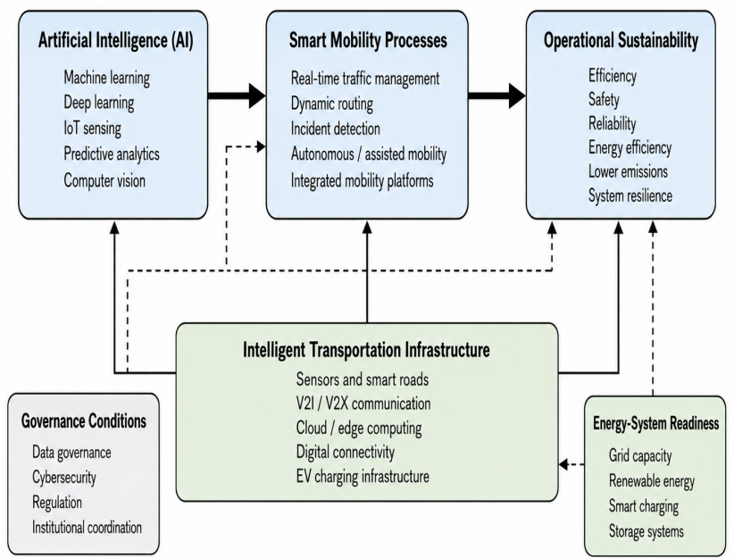

Figure 1. Integrated Conceptual Framework of the AI–Smart Mobility Nexus

Source: Authors’ conceptualisation based on the reviewed literature.

The framework shows how artificial intelligence supports smart mobility through machine learning, predictive analytics, IoT sensing and computer vision. These capabilities influence traffic management, routing, incident detection and integrated mobility services, which in turn shape operational sustainability. Intelligent transportation infrastructure provides the enabling platform, while governance conditions and energy-system readiness influence the strength and sustainability of these relationships.

2.3 Empirical Review
Recent evidence demonstrates rapid expansion of AI across traffic prediction, intelligent infrastructure, autonomous mobility, safety management and integrated transport services. AI and machine-learning applications increasingly support congestion forecasting, adaptive signal control, route optimisation, infrastructure monitoring and real-time mobility decisions (Bazzan, 2026; Del-Coco et al., 2025; Jalil et al., 2024; Rong et al., 2025). Recent systematic reviews further show that AI applications within Mobility-as-a-Service increasingly support demand forecasting, personalisation, multimodal coordination and service optimisation (Rouky et al., 2025).
Traffic management remains the most mature application domain. Machine learning and deep learning allow transport systems to process large volumes of sensor, GPS and vehicle data and respond dynamically to changing network conditions. However, model effectiveness remains sensitive to data quality, sensor coverage, computational capacity and transferability across different traffic environments (Bazzan, 2026; Del-Coco et al., 2025). Evidence on roadside intelligent transportation systems similarly demonstrates that connected infrastructure can improve real-time traffic perception, but wider deployment still requires reliable sensing, communication and secure information exchange (Creß et al., 2024).
Safety research reports comparable progress. Computer vision, sensor fusion and action-recognition models increasingly support collision avoidance, accident detection and automated emergency response. Adewopo et al. (2023) found substantial advancement in AI-supported accident recognition but also identified persistent limitations involving dataset diversity, occlusion, unusual traffic events and real-world generalisability. Del-Coco et al. (2025) similarly identify sensor fusion, connected vehicles and advanced driver-assistance systems as central to safer intelligent mobility, while noting cybersecurity, interpretability and adverse operating conditions as continuing challenges.
The sustainability evidence is more qualified. Smart mobility may reduce travel time, congestion and energy use, yet direct environmental effects remain less extensively examined than technical performance (D'Alberto & Giudici, 2023; Mitieka et al., 2023). Operational efficiencies also depend on wider transport behaviour, clean-energy availability and modal integration. This distinction is especially relevant for electric mobility, where AI-supported charging and energy management can improve resource use but cannot independently overcome grid constraints or carbon-intensive electricity supply.
Governance and institutional conditions further shape outcomes. Servou et al. (2023) show that AI-supported mobility platforms can improve coordination while simultaneously creating concerns around algorithmic decision-making, inequality, rebound effects and accountability. Regional evidence similarly indicates uneven adoption, with stronger implementation in digitally mature cities and greater infrastructure, institutional and financial constraints in developing urban environments (Adeniran et al., 2025; Mitieka et al., 2023).
Overall, the empirical literature supports AI's contribution to prediction, safety, connectivity and operational efficiency but reveals three persistent gaps. Environmental and social outcomes remain less established than technical performance; evidence continues to be geographically concentrated; and AI, infrastructure, energy and governance are frequently studied separately. These limitations justify an integrated systematic examination of the AI–smart mobility nexus.

3.0 Methodology

3.1 Review Design
This study adopted a systematic review design to synthesise recent evidence on artificial intelligence, smart mobility, intelligent transportation infrastructure and operational sustainability. The review followed the PRISMA 2020 framework to support transparent identification, screening, eligibility assessment and inclusion of relevant studies (Page et al., 2021).

3.2 Search Strategy
Relevant studies were identified from Scopus, Web of Science, IEEE Xplore, ScienceDirect and Google Scholar. The search covered publications from 2015 to 2026 and combined keywords using Boolean operators. A representative search string was: ("artificial intelligence" OR "machine learning" OR "predictive analytics") AND ("smart mobility" OR "intelligent transportation systems" OR "transport infrastructure") AND ("sustainability" OR "renewable energy" OR "operational efficiency"). Search terms were adapted to the syntax of each database. Reference tracking and selected institutional sources were used to identify additional relevant studies.

3.3 Eligibility Criteria
Studies were included where they examined AI-enabled transport, smart mobility, intelligent transportation infrastructure, IoT-based transport systems, renewable-energy-supported mobility or transport sustainability. Eligible sources comprised peer-reviewed journal articles, high-quality conference papers and authoritative technical reports published in English between 2015 and 2026. Duplicates, abstracts without accessible full texts, studies outside the review period and publications unrelated to AI-enabled transportation were excluded.

3.4 Study Selection
The search initially identified 380 records. After removal of duplicates and records that did not satisfy the preliminary scope, 288 titles and abstracts were screened. Seventy-two reports were sought for retrieval, of which three could not be obtained. Sixty-nine full-text publications were therefore assessed against the predefined eligibility criteria, and 39 were excluded for insufficient topical or methodological relevance. Thirty studies met the final inclusion criteria and were retained for synthesis. The selection process is reported in the PRISMA 2020 flow diagram.

selection process is presented in the PRISMA 2020 flow diagram.

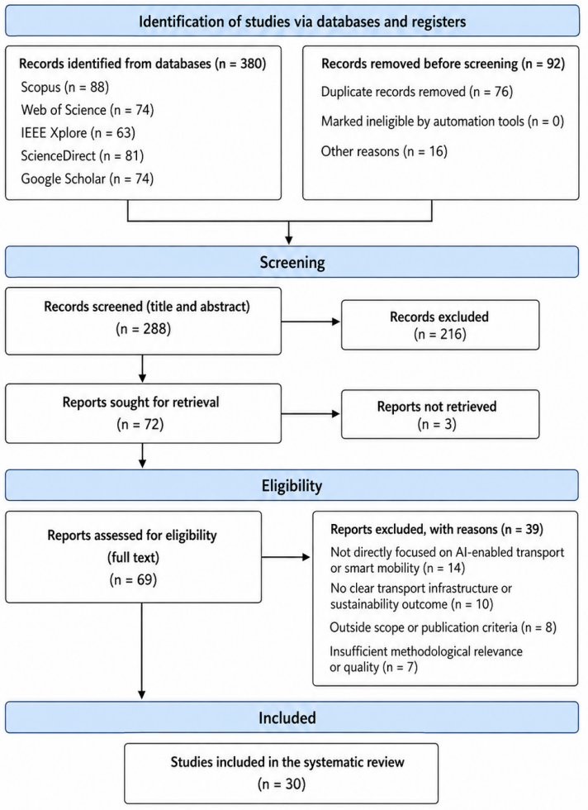

Figure 2. PRISMA 2020 Flow Diagram for Study Selection
Source: Authors’ revised systematic review synthesis, adapted from Page et al. (2021).

3.5 Data Extraction and Thematic Synthesis
A structured extraction framework captured publication year, geographical setting, technology examined, infrastructure characteristics, research method, operational outcomes, sustainability implications and reported limitations. Data from the 30 included studies were coded iteratively and synthesised around recurring themes relating to AI-enabled traffic management, intelligent infrastructure, safety, renewable-energy integration and operational sustainability. The characteristics of the 30 included studies are reported in Supplementary Table S1

3.6 Quality Appraisal
Methodological quality was assessed using criteria adapted from CASP and JBI appraisal guidance. Each study was examined for clarity of research objectives, appropriateness of design, adequacy of data and analysis, transparency of methods and credibility of conclusions. Studies presenting substantial methodological weaknesses or insufficient evidence relevant to the review questions were excluded. Only studies meeting the predefined eligibility and quality requirements were retained in the final synthesis.

Table 1. Selected Characteristics of Studies Included in the Systematic Review
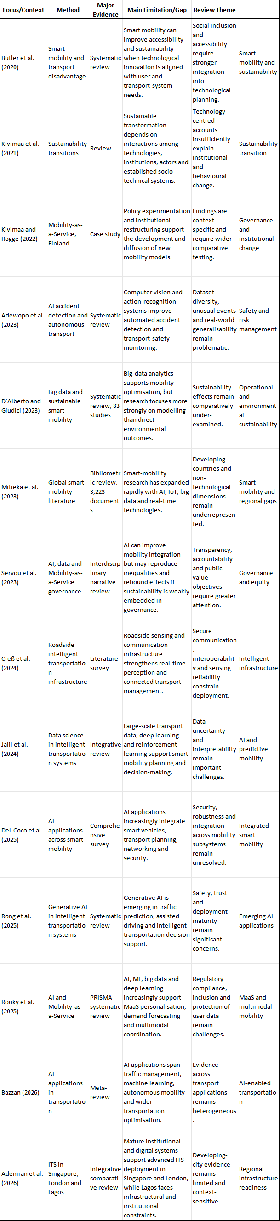

4.0 Narrative Synthesis of Findings
The synthesis of the 30 included studies revealed growing application of AI across traffic management, connected infrastructure, safety, electric mobility and transport-system sustainability. Across these domains, technological performance was generally favourable, but the strength and transferability of reported outcomes depended substantially on data availability, connectivity, infrastructure quality and institutional conditions.

4.1 AI-Enabled Traffic Management and Predictive Mobility
Traffic prediction and network optimisation emerged as the most developed applications. Machine learning, deep learning and increasingly advanced AI architectures supported congestion forecasting, adaptive signals, incident prediction and dynamic routing (Bazzan, 2026; Del-Coco et al., 2025; Jalil et al., 2024; Rong et al., 2025). The evidence consistently indicated a movement from reactive traffic management toward predictive and adaptive control.
However, performance varied with sensor density, data quality and local traffic characteristics. Models trained in data-rich or controlled environments were not always readily transferable to heterogeneous urban settings. The evidence therefore suggests that predictive capability depends jointly on algorithmic quality and the information infrastructure supporting it.

4.2 Intelligent Infrastructure and Connected Mobility
Intelligent infrastructure emerged as the principal physical-digital foundation of AI-enabled mobility. Roadside sensors, connected signals, V2I/V2X communication and edge-cloud platforms improved real-time perception and coordination between vehicles and networks (Creß et al., 2024; Del-Coco et al., 2025). Creß et al. (2024), after reviewing more than 300 publications and 53 test-bed projects, found considerable potential in roadside ITS but identified reliable perception, interoperability and secure real-time communication as continuing deployment requirements.
These findings explain why similar AI applications produce different outcomes across regions. Where connectivity and digital infrastructure are mature, intelligent systems can operate as coordinated networks; where infrastructure remains fragmented, AI applications tend to remain isolated or experimental.

4.3 Safety, Risk Management and Reliability
AI-supported computer vision, automated driving assistance and predictive risk systems generally improved hazard recognition and response. Evidence from accident-detection research demonstrates increasing capability to analyse surveillance, vehicle and roadside data for automated recognition of dangerous events (Adewopo et al., 2023; Del-Coco et al., 2025). Yet safety performance remains constrained by rare events, adverse weather, occluded objects, limited datasets and mixed human-machine traffic environments.
The synthesis therefore supports AI as an important safety-support technology, but does not support treating automation as independent of infrastructure standards, regulatory safeguards and operational risk management.

4.4 AI, Electric Mobility and Energy Integration
The reviewed evidence increasingly connected smart mobility with electrification, charging optimisation and intelligent energy management. AI-supported forecasting can coordinate charging demand, battery use and grid interaction, while integrated mobility platforms can improve transport-energy scheduling. These developments extend intelligent transportation beyond traffic management toward interaction among mobility, electricity and digital networks.
However, environmental benefits remained conditional on charging availability, grid resilience and electricity generation sources. This reinforces findings that technological efficiency should not be equated automatically with environmental sustainability (D'Alberto & Giudici, 2023; Mitieka et al., 2023).

4.5 Operational Sustainability and System Performance
AI applications were generally associated with improved traffic flow, travel-time reliability, infrastructure monitoring, maintenance planning and resource utilisation (Bazzan, 2026; Del-Coco et al., 2025; Rouky et al., 2025). Nevertheless, the evidence distinguished operational efficiency from broader sustainability. Gains in routing or congestion management may be offset where technological improvements stimulate additional travel or where accessibility, energy and social considerations remain weak (Servou et al., 2023).
Sustainable outcomes therefore appear strongest where AI is combined with public-transport integration, clean energy, accessible mobility and coherent governance rather than deployed primarily to maximise vehicle movement.

4.6 Cross-Cutting Synthesis
Across the reviewed evidence, a consistent sequence emerged: AI provides analytical capability; intelligent infrastructure supplies data and connectivity; smart-mobility applications translate these capabilities into operational improvements; and institutional and energy conditions determine their sustainability.
The synthesis also reveals three limitations in the evidence base. Research remains disproportionately concentrated in technologically advanced environments; many studies evaluate short-term technical performance rather than long-term system effects; and social, governance and energy dimensions receive less attention than algorithmic performance (Adeniran et al., 2025; D'Alberto & Giudici, 2023; Mitieka et al., 2023; Servou et al., 2023).
The overall evidence therefore supports a qualified conclusion: AI can substantially improve intelligent transportation, but sustainable mobility outcomes depend on the wider system in which AI is deployed.

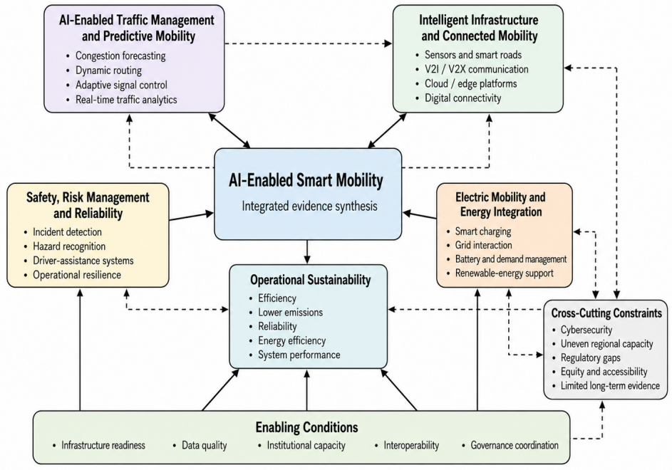
Figure 3. Integrated Thematic Synthesis of AI-Enabled Smart Mobility
Source: Authors’ synthesis of reviewed literature.
The figure integrates the major themes emerging from the systematic review. AI-enabled traffic management, intelligent infrastructure, safety systems, electric mobility, and operational sustainability interact within a common smart-mobility system. Their effectiveness depends on infrastructure readiness, data quality, interoperability, institutional capacity, and governance coordination, while cybersecurity, regional disparities, regulatory gaps, equity concerns, and limited long-term evidence constrain sustainable deployment.

5.0 Discussion
The findings confirm that artificial intelligence is becoming an important operational component of contemporary mobility systems. Across the reviewed evidence, AI strengthened prediction, routing, traffic coordination, safety monitoring and transport decision-making (Bazzan, 2026; Del-Coco et al., 2025; Jalil et al., 2024; Rong et al., 2025). Recent reviews similarly show that smart mobility increasingly combines machine learning, IoT, connected vehicles and intelligent planning rather than treating individual technologies separately (Del-Coco et al., 2025; Rouky et al., 2025).
The principal finding, however, is that these benefits remain infrastructure-dependent. AI requires reliable sensing, connectivity, interoperable platforms and computing capability to function at network scale. Creß et al. (2024) similarly conclude that roadside intelligent transportation systems can provide accurate real-time traffic information but require improved sensing, secure communication and interoperable infrastructure for wider deployment. This explains why AI capability alone cannot compensate for weak transport and digital infrastructure.
This pattern is consistent with Technological Innovation Systems Theory. Intelligent mobility develops through interaction among technological capabilities, infrastructure, institutions, markets and regulatory actors. Its diffusion therefore depends on standards, skills, investment, institutional legitimacy and complementary assets. Regional differences in AI adoption are consequently better understood as differences in innovation-system readiness than simply differences in access to algorithms.
The findings also support Sustainability Transition Theory by demonstrating that mobility sustainability requires simultaneous changes in technology, infrastructure, policy, energy and user practices. Kivimaa and Rogge (2022) similarly show that mobility innovation depends on institutional restructuring and policy experimentation. AI-enabled mobility should therefore be understood within a wider socio-technical transition rather than primarily as digital optimisation.
A further contribution of the review is the distinction between operational efficiency and sustainability. AI can improve traffic flow, travel time, energy management and infrastructure utilisation, but environmental gains are less certain where electricity remains carbon intensive, travel demand rises or cleaner modes remain inaccessible (D'Alberto & Giudici, 2023; Mitieka et al., 2023). Digital efficiency should therefore be treated as one contributor to sustainable mobility rather than an adequate sustainability outcome by itself.
Safety findings require similar qualification. AI-supported computer vision and connected sensing improve accident recognition and hazard detection, yet model performance remains sensitive to unusual events, dataset limitations, adverse environments and computational constraints (Adewopo et al., 2023; Del-Coco et al., 2025). These limitations strengthen the case for combining technological innovation with regulatory standards and resilient infrastructure.
Governance represents the final critical condition. As algorithms increasingly influence routing, service provision and mobility choices, issues of privacy, cybersecurity, transparency, accessibility and accountability become central. Servou et al. (2023) demonstrate that AI-enabled mobility can produce rebound or distributional effects where sustainability and public-interest objectives are weakly embedded in governance arrangements.
Taken together, the review positions the AI–smart mobility nexus as an integrated socio-technical system. AI supplies predictive intelligence; infrastructure provides connectivity; mobility applications translate intelligence into operational functions; while energy, institutional capacity and governance determine whether those functions produce sustainable outcomes. This system-level interpretation constitutes the principal analytical contribution of the study.

6.0 Policy and Practical Implications
The findings indicate that effective AI-enabled mobility policy should prioritise system readiness rather than isolated technology acquisition. Governments and transport authorities should therefore align investment in AI applications with digital connectivity, sensor networks, interoperable traffic platforms, vehicle-to-infrastructure communication and reliable power systems. Without these supporting assets, advanced transport algorithms are unlikely to produce sustained network-level benefits.
Policy frameworks should also establish clear standards for data interoperability, cybersecurity, privacy, algorithmic accountability and platform governance. As AI increasingly influences routing, service allocation and mobility demand, transparent governance becomes essential for protecting public value and avoiding technological bias or unequal access. Servou et al. (2023) similarly emphasise that sustainable AI-supported mobility requires clear sustainability objectives, transparency and coordination among policymakers, service providers and technology developers.
Transport and energy policies should further be coordinated as electric mobility expands. Smart charging, renewable-energy integration, storage and grid-responsive charging systems should form part of transport infrastructure planning rather than being treated as separate energy investments. AI can optimise charging demand and energy allocation, but environmental gains will remain limited where electricity supply is unreliable or predominantly carbon intensive.
Implementation should proceed progressively. Cities with limited digital infrastructure may initially prioritise high-impact applications such as adaptive traffic signals, congestion forecasting, incident detection and public-transport management before advancing toward highly automated mobility systems. This phased approach can reduce implementation costs, build institutional capability and generate locally relevant evidence before wider deployment.
Finally, policymakers should incorporate accessibility, affordability and environmental performance into the evaluation of intelligent mobility projects. Travel-time reduction or algorithmic accuracy alone provides an incomplete measure of success. Performance frameworks should also assess safety, emissions, service accessibility, energy efficiency, resilience and distributional effects. The practical implication is clear: AI-supported mobility is most effective when technology, infrastructure, energy policy and governance are developed as coordinated components of the transport system.

7.0 Research Gaps and Future Research Directions
The reviewed literature reveals several areas requiring further investigation. First, much of the existing evidence emphasises short-term technological performance, particularly traffic prediction, routing, automation and network optimisation, while fewer studies examine the long-term effects of AI-enabled mobility on system resilience, emissions, infrastructure efficiency and broader sustainability outcomes. Longitudinal and system-level studies are therefore needed to determine whether operational gains persist over time.
Second, the geographical distribution of research remains uneven. Evidence is concentrated largely in technologically advanced economies, while developing regions, particularly Africa and parts of Latin America and South Asia, remain comparatively underrepresented. Future studies should examine how infrastructure deficits, unreliable energy systems, institutional capacity, affordability and local mobility patterns shape AI adoption and performance across different contexts.
Third, renewable-energy integration remains less developed empirically than traffic and automation applications. Further research should evaluate AI-supported smart charging, vehicle-to-grid systems, renewable-powered charging infrastructure, energy storage and grid resilience under real operating conditions. Greater attention should also be given to the lifecycle environmental effects of electric and intelligent mobility systems rather than operational emissions alone.
Fourth, governance and social dimensions require stronger empirical treatment. Issues involving algorithmic accountability, data ownership, cybersecurity, privacy, accessibility, public trust and distributional equity remain less developed than technical research. Future studies should therefore examine how regulatory design and institutional arrangements influence the social acceptance and sustainability of AI-enabled transport systems.
Finally, methodological development is required. Future research should increasingly employ longitudinal datasets, digital twins, real-time learning systems, cross-city comparisons and integrated transport-energy models capable of capturing interactions among technology, infrastructure, users and institutions. Such approaches would strengthen understanding of the conditions under which AI contributes to genuinely sustainable mobility rather than isolated improvements in operational efficiency.
Taken together, future research should move beyond technology-centred evaluation toward integrated assessment of AI capability, infrastructure readiness, energy systems, governance and social outcomes. This would provide a stronger empirical basis for designing intelligent mobility systems that are efficient, resilient, inclusive and environmentally sustainable.

8.0 Conclusion
This systematic review examined the relationship between artificial intelligence and smart mobility, with particular attention to intelligent transportation infrastructure and operational sustainability. The evidence shows that AI has become increasingly important in traffic prediction, route optimisation, safety management, connected mobility, infrastructure monitoring and energy coordination. Across these applications, AI generally improves transport responsiveness, efficiency and decision quality when supported by reliable data, digital connectivity and appropriate infrastructure.
The review also establishes that the sustainability contribution of AI is conditional. Intelligent algorithms alone cannot deliver sustainable mobility where transport infrastructure, energy systems, institutional capacity or governance arrangements remain weak. Operational gains such as reduced congestion, improved routing and predictive maintenance may enhance efficiency, but wider environmental and social benefits depend on clean-energy integration, accessible mobility services, effective regulation and responsible data governance.
The theoretical synthesis further indicates that AI-enabled mobility is best understood as part of a broader socio-technical transition. Technological Innovation Systems Theory explains the importance of institutions, markets, infrastructure and innovation networks in supporting diffusion, while Sustainability Transition Theory clarifies how technological change interacts with policy, user practices, energy systems and institutional restructuring.
The review therefore concludes that the future of intelligent transportation lies in coordinated system development rather than isolated technological adoption. AI can contribute meaningfully to safer, more efficient and more sustainable mobility when technological capability is matched by intelligent infrastructure, renewable-energy integration, institutional readiness and accountable governance. Future progress will depend on stronger system-level evidence, broader geographical representation and greater attention to long-term environmental, social and governance outcomes.

Declaration of AI Use

This manuscript was prepared through the intellectual contributions of the author(s) to the study design, data analysis, interpretation of results, and scholarly content. Grammarly and ChatGPT were used solely to assist with grammatical refinement and reference formatting during manuscript revision. The author(s) accept full responsibility for the accuracy, integrity, and final content of the manuscript.

References
Adeniran, A. O., Adeniran, A. A., Ogieva, M. O., & Ogwuche, G. (2026). Adoption of intelligent transport systems (ITS) in urban transportation planning. Discover Global Society, 4, Article 13. https://doi.org/10.1007/s44282-025-00312-3
Adewopo, V. A., Elsayed, N., ElSayed, Z., Ozer, M., Abdelgawad, A., & Bayoumi, M. (2023). A review on action recognition for accident detection in smart city transportation systems. Journal of Electrical Systems and Information Technology, 10, Article 57. https://doi.org/10.1186/s43067-023-00124-y
Anthony, B., Jr. (2024). Artificial intelligence of things and distributed technologies as enablers for intelligent mobility services in smart cities: A survey. Internet of Things, 28, Article 101399. https://doi.org/10.1016/j.iot.2024.101399
Anthony, B., Jr. (2025). Sustainable mobility governance in smart cities for urban policy development: A scoping review and conceptual model. Smart and Sustainable Built Environment, 14(3), 649–671. https://doi.org/10.1108/SASBE-05-2023-0109
Bazzan, A. L. C. (2026). Artificial intelligence in transportation: A meta review. SN Computer Science, 7, Article 172. https://doi.org/10.1007/s42979-025-04530-z
Butler, L., Yigitcanlar, T., & Paz, A. (2020). How can smart mobility innovations alleviate transportation disadvantage? Assembling a conceptual framework through a systematic review. Applied Sciences, 10(18), Article 6306. https://doi.org/10.3390/app10186306
Creß, C., Bing, Z., & Knoll, A. C. (2024). Intelligent transportation systems using roadside infrastructure: A literature survey. IEEE Transactions on Intelligent Transportation Systems, 25(7), 6309–6327. https://doi.org/10.1109/TITS.2023.3343434
D’Alberto, R., & Giudici, H. (2023). A sustainable smart mobility? Opportunities and challenges from a big data use perspective. Sustainable Futures, 6, Article 100118. https://doi.org/10.1016/j.sftr.2023.100118
Del-Coco, M., Carcagnì, P., Trilles Oliver, S., Iskandaryan, D., & Leo, M. (2025). The role of AI in smart mobility: A comprehensive survey. Electronics, 14(9), Article 1801. https://doi.org/10.3390/electronics14091801
Du, K., Guo, X., Li, L., Song, J., Shi, Q., Hu, M., & Fang, J. (2025). Traffic prediction in time series, spatiotemporal, and OD data: A systematic survey. Journal of Traffic and Transportation Engineering (English Edition), 12(3), 666–700. https://doi.org/10.1016/j.jtte.2025.03.001
Gheorghe, C., & Soica, A. (2025). Revolutionizing urban mobility: A systematic review of AI, IoT, and predictive analytics in adaptive traffic control systems for road networks. Electronics, 14(4), Article 719. https://doi.org/10.3390/electronics14040719
Goumiri, S., Yahiaoui, S., & Djahel, S. (2025). Smart mobility in smart cities: Emerging challenges, recent advances and future directions. Journal of Intelligent Transportation Systems: Technology, Planning, and Operations, 29(1), 81–117. https://doi.org/10.1080/15472450.2023.2245750
Jalil, K., Xia, Y., Chen, Q., Zahid, M. N., Manzoor, T., & Zhao, J. (2024). Integrative review of data sciences for driving smart mobility in intelligent transportation systems. Computers & Electrical Engineering, 119, Article 109624. https://doi.org/10.1016/j.compeleceng.2024.109624
Joshi, S., Baviskar, A., & Rajmane, S. (2026). A review of cybersecurity in smart cities and intelligent transport systems. Discover Internet of Things, 6, Article 41. https://doi.org/10.1007/s43926-026-00312-y
Kivimaa, P., Laakso, S., Lonkila, A., & Kaljonen, M. (2021). Moving beyond disruptive innovation: A review of disruption in sustainability transitions. Environmental Innovation and Societal Transitions, 38, 110–126. https://doi.org/10.1016/j.eist.2020.12.001
Kivimaa, P., & Rogge, K. S. (2022). Interplay of policy experimentation and institutional change in sustainability transitions: The case of mobility as a service in Finland. Research Policy, 51(1), Article 104412. https://doi.org/10.1016/j.respol.2021.104412
Mitieka, D., Luke, R., Twinomurinzi, H., & Mageto, J. (2023). Smart mobility in urban areas: A bibliometric review and research agenda. Sustainability, 15(8), Article 6754. https://doi.org/10.3390/su15086754
Mitieka, D., Luke, R., Twinomurinzi, H., & Mageto, J. (2026). From concepts to connectivity: A systematic review of smart mobility antecedents and impacts. Technological Forecasting and Social Change, 228, Article 124684. https://doi.org/10.1016/j.techfore.2026.124684
Nandy, T., Md Noor, R., Kolandaisamy, R., Idris, M. Y. I., & Bhattacharyya, S. (2024). A review of security attacks and intrusion detection in the vehicular networks. Journal of King Saud University - Computer and Information Sciences, 36(2), Article 101945. https://doi.org/10.1016/j.jksuci.2024.101945
Nikitas, A., Michalakopoulou, K., Njoya, E. T., & Karampatzakis, D. (2020). Artificial intelligence, transport and the smart city: Definitions and dimensions of a new mobility era. Sustainability, 12(7), Article 2789. https://doi.org/10.3390/su12072789
Page, M. J., McKenzie, J. E., Bossuyt, P. M., Boutron, I., Hoffmann, T. C., Mulrow, C. D., Shamseer, L., Tetzlaff, J. M., Akl, E. A., Brennan, S. E., Chou, R., Glanville, J., Grimshaw, J. M., Hróbjartsson, A., Lalu, M. M., Li, T., Loder, E. W., Mayo-Wilson, E., McDonald, S., McGuinness, L. A., Stewart, L. A., Thomas, J., Tricco, A. C., Welch, V. A., Whiting, P., & Moher, D. (2021). The PRISMA 2020 statement: An updated guideline for reporting systematic reviews. BMJ, 372, n71. https://doi.org/10.1136/bmj.n71
Rong, R., Ma, S., Ren, N., Lin, Q., & Jia, N. (2025). Generative artificial intelligence in intelligent transportation systems: A systematic review of applications. Frontiers of Engineering Management, 12(4), 1020–1036. https://doi.org/10.1007/s42524-025-4241-9
Rouky, N., Benmoussa, O., Fri, M., Abourraja, M. N., & Ben-Bouazza, F.-E. (2025). Artificial intelligence applications for smart and sustainable mobility as a service concept: A systematic literature review. Future Transportation, 5(3), Article 122. https://doi.org/10.3390/futuretransp5030122
Sadeghian, O., Oshnoei, A., Mohammadi-Ivatloo, B., Vahidinasab, V., & Anvari-Moghaddam, A. (2022). A comprehensive review on electric vehicles smart charging: Solutions, strategies, technologies, and challenges. Journal of Energy Storage, 54, Article 105241. https://doi.org/10.1016/j.est.2022.105241
Servou, E., Behrendt, F., & Horst, M. (2023). Data, AI and governance in MaaS: Leading to sustainable mobility? Transportation Research Interdisciplinary Perspectives, 19, Article 100806. https://doi.org/10.1016/j.trip.2023.100806
Son, H., Jang, J., Park, J., Balog, A., Ballantyne, P., Kwon, H. R., Singleton, A., & Hwang, J. (2025). Leveraging advanced technologies for (smart) transportation planning: A systematic review. Sustainability, 17(5), Article 2245. https://doi.org/10.3390/su17052245
Tightiz, L., Dang, L. M., Yoo, J., & Padmanaban, S. (2025). A comprehensive review on AIoT applications for intelligent EV charging/discharging ecosystem. Energy Conversion and Management: X, 27, Article 101088. https://doi.org/10.1016/j.ecmx.2025.101088
Yu, G., Ye, X., Xia, X., & Chen, Y. (2024). Digital twin enabled transition towards the smart electric vehicle charging infrastructure: A review. Sustainable Cities and Society, 108, Article 105479. https://doi.org/10.1016/j.scs.2024.105479
Zhang, Y., Zhang, S., & Dinavahi, V. (2025). A survey of machine learning applications in advanced transportation systems: Trends, techniques, and future directions. eTransportation, 24, Article 100417. https://doi.org/10.1016/j.etran.2025.100417
Zhao, Z., Lee, C. K. M., Yan, X., & Wang, H. (2024). Reinforcement learning for electric vehicle charging scheduling: A systematic review. Transportation Research Part E: Logistics and Transportation Review, 190, Article 103698. https://doi.org/10.1016/j.tre.2024.103698
Zulkarnain, & Putri, T. D. (2021). Intelligent transportation systems (ITS): A systematic review using a natural language processing (NLP) approach. Heliyon, 7(12), Article e08615. https://doi.org/10.1016/j.heliyon.2021.e08615

Supplementary Table S1. Characteristics of the 30 Studies Included in the Systematic Review

No. | Study | Scope/Design | Technology or Analytical Focus | Mobility/Sustainability Domain | Principal Contribution to the Review
1 | Adeniran et al. (2026) | Comparative urban review; Singapore, London and Lagos | Intelligent transportation systems | Infrastructure readiness and urban mobility | Demonstrates that ITS deployment varies substantially with digital infrastructure, institutional capability, financing and urban governance.
2 | Adewopo et al. (2023) | Review | Computer vision and AI-based action recognition | Accident detection and road safety | Shows growing capability for automated accident recognition while identifying limitations involving datasets, occlusion and unusual traffic events.
3 | Anthony (2024) | Survey/review | AIoT and distributed technologies | Intelligent mobility services and smart cities | Explains how AI, IoT and distributed technologies support data-driven mobility services while requiring organisational and technological readiness.
4 | Anthony (2025) | Scoping review and conceptual development | Smart-mobility governance | Accessibility, inclusion and sustainable mobility | Identifies governance, infrastructure management and policy coordination as critical conditions for sustainable smart mobility.
5 | Bazzan (2026) | Meta-review | AI and machine learning | Intelligent transportation applications | Synthesises AI applications across traffic management, autonomous mobility and transport optimisation and identifies continuing evidence heterogeneity.
6 | Butler et al. (2020) | Systematic review | Smart-mobility innovation | Accessibility and transport disadvantage | Shows that technology-based mobility improvements require explicit consideration of accessibility and disadvantaged transport users.
7 | Creß et al. (2024) | Literature survey | Roadside sensing, communication and ITS | Connected infrastructure | Establishes roadside infrastructure as an important foundation for real-time traffic perception while identifying interoperability, sensing and communication challenges.
8 | D’Alberto and Giudici (2023) | Systematic review | Big-data analytics | Smart mobility and environmental sustainability | Finds that smart-mobility research emphasises modelling and data applications more strongly than direct environmental outcomes.
9 | Del-Coco et al. (2025) | Comprehensive survey | AI, connected vehicles, sensing and planning | Integrated smart mobility | Demonstrates broad AI application across transport planning, vehicle intelligence and mobility security while identifying robustness and integration constraints.
10 | Du et al. (2025) | Systematic survey of approximately 350 studies | Deep learning and traffic prediction | Time-series, spatiotemporal and origin-destination forecasting | Shows strong progress in traffic-prediction accuracy while identifying data quality and model-transferability challenges.
11 | Gheorghe and Soica (2025) | Systematic review | AI, IoT and predictive analytics | Adaptive traffic-control systems | Reports that integrated AI-IoT systems improve traffic responsiveness, congestion control and safety, subject to data and infrastructure readiness.
12 | Goumiri et al. (2025) | Review | Smart-mobility technologies | Traffic, routing, parking, safety and emissions | Frames smart mobility as an interconnected urban system requiring coordination among technological and infrastructure components.
13 | Jalil et al. (2024) | Integrative review | Data science, deep learning and analytics | Intelligent transportation decision-making | Demonstrates how large-scale mobility data support prediction, planning and transport-system optimisation.
14 | Joshi et al. (2026) | Review | Cybersecurity | Smart cities and intelligent transportation systems | Identifies cyber threats to transport infrastructure, data privacy and public safety as central challenges for increasingly connected mobility systems.
15 | Kivimaa et al. (2021) | Review | Sustainability-transition processes | Socio-technical mobility transformation | Shows that sustainable transitions depend on interactions among technology, institutions, actors and established systems rather than technological disruption alone.
16 | Kivimaa and Rogge (2022) | Case study; Finland | Policy experimentation and institutional change | Mobility-as-a-Service | Demonstrates that new mobility models require regulatory experimentation and institutional restructuring alongside technological innovation.
17 | Mitieka et al. (2023) | Bibliometric review | Smart-mobility research | Global smart mobility | Shows rapid growth in smart-mobility research while identifying geographical imbalance and insufficient attention to developing-country contexts.
18 | Mitieka et al. (2026) | Systematic literature review | Smart-mobility antecedents and impacts | Technology adoption, sustainability and governance | Integrates technological, institutional and behavioural conditions shaping smart-mobility adoption and reported outcomes.
19 | Nandy et al. (2024) | Review | Vehicular network security and intrusion detection | Connected and autonomous transport | Identifies security threats and limitations of intrusion-detection systems, supporting the need for adaptive and resource-efficient security mechanisms.
20 | Nikitas et al. (2020) | Conceptual/review study | Artificial intelligence | Transport and smart-city mobility | Establishes AI as a potential contributor to sustainable urban transport while emphasising responsible deployment and broader urban-system considerations.
21 | Rong et al. (2025) | Systematic review | Generative AI | Traffic prediction, assisted driving and transport decision support | Identifies growing generative-AI applications while noting continuing concerns involving safety, trust and deployment maturity.
22 | Rouky et al. (2025) | Systematic literature review | AI, ML and big data | Mobility-as-a-Service | Shows that AI supports demand forecasting, personalisation and multimodal integration while raising regulatory, privacy and inclusion issues.
23 | Sadeghian et al. (2022) | Comprehensive review | Smart EV charging | Charging, grid services and energy management | Demonstrates that intelligent charging can reduce charging and grid operating costs while facilitating renewable-energy integration.
24 | Servou et al. (2023) | Interdisciplinary review | Data and AI governance | Mobility-as-a-Service and sustainability | Shows that algorithmic mobility systems may improve coordination but can also produce inequality and rebound effects without appropriate governance.
25 | Son et al. (2025) | Systematic review | AI, IoT, digital twins and optimisation | Smart transportation planning | Shows how advanced digital technologies address congestion, safety and environmental challenges in transportation planning.
26 | Tightiz et al. (2025) | Comprehensive review | AIoT, V2G and optimisation | Intelligent EV charging/discharging | Demonstrates the role of AIoT in charging scheduling, renewable-energy integration and grid stability while identifying interoperability and privacy challenges.
27 | Yu et al. (2024) | Review | Digital twins | Smart EV charging infrastructure | Shows that digital twins can improve charging-system adaptability, management, scalability and sustainability but require standardisation and architecture development.
28 | Zhang et al. (2025) | Comprehensive survey of 124 studies | Machine learning | Advanced transportation systems | Finds improvements in predictive maintenance, energy management, fault diagnosis and optimisation, with persistent data and real-time implementation constraints.
29 | Zhao et al. (2024) | Systematic review of 111 studies | Reinforcement learning | EV charging scheduling | Demonstrates increasing application of reinforcement learning to EV charging optimisation while identifying methodological and deployment challenges.
30 | Zulkarnain and Putri (2021) | Systematic review using NLP | NLP, topic modelling and knowledge mapping | Intelligent transportation systems | Maps the multidisciplinary ITS literature and demonstrates the usefulness of automated methods for identifying research themes and knowledge-development patterns.

