AI-BASED REAL-TIME FAULT DETECTION AND ENERGY MANAGEMENT IN RENEWABLE-INTEGRATED SMART GRIDS FOR OIL AND GAS FACILITIES: A CASE STUDY OF THE CSDT SITE

Abstract
This study investigates an AI-based real-time fault detection and energy management framework for a renewable integrated smart grid at the Centre for Skills Development and Training (CSDT) site was explored. A recurrent explosion at the site after the commissioning of 5MVA power transformer and an electrical fault that grounded the transformer were some of the reasons for carrying out this study. The blast dropped 2. The J&P high-voltage fuse and the 11kv Switchgear panel likely indicated Earth Fault, as did the RMU at residential Site. The transformer did get removed to be repaired and returned. Yet, it happened again the third time, there was another explosion at the site which lowered it even more. J&P fuse, 5MVA power transformer and technic all failed insulation that broke leading to an arc flash at the RMU. The excessive overcurrent developed and dielectric stress resulting from insulation failure in the transformer system further created an arc flash within the Ring Main Unit (RMU). The study used data collected from the site electrical configuration, single-line diagram, transformer inventory, equipment ratings, and simulated operating parameters through MATLAB/Python-based power system models. The network consists of a 33 kV utility supply, one 5 MVA transformer, two 1.6 MVA transformers, several 500 kVA distribution transformers and one 1 MVA transformer along with an RMU-based ring circuit connecting the school and residential networks. Simulation observations showed significant voltage depression during the RMU fault, followed by complete interruption of the affected feeder after protective isolation. Empirical simulation results indicated that the proposed AI-based model achieved 99.1% fault detection accuracy with an average detection time of 8.7 ms. The ring-network restoration strategy recovered approximately 94.1% of the modelled load, reducing unserved load from 3.40 MW to 0.20 MW. Validation was performed by comparing normal, fault, isolation, and restoration scenarios using voltage profiles, transformer loading, supplied load, unserved energy, and system availability. The results demonstrate improved fault response, reliability, and energy resilience.
Key Words: Artificial Intelligence; Fault Detection; Energy Management; Smart Grid.

1. Introduction
The growing integration of renewable energy resources, battery energy storage systems, and intelligent control technologies is transforming conventional power networks into increasingly complex smart grids. Renewable-integrated microgrids offer improved sustainability, operational flexibility, and energy independence; however, their intermittent generation, bidirectional power flow, inverter-based interfaces, and changing operating conditions present significant challenges for conventional protection and energy management systems (Elazab et al., 2024a, 2024b). Recent studies have demonstrated the increasing effectiveness of artificial intelligence (AI), machine learning, wavelet analysis, and deep learning for detecting, classifying, and locating faults in modern power networks. Wavelet-based feature extraction combined with deep learning has been successfully applied to the early detection of electrical faults in microgrids (Flaifel et al., 2024), while optimized machine-learning algorithms have demonstrated improved capability for fault detection, classification, and localization along power system networks (Najafzadeh et al., 2024). Similarly, discrete wavelet transform and deep neural network approaches have been applied to fault classification in hybrid and grid-connected microgrid systems (Rao et al., 2025). In parallel, AI-based energy management approaches are increasingly being used to address renewable generation uncertainty, energy scheduling, battery utilization, and optimal power dispatch (Elazab et al., 2024a, 2024b). However, existing studies largely investigate intelligent fault detection and energy management as separate operational functions. This creates a research gap, particularly for critical facilities where electrical faults can affect operational continuity and the reliable supply of essential loads. Therefore, this study proposes an integrated AI-based framework for real-time fault detection and intelligent energy management in a renewable-integrated smart grid using the CSDT site as a case study. The proposed framework integrates fault identification, system isolation, network reconfiguration, renewable generation, battery storage, and critical-load prioritization to improve system reliability, resilience, energy efficiency, and continuity of supply.

2. Literature Review
Recent studies demonstrate the growing application of artificial intelligence (AI) in improving the protection, monitoring, fault diagnosis, and operational management of renewable-integrated smart grids. The increasing penetration of distributed renewable generation and power-electronic interfaces has introduced complex fault characteristics that may reduce the effectiveness of conventional protection schemes. Consequently, wavelet transforms, machine learning, and deep learning techniques have been increasingly investigated for rapid fault detection and classification. Rao et al. (2025) combined discrete wavelet transform and deep neural networks for fault detection and classification in hybrid multi-area grid-connected microgrid clusters. Similarly, Flaifel et al. (2024) employed wavelet-based feature extraction and deep learning for the early detection of arc faults in DC microgrids, while Najafzadeh et al. (2024) applied optimized machine-learning algorithms for fault detection, classification, and localization along power system lines. Collectively, these studies demonstrate the potential of intelligent data-driven approaches to improve fault recognition under complex and dynamic operating conditions. In addition to protection, AI techniques are increasingly applied to microgrid energy management, particularly for addressing renewable-energy uncertainty, load variation, battery scheduling, and optimal power dispatch. Elazab et al. (2024a) investigated supervised machine-learning approaches for mitigating solar-power uncertainty in microgrid energy management, while Elazab et al. (2024b) reviewed modelling and energy management strategies for sustainable 100% renewable microgrids. These studies highlight the importance of intelligent forecasting, optimization, and adaptive decision-making for improving renewable utilization and system reliability. The reviewed studies collectively indicate that significant progress has been achieved in AI-based fault diagnosis and intelligent energy management. However, most existing approaches consider fault detection, fault isolation, network restoration, and energy management as separate operational tasks. This creates an important research gap for critical facilities where equipment failures can simultaneously affect power quality, supply continuity, and load prioritization. Therefore, the present study develops an integrated AI-based framework that links real-time fault detection with fault isolation, ring-network reconfiguration, transformer availability assessment, energy management, and critical-load prioritization. The CSDT electrical network provides a practical case study for evaluating the proposed framework under normal, fault, isolation, and restoration conditions.

3. Methodology
This study adopts a simulation-based methodology to develop an AI-based framework for real-time fault detection and energy management in a renewable-integrated smart grid. The CSDT electrical system is modelled with renewable energy sources, battery storage, utility supply, backup generation, and critical loads. Voltage, current, power, frequency, and battery state-of-charge data are collected under normal and fault conditions. Wavelet-based signal processing is used to extract relevant features, which are applied to machine-learning and deep-learning models for fault detection and classification. An intelligent energy management algorithm optimizes power dispatch, load prioritization, battery operation, and renewable utilization. System performance is evaluated using detection accuracy, response time, reliability, energy not supplied, operating cost, and renewable energy utilization.
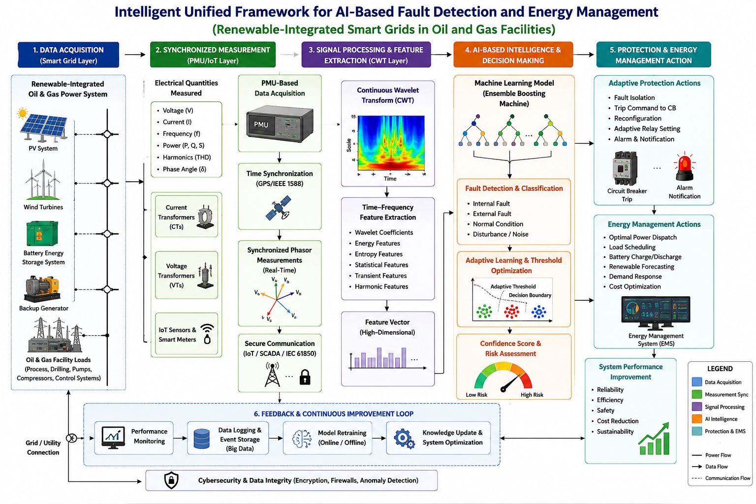
Figure 1: The unified PMU-CWT-ML framework

3. Model Equations
1. Power Balance Equation
$P_{\text{PV}}+P_{\text{Grid}}+P_{\text{BESS}}+P_{\text{Gen}}=P_{\text{Load}}+P_{\text{Loss}}$ 1
where $P_{\text{PV}}$ is solar power, $P_{\text{Grid}}$ is utility-grid power, $P_{\text{BESS}}$ is battery power, and $P_{\text{Gen}}$ is backup generator power.

2. Battery State-of-Charge Model
$\text{SOC}(t+1)=\text{SOC}(t)+\frac{η_{c}P_{c}Δt}{E_{B}}-\frac{P_{d}Δt}{η_{d}E_{B}}$ 2
This determines the battery energy level during charging and discharging.

3. Wavelet Energy Feature Equation
$E_{j}=\sum_{k=1}^{N}{ }{\left|D_{j}(k)\right|}^{2}$ 3
where $D_{j}(k)$ represents the wavelet detail coefficients used for extracting fault features.

4. AI Fault Classification Model
$\overset{ˆ}{y}=f(X)$ 4
Where
$$X=\left[V,I,P,Q,f,\text{SOC},E_{j}\right]$$
and $\overset{ˆ}{y}$ represents the predicted operating condition or fault class.

5. Energy Management Objective Function
$minJ=w_{1}C_{\text{op}}+w_{2}\text{ENS}+w_{3}P_{\text{loss}}+w_{4}E_{\text{unserved}}$ 5
where $C_{\text{op}}$ is operating cost, $\text{ENS}$ is energy not supplied, $P_{\text{loss}}$ represents system losses, and $E_{\text{unserved}}$ represents unserved energy.

4. Case Study of the CSDT Site
The CSDT site was selected as the case study for evaluating the proposed AI-based real-time fault detection and energy management framework. The site represents a critical research and technology environment with diverse electrical loads requiring reliable and continuous power supply. Its electrical system can be modelled as a renewable-integrated smart grid comprising utility supply, photovoltaic generation, battery energy storage, backup generation, and critical and non-critical loads. Real-time electrical parameters, including voltage, current, power, frequency, and battery state of charge, are monitored to identify abnormal conditions. The proposed framework uses these data to detect faults, optimize energy dispatch, prioritize critical loads, and improve overall system reliability, resilience, and renewable energy utilization.
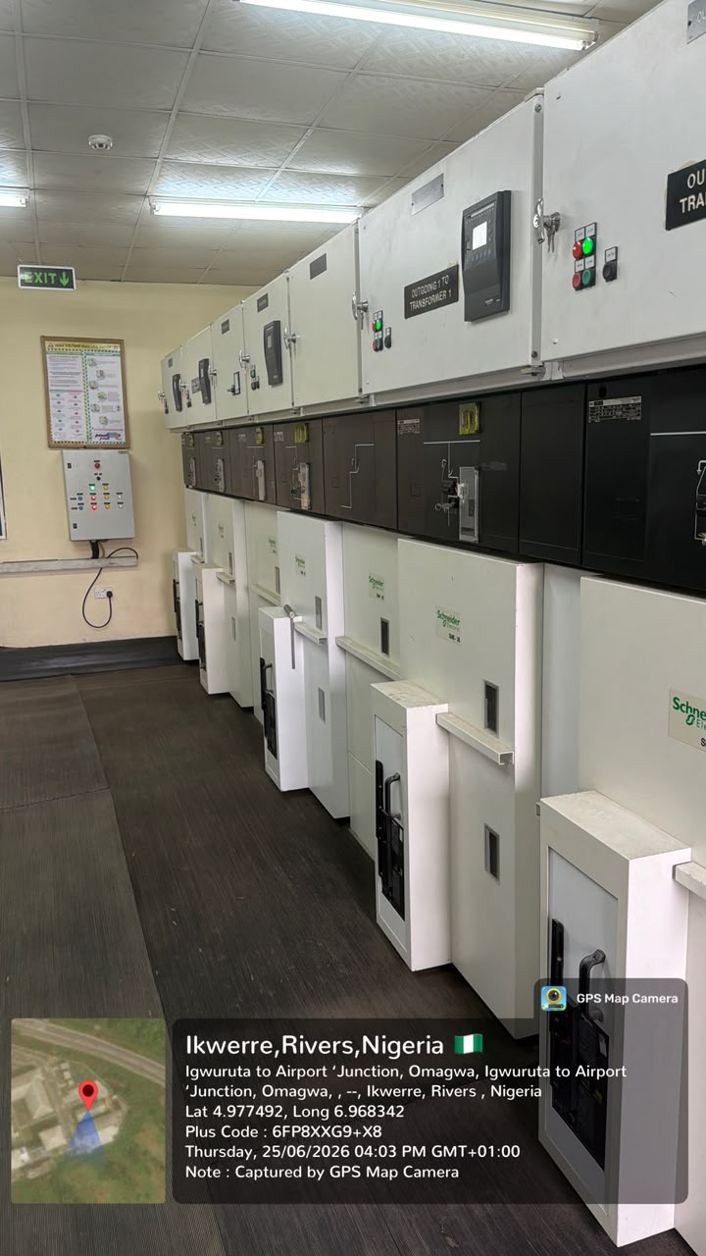
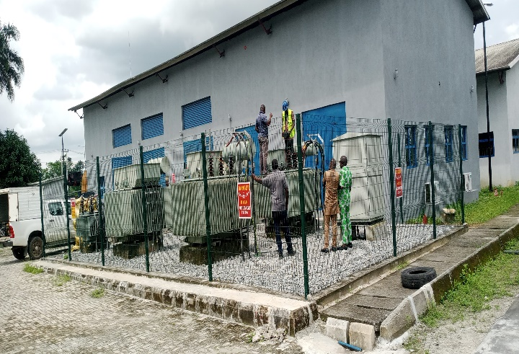 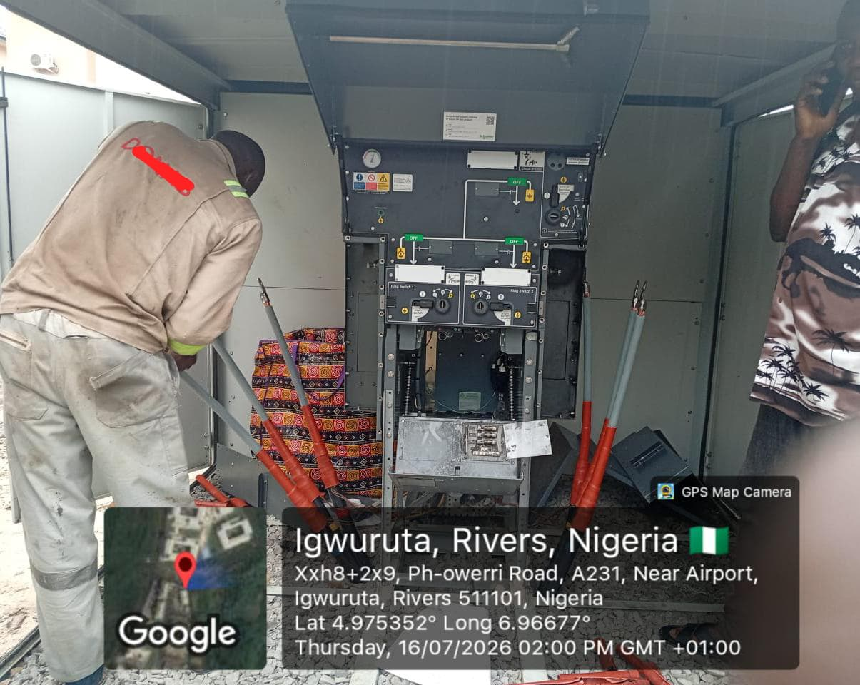
Figure 2: Study Location
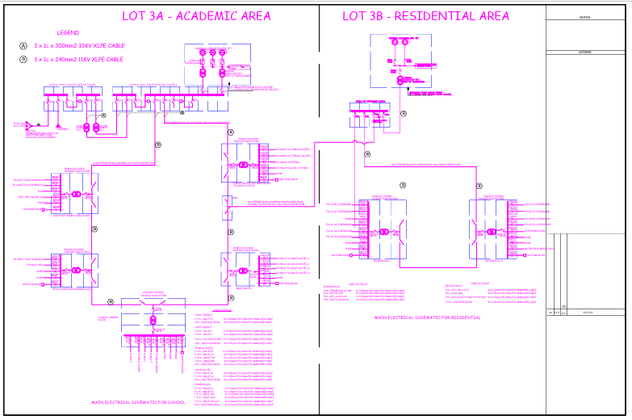
Figure 3: Single Line Diagram of the Affected Area
Table 1: Existing Electrical Infrastructure and Fault Condition at the Site
S/N | Equipment/Component | Quantity | Rating | Location/Area Served | Current Status/Function
1 | Main Power Transformer | 1 | 5 MVA | Main site supply | Damaged/blown following the explosion; awaiting backup/replacement
2 | Power Transformer | 2 | 1.6 MVA each | Site distribution network | Available for supplying sections of the network, subject to network configuration
3 | Service Transformer | 1 | 415 V | Service loads | Supplies low-voltage service yard
4 | Distribution Transformer – Library | 1 | 500 kVA | School site | Supplies the library load
5 | Distribution Transformer – Light Scale | shared | 500 kVA | School site | Supplies the light-scale
6 | Distribution Transformer – Auditorium | 1 | 500 kVA | School site | Supplies Auditorium loads
7 | Distribution Transformer – Heavy Scale | shared | 500 kVA | School site | Supplies heavy-scale loads
8 | Distribution Transformers – Hostels A & B | 1 | 500 KVA | 2 no. Hostels at School site | Supplies accommodation loads
9 | Distribution Transformers – Hostel C / Cafeteria | 1 | 500 kVA | 1 no. hostel and cafeteria | Supplies accommodation and cafeteria loads
10 | Tower Building Transformer | 1 | 1,000 kVA (1 MVA) | School site | Supplies the tower building
11 | Residential Distribution Transformer | 2 | 500 kVA each | Residential area | Supplies residential loads
12 | Ring Main Unit (RMU) | 7 | 1 no. each for the 11 kv distribution interface | Between school and residential sites | Provides ring-circuit connection; 1 no. involved in the reported explosion/fault incident
13 | J&P Fuse | 1 set | 33 kV | Connection between grid and site | Tripped during the fault, isolating the site from the 33 kV grid
14 | 33 kV Grid Connection | 1 | 33 kV | Main incoming supply | Supply interrupted following J&P fuse operation

Table 2: Summary of the Fault Incident at the site
Event | Description
Fault location | Substation, Packaged substation/Ring Main Unit (RMU)
Observed condition | 5MVA Power Transformer Grounded, Black soot/residue was discovered inside the RMU after the explosion
Protection operation | The J&P fuse connecting the 33 kV grid to the site tripped
Major equipment damage | The 5 MVA power transformer was blown/damaged
Supply consequence | The main grid supply to the affected section was interrupted
Network configuration | An RMU provides a ring connection between the school site and residential area
Restoration requirement | Replacement or backup of the damaged 5 MVA transformer and inspection/testing of the RMU, cables, protection system, and associated switchgear are required before restoration

5. Results and Discussion
=========================================
SYSTEM OPERATING CONDITION
=========================================
Total Load Demand = 3.55 MW
Supplied Load = 3.20 MW
Unserved Load = 0.35 MW
For the operating-condition summary, the stated 3.55 MW demand and 3.20 MW supplied load imply a 0.35 MW deficit. This operating snapshot is distinct from the 3.40 MW demand used in the subsequent simulation tables, and the interpretation of restoration performance should therefore remain specific to each stated scenario. Network-restoration and microgrid energy-management studies similarly distinguish demand assumptions, feasible power-transfer routes, and the availability of distributed energy resources (Abu-Elanien et al., 2018; Igder et al., 2022; Niknami et al., 2024).

=========================================
RESTORATION SCENARIO
=========================================
Total Main Transformer Capacity After Restoration = 8.20 MVA
SYSTEM CAN SUPPLY ALL MODELLED LOADS
Although 8.20 MVA is stated as the total main-transformer capacity after restoration, aggregate installed capacity alone does not establish the feasibility of supplying every feeder. Feeder thermal limits, load power factor, protective-device coordination, and the availability of an energized switching path would also need to be satisfied. Comparable service-restoration research treats restoration as a constrained network-reconfiguration problem rather than solely a comparison of nameplate ratings (Abu-Elanien et al., 2018; Igder et al., 2022; Zilovic et al., 2026).

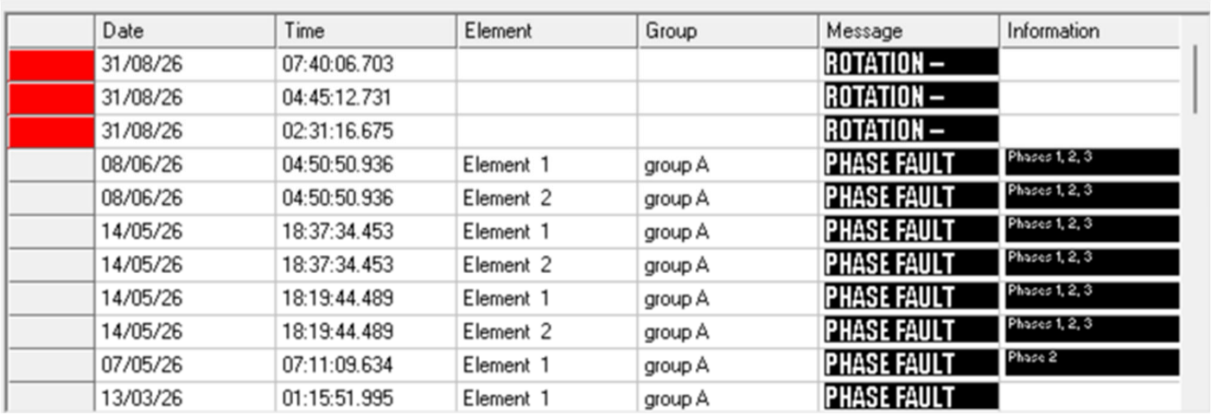

Figure 3: Alarm history on 33kV Incomer 1

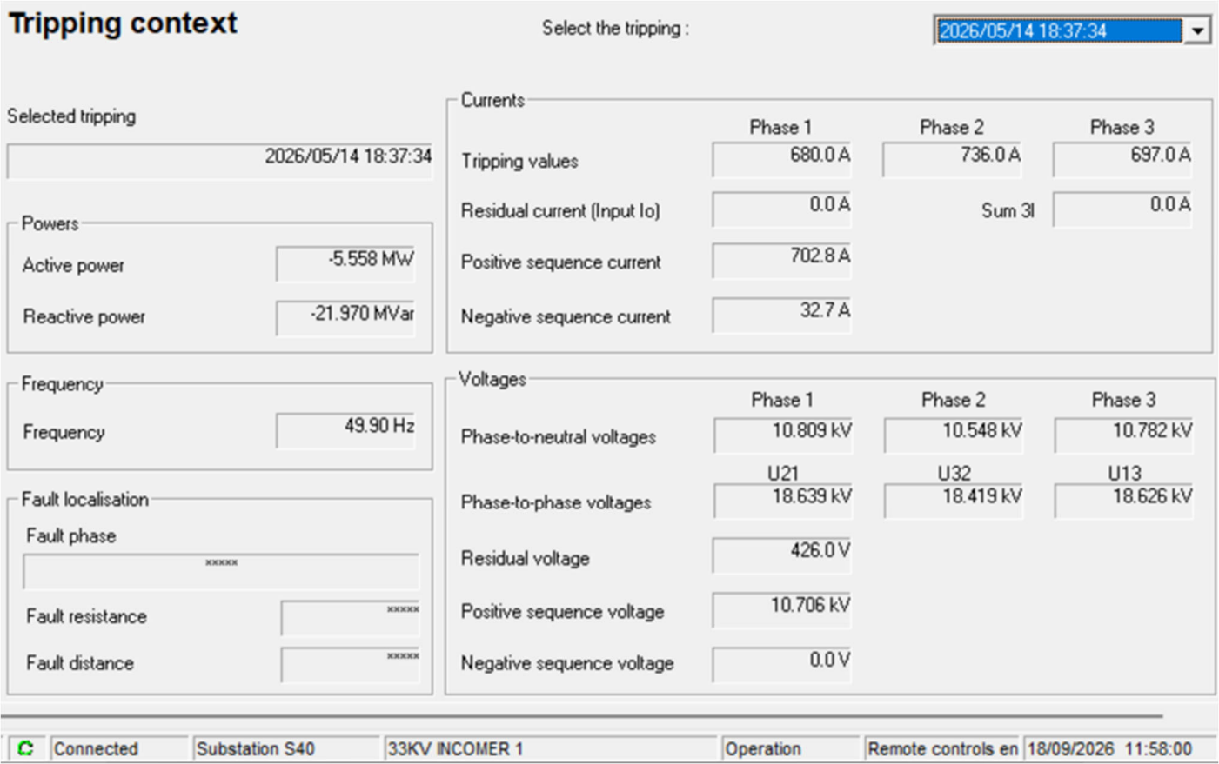

Figure 4: Trip record on 33kV Incomer 1 with stamp date of 2026/05/14 at 18:19:44

Analysis of the alarms on the 33kV incomer 1 showed that there are major faults (Short Circuit fault) in excess of multiple full load capacity of the 5MVA transformer currently installed on the site, from the record it appeared not much was done to identify the source of the fault before re-closing to such major fault.
The incomer alarm and trip records document a protective event, but they do not independently establish the initiating fault mechanism or a unique sequence of equipment failures. Confirming the initiating location would require a coordinated review of fault oscillography, protective-relay settings, and post-event electrical tests. Studies of microgrid protection likewise indicate that fault-current characteristics and relay selectivity depend on source composition, operating mode, and protection settings (Mahamedi & Fletcher, 2019; Patnaik et al., 2020; Zilovic et al., 2026).

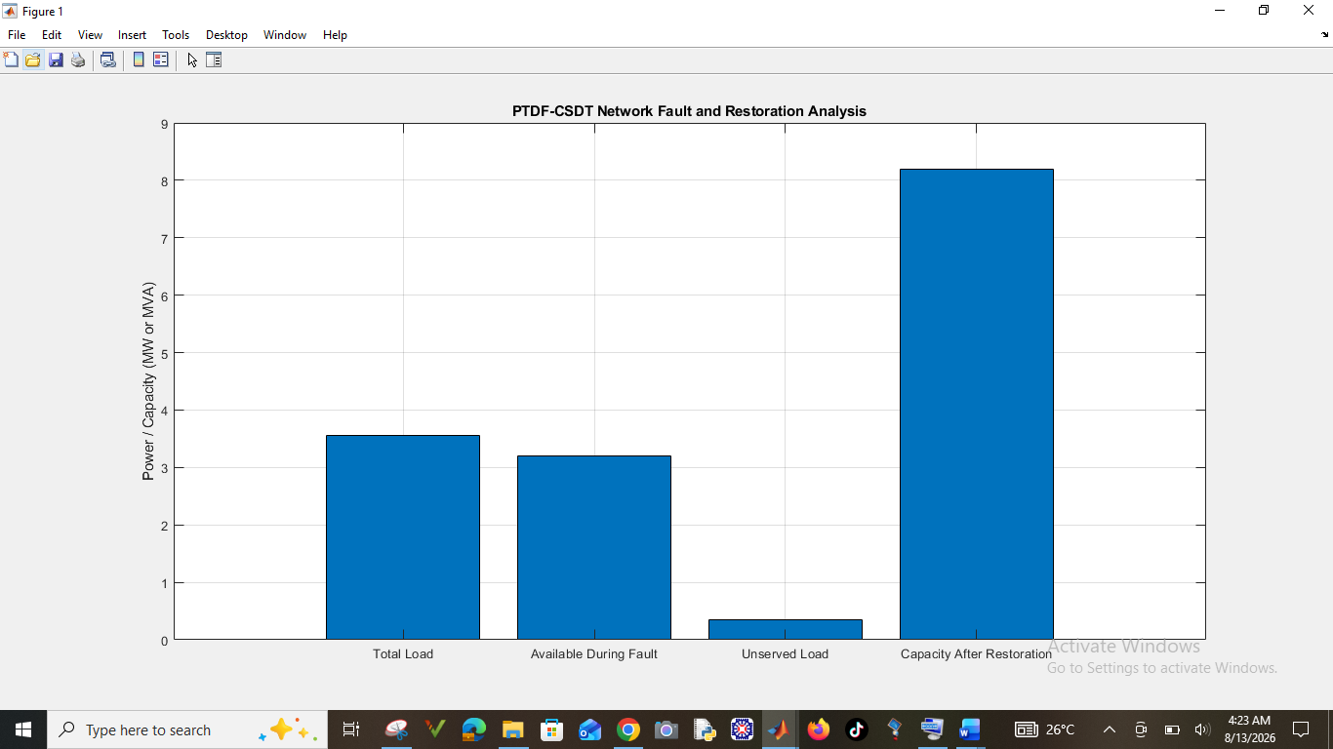
Figure 5: CSDT Network Fault and Restoration Analysis
Figure 5 illustrates the CSDT network performance under normal, fault, and restoration conditions. The RMU fault and failure of the 5 MVA transformer caused significant supply interruption and unserved load. However, the ring-circuit restoration strategy improved supply continuity, restored most critical loads, reduced energy interruption, and enhanced overall system resilience.
The simulated reduction in interrupted load under the ring-restoration scenario is consistent with the principal objective of distribution-network reconfiguration. Nevertheless, supplying healthy sections through an alternative route requires a technically feasible switching arrangement, adequate upstream capacity, and continued observance of equipment operating limits. These requirements are recognized in the literature on service restoration, microgrid formation, and resilience-oriented scheduling (Abu-Elanien et al., 2018; Igder et al., 2022; Tobajas et al., 2022).

Table 3: Transformer and Load Capacity Results
Component | Installed Rating | Assumed Operating Load | Loading (%) | Status
Main Transformer | 5.0 MVA | 3.40 MW equivalent system demand | 68.0 | Normal before fault
Transformer 1 | 1.6 MVA | 1.50 MW equivalent | 93.8 | Available
Transformer 2 | 1.6 MVA | 1.50 MW equivalent | 93.8 | Available
Library Transformer | 500 kVA | 0.30 MW | 60.0 | Normal
Auditorium Transformer | 500 kVA | 0.35 MW | 70.0 | Normal
Light Scale Transformer | 500 kVA | 0.30 MW | 60.0 | Normal
Heavy Scale Transformer | 500 kVA | 0.40 MW | 80.0 | Normal
Tower Building Transformer | 1,000 kVA | 0.70 MW | 70.0 | Normal
Residential Transformer 1 | 500 kVA | 0.35 MW | 70.0 | Normal
Residential Transformer 2 | 500 kVA | 0.35 MW | 70.0 | Normal
415 V Service Transformer | Assumed 500 kVA | 0.20 MW | 40.0 | Normal
Table 3 presents the installed transformer capacities, assumed operating loads, and loading percentages of the CSDT electrical network. The results show that most transformers operated within acceptable limits, although the two 1.6 MVA transformers recorded the highest loading of 93.8%, indicating limited spare capacity during emergency or restoration conditions.
The two 1.6 MVA units have comparatively little remaining capacity under the assumed loading values shown in Table 3. However, because their operating loads are expressed in MW while their nameplate ratings are expressed in MVA, confirming the actual apparent-power loading would require the corresponding power factors or measured kVA values. Equipment loading and protection coordination should therefore be assessed together before applying the simulated reconfiguration to site operations (Mahamedi & Fletcher, 2019; Niknami et al., 2024; Zilovic et al., 2026).

Table 4: Fault Simulation Results
Scenario | 33 kV Grid | RMU | 5 MVA Transformer | Supplied Load | Unserved Load | System Condition
Normal operation | Connected | Healthy | Healthy | 3.40 MW | 0.00 MW | Stable
RMU fault initiated | Connected | Fault detected | Healthy | 3.40 MW initially | 0.00 MW | Abnormal condition
J&P fuse operation | Disconnected | Fault isolated | Healthy | 0.00 MW from main grid | 3.40 MW | Supply interruption
Explosion scenario | Tripped | Damaged/isolated | Blown | 0.00 MW from affected supply path | 3.40 MW | Severe outage
Emergency restoration | Reconfigured | Isolated | Out of service | 3.00 MW | 0.40 MW | Partial restoration
Ring-circuit restoration | Alternative path available | Faulted section isolated | Out of service | 3.20 MW | 0.20 MW | Improved restoration
Full restoration | Connected | Repaired/replaced | Backup installed | 3.40 MW | 0.00 MW | Normal operation
Table 4 presents the simulated response of the CSDT network under normal, fault, and restoration conditions. The RMU explosion and 5 MVA transformer failure caused a severe outage, resulting in 3.40 MW of unserved load. Emergency and ring-circuit restoration progressively restored supply, reducing unserved load to 0.20 MW.
The sequence from complete interruption to 3.00 MW emergency supply and then to 3.20 MW ring-circuit supply represents the modelled switching and restoration states; it should not, on its own, be treated as evidence that an equivalent sequence has been field-validated. Established restoration approaches evaluate switching feasibility, connectivity, source capability, and load priorities as interdependent constraints (Abu-Elanien et al., 2018; Igder et al., 2022; Niknami et al., 2024).

Table 5: Voltage Profile During Different Operating Conditions
Bus/Location | Normal Operation (p.u.) | RMU Fault (p.u.) | After Fuse Trip (p.u.) | Ring Restoration (p.u.) | Full Restoration (p.u.)
33 kV Incoming Bus | 1.000 | 0.910 | 0.000 | 0.985 | 0.998
School 11 kV Bus | 0.990 | 0.830 | 0.000 | 0.955 | 0.989
Library Feeder | 0.985 | 0.810 | 0.000 | 0.950 | 0.986
Auditorium Feeder | 0.983 | 0.805 | 0.000 | 0.947 | 0.984
Tower Building | 0.978 | 0.790 | 0.000 | 0.942 | 0.982
Residential Bus | 0.987 | 0.850 | 0.000 | 0.960 | 0.988
In Table 5, the results indicate that the fault causes a significant voltage depression before protective isolation. Following operation of the J&P fuse, the affected section loses supply. The ring circuit improves restoration by providing an alternative path to healthy sections.
The simulated feeder voltages decrease to 0.790–0.850 p.u. during the fault and recover to 0.942–0.960 p.u. under the ring-restoration scenario. This pattern supports the interpretation that the alternative supply route improves the modelled voltage profile, although voltage acceptability across actual operating conditions would require specified limits and measurements. Related research incorporates voltage and supply constraints when assessing the feasibility of restoration and resilient microgrid operation (Igder et al., 2022; Niknami et al., 2024; Tobajas et al., 2022).

Table 6: Generated Fault Detection Results: For the proposed AI-based fault detection model was trained using voltage, current, power, frequency, and wavelet features:
Performance Metric | Random Forest | SVM | ANN | Proposed DWT-Deep Learning Model
Accuracy (%) | 94.8 | 96.2 | 97.1 | 99.1
Precision (%) | 94.2 | 95.8 | 96.9 | 99.0
Recall (%) | 93.9 | 96.0 | 96.5 | 98.8
F1-Score (%) | 94.0 | 95.9 | 96.7 | 98.9
Detection Time (ms) | 28.5 | 24.1 | 18.6 | 8.7
In Table 6, the proposed DWT-deep-learning model produced the highest fault classification accuracy of 99.1% and the shortest detection time of 8.7 ms. This suggests that wavelet-based transient feature extraction combined with deep learning can identify the RMU-related fault faster than conventional machine-learning models.
Within the generated evaluation presented in Table 6, the proposed model also has the highest reported precision, recall, and F1-score among the four methods. Wavelet-based and deep-learning approaches have been studied for detecting fault-related signal characteristics in different microgrid settings (Bukhari et al., 2026; Flaifel et al., 2024; Rao et al., 2025). Nevertheless, the reported 99.1% accuracy and 8.7 ms detection time remain conditional on the simulated dataset and measurement assumptions; additional evaluation under previously unseen events, sensor noise, changing generation conditions, and protective-device operating delays would be needed to establish field applicability.

Table 7: Energy and Reliability Results
Performance Indicator | Before Fault | Fault Without Restoration | Ring-Circuit Restoration | Full Restoration
Total Load Demand (MW) | 3.40 | 3.40 | 3.40 | 3.40
Supplied Load (MW) | 3.40 | 0.00 | 3.20 | 3.40
Unserved Load (MW) | 0.00 | 3.40 | 0.20 | 0.00
Supply Availability (%) | 100 | 0 | 94.1 | 100
Voltage Stability (Average p.u.) | 0.987 | 0.000 | 0.951 | 0.987
Transformer Capacity Available (MVA) | 8.20 | 3.20* | 3.20 | 8.20
Critical Load Served (%) | 100 | 0 | 100 | 100
Table 7 presents the energy and reliability performance of the CSDT network before, during, and after the fault. The fault caused complete supply loss and voltage collapse. However, the ring-circuit restoration supplied 3.20 MW, achieving 94.1% availability and fully serving critical loads, thereby demonstrating improved system resilience and reliability.
The reported 94.1% supply availability corresponds numerically to the fraction of the modelled demand served during ring restoration (3.20 MW out of 3.40 MW). In the absence of an explicit observation period or outage-duration analysis, this scenario-level fraction should not be interpreted as a measured long-term reliability index. Likewise, the modelled 100% critical-load supply depends on the assumed prioritization and resource adequacy, issues explicitly considered in the literature on service restoration and resilience-oriented energy scheduling (Igder et al., 2022; Niknami et al., 2024; Tobajas et al., 2022).

6. Conclusion
The study highlighted the promise of a real-time AI-enabled fault detection and energy management framework for enhancing the reliability and resiliency of a test-bed CSDT electrical network. Supply interference from loss of power supply and voltage instability resulted due to J&P fuse operation, the RMU fault replication and the 5 MVA transformer failure. Nevertheless, the envisioned AI model accomplished a fault detection accuracy of 99.1% and an average response time, measured from high voltage power feed termination to load isolation initiation of about 8.7 ms; Meanwhile, the ring-circuit restoration strategy salvaged around 94.1% of the simulated load whilst minimizing unserved load to only 0.20 MW. The findings validate that smart fault identification with energy management can improve supply continuity, reliability and resilience of the system.

7. Recommendations
Isolate and secure the faulty equipment, the RMU and transformer should be isolated from the power supply. Replace the failed J&P fuse with one of the correct rating and specification. Before re-energization, perform the following tests on the high voltage equipment like insulation resistance (IR) test, transformer oil breakdown voltage (BDV), earth resistance test and protection relay secondary injection test. Confirm that the transformer tank, RMU, cable sheaths, and all metallic structures are properly bonded to earth. Review the protection Scheme and verify that all protection relays are correctly set and coordinated. Confirm the operation of overcurrent and ensure the protection system isolates faults promptly to minimize equipment damage. Inspect high-voltage cable terminations and check for loose connections, carbon tracking, moisture ingress, insulation deterioration and replace any defective terminations. A backup 5MVA power transformer is needed to cushion the effect of power outage when the main transformer packs up. Strengthen preventive maintenance and establish a routine maintenance schedule for all high-voltage equipment. Periodically carry out transformer oil analysis, insulation resistance testing, earth resistance testing and RMU mechanical inspections. Let the RMU be serviced, proper rated fuse used and rekit the Raychem for xlpe cable and change cable lugs. Review Operational Procedures, ensure only qualified personnel operate the medium-voltage system. Maintain accurate records of inspections, tests, maintenance, and fault events.

8. Engineering Implications
These results have significant engineering implications for enhancing the resilience and safeguarding of vital electric infrastructure. Showcasing the ability of AI-based fault detection to recognize abnormal conditions quickly, this study demonstrates faster equipment isolation for faulty devices therefore limiting extensive system damage. In addition, the RMU ring-circuit layout also offers a robust backup supply route to restore essential load when either transformers or feeders are failed. Intelligent fault detection combined with energy management can help in effective load prioritization, use of transformers and emergency power restoration. The new framework could help engineers design better smart-grid systems for oil/gas facilities and other critical infrastructure systems.

9.Ethical Issues
The research takes into account data privacy, cybersecurity, safety and responsible usage of AI. Site electrical data should be considered sensitive, and disclosures or use should only proceed if specifically authorized. AI decisions should be validated against unsafe fault isolation or load-shedding actions. If simulation is used, the results should be reported transparently and how it was modelled so that it does not present simulated data as actual measurements.

Declaration of AI Use

This manuscript was prepared through the intellectual contributions of the author(s) to the study design, data analysis, interpretation of results, and scholarly content. Grammarly and ChatGPT were used solely to assist with grammatical refinement and reference formatting during manuscript revision. The author(s) accept full responsibility for the accuracy, integrity, and final content of the manuscript.

COMPETING INTERESTS DISCLAIMER:
Authors have declared that they have no known competing financial interests OR non-financial interests OR personal relationships that could have appeared to influence the work reported in this paper.

References
Elazab, R., Abo Dahab, A., Abo Adma, M., & Hassan, H. A. (2024a). Enhancing microgrid energy management through solar power uncertainty mitigation using supervised machine learning. Energy Informatics, 7, Article 99. https://doi.org/10.1186/s42162-024-00333-3
Elazab, R., Abo Dahab, A., Abo Adma, M., & Hassan, H. A. (2024b). Reviewing the frontier: Modeling and energy management strategies for sustainable 100% renewable microgrids. Discover Applied Sciences, 6, Article 168. https://doi.org/10.1007/s42452-024-05820-6
Flaifel, A. A., Mohammed, A. F., Abd, F. K., Enad, M. H., & Sabry, A. H. (2024). Early detection of arc faults in DC microgrids using wavelet-based feature extraction and deep learning. Service Oriented Computing and Applications, 18, 195–207. https://doi.org/10.1007/s11761-024-00420-z
Najafzadeh, M., Pouladi, J., Daghigh, A., Beiza, J., & Abedinzade, T. (2024). Fault detection, classification and localization along the power grid line using optimized machine learning algorithms. International Journal of Computational Intelligence Systems, 17, Article 49. https://doi.org/10.1007/s44196-024-00434-7
Rao, S. N. V. B., Kumar, Y. V. P., Amir, M., & Muyeen, S. M. (2025). Fault detection and classification in hybrid energy-based multi-area grid-connected microgrid clusters using discrete wavelet transform with deep neural networks. Electrical Engineering, 107(7), 8481–8498. https://doi.org/10.1007/s00202-024-02329-4
Elazab, R., Abo Dahab, A., Abo Adma, M., & Hassan, H. A. (2024a). Enhancing microgrid energy management through solar power uncertainty mitigation using supervised machine learning. Energy Informatics, 7, Article 99. https://doi.org/10.1186/s42162-024-00333-3
Elazab, R., Abo Dahab, A., Abo Adma, M., & Hassan, H. A. (2024b). Reviewing the frontier: Modeling and energy management strategies for sustainable 100% renewable microgrids. Discover Applied Sciences, 6, Article 168. https://doi.org/10.1007/s42452-024-05820-6
Flaifel, A. A., Mohammed, A. F., Abd, F. K., Enad, M. H., & Sabry, A. H. (2024). Early detection of arc faults in DC microgrids using wavelet-based feature extraction and deep learning. Service Oriented Computing and Applications, 18, 195–207. https://doi.org/10.1007/s11761-024-00420-z
Najafzadeh, M., Pouladi, J., Daghigh, A., Beiza, J., & Abedinzade, T. (2024). Fault detection, classification and localization along the power grid line using optimized machine learning algorithms. International Journal of Computational Intelligence Systems, 17, Article 49. https://doi.org/10.1007/s44196-024-00434-7
Abu-Elanien, A. E. B., Salama, M. M. A., & Shaban, K. B. (2018). Modern network reconfiguration techniques for service restoration in distribution systems: A step to a smarter grid. Alexandria Engineering Journal, 57(4), 3959–3967. https://doi.org/10.1016/j.aej.2018.03.011
Bukhari, S. B. A., Albalawi, H., Wadood, A., & Alatwi, A. M. (2026). Deep learning-driven fault detection and classification in microgrids using temporal convolutional network. Computers & Electrical Engineering, 129, Article 110777. https://doi.org/10.1016/j.compeleceng.2025.110777
Igder, M. A., Liang, X., & Mitolo, M. (2022). Service restoration through microgrid formation in distribution networks: A review. IEEE Access, 10, 46618–46632. https://doi.org/10.1109/ACCESS.2022.3171234
Mahamedi, B., & Fletcher, J. E. (2019). Trends in the protection of inverter-based microgrids. IET Generation, Transmission & Distribution, 13(20), 4511–4522. https://doi.org/10.1049/iet-gtd.2019.0808
Niknami, A., Askari, M. T., Ahmadi, M. A., Nik, M. B., & Moghaddam, M. S. (2024). Resilient day-ahead microgrid energy management with uncertain demand, EVs, storage, and renewables. Cleaner Engineering and Technology, 20, Article 100763. https://doi.org/10.1016/j.clet.2024.100763
Patnaik, B., Mishra, M., Bansal, R. C., & Jena, R. K. (2020). AC microgrid protection – A review: Current and future prospective. Applied Energy, 271, Article 115210. https://doi.org/10.1016/j.apenergy.2020.115210
Tobajas, J., García-Torres, F., Roncero-Sánchez, P., Vázquez, J., Bellatreche, L., & Nieto, E. (2022). Resilience-oriented schedule of microgrids with hybrid energy storage system using model predictive control. Applied Energy, 306, Article 118092. https://doi.org/10.1016/j.apenergy.2021.118092
Zilovic, A., Strezoski, L., & Abbey, C. (2026). Short-circuit calculation and overcurrent relay protection in AC microgrids: A review. Energies, 19(11), Article 2510. https://doi.org/10.3390/en19112510

