Original Research Article

Human-Wildlife Conflict in Kerala: Spatial Patterns and Community Perceptions in Selected Forest-Fringe Areas

ABSTRACT
Background: Human-wildlife conflict has become a persistent concern in Kerala, where forest habitats, agricultural land and human settlements occur in close proximity. Although crop loss and human casualties are widely reported, the psychological experiences of affected residents and their access to financial support mechanisms receive comparatively less attention.
Objective: The study examined the distribution of fatal human-wildlife conflict incidents in Kerala and assessed psychological, sleep-related and socio-educational impacts among residents of conflict-prone communities. Awareness of compensation, insurance and perceptions of institutional measures were also examined.
Methods: Forty-two wildlife-related human fatalities identified from newspaper archives and supporting reports from 2021 to 2025 were mapped using Google Earth Pro and ArcGIS 10.5. Point Density Analysis was used to examine the concentration of fatal incidents. Primary data were collected from 50 residents in Mulli, Sholayur and settlements near Chimmini Dam through structured field surveys. Fear, sleep distress, educational effects and perceptions of institutional measures were assessed using mean scores. Compensation and insurance awareness were analysed using percentages.
Results: Wayanad accounted for 40.48% of the fatalities identified through the media/records search, while Asian elephants were associated with 64.29% of recorded deaths. Avoidance of outdoor movement at night recorded the highest fear-related mean score (4.22), followed by concern for family safety (3.84). Disturbed sleep had the highest mean score among sleep indicators (3.24). Educational impacts were comparatively low, with fear of going to school recording a mean score of 2.3. Awareness of compensation schemes showed a clear increase with educational attainment, rising from 30.8% among respondents without formal education to 83.3% among degree holders. In terms of insurance access, limited awareness emerged as the most reported barrier, accounting for 42.1% of the responses. Forest Department response received a mean score of 4.38, whereas government measures to control wildlife scored 2.24.
Conclusion: Human-wildlife conflict in Kerala shows a geographically concentrated fatality pattern and extends into the everyday psychological wellbeing of forest-fringe communities. Better maintenance of preventive infrastructure and improved communication of compensation and insurance provisions are needed alongside rapid conflict response.
Keywords: human-wildlife conflict; Asian elephant; Western Ghats; GIS point density analysis; fear index; compensation awareness

Introduction
Human-wildlife conflict (HWC) is common in places where people and wild animals depend on the same or adjoining landscapes. Farms, settlements and transport routes are often located close to forests, leaving little physical separation between human activities and wildlife movement. This situation has become more pronounced with the expansion of cultivation, infrastructure and other forms of land use [1,2]. Changes in human-dominated landscapes can also alter wildlife behaviour and increase the possibility of interactions with people [3,4]. Encounters arising from such overlap may lead to crop raiding, livestock depredation, property damage and human casualties. For affected communities, however, the consequences do not always end with the immediate loss. Wildlife presence can also influence movement, work routines and concerns about personal and family safety [5,6].
Residents of forest-fringe settlements are regularly exposed to wildlife while travelling, farming, or working outdoors. Repeated wildlife movement near these places can change ordinary routines, particularly where communities depend directly on agriculture and forest-linked livelihoods [7,8]. People may postpone travel, alter working hours or remain in agricultural fields to protect crops. Night-time encounters with large mammals create

a different concern because the possibility of an unexpected encounter may keep residents alert or interfere with sleep. The social and psychological consequences of severe wildlife encounters have also been observed among conflict-affected communities in India [9]. These experiences are difficult to express as monetary losses and may receive less attention in conventional assessments of wildlife conflict, described as ‘hidden dimensions’ of HWC
— the harder-to-quantify psychological and social costs of conflict [5]. Recurring conflict can also produce wider social pressures within affected communities [6]. Fear and anxiety may differ between individuals depending on exposure and previous encounters, but psychological stress remains an important concern in conflict-prone landscapes [10].
The Indian landscape presents particular difficulties for HWC management. Areas supporting rich wildlife populations frequently occur close to densely populated and intensively used land. Human casualties are a substantial component of conflict costs, especially in areas where people encounter elephants and large carnivores [11]. Crop damage by wild pigs, monkeys and other species can also place considerable economic pressure on agricultural communities [12]. Elephants are often involved because their movements cover large areas and may take them through cultivated land, settlements and transport corridors. Habitat alteration and changes in the availability of natural resources can influence these movements and contribute to conflict [13]. Crops grown near forest boundaries may provide another attraction and increase contact between wildlife and people [14,2].
Kerala experiences many of these pressures along the Western Ghats. Forests and protected areas occur close to plantations, farms and densely settled villages. Studies from Wayanad, Nilambur, Central Kerala and Malakkapara have reported crop losses, livestock damage, financial strain and difficulties related to compensation and conflict management [15-19]. Human-leopard conflict has also been documented in forest-fringe areas along the Kerala-Tamil Nadu border [20]. Studies in the Nilgiri landscape further indicate that habitat conditions and resource availability can influence the occurrence of human-elephant conflict in the Western Ghats [13]. The available evidence shows that wildlife conflict in Kerala is closely connected with the livelihoods and daily activities of communities near forests.
Much of the existing work has examined the occurrence of conflict, agricultural losses and wildlife management. The everyday psychological effects of repeated wildlife intrusion have received less direct attention in community-based assessments. Fear may change behaviour and mobility, while night-time wildlife movement can affect sleep. Children's education may also be influenced where travel routes pass through conflict-prone areas. Alongside these social effects, compensation and insurance are intended to reduce the financial burden of wildlife-related losses. Studies of conflict-affected communities have emphasised the importance of compensation, awareness and accessible support mechanisms in reducing livelihood impacts [8,18]. Their practical value depends partly on whether affected households know about the available provisions and can access them.
The present study examined HWC from both spatial and community perspectives. Reported fatal incidents across Kerala were mapped to assess their geographic concentration and the wildlife species involved. Field surveys in selected conflict-prone communities were used to examine fear, sleep-related experiences and possible effects on children's education. The study also assessed awareness of compensation and insurance, barriers to insurance access and residents' perceptions of preventive measures and institutional responses.

Materials and Methods

Research Design
A mixed-method research design was used, combining spatial analysis of reported HWC fatalities with a structured field survey. Spatial analysis addressed the distribution of fatal incidents across Kerala, whereas the survey examined the experiences and perceptions of residents living in selected conflict-prone areas.

Secondary Data Collection
Secondary data were used to identify locations where human deaths had been reported due to wildlife conflict from 2021 to 2025. Incident information was collected mainly from Malayalam and English newspaper reports and online archives, including Mathrubhumi, Malayala Manorama, The Hindu and The New Indian Express. Forest department reports and published documents on HWC were also consulted.
Available details on the incident location, wildlife species and nature of the event were examined. Records were organised district-wise, and reports from different sources were compared to reduce duplication. Newspaper-based

data may be affected by underreporting or uneven media coverage. Cross-checking incidents across several publications was used to reduce this limitation. Duplicate reports of the same incident across different newspapers were identified by comparing key details such as the incident date, location, type, and other relevant characteristics. Reports referring to the same event were subsequently merged and recorded as a single incident to avoid double counting and improve the completeness and reliability of the dataset.

Spatial Mapping and Point Density Analysis
Locations of reported fatalities were plotted in Google Earth Pro. Newspaper reports commonly identified a village, settlement or panchayath rather than the exact geographic coordinates of an incident. Points were therefore assigned to the corresponding reported location.
The spatial data were imported into ArcGIS 10.5 and mapped against a Kerala base map. Point Density Analysis was carried out using the Spatial Analyst tools to examine areas where fatality points were concentrated. The density surface was used to interpret the geographic clustering of reported fatal incidents.

Study Areas
Primary data were collected from selected forest-fringe areas in three Grama Panchayaths. These were the Mulli region of Pudur Grama Panchayath and Sholayur in Palakkad District, and settlements around Chimmini Dam in Varandarappilly Grama Panchayath, Thrissur District. The selected areas contain agricultural land and settlements close to forest landscapes and experience regular wildlife movement.
Figure 1: Study Area Map
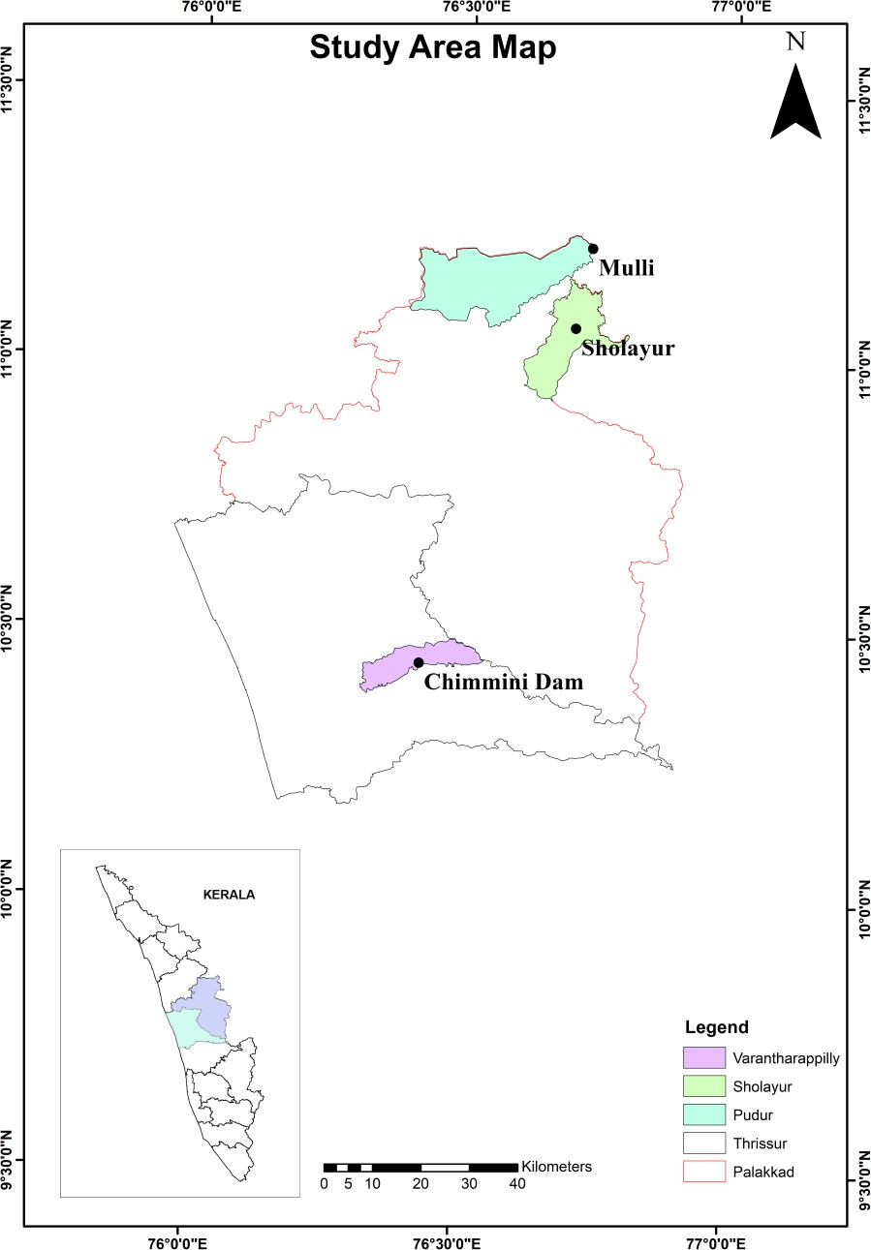

Sampling and Survey Procedure
A total of 50 respondents were included in the survey using random sampling. Households in rural and forest-fringe settlements were approached during direct field visits. Interviews were conducted face to face. Although the questionnaire was prepared in English, questions were communicated in Malayalam to improve respondent understanding.
The survey focused on the broader rural farming communities in the selected settlements. Respondents were informed about the purpose of the research and that participation was voluntary. No personally identifying information was recorded.

Questionnaire Design
The structured questionnaire included Likert-scale and open-ended questions. Six areas were examined: fear and psychological stress, sleep disturbance, educational effects on children, awareness of compensation, insurance accessibility, and perceptions of government and institutional measures.
Responses to the Likert-scale questions were scored from 1 for strongly disagree to 5 for strongly agree. The educational component was assessed using a sub-sample of 10 respondents who had school-going children.

Data Analysis
Survey responses were organised and analysed in Microsoft Excel. Descriptive analysis included mean scores and percentages.
Mean scores were used for fear, sleep distress, educational impacts and perceptions of government measures:
Mean Score = Σfx / N
where f is the frequency of a response, x is the assigned Likert score and N is the total number of respondents. Percentage analysis was used to examine awareness of compensation and insurance:
Percentage = (Number of responses / Total number of respondents) × 100
Awareness was compared across educational categories. Gender-based comparisons were also carried out for fear and sleep distress.

Results and Discussion

Spatial Distribution of Human Fatalities
The secondary data search identified 42 reported fatal HWC incidents from 11 districts of Kerala as in Table 1. Five wildlife species were represented in the records. The Asian elephant (Elephas maximus) was the main species associated with human fatalities. These findings formed the basis of the mapped distribution of fatal conflict incidents.
Table 1. Summary of HWC fatality mapping across Kerala.

Parameter | Value
Total fatalities recorded | 42
Districts affected | 11
Wildlife species involved | 5
Primary conflicting species | Asian Elephant (Elephas maximus)
Highest conflict district | Wayanad (n = 17; 40.48%)
Lowest conflict districts | Pathanamthitta, Kozhikode, Kottayam (n = 1 each)

Wayanad recorded 17 fatalities and accounted for 40.48% of the fatalities identified through the media/records search. Idukki followed with six incidents (14.29%), while Thrissur recorded five (11.90%). Together, the three districts represented 66.67% of all fatalities identified in the dataset. The remaining incidents were distributed among eight districts as shown in Table 2.

The concentration of fatalities in Wayanad indicates that HWC is not distributed uniformly across Kerala. The northern Western Ghats contain extensive forest landscapes alongside agricultural settlements, creating repeated opportunities for contact between people and wildlife. Similar patterns of conflict have been associated with areas where wildlife ranges overlap with farms and human-use corridors [11].
Table 2. District-wise distribution of HWC fatalities in Kerala.

Rank | District | Fatalities | % of Total | Zone
1 | Wayanad | 17 | 40.48% | Northern
2 | Idukki | 6 | 14.29% | Central
3 | Thrissur | 5 | 11.90% | Central
4 | Palakkad | 3 | 7.14% | Northern
5 | Kollam | 2 | 4.76% | Southern
6 | Ernakulam | 2 | 4.76% | Central
7 | Malappuram | 2 | 4.76% | Northern
8 | Kannur | 2 | 4.76% | Northern
9 | Pathanamthitta | 1 | 2.38% | Southern
10 | Kozhikode | 1 | 2.38% | Northern
11 | Kottayam | 1 | 2.38% | Southern

Asian elephants accounted for 27 of the 42 reported deaths (64.29%). Tigers were associated with nine fatalities (21.43%), gaurs with four (9.52%), and leopard and wild boar with one fatality each (2.38%) as in Table 3.
The predominance of elephant-related deaths agrees with evidence from other parts of India, where elephants account for a considerable share of human casualties associated with wildlife conflict [11]. Their movement over large areas increases the possibility of encounters near agricultural fields and settlements. Food availability in cultivated land and seasonal changes in resources may also influence the movement of animals towards human-use areas [14,2].
Table 3. Species-wise analysis of HWC fatalities.

Species | Scientific Name | Fatalities | % of Total | Districts Affected
Asian Elephant | Elephas maximus | 27 | 64.29% | All 11
Tiger | Panthera tigris | 9 | 21.43% | Wayanad, Idukki
Gaur | Bos gaurus | 4 | 9.52% | Kozhikode, Thrissur, Kottayam, Kollam
Leopard | Panthera pardus | 1 | 2.38% | Thrissur
Wild Boar | Sus scrofa | 1 | 2.38% | Kannur

When fatalities were grouped by zone, the northern zone, comprising Wayanad, Malappuram, Kannur and Kozhikode, accounted for 52.38% of all recorded deaths, as shown in Table 4. The central zone, comprising Thrissur, Ernakulam, Palakkad and Idukki, contributed 38.10%, with Idukki recording the highest district-level fatality count within the zone. The southern zone, comprising Kollam, Pathanamthitta and Kottayam, accounted for 9.52% of the recorded fatalities.
Table 4. Zone-wise spatial analysis of HWC fatalities.

Zone | Districts | Fatalities | % of Total | Dominant Species
Northern | Wayanad, Malappuram, Kannur, Kozhikode | 22 | 52.38% | Elephant, Tiger
Central | Thrissur, Ernakulam, Palakkad, Idukki | 16 | 38.10% | Elephant
Southern | Kollam, Pathanamthitta, Kottayam | 4 | 9.52% | Elephant

As shown in figure 2, Point Density Analysis resolved three spatial clusters. Wayanad formed the core of the northern hotspot, extending into Malappuram and Kannur, and approached the maximum density value of 0.0314 incidents per km². A more diffuse secondary cluster spanned the Idukki-Thrissur-Palakkad corridor, indicating a concentration of reported fatal incidents across adjoining districts. Around Kollam and Kottayam, a low-intensity southern cluster emerged, consistent with the lower number of recorded incidents in the southern zone. With only

42 incident points, the resulting density surface is sensitive to the search radius chosen, and the three clusters described should be read as a smoothed pattern rather than a statistically confirmed hotspot.
Figure 2: Human Wildlife Conflict Areas in Kerala
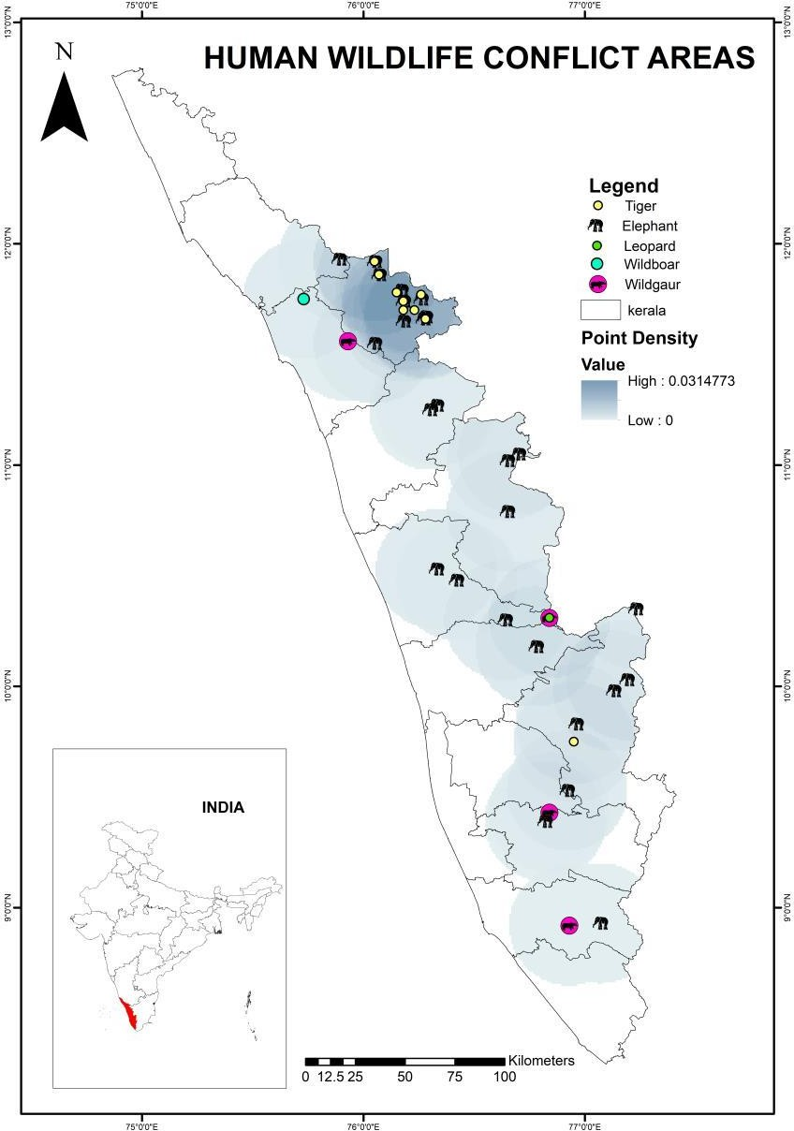

Community Profile
As shown in figure 3, primary education was the most common attainment level among the 50 respondents (32%, n=16), followed by higher secondary (30%, n=15), no formal education (26%, n=13), and degree-level qualification (12%, n=6).
Daily wage labourers were the largest occupational group (46%, n=23), followed by those with no declared occupation (26%, n=13) and estate workers (12%, n=6); farmers, business operators, and service workers made up the remainder (n=8) as shown in figure 4. Livelihoods tightly coupled to land-based activity placed these households in direct and repeated contact with wildlife-related losses.

Figure 3: Education Level of Respondents
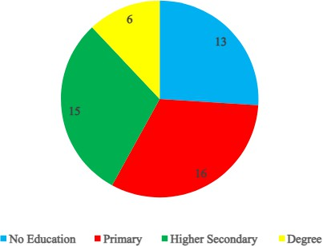
Figure 4: Occupation of Respondents
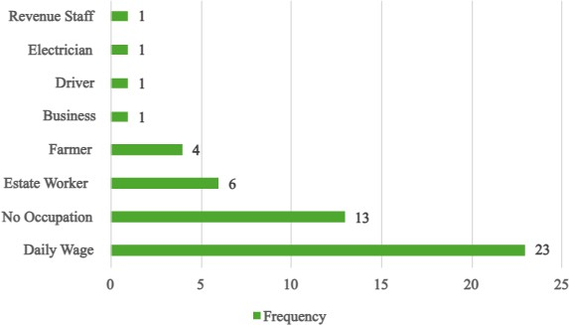

As shown in figure 5, elephants were the most commonly encountered species (96%, n=48), followed by wild boar (58%, n=29), monkey (48%, n=24), and leopard (44%, n=22). Among the forms of damage reported, crop loss was by far the most common: crop damage was reported by 75% of households (n=37), and 32% (n=16) also reported property damage — respondents could report more than one type of damage. One respondent (2%) reported a wildlife-related death within their immediate household or community. Sixteen percent (n=8) described no direct damage, pointing to spatial variation in exposure even within these conflict-prone panchayaths as shown in figure 6.
Figure 5: Animals Commonly Seen in the Area
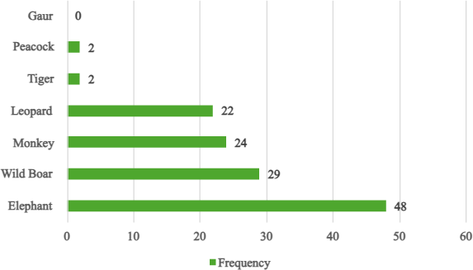

Figure 6: Types of Damages Experienced
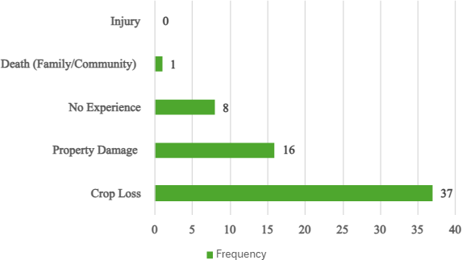

Psychological Impacts: Fear Index
As shown in figure 7, the fear index showed that avoiding outdoor movement at night had the highest mean score (4.22). Concern for family safety followed with a mean of 3.84. Fear after hearing animal sounds near residential areas recorded 3.62, while stress and anxiety in daily life and mental disturbance following encounters recorded mean scores of 3.24 and 3.20, respectively. Feeling unsafe in the place of residence had the lowest mean score of 3.00.
Night-time movement appears to be one of the clearest behavioural effects of wildlife conflict in the surveyed communities. Respondents may continue to live and work close to forests, yet they remain cautious about moving outside after dark. Madden and McQuinn [6] identified restrictions on movement and continuing psychological pressure as important non-economic consequences of HWC. The moderate score for feeling unsafe may indicate some degree of adaptation among residents who have lived close to wildlife for long periods, although the fear of specific encounters remains.
Gender differences were small. Female respondents recorded marginally higher mean scores for most fear-related indicators. Both male and female respondents reported high avoidance of night-time movement. The findings indicate that the behavioural effect of fear was broadly shared across genders.
Figure 7: Fear Index Among Residents
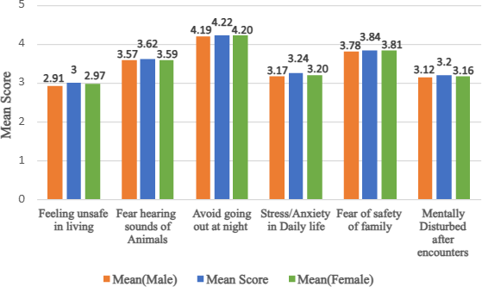

Sleep Distress
As shown in figure 8, disturbed sleep recorded the highest mean score among the sleep indicators (3.24). Frequent waking at night followed with a mean score of 3.04. Reduced sleep quality recorded 2.96, whereas staying alert at night had a mean of 2.66.
The findings suggest that wildlife-related concern affects sleep even when residents do not remain continuously awake throughout the night. Sounds or the possibility of animals moving close to homes may interrupt rest and

create uncertainty. Fredy and Mathew [15] similarly reported fear, stress and sleep-related concerns among residents of Malakkapara exposed to recurring wildlife encounters. Only minor differences were found between male and female respondents. The overall pattern was similar for both groups, suggesting that sleep disturbance is experienced across households rather than being limited to one gender.
Figure 8: Sleep Distress among Respondents
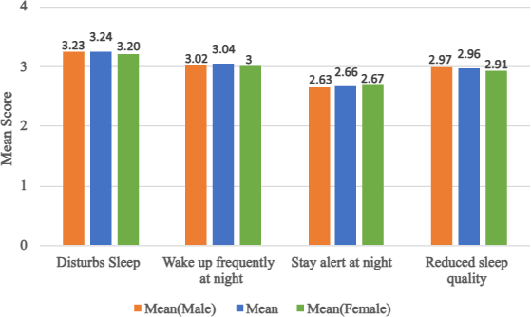

Educational Impacts
Educational impacts were assessed among the 10 respondents with school-going children. As shown in figure 9, fear of going to school (2.3) and perceived insecurity of school routes (2.3) recorded the highest mean score. Disruption of attendance recorded 1.9, and difficulty concentrating on studies had the lowest mean score of 1.6.
Compared with the psychological indicators, educational effects were limited. School buses and jeeps operating in the surveyed areas appeared to reduce the need for children to travel independently through wildlife-prone routes. Field responses suggested organised school transport as a possible contributing factor; this interpretation was not formally tested. This differs from the situation reported by Fredy and Mathew [15] in Malakkapara, where wildlife presence created greater difficulties for school travel. The contrast suggests that transport arrangements can reduce some indirect educational consequences of HWC.
Figure 9: Educational Impacts
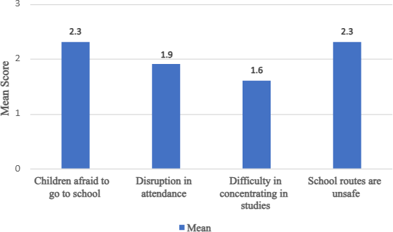

Awareness of Compensation and Insurance Mechanisms

As shown in figure 10, compensation awareness varied with educational attainment. Among respondents with no formal education, 30.8% (4 of 13) were aware of compensation provisions. Awareness increased to 43.8% (7 of 16) among those with primary education, 66.7% (10 of 15) among higher secondary respondents and 83.3% (5 of 6) among degree holders.
A similar educational pattern was observed for insurance awareness as shown in figure 11, although knowledge of insurance remained comparatively limited. Awareness was 23.1% (3 of 13) among respondents with no formal education and 37.5% (6 of 16) among those with primary education. It reached 40.0% (6 of 15) among higher secondary respondents and 66.7% (4 of 6) among degree holders.
The pattern indicates that access to information about financial support mechanisms is uneven. Higher educational attainment may make it easier to obtain and understand information concerning application procedures and available schemes. Earlier research in Nilambur also identified awareness and accessibility as difficulties associated with compensation mechanisms [18].
Figure 10: Awareness of Compensation
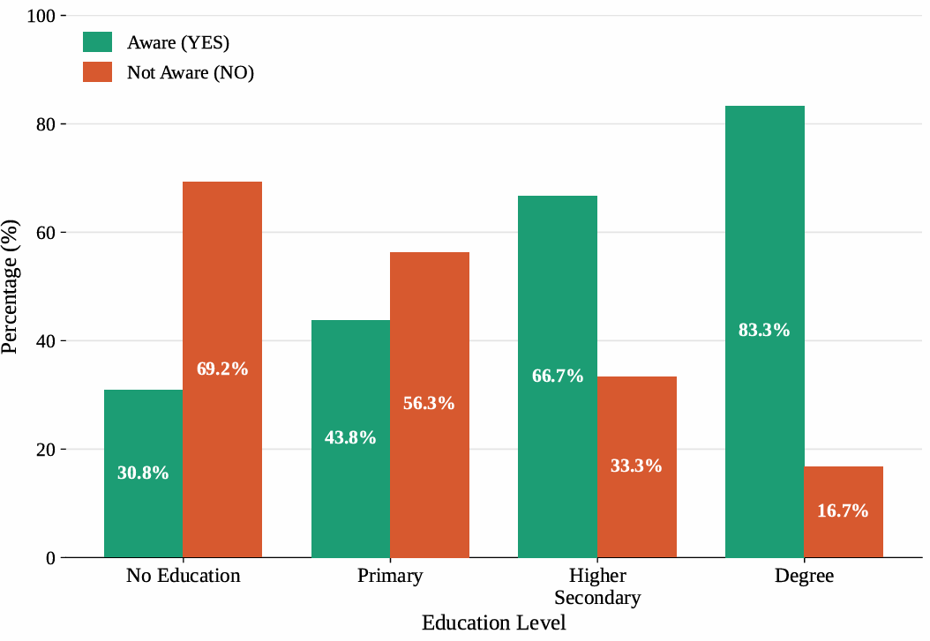

Figure 11: Awareness of Insurance
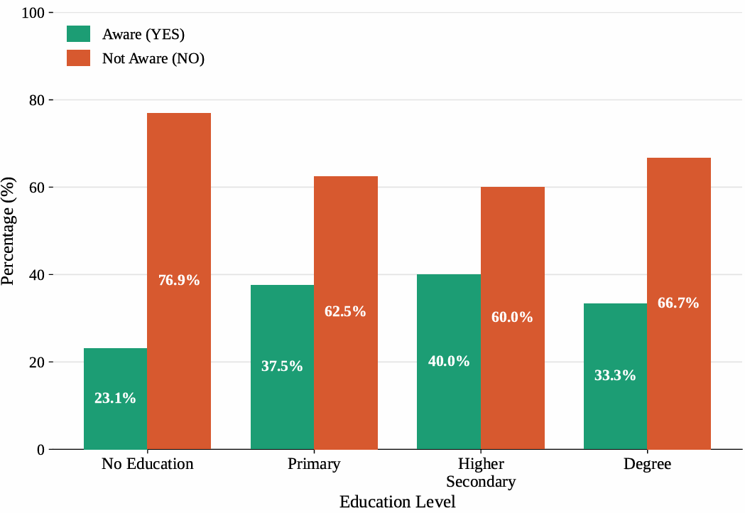

Lack of awareness was the most frequently reported insurance barrier and accounted for 42.1% of responses (32 of 76). Complicated procedures represented 30.3% (23 of 76), while 22.4% (17 of 76) identified cost as a barrier. Limited availability of insurance services was reported in 5.3% (4 of 76) of responses.
The findings show that the main obstacle was not simply the physical absence of insurance services. Many respondents lacked information on available programmes, eligibility and claim procedures. Administrative requirements also discouraged access. These issues are particularly relevant to rural households that may require assistance to complete documentation and verification procedures. Fredy and Mathew [15] reported limited satisfaction with government support among the Malakkapara community, while studies from Nilambur have also identified shortcomings in the accessibility of compensation mechanisms [18].
Figure 12: Barriers to Accessing Insurance

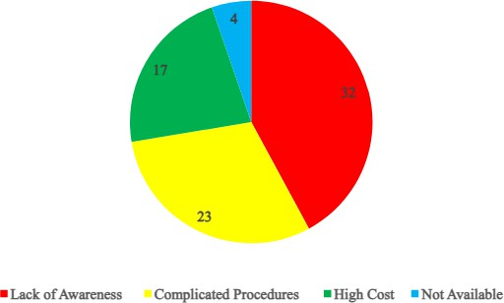

Perceived Effectiveness of Mitigation Measures and Institutional Response
As shown in figure 13, government measures for controlling wildlife conflict received a mean score of 2.24. Respondents frequently referred to damaged or poorly maintained fencing. During field visits, concerns were raised about fences remaining unrepaired and allowing animals to enter farms and settlements.
Physical barriers can reduce wildlife entry, but their effectiveness depends on regular maintenance. Burudi, Tormáné Kovács and Katona [21] also observed that fencing requires continued upkeep and should form part of a wider ecological approach to conflict management.
In contrast, forest department response during conflict incidents received a mean score of 4.38. Respondents generally stated that officers arrived after incidents were reported and used crackers or other sound-based deterrents to move animals away. Patrols were also reported in some locations. The positive assessment of incident response differs from respondents' concerns about preventive infrastructure. Respondents rated incident response more favourably than preventive measures, indicating a perceived difference between the two functions.
The findings point towards the need for regular inspection and repair of existing fencing rather than relying only on the installation of new barriers. Awareness of compensation and insurance also requires attention, particularly among residents with limited formal education. Information on eligibility and claim procedures could be communicated through panchayaths and local community networks in simpler forms. Early warning and community-based communication may further support residents in areas with frequent wildlife movement. These recommendations are consistent with the practical issues identified during the field survey and the suggestions developed from the field findings of the present study.

Figure 13: Effectiveness of Policies and Institutional Response
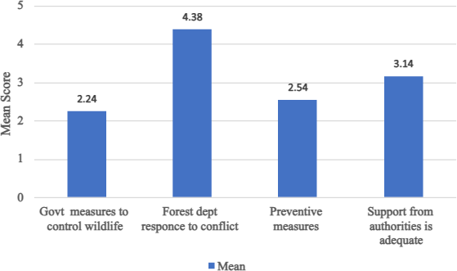

Conclusion
Fatal human-wildlife conflict incidents identified in this study were concentrated unevenly across Kerala. Wayanad recorded the largest share of reported deaths, and Asian elephants were associated with most fatalities. The field survey showed that the effects of HWC extended into the daily lives of residents. Avoidance of night-time movement, concern for family safety and disturbed sleep were prominent experiences, while educational effects were comparatively low in the surveyed communities.
Awareness of compensation increased with educational attainment, but knowledge of insurance provisions remained uneven. Lack of awareness was the main reported barrier to insurance access, followed by procedural difficulties and cost. Respondents viewed forest department response during conflict incidents positively, although existing preventive measures, particularly fencing, were considered less effective because of poor maintenance.
The findings show that HWC in Kerala cannot be addressed only through responses to crop damage or wildlife intrusion. Psychological experiences, access to financial support and the condition of preventive infrastructure also require attention. Regular maintenance of existing mitigation structures, clearer communication of compensation and insurance provisions, and stronger preventive and community-based approaches may improve conflict management in forest-fringe areas.

Abbreviations
HWC: Human-Wildlife Conflict GIS: Geographic Information System

Disclosure Statement
The authors declare that they have no known competing financial interests or personal relationships that could have appeared to influence the work reported in this paper.

Data Availability Statement
The data supporting the findings of this study are available within the manuscript. Additional data related to this research may be obtained from the corresponding author upon reasonable request.

Declaration of AI Use

This manuscript was prepared through the intellectual contributions of the author(s) to the study design, data analysis, interpretation of results, and scholarly content. Grammarly and ChatGPT were used solely to assist with grammatical refinement and reference formatting during manuscript revision. The author(s) accept full responsibility for the accuracy, integrity, and final content of the manuscript.

References
- Nyhus PJ. Human-wildlife conflict and coexistence. Annual Review of Environment and Resources. 2016;41:143-171. Available: https://doi.org/10.1146/annurev-environ-110615-085634
- Woodroffe R, Thirgood S, Rabinowitz A, editors. People and wildlife: Conflict or coexistence? Cambridge University Press; 2005.
- Zimmermann A, McQuinn B, Macdonald DW. Levels of conflict over wildlife: Understanding and addressing the right problem. Conservation Science and Practice. 2020;2(10):e259. Available: https://doi.org/10.1111/csp2.259
- Schell CJ, Stanton LA, Young JK, Angeloni LM, Lambert JE, Breck SW, Murray MH. The evolutionary consequences of human-wildlife conflict in cities. Evolutionary Applications. 2021;14(3):757-776. Available: https://doi.org/10.1111/eva.13131
- Barua M, Bhagwat SA, Jadhav S. The hidden dimensions of human-wildlife conflict: Health impacts, opportunity and transaction costs. Biological Conservation. 2013;157:309-316. Available: https://doi.org/10.1016/j.biocon.2012.07.014
- Madden F, McQuinn B. Conservation's blind spot: The case for conflict transformation in wildlife conservation. Biological Conservation. 2014;178:97-106. Available: https://doi.org/10.1016/j.biocon.2014.07.015
- Shanko G, Tona B, Adare B. Human-wildlife conflict around Belo-Bira Forest, Dawro Zone, Southwestern Ethiopia. International Journal of Forestry Research. 2021;2021:9944750. Available: https://doi.org/10.1155/2021/9944750
- Baral K, Sharma HP, Kunwar R, Morley C, Aryal A, Rimal B, Ji W. Human wildlife conflict and impacts on livelihood: A study in community forestry system in mid-hills of Nepal. Sustainability. 2021;13(23):13170. Available: https://doi.org/10.3390/su132313170
- Chowdhury AN, Mondal R, Biswas MK. Ecopsychosocial aspects of human-tiger conflict: An ethnographic study of tiger widows of Sundarban Delta, India. Environmental Health Insights. 2016;10:1-13. Available: https://doi.org/10.4137/EHI.S24899
- Bharti S, Kumar G, Kapoor G. Navigating human-wildlife conflict: Key species, impacts, mitigation and challenges in Himachal Pradesh, India. Asian Journal of Research in Zoology. 2025;8(1):33-49. Available: https://doi.org/10.9734/ajriz/2025/v8i1180
- Gulati S, Karanth KK, Le NA, Noack F. Human casualties are the dominant cost of human-wildlife conflict in India. Proceedings of the National Academy of Sciences. 2021;118(8):e1921338118. Available: https://doi.org/10.1073/pnas.1921338118
- Agarwal PK, Raj B, Radhakrishna S, Verghese A, Subaharan K, Gupta A. Human-wildlife conflict. Current Science. 2016;111(10):1581-1582.

- Baskaran N, Sathishkumar S, Vanitha V, Arjun M, Keerthi P, Bandhala NG. Unveiling the hidden causes: Identifying the drivers of human-elephant conflict in Nilgiri Biosphere Reserve, Western Ghats, Southern India. Animals. 2024;14(22):3193. Available: https://doi.org/10.3390/ani14223193
- Rangarajan M, Desai A, Sukumar R, Easa PS, Menon V, Vincent S, Ganguly S, Talukdar BK, Singh B, Mudappa D, Chowdhary S, Prasad AN. Gajah: Securing the future for elephants in India. The Report of the Elephant Task Force. Ministry of Environment and Forests, Government of India, New Delhi; 2010.
- Fredy AJ, Mathew J. Socio-economic impact of human-wildlife conflict: A case study conducted among the frontline community of Malakkapara, Kerala. International Journal of Contemporary Research in Multidisciplinary. 2023;2(6):1-6.
- Govind SK. Studies on human-wildlife conflict in Central Kerala, India. PhD thesis. Forest Research Institute (Deemed) University, Dehra Dun; 2015.
- Jayson EA. Assessment of human-wildlife conflict and mitigation measures in Northern Kerala. KFRI Research Report No. 530. Kerala Forest Research Institute; 2016. 57 p.
- Rohini CK, Aravindan T, Das KSA, Vinayan PA. Patterns of human-wildlife conflict and people's perception towards compensation program in Nilambur, Southern Western Ghats, India. Conservation Science. 2017;4(1):1-
6. Available: https://doi.org/10.3126/cs.v4i1.16891
- Sumitha PS, Shaharban V. Economic impact of wild animal conflict on agricultural sector: A study in Wayanad District, Kerala, India. Asian Journal of Research and Review in Agriculture. 2022;4(1):17-25.
- Govind SK, Jayson EA. Human-leopard conflict on the Kerala-Tamil Nadu border, Southern India. Journal of the Bombay Natural History Society. 2021;118. Available: https://doi.org/10.17087/jbnhs/2021/v118/148822
- Burudi JW, Tormáné Kovács E, Katona K. Wildlife fences to mitigate human-wildlife conflicts in Africa: A literature analysis. Diversity. 2025;17(2):87. Available: https://doi.org/10.3390/d17020087

