Microwave-Assisted Preparation and Physicochemical Characterization of a Phoenix sylvestris Seed-Derived PSSSAA Resin: pH-Dependent Heavy-Metal Removal

Abstract
Heavy-metal contamination remains a persistent challenge in water treatment, and bio-derived polymeric adsorbents are being investigated as lower-cost alternatives to conventional materials. In this study, a PSSSAA resin was prepared from Phoenix sylvestris seed powder by a microwave-assisted route and characterised by thermogravimetric-differential thermal-derivative thermogravimetric analysis (TG-DTA-DTG), scanning electron microscopy (SEM), Fourier transform infrared (FTIR) spectroscopy, and proton nuclear magnetic resonance (1H NMR) spectroscopy. Batch screening was conducted for Cd(II), Pb(II), Ni(II), and Zn(II) over pH 2–8 using 50 mg of resin and a 2 h equilibration period at 25 °C. The modified material showed a rougher and more heterogeneous surface than the precursor powder, multistep thermal degradation with 16.9% residue at 774 °C, and changes in the hydroxyl, carbonyl, and carbohydrate fingerprint regions of the FTIR spectrum. Apparent metal removal increased with pH and reached maximum values at pH 7: 88.75% for Cd(II), 85.16% for Pb(II), 79.01% for Ni(II), and 74.75% for Zn(II), followed by a decrease at pH 8. Because metal hydrolysis or precipitation may contribute to removal near neutral pH, these values are interpreted as pH-dependent apparent removal under the applied batch conditions rather than as intrinsic adsorption capacities. The findings support further evaluation of PSSSAA as a seed-derived sorbent, including adsorption isotherms and kinetics, precipitation controls, regeneration studies, quantitative surface-area analysis, and validation in multicomponent or real wastewater.
Keywords: batch adsorption; Phoenix sylvestris; distribution coefficient; heavy metals; biomass-derived resin; PSSSAA

1. Introduction
Heavy metals can persist in aquatic systems, accumulate in biological compartments, and pose ecological and human-health risks when present at elevated concentrations. Adsorption remains widely investigated for metal removal because it can be implemented with diverse sorbents and relatively simple process configurations, although performance depends strongly on solution chemistry, adsorbent structure, and operational conditions (Babel & Kurniawan, 2003; Qasem et al., 2021; Raji et al., 2023).
Biomass-derived and carbohydrate-based materials are attractive adsorbent precursors because they are renewable and contain oxygen-rich functional groups that can participate in metal binding. Biochar, cellulose, chitosan, starch, and related biopolymers have consequently been investigated for the removal of metal ions and other contaminants (Ahmed et al., 2021; Fouda-Mbanga et al., 2021; Joshi et al., 2024; Zubair et al., 2021). Date-palm biomass has likewise been explored as a feedstock for activated carbon and biochar, demonstrating the broader potential of palm-derived residues for adsorbent development (Al Malki et al., 2023).
Native starch is abundant and biodegradable but often requires chemical modification to improve the density and accessibility of binding sites. Grafting, cross-linking, esterification, oxidation, and composite formation can modify the hydroxyl-rich polysaccharide network and improve interaction with dissolved metal ions (Gupta et al., 2021; Khoo et al., 2023). Recent work on starch hydrogels, aerogels, and chitosan-starch composites also emphasises that adsorption behaviour is controlled by functional-group chemistry, polymer architecture, porosity, pH, and mass-transfer conditions (Çelik et al., 2025; Costa et al., 2025; da Costa et al., 2025; Kirti et al., 2024).
Phoenix sylvestris is a wild date palm whose seed material is available as a plant-derived biomass. Direct use of P. sylvestris seed powder has previously been investigated for Cr(VI) removal, indicating that the seed matrix can interact with aqueous contaminants (Meghana et al., 2019). More broadly, recent adsorbent research has continued to examine functionalised agricultural residues, polymeric materials, and membrane-based systems for metal-ion removal (Arshad et al., 2026; Ismael et al., 2026; Pascu et al., 2026). These studies support continued investigation of chemically modified seed-derived materials while also highlighting the need for careful characterisation and appropriately controlled adsorption experiments.
Despite these advances, the studies considered here do not provide an integrated assessment of a microwave-assisted PSSSAA resin derived specifically from P. sylvestris seed powder that combines physicochemical characterisation with pH-dependent screening of Cd(II), Pb(II), Ni(II), and Zn(II) under the stated batch conditions. This specific gap is addressed in the present study.
The present study evaluates a microwave-assisted PSSSAA resin prepared from Phoenix sylvestris seed powder. The objectives were to describe the synthesis route, characterise the resulting material using thermal analysis, SEM, FTIR, and 1H NMR, and examine pH-dependent removal of Cd(II), Pb(II), Ni(II), and Zn(II) in batch experiments. The study is intentionally interpreted as a material-characterisation and pH-screening investigation; performance comparisons that require adsorption capacity, kinetic constants, regeneration data, or real-wastewater validation are not made.

2. Materials and Methods

2.1 Materials
Phoenix sylvestris seed powder, ascorbic acid, dioxane, hydrochloric acid, sodium hydroxide, epichlorohydrin, methanol, buffer reagents, and standard aqueous solutions of Cd(II), Ni(II), Pb(II), and Zn(II) were used. Reagents were of high-purity commercial grade and were used without additional purification.

2.2 Instrumentation
FTIR spectra were recorded with a PerkinElmer instrument (Spectrum software version 10.4.00) using KBr pellets. Surface morphology was examined with a Zeiss FE-SEM Ultra Plus instrument. Thermal analysis was performed with a HITACHI STA300 TG/DTA system. Proton NMR data were acquired on a JEOL JNM-ECS400 spectrometer operating at approximately 400 MHz.

2.3 Synthesis of Phoenix sylvestris Seed-Derived PSSSAA Resin
Phoenix sylvestris seed powder was dispersed in dioxane to form a slurry. The reaction mixture was adjusted to pH 9–10 with 15 mL of 40% (w/v) sodium hydroxide and stirred at 60 °C for approximately 3 h. Epichlorohydrin (0.1 mol) was then introduced with continuous stirring. The mixture was subjected to microwave irradiation for a total of 2 min in 10 s intervals. The resulting epoxide-functionalised intermediate was isolated by vacuum filtration, washed thoroughly with methanol, and dried.
The intermediate was subsequently combined with ascorbic acid (0.1 mol) and subjected to a second 2 min microwave treatment in 10 s intervals. The reaction mixture was left overnight, filtered under vacuum, and washed with 90% methanol containing a small amount of hydrochloric acid, followed by final washing with methanol. The dried product was obtained as a free-flowing light-brown powder and is referred to throughout as PSSSAA resin.

2.4 TG-DTA-DTG Analysis
A PSSSAA resin sample of approximately 5.02 mg was analysed using a HITACHI STA300 TG/DTA system. The material was heated to 800 °C at 50 °C min⁻¹ under nitrogen flowing at 200 mL min⁻¹. Thermogravimetric (TG), differential thermal (DTA), and derivative thermogravimetric (DTG) responses were evaluated to describe the thermal decomposition profile.

2.5 Scanning Electron Microscopy
The morphology of the precursor Phoenix sylvestris (PS) powder and the synthesised PSSSAA resin was examined by field-emission scanning electron microscopy using a Zeiss FE-SEM Ultra Plus instrument. Representative micrographs at several magnifications were compared qualitatively with respect to surface texture, visible cavities, particle packing, and heterogeneity.

2.6 Fourier Transform Infrared Spectroscopy
FTIR spectra of PS powder and PSSSAA resin were recorded using KBr pellets. The spectra were compared with emphasis on the O-H, C-H, carbonyl, C-O, and carbohydrate fingerprint regions. Because several bands occur in both the precursor and modified material, the FTIR data were interpreted as evidence of changes in the local chemical environment rather than as stand-alone proof of a unique covalent structure.

2.7 Proton Nuclear Magnetic Resonance Spectroscopy
The 1H NMR spectrum of PSSSAA resin was acquired on a JEOL JNM-ECS400 instrument at approximately 400 MHz using chloroform-d (CDCl3) as solvent and tetramethylsilane (TMS) as the chemical-shift reference. The acquisition used 256 scans at approximately 20.5 °C. Resonance regions were interpreted conservatively because of substantial overlap expected for a heterogeneous carbohydrate-rich material.

2.8 Batch pH-Dependent Removal Experiments
Batch experiments were conducted to compare the pH-dependent removal of Cd(II), Ni(II), Pb(II), and Zn(II). For each experiment, 1 mL of the corresponding standard aqueous metal-ion solution was transferred to a 250 mL Erlenmeyer flask. The pH was adjusted within the range 2–8 using acetate and NH4OH-NH4Cl buffer systems as appropriate, after which 50 mg of PSSSAA resin was added. The suspensions were agitated at 25 °C for 2 h.
After equilibration, the suspensions were filtered through Whatman No. 40 filter paper. The retained resin phase was treated with 4 N HCl to desorb metal ions and was subsequently filtered through Whatman No. 42 filter paper. Metal concentrations in the solution and desorbed fractions were determined using a double-beam UV-Visible spectrophotometer against calibration curves prepared from standard solutions. The distribution coefficient (Kd) was calculated from the relative amounts of metal in the resin and solution phases:
Kd (mL g−1) = (amount of metal in resin phase / dry resin mass) ÷ (amount of metal in solution phase / solution volume)
Percentage removal was derived from the measured redistribution of metal between the aqueous and retained phases. The experiments were used to compare pH response within the present study rather than to determine equilibrium adsorption capacity or kinetic parameters.

3. Results and Discussion

3.1 Thermal Behaviour of PSSSAA Resin
The TG-DTA-DTG profile showed multistep thermal decomposition (Figure 1). An initial mass decrease occurred below approximately 150 °C and was consistent with the loss of physically retained moisture and volatile components. By 313 °C, the TG trace indicated a remaining mass of approximately 76.7%. The major decomposition region occurred thereafter, with a maximum DTG response near 406 °C (1.438 mg min⁻¹) and a corresponding DTA event near 446 °C. A residual mass of 16.9% remained at 774 °C. The thermal profile therefore demonstrates a broad, multistage decomposition process but does not by itself establish a specific covalent architecture.
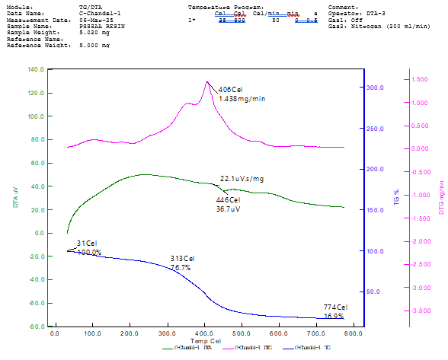
Figure 1. TG-DTA-DTG profile of PSSSAA resin under nitrogen.

3.2 Surface Morphology
SEM examination revealed clear qualitative differences between PS powder and PSSSAA resin. The precursor particles were predominantly compact, flaky, and agglomerated, with comparatively limited visible pore and cavity features (Figure 2). The modified resin exhibited a rougher and more heterogeneous morphology, including cavities, cracks, channels, and sponge-like regions (Figure 3). These observations are compatible with morphological restructuring during chemical treatment; however, SEM alone does not provide a quantitative measure of specific surface area. Accordingly, no BET-equivalent surface-area claim is made from the micrographs. A qualitative comparison of the observed surface features is presented in Table 1.
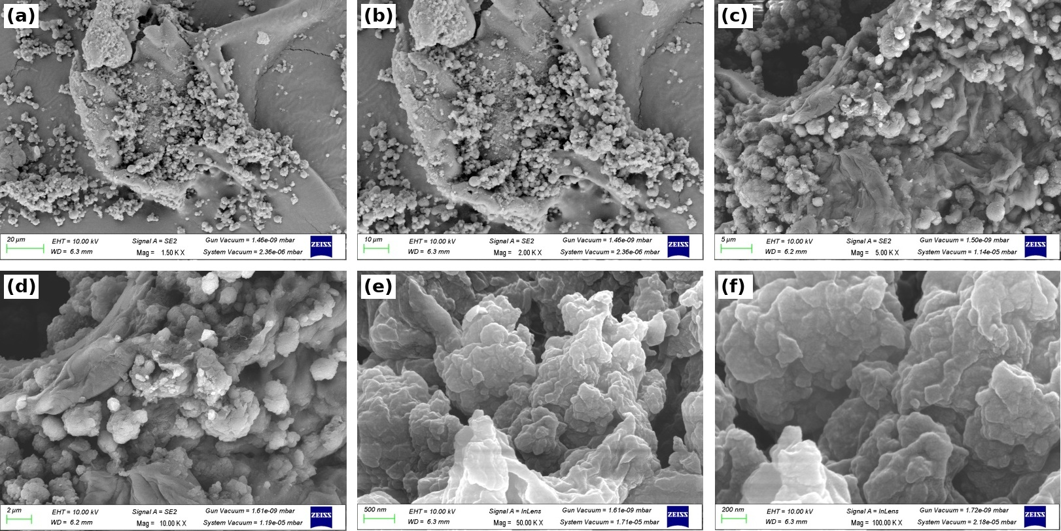
Figure 2. Representative SEM micrographs of PS powder at the magnifications shown in the individual panels.
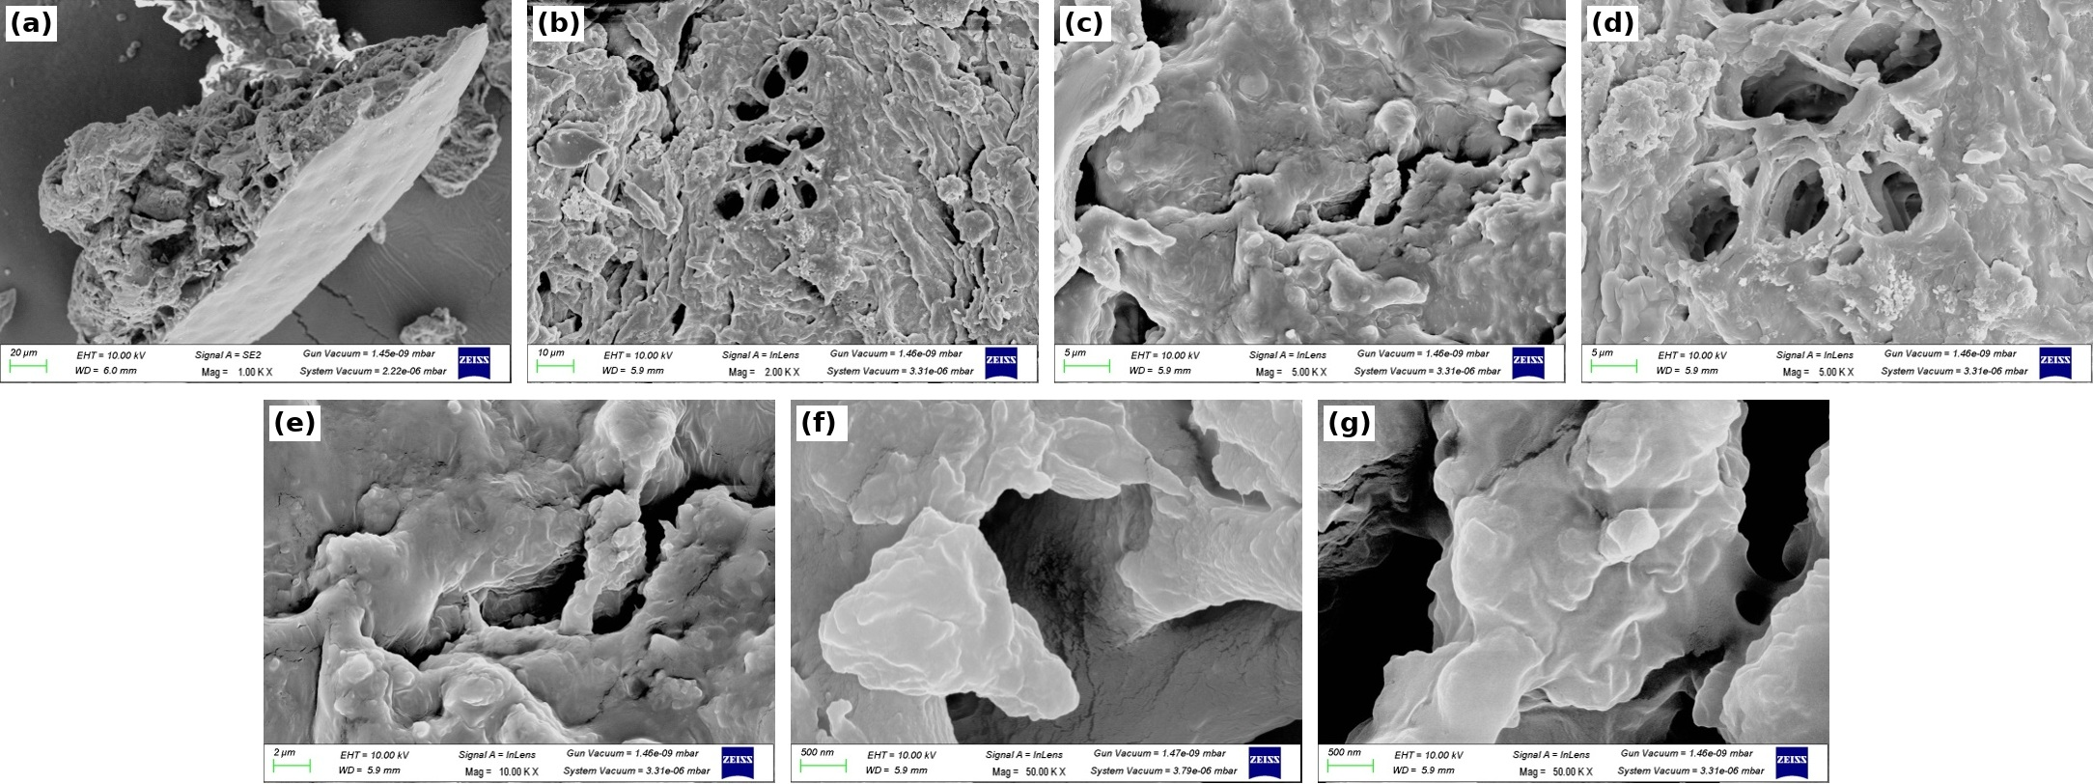
Figure 3. Representative SEM micrographs of PSSSAA resin at the magnifications shown in the individual panels.
Table 1
Qualitative comparison of SEM-observed surface features of PS powder and PSSSAA resin
Feature | PS powder | PSSSAA resin
Surface texture | Relatively smooth to slightly rough | Highly rough and irregular
Visible pores/cavities | Limited visible pore features | Prominent cavities, cracks, and channels
Particle packing | Compact and dense regions | More open and heterogeneous regions
Dominant morphology | Flaky/agglomerated particles | Granular and sponge-like regions

3.3 FTIR Spectral Changes
The FTIR spectra of PS powder and PSSSAA resin are shown in Figures 4 and 5. The broad O-H band occurred at 3294 cm⁻¹ in PS powder and 3298 cm⁻¹ in PSSSAA resin, while the C-H stretching region remained near 2926 cm⁻¹. Importantly, a carbonyl-region band was already present in PS powder at approximately 1738 cm⁻¹ and shifted slightly to approximately 1742 cm⁻¹ in the modified material. Consequently, the 1742 cm⁻¹ feature cannot be treated as a newly appearing band that independently proves ascorbic-acid incorporation. Changes were also observed around 1623/1600 cm⁻¹ and within the 1200–800 cm⁻¹ carbohydrate fingerprint region.
Taken together, the modest peak shifts and intensity changes are consistent with altered hydrogen bonding and local chemical environments after treatment. This interpretation is in line with the broader literature showing that chemical modification of starch changes its functional-group environment and metal-binding behaviour (Gupta et al., 2021; Khoo et al., 2023). Nevertheless, confirmation of a specific covalent linkage would require complementary structural evidence beyond these FTIR spectra. The key FTIR bands and their interpretations are summarised in Table 2.
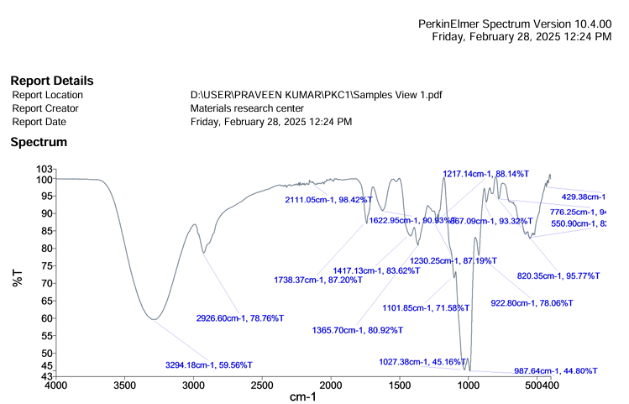
Figure 4. FTIR spectrum of PS powder.
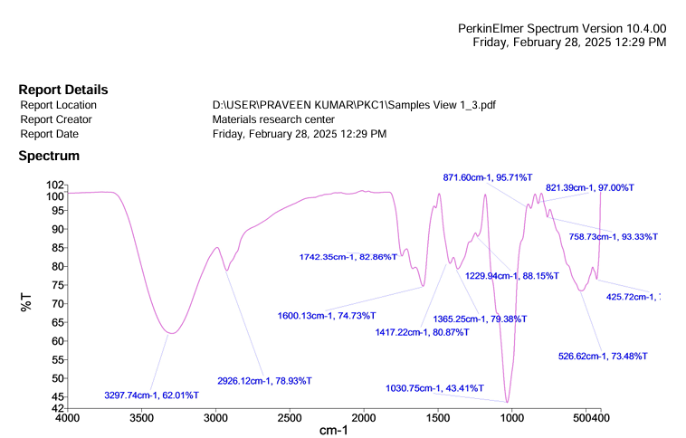
Figure 5. FTIR spectrum of PSSSAA resin.
Table 2
Comparison of key FTIR bands of PS powder and PSSSAA resin
Region / assignment | PS powder (cm⁻¹) | PSSSAA resin (cm⁻¹) | Observed change | Interpretation
O-H stretching | 3294 | 3298 | Small shift; broad band retained | Hydrogen-bonded hydroxyl environment retained with modest change
C-H stretching | 2927 | 2926 | Essentially unchanged | Aliphatic carbohydrate framework retained
Carbonyl-region band | 1738 | 1742 | Small shift | Carbonyl-region band is present in both materials; shift alone is not definitive evidence of a new ester linkage
1600–1630 cm⁻¹ region | 1623 | 1600 | Shift in band position | Change in local environment and/or bound-water contribution
CH2 bending | 1417 | 1417 | No substantive shift | Carbohydrate backbone feature retained
C-H bending | 1366 | 1365 | Minimal change | Minor local-environment change
C-O stretching | 1230 | 1230 | Similar position | Oxygen-containing functionality retained
C-O/C-O-C fingerprint | 1102, 1027 | 1031 | Fingerprint profile changed | Consistent with modification of carbohydrate local environment
Lower fingerprint region | 923, 820 | 872, 821 | Peak redistribution | Structural rearrangement within the fingerprint region

3.4 1H NMR Spectroscopy
The 1H NMR spectrum of PSSSAA resin is presented in Figure 6. Signals in the approximately 3.5–5.5 ppm range are compatible with oxygenated methine, methylene, and anomeric proton environments expected in carbohydrate-rich materials. The spectrum was acquired in CDCl3; therefore, the resonance near 7.26 ppm is attributable to residual chloroform and should not be assigned to unsaturation in the resin or used as evidence of ascorbic-acid incorporation. The strong overlap of signals limits unambiguous assignment of individual starch and ascorbate proton environments.
Accordingly, the NMR spectrum supports the presence of an oxygenated carbohydrate framework but is interpreted as complementary rather than conclusive structural evidence for a specific covalent linkage. More detailed structural confirmation would require additional experiments such as 13C NMR, two-dimensional NMR, or other linkage-sensitive analyses. A conservative interpretation of the principal ¹H NMR regions is summarised in Table 3.
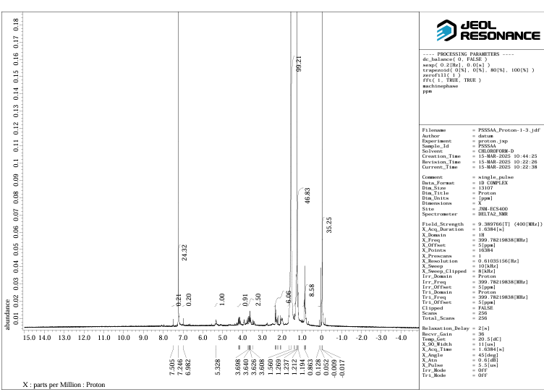
Figure 6. 1H NMR spectrum of PSSSAA resin acquired at approximately 400 MHz in CDCl3.
Table 3
Conservative interpretation of key 1H NMR regions of PSSSAA resin
Chemical shift / region (ppm) | Assignment | Interpretation
~7.26 | Residual CHCl3 from CDCl3 solvent | Solvent signal; not assigned to resin unsaturation
~5.0–5.5 | Anomeric and other oxygenated proton region | Compatible with carbohydrate backbone
~3.5–4.2 | Oxygenated methine/methylene protons | Consistent with starch-ring/CH2OH environments; overlap with ascorbate-related proton environments is possible
0 | TMS reference | Chemical-shift reference

3.5 pH-Dependent Distribution and Apparent Removal of Metal Ions
The distribution coefficients and apparent percentage removal values changed systematically with pH (Figures 7 and 8). Removal was lower under strongly acidic conditions and increased as the pH approached neutral values. This trend is consistent with reduced competition from H+ and greater availability of deprotonated oxygen-containing binding sites as pH increases, a behaviour widely reported for biosorbents and polysaccharide-based adsorbents (Azizul-Rahman et al., 2014; Babel & Kurniawan, 2003; Çelik et al., 2025).
The highest measured values occurred at pH 7 and followed the order Cd(II) > Pb(II) > Ni(II) > Zn(II), with apparent removals of 88.75%, 85.16%, 79.01%, and 74.75%, respectively. The corresponding Kd trend was consistent with the same affinity order. Differences among metal ions can reflect multiple physicochemical factors, including hydration, ionic size, coordination behaviour, and affinity for oxygen-donor sites (Raji et al., 2023; Volesky, 2001).
The decline at pH 8 is compatible with a change in aqueous speciation and/or surface interactions. At the same time, the pH 7 maximum must be interpreted cautiously because hydrolysis and metal-hydroxide precipitation can contribute to apparent removal near neutral or alkaline conditions depending on metal concentration and solution composition (Qasem et al., 2021; Raji et al., 2023). In the absence of no-resin precipitation controls or explicit aqueous-speciation calculations, the present data cannot separate sorption from any concurrent precipitation contribution. The term apparent removal is therefore used for these pH-screening results.
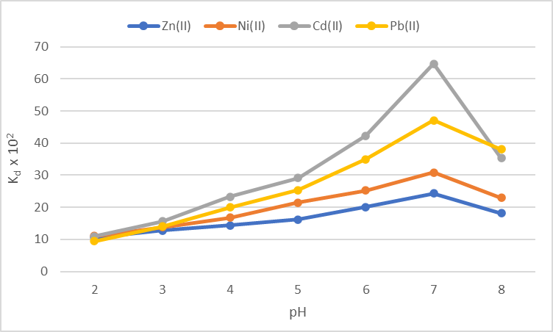
Figure 7. Relationship between distribution coefficient (Kd) and pH for Cd(II), Pb(II), Ni(II), and Zn(II) in the PSSSAA batch system.
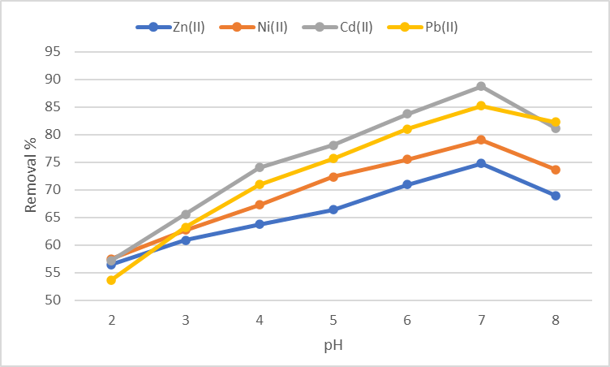
Figure 8. Apparent percentage removal of Cd(II), Pb(II), Ni(II), and Zn(II) as a function of pH in the PSSSAA batch system.

3.6 Context, Scope, and Study Limitations
Modified starch materials can exhibit substantially improved metal-ion interactions after functionalisation, but meaningful cross-study comparisons generally require adsorption capacity, adsorbent dose, starting concentration, equilibrium modelling, kinetic analysis, and uncertainty estimates (Costa et al., 2025; Foo & Hameed, 2010; Gupta et al., 2021). Recent starch-based systems also commonly assess isotherms, kinetic models, and regeneration to distinguish material affinity from experimental-condition effects (Çelik et al., 2025; da Costa et al., 2025; Kirti et al., 2024). Because the present study reports pH-dependent Kd and percentage removal rather than qmax, isotherm, kinetic, or regeneration parameters, the results should not be used to rank PSSSAA as superior to other adsorbents.
The work also used standard aqueous metal solutions rather than real wastewater. This distinction is important because real effluents contain competing ions, dissolved organic matter, variable ionic strength, and multiple contaminants that can modify sorption performance (Qasem et al., 2021). In addition, the SEM observations are qualitative and do not replace BET surface-area measurements, while the FTIR and 1H NMR data support chemical and morphological changes without uniquely proving a specific covalent structure. Contact-time, temperature, adsorption-capacity, regeneration, leaching, and column-performance studies remain necessary before practical wastewater-treatment claims can be made.
From a sustainability perspective, the use of a seed-derived precursor and short microwave irradiation is potentially advantageous for biomass valorisation, but the synthesis also uses organic solvents and chemical reagents. For this reason, the material is described here as bio-derived rather than intrinsically green. A future process-level assessment should include solvent recovery, material and energy balances, regeneration, and quantitative green-chemistry metrics.

4. Conclusions
A microwave-assisted route was used to prepare PSSSAA resin from a Phoenix sylvestris seed-derived precursor, and the material was characterised by TG-DTA-DTG, SEM, FTIR, and 1H NMR. Thermal analysis showed multistep degradation with a major DTG maximum near 406 °C and 16.9% residue at 774 °C. SEM revealed a transition from comparatively compact precursor particles to a rougher and more heterogeneous resin morphology. FTIR and 1H NMR spectra showed changes compatible with chemical modification of a carbohydrate-rich material, although the available spectra do not independently establish a unique covalent linkage.
Within the batch pH-screening experiments, apparent metal removal increased towards pH 7, where the measured order was Cd(II) (88.75%) > Pb(II) (85.16%) > Ni(II) (79.01%) > Zn(II) (74.75%), followed by a decline at pH 8. These observations identify a pH region of interest for subsequent study but should not be interpreted as intrinsic adsorption capacities because hydrolysis or precipitation may contribute near neutral pH. The current findings therefore support PSSSAA as a candidate material for further controlled adsorption studies. Future work should establish complete analytical validation, adsorption capacities, isotherms and kinetics, precipitation controls, regeneration performance, quantitative surface area, multicomponent selectivity, and performance in real wastewater before scale-up is considered.

Declaration of AI-Assisted Editing
Grammarly and ChatGPT were used as language-editing and manuscript-revision aids. No generative tool was used to create experimental data. Responsibility for the study design, experimental data, scientific interpretation, references, and final manuscript rests with the authors.

References
Ahmed, W., Mehmood, S., Núñez-Delgado, A., Ali, S., Qaswar, M., Khan, Z. H., Ying, H., & Chen, D.-Y. (2021). Utilization of Citrullus lanatus L. seeds to synthesize a novel MnFe₂O₄-biochar adsorbent for the removal of U(VI) from wastewater: Insights and comparison between modified and raw biochar. Science of the Total Environment, 771, 144955. https://doi.org/10.1016/j.scitotenv.2021.144955
Al Malki, M., Yaser, A. Z., Mohd Hamzah, M. A. A., Zaini, M. A. A., Ab. Latif, N., Hasmoni, S. H., & Zakaria, Z. A. (2023). Date palm biochar and date palm activated carbon as green adsorbent—Synthesis and application. Current Pollution Reports, 9, 374–390. https://doi.org/10.1007/s40726-023-00275-6
Arshad, A., Mehdi, M. S., Zaman, S. U., & Rehman, S. U. (2026). Sustainable nanocomposite-integrated polysulfone membranes with tunable surface charge and enhanced adsorptive capacity for heavy metal ions removal from wastewater. Chemical Engineering Journal, 534, 174915. https://doi.org/10.1016/j.cej.2026.174915
Azizul-Rahman, M. F. H., Mohd-Suhaimi, A. A., & Othman, N. (2014). Biosorption of Pb(II) and Zn(II) in synthetic wastewater by watermelon rind (Citrullus lanatus). Applied Mechanics and Materials, 465–466, 906–910. https://doi.org/10.4028/www.scientific.net/AMM.465-466.906
Babel, S., & Kurniawan, T. A. (2003). Low-cost adsorbents for heavy metals uptake from contaminated water: A review. Journal of Hazardous Materials, 97(1–3), 219–243. https://doi.org/10.1016/S0304-3894(02)00263-7
Çelik, M. S., Çaylak, O., Kütük, N., Yenidünya, A. F., Çetinkaya, S., Maslov, M. M., & Kaya, S. (2025). Removal of lead ions (Pb²⁺) from aqueous solution using chitosan/starch composite material: Experimental and density functional theory findings. Biomass Conversion and Biorefinery, 15, 1041–1056. https://doi.org/10.1007/s13399-024-05287-w
Costa, T. B., Matias, P. M. C., Sharma, M., Murtinho, D., Rosa, D. S., & Valente, A. J. M. (2025). Recent advances on starch-based adsorbents for heavy metal and emerging pollutant remediation. Polymers, 17(1), 15. https://doi.org/10.3390/polym17010015
da Costa, T. B., Camani, P. H., Ferreira, R. R., Barbosa, R. F. S., & dos S. Rosa, D. (2025). Enhancing corn starch hydrogels for effective sorption of potentially toxic metals: The role of amylose and amylopectin content. Journal of Polymers and the Environment, 33(3), 1615–1635. https://doi.org/10.1007/s10924-025-03495-7
Foo, K. Y., & Hameed, B. H. (2010). Insights into the modeling of adsorption isotherm systems. Chemical Engineering Journal, 156(1), 2–10. https://doi.org/10.1016/j.cej.2009.09.013
Fouda-Mbanga, B. G., Prabakaran, E., & Pillay, K. (2021). Carbohydrate biopolymers, lignin based adsorbents for removal of heavy metals (Cd²⁺, Pb²⁺, Zn²⁺) from wastewater, regeneration and reuse for spent adsorbents including latent fingerprint detection: A review. Biotechnology Reports, 30, e00609. https://doi.org/10.1016/j.btre.2021.e00609
Gupta, A. D., Rawat, K. P., Bhadauria, V., & Singh, H. (2021). Recent trends in the application of modified starch in the adsorption of heavy metals from water: A review. Carbohydrate Polymers, 269, 117763. https://doi.org/10.1016/j.carbpol.2021.117763
Ismael, Y. A., Omer, D. A., Ibrahim, S. S., & Saad, D. N. (2026). Green approach based on micellar-modified Kalonji seeds waste for removal of hexavalent chromium ions and methyl orange dye from aqua. Journal of the Indian Chemical Society, 103(3), 102470. https://doi.org/10.1016/j.jics.2026.102470
Joshi, N. C., Joshi, A., Mitra, D., Gururani, P., Kumar, N., & Joshi, H. K. (2024). Removal of heavy metals using cellulose-based materials: A mini-review. Environmental Nanotechnology, Monitoring & Management, 21, 100942. https://doi.org/10.1016/j.enmm.2024.100942
Khoo, P. S., Ilyas, R. A., Uda, M. N. A., Hassan, S. A., Nordin, A. H., Norfarhana, A. S., Ab Hamid, N. H., Rani, M. S. A., Abral, H., Norrrahim, M. N. F., Knight, V. F., Lee, C. L., & Rafiqah, S. A. (2023). Starch-based polymer materials as advanced adsorbents for sustainable water treatment: Current status, challenges, and future perspectives. Polymers, 15(14), 3114. https://doi.org/10.3390/polym15143114
Kirti, N., Gupta, A. D., Singh, H., Tiwari, H., & Blennow, A. (2024). Advancements in starch-based aerogels and hydrogels for treatment of water containing heavy metals—A short review. Starch/Stärke, 77(1), 2400044. https://doi.org/10.1002/star.202400044
Meghana, P. K., Pravalika, K. V., Sriram, P. J., & Ravindhranath, K. (2019). Effective removal of hexavalent chromium from polluted water using Phoenix sylvestris seed powder as adsorbent. Asian Journal of Chemistry, 31(6), 1327–1331. https://doi.org/10.14233/ajchem.2019.21760
Pascu, L. F., Galaon, T., Borș, A. M., & Marin, N. M. (2026). New sustainable material for metal ions removal: Adsorption mechanism and technological innovations. Polymers, 18(6), 712. https://doi.org/10.3390/polym18060712
Qasem, N. A. A., Mohammed, R. H., & Lawal, D. U. (2021). Removal of heavy metal ions from wastewater: A comprehensive and critical review. npj Clean Water, 4, Article 36. https://doi.org/10.1038/s41545-021-00127-0
Raji, Z., Karim, A., Karam, A., & Khalloufi, S. (2023). Adsorption of heavy metals: Mechanisms, kinetics, and applications of various adsorbents in wastewater remediation—A review. Waste, 1(3), 775–805. https://doi.org/10.3390/waste1030046
Volesky, B. (2001). Detoxification of metal-bearing effluents: Biosorption for the next century. Hydrometallurgy, 59(2–3), 203–216. https://doi.org/10.1016/S0304-386X(00)00160-2
Zubair, M., Ihsanullah, I., Aziz, H. A., Ahmad, M. A., & Al-Harthi, M. A. (2021). Sustainable wastewater treatment by biochar/layered double hydroxide composites: Progress, challenges, and outlook. Bioresource Technology, 319, 124128. https://doi.org/10.1016/j.biortech.2020.124128

