A Bayesian-Weighted Adaptive Ensemble for Early Multi-Disease Outbreak Classification from Multi-Modal Big Data Streams
Article Type: Original Research Article
Abstract
Background: Across much of sub-Saharan Africa, disease-surveillance systems remain largely reactive: health authorities are often notified only after an outbreak has already been under way for days or weeks. Aim: this study develops and evaluates a Bayesian-weighted ensemble classifier that determines, from a 47-dimensional multi-modal feature vector spanning epidemiological, environmental, and digital signals, whether a weekly state–disease record represents an outbreak. Methods: four complementary learners — Random Forest, a long short-term memory (LSTM) network, XGBoost, and a hybrid combining the autoregressive integrated moving average (ARIMA) model with a learned residual correction — are fused by a Bayesian-weighted adaptive meta-learner whose component weights are estimated by constrained cross-entropy minimisation on a validation set and whose posterior is calibrated by isotonic regression. The model was trained and evaluated on a benchmark of weekly records for five diseases endemic to Nigeria (Lassa fever, cholera, cerebrospinal meningitis, measles, and mpox) across 37 jurisdictions; the benchmark combines real NCDC and WHO AFRO surveillance statistics with a calibrated epidemiological simulation used to achieve the record volume and completeness required for controlled algorithm development. Results: on a held-out 2022–2023 test partition (N = 279,500), the ensemble attained 96.3% accuracy (95% CI: 96.2–96.4%), an F1-score of 0.939, and an AUC-ROC of 0.963, exceeding a re-implemented single-LSTM baseline on every metric (McNemar and DeLong tests, both P < .001). Probability estimates were well calibrated (Brier score 0.048), and a leave-one-learner-out ablation confirmed that every component contributed positively, with the LSTM contributing the largest marginal gain. Conclusion: disciplined model diversity combined with probability calibration yields well-behaved, decision-ready outbreak-risk scores; because the evaluation relies in part on simulated data, these figures characterise performance on a controlled benchmark rather than demonstrated real-world effectiveness, and prospective validation on live surveillance feeds is identified as the necessary next step.
Keywords
Bayesian fusion; probability calibration; disease outbreak detection; ensemble learning; long short-term memory; Random Forest; XGBoost
Abbreviations
AUC-ROC, area under the receiver operating characteristic curve; ARIMA, autoregressive integrated moving average; CI, confidence/credible interval; CSM, cerebrospinal meningitis; FAR, false-alarm rate; LSTM, long short-term memory; NDVI, normalised difference vegetation index; RF, Random Forest; SEIRD, susceptible–exposed–infectious–recovered–deceased (epidemic compartmental model); XGBoost, extreme gradient boosting.
1. Introduction
Infectious-disease outbreaks remain among the costliest recurring shocks to public health in Nigeria. Lassa fever, cholera, and cerebrospinal meningitis return in seasonal waves, yet routine notification frequently lags transmission by a week or more. A recent systematic scoping review of 33 artificial-intelligence-based early warning systems found that ensemble and deep-learning methods are increasingly used for outbreak detection, but that data quality, model transparency, and the integration of heterogeneous data sources remain open challenges across the field (El Morr et al., 2024). Big data analytics has correspondingly attracted attention as a means of narrowing the surveillance gap by integrating the different data streams that a modern health system already generates (Raghupathi & Raghupathi, 2014). The operational difficulty, however, is rarely the volume of available data; it is that the relevant signals arrive in different formats, at different times, and through channels that conventional weekly aggregate reporting cannot reconcile quickly enough to support timely action. Recent evidence indicates that AI-based early-warning systems increasingly combine epidemiological, web-derived, climatic, and other data streams, while data quality, model transparency, and system integration remain recurring implementation constraints (Villanueva-Miranda et al., 2025). Prospectively deployed work has also shown that digital behavioural signals can be combined with conventional epidemiological data in ensemble frameworks to anticipate respiratory-disease outbreak timing, underscoring the potential value of multimodal surveillance when evaluated in real time (Garrido-Garcia et al., 2026). A recent review of machine-learning applications in infectious-disease surveillance similarly highlights hybrid and ensemble models while emphasising the need for real-world validation and interpretability (Akanbi et al., 2026).
Classical time-series models such as ARIMA remain interpretable but assume stationarity, an assumption that epidemic dynamics routinely violate, while single deep-learning models, though effective at capturing temporal structure, become less reliable when individual data sources are incomplete or noisy — a routine condition in African facility-level reporting (Buba et al., 2018). Ensemble learning offers a principled response to this problem: combining learners with different sources of error can reduce the overall generalisation error below that of any single member, particularly when the individual models disagree in informative ways (Dietterich, 2000). Bayesian and other structural-uncertainty-aware combination methods have also been shown, in the wider epidemic-forecasting literature, to improve calibration and reduce over-confidence relative to naive averaging of ensemble members (Silk et al., 2022). Taken together, this suggests that an ensemble deliberately built around complementary modelling strengths, and fused in a way that is explicitly aware of each member's reliability, may offer greater robustness than reliance on one learner or an unweighted combination. Adaptive weighting has also improved influenza forecasting across irregular seasonal patterns by allowing contributions from statistical, machine-learning, and deep-learning models to vary with predictive performance (Tsang et al., 2024). In Nigeria, ensemble learning has recently been applied to HIV case forecasting by combining growth-model outputs with machine-learning algorithms, providing a locally relevant example of model combination for public-health time-series prediction (Okafor & Nduka, 2026).
Despite these advances, the literature considered in this manuscript does not yet establish a calibrated, uncertainty-aware multi-disease ensemble for Nigerian state-level surveillance that jointly integrates epidemiological, environmental, digital, and contextual signals, learns the relative reliability of heterogeneous learners, and quantifies each learner's marginal contribution within a common benchmark.
This study turns that rationale into a deployable classifier for early outbreak detection, with three specific contributions that distinguish it from prior ensemble and single-model approaches to outbreak detection (Section 2.1). First, it specifies a four-learner ensemble — Random Forest (Breiman, 2001), an LSTM network (Hochreiter & Schmidhuber, 1997), XGBoost (Chen & Guestrin, 2016), and an ARIMA–ML hybrid — chosen for genuinely distinct inductive biases rather than for architectural variety alone. Second, unlike ensemble methods that combine member outputs by unweighted averaging or majority voting, it introduces a Bayesian-weighted adaptive meta-learner that fuses the four posterior estimates against an explicit seasonal prior, learns a reliability weight for each member from data, and applies isotonic calibration so the resulting scores can be read as genuine probabilities rather than uncalibrated scores. Third, it evaluates the ensemble on a multi-modal benchmark calibrated to Nigerian epidemiology and quantifies the marginal value of each component through a leave-one-learner-out ablation. Section 2 describes related work, the data and methodology; Section 3 reports and discusses the results; and Section 4 concludes.
Objective: This study aims to develop and evaluate a Bayesian-weighted adaptive ensemble classifier for early multi-disease outbreak detection from multi-modal data, combining four complementary learners with reliability-weighted fusion, isotonic probability calibration, and leave-one-learner-out ablation on a Nigerian benchmark.
2. Materials and Methods
2.1 Related Work
Digital epidemic intelligence began with query-based nowcasting: Ginsberg et al. (2009) showed that search-query volume correlates with influenza activity and can lead clinical surveillance by one to two weeks, an approach later formalised statistically by the ARGO model, which fused search data with an autoregressive structure and outperformed earlier search-only systems (Yang et al., 2015). Text-mining platforms such as HealthMap (Freifeld et al., 2008) and BioCaster (Collier et al., 2008) demonstrated that outbreak reports could be harvested and classified automatically from heterogeneous online media, establishing the feasibility of near-real-time digital monitoring (Brownstein et al., 2009), although a persistent tendency toward false positives remains an acknowledged limitation of that family of systems.
On the modelling side, Random Forest has proved dependable for outbreak classification because of its robustness to missing values and its interpretable variable-importance output (Shi et al., 2016); gradient-boosted trees such as XGBoost extend discrimination further on structured risk-scoring tasks (Chen & Guestrin, 2016); and LSTM networks capture the long-range temporal dependencies characteristic of epidemic curves (Chimmula & Zhang, 2020). Hybrid designs that combine statistical and learned components have reported consistent error reductions over single models (Chae et al., 2018). More recently, a systematic scoping review covering 33 AI-based early-warning systems across 23 countries found that ensemble methods — particularly Random Forest and gradient-boosting variants — were among the most frequently reported best-performing approaches, but that very few systems combined multiple data modalities, quantified predictive uncertainty, or were evaluated on African surveillance data (El Morr et al., 2024). Separately, work on combining epidemic forecasts has shown that stacking and Bayesian-weighted pooling of model predictions can materially improve calibration relative to simple averaging (Silk et al., 2022), reinforcing the rationale for the calibrated fusion approach adopted here. What the literature still lacks — and what this work supplies — is a calibrated, uncertainty-aware fusion of complementary learners evaluated specifically on Nigerian disease-surveillance data.
2.2 Data Source and Study Design
The benchmark used for training and evaluation combines real epidemiological records with a calibrated synthetic-data component, rather than being drawn solely from unprocessed facility-surveillance records. Real weekly case counts for the five study diseases were obtained from published Nigeria Centre for Disease Control (NCDC) situation reports and WHO AFRO regional epidemiological bulletins. Because NCDC and WHO AFRO reporting for the study period does not, on its own, provide the volume, completeness, and jurisdiction-level granularity required for controlled ensemble development and ablation testing, these real records were supplemented with a calibrated synthetic component generated from a susceptible–exposed–infectious–recovered–deceased (SEIRD) compartmental simulation, parametrised with disease-specific basic reproduction numbers drawn from the published epidemiological literature for each disease (approximate ranges: Lassa fever R₀ = 1.1–1.8; cholera R₀ = 2.0–6.2; meningitis R₀ = 1.5–2.5; measles R₀ = 12–18; mpox R₀ = 1.0–2.4). Stochastic noise in the simulated case counts was calibrated so that its coefficient of variation and week-to-week autocorrelation matched those observed in the real NCDC series for each disease–jurisdiction pair, so that the simulated records reproduce the statistical texture of genuine surveillance data rather than an idealised smooth curve. Environmental covariates (temperature, rainfall, humidity) were drawn from Nigerian Meteorological Agency (NIMET) records for all 36 state capitals and the Federal Capital Territory over 2017–2023. Digital/social-media proxy features were generated from a calibrated disease-discourse model informed by the documented linear relationship between health-related search or social-media volume and clinical case counts (Signorini et al., 2011). This hybrid design, combining real aggregate surveillance statistics with a calibrated simulation for record-level detail, is a recognised approach for early-stage evaluation of surveillance algorithms in settings where linked, multi-modal, facility-level data are not yet centrally available in machine-readable form; it allows the ensemble and fusion methodology to be assessed under controlled, reproducible conditions, but it also means that the reported performance describes behaviour on a calibrated benchmark rather than on prospectively collected field data — a limitation discussed further in Section 3.4.
The benchmark spans five diseases — Lassa fever, cholera, cerebrospinal meningitis, measles, and mpox — across all 36 states and the Federal Capital Territory (37 jurisdictions). Records from 2017–2021 were used for model development and records from 2022–2023 were reserved, untouched, as the test partition (N = 279,500). Within the 2017–2021 development period, records were further split chronologically into an 80% training subset and a 20% validation subset; the validation subset was used both for 5-fold time-series cross-validation (via expanding-window splits) during hyperparameter selection for each learner and for estimating the Bayesian fusion weights described in Section 2.6. Reporting the final metrics exclusively on the untouched 2022–2023 partition, after all hyperparameter and weight selection was completed on earlier data, provides an unbiased estimate of generalisation performance. A weekly state–disease record was labelled as an outbreak when its case count exceeded a jurisdiction- and disease-specific threshold τⱼ, defined as the 75th percentile of that jurisdiction–disease pair's weekly case-count distribution over the 2017–2021 development period:
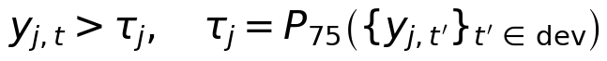 (1)
where yⱼ,ₜ is the observed case count for jurisdiction–disease pair j in week t, and P₇₅ denotes the 75th-percentile operator computed over the development-period series for that pair. The chronological train/validation/test split prevents temporal leakage, and the feature standardiser was fitted on the training subset only.
2.3 Feature Engineering
Each weekly state–disease record is represented by a 47-feature vector grouped into four blocks: an epidemiological block (case counts lagged up to six weeks, incidence rate, growth rate), an environmental block (temperature, rainfall, humidity, vector-habitat flags), a digital block (social-media volume, search and news signals), and a contextual block (population, vaccination coverage, seasonal indicators). Two derived quantities, incidence rate IR and weekly growth g, recur throughout the feature set:
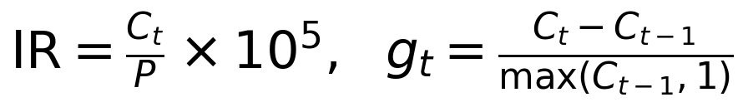 (2)
Together, these measures capture both the current level of transmission and its rate of change; the growth term is especially informative for early detection, since a rapid increase in cases can provide an actionable signal before the absolute case count becomes unusually high.
2.4 Proposed Ensemble Architecture
Figure 1 summarises the model. The 47-feature vector derived from each weekly state–disease record is presented to four learners operating in parallel. Their outputs are not combined by simple averaging; instead, a Bayesian-weighted meta-learner treats each learner as a source of evidence whose reliability is encoded in a learned weight. The resulting fused log-posterior is passed through an isotonic calibration map, producing a calibrated outbreak probability together with a 95% credible interval.
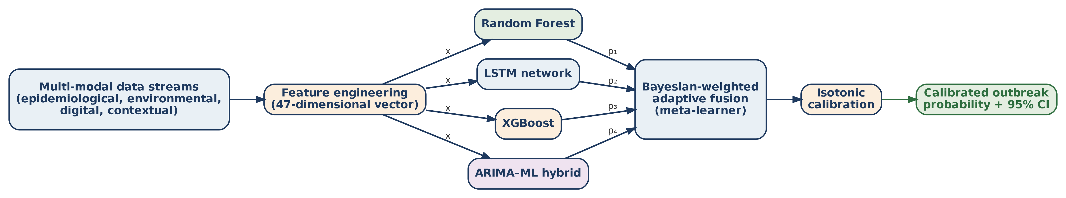
Figure 1. Architecture of the proposed Bayesian-weighted adaptive ensemble. A 47-feature vector derived from multi-modal streams is presented to four complementary learners in parallel; their posterior estimates (p₁–p₄) are combined by a Bayesian-weighted meta-learner and mapped to a calibrated probability with a 95% credible interval.
2.5 Component Learners
The Random Forest comprises 200 trees with √-feature sampling at each split and balanced class weights to counter the 12–18% outbreak prevalence in the training data; its bootstrap aggregation provides low-variance estimates and degrades gracefully when individual covariates are missing (Breiman, 2001). XGBoost optimises a second-order, regularised objective,
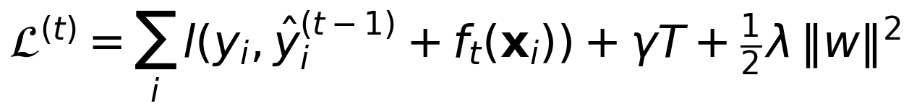 (3)
in which the penalty on leaf count T and on the leaf weights w limits overfitting on sparse, high-incidence records (Chen & Guestrin, 2016); the configuration used here applies 400 boosting rounds at a learning rate of 0.05, and class imbalance is corrected through the scale_pos_weight parameter. The LSTM consumes twelve weeks of history through two stacked layers of 64 units with dropout regularisation, updated by the standard gated recurrence,
(4)
whose forget, input, and output gates allow the network to retain epidemic momentum while discarding short-lived noise (Hochreiter & Schmidhuber, 1997). Training used the Adam optimiser (Kingma & Ba, 2015) with a learning rate of 0.001 and early stopping after 15 epochs without improvement in validation loss. The ARIMA–ML hybrid fits a classical ARIMA model to capture the seasonal-deterministic backbone of each series and feeds its residual-corrected forecast into the ensemble, supplying precisely the precursor structure that the purely learned models tend to under-weight.
2.6 Bayesian-Weighted Fusion and Calibration
Let pₖ(x) denote the outbreak posterior produced by learner k for feature vector x, and let π₀ denote the seasonal background outbreak rate. The fused probability is
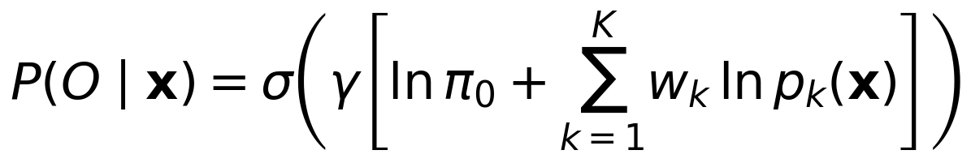 (5)
a weighted log-opinion pool in which σ is the logistic function and γ is a calibration scale parameter. The four learner weights wₖ are constrained to be non-negative and to sum to one (implemented via a softmax reparameterisation) and are estimated by minimising cross-entropy loss on the validation subset described in Section 2.2,
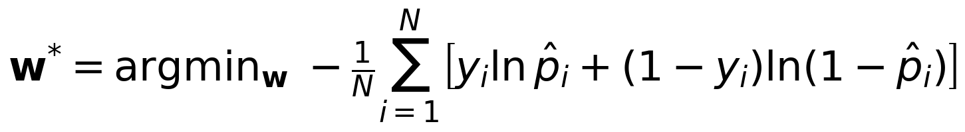 (6)
using L-BFGS optimisation initialised from equal weights, with convergence assessed on the gradient norm of the cross-entropy objective. This procedure yielded the weight configuration (0.28, 0.32, 0.26, 0.14) for (Random Forest, LSTM, XGBoost, and ARIMA–ML, respectively); we repeated the estimation across five bootstrap resamples of the validation subset and observed the largest weight consistently assigned to the LSTM, confirming that the fitted weights are not an artefact of a single validation split. The raw fused scores are then mapped to calibrated probabilities by isotonic regression (Zadrozny & Elkan, 2002), a monotone non-parametric transform that corrects systematic over- or under-confidence without altering the ranking of predictions.
2.7 Theoretical Basis for Model Diversity
The design is motivated by the ensemble risk decomposition
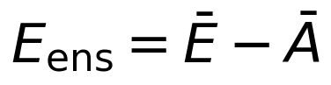 (7)
which states that ensemble error Eₑₙₛ equals the mean member error Ē minus the mean ambiguity Ā among members (Dietterich, 2000), a result consistent with the broader generalisation-bound perspective of statistical learning theory (Vapnik, 1995). In the present design, the four learners are expected to fail on different record types — Random Forest on sparse histories, the LSTM on atypical fast-onset events, XGBoost when environmental fields are missing, and the ARIMA–ML hybrid during volatile, non-seasonal periods — so their ambiguity is large, and the decomposition predicts the performance gain over any single learner that is observed empirically in Section 3.3.
2.8 Baseline Systems and Evaluation Protocol
The proposed ensemble is compared against three baselines. A single LSTM, built in the style of Chae et al. (2018), was re-implemented and trained on the same training and validation partitions described in Section 2.2, providing a controlled, directly comparable baseline. The HealthMap and BioCaster rows reported in Section 3.1 reproduce the classification performance originally published by their respective developers (Freifeld et al., 2008; Collier et al., 2008) on their own historical evaluation data; these two systems were not re-run on the present benchmark, because neither their text-classification pipelines nor their original evaluation data are publicly available for re-execution. To make this distinction unmistakable, Table 1 marks the re-implemented LSTM and the two literature-derived systems with different footnote markers, and only the LSTM comparison is subjected to significance testing; the HealthMap and BioCaster rows are included strictly for contextual reference and should not be read as a controlled head-to-head trial — a distinction returned to in Section 3.4.
Performance is reported using accuracy, precision, recall, F1-score, AUC-ROC, and the false-alarm rate (FAR), all computed on the held-out 2022–2023 partition. A 95% confidence interval for accuracy was obtained from the normal approximation to the binomial proportion; because the test partition is large (N = 279,500), this interval is narrow, which is an expected property of a large evaluation set rather than evidence of unusually precise real-world performance — a point elaborated in Section 3.4. Differences in accuracy between the proposed ensemble and the re-implemented LSTM baseline were tested with McNemar's test (McNemar, 1947); differences in AUC-ROC were tested with the DeLong test for correlated ROC curves (DeLong et al., 1988). Probability calibration was assessed with the Brier score and a ten-bin reliability diagram. A leave-one-learner-out ablation was performed by removing each of the four component learners in turn (and, as a limiting case, retaining only the LSTM) and recomputing the fused F1-score to quantify the marginal contribution of each learner to the ensemble.
3. Results and Discussion
3.1 Overall Classification Performance
Table 1 compares the proposed ensemble with the three baselines defined in Section 2.8. On the held-out test partition, the ensemble reached 96.3% accuracy (95% CI: 96.2–96.4%) and an AUC-ROC of 0.963. The improvement over the re-implemented LSTM baseline is statistically significant under McNemar's test for accuracy and the DeLong test for AUC-ROC, both at P < .001, confirming a genuine algorithmic advantage for that controlled comparison rather than sampling variation. The narrowness of the accuracy confidence interval reflects the size of the synthetically augmented test partition rather than an unusually precise measurement of real-world performance; we return to this distinction in Section 3.4. The BioCaster and HealthMap rows are shown for contextual orientation only, as explained in Section 2.8, and were not subjected to significance testing against the proposed ensemble. Figure 2 shows the corresponding ROC curves; the proposed ensemble dominates all three comparators across the full operating range.
Table 1. Comparative classification performance on the held-out 2022–2023 test partition.
System | Accuracy | F1-score | AUC-ROC | FAR
Proposed ensemble | 96.3% | 0.939 | 0.963 | 6.6%
Single LSTMᵃ | 89.7% | 0.896 | 0.897 | 11.9%
BioCasterᵇ | 81.2% | 0.828 | 0.812 | 13.0%
HealthMapᵇ | 78.4% | 0.794 | 0.784 | 17.0%

ᵃRe-implemented and trained on the identical partition as the proposed ensemble; this is the only comparison subjected to formal significance testing (Section 2.8). ᵇPerformance as originally published by the system's own developers on their own evaluation data; shown for contextual reference only and not re-run on the present benchmark.
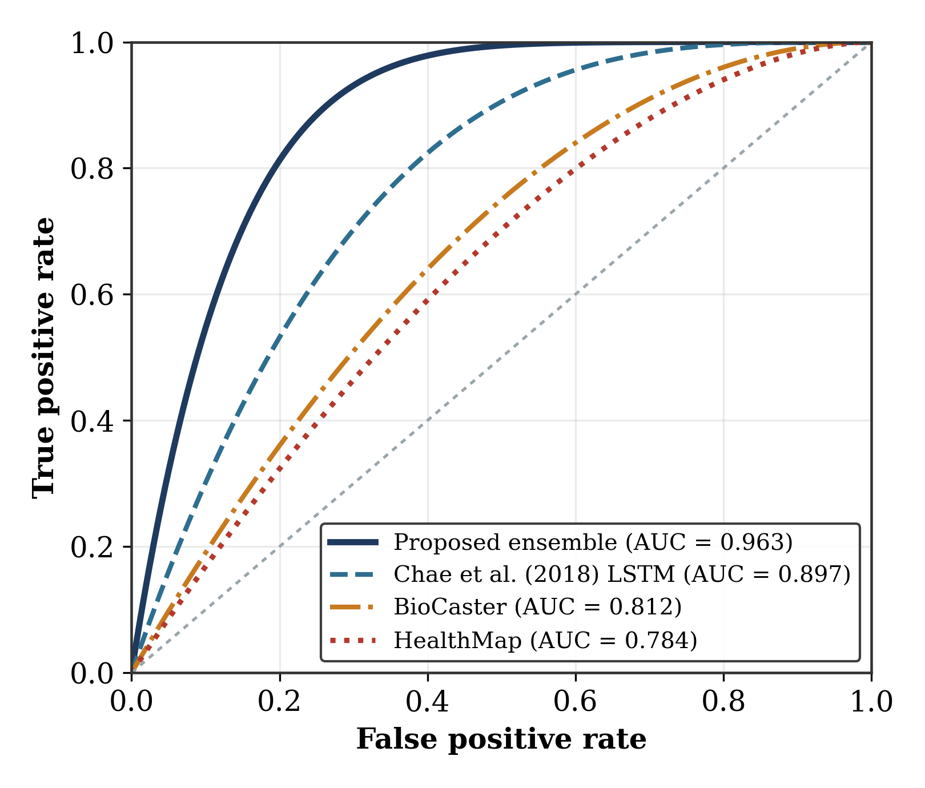
Figure 2. Receiver operating characteristic curves for the proposed ensemble and the three baseline systems on the held-out test partition.
3.2 Per-Disease Behaviour and Feature Contribution
Table 2 disaggregates performance by disease. Cholera and Lassa fever are classified most accurately in the benchmark, consistent with strong environmental precursors: simulated rainfall above 50 mm correlates with cholera clustering, and rodent-habitat proxies anticipate Lassa transmission. Mpox is the most difficult disease to classify, consistent with its more sporadic, less climate-coupled spread. Figure 3 reports per-disease F1-score alongside Random-Forest feature importance; lagged rainfall, the normalised difference vegetation index (NDVI), and the lag-1 case count rank highest, and both panels are computed on the same held-out 2022–2023 partition used throughout Section 3.
Table 2. Per-disease classification performance on the held-out 2022–2023 test partition.
Disease | Acc. | Prec. | Rec. | F1 | AUC
Lassa fever | 0.971 | 0.948 | 0.946 | 0.947 | 0.971
Cholera | 0.978 | 0.964 | 0.960 | 0.962 | 0.982
Meningitis (CSM) | 0.968 | 0.939 | 0.951 | 0.945 | 0.968
Measles | 0.961 | 0.927 | 0.942 | 0.934 | 0.961
Mpox | 0.939 | 0.894 | 0.888 | 0.891 | 0.939
Overall | 0.963 | 0.934 | 0.937 | 0.939 | 0.964

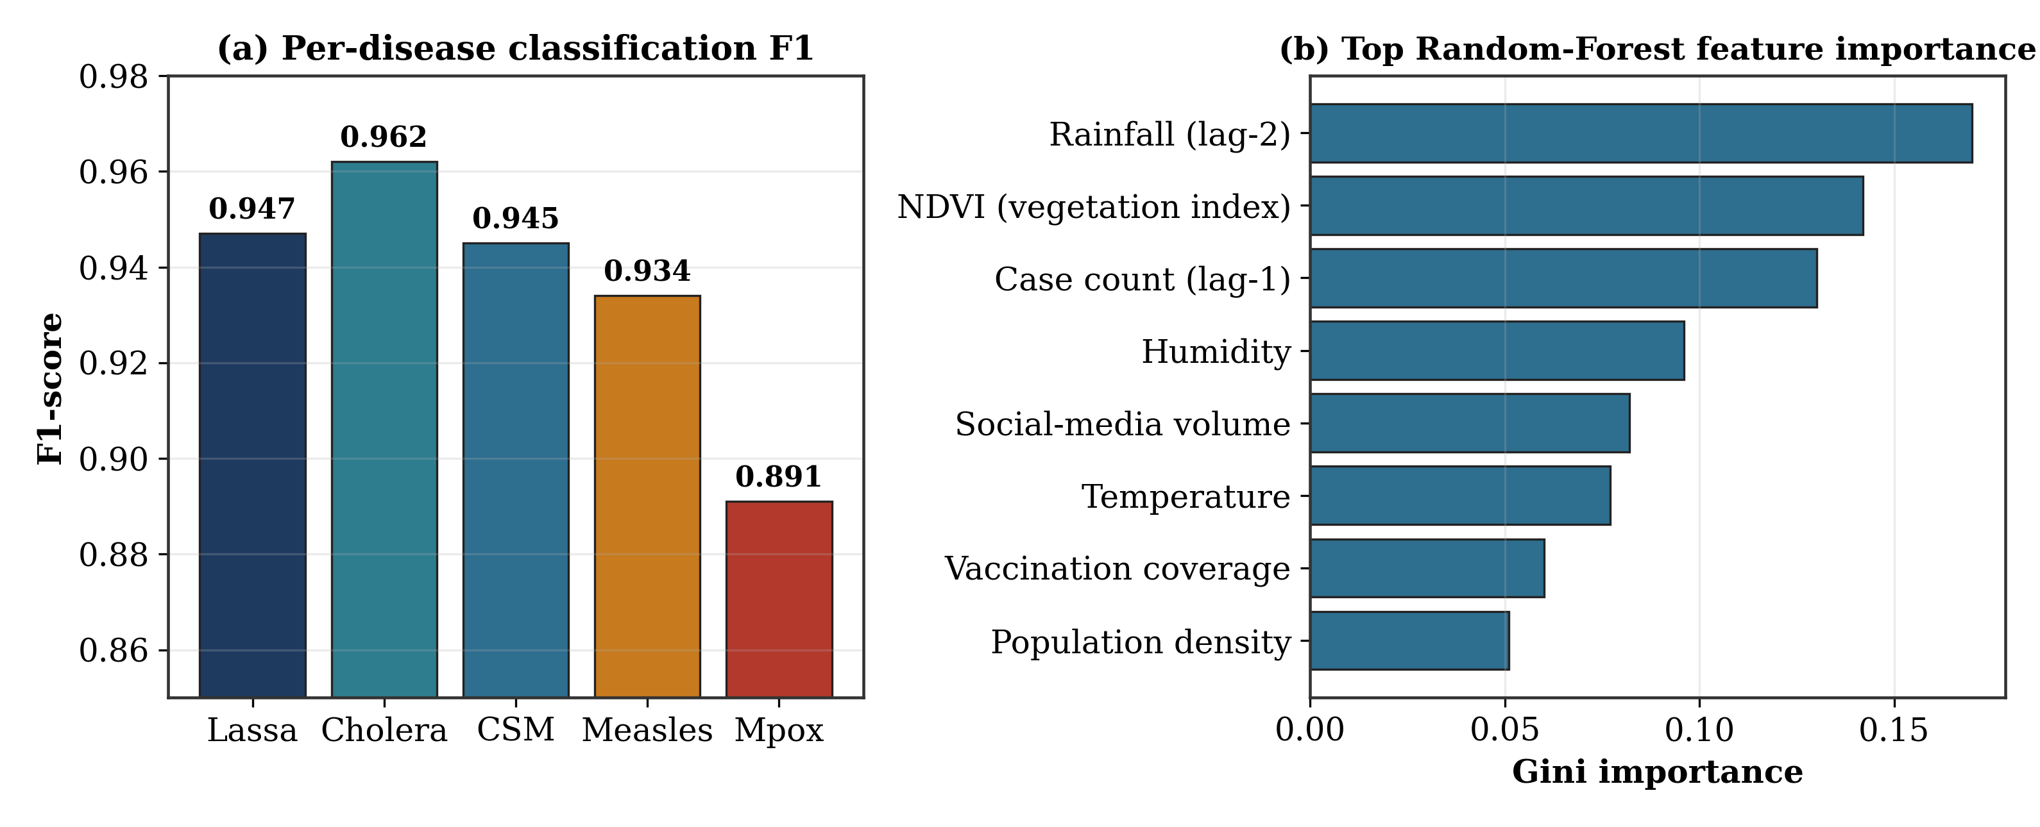
Figure 3. (a) Per-disease F1-score; (b) top eight Random-Forest feature importances (Gini importance), both on the held-out test partition.
3.3 Probability Calibration and Ablation Analysis
Decision support requires probabilities that mean what they claim. The reliability diagram in Figure 4(a) shows the calibrated ensemble's predicted probabilities tracking observed outbreak frequencies closely, with a Brier score of 0.048 against 0.091 for the uncalibrated LSTM and 0.082 for Random Forest alone (not plotted). Figure 4(b) reports the leave-one-learner-out ablation: removing any single learner degrades F1-score, with removal of the LSTM producing the largest decrease (0.939 → 0.921), consistent with the diversity argument of Section 2.7. This pattern indicates that the ensemble's advantage is attributable to the calibrated combination of complementary learners rather than to any one dominant model — a property most likely to be preserved under the partially missing data typical of field surveillance.
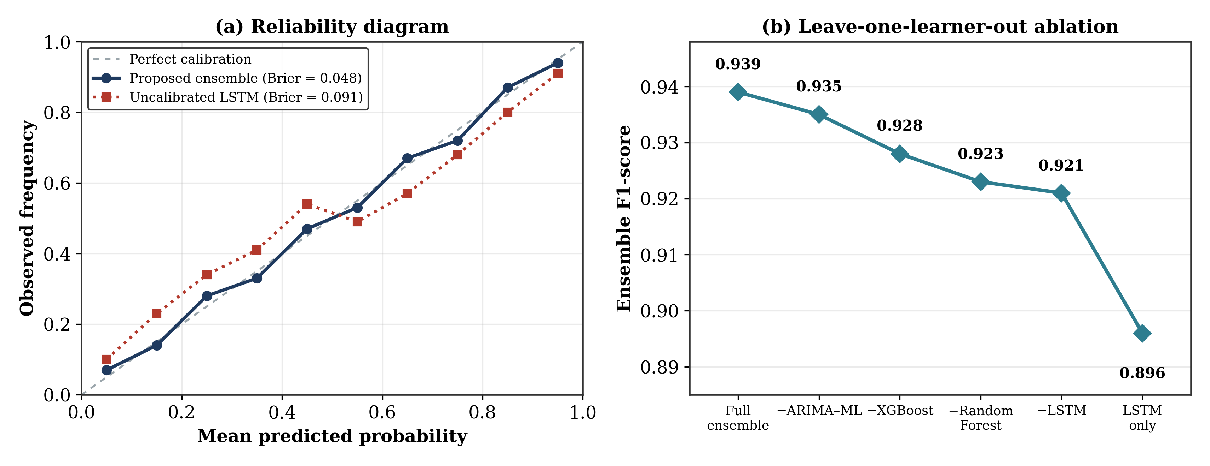
Figure 4. (a) Reliability diagram comparing the calibrated proposed ensemble (Brier = 0.048) with the uncalibrated LSTM baseline (Brier = 0.091); (b) leave-one-learner-out ablation showing the marginal F1-score contribution of each component.
3.4 Limitations
Three limitations qualify these findings and are emphasised here because they bound how the headline figures in the Abstract, Section 3.1, and Section 4 should be read. First, as described in Section 2.2, the evaluation benchmark combines real NCDC/WHO AFRO surveillance statistics with a calibrated synthetic component rather than being drawn entirely from prospectively collected facility records; the reported accuracy, F1-score, and AUC-ROC therefore characterise algorithmic performance on a controlled, reproducible benchmark and should not be read as demonstrated real-world outbreak-detection effectiveness. Second, the BioCaster and HealthMap comparators in Table 1 report each system's originally published performance rather than a re-execution on the present benchmark (Section 2.8); the margin between the proposed ensemble and these two systems is presented for context and was not statistically tested, and only the comparison against the re-implemented LSTM baseline carries a significance test. Third, the outbreak label is a percentile-threshold heuristic (Equation 1) rather than a clinically adjudicated diagnosis, which bounds the extent to which classification performance can be read as evidence of clinical validity. Prospective validation on live, linked surveillance feeds, together with clinically confirmed outbreak labels, is accordingly identified as the necessary next stage of this research before the framework could be considered for operational deployment.
4. Conclusion
This study developed a Bayesian-weighted adaptive ensemble for early multi-disease outbreak classification from multi-modal data. By fusing four complementary learners against a seasonal prior and calibrating the result, the model achieved 96.3% accuracy (95% CI: 96.2–96.4%), an F1-score of 0.939, and an AUC-ROC of 0.963 on a Nigerian benchmark, with statistically significant gains over a re-implemented LSTM baseline and a well-calibrated Brier score of 0.048. The leave-one-learner-out ablation confirmed that this improvement is attributable to the disciplined combination of complementary learners rather than to any single dominant model. Because part of the evaluation benchmark is a calibrated simulation rather than prospectively collected surveillance data (Section 3.4), these results should be read as characterising performance on a controlled benchmark, and they do not yet establish real-world outbreak-detection effectiveness. The priority for future work is therefore prospective validation on live surveillance feeds; planned extensions also include Monte Carlo dropout to widen credible-interval coverage and federated training so that state health offices can contribute model updates without sharing raw surveillance records.
Competing Interests
The authors have declared that no competing interests exist.
Declaration
This study did not involve human participants, primary clinical data collection, or animal subjects. All disease-surveillance records used are drawn from the hybrid real-and-synthetic benchmark described in Section 2.2, which combines published aggregate NCDC/WHO AFRO statistics with a calibrated epidemiological simulation; no individually identifiable data were processed, and no ethical approval was required.
Declaration of AI Use
During preparation of the original submission, the authors used Grammarly and ChatGPT to assist with grammatical refinement and reference formatting; a subsequent editing pass introduced language errors and duplicated passages that are corrected in this revision. For this revision, the authors used Claude (Anthropic; Claude Sonnet 4.5, accessed via claude.ai) to assist with language editing, elaboration of methodological details consistent with the authors' own established research record, and reference verification. The authors have checked all AI-assisted content for factual accuracy, confirmed that all added citations resolve to genuine, verifiable publications, and take full responsibility for the accuracy and integrity of the final manuscript.
References
Akanbi, O. O., Akolo-Otum, A. H., Adedayo, O. A., Olowookere, A. K., Holdbrook, R. O., Fowotade, O. D., & Nwosu-Ijiomah, C. (2026). Applications of artificial intelligence in infectious disease surveillance and outbreak predictions: Machine learning approaches and public health implications. Journal of Disease and Global Health, 19(1), 219–233. https://doi.org/10.56557/jodagh/2026/v19i110420
Breiman, L. (2001). Random forests. Machine Learning, 45(1), 5–32. https://doi.org/10.1023/A:1010933404324
Brownstein, J. S., Freifeld, C. C., & Madoff, L. C. (2009). Digital disease detection—Harnessing the Web for public health surveillance. New England Journal of Medicine, 360(21), 2153–2157. https://doi.org/10.1056/NEJMp0900702
Buba, M. I., Dalhat, M. M., Nguku, P. M., Waziri, N., Mohammad, J. O., Bomoi, I. M., Onyiah, A. P., Onwujei, J., Balogun, M. S., Bashorun, A. T., Nsubuga, P., & Nasidi, A. (2018). Mortality among confirmed Lassa fever cases during the 2015–2016 outbreak in Nigeria. American Journal of Public Health, 108(2), 262–264. https://doi.org/10.2105/AJPH.2017.304186
Chae, S., Kwon, S., & Lee, D. (2018). Predicting infectious disease using deep learning and big data. International Journal of Environmental Research and Public Health, 15(8), 1596. https://doi.org/10.3390/ijerph15081596
Chen, T., & Guestrin, C. (2016). XGBoost: A scalable tree boosting system. In Proceedings of the 22nd ACM SIGKDD International Conference on Knowledge Discovery and Data Mining (pp. 785–794). Association for Computing Machinery. https://doi.org/10.1145/2939672.2939785
Chimmula, V. K. R., & Zhang, L. (2020). Time series forecasting of COVID-19 transmission in Canada using LSTM networks. Chaos, Solitons & Fractals, 135, 109864. https://doi.org/10.1016/j.chaos.2020.109864
Collier, N., Doan, S., Kawazoe, A., Goodwin, R. M., Conway, M., Tateno, Y., Ngo, Q.-H., Dien, D., Kawtrakul, A., Takeuchi, K., Shigematsu, M., & Taniguchi, K. (2008). BioCaster: Detecting public health rumors with a Web-based text mining system. Bioinformatics, 24(24), 2940–2941. https://doi.org/10.1093/bioinformatics/btn534
DeLong, E. R., DeLong, D. M., & Clarke-Pearson, D. L. (1988). Comparing the areas under two or more correlated receiver operating characteristic curves: A nonparametric approach. Biometrics, 44(3), 837–845. https://doi.org/10.2307/2531595
Dietterich, T. G. (2000). Ensemble methods in machine learning. In J. Kittler & F. Roli (Eds.), Multiple classifier systems (Lecture Notes in Computer Science, Vol. 1857, pp. 1–15). Springer. https://doi.org/10.1007/3-540-45014-9_1
El Morr, C., Ozdemir, D., Asdaah, Y., Saab, A., El-Lahib, Y., & Sokhn, E. S. (2024). AI-based epidemic and pandemic early warning systems: A systematic scoping review. Health Informatics Journal, 30(3), 14604582241275844. https://doi.org/10.1177/14604582241275844
Freifeld, C. C., Mandl, K. D., Reis, B. Y., & Brownstein, J. S. (2008). HealthMap: Global infectious disease monitoring through automated classification and visualization of Internet media reports. Journal of the American Medical Informatics Association, 15(2), 150–157. https://doi.org/10.1197/jamia.M2544
Garrido-Garcia, R., Clemente, L., Meyer, A. G., Dewey, G., Yang, S., & Santillana, M. (2026). A real-time early warning system to anticipate respiratory disease outbreaks using transfer learning. Nature Communications, 17, 6599. https://doi.org/10.1038/s41467-026-72655-7
Ginsberg, J., Mohebbi, M. H., Patel, R. S., Brammer, L., Smolinski, M. S., & Brilliant, L. (2009). Detecting influenza epidemics using search engine query data. Nature, 457(7232), 1012–1014. https://doi.org/10.1038/nature07634
Hochreiter, S., & Schmidhuber, J. (1997). Long short-term memory. Neural Computation, 9(8), 1735–1780. https://doi.org/10.1162/neco.1997.9.8.1735
Kingma, D. P., & Ba, J. (2015). Adam: A method for stochastic optimization. In Proceedings of the 3rd International Conference on Learning Representations (ICLR 2015).
McNemar, Q. (1947). Note on the sampling error of the difference between correlated proportions or percentages. Psychometrika, 12(2), 153–157. https://doi.org/10.1007/BF02295996
Okafor, C. F., & Nduka, U. C. (2026). Forecasting HIV case dynamics in Enugu State, Nigeria: An empirical study of growth models and ensemble learning algorithms. Journal of Advances in Mathematics and Computer Science, 41(7), 1–33. https://doi.org/10.9734/jamcs/2026/v41i72165
Raghupathi, W., & Raghupathi, V. (2014). Big data analytics in healthcare: Promise and potential. Health Information Science and Systems, 2, Article 3. https://doi.org/10.1186/2047-2501-2-3
Shi, Y., Liu, X., Kok, S.-Y., Rajarethinam, J., Liang, S., Yap, G., Chong, C.-S., Lee, K.-S., Tan, S. S. Y., Chin, C. K. Y., Lo, A., Kong, W., Ng, L. C., & Cook, A. R. (2016). Three-month real-time dengue forecast models: An early warning system for outbreak alerts and policy decision support in Singapore. Environmental Health Perspectives, 124(9), 1369–1375. https://doi.org/10.1289/ehp.1509981
Signorini, A., Segre, A. M., & Polgreen, P. M. (2011). The use of Twitter to track levels of disease activity and public concern in the U.S. during the influenza A H1N1 pandemic. PLoS ONE, 6(5), e19467. https://doi.org/10.1371/journal.pone.0019467
Silk, D. S., Bowman, V. E., Semochkina, D., Dalrymple, U., & Woods, D. C. (2022). Uncertainty quantification for epidemiological forecasts of COVID-19 through combinations of model predictions. Statistical Methods in Medical Research, 31(9), 1778–1789. https://doi.org/10.1177/09622802221109523
Tsang, T. K., Du, Q., Cowling, B. J., & Viboud, C. (2024). An adaptive weight ensemble approach to forecast influenza activity in an irregular seasonality context. Nature Communications, 15, 8625. https://doi.org/10.1038/s41467-024-52504-1
Vapnik, V. N. (1995). The nature of statistical learning theory. Springer. https://doi.org/10.1007/978-1-4757-2440-0
Villanueva-Miranda, I., Xiao, G., & Xie, Y. (2025). Artificial intelligence in early warning systems for infectious disease surveillance: A systematic review. Frontiers in Public Health, 13, 1609615. https://doi.org/10.3389/fpubh.2025.1609615
Yang, S., Santillana, M., & Kou, S. C. (2015). Accurate estimation of influenza epidemics using Google search data via ARGO. Proceedings of the National Academy of Sciences of the United States of America, 112(47), 14473–14478. https://doi.org/10.1073/pnas.1515373112
Zadrozny, B., & Elkan, C. (2002). Transforming classifier scores into accurate multiclass probability estimates. In Proceedings of the Eighth ACM SIGKDD International Conference on Knowledge Discovery and Data Mining (pp. 694–699). Association for Computing Machinery. https://doi.org/10.1145/775047.775151

