Original Research Article

Optimization of Osmotic Dehydration Conditions for Pineapple Cubes Using Response Surface Methodology

ABSTRACT
Pineapple is a widely consumed tropical and subtropical non-citrus fruit because of its pleasant flavour, refreshing balance of sweetness and acidity, and high vitamin C content. The objective of this study was to optimise the osmotic dehydration conditions of pineapple cubes using Response Surface Methodology (RSM) by evaluating the effects of solution temperature, immersion time, and sucrose solution concentration on water loss (WL), weight reduction (WR), and solid gain (SG). A Central Composite Rotatable Design (CCRD) was employed with solution temperature ranging from 32 to 48°C, immersion time from 40 to 141 min, and sucrose solution concentration from 42 to 58 °Brix. A constant sample-to-solution ratio of 1:5 was maintained throughout the osmotic dehydration process. Quadratic regression models were developed for WL, WR, and SG, and all models were statistically significant (p < 0.001). Among the investigated process variables, immersion time had the greatest influence on all three responses, followed by sucrose solution concentration and solution temperature. Numerical optimisation was performed by maximising WL and WR while minimising SG. The optimum conditions were determined as a solution temperature of 45°C, an immersion time of 119 min, and a sucrose solution concentration of 55 °Brix. Under these optimum conditions, the experimentally validated WL, WR, and SG values were 22.30%, 10.70%, and 14.58%, respectively, with an overall desirability of 0.74. These results demonstrate that RSM can be effectively applied to identify suitable operating conditions for the osmotic dehydration of pineapple cubes within the investigated experimental range.
Keywords: Pineapple cubes; osmotic dehydration; response surface methodology; Central Composite Rotatable Design; water loss; weight reduction; solid gain; sucrose concentration; immersion time; solution temperature

- INTRODUCTION
Pineapple (Ananas comosus) is an important tropical fruit widely appreciated for its distinctive aroma, sweet taste, and nutritional value. It is also known as the queen of fruits due to its excellent flavour and taste (Chaudhary et al., 2019). It is considered one of the major tropical fruits in the international market and contains considerable amounts of nutrients, dietary fibre, minerals, vitamins, and various bioactive compounds. In addition to fresh consumption, pineapple has considerable potential for the development of processed and value-added food products (Ali et al., 2020). The high water content of fruit can lead to storage-life problems during processing. To address this problem, processing is necessary. Pineapple can be processed into various value-added products, such as concentrated juice, jam, syrup, wine, and dried pineapple. Food processing plays an important role in increasing the availability and useful life of food products by reducing food losses and waste. Therefore, food processing is one approach used to reduce postharvest losses, extend shelf life, enhance food security, increase income, and make pineapple products available year-round (Mogeni & Mogeni, 2025).
Osmotic dehydration (OD) is a partial dehydration process in which food material is immersed in a hypertonic solution, resulting in mass transfer between the food tissue and the surrounding solution. During the process, water moves from the food tissue into the osmotic solution, while solutes from the solution are simultaneously incorporated into the food. These mass-transfer phenomena are generally characterised by water loss (WL) and solid gain (SG) (Abrahão & Corrêa, 2023; Ahmed et al., 2016). Osmotic dehydration is commonly applied as a pretreatment prior to subsequent drying because partial removal of water can reduce the moisture load during further dehydration. Furthermore, the relatively mild processing conditions associated with osmotic dehydration can help minimise thermal damage and maintain desirable nutritional, physicochemical, and sensory characteristics of fruits and vegetables (Ahmed et al., 2016). The efficiency of osmotic dehydration and the resulting mass-transfer behaviour are influenced by several factors, including the characteristics and geometry of the food material, type and concentration of the osmotic agent, solution temperature, and treatment time (Ahmed et al., 2016). The concentration of the osmotic solution affects the driving force for mass transfer, while temperature and immersion time influence the rate and extent of water removal and solute incorporation. Consequently, appropriate control of these processing variables is important for obtaining sufficient water removal while limiting excessive solid uptake (Abrahão & Corrêa, 2023; Ahmed et al., 2016). Recent studies further indicate that osmotic solution concentration, process temperature, and treatment conditions influence water loss and solute uptake across plant tissues, underscoring the need for commodity-specific optimisation of mass transfer (Asghari et al., 2024; Konar & Das, 2025).
Response Surface Methodology (RSM) is a useful statistical approach for evaluating the simultaneous effects of multiple processing variables and their interactions and for determining suitable operating conditions. RSM, together with desirability-based optimisation, has been successfully applied to osmotic dehydration for modelling the effects of process variables and identifying optimum combinations of processing conditions (Giannakourou et al., 2020). Moreover, Meena et al. (2022) applied RSM to pineapple osmotic dehydration to evaluate the effects of osmotic solution concentration, treatment time, and temperature on mass-transfer responses and to determine optimum processing conditions. These findings demonstrate the suitability of RSM for analysing and optimising osmotic dehydration processes involving several interacting factors. In the present study, solution temperature, immersion time, and sucrose concentration were therefore selected as the principal independent variables. The experimental ranges of solution temperature (35-45°C), immersion time (60-120 min.), and sucrose solution concentration (45-55°Brix) were selected based on ranges previously reported for the osmotic dehydration of pineapple cubes, while providing sufficiently broad conditions to evaluate their individual and interactive effects on mass transfer (Sridevi & Genitha, 2012). For pineapple, sucrose-based osmotic dehydration has been shown to influence weight loss and solid gain (Manasa et al., 2022), while recent work has also examined osmotic dehydration as a pretreatment in subsequent pineapple drying processes (Yan et al., 2025). Accordingly, within the experimental context of this study, the simultaneous trade-off between increasing water loss and weight reduction and limiting solid gain across the selected temperature, immersion-time, and sucrose-concentration ranges remains to be established.
The objectives of this study are to investigate the effects of solution temperature, immersion time and sucrose solution concentration on water loss, weight reduction and solid gain during the osmotic dehydration of pineapple cubes and to determine the optimum combination of solution temperature, immersion time, and sucrose solution concentration using response surface methodology. The optimisation aimed to maximise water loss (WL) and weight reduction (WR) while minimising solid gain (SG). Since these responses were optimised simultaneously, the optimum condition was determined based on a compromise among the three responses rather than on the minimum possible solid gain alone.

2. MATERIALS AND METHODS
2.1 Materials
Uniformly mature, locally grown pineapple fruits were obtained from Seik Khaung Village, Hsihseng Township, Southern Shan State. The fruits were harvested approximately 165 days after flowering. Fruit maturity was assessed based on total soluble solids (TSS), pH, and titratable acidity. The initial TSS, pH, and acidity of the fresh pineapple fruits were 14.06 ± 0.45 °Brix, 3.68 ± 0.09, and 0.98 ± 0.05%, respectively. The initial moisture content was 87.11 ± 1.23%. One pineapple fruit was used for each experimental batch, and a total of twenty fruits (n = 20) were used in the study. For each experimental run, a 100 g portion of pineapple cubes was used for the osmotic dehydration process.

2.2 Preparation of Osmotic Solution
The osmotic solutions (42-58 °Brix) were prepared by dissolving the required amount of food-grade fresh refined sugar in distilled water on a weight-to-weight (w/w) basis. The sample-to-solution ratio was maintained at 1:5. The total soluble solids (°Brix) content of each prepared solution was measured using a digital refractometer.

2.3 Osmotic Dehydration of Pineapple Cubes
The pineapples were peeled and cut into cubes (15 × 15 × 15) mm³ (Kumar et al., 2021). The prepared samples were subjected to osmotic dehydration according to the experimental conditions (Table 2). During osmotic dehydration, the required temperature was maintained using a constant-temperature water bath. The sample-to-solution ratio was maintained at 1:5 (w/w) throughout the osmotic dehydration experiments, consistent with ratios previously employed for the osmotic dehydration of pineapple (Zahoor & Khan, 2017). Fresh osmotic solution was used for each experimental run to minimise changes in solution concentration due to dilution during mass transfer. After osmotic dehydration, the samples were removed from the solution and quickly rinsed with water. The excess water on the surface of the samples was gently removed using tissue paper. The samples were then dried in a hot-air oven at 70 °C for 18 hr. to determine the dry matter content. After oven drying, the samples were cooled in a desiccator and then packed in low-density polyethylene (LDPE). All experiments were carried out in duplicate, and the average values were used for subsequent calculations.

2.4 Determination of Rate of Mass Transfer
2.4.1 Determination of Water Loss
The mass transfer parameters, i.e., water loss (WL), weight reduction (WR), and solid gain (SG), were calculated using the equations reported by Sridevi and Genitha (2012).
$$WL (\%) = \frac{[(W₀ - Wₜ) + (Sₜ - S₀)]}{W₀} × 100$$
Where,
W₀ = initial weight of the sample (g)
Wₜ = weight of the sample after osmotic dehydration at time t (g)
S₀ = initial dry matter of the sample (g)
Sₜ = dry matter of the sample after osmotic dehydration at time t (g)
(Sridevi & Genitha, 2012)
2.4.2 Determination of Weight Reduction
$$WR (\%) = \frac{(W₀ - Wₜ)}{W₀} × 100$$
Where,
W₀ = initial weight of the sample (g)
Wₜ = weight of the sample after osmotic dehydration at time t (g)
(Sridevi & Genitha, 2012)
2.4.3 Determination of Solid Gain
$$SG (\%) = \frac{(Sₜ - S₀)}{W₀} × 100$$
Where,
S₀ = initial dry matter of the sample (g)
Sₜ = dry matter of the sample after osmotic dehydration at time t (g)
W₀ = initial weight of the sample (g)
(Sridevi & Genitha, 2012)
2.5 Statistical Analysis and Optimisation
The effects of three independent variables, namely solution temperature, immersion time, and sucrose solution concentration, on water loss, weight reduction, and solid gain were investigated. The optimisation was performed using Design-Expert software (Version 12.0, Stat-Ease Inc., Minneapolis, MN, USA) based on a Central Composite Rotatable Design (CCRD) with three factors at five levels. The factorial levels were set at 35-45 °C for solution temperature, 60-120 min. for immersion time and 45-55 °Brix for sucrose solution concentration. The design also included axial (±α) points, which extended the experimental ranges to 32-48 °C, 40-141 min. and 42-58 °Brix for solution temperature, immersion time, and sucrose solution concentration, respectively (Table 1). A total of twenty experimental runs were generated using the CCRD and conducted in random order (Table 2). Water loss, weight reduction and solid gain were considered as the response variables. The experimental data were fitted to a second-order polynomial regression model using the least-squares method to predict each response (Y). The quadratic polynomial equation used for the model was expressed as:
Y = a₀ + a₁A + a₂B + a₃C + a₁₁A² + a₂₂B² + a₃₃C² + a₁₂AB + a₁₃AC + a₂₃BC + ε
where Y represents the response variables, including water loss, weight reduction, and solid gain; a₀ is the intercept; and A, B, and C represent the independent variables; a₁, a₂, and a₃ are the linear coefficients; a₁₁, a₂₂, and a₃₃ are the quadratic coefficients; a₁₂, a₁₃, and a₂₃ are the interaction coefficients; and ε represents the random error.
The model was used to evaluate the linear, quadratic and interaction effects of the independent variables on each response. Multiple regression analysis was performed to determine the effects of the process variables on the responses. A quadratic model containing linear, squared and interaction terms was initially fitted to the experimental data. Analysis of variance (ANOVA) was used to evaluate the statistical significance of the model terms, and terms with a probability value (P-value) of less than 0.05 were considered statistically significant. The adequacy of the developed models was evaluated using the coefficient of determination (R²), adjusted R² and predicted R². After fitting the models, residual analysis was also performed to examine the assumptions associated with ANOVA. The desirability function approach was used to determine the optimum processing conditions by maximising water loss and weight reduction while minimising solid gain. The fitted response surfaces and optimisation results were generated using Design-Expert software. Validation experiments were conducted separately from the CCRD experimental runs using the predicted optimum processing conditions. The observed values for water loss, weight reduction, and solid gain were compared with their corresponding predicted values to evaluate the adequacy of the developed quadratic models.

Table 1: Process Variables and their levels of experimental design
Symbol  (Factor Levels) | Independent Variables | Coded Levels
Symbol  (Factor Levels) | Independent Variables | -α | -1 | 0 | +1 | +α
X₁ | Solution temperature (℃) | 32 | 35 | 40 | 45 | 48
X₂ | Immersion time (min.) | 40 | 60 | 90 | 120 | 141
X₃ | Sucrose solution Concentration (ºBrix) | 42 | 45 | 50 | 55 | 58
(Sridevi & Genitha, 2012)
Table 2: Observed values of dependent variables for different runs of optimization process
 | Coded Values |  |  | Actual Values
Run No. | X₁ | X₂ | X₃ | X₁ | X₂ | X₃
1 | (0) | (0) | (0) | 40 | 90 | 50
2 | (0) | (0) | (0) | 40 | 90 | 50
3 | (0) | (0) | (0) | 40 | 90 | 50
4 | (0) | (0) | (0) | 40 | 90 | 50
5 | (0) | (0) | (0) | 40 | 90 | 50
6 | (0) | (0) | (0) | 40 | 90 | 50
7 | (–1) | (+1) | (–1) | 35 | 120 | 45
8 | (0) | (0) | (– α) | 40 | 90 | 42
9 | (0) | (-α) | (0) | 40 | 40 | 50
10 | (+α) | (0) | (0) | 48 | 90 | 50
11 | (–1) | (-1) | (+1) | 35 | 60 | 55
12 | (+1) | (+1) | (+1) | 45 | 120 | 55
13 | (–1) | (-1) | (-1) | 35 | 60 | 45
14 | (– α) | (0) | (0) | 32 | 90 | 50
15 | (+1) | (-1) | (+1) | 45 | 60 | 55
16 | (0) | (+α) | (0) | 40 | 141 | 50
17 | (0) | (0) | (+α) | 40 | 90 | 58
18 | (–1) | (+1) | (+1) | 35 | 120 | 55
19 | (+1) | (+1) | (–1) | 45 | 120 | 45
20 | (+1) | (–1) | (–1) | 45 | 60 | 45

3. Results and Discussion
3.1 Effect of Temperature, Time and Concentration on Water Loss
Water loss ranged from 10.50% to 24.10% during the osmotic dehydration process (Table 3). Table 4 presents the regression analysis of the developed process model for the response; the quadratic model was significant (p < 0.001). The relative influence of the process variables on water loss (WL) was quantitatively assessed based on the F-values obtained from ANOVA. Among the linear terms, immersion time (B) showed the strongest effect on WL (F = 157.41, p < 0.001), followed by sucrose concentration (C) (F = 56.62, p < 0.001) and solution temperature (A) (F = 10.32, p = 0.0093). Thus, the relative influence of the process variables on WL followed the order: immersion time, sucrose solution concentration and solution temperature. These results demonstrate that immersion time was the dominant linear factor affecting water loss within the experimental range investigated. The water loss (WL) obtained in the present study ranged from 10.50 to 24.10%, which was comparable to the values reported for osmotically dehydrated pineapple slices under similar processing conditions. Chaudhary et al. (2018) reported WL values of 11.89 and 25.50% after 30 and 60 min., respectively, at 45°C and 50 °Brix sucrose concentration. At 60 °Brix, WL values of 17.50 and 28.06% were obtained after 30 and 60 min., respectively. The comparable WL values support the present findings, while the differences may be attributed to variations in sample dimensions, immersion time, and sucrose concentration.
The interaction terms AB (solution temperature and immersion time), AC (solution temperature and sucrose solution concentration), and BC (immersion time and sucrose solution concentration) were not statistically significant (p > 0.05), with p-values of 0.8970, 0.3987, and 0.0954, respectively, indicating that the interaction effects did not significantly influence WL. Among the quadratic terms, B² (immersion time) and C² (sucrose concentration) were highly significant (p < 0.001 and p = 0.009, respectively), whereas A² (temperature) was not significant (p=0.1530). These results indicate significant curvature in the response of water loss mainly with respect to immersion time and sucrose concentration.
The lack of fit was non-significant (p=0.0706), indicating that the model adequately represented the experimental data (Table 4). The coefficient of determination (R²) of 0.9685 indicated that 96.85% of the variability in water loss was explained by the fitted quadratic model. The adjusted R² value of 0.9402 further indicated a good fit of the model after accounting for the number of model terms. The predicted R² value of 0.7953 was in reasonable agreement with the adjusted R², as the difference between the two values was less than 0.20. In addition, the coefficient of variation (CV = 7.18%) indicated acceptable precision and reliability of the experimental data (Table 4). The estimated regression coefficients of the quadratic model are presented in Table 5. The optimisation goal was set to maximise the response within the observed range of 10.50-24.10% (Table 6). The quadratic regression equation describing the relationship between the independent variables and water loss (WL) in terms of coded factors is given as follows:
WL = 11.82 + 0.9032 A +3.53 B+ 2.12 C + 0.049 AB - 0.324 AC + 0.676 BC + 0.4232 A² + 2.18 B ² +1.28 C ²
where WL represents water loss (%), while A, B, and C are the coded factors representing solution temperature, immersion time, and sucrose solution concentration, respectively.
Figure 1(a) shows the effects of solution temperature and immersion time on water loss at a fixed sucrose solution concentration of 50 °Brix. Water loss generally increased with increasing immersion time, while solution temperature showed a smaller effect. Figure 1(b) illustrates the effects of solution temperature and sucrose solution concentration at a fixed immersion time of 90 min. Figure 1(c) shows the effects of immersion time and sucrose solution concentration at a fixed temperature of 40 °C. The response surface plots showed that water loss increased with increasing immersion time and sucrose solution concentration. None of the two-factor interaction terms (AB, AC, and BC) was statistically significant (p > 0.05). However, curvature was evident in the response surfaces, mainly due to the significant quadratic effects of immersion time (B²,p<0.001) and sucrose solution concentration (C², p = 0.009).

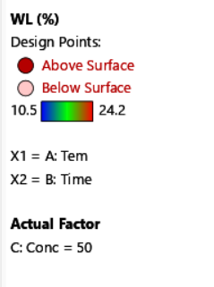
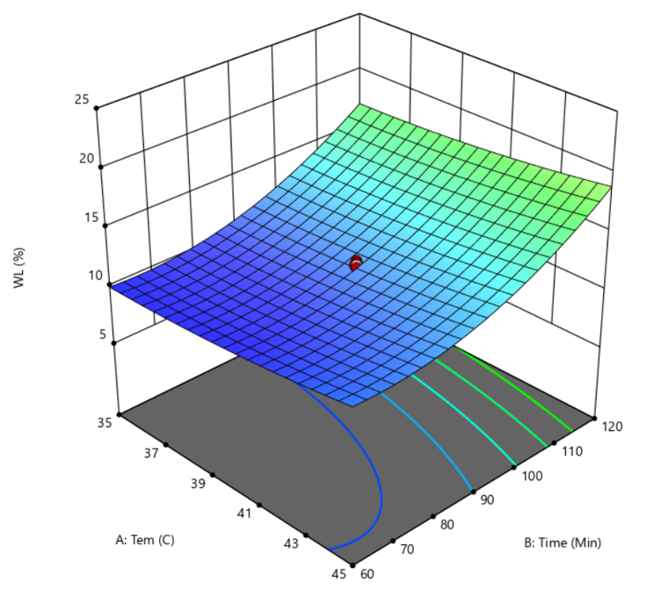

Figure (1) (a) Effect of Solution temperature and immersion time on water loss at a fixed concentration of 50 °Brix

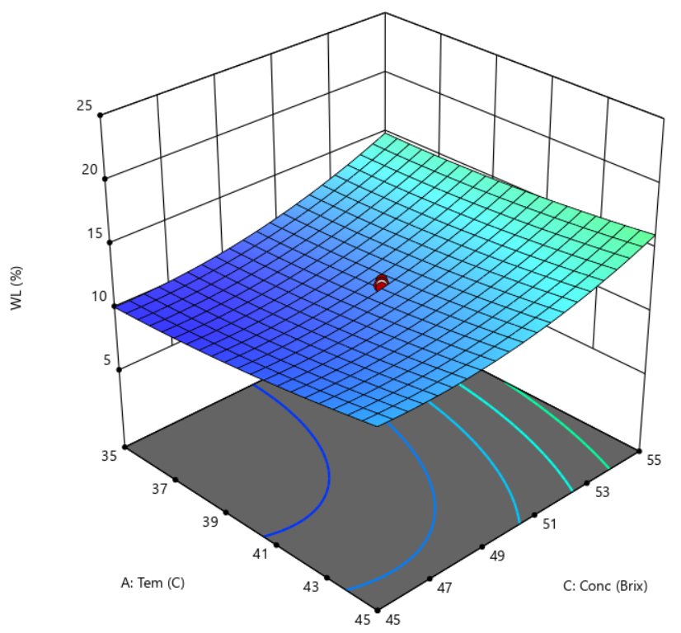
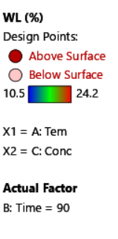

Figure (1) (b) Effect of solution temperature and sucrose solution concentration on water loss at a fixed time of 90 min.
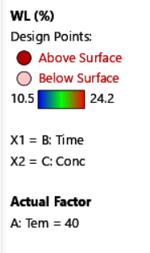
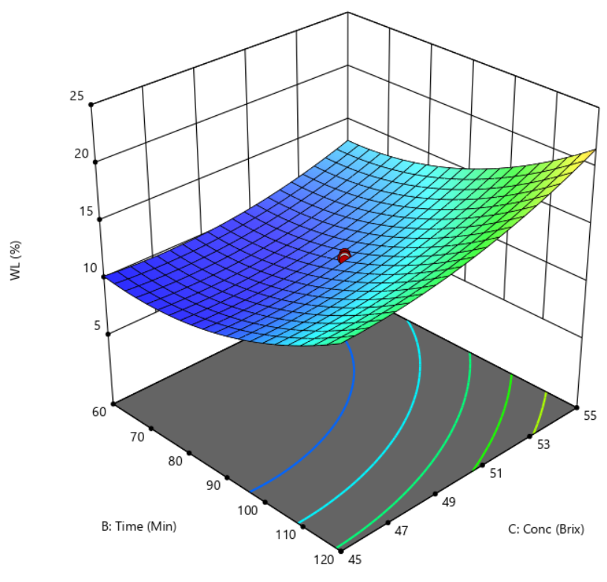

Figure (1) (c) Effect of immersion time and sucrose solution concentration on water loss at a
fixed solution temperature of 40 ℃

3.2 Effect of Temperature, Time and Concentration on Weight Reduction (WR)
The weight reduction of osmotically dehydrated pineapple cubes ranged from 3.20% to 11.31% (Table 3). The regression analysis of the developed process model and response is presented in Table 4. The quadratic model was highly significant (F=168.52, p<0.001), indicating that the fitted model adequately described the effect of the process variables on weight reduction (Table 4). The relative influence of the process variables on WR was quantitatively assessed based on the F-values obtained from ANOVA. Among the linear terms, immersion time (B) exhibited the strongest effect on WR (F = 783.15, p < 0.001), followed by sucrose solution concentration (C) (F = 409.05, p < 0.001) and solution temperature (A) (F=13.40, p = 0.0044). Thus, within the experimental range investigated, the relative influence of the process variables on WR followed the order: immersion time, sucrose solution concentration and solution temperature. These results demonstrate that immersion time was the dominant linear factor affecting weight reduction. The weight reduction (WR) obtained in the present study ranged from 3.20 to 11.31%. Comparable WR values have been reported for osmotically dehydrated pineapple slices. Chaudhary et al. (2018) reported a minimum weight reduction of 6.66% under a relatively mild osmotic treatment, while WR increased to 35.0% at 45°C, 60 °Brix, and 180 min. The lower weight reduction range observed in the present study may be associated with the lower sucrose concentration (45-55 °Brix) and shorter immersion time (60-120 min) compared with the more intensive conditions used in that study.
Among the two-factor interaction terms, the interaction between immersion time and sucrose solution concentration (BC) was statistically significant (F=7.45, p =0.0212), whereas the interactions between solution temperature and immersion time (AB) and between solution temperature and sucrose solution concentration (AC) were not statistically significant (p > 0.05). The significant BC interaction indicates that the effect of immersion time on WR depended partly on the sucrose solution concentration. Significant quadratic effects were also observed for immersion time (B²) (F=208.95, p < 0.001) and sucrose solution concentration (C²) (F =122.22, p < 0.001), whereas the quadratic effect of solution temperature (A²) was not significant (p=0.2301). Therefore, the curvature observed in the response surfaces was mainly associated with immersion time and sucrose solution concentration.
The lack of fit was non-significant (p=0.0820), indicating that the fitted quadratic model adequately represented the experimental data (Table 4). The coefficient of determination (R²) of 0.9934 indicated that 99.34% of the variability in WR was explained by the fitted quadratic model. The adjusted R² value of 0.9876 further indicated a good model fit after accounting for the number of model terms. The predicted R² value of 0.9585 was in reasonable agreement with the adjusted R², with a difference of only 0.0291. In addition, the coefficient of variation (CV=4.81%) indicated good precision and reliability of the experimental data (Table 4). The optimisation goal was set to maximise the response within the observed range of 3.20-11.31% (Table 6). The relationship between solution temperature, immersion time, and sucrose solution concentration was described by the following second-order polynomial regression equation in terms of coded factors:
WR = 4.58 + 0.2835 A +2.17 B+ 1.57 C + 0.0287 AB - 0.0262 AC + 0.2762 BC + 0.0964 A ² + 1.09 B ² +0.8335 C ²
where WR represents weight reduction (%), while A, B, and C are the coded factors representing solution temperature, immersion time, and sucrose solution concentration, respectively.
Figure 2 (a) shows the effects of solution temperature and immersion time at a fixed sucrose concentration of 50°Brix. Figure 2 (b) illustrates the effects of solution temperature and sucrose solution concentration at a fixed immersion time of 90 min. Figure 2 (c) presents the effects of immersion time and sucrose concentration at a fixed temperature of 40°C. Weight reduction increased mainly with increasing immersion time and sucrose solution concentration. Immersion time showed the greatest positive effect (B=2.17), followed by sucrose solution concentration (C=1.57) and solution temperature (A=0.2835). A significant interaction between immersion time and sucrose solution concentration (BC, p=0.0212) was observed, indicating that the effect of immersion time on weight reduction depended partly on sucrose solution concentration. The AB and AC interactions were not significant (p>0.05). Significant quadratic effects of B² and C² (p < 0.001) contributed to the curvature of the response surfaces. Higher weight reduction was observed at longer immersion times and higher sucrose solution concentrations.

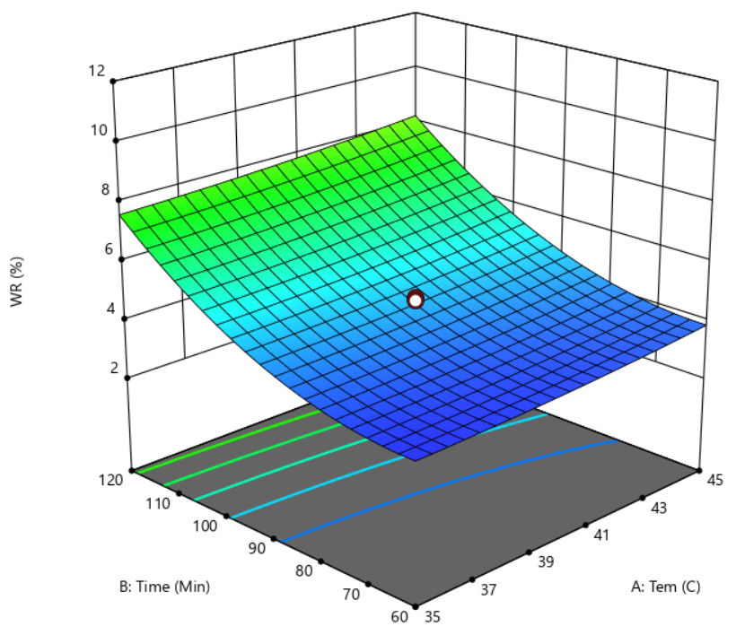
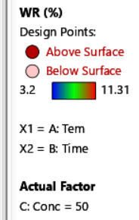

Figure (2) (a) Effect of Solution temperature and immersion time on weight reduction at a fixed concentration of 50 °Brix
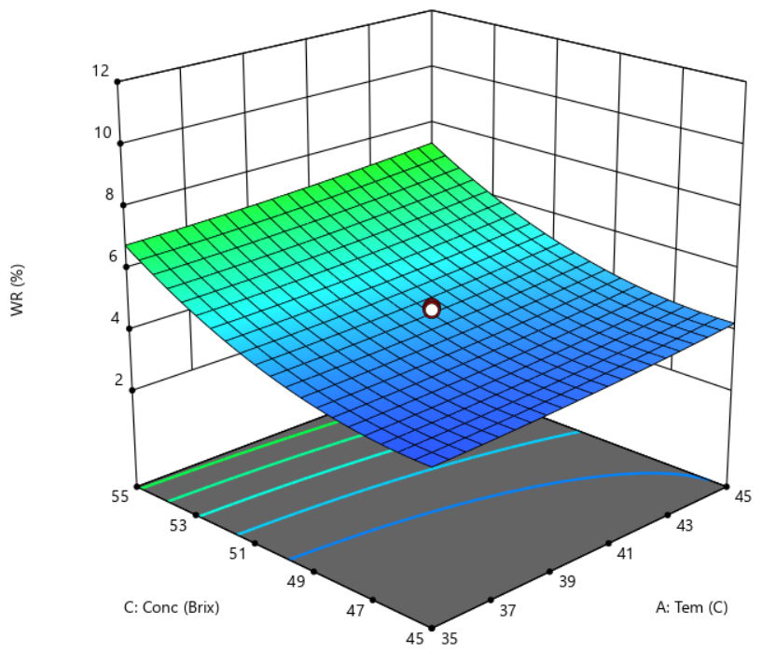
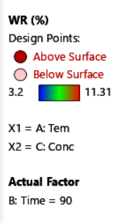

Figure (2) (b) Effect of sucrose solution concentration and solution temperature on weight reduction at a fixed time of 90 min.
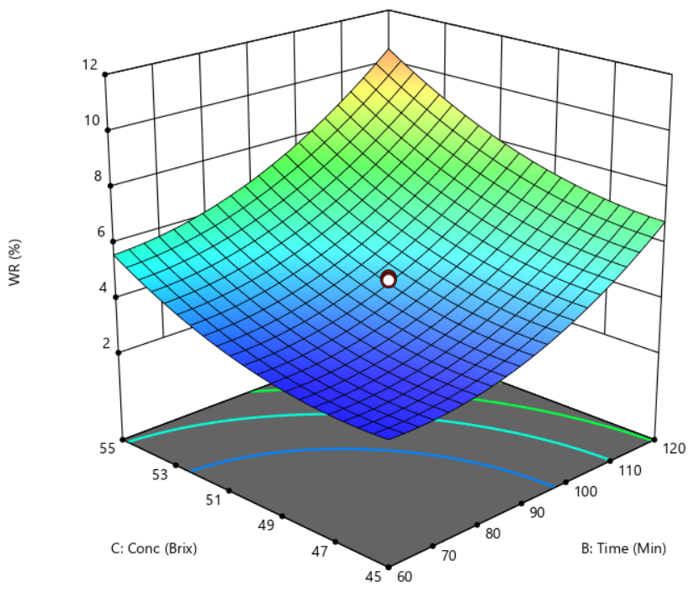
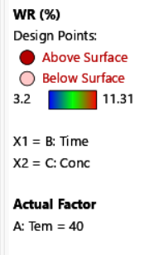

Figure (2) (c) Effect of sucrose solution concentration and immersion time on weight reduction at a fixed solution temperature of 40 ℃
3.3 Effect of Temperature, Time and Concentration on Solid Gain (SG)
The solid gain of osmotically dehydrated pineapple cubes ranged from 7.52% to 16.50% (Table 3). The quadratic model developed for solid gain (SG) was significant (F = 26.14, p < 0.001) (Table 4). The relative influence of the process variables on SG was quantitatively assessed based on the F-values obtained from ANOVA. Among the linear terms, immersion time (B) exhibited the strongest effect on SG (F =123.56, p < 0.001), followed by sucrose solution concentration (C) (F = 29.81, p = 0.003) and solution temperature (A) (F=5.18, p = 0.046). Thus, within the experimental range investigated, the relative influence of the process variables on SG followed the order: immersion time, sucrose solution concentration and solution temperature. These results demonstrate that immersion time was the dominant linear factor affecting solid gain. The solid gain (SG) values obtained in the present study were comparable with those reported in previous studies on osmotic dehydration of pineapple. Chaudhary et al. (2018) reported SG values ranging from 5.22 to 17.50% for pineapple slices treated at 45°C with 50 and 60 °Brix sucrose solutions for 30–180 min. At 50 °Brix, SG increased from 5.22% at 30 min. to 10.50, 13.72, and 15.23% at 60, 90, and 120 min., respectively, demonstrating the progressive increase in solute uptake with immersion time. Similarly, Sridevi and Genitha (2012) reported an SG of 13.36% at the optimised conditions of 38.2°C, 128.7 min, and 44.05 °Brix during osmotic dehydration of pineapple. Tippanna et al. (2019) also reported a solid gain of 16.39% for pineapple slices treated with a 60 °Brix sucrose solution. These reported values are generally comparable with the SG obtained in the present study, while differences among studies may be attributed to variations in sucrose concentration, immersion time, solution temperature, sample dimensions, solution-to-sample ratio, and fruit characteristics.
None of the two-factor interaction terms (AB, AC and BC) was statistically significant at the 5% level (p>0.05). Although the BC interaction approached significance (p=0.0652), it remained above the significance threshold of 0.05 and was therefore considered non-significant. Significant quadratic effects were observed for immersion time (B²) (F=62.16, p<0.001) and sucrose solution concentration (C²) (F=14.39, p=0.0035), whereas the quadratic effect of solution temperature (A²) was not significant (p=0.1412). Therefore, the curvature observed in the response surfaces was mainly associated with immersion time and sucrose solution concentration.
The lack of fit was non-significant (F = 4.62, p = 0.0592), indicating that the fitted quadratic model adequately represented the experimental data (Table 4). The coefficient of determination (R²) of 0.9592 indicated that 95.92% of the variability in SG was explained by the fitted quadratic model. The adjusted R² value of 0.9225 further indicated a good model fit after accounting for the number of model terms. The predicted R² value of 0.7345 was in reasonable agreement with the adjusted R², as the difference between the two values was 0.1880, which was less than 0.20. In addition, the coefficient of variation (CV = 7.59%) indicated acceptable precision and reliability of the experimental data (Table 4). The optimisation goal was set to minimise the response within the observed range of 7.52-16.50% (Table 6). The relationship between solution temperature, immersion time, and sucrose solution concentration was described by the following second-order polynomial regression equation in terms of coded factors:
SG = 8.14 + 0.4650A +2.27 B+ 1.12 C – 0.0775AB – 0.2225 AC + 0.5525 BC + 0.3177 A ² + 1.57 B ² + 0.7543 C ²
where SG represents solid gain (%), while A, B, and C are the coded factors representing solution temperature, immersion time, and sucrose solution concentration, respectively
​ Figure 3 (a) shows the effects of solution temperature and immersion time at a fixed sucrose concentration of 50 °Brix. Solid gain was mainly influenced by immersion time, while solution temperature showed a smaller effect. Figure 3 (b) illustrates the effects of solution temperature and sucrose solution concentration at a fixed immersion time of 90 min., showing a greater effect of sucrose solution concentration than temperature on solid gain. Figure 3 (c) presents the effects of immersion time and sucrose solution concentration at a fixed temperature of 40°C. Solid gain increased predominantly with increasing immersion time and sucrose solution concentration. Immersion time had the greatest positive effect (B = 2.27), followed by sucrose solution concentration (C = 1.12) and solution temperature (A = 0.4650). None of the two-factor interactions (AB, AC, and BC) was statistically significant (p > 0.05). The curvature observed in the response surfaces was mainly associated with the significant quadratic effects of immersion time (B², p < 0.001) and sucrose solution concentration (C², p = 0.0035). The increase in solid gain may be attributed to greater solute penetration into the pineapple tissue with longer immersion time and higher sucrose concentration.

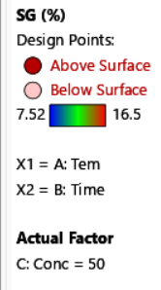
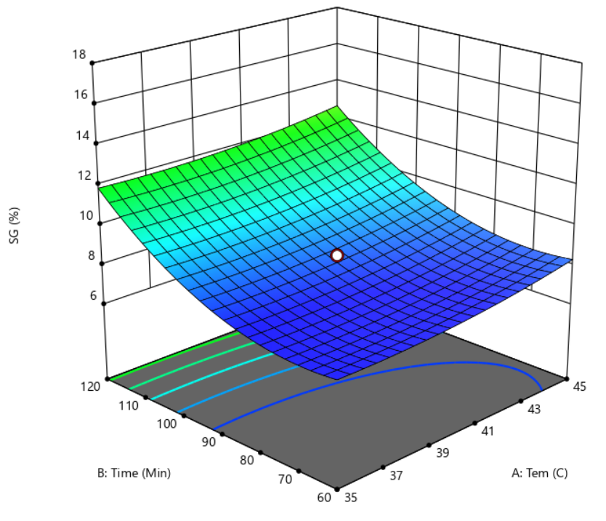

.

Figure (3) (a) Effect of immersion time and solution temperature on solid gain at a fixed concentration of 50 °Brix

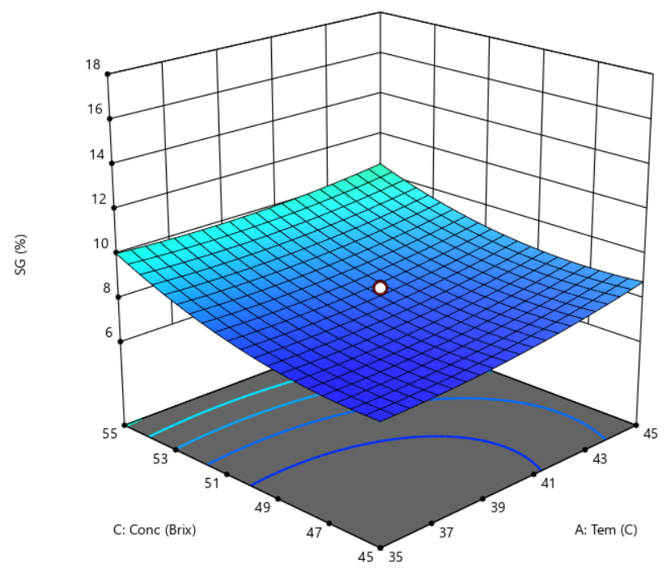
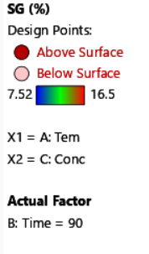

Figure (3) (b) Effect of sucrose solution concentration and solution temperature on solid gain at a fixed time of 90 min.
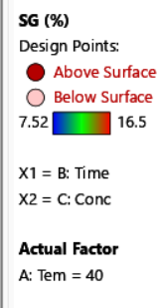
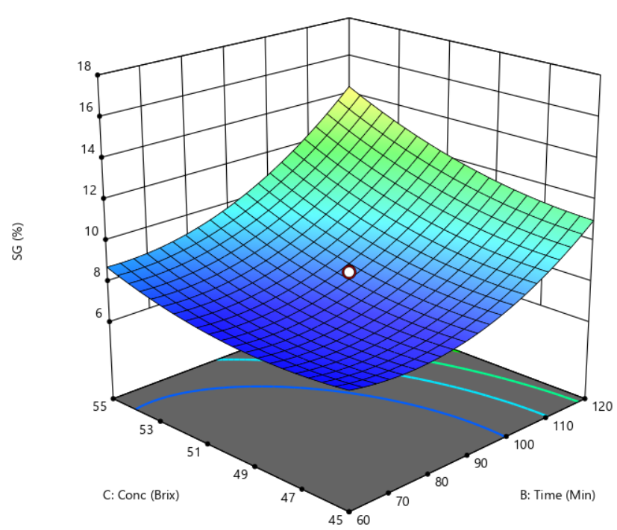

Figure (3) (c) Effect of sucrose solution concentration and immersion time on solid gain at a fixed solution temperature of 40 ℃
Table 3. Effect of different osmotic dehydration conditions and responses of osmotically dehydrated pineapple cubes according to central composite rotatable design
Run No. | Independent Variables |  |  | Dependent Variables
Run No. | Factor A  Temperature (℃) | Factor B  Time (min.) | Factor C  Conc:  (˚B) | Water Loss  (%) | Weight Reduction  (%) | Solid Gain  (%)
1 | 40 | 90 | 50 | 12.10 | 4.70 | 8.50
2 | 40 | 90 | 50 | 12.50 | 4.30 | 8.60
3 | 40 | 90 | 50 | 11.60 | 4.80 | 7.60
4 | 40 | 90 | 50 | 12.30 | 4.50 | 8.60
5 | 40 | 90 | 50 | 10.70 | 4.70 | 8.60
6 | 40 | 90 | 50 | 11.90 | 4.50 | 7.80
7 | 35 | 120 | 45 | 16.00 | 6.78 | 11.20
8 | 40 | 90 | 42 | 10.58 | 4.10 | 7.59
9 | 40 | 40 | 50 | 10.67 | 3.80 | 7.59
10 | 48 | 90 | 50 | 14.40 | 5.59 | 9.50
11 | 35 | 60 | 55 | 13.99 | 5.70 | 9.48
12 | 45 | 120 | 55 | 22.50 | 10.70 | 14.9
13 | 35 | 60 | 45 | 10.50 | 3.20 | 7.90
14 | 32 | 90 | 50 | 10.50 | 3.90 | 7.52
15 | 45 | 60 | 55 | 14.10 | 5.90 | 9.70
16 | 40 | 141 | 50 | 24.10 | 11.31 | 16.50
17 | 40 | 90 | 58 | 19.20 | 9.56 | 11.90
18 | 35 | 120 | 55 | 21.00 | 10.49 | 14.50
19 | 45 | 120 | 45 | 17.60 | 7.20 | 12.00
20 | 45 | 60 | 45 | 13.10 | 3.40 | 11.15
Table 4. Analysis of variance for the fit of experimental data to the quadratic model
Factors | Water loss (%) | Weight reduction (%) | Solid gain (%)
Model F- value | 34.18*** | 168.52*** | 26.14***
Model P- value | < 0.001 | <0 .001 | < 0.001
Lack of Fit (P value) | 0.071 ^{ns} | 0.082 ^{ns} | 0.0592 ^{ns}
R² | 0.9685 | 0.9934 | 0.9592
Adjusted R² value | 0.9402 | 0.9876 | 0.9225
Predicted R² value | 0.7953 | 0.9585 | 0.7345
CV % | 7.18 | 4.81 | 7.59
* - significant at probability level at 5% level; ** - significant at probability level at 1% level; *** - significant at probability level at 0.01% level; ns - non-significant R² = coefficient of determination; CV % = coefficient of variation
Table 5. Estimated regression coefficients of the fitted quadratic models
Model term | Water loss (%) | Weight reduction (%) | Solid Gain (%)
Intercept | 11.82 | 4.58 | 8.14
Tem (A) | 0.9032 | 0.2835 | 0.4650
Time (B) | 3.53 | 2.17 | 2.27
Conc (C) | 2.12 | 1.57 | 1.12
AB | 0.0487 | 0.0287 | -0.0775
AC | -0.3238 | -0.0262 | -0.2225
BC | 0.6762 | 0.2762 | 0.5525
A² | 0.4232 | 0.0964 | 0.3177
B² | 2.18 | 1.09 | 1.57
C² | 1.28 | 0.8335 | 0.7543
Table 6. Goal and important factor and response variables for determining optimum osmotic dehydration conditions
Factor/response | Goal | Importance | Lower limit | Upper limit | Optimum value
Factor
Temperature (°C) | In range | +++ | 35 | 45 | 45
Immersion time (min) | In range | +++ | 60 | 120 | 119
Concentration (ºB) | In range | +++ | 45 | 55 | 55
Response
Water loss (%) | Maximum | +++ | 10.50 | 24.10 | 22.25
Weight reduction (%) | Maximum | +++ | 3.20 | 11.31 | 10.68
Solid Gain (%) | Minimum | +++ | 7.52 | 16.50 | 14.60
Desirability |  |  |  |  | 0.74
Table 7. Comparison of predicted and observed values for response variables
Independent Variables (Process Parameter) | Optimum Conditions
Temperature (°C) | 45
Immersion time (min.) | 119
Concentration (B) | 55
 | Predicted Value | Observed Value | Absolute Error | Relative  Error
Water loss (%) | 22.25 | 22.30 | 0.05 | 0.22
Weight reduction (%) | 10.68 | 10.70 | 0.02 | 0.19
Solid gain (%) | 14.60 | 14.58 | 0.02 | 0.14
Note: Observed values represent the results of five independent validation experiments (n=5)

3.4 Optimisation of the Osmotic Dehydration Process
The osmotic dehydration process was optimised using the numerical desirability function approach with the simultaneous objectives of maximising water loss (WL) and weight reduction (WR) while minimising solid gain (SG). Higher WL and WR are desirable because they indicate greater water and mass removal, whereas lower SG is preferred to limit excessive solute uptake into the pineapple tissue. For numerical optimisation, solution temperature, immersion time, and sucrose solution concentration were constrained within the experimental ranges of 35-45°C, 60-120 min., and 45-55°Brix, respectively. WL and WR were set to maximise, while SG was set to minimise, with equal importance (+++) assigned to all three responses (Table 6).
The optimum condition predicted by the desirability function was a temperature of 45°C, an immersion time of 119 min., and a sucrose solution concentration of 55°Brix, with an overall desirability value of 0.74 (Table 6). According to Harrington (1965), a desirability value ranging from 0.40-0.60 indicates acceptable but relatively poor satisfaction, a value from 0.60-0.80 indicates good satisfaction, and a value of 1.00 indicates excellent satisfaction. At the selected optimum condition, the predicted values of WL, WR, and SG were 22.25%, 10.68%, and 14.60%, respectively (Table 7). The desirability value of 0.74 reflects a satisfactory compromise among the three simultaneous optimisation objectives rather than the individual optimum of a single response. Although SG was targeted for minimisation, conditions favouring greater WL and WR may also enhance solute penetration into the pineapple tissue. Therefore, the selected condition represents the best overall balance within the specified experimental region, providing relatively high water and mass removal while limiting solid uptake.

4. CONCLUSION
The osmotic dehydration process of pineapple cubes was successfully investigated and optimised using Response Surface Methodology (RSM). The effects of three independent process variables were evaluated over the CCRD experimental ranges of solution temperature (32-48°C), immersion time (40-141 min.), and sucrose solution concentration (42-58 °Brix) on water loss (WL), weight reduction (WR), and solid gain (SG). Within the investigated experimental range, immersion time had the greatest influence on all three responses, followed by sucrose solution concentration and solution temperature. These findings indicate that immersion time and sucrose solution concentration were the major factors governing mass transfer during the osmotic dehydration of pineapple cubes. Numerical optimisation was performed with the objective of maximising water loss and weight reduction while minimising solid gain. The selected optimum conditions were a solution temperature of 45°C, an immersion time of 119 min., and a sucrose solution concentration of 55 °Brix. Under these conditions, the experimentally validated values of WL, WR, and SG were 22.30%, 10.70%, and 14.58%, respectively. The selected optimum therefore represented a practical compromise between maximising WL and WR and limiting SG, rather than achieving the minimum SG alone. These experimental values were close to the model-predicted responses, confirming the adequacy of the developed RSM models. Therefore, within the investigated ranges of process conditions, RSM was effective for evaluating the effects of the process variables and identifying suitable operating conditions for the osmotic dehydration of pineapple cubes.

Limitations

This study used 20 pineapple fruits obtained from a single location in Southern Shan State, which may limit the generalisability of the findings to pineapples from other cultivars, growing regions, or maturity conditions. The optimisation was restricted to three process variables—solution temperature, immersion time, and sucrose concentration—within predefined experimental ranges and at a fixed sample-to-solution ratio of 1:5. Experimental runs were conducted in duplicate, and optimisation focused only on water loss, weight reduction, and solid gain. Future studies should include broader sample sources, additional processing conditions, and wider quality assessments.

Declaration of AI Use

This manuscript was prepared through the intellectual contributions of the author(s) to the study design, data analysis, interpretation of results, and scholarly content. Grammarly and ChatGPT were used solely to assist with grammatical refinement and reference formatting during manuscript revision. The author(s) accept full responsibility for the accuracy, integrity, and final content of the manuscript.

Competing interests
Authors have declared that no competing interests exist.
References
Abrahão, F. R., & Corrêa, J. L. G. (2023). Osmotic dehydration: More than water loss and solid gain. Critical Reviews in Food Science and Nutrition, 63(17), 2970–2989. https://doi.org/10.1080/10408398.2021.1983764
Ahmed, I., Qazi, I. M., & Jamal, S. (2016). Developments in osmotic dehydration technique for the preservation of fruits and vegetables. Innovative Food Science & Emerging Technologies, 34, 29–43. https://doi.org/10.1016/j.ifset.2016.01.003
Ali, M. M., Hashim, N., Abd Aziz, S., & Lasekan, O. (2020). Pineapple (Ananas comosus): A comprehensive review of nutritional values, volatile compounds, health benefits, and potential food products. Food Research International, 137, 109675. https://doi.org/10.1016/j.foodres.2020.109675
Asghari, A., Zongo, P. A., Osse, E. F., Aghajanzadeh, S., Raghavan, V., & Khalloufi, S. (2024). Review of osmotic dehydration: Promising technologies for enhancing products’ attributes, opportunities, and challenges for the food industries. Comprehensive Reviews in Food Science and Food Safety, 23(3), e13346. https://doi.org/10.1111/1541-4337.13346
Chaudhary, V., Kumar, V., Singh, G. R., Singh, J., Chauhan, N., & Kumar, P. (2018). To study the osmotic dehydration characteristics of pineapple (Ananas comosus) slices. International Journal of Chemical Studies, 6(5), 1081–1083. https://www.chemijournal.com/archives/?ArticleId=3699&issue=5&si=&vol=6&year=2018
Chaudhary, V., Kumar, V., Sunil, Chandra, S., Samsher, & Singh, B. R. (2019). Effects on drying characteristics of osmotic dehydrated pineapple (Ananas comosus) slices using different drying temperatures. South Asian Journal of Food Technology and Environment, 5(1), 778–784. https://doi.org/10.46370/sajfte.2019.v05i01.04
Giannakourou, M. C., Lazou, A. E., & Dermesonlouoglou, E. K. (2020). Optimization of osmotic dehydration of tomatoes in solutions of non-conventional sweeteners by response surface methodology and desirability approach. Foods, 9(10), 1393. https://doi.org/10.3390/foods9101393
Harrington, E. C., Jr. (1965). The desirability function. Industrial Quality Control, 21(10), 494–498. https://asq.org/about-asq/asq-awards/honors/brumbaugh
Zahoor, I., & Khan, M. A. (2017). Mass transfer kinetics of osmotic dehydration of pineapple. Journal of Food Processing & Technology, 8(2), 653. https://doi.org/10.4172/2157-7110.1000653
Konar, H. S., & Das, S. (2025). Osmotic dehydration of pink radish (Raphanus sativus): Effects of NaCl concentration and temperature on mass transfer. Journal of Basic and Applied Research International, 31(6), 134–145. https://doi.org/10.56557/jobari/2025/v31i610029
Kumar, A., Begum, A., Hoque, M., Hussain, S., & Srivastava, B. (2021). Textural degradation, drying and rehydration behaviour of ohmically treated pineapple cubes. LWT, 142, 110988. https://doi.org/10.1016/j.lwt.2021.110988
Manasa, B., Mishra, R. P., Joshi, V., & Vijaya, D. (2022). Effect of osmotic dehydration on drying method and physicochemical properties of pineapple (Ananas comosus var. Queen). International Journal of Environment and Climate Change, 12(11), 2635–2644. https://doi.org/10.9734/ijecc/2022/v12i111479
Meena, N., Prince, M. V., & Sreeja, R. (2022). Optimization of process parameters for ultrasound-assisted osmotic dehydration of pineapple slices using response surface methodology. Journal of Food Processing and Preservation, 46(9), e16507. https://doi.org/10.1111/jfpp.16507
Mogeni, H. S., & Mogeni, C. N. (2025). Value addition in pineapples: Enhancing local economies and sustainability through canning, juicing, and agro-processing [Preprint]. SSRN. https://doi.org/10.2139/ssrn.5243100
Sridevi, M., & Genitha, T. R. (2012). Optimization of osmotic dehydration process of pineapple by response surface methodology. Journal of Food Processing & Technology, 3(8), 173. https://doi.org/10.4172/2157-7110.1000173
Tippanna, K. S., Mangesh, Pratiksha, Srinivas, N., & Patil, A. G. (2019). Effect of osmotic dehydration on mass transfer kinetics in pineapple slices. Journal of Pharmacognosy and Phytochemistry, 8(4), 2161–2164. https://www.phytojournal.com/archives/2019.v8.i4.9284/effect-of-osmotic-dehydration-on-mass-transfer-kinetics-in-pineapple-slices
Yan, W.-M., Chen, X.-L., Chen, B.-L., Sajjad, U., Wang, T.-H., & Amani, M. (2025). Enhancing microwave-assisted vacuum freeze-drying efficiency and quality of pineapple slices through osmotic dehydration and ultrasonic pretreatment. Journal of Food Process Engineering, 48(1), e70010. https://doi.org/10.1111/jfpe.70010

