In vitro Larvicidal Efficacy and GC-MS Analysis of Carica papaya Ethanol Leaf Extract Against Anopheles gambiae Larvae

Abstract
Infections due to mosquito vectors such as the female Anopheles gambiae constitute a significant threat to public health, especially in tropical and sub-tropical regions. This study aimed to evaluate the in vitro larvicidal efficacy of Carica papaya ethanol leaf extract against A. gambiae larvae. Freshly obtained leaves were carefully washed, air-dried and ground into powder. Bioactive constituents were extracted by maceration, while phytochemical compounds were characterised using gas chromatography-mass spectrometry. Five concentrations ranging from 50% to 10% were prepared by serial dilution and used for the larval bioassay. Data were analysed using one-way ANOVA, the chi-square test and probit regression analysis. The GC-MS analysis revealed the presence of 30 bioactive compounds in the ethanol leaf extract of C. papaya. Vitamin E was the most abundant compound (34.59%) followed by 1H-Indole, 5-methyl-2-phenyl- (10.16%), while Decanoic acid, hexyl ester was the least abundant compound (0.71%). The larval bioassay showed significant larvicidal activity of C. papaya leaf extract against the studied larvae. The highest percentage mortality (100%) and mean larval mortality (3.00±1.00 – 20.00±0.00) occurred at the 50% extract concentration, while the lowest percentage mortality (16.6%) and mean larval mortality (0.67±0.58 – 3.33±1.53) were recorded at the 10% extract concentration. Exposure time showed that the highest mean larval mortality (3.33±1.53 - 20.00±0.00) occurred after 24 h of larval exposure to the plant extract, while the lowest mean larval mortality (0.67±0.58 – 3.00±1.00) was recorded at 3 h of larval exposure. The lethal concentrations (LC₅₀ and LC₉₀) required to induce 50% and 90% mortality were (LC₅₀=24.11 mg/ml; LC₉₀=56.79 mg/ml), while the lethal times (LT₅₀ and LT₉₀) were (LT₅₀=17.44 h; LT₉₀=87.31 h). These findings suggest that C. papaya possesses enormous potential as a green larvicide and can be utilised, following standardisation, as a plant-based alternative agent for mosquito larval control.

Key words: Anopheles gambiae, larvae, in vitro, Carica papaya, leaf extract, ethanol, phytochemical compounds, GC-MS

Introduction
The Anopheles gambiae mosquitoes have been implicated as vectors of Plasmodium falciparum, the causative organism of plasmodiasis. Mosquitoes are small biting and flying insects belonging to the order Diptera and family Culicidae (Tandina et al., 2018). There are over 3,500 species of mosquitoes globally, although only a few species are of significant public health concern (Hawkes & Hopkins, 2022). The most common genera include Anopheles, Aedes and Culex. Aside from malaria infection, the A. gambiae mosquitoes are also known for their ability to transmit a deadly infectious disease known as lymphatic filariasis, which causes important pathologies in humans (WHO, 2020). Malaria remains one of the most significant public health challenges in Nigeria, a country that bears the highest burden of the disease worldwide. With an estimated population of 225 million inhabitants, the country accounts for nearly 27% of global malaria cases and a substantial portion of malaria-related deaths (WHO, 2024). According to estimates from 85 malaria-endemic countries, the global malaria burden rose from 227 million cases in 2019 to 241 million cases in 2020 (Duguma et al., 2022). In 2022, global malaria cases rose to 249 million cases and 608,000 deaths, as against the 244 million cases and 610,000 deaths in 2021 (WHO, 2023). Sub-Saharan Africa bears the majority of the global load, with associated morbidity and mortality in the world being at an all-time high (WHO, 2024). The World Health Organization report reveals that the region is home to 94% of malaria cases (233 million) and 95% (580,000) of malaria deaths (WHO, 2023). It adversely affects both human health and economic development in many developing nations, especially in sub–Saharan Africa (Nwoke, 2018). The epidemiology of malaria in Nigeria is influenced by a combination of factors, including poverty, inadequate access to healthcare and, most importantly, the presence of the primary vector, female Anopheles gambiae. The disease is endemic across all states, with transmission occurring throughout the year. In view of these statistics, malaria vector control remains an essential exercise. Vector control is a highly effective way to reduce malaria transmission and is a vital component of malaria control and elimination strategies. The control of vector-borne diseases represents one of the greatest global public health challenges of the 21st century. Malaria and other vector-borne diseases contribute substantially to the global burden of disease and disproportionately affect poor and under-served populations living in tropical and sub-tropical regions (Stratton et al., 2008). Much of the recent decrease in the global malaria burden has been achieved through the scale-up of vector interventions, particularly the use of insecticide-treated nets as well as indoor residual spraying. Historically, vector control has been largely achieved through the use of chemical insecticides. However, the use of these chemicals has resulted in adverse effects such as the development of insecticide resistance, environmental pollution and destruction of non-target organisms (Muhammad et al., 2021). As a result of the dangers posed by chemical insecticides, efforts to explore safer alternative vector control strategies such as the use of plant-based extracts, have been intensified over the years. Plants are known to possess secondary metabolites such as alkaloids, terpenoids, phenols etc., that are toxic to various mosquito species (Şengül Demirak & Canpolat, 2022). Recent laboratory studies continue to support the investigation of plant-derived larvicides, with concentration- and time-dependent mortality reported for botanical extracts against Anopheles and other medically important mosquito vectors (Nwigwe et al., 2026; Kalpana et al., 2026; Gebissa et al., 2025). Recent syntheses further indicate that botanical mosquito-control agents can act through multiple bioactive constituents, while their practical use requires attention to formulation, target-species response, efficacy validation, and potential effects on non-target organisms (Nazmin et al., 2025; Vargas-Abasolo et al., 2026). One such plant used locally for treatment of malaria infection and other health issues is Carica papaya. Carica papaya is a herbaceous perennial fruit-bearing plant that belongs to the family Caricaceae and is widely distributed in tropical and subtropical regions (Türker et al., 2022). Extracts from the leaves and seeds of C. papaya have shown activity as antimalarial, anticancer, antihelminthic, antimicrobial and antioxidant agents in traditional medicine. Studies have demonstrated that its biological properties are due to a high content of vitamins A, B and C and the presence of numerous volatile compounds, which supports its use as a natural remedy for parasitic infections (Vij & Prashar, 2015). Although many studies have been carried out to evaluate its biological properties such as antioxidant and antimicrobial effects, little information exists on the in vitro larvicidal efficacy of C. papaya ethanol leaf extracts against A. gambiae larvae 4th instar. Similarly, profiling of its bioactive compounds has mostly been conducted using its essential oil components while its crude leaf extracts have been largely limited to qualitative and quantitative analysis. Therefore, this study was carried out to characterise the phytochemical compounds and evaluate the larvicidal efficacy of C. papaya ethanol leaf extract on A. gambiae 4th instar larvae.

Materials and Methods
Study Area
This study was carried out in the laboratory of the Department of Zoology and Biochemistry, Faculty of Biosciences, Nnamdi Azikiwe University, Awka, Anambra State, Nigeria. Nnamdi Azikiwe University, Awka campus is located on latitude 6°14́ 55́́ ́ N and longitude 7°6́ 56́́́́ ́ E. On the other hand, Awka, the capital city of Anambra State, is situated on latitude 6.2106°N and longitude 7.0744°E (Ishar et al., 2026). Awka is located in Nigeria’s tropical rainforest zone and has two distinct seasons: wet and dry. The wet season occurs between April and October and is followed by five months of dryness (November to March). The city reportedly had a population of 301,657 as of the 2006 Nigerian census (National Population Commission, 2007). Temperatures in Awka vary between 27°-30°C from June-December but increase to 32°-34°C between January and April. Annual rainfall in the area is documented at 2000 mm, while relative humidity stands at 70%, reaching 80% during the wet season (Okeke et al., 2024). Awka metropolis comprises several hospitals and healthcare facilities, including government-owned, missionary and privately owned facilities.

Study Design
This study adopted a completely randomised design (CRD), in which larval instars were randomly distributed to different experimental groups in triplicate. A total of 420 larvae were randomly allocated to seven experimental groups as follows:
Group 1: 4th Instar larvae treated with 10% concentration of the extract
Group 2: 4th Instar larvae treated with 20% concentration of the extract
Group 3: 4th Instar larvae treated with 30% concentration of the extract
Group 4: 4th Instar larvae treated with 40% concentration of the extract
Group 5: 4th Instar larvae treated with 50% concentration of the extract
Group 6: 4th Instar larvae treated with Deltametrin (Positive Control)
Group 7: 4th Instar larvae treated with Acetone (Negative Control).
A total of 20 larvae were assigned to each replicate per treatment.

Collection, Identification and Authentication of Study Plant
The fresh leaves of Carica papaya (Plate 1) were obtained from around the Faculty of Engineering complex and taken to the herbarium section in the laboratory of the Department of Botany, Nnamdi Azikiwe University, Awka. Identification and authentication of the plant were performed by Prof. Chinelo Ezeabara, a plant taxonomist in the Department of Botany. A plant specimen was deposited and assigned voucher number NAUH190^{A}.
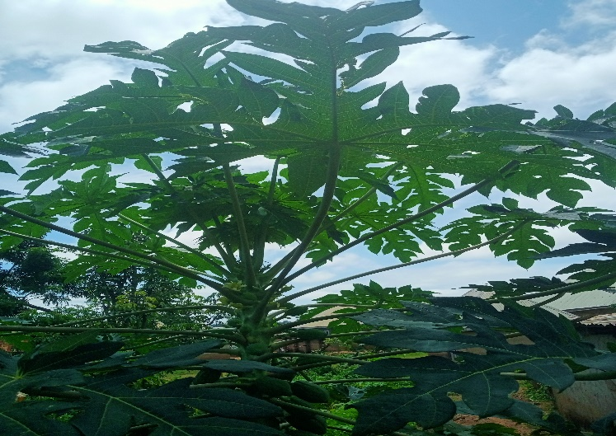
Plate 1: Carica papaya plant specie
Source: (Digital camera capture by the lead researcher)
Study Organism
The first and second instar larvae of A. gambiae mosquitoes were obtained from the insectary unit of the Department of Parasitology and Entomology, Faculty of Biosciences, Nnamdi Azikiwe University, Awka. The early instars were reared under laboratory conditions in transparent plastic bowls containing distilled water and covered with untreated netting to avoid predation. The larvae were fed a chicken feed known as ‘Vital Feed Broiler Finisher’ with the following composition: crude protein (20%), fat (5%), crude fibre (5%), calcium (1%), available phosphorus (0.45%), lysine (1.0%), methionine (0.45%) and metabolisable energy (3060 Kcal/kg). The 4th instar larvae (Plate 2) used for the larval bioassay were differentiated and sorted with the aid of a dissecting microscope by detailed morphological examination using the keys of Service (1980).
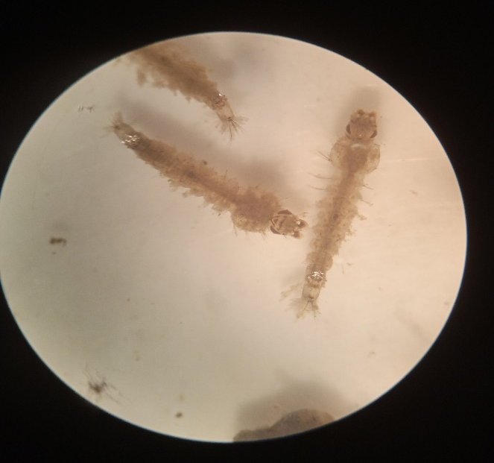
Plate 2: Fourth (4th) instar larvae of A. gambiae viewed from the dissecting microscope

Preparation and Extraction of Crude Extract
Freshly harvested leaves of C. papaya were carefully washed, rinsed with distilled water and air-dried in the shade for a week in a room. The dried leaves were pulverised into powdered form using an electric blender. Extraction of the chemical constituents was carried out using the maceration method as described by Ishar et al. (2026). Eighty grams (80 g) of the leaf powder was measured using an electric weighing balance and macerated in 800 ml of 70% ethanol. This was allowed to stand for 72 hours to ensure adequate extraction of the available bioactive constituents. The mixture was then filtered using a muslin cloth, and the filtrate was transferred into a 100ml beaker, where it was concentrated. The semi-solid extract was then transferred into a plain specimen bottle and stored in a refrigerator until it was needed.

Serial Dilution
The pure undiluted extract was regarded as having 100% concentration and acetone was used as the diluent. Five different concentrations of 50%, 40%, 30%, 20% and 10% were prepared through serial dilution and used for larval treatment. The serial dilution was done using the dilution factor (C₁V₁=C₂V₂), where C₁ is the initial concentration (100%), V₁ =unknown, C₂=50% and V₂=10ml (volume of syringe used).

Phytochemical Profiling of the leaf extract
Determination of the exact bioactive compound profile of the leaf extract of C. papaya was carried out using the gas chromatography-mass spectrometry (GC-MS) technique as described by Thamer and Thamer (2023). The GC-MS analysis was carried out using a Thermo Scientific, Trace GC Ultra/ISQ Single Quadruple MS, TG-5MS fused silica capillary column (30m, 0.251mm, 0.1mm film thickness). Helium gas was used as the carrier gas at a steady flow rate of 1mL/min while an electron ionisation system with an ionisation energy of 70eV was used for GC-MS detection. A sample volume of 1µl was used for the phytochemical analysis. The injector and MS transfer line temperatures were set at 280°C. The oven temperature was initially set at 40°C for 3 mins and increased at a rate of 5°C/min to a final temperature of 280°C for 5 mins. All identified compounds were quantified using percent relative peak area. Identification of the phytochemical compounds was achieved by comparison of their relative retention times and mass spectra with data in the National Institute of Standards and Technology (NIST) and Wiley libraries of the GC-MS system.

Larval Bioassay
The bioassay of A. gambiae mosquito larvae was carried out according to the standard guidelines for laboratory and field testing of mosquito larvicides as laid down by the World Health Organization (WHO, 2005). C. papaya leaf extract at concentrations of 50%, 40%, 30%, 20% and 10% was used to treat the 4th instar larvae of A. gambiae mosquito in triplicate. Acetone (1 ml) was used as the negative control while deltamethrin, a standard chemical insecticide, was used as the positive control. A total of 20 larvae were randomly introduced into each treatment plate containing 100 ml of distilled water and a 1ml aliquot of each prepared concentration. The 4th instar larvae that did not wriggle or move when touched with a needle were considered dead while those that responded to touch by moving or wriggling away were regarded as alive. Mortality was recorded after 3, 6, 9, 12 and 24 hours.

Determination of Percentage Mortality
The total number of dead larvae from each treatment concentration in the study was used to calculate the percentage mortality. This was done as described by Ahmad et al. (2019) using the formula stated below:
% mortality = Number of dead larvae / Number of larvae exposed x 100

Data Analysis
Data obtained from this study were subjected to statistical analysis using the Statistical Package for Social Sciences, version 22. Mean mortality values for each treatment concentration were compared using one-way analysis of variance. The Pearson chi-square test was used to investigate the association of concentration and exposure time with larval mortality, and p < 0.05 was considered significant. Lethal concentration (LC₅₀ and LC₉₀) and lethal time (LT₅₀ and LT₉₀) were determined using probit regression analysis.

Results
The gas chromatography-mass spectrometry analysis revealed the presence of 30 phytochemical compounds in the leaf extract of Carica papaya. Vitamin E was found to be the most abundant compound, with a percentage area of 34.59%, a molecular weight of 430 and the chemical formula (C₂₉H₅₀O₂), followed by 1H-Indole, 5-methyl-2-phenyl-, with a percentage area of 10.16%, a molecular weight of 207 and the chemical formula C₁₅H₁₃N. In contrast, Decanoic acid, hexyl ester with a molecular weight of 256 g/mol was detected as the least abundant compound with a percentage area of 0.71% (Table 1). The various peak heights and retention times for the identified compounds are presented in Figure 1. Vitamin E was identified at the highest peak area (27) with a retention time (RT) of 17.942 minutes, followed by 1H-Indole, 5-methyl-2-phenyl- at peak 30, with a retention time of 19.959 minutes, while Decanoic acid, hexyl ester was detected at peak 6 with an RT of 4.362 minutes (Figure 1).
Table 1: Profile of Compounds identified from the ethanol leaf extract of Carica papaya
Peak No | RT (min) | Compound Name | Area (%) | Molecular formula | Molecular weight (g/mol)
1  2  3  4  5  6  7  8  9  10  11  12  13  14  15  16  17  18  19  20  21  22  23  24  25  26  27  28  29  30 | 2.459  3.093  3.556  3.911  4.088  4.362  5.334  5.397  5.974  6.437  7.551  7.906  8.060  8.431  8.963  9.557  10.032  11.626  11.729  13.227  14.352  15.798  16.147  16.964  17.284  17.799  17.942  18.988  19.313  19.959 | L- Arabinitol  2-Tetrazaboroline, 5-ethyl-1, 4-dimethyl-  4H-Pyran-4-one, 2,3-dihydro-3, 5-dihydroxy-6-methyl-  1-Silacyclo-3-pentene  2-Phenyl-1,3-oxazol-2-ine  Decanoic acid, hexyl ester  4-Heptadecanone  Caryophyllene  Naphthalene, 1,2,3,5,6,8a-hexahydro-4,7-dimethyl-1-(1-methylethyl)-, (1S-cis)-  3-Heptene, 4-methyl-  Tetradecanoic acid  6-Hydroxy-4, 4, 7a-trimethyl-5, 6, 7, 7a-tetrahydrobenzofuran-2 (4H)-one  2-Cyclohexen-1-one, 4-hydroxy-3,5,5-trimethyl- 4 - (3-oxo-1-butenyl)-  Neophytadiene  1,2-Dipropylcyclopropene  Hexadecanoic acid, methyl ester  n-Hexadecanoic acid  7,10,13-Hexadecatrienoic acid, methyl ester  Phytol  2-Ethylacridine  N-Methyl-1-adamantaneacetamide  N-Methyl-1-adamantaneacetamide  Cyclotrisiloxane, hexamethyl-  Silicic acid, diethyl bis(trimethylsilyl) ester  γ-Tocopherol  Tris(tert-butyldimethylsilyloxy) arsane  Vitamin E  Arsenous acid, tris (trimethylsilyl) ester  Cyclotrisiloxane, hexamethyl-  1H-Indole, 5-methyl-2-phenyl- | 4.10  0.89  0.81  0.73  2.36  0.71  1.26  1.42  0.88  3.96  1.02  1.23  4.33  2.58  0.94  1.01  2.29  1.08  4.72  0.73  1.29  3.40  1.51  1.61  3.76  2.76  34.59  2.15  1.71  10.16 | C₅H₁₂O₅  C₄H₁₁BN₄  C₆H₈O₄  C₄H₈Si  C₉H₉NO  C₁₆H₃₂O₂  C₁₇H₃₄O  C₁₅H₂₄  C₁₅H₂₄  C₈H₁₆  C₁₄H₂₈O₂  C₁₁H₁₆O₃  C₁₃H₁₈O₃  C₂₀H₃₈  C₉H₁₆  C₁₇H₃₄O₂  C₁₆H₃₂O₂  C₁₇H₂₈O₂  C₂₀H₄₀O  C₁₅H₁₃N  C₁₃H₂₁NO  C₁₃H₂₁NO  C₆H₁₈O₃Si₃  C₁₀H₂₈O₄Si₃  C₂₈H₄₈O₂  C₁₈H₄₅AsO₃Si₃  C₂₉H₅₀O₂  C₉H₂₇AsO₃Si₃  C₆H₁₈O₃Si₃  C₁₅H₁₃N | 152  126  144  84  147  256  254  204  204  112  228  196  222  278  124  270  256  264  296  207  207  207  222  296  416  468  430  342  222  207
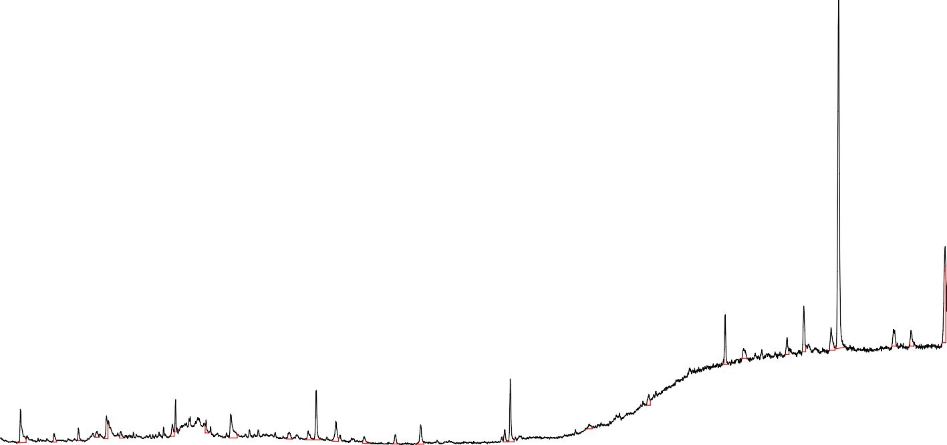
100000 2.459
3.00 4.00 5.00 6.00 7.00 8.00 9.00 10.00 11.00 12.00 13.00 14.00 15.00 16.00 17.00 18.00 19.00
4.088
3.0933.535.69141.362
5.397
5.334
8.060
14.352
5.9764.437
7.575.1906
8.431
10.032
8.9639.
557
11.626
13.227
Time-->
11.729
16.964
16.147
200000
15.798 17.284
17.799 18.1998.8313
300000
19.
400000
500000
600000
700000
800000
17.942
900000
TIC: SAMPLE C.D\data.ms
Abundance
Figure 1: GC-MS Chromatogram for the Ethanol Leaf Extract of Carica papaya

Table 2 shows the mean larval mortality rates of Anopheles gambiae exposed to various concentrations of the ethanol leaf extract of Carica papaya at different time intervals. The highest mean larval mortality (3.00±1.00 - 20.00±0.00) and percentage mortality (100%) were recorded at the 50% concentration of the leaf extract of C. papaya, while the lowest mean larval mortality rate (0.67±0.58 - 3.33±1.53) and percentage mortality (16.6%) occurred at the lowest concentration of 10% leaf extract. With respect to time of exposure, the highest mean larval mortality occurred after 24 hours of exposure (3.33±1.53 - 20.00±0.00), while the lowest mean larval mortality occurred after 3 hours of exposure (0.67±0.58 – 3.00±1.00). Statistically, there was no significant difference in the mean larval mortality of A. gambiae 4th instar larvae exposed to different concentrations of Carica papaya after 3 hours (P>0.05). On the other hand, mean larval mortality differed significantly (P˂0.05) among the different extract concentrations from 6 to 24 hours of exposure.
Table 2: In vitro Larvicidal Effect of the Ethanolic Leaf Extract of C. papaya on A. gambiae 4th instar Larvae
Concentration | 3 hrs | 6 hrs | 9 hrs | 12 hrs | 24 hrs | % Mortality
10% | 0.67±0.58ª | 1.33±0.58^{b} | 2.67±1.15^{d} | 2.67±1.15^{h} | 3.33±1.53^{l} | 16.6
20% | 0.67±1.15a | 0.67±1.15^{b} | 4.67±1.15d^{e} | 5.33±1.53h^{i} | 6.33±1.53^{lm} | 31.6
30% | 0.67±0.58ª | 2.67±1.15b^{c} | 6.67±2.08e^{f} | 9.33±1.53^{ij} | 10.00±1.00^{m} | 50
40% | 2.67±1.15ª | 3.33±1.15b^{c} | 9.67±0.58f^{g} | 12.67±2.08^{jk} | 14.67±3.06^{n} | 73.3
50%  Negative control  Positive control | 3.00±1.00ª  0.00±0.00  20.0±0.00 | 5.00±1.00^{c}  0.00±0.00  20.00± 0.00 | 12.67±1.53^{g}  0.00±0.00  20.00± 0.00 | 15.33±1.53^{k}  0.00±0.00  20.00 ±0.00 | 20.00±0.00^{p}  0.00±0.00  20.00 ±0.00 | 100  0.0  100
Sig. | 0.070 | 0.003 | 0.000 | 0.000 | 0.000
*Values are Mean ± Standard deviation. Mean values with similar superscripts in a column are not significant

Lethal Concentration (LC₅₀ and LC₉₀) of Plant Extracts
The lethal concentration of the ethanol leaf extract of C. papaya on the 4th instar larvae of Anopheles gambiae is presented in Table 3. Carica papaya recorded a lethal concentration (LC₅₀) of 24.11 mg/ml and an LC₉₀ value of 56.79 mg/ml. This result indicates that 24.11 mg/ml of Carica papaya extract was required to cause 50% mortality, while 56.79 mg/ml was required to induce 90% larval mortality. The regression slope (β) value for C. papaya was found to be 3.45, which indicates the sensitivity of the larval population to the extract, suggesting a moderate degree of population homogeneity in response to the extract. The result showed a significant χ2-value (P = 0.007).
Table 3: Lethal concentration (LC₅₀ and LC₉₀) of the Ethanolic Leaf Extract of C. papaya on the 4th instar Larvae of Anopheles gambiae,
Plant Extract | Slope (β±SE) | LC₅₀ | LC₉₀ | χ²-value | P-value
C. papaya | 3.45±0.37 | 24.11 | 56.79 | 28.993 | 0.007
= Slope; SE = Standard Error of Mean
Dose-Response Relationships
The relationship between the concentration of the plant extract and the mortality of A. gambiae larvae is illustrated in Figure 2 below. For the tested extract, a positive linear correlation was observed between the log-transformed concentration and the probit of mortality. The regression line for C. papaya (Figure 2) demonstrates a steep gradient, which visually confirms the high susceptibility of the larvae to the extract at lower dose increments.

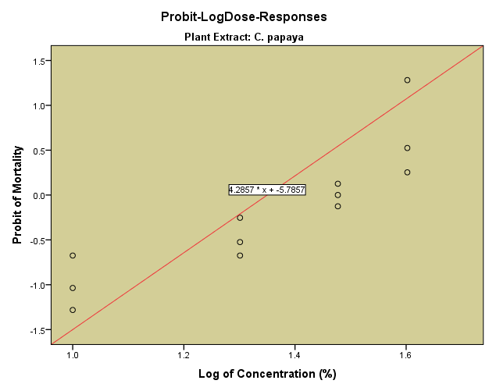
Figure 2: Dose-Response relationship of C. papaya against Anopheles gambiae 4th instar

Lethal Time (LT₅₀ and LT₉₀) of Carica papaya plant
The time-dependent mortality of the 4th instar larvae of A. gambiae exposed to the leaf extract of Carica papaya is presented in Table 4. The result shows that Carica papaya recorded a lethal time (LT₅₀) of 17.44 hours and an LT₉₀ of 87.31 hours. This indicates that C. papaya required 17.44 hours to achieve 50% mortality and 87.31 hours for 90% mortality. The result further showed that C. papaya exhibited a high time-response slope (1.83±0.13), indicating a rapid increase in mortality rate over the exposure period. The result showed a highly significant chi-square value (P < 0.05), confirming that larval mortality was significantly influenced by the duration of exposure.
Table 4: Lethal Time (LT₅₀ and LT₉₀) of the Ethanolic leaf extract of C. papaya on the 4th instar larvae of Anopheles gambiae
Plant Extract | Slope (β±SE) | LT₅₀ | LT₉₀ | χ²-value | P-value
C. papaya | 1.83±0.13 | 17.44 | 87.31 | 296.083 | 0.000
SE= standard error

Time-Response Relationships
The temporal pattern of mortality for C. papaya leaf extract is shown in Figure 3 below. The graph indicates a consistent trend in which the mortality probit increased linearly with the log of exposure time. The distribution of data points for C. papaya (Figure 3) along the regression line reflects the predictability of its toxic effect over time.
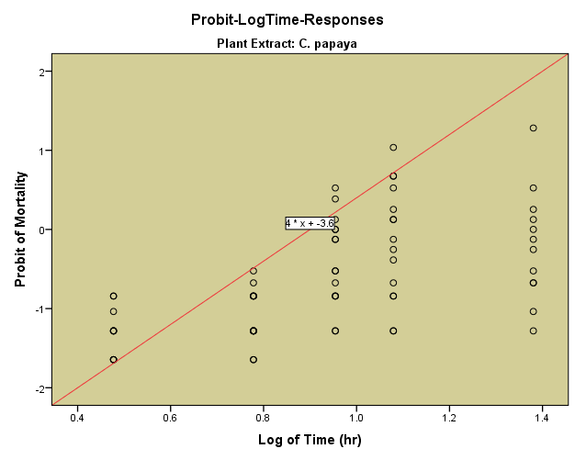
Figure 3: Time-Response relationship of C. papaya against Anopheles gambiae 4th instar

Discussion
In the current study, Gas Chromatography - Mass Spectrometry (GC-MS) evaluation of the ethanol leaf extract of Carica papaya showed the presence of 30 phytocompounds. Vitamin E, also known as α-tocopherol (34.59 %), was the most abundant, while Decanoic acid, hexyl ester (0.71%) was the least abundant chemical compound. The wide range of phytocompounds present in the leaf extract of C. papaya explains the high toxicity level recorded in this study, as these phytochemicals are known to be toxic to mosquito larvae. A similar finding was reported by Opoggen et al. (2019), in which leaf extract of C. papaya was the third most potent extract out of five different plant extracts. The number of chemical compounds detected in this extract was higher than that reported by Türker et al. (2022), who reported 3, 1 and 8 compounds in the essential extracts obtained from the leaves, ripe and unripe fruit of C. papaya in Turkiye. Studies conducted in different parts of Nigeria and beyond have equally documented various phytoconstituents from C. papaya including terpenoids, saponins, tannins, alkaloids and cardiac glycosides (Ayoola & Adeyeye, 2010), phenol, steroids and flavonoids (Ekpo et al., 2025). The lethal concentrations (LC₅₀ and LC₉₀) of C. papaya in this study were found to be 24.11 mg/ml and 56.79 mg/ml, which imply that 24.11 and 56.79 mg/ml were the concentrations of extract required to induce 50 % and 90 % mortality of A. gambiae larvae treated in this study. The LC₅₀ (24.11 mg/ml) in this study is similar to the 25.10 ppm LC₅₀ reported by Sivakumar et al. (2011) in Aedes aegypti larvae using tetradecanoic acid. However, this result is higher than the LC₅₀ (2.8 mg/ml) reported by Ishak et al. (2019) using C. papaya leaf extract. Elsewhere in Indonesia, Nayiron et al. (2025) reported LC₅₀ values of 10.16 ppm and 4.04 ppm at 30 and 48 hours, respectively, in A. aegypti larvae, using California papaya leaf extract. The LC₉₀ value of 56.79 mg/ml observed in this study is equally higher than the 27.12 mg/ml reported by Nayiron et al. (2025). On the other hand, this result is much lower than the 982.2 ppm LC₅₀ value at 24 hours reported by Opoggen et al. (2019). Another study conducted in India by Ilham et al. (2019) also reported a higher LC₅₀ (215.96 mg/ml) using C. papaya leaf extract against Aedes species. The differences in LC₅₀ and LC₉₀ observed across the different studies could result from the solvent used and the susceptibility of the vector species being tested. In the present study, C. papaya ethanol leaf extract demonstrated highly significant time- and dose-dependent larvicidal effects against A. gambiae larvae. The findings of this study reveal lethal times (LT₅₀ and LT₉₀) of 17.44 hours and 87.31 hours, representing the times required to achieve 50 % and 90 % larval mortality, respectively. Comparatively, the LT₅₀ in this study is lower than the 2369.64 minutes, i.e., 39.49 h reported by Ilham et al. (2019). However, using C. papaya leaf extract against Anopheles sp, Ishak et al. (2019) recorded a lower LT₅₀ (5 min), contrary to our study. Differences in the lethal times needed to achieve 50 % and 90 % mortality in mosquito larvae treated with different plant extracts are primarily due to physiological variations of the larvae, experimental and environmental conditions, penetration rate of active phytochemicals and mechanisms of action (Şengül Demirak & Canpolat, 2022). Similarly, the highest mortality rates occurred at higher concentrations (i.e., 50 mg/ml) of C. papaya leaf extract, while lower mortality was observed at lower concentrations. Several studies have also shown that larval mortality increases with increasing concentration (Ishar et al., 2026; Obiakor et al., 2026; Nayiron et al., 2025; Ozioko et al., 2021; Sivakumar et al., 2011). The reason for increased mortality at higher concentrations could be attributed to saturation of bioavailable toxins that overwhelm the physiological systems of the larvae (Hillary et al., 2024). For instance, higher doses of extracts can inhibit enzymatic pathways, particularly by disrupting cellular respiration and electron transport, thereby causing death through lack of energy. Aside from mosquito larval control, the toxicity of C. papaya extract has been reported by many researchers globally. For example, Yusuf et al. (2023) documented a significant insecticidal effect of C. papaya leaf extract against Aspavia armigeria and Hymerni recurvalis, both insect pests of leafy vegetables (Amaranthus hybridus Lin). Other scholars such as Rahayu et al. (2020) and Adenekan et al. (2019) had previously reported the pesticidal effects of C. papaya extract against insects such as Blattella germanica and Sitophilus zeamais.
Conclusion
This study demonstrated that ethanol leaf extract of C. papaya possesses significant larvicidal activity against the 4th instar larvae of A. gambiae under laboratory conditions. The toxic nature of secondary metabolites on mosquito larvae, as evidenced in numerous studies, and the high number of phytochemical compounds present in the leaf extract explain the significant mortality rate observed in this study. Larval mortality was found to be dependent on concentration and exposure time. This suggests its potential as a green larvicidal agent for A. gambiae mosquito larval control, subject to further scientific validation. Further studies are required to evaluate its efficacy in field trials, its safety for the environment and non-target organisms such as aquatic species.

Limitation
The study was conducted under laboratory conditions and evaluated larval mortality over a maximum exposure period of 24 h. Consequently, the estimated LT₉₀ of 87.31 h was extrapolated beyond the observed experimental period and should be interpreted as a model-based prediction. The study did not assess field performance, environmental persistence, or effects on non-target aquatic organisms. These limitations restrict direct generalisation of the laboratory findings to operational mosquito-control settings.

Conflict of Interest
The authors declare that they have no competing interests.

Declaration of AI Use

This manuscript was prepared through the intellectual contributions of the author(s) to the study design, data analysis, interpretation of results, and scholarly content. Grammarly and ChatGPT were used solely to assist with grammatical refinement and reference formatting during manuscript revision. The author(s) accept full responsibility for the accuracy, integrity, and final content of the manuscript.

References

Adenekan, M. O., Onasanya, R. O., & Owolade, E. O. (2019). Assessment of the toxicity of Carica papaya plant powders against Sitophilus zeamais (Mots.) (Coleoptera: Curculionidae) on maize seeds during storage. Journal of Bioscience and Biotechnology Discovery, 4(5), 108–113. https://doi.org/10.31248/JBBD2019.109
Ahmad, I. I., Amuga, G. A., Ombugadu, R. J., Tongjura, J. D. C., & Abdulmalik, A. A. (2019). Bioactivity of leaf extract Hyptis suaveolens (bush tea) on larvae of Anopheles gambiae collected from Keffi Area, Nasarawa State, Nigeria. Nigerian Annals of Pure and Applied Sciences, 2, 57–66. https://doi.org/10.46912/napas1i.2019109
Ayoola, P. B., & Adeyeye, A. (2010). Phytochemical and nutrient evaluation of Carica papaya (pawpaw) leaves. International Journal of Research and Reviews in Applied Sciences, 5(3), 325–328. https://www.arpapress.com/ijrras/volume5issue3.html
Şengül Demirak, M. Ş., & Canpolat, E. (2022). Plant-based bioinsecticides for mosquito control: Impact on insecticide resistance and disease transmission. Insects, 13(2), 162. https://doi.org/10.3390/insects13020162
Duguma, T., Nuri, A., & Melaku, Y. (2022). Prevalence of malaria and associated risk factors among the community of Mizan-Aman town and its catchment area in southwest Ethiopia. Journal of Parasitology Research, 2022, 3503317. https://doi.org/10.1155/2022/3503317
Ekpo, B. O., Iwuagwu, M. O., Emmanuel, N. C., & Igwe, J. C. (2025). Repellent and larvicidal effects of some indigenous plants in Abia State, Nigeria, against female Anopheles gambiae. World Journal of Biology, Pharmacy and Health Sciences, 24(1), 528–539. https://doi.org/10.30574/wjbphs.2025.24.1.0920
Gebissa, N., Tolossa, K., Gebresilassie, A., Aklilu, E., Bisrat, D., Kumsa, B., & Dugassa, S. (2025). Larvicidal effects of selected medicinal plant extracts against Anopheles arabiensis, Anopheles stephensi, and Aedes aegypti. Tropical Medicine and Health, 53, 197. https://doi.org/10.1186/s41182-025-00879-2
Hawkes, F. M., & Hopkins, R. J. (2022). The mosquito: An introduction. In M. Hall & D. Tamïr (Eds.), Mosquitopia: The place of pests in a healthy world (pp. 16–31). Routledge. https://doi.org/10.4324/9781003056034-3
Hillary, V. E., Ceasar, S. A., & Ignacimuthu, S. (2024). Efficacy of plant products in controlling disease vector mosquitoes, a review. Entomologia Experimentalis et Applicata, 172(3), 195–214. https://doi.org/10.1111/eea.13401
Ilham, R., Lelo, A., Harahap, U., Widyawati, T., & Siahaan, L. (2019). The effectivity of ethanolic extract from papaya leaves (Carica papaya L.) as an alternative larvicide to Aedes spp. Open Access Macedonian Journal of Medical Sciences, 7(20), 3395–3399. https://doi.org/10.3889/oamjms.2019.432
Ishak, H., Mallongi, A., & Aras, N. (2019). Effects of Carica papaya seed and leaf extracts on Anopheles sp. larval mortality. Pakistan Journal of Nutrition, 18(10), 946–952. https://doi.org/10.3923/pjn.2019.946.952
Ishar, C. O., Ikeh, M. I., Mbelede, K. C., & Umeanor, B. C. (2026). Phytochemical analysis and in-vitro larvicidal effect of ethanolic leaf extract of Hyptis suaveolens against the 4th instar larvae of Anopheles gambiae. South Asian Journal of Parasitology, 9(3), 562–575. https://doi.org/10.9734/sajp/2026/v9i3300
Kalpana, B., Reddy, K. S., & Suhasini, G. (2026). Preliminary phytochemical screening and larvicidal activity of selected plant extracts from Telangana, India, against major mosquito vectors. Uttar Pradesh Journal of Zoology, 47(17), 237–245. https://doi.org/10.56557/upjoz/2026/v47i175848
Muhammad, A., Ibrahim, S. S., Mukhtar, M. M., Irving, H., Abajue, M. C., Edith, N. M. A., Da’u, S. S., Paine, M. J. I., & Wondji, C. S. (2021). High pyrethroid/DDT resistance in major malaria vector Anopheles coluzzii from Niger-Delta of Nigeria is probably driven by metabolic resistance mechanisms. PLOS ONE, 16(3), e0247944. https://doi.org/10.1371/journal.pone.0247944

Nayiron, C. O. S., Hastutiek, P., Meles, D. K., Herupradoto, E. B. A. H., Lazuardi, M., & Sunarso, A. (2025). Efficacy of ethanol extract of papaya leaves (Carica papaya var. California L.) on mortality of instar III larvae of Aedes aegypti mosquito. Journal of Parasite Science, 9(2), 53–56. https://doi.org/10.20473/jops.v9i2.64877
National Population Commission. (2007). Legal notice on publication of the details of the breakdown of the national and state provisional population totals 2006 census. Federal Republic of Nigeria Official Gazette, 94(24), B175–B198.
Nazmin, F., Barek, M. A., Miah, A., Hossen, M. S., Islam, M. S., & Ahmed, J. (2025). Mosquito repellent and larvicidal activity of essential oils of aromatic plant growing in Bangladesh: A review. Clinical Phytoscience, 11, 7. https://doi.org/10.1186/s40816-025-00391-4
Nwigwe, J. O., Uhuo, C. A., Emeka, N. J., Chinebu, T. I., Onuora, A. L., Adimora, E. E., Nduka, F. O., Ossai, I. I., & Ani, O. C. (2026). Phytochemical characterization and bioefficacy of bush mint leaf Hyptis suaveolens extracts as natural mosquito larvicides. International Journal of Tropical Disease & Health, 47(2), 75–84. https://doi.org/10.9734/ijtdh/2026/v47i21722
Nwoke, B. E. B. (2018). Public health parasitology. Milestone Publishers Limited.
Obiakor, U. A., Ishar, C. O., Ugwuanyi, G. C., Umeanor, B. C., & Onuegbu, P. I. (2026). Larvicidal effect of the ethanoic leaf extract of Chromolaena odorata against the 4th instar larvae of Aedes aegypti. Journal of Parasite Science, 10(1), 15–20. https://doi.org/10.20473/jops.v10i1.75851
Okeke, O. A., Muoghalu, C. V., Udeh, N. P., Nnatuanya, I. O., Nwadike, C. C., Afoemezie, P. I., Ikeh, I. M., Ishar, C. O., Imakwu, C. A., & Ubaka, U. A. (2024). Mosquito species composition, diversity and relative abundance in Science Village, Nnamdi Azikiwe University, Awka, Anambra State, Nigeria. Journal of Current Biomedical Research, 4(3), 1647–1662. https://doi.org/10.54117/jcbr.v4i3.4
Opoggen, L., Rotimi, J., Aigbodion, F. I., & Omoregie, A. O. (2019). Larvicidal efficacy of six medicinal plants on Anopheles gambiae s.l. mosquito. Merit Research Journal of Medicine and Medical Sciences, 7(1), 18–23. https://doi.org/10.5281/zenodo.2550808
Ozioko, K. U., Okoye, C. I., Okafor, F. C., & Obiezue, R. N. (2021). Anopheles gambiae larvicidal and adulticidal potential of Phyllanthus amarus (Schumach and Thonn, 1827) obtained from different localities of Nigeria. Asian Pacific Journal of Tropical Medicine, 14(1), 27–33. https://doi.org/10.4103/1995-7645.304298
Rahayu, R., Darmis, A., & Jannatan, R. (2020). Potency of papaya leaf (Carica papaya L.) as toxicant and repellent against German cockroach (Blattella germanica L.). Pakistan Journal of Biological Sciences, 23(2), 126–131. https://doi.org/10.3923/pjbs.2020.126.131
Service, M. W. (1980). A guide to medical entomology. Macmillan Press.
Sivakumar, R., Jebanesan, A., Govindarajan, M., & Rajasekar, P. (2011). Larvicidal and repellent activity of tetradecanoic acid against Aedes aegypti (Linn.) and Culex quinquefasciatus (Say.) (Diptera: Culicidae). Asian Pacific Journal of Tropical Medicine, 4(9), 706–710. https://doi.org/10.1016/S1995-7645(11)60178-8
Tandina, F., Doumbo, O., Yaro, A. S., Traoré, S. F., Parola, P., & Robert, V. (2018). Mosquitoes (Diptera: Culicidae) and mosquito-borne diseases in Mali, West Africa. Parasites & Vectors, 11, 467. https://doi.org/10.1186/s13071-018-3045-8
Stratton, L., O’Neill, M. S., Kruk, M. E., & Bell, M. L. (2008). The persistent problem of malaria: Addressing the fundamental causes of a global killer. Social Science & Medicine, 67(5), 854–862. https://doi.org/10.1016/j.socscimed.2008.05.013
Thamer, F. H., & Thamer, N. (2023). Gas chromatography–mass spectrometry (GC-MS) profiling reveals newly described bioactive compounds in Citrullus colocynthis (L.) seeds oil extracts. Heliyon, 9(6), e16861. https://doi.org/10.1016/j.heliyon.2023.e16861
Türker, E., Gübbük, H., Öztürk, G., & Demirci, B. (2022). Chemical characterizations and biological evaluation of papaya (Carica papaya L.) essential oils and fatty acids. Journal of Research in Pharmacy, 26(6), 1771–1779. https://doi.org/10.29228/jrp.267
Vargas-Abasolo, R., Aguilar-Marcelino, L., Rodríguez-González, S., Cime-Castillo, J., & Córdoba-Aguilar, A. (2026). Nature-inspired solutions: Semiochemical, botanical, and microbial tools, for mosquito management. Journal of Pest Science, 99, 21. https://doi.org/10.1007/s10340-025-01989-w
Vij, T., & Prashar, Y. (2015). A review on medicinal properties of Carica papaya Linn. Asian Pacific Journal of Tropical Disease, 5(1), 1–6. https://doi.org/10.1016/S2222-1808(14)60617-4
World Health Organization. (2005). Guidelines for laboratory and field testing of mosquito larvicides (WHO/CDS/WHOPES/GCDPP/2005.13). https://www.who.int/publications/i/item/WHO-CDS-WHOPES-GCDPP-2005.13
World Health Organization. (2020, January 30). Lymphatic filariasis. https://www.who.int/news-room/questions-and-answers/item/lymphatic-filariasis
World Health Organization. (2023). World malaria report 2023. https://www.who.int/publications/i/item/9789240086173
World Health Organization. (2024). Malaria 2024 Nigeria country profile. https://www.who.int/publications/m/item/malaria-2024-nga-country-profile
Yusuf, S. Y., Alao, F. O., Olaniran, O. A., Adebayo, T. A., Iyanuoluwa, T. I., Gbadegesin, O. J., & Akanji, K. A. (2023). Field evaluation of Carica papaya and Anarcadium occidentale leaves extracts on major insect pests of leafy vegetable (Amaranthus hybridus Lin.). Journal of Renewable Agricultural Technology Research, 2(2), 10–18. https://ssaapublications.com/index.php/sjratr/article/view/77

Checking List for Tables, Figures, Charts, Plates, and Equations
Category | Item | Caption / Description | Text Cross-reference | Check Status
Table | Table 1 | Profile of Compounds identified from the ethanol leaf extract of Carica papaya | Referred to in Results | Preserved; caption and table unchanged
Table | Table 2 | In vitro Larvicidal Effect of the Ethanolic Leaf Extract of C. papaya on A. gambiae 4th instar Larvae | Referred to in Results | Preserved; caption and table unchanged
Table | Table 3 | Lethal concentration (LC50 and LC90) of the Ethanolic Leaf Extract of C. papaya on the 4th instar Larvae of Anopheles gambiae | Referred to immediately before table | Preserved; caption and table unchanged
Table | Table 4 | Lethal Time (LT50 and LT90) of the Ethanolic leaf extract of C. papaya on the 4th instar larvae of Anopheles gambiae | Referred to immediately before table | Preserved; caption and table unchanged
Figure | Figure 1 | GC-MS Chromatogram for the Ethanol Leaf Extract of Carica papaya | Referred to in Results | Preserved; figure and caption unchanged
Figure | Figure 2 | Dose-Response relationship of C. papaya against Anopheles gambiae 4th instar | Referred to immediately before figure | Preserved; figure and caption unchanged
Figure | Figure 3 | Time-Response relationship of C. papaya against Anopheles gambiae 4th instar | Referred to immediately before figure | Preserved; figure and caption unchanged
Plate | Plate 1 | Carica papaya plant specie | Referred to in Collection, Identification and Authentication of Study Plant | Preserved; plate and caption unchanged
Plate | Plate 2 | Fourth (4th) instar larvae of A. gambiae viewed from the dissecting microscope | Referred to in Study Organism | Preserved; plate and caption unchanged
Chart | None separately labelled | Graphical outputs are labelled as Figures 1–3 | N/A | No separately labelled chart found
Equation | C1V1 = C2V2 | Serial dilution equation | Presented in Serial Dilution subsection | Preserved unchanged
Equation | % mortality = Number of dead larvae / Number of larvae exposed × 100 | Percentage mortality equation | Presented in Determination of Percentage Mortality subsection | Preserved unchanged

