A FOURTH-ORDER RUNGE–KUTTA APPROACH TO A FUZZY INVENTORY MODEL WITH TWO-PARAMETER WEIBULL DETERIORATION AND QUARTIC DEMAND

ABSTRACT
This study develops a fuzzy inventory model for a single deteriorating item under quartic time-dependent demand and a two-parameter Weibull deterioration process, assuming zero lead time, instantaneous replenishment, and no shortages. Uncertainty in the demand and deterioration parameters is represented through triangular fuzzy numbers. The corresponding α-cut formulation yields lower and upper inventory systems governed by nonlinear time-dependent differential equations. Because the interaction between quartic demand and Weibull deterioration does not provide a convenient closed-form solution, the fourth-order Runge–Kutta method is employed to obtain numerical inventory trajectories over the replenishment cycle. The resulting holding, purchasing, ordering, and deterioration costs are evaluated from the numerical solutions, and the Graded Mean Integration Representation method is used to defuzzify the fuzzy total and average inventory costs. Numerical examples are considered for both non-fuzzy and fuzzy cases, and a one-at-a-time sensitivity analysis is performed by varying selected demand, deterioration, and cost parameters by ±20% while holding the remaining parameters constant. The results indicate that the optimal cycle length and inventory costs respond more strongly to changes in selected demand and cost parameters than to changes in the Weibull deterioration parameters within the ranges examined. The model therefore provides a numerical framework for analysing replenishment and cost decisions when demand and deterioration parameters are imprecisely specified.
Keywords: Fuzzy inventory model; two-parameter Weibull deterioration; quartic demand; triangular fuzzy numbers; α-cut method; fourth-order Runge–Kutta method; Graded Mean Integration Representation; total inventory cost; optimal cycle length; sensitivity analysis.

- INTRODUCTION
The inventory management technique is significant when it comes to evaluating the efficiency of supply and replenishment of the items, which have decreasing availability in time. Items, which belong to this category, are often referred to as deteriorating items and deterioration of such items may occur due to reasons like spoilage, obsolescence, damage or others. Deterioration in inventory management has been addressed first by Whitin (1957) and Ghare & Schrader (1963), whereas the classical EOQ model, designed by Harris (1913), served as the basis for further development of inventory models. One of the important developments in the literature regarding deteriorating inventory models has been the inclusion of time-varying deterioration rates. Covert and Philip (1973) made use of a Weibull deterioration function that was based on two parameters, while Philip (1974) extended the inventory model to include deteriorating conditions. The advantage of using the Weibull function is that it allows the deterioration rate to change over time and therefore provides an appropriate setting to study the deteriorating nature of certain products. Further developments have been made by researchers such as Jalan et al. (1996), Jen-Ming Chen (1998), and Goyal & Giri (2001). Demand also plays an important role in developing an inventory model. The assumption of a constant rate of demand is often limited in situations where the demand is time-dependent. The work of Donaldson (1977), Dave and Patel (1981), and Datta and Pal (1988) considered the issue of inventory models with time-dependent demands, hence developing models which could account for changing demands. Khanra and Chaudhuri (2003) also considered the situation of inventory models with time-varying demand and deterioration. Higher-order polynomial demand function offers more flexibility for modelling the complex demand behaviours. Yadav & Yadav (2013) studied an inventory model under time-varying demand conditions, while Suman & Kumar (2021) have considered the demand pattern to be a cubic demand. Later, Suman & Kumar (2022) considered the demand function to be a quartic demand function. Onyenike et al. (2026) also developed an inventory model for two-parameter Weibull deteriorating items model with time dependent quartic demand. The model assumed that shortages are not permitted and that all demand is satisfied and instantaneous with zero lead time. Ramya and Sivakumar (2026) extended the model on quartic demand with two-parameter Weibull deteriorating items by considering a case of shortages partially backlogged
A quartic demand function provides more flexibility for modelling nonlinear demand variation during the inventory cycle than other demand functions. Uncertainty associated with the parameters of the inventory is another factor that should be taken into account when dealing with inventory modelling. In real-life inventory systems, it may happen that some parameters related to demand, deterioration, and others are not precisely known. Fuzzy set theory provides an opportunity to deal with the impreciseness without applying the probability approach. Patro et al. (2017) applied fuzzy theory to inventory modelling. Sarkar and Chakrabarti (2012) who presented EPQ model with two-component demand in fuzzy environment. In their model, the demand function was assumed as exponentially fuzzy function of time with baseline demand parameter as fuzzy while the exponential growth parameter is crisp. Poswal et al. (2022 developed a fuzzy EOQ model for deteriorating items with price-sensitive and stock-dependent demand under permissible shortages, considering uncertainty in selected inventory parameters. Shaikh and Gite (2024) developed a model considering demand dependent on selling price and deterioration occurs after a certain period of time which followed a two-parameter Weibull distribution with shortages fully backlogged. Sethi et al. (2022) also developed a model where the costs parameters are fuzzy in study for two-warehouse Weibull deteriorating items with ramp type demand with shortages allowed and partially backlogged at a constant rate. In a recent development, Ray et al (2025) developed an Optimized Inventory Model for Perishable Items with Cost and Visibility-Driven Demand, Partial Backlogging, Price Escalation, and Value Adjustment in Fuzzy Environment. Onyenike et al. (2026) developed fuzzy inventory model with deteriorating items and time-dependent demand cubic function. Singh et al. (2026) also proposed an imperfect inventory model for Weibull deteriorating items with selling price time dependent and reliability with fuzzy parameters and shortages fully backlogged. Recent studies have examined Weibull deterioration, higher-order demand, fuzzy parameters, and numerical techniques under different inventory conditions. However, limited attention has been given to integrating quartic time-dependent demand and two-parameter Weibull deterioration within a fuzzy no-shortage framework, with uncertainty in both demand and deterioration parameters. This study addresses this gap by developing and numerically analysing such an integrated fuzzy inventory model using the α-cut and fourth-order Runge–Kutta approaches, with GMIR used for cost defuzzification. Although, analytical and series-based approach has been employed in solving the developed differential equation of the inventory problem, the integration of the two-parameter Weibull function for deterioration and the quartic demand function results in a nonlinear time-varying differential equation whose numerical solution would be highly useful. Particularly, using numerical methods, it will be possible to calculate the inventory levels at different times within the replenishment period without having to expand the solution analytically. Because the interaction between quartic demand and two-parameter Weibull deterioration produces a nonlinear time-dependent differential equation, a numerical solution is required. The fourth-order Runge–Kutta method is therefore employed to obtain the inventory trajectories corresponding to the lower and upper α-cut systems. The associated costs are then evaluated and defuzzified using the Graded Mean Integration Representation (GMIR).
2.0 PRELIMINARIES
2.1. FUZZY SET: Let $X$ be a universe of discourse, a fuzzy set $\tilde{A}$ in $X$ is defined as a set of ordered pairs $\tilde{A}=\{x,μ_{\tilde{A}}(x)|x∈X\}$ where $μ_{\tilde{A}}(x):X→[0, 1]$
2.2. FUZZY NUMBERS
A fuzzy set $\tilde{A}=R→[0, 1]$is called a fuzzy number if:
$$\left\{\begin{matrix}For all x_{0}∈R, the exist μ_{\check{A}}(x)=1 \\ μ_{\tilde{A}}(x)(λx_{1}+(1-λ)x_{2}≥min(μ_{\tilde{A}}(x_{1}),μ_{\tilde{A}}(x_{2})), μ_{\tilde{A}}(x_{2})), x_{1}, x_{2}∈R, λ∈[0, 1] \end{matrix}\right.$$
2.3. $α-$CUT OF A FUZZY NUMBER
Let $\tilde{A}$ be a fuzzy number, the $α-cut$is a closed form interval ${\tilde{A}}_{α}=\{x∈R|μ_{\tilde{A}}(x)≥α\}=[A_{L}(α),A_{U}(α)]$, $α∈[0,1]$ where $A_{L}(α)$ is the lower bound and $A_{U}(α)$ upper bound.
For a triangular fuzzy number $\tilde{A}={(A}_{L}, A_{M}, A_{U})$ the lower and upper $α-cut$ bounds value is given by
$$\left\{\begin{matrix}A_{L}(α)=A_{L}+α(A_{M}-A_{L}), lower bound \\ A_{U}(α)=A_{U}+α(A_{M}-A_{U}) upper bound\end{matrix}\right.$$
And this converts a fuzzy parameter into an interval of possible values corresponding to a specific membership level.
2.4. GRADED MEAN INTEGRATION REPRESENTATION (GMIR)
This serves as a defuzzification process that transforms a fuzzy number to a definite crisp number. The method is based on the integration of the upper and lower limits of a fuzzy number over its whole membership range.
For a triangular fuzzy number $\tilde{A}={(A}_{L}, A_{M}, A_{U})$, the GMIR of $\tilde{A}$ is define as
$$P(\tilde{A})=\frac{\left(A_{L}+4A_{M}+A_{U}\right)}{6}$$
The result of $P(\tilde{A})$is a crisp value which was obtained from the fuzzy number $\tilde{A}$. In this regard, the GMIR technique results in a crisp value after examining the upper and lower limits of the fuzzy number at all membership grades.

3.0 MODEL ASSUMPTIONS AND NOTATION
3.1. ASSUMPTIONS
The following are model assumptions
- The inventory system is for only single item.
The demand rate is time dependent quartic function with fuzzy parameters, i.e.,
$\tilde{D}(t)={\tilde{a}}_{1}+{\tilde{a}}_{2}t+{\tilde{a}}_{3}t^{2}+{\tilde{a}}_{4}t^{3}+{\tilde{a}}_{5}t^{4}{, \tilde{a}}_{1}$, ${\tilde{a}}_{2},{\tilde{a}}_{3},{\tilde{a}}_{4},{\tilde{a}}_{5}>0$.where $a_{1}$ is the initial demand, $a_{2}$ initial rate of change, $a_{3}$ rapid growth, $a_{4}$ maturation point. $a_{5}$ decline.
- Lead time is zero
- Replenishment rate is instantaneous
- The deterioration rate follows two-parameter Weibull distribution with fuzzy scale $\tilde{γ}$and shape parameter $\tilde{β}$, i.e., $\tilde{θ}(t)= \tilde{γ}\tilde{β}t^{\tilde{β}-1}$
- Fuzzy parameters are modelled as a triangular number
- No Shortages are allowed

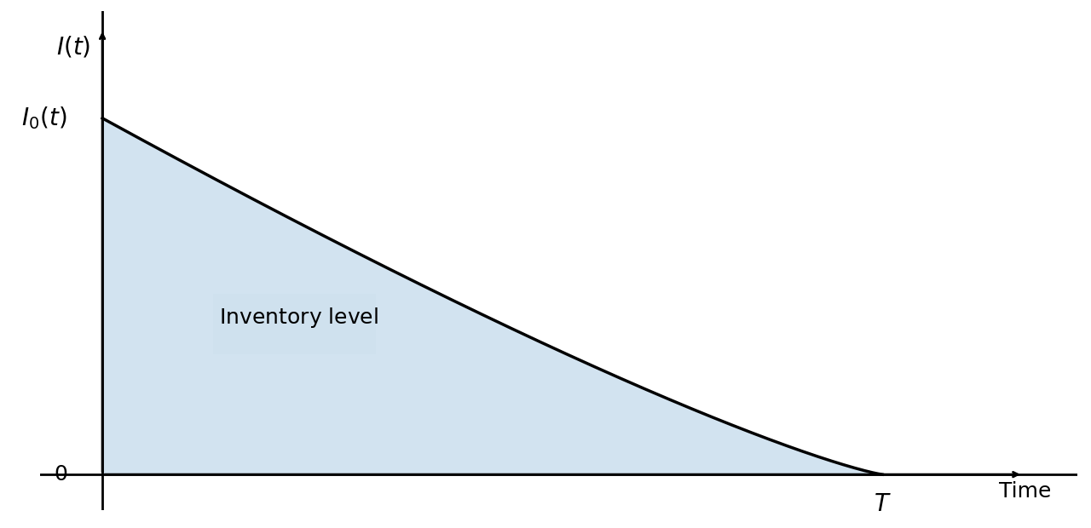
Figure 1: Inventory level for the no-shortage case

3.2 NOTATIONS
Notation | Meaning
$$I(t)$$ | Inventory level at time $t$
$$Q_{0}$$ | Optimal ordered quantity
$$T$$ | Inventory cycle length
${\tilde{a}}_{1}$, ${\tilde{a}}_{2},{\tilde{a}}_{3},{\tilde{a}}_{4}, {\tilde{a}}_{5}$ | Fuzzy demand parameters
$$\tilde{D}(t)$$ | Fuzzy time dependent demand
$$\tilde{γ, }\tilde{β}$$ | Fuzzy parameters of Weibull deterioration
$$I_{L}(t)$$ | $α$-cut inventory lower bound
$$I_{U}(t)$$ | $α$-cut inventory upper bound
$$Q_{L0}$$ | $α$-cut initial quantity ordering lower bound
$$Q_{U0}$$ | $α$-cut initial quantity ordering upper bound
$$TC$$ | Total inventory cost
$$HC$$ | Inventory holding cost
$$OC$$ | Ordering cost
$$PC$$ | Purchasing cost
$$c$$ | Ordering cost per unit
$$h$$ | Holding cost per unit
$$T^{*}$$ | Optimal inventory cycle length
$$\tilde{DC}$$ | Fuzzy deterioration cost
$d$ Deterioration cost per unit
$p$ Purchasing cost per unit

4.0. MATHEMATICAL MODEL FORMULATION

Let $I(t)$ be an inventory level at time $t$. We consider a fuzzy two-parameter Weibull distribution $\tilde{θ}(t)=\tilde{γ}\tilde{β}t^{\tilde{β}-1}$ with quartic time dependent demand function $\tilde{D}(t)={\tilde{a}}_{1}+{\tilde{a}}_{2}t+{\tilde{a}}_{3}t^{2}+{\tilde{a}}_{4}t^{3}+{\tilde{a}}_{5}t^{4}{, \tilde{a}}_{1}$, ${\tilde{a}}_{2},{\tilde{a}}_{3},{\tilde{a}}_{4},{\tilde{a}}_{5}>0$. Here, represent the fuzzy demand and Weibull parameters with triangular fuzzy numbers.
$\tilde{γ}=$($γ_{1}, γ_{2}, γ_{3})$, $\tilde{β}={(β}_{1}, β_{2}, β_{3})$,
${\tilde{a}}_{i}=(a_{i1}, a_{i2}, a_{i3})$, $i=1, 2, . . .$
Over a cycle $T$ and time and is described by the differential equation

$\frac{dI(t)}{dt}$ +$\tilde{γ}\tilde{β}t^{\tilde{β}-1}I(t)=-({\tilde{a}}_{1}+{\tilde{a}}_{2}t+{\tilde{a}}_{3}t^{2}+{\tilde{a}}_{4}t^{3}+{\tilde{a}}_{5}t^{4})$ (1)
With boundary conditions $I(0)=Q_{0}$ and $I(T)=0$
We define $α$-cut for demand and Weibull parameters as follows:
$${[{\tilde{a}}_{i}]}_{α}=[a_{iL}(α),a_{iU}(α)]$$
where
$\left\{\begin{matrix}{a_{iL}(α)=a}_{iL}+α(a_{iM}-a_{iL}) \\ a_{iU}(α)=a_{iU}+α(a_{iM}-a_{iU})\end{matrix}\right.$ (2)
And
$${[{\tilde{γ}}_{i}]}_{α}=[γ_{L}(α),γ_{U}(α)]$$
Where
$\left\{\begin{matrix}{γ_{L}(α)=γ}_{L}+α(γ_{M}-γ_{L}) \\ γ_{U}(α)=γ_{U}+α(γ_{M}-γ_{U})\end{matrix}\right.$ (3)
$${[{\tilde{β}}_{i}]}_{α}=[β_{L}(α),β_{U}(α)]$$
where
$\left\{\begin{matrix}{β_{L}(α)=β}_{L}+α(β_{M}-β_{L}) \\ β_{U}(α)=β_{U}+α(β_{M}-β_{U})\end{matrix}\right.$ (4)
To solve the differential equation (1), we decompose it into an upper and lower α-cut;
$\frac{dI_{U}(t)}{dt}+γ_{U}β_{U}t^{β_{U}-1}I_{U}(t)=-(a_{1U}+a_{2U}t+a_{3U}t^{2}+a_{4U}t^{3}+a_{5U}t^{4})$ (5)
With boundary condition $I_{U}(0)=Q_{0U}$ and $I_{U}(T)=0$
And
$\frac{dI_{L}(t)}{dt}+γ_{L}β_{L}t^{β_{L}-1}I_{L}(t)=-(a_{1L}+a_{2L}t+a_{3L}t^{2}+a_{4L}t^{3}+a_{5L}t^{4})$ (6)
With boundary $I_{L}(0)=Q_{0L}$ and $I_{L}(T)=0$
To solve equation (5) and (6), let us first define
$f_{L}(t, I_{L})= -(a_{1L}+a_{2L}t+a_{3L}t^{2}+a_{4L}t^{3}+a_{5L}t^{4})-γ_{L}β_{L}t^{β_{L}-1}I_{L}(t)$ (7)
And
$f_{U}(t, I_{U})=-(a_{1U}+a_{2U}t+a_{3U}t^{2}+a_{4U}t^{3}+a_{5U}t^{4})-γ_{U}β_{U}t^{β_{U}-1}I_{U}(t)$ (8)
Let the inventory interval $[0, T]$ be divided into equal subintervals with step size
$h=\frac{T}{N}$, with $t_{n}=nh$, $n=0, 1, 2,3,..., N$
we define the Fourth Order Runge-Kutta formula for the lower $α$-cut value as;
$$k_{1L}=f_{L}(t_{n},I_{n})$$
$k_{2L}=f_{L}(t_{n}+h/2,I_{Ln}+h/2k_{1L}$)
$k_{3L}=f_{L}(t_{n}+h/2,I_{Ln}+h/2k_{2L}$)
$k_{4L}=f_{L}(t_{n}+h,I_{Ln}+hk_{3L}$
$I_{L,n+1}=I_{L,n}+h/6(k_{1L}+2k_{2L}+{2k}_{3L}+k_{4L}$) (9)
With
$k_{1L}=f_{L}(t_{n}, I_{L.n})=-(a_{1L}+a_{2L}t_{n}+a_{3L}{t_{n}}^{2}+a_{4L}{t_{n}}^{3}+a_{5L}{t_{n}}^{4})-γ_{L}β_{L}{t_{n}}^{β_{L}-1}I_{L},n$ (7)
$k_{2L}=-\left[(a_{1L}+a_{2L}(t_{n}+h/2)+a_{3L}{(t_{n}+h/2)}^{2}+a_{4L}{(t_{n}+h/2)}^{3}+a_{5L}{{(t}_{n}+h/2)}^{4}\right]-\left[γ_{L}β_{L}{(t_{n}+h/2)}^{β_{L}-1}I_{L,n}-h/2{(γ}_{L}^{2}β_{L}^{2}({t_{n}+h/2)}^{β_{L}-1}t_{n}^{β_{L}-1}I_{L,n})-(h/2γ_{L}β_{L}{(t_{n}+h/2)}^{β_{L}-1})\left(a_{1L}+a_{2L}t_{n}+a_{3L}{t_{n}}^{2}+a_{4L}{t_{n}}^{3}+a_{5L}{t_{n}}^{4}\right)\right]$ (10)
$k_{3L}=-\left[(a_{1L}+a_{2L}(t_{n}+h/2)+a_{3L}{(t_{n}+h/2)}^{2}+a_{4L}{(t_{n}+h/2)}^{3}+a_{5L}{{(t}_{n}+h/2)}^{4}\right]+γ_{L}β_{L}{(t_{n}+h/2)}^{β_{L}-1}I_{L,n}-\frac{h}{2}γ_{L}β_{L}{(t_{n}+h/2)}^{β_{L}-1}\left[a_{1L}+a_{2L}(t_{n}+h/2)+a_{3L}{(t_{n}+h/2)}^{2}+a_{4L}{(t_{n}+h/2)}^{3}+a_{5L}{{(t}_{n}+h/2)}^{4} \right]-\frac{h}{2}{(γ}_{L}^{2}β_{L}^{2}({t_{n}+h/2)}^{{2β}_{L}-2}I_{L,n})+\frac{h^{2}}{4}{(γ}_{L}^{3}β_{L}^{3}({t_{n}+h/2)}^{{2β}_{L}-2}t_{n}^{β_{L}-1}I_{L,n})+\frac{h^{2}}{4}{(γ}_{L}^{2}β_{L}^{2}({t_{n}+h/2)}^{{2β}_{L}-2}\left(a_{1L}+a_{2L}t_{n}+a_{3L}{t_{n}}^{2}+a_{4L}{t_{n}}^{3}+a_{5L}{t_{n}}^{4}\right)$ (11)
$k_{4L}=-\left[a_{1L}+a_{2L}(t_{n}+h)+a_{3L}{(t_{n}+h)}^{2}+a_{4L}{(t_{n}+h)}^{3}+a_{5L}{{(t}_{n}+h)}^{4}\right]-γ_{L}β_{L}{(t_{n}+h)}^{β_{L}-1}I_{L}t_{n}+hγ_{L}β_{L}{(t_{n}+h)}^{β_{L}-1}\left[a_{1L}+a_{2L}(t_{n}+h)+a_{3L}{(t_{n}+h)}^{2}+a_{4L}{(t_{n}+h)}^{3}+a_{5L}{{(t}_{n}+h)}^{4}\right]+{hγ}_{L}^{2}β_{L}^{2}{(t_{n}+h)}^{β_{L}-1}({t_{n}+h/2)}^{{2β}_{L}-2}I_{L,n}-\frac{h^{2}}{2}γ_{L}^{2}β_{L}^{2}{(t_{n}+h)}^{β_{L}-1}({t_{n}+h/2)}^{β_{L}-1}\left(a_{1L}+a_{2L}t_{n}+a_{3L}{t_{n}}^{2}+a_{4L}{t_{n}}^{3}+a_{5L}{t_{n}}^{4}\right)-\frac{h^{2}}{2}γ_{L}^{3}β_{L}^{3}{(t_{n}+h)}^{β_{L}-1}({t_{n}+h/2)}^{{2β}_{L}-2}I_{L,n}+\frac{h^{3}}{4}γ_{L}^{3}β_{L}^{3}{(t_{n}+h)}^{β_{L}-1}({t_{n}+h/2)}^{{2β}_{L}-2}\left(a_{1L}+a_{2L}t_{n}+a_{3L}{t_{n}}^{2}+a_{4L}{t_{n}}^{3}+a_{5L}{t_{n}}^{4}\right)+\frac{h^{3}}{4}γ_{L}^{4}β_{L}^{4}{(t_{n}+h)}^{β_{L}-1}({t_{n}+h/2)}^{{2β}_{L}-2}{t_{n}^{β_{L}-1}I}_{L,n}$ (12)
Similarly, the Fourth Order Runge-Kutta formula for the upper $α$-cut value is;
$I_{U,n+1}=I_{U,n}+h/6(k_{1U}+2k_{2U}+{2k}_{3U}+k_{4U}$) (13)
Costs Analysis
Once we obtain the inventory level from the RK4 method for the upper and lower α-cut value, the associated inventory costs are evaluated over the replenishment cycle $0≤t≤T$ as follows:
For RK4 step size $h=\frac{T}{N}$ with $t_{n}=nh$, $n=0, 1, 2, 3, . . ., N$ for each $α$-cut, we generate
$I_{L,0}, I_{L,1}, I_{L,2}, ..., I_{L,N}$ and $I_{U,0}, I_{U,1}, I_{U,2}, ..., I_{U,N}$ for lower and upper bound respectively. The total inventory cost is given as:

$\tilde{{TC}_{W}}(T)=OC(T)+{PC(T)}_{α}+ {[HC]}_{α}+DC(T)$ (14)
With $OC(T)=c,$
${PC(T)}_{α}=\left[pQ_{L},pQ_{U}\right]$
${[HC]}_{α}={[HC}_{L}(T), {HC}_{U}(T)]$
Where ${HC}_{L}(T)=C_{h}h\sum_{n=0}^{N}{I_{L,n}=C_{h}h\left(I_{L,0}+I_{L,1}+ I_{L,2}+, ...+ I_{L,N}\right)}$
And ${HC}_{U}(T)=C_{h}h\sum_{n=0}^{N}{I_{U,n}=C_{h}h\left(I_{U,0}+I_{U,1}+ I_{U,2}+, ...+ I_{U,N}\right)}$,
$${[DC]}_{α}={[DC}_{L}(T), {DC}_{U}(T)]$$
With ${DC}_{L}(T)=dh\sum_{n=0}^{N}{γ_{L}β_{L}{(nh)}^{β_{L}-1}I_{L,n}}$
And ${DC}_{U}(T)=dh\sum_{n=0}^{N}{γ_{U}β_{U}{(nh)}^{β_{U}-1}I_{U,n}}$
The total fuzzy inventory cost in equation (14) now becomes:
$\tilde{{TC}_{W}}(T)=C_{0}+\left[pQ_{L},pQ_{U}\right]+\left[C_{h}h\sum_{n=0}^{N}{I_{L,n}},C_{h}h\sum_{n=0}^{N}{I_{U,n}}\right]+\left[dh\sum_{n=0}^{N}{γ_{L}β_{L}{(nh)}^{β_{L}-1}I_{L,n}},dh\sum_{n=0}^{N}{γ_{U}β_{U}{(nh)}^{β_{U}-1}I_{U,n}} \right]$ (15)
We defuzzify $\tilde{{TC}_{W}}(T)$ using the graded mean integration representation (GMIR)
${TC}_{W}(T)=\frac{{TC}_{WL}(T)+4{TC}_{WM}(T)+{TC}_{WU}(T)}{6}$ (16)

Where,
${TC}_{WL}(T)=c+pQ_{L}+C_{h}h\sum_{n=0}^{N}{I_{L,n}}+dh\sum_{n=0}^{N}{γ_{L}β_{L}{(nh)}^{β_{L}-1}I_{L,n}},$ (17)
${TC}_{WU}(T)=c+pQ_{U}+C_{h}h\sum_{n=0}^{N}{I_{U,n}}+dh\sum_{n=0}^{N}{γ_{U}β_{U}{(nh)}^{β_{U}-1}I_{U,n}}$ (18)
${TC}_{WM}(T)=c+pQ_{M}+C_{h}h\sum_{n=0}^{N}{I_{M,n}}+dh\sum_{n=0}^{N}{γ_{M}β_{M}{(nh)}^{β_{M}-1}I_{M,n}}$ (19)
Which implies;
${TC}_{W}(T)=\frac{1}{6}\left\{\left(c+pQ_{L}+C_{h}h\sum_{n=0}^{N}{I_{L,n}}+dh\sum_{n=0}^{N}{γ_{L}β_{L}{(nh)}^{β_{L}-1}I_{L,n}}\right)+4\left(c+pQ_{M}+C_{h}h\sum_{n=0}^{N}{I_{M,n}}+dh\sum_{n=0}^{N}{γ_{M}β_{M}{(nh)}^{β_{M}-1}I_{M,n}}\right)+\left(c+pQ_{U}+C_{h}h\sum_{n=0}^{N}{I_{U,n}}+dh\sum_{n=0}^{N}{γ_{U}β_{U}{(nh)}^{β_{U}-1}I_{U,n}}\right)\right\}$ (20)
And the average cost is given as:
${AC}_{w}(T)=\frac{{TC}_{w}(T)}{T}$ (21)
Optimal cycle length of inventory is obtained by minimizing the average total cost of inventory. Hence, the optimal cycle length of inventory is stated as:
$T^{*}=\underset{T>0}{argmin}{{AC}_{w}(T)}$ (22)
and optimal Average cost ${AC}_{w}(T^{*})=\min_{T>0}{{AC}_{w}(T)}$ (23)
5.0. NUMERICAL EXAMPLE
In order to demonstrate the relevance of the model, an example with the following set of parameters is used. Based on the below parameters values and total cost of the inventory system given by the cost equations above, the inventory model is solved numerically using Python programming language. The results obtained are the following:
Case 1. Non-Fuzzy Case:
$a_{1}=15$ $a_{2}=$6, $a_{3}=8$ $a_{4}=4,$ $a_{5}=2,$ $γ=0.2$
$β=2$, $d=6$, $C_{h}=3$, $c=90$, $p=8$ $T=2$
Total inventory cost ${TC}_{W}(T)=2103.665045$, Average cost ${AC}_{w}(T)=1051.832523$
optimal cycle length $T^{*}=0.73704566$, optimal quantity $Q^{*}=14.74251884,$
${TC}_{W}(T^{*})=229.37132781$ and optimal average cost ${AC}_{w}(T^{*})=311.20368695$
Case 2. Fuzzy Case:
${\tilde{a}}_{1}=(14$,15,16) ${\tilde{a}}_{2}=(5$,6,7) ${\tilde{a}}_{3}=(7,8$,9) ${\tilde{a}}_{4}=(3,4,5)$ ${\tilde{a}}_{5}=(1,2,3)$ γ=(0.1,0.2,0.3)
$\tilde{β}=(1,2,3)$, $d=6$, $C_{h}=3$, $c=90$, $p=8$ $T=2$, $N=800$
Total inventory cost ${TC}_{W}(T)=2745.34353769$, Average cost ${AC}_{w}(T)=1372.67176885$,
optimal inventory cost ${TC}_{W}(T^{*})=229.57937669$,
optimal cycle length $T^{*}=0.73867431$ optimal quantity $Q^{*}=14.7897$
and optimal average cost ${AC}_{w}(T^{*})=310.79918870$
6.0 SENSITIVITY ANALYSIS
In order to evaluate the impact of changes in the demand-related parameter, Weibull deterioration parameters, and their relevant inventory costs on the total cost, average cost, optimal cost, optimal cycle time, and optimal order quantity, the sensitivity analysis method is applied. In this regard, each of these parameters is changed by ±20% with all other parameters remaining unchanged. One of these parameters is changed each time. The results of this process have been presented in Tables 1–3. In Table 1, impacts of the changes in parameter values on the total and average cost in the non-fuzzy model have been shown, while Table 2 presents the sensitivity analysis results for the fuzzy model. Table 3 presents the sensitivity of the optimal cycle time, along with its optimal cost and quantity.

Table 1. Sensitivity Analysis of Cycle Length, Total Cost, and Average Cost to ±20% Changes in Non-Fuzzy Model Parameters
Parameter | Variation (%) | Changed Value | Initial Inventory $Q$ | $${TC}_{W}(T)$$ | % Change  $${TC}_{W}(T)$$ | $${AC}_{w}(T)$$ | % Change ${AC}_{w}(T)$
$$a_{1}$$ | −20 | 12.000000 | 136.612340 | 2002.624163 | -4.8031 | 1001.312082 | -4.8031
$$a_{1}$$ | +20 | 18.000000 | 152.752733 | 2204.705927 | 4.8031 | 1102.352963 | 4.8031
$$a_{2}$$ | −20 | 4.800000 | 141.005914 | 2053.058896 | -2.4056 | 1026.529448 | -2.4056
$$a_{2}$$ | +20 | 7.200000 | 148.359159 | 2154.271194 | 2.4056 | 1077.135597 | 2.4056
$$a_{3}$$ | −20 | 6.400000 | 137.638471 | 2002.606511 | -4.8039 | 1001.303256 | -4.8039
$$a_{3}$$ | +20 | 9.600000 | 151.726602 | 2204.723579 | 4.8039 | 1102.361790 | 4.8039
$$a_{4}$$ | −20 | 3.200000 | 139.133618 | 2022.172520 | -3.8738 | 1011.086260 | -3.8738
$$a_{4}$$ | +20 | 4.800000 | 150.231455 | 2185.157570 | 3.8738 | 1092.578785 | 3.8738
$$a_{5}$$ | −20 | 1.600000 | 140.085832 | 2035.130126 | -3.2579 | 1017.565063 | -3.2579
$$a_{5}$$ | +20 | 2.400000 | 149.279241 | 2172.199965 | 3.2579 | 1086.099982 | 3.2579
$$γ$$ | −20 | 0.160000 | 131.592126 | 1880.334914 | -10.6162 | 940.167457 | -10.6162
$$γ$$ | +20 | 0.240000 | 159.424462 | 2354.424951 | 11.9201 | 1177.212475 | 11.9201
$$β$$ | −20 | 1.600000 | 132.841171 | 1888.603115 | -10.2232 | 944.301557 | -10.2232
$$β$$ | +20 | 2.400000 | 162.312123 | 2421.889059 | 15.1271 | 1210.944530 | 15.1271
d | −20 | 4.800000 | 144.682537 | 2040.606099 | -2.9976 | 1020.303049 | -2.9976
d | +20 | 7.200000 | 144.682537 | 2166.723991 | 2.9976 | 1083.361996 | 2.9976
$$C_{h}$$ | −20 | 2.400000 | 144.682537 | 1995.483041 | -5.1425 | 997.741520 | -5.1425
$$C_{h}$$ | +20 | 3.600000 | 144.682537 | 2211.847049 | 5.1425 | 1105.923525 | 5.1425
c | −20 | 72.000000 | 144.682537 | 2085.665045 | -0.8556 | 1042.832523 | -0.8556
c | +20 | 108.000000 | 144.682537 | 2121.665045 | 0.8556 | 1060.832523 | 0.8556
p | −20 | 6.400000 | 144.682537 | 1872.172987 | -11.0042 | 936.086493 | -11.0042
p | +20 | 9.600000 | 144.682537 | 2335.157104 | 11.0042 | 1167.578552 | 11.0042

Table 2. Sensitivity Analysis of Cycle Length, Total Cost, and Average Cost to ±20% Changes in Fuzzy Model Parameters
Parameter | Variation (%) | Initial Inventory $Q$ | $${TC}_{W}(T)$$ | % Change  $${TC}_{W}(T)$$ | $${AC}_{w}(T)$$ | % Change ${AC}_{w}(T)$
$$a_{1}$$ | −20 | 172.151673 | 2628.251583 | -4.2651 | 1314.125791 | -4.2651
$$a_{1}$$ | +20 | 190.117917 | 2862.435493 | 4.2651 | 1431.217746 | 4.2651
$$a_{2}$$ | −20 | 176.710312 | 2681.585808 | -2.3224 | 1340.792904 | -2.3224
$$a_{2}$$ | +20 | 185.559278 | 2809.101267 | 2.3224 | 1404.550634 | 2.3224
$$a_{3}$$ | −20 | 172.374237 | 2614.072760 | -4.7816 | 1307.036380 | -4.7816
$$a_{3}$$ | +20 | 189.895353 | 2876.614315 | 4.7816 | 1438.307157 | 4.7816
$$a_{4}$$ | −20 | 173.775490 | 2631.972703 | -4.1296 | 1315.986351 | -4.1296
$$a_{4}$$ | +20 | 188.494099 | 2858.714373 | 4.1296 | 1429.357186 | 4.1296
$$a_{5}$$ | −20 | 174.435304 | 2639.766127 | -3.8457 | 1319.883064 | -3.8457
$$a_{5}$$ | +20 | 187.834286 | 2850.920948 | 3.8457 | 1425.460474 | 3.8457
$$γ$$ | −20 | 153.178092 | 2263.105539 | -17.5657 | 1131.552770 | -17.5657
$$γ$$ | +20 | 218.778929 | 3392.279204 | 23.5648 | 1696.139602 | 23.5648
$$β$$ | −20 | 148.028627 | 2161.361330 | -21.2717 | 1080.680665 | -21.2717
$$β$$ | +20 | 273.793460 | 4386.189792 | 59.7683 | 2193.094896 | 59.7683
d | −20 | 181.134795 | 2638.539763 | -3.8904 | 1319.269881 | -3.8904
d | +20 | 181.134795 | 2852.147313 | 3.8904 | 1426.073656 | 3.8904
$$C_{h}$$ | −20 | 181.134795 | 2610.894277 | -4.8974 | 1305.447139 | -4.8974
$$C_{h}$$ | +20 | 181.134795 | 2879.792798 | 4.8974 | 1439.896399 | 4.8974
c | −20 | 181.134795 | 2727.343538 | -0.6557 | 1363.671769 | -0.6557
c | +20 | 181.134795 | 2763.343538 | 0.6557 | 1381.671769 | 0.6557
p | −20 | 181.134795 | 2455.527866 | -10.5566 | 1227.763933 | -10.5566
p | +20 | 181.134795 | 3035.159210 | 10.5566 | 1517.579605 | 10.5566

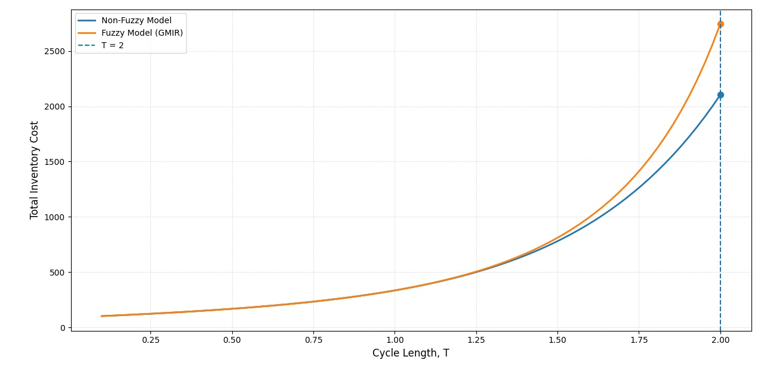
Figure 2: Total cost comparison between the Fuzzy and Non-Fuzzy Model
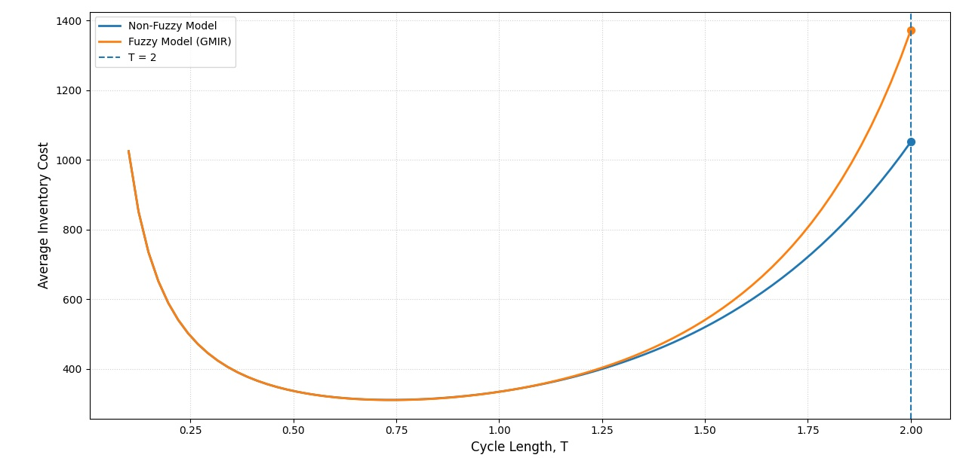
Figure 3: Average cost comparison between the Fuzzy and Non-Fuzzy Model

Table 3. Sensitivity Analysis of Optimal Cycle Length, Total Cost, and Average Cost to ±20% Changes in Model Parameters
Parameter | Change (%) | $$T^{*}$$ | % Change  $$T^{*}$$ | $$Q^{*}$$ | $${TC}_{W}(T^{*})$$ | % Change  $${TC}_{W}(T^{*})$$ | $${AC}_{w}(T^{*})$$ | % Change  $${AC}_{w}(T^{*})$$
$$a_{1}$$ | -20 | 0.751482 | 1.723562 | 12.804553 | 211.718855 | -7.780550 | 281.735105 | -9.343078
$$a_{1}$$ | +20 | 0.726570 | -1.648673 | 16.680115 | 246.808929 | 7.503810 | 339.690678 | 9.305907
$$a_{2}$$ | -20 | 0.749923 | 1.512592 | 14.742042 | 229.594709 | 0.005726 | 306.157529 | -1.484413
$$a_{2}$$ | +20 | 0.727992 | -1.456109 | 14.798764 | 229.531740 | -0.021702 | 315.294234 | 1.455602
$$a_{3}$$ | -20 | 0.752627 | 1.878619 | 14.935160 | 231.507770 | 0.839007 | 307.599417 | -1.020441
$$a_{3}$$ | +20 | 0.725926 | -1.735781 | 14.622065 | 227.802438 | -0.774943 | 313.809399 | 0.977811
$$a_{4}$$ | -20 | 0.744299 | 0.751308 | 14.867999 | 230.644518 | 0.462996 | 309.881343 | -0.286162
$$a_{4}$$ | +20 | 0.733452 | -0.716993 | 14.682219 | 228.571687 | -0.439877 | 311.638064 | 0.279117
$$a_{5}$$ | -20 | 0.740896 | 0.290582 | 14.815702 | 230.052169 | 0.204984 | 310.505406 | -0.085350
$$a_{5}$$ | +20 | 0.736655 | -0.283479 | 14.731050 | 229.123674 | -0.199445 | 311.032543 | 0.084272
$$γ$$ | -20 | 0.751986 | 1.791778 | 15.028969 | 231.773581 | 0.954788 | 308.215317 | -0.822257
$$γ$$ | +20 | 0.726519 | -1.655552 | 14.538152 | 227.574210 | -0.874353 | 313.239256 | 0.794350
$$β$$ | -20 | 0.733194 | -0.751921 | 14.782678 | 230.358333 | 0.338341 | 314.184536 | 1.098523
$$β$$ | +20 | 0.744071 | 0.720358 | 14.800854 | 229.374426 | -0.090224 | 308.269615 | -0.804785
d | -20 | 0.743437 | 0.634496 | 14.908812 | 230.315759 | 0.319797 | 309.798823 | -0.312715
d | +20 | 0.734222 | -0.612797 | 14.642283 | 228.876627 | -0.307053 | 311.726672 | 0.307630
$$C_{h}$$ | -20 | 0.752945 | 1.921605 | 15.187405 | 230.302425 | 0.313989 | 305.868844 | -1.577306
$$C_{h}$$ | +20 | 0.725462 | -1.798583 | 14.391978 | 228.906546 | -0.294021 | 315.532023 | 1.532118
c | -20 | 0.690230 | -6.567685 | 13.414415 | 197.126171 | -14.136759 | 285.594713 | -8.101130
c | +20 | 0.779687 | 5.541491 | 15.990963 | 260.780748 | 13.589586 | 334.468551 | 7.625528
p | -20 | 0.766542 | 3.762084 | 15.592204 | 213.488523 | -7.009727 | 278.508742 | -10.381259
p | +20 | 0.714380 | -3.298667 | 14.079537 | 244.695876 | 6.583417 | 342.528864 | 10.219181

A careful analysis of table 3 shows that cycle time, order quantity, total cost, and average cost do not behave identically as a result of fluctuations in the parameter values. Specifically, a relatively high level of sensitivity is demonstrated for the first parameter. A 20% growth in its value brings about a 7.50% increase in total cost and a 9.31% increment in average cost and a 1.65% decrease in the optimal cycle length. The ordering cost is the most sensitive parameter. As can be seen, a 20% growth in this parameter causes a 5.54% increment in the optimal cycle length and a 13.59% increase in total cost. The same happens to a 20% growth in purchase cost, which causes a 3.30% decrement in the optimal cycle length and a 6.58% and 10.22% increase in total and average costs, respectively. Meanwhile, small changes in Weibull deterioration parameters lead to relatively small changes in cost measures. It should be noted that the findings suggest that the inventory managers should pay special attention to demand forecasting, reducing ordering costs, and procurement price management in selecting the replenishment policy.
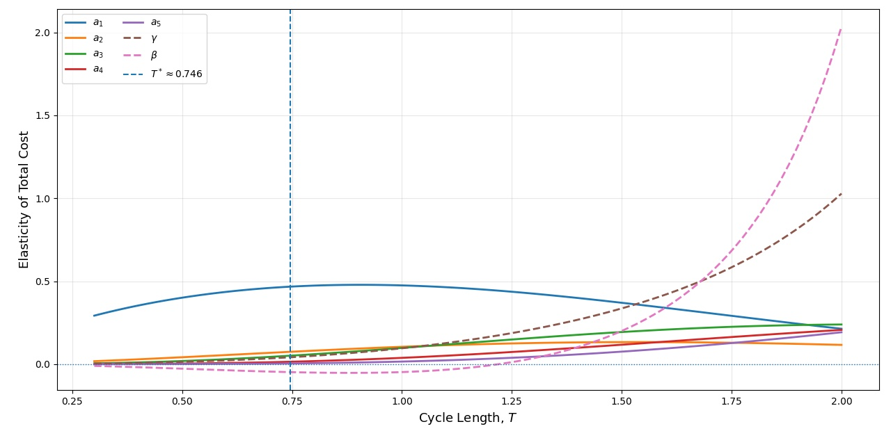
Figure 4: Elasticity of Total Cost with Respect to Demand and Weibull Deterioration Parameters against Cycle Length

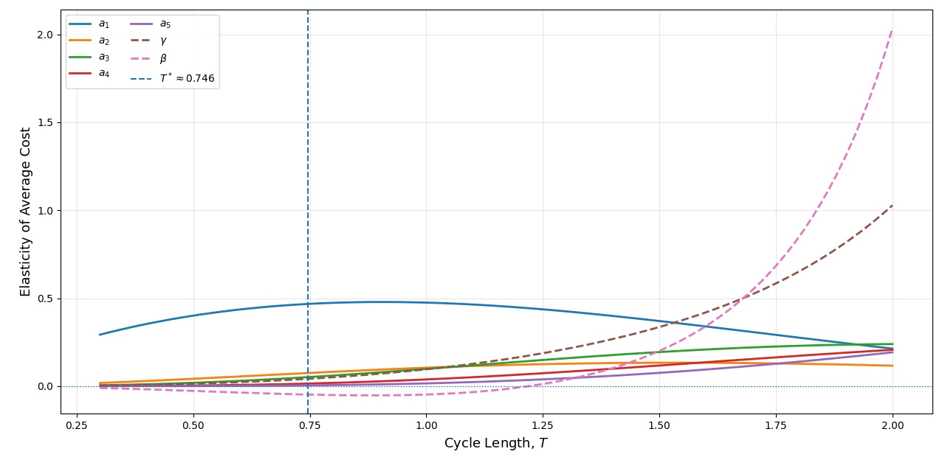Figure 5: Elasticity of Average Cost with Respect to Demand and Weibull Deterioration Parameters against Cycle Length
6.0 CONCLUSION
In this paper, we formulate a fuzzy inventory model for items with two parameter Weibull deterioration distribution and quartic demand pattern without any shortage condition. For this, the fourth-order Runge–Kutta approach was used to calculate inventory, the Graded Mean Integration Representation (GMIR) method was used to obtain the fuzzy cost-related values.
The results obtained through the numerical analysis and sensitivity analysis show that the demand and cost parameters play a significant role in shaping the optimal inventory policy and cost, but the Weibull deterioration parameters show only minor fluctuations. Furthermore, by adopting the fuzzy environment, the parameters uncertainty is incorporated in this problem, and the fuzzy inventory model provides more flexibility than the non-fuzzy inventory model.
Overall, the proposed fuzzy inventory model provides a strong framework for replenishment and cost planning when demand and deterioration are uncertain. Future research can further improve the proposed model by incorporating shortage, finite replenishment rate, price dependent demand, etc.

Limitations
The model is limited to a single-item inventory system with zero lead time, instantaneous replenishment, no shortages, quartic time-dependent demand, and two-parameter Weibull deterioration. Parameter uncertainty is represented only through triangular fuzzy numbers, and the numerical evaluation is based on the specified parameter sets and one-at-a-time ±20% sensitivity changes. Consequently, the reported sensitivity patterns are specific to the model assumptions and parameter ranges examined. Extensions may consider shortages, finite replenishment, alternative fuzzy representations, and other demand or deterioration structures.

Declaration of AI Use
This manuscript was prepared through the intellectual contributions of the author(s) to the study design, data analysis, interpretation of results, and scholarly content. Grammarly and ChatGPT were used solely to assist with grammatical refinement and reference formatting during manuscript revision. The author(s) accept full responsibility for the accuracy, integrity, and final content of the manuscript.

REFERENCES
Chen, J.-M. (1998). An inventory model for deteriorating items with time-proportional demand and shortages under inflation and time discounting. International Journal of Production Economics, 55(1), 21–30. https://doi.org/10.1016/S0925-5273(98)00011-5
Covert, R. P., & Philip, G. C. (1973). An EOQ model for items with Weibull distribution deterioration. AIIE Transactions, 5(4), 323–326. https://doi.org/10.1080/05695557308974918
Datta, T. K., & Pal, A. K. (1988). Order level inventory system with power demand pattern for items with variable rate of deterioration. Indian Journal of Pure and Applied Mathematics, 19(11), 1043–1053.
Dave, U., & Patel, L. K. (1981). (T, Sᵢ) policy inventory model for deteriorating items with time proportional demand. Journal of the Operational Research Society, 32(2), 137–142. https://doi.org/10.1057/jors.1981.27
Donaldson, W. A. (1977). Inventory replenishment policy for a linear trend in demand—An analytical solution. Journal of the Operational Research Society, 28(3), 663–670. https://doi.org/10.1057/jors.1977.142
Ghare, P. M., & Schrader, G. F. (1963). A model for exponentially decaying inventory. Journal of Industrial Engineering, 14(5), 238–243.
Goyal, S. K., & Giri, B. C. (2001). Recent trends in modeling of deteriorating inventory. European Journal of Operational Research, 134(1), 1–16. https://doi.org/10.1016/S0377-2217(00)00248-4
Harris, F. W. (1913). How many parts to make at once. Factory, The Magazine of Management, 10(2), 135–136, 152.
Jalan, A. K., Giri, R. R., & Chaudhuri, K. S. (1996). EOQ model for items with Weibull distribution deterioration, shortages and trended demand. International Journal of Systems Science, 27(9), 851–855. https://doi.org/10.1080/00207729608929285 Taylor &
Khanra, S., & Chaudhuri, K. S. (2003). A note on an order-level inventory model for a deteriorating item with time-dependent quadratic demand. Computers & Operations Research, 30(12), 1901–1916. https://doi.org/10.1016/S0305-0548(02)00113-2
Onyenike, K., Gideon, O., & Jonathan, T. (2026). Fuzzy EOQ model for two-parameter Weibull deteriorating items with time-dependent cubic demand under no shortage condition. International Journal of Innovative Research in Technology, 13(1), 4110–4116.
Patro, R., Acharya, M., Nayak, M. M., & Patnaik, S. (2017). A fuzzy inventory model with time dependent Weibull deterioration, quadratic demand and partial backlogging. International Journal of Management and Decision Making, 16(3), 243–279. https://doi.org/10.1504/IJMDM.2017.085636
Philip, G. C. (1974). A generalized EOQ model for items with Weibull distribution deterioration. AIIE Transactions, 6(2), 159–162. https://doi.org/10.1080/05695557408974948
Poswal, P., Chauhan, A., Boadh, R., Rajoria, Y. K., Kumar, A., & Khatak, N. (2022). Investigation and analysis of fuzzy EOQ model for price sensitive and stock dependent demand under shortages. Materials Today: Proceedings, 56, 542–548. https://doi.org/10.1016/j.matpr.2022.02.273
Ramya, S., & Sivakumar, D. (2026). An economic order quantity model with quartic demand, Weibull deterioration and time-dependent partial backlogging. International Journal of Innovative Research in Technology, 12(8), 3401–3410.
Ray, R. K., Biswas, A. K., & Das, K. (2025). An optimized inventory model for perishable items with cost and visibility-driven demand, partial backlogging, price escalation, and value adjustment in fuzzy environment. Applied Mathematical Biosystems, 1(1), 70–76. https://doi.org/10.67029/j.amb.2025.0011.15
Sarkar, S., & Chakrabarti, T. (2012). An EPQ model with two-component demand under fuzzy environment and Weibull distribution deterioration with shortages. Advances in Operations Research, 2012, Article 264182, 1–22. https://doi.org/10.1155/2012/264182
Sethi, G., Yadav, A. S., & Singh, C. (2022). Two ware-houses fuzzy inventory model for deteriorating items with ramp type demand and shortages. Journal of Management Information and Decision Sciences, 25(2), 1–22.
Shaikh, T. S., & Gite, S. P. (2024). Fuzzy inventory model under selling price dependent demand and variable deterioration with fully backlogged shortages. American Journal of Operations Research, 14(2), 87–103. https://doi.org/10.4236/ajor.2024.142005
Singh, S., Kumar, S., & Kumar, M. (2026). Imperfect inventory model for Weibull deteriorating items with selling price dependent demand under reliability consideration and fuzzy environment. International Journal of Fundamental and Multidisciplinary Research, 8(4). https://doi.org/10.36948/ijfmr.2026.v08i04.83842
Suman, & Kumar, V. (2021). Analytical investigation of a deterministic inventory model using the cubic demand rate and the exponential distribution as deterioration rate. International Journal of Engineering Research & Technology, 10(9). https://doi.org/10.5281/zenodo.18516533
Suman, & Kumar, V. (2022). Analytical study of deterministic inventory model with consideration of biquadratic demand rate and Weibull distribution as deterioration rate. International Journal of Innovative Research in Technology, 9(4), 642–651.
Whitin, T. M. (1957). The theory of inventory management (2nd ed.). Princeton University Press.
Yadav, R. K., & Yadav, P. (2013). Volume flexibility in production model with cubic demand rate and Weibull deterioration with partial backlogging. IOSR Journal of Mathematics, 6(4), 29–34. https://doi.org/10.9790/5728-0642934

