A Mathematical Model of Vaccination Control for Diphtheria in Nigeria
Abstract
Diphtheria remains a public health concern in Nigeria, where interruptions in routine immunisation, uneven access to health services, waning immunity, and surveillance limitations may leave sizeable groups susceptible to infection. This study develops a deterministic susceptible–infectious–recovered–vaccinated (SIRV) model to examine the influence of vaccination on diphtheria transmission. The model incorporates demographic turnover, disease-induced mortality, recovery, vaccination, and waning infection-acquired and vaccine-induced immunity. The basic reproduction number, $R_{0}$, is derived using the next-generation method, and the disease-free and endemic equilibria are characterised. Local stability analysis shows that the disease-free equilibrium is locally asymptotically stable when $R_{0}<1$and unstable when $R_{0}>1$, while a biologically meaningful endemic equilibrium exists above the invasion threshold. Sensitivity analysis indicates that transmission increases $R_{0}$, whereas vaccination and recovery reduce it; faster loss of vaccine-induced immunity increases transmission potential. Numerical illustrations show a monotonic decline in $R_{0}$as the vaccination rate increases and demonstrate how waning protection can replenish the susceptible population. The model therefore highlights the importance of sustained routine immunisation, appropriate booster delivery, surveillance, and rapid outbreak response. Because the numerical parameter values are illustrative rather than fitted to a unified Nigerian dataset, the framework requires calibration and validation with current Nigerian surveillance, demographic, and immunisation data before use for forecasting or resource allocation.
Keywords: diphtheria; vaccination; SIRV model; basic reproduction number; stability; waning immunity; Nigeria.
1 Introduction
Diphtheria is a vaccine-preventable bacterial infection caused principally by toxigenic strains of Corynebacterium diphtheriae. Respiratory transmission occurs through droplets and close contact. Although early symptoms may resemble those of other upper-respiratory infections, toxin production can lead to a characteristic pharyngeal pseudomembrane, airway obstruction, myocarditis, neurological complications, and death. Effective toxoid vaccines have greatly reduced the global burden of the disease, but transmission can return when immunity gaps accumulate (Anderson & May, 1991; World Health Organization, 2026).
Nigeria has experienced recurrent outbreaks in settings where routine immunisation is incomplete and access to timely diagnosis and treatment is uneven (Nigeria Centre for Disease Control and Prevention, 2023; UNICEF, 2023). The reasons are not purely biomedical. Distance from health facilities, insecurity, population displacement, supply-chain interruptions, misinformation, and vaccine hesitancy can all affect vaccine uptake. Consequently, national averages may conceal local clusters of susceptible people capable of sustaining transmission. Recent Nigerian evidence similarly links diphtheria persistence and resurgence to incomplete immunisation and emphasises the importance of vaccination, surveillance, and coordinated outbreak response (Gaiya et al., 2024; Jega et al., 2024; Nwokeji et al., 2023).
Mathematical models provide a structured way to connect these processes. By dividing the population into epidemiological states and representing movement between them with differential equations, a model can identify threshold conditions for invasion, clarify the influence of uncertain parameters, and compare intervention scenarios (Diekmann et al., 1990; Hethcote, 2000). It cannot replace surveillance or clinical evidence, but it can make assumptions explicit and help decision-makers understand their consequences. Recent diphtheria modelling studies have also used vaccination-focused compartmental and optimal-control frameworks to examine transmission thresholds and booster vaccination strategies (Fauzi et al., 2024; Madubueze et al., 2023).
Within the scope of this study, there is a need for a compact baseline formulation that simultaneously represents transmission, vaccination, recovery, mortality, and loss of infection-acquired and vaccine-induced immunity while remaining sufficiently tractable for equilibrium, threshold, stability, and sensitivity analysis. The present study addresses this modelling need in the Nigerian context.
This study formulates an SIRV model for diphtheria vaccination control in Nigeria. Specifically, it aims to:
- represent transmission, vaccination, recovery, mortality, and waning immunity in a single framework;
- derive the disease-free and endemic equilibria and the basic reproduction number, $R_{0}$;
- establish the local stability condition for the disease-free equilibrium;
- quantify the sensitivity of $R_{0}$ to key parameters; and
- illustrate how alternative vaccination rates affect epidemic trajectories and the transmission threshold.
2 Related literature and Nigerian context
The classical SIR framework separates a host population into susceptible, infectious, and recovered classes. Vaccination models commonly add a protected class, while more detailed formulations may also include age, latency, asymptomatic carriage, imperfect vaccine protection, seasonality, or spatial movement (Hethcote, 2000; Kanchanarat et al., 2022). The appropriate level of detail depends on the research question and the data available. For the present threshold analysis, an SIRV system offers a useful balance between interpretability and epidemiological relevance.
Vaccination affects transmission by reducing the pool of susceptible hosts. Its population-level benefit therefore depends not only on the number of doses delivered, but also on the timing and distribution of those doses and the duration of protection. When vaccine-induced or infection-acquired immunity wanes, previously protected people may again become susceptible. Booster vaccination can counter this replenishment, especially when routine coverage has been inconsistent.
In Nigeria, immunisation performance differs across regions and socioeconomic groups (National Bureau of Statistics & UNICEF, 2022; UNICEF, 2023). Rural access, conflict, cold-chain reliability, workforce constraints, and confidence in vaccination may influence both primary-series and booster coverage. A national control strategy must therefore combine routine delivery with surveillance-led responses in locations where susceptibility is concentrated. The present model does not resolve this heterogeneity; rather, it supplies a baseline against which age-structured, spatial, and data-driven extensions can be compared.
2.1 Classical SIR model
The simplest relevant formulation is the susceptible-infectious-recovered (SIR) model. With recruitment and natural mortality, it may be written as (Anderson & May, 1991; Hethcote, 2000)
$$\begin{aligned}\frac{dS}{ dt}=Λ-\frac{βSI}{N}-μS,\#(1) \\ \frac{ dI}{ dt}=\frac{βSI}{N}-(γ+μ)I,\#(2) \\ \frac{ dR}{ dt}=γI-μR.\#(3)\end{aligned}$$
Here, susceptible individuals become infected at rate $βSI/N$, while infectious individuals recover at rate $γI$. For this basic system, the reproduction number is
$$\begin{aligned}R_{0}^{SIR}=\frac{β}{γ+μ}.\#(4)\end{aligned}$$
Although the SIR model captures the principal transmission process, it assumes that recovered individuals remain immune and does not explicitly represent vaccination.
2.2 SEIR model with a latent period
An exposed class can be introduced when the delay between infection and infectiousness is epidemiologically important. A representative susceptible-exposed-infectious-recovered (SEIR) model is
$$\begin{aligned}\frac{dS}{ dt} =Λ-\frac{βSI}{N}-μS,\#(5) \\ \frac{ dE}{ dt} =\frac{βSI}{N}-(σ+μ)E,\#(6) \\ \frac{ dI}{ dt} =σE-(γ+δ+μ)I,\#(7) \\ \frac{ dR}{ dt} =γI-μR,\#(8)\end{aligned}$$
where $E(t)$ denotes infected individuals who are not yet infectious and $1/σ$ is the average latent period. Its basic reproduction number is
$$\begin{aligned}R_{0}^{SEIR}=\frac{βσ}{(σ+μ)(γ+δ+μ)}.\#(9)\end{aligned}$$
The factor $σ/(σ+μ)$ represents the probability that an exposed individual survives the latent stage and progresses to infectiousness.
2.3 Vaccination and waning-immunity extensions
Vaccination models add a protected class $V(t)$. If susceptible individuals are vaccinated at rate $ν$ and vaccine-induced immunity wanes at rate $ω_{V}$, the vaccination-related flows are
$$\begin{aligned}\frac{dS}{ dt}=⋯-νS+ω_{V}V,\#(10) \\ \frac{ dV}{ dt}=νS-\left(ω_{V}+μ\right)V.\#(11)\end{aligned}$$
Similarly, temporary infection-acquired immunity is represented by returning recovered individuals to susceptibility at rate $ω_{R}R$:
$$\begin{aligned}\frac{dR}{ dt}=γI-\left(ω_{R}+μ\right)R, \frac{ dS}{ dt}=⋯+ω_{R}R.\#(12)\end{aligned}$$
These extensions are particularly relevant to diphtheria because vaccination and the maintenance of immunity are central to disease control. The SIRV framework adopted in this study combines these mechanisms while retaining a sufficiently compact structure for equilibrium, threshold, stability, and sensitivity analysis.
3 Model formulation
3.1 State variables and assumptions
At time $t$, the population is partitioned into susceptible $S(t)$, infectious $I(t)$, recovered $R(t)$, and vaccinated $V(t)$ individuals. Thus,
$$\begin{aligned}N(t)=S(t)+I(t)+R(t)+V(t).\#(13)\end{aligned}$$
New individuals enter the susceptible class at rate $Λ$. Susceptible individuals acquire infection through homogeneous contact with infectious individuals or enter the vaccinated class at per-capita rate $ν$. Infectious individuals recover at rate $γ$ and experience disease-induced mortality at rate $δ$. Natural mortality occurs in every class at rate $μ$. Infection-acquired and vaccine-induced protection wane at rates $ω_{R}$ and $ω_{V}$, respectively. Vaccinated individuals are treated as fully protected while they remain in $V$; this simplifying assumption is revisited in Section 7.
The force of infection is
$$\begin{aligned}λ(t)=\frac{βI(t)}{N(t)},\#(14)\end{aligned}$$
where $β$ is the effective transmission rate. The corresponding incidence is $λS=βSI/N$.
3.2 Compartmental diagram
Figure 1 summarises the population flows. Recruitment enters $S$; infection moves individuals from $S$ to $I$; recovery moves them from $I$ to $R$; vaccination moves them from $S$ to $V$; and waning immunity returns individuals from $R$ or $V$ to $S$.
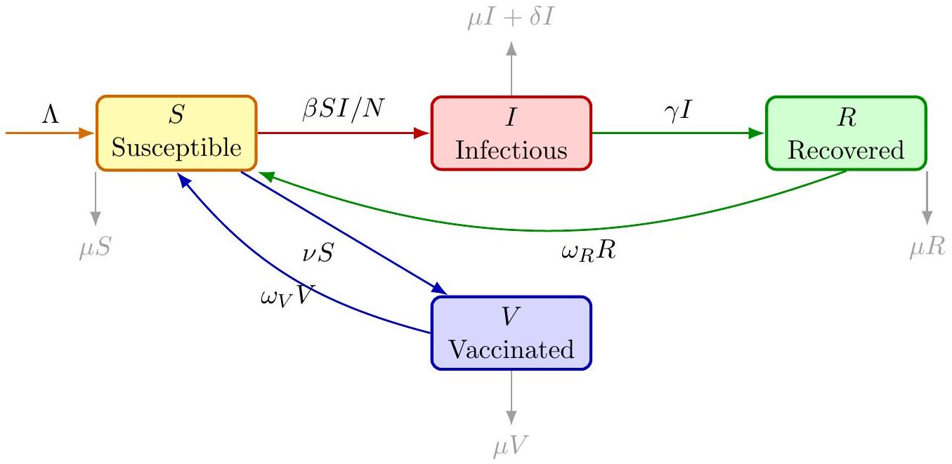
Figure 1: Compartmental structure of the SIRV model for diphtheria transmission and vaccination control.
3.3 Governing equations
The model is governed by
$$\begin{aligned}\frac{dS}{ dt}=Λ-\frac{βSI}{N}-νS+ω_{R}R+ω_{V}V-μS,\#(15) \\ \frac{ dI}{ dt}=\frac{βSI}{N}-(γ+δ+μ)I,\#(16) \\ \frac{ dR}{ dt}=γI-\left(ω_{R}+μ\right)R,\#(17) \\ \frac{ dV}{ dt}=νS-\left(ω_{V}+μ\right)V.\#(18)\end{aligned}$$
Summing Equations (15)-(18) gives
$$\begin{aligned}\frac{dN}{ dt}=Λ-μN-δI.\#(19)\end{aligned}$$
Hence, for non-negative initial conditions, solutions remain non-negative and eventually enter the feasible region
$$\begin{aligned}Ω=\left\{(S,I,R,V)∈R_{+}^{4}:N≤\frac{Λ}{μ}\right\}.\#(20)\end{aligned}$$
This boundedness follows from $dN/dt≤Λ-μN$.
3.4 Parameters
Table 1 retains the exploratory parameter ranges used in the original study. These values are illustrative rather than fitted estimates; a publishable forecasting application would require estimation from Nigerian case, mortality, demographic, and immunisation data.
Table 1: Parameters of the SIRV diphtheria model.
Parameter | Description | Exploratory value or range
$$Λ$$ | Recruitment into the susceptible population | To be estimated
$$β$$ | Effective transmission rate | $$0.4-0.6{day}^{-1}$$
$$ν$$ | Vaccination rate among susceptible individuals | $$0.002-0.01{day}^{-1}$$
$$γ$$ | Recovery rate | $0.1-0.2$ day $^{-1}$
$$δ$$ | Disease-induced mortality rate | $$0.01-0.05{day}^{-1}$$
$$ω_{R}$$ | Loss of infection-acquired immunity | $$0.001-0.005{day}^{-1}$$
$$ω_{V}$$ | Loss of vaccine-induced immunity | $$0.0005-0.002{day}^{-1}$$
$$μ$$ | Natural mortality rate | $$0.0001-0.0002{day}^{-1}$$

4 Model analysis
4.1 Disease-free equilibrium
At the disease-free equilibrium (DFE), $I^{0}=R^{0}=0$. Setting the remaining derivatives to zero gives
$$\begin{aligned}S^{0}=\frac{Λ\left(ω_{V}+μ\right)}{μ\left(ω_{V}+μ+ν\right)}, V^{0}=\frac{νΛ}{μ\left(ω_{V}+μ+ν\right)}.\#(21)\end{aligned}$$
Therefore,
$$\begin{aligned}E_{0}=\left(\frac{Λ\left(ω_{V}+μ\right)}{μ\left(ω_{V}+μ+ν\right)},0,0,\frac{νΛ}{μ\left(ω_{V}+μ+ν\right)}\right),\#(22)\end{aligned}$$
with $N^{0}=Λ/μ$.
4.2 Basic reproduction number
For the single infectious compartment, the new-infection and transition terms are
$$\begin{aligned}F=\frac{βSI}{N}, V=(γ+δ+μ)I\#(23)\end{aligned}$$
The next-generation method (Diekmann et al., 1990) yields
$$\begin{matrix}R_{0} & & =\frac{βS^{0}}{N^{0}(γ+δ+μ)} \\ & =\frac{β\left(ω_{V}+μ\right)}{\left(ω_{V}+μ+ν\right)(γ+δ+μ)}. & \text{(24)}\end{matrix}$$
This expression separates three mechanisms: transmission through $β$, the average infectious period $1/(γ+δ+μ)$, and the susceptible fraction at the DFE, $\left(ω_{V}+μ\right)/\left(ω_{V}+μ+ν\right)$.
Solving $R_{0}<1$ for $ν$ gives the critical vaccination rate
$$\begin{aligned}ν_{c}=\left(ω_{V}+μ\right)\left(\frac{β}{γ+δ+μ}-1\right),\#(25)\end{aligned}$$
whenever the quantity in parentheses is positive. Thus, $ν>ν_{c}$ is sufficient to reduce $R_{0}$ below unity under the assumptions of this model.
4.3 Local stability of the disease-free equilibrium
Let $k=γ+δ+μ$. Evaluated at $E_{0}$, the Jacobian is
$$\begin{aligned}J\left(E_{0}\right)=\left(\begin{matrix}-(ν+μ) & -βS^{0}/N^{0} & ω_{R} & ω_{V} \\ 0 & βS^{0}/N^{0}-k & 0 & 0 \\ 0 & γ & -\left(ω_{R}+μ\right) & 0 \\ ν & 0 & 0 & -\left(ω_{V}+μ\right)\end{matrix}\right).\#(26)\end{aligned}$$
The infection-associated eigenvalue is
$$\begin{aligned}λ_{I}=\frac{βS^{0}}{N^{0}}-k=k\left(R_{0}-1\right).\#(27)\end{aligned}$$
The remaining eigenvalues have negative real parts: one is $-\left(ω_{R}+μ\right)$, while the final two arise from a 2 × 2 block with negative trace and positive determinant $μ\left(ν+ω_{V}+μ\right)$. It follows that $E_{0}$ is locally asymptotically stable if $R_{0}<1$ and unstable if $R_{0}>1$.
4.4 Endemic equilibrium
Let $E^{*}=\left(S^{*},I^{*},R^{*},V^{*}\right)$ denote an equilibrium with $I^{*}>0$. Equation (16) implies
$$\begin{aligned}S^{*}=\frac{kN^{*}}{β}, R^{*}=\frac{γI^{*}}{ω_{R}+μ}, V^{*}=\frac{νS^{*}}{ω_{V}+μ}.\#(28)\end{aligned}$$
Define
$$\begin{aligned}q=\frac{1-R_{0}^{-1}}{1+γ/\left(ω_{R}+μ\right)}.\#(29)\end{aligned}$$
Using $N^{*}=S^{*}+I^{*}+R^{*}+V^{*}$ gives $I^{*}=qN^{*}$. Equation (19) then yields
$$\begin{aligned}N^{*}=\frac{Λ}{μ+δq}, I^{*}=\frac{qΛ}{μ+δq}.\#(30)\end{aligned}$$
Because $q>0$ precisely when $R_{0}>1$, a biologically meaningful endemic equilibrium exists above the invasion threshold.
4.5 Sensitivity analysis
The normalised forward sensitivity index of $R_{0}$ with respect to a parameter $p$ is
$$\begin{aligned}Υ_{p}^{R_{0}}=\frac{∂R_{0}}{∂p}\frac{p}{R_{0}}.\#(31)\end{aligned}$$
From Equation (24),
$$\begin{aligned}Υ_{β}^{R_{0}}=1\#(32) \\ Υ_{ν}^{R_{0}}=-\frac{ν}{ω_{V}+μ+ν}\#(33) \\ Υ_{γ}^{R_{0}}=-\frac{γ}{γ+δ+μ}\#(34) \\ Υ_{δ}^{R_{0}}=-\frac{δ}{γ+δ+μ}\#(35) \\ Υ_{ω_{V}}^{R_{0}}=ω_{V}\left(\frac{1}{ω_{V}+μ}-\frac{1}{ω_{V}+μ+ν}\right)\#(36)\end{aligned}$$
The unit elasticity with respect to $β$ means that a given percentage change in transmission produces the same percentage change in $R_{0}$. Vaccination and recovery have negative indices, whereas faster waning of vaccine protection increases $R_{0}$.
5 Numerical illustration
The numerical results in this section illustrate model behaviour; they are not forecasts. We use $β=0.5,γ=0.15,δ=0.02,ω_{R}=0.003,ω_{V}=0.001$, and $μ=0.00015$ per day, with $Λ=100$ persons per day and initial state $(S,I,R,V)=(90000,1000,0,9000)$. Three vaccination rates are considered: low $(ν=0.005)$, moderate $(ν=0.01)$, and high $(ν=0.02)$ per day.
For these illustrative values, Equation (24) gives $R_{0}≈0.549,0.303$, and 0.160, respectively. The threshold from Equation (25) is $ν_{c}≈0.00223$ per day. Figure 2 shows the monotone decline in $R_{0}$ as vaccination increases.
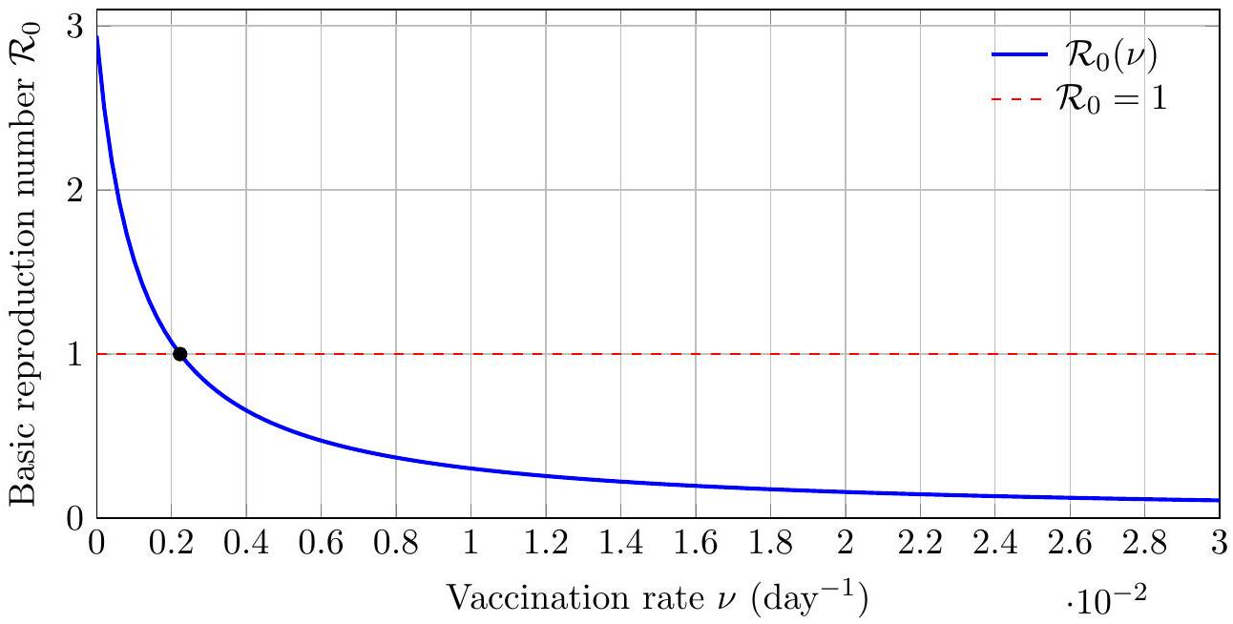
Figure 2: Relationship between vaccination rate and the basic reproduction number for the illustrative parameter set. The marked point is the threshold $ν_{c}$.
5.1 Calculations underlying Figure 2
Figure 2 is obtained by substituting the illustrative parameter values into Equation (24). First, define
$$\begin{aligned}a=ω_{V}+μ=0.001+0.00015=0.00115\#(37)\end{aligned}$$
and
$$\begin{aligned}k=γ+δ+μ=0.15+0.02+0.00015=0.17015.\#(38)\end{aligned}$$
The reproduction number can then be written as a function of the vaccination rate:
$$\begin{aligned}R_{0}(ν)=\frac{βa}{(a+ν)k}=\frac{0.5(0.00115)}{(0.00115+ν)(0.17015)}.\#(39)\end{aligned}$$
For example, in the absence of vaccination,
$$\begin{aligned}R_{0}(0)=\frac{0.5(0.00115)}{(0.00115)(0.17015)}=\frac{0.5}{0.17015}≈2.938.\#(40)\end{aligned}$$
Thus, without vaccination, one typical infectious individual would generate approximately 2.94 secondary infections under the model assumptions.
At the three vaccination rates considered in the numerical illustration,
$$\begin{aligned}R_{0}(0.005)=\frac{0.5(0.00115)}{(0.00615)(0.17015)}≈0.549,\#(41) \\ R_{0}(0.010)=\frac{0.5(0.00115)}{(0.01115)(0.17015)}≈0.303,\#(42) \\ R_{0}(0.020)=\frac{0.5(0.00115)}{(0.02115)(0.17015)}≈0.160.\#(43)\end{aligned}$$
These values correspond to reductions of approximately 81.3%, 89.7%, and 94.6%, respectively, relative to the no-vaccination value. In general, the proportional reduction is
$$\begin{aligned}1-\frac{R_{0}(ν)}{R_{0}(0)}=1-\frac{a}{a+ν}=\frac{ν}{a+ν}.\#(44)\end{aligned}$$
The black point in Figure 2 is found by setting $R_{0}\left(ν_{c}\right)=1$:
$$\begin{aligned}1 =\frac{0.5(0.00115)}{\left(0.00115+ν_{c}\right)(0.17015)}\#(45) \\ ν_{c} =0.00115\left(\frac{0.5}{0.17015}-1\right)≈0.00223{day}^{-1}\#(46)\end{aligned}$$
Therefore, the model predicts $R_{0}<1$ when $ν>0.00223$ day $^{-1}$, provided all other parameters remain fixed.
Finally, differentiating Equation (39) gives
$$\begin{aligned}\frac{dR_{0}}{ dν}=-\frac{βa}{k(a+ν)^{2}}<0.\#(47)\end{aligned}$$
The negative derivative explains the downward-sloping curve. Its magnitude decreases as $ν$ increases, which accounts for the curve becoming progressively flatter at higher vaccination rates.
The result has a direct interpretation. Raising $ν$ moves susceptible individuals into the vaccinated class more quickly, so fewer remain available for infection. The marginal gain is largest when vaccination begins from a low rate; at higher values, $R_{0}$ continues to fall but with diminishing absolute change. This pattern does not imply that every community has crossed the threshold, because the homogeneous model averages over local differences in coverage and contact.
6 Discussion
The model identifies vaccination as a central determinant of diphtheria transmission. At the DFE, the susceptible share is controlled by the competition between vaccination, waning vaccine protection, and demographic turnover. Increasing $ν$ lowers that share and therefore lowers $R_{0}$. Conversely, faster loss of vaccine-induced immunity returns people to susceptibility and raises the transmission potential.
The threshold $R_{0}=1$ should be interpreted as a population-level condition rather than a guarantee for every location. Even if a national average suggests $R_{0}<1$, outbreaks may still occur in districts where coverage is low, immunity has waned, or contact patterns differ from the homogeneous-mixing assumption. This distinction is particularly relevant in settings with substantial geographical variation in service access.
Recovery and mortality shorten the infectious period in the mathematical system and consequently reduce the number of secondary cases generated by an infectious person. Disease-induced mortality, however, is not a desirable control mechanism; its negative sensitivity index reflects only its mathematical effect on infectious duration. Prevention, early diagnosis, appropriate treatment, case isolation, contact management, and vaccination remain the appropriate public-health responses.
The analysis also underscores the importance of continuity. A temporary campaign may rapidly increase the vaccinated population, but waning protection and new recruitment can rebuild susceptibility. Routine immunisation, appropriate booster schedules, reliable vaccine supply, and surveillance capable of identifying immunity gaps are therefore complementary rather than competing interventions.
6.1 Policy implications for Nigeria
The model supports five practical priorities:
- Close local coverage gaps. Resources should be directed not only towards increasing national coverage but also towards communities with persistently low uptake.
- Maintain protection over time. Booster policies should follow epidemiological evidence and national guidance, with systems in place to identify missed doses.
- Link surveillance to rapid response. Prompt detection, laboratory confirmation, case management, contact tracing, and targeted vaccination can prevent local transmission from expanding.
- Strengthen delivery systems. Cold-chain capacity, dependable supply, trained health workers, and access in insecure or remote areas are necessary for effective coverage.
- Build public confidence. Communication should be locally grounded, transparent, and responsive to concerns about vaccine safety and access.
7 Limitations and future work
Several limitations should guide interpretation. First, homogeneous mixing overlooks age-specific contact, household clustering, and regional variation. Second, the vaccinated class is assumed to be fully protected until immunity wanes; an extended model should allow partial vaccine efficacy, breakthrough infection, and multiple doses. Third, the model does not distinguish exposed, symptomatic, asymptomatic, treated, or carrier states. Fourth, all parameters are constant, although transmission and service delivery may vary over time. Fifth, the numerical values have not been estimated from a unified Nigerian dataset and therefore should not be treated as forecasts.
Future research should fit the model to Nigerian surveillance data and quantify parameter uncertainty. Useful extensions include age and dose structure, spatial coupling among states, stochastic outbreak dynamics, migration, vaccine hesitancy, time-dependent controls, and economic evaluation. An optimal-control formulation could compare the costs and effects of routine vaccination, booster delivery, case finding, and outbreak campaigns (Adewole et al., 2021; Peter et al., 2018).
8 Conclusion
This study develops a transparent SIRV framework for examining vaccination control of diphtheria in Nigeria. The analysis shows that the disease-free equilibrium is locally asymptotically stable when $R_{0}<1$, whereas a biologically meaningful endemic equilibrium exists above the invasion threshold. Vaccination lowers the basic reproduction number by reducing the susceptible fraction, while waning vaccine-induced protection replenishes susceptibility and increases transmission potential. The derived critical vaccination rate provides a concise theoretical threshold under the assumptions of the model. The findings emphasise that effective control depends on sustained and equitable immunity rather than isolated increases in aggregate vaccination coverage. Routine immunisation, appropriate booster delivery, surveillance, rapid outbreak response, reliable vaccine delivery systems, and public confidence should therefore operate as complementary measures. Since the numerical parameter values are illustrative and have not been estimated from a unified Nigerian dataset, the model should be calibrated and validated with current Nigerian surveillance, demographic, and immunisation data before it is applied to forecasting, operational decision-making, or resource allocation.

Declaration of AI Use

This manuscript was prepared through the intellectual contributions of the author(s) to the study design, data analysis, interpretation of results, and scholarly content. Grammarly and ChatGPT were used solely to assist with grammatical refinement and reference formatting during manuscript revision. The author(s) accept full responsibility for the accuracy, integrity, and final content of the manuscript.

References
Adewole, M. O., Onifade, A. A., Abdullah, F. A., Kasali, F., & Ismail, A. I. M. (2021). Modeling the dynamics of COVID-19 in Nigeria. International Journal of Applied and Computational Mathematics, 7(3), Article 67. https://doi.org/10.1007/s40819-021-01014-5
Anderson, R. M., & May, R. M. (1991). Infectious diseases of humans: Dynamics and control. Oxford University Press. https://doi.org/10.1093/oso/9780198545996.001.0001
Diekmann, O., Heesterbeek, J. A. P., & Metz, J. A. J. (1990). On the definition and the computation of the basic reproduction ratio R0 in models for infectious diseases in heterogeneous populations. Journal of Mathematical Biology, 28(4), 365–382. https://doi.org/10.1007/BF00178324
Fauzi, I. S., Nuraini, N., Sari, A. M., Wardani, I. B., Taurustiati, D., Simanullang, P. M., & Lestari, B. W. (2024). Assessing the impact of booster vaccination on diphtheria transmission: Mathematical modeling and risk zone mapping. Infectious Disease Modelling, 9(1), 245–262. https://doi.org/10.1016/j.idm.2024.01.004
Gaiya, D. D., Ozioko, P. C., Entonu, M. E., & Umeasiegbu, C. U. (2024). Diphtheria outbreak in Nigeria: What we know now. Infection Prevention in Practice, 6(1), Article 100345. https://doi.org/10.1016/j.infpip.2024.100345
Hethcote, H. W. (2000). The mathematics of infectious diseases. SIAM Review, 42(4), 599–653. https://doi.org/10.1137/S0036144500371907
Jega, M., Kolawole, E. T., Ahaneku, E. B., Abraham, K. E., Oduah, J. U., Udoh, I., Imoke, I., & Ndubueze, C. W. (2024). Diphtheria outbreak response and mitigation strategies in Nigeria: A case study of the Nigerian Red Cross Society (NRCS) intervention. International Journal of Tropical Disease & Health, 45(12), 69–84. https://doi.org/10.9734/ijtdh/2024/v45i121613
Kanchanarat, S., Chinviriyasit, S., & Chinviriyasit, W. (2022). Mathematical assessment of the impact of the imperfect vaccination on diphtheria transmission dynamics. Symmetry, 14(10), Article 2000. https://doi.org/10.3390/sym14102000
Madubueze, C. E., Tijani, K. A., & Fatmawati. (2023). A deterministic mathematical model for optimal control of diphtheria disease with booster vaccination. Healthcare Analytics, 4, Article 100281. https://doi.org/10.1016/j.health.2023.100281
National Bureau of Statistics, & UNICEF. (2022). Nigeria: 2021 Multiple Indicator Cluster Survey (MICS) & National Immunization Coverage Survey (NICS): Survey findings report.
Nigeria Centre for Disease Control and Prevention. (2023, September 25). Update on the Federal Government’s response to the diphtheria outbreak.
Nwokeji, C. M., Nkem, B. I., & Azudialu, B. C. (2023). Endemicity of diphtheria in some regions of Nigeria: Chronology of a fourteen month sustained outbreak. Journal of Disease and Global Health, 16(3), 1–5. https://doi.org/10.56557/jodagh/2023/v16i38434
Peter, O. J., Akinduko, O. B., Oguntolu, F. A., & Ishola, C. Y. (2018). Mathematical model for the control of infectious disease. Journal of Applied Sciences and Environmental Management, 22(4), 447–451. https://doi.org/10.4314/jasem.v22i4.1
UNICEF. (2023, August 3). Diphtheria outbreak in Nigeria: UNICEF intensifies response.
World Health Organization. (2026, July 15). Diphtheria.

