Short Research Article

Testing the Assumptions of Geometric Brownian Motion Using Nairobi Securities Exchange Returns

ABSTRACT
Aims: This study examines whether stock returns from the Nairobi Securities Exchange 20-Share Index satisfy the main assumptions underlying the Geometric Brownian Motion model.
Study Design: Quantitative time-series analysis.
Methodology: The analysis focuses on weekly and monthly logarithmic returns computed from historical closing prices covering the period from January 2016 to December 2024. After data cleaning and aggregation, the study used approximately 450 weekly observations and 108 monthly observations. The assumptions assessed were stationarity, normality, and independence of returns. Stationarity was examined using visual time-series inspection and the Augmented Dickey-Fuller test. Logarithmic returns ( $R_{t}= \frac{{\ln{S}}_{t}}{{\ln{S}}_{t-1}}$ ) were computed from weekly and monthly closing prices. Stationarity was tested using time-series plots and the Augmented Dickey-Fuller (ADF) test. Normality was assessed via histograms, Q-Q plots, and the Shapiro-Wilk test. Independence was evaluated using the Ljung-Box test and Hurst exponent analysis(Suganthi & Jayalalitha, 2019).
Results: The results indicate that both weekly and monthly return series are stationary, with Augmented Dickey-Fuller test p-values of 0.01 for both frequencies. The normality results differ by data frequency. Weekly returns do not satisfy the normality assumption, with a Shapiro-Wilk statistic of 0.95935 and a p-value of 3.471 × 10^-11, indicating significant departure from normality. Monthly returns show better agreement with normality, with a Shapiro-Wilk statistic of 0.98122 and a p-value of 0.07754. The Ljung-Box test results provide no evidence of significant serial correlation for either weekly or monthly returns, with p-values of 0.3687 and 0.9342, respectively. The Hurst exponent values, approximately 0.49 for weekly returns and 0.51 for monthly returns, further support behavior close to independence.
Conclusion: Overall, the findings suggest that monthly NSE returns conform more closely to the assumptions of the Geometric Brownian Motion model than weekly returns. The results emphasize the importance of testing model assumptions before applying stochastic models to emerging market data.
Keywords: Geometric Brownian Motion, stock returns, stationarity, normality, independence, Nairobi Securities Exchange, emerging markets, Hurst exponent
1. INTRODUCTION
The Geometric Brownian Motion (GBM) model is one of the most widely used stochastic processes in financial mathematics for modeling stock price dynamics (Suganthi & Jayalalitha, 2019). It is defined by the stochastic differential equation:
$$dS_{t}=μS_{t}dt+σS_{t}dW_{t}$$
where logarithmic returns are assumed to be stationary, independent, and normally distributed (Quayesam et al., 2024).
However, real financial markets often exhibit volatility clustering, fat tails, and serial dependence that may violate these ideal assumptions. Such deviations are particularly common in emerging markets (Mettle et al., 2014). The Nairobi Securities Exchange (NSE), established in 1954, plays a vital role in Kenya’s economy. Nevertheless, it operates under several challenges including liquidity constraints, frequent policy changes, and vulnerability to external economic shocks (Dabafinance, 2024; Philita, 2018).
Validating the underlying assumptions of stochastic models is therefore essential before their application in real market conditions. Despite the popularity of the GBM model, limited empirical studies have examined its suitability in the East African context. This study empirically tests whether stock returns from the Nairobi Securities Exchange satisfy the core GBM assumptions of stationarity, normality, and independence using both weekly and monthly data.
2. MATERIAL AND METHODS
2.1 Data
The study utilized historical closing prices of the Nairobi Securities Exchange (NSE) 20-Share Index, which serves as a benchmark for the overall performance of the Kenyan stock market. Weekly and monthly closing prices were collected from January 2016 to December 2024. This timeframe was deliberately chosen to capture a comprehensive range of market conditions, including periods of economic stability, volatility induced by global events (such as the COVID-19 pandemic), and domestic policy shifts.
Data were sourced primarily from the official Nairobi Securities Exchange website and supplemented with Yahoo Finance historical data for the NSE 20 Index (^NSEI) to ensure completeness and accuracy. After cleaning for missing values and non-trading days, the final dataset comprised approximately 450 weekly observations and 108 monthly observations. Logarithmic returns were computed as $r_{t}=ln⁡\left(\frac{P_{t}}{P_{t-1}}\right)$, where $P_{t}$denotes the closing price at time $t$. This transformation is standard in financial econometrics as it approximates continuously compounded returns and helps stabilize variance.

2.2 Geometric Brownian Motion Model
The Geometric Brownian Motion (GBM) is a continuous-time stochastic process widely employed in financial modeling for asset price dynamics. It is governed by the stochastic differential equation (SDE):
$$dS_{t}=μS_{t}dt+σS_{t}dW_{t}$$
where $S_{t}$is the stock price at time $t$, $μ$is the constant drift (expected return), $σ$is the constant volatility, and $W_{t}$is a standard Wiener process (Brownian motion). Under this model, the logarithmic returns $r_{t}$are assumed to be independent and identically distributed (i.i.d.) as normal random variables with mean $μ-\frac{σ^{2}}{2}$and variance $σ^{2}$ (Suganthi & Jayalalitha, 2019). The core assumptions tested in this study are therefore stationarity, normality, and independence of the logarithmic returns.

2.3 Statistical Tests
Stationarity, normality, and independence were evaluated using both visual methods and formal statistical tests.
2.3.1 Stationarity
Time-series plots of the logarithmic returns were examined visually for any obvious trends or patterns. The Augmented Dickey-Fuller (ADF) test was used to formally test the null hypothesis of a unit root (non-stationarity), with lag selection based on information criteria.
2.3.2 Normality
Histograms were used to assess the distribution's shape and kurtosis. Quantile-Quantile (Q-Q) plots were examined for deviations from normality, particularly in the tails. The Shapiro-Wilk test was applied to formally test the null hypothesis that the returns follow a normal distribution.
2.3.3 Independence
The Ljung-Box test was used to check for serial correlation up to 20 lags. In addition, the Hurst exponent was calculated using rescaled range analysis (Suganthi & Jayalalitha, 2019). A value near 0.5 indicates behavior consistent with independence and a random walk (Quayesam et al., 2024).
All analyses were performed using R statistical software (version 4.3.x) with the following packages: tseries, forecast, ggplot2, and pracma. Statistical significance was evaluated at the 5% level.

3. RESULTS AND DISCUSSION
3.1 Stationarity
Stationarity of the return series is a fundamental assumption of the Geometric Brownian Motion model, as it ensures that the statistical properties of returns do not change over time. Visual inspection of the time-series plots for both weekly and monthly logarithmic returns showed that the data points fluctuated randomly around a constant mean of zero. There were no visible long-term upward or downward trends, suggesting that the series are mean-reverting and potentially stationary.
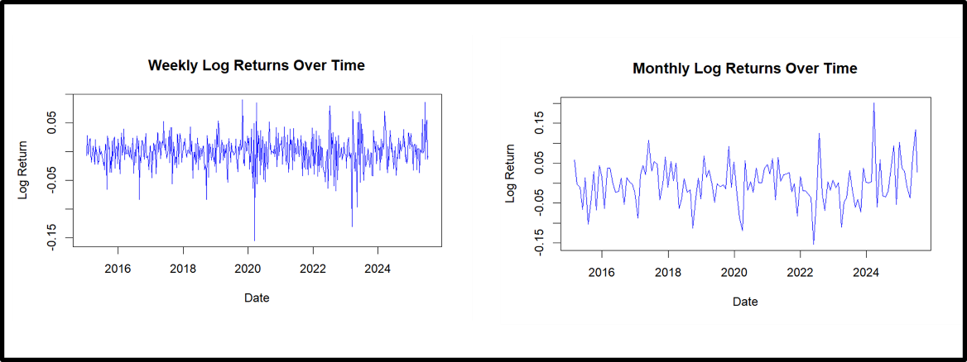
Figure 1. Time series plots of weekly and monthly logarithmic returns for the NSE.

To confirm this observation statistically, the Augmented Dickey-Fuller (ADF) test was conducted. The null hypothesis of the test states that the series contains a unit root and is non-stationary. The test results are presented below:
Table 1. Augmented Dickey-Fuller test for NSE returns
Time Series | Dickey-Fuller Statistic | Lag Order | p-value
Weekly Log Returns | -7.3637 | 8 | 0.01
Monthly Log Returns | -4.3877 | 4 | 0.01

Both p-values were 0.01, which is well below the 5% significance level. Therefore, the null hypothesis of non-stationarity was strongly rejected for both weekly and monthly returns. This confirms that the return series are stationary, satisfying one of the key assumptions of the GBM model.

3.2 Normality
The normality assumption is critical for the GBM model because it underpins the use of standard statistical inference and Monte Carlo simulation techniques. The histograms of the returns revealed notable differences between the two frequencies. The weekly returns displayed a sharp peak (high kurtosis) and extended heavy tails (leptokurtosis), indicating a higher likelihood of extreme positive and negative returns than would be expected under a normal distribution. In contrast, the monthly returns exhibited a more symmetrical, bell-shaped distribution that closely resembled a normal curve.

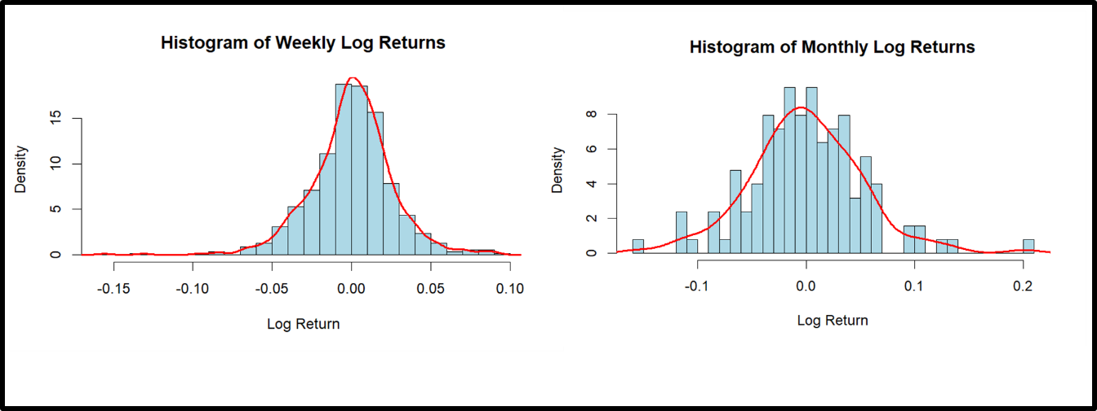
Figure 2. Histograms of weekly and monthly logarithmic returns for the NSE.
The Q-Q plots reinforced these observations. Weekly returns deviated markedly from the theoretical normal line in the tails, while monthly returns aligned closely with the straight line.
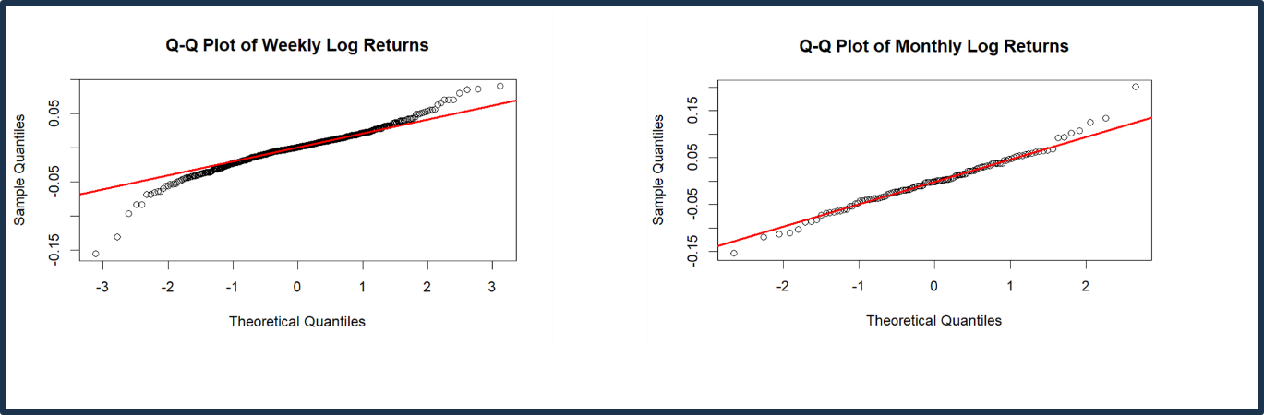
Figure 3. Q-Q plots of weekly and monthly logarithmic returns for the NSE.

The Shapiro-Wilk test confirmed the visual findings:
Table 2. Shapiro-Wilk Test for NSE returns
Returns | W Statistic | p-value
Weekly | 0.95935 | 3.471 × 10^{-11}
Monthly | 0.98122 | 0.07754

The test strongly rejected the null hypothesis of normality for weekly returns (p < 0.001) but failed to reject it for monthly returns (p = 0.07754 > 0.05).
3.3 Independence
The Hurst exponent was calculated as approximately 0.49 for weekly and 0.51 for monthly returns, close to 0.5, indicating random walk behavior and supporting the independence assumption.

Table 3. Ljung-Box Test for NSE returns
Time Series | X-squared | df | p-value
Weekly | 21.491 | 20 | 0.3687
Monthly | 11.435 | 20 | 0.9342

Discussion:
The combined visual and statistical analysis reveals important frequency-dependent behavior in NSE returns. Monthly returns fully satisfy all three core assumptions of the Geometric Brownian Motion model. Weekly returns, however, significantly violate the normality assumption due to pronounced leptokurtosis and heavy tails. This pattern is clearly illustrated by the histograms and Q-Q plots.
The time series plots confirm mean reversion and support the stationarity assumption. In addition, the Ljung-Box test shows no significant serial correlation, which supports the independence assumption for both weekly and monthly returns. These findings are consistent with previous studies conducted in other African emerging markets (Quayesam et al., 2024).
Such studies have shown that higher-frequency data tend to deviate more from normality because of thin trading, news shocks, and market microstructure effects (Mettle et al., 2014; Nkemnole, 2019). The relatively better performance of monthly returns also aligns with findings reported by Toby and Agbam (2021).
Overall, the results suggest that monthly returns from the NSE are more suitable for Geometric Brownian Motion modelling than weekly returns. The standard GBM model therefore performs better when applied to monthly data in this market. For weekly data, more advanced approaches such as regime-switching GBM or jump-diffusion models may be necessary to better account for the observed deviations from normality.
These findings have practical implications for investors, portfolio managers, and financial analysts operating in the Kenyan capital market. They indicate that using the standard GBM model with weekly data without proper adjustments may result in underestimation of extreme risks and less reliable forecasts. The study therefore emphasizes the need for thorough validation of model assumptions before applying stochastic processes in emerging markets like the NSE. The combined visual and statistical analysis reveals important frequency-dependent behavior in NSE returns. Monthly returns fully satisfy all three core assumptions of the Geometric Brownian Motion model. Weekly returns, however, significantly violate the normality assumption due to pronounced leptokurtosis and heavy tails. This pattern is clearly illustrated by the histograms and Q-Q plots.
The time series plots confirm mean reversion and support the stationarity assumption. In addition, the Ljung-Box test shows no significant serial correlation, which supports the independence assumption for both weekly and monthly returns. These findings are consistent with previous studies conducted in other African emerging markets (Quayesam et al., 2024).
Such studies have shown that higher-frequency data tend to deviate more from normality because of thin trading, news shocks, and market microstructure effects (Mettle et al., 2014; Nkemnole, 2019). The relatively better performance of monthly returns also aligns with findings reported by Toby and Agbam (2021).
Overall, the results suggest that monthly returns from the NSE are more suitable for Geometric Brownian Motion modelling than weekly returns. The standard GBM model therefore performs better when applied to monthly data in this market. For weekly data, more advanced approaches such as regime-switching GBM or jump-diffusion models may be necessary to better account for the observed deviations from normality.
These findings have practical implications for investors, portfolio managers, and financial analysts operating in the Kenyan capital market. They indicate that using the standard GBM model with weekly data without proper adjustments may result in underestimation of extreme risks and less reliable forecasts. The study therefore emphasizes the need for thorough validation of model assumptions before applying stochastic processes in emerging markets like the NSE.
Limitations of the Study
This study has several limitations. First, the analysis is restricted to the Nairobi Securities Exchange 20-Share Index over the period from January 2016 to December 2024. Therefore, the findings may not fully represent the behavior of individual listed stocks, other Kenyan market indices, or different time periods. Second, the study uses weekly and monthly aggregated returns, and such aggregation may smooth short-term market movements. Third, the analysis focuses on basic diagnostic tests for stationarity, normality, and independence. More advanced methods for volatility dynamics, structural breaks, and tail behavior were not included. Fourth, the study assesses whether the data are consistent with selected assumptions of the Geometric Brownian Motion model, but it does not evaluate forecasting accuracy or compare model performance against alternative stochastic models. These limitations should be considered when interpreting the results and applying them to practical financial modelling..

4. CONCLUSION
This study evaluated the suitability of the Geometric Brownian Motion model for Nairobi Securities Exchange 20-Share Index returns by testing three core assumptions: stationarity, normality, and independence. The analysis showed that both weekly and monthly logarithmic returns were stationary, as indicated by the Augmented Dickey-Fuller test results. The independence assumption was also supported for both data frequencies, based on the Ljung-Box test and Hurst exponent values close to 0.5. The main difference between the two return frequencies was observed in the normality assessment. Weekly returns showed clear evidence of departure from normality, with heavy-tailed behavior and a highly significant Shapiro-Wilk test result. Monthly returns, in contrast, did not show statistically significant evidence against normality at the 5% level. These findings indicate that monthly returns are more consistent with the assumptions required for applying the standard Geometric Brownian Motion model. The results suggest that the use of weekly NSE returns in a standard Geometric Brownian Motion framework should be approached with caution, particularly where tail behavior and extreme-return risk are important. Monthly returns provide a more suitable basis for this model within the period and dataset considered. Future work may extend the analysis by considering alternative stochastic models and broader datasets.

Disclaimer (Artificial intelligence)

The author (s) hereby declare that NO generative AI technologies such as Large Language Models (ChatGPT, COPILOT, etc.) and text-to-image generators have been used during the writing or editing of this manuscript.

References
- Brătian, V., Acu, A., Mihaiu, D. M., & Șerban, R. A. (2021). Efficient or Fractal Market Hypothesis? A Stock Indexes Entropy Analysis. Mathematics, 9(22), 2973.
- Boateng Kwadwo Prempeh, E., Osei, A., & Antwi, S. (2022). Determining the return volatility of the Ghana Stock Exchange using exponential GARCH model. Journal of Economics and Financial Analysis, 6(1), 45-68.
- Dabafinance. (2024). The Largest Stock Exchanges in Africa. Retrieved from https://dabafinance.com
- Karangwa, I. (2008). Comparing South African financial markets behavior to the Geometric Brownian motion process. University of the Witwatersrand.
- Lidén, J. (2018). Stock Price Predictions using a Geometric Brownian Motion. KTH Royal Institute of Technology.
- Marathe, R. R., & Ryan, S. M. (2005). On the validity of the geometric Brownian motion assumption. The Engineering Economist, 50(2), 159-192.
- Mensah, E. T. (2023). Simulating stock prices using geometric Brownian motion. Journal of Finance and Investment Analysis.
- Mettle, F. O., Quaye, E. N. B., & Laryea, R. A. (2014). A methodology for stochastic analysis of share prices. SpringerPlus, 3(1), 1-13.
- Nkemnole, B. (2019). Estimation of Geometric Brownian Motion Model for Stock Prices: A Case of Nigerian Stock Exchange. Journal of Economics and Financial Sciences, 12(2), 45-58.
- Philita, G. (2018). Effects of Portfolio Diversification on Financial Performance of Commercial Banks in Kenya. University of Nairobi.
- Quayesam, D. L., Lotsi, A., & Mettle, F. O. (2024). Modeling Stock Price Dynamics on the Ghana Stock Exchange Using Geometric Brownian Motion.
- Suganthi, K., & Jayalalitha, G. (2019). Geometric Brownian Motion in stock prices. Journal of Physics: Conference Series, 1377(1), 012016.
- Toby, A. J., & Agbam, S. A. (2021). Stochastic Forecasting of Stock Prices in Nigeria Using Geometric Brownian Motion. International Journal of Finance and Banking Research, 7(3), 78-92.
- Remillard, B., & Rubenthaler, S. (2023). Option pricing and hedging for regime-switching geometric Brownian motion models
- Yan, Y., et al. (2025). Bayesian Inference of Geometric Brownian Motion with Jumps. Model Assisted Statistics and Applications.
- Antwi, O., et al. (2020). Jump Diffusion Modeling of Stock Prices on the Ghana Stock Exchange. Journal of Mathematical Finance, 10(4), 567-589.
- Agbam, A. S. A. (2021). Stock Prices Prediction Using Geometric Brownian Motion: Evidence from the Nigerian Stock Exchange. African Journal of Economic Review.
- Sonkavde, G., et al. (2023). Empirical Mode Decomposition on Ghana Stock Exchange Indices. Computational Economics.
- Straja, S. (1997). Limitations of Geometric Brownian Motion in Financial Modeling. Journal of Risk Management.
- Akurugu, A., et al. (2022). Bayesian Switching Volatility Models for Emerging African Markets. Journal of Financial Econometrics.

