Ethyl Acetate Extract of Embelia ribes Seed (Myrsinaceae) and Vitamin E (alpha-tocopherol) Protect Against Hematological Disorder and Redox Imbalance Associated with Tamoxifen Administration

ABSTRACT
Tamoxifen is a widely used hormonal therapy for the treatment and prevention of hormone receptor-positive breast cancer. Its prolonged administration may be associated with adverse effects. Natural plant products have gained considerable attention in recent years as potential drug sources. This study evaluated the protective roles of the ethyl acetate extract of Embelia ribes seed and vitamin E against haematological disorders and redox imbalance associated with tamoxifen administration in female Wistar rats. Fifty-six (56) rats, with an average weight of 120 g, were acclimatised and randomly allocated to eight groups, A-H: Group A (control), Group B (2.5 mg/kg tamoxifen only), Group C (100 mg/kg extract and 2.5 mg/kg tamoxifen), Group D (100 mg/kg vitamin E and 2.5 mg/kg tamoxifen), Group E (100 mg/kg extract, 100 mg/kg vitamin E and 2.5 mg/kg tamoxifen), Group F (100 mg/kg extract only), Group G (100 mg/kg vitamin E only), and Group H (100 mg/kg extract and 100 mg/kg vitamin E). Treatments were administered orally in 0.1 mL solutions daily for 60 days. Haematological and tissue redox indices were determined using standard methods. Results showed that tamoxifen significantly (p < 0.05) decreased serum and breast total protein levels, red blood cell count, haemoglobin concentration and packed cell volume, while significantly increasing white blood cell, lymphocyte and platelet counts. In contrast, treatments in Groups C, D and E improved these metabolic alterations, which were reversed to levels comparable with the control. Antioxidant indices in Group B showed significant (p < 0.05) decreases in breast-tissue superoxide dismutase, catalase, glutathione peroxidase and reduced glutathione, with a corresponding increase in malondialdehyde concentration; these changes were reversed by treatments in Groups C, D and E, although the magnitude of the response varied across the measured parameters and treatment combinations. The results suggest adverse effects of tamoxifen through the induction of oxidative stress, inflammation and haematological disorders, while the extract, alone or in combination with vitamin E, exhibited antioxidant and haematological protective potential against some of the biochemical alterations associated with tamoxifen administration. Further studies are required to characterise the active constituents and investigate the underlying mechanisms of action.
Keywords: Tamoxifen; Hematological disorder; Redox Imbalance; Anti oxidative; Embelia ribes seed; Vitamin E, Synergistic effect, Breast cancer

- INTRODUCTION
Breast cancer continues to represent a major contributor to cancer-related morbidity and mortality among women globally (Zhang et al., 2024). The increasing prevalence of the disease has continued to be a major public health concern, particularly in developing countries where access to early diagnosis and effective treatment remains limited (Francis et al., 2024). One of the therapeutic drugs commonly used in the treatment and management of hormone-responsive breast cancer is tamoxifen, a selective estrogen receptor modulator widely recognised for its anti-estrogenic activity in breast tissues (Lloyd et al., 2022). Tamoxifen inhibits estrogen-dependent proliferation of malignant cells, and this has led to its use for the prevention and treatment of breast cancer, with a high rate of patient survival (Javankiani et al., 2025). Despite its clinical importance, prolonged use as a preventive and therapeutic agent for breast cancer has been linked to several adverse effects, including hepatotoxicity, nephrotoxicity, haematological abnormalities and oxidative stress (Radeva & Yoncheva, 2025). Studies have shown that tamoxifen metabolism may generate reactive oxygen species (ROS) capable of disrupting cellular redox homeostasis, leading to oxidative damage to lipids, proteins and nucleic acids, with subsequent effects on membrane integrity and normal cellular functions (Sadiq, 2023).Current global estimates continue to identify female breast cancer as the most frequently diagnosed cancer among women worldwide (Bray et al., 2024). A recent review also emphasises that, despite its established efficacy, tamoxifen is associated with a broad spectrum of adverse effects that can limit treatment tolerability (Buijs et al., 2024).
Tamoxifen-induced haematological disorders have been linked to oxidative injury and suppression of haematopoietic tissues (Rossi et al., 2023), which represent another major clinical challenge during cancer treatment (Costanzo et al., 2024). Alterations in red blood cell indices, haemoglobin concentration, lymphocyte counts and platelet parameters may compromise immune function, oxygen transport and redox balance, thereby affecting the overall physiological condition of affected individuals (Shah et al., 2024). In recent years, medicinal plants have gained considerable attention because of their rich phytochemical composition and therapeutic potential (Nwozo et al., 2023). Natural products possessing antioxidant activities have been widely investigated for their ability to reduce oxidative damage associated with several pathological conditions, such as malaria, diabetes, ulcers and cancer (Adedosu et al., 2017; Adedosu et al., 2018; Muscolo et al., 2024).
Embelia ribes, commonly called black pepper (family: Myrsinaceae), is a medicinal plant used in Ayurvedic and Unani traditional medicine for its antioxidant, antimicrobial, anti-inflammatory, antihelminthic, antidiabetic and anticancer effects (Rout et al., 2021). These biological activities have largely been attributed to the presence of bioactive compounds such as flavonoids, phenolics, tannins, alkaloids and embelin (Naik & Gamare, 2025). Recent in silico pharmacophore profiling of Embelia ribes has reported multiple potentially bioactive constituents, including embelin and phenolic acids, supporting continued pharmacological interest in the species (Dubey et al., 2025).
Vitamin E is a lipid-soluble antioxidant vitamin that plays an important role in protecting cellular membranes against oxidative damage and is commonly used as an adjuvant in cancer treatment. It neutralises free radicals and inhibits lipid peroxidation (Kilicarslan You et al., 2024). Because of its potent antioxidant activity, vitamin E has been extensively studied as a protective agent against oxidative stress-induced tissue injury and related diseases (Jomova et al., 2024). Experimental evidence from albino rats has also shown that vitamin E treatment can improve superoxide dismutase and catalase activities under chemically induced oxidative stress (Savithri et al., 2023).
However, evidence remains limited regarding whether ethyl acetate extract of Embelia ribes seed, alone or combined with vitamin E, can attenuate tamoxifen-associated haematological disturbances and breast-tissue redox imbalance in female Wistar rats.
Objective
Hence, given the limited scientific data supporting the medicinal claims for Embelia ribes seed, which is traditionally used for the treatment and management of breast cancer and several other ailments, this study evaluated the roles of ethyl acetate extract of Embelia ribes seed and vitamin E, a known antioxidant adjuvant in cancer treatment, following tamoxifen administration in female Wistar rats.

- MATERIALS AND METHODS
Materials
Materials used in this study included an electronic weighing balance, measuring cylinders, syringes and needles, beakers, test tubes, conical flasks, plasma bottles, a water bath, a pH meter, a spatula, a centrifuge, a thermometer, disposable gloves, tissue paper, micropipettes, washing brushes, detergents, separating funnels, a refrigerator, a spectrophotometer, dissecting sets, a mortar and pestle, a stopwatch and test-tube racks.
Reagents
Some of the reagents used in this study included: Trisbuffer, Phosphate buffer, Carbonate buffer, Sodium azide, Hydrogen peroxide, Potassium chloride, sodium hydroxide, adrenaline, Trichloroacetic acid (TCA), Trishydrochloric acid, Ellman’s reagent (5,5-thiobis-2-nitrobenzoic acid, DTNB), thiobarbituric acid (TBA), Tris(hydroxylmethyl)aminomethane, Triton X-100, distilled water, chloroform, ethyl-acetate, washing buffer and homogenizing buffer. Tamoxifen, a product of Khandelwal Laboratories Pvt. Ltd., India, was obtained from Bowen University Teaching Hospital Pharmacy, Ogbomoso, Oyo State, Nigeria. Tocopherol, a product of Nigerian Airforce Manufacturing Unit Ltd., Airforce Base Ikeja, Lagos, was obtained from Savidep Medical and Scientific Laboratory, Osogbo, Osun State. All reagents used were of high analytical grade and were mostly obtained from Sigma, USA.
Plant Material and Preparation of ethyl acetate Extract
Embelia ribes seed was obtained from Oja-Igbo Local Market, Ogbomoso, Oyo State, and identified at the Botany Unit of the Department of Pure and Applied Biology, Ladoke Akintola University of Technology, Ogbomoso, with herbarium voucher number LHO 969 deposited. The seed was air-dried, powdered and weighed. The powdered seeds (310g) were soaked in 3000ml ethyl acetate solution for 72 hours and filtered. The filtrate was concentrated to dryness between 30-35⁰ C to obtain dried ethyl acetate extract residue inside a 1000ml measuring beaker (Rafiu et al., 2019).

Experimental Animals and Groupings
Female Wistar rats used in this study were obtained from the Animal House of Ladoke Akintola University of Technology, Ogbomoso, Oyo State, Nigeria. The animals were handled and treated in accordance with the institutional guidelines for the ethical care and use of experimental animals, which were consistent with internationally accepted standards. Prior to the commencement of the experimental procedures, the rats were acclimatised to the laboratory environment for two weeks. During the acclimatisation period, the animals had unrestricted access to standard laboratory pellet feed and water ad libitum, and their body weights were monitored throughout the period. The animals were randomly selected into eight groups, A-H, with seven animals in each group, and treated as shown below.
Group A: Control (treated with normal saline)
Group B: Tamoxifen only (2.5 mg/kg body weight) made into 0.1 mL of normal saline and administered orally, daily by intubation for 60 days.
Group C: Extract (100 mg/kg body weight) made into 0.1 mL of corn oil and treated with Tamoxifen (2.5 mg/kg body weight) made into 0.1 mL of normal saline orally, daily by intubation for 60 days.
Group D: Vitamin E (100 mg/kg body weight) made into 0.1 mL of corn oil with Tamoxifen (2.5 mg/kg body weight) made into 0.1 mL of normal saline, all administered orally, daily by intubation for 60 days.
Group E: Extract (100 mg/kg body weight), Vitamin E (100 mg/kg body weight) and Tamoxifen (2.5 mg/kg body weight) were administered orally, daily by intubation for 60 days.
Group F: Extract only (100 mg/kg body weight) administered orally, daily by intubation for 60 days.
Group G: Vitamin E only (100 mg/kg body weight) administered orally, daily by intubation for 60 days.
Group H: Extract (100 mg/kg body weight) and Vitamin E (100 mg/kg body weight) were administered orally, daily by intubation for 60 days. All the procedures involving the use of laboratory animals were in accordance to the Institute Animal Ethics Committee regulation approved by the committee for the purpose of control and supervision of Experiments on Animals (CPCSEA) as made available in our laboratory.
Animal sacrifice, blood collection and preparation of breast homogenates
The animals were fasted for 24 hours and sacrificed under light anaesthesia using chloroform. Blood was obtained through cardiac puncture from the jugular vein using a 5 mL syringe and needle. The obtained blood was transferred into an EDTA sample bottle for analysis of haematological indices, while blood serum was obtained from centrifuged blood in plain bottles spun at 4000 rpm for 10 minutes.
The animals were carefully opened using a dissecting set, and tissue homogenates (breast) were prepared after the tissues were excised and placed in a pre-weighed beaker containing 5 mL of washing buffer. The washed tissues were weighed, while 1 g of the tissues was transferred to a beaker containing 4 mL of homogenizing buffer and homogenised to prepare the breast homogenates.
Biochemical Parameters evaluated
Serum and tissue total protein were determined by the Biuret method as described by Dominiczak (1998). Haematological indices were determined using standard haemocytometry and an automated method as described by Bain et al. (2011).
Malondialdehyde (MDA) concentration was estimated spectrophotometrically using thiobarbituric acid-reacting substances (TBARS) as described by Ohkawa et al. (1979). Reduced glutathione (GSH) concentration was evaluated using the method described by Andersen et al. (1997). Glutathione Peroxidase activity was determined by the method of Anderson (1985), while Superoxide Dismutase (SOD) and Catalase (CAT) activities were determined by the methods of Misra and Fridovich (1972) and Aebi (1984), respectively.
Statistical Analysis
The results were reported as means ± SD, and the data obtained were analysed using analysis of variance (ANOVA). A value of p < 0.05 was considered statistically significant.

- RESULTS & DISCUSSION
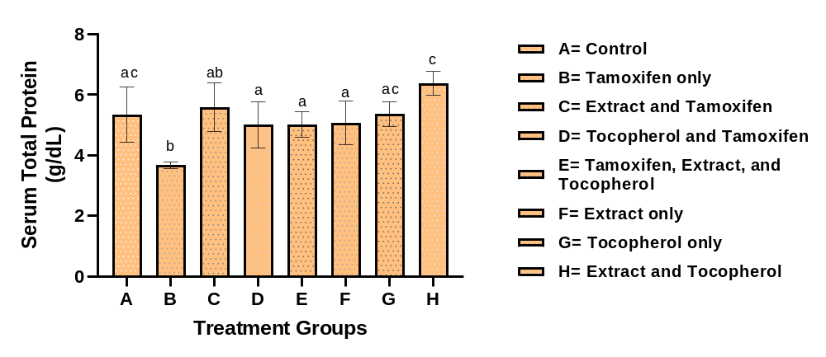Figure 1: Serum total protein concentration (g/dl) of various treatment groups. Values are expressed as mean ± SD (n=7); significant differences (p <0.05). Bar with same superscript indicate no significant difference while Bar with different superscript indicate significant difference
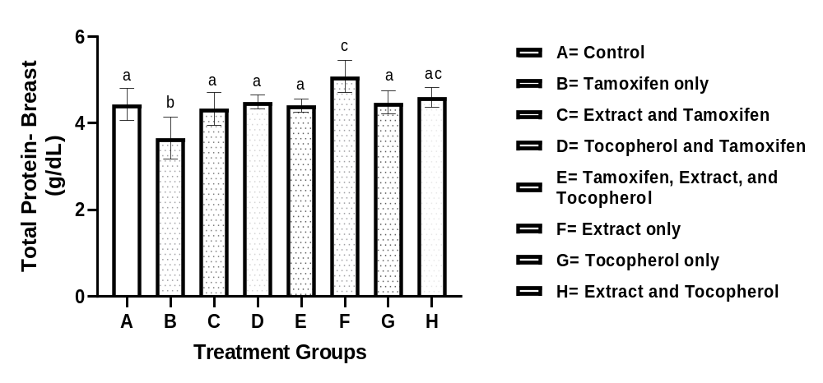Figure 2: Total protein concentration (g/dl) in breast homogenate of various treatment groups. Values are expressed as mean ± SD (n=7); significant differences (p <0.05). Bar with same superscript indicate no significant difference while Bar with different superscript indicate significant difference

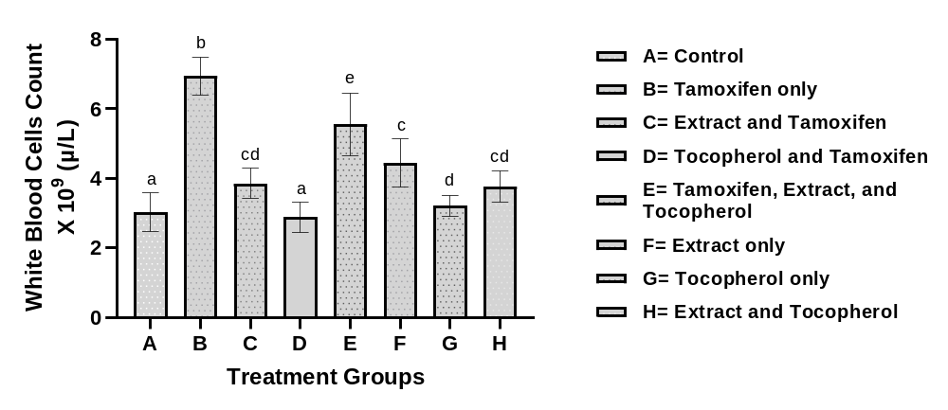
Figure 3: White blood cell (WBC) count of various treatment groups. Values are expressed as mean ± SD (n=7); significant differences (p <0.05). Bar with same superscript indicate no significant difference while Bar with different superscript indicate significant difference
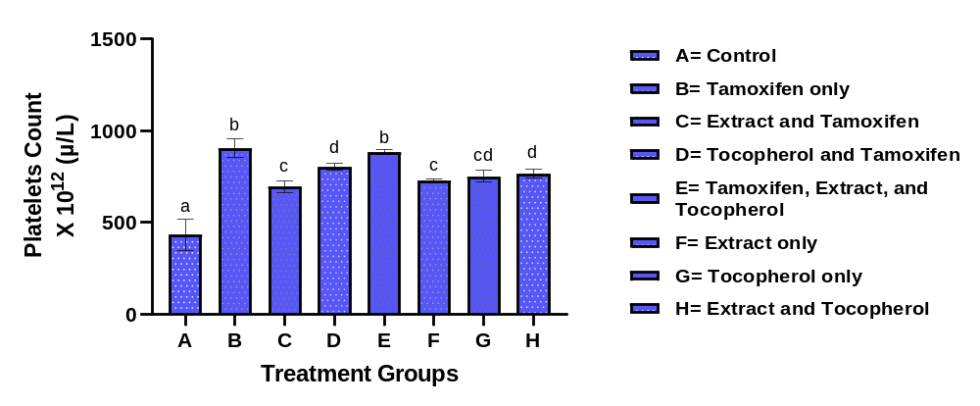Figure 4: Platelet count of various treatment groups. Values are expressed as mean ± SD (n=7); significant differences (p <0.05). Bar with same superscript indicate no significant difference while Bar with different superscript indicate significant difference

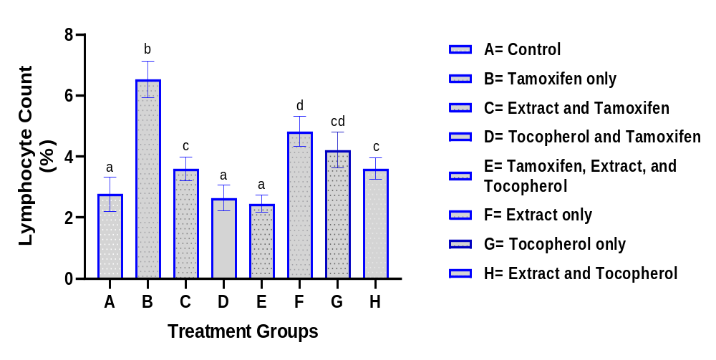Figure 5: Lymphocyte (%) count of various treatment groups. Values are expressed as mean ± SD (n=7); significant differences (p <0.05). Bar with same superscript indicate no significant difference while Bar with different superscript indicate significant difference
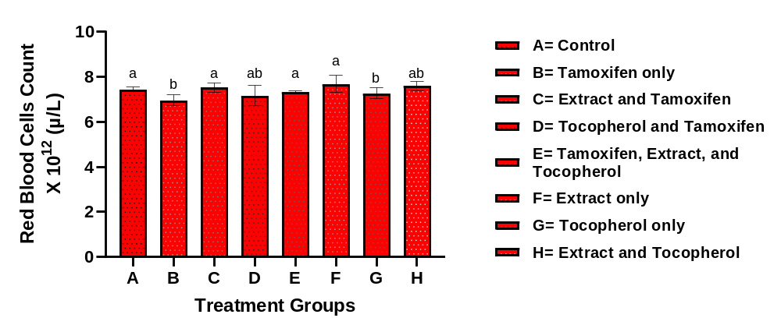Figure 6: Red blood cell (RBC) count of various treatment groups. Values are expressed as mean ± SD (n=7); significant differences (p <0.05). Bar with same superscript indicate no significant difference while Bar with different superscript indicate significant difference

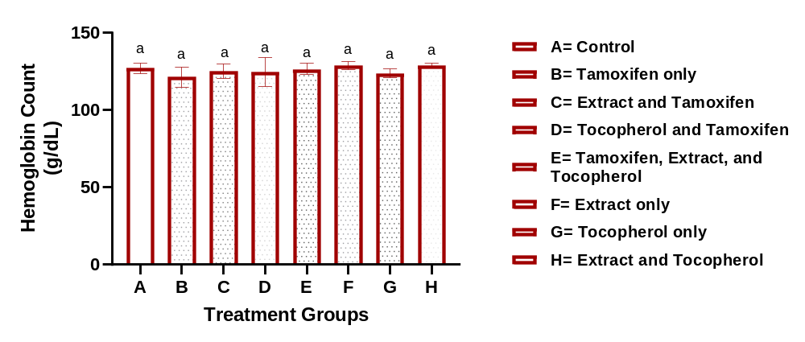Figure 7: Hemoglobin count of various treatment groups. Values are expressed as mean ± SD (n=7); significant differences (p <0.05). Bar with same superscript indicate no significant difference while Bar with different superscript indicate significant difference
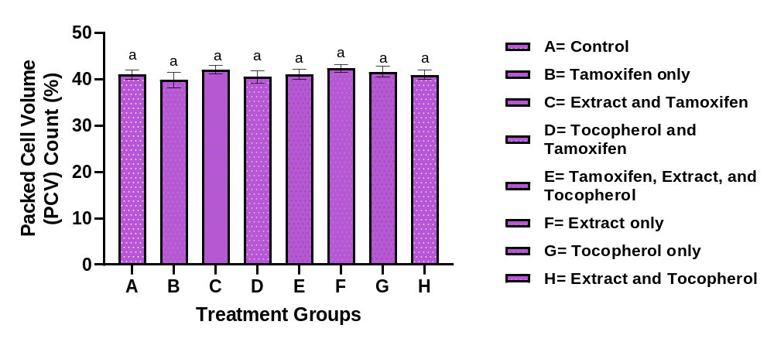Figure 8: Packed cell volume (PCV) of various treatment groups. Values are expressed as mean ± SD (n=7); significant differences (p <0.05). Bar with same superscript indicate no significant difference while Bar with different superscript indicate significant difference

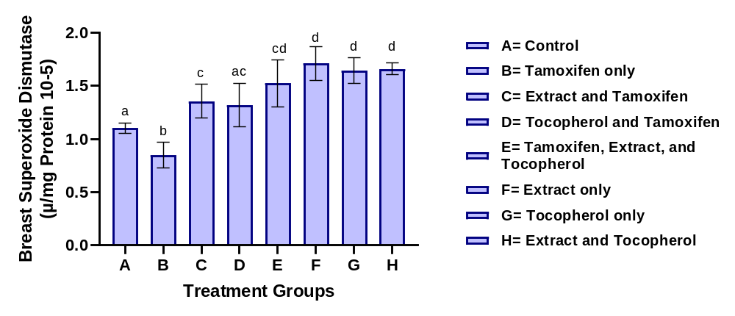Figure 9: Superoxide dismutase (SOD) activity in breast homogenate of various treatment groups. Values are expressed as mean ± SD (n=7); significant differences (p <0.05). Bar with same superscript indicate no significant difference while Bar with different superscript indicate significant difference
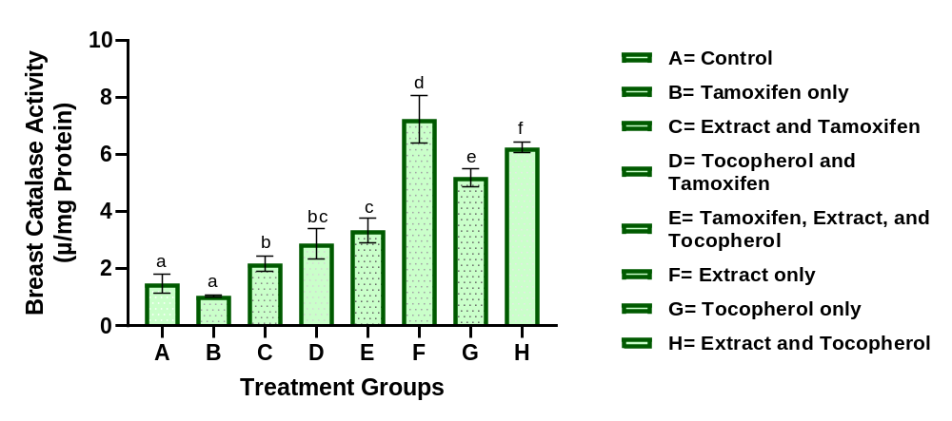Figure 10: Catalase (CAT) activity in breast homogenate of various treatment groups. Values are expressed as mean ± SD (n=7); significant differences (p <0.05). Bar with same superscript indicate no significant difference while Bar with different superscript indicate significant difference

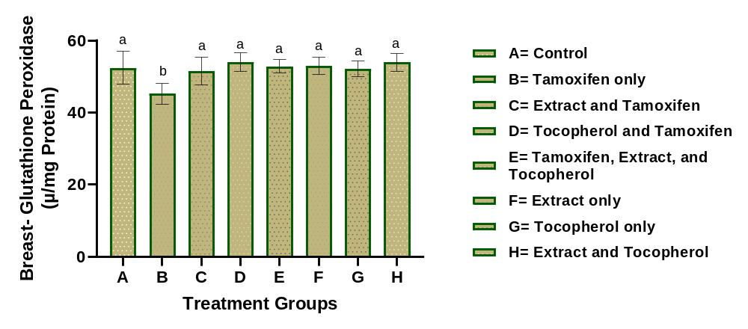Figure 11: Glutathione peroxidase (GPX) activity in breast homogenate of various treatment groups. Values are expressed as mean ± SD (n=7); significant differences (p <0.05). Bar with same superscript indicate no significant difference while Bar with different superscript indicate significant difference
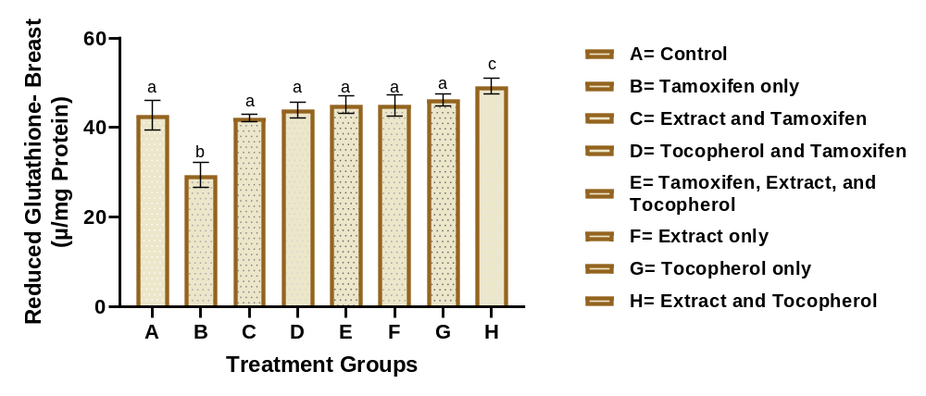Figure 12: Reduced glutathione (GSH) level in breast homogenate of various treatment groups. Values are expressed as mean ± SD (n=7); significant differences (p <0.05). Bar with same superscript indicate no significant difference while Bar with different superscript indicate significant difference

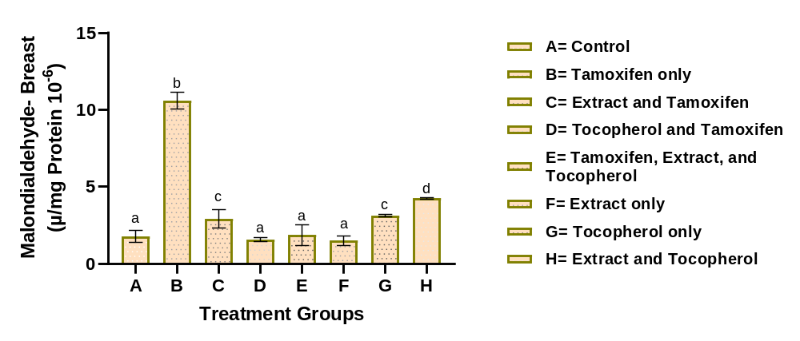Figure 13: Malondialdehyde (MDA) concentration in breast homogenate of various treatment groups. Values are expressed as mean ± SD (n=7); significant differences (p <0.05). Bar with same superscript indicate no significant difference while Bar with different superscript indicate significant difference

Complications associated with anticancer therapy have been linked to oxidative stress, redox imbalance and alterations in normal physiological functions (Adedosu et al., 2018). Tamoxifen is an important drug used in the prevention and treatment of hormone receptor-positive breast cancer, although prolonged use may be associated with adverse effects (Gaies et al., 2012; Buijs et al., 2024). Therefore, the identification of interventions that may attenuate treatment-associated biochemical and haematological alterations remains important (Khallouki et al., 2023). In the present study, the effects of Embelia ribes seed extract and vitamin E on tamoxifen-associated alterations in total protein, haematological indices and breast-tissue antioxidant status were evaluated.
Protein determination provides useful information on metabolic and cellular status because proteins are involved in numerous physiological processes, including transport, enzymatic activity and maintenance of cellular structure. In the present study, tamoxifen administration significantly (p < 0.05) reduced total protein concentration in both serum and breast homogenate (Figures 1 and 2) compared with the control group. The reduction may reflect disturbances in protein metabolism, increased protein degradation or cellular alterations associated with oxidative stress (Sharma & Kim, 2021; Liu et al., 2024). Interestingly, administration of Embelia ribes seed extract and vitamin E attenuated the reduction in total protein observed in the tamoxifen-treated animals. In serum, extract and tamoxifen increased total protein to 5.58 g/dL, while vitamin E and tamoxifen and the combined treatment produced values of 5.00 and 5.02 g/dL, respectively, compared with 3.69 g/dL in the tamoxifen-only group. A similar pattern was observed in breast homogenate, where extract and tamoxifen, vitamin E and tamoxifen, and the combined treatment (extract, vitamin E and tamoxifen) increased total protein relative to tamoxifen alone. These findings suggest that the treatments may have reduced the biochemical disturbances associated with tamoxifen administration (Abdelqader et al., 2023; Fang et al., 2023). The improvement observed with vitamin E may be related to its established antioxidant role and ability to reduce lipid peroxidation and oxidative damage to cellular components (Ralla et al., 2024; Khalid et al., 2024). The effects observed with Embelia ribes seed extract may also be associated with its previously reported antioxidant properties (Rudrapal et al., 2024; Mubeen et al., 2025). However, the specific compounds responsible for the effects were not characterised in the present study. Although the combination treatment produced the most pronounced improvement in serum total protein, all treatment groups showed better protein status than the tamoxifen-only treated group, suggesting varying degrees of protection against tamoxifen-induced biochemical disturbances (Fang et al., 2023). These findings suggest that the extract and vitamin E may attenuate some of the biochemical disturbances associated with tamoxifen administration (Khallouki et al., 2023; Ahmed et al., 2026).
Haematological parameters are useful indicators of physiological changes and may provide evidence of drug-associated alterations in blood homeostasis. In the present study, Figures 3, 4 and 5 show that tamoxifen administration significantly (p < 0.05) increased white blood cell (WBC), lymphocyte and platelet counts, while red blood cell (RBC) count, haemoglobin concentration and packed cell volume (PCV) (Figures 6, 7 and 8) were significantly (p < 0.05) reduced compared with the control group. These findings indicate that prolonged tamoxifen administration was associated with haematological alterations, including changes consistent with an anaemic status (Mahdiani et al., 2022). The elevations in WBC and lymphocyte counts following tamoxifen administration may reflect a physiological response to drug-associated cellular stress or inflammatory processes (Fang, 2023; Sikora et al., 2023). Persistent changes in leukocyte populations have been associated with cellular injury and inflammatory stress (Gaman et al., 2019). Treatment with Embelia ribes seed extract and vitamin E attenuated the increases in WBC and lymphocyte counts observed in the tamoxifen-only group, suggesting improvement in the haematological response associated with tamoxifen administration (Barboza et al., 2018). Tamoxifen administration also elicited a significant increase in platelet count, indicating an alteration in normal haematological balance. Increased platelet counts may occur in association with inflammatory and oxidative conditions (Chaudhary et al., 2022). Treatment with the extract and vitamin E reduced the elevated platelet count relative to the tamoxifen-only group, although the reduction was not complete in all treatment groups. This suggests that the treatments attenuated, but did not uniformly normalise, the platelet alteration associated with tamoxifen administration (Pather, 2020; Giurranna et al., 2024).

The reduction in RBC count, haemoglobin concentration and PCV observed in the tamoxifen-treated group suggests the development of mild anaemia. Such alterations may result from oxidative damage to erythrocytes, impaired erythropoiesis or reduced red-cell survival (Obeagu et al., 2024). Red blood cells are particularly susceptible to oxidative damage because of their continuous exposure to oxygen and the high polyunsaturated fatty acid content of their membranes (Engwa et al., 2022). Treatment with Embelia ribes seed extract and vitamin E improved RBC count, haemoglobin concentration and PCV compared with the tamoxifen-only group, indicating attenuation of the haematological alterations associated with tamoxifen administration (Orrico et al., 2023; Vona et al., 2021). Vitamin E may contribute to this effect by protecting membrane lipids against peroxidation (Altamura et al., 2020).
Oxidative stress results from an imbalance between reactive oxygen species generation and antioxidant defence and is an important mechanism underlying drug-associated cellular injury (Alfhili et al., 2023; Afzal et al., 2023). In the present study, the redox indices used as indicators of oxidative stress and lipid peroxidation are presented in Figures 9, 10, 11, 12 and 13. The results showed that animals treated with tamoxifen only (Group B) had significant (p < 0.05) decreases in the activities of Superoxide Dismutase (SOD), Catalase (CAT) and Glutathione Peroxidase (GPx), and in the concentration of Reduced Glutathione (GSH) in breast homogenates, while malondialdehyde (MDA) concentration was significantly (p < 0.05) increased. This pattern indicates impaired antioxidant defence accompanied by increased lipid peroxidation and is consistent with disruption of breast-tissue redox balance following tamoxifen administration (Guneidy et al., 2024; Sadiq, 2023). Such alterations suggest that excessive production of free radicals overwhelmed the antioxidant system, resulting in oxidative damage to cellular macromolecules (Sadiq, 2023).
Superoxide dismutase (SOD) constitutes an important component of enzymatic antioxidant defence by converting superoxide radicals to hydrogen peroxide, which is subsequently removed by enzymes such as Catalase and Glutathione peroxidase (Jomova et al., 2024). The reduction in SOD activity following tamoxifen administration suggests reduced capacity to neutralise superoxide radicals (Abd Al-Hameed & Al-Ani, 2023). Treatment with Embelia ribes seed extract and vitamin E increased SOD activity relative to the tamoxifen-only group, indicating attenuation of the antioxidant imbalance (Abu-Zahra et al., 2025). The extract-only group showed the highest SOD activity among the treatment groups; therefore, the response should not be described as evidence that the combined treatment produced the greatest SOD improvement.
Catalase functions together with Superoxide dismutase to remove hydrogen peroxide and protect cells from oxidative injury (Anwar et al., 2024). Tamoxifen administration reduced CAT activity, suggesting impairment of enzymatic antioxidant defence (Nazmeen et al., 2020). Treatment with Embelia ribes seed extract and vitamin E increased CAT activity compared with the tamoxifen-only group, indicating improved antioxidant capacity (Andrés et al., 2022; Dubey & Sharma, 2025). The highest CAT activity was observed in the extract-only group, followed by the extract and vitamin E group, indicating that the antioxidant response varied according to treatment combination. Vitamin E may have contributed through its membrane-protective antioxidant activity (Polutchko et al., 2021).
Glutathione peroxidase (GPx) and reduced glutathione (GSH) form an important intracellular antioxidant system involved in the removal of peroxides and maintenance of cellular redox balance (Vašková et al., 2023). The reductions in GPx activity and GSH concentration observed in the tamoxifen-treated group indicate depletion of antioxidant capacity during oxidative stress (Rui et al., 2021; Chen et al., 2024). However, administration of Embelia ribes seed extract and vitamin E increased GPx and GSH relative to the tamoxifen-only group, with several treatment groups approaching or exceeding the control values. This suggests that the treatments attenuated the depletion of endogenous antioxidant defences associated with tamoxifen exposure (Liu et al., 2024; Chandimali et al., 2025).
Malondialdehyde (MDA) is a commonly used indicator of lipid peroxidation and oxidative damage to cellular membranes (Abd Al-Hameed & Al-Ani, 2023). In this study, tamoxifen produced a marked increase in MDA concentration, from 1.78 in the control group to 10.62 in the tamoxifen-only group, indicating enhanced lipid peroxidation (Guneidy et al., 2023; Voronina et al., 2024). Co-administration of Embelia ribes seed extract or vitamin E with tamoxifen substantially reduced MDA relative to the tamoxifen-only group, with values of 2.93, 1.58 and 1.87 in the extract and tamoxifen, vitamin E and tamoxifen, and combination treatment groups (extract, vitamin E and tamoxifen), respectively. The extract-only group also showed a low MDA value of 1.50. These findings indicate attenuation of tamoxifen-associated lipid peroxidation, although the response varied among treatment combinations (Dell’Acqua et al., 2020; Uti et al., 2025). The antioxidant response observed with Embelia ribes seed is consistent with previously reported antioxidant properties of the plant (Tumilaar et al., 2024; Parcheta et al., 2021). However, the specific phytochemical constituents responsible for the observed effects were not characterised in the present study. Similarly, vitamin E is a lipid-soluble antioxidant that protects polyunsaturated fatty acids in biological membranes from peroxidative damage (Recknagel et al., 2020). Its ability to limit lipid peroxidation may therefore contribute to the improved antioxidant status observed in several vitamin E-treated groups. The combined treatment produced an enhanced response for some parameters compared with individual treatments, although the magnitude of the effect varied across the biochemical and haematological indices (Chaib et al., 2026).
Overall, the improvement in antioxidant enzyme activities and reduction in MDA observed in several treated groups indicate that Embelia ribes seed extract and vitamin E attenuated the redox disturbances associated with tamoxifen administration. Together with the improvement in haematological and total protein parameters, these findings support the potential of Embelia ribes seed extract as a candidate for further investigation in the context of tamoxifen-associated biochemical alterations. However, the present biochemical findings do not by themselves establish histological protection or identify the specific compounds responsible for the observed effects.

- CONCLUSION
The findings of this study indicate that prolonged tamoxifen administration was associated with alterations in serum and breast total protein, haematological parameters and antioxidant defence in breast tissue, as evidenced by changes in SOD, CAT, GPx, GSH and MDA. Administration of the ethyl acetate extract of Embelia ribes seed and vitamin E ameliorated several of these alterations, although the magnitude of the response varied across the measured parameters and treatment combinations. The findings suggest that the ethyl acetate extract of Embelia ribes seed may have antioxidant and haematological protective potential against some of the biochemical and haematological alterations associated with tamoxifen administration. These findings provide a basis for further investigation of Embelia ribes seed as a potential complementary candidate during tamoxifen administration.
- LIMITATION
This study was limited to selected biochemical and haematological investigations, with seven animals analysed per group. Detailed phytochemical characterisation of the Embelia ribes seed extract and histopathological evaluation of the breast, liver and kidney tissues were not included in the present study. Therefore, further studies involving detailed phytochemical characterisation, histopathological assessment and molecular investigations are recommended to identify the specific constituents and mechanisms underlying the observed effects and to provide further evidence of tissue-level changes.

Declaration of AI Use

This manuscript was prepared through the intellectual contributions of the author(s) to the study design, data analysis, interpretation of results, and scholarly content. Grammarly and ChatGPT were used solely to assist with grammatical refinement and reference formatting during manuscript revision. The author(s) accept full responsibility for the accuracy, integrity, and final content of the manuscript.

COMPETING INTERESTS DISCLAIMER:
Authors have declared that they have no known competing financial interests OR non-financial interests OR personal relationships that could have appeared to influence the work reported in this paper.

Declaration of conflict of interests
The authors declare that there is no conflict of interests among them.

REFERENCE
Abd Al-Hameed, N. M., & Al-Ani, A. W. (2023). Assessment of systemic oxidative stress and antioxidants in Iraqi women with newly diagnosed and tamoxifen-treated breast cancer. Eurasian Chemical Communications, 5, 204–215. https://doi.org/10.22034/ecc.2023.365482.1538
Abdelqader, A., Obeidat, M. D., Al-Rawashdeh, M. S., & Alrazak, A. A. (2023). The role of vitamin E as an antioxidant and preventing damage caused by free radicals. Journal of Life Science and Applied Research, 4(2), 89–95. https://doi.org/10.59807/jlsar.v4i2.89
Abu-Zahra, N. I., Elbaz, S., El-Gammal, G. A., Kassab, A. S., Gouda, M., Elseify, M. M., & Soliman, S. (2025). Selenium and vitamin E supplementation alleviate high-fat diet-induced stress in Oreochromis niloticus: Enhancing growth, antioxidant defense, and disease resistance. Aquaculture International, 33(8), 695. https://doi.org/10.1007/s10499-025-02344-7
Adedosu, O. T., Badmus, J. A., Adeleke, G. E., & Olalere, G. O. (2017). Thaumatococcus daniellii extract modulates glibenclamide activity and ameliorates haematological disorders, oxidative stress and dyslipidemia associated with diabetes mellitus in rats. British Journal of Pharmaceutical Research, 16(5), 1–12. https://doi.org/10.9734/BJPR/2017/33134
Adedosu, O. T., Jimoh, R. A., Saraki, M. A., & Badmus, J. A. (2018). Ethanol leaves extract of Mangifera indica (L.) exhibits protective, antioxidative, and antidiabetic effects in rats. Asian Pacific Journal of Health Sciences, 5(1), 182–188. https://doi.org/10.21276/apjhs.2018.5.1.42
Aebi, H. (1984). Catalase in vitro. Methods in Enzymology, 105, 121–126. https://doi.org/10.1016/S0076-6879(84)05016-3
Afzal, S., Abdul Manap, A. S., Attiq, A., Albokhadaim, I., Kandeel, M., & Alhojaily, S. M. (2023). From imbalance to impairment: The central role of reactive oxygen species in oxidative stress-induced disorders and therapeutic exploration. Frontiers in Pharmacology, 14, 1269581. https://doi.org/10.3389/fphar.2023.1269581
Ahmed, A. S., Sabra, M. S., Abbas, A. Y. A., Kamal, A. A., & Abdelqader, Z. S. (2026). Targeting a novel tamoxifen-using pathway to preserve ovarian reserve in rats with experimental chemotherapy-induced ovarian failure. BMC Pharmacology and Toxicology, 27(1), 57. https://doi.org/10.1186/s40360-026-01103-5
Alfhili, M. A., Alyousef, A. M., & Alsughayyir, J. (2023). Tamoxifen induces eryptosis through calcium accumulation and oxidative stress. Medical Oncology, 40(11), 333. https://doi.org/10.1007/s12032-023-02205-4
Altamura, S., Vegi, N. M., Hoppe, P. S., Schroeder, T., Aichler, M., Walch, A., Okreglicka, K., Hültner, L., Schneider, M., Ladinig, C., Kuklik-Roos, C., Mysliwietz, J., Janik, D., Neff, F., Rathkolb, B., Hrabé de Angelis, M., Buske, C., da Silva, A. R., Muedder, K., ... Bornkamm, G. W. (2020). Glutathione peroxidase 4 and vitamin E control reticulocyte maturation, stress erythropoiesis and iron homeostasis. Haematologica, 105(4), 937–950. https://doi.org/10.3324/haematol.2018.212977
Andersen, H. R., Nielsen, J. B., Nielsen, F., & Grandjean, P. (1997). Antioxidative enzyme activities in human erythrocytes. Clinical Chemistry, 43(4), 562–568. https://doi.org/10.1093/clinchem/43.4.562
Anderson, M. E. (1985). Determination of glutathione and glutathione disulfide in biological samples. Methods in Enzymology, 113, 548–555. https://doi.org/10.1016/S0076-6879(85)13073-9
Andrés, C. M. C., Pérez de la Lastra, J. M., Juan, C. A., Plou, F. J., & Pérez-Lebeña, E. (2022). Chemistry of hydrogen peroxide formation and elimination in mammalian cells, and its role in various pathologies. Stresses, 2(3), 256–274. https://doi.org/10.3390/stresses2030019
Anwar, S., Alrumaihi, F., Sarwar, T., Babiker, A. Y., Khan, A. A., Prabhu, S. V., & Rahmani, A. H. (2024). Exploring therapeutic potential of catalase: Strategies in disease prevention and management. Biomolecules, 14(6), 697. https://doi.org/10.3390/biom14060697
Bain, B. J., Bates, I., Laffan, M. A., & Lewis, S. M. (Eds.). (2011). Dacie and Lewis practical haematology (11th ed.). Churchill Livingstone.
Barboza, J. N., da Silva Maia Bezerra Filho, C., Silva, R. O., Medeiros, J. V. R., & de Sousa, D. P. (2018). An overview on the anti-inflammatory potential and antioxidant profile of eugenol. Oxidative Medicine and Cellular Longevity, 2018, 3957262. https://doi.org/10.1155/2018/3957262
Bray, F., Laversanne, M., Sung, H., Ferlay, J., Siegel, R. L., Soerjomataram, I., & Jemal, A. (2024). Global cancer statistics 2022: GLOBOCAN estimates of incidence and mortality worldwide for 36 cancers in 185 countries. CA: A Cancer Journal for Clinicians, 74(3), 229–263. https://doi.org/10.3322/caac.21834
Buijs, S. M., Koolen, S. L. W., Mathijssen, R. H. J., & Jager, A. (2024). Tamoxifen dose de-escalation: An effective strategy for reducing adverse effects? Drugs, 84, 385–401. https://doi.org/10.1007/s40265-024-02010-x
Chaib, N., Elouardi, M., Azdem, D., Mabrouki, J., Boutakiout, A., Rouas, S., Chafai, Y., Wissal, J., & Alaoui El Belghiti, M. (2026). Synergistic interactions of antioxidants in lipid peroxidation: Mechanistic insights and applications. Euro-Mediterranean Journal for Environmental Integration, 11(5), 164. https://doi.org/10.1007/s41207-026-01136-6
Chandimali, N., Bak, S. G., Park, E. H., Lim, H. J., Won, Y. S., Kim, E. K., Park, S. I., & Lee, S. J. (2025). Free radicals and their impact on health and antioxidant defenses: A review. Cell Death Discovery, 11(1), 19. https://doi.org/10.1038/s41420-024-02278-8
Chaudhary, P. K., Kim, S., & Kim, S. (2022). An insight into recent advances on platelet function in health and disease. International Journal of Molecular Sciences, 23(11), 6022. https://doi.org/10.3390/ijms23116022
Chen, T. H., Wang, H. C., Chang, C. J., & Lee, S. Y. (2024). Mitochondrial glutathione in cellular redox homeostasis and disease manifestation. International Journal of Molecular Sciences, 25(2), 1314. https://doi.org/10.3390/ijms25021314
Costanzo, V., Ratre, Y. K., Andretta, E., Acharya, R., Bhaskar, L. V. K. S., & Verma, H. K. (2024). A comprehensive review of cancer drug-induced cardiotoxicity in blood cancer patients: Current perspectives and therapeutic strategies. Current Treatment Options in Oncology, 25(4), 465–495. https://doi.org/10.1007/s11864-023-01175-z
Dell’Acqua, G., Richards, A., & Thornton, M. J. (2020). The potential role of nutraceuticals as an adjuvant in breast cancer patients to prevent hair loss induced by endocrine therapy. Nutrients, 12(11), 3537. https://doi.org/10.3390/nu12113537
Dominiczak, M. H. (1998). Teaching and training laboratory professionals for the 21st century. Clinical Chemistry and Laboratory Medicine, 36(3), 133–136. https://doi.org/10.1515/CCLM.1998.025
Dubey, A., & Sharma, B. (2025). Targeting oxidative stress biomarkers in breast cancer development and the potential protective effect of phytochemicals. Drugs and Drug Candidates, 4(2), 23. https://doi.org/10.3390/ddc4020023
Dubey, S. K., Behar, N., & Behar, N. (2025). In silico pharmacophore profiling of Embelia ribes and Gloriosa superba for potential therapeutic applications. European Journal of Medicinal Plants, 36(2), 129–138. https://doi.org/10.9734/ejmp/2025/v36i21252
Engwa, G. A., Nweke, F. N., & Nkeh-Chungag, B. N. (2022). Free radicals, oxidative stress-related diseases and antioxidant supplementation. Alternative Therapies in Health & Medicine, 28(1), 114–128.
Fang, Z. (2023). Investigating the anti-leukaemic effect of tamoxifen in the myeloproliferative neoplasms [Doctoral dissertation, University of Cambridge]. https://doi.org/10.17863/CAM.103276
Fang, Z., Xu, H., Duan, J., Ruan, B., Liu, J., Song, P., Ding, J., Xu, C., Li, Z., Dou, K., & Wang, L. (2023). Short-term tamoxifen administration improves hepatic steatosis and glucose intolerance through JNK/MAPK in mice. Signal Transduction and Targeted Therapy, 8(1), 94. https://doi.org/10.1038/s41392-022-01299-y
Francis, A., Harhay, M. N., Ong, A. C. M., Tummalapalli, S. L., Ortiz, A., Fogo, A. B., Fliser, D., Roy-Chaudhury, P., Fontana, M., Nangaku, M., Wanner, C., Malik, C., Hradsky, A., Adu, D., Bavanandan, S., Cusumano, A., Sola, L., Ulasi, I., Jha, V., ... International Society of Nephrology. (2024). Chronic kidney disease and the global public health agenda: An international consensus. Nature Reviews Nephrology, 20(7), 473–485. https://doi.org/10.1038/s41581-024-00820-6
Gaies, E., Jebabli, N., Trabelsi, S., Salouage, I., Charfi, R., Lakhal, M., & Klouz, A. (2012). Methotrexate side effects: Review article. Journal of Drug Metabolism & Toxicology, 3(4), 1–5. https://doi.org/10.4172/2157-7609.1000125
Gaman, A. M., Moisa, C., Diaconu, C. C., & Gaman, M. A. (2019). Crosstalk between oxidative stress, chronic inflammation and disease progression in essential thrombocythemia. Revista de Chimie, 70(10), 3486–3489. https://doi.org/10.37358/RC.19.10.7581
Giurranna, E., Nencini, F., Bettiol, A., Borghi, S., Argento, F. R., Emmi, G., Silvestri, E., Taddei, N., Fiorillo, C., & Becatti, M. (2024). Dietary antioxidants and natural compounds in preventing thrombosis and cardiovascular disease. International Journal of Molecular Sciences, 25(21), 11457. https://doi.org/10.3390/ijms252111457
Guneidy, R. A., Zaki, E. R., Abdel Karim, G. S. A., Saleh, N. S., & Shokeer, A. (2023). Adverse effect of Tamarindus indica and tamoxifen combination on redox balance and genotoxicity of breast cancer cell. Journal of Genetic Engineering and Biotechnology, 21(1), 131. https://doi.org/10.1186/s43141-023-00564-z
Guneidy, R. A., Shokeer, A., Abdel Karim, G. S. A., Saleh, N. S. E.-D., & Zaki, E. R. (2024). Effect of protocatechuic acid on tamoxifen efficacy and oxidative stress in breast cancer cells: Implications for combination therapy. Egyptian Journal of Chemistry, 67(12), 167–181. https://doi.org/10.21608/ejchem.2024.312360.10195
Javankiani, S., Bolandi, S., Soleimani, A., Soleimani Meigoli, M. S., Parsafar, M., Safaei, S., Esmailpour, M., Nadimi, S., Aghajamal Avval, N., Fazayel, S. M. A., Zahed, Z., & Sharafi, M. (2025). MAPK signaling mediates tamoxifen resistance in estrogen receptor-positive breast cancer. Molecular and Cellular Biochemistry, 480(9), 4973–4989. https://doi.org/10.1007/s11010-025-05304-0
Jomova, K., Alomar, S. Y., Alwasel, S. H., Nepovimova, E., Kuca, K., & Valko, M. (2024). Several lines of antioxidant defense against oxidative stress: Antioxidant enzymes, nanomaterials with multiple enzyme-mimicking activities, and low-molecular-weight antioxidants. Archives of Toxicology, 98(5), 1323–1367. https://doi.org/10.1007/s00204-024-03696-4
Khalid, M. Z., Mohagheghi, S., Pourkabir, R. A., Bahmani, M., Nourian, A., & Shafiee, G. (2024). Evaluation of the protective effects of vitamins E and D on oxidative stress and inflammation caused by tamoxifen in the renal tissue of female Wistar rats. Current Drug Therapy, 19(5), 604–612. https://doi.org/10.2174/1574885519666230918091035
Khallouki, F., Hajji, L., Saber, S., Bouddine, T., Edderkaoui, M., Bourhia, M., Mir, N., Lim, A., El Midaoui, A., Giesy, J. P., Aboul-Soud, M. A. M., Silvente-Poirot, S., & Poirot, M. (2023). An update on tamoxifen and the chemo-preventive potential of vitamin E in breast cancer management. Journal of Personalized Medicine, 13(5), 754. https://doi.org/10.3390/jpm13050754
Kilicarslan You, D., Fuwad, A., Lee, K. H., Kim, H. K., Kang, L., Kim, S. M., & Jeon, T. J. (2024). Evaluation of the protective role of vitamin E against ROS-driven lipid oxidation in model cell membranes. Antioxidants, 13(9), 1135. https://doi.org/10.3390/antiox13091135
Liu, Y., Yang, C., Zhang, J., Ihsan, A., Ares, I., Martínez, M., Lopez-Torres, B., Martínez-Larrañaga, M.-R., Wang, X., Anadón, A., & Martínez, M.-A. (2024). Recent progress in adverse events of carboxylic acid non-steroidal anti-inflammatory drugs (CBA-NSAIDs) and their association with the metabolism: The consequences on mitochondrial dysfunction and oxidative stress, and prevention with natural plant extracts. Expert Opinion on Drug Metabolism & Toxicology, 20(8), 765–785. https://doi.org/10.1080/17425255.2024.2378885
Lloyd, M. R., Wander, S. A., Hamilton, E., Razavi, P., & Bardia, A. (2022). Next-generation selective estrogen receptor degraders and other novel endocrine therapies for management of metastatic hormone receptor-positive breast cancer: Current and emerging role. Therapeutic Advances in Medical Oncology, 14, 17588359221113694. https://doi.org/10.1177/17588359221113694
Mahdiani, S., Omidkhoda, N., Heidari, S., Hayes, A. W., & Karimi, G. (2022). Protective effect of luteolin against chemical and natural toxicants by targeting NF-κB pathway. BioFactors, 48(4), 744–762. https://doi.org/10.1002/biof.1876
Misra, H. P., & Fridovich, I. (1972). The role of superoxide anion in the autoxidation of epinephrine and a simple assay for superoxide dismutase. Journal of Biological Chemistry, 247(10), 3170–3175. https://doi.org/10.1016/S0021-9258(19)45228-9
Mubeen, B., Hasnain, A., Naqvi, S. A. H., Hakim, F., Naqvi, S. S. H., Hassan, M. Z., Iqbal, M. U., Moustafa, M., Alshaharni, M. O., & Duan, M. (2025). Phytochemicals as multi-target therapeutic agents for oxidative stress-driven pathologies: Mechanisms, synergies, and clinical prospects. Phyton-International Journal of Experimental Botany, 94(7), 1941–1971. https://doi.org/10.32604/phyton.2025.064056
Muscolo, A., Mariateresa, O., Giulio, T., & Mariateresa, R. (2024). Oxidative stress: The role of antioxidant phytochemicals in the prevention and treatment of diseases. International Journal of Molecular Sciences, 25(6), 3264. https://doi.org/10.3390/ijms25063264
Naik, S. R., & Gamare, D. (2025). Evidenced-based phytotherapy overview: Protective role of diverse bioactive phytochemicals in myocardial ischemia through pharmacodynamics and molecular mechanisms. Journal of Cardiovascular Medicine and Cardiology, 12(2), 22–33. https://doi.org/10.17352/2455-2976.000223
Nazmeen, A., Chen, G., Ghosh, T. K., & Maiti, S. (2020). Breast cancer pathogenesis is linked to the intra-tumoral estrogen sulfotransferase (hSULT1E1) expressions regulated by cellular redox dependent Nrf-2/NF κ β interplay. Cancer Cell International, 20(1), 70. https://doi.org/10.1186/s12935-020-1153-y
Nwozo, O. S., Effiong, E. M., Aja, P. M., & Awuchi, C. G. (2023). Antioxidant, phytochemical, and therapeutic properties of medicinal plants: A review. International Journal of Food Properties, 26(1), 359–388. https://doi.org/10.1080/10942912.2022.2157425
Obeagu, E. I., Igwe, M. C., & Obeagu, G. U. (2024). Oxidative stress’s impact on red blood cells: Unveiling implications for health and disease. Medicine, 103(9), e37360. https://doi.org/10.1097/MD.0000000000037360
Ohkawa, H., Ohishi, N., & Yagi, K. (1979). Assay for lipid peroxides in animal tissues by thiobarbituric acid reaction. Analytical Biochemistry, 95(2), 351–358. https://doi.org/10.1016/0003-2697(79)90738-3
Orrico, F., Laurance, S., Lopez, A. C., Lefevre, S. D., Thomson, L., Möller, M. N., & Ostuni, M. A. (2023). Oxidative stress in healthy and pathological red blood cells. Biomolecules, 13(8), 1262. https://doi.org/10.3390/biom13081262
Parcheta, M., Świsłocka, R., Orzechowska, S., Akimowicz, M., Choińska, R., & Lewandowski, W. (2021). Recent developments in effective antioxidants: The structure and antioxidant properties. Materials, 14(8), 1984. https://doi.org/10.3390/ma14081984
Pather, K. (2020). Hormone-therapy mediated interactions between platelets and breast cancer cells: An in vitro study [Doctoral dissertation, University of the Witwatersrand].
Polutchko, S. K., Glime, G. N., & Demmig-Adams, B. (2021). Synergistic action of membrane-bound and water-soluble antioxidants in neuroprotection. Molecules, 26(17), 5385. https://doi.org/10.3390/molecules26175385
Radeva, L., & Yoncheva, K. (2025). Doxorubicin toxicity and recent approaches to alleviating its adverse effects with focus on oxidative stress. Molecules, 30(15), 3311. https://doi.org/10.3390/molecules30153311
Rafiu, B. O., Sonibare, A. M., & Adesanya, E. O. (2019). Phytochemical screening, antimicrobial and antioxidant studies of Lannea egregia Engl. and K. Krause (Anacardiaceae) stem bark. Journal of Medicinal Plants for Economic Development, 3(1), a62. https://doi.org/10.4102/jomped.v3i1.62
Ralla, T., Kluenter, A. M., Litta, G., Müller, M. A., Bonrath, W., & Schäfer, C. (2024). Over 100 years of vitamin E: An overview from synthesis and formulation to application in animal nutrition. Journal of Animal Physiology and Animal Nutrition, 108(3), 646–663. https://doi.org/10.1111/jpn.13919
Recknagel, R. O., Glende, E. A., & Britton, R. S. (2020). Free radical damage and lipid peroxidation. In R. G. Meeks, S. D. Harrison, & R. J. Bull (Eds.), Hepatotoxicology (pp. 401–436). CRC Press. https://doi.org/10.1201/9780367812041-9
Rossi, M., Salomon, A., Chaumontel, N., Molet, J., Bailly, S., Tillet, E., & Bouvard, C. (2023). Warning regarding hematological toxicity of tamoxifen activated CreERT2 in young Rosa26CreERT2 mice. Scientific Reports, 13(1), 5976. https://doi.org/10.1038/s41598-023-32633-1
Rout, P. R., Shahid, M. K., Dash, R. R., Bhunia, P., Liu, D., Varjani, S., Zhang, T. C., & Surampalli, R. Y. (2021). Nutrient removal from domestic wastewater: A comprehensive review on conventional and advanced technologies. Journal of Environmental Management, 296, 113246. https://doi.org/10.1016/j.jenvman.2021.113246
Rudrapal, M., Rakshit, G., Singh, R. P., Garse, S., Khan, J., & Chakraborty, S. (2024). Dietary polyphenols: Review on chemistry/sources, bioavailability/metabolism, antioxidant effects, and their role in disease management. Antioxidants, 13(4), 429. https://doi.org/10.3390/antiox13040429
Rui, T., Wang, H., Li, Q., Cheng, Y., Gao, Y., Fang, X., Ma, X., Chen, G., Gao, C., Gu, Z., Song, S., Zhang, J., Wang, C., Wang, Z., Wang, T., Zhang, M., Min, J., Chen, X., Tao, L., ... Luo, C. (2021). Deletion of ferritin H in neurons counteracts the protective effect of melatonin against traumatic brain injury-induced ferroptosis. Journal of Pineal Research, 70(2), e12704. https://doi.org/10.1111/jpi.12704
Sadiq, I. Z. (2023). Free radicals and oxidative stress: Signaling mechanisms, redox basis for human diseases, and cell cycle regulation. Current Molecular Medicine, 23(1), 13–35. https://doi.org/10.2174/1566524022666211222161637
Savithri, Y., Ravi Sekhar, P., & Aruna Kumari, D. (2023). Protective role of magnesium malate and vitamine E against aluminium chloride toxicity on antioxidant enzymeactivity in albino rats. Uttar Pradesh Journal of Zoology, 44(24), 1–7. https://doi.org/10.56557/upjoz/2023/v44i243803
Shah, A., Srivastava, S., & Chaturvedi, C. P. (2024). Biomolecular components of blood and their role in health and diseases. In R. L. Singh, P. Singh, & N. Pathak (Eds.), Clinical applications of biomolecules in disease diagnosis: A comprehensive guide to biochemistry and metabolism (pp. 289–322). Springer Nature Singapore. https://doi.org/10.1007/978-981-97-4723-8_12
Sharma, C., & Kim, S. R. (2021). Linking oxidative stress and proteinopathy in Alzheimer’s disease. Antioxidants, 10(8), 1231. https://doi.org/10.3390/antiox10081231
Sikora, J. P., Karawani, J., & Sobczak, J. (2023). Neutrophils and the systemic inflammatory response syndrome (SIRS). International Journal of Molecular Sciences, 24(17), 13469. https://doi.org/10.3390/ijms241713469
Tumilaar, S. G., Hardianto, A., Dohi, H., & Kurnia, D. (2024). A comprehensive review of free radicals, oxidative stress, and antioxidants: Overview, clinical applications, global perspectives, future directions, and mechanisms of antioxidant activity of flavonoid compounds. Journal of Chemistry, 2024, 5594386. https://doi.org/10.1155/2024/5594386
Uti, D. E., Atangwho, I. J., Alum, E. U., Ntaobeten, E., Obeten, U. N., Bawa, I., Agada, S. A., Ukam, C. I.-O., & Egbung, G. E. (2025). Antioxidants in cancer therapy mitigating lipid peroxidation without compromising treatment through nanotechnology. Discover Nano, 20(1), 70. https://doi.org/10.1186/s11671-025-04248-0
Vašková, J., Kočan, L., Vaško, L., & Perjési, P. (2023). Glutathione-related enzymes and proteins: A review. Molecules, 28(3), 1447. https://doi.org/10.3390/molecules28031447
Vona, R., Sposi, N. M., Mattia, L., Gambardella, L., Straface, E., & Pietraforte, D. (2021). Sickle cell disease: Role of oxidative stress and antioxidant therapy. Antioxidants, 10(2), 296. https://doi.org/10.3390/antiox10020296
Voronina, M. V., Frolova, A. S., Kolesova, E. P., Kuldyushev, N. A., Parodi, A., & Zamyatnin, A. A., Jr. (2024). The intricate balance between life and death: ROS, cathepsins, and their interplay in cell death and autophagy. International Journal of Molecular Sciences, 25(7), 4087. https://doi.org/10.3390/ijms25074087
Zhang, S., Jin, Z., Bao, L., & Shu, P. (2024). The global burden of breast cancer in women from 1990 to 2030: Assessment and projection based on the Global Burden of Disease Study 2019. Frontiers in Oncology, 14, 1364397. https://doi.org/10.3389/fonc.2024.1364397

