Original Research Article

Quinoline-Based Aromatic Aldehydes as Novel Inhibitors of Plasmodium falciparum Transketolase: An In-Silico Study

Abstract
Background: The emergence of drug-resistant Plasmodium falciparum strains, especially those showing resistance to artemisinin-based combination therapies (ACTs), highlights the critical need for new antimalarial compounds that target different biochemical pathways.
Objectives: This study explores the inhibitory potential of quinoline-derived aromatic aldehydes against Plasmodium falciparum transketolase, a key enzyme in the pentose phosphate pathway that plays a vital role in parasite nucleotide synthesis and redox homeostasis, through an in-silico assessment.
Methodology: A combination of ligand-based and structure-based drug design strategies was employed. Drug-likeness, pharmacokinetic and toxicological properties were assessed using qualitative drug estimation and ADMET profiling. Molecular docking was used to determine binding affinities, while binding free energies were calculated using molecular mechanics. The stability of binding interactions was further examined using molecular dynamics simulations.
Results: Molecular docking studies identified 3,4,5-trimethoxybenzaldehyde (A3) and 2-nitrobenzaldehyde (A6) as having the highest binding affinities for Plasmodium falciparum transketolase (−8.3 kcal/mol and −8.2 kcal/mol, respectively), outperforming the reference drug oxythiamine. MM-PBSA analysis further confirmed Compound A6 as the thermodynamically most favourable complex, exhibiting superior overall binding free energy (ΔG_bind), driven by significant van der Waals and covalent contributions. Pharmacokinetic evaluations, including drug-likeness and ADMET profiling, indicated favourable drug-like properties and low toxicity across all compounds. Molecular dynamics simulations over 100 ns further validated Compounds A3 (7-(3,4,5-trimethoxyphenyl) chromenoquinoline) and A6 (7-(2-nitrophenyl) chromenoquinolinone) as the most stable complexes with Plasmodium falciparum transketolase, recording average RMSD values of 0.24–0.25 nm, RMSF values of 0.12–0.14 nm, radii of gyration of 2.85–2.93 nm, and consistent hydrogen-bond persistence throughout the trajectory.
Conclusion: Compared with the reference drug oxythiamine, both compounds demonstrated superior conformational stability and active-site complementarity, reinforcing their potential as credible antimalarial lead candidates.
Keywords: Antimalarial resistance; Plasmodium falciparum transketolase; oxythiamine; Chromenoquinoline; ligand-based drug design; structure-based drug design.

1.1 Introduction
Malaria remains one of the most devastating infectious diseases globally and is caused by Plasmodium parasites transmitted to humans through the bites of infected female Anopheles mosquitoes (Alharbi & Ahmed, 2026; Weiss et al., 2025; Zambare et al., 2019). These vectors thrive predominantly in tropical and subtropical regions where environmental conditions support their spread. According to the World Health Organization's 2025 report, approximately 282 million malaria cases and 610,000 deaths were recorded worldwide, reinforcing the disease's continued threat to global public health (World Health Organization, 2025). Africa bears the heaviest burden, accounting for about 213 million of these cases. Four sub-Saharan African nations — Nigeria (26.6%), the Democratic Republic of the Congo (12.3%), Uganda (5.1%), and Mozambique (4.1%) — together accounted for nearly half of all malaria-related deaths globally, reflecting the disproportionate regional impact of this disease.
Significant progress was achieved between 2000 and 2015, with global malaria cases declining by 37% and deaths decreasing by 60% (Sharma et al., 2025; Thellier et al., 2024). This was largely driven by expanded vector-control measures, such as insecticide-treated bed nets and indoor residual spraying, widespread adoption of artemisinin-based combination therapies (ACTs), and improved diagnostic tools. However, this momentum has slowed considerably since 2015. The WHO Global Malaria Report recorded 241 million cases in 2020, up from 227 million in 2019, suggesting a worrying reversal of earlier gains. Factors such as emerging drug resistance, fragile health systems, climate variability, and ongoing conflicts in endemic regions continue to undermine progress. The Global Burden of Disease analysis similarly identified malaria as a leading cause of infectious-disease morbidity and mortality in low-income countries, underscoring the persistent urgency for new and effective intervention strategies (Feng et al., 2025). The recent emergence of artemisinin partial resistance in several African settings further reinforces the need to investigate antimalarial strategies that act through alternative parasite targets (Rosenthal et al., 2024).
One emerging and promising area in antimalarial drug development is the exploitation of the pentose phosphate pathway (PPP), particularly through inhibition of transketolase. This thiamine diphosphate (ThDP)-dependent enzyme plays a central role in nucleotide synthesis and redox balance within the parasite, both of which are critical for its survival and replication inside host erythrocytes (Boateng et al., 2020; Fathoni et al., 2024). Recent research has recognised transketolase as a metabolic vulnerability in Plasmodium falciparum that can be therapeutically exploited (Orogun et al., 2025). Since this enzyme operates within a pathway distinct from those targeted by existing antimalarials, inhibiting it offers a viable strategy for circumventing established drug-resistance mechanisms, making it an attractive target for novel drug design. Related computational work targeting P. falciparum dihydroorotate dehydrogenase has also used molecular docking and QSAR approaches to prioritise candidate antimalarial inhibitors (Niaré et al., 2025).
Thiamine analogues, structurally similar to the ThDP cofactor, have demonstrated the ability to inhibit ThDP-dependent enzymes, making them early candidates for targeting transketolase (Atanda et al., 2025; Costliow, 2018). Oxythiamine, for example, has shown inhibitory activity within the PPP by competing with thiamine for enzyme binding (Zhang et al., 2016). However, its clinical usefulness is significantly limited by adverse effects, including nephrotoxicity, a short half-life, and broader toxicity concerns, rendering it unsuitable for long-term therapeutic use. These shortcomings have prompted a shift in research focus towards identifying alternative thiamine analogues that retain strong inhibitory potential while offering safer pharmacokinetic and toxicological profiles, a key motivation behind the investigation of quinoline-based compounds in this study.
Quinoline alkaloids are naturally occurring compounds predominantly sourced from plants of the genus Cinchona, members of the Rubiaceae family (Aslam et al., 2023). The bark of several Cinchona species, including C. officinalis, C. ledgeriana, C. calisaya, and C. succirubra, is particularly rich in these biologically active alkaloids, including quinine, quinidine, cinchonine, and cinchonidine (Hariyanti et al., 2022). These compounds have long held significant pharmaceutical importance, most notably in the historical treatment of malaria. Molecular docking of 4-aminoquinoline derivatives has likewise supported continued evaluation of quinoline-based structures for antimalarial drug discovery (Kumawat et al., 2021). A recent medicinal chemistry perspective further identifies quinoline as a continuing antimalarial scaffold across multiple parasite targets and drug-development strategies (Huang & Yuan, 2026).
Beyond antimalarial activity, quinoline alkaloids exhibit a broad range of pharmacological properties, including anti-inflammatory, antimicrobial, anticancer, and cardiovascular effects, making them valuable scaffolds in medicinal chemistry and drug development (Elebiju et al., 2023). Their heterocyclic structural framework contributes to diverse biological interactions, and they have been extensively studied for multiple therapeutic applications (Mallappa et al., 2025). Despite this wealth of pharmacological data, studies specifically exploring their antimalarial potential, particularly through enzyme-targeted mechanisms, remain relatively limited, representing a significant gap that this study aims to address (Jia et al., 2025).
The functionalisation of aromatic aldehyde onto the quinoline scaffold further enhances its therapeutic potential. Aromatic aldehydes introduce hydrogen-bonding capabilities and distinct electronic properties that can significantly influence how a ligand interacts with its protein target. These structural features make quinoline-derived aromatic aldehydes particularly attractive as candidate inhibitors of Plasmodium falciparum transketolase (Patel et al., 2026). Selective interactions with amino acid residues surrounding the enzyme's cofactor-binding or regulatory regions could contribute to stronger binding affinity and greater target specificity, key attributes for an effective and selective antimalarial agent.
The persistence of malaria as a global health crisis, coupled with the increasing threat of drug resistance, indicates a need for new therapeutic strategies. Transketolase in the PPP plays a significant role in parasite proliferation and redox balance, making it a potential drug target. Together with the promising pharmacological profile of quinoline-derived aromatic aldehydes, this provides a rationale for computational evaluation of these compounds as potential antimalarial leads. Therefore, this study employed a rigorous in-silico approach to evaluate these compounds against Plasmodium falciparum transketolase.
2.0 Methodology

2.1 Preparation of Ligands
Ten aromatic aldehyde quinoline-based compounds were selected for evaluation as potential antimalarial agents in this in-silico study. These compounds included 3-hydroxybenzaldehyde, 4-hydroxybenzaldehyde, 3,4,5-trimethoxybenzaldehyde, 3-pyridylcarboxaldehyde, p-tolylbenzaldehyde, 2-nitrobenzaldehyde, 4-hydroxy-3-methoxyphenyl, 4-dimethylaminobenzaldehyde, 3,4-dimethoxybenzaldehyde, and 2,4-dihydroxybenzaldehyde, which were designated A1–A10, respectively (Fig 1). These compounds were purposefully selected through a deliberate structure-activity rationale aimed at identifying the most promising inhibitor scaffolds against the target while maintaining drug-likeness and safety compatibility (Guha & Bender, 2011; Jia et al., 2025). Their two-dimensional (2D) structures were drawn using ChemDraw Ultra version 12.0 and subsequently converted into three-dimensional (3D) conformations using Chem3D Ultra version 12.0. Energy minimisation was then performed on each ligand to stabilise its structure, and the optimised conformations were saved in Protein Data Bank (.pdb) format. OpenBerbal version 1.5.4 was used to convert the ligand files into the AutoDock-compatible PDBQT format. Oxythiamine, which served as the reference drug, was retrieved from the PubChem database and optimised in 3D using OpenBerbal version 1.5.4 (Atanda et al., 2024).

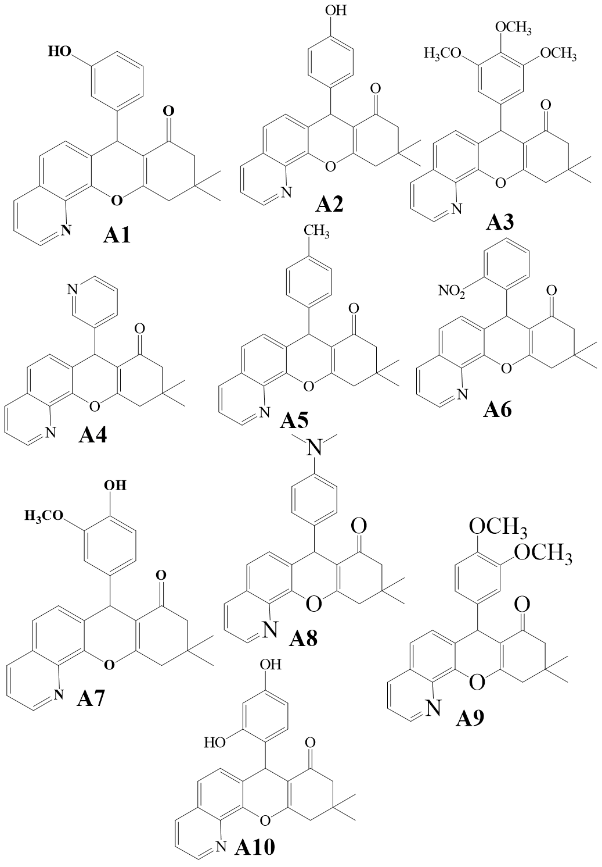
Fig i: Structures of Chromenoquinolinone derivatives drawn using ChemDraw Software

2.2 Preparation of Target Protein
Structural information on Plasmodium falciparum transketolase was obtained from the RCSB Protein Data Bank (https://www.rcsb.org) (Fig 2). The three-dimensional crystal structure of the enzyme (PDB ID: 9TME), resolved at 1.81 Å, was selected as the receptor for this study, with particular attention to domains A and C. The protein structure was processed and optimised using Biovia Discovery Studio 2021 to eliminate any unintended interactions that could compromise the virtual screening process (Ishola et al., 2021; Jejurikar & Rohane, 2021; Pawar & Rohane, 2021). Water molecules, co-crystallised ligands, and redundant chains were removed, retaining only chains A and C. All compounds were subsequently converted to PDBQT format using AutodockTools 1.5.7 to facilitate interaction studies with the target protein.
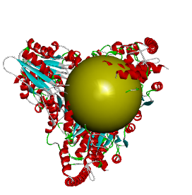
Fig 2: 3D structure of Plasmodium falciparum transketolase. (Source: Protein data bank)

2.3 Molecular Docking Validation
To ensure the reliability and accuracy of the docking protocol, validation was carried out by re-docking the co-crystallised ligand, oxythiamine, into the active site of P. falciparum transketolase using AutoDock Vina executed through the Perl command-prompt environment (Agbedahunsi et al., 2025). The re-docked pose was compared with the experimentally observed binding conformation, and the resulting binding scores and structural alignment confirmed that AutoDock Vina, when integrated with Perl scripting, is capable of producing accurate and reproducible docking results. This validated approach demonstrates that the AutoDock Vina-Perl combination provides a reliable and robust framework for predicting ligand-binding interactions, minimising false positives and negatives, and ensuring dependable predictions throughout the virtual-screening process.

2.3.1 Molecular Docking
Molecular docking was performed to evaluate binding interactions between the selected aromatic aldehyde quinoline derivatives and P. falciparum transketolase using AutoDock Vina executed through the Perl command-prompt environment. Perl scripting was utilised to automate docking commands and streamline the ligand-screening process. All ligand structures were prepared in PDBQT format using OpenBabel 1.5.4, with proper assignment of atom types and torsional bonds.
A docking configuration file was prepared to define the grid-box parameters around the enzyme's active binding pocket. The grid-box coordinates were set at X = −44.896, Y = 10.0, and Z = -48.573, with a grid spacing of 1 Å, ensuring adequate coverage of the catalytic-site residues responsible for substrate binding. Docking simulations were conducted at an exhaustiveness level of 8, allowing sufficient exploration of ligand conformational space to identify optimal binding poses. Batch docking of multiple ligands was automated through Perl scripting, which also facilitated the organisation and efficient processing of output files.
Following docking, the best binding conformations were selected based on the lowest binding-energy values and favourable interactions with key active-site residues. Visualisation and interaction analysis were subsequently performed to examine hydrogen bonding, hydrophobic contacts, and π–π stacking interactions between the ligands and the transketolase binding pocket using Discovery Studio Software (Ishola et al., 2021).

2.4 Physicochemical, Pharmacokinetic, and Toxicological Assessment

2.4.1 Drug-Likeness Properties
Drug-likeness assessment was conducted using the Quantitative Estimate of Drug-likeness (QED) approach via ADMETLab 3.0. QED offers a more comprehensive and nuanced evaluation of drug-likeness compared with the conventional Lipinski Rule of Five (Ro5) (Sukhachev et al., 2024). While the Ro5 applies a set of binary cut-off thresholds - molecular weight ≤500 Da, LogP ≤5, hydrogen-bond donors ≤5, and hydrogen-bond acceptors ≤10 - QED integrates multiple molecular descriptors into a single continuous score ranging from 0 to 1, where values from 0.6 to 1 indicate greater drug-likeness. This makes QED a more sensitive and informative metric, as it captures the overall desirability of a compound's physicochemical profile rather than simply flagging rule violations. Parameters evaluated included molecular weight, lipophilicity (LogP), rotatable bonds, hydrogen-bond donors and acceptors, and other features relevant to oral bioavailability and suitability for human administration.
2.4.2 ADMET Prediction
A thorough assessment of absorption, distribution, metabolism, excretion, and toxicity (ADMET) properties was conducted for all candidate compounds using ADMETLab 3.0. SMILES notations for each ligand were generated by converting the 3D structures drawn in ChemDraw using Open Babel and were then entered into the platform for analysis (Ehigie et al., 2022). Key parameters evaluated included Caco-2 permeability, human intestinal absorption, P-glycoprotein inhibition, cytochrome P450 enzyme inhibition, acute oral toxicity, Ames toxicity, carcinogenicity, hepatotoxicity, nephrotoxicity, human ether-a-go-go-related gene (hERG) inhibition, half-life (t½), and total clearance (AlRawashdeh et al., 2023; Patel et al., 2026; Zhang et al., 2020). These parameters collectively provided a comprehensive picture of each compound's pharmacokinetic behaviour and safety profile, which are critical considerations in early-stage drug development.

2.5 Molecular Mechanics (MM-PBSA)
Binding free-energy calculations were carried out using the Prime MM-PBSA tool within Maestro version 12.5. This method decomposes the total binding free energy into individual energy contributions - including electrostatic interactions, van der Waals forces, covalent interactions, and solvation energies - providing detailed insight into the thermodynamic basis of ligand binding (Ajao et al., 2024; Fakuade et al., 2024). The binding free energy (ΔG_bind) was calculated using the equation:
ΔG_bind = ΔE_MM + ΔG_GP + ΔG_SA
where ΔE_MM represents the molecular mechanical energy (the sum of electrostatic, van der Waals, hydrogen-bond, and torsional-angle energies), ΔG_PB is the polar solvation energy, and ΔG_SA is the non-polar solvation energy. The results provided quantitative insights into the relative binding stability of each ligand at the transketolase active site.

2.6 Molecular Dynamics (MD) Simulation
Molecular dynamics simulations were performed to assess the structural stability, conformational dynamics, and interaction behaviour of the protein-ligand complexes under physiological conditions (Cino et al., 2016; Kesari et al., 2020; Ogunyemi et al., 2026; Omotara et al., 2026; Shukla & Tripathi, 2020). Simulations were carried out using GROMACS version 2022, with protein and ligand topologies generated using the CHARMM36 force field and CGenFF parameters. Each complex was placed in a dodecahedron simulation box filled with SPC water molecules and neutralised with counterions using the GROMACS genion tool.
Energy minimisation was first performed using steepest-descent and conjugate-gradient algorithms until the maximum force fell below 100 kJ/mol/nm. The system was then equilibrated in two phases: NVT ensemble equilibration from 0 to 300 K over 100 picoseconds using the Verlet algorithm with a 2 fs time step, followed by NPT ensemble equilibration using the Berendsen algorithm with the same time step for 100 ps. Production MD simulations were subsequently run for 100 nanoseconds for each protein-ligand complex.
Post-simulation analyses were performed using Xmgrace, focusing on Root Mean Square Deviation (RMSD), Root Mean Square Fluctuation (RMSF), Radius of Gyration (RoG), and Intermolecular Hydrogen Bonds. These parameters collectively offered a detailed understanding of the dynamic stability and interaction mechanisms of the complexes throughout the simulation period (Mitiku & Abebe, 2024).
3.0 Results
Table 1: This table is showing Molecular Docking Results of 9TME and Chromenoquinoline derivatives from Perl cmd (Autodockvina)
Ligands | Chemical name | Binding Energy (Perl)  (Kcal/mol) | H-Bond  Interaction
Reference drug | Oxythiamine | -5.2 | A: SER 456  A: PHE 639  C: PHE 639  C: SER 642
A1 | 3-hydroxylphenyl derivative of Chromenoquinolinone | -7.8 | A: ASP 627
A2 | 4-hydroxyphenyl derivatives of Chromenoquinolinone | -7.8 | A: LYS 595  A: ASN 491  A: ASN 493
A3 | 3,4,5-trimethoxyphenyl derivatives of Chromenoquinolinone | -8.3 | A: GLY 30  A: LEU 268  A : HIS 266
A4 | 3-Pyridyl derivatives of Chromenoquinolinone | -7.6 | C: LYS 595
A5 | p-Toyl derivatives of Chromenoquinolinone | -8.0 | Nil
Ligands | Compound Name | Binding Energy (Perl)(K/mol) | Hydrogen-Bond Interaction
A6 | 2-nitrophenyl derivatives of Chromenoquinolinone | -8.2 | C: ARG 361  C: HIS 465  C: ARG 524  C: ARG 524
A7 | 4-hydroxy-3-methoxyphenyl  derivative of Chromenoquinolinone | -7.9 | Nil
A8 | 4-(dimethylamino)phenyl derivatives of Chromenoquinolinone | -7.9 | Nil
A9 | 3,4-dimethoxyphenyl derivatives of Chromenoquinolinone | -8.1 | Nil
A10 | 2,4-dihydroxylphenyl derivatives of Chromenoquinolinone | -8.0 | A: SER 488  A: ARG 487

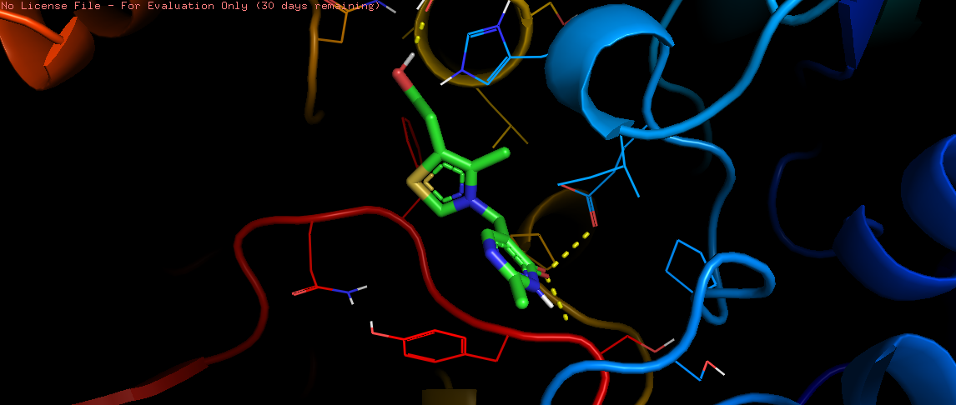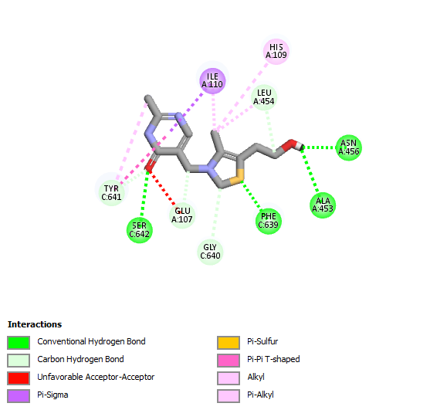
Figure 3: Molecular Interaction between 9TME_Oxythiamine visualized using Discovery Studio

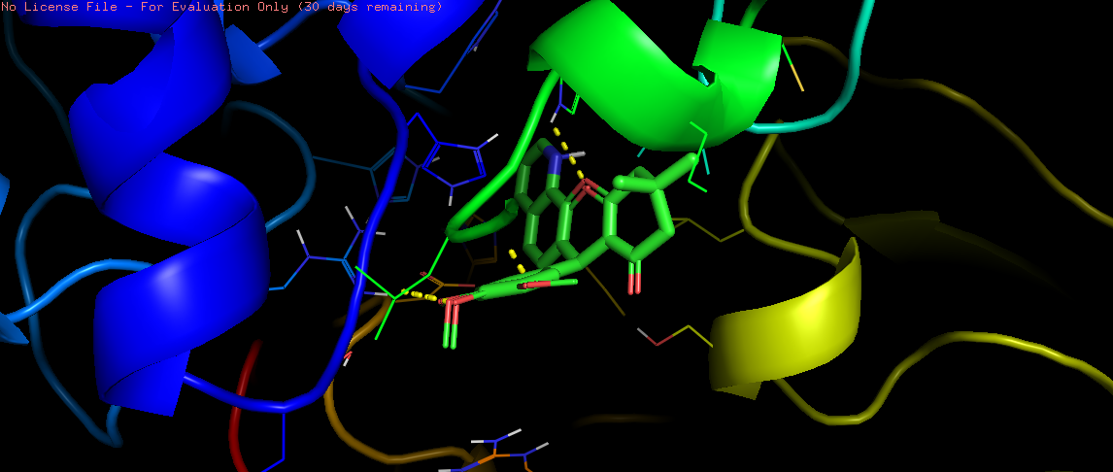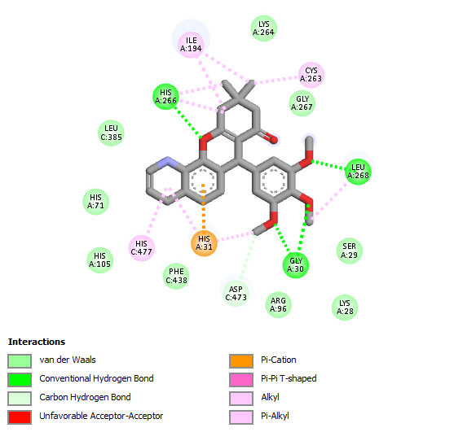
Figure 4: Molecular Interaction between 9TME_Trimethoxyphenyl visualized using Discovery Studio

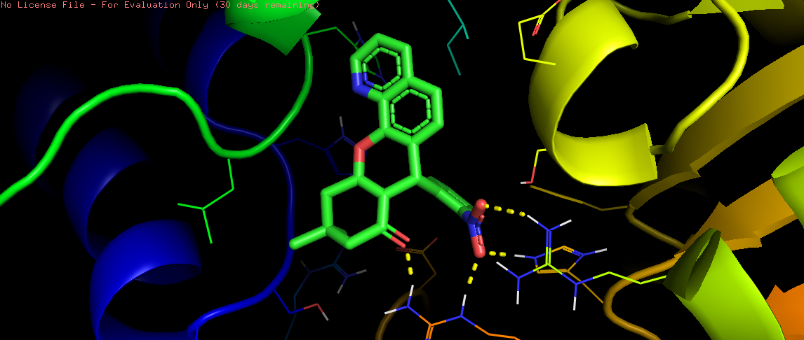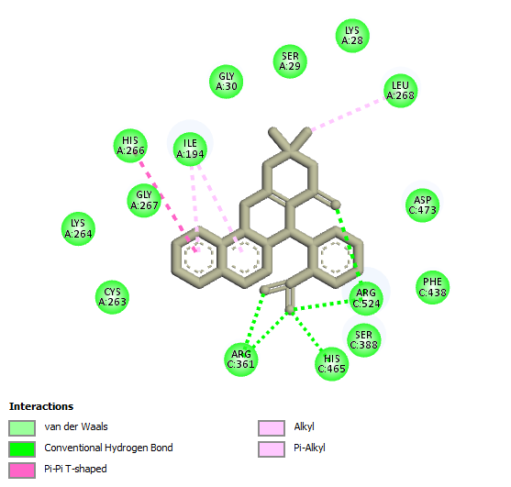
Figure 5: Molecular Interaction between 9TME_Nitrophenyl visualized using Discovery Studio

Ligands | MM-PBSA  ΔG  Bind Electrostatic Energy (Kcal/mol) | MM-PBSA  ΔG  Bind Covalent bond (Kcal/mol) | MM-PBSA  ΔG  Bind VanderWaal Forces  (Kcal/mol) | MM-PBSA  ΔG  Bind Polar Solvation (Kcal/mol) | MM-PBSA  ΔG  Overall Binding Energy (Kcal/mol)
Oxythiamine | -52.63 | -0.02 | -0.12 | 52.74 | -0.02
Compound A3 (Trimethoxylphenyl) | -0.07 | -0.02 | -0.20 | 0.29 | -0.01
Compound A6 (Nitrophenyl) | -3.03 | -2.81 | -23.92 | 18.00 | -11.76
Table 2: Table showing the binding free energies of oxythiamine, compound A3 and A6

Ligands | Drug ability | Absorption and  Distribution |  |  |  | Metabolism |  |  |  |  | Excretion and Toxicity
Compound Identifier | QED SCORE | Caco2  permeability | BBB | Human Intestinal  Absorption | P-glycoprotein  Inhibitor | CYP2D6 | CYP3A4 | CYP1A2 | CYPC19 | CYP2C9 |  | Half-life | Total Clearance | Nephrotoxicity | Acute oral toxicity | AMES toxicity | Carcinogenicity | HERG inhibitor | Hematoxicity
A1 | 0.646 | M | G | G | G | G | R | G | R | R |  | 0.6 | M | M | M | M | M | G | G
A2 | 0.534 | M | G | G | G | G | M | G | R | R |  | 0.7 | M | M | M | M | M | G | G
A3 | 0.646 | G | M | G | G | G | R | G | M | M |  | 0.7 | G | G | M | G | M | G | M
A4 | 0.629 | G | G | G | G | G | R | G | M | M |  | 0.5 | M | M | M | M | M | G | M
A5 | 0.551 | G | G | G | R | G | R | G | R | R |  | 0.5 | G | M | G | M | M | G | M
A6 | 0.646 | G | G | G | G | G | R | G | M | R |  | 0.6 | G | R | M | R | M | G | M
A7 | 0.430 | G | G | G | G | G | R | G | R | M |  | 0.8 | G | M | M | M | M | G | M
A8 | 0.574 | G | G | G | R | G | R | G | M | R |  | 0.4 | G | M | R | G | M | G | M
A9 | 0.572 | G | G | G | R | G | R | G | R | R |  | 0.7 | M | M | R | G | M | G | M
A10 | 0.646 | G | G | G | G | G | M | G | R | R |  | 0.7 | G | R | M | G | M | G | G
M-Medium
R- Poor
G- Good
Table 3: ADMET properties for the Chromenoquinoline derivatives. (Note: Good means low risk prediction, medium means medium risk prediction, poor means the compound needs further investigation or optimization.)

MD Parameter | Oxythiamine | Compound A3 | Compound A6
RMSD (nm) | 0.23 | 0.24 | 0.25
RMSF (nm) | 0.13 | 0.14 | 0.12
Radius of Gyration (nm) | 2.90 | 2.85 | 2.93
H-bonds (count) | 1.8 | 1.2 | 1.0
SASA (nm²) | 290 | 280 | 272
Table 4: Average Values of RMSD, RMSF, RoG, and H-Bonds Oxythiamine, Compound A3 a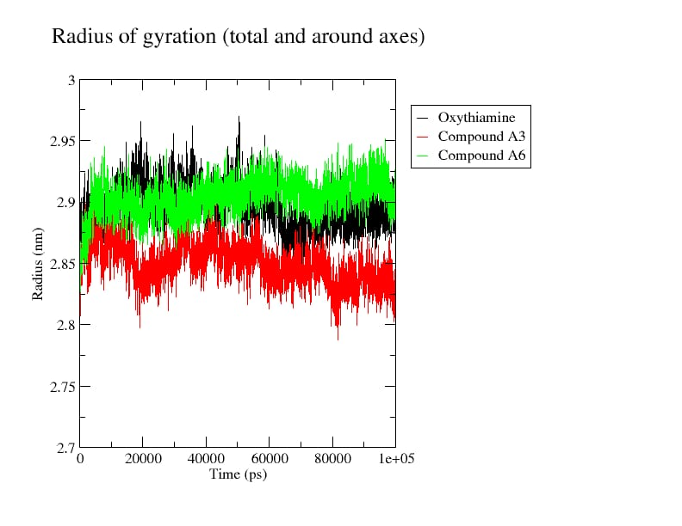

Figure 6: Radius of gyration of Plasmodium flaciparum transketolase complex with Oxythiamine and Compound A3, A6

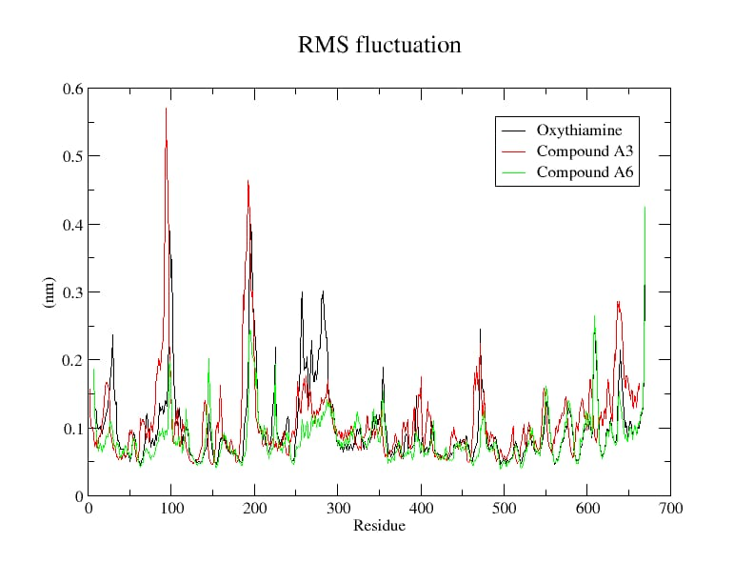
Figure 7: Residue fluctuation of Plasmodium flaciparum transketolase complex with Oxythiamine and Compound A3, A6
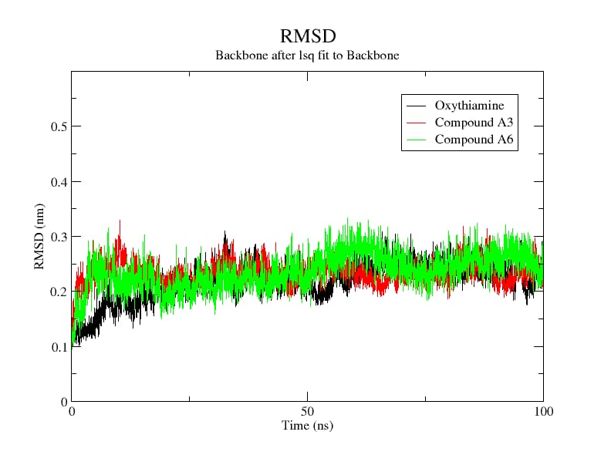

Figure 8: The Conformational stability of Plasmodium flaciparum transketolase complex with Oxythiamine and Compound A3, A6

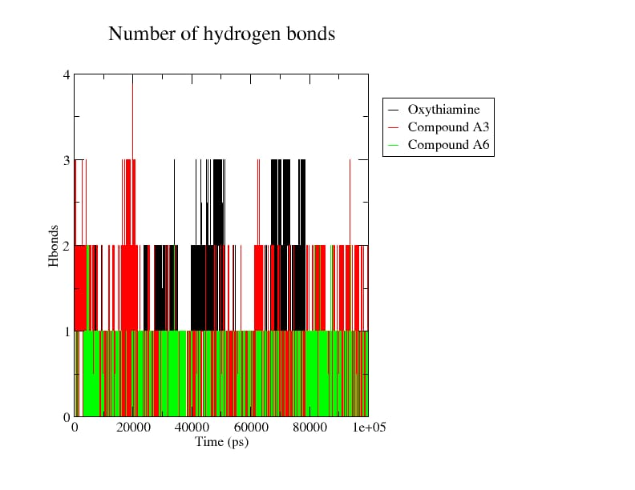
Figure 9: Hydrogen Bond Interactions of Plasmodium flaciparum transketolase complex with Oxythiamine and Compound A3, A6

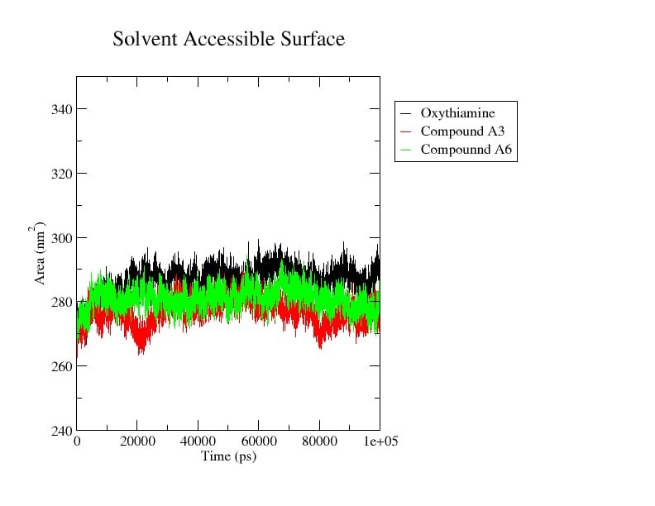

Fig 10: Solvent Accessible Surface Area of Plasmodium flaciparum transketolase complex with Oxythiamine and Compound A3, A6

DISCUSSION
The 3D structure of Plasmodium falciparum transketolase was obtained from the Protein Data Bank. The protein was tested against 10 different quinoline-based aromatic aldehyde derivatives. Molecular docking analysis provided critical insights into the binding interactions between Plasmodium falciparum transketolase (PDB ID: 9TME) and ten aromatic aldehyde quinoline derivatives, alongside the reference drug oxythiamine, with the results presented in Table 1. Oxythiamine recorded a binding affinity of -5.2 kcal/mol. This comparatively weaker binding energy is consistent with its known pharmacological limitations, including nephrotoxicity and carcinogenicity, which further restrict its clinical utility as a direct antimalarial agent.
Notably, two compounds demonstrated significantly superior binding affinities: 7-(3,4,5-trimethoxyphenyl)-10,11-dihydro-7H-chromenquinolin-8(9H)-one (Common Name: 3,4,5-trimethoxyphenyl derivatives of Chromenoquinoline) and 7-(2-nitrophenyl)-10,11-dihydro-7H-chromeno[3,2-h] quinolin-8(9H)-one (Common Name: 2-Nitrophenyl derivatives of Chromenoquinoline), scoring -8.3 kcal/mol and -8.2 kcal/mol, respectively (Table 1). These compounds engaged key catalytic residues - Gly30, Leu268, His266, Arg316, and Arg524 - through hydrogen bonding, while additional alkyl interactions with Cys263, Ile194, and Ile19 further reinforced their binding stability within the active site. These multi-point interactions suggest strong complementarity between the ligands and the enzyme's binding pocket, indicative of favourable selectivity and potency. The higher binding affinities compared with oxythiamine position these two compounds as promising lead candidates for further antimalarial drug development targeting P. falciparum transketolase.
Visualisation of these lead compounds (A3 and A6) was performed using Biovia Discovery Studio software. Oxythiamine engaged the active site of P. falciparum transketolase through conventional hydrogen bonds with Tyr C641, Glu A107, and Ser C642, supplemented by unfavourable acceptor-acceptor contacts and Pi-sigma interactions with Ile A110 and Leu A454 (Figure 3). The limited interaction profile and presence of unfavourable contacts are consistent with its weak binding affinity (−5.2 kcal/mol), corroborating its poor clinical efficacy.
This compound established robust conventional hydrogen bonds with Gly A30, Leu A268, His A266, and Arg A96, alongside van der Waals contacts and Pi-alkyl interactions with His A477, Phe C438, and Asp C473 (Figure 4). This extensive multi-residue engagement within the catalytic pocket suggests strong binding complementarity and favourable selectivity towards the transketolase active site.
The nitrophenyl derivative demonstrated stable binding through conventional hydrogen bonds with Arg C524 and His A269, Pi-Pi T-shaped interactions with Ile A194, and broad van der Waals contacts with Gly A30, Leu A268, Cys A263, and Phe C438 (Fig 5). These diverse non-covalent interactions reinforce its high binding affinity, suggesting strong inhibitory potential against P. falciparum transketolase; this supports the findings of Seo et al. (2014).
MM-PBSA calculations were performed, providing quantitative insights into the thermodynamic contributions governing ligand binding, as presented in Table 2. Compound A6 (Nitrophenyl) demonstrated the most favourable overall binding free energy of -11.76 kcal/mol, driven predominantly by significant van der Waals contributions (−23.92 kcal/mol) and covalent interactions (−2.81 kcal/mol), partially offset by polar solvation energy (18.00 kcal/mol). This energetic profile suggests strong hydrophobic complementarity within the transketolase active site. Compound A3 recorded a modest overall binding energy of -0.01 kcal/mol, while oxythiamine yielded -0.02 kcal/mol, with its large electrostatic contribution (−52.63 kcal/mol) almost entirely cancelled by unfavourable polar solvation (52.74 kcal/mol), reflecting thermodynamically inefficient binding. These findings further validate A6 as the superior lead candidate (Fakuade et al., 2024; Ishola et al., 2021).
The drug-likeness of all ten aromatic aldehyde quinoline derivatives (A1–A10) was assessed using the Quantitative Estimate of Drug-likeness (QED) scoring system (Table 2), which provides a more holistic and continuous measure of molecular desirability compared with the binary thresholds of Lipinski's Rule of Five. QED scores range from 0 to 1, with values approaching 1 reflecting more favourable drug-like characteristics. As presented in Table 3, the compounds recorded QED scores between 0.430 and 0.646. Compounds A1, A3, A6, and A10 achieved the highest score of 0.646, indicating strong drug-likeness, while A7 recorded the lowest score of 0.430 (Sukhachev et al., 2024). Overall, the majority of compounds demonstrated acceptable drug-likeness profiles, supporting their suitability for further pharmacological development.
The absorption, distribution, metabolism, excretion, and toxicity (ADMET) properties of all compounds were evaluated using ADMETLab 3.0, with the results presented in Table 2.
Most compounds demonstrated good human intestinal absorption and blood-brain barrier (BBB) permeability. Compounds A3–A10 exhibited good Caco-2 permeability, while A1 and A2 showed moderate permeability, suggesting slightly reduced passive uptake. The majority of compounds showed good P-glycoprotein inhibition, indicating a reduced likelihood of drug efflux and enhanced intracellular retention, favourable attributes for sustained antimalarial activity. Notably, A5, A8, and A9 showed reduced P-glycoprotein inhibition, which may slightly limit their intracellular accumulation.
All ten compounds showed good CYP3A4 non-inhibition, suggesting a low propensity for metabolic drug-drug interactions involving this critical enzyme. CYP2D6 inhibition was absent across all compounds, indicating metabolic safety. However, CYP1A2 and CYP2C19 inhibition was observed across several compounds, warranting consideration in co-therapy scenarios. CYP2C9 inhibition was similarly flagged in most compounds and should be monitored during further development.
Half-life values across the compounds ranged from 0.4 to 0.8 hours, reflecting relatively rapid clearance and reducing the risk of bioaccumulation. Total clearance was good for A3, A5, A6, A8, A9, and A10, while A1, A2, A4, and A7 showed moderate clearance. Notably, A3 and A10 demonstrated the most favourable overall excretion profiles.
Toxicologically, A3 emerged as the standout compound, exhibiting good nephrotoxicity and acute oral toxicity profiles, with no carcinogenic risk; it was the only compound to achieve this combination. A6 and A10 showed reduced nephrotoxicity ratings and require cautious monitoring. AMES toxicity was moderate across all compounds, while most compounds were predicted to have a favourable hERG inhibition-risk profile, suggesting a low predicted risk of hERG-related cardiac liability. Haematotoxicity profiles were generally favourable, with most compounds rated as good. Compared with oxythiamine, which is associated with nephrotoxicity, poor clearance, and carcinogenicity, the aromatic aldehyde quinoline derivatives collectively demonstrate markedly superior pharmacokinetic and safety profiles.
The lead compounds, A3 (7-(3,4,5-trimethoxyphenyl)-10,11-dihydro-7H-chromeno[3,2-h] quinolin-8(9H)-one) and A6 (7-(2-nitrophenyl)-10,11-dihydro-7H-chromeno[3,2-h] quinolin-8(9H)-one), stand out as promising lead candidates, combining the highest binding affinities from molecular docking with favourable ADMET characteristics and making them promising candidates for further experimental validation and antimalarial drug development.
To gain a comprehensive and time-resolved understanding of the structural stability, conformational flexibility, and dynamic behaviour of the protein-ligand complexes under physiological conditions, molecular dynamics simulations were conducted over an extended 100 ns trajectory.
RMSD analysis revealed that all three complexes achieved equilibration and maintained stable conformations throughout the simulation period. Compounds A3 and A6 recorded average RMSD values of 0.24 nm and 0.25 nm, respectively (Table 3), reflecting dynamic yet stable binding conformations within the transketolase active site. Oxythiamine, despite recording a slightly lower average RMSD of 0.23 nm, exhibited intermittent conformational fluctuations (Figure 7) during the early simulation stages, suggesting less consistent structural adaptation to the binding pocket compared with the test compounds (Cino et al., 2016).
RMSF analysis assessing per-residue flexibility revealed that Compound A6 demonstrated the lowest average fluctuation of 0.12 nm, indicating that its binding induces greater rigidity and stabilisation of active-site residues, a highly desirable property for a potent enzyme inhibitor. Compound A3 recorded an average RMSF of 0.14 nm, while oxythiamine showed 0.13 nm. The localised peaks observed around residues 90–100 and 190–200 are attributable to inherently flexible loop regions distant from the catalytic site and do not compromise the overall binding stability of A3 and A6.
Radius of Gyration (RoG) values reflect the overall compactness of the protein-ligand complexes. Compound A3 recorded the lowest average RoG of 2.85 nm, indicating that its binding promotes a more compact and structurally stable protein conformation relative to oxythiamine (2.90 nm) and A6 (2.93 nm). The consistently stable RoG trajectories observed for both A3 and A6 throughout the simulation confirm that neither compound induces significant unfolding or structural distortion of the transketolase enzyme, further supporting their compatibility with the target.
Hydrogen-bond analysis demonstrated that oxythiamine maintained an average of 1.8 hydrogen bonds throughout the simulation. However, this did not translate into superior binding stability, as hydrogen-bond counts for oxythiamine fluctuated considerably across the trajectory. Compounds A3 and A6 maintained consistent hydrogen-bond counts of 1.2 and 1.0, respectively, with sustained persistence throughout the 100 ns period. The consistency of these interactions is more therapeutically significant than sheer count, as stable, persistent hydrogen bonding reflects stronger and more reliable protein-ligand complementarity under physiological conditions.
Solvent Accessible Surface Area (SASA) analysis further reinforced the superiority of A3 and A6. Both compounds recorded lower average SASA values of 280 nm² and 272 nm², respectively, compared with oxythiamine's 290 nm². Lower SASA values indicate that the protein adopts a more closed, compact conformation upon ligand binding, reflecting deeper and more favourable burial of the compounds within the active site. This suggests that A3 and A6 engage the transketolase binding pocket more effectively, limiting solvent exposure and enhancing binding-stability characteristics that are strongly associated with potent enzyme inhibition.
Collectively, the MD simulation data establish that Compounds A3 and A6 form stable, persistent, and energetically favourable complexes with P. falciparum transketolase throughout the entire simulation period. Their superior compactness, consistent active-site stabilisation, and lower solvent exposure compared with oxythiamine position them as structurally robust and pharmacodynamically promising antimalarial lead candidates worthy of further experimental investigation.

CONCLUSION
This computational study evaluated ten quinoline-based aromatic aldehyde derivatives as potential inhibitors of Plasmodium falciparum transketolase. Among the evaluated compounds, A3 and A6 demonstrated the most favourable molecular-docking scores, with binding affinities of −8.3 and −8.2 kcal/mol, respectively, compared with −5.2 kcal/mol for oxythiamine. The MM-PBSA results further identified A6 as the most favourable complex, with an overall binding free energy of −11.76 kcal/mol. The predicted drug-likeness and ADMET profiles generally supported the suitability of the investigated derivatives for further evaluation. Molecular dynamics simulations indicated that the A3 and A6 complexes maintained relatively stable conformations throughout the 100-ns trajectories, as reflected by the reported RMSD, RMSF, radius-of-gyration, hydrogen-bond and SASA parameters. Taken together, the computational findings identify A3 and A6 as candidates for subsequent experimental assessment. Biochemical and biological studies are required to determine whether the predicted interactions translate into measurable transketolase inhibition and antimalarial activity.

Limitations
This study is limited to in-silico predictions based on molecular docking, drug-likeness and ADMET assessment, binding free-energy calculations, and 100-ns molecular dynamics simulations. Consequently, the reported binding affinities, energetic contributions, and pharmacokinetic and toxicological profiles represent computational estimates rather than experimental confirmation of transketolase inhibition or antiplasmodial activity. The analysis was also restricted to the selected derivatives and target structure. Biochemical, cellular, and in-vivo investigations are therefore required to establish the biological activity, safety, and therapeutic relevance of the identified candidates.

Declaration of AI Use

This manuscript was prepared through the intellectual contributions of the author(s) to the study design, data analysis, interpretation of results, and scholarly content. Grammarly and ChatGPT were used solely to assist with grammatical refinement and reference formatting during manuscript revision. The author(s) accept full responsibility for the accuracy, integrity, and final content of the manuscript.

COMPETING INTERESTS
Authors have declared that no competing interests exist.

COMPETING INTERESTS DISCLAIMER:
Authors have declared that they have no known competing financial interests OR non-financial interests OR personal relationships that could have appeared to influence the work reported in this paper.

References

Adama, N., Alex, A. Y. J., Bernard, D. A. M., Marius, K. S., Stéphane, D. G., Moise, K. A., Guy-Richard, K. M., Fagnidi, Y. K. H., & Doh, S. (2025). Study by molecular docking of the interactions between dihydroorotate dehydrogenase and a series of inhibitors of pyrrole derivatives for the treatment of malaria. Asian Journal of Chemical Sciences, 15(1), 92–110. https://doi.org/10.9734/ajocs/2025/v15i1352
Agbedahunsi, J. M., Cyril-Olutayo, M. C., Fadare, R. Y., Ogundolie, F. A., Salaria, D., Rolta, R., Idowu, S. A., Oladele, A. B., Eso, P. D., Olatunji, E. O., & Fadare, O. A. (2025). Computational study of phytochemicals from Khaya grandifoliola (Welw.) as potential inhibitors of the Plasmodium falciparum transketolase and putative antimalarial agents. In Silico Pharmacology, 13(2), 87. https://doi.org/10.1007/s40203-025-00378-6
Ajao, F. O., Ehigie, A. F., Odunitan, T. T., Atanda, O. E., Ayoola, P. B., & Olaniyan, L. W. B. (2024). Computational exploration of Psidii guajavae folium bioactive compounds as novel DPP-IV inhibitors for type 2 diabetes mellitus intervention. European Journal of Pharmaceutical and Medical Research, 11(6), 11–25.
Alharbi, B. F., & Ahmed, M. A. (2026). Malaria in the 21st century: Global disease burden, epidemiological insights, and strategic control approaches. Biology, 15(7), 575. https://doi.org/10.3390/biology15070575
AlRawashdeh, S., Chandrasekaran, S., & Barakat, K. H. (2023). Structural analysis of hERG channel blockers and the implications for drug design. Journal of Molecular Graphics and Modelling, 120, 108405. https://doi.org/10.1016/j.jmgm.2023.108405
Aslam, S., Jabeen, T., Ahmad, M., & Al-Huqail, A. A. (2023). Cinchona. In Essentials of medicinal and aromatic crops (pp. 221–248). Springer. https://doi.org/10.1007/978-3-031-35403-8_10
Atanda, O. E., Ehigie, A. F., Adisa, T. A., Olaniyan, L. W. B., Odunitan, T. T., Fadare, O. A., Jesulade, M. O., Adesina, A. O., & Ehigie, L. O. (2025). Computational evaluation of some Schiff-bases of phenylisocytosine as potent inhibitors of Plasmodium falciparum transketolase in anti-malarial drug discovery. International Journal of Biochemistry Research & Review, 34(4), 280–301. https://doi.org/10.9734/ijbcrr/2025/v34i41021
Atanda, O. E., Olaniyan, L. W. B., Fadare, O. A., Ehigie, A. F., Adisa, T. A., Odunitan, T. T., Alabi, O. T., Omonijo, B. A., Aloba, G. O., & Ehigie, L. O. (2024). In-silico evaluation of phenylisocytosine and its analogs as potent inhibitors of Plasmodium falciparum transketolase: A strategic approach in anti-malarial drug discovery. International Journal of Biochemistry Research & Review, 33(6), 616–636. https://doi.org/10.9734/ijbcrr/2024/v33i694
Boateng, R. A., Tastan Bishop, Ö., & Musyoka, T. M. (2020). Characterisation of plasmodial transketolases and identification of potential inhibitors: An in silico study. Malaria Journal, 19, 442. https://doi.org/10.1186/s12936-020-03512-1
Cino, E. A., Choy, W.-Y., & Karttunen, M. (2016). Characterization of the free state ensemble of the CoRNR box motif by molecular dynamics simulations. The Journal of Physical Chemistry B, 120(6), 1060–1068. https://doi.org/10.1021/acs.jpcb.5b11565
Costliow, Z. A. (2018). Identification and characterization of thiamine biosynthesis, transport, and regulation elements among Bacteroides species [Doctoral dissertation, University of Illinois at Urbana-Champaign]. IDEALS.
Ehigie, L. O., Ojeniyi, F. D., Rashidat, A., Igbeneghu, C., Sulaimon, N., & Ehigie, A. F. (2022). Molecular docking and molecular dynamics simulation to investigate protein-ligand binding of potential drug candidates from Vernonia amygdalina against Wilms’ tumor 1 (WT1) protein. European Journal of Biomedical and Pharmaceutical Sciences, 9(8), 499–514.
Elebiju, O. F., Ajani, O. O., Oduselu, G. O., Ogunnupebi, T. A., & Adebiyi, E. (2023). Recent advances in functionalized quinoline scaffolds and hybrids—Exceptional pharmacophore in therapeutic medicine. Frontiers in Chemistry, 10, 1074331. https://doi.org/10.3389/fchem.2022.1074331
Fakuade, A. A., Oyeniyi, P. V., Adetunji, I. H., Ojo, O. V., Clement, J. D., & Ishaya, B. J. (2024). Computational identification and validation of novel inhibitors targeting LLM genes in Staphylococcus aureus for antimicrobial drug development [Preprint]. Research Square. https://doi.org/10.21203/rs.3.rs-4884390/v1
Fathoni, I., Ho, T. C. S., Chan, A. H. Y., Leeper, F. J., Matuschewski, K., & Saliba, K. J. (2024). Identification and characterization of thiamine analogs with antiplasmodial activity. Antimicrobial Agents and Chemotherapy, 68(12), e01096-24. https://doi.org/10.1128/aac.01096-24
Feng, L., Mo, G., Liu, Z., & Liu, Q. (2025). Global, regional, national burden, trends and health inequality of neglected tropical diseases and malaria from 1990 to 2021. BMC Infectious Diseases, 25, 1649. https://doi.org/10.1186/s12879-025-12068-x
Guha, R., & Bender, A. (Eds.). (2011). Computational approaches in cheminformatics and bioinformatics. John Wiley & Sons. https://doi.org/10.1002/9781118131411
Hariyanti, H., Mauludin, R., Sumirtapura, Y. C., & Kurniati, N. F. (2022). A review: Pharmacological activities of quinoline alkaloid of Cinchona sp. Biointerface Research in Applied Chemistry, 13(4), 319. https://doi.org/10.33263/BRIAC134.319
Huang, G., & Yuan, Y. (2026). Harnessing the quinoline scaffold toward discovery and development of antimalarials. Journal of Medicinal Chemistry, 69(11), 12767–12804. https://doi.org/10.1021/acs.jmedchem.5c03762
Ishola, A. A., Adedirin, O., Joshi, T., & Chandra, S. (2021). QSAR modeling and pharmacoinformatics of SARS coronavirus 3C-like protease inhibitors. Computers in Biology and Medicine, 134, 104483. https://doi.org/10.1016/j.compbiomed.2021.104483
Jejurikar, B. L., & Rohane, S. H. (2021). Drug designing in Discovery Studio. Asian Journal of Research in Chemistry, 14(2), 135–138. https://doi.org/10.5958/0974-4150.2021.00025.0
Jia, D., Liu, C., Liu, W., Fu, J., Chen, X., & Wang, H. Y. (2025). Evaluation of binding, affinity and metabolic regulatory activity of a transketolase inhibitor. In Methods in Enzymology (Vol. 722, pp. 51–72). Academic Press. https://doi.org/10.1016/bs.mie.2025.07.012
Kesari, P., Pratap, S., Dhankhar, P., Dalal, V., Mishra, M., Singh, P. K., Chauhan, H., & Kumar, P. (2020). Structural characterization and in-silico analysis of Momordica charantia 7S globulin for stability and ACE inhibition. Scientific Reports, 10, 1160. https://doi.org/10.1038/s41598-020-58138-9
Kumawat, M. K., Sharma, M. K., & Tewatia, S. (2021). 4-Aminoquinoline derivatives as antimalarial agents: Molecular docking studi. Uttar Pradesh Journal of Zoology, 42(24), 1286–1292. https://doi.org/10.56557/upjoz/2021/v42i243248
Mallappa, Chahar, M., Choudhary, N., Yadav, K. K., Qasim, M. T., Zairov, R., Patel, A., Yadav, V. K., & Jangir, M. (2025). Recent advances in the synthesis of nitrogen-containing heterocyclic compounds via multicomponent reaction and their emerging biological applications: A review. Journal of the Iranian Chemical Society, 22(1), 1–33. https://doi.org/10.1007/s13738-024-03142-3
Mitiku, T., & Abebe, B. (2024). Molecular machinery of malaria infection: Insights into host-parasite interactions and therapeutic targets. Asian Journal of Research in Biosciences, 6(1), 79–95.
Ogunyemi, O. M., Macaulay, O. S., Gyebi, G. A., Ogunyemi, M. M., Agunloye, M. O., & Olaiya, C. O. (2026). Binding interaction of acetylcholinesterase with steroidal pregnanes: Insight from machine learning and atomistic simulation. Journal of Biomolecular Structure and Dynamics, 44(10), 4725–4751. https://doi.org/10.1080/07391102.2025.2480262
Omotara, B. S., Solanki, P. R., Manica, A. K., Ajala, C. F., Junaid, I. O., Anifowose, L. O., & Oyedele, A. Q. K. (2026). Unveiling KRAS G12D inhibition: From molecular dynamics to therapeutic strategies. Journal of Biomolecular Structure and Dynamics, 44(11), 5129–5152. https://doi.org/10.1080/07391102.2025.2563084
Orogun, Y., Fadare, O., Bajepade, T., Raimi, O., & Ogunlana, O. (2025). Plasmodium falciparum transketolase as a drug target in malaria: A review of current research and future perspectives. NIPES Journal of Science and Technology Research, 7(Special Issue), 1913–1918. https://doi.org/10.37933/nipes/7.4.2025.SI222
Patel, P. J., Chudasma, K., Chaudhary, H. R., Rana, S., & Patel, D. M. (2026). Design, green synthesis, and characterization of benzo[h]pyrimido[4,5-b]quinoline-8,10(7H,9H)-dione derivatives: Insights from ADMET, molecular docking, and DFT studies. Research on Chemical Intermediates, 52(2), 1493–1515. https://doi.org/10.1007/s11164-025-05829-5
Pawar, S. S., & Rohane, S. H. (2021). Review on Discovery Studio: An important tool for molecular docking. Asian Journal of Research in Chemistry, 14(1), 86–88. https://doi.org/10.5958/0974-4150.2021.00014.6
Rosenthal, P. J., Asua, V., & Conrad, M. D. (2024). Emergence, transmission dynamics and mechanisms of artemisinin partial resistance in malaria parasites in Africa. Nature Reviews Microbiology, 22(6), 373–384. https://doi.org/10.1038/s41579-024-01008-2
Seo, M.-H., Park, J., Kim, E., Hohng, S., & Kim, H.-S. (2014). Protein conformational dynamics dictate the binding affinity for a ligand. Nature Communications, 5, 3724. https://doi.org/10.1038/ncomms4724
Sharma, M., Akhter, M. S., Roy, S., & Srejon, R. (2025). Future issues in global health: Challenges and conundrums. International Journal of Environmental Research and Public Health, 22(3), 325. https://doi.org/10.3390/ijerph22030325
Shukla, R., & Tripathi, T. (2020). Molecular dynamics simulation of protein and protein–ligand complexes. In Computer-aided drug design (pp. 133–161). Springer. https://doi.org/10.1007/978-981-15-6815-2_7
Sukhachev, V. S., Dmitriev, A. V., Ivanov, S. M., Savosina, P. I., Druzhilovskiy, D. S., Filimonov, D. A., & Poroikov, V. V. (2024). Assessment of the efficiency of selecting promising compounds during virtual screening based on various estimations of drug-likeness. Pharmaceutical Chemistry Journal, 58(9), 1388–1396. https://doi.org/10.1007/s11094-025-03286-3
Thellier, M., Gemegah, A. A. J., & Tantaoui, I. (2024). Global fight against malaria: Goals and achievements 1900–2022. Journal of Clinical Medicine, 13(19), 5680. https://doi.org/10.3390/jcm13195680
Weiss, D. J., Dzianach, P. A., Saddler, A., Lubinda, J., Browne, A., McPhail, M., Rumisha, S. F., Sanna, F., Gelaw, Y., Kiss, J. B., Hafsia, S., Jayaseelen, R., Baggen, H. S., Amratia, P., Bertozzi-Villa, A., Nesbit, O., Whisnant, J., Battle, K. E., Nguyen, M., … Gething, P. W. (2025). Mapping the global prevalence, incidence, and mortality of Plasmodium falciparum and Plasmodium vivax malaria, 2000–22: A spatial and temporal modelling study. The Lancet, 405(10483), 979–990. https://doi.org/10.1016/S0140-6736(25)00038-8
World Health Organization. (2025). World malaria report 2025: Addressing the threat of antimalarial drug resistance.
Zambare, K. K., Thalkari, A. B., & Tour, N. S. (2019). A review on pathophysiology of malaria: A overview of etiology, life cycle of malarial parasite, clinical signs, diagnosis and complications. Asian Journal of Research in Pharmaceutical Sciences, 9(3), 226–230. https://doi.org/10.5958/2231-5659.2019.00035.3
Zhang, A., Meng, K., Liu, Y., Pan, Y., Qu, W., Chen, D., & Xie, S. (2020). Absorption, distribution, metabolism, and excretion of nanocarriers in vivo and their influences. Advances in Colloid and Interface Science, 284, 102261. https://doi.org/10.1016/j.cis.2020.102261
Zhang, F., Masania, J., Anwar, A., Xue, M., Zehnder, D., Kanji, H., Rabbani, N., & Thornalley, P. J. (2016). The uremic toxin oxythiamine causes functional thiamine deficiency in end-stage renal disease by inhibiting transketolase activity. Kidney International, 90(2), 396–403. https://doi.org/10.1016/j.kint.2016.03.010

