CASE STUDY

SCRUB TYPHUS WITH MULTIPLE ORGAN DYSFUNCTION AND THROMBOCYTOPENIA – A CASE STUDY

Abstract
Background: Scrub typhus is an acute zoonotic infection caused by Orientia tsutsugamushi and may progress to thrombocytopenia and multiple organ dysfunction. Case presentation: A 57-year-old man presented with a one-week history of fever, cough with expectoration, headache, and dyspnoea. At admission, he was unconscious. Investigations showed severe thrombocytopenia, raised creatinine, hepatic dysfunction, encephalopathy, and acute kidney injury. Testing for scrub typhus was positive, while dengue and malaria markers were negative. During hospitalisation, the patient developed worsening respiratory status, decreased urine output, recurrent atrial fibrillation, septic shock, and multiple organ dysfunction. Bi-level positive airway pressure was initiated, followed by intubation and mechanical ventilation when respiratory status failed to improve. Doxycycline was added to the treatment regimen, with azithromycin and rifaximin also administered. Supportive management included intravenous antibiotics, fluids, inotropes, respiratory support, cardiovascular management, and continued monitoring. The patient subsequently improved, was extubated, and transferred from the intensive care unit to the ward. Platelet count increased, C-reactive protein decreased, acute kidney injury resolved, and liver function showed recovery. At discharge, the patient was clinically improved, haemodynamically stable, with improving sensorium and recovered renal and hepatic functions. Conclusion: This case demonstrates the severe multisystem presentation of scrub typhus with thrombocytopenia and emphasises the importance of timely diagnosis, antimicrobial therapy, and supportive care.
Keywords: Scrub typhus; Orientia tsutsugamushi; thrombocytopenia; multiple organ dysfunction syndrome; acute kidney injury

Introduction
Scrub typhus, also known as tsutsugamushi disease, is an acute zoonotic infection caused by the intracellular bacterium Orientia tsutsugamushi (Lee et al., 2011). Humans contract the infection through the bite of infected larval trombiculid mites, also referred to as chiggers. Humans are accidental hosts, whereas rodents serve as important natural reservoirs. Traditionally linked to the "Tsutsugamushi triangle", which stretches from Japan and far-eastern Russia to northern Australia and westward to India and Pakistan, scrub typhus is a significant public health issue in the Asia-Pacific region (McCrumb et al., 1957). The infection can occur in various environments, including agricultural fields, grasslands, forests, and mountainous regions, making individuals involved in farming and other outdoor activities more susceptible. Following the bite of an infected chigger, O. tsutsugamushi enters the body and may produce a localised inflammatory lesion that can develop into a characteristic eschar. The incubation period is usually 5–20 days, after which patients commonly develop acute high-grade fever, headache, myalgia, malaise, rash, lymphadenopathy, and sometimes cough or gastrointestinal symptoms (Rajapakse et al., 2012; Rajapakse et al., 2017). An eschar is an important diagnostic clue, but it may be absent, making clinical recognition difficult. Because the initial presentation can resemble other bacterial, viral, parasitic, and rickettsial infections, diagnosis may frequently be delayed. A recent clinical and environmental investigation in India likewise emphasised the importance of considering scrub typhus in patients with undifferentiated febrile illness when compatible epidemiological and clinical features are present (Sharma et al., 2025). A recent review also describes the broad clinical spectrum of scrub typhus and emphasises prompt diagnosis and treatment to reduce progression to severe complications (Gitau et al., 2024). Recent systematic evidence from India confirms that scrub typhus remains a substantial contributor to acute febrile illness, reinforcing the need for diagnostic awareness in endemic settings (Sondhiya et al., 2024). A 2026 systematic review further underscores the importance of standardised diagnostic approaches because differences in testing practices can complicate the recognition and assessment of scrub typhus among patients with acute febrile illness (Yadav et al., 2026).
The severity of scrub typhus ranges from a mild febrile illness to severe, life-threatening multisystem disease. Thrombocytopenia is a common laboratory finding and can worsen in severe circumstances. The major pathological mechanism involves infection and inflammation of vascular endothelial cells, resulting in disseminated vasculitis, increased vascular permeability, and impaired tissue perfusion. Consequently, severe disease may involve multiple organs, including the liver, kidneys, lungs, brain, cardiovascular system, and haematological system. In severe cases, the condition can lead to several serious complications, including liver and kidney dysfunction, fluid accumulation in the lungs that may cause breathing difficulty or respiratory failure, inflammation of the brain and surrounding tissues (meningoencephalitis), abnormal blood clotting (DIC), a very low platelet count, and, in the most severe cases, multiple organ dysfunction syndrome (MODS) (Carcillo et al., 2017; Saugel et al., 2010). One of the most serious complications of severe scrub typhus is MODS. It occurs when two or more vital organs become impaired because of the infection. Widespread inflammation, damage to blood vessels, abnormalities in blood clotting, and reduced blood flow to tissues can all contribute to progressive organ damage.
Early diagnosis and prompt treatment are therefore very important, especially in patients with unexplained fever, low platelet counts, rash, an eschar, or rapidly worsening organ function. Treatment mainly involves starting effective antibiotics as early as possible, with doxycycline and macrolides being commonly used. Depending on the patient's condition and local treatment practices, other antibiotics such as chloramphenicol, rifampicin, and certain quinolones may also be considered (Lu et al., 2021). Patients with severe scrub typhus and MODS require not only appropriate antimicrobial treatment but also supportive care to manage complications involving the lungs, kidneys, liver, blood, and cardiovascular system. Recent comparative evidence found no statistically significant overall differences in major clinical outcomes between doxycycline and azithromycin for scrub typhus, although the available studies had important risk-of-bias limitations (Gupta et al., 2023).
The limited published documentation of scrub typhus with thrombocytopenia and multiple organ dysfunction indicates a need for additional detailed case descriptions of presentation, management, and recovery.
Objective
The objective of this case study is to describe the clinical presentation, diagnostic evaluation, treatment, and in-hospital course of scrub typhus complicated by thrombocytopenia and multiple organ dysfunction syndrome.

Case presentation
A 57-year-old male patient presented to the casualty department with fever, cough with expectoration, headache, and dyspnoea for 1 week. At admission, the patient was unconscious. Blood pressure was 112/70 mmHg; tachycardia was present; RR was 22; temperature was 99°F; and GRBS was 173. Relevant investigations showed a very low platelet count of 38000 cells/cumm, creatinine of 1.8mg/dl, urea of 156mg/dl, uric acid of 9.6mg/dl, and total protein of 5.7g/dl.
Other laboratory results were SGOT – 120 U/L, SGPT – 90U/L, Alkaline PO4 – 165U/L, and CRP – 52.4mg/dl. Since the platelet count was very low, further investigations were performed for malaria, dengue, and scrub typhus. Cardiology, nephrology, neurology, and general physician referrals were made. In accordance with the physician's recommendations, further laboratory parameters were monitored and evaluated. The albumin level was 2.2 g/dl. T bilirubin was 1.4 mg/dl, D bilirubin was 0.2 mg/dl, and CRP increased to 73.7 mg/L. SGOP increased to 130, creatinine increased to 4.2, and GGPT increased to 181. Urinalysis was positive for sugar and albumin and showed pus cells and RBCs. PT INR T was 19.17, C was 13.92, INR was 1.42, and ferritin was 1824. Overall, the investigations indicated hepatic dysfunction, encephalopathy, and AKI. The patient was started on IV antibiotics, IV fluids, and inotropes. Fluid resuscitation and appropriate fluid management were undertaken in view of the acute kidney injury. During the ICU stay, the patient developed recurrent episodes of atrial fibrillation, which were considered in the context of underlying severe sepsis. A working diagnosis of myocarditis with septic shock and multiple organ dysfunction was considered, and the patient was managed with appropriate pharmacological therapy.

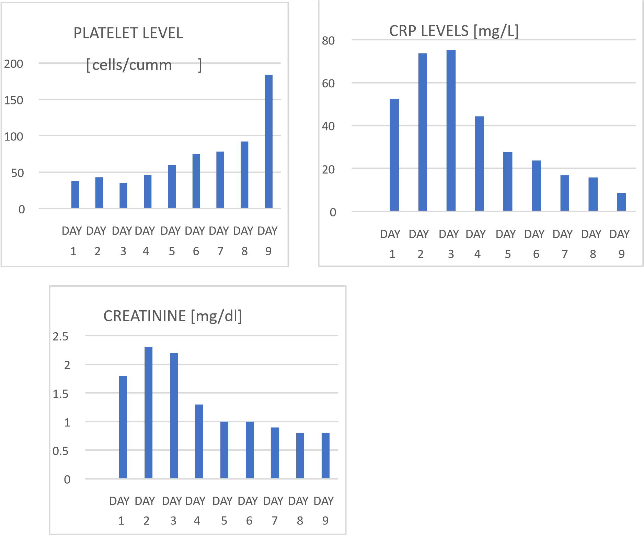
Fig 1- Trends in platelet count, C-reactive protein (CRP), and serum creatinine levels during the course of hospitalization

On the third day, the patient's respiratory status deteriorated, with decreased urine output. Therefore, bi-level positive airway pressure (BiPAP) non-invasive ventilation was administered. The platelet level was 46000 cells/cumm.
However, there was no improvement in respiratory status. Hence, the patient was intubated and placed on mechanical ventilation, and the creatinine level rose to 2.8 mg/dl. Meanwhile, the scrub typhus antibody result was positive, whereas dengue and malaria markers were negative. At this point, INJ. DOXYCYCLINE was added to the treatment regimen, and TAB AZITHROMYCIN 500 mg and TAB RIFAXIMIN 550 mg were started and continued for 5 days.
Over the course of treatment, the patient’s haemodynamic status improved, with normalisation of blood pressure and improvement in oxygenation and sensorium. Following clinical improvement, he was successfully extubated and subsequently maintained on face-mask oxygen. The patient's platelet level improved to 109000 10⁹/L, and the CRP level decreased to 44.2 mg/L. The patient continued to have intermittent episodes of pulmonary oedema and atrial fibrillation, which were managed conservatively with appropriate pharmacological treatment and supportive measures. With continued improvement in vital parameters and overall clinical status, the patient was transferred from the ICU to the ward. The patient continued to receive supportive care and IV antibiotics. Organ function progressively improved, and the CRP level decreased to 8.5 mg/L. The acute kidney injury completely resolved. Liver function showed a recovery trend, with bilirubin and liver enzyme levels decreasing. The clinical features of sepsis resolved, with stabilisation and normalisation of blood pressure. Hyperglycaemia was managed, and the patient was started on oral antidiabetic medication. At discharge, the patient had clinically improved, was haemodynamically stable, had an improving sensorium, and had recovered renal and hepatic function. The patient was discharged with oral antibiotics and cardiac medications.

Discussion
Scrub typhus is a confirmed aetiology of acute febrile illness (Ittyachen & Ramachandran, 2015; Acestor et al., 2012). Multiple organ failure is observed in around one-third of admitted patients with scrub typhus (Mahajan, 2005). Hepatitis, thrombocytopenia, myocarditis with significant left ventricular dysfunction, and renal failure were all present in our patient. Scrub typhus-related multi-organ dysfunction has a significant mortality rate. Scrub typhus can be difficult to diagnose, and the rate of incorrect diagnosis increases as more organs are affected. Limited recognition of the complexity of the clinical presentation of scrub typhus is one of the primary causes of misdiagnosis (Jamil et al., 2015; Sharma et al., 2015). An eschar is one of the most important clinical signs for the diagnosis of scrub typhus (Arun Babu et al., 2017). Eschar, fever, and MODS were the main clinical features used to diagnose this illness, and doxycycline treatment was successful. The severity and prognosis of scrub typhus are influenced by several risk factors. A growing body of research has shown a strong correlation between the infecting genotype and the prevalence of eschars and rash in scrub typhus (Blacksell et al., 2007). Scrub typhus can result in MODS and thrombocytopenia. Earlier research has shown that the mechanism of thrombocytopenia linked to MODS is thrombotic microangiopathic syndrome (Nguyen & Carcillo, 2006; Nguyen et al., 2015). A series of pathological changes, such as thrombotic thrombocytopenic purpura (TTP), secondary thrombotic microangiopathy (TMA), and DIC, may occur (Nguyen & Carcillo, 2006). However, to the best of our knowledge, only one case of scrub typhus with thrombocytopenia and MODS has been reported thus far (Ittyachen et al., 2017). Early antibiotic use is important to prevent life-threatening scrub typhus, and several effective antibiotics are available to clinicians. Effective antibiotics against scrub typhus include doxycycline, chloramphenicol, tetracycline, and azithromycin. Additionally, azithromycin may have a similar effect while being more acceptable than doxycycline (Wee et al., 2017). However, because of the low-certainty evidence and the possibility of developing resistance in undetected tuberculosis, randomised controlled studies have recommended against using rifampicin as a first-line treatment option (El Sayed et al., 2018). A substantial body of literature summarises the manifestations of secondary multiple-organ involvement in scrub typhus. It typically manifests as an acute febrile illness with high fever, headache, cough, and malaise. The presence of an eschar at the mite-bite site is the most distinctive clinical sign of scrub typhus. This case further emphasises the importance of intensive care when managing a tropical infection for which a favourable outcome can be achieved. Scrub typhus with thrombocytopenia and MODS progressed rapidly in this case. The diagnosis was made on the basis of laboratory findings and medical history. The patient recovered rapidly, and the anticipated therapeutic outcome was achieved following prompt therapy.

Conclusion
Scrub typhus is a serious infectious disease that can progress rapidly and lead to complications such as thrombocytopenia and multiple organ dysfunction syndrome (MODS). This case highlights how severe scrub typhus can affect several organs, including the kidneys, liver, lungs, brain, and heart, making early diagnosis and management challenging. During the illness, the patient developed significant thrombocytopenia, acute kidney injury, liver dysfunction, encephalopathy, respiratory complications, and cardiac involvement.
The positive scrub typhus test, together with the patient's clinical findings, helped confirm the diagnosis and allowed doxycycline-based treatment to be started promptly. Along with antimicrobial therapy, careful supportive management, including respiratory support, fluid and cardiovascular management, and regular monitoring of organ function, played an important role in the patient's recovery. Gradually, the patient's oxygenation, mental status, kidney and liver function, and haemodynamic condition improved, allowing discharge in a clinically stable condition. This case highlights the importance of early diagnosis, timely antimicrobial treatment, continuous monitoring, and appropriate supportive care in patients with severe scrub typhus. Maintaining a high index of suspicion in patients with unexplained fever, thrombocytopenia, and rapidly developing organ dysfunction may help facilitate early treatment and improve clinical outcomes.

Limitation
This report describes a single patient and therefore cannot establish the frequency, risk factors, or general outcomes of scrub typhus with thrombocytopenia and multiple organ dysfunction. The study presents the in-hospital clinical course and laboratory findings but does not provide long-term follow-up after discharge. These limitations should be considered when interpreting the clinical observations from this case.

Ethical Approval:
As per international standards or university standards written ethical approval has been collected and preserved by the author(s).
Consent:
As per international standards or university standards, patient(s) written consent has been collected and preserved by the author(s).

Declaration of AI Use

This manuscript was prepared through the intellectual contributions of the author(s) to the study design, data analysis, interpretation of results, and scholarly content. Grammarly and ChatGPT were used solely to assist with grammatical refinement and reference formatting during manuscript revision. The author(s) accept full responsibility for the accuracy, integrity, and final content of the manuscript.

COMPETING INTERESTS DISCLAIMER:
Authors have declared that they have no known competing financial interests OR non-financial interests OR personal relationships that could have appeared to influence the work reported in this paper.

References
Acestor, N., Cooksey, R., Newton, P. N., Ménard, D., Guerin, P. J., Nakagawa, J., Christophel, E., González, I. J., & Bell, D. (2012). Mapping the aetiology of non-malarial febrile illness in Southeast Asia through a systematic review—Terra incognita impairing treatment policies. PLOS ONE, 7(9), Article e44269. https://doi.org/10.1371/journal.pone.0044269
Arun Babu, T., Vijayadevagaran, V., & Ananthakrishnan, S. (2017). Characteristics of pediatric scrub typhus eschar in South Indian children. Pediatric Dermatology, 34(2), 124–127. https://doi.org/10.1111/pde.13048
Blacksell, S. D., Bryant, N. J., Paris, D. H., Doust, J. A., Sakoda, Y., & Day, N. P. J. (2007). Scrub typhus serologic testing with the indirect immunofluorescence method as a diagnostic gold standard: A lack of consensus leads to a lot of confusion. Clinical Infectious Diseases, 44(3), 391–401. https://doi.org/10.1086/510585
Carcillo, J. A., Podd, B., Aneja, R., Weiss, S. L., Hall, M. W., Cornell, T. T., Shanley, T. P., Doughty, L. A., & Nguyen, T. C. (2017). Pathophysiology of pediatric multiple organ dysfunction syndrome. Pediatric Critical Care Medicine, 18(3 Suppl. 1), S32–S45. https://doi.org/10.1097/PCC.0000000000001052
El Sayed, I., Liu, Q., Wee, I., & Hine, P. (2018). Antibiotics for treating scrub typhus. Cochrane Database of Systematic Reviews, 2018(9), Article CD002150. https://doi.org/10.1002/14651858.CD002150.pub2
Gitau, M. S., Asiago, O. H., Rogers, O. O., Reddy, K. S., PradeepKumar, B., Sudheer, A., Pasala, P. K., & Swarna, P. (2024). A comprehensive review on scrub typhus: Epidemiology, transmission, diagnosis and management. Uttar Pradesh Journal of Zoology, 45(8), 93–105. https://doi.org/10.56557/upjoz/2024/v45i84002
Gupta, N., Boodman, C., Jouego, C. G., & Van Den Broucke, S. (2023). Doxycycline vs azithromycin in patients with scrub typhus: A systematic review of literature and meta-analysis. BMC Infectious Diseases, 23, Article 884. https://doi.org/10.1186/s12879-023-08893-7
Ittyachen, A. M., Abraham, S. P., Krishnamoorthy, S., Vijayan, A., & Kokkat, J. (2017). Immune thrombocytopenia with multi-organ dysfunction syndrome as a rare presentation of scrub typhus: A case report. BMC Research Notes, 10, Article 496. https://doi.org/10.1186/s13104-017-2826-z
Ittyachen, A. M., & Ramachandran, R. (2015). Study of acute febrile illness: A 10-year descriptive study and a proposed algorithm from a tertiary care referral hospital in rural Kerala in southern India. Tropical Doctor, 45(2), 114–117. https://doi.org/10.1177/0049475514566264
Jamil, M. D., Hussain, M., Lyngdoh, M., Sharma, S., Barman, B., & Bhattacharya, P. K. (2015). Scrub typhus meningoencephalitis, a diagnostic challenge for clinicians: A hospital-based study from North-East India. Journal of Neurosciences in Rural Practice, 6(4), 488–493. https://doi.org/10.4103/0976-3147.169769
Lee, B.-J., Chen, C.-Y., Hu, S.-Y., Tsan, Y.-T., Lin, T.-C., & Wang, L.-M. (2011). Otalgia and eschar in the external auditory canal in scrub typhus complicated by acute respiratory distress syndrome and multiple organ failure. BMC Infectious Diseases, 11, Article 79. https://doi.org/10.1186/1471-2334-11-79
Lu, C.-T., Wang, L.-S., & Hsueh, P.-R. (2021). Scrub typhus and antibiotic-resistant Orientia tsutsugamushi. Expert Review of Anti-Infective Therapy, 19(12), 1519–1527. https://doi.org/10.1080/14787210.2021.1941869
Mahajan, S. K. (2005). Scrub typhus. Journal of the Association of Physicians of India, 53, 954–958. https://www.researchgate.net/publication/7263231_Scrub_Typhus
McCrumb, F. R., Jr., Stockard, J. L., Robinson, C. R., Turner, L. H., Levis, D. G., Maisey, C. W., Kelleher, M. F., Gleiser, C. A., & Smadel, J. E. (1957). Leptospirosis in Malaya. I. Sporadic cases among military and civilian personnel. The American Journal of Tropical Medicine and Hygiene, 6(2), 238–256. https://doi.org/10.4269/ajtmh.1957.6.238
Nguyen, T. C., & Carcillo, J. A. (2006). Bench-to-bedside review: Thrombocytopenia-associated multiple organ failure—A newly appreciated syndrome in the critically ill. Critical Care, 10(6), Article 235. https://doi.org/10.1186/cc5064
Nguyen, T. C., Cruz, M. A., & Carcillo, J. A. (2015). Thrombocytopenia-associated multiple organ failure and acute kidney injury. Critical Care Clinics, 31(4), 661–674. https://doi.org/10.1016/j.ccc.2015.06.004
Rajapakse, S., Rodrigo, C., & Fernando, D. (2012). Scrub typhus: Pathophysiology, clinical manifestations and prognosis. Asian Pacific Journal of Tropical Medicine, 5(4), 261–264. https://doi.org/10.1016/S1995-7645(12)60036-4
Rajapakse, S., Weeratunga, P., Sivayoganathan, S., & Fernando, S. D. (2017). Clinical manifestations of scrub typhus. Transactions of the Royal Society of Tropical Medicine and Hygiene, 111(2), 43–54. https://doi.org/10.1093/trstmh/trx017
Saugel, B., Phillip, V., Moessmer, G., Schmid, R. M., & Huber, W. (2010). Argatroban therapy for heparin-induced thrombocytopenia in ICU patients with multiple organ dysfunction syndrome: A retrospective study. Critical Care, 14(3), Article R90. https://doi.org/10.1186/cc9024
Sharma, S., Chatterjee, K., Samanta, I., Mahajan, S., & Kaul, S. M. (2025). Clinical and environmental investigation of a scrub typhus case in Delhi NCR: Implications for public health. International Journal of Tropical Disease & Health, 46(11), 29–39. https://doi.org/10.9734/ijtdh/2025/v46i111699
Sharma, S. R., Masaraf, H., Lynrah, K. G., & Lyngdoh, M. (2015). Tsutsugamushi disease (scrub typhus) meningoencephalitis in north eastern India: A prospective study. Annals of Medical and Health Sciences Research, 5(3), 163–167. https://doi.org/10.4103/2141-9248.157486
Sondhiya, G., Manjunathachar, H. V., Singh, P., & Kumar, R. (2024). Unveiling the burden of scrub typhus in acute febrile illness cases across India: A systematic review & meta-analysis. Indian Journal of Medical Research, 159(6), 601–618. https://doi.org/10.25259/ijmr_1442_23
Wee, I., Lo, A., & Rodrigo, C. (2017). Drug treatment of scrub typhus: A systematic review and meta-analysis of controlled clinical trials. Transactions of the Royal Society of Tropical Medicine and Hygiene, 111(8), 336–344. https://doi.org/10.1093/trstmh/trx066
Yadav, J., Chenchula, S., Nema, R. K., Choudhari, J. K., & Purwar, S. (2026). Sero-diagnosis of scrub typhus infection in India: A systematic review and meta-analysis. Tropical Medicine & International Health, 31(9), 1172–1182. https://doi.org/10.1111/tmi.70185

