Case Report

Cerebral Fat Embolism with Status Epilepticus Following Closed Femoral Shaft Fracture: A Case Report

ABSTRACT
Background: Fat embolism syndrome (FES) is a rare but potentially serious complication of long-bone fractures. Cerebral fat embolism (CFE) is an uncommon and severe neurological manifestation that may occur with or without prominent pulmonary involvement and can be difficult to diagnose because its clinical presentation may mimic other acute neurological conditions.
Case Presentation: A 23-year-old male presented with a closed, displaced left femoral shaft fracture following blunt trauma during a volleyball incident. Approximately 18 hours after the injury, he developed nausea, vomiting, generalised tonic posturing, frothing, and severe impairment of consciousness, with a Glasgow Coma Scale (GCS) score of 6/15. He was intubated and mechanically ventilated because of neurological deterioration and respiratory compromise. Computed tomography pulmonary angiography (CTPA) showed diffuse ground-glass opacities without evidence of macro-pulmonary thromboembolism. Brain MRI demonstrated multiple acute lesions involving the bilateral centrum semiovale and basal ganglia, consistent with cerebral microvascular embolic injury. The patient also developed a marked elevation in C-reactive protein and a transient reduction in platelet count. No petechial rash was observed, and echocardiography showed no intracardiac shunt.
Management and Outcome: The patient was managed in the neuro-intensive care unit with lung-protective mechanical ventilation, intravenous antiepileptic therapy with sodium valproate and levetiracetam, corticosteroid therapy with hydrocortisone, and supportive critical care. Definitive open reduction and internal fixation of the femoral fracture was subsequently performed. The patient showed progressive neurological and respiratory improvement, was successfully extubated on day 4, and achieved complete neurological recovery. He was discharged with oral antiepileptic therapy and a planned rehabilitation programme.
Conclusion: CFE should be considered in patients who develop unexplained neurological deterioration, seizures, or coma following long-bone fractures, even in the absence of petechial rash or intracardiac shunting. Early recognition, appropriate neuroimaging, seizure control, respiratory support, and multidisciplinary management may contribute to favourable neurological outcomes.

Keywords: Cerebral fat embolism; fat embolism syndrome; femoral shaft fracture; status epilepticus; long-bone fracture; cerebral microembolism; magnetic resonance imaging; neurocritical care; thrombocytopenia; hypoxaemia

1.INTRODUCTION
Fat embolism syndrome (FES) is a potentially life-threatening complication of long-bone and pelvic fractures, particularly following trauma involving the femur and tibia. Although fat droplets from bone marrow may enter the circulation following long-bone fractures, clinically apparent FES is relatively uncommon. The syndrome typically develops after a latent period of approximately 12–72 hours and is classically characterised by a triad of respiratory insufficiency, neurological manifestations, and petechial rash. However, the complete triad is not always present, particularly in patients with predominantly neurological involvement. [1–4] The pathogenesis of FES is complex and is explained by the interaction of mechanical and biochemical mechanisms. According to the mechanical theory, trauma and increased intramedullary pressure associated with long-bone fractures cause disruption of marrow sinusoids, allowing fat droplets to enter the venous circulation and subsequently reach the pulmonary microcirculation. The biochemical theory proposes that circulating lipases hydrolyse neutral triglycerides into free fatty acids, which can produce endothelial injury, increase capillary permeability, and initiate a systemic inflammatory response. These mechanisms may contribute to pulmonary dysfunction, thrombocytopenia, tissue hypoxia, and neurological injury. [5–7] Cerebral fat embolism (CFE) is a severe neurological manifestation of fat embolism in which cerebral microcirculation is affected. It may occur as part of FES or, less commonly, present predominantly with neurological manifestations. The clinical presentation is highly variable and can range from headache, confusion, agitation, and altered mental status to seizures, focal neurological deficits, severe encephalopathy, and coma. In severe cases, status epilepticus may be the initial neurological manifestation, creating diagnostic difficulty in the acute post-traumatic setting. [7–9] The mechanisms by which fat reaches the cerebral circulation include paradoxical embolisation through a patent foramen ovale or other right-to-left shunts, as well as passage of small fat particles through the pulmonary capillary circulation. Fat droplets that reach the systemic circulation may obstruct cerebral microvessels and produce ischaemic injury, cytotoxic oedema, and microhaemorrhages. Importantly, the absence of an intracardiac shunt does not exclude CFE because small embolic particles may traverse the pulmonary microcirculation. [9,17,18] Diagnosis of CFE remains challenging because its clinical manifestations are nonspecific and may mimic other causes of acute neurological deterioration following trauma, including traumatic brain injury, thromboembolic stroke, hypoxic brain injury, metabolic encephalopathy, and postictal states. Conventional non-contrast computed tomography (CT) of the brain may be normal during the early stages because of the microscopic nature of the embolic lesions. Magnetic resonance imaging (MRI), particularly diffusion-weighted imaging (DWI) and T2-weighted/FLAIR sequences, is considerably more sensitive for detecting cerebral microembolic lesions. The characteristic MRI appearance may demonstrate multiple scattered hyperintense lesions, commonly referred to as the “starfield pattern,” reflecting widespread cerebral microvascular involvement. [4,19–22] Clinical diagnostic criteria such as the Gurd and Wilson criteria and the Schonfeld score may assist in identifying FES, particularly when respiratory and systemic manifestations accompany neurological deterioration. However, these criteria were primarily developed for FES and may have limitations in patients presenting predominantly with cerebral manifestations or in the absence of petechial rash. Therefore, a high index of suspicion and correlation of clinical findings with laboratory investigations and neuroimaging is essential for early recognition of CFE. [3,10] Management of CFE is largely supportive and focuses on maintaining adequate oxygenation and ventilation, controlling seizures, preventing secondary neurological injury, and providing appropriate intensive care. Early stabilisation of the associated long-bone fracture is also an important component of management because it may reduce continued release of marrow fat into the circulation. Although various therapeutic approaches, including corticosteroids and antiepileptic therapy, have been described, there is no universally established specific pharmacological treatment for CFE, and management remains primarily directed toward supportive and complication-based care. [23–25] The present case describes a rare and clinically important presentation of cerebral fat embolism following a closed femoral shaft fracture in a young adult, characterised by acute neurological deterioration, status epilepticus, severe encephalopathy, and multifocal cerebral lesions on MRI. The case emphasises the importance of recognising CFE as a potential cause of acute neurological deterioration after long-bone trauma and highlights the role of prompt multimodal imaging and multidisciplinary neurocritical care in achieving favourable neurological outcomes.

Recent trauma literature continues to identify FES as a diagnostically challenging post-traumatic syndrome in which timely recognition is important because severe cases may involve substantial respiratory and neurological dysfunction [27]. In a recent report of FES following femoral shaft fracture, pulmonary CT angiography showed no pulmonary thromboembolism despite respiratory deterioration, illustrating the need to interpret negative macrovascular imaging within the broader clinical context [28]. Recent review evidence further indicates that CFE lacks universally accepted diagnostic criteria and that MRI remains a key supportive modality, while a disease-specific treatment has not been definitively established [29]. A recent multicentre study of adult femoral shaft fractures further documents the clinical importance of these injuries and the need for appropriate fracture management [26].
A practical diagnostic gap remains in recognising CFE when the classical triad is incomplete, particularly when severe neurological deterioration and seizures occur despite an initially unremarkable head CT, absent petechial rash, and no demonstrable intracardiac shunt.
Objective: The objective of this case report is to describe the clinical course, diagnostic evaluation, neuroimaging findings, critical-care management, and neurological outcome of CFE presenting with status epilepticus after a closed femoral shaft fracture, with particular attention to recognition in the absence of petechial rash and intracardiac shunting.
2. CASE PRESENTATION
2.1. Initial Clinical History and Presentation
A previously well 23-year-old male patient presented to the emergency department after sustaining blunt trauma to the left anterior thigh while playing volleyball. At a local primary healthcare centre, he was assessed as having a fully displaced fracture of the left femoral shaft. The patient was haemodynamically stable, oriented, and awake while awaiting orthopaedic operative assessment. Approximately 18 hours after the initial trauma (at 4 p.m.), the patient developed nausea and vomited food contents. After the seizure, he did not regain consciousness and remained unconscious; therefore, he was transferred by emergency transport to our neurotrauma and neurocritical care centre.

2.2. Emergency Physical and Neurological Examination
On arrival in the emergency resuscitation room, the patient was lethargic, agitated, irritable, and unable to follow commands. Vital signs showed tachypnoea (respiratory rate, 26 breaths/min) and sinus tachycardia (heart rate, 114 beats/min), with a blood pressure of 134/86 mm Hg and peripheral oxygen saturation of 88% on room air (improving to 94% with oxygen via a non-rebreather mask). The GCS score was 6/15 (E1, V1, M4; localising/withdrawing to noxious stimuli). The pupils were 2–3 mm, symmetrical, and normally reactive. The doll's eye test (oculocephalic reflex) was bilaterally positive. Muscle tone was pathologically abnormal in the right upper arm. None of the four limbs demonstrated purposeful movement during stimulation, although withdrawal from noxious stimuli was observed in all extremities. Deep tendon reflexes were 3+ bilaterally. The plantar reflex was extensor on the right and negative on the left. No classic subconjunctival or petechial rash was observed.

Table 1: Longitudinal Laboratory Investigation Profile
Parameter | Reference Range | Day 1 (19/12/25) | Day 2 (20/12/25) | Day 4 (22/12/25)
Hemoglobin (Hb%) | 13.0 - 17.0 g/dL | 14.8 | 13.5 | 13.2
Packed Cell Volume (PCV) | 40.0 - 50.0 % | 44.4 | 41.2 | 40.5
Total Leukocyte Count (WBC) | 4,000 - 10,000 /μL | 14,030 (Elevated) | 11,080 (Elevated) | 8,900
Platelet Count | 1.50 - 4.50 × 10⁵/μL | 2.00 × 10⁵ | 1.49 × 10⁵ (Decreased) | 1.85 × 10⁵
C-Reactive Protein (CRP) | < 6.0 mg/L | Not done | 195.7 (Markedly High) | 84.2
Serum Sodium (Na⁺) | 135 - 145 mmol/L | 132.2 | 133.0 | 138.0
Serum Potassium (K⁺) | 3.5 - 5.0 mmol/L | 3.74 | 4.50 | 3.90
Serum Chloride (Cl⁻) | 96 - 106 mmol/L | 101.5 | 105.0 | 109.0
Blood Urea | 15 - 40 mg/dL | 27.5 | 38.4 | 24.0
Serum Creatinine | 0.6 - 1.2 mg/dL | 1.26 (Borderline) | 0.90 | 0.85
Total Bilirubin | 0.2 - 1.2 mg/dL | 1.70 (Elevated) | 1.10 | 0.80
Direct Bilirubin | 0.0 - 0.3 mg/dL | 0.30 | 0.20 | 0.20
Aspartate Aminotransferase (AST) | 10 - 40 U/L | 31.0 | 28.0 | 22.0
Alanine Aminotransferase (ALT) | 10 - 45 U/L | 16.8 | 19.0 | 18.5
Prothrombin Time / Control (PT) | 11 - 14 sec | -- | 15.4 / 11.8 | --
INR / APTT | 0.9-1.1 / 25-35s | -- | 1.3 / 27.4 (Control 28.7) | --
Note: Serology for HIV, HBsAg, and HCV were non-reactive. Urine microscopy for fat globules was negative. 2D-Echocardiography showed normal biventricular dimensions and ejection fraction (62%) without intracardiac shunt or right ventricular strain.
2.3. Diagnostic Neuroimaging and Radiological Investigations
Emergency radiological examinations (Figures 1, 2 and 3) were performed in the context of a skeletal trauma-related post-seizure state and sudden-onset coma in an attempt to identify any primary intracranial traumatic lesion, acute thromboembolic stroke, fat embolism syndrome, and/or acute pulmonary thromboembolic phenomena, as follows:
1. Head CT scan without contrast (Figure 1): On axial planes, the cranial CT showed preservation of grey/white matter differentiation without intracranial haemorrhage, a mass lesion, midline shift, or large territorial arterial changes such as those seen in hyperacute cerebral microembolisation.
2. Brain MRI (Figures 2 and 3): Brain MRI at 24 hours revealed the presence of multiple acute lacunar lesions in the bilateral centrum semiovale and bilateral basal ganglia, which appeared hyperdense on T2-weighted and FLAIR images and were accompanied by reduced signal hyperintensity on the diffusion-weighted imaging sequence. The imaging findings were correlated with a diagnosis of cerebral fat microembolisation.

3. CTPA was performed to assess acute desaturation and exclude a macro-pulmonary embolism; it demonstrated only a few punctiform calcified lesions in the segmental branches of the left pulmonary artery.
4. Plain Radiography of the Left Femur (Figure 2): Anteroposterior (AP) and lateral radiographs of the left thigh demonstrated a complete, displaced mid-diaphyseal fracture of the left femur with cortical displacement and shortening, consistent with the clinical diagnosis of a closed left femoral shaft fracture.

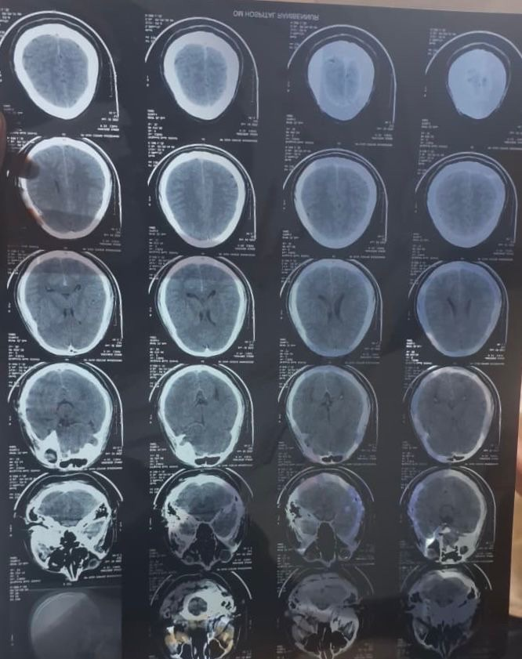
Figure 1: Serial axial non-contrast brain computed tomography(NCCT) sections obtained at presentation demonstrating unremarkable parenchymal density without midline shift or acute gross hemorrhage, highlighting the early insensitivity of CT in microvascular cerebral fat embolism.
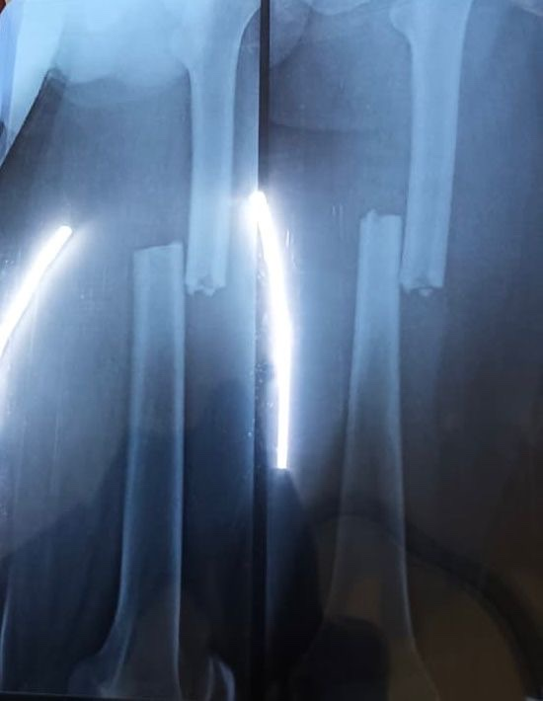
Figure 2: Anteroposterior (AP) and lateral plain radiographs of the left thigh demonstrating a complete, displaced mid-diaphyseal left femur fracture with cortical displacement and shortening.
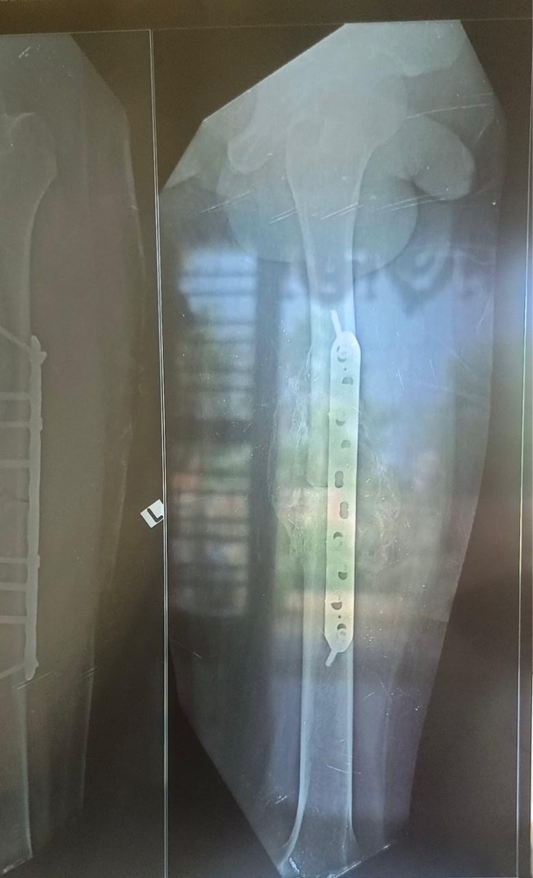
Figure 3: Post-operative radiograph of the left femur showing successful open reduction and rigid internal fixation(ORIF) utilizing a broad locking plate and screw construct with restored anatomical alignment and length.
2.4. Intensive Care Management and Hospital Course
In view of acute airway compromise, a low GCS (6/15), respiratory distress, and an ongoing post-seizure state, the patient was promptly intubated in the resuscitation bay and transferred to the Neuro-Intensive Care Unit (NICU) for invasive mechanical ventilation using lung-protective settings (tidal volume: 6 mL/kg predicted body weight, positive end-expiratory pressure [PEEP]: 8 cmH2O).
A multidisciplinary critical care regimen was instituted:
• Antiepileptic Therapy: An intravenous Sodium Valproate loading dose of 1.5 g (20 mg/kg) was administered over 30 minutes, followed by maintenance dosing of 500 mg IV twice daily, combined with Levetiracetam 500 mg IV three times daily and Lorazepam 2-4 mg IV as needed for seizure suppression.
• Anti-inflammatory / Corticosteroid Therapy: Intravenous Hydrocortisone 100 mg twice daily was administered to stabilise capillary endothelial membrane integrity, blunt the systemic inflammatory cascade, and mitigate cerebral oedema.
• Anticoagulation & Haemodynamic Stabilisation: Subcutaneous unfractionated heparin (5,000 IU three times daily) was administered for venous thromboembolism prophylaxis and microcirculatory optimisation. Heart rate control was achieved using oral Ivabradine 5 mg twice daily (titrated to maintain a resting heart rate between 70–85 bpm).
• Sedation and Analgesia: Continuous Midazolam and Morphine infusions (titrated at 2 mL/hr) were administered during early mechanical ventilation.
• Antimicrobial Prophylaxis & Escalation: Initial Ceftriaxone-Sulbactam (1.5 g IV twice daily) was escalated on Day 3 to Piperacillin-Tazobactam (1.5 g IV thrice daily) and Clindamycin (600 mg IV twice daily) for aspiration-related coverage.
• Neuroprotection & Adjuvant Therapy: Intravenous Piracetam (Neurocetam 200 mg slow IV twice daily) was administered for cortical neuroprotection; oral Baclofen 5 mg twice daily was used for muscular tone modulation; proton pump inhibitors (Pantoprazole 40 mg IV daily), antiemetics (Ondansetron 4 mg IV thrice daily), and respiratory bronchodilator/mucolytic nebulisation (Combihale FB and Mucomix twice daily) were also administered.
2.5. Clinical Resolution and Discharge Outcome
The patient's neurological and respiratory status had improved markedly by day 4 (the last day of admission). Neurological examination revealed that he was conscious and oriented, demonstrated purposeful activity in all four extremities, and obeyed commands of higher complexity (improved GCS to E4V5M6, 15/15). He was successfully weaned and extubated on day 4 of admission without neurological or respiratory relapse. Definitive orthopaedic plating of the fractured femur was performed under combined regional and general anaesthesia, producing excellent stability.
The patient was discharged in a neurologically stable condition on oral antiepileptic therapy (Levetiracetam 500 mg t.d.s, Sodium Valproate 500 mg B.D), a tapered course of oral corticosteroids, oral Baclofen, and bronchodilator medications, with a planned neurology outpatient review in 15 days and a well-documented orthopaedic physical rehabilitation programme.

3. DISCUSSION
Fat Embolism Syndrome (FES) remains one of the most enigmatic and dangerous acute systemic complications following skeletal trauma, particularly involving the femur, pelvis, and tibia [11]. Cerebral Fat Embolism (CFE) represents a specific, clinically devastating manifestation in which fat microemboli lodge preferentially in the cerebral microcirculation, presenting with acute encephalopathy, seizures, or focal ischaemic deficits [12]. The index case illustrates classic features of post-traumatic CFE following a closed femoral fracture, marked by a 21-hour latency, generalised seizures, severe encephalopathy, bilateral lacunar infarcts on MRI, and diffuse ground-glass infiltrates on CTPA, resolving completely with timely multidisciplinary intervention.
The pathophysiological mechanism of CFE involves two distinct yet synergistic phases [13]. In the initial mechanical phase, high intraosseous pressures generated by fracture displacement force marrow adipocytes and neutral fat droplets into torn venules and medullary sinusoids, leading to systemic venous embolisation [14]. In the subsequent biochemical phase, plasma lipases and pulmonary endothelial cells hydrolyse neutral fats into toxic free fatty acids (FFAs), provoking capillary endothelial injury, local vasoconstriction, and intense pro-inflammatory cytokine release (IL-1, IL-6, TNF-alpha) [15]. This explains the marked elevation of systemic inflammatory markers in our patient (CRP: 195.7 mg/L) and rapid consumption of circulating platelets (thrombocytopenia down to 1.49 × 10⁵/μL) due to platelet aggregation on fat globules [16].
A fundamental question in CFE is how embolised fat droplets reach the systemic arterial circulation. Two primary pathways exist: (1) Paradoxical embolism through a patent foramen ovale (PFO) or intrapulmonary arteriovenous shunts, and (2) Microvascular filtration bypass, wherein deformed fat droplets smaller than 7 to 10 μm pass directly through pulmonary capillary networks into the pulmonary veins and left atrium [17]. In our patient, 2D echocardiography demonstrated an intact interatrial septum and normal ventricular haemodynamics without intracardiac shunting, confirming that systemic cerebral microembolisation occurred via the transpulmonary capillary filtration pathway [18].
Table 2: Clinical Benchmarking of Diagnostic Criteria for Fat Embolism Syndrome in the Index Patient
Diagnostic System | Criteria Description | Clinical Finding in Index Patient | Criteria Met?
Gurd & Wilson (Major) | Central Nervous System Depression (Unresponsiveness/Seizure) | Coma (GCS 6/15), Tonic Posturing, Seizures | Yes (Major Criterion)
Gurd & Wilson (Major) | Respiratory Insufficiency / Hypoxemia (PaO2/SpO2 drop) | SpO2 88% on room air, Diffuse ground-glass on CTPA | Yes (Major Criterion)
Gurd & Wilson (Major) | Petechial Rash (Axillae, Neck, Conjunctivae) | Absent on admission | No
Gurd & Wilson (Minor) | Thrombocytopenia (< 150 × 10⁹/L) | Platelets dropped to 1.49 × 10⁵/μL (Day 2) | Yes (Minor Criterion)
Gurd & Wilson (Minor) | Elevated ESR / CRP or Systemic Inflammation | C-Reactive Protein 195.7 mg/L | Yes (Minor Criterion)
Gurd & Wilson (Minor) | Tachycardia (Heart Rate > 120 bpm / persistent) | Heart rate 114–125 bpm, managed with Ivabradine | Yes (Minor Criterion)
Gurd & Wilson (Minor) | Fat Macroglobulinemia / Retinal Fat | Urine fat negative; fundoscopy unremarkable | No
Schonfeld Score | Diffuse alveolar infiltrates (4 pts), Hypoxemia (3 pts) | CTPA diffuse ground glass + desaturation (7 pts) | Yes (Score > 5 indicates FES)
Schonfeld Score | CNS changes (1 pt), Tachycardia (1 pt), Fever (1 pt) | Severe encephalopathy + sinus tachycardia (2 pts) | Total Score: 9 (Diagnostic for FES)
Note: Gurd and Wilson's criteria require at least one major and four minor criteria, or two major criteria. The present case satisfied two major and three minor criteria, definitively confirming FES [3, 10].
Neuroimaging plays a pivotal role in confirming CFE. While non-contrast head CT is characteristically normal or reveals only non-specific, subtle hypoattenuation during the hyperacute stage [19], brain MRI represents the diagnostic gold standard. Diffusion-weighted imaging (DWI) and T2/FLAIR sequences classically reveal the pathognomonic 'starfield' pattern or discrete punctate lacunar infarctions scattered predominantly across the centrum semiovale, internal capsules, and deep basal ganglia [20]. These lesions reflect cytotoxic oedema and ischaemic necrosis arising from microvascular fat occlusion in border-zone and terminal perforating microvessels [21]. MR spectroscopy, when performed, can uniquely demonstrate lipid peaks at 0.9 and 1.3 ppm, confirming intra-parenchymal lipid accumulation [22].
The therapeutic armamentarium for CFE remains predominantly supportive, focused on neuroprotection, organ stabilisation, and fracture immobilization [23]. High-dose systemic corticosteroids (Hydrocortisone or Methylprednisolone) act by stabilising lysosomal membranes, decreasing free fatty acid-mediated capillary permeability, and reducing cerebral oedema [11,23]. Prophylactic and aggressive antiepileptic therapy with Sodium Valproate and Levetiracetam is crucial in preventing secondary metabolic insults and controlling seizure activity. Furthermore, timely orthopaedic fixation is vital: early plate osteosynthesis or damage control external fixation prevents ongoing bone marrow microembolisation compared to delayed or unstabilised fracture management [24,25].
4. CONCLUSION AND LIMITATIONS
Cerebral fat embolism (CFE) is an uncommon but potentially life-threatening neurological complication of long-bone fractures that can present with acute encephalopathy, seizures, or coma. In this case, a 23-year-old male with a closed, displaced left femoral shaft fracture developed sudden neurological deterioration with generalised tonic posturing, frothing, and severe impairment of consciousness approximately 18 hours after trauma. The presence of hypoxaemia, marked elevation of C-reactive protein, transient thrombocytopenia, and diffuse pulmonary ground-glass changes, together with multifocal acute lesions involving the bilateral centrum semiovale and basal ganglia on brain MRI, supported the diagnosis of fat embolism syndrome with prominent cerebral involvement. Importantly, the absence of petechial rash, negative urinary fat globules, and absence of an intracardiac shunt demonstrate that these findings do not necessarily exclude CFE.
The case emphasises the importance of considering CFE in patients with unexplained neurological deterioration following long-bone trauma, particularly when the initial CT brain is unremarkable. MRI with diffusion-weighted and FLAIR sequences is valuable for identifying cerebral microvascular lesions when clinical suspicion remains high. Early neurocritical care, including airway and respiratory support, seizure control with antiepileptic therapy, close monitoring of neurological and systemic parameters, and timely definitive stabilisation of the femoral fracture, contributed to a favourable outcome in this patient. The patient demonstrated marked neurological and respiratory improvement, was successfully extubated on day 4, and achieved complete neurological recovery. Therefore, early recognition and a multidisciplinary management approach are essential to minimise neurological morbidity and improve outcomes in patients with cerebral fat embolism following long-bone fractures.
Limitations: This case report has several limitations. First, as this report describes a single patient, the clinical findings and favourable outcome cannot be generalised to all patients with cerebral fat embolism. Second, although the diagnosis was supported by the clinical presentation, laboratory abnormalities, and characteristic MRI findings, some investigations that may provide additional diagnostic information, such as magnetic resonance spectroscopy and continuous electroencephalographic monitoring, were not performed. Third, the patient had a rapid clinical recovery, limiting the availability of longer-term neurological follow-up data. Therefore, further case series and larger clinical studies are needed to better characterise the clinical spectrum, diagnostic approach, and optimal management strategies for cerebral fat embolism.
Ethics Approval: As per international standards or university standards written ethical approval has been collected and preserved by the author(s).
Consent: Written informed consent was obtained from the patient for publication of this case report and any accompanying images.
Competing Interests: The authors declare that they have no competing financial or non-financial interests.
Declaration of AI Use

This manuscript was prepared through the intellectual contributions of the author(s) to the study design, data analysis, interpretation of results, and scholarly content. Grammarly and ChatGPT were used solely to assist with grammatical refinement and reference formatting during manuscript revision. The author(s) accept full responsibility for the accuracy, integrity, and final content of the manuscript.

REFERENCES
1. Rothberg, D. L., & Makarewich, C. A. (2019). Fat embolism and fat embolism syndrome. Journal of the American Academy of Orthopaedic Surgeons, 27(8), e346–e355. https://doi.org/10.5435/JAAOS-D-17-00571
2. Stein, P. D., Yaekoub, A. Y., Matta, F., & Kleerekoper, M. (2008). Fat embolism syndrome. The American Journal of the Medical Sciences, 336(6), 472–477. https://doi.org/10.1097/MAJ.0b013e318172f5d2
3. Gurd, A. R., & Wilson, R. I. (1974). The fat embolism syndrome. The Journal of Bone and Joint Surgery. British Volume, 56-B(3), 408–416. https://doi.org/10.1302/0301-620X.56B3.408
4. Scarpino, M., Lanzo, G., Lolli, F., & Grippo, A. (2019). From the diagnosis to the therapeutic management: Cerebral fat embolism, a clinical challenge. International Journal of General Medicine, 12, 39–48. https://doi.org/10.2147/IJGM.S177407
5. Gauss, H. (1924). The pathology of fat embolism. Archives of Surgery, 9(3), 593–605. https://doi.org/10.1001/archsurg.1924.01120090110007
6. Lehman, E. P., & Moore, R. M. (1927). Fat embolism: Including experimental production without trauma. Archives of Surgery, 14(3), 621–662. https://doi.org/10.1001/archsurg.1927.01130150002001
7. DeFroda, S. F., & Klinge, S. A. (2016). Fat embolism syndrome with cerebral fat embolism associated with long-bone fracture. The American Journal of Orthopedics, 45(7), E515–E521. https://pubmed.ncbi.nlm.nih.gov/28005103/
8. Panigrahi, P., Nair, R. S., Punetha, H., & Sharma, H. (2025). Cerebral fat embolism syndrome: A case series of five patients with delayed neurological manifestations. European Journal of Cardiovascular Medicine, 15(3), 691–695. https://doi.org/10.5083/ejcm/25-03-118
9. Jorgensen, A., Bashir, A., & Satpathy, J. (2018). Cerebral fat embolism syndrome (FES): Similar cases with different outcomes. BMJ Case Reports, 2018, bcr2018225261. https://doi.org/10.1136/bcr-2018-225261
10. Schonfeld, S. A., Ploysongsang, Y., DiLisio, R., Crissman, J. D., Miller, E., Hammerschmidt, D. E., & Jacob, H. S. (1983). Fat embolism prophylaxis with corticosteroids: A prospective study in high-risk patients. Annals of Internal Medicine, 99(4), 438–443. https://doi.org/10.7326/0003-4819-99-4-438
11. Akhtar, S. (2009). Fat embolism. Anesthesiology Clinics, 27(3), 533–550. https://doi.org/10.1016/j.anclin.2009.07.018
12. Godoy, D. A., Di Napoli, M., & Rabinstein, A. A. (2018). Cerebral fat embolism: Recognition, complications, and prognosis. Neurocritical Care, 29(3), 358–365. https://doi.org/10.1007/s12028-017-0463-y
13. Mellor, A., & Soni, N. (2001). Fat embolism. Anaesthesia, 56(2), 145–154. https://doi.org/10.1046/j.1365-2044.2001.01724.x
14. Eriksson, E. A., Pellegrini, D. C., Vanderkolk, W. E., Minshall, C. T., Fakhry, S. M., & Cohle, S. D. (2011). Incidence of pulmonary fat embolism at autopsy: An undiagnosed epidemic. The Journal of Trauma, 71(2), 312–315. https://doi.org/10.1097/TA.0b013e3182208280
15. Newbigin, K., Souza, C. A., Torres, C., Marchiori, E., Gupta, A., Inacio, J., Armstrong, M., & Peña, E. (2016). Fat embolism syndrome: State-of-the-art review focused on pulmonary imaging findings. Respiratory Medicine, 113, 93–100. https://doi.org/10.1016/j.rmed.2016.01.018
16. Robinson, C. M. (2001). Current concepts of respiratory insufficiency syndromes after fracture. The Journal of Bone and Joint Surgery. British Volume, 83-B(6), 781–791. https://doi.org/10.1302/0301-620X.83B6.12440
17. Byrick, R. J., Mullen, J. B., Mazer, C. D., & Guest, C. B. (1994). Transpulmonary systemic fat embolism: Studies in mongrel dogs after cemented arthroplasty. American Journal of Respiratory and Critical Care Medicine, 150(5), 1416–1422. https://doi.org/10.1164/ajrccm.150.5.7952570
18. Pell, A. C. H., Hughes, D., Keating, J., Christie, J., Busuttil, A., & Sutherland, G. R. (1993). Fulminating fat embolism syndrome caused by paradoxical embolism through a patent foramen ovale. The New England Journal of Medicine, 329(13), 926–929. https://doi.org/10.1056/NEJM199309233291305
19. Parizel, P. M., Demey, H. E., Veeckmans, G., Verstreken, F., Cras, P., Jorens, P. G., & De Schepper, A. M. (2001). Early diagnosis of cerebral fat embolism syndrome by diffusion-weighted MRI (starfield pattern). Stroke, 32(12), 2942–2944. https://doi.org/10.1161/STR.32.12.2942
20. Takahashi, M., Suzuki, R., Osakabe, Y., Asai, J. I., Miyo, T., Nagashima, G., Fujimoto, T., & Takahashi, Y. (1999). Magnetic resonance imaging findings in cerebral fat embolism: Correlation with clinical manifestations. The Journal of Trauma, 46(2), 324–327. https://doi.org/10.1097/00005373-199902000-00021
21. Kokatnur, L., Rudrappa, M., & Khasawneh, K. R. (2015). Cerebral fat embolism: Use of MR spectroscopy for accurate diagnosis. Annals of Indian Academy of Neurology, 18(2), 252–255. https://doi.org/10.4103/0972-2327.150604
22. Guillevin, R., Vallée, J. N., Demeret, S., Sonneville, R., Bolgert, F., Mont'alverne, F., Pierrot-Deseilligny, C., & Chiras, J. (2005). Cerebral fat embolism: Usefulness of magnetic resonance spectroscopy. Annals of Neurology, 57(3), 434–439. https://doi.org/10.1002/ana.20388
23. Bederman, S. S., Bhandari, M., McKee, M. D., & Schemitsch, E. H. (2009). Do corticosteroids reduce the risk of fat embolism syndrome in patients with long-bone fractures? A meta-analysis. Canadian Journal of Surgery, 52(5), 386–393. https://pubmed.ncbi.nlm.nih.gov/19865573/
24. White, T., Petrisor, B. A., & Bhandari, M. (2006). Prevention of fat embolism syndrome. Injury, 37(Suppl. 4), S59–S67. https://doi.org/10.1016/j.injury.2006.08.041
25. Pape, H.-C., Giannoudis, P. V., & Krettek, C. (2002). The timing of fracture treatment in polytrauma patients: Relevance of damage control orthopedic surgery. The American Journal of Surgery, 183(6), 622–629. https://doi.org/10.1016/S0002-9610(02)00865-6
26. Atemkeng Tsatedem Faustin, Douryang Maurice, Saha Tchida Laetitia Laura, Dongmo Arlette, Banga Nkomo David Douglas, Amougou Boris, Djam Chefor Alain, Ngono Ateba Gladys, Njifou Njimah Amadou, Guifo Marc Leroy, Mouafo Tambo Faustin, Chichom Mefire Alain, & Bahebeck Jean. (2025). Femoral Shaft Fracture Epidemiology in Adults and Outcomes at Four Hospitals in the Western Cameroon. Asian Journal of Research in Surgery, 8(2), 591–603. https://doi.org/10.9734/ajrs/2025/v8i2335
27. Kwon, J., & Coimbra, R. (2024). Fat embolism syndrome after trauma: What you need to know. Journal of Trauma and Acute Care Surgery, 97(4), 505–513. https://doi.org/10.1097/TA.0000000000004434
28. Gholipour, M., Salimi, M., Motamedi, A., & Abbasi, F. (2025). Fat embolism syndrome following femoral shaft fracture: A case report and diagnostic considerations. Radiology Case Reports, 20(2), 943–948. https://doi.org/10.1016/j.radcr.2024.10.126
29. Alrasheed, A. S., Elazrag, A. M., Alqahtani, M. S., & Alabbas, F. (2026). Pathophysiology, clinical manifestations, and prognostic insights of cerebral fat embolism: A literature review. Frontiers in Neurology, 16, 1732428. https://doi.org/10.3389/fneur.2025.1732428

