Case Report

Cerebral Fat Embolism With Status Epilepticus Following Closed Femoral Shaft Fracture: A Case Report

ABSTRACT
Background: Fat embolism syndrome (FES) is a rare but potentially serious complication of long-bone fractures. Cerebral fat embolism (CFE) is an uncommon and severe neurological manifestation that may occur with or without prominent pulmonary involvement and can be difficult to diagnose because its clinical presentation may mimic other acute neurological conditions.
Case Presentation: A 23-year-old male presented with a closed, displaced left femoral shaft fracture following blunt trauma during a volleyball incident. Approximately 18 hours after the injury, he developed nausea, vomiting, generalized tonic posturing, frothing, and severe impairment of consciousness, with a Glasgow Coma Scale (GCS) score of 6/15. He was intubated and mechanically ventilated because of neurological deterioration and respiratory compromise. Computed tomography pulmonary angiography (CTPA) showed diffuse ground-glass opacities without evidence of macro-pulmonary thromboembolism. Brain MRI demonstrated multiple acute lesions involving the bilateral centrum semi vale and basal ganglia, consistent with cerebral microvascular embolic injury. The patient also developed marked elevation of C-reactive protein and a transient reduction in platelet count. No petechial rash was observed, and echocardiography showed no intracardiac shunt.
Management and Outcome: The patient was managed in the neuro-intensive care unit with lung-protective mechanical ventilation, intravenous antiepileptic therapy with sodium valproate and levetiracetam, corticosteroid therapy with hydrocortisone, and supportive critical care. Definitive open reduction and internal fixation of the femoral fracture was subsequently performed. The patient showed progressive neurological and respiratory improvement, was successfully extubated on day 4, and achieved complete neurological recovery. He was discharged with oral antiepileptic therapy and a planned rehabilitation program.
Conclusion: CFE should be considered in patients who develop unexplained neurological deterioration, seizures, or coma following long-bone fractures, even in the absence of petechial rash or intracardiac shunting. Early recognition, appropriate neuroimaging, seizure control, respiratory support, and multidisciplinary management may contribute to favourable neurological outcomes.

Keywords: Cerebral Fat Embolism, Fat Embolism Syndrome, Femur Fracture, Status Epilepticus, Lacunar Infarction, Neurocritical Care.

1.INTRODUCTION
Fat embolism syndrome (FES) is a potentially life-threatening complication of long-bone and pelvic fractures, particularly following trauma involving the femur and tibia. Although fat droplets from bone marrow may enter the circulation following long-bone fractures, clinically apparent FES is relatively uncommon. The syndrome typically develops after a latent period of approximately 12–72 hours and is classically characterized by a triad of respiratory insufficiency, neurological manifestations, and petechial rash. However, the complete triad is not always present, particularly in patients with predominantly neurological involvement. [1–4] The pathogenesis of FES is complex and is explained by the interaction of mechanical and biochemical mechanisms. According to the mechanical theory, trauma and increased intramedullary pressure associated with long-bone fractures cause disruption of marrow sinusoids, allowing fat droplets to enter the venous circulation and subsequently reach the pulmonary microcirculation. The biochemical theory proposes that circulating lipases hydrolyse neutral triglycerides into free fatty acids, which can produce endothelial injury, increase capillary permeability, and initiate a systemic inflammatory response. These mechanisms may contribute to pulmonary dysfunction, thrombocytopenia, tissue hypoxia, and neurological injury. [5–7] Cerebral fat embolism (CFE) is a severe neurological manifestation of fat embolism in which cerebral microcirculation is affected. It may occur as part of FES or, less commonly, present predominantly with neurological manifestations. The clinical presentation is highly variable and can range from headache, confusion, agitation, and altered mental status to seizures, focal neurological deficits, severe encephalopathy, and coma. In severe cases, status epilepticus may be the initial neurological manifestation, creating diagnostic difficulty in the acute post-traumatic setting. [7–9] The mechanisms by which fat reaches the cerebral circulation include paradoxical embolization through a patent foramen ovule or other right-to-left shunts, as well as passage of small fat particles through the pulmonary capillary circulation. Fat droplets that reach the systemic circulation may obstruct cerebral micro vessels and produce ischemic injury, cytotoxic edema, and microhaemorrhages. Importantly, the absence of an intracardiac shunt does not exclude CFE because small embolic particles may traverse the pulmonary microcirculation. [9,17,18] Diagnosis of CFE remains challenging because its clinical manifestations are nonspecific and may mimic other causes of acute neurological deterioration following trauma, including traumatic brain injury, thromboembolic stroke, hypoxic brain injury, metabolic encephalopathy, and postictal states. Conventional non-contrast computed tomography (CT) of the brain may be normal during the early stages because of the microscopic nature of the embolic lesions. Magnetic resonance imaging (MRI), particularly diffusion-weighted imaging (DWI) and T2-weighted/FLAIR sequences, is considerably more sensitive for detecting cerebral micro embolic lesions. The characteristic MRI appearance may demonstrate multiple scattered hyperintense lesions, commonly referred to as the “starfield pattern,” reflecting widespread cerebral microvascular involvement. [4,19–22] Clinical diagnostic criteria such as the Gurd and Wilson criteria and the Schonfeld score may assist in identifying FES, particularly when respiratory and systemic manifestations accompany neurological deterioration. However, these criteria were primarily developed for FES and may have limitations in patients presenting predominantly with cerebral manifestations or in the absence of petechial rash. Therefore, a high index of suspicion and correlation of clinical findings with laboratory investigations and neuroimaging are essential for early recognition of CFE. [3,10] Management of CFE is largely supportive and focuses on maintaining adequate oxygenation and ventilation, controlling seizures, preventing secondary neurological injury, and providing appropriate intensive care. Early stabilization of the associated long-bone fracture is also an important component of management because it may reduce continued release of marrow fat into the circulation. Although various therapeutic approaches, including corticosteroids and antiepileptic therapy, have been described, there is no universally established specific pharmacological treatment for CFE, and management remains primarily directed toward supportive and complication-based care. [23–25] The present case describes a rare and clinically important presentation of cerebral fat embolism following a closed femoral shaft fracture in a young adult, characterized by acute neurological deterioration, status epilepticus, severe encephalopathy, and multifocal cerebral lesions on MRI. The case emphasizes the importance of recognizing CFE as a potential cause of acute neurological deterioration after long-bone trauma and highlights the role of prompt multimodal imaging and multidisciplinary neurocritical care in achieving favourable neurological outcomes.

2. CASE PRESENTATION
2.1. Initial Clinical History and Presentation
A 23 year-old, male patient, who was previously well presented to the emergency department after a history of blunt trauma to the left anterior thigh after playing volleyball. In local primary healthcare centre, it was assessed to be fully displaced fracture of left femoral shaft, patient was hemodynamically stable, oriented, awake awaiting for orthopaedic operative assessment. Around 18 hours after the initial trauma (at 4pm), the patient started feeling nauseous and vomited food content. After the seizure, he did not get up and remain unconscious, for which the patient was brought by emergency transfer to our neuro trauma and neurocritical care centre.

2.2. Emergency Physical and Neurological Examination
On arrival in the emergency resuscitation room, the patient was lethargic, agitated, irritable, and unable to follow any commands. Vital signs showed tachypnoea (rr26 breaths/min), sinus tachycardia (hr 114beats/min) with a blood pressure of 134/86mm Hg, and a peripheral oxygen saturation of 88% on room air (improved to 94% with oxygen via nonrebreather mask). GCS score was 6/15(E1, V1, m4-localizing/withdrawing to noxious stimuli). Pupils were 2-3mm and was symmetrical with normal reactivity. Doll's eye test(oculocephalic reflex) was positive bilateral. Muscle tone was pathologically tone of right upper arm. Four limbs did not carry out purpose movements during stimulation, and withdrawn to noxious stimuli from all extremities was shown. Deep tendon reflexes were 3+bilaterally. Plantar reflex was positive extensor on right, negative on left. No classic subconjunctival or petechial rashes was observed.

Table 1: Longitudinal Laboratory Investigation Profile
Parameter | Reference Range | Day 1 (19/12/25) | Day 2 (20/12/25) | Day 4 (22/12/25)
Hemoglobin (Hb%) | 13.0 - 17.0 g/dL | 14.8 | 13.5 | 13.2
Packed Cell Volume (PCV) | 40.0 - 50.0 % | 44.4 | 41.2 | 40.5
Total Leukocyte Count (WBC) | 4,000 - 10,000 /μL | 14,030 (Elevated) | 11,080 (Elevated) | 8,900
Platelet Count | 1.50 - 4.50 × 10⁵/μL | 2.00 × 10⁵ | 1.49 × 10⁵ (Decreased) | 1.85 × 10⁵
C-Reactive Protein (CRP) | < 6.0 mg/L | Not done | 195.7 (Markedly High) | 84.2
Serum Sodium (Na⁺) | 135 - 145 mmol/L | 132.2 | 133.0 | 138.0
Serum Potassium (K⁺) | 3.5 - 5.0 mmol/L | 3.74 | 4.50 | 3.90
Serum Chloride (Cl⁻) | 96 - 106 mmol/L | 101.5 | 105.0 | 109.0
Blood Urea | 15 - 40 mg/dL | 27.5 | 38.4 | 24.0
Serum Creatinine | 0.6 - 1.2 mg/dL | 1.26 (Borderline) | 0.90 | 0.85
Total Bilirubin | 0.2 - 1.2 mg/dL | 1.70 (Elevated) | 1.10 | 0.80
Direct Bilirubin | 0.0 - 0.3 mg/dL | 0.30 | 0.20 | 0.20
Aspartate Aminotransferase (AST) | 10 - 40 U/L | 31.0 | 28.0 | 22.0
Alanine Aminotransferase (ALT) | 10 - 45 U/L | 16.8 | 19.0 | 18.5
Prothrombin Time / Control (PT) | 11 - 14 sec | -- | 15.4 / 11.8 | --
INR / APTT | 0.9-1.1 / 25-35s | -- | 1.3 / 27.4 (Control 28.7) | --
Note: Serology for HIV, HBsAg, and HCV were non-reactive. Urine microscopy for fat globules was negative. 2D-Echocardiography showed normal biventricular dimensions and ejection fraction (62%) without intracardiac shunt or right ventricular strain.
2.3. Diagnostic Neuroimaging and Radiological Investigations
Emergency radiological examinations (Figures 1, 2 and 3) of skeletal trauma-related post-seizure state and sudden onset in coma were carried out in attempt to identify any primary intracranial traumatic lesion, acute thrombo-embolic stroke, fat embolism syndrome and/or acute pulmonary thrombo-embolic phenomena such as:-
1. Head CT scan without contrast (Figure 1) On axial planes the cranial CT shows conservation of the gray/white matter differentiation without intracranial hemorrhage, mass lesion, midline shift, nor large territorially located arteries like in hyperacute cerebral microembolisation.
2. Brain MRI (Figure 2 and 3) 24 hours Brain MRI revealed presence of many lacunar acute lesions in bilateral centrum semiovale and bilateral basal ganglia which appeared hyperdense on the T2-weighted and FLAIR images, accompanied with reduced signal hyperintensity in the diffusion weighted imaging sequence, the picture is to be correlated with diagnosis of cerebral fat micro embolization

3. CTPA to assess acute desaturation and exclude a macro-pulmonary embolism was also computed by demonstrating nothing more than a few punctiform calcified lesions in the segmental branches of left pulmonary artery.
4. Plain Radiography of the Left Femur (Figure 2) Anteroposterior (AP) and lateral radiographs of the left thigh demonstrated a complete, displaced mid-diaphyseal fracture of the left femur with cortical displacement and shortening, consistent with the clinical diagnosis of a closed left femoral shaft fracture..

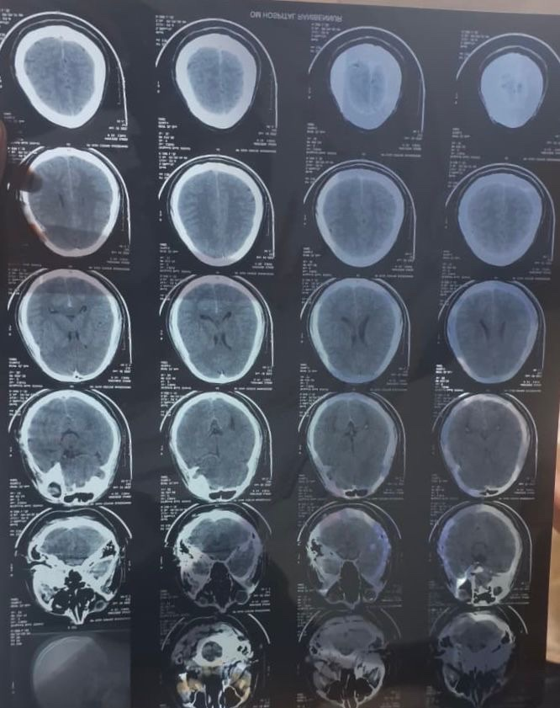
Figure 1: Serial axial non-contrast brain computed tomography(NCCT) sections obtained at presentation demonstrating unremarkable parenchymal density without midline shift or acute gross hemorrhage, highlighting the early insensitivity of CT in microvascular cerebral fat embolism.
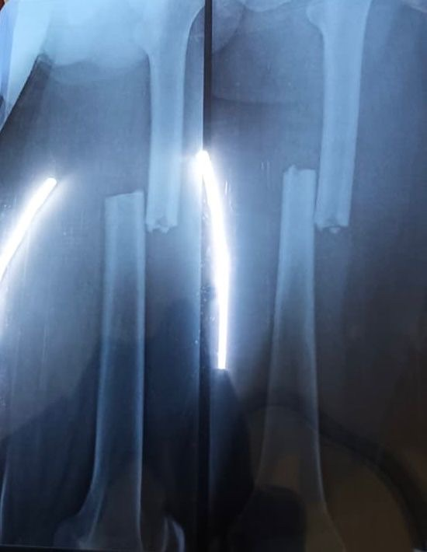
Figure 2: Anteroposterior (AP) and lateral plain radiographs of the left thigh demonstrating a complete, displaced mid-diaphyseal left femur fracture with cortical displacement and shortening.
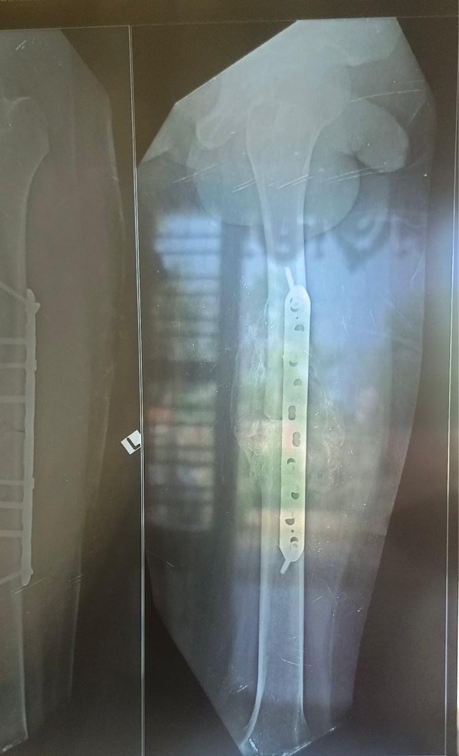
Figure 3: Post-operative radiograph of the left femur showing successful open reduction and rigid internal fixation(ORIF) utilizing a broad locking plate and screw construct with restored anatomical alignment and length.
2.4. Intensive Care Management and Hospital Course
In view of acute airway compromise, low GCS (6/15), respiratory distress, and ongoing status post-seizure, the patient was promptly intubated in the resuscitation bay and transferred to the Neuro-Intensive Care Unit (NICU) for invasive mechanical ventilation under lung-protective settings (tidal volume: 6 mL/kg predicted body weight, positive end-expiratory pressure [PEEP]: 8 cmH2O).
A multidisciplinary critical care regimen was instituted:
• Antiepileptic Therapy: Intravenous Sodium Valproate loading dose of 1.5 g (20 mg/kg) over 30 minutes, followed by maintenance dosing of 500 mg IV twice daily, combined with Levetiracetam 500 mg IV three times daily and Lorazepam 2-4 mg IV as needed for seizure suppression.
• Anti-inflammatory / Corticosteroid Therapy: Intravenous Hydrocortisone 100 mg twice daily to stabilize capillary endothelial membrane integrity, blunt the systemic inflammatory cascade, and mitigate cerebral edema.
• Anticoagulation & Hemodynamic Stabilization: Subcutaneous unfractionated heparin (5,000 IU three times daily) for venous thromboembolism prophylaxis and microcirculatory optimization. Heart rate control was achieved using oral Ivabradine 5 mg twice daily (titrated to maintain resting heart rate between 70–85 bpm).
• Sedation and Analgesia: Continuous Midazolam and Morphine infusions (titrated at 2 mL/hr) during early mechanical ventilation.
• Antimicrobial Prophylaxis & Escalation: Initial Ceftriaxone-Sulbactam (1.5 g IV twice daily), escalated on Day 3 to Piperacillin-Tazobactam (1.5 g IV thrice daily) and Clindamycin (600 mg IV twice daily) for aspiration-related coverage.
• Neuroprotection & Adjuvant Therapy: Intravenous Piracetam (Neurocetam 200 mg slow IV twice daily) for cortical neuroprotection, oral Baclofen 5 mg twice daily for muscular tone modulation, proton pump inhibitors (Pantoprazole 40 mg IV daily), antiemetics (Ondansetron 4 mg IV thrice daily), and respiratory bronchodilator/mucolytic nebulization (Combihale FB and Mucomix twice daily).
2.5. Clinical Resolution and Discharge Outcome
Neurologically and respiratory the patient had improved markedly by day 4 (last day of admission); Neurological examination has revealed conscious in terms of orientation, purposeful activity in four extremities and obedience of commands of higher complexity (improved GCS to E4V5M6, 15/15. He has been successfully weaned and extubated on day 4 of admission without neurological and respiratory relapse; Definitive orthopaedic plating for fractured femur has been performed under combined regional and general anaesthesia producing excellent stability.
Patient has been discharged in a neurologically stable manner on orally administered antiepileptics (Levetiracetam 500mg t.d.s, Sodium Valproate 500mg B.D), tapered course of oral corticosteroids, orally administered Baclofen, and bronchodilator medications, with planned review by neurology out patient in 15 days, and well documented orthopaedic physical rehabilitation program.

3. DISCUSSION
Fat Embolism Syndrome (FES) remains one of the most enigmatic and dangerous acute systemic complications following skeletal trauma, particularly involving the femur, pelvis, and tibia [11]. Cerebral Fat Embolism (CFE) represents a specific, clinically devastating manifestation where fat microemboli lodge preferentially in the cerebral microcirculation, presenting with acute encephalopathy, seizures, or focal ischemic deficits [12]. The index case illustrates classic features of post-traumatic CFE following a closed femoral fracture, marked by a 21-hour latency, generalized seizures, severe encephalopathy, bilateral lacunar infarcts on MRI, and diffuse ground-glass infiltrates on CTPA, resolving completely with timely multidisciplinary intervention.
The pathophysiological mechanism of CFE involves two distinct yet synergistic phases [13]. In the initial mechanical phase, high intraosseous pressures generated by fracture displacement force marrow adipocytes and neutral fat droplets into torn venules and medullary sinusoids, leading to systemic venous embolization [14]. In the subsequent biochemical phase, plasma lipases and pulmonary endothelial cells hydrolyze neutral fats into toxic free fatty acids (FFAs), provoking capillary endothelial injury, local vasoconstriction, and intense pro-inflammatory cytokine release (IL-1, IL-6, TNF-alpha) [15]. This explains the marked elevation of systemic inflammatory markers in our patient (CRP: 195.7 mg/L) and rapid consumption of circulating platelets (thrombocytopenia down to 1.49 × 10⁵/μL) due to platelet aggregation on fat globules [16].
A fundamental question in CFE is how embolized fat droplets reach the systemic arterial circulation. Two primary pathways exist: (1) Paradoxical embolism through a patent foramen ovale (PFO) or intrapulmonary arteriovenous shunts, and (2) Microvascular filtration bypass, wherein deformed fat droplets smaller than 7 to 10 μm pass directly through pulmonary capillary networks into the pulmonary veins and left atrium [17]. In our patient, 2D echocardiography demonstrated an intact interatrial septum and normal ventricular hemodynamics without intracardiac shunting, confirming that systemic cerebral microembolization occurred via the transpulmonary capillary filtration pathway [18].
Table 2: Clinical Benchmarking of Diagnostic Criteria for Fat Embolism Syndrome in the Index Patient
Diagnostic System | Criteria Description | Clinical Finding in Index Patient | Criteria Met?
Gurd & Wilson (Major) | Central Nervous System Depression (Unresponsiveness/Seizure) | Coma (GCS 6/15), Tonic Posturing, Seizures | Yes (Major Criterion)
Gurd & Wilson (Major) | Respiratory Insufficiency / Hypoxemia (PaO2/SpO2 drop) | SpO2 88% on room air, Diffuse ground-glass on CTPA | Yes (Major Criterion)
Gurd & Wilson (Major) | Petechial Rash (Axillae, Neck, Conjunctivae) | Absent on admission | No
Gurd & Wilson (Minor) | Thrombocytopenia (< 150 × 10⁹/L) | Platelets dropped to 1.49 × 10⁵/μL (Day 2) | Yes (Minor Criterion)
Gurd & Wilson (Minor) | Elevated ESR / CRP or Systemic Inflammation | C-Reactive Protein 195.7 mg/L | Yes (Minor Criterion)
Gurd & Wilson (Minor) | Tachycardia (Heart Rate > 120 bpm / persistent) | Heart rate 114–125 bpm, managed with Ivabradine | Yes (Minor Criterion)
Gurd & Wilson (Minor) | Fat Macroglobulinemia / Retinal Fat | Urine fat negative; fundoscopy unremarkable | No
Schonfeld Score | Diffuse alveolar infiltrates (4 pts), Hypoxemia (3 pts) | CTPA diffuse ground glass + desaturation (7 pts) | Yes (Score > 5 indicates FES)
Schonfeld Score | CNS changes (1 pt), Tachycardia (1 pt), Fever (1 pt) | Severe encephalopathy + sinus tachycardia (2 pts) | Total Score: 9 (Diagnostic for FES)
Note: Gurd and Wilson's criteria require at least one major and four minor criteria, or two major criteria. The present case satisfied two major and three minor criteria, definitively confirming FES [3, 10].
Neuroimaging plays a pivotal role in confirming CFE. While non-contrast head CT is characteristically normal or reveals only non-specific, subtle hypoattenuation during the hyperacute stage [19], brain MRI represents the diagnostic gold standard. Diffusion-weighted imaging (DWI) and T2/FLAIR sequences classically reveal the pathognomonic 'starfield' pattern or discrete punctate lacunar infarctions scattered predominantly across the centrum semiovale, internal capsules, and deep basal ganglia [20]. These lesions reflect cytotoxic edema and ischemic necrosis arising from microvascular fat occlusion in border-zone and terminal perforating microvessels [21]. MR spectroscopy, when performed, can uniquely demonstrate lipid peaks at 0.9 and 1.3 ppm, confirming intra-parenchymal lipid accumulation [22].
The therapeutic armamentarium for CFE remains predominantly supportive, focused on neuroprotection, organ stabilization, and fracture immobilization [23]. High-dose systemic corticosteroids (Hydrocortisone or Methylprednisolone) act by stabilizing lysosomal membranes, decreasing free fatty acid-mediated capillary permeability, and reducing cerebral edema [24]. Prophylactic and aggressive antiepileptic therapy with Sodium Valproate and Levetiracetam is crucial in preventing secondary metabolic insults and controlling seizure activity. Furthermore, timely orthopedic fixation is vital: early plate osteosynthesis or damage control external fixation prevents ongoing bone marrow microembolization compared to delayed or un-stabilized fracture management [25].
4. CONCLUSION AND LIMITATIONS
Cerebral fat embolism (CFE) is an uncommon but potentially life-threatening neurological complication of long-bone fractures that can present with acute encephalopathy, seizures, or coma. In this case, a 23-year-old male with a closed, displaced left femoral shaft fracture developed sudden neurological deterioration with generalized tonic posturing, frothing, and severe impairment of consciousness approximately 18 hours after trauma. The presence of hypoxemia, marked elevation of C-reactive protein, transient thrombocytopenia, and diffuse pulmonary ground-glass changes, together with multifocal acute lesions involving the bilateral centrum semiovale and basal ganglia on brain MRI, supported the diagnosis of fat embolism syndrome with prominent cerebral involvement. Importantly, the absence of petechial rash, negative urinary fat globules, and absence of an intracardiac shunt demonstrate that these findings do not necessarily exclude CFE.
The case emphasizes the importance of considering CFE in patients with unexplained neurological deterioration following long-bone trauma, particularly when the initial CT brain is unremarkable. MRI with diffusion-weighted and FLAIR sequences is valuable for identifying cerebral microvascular lesions when clinical suspicion remains high. Early neurocritical care, including airway and respiratory support, seizure control with antiepileptic therapy, close monitoring of neurological and systemic parameters, and timely definitive stabilization of the femoral fracture, contributed to a favourable outcome in this patient. The patient demonstrated marked neurological and respiratory improvement, was successfully extubated on day 4, and achieved complete neurological recovery. Therefore, early recognition and a multidisciplinary management approach are essential to minimize neurological morbidity and improve outcomes in patients with cerebral fat embolism following long-bone fractures.
Limitations: This case report has several limitations. First, as this report describes a single patient, the clinical findings and favorable outcome cannot be generalized to all patients with cerebral fat embolism. Second, although the diagnosis was supported by the clinical presentation, laboratory abnormalities, and characteristic MRI findings, some investigations that may provide additional diagnostic information, such as magnetic resonance spectroscopy and continuous electroencephalographic monitoring, were not performed. Third, the patient had a rapid clinical recovery, limiting the availability of longer-term neurological follow-up data. Therefore, further case series and larger clinical studies are needed to better characterize the clinical spectrum, diagnostic approach, and optimal management strategies for cerebral fat embolism.
DECLARATIONS
• Ethics Approval and Consent to Participate: Not applicable for single anonymized case reports according to institutional ethical guidelines.
• Consent for Publication: Written informed consent was obtained from the patient for publication of this case report and any accompanying images.
• Competing Interests: The authors declare that they have no competing financial or non-financial interests.
Declaration of AI Use

This manuscript was prepared through the intellectual contributions of the author(s) to the study design, data analysis, interpretation of results, and scholarly content. Grammarly and ChatGPT were used solely to assist with grammatical refinement and reference formatting during manuscript revision. The author(s) accept full responsibility for the accuracy, integrity, and final content of the manuscript.

REFERENCES
1. Rothberg DL, Makarewich CA. Fat Embolism and Fat Embolism Syndrome. J Am Acad Orthop Surg. 2019 Apr 15;27(8):e346-e355. doi: 10.5435/JAAOS-D-17-00553.
2. Stein PD, Yaekoub AY, Matta F, Kleerekoper M. Fat embolism syndrome. Am J Med Sci. 2008 Oct;336(5):472-477. doi: 10.1097/MAJ.0b013e318172f5d2.
3. Gurd AR, Wilson RI. The fat embolism syndrome. J Bone Joint Surg Br. 1974 Aug;56B(3):408-416.
4. Scarpino M, Lanzo G, Lolli F, Grippo A. From the diagnosis to the therapeutic management: cerebral fat embolism, a clinical challenge. Int J Gen Med. 2019 Jan 4;12:39-48. doi: 10.2147/IJGM.S177407.
5. Gauss H. The pathology of fat embolism. Arch Surg. 1924;9(3):593-605. doi: 10.1001/archsurg.1924.01120090096007.
6. Lehman EP, Moore RM. Fat embolism: including experimental production with fatty acid. Arch Surg. 1927;14(3):621-662. doi: 10.1001/archsurg.1927.01130150002001.
7. DeFroda SF, Klinge SA. Fat Embolism Syndrome With Cerebral Fat Embolism Associated With Femoral Shaft Fracture. Am J Orthop (Belle Mead NJ). 2016 Nov/Dec;45(7):E515-E521.
8. Panigrahi P. Cerebral Fat Embolism Syndrome: A Case Series of Five Patients with Delayed Neurological Manifestations. Healthcare Bull. 2025 Mar;11(2):3018-3024.
9. Jorgensen A, Bashir A, Satpathy J. Cerebral fat embolism syndrome (FES): similar cases with different outcomes. BMJ Case Rep. 2018 Oct 21;2018:bcr2018225261. doi: 10.1136/bcr-2018-225261.
10. Schonfeld SA, Ploysongsang Y, DiLisio R, Crissman JD, Miller E, Hammerschmidt DE, et al. Fat embolism prophylaxis with corticosteroids. A prospective study in high-risk patients. Ann Intern Med. 1983 Oct;99(4):438-443. doi: 10.7326/0003-4819-99-4-438.
11. Akhtar S. Fat embolism. Anesthesiol Clin. 2009 Sep;27(3):533-550. doi: 10.1016/j.anclin.2009.07.018.
12. Godoy DA, Di Napoli M, Rabinstein AA. Cerebral fat embolism: a comprehensive review of diagnosis and management. Neurocrit Care. 2018 Dec;29(3):370-384. doi: 10.1007/s12028-017-0487-1.
13. Mellor A, Soni N. Fat embolism. Anaesthesia. 2001 Feb;56(2):145-154. doi: 10.1046/j.1365-2044.2001.01724.x.
14. Eriksson EA, Pellegrini DC, Vanderkolk WE, Minshall CT, Fakhry SM, Cohle SD. Incidence of pulmonary fat embolism at autopsy: an undiagnosed epidemic. J Trauma Acute Care Surg. 2011 Jul;71(1):312-315. doi: 10.1097/TA.0b013e3182182b84.
15. Newbigin K, Macdonald S. Subclinical and clinical fat embolism syndrome: pathophysiology, clinical features, and imaging findings. AJR Am J Roentgenol. 2016 Oct;207(4):872-882. doi: 10.2214/AJR.15.15875.
16. Robinson CM. Current concepts of respiratory insufficiency syndromes after fracture. J Bone Joint Surg Br. 2001 Aug;83(6):781-791. doi: 10.1302/0301-620x.83b6.12456.
17. Fortin M, Robert C, Bouthors AS, Fourrier F. Cerebral fat embolism without pulmonary signs following a minor orthopedic trauma: paradoxical embolism through patent foramen ovale. Intensive Care Med. 2004 Jul;30(7):1487-1488. doi: 10.1007/s00134-004-2287-9.
18. Pell ACH, Hughes D, Keating J, Christie J, Busuttil A, Sutherland GR. Brief report: fulminating fat embolism syndrome caused by paradoxical embolism through a patent foramen ovale. N Engl J Med. 1993 Sep 23;329(13):926-929. doi: 10.1056/NEJM199309233291305.
19. Parizel PM, Demey HE, Veeckmans G, Verstreken F, Cras P, Jorens PG, et al. Early diagnosis of cerebral fat embolism syndrome by diffusion-weighted MRI (starfield pattern). Lancet. 2001 Aug 11;358(9280):469-470. doi: 10.1016/S0140-6736(01)05626-6.
20. Takahashi M, Suzuki R, Osakabe Y, Asai JI, Miyo T, Nagashima G, et al. Magnetic resonance imaging findings in cerebral fat embolism: correlation with clinical severity. J Trauma. 1999 Jan;46(1):42-47. doi: 10.1097/00005373-199901000-00007.
21. Kokatnur L, Rudrappa M, Khasawneh KR. Cerebral fat embolism: Use of MR spectroscopy for accurate diagnosis. Ann Indian Acad Neurol. 2015 Apr-Jun;18(2):252-254. doi: 10.4103/0972-2327.150604.
22. Gupta A, Reilly CS. Fat embolism and fat embolism syndrome: current concepts and diagnosis. Curr Opin Anaesthesiol. 2007 Apr;20(2):120-125. doi: 10.1097/ACO.0b013e3280807759.
23. Bederman SS, Bhandari M, McKee MD, Schemitsch EH. Do corticosteroids reduce the risk of fat embolism syndrome in patients with long-bone fractures? A meta-analysis. Can J Surg. 2009 Oct;52(5):386-393.
24. White T, Petrisor BA, Jeray KJ. Prevention of fat embolism syndrome: is early stabilization the key? J Orthop Trauma. 2017 Jan;31(Suppl 1):S11-S14. doi: 10.1097/BOT.0000000000000778.
25. Pape HC, Giannoudis PV, Krettek C. The timing of fracture treatment in polytrauma patients: relevance of damage control orthopedic surgery. Am J Surg. 2002 Jun;183(6):622-629. doi: 10.1016/S0002-9610(02)00865-6.

