Hypertensive Encephalopathy Associated with Suspected Post-Mumps Glomerulonephritis in an Adolescent Male: A Rare Case Report
ABSTRACT
Aims: We report an adolescent male with severe hypertensive encephalopathy and generalised tonic-clonic seizures as a rare and emergent paediatric complication occurring in the setting of suspected post-mumps acute glomerulonephritis (AGN).
Presentation of Case: A previously well 15-year-old adolescent male presented with a 7-day history of intermittent fever, progressive throbbing headache, intermittent non-bilious vomiting, visual blurring, and two generalised tonic-clonic seizures. He reported a history of tender bilateral parotitis 5–6 days earlier, which had regressed spontaneously. On presentation to the ED, he had a severe hypertensive crisis with a blood pressure (BP) of 180/104 mmHg (>99th percentile + 30 mmHg) and sinus bradycardia (52–55 bpm), with evidence of Cushing’s reflex. Examination revealed moderate periorbital facial puffiness without peripheral oedema. A non-contrast computed tomography scan of the brain showed no intracerebral haemorrhage or gross structural abnormality. Investigations showed 17–19 RBC/HPF on urinalysis, with dipstick blood 2+, microscopic haematuria, proteinuria, CRP 6.50 mg/L, and positive serum mumps IgM at 1:160, while serum creatinine (0.76 mg/dL) and urea (18 mg/dL) remained normal. Bilateral renal Doppler ultrasonography revealed structurally normal renal parenchyma with a normal resistive index (0.50–0.70) and no renal artery stenosis. On admission to the PICU, a continuous intravenous labetalol infusion was started (0.25 mg/kg/hr, titrated to achieve a 25% reduction in mean blood pressure over 6–8 hours), together with intravenous levetiracetam (20 mg/kg/day), mannitol, and furosemide to correct volume overload. His blood pressure and neurological condition improved within 48–72 hours, and he was subsequently discharged after transition to oral amlodipine (5 mg OD), without neurological or renal sequelae.
Discussion: Acute post-streptococcal glomerulonephritis (APSGN) is the leading cause of post-infectious glomerulonephritis in children, but other infections, including viral infection with mumps paramyxovirus, have been associated with immune-complex endocapillary glomerulonephritis. Acute volume overload may exceed the brain’s vascular autoregulatory capacity, producing vasogenic oedema, hypertensive encephalopathy, and seizures, and warrants clinical awareness and careful differentiation from viral meningoencephalitis. Conclusion and Clinical Outcome: The differential diagnosis of an acute hypertensive crisis and encephalopathy occurring after parotitis includes suspected post-mumps acute glomerulonephritis. Prompt PICU stabilisation with controlled intravenous labetalol administration, neuroprotection, and transition to oral antihypertensive therapy resulted in a favourable neurological and haemodynamic outcome.
Keywords: Acute glomerulonephritis; Adolescent; Hypertensive encephalopathy; Hypertensive emergency; Mumps; Parotitis; Paediatric hypertension; Post-infectious glomerulonephritis; Seizures; Microscopic haematuria
1. INTRODUCTION
Hypertension is a growing clinical challenge in paediatrics and, in its most severe or unrecognised form, is a major cause of morbidity and mortality. Although relatively less common in children than in adults, acute hypertensive emergencies are rare, occurring in no more than 0.5–1.0% of the paediatric ED population (Flynn et al., 2017; Yang & Wu, 2010). A hypertensive emergency is defined as an elevation in systolic and/or diastolic BP to a value above the 95th percentile for age and sex by ≥30 mmHg, or a value corresponding to Stage 2 hypertension, together with acute, life-threatening target-organ injury involving the central nervous system, cardiovascular system, or kidneys (Patel et al., 2012; Yang & Wu, 2010). Unlike untreated or uncomplicated hypertension, hypertensive emergencies require immediate recognition and BP reduction to prevent progressive end-organ disease. More than 80–90% of severe paediatric hypertensive emergencies are associated with an identifiable secondary condition, most commonly renal parenchymal or renovascular disease (Patel et al., 2012; Seeman et al., 2019). Evaluation for underlying renal disease is therefore appropriate when a child presents with sudden, severe hypertension. Recent evidence emphasises that acute severe hypertension in children is uncommon but clinically important because abrupt blood pressure elevation can produce target-organ injury, while kidney disease remains an important clinical context for paediatric hypertensive crises (Bertazza Partigiani et al., 2025; Elsamny & Samuel, 2026). Of all end-organ complications in critically hypertensive children, neurological manifestations are among the most serious and potentially devastating sequelae. Causes of hypertension-induced cerebral oedema and hypertensive encephalopathy in children are numerous and are typically related to an abrupt increase in BP beyond the limits of cerebrovascular autoregulation (Chen et al., 2013; Seeman et al., 2019). Cerebral vasculature is tightly controlled by autoregulatory mechanisms, and cerebral blood flow remains within a narrow range despite significant systemic hypertension. However, when BP rises to or beyond the upper limit of autoregulation, cerebral arterioles constrict inadequately, causing cerebral hyperperfusion, loss of blood–brain barrier integrity, and interstitial fluid accumulation that produces vasogenic oedema (Chen et al., 2013; Fugate & Rabinstein, 2015). Clinical manifestations of cerebral vasogenic oedema range from headache, nausea, vomiting, and visual disturbance to altered mental status, focal neurological deficits, and generalised tonic-clonic seizures (Chen et al., 2013; Fugate & Rabinstein, 2015). Thus, hypertensive encephalopathy can mimic primary neurological disease and is an important consideration in a child presenting to the ED with altered mentation or seizures (Fugate & Rabinstein, 2015; Rodriguez-Iturbe & Musser, 2008). Acute glomerulonephritis is an important cause of acute hypertension in children, and post-infectious GN is a commonly described cause of acute nephritic syndrome (Duong & Reidy, 2022; Kher, 2015; Rodriguez-Iturbe & Musser, 2008). GN results in reduced glomerular filtration, leading to salt and water retention with significant expansion of intravascular fluid volume. These factors contribute to sudden elevations in BP. Post-infectious GN has most commonly been attributed to group A beta-haemolytic streptococcal infection, classically termed post-streptococcal GN (Duong & Reidy, 2022; Kher, 2015; Rodriguez-Iturbe & Musser, 2008). Glomerular injury with features of PIGN may rarely follow infection by non-streptococcal agents, particularly viral agents (Kabakus et al., 1999; Shah & Yadav, 2014). Recent paediatric studies continue to identify oedema, haematuria, and hypertension as core manifestations of post-infectious glomerulonephritis, with hypertensive neurological complications occurring in a subset of affected children (Abugrain et al., 2024; Baroi et al., 2026). One extremely rare cause of acute GN, and thus an unusual contributor to post-infectious nephritic disease causing profound acute hypertension, is mumps paramyxovirus (Kabakus et al., 1999; Monteiro & Lillicrap, 1967; Shah & Yadav, 2014). Renal injury attributed to mumps may involve direct viral effects on renal tissues and immune-mediated pathology, such as immune-complex formation with activation of the complement cascade, contributing to immunoglobulin and complement deposition within the glomerulus and resulting in inflammation and renal damage (Kher, 2015; Monteiro & Lillicrap, 1967; Shah & Yadav, 2014; Utz et al., 1964). Resultant salt and water retention leads to volume overload, causing significant BP elevation and potentially contributing to seizures and hypertensive encephalopathy. Renal manifestations may accompany or follow systemic symptoms, making this cause of acute GN difficult to recognise, particularly during an acute hypertensive emergency (Kher, 2015; Monteiro & Lillicrap, 1967; Rodriguez-Iturbe & Musser, 2008; Utz et al., 1964). Diagnostic difficulty is greatest when seizures are the most prominent symptom. Mumps may also present with meningoencephalitis and seizures that are not necessarily precipitated by elevated BP, although an association with elevated BP has been described in acute GN caused by viral infections such as mumps (Fugate & Rabinstein, 2015; Kabakus et al., 1999; Monteiro & Lillicrap, 1967; Nussinovitch et al., 1995; Shah & Yadav, 2014). Prompt BP assessment in an ill child presenting with seizures or impaired cognition is therefore important when evaluating alternative diagnoses. Central nervous system infection also remains an important competing diagnostic consideration in children with acute neurological presentations because meningitis can cause cerebral oedema and secondary neurological injury (Kaur & Gill, 2026). However, within the clinical context described in this manuscript, the sequence of recent mumps-compatible parotitis, nephritic urinary abnormalities, and hypertensive encephalopathy is uncommon, and diagnostic attribution is challenging when renal histopathology and paired streptococcal serology are unavailable. Here, we present a case of a 15-year-old adolescent male who presented with severe hypertensive encephalopathy and generalised tonic-clonic seizures in the setting of presumptive post-mumps GN. This case highlights acute renal disease as an important cause of severe paediatric hypertension and the need for prompt recognition of hypertensive encephalopathy in children presenting with neurological dysfunction because of its close resemblance to primary neurological disease (Hoyer et al., 1967; Kabakus et al., 1999; Shah & Yadav, 2014). This report describes the patient’s evaluation, diagnostic approach, intensive management, haemodynamic control, and favourable response to intervention. The objective of this case report is to describe the diagnostic evaluation and intensive management of an adolescent with hypertensive encephalopathy and generalised tonic-clonic seizures occurring in the setting of suspected post-mumps acute glomerulonephritis.

2. PRESENTATION OF CASE
2.1 Patient History and Chief Complaints
A 15-year-old adolescent boy with acute neurological and constitutional symptoms presented to the Paediatric Emergency Department and PICU at S. S. Institute of Medical Sciences & Research Centre (SSIMS & RC), Davangere, Karnataka, India. He had been acutely unwell for 7 days, with remitting, intermittent, low- to moderate-grade fever accompanied by rigors. During the preceding 3 days, he developed a progressively worsening diffuse, throbbing headache that was poorly relieved by conventional analgesics and was associated with recurrent non-bilious, non-projectile vomiting, approximately 5–6 times in 24 hours. On the morning of presentation, he developed acute blurring of vision followed by two distinct episodes of generalised tonic-clonic seizures. The first occurred at 14:20 h at home and was characterised by staring, involuntary tonic contractions of the upper and lower limbs, sustained rhythmic clonus, frothing from the mouth, and post-ictal confusion lasting 5 minutes. The second generalised tonic-clonic seizure occurred at 23:45 h while he was in the PICU.
2.2 Past, Family, and Developmental History
The past medical history obtained from the parents included an episode of bilateral tender parotid enlargement (mumps parotitis) occurring 5–6 days before the onset of the neurological illness, which resolved spontaneously without further treatment or intervention. There was no history of sore throat, skin impetigo, gross tea- or cola-coloured macroscopic haematuria, dysuria, otorrhoea, chest pain, palpitations, or recent acute head trauma, apart from a minor fall on the chin 5 months before neurological symptom onset, with complete recovery and no concussion. He had no significant past medical history. He was born at term by lower-segment Caesarean section, with a birth weight of 3.2 kg and no history of neonatal problems. He had received all immunisations expected for his age according to the National Immunization Schedule (NIS). Family history was negative for chronic hypertension, chronic parenchymal kidney disease, or epilepsy, although his mother had been diagnosed with thyroid disease 6 months before the onset of his neurological illness. Development and school performance were appropriate for age (10th-standard student).
2.3 Physical and Systemic Examination at Admission
On initial evaluation in triage, the patient was conscious and oriented to time, place, and person, but was drowsy and in distress because of severe cephalalgia. Anthropometric measurements showed a height of 167 cm (50th–75th percentile), body weight of 50 kg (25th–50th percentile), and BMI of 17.9 kg/m² (25th–50th percentile). Vital signs demonstrated a severe Stage 2 hypertensive emergency: initial blood pressure was 180/104 mmHg in the right upper limb (>99th percentile + 30 mmHg; mean arterial pressure [MAP] ~130 mmHg). Synchronous four-limb blood pressures confirmed concordance (Right Upper Limb: 185/102 mmHg; Left Upper Limb: 185/110 mmHg; Right Lower Limb: 187/106 mmHg; Left Lower Limb: 185/110 mmHg), ruling out aortic coarctation. Marked sinus bradycardia was noted (heart rate 52–55 bpm), indicative of Cushing’s reflex in response to raised intracranial pressure. Respiratory rate was 18–20 breaths/min, with SpO2 of 98% on room air. Axillary temperature was 98.0°F (spiking to 100.2°F on Day 2). General examination revealed prominent facial and periorbital puffiness; there was no pallor, icterus, cyanosis, clubbing, lymphadenopathy, or peripheral dependent pedal oedema.
Systemic Examination:
• Central Nervous System (CNS): Glasgow Coma Scale (GCS) was 14–15/15. Speech and higher mental functions were preserved. Cranial nerves I–XII were intact, with full conjugate extraocular movements and no nystagmus or diplopia. Direct fundoscopy revealed clear media, distinct optic disc margins, a normal arteriovenous ratio (2:3), and preserved bilateral foveal reflexes, without papilloedema, retinal haemorrhages, or exudates. Motor power was 5/5 across all muscle groups, with normal muscle tone. Deep tendon reflexes were brisk (2+) bilaterally, and plantar responses were flexor. Meningeal signs (neck rigidity, Kernig’s sign, and Brudzinski’s sign) were completely negative.
• Cardiovascular System (CVS): Heart sounds S1 and S2 were normal, without murmurs, gallops, or friction rubs.
• Respiratory System (RS): Vesicular breath sounds were clear bilaterally, with a central trachea and no adventitious sounds.
• Abdomen (P/A): The abdomen was soft, non-tender, and non-distended, without hepatosplenomegaly or renal/abdominal vascular bruits.
2.4 Laboratory Investigations
Parameter / Investigation | Patient Result | Reference Range | Clinical Significance
Hemoglobin (Hb) | 12.3 – 12.5 g/dL | 13.0 – 18.0 g/dL | Mild normocytic anemia
Total Leukocyte Count (TLC) | 10,740 – 11,300 /mm³ | 4,000 – 11,000 /mm³ | Mild reactive leukocytosis
Differential Count (Neut/Lymph) | 76% / 18–20% | 34–75% / 20–45% | Neutrophil predominance
Platelet Count | 2.63 Lakhs/mm³ | 1.5 – 4.5 Lakhs/mm³ | Adequate / normal morphology
Erythrocyte Sedimentation Rate (ESR) | 20 mm/hr | Up to 22 mm/hr | Normal Westergren ESR
C-Reactive Protein (CRP) | 6.50 mg/L | < 5.0 mg/L | Mildly elevated inflammatory marker
Blood Urea | 18.0 mg/dL | 10.8 – 38.4 mg/dL | Normal renal nitrogenous clearance
Serum Creatinine | 0.76 mg/dL | 0.55 – 1.02 mg/dL | Preserved baseline renal function
Serum Sodium (Na+) | 137.6 mmol/L | 133 – 152 mmol/L | Eunatremic
Serum Potassium (K+) | 4.2 mmol/L | 3.5 – 5.5 mmol/L | Normokalemic
Serum Chloride (Cl-) | 107.6 mmol/L | 96 – 106 mmol/L | Mildly elevated
Serum Calcium (Ca++) | 8.96 mg/dL | 8.8 – 10.6 mg/dL | Normal total calcium
Liver Enzymes (AST / ALT / ALP) | 20.0 / 7.8 / 277.3 U/L | < 50 / < 35 / 74–390 U/L | Normal hepatic enzymes
Serum Bilirubin (Total / Direct) | 0.9 / 0.2 mg/dL | 0.3–1.2 / <0.2 mg/dL | Normal bilirubin levels
Total Serum Protein / Albumin | 6.2 g/dL / 3.4 g/dL | 6.6–8.3 / 3.5–5.2 g/dL | Mild hypoproteinemia
Coagulation (PT / INR / APTT) | 13.9s (C:11.8) / 1.1 / 30.6s | 10.3–14.3s / 0.9–1.3 / 25–35s | Normal coagulation profile
Arterial Blood Gas (pH/pCO2/HCO3/Lac) | 7.39 / 39 mmHg / 23.6 / 0.7 | 7.35–7.45 / 35–45 / 22–26 / <2.0 | Normal acid-base balance
Thyroid Profile (T3 / T4 / TSH) | 1.11 ng/mL / 10.03 µg/dL / 1.88 | 0.8–2.0 / 5.9–13.2 / 0.5–4.3 | Euthyroid status
Lipid Profile (TC / TGL / HDL / LDL) | 95 / 65 / 31 / 57 mg/dL | <200 / <150 / >40 / <100 | Normal lipid profile
Urinalysis: RBCs | 17–19 cells/HPF (Blood 2+) | 0 – 2 cells/HPF (Negative) | Active microscopic hematuria
Urinalysis: Protein / Sugar / Leucocytes | Trace / Negative / 3–4 /HPF | Negative / Negative / 0–5 | Mild proteinuria, no pyuria
Mumps Serology (IgM Titers) | Positive (1:160) | Negative | Serological confirmation of recent mumps
Widal Agglutination Test | O: 1:160, H: 1:80, AH/BH: 1:40 | < 1:80 | Endemic baseline co-reactivity
Table 1. Comprehensive Hematological, Biochemical, and Urinalysis Profile of the Patient.
2.5 Radiodiagnostic and Electrocardiographic Evaluations
• Non-Contrast Computed Tomography (MDCT) of the Brain: Axial multi-detector CT from the vertex to the foramen magnum revealed normal brain parenchyma. There was no intraparenchymal haemorrhage, subarachnoid haemorrhage, territorial infarction, focal space-occupying lesion, or midline shift. The ventricular system and basal cisterns were patent and symmetrical. Incidental mucosal thickening was present within the maxillary and anterior ethmoid sinuses.
• Chest Radiography (AP View): The lung parenchyma was clear bilaterally, with a central trachea, normal cardiothoracic index, and clear costophrenic recesses.
• 12-Lead Electrocardiogram (ECG): Normal sinus rhythm at 75 bpm, PR interval 150 ms, QRS duration 70 ms, QTc interval 410/457 ms, and rightward axis (113°).
• Abdominal and Pelvic Ultrasonography (USG): Normal hepatic parenchyma (13.2 cm) and spleen (11.0 cm). Both kidneys exhibited normal dimensions (Right: 8.8 × 4.1 cm; Left: 8.3 × 4.0 cm; follow-up: RK 9.0 × 4.1 cm, LK 9.4 × 4.7 cm), with preserved corticomedullary differentiation and no hydronephrosis, nephrocalcinosis, or calculus. Trace physiological free fluid was observed in dependent pelvic spaces.
• Bilateral Renal Colour Doppler Duplex Sonography: Complete velocimetric duplex imaging confirmed patent bilateral main renal arteries and segmental branches without haemodynamically significant narrowing. Normal spectral waveforms and resistive indices were obtained bilaterally (Table 2).
Vascular Anatomical Level | Right PSV (cm/s) | Right Resistive Index (RI) | Left PSV (cm/s) | Left Resistive Index (RI)
Renal Artery at Origin | 57.9 – 58.0 | 0.60 – 0.70 | 88.0 – 90.0 | 0.60
Renal Artery at Hilum | 41.3 – 59.0 | 0.50 – 0.60 | 52.0 – 90.0 | 0.50 – 0.60
Upper Segmental Artery | 43.0 – 50.0 | 0.60 – 0.70 | 51.0 – 60.0 | 0.50 – 0.60
Interpolar Segmental Artery | 47.0 – 51.0 | 0.50 – 0.90 | 47.0 – 59.0 | 0.50
Lower Segmental Artery | 38.0 – 72.0 | 0.50 | 52.0 – 60.0 | 0.40 – 0.50
Arcuate Artery | 59.0 | 0.50 | 45.0 | 0.40
Abdominal Aorta PSV | 78.0 cm/s (Normal) | — | 78.0 cm/s (Normal) | —
Renal-Aortic Ratio (RAR) | < 3.5 (Normal) | — | < 3.5 (Normal) | —
Table 2. Bilateral Renal Arterial Color Doppler Sonography Velocimetric and Resistive Parameters.
2.6 Therapeutic Management and Clinical Course
The patient was admitted directly to the PICU and was monitored continuously from admission using cardiorespiratory, non-invasive arterial pressure, and neurological monitoring systems.
1. Hypertensive Emergency Management: For presumed severe Stage 2 HTN with evidence of encephalopathy and seizure, a continuous IV labetalol infusion was administered at 0.25 mg/kg/hr, with strict haemodynamic targets to lower the mean arterial pressure (MAP: 130 mmHg) by <20–25% over the first 6–8 hours, thereby avoiding watershed cerebral hypoperfusion. MAP decreased from BP 180/104mmHg to 146/96mmHg (MAP ~112mmHg) by Day 2 and to BP 130/80mmHg-124/76mmHg (MAP ~103-100mmHg) by Day 3-4.
2. Anticonvulsant Therapy: Acute seizure activity was terminated with IV lorazepam (0.1 mg/kg stat). IV levetiracetam was started with a loading dose of 1.0 g (IV stat), followed by a maintenance infusion of 500mg IV BID (20 mg/kg/day). There were no further seizures in the PICU during the first 24 hours.
3. Anti-Oedema and Diuretic Measures: Intravenous mannitol 20% 100ml IV TDS, 2ml/kg was administered for 48hours for cerebral congestion. Intravenous furosemide 20mg IV BD was added to initiate natriuresis, prevent or alleviate intravascular volume overload, and reduce facial puffiness.
4. Antimicrobial and Supportive Therapy: Ceftriaxone 1.5 g IV BD and pantoprazole 40 mg IV OD were administered. Intravenous acyclovir (500 mg/m/day empirically) was initially given to cover potential viral meningoencephalitis but was discontinued when the CT head was normal, meningeal signs were absent, and the patient remained afebrile. A fluid-restriction policy was implemented: (Insensible Water Loss) + prior days urine output = 400 mL/ m²/day x 1.23 m²=492 ml.
5. Transition to Oral Antihypertensives: After the initial 2 days, as BP normalised and encephalopathy improved, the patient had a stabilised BP of 130/90 mmHg. He was maintained on IV labetalol with 50% dose reductions q 4-6 hourly while PO amlodipine 5mg PO OD was started at night at PMHS. On Day 4, the patient was off IV infusions. His mental status was normal, the headaches had resolved, and his BP was 120/78 mmHg. He was considered ready for discharge on PO amlodipine and levetiracetam, with nephrology follow-up.
2.7 Clinical and Diagnostic Documentation (Figures)
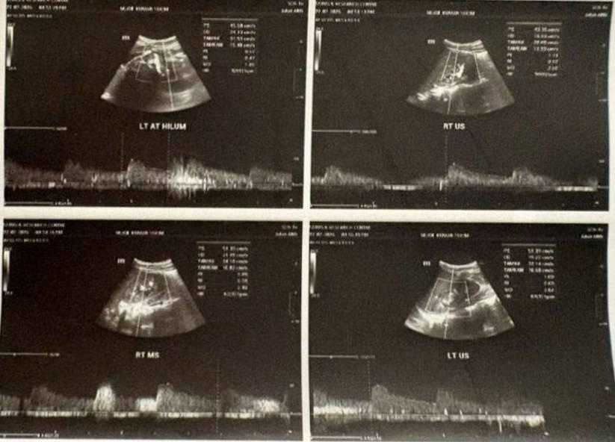
Figure 1: Bilateral Renal Arterial Color Doppler Sonography depicting left and right main and hilar renal artery waveforms, confirming patent vascular lumens, normal peak systolic velocities (PSV), and absence of renal artery stenosis.
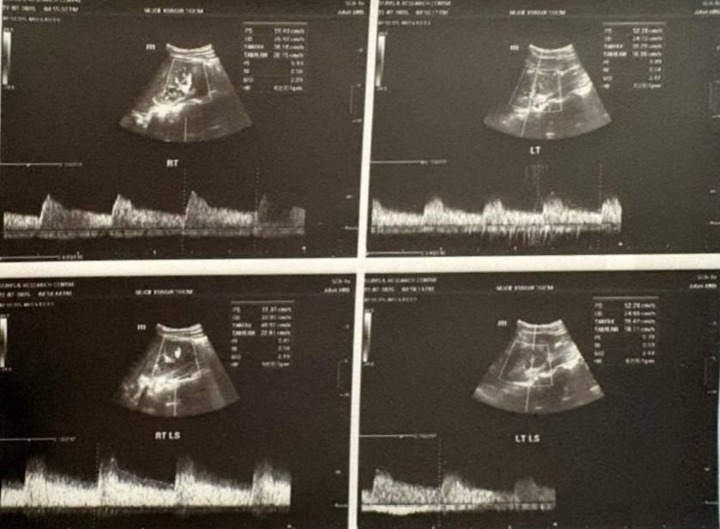
Figure 2: Spectral Doppler ultrasound examination of bilateral upper, interpolar, and lower segmental renal arteries demonstrating normal intrarenal arterial resistive indices (RI: 0.5–0.7) and preserved diastolic flow.
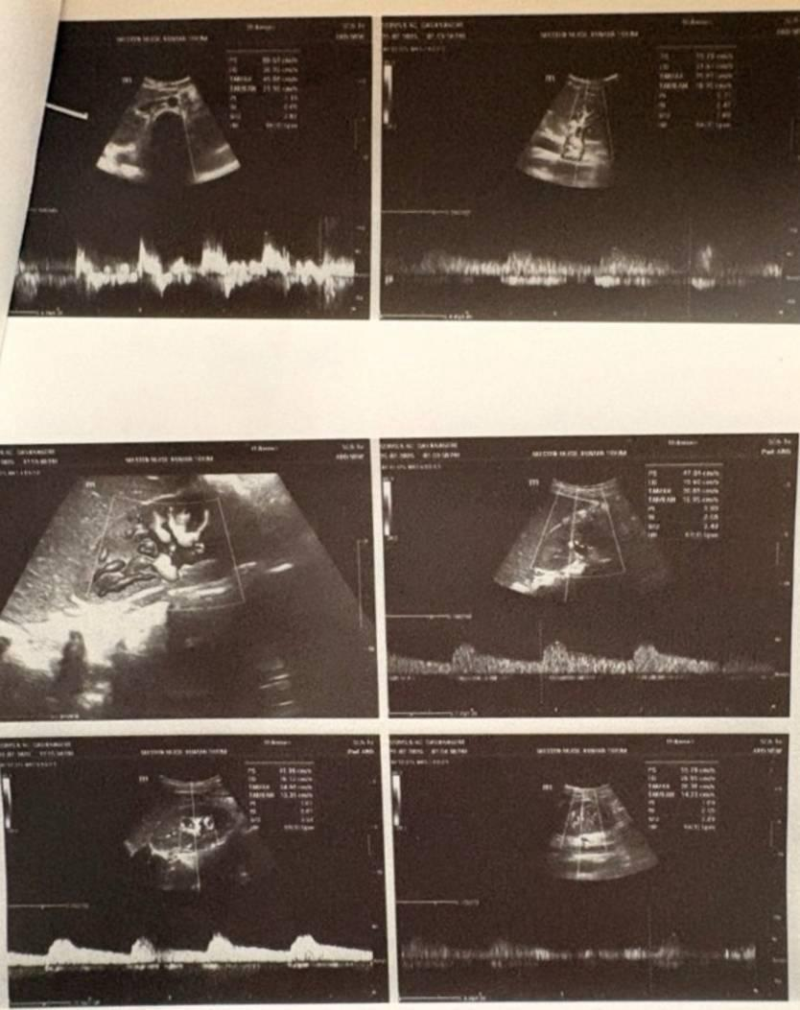
Figure 3: Color Doppler interrogation of renal parenchyma and hilar vasculature demonstrating symmetrical perfusion without focal perfusion defects, vascular cutoff, or turbulent flow.
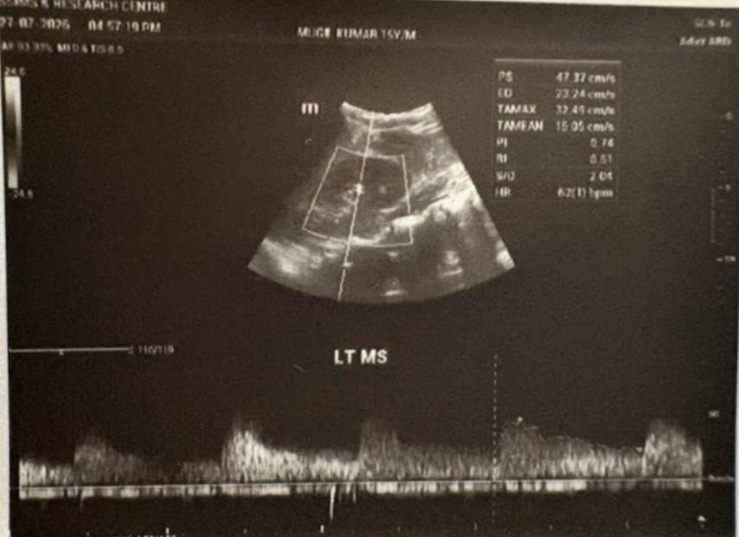
Figure 4: Detailed spectral waveform analysis of the left mid-segmental renal artery (LT MS) showing normal systolic acceleration time and normal resistive index (RI 0.51).
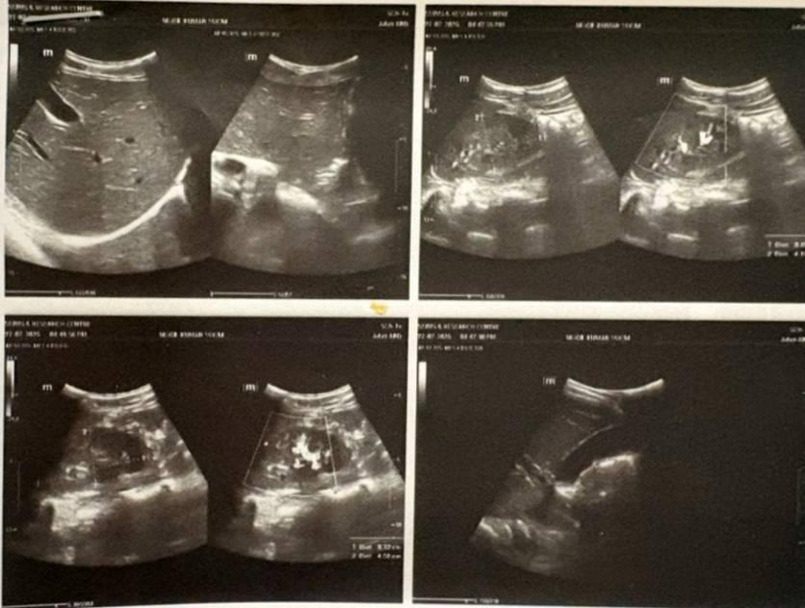
Figure 5: High-resolution B-mode and color Doppler ultrasonography of the liver, gallbladder, spleen, and bilateral kidneys, demonstrating normal renal dimensions and mild physiological inter-loop free fluid.
2.8 Discharge Medications and Post-Discharge Follow-Up Plan
The patient was discharged in a stable condition and was neurologically intact. Discharge treatment comprised oral syrup glycerol 20 mL three times daily for three days for residual tension cephalalgia, oral maintenance antihypertensive treatment (tablet amlodipine 5 mg once daily at bedtime), and antiepileptic treatment (oral levetiracetam 500 mg BID); the complete course of intravenous ceftriaxone had been completed before discharge. Family members were advised regarding regular home BP monitoring using a dedicated logbook, reviewed bi-weekly, moderate restriction of fluid and salt intake, and warning symptoms such as severe headache, vomiting, visual disturbances, and seizures. Follow-up was scheduled at 1 week and 8 weeks for optimisation of BP control at the Paediatric Nephrology Outpatient Department (PDN OPD), normalisation of serological results, and consideration of elective renal biopsy in the event of recurrence or persistent haematuria and/or proteinuria (repeat ASO titres and serial C3 levels to document definitive resolution).
3. DISCUSSION
We report a case of hypertensive encephalopathy in an adolescent patient secondary to suspected post-mumps acute glomerulonephritis. This is a severe medical emergency requiring prompt recognition, strict haemodynamic control, and careful evaluation of the underlying cause (Hoyer et al., 1967; Tizki et al., 2025). Acute post-infectious glomerulonephritis (PIGN) is considered a prototype cause of acute volume-dependent hypertension in children, with post-streptococcal GN accounting for >85–90% of paediatric PIGN cases (Anochie et al., 2009; Duong & Reidy, 2022; Tizki et al., 2025).
Post-viral glomerulonephritis other than post-streptococcal GN is uncommon but may cause significant morbidity (1–3% of cases) (Anochie et al., 2009; Stevens et al., 2016). A preceding history of bilateral parotid swelling 5–6 days earlier, bilateral painful parotitis followed by abrupt gross haematuria, marked facial oedema and moderate oedema of both ankles, severe hypertension (BP 230/160), and a positive serological test for mumps IgM antibodies at a titre of 1:160 suggests post-mumps post-infectious acute glomerulonephritis. The pathophysiology of mumps virus-mediated glomerular injury includes direct damage to renal tubular cells and glomerular endothelial cells, as well as the production of immune complexes that can activate the complement cascade and trigger acute inflammatory responses, resulting in reduced glomerular filtration rate (GFR), excessive tubular reabsorption of sodium and water, expansion of extracellular fluid (ECF) volume, and a rapid increase in severe volume-dependent arterial hypertension (Kabakus et al., 1999; Monteiro & Lillicrap, 1967; Utz et al., 1964). When uncontrolled hypertension exceeds cerebral autoregulatory limits (usually 60–120 mmHg mean arterial pressure [MAP]), cerebral arteries may become excessively dilated, leading to cerebral overperfusion. The increased transmural pressure may widen transendothelial tight junctions, resulting in extravasation of macromolecules into the extravascular compartment, diffuse or vasogenic brain oedema, and the signs and symptoms of hypertensive encephalopathy (Bartynski, 2008; Flynn & Tullus, 2009; Immink et al., 2004). Identification of hypertensive encephalopathy is important during paediatric ED triage because it must be differentiated from other neurological causes of altered mental status, particularly primary CNS viral infections such as mumps encephalitis (Nussinovitch et al., 1995; Shah & Yadav, 2014). In contrast to post-viral meningoencephalitis characterised by meningeal inflammation and signs of increased ICP, our patient had not had fever before presenting to the ED; the brain MDCT was normal, meningeal signs were absent, cranial nerve functions were intact, and his neurological functions returned completely to normal after BP control, supporting a hypertensive rather than primary intracranial cause of the neurological symptoms (Hoyer et al., 1967; Raina et al., 2020). Management of a paediatric hypertensive emergency should include controlled, gradual reduction in blood pressure to avoid cerebral hypoperfusion and resultant ischaemic stroke (Chandar & Zilleruelo, 2012; Constantine & Linakis, 2005; Hari & Sinha, 2011). Blood pressure reduction should be approximately 20–25% of MAP during the initial 6–8 hr (Chandar & Zilleruelo, 2012; Flynn & Tullus, 2009; Hari & Sinha, 2011). Labetalol, a vasodilator with both alpha1-adrenergic and non-selective beta-blocking actions, is widely used as first-line treatment for paediatric hypertensive emergencies. Labetalol causes systemic vasodilatation and a reduction in peripheral vascular resistance without a significant increase in HR or ICP (Flynn & Tullus, 2009; Patel et al., 2012; Raina et al., 2020). Intravenous (IV) labetalol infusion at 0.25 mg/kg/hr in our patient achieved the target 20–25% reduction in MAP over 6–8 hr without signs of haemodynamic instability. Prompt intervention with concomitant IV mannitol for cerebral decongestion, levetiracetam as anticonvulsant therapy, and loop diuretics for fluid overload resulted in gradual resolution of neurological deficits and permitted gradual transition to oral amlodipine (Chandar & Zilleruelo, 2012; Hari & Sinha, 2011; Patel et al., 2012).

3.1 Study Limitations and Diagnostic Considerations
This case report has several diagnostic limitations that should be acknowledged. First, and most importantly, because the patient showed marked clinical improvement, remained relatively free of renal nitrogen retention (BUN, 18 mg/dL; creatinine, 0.76 mg/dL), and sustained recovery with conservative treatment, percutaneous renal biopsy was not clinically feasible during the initial episode. Therefore, direct histological and immunofluorescence evidence of subepithelial or mesangial immune deposition could not be documented. Second, although the chronological association with parotitis and positive mumps IgM serology provides evidence supporting post-mumps GN, the absence of acute and convalescent anti-streptolysin O (ASO) and anti-DNase B titres at admission makes it impossible to completely exclude a subclinical antecedent streptococcal coinfection or other viral triggers. Nevertheless, the overall presentation, including acute and transient nephritic features, mumps-compatible parotitis, positive serology, and hypertensive encephalopathy, provides clinical evidence suggestive of post-mumps acute glomerulonephritis.
4. CONCLUSION
This case describes an uncommon and emergent paediatric presentation of generalised seizures and hypertensive encephalopathy attributed to probable post-mumps acute glomerulonephritis in an adolescent male. A high index of suspicion for post-infectious acute glomerulonephritis and hypertensive emergency should be maintained in paediatric patients presenting with acute headache, visual blurring, nausea, vomiting, or seizures after recent parotitis or another viral illness. Prompt intensive care stabilisation with titrated intravenous labetalol at 0.25 mg/kg/h, appropriate neuroprotection, judicious use of loop diuretics, and transition to an oral calcium-channel blocker facilitated rapid neurological and haemodynamic recovery without lasting renal problems.
ETHICAL APPROVAL AND CONSENT
Written informed consent for the publication of this case report and the relevant imaging findings and clinical information was obtained from the legal guardians of the patient (parents) and was documented with respect. Ethical approval from the Institutional Ethics Review Committee, S. S. Institute of Medical Sciences & Research Centre (SSIMS & RC) was obtained for carrying out this study, according to the guidelines set forth by the Declaration of Helsinki.
COMPETING INTERESTS
The authors state that they have no competing financial or non-financial interests to declare for this case report.
DECLARATION OF AI USE
This manuscript was written based on the intellectual contributions of the author(s) to the study design, statistical analysis, interpretation, conclusions, and academic content. Grammarly and ChatGPT were used only to improve grammar and citation formatting. The author(s) take full responsibility for the accuracy and content.
REFERENCES
Abugrain, K., McCulloch, M. I., Muloiwa, R., Luyckx, V. A., & Buys, H. (2024). A 6-year review of acute post-streptococcal glomerulonephritis at a public children's hospital in Cape Town, South Africa. Pediatric Nephrology, 39(6), 1809–1816. https://doi.org/10.1007/s00467-023-06247-8
Hoyer, J. R., Michael, A. F., Fish, A. J., & Good, R. A. (1967). Acute poststreptococcal glomerulonephritis presenting as hypertensive encephalopathy with minimal urinary abnormalities. Pediatrics, 39(3), 412–417. https://doi.org/10.1542/peds.39.3.412
Anochie, I. C., Eke, F. U., & Okpere, A. N. (2009). Childhood acute glomerulonephritis in Port Harcourt, Rivers State, Nigeria. Nigerian Journal of Medicine, 18(2), 162–167. https://doi.org/10.4314/njm.v18i2.45056
Monteiro, G. E., & Lillicrap, C. A. (1967). Case of mumps nephritis. British Medical Journal, 4(5581), 721–722. https://doi.org/10.1136/bmj.4.5581.721
Baroi, S., Afroz, S., Ferdaus, T., Yasmin, F., Hasnat, M. A., & Haque, S. A. (2026). Clinical features of acute post-streptococcal glomerulonephritis among children in a tertiary care hospital of Bangladesh. Asian Journal of Medicine and Health, 24(1), 60–67. https://doi.org/10.9734/ajmah/2026/v24i11343
Bartynski, W. S. (2008). Posterior reversible encephalopathy syndrome, part 1: Fundamental imaging and clinical features. AJNR American Journal of Neuroradiology, 29(6), 1036–1042. https://doi.org/10.3174/ajnr.A0928
Bertazza Partigiani, N., Vigezzi, S., Meneghesso, D., Tinnirello, M., Brazzale, A. R., Daverio, M., & Vidal, E. (2025). Efficacy and safety of fenoldopam for the treatment of hypertensive crises in children with kidney disease: A retrospective study. Pediatric Nephrology, 40(1), 165–175. https://doi.org/10.1007/s00467-024-06490-7
Constantine, E., & Linakis, J. (2005). The assessment and management of hypertensive emergencies and urgencies in children. Pediatric Emergency Care, 21(6), 391–396. https://doi.org/10.1097/01.pec.0000166733.08965.23
Hari, P., & Sinha, A. (2011). Hypertensive emergencies in children. Indian Journal of Pediatrics, 78(5), 569–575. https://doi.org/10.1007/s12098-010-0297-5
Elsamny, E., & Samuel, J. P. (2026). Acute severe hypertension in children. Advances in Kidney Disease and Health. Advance online publication. https://doi.org/10.1053/j.akdh.2026.06.005
Flynn, J. T., & Tullus, K. (2009). Severe hypertension in children and adolescents: Pathophysiology and treatment. Pediatric Nephrology, 24(6), 1101–1112. https://doi.org/10.1007/s00467-008-1000-1
Flynn, J. T., Kaelber, D. C., Baker-Smith, C. M., Blowey, D., Carroll, A. E., Daniels, S. R., de Ferranti, S. D., Dionne, J. M., Falkner, B., Flinn, S. K., Gidding, S. S., Goodwin, C., Leu, M. G., Powers, M. E., Rea, C., Samuels, J., Simasek, M., Thaker, V. V., & Urbina, E. M. (2017). Clinical practice guideline for screening and management of high blood pressure in children and adolescents. Pediatrics, 140(3), e20171904. https://doi.org/10.1542/peds.2017-1904
Fugate, J. E., & Rabinstein, A. A. (2015). Posterior reversible encephalopathy syndrome: Clinical and radiological manifestations, pathophysiology, and outstanding questions. The Lancet Neurology, 14(9), 914–925. https://doi.org/10.1016/S1474-4422(15)00111-8
Chen, T.-H., Lin, W.-C., Tseng, Y.-H., Tseng, C.-M., Chang, T.-T., & Lin, T.-J. (2013). Posterior reversible encephalopathy syndrome in children: Case series and systematic review. Journal of Child Neurology, 28(11), 1378–1386. https://doi.org/10.1177/0883073813500714
Raina, R., Mahajan, Z., Sharma, A., Chakraborty, R., Mahajan, S., Sethi, S. K., Kapur, G., & Kaelber, D. (2020). Hypertensive crisis in pediatric patients: An overview. Frontiers in Pediatrics, 8, 588911. https://doi.org/10.3389/fped.2020.588911
Immink, R. V., van den Born, B.-J. H., van Montfrans, G. A., Koopmans, R. P., Karemaker, J. M., & van Lieshout, J. J. (2004). Impaired cerebral autoregulation in patients with malignant hypertension. Circulation, 110(15), 2241–2245. https://doi.org/10.1161/01.CIR.0000144472.08647.40
Kabakus, N., Aydinoglu, H., Yekeler, H., & Arslan, I. N. (1999). Fatal mumps nephritis and myocarditis. Journal of Tropical Pediatrics, 45(6), 358–360. https://doi.org/10.1093/tropej/45.6.358
Kaur, K., & Gill, P. K. (2026). Pediatric meningitis: Contemporary epidemiology, pathogenesis, diagnosis, and evidence-based management in the vaccine era. Journal of Medicine and Health Research, 11(1), 131–142. https://doi.org/10.56557/jomahr/2026/v11i110245
Kher, K. K. (2015). Acute glomerular diseases in children. The Open Urology & Nephrology Journal, 8(1), 104–116. https://doi.org/10.2174/1874303X015080100104
Nussinovitch, M., Volovitz, B., & Varsano, I. (1995). Complications of mumps requiring hospitalization in children. European Journal of Pediatrics, 154(9), 732–734. https://doi.org/10.1007/BF02276717
Duong, M. D., & Reidy, K. J. (2022). Acute postinfectious glomerulonephritis. Pediatric Clinics of North America, 69(6), 1051–1078. https://doi.org/10.1016/j.pcl.2022.08.001
Patel, N. H., Romero, S. K., & Kaelber, D. C. (2012). Evaluation and management of pediatric hypertensive crises: Hypertensive urgency and hypertensive emergencies. Open Access Emergency Medicine, 4, 85–92. https://doi.org/10.2147/OAEM.S32809
Rodriguez-Iturbe, B., & Musser, J. M. (2008). The current state of poststreptococcal glomerulonephritis. Journal of the American Society of Nephrology, 19(10), 1855–1864. https://doi.org/10.1681/ASN.2008010092
Seeman, T., Hamdani, G., & Mitsnefes, M. (2019). Hypertensive crisis in children and adolescents. Pediatric Nephrology, 34(12), 2523–2537. https://doi.org/10.1007/s00467-018-4092-2
Chandar, J., & Zilleruelo, G. (2012). Hypertensive crisis in children. Pediatric Nephrology, 27(5), 741–751. https://doi.org/10.1007/s00467-011-1964-0
Shah, G. S., & Yadav, S. P. (2014). Clinical profile and outcome of acute glomerulonephritis in a tertiary care centre in Eastern Nepal. Journal of Institute of Medicine Nepal, 36(1), 29–33. https://doi.org/10.59779/jiomnepal.564
Stevens, J., Herberg, J. A., & Levin, M. (2016). Infectious diseases and the kidney in children. In E. D. Avner, W. E. Harmon, P. Niaudet, N. Yoshikawa, F. Emma, & S. L. Goldstein (Eds.), Pediatric nephrology (7th ed., pp. 1609–1654). Springer. https://doi.org/10.1007/978-3-662-43596-0_47
Tizki, S., Nassih, H., Elqadiry, R., Abourrahouat, A., Lahlou, L., & Aitsab, I. (2025). Acute post-streptococcal glomerulonephritis in children: A Moroccan experience. Cureus, 17(10), e94683. https://doi.org/10.7759/cureus.94683
Utz, J. P., Houk, V. N., & Alling, D. W. (1964). Clinical and laboratory studies of mumps. IV. Viruria and abnormal renal function. New England Journal of Medicine, 270(24), 1283–1286. https://doi.org/10.1056/NEJM196406112702404
Yang, W.-C., & Wu, H.-P. (2010). Clinical analysis of hypertension in children admitted to the emergency department. Pediatrics & Neonatology, 51(1), 44–51. https://doi.org/10.1016/S1875-9572(10)60009-5

