Case report

Keloidal Morphea: A Rare Variant Presenting as a Diagnostic Challenge

ABSTRACT
Aims: Keloidal morphea, also referred to as nodular scleroderma, is an extremely rare variant of localized scleroderma characterized by keloid-like nodules developing within sclerotic skin lesions. Because of its rarity and clinical resemblance to keloids, it may represent a significant diagnostic challenge. We describe such a case and underline its diagnostic pitfalls.
Presentation of Case: A 40-year-old woman presented with multiple hyperpigmented sclerotic plaques involving the trunk, back, axilla, and upper limbs that had progressively evolved over 10 years. Firm keloid-like nodules, some with pseudopod-like extensions, developed within these plaques. There was no history of trauma or keloid formation and no clinical or serological evidence of systemic sclerosis. Histopathological examination revealed dermal fibrosis with thickened collagen bundles arranged in a sclerotic pattern, consistent with morphea and keloidal change.
Discussion: The patient was treated with systemic corticosteroids combined with methotrexate, but no significant clinical improvement was observed after six months of therapy, in keeping with the frequently reported therapeutic resistance of this condition.
Conclusion: This case highlights the importance of recognizing keloidal morphea as a rare variant of morphea and of considering it in the differential diagnosis of keloid-like lesions, particularly in patients without known risk factors for keloid formation.
Keywords: dermatopathology; keloidal morphea; keloid-like lesions; localized scleroderma; nodular scleroderma
1. INTRODUCTION
Morphea, or localized scleroderma, is a chronic autoimmune condition characterized by one or more sclerotic plaques affecting the skin and underlying tissues. It differs from systemic sclerosis, which is marked by widespread cutaneous fibrosis associated with internal organ involvement (García-García & Sánchez-González, 2023). Among the various clinical forms described, the nodular or keloidal variant is one of the rarest subtypes (Kauer et al., 2009). Keloidal morphea (KM), also called nodular or keloidal scleroderma, is characterized by firm keloid-like nodules arising within pre-existing sclerotic plaques, and its clinical resemblance to keloids may lead to diagnostic confusion. Fewer than 60 cases have been reported to date, underscoring the rarity of this condition. We report a case of keloidal morphea in a 40-year-old woman with long-standing hyperpigmented sclerotic plaques and multiple keloidal nodules.
2. PRESENTATION OF CASE
A 40-year-old woman presented for evaluation of hyperpigmented sclerotic plaques involving the neck, trunk, arms, and axillae that had progressively increased in number over 10 years. Firm nodules subsequently developed within the hyperpigmented plaques. She reported no features of systemic involvement such as Raynaud phenomenon, diarrhea, or dyspnea, no history of keloid formation, and no trauma to the affected sites.
Physical examination revealed multiple asymptomatic hyperpigmented plaques with mild induration on palpation, scattered over the trunk, abdomen, back, axillae, upper arms, and legs (Figure 1).
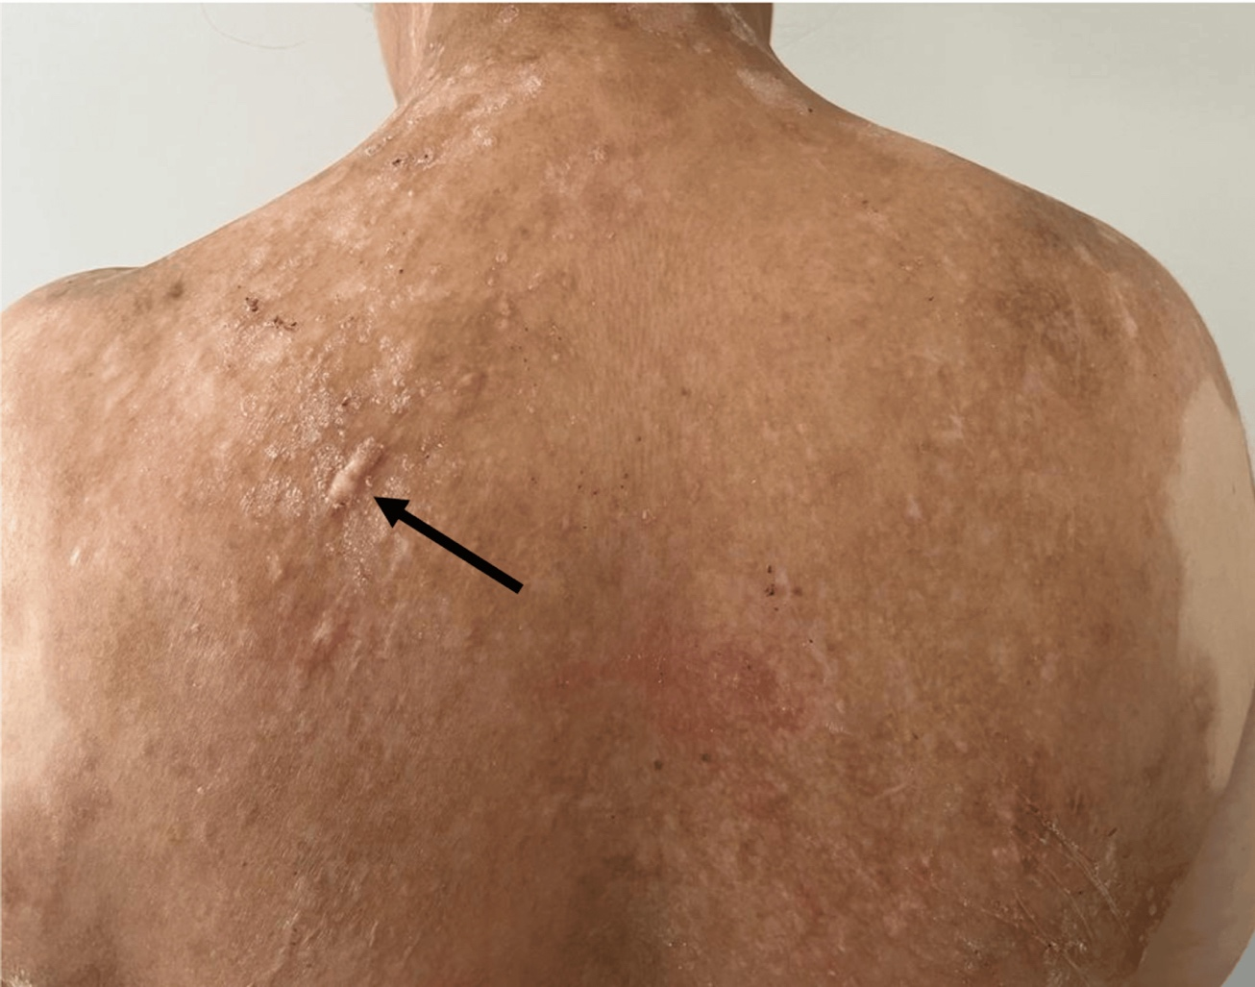
Figure 1. Clinical photograph of the back demonstrating hypertrophic, linear keloid-like lesions (arrow).
Multiple firm, non-tender nodules measuring 5 to 40 mm were observed on the back, abdomen, arms, and legs; they were not fixed to deeper tissues, and pseudopod-like extensions were noted on both upper arms (Figure 2).
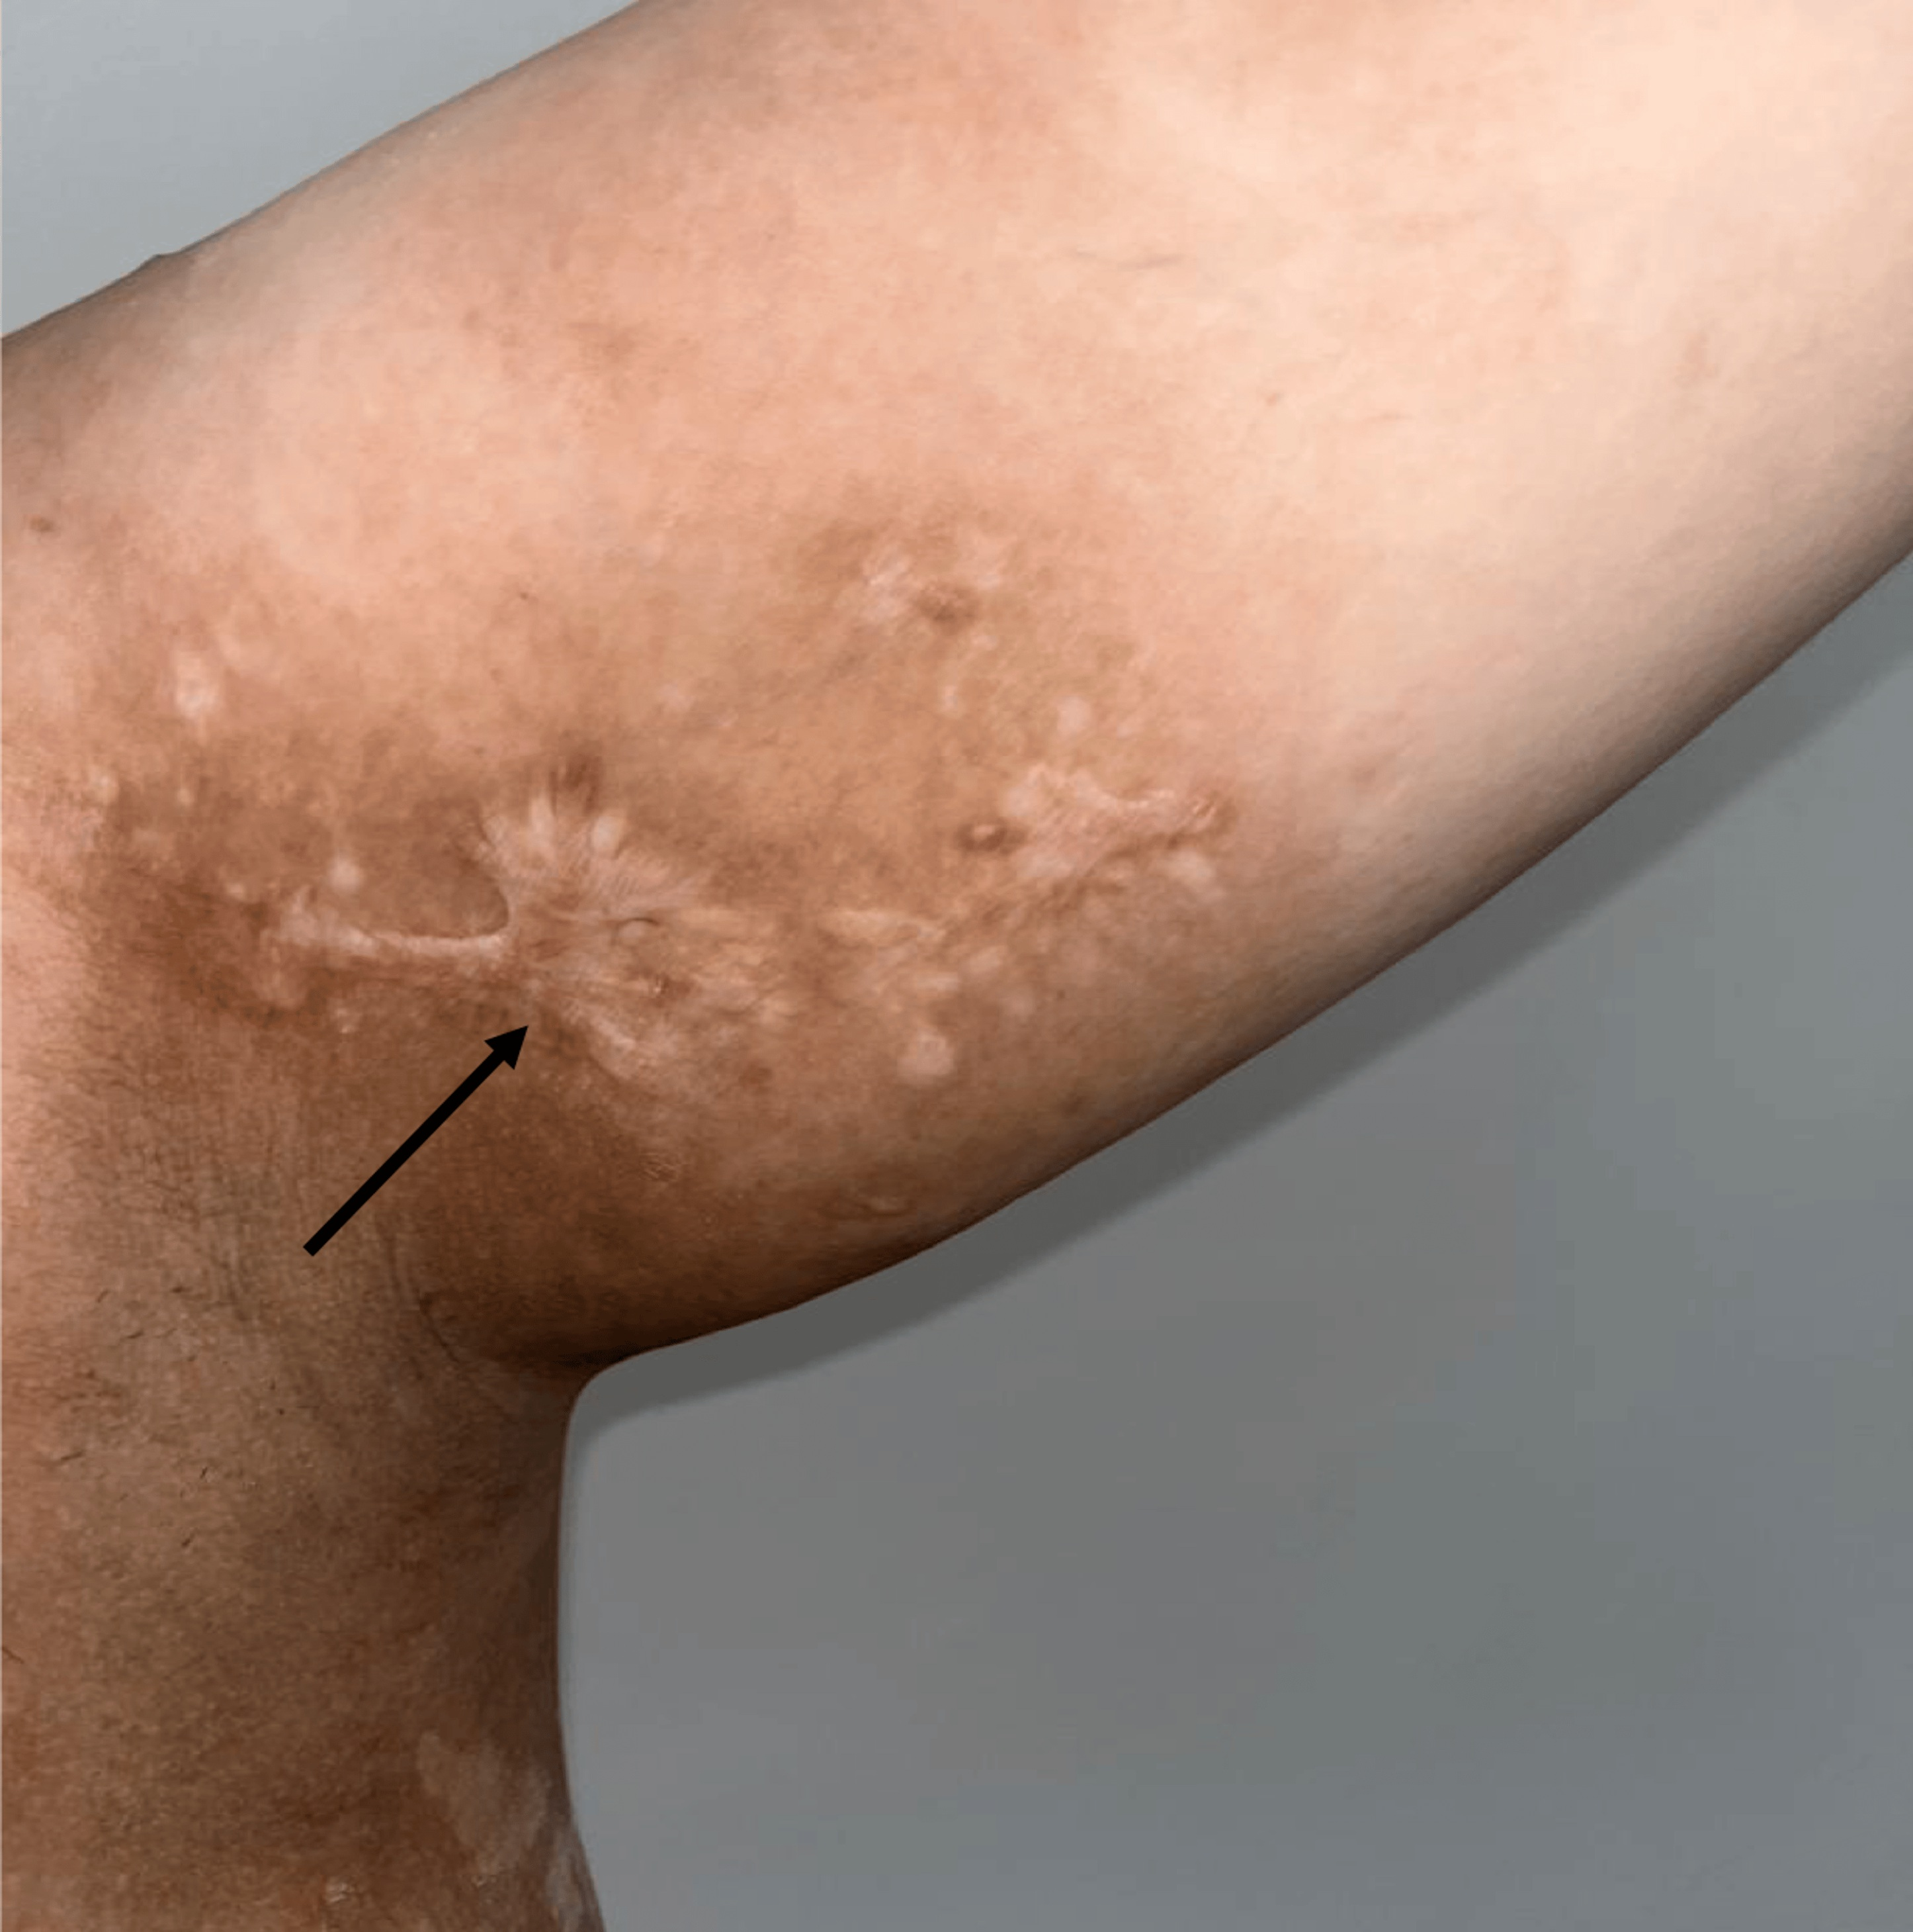
Figure 2. Clinical photograph of the left axilla showing firm keloid-like nodules with pseudopod-like extensions arising on hyperpigmented sclerotic plaques (arrow).
Periungual dermoscopy was unremarkable, and there was no calcinosis, sclerodactyly, or telangiectasia. A thin, normally healed scar was present on the lower abdomen following a cesarean section performed two years before the onset of the cutaneous lesions, with no keloidal changes observed at this site.

Routine laboratory tests were within normal limits. Immunological work-up, including antinuclear, anticentromere, anti-dsDNA, and anti-Scl70 antibodies, was negative. Two biopsy specimens were obtained. Histopathological examination of a hyperpigmented plaque showed a fibrotic dermis with thickened, densely arranged collagen bundles consistent with dermal sclerosis (Figure 3).
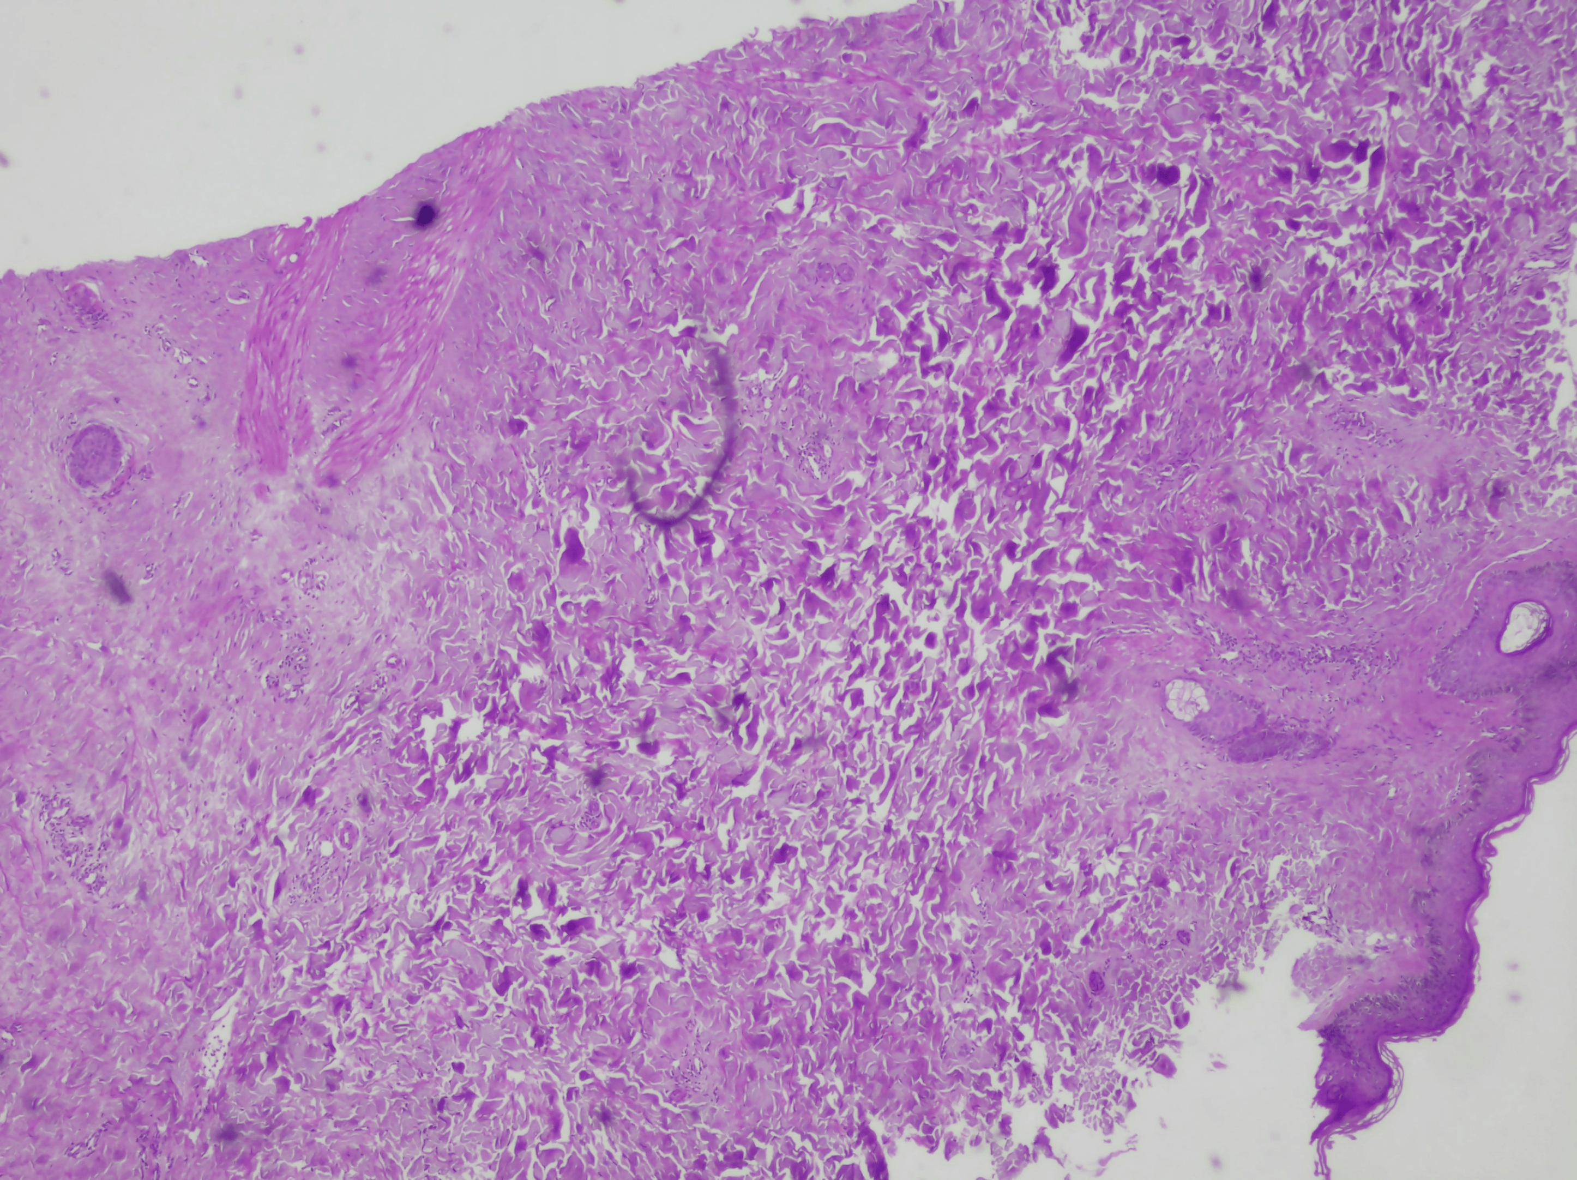
Figure 3. Histopathological examination showing dense, thickened collagen bundles within the dermis, consistent with dermal sclerosis in morphea (hematoxylin and eosin, ×100).
Biopsy of a nodular lesion revealed an acanthotic, orthokeratotic epidermis with thickened dermal collagen bundles. The combined clinical and histopathological findings were consistent with keloidal morphea.
The patient was treated with oral prednisone (0.5 mg/kg/day) for one month, gradually tapered over four months, combined with methotrexate 15 mg/week. After six months of follow-up, the lesions remained clinically stable, with no significant progression or improvement.
3. DISCUSSION
Keloidal morphea and nodular scleroderma have been used interchangeably to describe nodular lesions arising in the setting of cutaneous sclerosis. The first description is attributed to Thomas Addison in 1854, who termed it “untrue keloid” (Dadkhahfar et al., 2020). The pathogenesis remains unclear. Some authors propose an inflammatory dermal process leading to sclerosis and secondary keloid-like lesions, whereas others suggest that repeated microtrauma and local inflammation trigger excessive fibrosis in predisposed individuals (Syder et al., 2025).
Clinically, the entity presents as one or several elevated lesions developing in association with classical morphea, either within pre-existing plaques or on clinically unaffected skin. Similar nodular lesions may occur in systemic sclerosis, where the condition is termed nodular scleroderma (Srisuttiyakorn & Aunhachoke, 2016; Krell et al., 1995; Wriston et al., 2008). The main clinical differential diagnoses include keloids, hypertrophic scars, sarcoidosis, sclerotic dermatofibroma, mycosis fungoides, and lichen sclerosus.
Histopathological features range from keloid-like hyalinized collagen bundles to changes typical of scleroderma with horizontally arranged sclerotic dermal bands, or a combination of both, as in our case. The main histological differential diagnoses include keloid or hypertrophic scar, storiform collagenoma, sclerotic dermatofibroma, sclerosing perineuroma, and keloidal fibroxanthoma (García-García & Sánchez-González, 2023; Castelli et al., 2021). In our patient, the combined features of morphea and keloidal change supported the diagnosis.
There is no standardized treatment for keloidal or nodular scleroderma; therapeutic strategies derive mainly from isolated case reports and small series, yielding inconclusive results. Reported options include topical or intralesional corticosteroids, phototherapy (UVA1 or PUVA), and systemic agents such as corticosteroids, methotrexate, azathioprine, and cyclosporine, with variable outcomes. Despite systemic corticosteroids and methotrexate, our patient showed no significant improvement after six months, supporting previous observations that this condition may be resistant to therapy (Trufin et al., 2024).
4. CONCLUSION
Keloidal morphea is a rare variant of morphea that may pose a diagnostic challenge because of its clinical resemblance to keloids and its unclear pathogenesis. It should be considered when firm keloid-like nodules develop in patients without known risk factors for keloid formation or in association with localized or systemic scleroderma. Given the rarity of this entity, evidence regarding optimal management remains limited.
COMPETING INTERESTS
The authors have declared that no competing interests exist.
CONSENT
Written informed consent was obtained from the patient for publication of this case report and the accompanying clinical and histopathological images. A copy of the written consent is available for review by the Editorial Office of this journal.
ETHICAL APPROVAL
All authors hereby declare that all experiments have been examined and approved by the appropriate ethics committee and have therefore been performed in accordance with the ethical standards laid down in the 1964 Declaration of Helsinki.

Declaration of AI Use

This manuscript was prepared through the intellectual contributions of the author(s) to the study design, data analysis, interpretation of results, and scholarly content. Grammarly and ChatGPT were used solely to assist with grammatical refinement and reference formatting during manuscript revision. The author(s) accept full responsibility for the accuracy, integrity, and final content of the manuscript.

REFERENCES
1. García-García, C., & Sánchez-González, N. (2023). Nodular (keloidal) scleroderma. Reumatol Clin (Engl Ed), 19, 463–464. https://doi.org/10.1016/j.reumae.2023.02.009
2. Kauer, F., Simon, J. C., & Sticherling, M. (2009). Nodular morphea. Dermatology, 218, 63–66. https://doi.org/10.1159/000173976
3. Dadkhahfar, S., Asadi Kani, Z., Araghi, F., & Moravvej, H. (2020). Development of keloidal morphea after treatment with cyclosporine in a case of recalcitrant generalized morphea. Clin Case Rep, 8, 837–839. https://doi.org/10.1002/ccr3.2776
4. Syder, N. C., Saizan, A. L., McKenzie, S., De Clerck, B., Hurtado, A. C. M., & Elbuluk, N. (2025). Keloidal morphea: a unique variant of morphea presenting in a Black female. J Drugs Dermatol, 24, 203–204. https://doi.org/10.36849/JDD.7960
5. Srisuttiyakorn, C., & Aunhachoke, K. (2016). Scleroderma with nodular scleroderma. Case Rep Dermatol, 8, 303–310. https://doi.org/10.1159/000452324
6. Krell, J. M., Solomon, A. R., Glavey, C. M., & Lawley, T. J. (1995). Nodular scleroderma. J Am Acad Dermatol, 32, 343–345. https://doi.org/10.1016/0190-9622(95)90400-X
7. Wriston, C. C., Rubin, A. I., Elenitsas, R., & Crawford, G. H. (2008). Nodular scleroderma: a report of 2 cases. Am J Dermatopathol, 30, 385–388. https://doi.org/10.1097/DAD.0b013e3181766177
8. Castelli, E., Orlando, E., Pardo, N., Turdo, A., Pistone, G., & Bongiorno, M. R. (2021). Nodular morphea keloidal type: a rare case with paradigmatic histopathology significantly accompanied by a flawless surgical scar. J Cutan Pathol, 48, 1329–1334. https://doi.org/10.1111/cup.13810
9. Trufin, I. I., Ungureanu, L., Halmágyi, S. R., Apostu, A. P., & Șenilă, S. C. (2024). Nodular/keloidal scleroderma with no systemic involvement: a case report and review of the literature. J Clin Med, 13, 2662. https://doi.org/10.3390/jcm13092662

