Ethyl Acetate Extract of Embelia ribes Seed (Myrsinaceae) and Vitamin E (alpha-tocopherol) Protect Against Hematological Disorder and Redox Imbalance Associated with Tamoxifen Administration

ABSTRACT
Tamoxifen is a widely used hormonal therapy for the treatment and prevention of hormone receptor-positive breast cancer. Its prolonged administration may be associated with adverse effects. Natural products of plants have gained considerable attention in recent years as potential drug sources. This study evaluated the protective roles of ethyl acetate extract of Embelia ribes seed, and Vitamin E against hematological disorder and redox imbalance associated with Tamoxifen administration in female Wistar rats. Fifty-six (56) rats averagely weighing 120g used for this study were acclimatized and randomly selected into eight groups, A-H: Group A (control), Group B (2.5mg/kg Tamoxifen only), Group C (100mg/kg Extract and 2.5mg/kg Tamoxifen), Group D (100mg/kg Vitamin E and 2.5mg/kg Tamoxifen), Group E (100mg/kg Extract, 100mg/kg Vitamin E and 2.5mg/kg Tamoxifen), Group F (100mg/kg Extract only), Group G (100mg/kg Vitamin E only), Group H (100mg/kg Extract and 100mg/kg Vitamin E) all carried out orally in 0.1ml solution daily for 60 days. Hematological and tissue Redox indices were determined using standard methods. Results showed that Tamoxifen significantly (p < 0.05) decreased serum and breast Total protein level, Red blood cell count, Hemoglobin concentration and Packed cell volume, while significantly increasing White blood cell, Lymphocyte and Platelet counts. In contrast treatments in Groups C, D and E showed improved metabolic alterations as these were reversed comparably with control. Antioxidants indices results in group B showed significant (p < 0.05) decreased in breast tissue Super oxide dismutase, Catalase, Glutathione peroxidase and Reduced glutathione, with a corresponding increase in Malondialdehyde concentration, which were reversed by group C, D and E, although the magnitude of response varied across the measured parameters and treatment combinations. Result obtained are suggestive of adverse effects of Tamoxifen via induction of oxidative stress, inflammation and hematological disorders while extract or combined treatment with vitamin E exhibited antioxidant and hematological protective potential against some of the biochemical alterations associated with Tamoxifen administration. Further studies are required to characterize the active constituents and investigate the underlying mechanisms of action.
Keywords: Tamoxifen; Hematological disorder; Redox Imbalance; Anti oxidative; Embelia ribes seed; Vitamin E, Synergistic effect, Breast cancer

- INTRODUCTION
Breast cancer remains one of the leading causes of cancer-related morbidity and mortality among women worldwide (Zhang et al., 2024). The increasing prevalence of the disease has continued to be a major public health concern, particularly in developing countries where access to early diagnosis and effective treatment remains limited (Francis et al., 2024). One of the therapeutic drugs commonly used in the treatment and management of hormone-responsive breast cancer is Tamoxifen, a selective estrogen receptor modulator widely recognized for its anti-estrogenic activity in breast tissues (Lloyd et al., 2022). Tamoxifen inhibits estrogen-dependent proliferation of malignant cells and this has led to its usage for prevention and treatment of breast cancer with high rate of patient’s survival (Javankiani et al., 2025). Despite its clinical importance, the prolonged use as preventive and therapeutic agent for breast cancer have been linked with several adverse effects including hepatotoxicity, nephrotoxicity, hematological abnormalities, and oxidative stress (Radeva, and Yoncheva, 2025). Studies have shown that Tamoxifen metabolism may generate reactive oxygen species known as ROS capable of disrupting cellular redox homeostasis, leading to cellular oxidative damage of lipids, proteins, nucleic acids and subsequent effect on membrane integrity and altered normal cellular functions (Sadiq, 2023).
Tamoxifen-induced hematological disorder has been linked to oxidative injury and suppression of hematopoietic tissues (Rossi et al., 2023), which represent another major clinical challenge during cancer treatment (Costanzo et al., 2024). Alterations in red blood cell indices, hemoglobin concentration, lymphocyte counts, and platelet parameters may compromise immune function, oxygen transport and redox balance thereby affecting the overall physiological condition of the affected individuals (Shah et al., 2024). In recent years, medicinal plants have gained considerable attention due to their rich phytochemical composition and therapeutic potentials (Nwozo et al., 2023). Natural products possessing antioxidant activities have been widely investigated for their ability to reduce oxidative damage associated with several pathological conditions such as Malaria, Diabetes, Ulcer and Cancer (Adedosu et al 2017; Adedosu et al.,2018; Muscolo et al., 2024).
Embelia ribes, commonly called black pepper (Family:Myrsinaceae) is a medicinal plant commonly used in traditional medicine in Ayurvedic and Unani medicine for antioxidant ,antimicrobial, anti-inflammatory , antihelmintic ,antidiabetic and anti-cancer effects (Rout et al., 2021) These biological activities have largely been attributed to the presence of bioactive compound such as flavonoids, phenolic, tannins, alkaloids, and embelin (Naik and Gamare, 2025). Vitamin E is a lipid-soluble antioxidant vitamin which plays important role in protecting cellular membranes against oxidative damage and commonly used as adjuvant in cancer treatment. It neutralizes free radicals and inhibit lipid peroxidation (Kilicarslan et al., 2024). However, due to its potent antioxidant activity, Vitamin E has been extensively studied as a protective agent against oxidative stress-induced tissue injury and related diseases (Jomova et al., 2024). Hence, with limited scientific data on the medical claims of Embelia ribes seed traditionally used for the treatment and management of breast cancer and several other ailments, this study evaluated the roles of ethyl acetate extract of Embelia ribes seed and vitamin E a known antioxidant adjuvant in cancer treatment following Tamoxifen administration in female Wistar rats.

- MATERIALS AND METHODS
Materials
Materials used in this study includes; electronic, weighing balance, measuring cylinders, syringes and needles, beakers, test tubes, conical flasks, plasma bottles, water bath, pH meter, spatula, centrifuge, thermometer, disposable gloves, tissue papers, micropipette, washing brushes, detergents, separating funnels, refrigerator, spectrophotometer, dissecting sets, mortar and pestle, stopwatch and test tube racks.
Reagents
Some of the reagents used for this study includes: Trisbuffer, Phosphate buffer, Carbonate buffer, Sodium azide, Hydrogen peroxide, Potassium chloride, sodium hydroxide, adrenaline, Trichloroacetic acid (TCA), Trishydrochloric acid, Ellman’s reagent (5,5-thiobis-2-nitrobenzoic acid, DTNB), thiobarbituric acid (TBA), Tris(hydroxylmethyl)aminomethane, Triton X-100 distilled water, chloroform, ethyl-acetate, washing buffer and homogenizing buffer. Tamoxifen, a product of Khandelwal laboratories pvt. ltd. India, obtained from Bowen University Teaching Hospital Pharmacy Ogbomoso, Oyo state, Nigeria. Tocopherol, a product of Nigerian Airforce manufacturing Unit Ltd, Airforce Base Ikeja, Lagos, obtained from Savidep Medical and Scientific Laboratory, Osogbo, Osun state. All the reagents used were of good and high analytical grade mostly obtained from Sigma USA.
Plant Material and Preparation of ethyl acetate Extract
Embelia ribes seed was obtained at Oja-igbo local market Ogbomoso, Oyo State and identified at the Botany Unit of the Department of Pure and Applied Biology, Ladoke Akintola University of Technology, Ogbomoso with herbarium voucher number LHO 969 deposited. The seed was air dried, powdered and weighed. The powdered seeds (310g) were soaked in 3000ml ethyl acetate solution for 72 hours and filtered. The filtrate of the extract was concentrated to dryness between 30-35⁰ C to obtain dried ethyl acetate extract residue inside a 1000ml measuring beaker (Rafiu et al. 2019).

Experimental Animals and Groupings
Female Wistar rats used for this study were obtained from the Animal house of Ladoke Akintola University of Technology, Ogbomoso, Oyo State. The animals were handled and treated based on our institutions guidelines on ethics and conducts for handling experimental animals which conformed with international standards. They were acclimatized in the laboratory for two weeks before any experimental work was undertaken. Animal were fed with dietary pellets and water ad-libitum and their weights were monitored during this period. The animals were randomly selected into eight groups; A-H, with seven animals in each group and treated as shown below.
Group A: Control (treated with normal saline)
Group B: Tamoxifen only (2.5 mg/kg body weight) made into 0.1 mL of normal saline and administered orally, daily by intubation for 60 days.
Group C: Extract (100 mg/kg body weight) made into 0.1 mL of corn oil and treated with Tamoxifen (2.5 mg/kg body weight) made into 0.1mL of normal saline orally, daily by intubation for 60days.
Group D: Vitamin E (100 mg/kg body weight) made into 0.1mL 0f corn oil with Tamoxifen (2.5 mg/kg body weight) made into 0.1mL of normal saline all administered orally, daily by intubation for 60 days.
Group E: Extract (100 mg/kg body weight), Vitamin E (100 mg/kg body weight) and Tamoxifen (2.5 mg/kg body weight) were treated orally, daily by intubation for 60 days.
Group F: Extract only (100 mg/kg body weight) administered orally, daily by intubation for 60 days.
Group G: Vitamin E only (100 mg/kg body weight) administered orally, daily by intubation for 60 days.
Group H: Extract (100 mg/kg body weight) and Vitamin E (100 mg/kg body weight) were administered orally, daily by intubation for 60 days. All the procedures involving the use of laboratory animals were in accordance to the Institute Animal Ethics Committee regulation approved by the committee for the purpose of control and supervision of Experiments on Animals (CPCSEA) as made available in our laboratory.
Animal sacrifice, blood collection and preparation of breast homogenates
The animals were fasted for 24 hours and sacrificed under light lights anesthesia using chloroform. Blood was obtained through cardiac puncture from the jugular vein using a 5 ml syringe and needle. The obtained blood was transferred into an EDTA sample bottle for analysis of hematological indices while blood serum was obtained from centrifuged blood in plain bottles spined at 4000rpm for 10 minutes.
The animals were carefully opened using dissecting set and tissue homogenates (breast) was prepared as they were excised and placed in a pre-weighed beaker containing 5ml of washing buffer. The washed tissues were weighed while 1g of the tissues was transferred to a beaker containing 4 ml of homogenizing buffer and homogenized to prepare the breast homogenates.
Biochemical Parameters evaluated
Serum and tissue total protein were determined by Biuret method as described by (Dominiczak, 1998). Hematological indices were determined using standard hemocytometry and automated method as described by (Dacie and Lewis, 2011).
Malondialdehyde (MDA) concentrations was estimated spectrophotometrically by thiobarbituric acid- reacting substances (TBARS) as described by (Ohkawa et al., 1979), Reduced glutathione (GSH) concentration was evaluated using the method described by (Andersen, et al., 1997), Glutathione Peroxidase activity was determined by the method of (Anderson, 1985), while Superoxide Dismutase (SOD) and Catalase (CAT) activities were determined by the methods of (Misra and Fridovich, 1975) and Aebi , (1984 ), respectively.
Statistical Analysis
The results were reported as means ± SD with data obtained analyzed using analysis of Variance (ANOVA). Value of p<0.05 was considered statistically significant.

- RESULTS & DISCUSSION
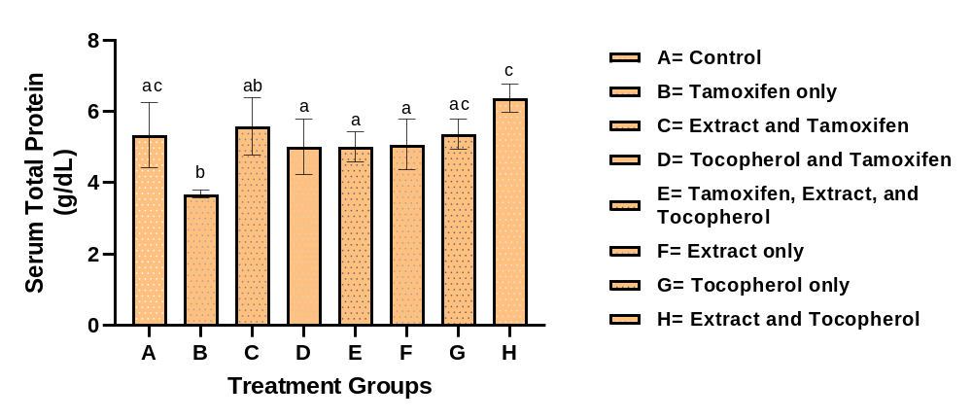Figure 1: Serum total protein concentration (g/dl) of various treatment groups. Values are expressed as mean ± SD (n=7); significant differences (p <0.05). Bar with same superscript indicate no significant difference while Bar with different superscript indicate significant difference
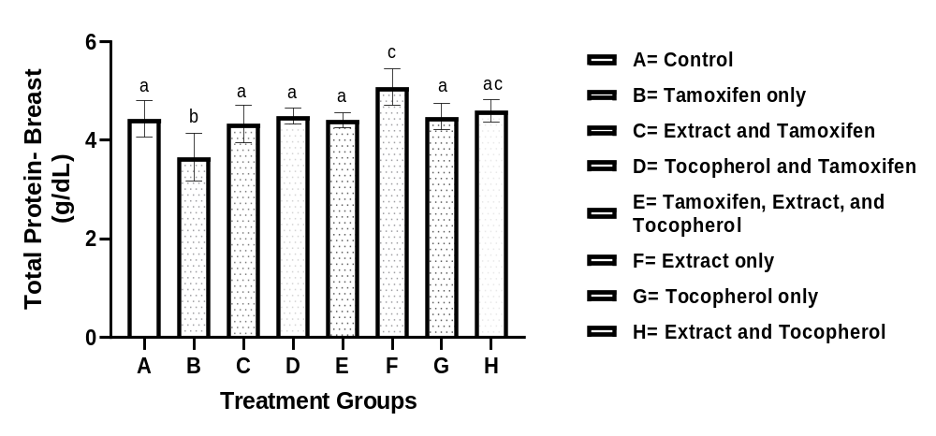Figure 2: Total protein concentration (g/dl) in breast homogenate of various treatment groups. Values are expressed as mean ± SD (n=7); significant differences (p <0.05). Bar with same superscript indicate no significant difference while Bar with different superscript indicate significant difference

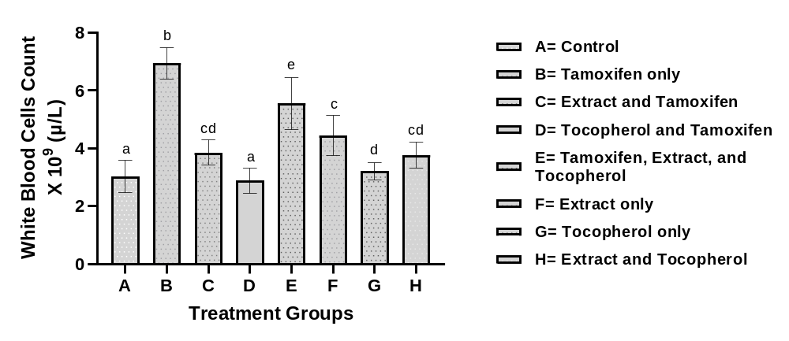
Figure 3: White blood cell (WBC) count of various treatment groups. Values are expressed as mean ± SD (n=7); significant differences (p <0.05). Bar with same superscript indicate no significant difference while Bar with different superscript indicate significant difference
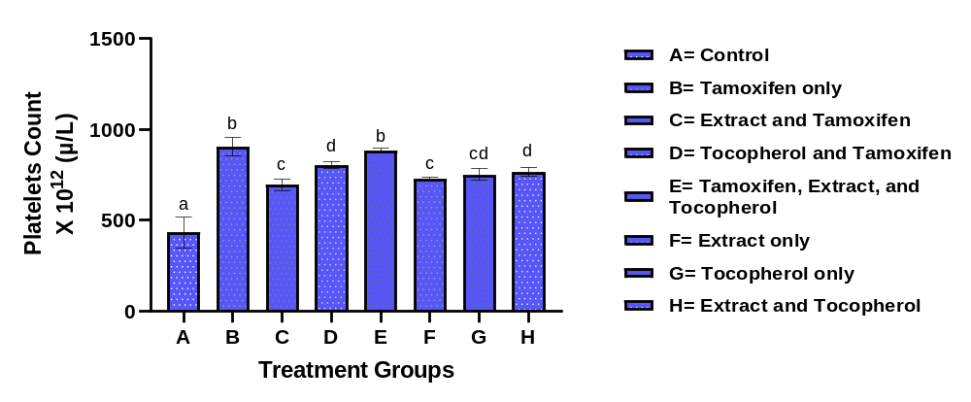Figure 4: Platelet count of various treatment groups. Values are expressed as mean ± SD (n=7); significant differences (p <0.05). Bar with same superscript indicate no significant difference while Bar with different superscript indicate significant difference

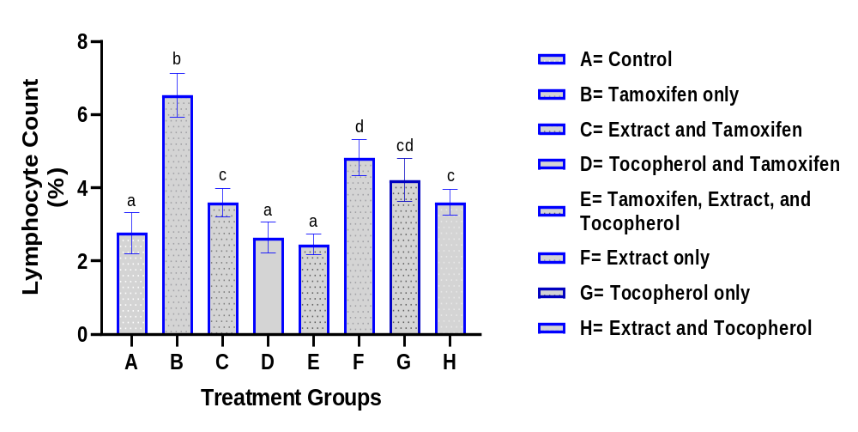Figure 5: Lymphocyte (%) count of various treatment groups. Values are expressed as mean ± SD (n=7); significant differences (p <0.05). Bar with same superscript indicate no significant difference while Bar with different superscript indicate significant difference
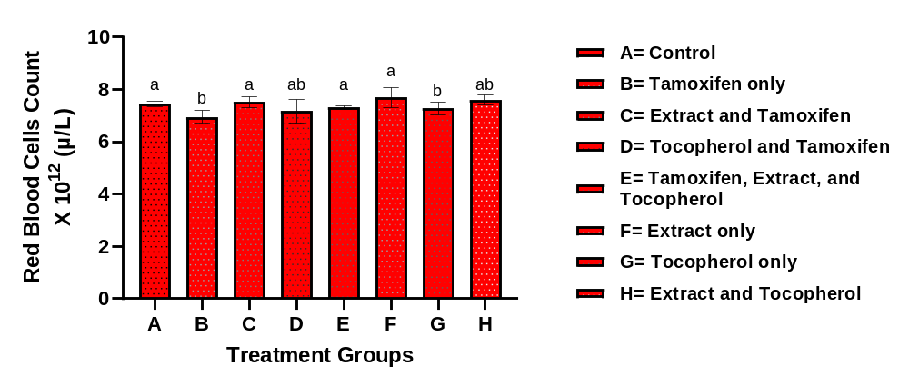Figure 6: Red blood cell (RBC) count of various treatment groups. Values are expressed as mean ± SD (n=7); significant differences (p <0.05). Bar with same superscript indicate no significant difference while Bar with different superscript indicate significant difference

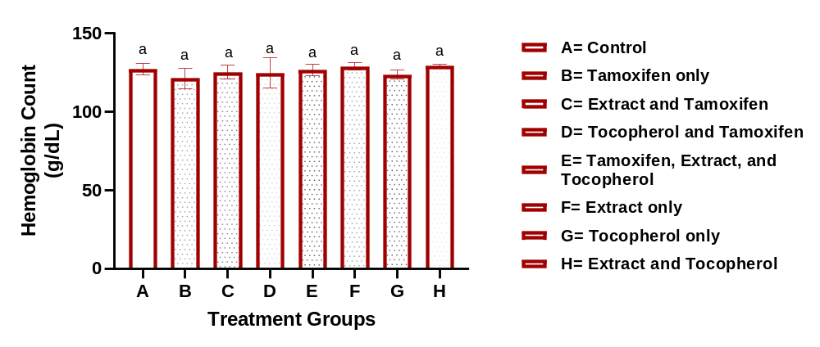Figure 7: Hemoglobin count of various treatment groups. Values are expressed as mean ± SD (n=7); significant differences (p <0.05). Bar with same superscript indicate no significant difference while Bar with different superscript indicate significant difference
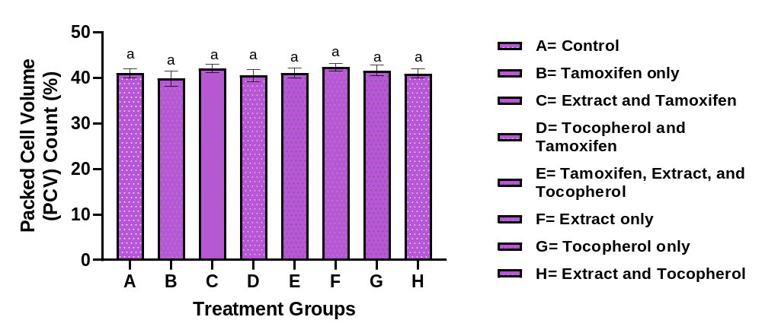Figure 8: Packed cell volume (PCV) of various treatment groups. Values are expressed as mean ± SD (n=7); significant differences (p <0.05). Bar with same superscript indicate no significant difference while Bar with different superscript indicate significant difference

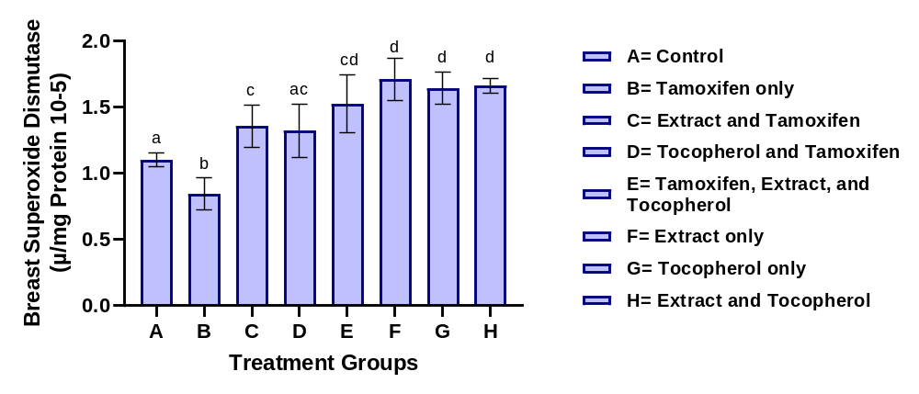Figure 9: Superoxide dismutase (SOD) activity in breast homogenate of various treatment groups. Values are expressed as mean ± SD (n=7); significant differences (p <0.05). Bar with same superscript indicate no significant difference while Bar with different superscript indicate significant difference
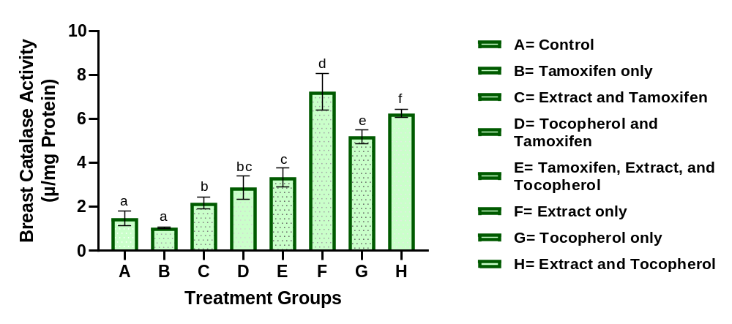Figure 10: Catalase (CAT) activity in breast homogenate of various treatment groups. Values are expressed as mean ± SD (n=7); significant differences (p <0.05). Bar with same superscript indicate no significant difference while Bar with different superscript indicate significant difference

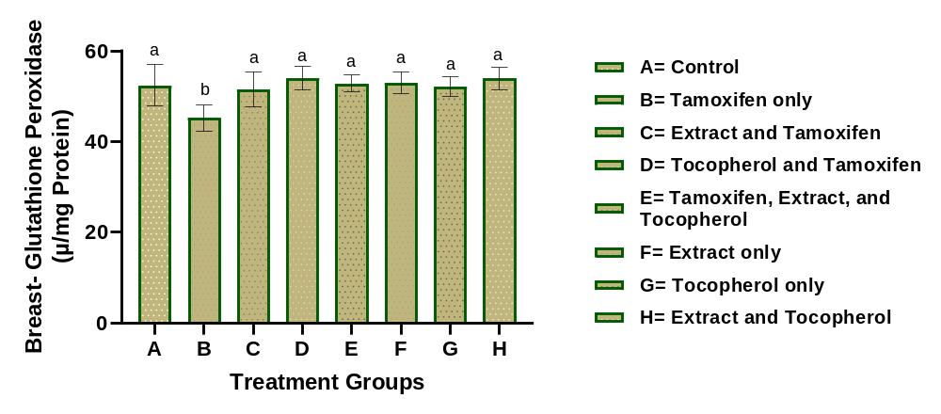Figure 11: Glutathione peroxidase (GPX) activity in breast homogenate of various treatment groups. Values are expressed as mean ± SD (n=7); significant differences (p <0.05). Bar with same superscript indicate no significant difference while Bar with different superscript indicate significant difference
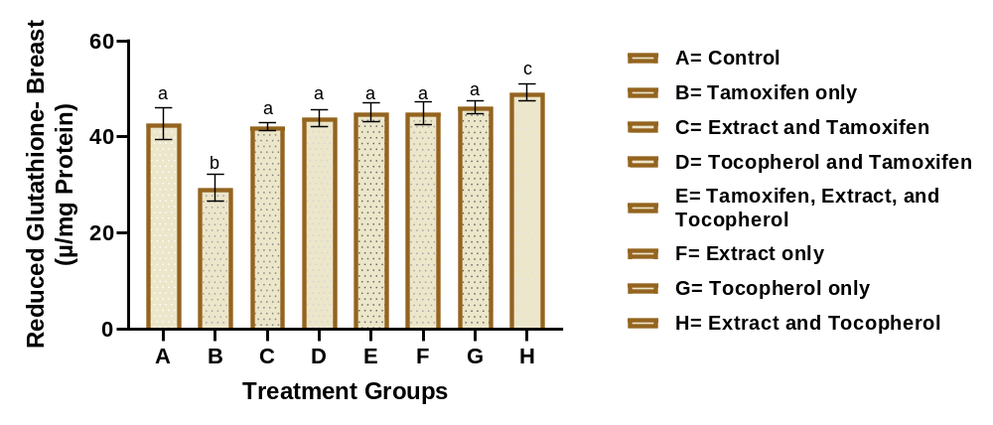Figure 12: Reduced glutathione (GSH) level in breast homogenate of various treatment groups. Values are expressed as mean ± SD (n=7); significant differences (p <0.05). Bar with same superscript indicate no significant difference while Bar with different superscript indicate significant difference

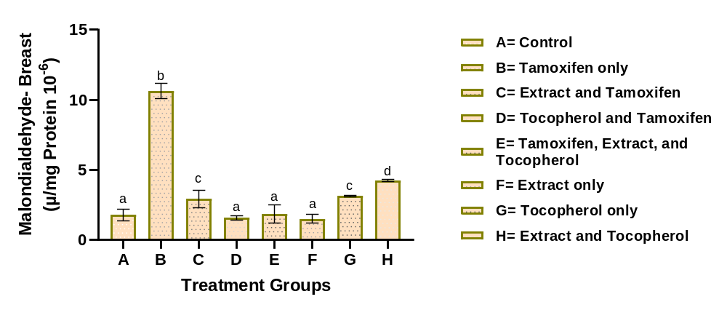Figure 13: Malondialdehyde (MDA) concentration in breast homogenate of various treatment groups. Values are expressed as mean ± SD (n=7); significant differences (p <0.05). Bar with same superscript indicate no significant difference while Bar with different superscript indicate significant difference

Complications associated with anticancer therapy have been linked to oxidative stress, redox imbalance and alterations in normal physiological functions (Adedosu et al., 2018). Tamoxifen is an important drug used in the prevention and treatment of hormone receptor-positive breast cancer, although prolonged use may be associated with adverse effects (Gaies et al., 2012; Manavi et al., 2024). Therefore, the identification of interventions that may attenuate treatment-associated biochemical and hematological alterations remains important (Zhang et al., 2023). In the present study, the effects of Embelia ribes seed extract and Vitamin E on Tamoxifen-associated alterations in total protein, hematological indices and breast tissue antioxidant status were evaluated.
Protein determination provides useful information on metabolic and cellular status because proteins are involved in numerous physiological processes, including transport, enzymatic activity and maintenance of cellular structure. In the present study, Tamoxifen administration significantly (p<0.05) reduced total protein concentration in both serum and breast homogenate (figure 1 and 2) compared with the control group. The reduction may reflect disturbances in protein metabolism, increased protein degradation or cellular alterations associated with oxidative stress (Sharma and Kim, 2021; Liu et al., 2024). Interestingly, administration of Embelia ribes seed extract and Vitamin E attenuated the reduction in total protein observed in the Tamoxifen-treated animals. In serum, Extract and Tamoxifen increased total protein to 5.58 g/dL, while Vitamin E and Tamoxifen and the combined treatment produced values of 5.00 and 5.02 g/dL, respectively, compared with 3.69 g/dL in the Tamoxifen-only group. A similar pattern was observed in breast homogenate, where Extract and Tamoxifen, Vitamin E and Tamoxifen and the combined treatment (Extract, Vitamin E and Tamoxifen) increased total protein relative to Tamoxifen alone. These findings suggest that the treatments may have reduced the biochemical disturbances associated with Tamoxifen administration (Abdelqader et al., 2023; Fang et al., 2023). The improvement observed with Vitamin E may be related to its established antioxidant role and ability to reduced lipid peroxidation and oxidative damage to cellular components (Ralla et al., 2024; Khalid et al., 2024). The effects observed with Embelia ribes seed extract may also be associated with its previously reported antioxidant properties (Rudrapal et al., 2024; Mubeen et al., 2025). However, the specific compounds responsible for the effects were not characterized in the present study. Although the combination treatment produced the most pronounced improvement in serum total protein, all treatment groups showed better protein status than the Tamoxifen-only treated group, suggestive of varying degrees of protection against Tamoxifen-induced biochemical disturbances (Fang et al., 2023). These findings suggesting that the extract and Vitamin E may attenuate some of the biochemical disturbances associated with Tamoxifen administration (Khallouki et al., 2023; Ahmed et al., 2026).
Hematological parameters are useful indicators of physiological changes and may provide evidence of drug-associated alterations in blood homeostasis. In the present study, figure 3, 4 and 5 it was observed Tamoxifen administration significantly (p<0.05) increased white blood cell (WBC), lymphocyte and platelet counts, while red blood cell (RBC) count, hemoglobin concentration and packed cell volume (PCV) figure 6, 7 and 8 were significantly (p<0.05) reduced compared with the control group. These findings indicate that prolonged Tamoxifen administration was associated with hematological alterations, including changes consistent with anemic status (Mahdiani et al., 2022). The elevations in WBC and lymphocyte counts following Tamoxifen administration may reflect a physiological response to drug-associated cellular stress or inflammatory processes (Fang, 2023; Sikora et al., 2023). Persistent changes in leukocyte populations have been associated with cellular injury and inflammatory stress (Gaman et al., 2019). Treatment with Embelia ribes seed extract and Vitamin E attenuated the increases in WBC and lymphocyte counts observed in the Tamoxifen-only group, suggesting improvement in the hematological response associated with Tamoxifen administration (Barboza et al., 2018). Tamoxifen administration also elicited a significant increase in platelet count, indicating an alteration in normal hematological balance. Increased platelet counts may occur in association with inflammatory and oxidative conditions (Chaudhary et al., 2022). Treatment with the extract and Vitamin E reduced the elevated platelet count relative to the Tamoxifen-only group, although the reduction was not complete in all treatment groups. This suggests that the treatments attenuated, but did not uniformly normalize, the platelet alteration associated with Tamoxifen administration (Pather, 2020; Giurranna et al., 2024).

The reduction in RBC count, hemoglobin concentration and PCV observed in the Tamoxifen-treated group suggests the development of mild anemia. Such alterations may result from oxidative damage to erythrocytes, impaired erythropoiesis or reduced red-cell survival (Obeagu et al., 2024). Red blood cells are particularly susceptible to oxidative damage because of their continuous exposure to oxygen and the high polyunsaturated fatty acid content of their membranes (Engwa et al., 2022). Treatment with Embelia ribes seed extract and Vitamin E improved RBC count, hemoglobin concentration and PCV compared with the Tamoxifen-only group, indicating attenuation of the hematological alterations associated with Tamoxifen administration (Orrico et al., 2023; Vona et al., 2021). Vitamin E may contribute to this effect by protecting membrane lipids against peroxidation (Altamura et al., 2019).
Oxidative stress results from an imbalance between reactive oxygen species generation and antioxidant defense and is an important mechanism underlying drug-associated cellular injury (Alfhili et al., 2023; Afzal et al., 2023). In the present study, the evaluation of redox indices as indication of oxidative stress and lipid peroxidation are reported in our results obtained in figure 9. 10, 11, 12 and 13 which showed that animal treated with Tamoxifen only (group B) caused significant (p<0.05) decreases in the activities of Superoxide Dismutase (SOD), Catalase (CAT), Glutathione Peroxidase (GPx) and concentrations of Reduced Glutathione (GSH) in breast homogenates. While, malondialdehyde (MDA) concentration was significantly (p<0.05) increase. This pattern indicates impaired antioxidant defense accompanied by increased lipid peroxidation and is consistent with disruption of breast tissue redox balance following Tamoxifen administration (Guneidy et al., 2024; Sadiq, 2023). Such alterations suggest that excessive production of free radicals overwhelmed the antioxidant system, resulting in oxidative damage to cellular macromolecules (Sadiq, 2023).
Super oxide dismutase (SOD) constitutes an important component of enzymatic antioxidant defense by converting superoxide radicals to hydrogen peroxide, which is subsequently removed by enzymes such as Catalase and Glutathione peroxidase (Jomova et al., 2024). The reduction in SOD activity following Tamoxifen administration suggests reduced capacity to neutralize superoxide radicals (Al-Hameed and Al-Ani, 2023). Treatment with Embelia ribes seed extract and Vitamin E increased SOD activity relative to the Tamoxifen-only group, indicating attenuation of the antioxidant imbalance (Abu-Zahra et al., 2025). The extract-only group showed the highest SOD activity among the treatment groups; therefore, the response should not be described as evidence that the combined treatment produced the greatest SOD improvement.
Catalase function together with Super oxide dismutase to remove hydrogen peroxide and protect cells from oxidative injury (Anwar et al., 2024). Tamoxifen administration reduced CAT activity, suggesting impairment of enzymatic antioxidant defense (Nazmeen et al., 2020). Treatment with Embelia ribes ssed extract and Vitamin E increased CAT activity compared with the Tamoxifen-only group, indicating improved antioxidant capacity (Andrés et al., 2022; Dubey and Sharm, 2025). The highest CAT activity was observed in the extract-only group, followed by the extract and Vitamin E group, indicating that the antioxidant response varied according to treatment combination. Vitamin E may have contributed through its membrane-protective antioxidant activity (Polutchko et al., 2021).
Glutathione peroxidase (GPx) and Reduced glutathione (GSH) form an important intracellular antioxidant system involved in the removal of peroxides and maintenance of cellular redox balance (Vašková et al., 2023). The reductions in GPx activity and GSH concentration observed in the Tamoxifen-treated group indicate depletion of antioxidant capacity during oxidative stress (Rui et al., 2021; Chen et al., 2024). However, administration of Embelia ribes seed extract and Vitamin E increased GPx and GSH relative to the Tamoxifen-only group, with several treatment groups approaching or exceeding the control values. This suggests that the treatments attenuated the depletion of endogenous antioxidant defenses associated with Tamoxifen exposure (Liu et al., 2024; Chandimali et al., 2024).
Malondialdehyde (MDA) is a commonly used indicator of lipid peroxidation and oxidative damage to cellular membranes (Al-Hameed and Al-Ani, 2023). In this study, Tamoxifen produced a marked increase in MDA concentration, from 1.78 in the control group to 10.62 in the Tamoxifen-only group, indicating enhanced lipid peroxidation (Guneidy et al., 2023; Voronina et al., 2024). Co-administration of Embelia ribes seed extract or Vitamin E with Tamoxifen substantially reduced MDA relative to the Tamoxifen-only group, with values of 2.93, 1.58 and 1.87 in the extract and Tamoxifen, Vitamin E and Tamoxifen and combination treatment groups (Extract, Vitamin E and Tamoxifen), respectively. The extract-only group also showed a low MDA value of 1.50. These findings indicate attenuation of Tamoxifen-associated lipid peroxidation, although the response varied among treatment combinations (Dell’Acqua et al., 2023; Uti et al., 2025). The antioxidant response observed with Embelia ribes seed is consistent with previous reported antioxidant properties of the plant (Tumilaar et al., 2024; Parcheta et al., 2021). However, the specific phytochemical constituents responsible for the observed effects were not characterized in the present study. Similarly, Vitamin E is a lipid-soluble antioxidant that protects polyunsaturated fatty acids in biological membranes from peroxidative damage (Recknagel et al., 2020). Its ability to limit lipid peroxidation may therefore contribute to the improved antioxidant status observed in several Vitamin E-treated groups. The combined treatment produced an enhanced response for some parameters compared with individual treatments, although the magnitude of the effect varied across the biochemical and hematological indices (Chaib et al., 2026).
Overall, the improvement in antioxidant enzyme activities and reduction in MDA observed in several treated groups indicate that Embelia ribes seed extract and Vitamin E attenuated the redox disturbances associated with Tamoxifen administration. Together with the improvement in hematological and total protein parameters, these findings support the potential of Embelia ribes seed extract as a candidate for further investigation in the context of Tamoxifen-associated biochemical alterations. However, the present biochemical findings do not by themselves establish histological protection or identify the specific compounds responsible for the observed effects.

- CONCLUSION
The findings of this study indicate that prolonged Tamoxifen administration was associated with alterations in serum and breast total protein, hematological parameters and antioxidant defense in breast tissue, as evidenced by changes in SOD, CAT, GPx, GSH and MDA. Administration of the ethyl acetate extract of Embelia ribes seed and Vitamin E ameliorated several of these alterations, although the magnitude of the response varied across the measured parameters and treatment combinations. The findings suggest that the ethyl acetate extract of Embelia ribes seed may have antioxidant and hematological protective potential against some of the biochemical and hematological alterations associated with Tamoxifen administration. These findings provide a basis for further investigation of Embelia ribes seed as a potential complementary candidate during Tamoxifen administration.
- LIMITATION
This study was limited to selected biochemical and hematological investigations, with seven animals analyzed per group. Detailed phytochemical characterization of the Embelia ribes seed extract and histopathological evaluation of the breast, liver and kidney tissues were not included in the present study. Therefore, further studies involving detailed phytochemical characterization, histopathological assessment and molecular investigations are recommended to identify the specific constituents and mechanisms underlying the observed effects and to provide further evidence of tissue-level changes.

Declaration of AI Use

This manuscript was prepared through the intellectual contributions of the author(s) to the study design, data analysis, interpretation of results, and scholarly content. Grammarly and ChatGPT were used solely to assist with grammatical refinement and reference formatting during manuscript revision. The author(s) accept full responsibility for the accuracy, integrity, and final content of the manuscript.

COMPETING INTERESTS DISCLAIMER:
Authors have declared that they have no known competing financial interests OR non-financial interests OR personal relationships that could have appeared to influence the work reported in this paper.

Declaration of conflict of interests
The authors declare that there is no conflict of interests among them.

REFERENCE
Abd Al-Hameed, N. M., & Al-Ani, A. W. (2023). Assessment of systemic oxidative stress and antioxidants in Iraqi women with newly diagnosed and tamoxifen-treated breast cancer. Eurasian Chemical Communications, 5, 204-215.
Abdelqader, A., Obeidat, M. D., Al-Rawashdeh, M. S., & Alrazak, A. A. (2023). The role of vitamin E as an antioxidant and preventing damage caused by free radicals. Journal of Life Science and Applied Research, 4(2), 88-95.
Abu-Zahra, N. I., Elbaz, S., El-Gammal, G. A., Kassab, A. S., Gouda, M., Elseify, M. M., & Soliman, S. (2025). Selenium and vitamin E supplementation alleviate high-fat diet-induced stress in or eochromis niloticus: enhancing growth, antioxidant defense, and disease resistance. Aquaculture International, 33(8), 695.
Adedosu, O. T., Badmus, J. A., Adeleke, G. E., & Olalere, G. O. (2017). Thaumatococcus daniellii extract modulates glibenclamide activity and ameliorates heamatological disorders, oxidative stress and dyslipidemia associated with diabetes mellitus in rats. Br. J. Pharm. Res, 16, 1-12.
Adedosu, O. T., Jimoh, R. A., Saraki, M. A., & Badmus, J. A. (2018). Ethanol leaves extract of Mangifera indica (L.) exhibits protective, antioxidative, and antidiabetic effects in rats. Asian Pac J Health Sci, 5(1), 188-194.
Aebi, H. (1984). Catalase in vitro. In Methods in enzymology (Vol. 105, pp. 121-126). Academic press.
Afzal, S., Abdul Manap, A. S., Attiq, A., Albokhadaim, I., Kandeel, M., & Alhojaily, S. M. (2023). From imbalance to impairment: the central role of reactive oxygen species in oxidative stress-induced disorders and therapeutic exploration. Frontiers in pharmacology, 14, 1269581.
Ahmed, A. S., Sabra, M. S., Abbas, A. Y. A., Kamal, A. A., & Abdelqader, Z. S. (2026). Targeting a novel tamoxifen-using pathway to preserve ovarian reserve in rats with experimental chemotherapy-induced ovarian failure. BMC Pharmacology and Toxicology, 27(1), 57.
Alfhili, M. A., Alyousef, A. M., & Alsughayyir, J. (2023). Tamoxifen induces eryptosis through calcium accumulation and oxidative stress. Medical Oncology, 40(11), 333.
Altamura, S., Vegi, N. M., Hoppe, P. S., Schroeder, T., Aichler, M., Walch, A., ... & Bornkamm, G. W. (2019). Glutathione peroxidase 4 and vitamin E control reticulocyte maturation, stress erythropoiesis and iron homeostasis. Haematologica, 105(4), 937.
Andersen, H.R., Nielsen, J.B., Nielsen, F. and Grandjean, P. Antioxidative Enzyme activities in human erythrocytes. Clinical chemistry, 1997,43(4), pp.562-568.
Anderson, M.E. Determination of glutathione and glutathione disulfide in biological samples. Methods in enzymology, 1985,113, pp.548-555.
Andrés, C. M. C., Pérez de la Lastra, J. M., Juan, C. A., Plou, F. J., & Pérez-Lebeña, E. (2022). Chemistry of hydrogen peroxide formation and elimination in mammalian cells, and its role in various pathologies. Stresses, 2(3), 256-274.
Anwar, S., Alrumaihi, F., Sarwar, T., Babiker, A. Y., Khan, A. A., Prabhu, S. V., & Rahmani, A. H. (2024). Exploring therapeutic potential of catalase: Strategies in disease prevention and management. Biomolecules, 14(6), 697.
Barbara, J., Bain, B., Bain, B. J., Dacie, J. V., Dacie, J. V., Bates, I., ... & Lewis, S. M. (2011). Dacie and Lewis practical haematology. Churchill Livingstone.
Barboza, J. N., da Silva Maia Bezerra Filho, C., Silva, R. O., Medeiros, J. V. R., & de Sousa, D. P. (2018). An overview on the anti‐inflammatory potential and antioxidant profile of eugenol. Oxidative medicine and cellular longevity, 2018(1), 3957262.
Batovska, D., Gerasimova, A., & Nikolova, K. (2024). Exploring the therapeutic potential of jujube (Ziziphus jujuba mill.) extracts in cosmetics: a review of bioactive properties for skin and hair wellness. Cosmetics, 11(5), 181.
Chaib, N., Elouardi, M., Azdem, D., Mabrouki, J., Boutakiout, A., Rouas, S., ... & Alaoui El Belghiti, M. (2026). Synergistic interactions of antioxidants in lipid peroxidation: mechanistic insights and applications. Euro-Mediterranean Journal for Environmental Integration, 11(5), 164.
Chandimali, N., Bak, S. G., Park, E. H., Lim, H. J., Won, Y. S., Kim, E. K., ... & Lee, S. J. (2025). Free radicals and their impact on health and antioxidant defenses: A review. Cell death discovery, 11(1), 19.
Chaudhary, P. K., Kim, S., & Kim, S. (2022). An insight into recent advances on platelet function in health and disease. International Journal of Molecular Sciences, 23(11), 6022.
Chen, T. H., Wang, H. C., Chang, C. J., & Lee, S. Y. (2024). Mitochondrial glutathione in cellular redox homeostasis and disease manifestation. International Journal of Molecular Sciences, 25(2), 1314.
Costanzo, V., Ratre, Y. K., Andretta, E., Acharya, R., Bhaskar, L. V. K. S., & Verma, H. K. (2024). A comprehensive review of cancer drug–induced cardiotoxicity in blood cancer patients: current perspectives and therapeutic strategies. Current treatment options in oncology, 25(4), 465-495.
Dell’Acqua, G., Richards, A., & Thornton, M. J. (2020). The potential role of nutraceuticals as an adjuvant in breast cancer patients to prevent hair loss induced by endocrine therapy. Nutrients, 12(11), 3537.
Dominiczak, M.H. 1998 Teaching and training laboratory professionals for the 21st century. Clinical Chemistry and laboratory Medicine ,1998, 36 ,133-136.
Dubey, A., & Sharma, B. (2025). Targeting oxidative stress biomarkers in breast cancer development and the potential protective effect of phytochemicals. Drugs and Drug Candidates, 4(2), 23.
Engwa, G. A., Nweke, F. N., & Nkeh-Chungag, B. N. (2022). Free radicals, oxidative stress-related diseases and antioxidant supplementation. Alternative Therapies in Health & Medicine, 28(1).
Fang, Z. (2023). Investigating the anti-leukaemic effect of tamoxifen in the myeloproliferative neoplasms (Doctoral dissertation).
Fang, Z., Xu, H., Duan, J., Ruan, B., Liu, J., Song, P., ... & Wang, L. (2023). Short-term tamoxifen administration improves hepatic steatosis and glucose intolerance through JNK/MAPK in mice. Signal Transduction and Targeted Therapy, 8(1), 94.
Fatoki, J.O., Adedosu, O.T., Afolabi, O.K., Adeleke, G.E., Adedeji, A.L., Ige, S.F., Adesope, E.O., Oyewole, O.V., Daramola, A.D. and Badmus, J.A. Dyslipidemic effect of doxorubicin and etoposide: a predisposing factor for the antineoplastic drugsinduced cardiovascular diseases. Research & Reviews: Journal of Pharmacology and Toxicological Studies, 2018,6(1), pp.34-42.
Francis, A., Harhay, M. N., Ong, A. C., Tummalapalli, S. L., Ortiz, A., Fogo, A. B., ... & International Society of Nephrology. (2024). Chronic kidney disease and the global public health agenda: an international consensus. Nature Reviews Nephrology, 20(7), 473-485.
Gaies, E., Jebabli, N., Trabelsi, S., Salouage, I., Charfi, R., Lakhal, M. and Klouz, A. Methotrexate side effects: review article. Journal of Drug Metabolism and Toxicology, 2012, 3(4), pp.1-5.
Gaman, A. M., Moisa, C., Diaconu, C. C., & Gaman, M. A. (2019). Crosstalk between oxidative stress, chronic inflammation and disease progression in essential thrombocythemia. Rev Chim, 70(10), 3486-3489.
Giurranna, E., Nencini, F., Bettiol, A., Borghi, S., Argento, F. R., Emmi, G., ... & Becatti, M. (2024). Dietary antioxidants and natural compounds in preventing thrombosis and cardiovascular disease. International Journal of Molecular Sciences, 25(21), 11457.
Guneidy, R. A., Zaki, E. R., Karim, G. A., Saleh, N. S., & Shokeer, A. (2023). Adverse effect of Tamarindus indica and tamoxifen combination on redox balance and genotoxicity of breast cancer cell. Journal of Genetic Engineering and Biotechnology, 21(1), 131.
Guneidy, R., Shokeer, A., Saleh, N., & Zaki, E. (2024). Effect of Protocatechuic Acid on Tamoxifen Efficacy and Oxidative Stress in Breast Cancer Cells: Implications for Combination Therapy. Egyptian Journal of Chemistry, 67(12), 167-181.
Javankiani, S., Bolandi, S., Soleimani, A., Meigoli, M. S. S., Parsafar, M., Safaei, S., ... & Sharafi, M. (2025). MAPK signaling mediates tamoxifen resistance in estrogen receptor-positive breast cancer. Molecular and Cellular Biochemistry, 480(9), 4973-4989.
Jin, Y. and Manabe, T. Differences in protein distribution between human plasma preparations, EDTA‐plasma and heparin‐plasma, analyzed by non‐denaturing micro‐2‐DE and MALDI‐MS PMF. Electrophoresis,2009, 30(6), pp.931-938
Jomova, K., Alomar, S. Y., Alwasel, S. H., Nepovimova, E., Kuca, K., & Valko, M. (2024). Several lines of antioxidant defense against oxidative stress: antioxidant enzymes, nanomaterials with multiple enzyme-mimicking activities, and low-molecular-weight antioxidants. Archives of toxicology, 98(5), 1323-1367.
Jomova, K., Alomar, S. Y., Alwasel, S. H., Nepovimova, E., Kuca, K., & Valko, M. (2024). Several lines of antioxidant defense against oxidative stress: antioxidant enzymes, nanomaterials with multiple enzyme-mimicking activities, and low-molecular-weight antioxidants. Archives of toxicology, 98(5), 1323-1367.
Khalid, M. Z., Mohagheghi, S., Pourkabir, R. A., Bahmani, M., Nourian, A., & Shafiee, G. (2024). Evaluation of the protective effects of vitamins E and D on oxidative stress and inflammation caused by tamoxifen in the renal tissue of female Wistar rats. Current Drug Therapy, 19(5), 604-612.
Khallouki, F., Hajji, L., Saber, S., Bouddine, T., Edderkaoui, M., Bourhia, M., ... & Poirot, M. (2023). An update on tamoxifen and the chemo-preventive potential of vitamin E in breast cancer management. Journal of Personalized Medicine, 13(5), 754.
Kilicarslan You, D., Fuwad, A., Lee, K. H., Kim, H. K., Kang, L., Kim, S. M., & Jeon, T. J. (2024). Evaluation of the protective role of vitamin E against ROS-driven lipid oxidation in model cell membranes. Antioxidants, 13(9), 1135.
Liu, Y. E., Wu, G., Feng, L., Li, J., Xia, Y., Guo, W., & Zhao, K. (2025). Harnessing antioxidants in cancer therapy: opportunities, challenges, and future directions. Antioxidants, 14(6), 674.
Liu, Y., Yang, C., Zhang, J., Ihsan, A., Ares, I., Martínez, M., ... & Martínez, M. A. (2024). Recent progress in adverse events of carboxylic acid non-steroidal anti-inflammatory drugs (CBA-NSAIDs) and their association with the metabolism: the consequences on mitochondrial dysfunction and oxidative stress, and prevention with natural plant extracts. Expert Opinion on Drug Metabolism & Toxicology, 20(8), 765-785.
Lloyd, M. R., Wander, S. A., Hamilton, E., Razavi, P., & Bardia, A. (2022). Next-generation selective estrogen receptor degraders and other novel endocrine therapies for management of metastatic hormone receptor-positive breast cancer: current and emerging role. Therapeutic advances in medical oncology, 14, 17588359221113694.
Mahdiani, S., Omidkhoda, N., Heidari, S., Hayes, A. W., & Karimi, G. (2022). Protective effect of luteolin against chemical and natural toxicants by targeting NF‐κB pathway. Biofactors, 48(4), 744-762.
Misra, H.P. and Fridovich, I. The role of superoxide anion in the autoxidation of epinephrine and a simple assay for superoxide dismutase. Journal of Biological chemistry, 1975,247(10), pp.3170-3175.
Mohideen, K., Chandrasekar, K., Ramsridhar, S., Rajkumar, C., Ghosh, S., & Dhungel, S. (2023). Assessment of oxidative stress by the estimation of lipid peroxidation marker malondialdehyde (MDA) in patients with chronic periodontitis: a systematic review and meta‐analysis. International journal of dentistry, 2023(1), 6014706.
Mubeen, B., Hasnain, A., Atif, S., Hakim, F., Sheharyar, S., Hassan, M., ... & Duan, M. (2025). Phytochemicals as multi-target therapeutic agents for oxidative stress-driven pathologies: mechanisms, synergies, and clinical prospects. Phyton, 94(7), 1941.
Muscolo, A., Mariateresa, O., Giulio, T., & Mariateresa, R. (2024). Oxidative stress: the role of antioxidant phytochemicals in the prevention and treatment of diseases. International journal of molecular sciences, 25(6), 3264.
Naik, S. R., & Gamare, D. (2025). Evidenced-based Phytotherapy Overview: Protective Role of Diverse Bioactive Phytochemicals in Myocardial ischemia through Pharmacodynamics and Molecular Mechanisms. Journal of Cardiovascular Medicine and Cardiology, 12(3), 022-033.
Nazmeen, A., Chen, G., Ghosh, T. K., & Maiti, S. (2020). Breast cancer pathogenesis is linked to the intra-tumoral estrogen sulfotransferase (hSULT1E1) expressions regulated by cellular redox dependent Nrf-2/NF κ β interplay. Cancer Cell International, 20(1), 70.
Nwozo, O. S., Effiong, E. M., Aja, P. M., & Awuchi, C. G. (2023). Antioxidant, phytochemical, and therapeutic properties of medicinal plants: A review. International Journal of Food Properties, 26(1), 359-388.
Obeagu, E. I., Igwe, M. C., & Obeagu, G. U. (2024). Oxidative stress’s impact on red blood cells: Unveiling implications for health and disease. Medicine, 103(9), e37360.
Ohkawa, H., Ohishi, N. and Yagi, K. Assay for lipid peroxides in animal tissues by thiobarbituric acid reaction. Analytical biochemistry, 1979,95(2), pp.351-358.
Orrico, F., Laurance, S., Lopez, A. C., Lefevre, S. D., Thomson, L., Möller, M. N., & Ostuni, M. A. (2023). Oxidative stress in healthy and pathological red blood cells. Biomolecules, 13(8), 1262.
Parcheta, M., Świsłocka, R., Orzechowska, S., Akimowicz, M., Choińska, R., & Lewandowski, W. (2021). Recent developments in effective antioxidants: The structure and antioxidant properties. Materials, 14(8), 1984.
Pather, K. (2020). Hormone-Therapy Mediated Interactions Between Platelets and Breast Cancer Cells: An in Vitro Study (Doctoral dissertation, University of the Witwatersrand, Johannesburg (South Africa)).
Polutchko, S. K., Glime, G. N., & Demmig-Adams, B. (2021). Synergistic action of membrane-bound and water-soluble antioxidants in neuroprotection. Molecules, 26(17), 5385.
Radeva, L., & Yoncheva, K. (2025). Doxorubicin toxicity and recent approaches to alleviating its adverse effects with focus on oxidative stress. Molecules, 30(15), 3311.
Rafiu, B.O., Adesanya, E.O. and Sonibare, A.M. Phytochemical screening, antimicrobial and antioxidant studies of Lannea egregia Engl. and K. Krause (Anacardiaceae) stem bark. Journal of Medicinal Plants for Economic Development, 2019, 3(1), pp.19.
Ralla, T., Kluenter, A. M., Litta, G., Müller, M. A., Bonrath, W., & Schäfer, C. (2024). Over 100 years of vitamin E: An overview from synthesis and formulation to application in animal nutrition. Journal of Animal Physiology and Animal Nutrition, 108(3), 646-663.
Recknagel, R. O., Glende, E. A., & Britton, R. S. (2020). Free radical damage and lipid peroxidation. In Hepatotoxicology (pp. 401-436). CRC press.
Rossi, M., Salomon, A., Chaumontel, N., Molet, J., Bailly, S., Tillet, E., & Bouvard, C. (2023). Warning regarding hematological toxicity of tamoxifen activated CreERT2 in young Rosa26CreERT2 mice. Scientific Reports, 13(1), 5976.
Rout, P. R., Shahid, M. K., Dash, R. R., Bhunia, P., Liu, D., Varjani, S., ... & Surampalli, R. Y. (2021). Nutrient removal from domestic wastewater: A comprehensive review on conventional and advanced technologies. Journal of Environmental Management, 296, 113246.
Rudrapal, M., Rakshit, G., Singh, R. P., Garse, S., Khan, J., & Chakraborty, S. (2024). Dietary polyphenols: review on chemistry/sources, bioavailability/metabolism, antioxidant effects, and their role in disease management. Antioxidants, 13(4), 429.
Rui, T., Wang, H., Li, Q., Cheng, Y., Gao, Y., Fang, X., ... & Luo, C. (2021). Deletion of ferritin H in neurons counteracts the protective effect of melatonin against traumatic brain injury‐induced ferroptosis. Journal of pineal research, 70(2), e12704.
Sadiq, I. Z. (2023). Free radicals and oxidative stress: Signaling mechanisms, redox basis for human diseases, and cell cycle regulation. Current molecular medicine, 23(1), 13-35.
Sadiq, I. Z. (2023). Free radicals and oxidative stress: Signaling mechanisms, redox basis for human diseases, and cell cycle regulation. Current molecular medicine, 23(1), 13-35.
Shah, A., Srivastava, S., & Chaturvedi, C. P. (2024). Biomolecular components of blood and their role in health and diseases. In Clinical applications of biomolecules in disease diagnosis: A comprehensive guide to biochemistry and metabolism (pp. 289-322). Singapore: Springer Nature Singapore.
Sharma, C., & Kim, S. R. (2021). Linking oxidative stress and proteinopathy in Alzheimer’s disease. Antioxidants, 10(8), 1231.
Sikora, J. P., Karawani, J., & Sobczak, J. (2023). Neutrophils and the systemic inflammatory response syndrome (SIRS). International Journal of Molecular Sciences, 24(17), 13469.
Swamy, A. M., Sehrawat, A., & Sundriyal, D. (2025). Unexpected thrombocytopenia of a rare tamoxifen-induced complication in breast cancer therapy: A case report. World Journal of Clinical Cases, 13(31), 109772.
Tumilaar, S. G., Hardianto, A., Dohi, H., & Kurnia, D. (2024). A comprehensive review of free radicals, oxidative stress, and antioxidants: Overview, clinical applications, global perspectives, future directions, and mechanisms of antioxidant activity of flavonoid compounds. Journal of Chemistry, 2024(1), 5594386.
Uti, D. E., Atangwho, I. J., Alum, E. U., Ntaobeten, E., Obeten, U. N., Bawa, I., ... & Egbung, G. E. (2025). Antioxidants in cancer therapy mitigating lipid peroxidation without compromising treatment through nanotechnology. Discover Nano, 20(1), 70.
Vašková, J., Kočan, L., Vaško, L., & Perjési, P. (2023). Glutathione-related enzymes and proteins: a review. Molecules, 28(3), 1447.
Vona, R., Sposi, N. M., Mattia, L., Gambardella, L., Straface, E., & Pietraforte, D. (2021). Sickle cell disease: role of oxidative stress and antioxidant therapy. Antioxidants, 10(2), 296.
Voronina, M. V., Frolova, A. S., Kolesova, E. P., Kuldyushev, N. A., Parodi, A., & Zamyatnin Jr, A. A. (2024). The intricate balance between life and death: ROS, cathepsins, and their interplay in cell death and autophagy. International Journal of Molecular Sciences, 25(7), 4087.
Zhang, S., Jin, Z., Bao, L., & Shu, P. (2024). The global burden of breast cancer in women from 1990 to 2030: assessment and projection based on the global burden of disease study 2019. Frontiers in oncology, 14, 1364397.

