Original Research Article

Comprehensive Standardization and Quality Evaluation of Katurohini (Picrorhiza kurroa Royle ex Benth.) Rhizome through Pharmacognostical, Physicochemical, Phytochemical and HPTLC Studies

ABSTRACT
Background: Picrorhiza kurroa Royle ex Benth. is an important Ayurvedic drug in which the rhizome constitutes the medicinal part. Establishment of pharmacognostical and analytical parameters is essential for its identification and quality evaluation.
Aim and Objectives: The present study was undertaken to establish pharmacognostical, physicochemical, preliminary phytochemical, and HPTLC fingerprint parameters of the rhizome of P. kurroa.
Materials and Methods: The authenticated rhizome was evaluated for macroscopic, organoleptic, transverse-section, and powder-microscopic characteristics. Physicochemical evaluation included foreign matter, extractive values, total ash, loss on drying, and pH. Preliminary phytochemical screening was carried out on aqueous and ethanol extracts. HPTLC fingerprinting was performed on the methanolic extract using silica gel 60 F254 aluminium plates and chloroform:methanol (8:2, v/v) as the mobile phase, with detection at 254 and 366 nm.
Results: The rhizome exhibited cylindrical morphology with a greyish-brown to dark-brown surface, bitter taste, and diagnostic microscopic features including cork, cortex, phloem, xylem, fibres, vessels, and starch-containing parenchyma. Physicochemical evaluation showed 0% foreign matter, alcohol-soluble extractive of 32.81%, water-soluble extractive of 36.28%, total ash of 2.98%, loss on drying of 4.12%, and pH 4.2. Aqueous and ethanol extracts showed positive reactions for flavonoids, phenolic compounds, glycosides, terpenoids, and steroids. HPTLC profiling of the methanolic extract produced chromatographic patterns, with Rf values ranging from 0.319–0.502 at 254 nm and 0.318–0.768 at 366 nm.
Conclusion: The study establishes pharmacognostical, physicochemical, preliminary phytochemical, and chromatographic parameters for P. kurroa rhizome. The data may serve as reference standards for authentication, quality evaluation, and standardization of the drug.
Keywords: Kutki, Picrorhiza kurroa Royle, Pharmacognosy, Physicochemical, Phytochemicals HPTLC

- INTRODUCTION
Picrorhiza kurroa Royle ex Benth. (syn. Picrorhiza kurrooa Royle and Picrorhiza lindleyana (Wall.) Steud.) is a small, perennial, stoloniferous alpine medicinal herb belonging to the family Plantaginaceae and is commonly known as Katurohini or Kutki in Ayurveda (POWO, 2026; Shitiz et al., 2013; Chettri et al., 2005). The plant generally attains a height of 10–20 cm and possesses a short, weak, creeping stem that becomes erect during flowering. It has a well-developed underground rhizomatous system consisting of elongated, cylindrical rhizomes and numerous adventitious roots. The rhizomes are cylindrical, irregularly curved and branched, with roots arising from distinct jointed nodes. The leaves are radical, alternate and rosulate, while the small, bisexual, zygomorphic flowers are white to pale bluish-purple and arranged in dense terminal spikes (Rasool et al., 2016; Kar, 2007; Kumari et al., 2021).
Picrorhiza kurroa is naturally distributed in the temperate and alpine regions of the Indo-China Himalayan belt and is adapted to cool conditions. It commonly grows in cool & moist alpine meadows, grassy slopes, rocky crevices, cliff faces, mountain slopes, stream banks and humus-rich soils at elevations of 2,700–4,500 m, with some reports extending up to 5,000 m above mean sea level (Shitiz et al., 2013; Chettri et al., 2005). Geographically, it extends from Garhwal in Uttarakhand to Bhutan, Nepal, North Myanmar, South-East Tibet and Western China. In India, it occurs in Jammu and Kashmir, Ladakh, Himachal Pradesh, Uttarakhand, Sikkim and Arunachal Pradesh (Sah and Varshney, 2013; Thani, 2021; Akbar, 2020; Mehra et al., 2017; Sharma, 2021). Owing to its extensive medicinal use, overexploitation from wild populations, habitat degradation and poor natural regeneration, the species has undergone significant population decline and is recognized as a threatened Himalayan medicinal plant, warranting conservation and sustainable utilization.
The rhizome and roots constitute the principal medicinal parts of Picrorhiza kurroa. The roots are hard, slender and wrinkled, greyish-brown to brown externally, while the rhizomes are greyish-brown externally and cream to pale yellow internally. The drug possesses a characteristic intensely bitter taste, which is an identifying feature. Well-developed aerenchyma tissues are present in the leaves, aerial stem and rhizomes, facilitating adaptation to its moist alpine habitat. Two types of glandular trichomes are present on the leaves. These characteristic features are useful for the identification and authentication of the crude drug (Rasool et al., 2016; Kar, 2007; Kumari et al., 2021).
In Ayurvedic medicine, Katurohini has traditionally been recognized for several therapeutic actions, including Bhedana (purgative), Lekhana (emaciating), Sara (cathartic), Stanyashodhana (breast milk purifier), Balya (tonic), Deepana (digestive stimulant), Prajasthapana (abortifacient), Hrudya (cardiac tonic), Agnipradipana (stomachic) and Rochana (appetizer), along with laxative, cholagogue and hepato-stimulatory activities. These applications establish Katurohini as an important Ayurvedic medicinal drug (Parihar and Behera, 2025).
Although several pharmacognostical, phytochemical, pharmacological and analytical studies have been reported on Picrorhiza kurroa, comprehensive investigations integrating pharmacognostical characterization, physicochemical evaluation, preliminary phytochemical screening and HPTLC fingerprint profiling of the rhizome are relatively limited. Authenticated reference data generated under standardized analytical conditions are essential for establishing reliable quality-control parameters and ensuring the identity, purity and consistency of the crude drug. Therefore, the present study was undertaken to establish comprehensive pharmacognostical, physicochemical, phytochemical and HPTLC fingerprint standards for the rhizome of Picrorhiza kurroa (Katurohini). The findings are expected to provide reference parameters for authentication, quality assessment and standardization and to facilitate future pharmacopoeial, phytopharmaceutical and formulation-based research.
- MATERIALS AND METHODS
2.1 Collection and Authentication of Plant Material
The raw drug used for the present study, consisting of the whole rhizome of Katurohini (Picrorhiza kurroa Royle ex Benth.), was procured from a local vendor in Baijnath, Himachal Pradesh, during October–November 2025. The collected drug sample was subsequently subjected to taxonomic identification and authentication at the BGIR, Botanical Survey of India (BSI), Sector 38A, Gautam Budh Nagar, Noida–201303. The authentication was carried out in November 2025 with Authentication No. BSI/BGIR/1/TECH./2025/281. Following authentication, the drug sample was used for further analysis and preparation of the trial formulation. HPTLC analysis of the authenticated drug sample was carried out at Delhi Pharmaceutical Sciences and Research University (DPSRU), New Delhi.
2.2 Pharmacognostical Study
Pharmacognostical evaluation of the P. kurroa rhizome was carried out in the Pharmacognosy Laboratory, Department of Dravya guna, A & U Tibbia College and Hospital, Karol Bagh, New Delhi, following standard pharmacognostical procedures.
2.3 Macroscopic and Organoleptic Study
Macroscopic examination was performed by visual observation to record the size, shape, colour, surface characteristics, fracture, odour, and taste of the rhizome. Organoleptic characters were evaluated using sensory perception and standard descriptive parameters.
2.4 Microscopic Study
Microscopic study of crude drug is helpful in the process of standardization of medicinal plants. This study can help identify the genuine drugs by their known histological characters through the transverse section (T.S.) and powder microscopy which helps in the evaluation of different constituents by using different staining reagents.

2.5 Transverse Section Microscopy
Fresh transverse sections of the rhizome were prepared manually using a sharp razor blade after softening the material in water. The sections were stained with safranin, mounted in glycerin, and examined under a compound microscope to study the anatomical characteristics of different tissues.
2.6 Powder Microscopy

Dried rhizome was finely powdered and passed through an 80-mesh sieve. The powdered drug was mounted in glycerin, with and without staining, and examined under an Axio cam ICc5 microscope at different magnifications (4×, 10×, and 40×). Diagnostic microscopic characters were recorded and photographed.
2.7 Physicochemical Analysis
Foreign matter, LOD, ash value, extractive value (Water-soluble extractive and Ethanol-soluble extractive) and pH were determined according to API guidelines.
2.8 Preparation of Extracts
Approx. 5 gm of (Picrorrhiza kurroa Royle ex Benth), Rhizome powder was taken in a conical flask. Following the ratio of 1:10, 50 ml of ethanol & distilled water was poured into this flask. Then, the mixtures were shaken on a rotary shaker for 5 hours, allowed to stand for extraction, and subsequently filtered through Whatman No. 1 filter paper. The filtrates obtained were used for preliminary phytochemical screening.
2.9 Phytochemical Analysis
Qualitative phytochemical screening of the aqueous and ethanolic extracts was performed using standard phytochemical procedures to detect the presence of major primary and secondary metabolites. The extracts were evaluated for alkaloids (Dragendorff’s reagent), flavonoids (alkaline reagent test), phenolic compounds (ferric chloride test), glycosides (Keller–Killiani test), terpenoids (Salkowski test), proteins and amino acids (Millon’s test), tannins (ferric chloride test), carbohydrates (Fehling’s test), saponins (foam test), and steroids (Salkowski test).
2.10 Analytical Study
2.10.1 High-Performance Thin-Layer Chromatography (HPTLC)
The study was carried out at Delhi Pharmaceutical Sciences and Research University (DPSRU), Tughlakabad, New Delhi. High-Performance Thin-Layer Chromatography (HPTLC) analysis was performed using the methanolic extract of Katurohini rhizome.
A volume of 2.0, 4.0, 6.0, 8.0, 10.0, 12.0 and 14.0 μL of the methanolic extract solution was applied as 8 mm bands onto pre-activated HPTLC silica gel 60 F254 plates (10 × 10 cm) using a CAMAG Linomat 5 applicator (Model: Linomat 5; S/N 270409; Version 1.00.13) fitted with a 100 μL Hamilton syringe. The application rate was maintained at 150 nL/s with a constant flow of inert nitrogen gas. The sample was applied 8 mm above the lower edge of the plate with a track spacing of 11.4 mm.
The ADC2 automatic development chamber (CAMAG, Switzerland) was saturated with mobile-phase vapours for 20 minutes using 20 mL of the selected mobile phase. Plate development was performed with 10 mL of mobile phase, allowing the solvent front to migrate up to 70 mm from the point of application.
Following development, the plate was subjected to densitometric scanning under UV light at 254 nm and 366 nm. Multiple solvent systems were tested, and the optimized mobile phase that produced distinct and well-resolved chromatographic bands was selected for analysis.
Mobile phase: Chloroform: methanol (8:2, v/v)
- RESULTS AND DISCUSSION
3.1 Pharmacognostical Study
3.2 Macroscopic Characters
The rhizome of Picrorhiza kurroa was observed as a dried underground stem collected from the mature plant. The rhizome was cylindrical, straight to slightly curved, and hard in texture. Its outer surface was greyish-brown to dark brown, rough, and distinctly marked with longitudinal wrinkles and numerous circular root scars. In some pieces, thin root remnants were attached, while the upper end showed a small growing bud surrounded by scale-like leaf bases. The dried rhizome was brittle and exhibited a short, uneven fracture on breaking. The fractured surface appeared dark to blackish with pale vascular tissues. It possessed a characteristic pleasant odour and a distinctly bitter taste.
3.3 Organoleptic Features
Table no. 1 Organoleptic features of Katurohini rhizome and its Powder
S. No. | Character | Katurohini (Picrorhiza kurroa)  Rhizome | Katurohini (Picrorhiza kurroa) Powder
1 | Shabda (Sound) | Hard and brittle; produces a short, dull sound on breaking | –
2 | Sparsha (Touch) | Hard, rough and brittle | Fine, smooth and dry
3 | Roopa (Colour) | Greyish-brown to dark brown externally; fractured surface dark black with a distinct whitish xylem ring | Dusty grey
4 | Rasa (Taste) | Distinctly bitter | Very bitter, long-lasting
5 | Gandha (Odour) | Characteristic, pleasant | Faint, disagreeable

3.2 Microscopic Evaluation
3.2.1 Transverse section: A transverse section of the Picrorhiza rhizome reveals a cork layer made up of several tiers of compact, uniformly arranged, thin-walled cells. This cork encloses a broad cortex composed primarily of thin-walled, mostly irregularly rounded to oval parenchymatous cells, some of which gradually transition into the secondary phloem. The phloem contains sieve tubes, companion cells, and parenchyma. The cambium appears narrow and wavy, consisting of several layers of compressed cells. The secondary xylem comprises thick-walled vessels showing annular, spiral, or reticulate thickening, along with tracheids and fibers. The pith occupies the center and is made up of thin-walled parenchymatous cells.
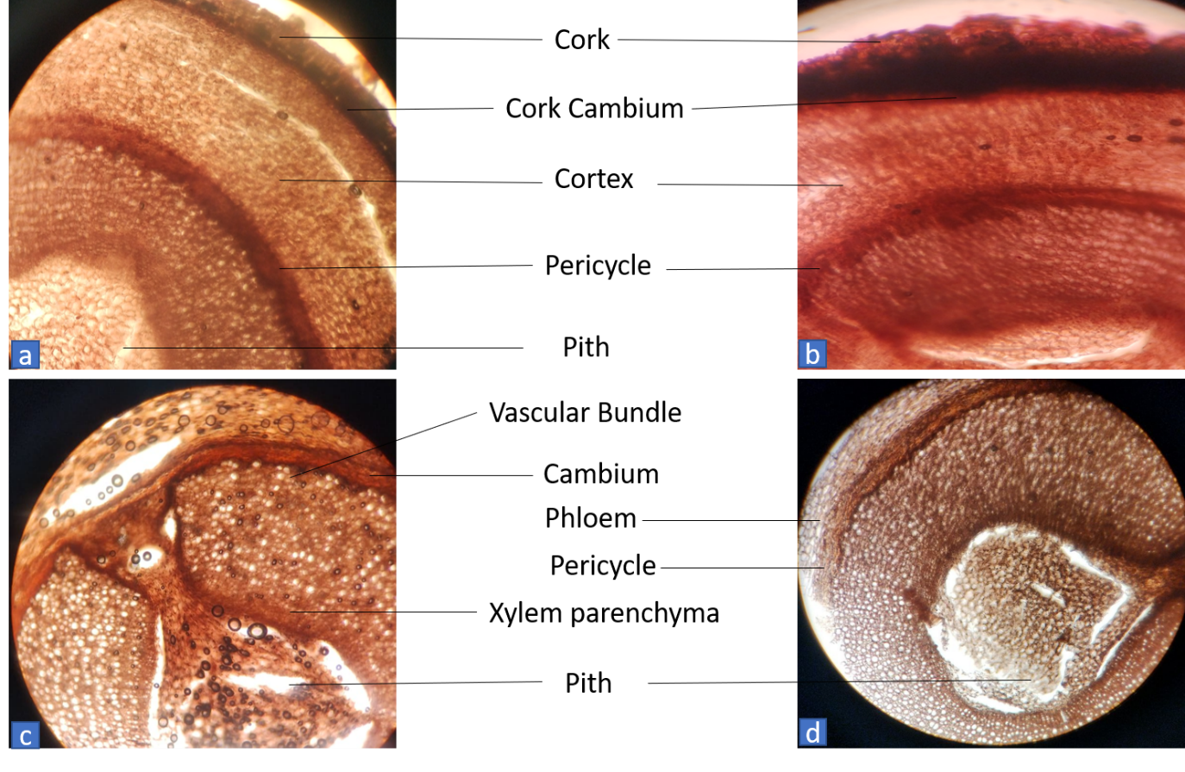
Figure No. 1: Picrorhiza kurroa Royle ex Benth. rhizome transverse section (T.S.) at 40×, stained with Safranin, showing a well-differentiated tissue organization comprising A. Cork, Cork Cambium, Cortex, Pericycle and Pith; B. Cork, Cork Cambium and Cortex; C. Vascular Bundle showing Cambium, Phloem and Xylem Parenchyma; and D. Pith.

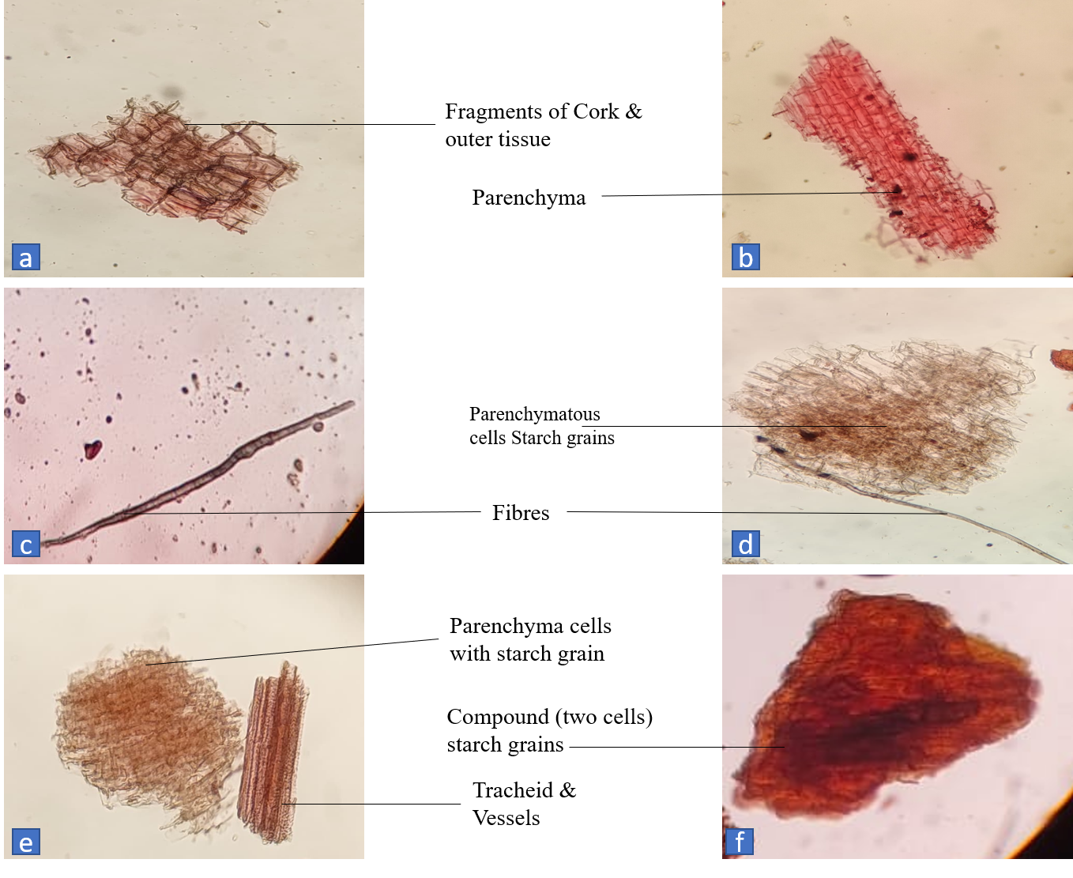
3.2.2 Powder microscopy: The powder microscopy of Picrorhiza kurroa rhizome showed several characteristic diagnostic features. The powder exhibited fragments of cork and outer tissue composed of compactly arranged polygonal cells. Parenchymatous tissue was observed in the form of thin-walled cells, many of which contained starch grains. Elongated thick-walled fibres providing mechanical support were also present in the powdered drug. Tracheids and vessel elements with characteristic thickened and lignified walls were observed in the powder preparation. Compound starch grains, consisting of two united cells, were also present. These characteristic microscopic features served as important diagnostic characters for the identification and authentication of the powdered rhizome.

Figure No. 2: Powder microscopy of Picrorhiza kurroa Royle ex Benth. rhizome (Safranin stained) showing A. Fragments of Cork & Outer Tissue, B. Parenchyma, C & D. Fibres, D & E. Parenchymatous Cells containing Starch Grains, E. Tracheids & Vessels, and F. Compound (Two-cell) Starch Grains.

PHYSICOCHEMICAL STUDY

3.3 Physicochemical Analysis
Table no. 2: Physicochemical observations of Katurohini
S. No. | Test | Observations | Standard Limits as Per API (API, Government of India, 1999).
- 1 | Foreign matter | 0% | Not more than 2.0 %
- 2 | Extractive Value (Alcohol soluble) | 32.81 % | Not less than 20.0 %
- 3 | Extractive Value (water-soluble) | 36.28 % | Not less than 10.0 %
- 4 | Total Ash | 2.98 % | Not more than 7.0 %
- 5 | Moisture Content (LOD) | 4.12 % | Not more than 10.0 %
- 6 | pH value  (10% aqueous solution) | 4.2 | Not specified in API
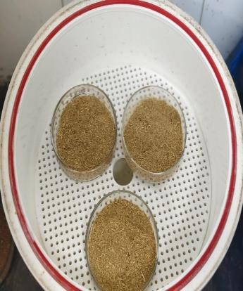
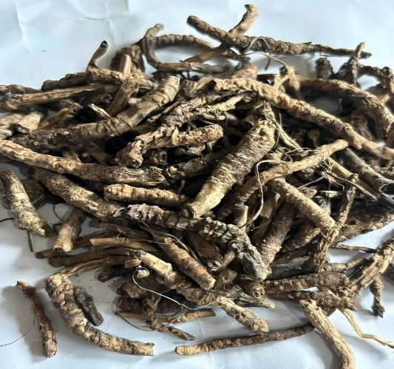
Figure No. 4: Moisture Content (LOD) of Katurohini powder

Figure No. 3: Foreign matter of Katurohini

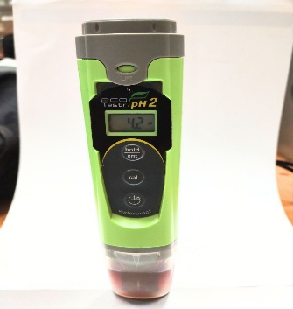
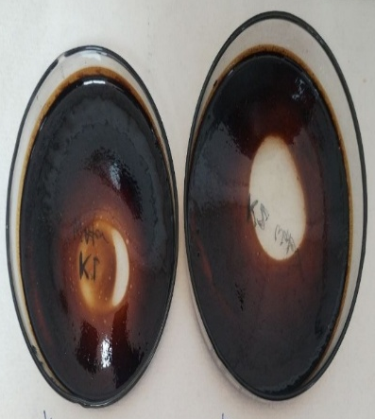
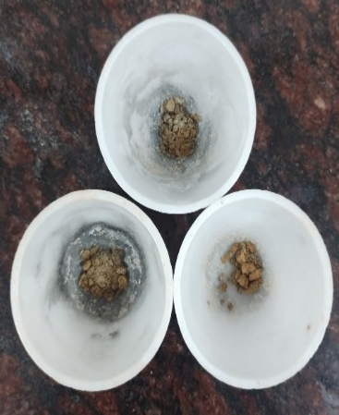
Figure No. 7: pH value of P. kurroa powder

Figure No. 6: Total Ash of Katurohini powder

Figure No. 5: Alcohol & Water-Soluble Extract of Katurohini powder

3.4 Phytochemical Screening
Table no. 3: Phytochemical Observations of Katurohini
S. No. | Tests | Name of Reagents | Water Extract | Ethanol Extract
1 | Alkaloids | Dragendorff's reagent | – | –
2 | Flavonoids | Alkaline Reagent Test | + | +
3 | Phenolic compounds | Ferric Chloride Test | + | +
4 | Glycosides | Keller–Killiani Test | + | +
5 | Terpenoids | Salkowski Test | + | +
6 | Proteins & Amino acids | Millon's Test | – | –
7 | Tannins | Ferric Chloride Test | – | –
8 | Carbohydrates | Fehling's Test | – | –
9 | Saponins | Foam Test | – | –
10 | Steroids | Salkowski Test | + | +

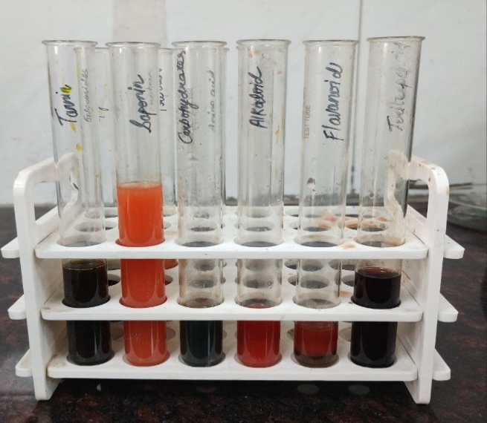
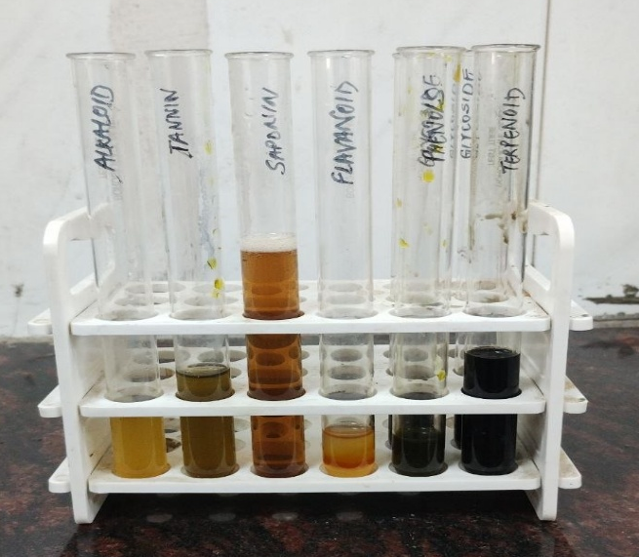
Note: (-): Absent, (+): Present
Figure No. 8: Phytochemical analysis of Water & Ethanolic extract of Katurohini powder

3.5 ANALYTICAL STUDY
HPTLC Profiling: The HPTLC done on the methanol extract of Picrorhiza kurroa Royle ex Benth is as follows:
Mobile phase
Chloroform: Methanol (8:2, v/v)
Chromatographic conditions
Application mode: CAMAG Linomat 5
Development Chamber: CAMAG twin-trough chamber
Plates: Precoated silica gel 60 F254 aluminium plates
Chamber Saturation: 20 min
Development distance: 70 mm
Scanner: CAMAG TLC Scanner 4.
Detection: Deuterium lamp and Tungsten lamp
Data System: visionCATS software
The methanolic extract of Picrorhiza kurroa was subjected to HPTLC fingerprint analysis under optimized chromatographic conditions using pre-coated silica gel 60 F₂₅₄ aluminium plates and Chloroform: Methanol (8:2, v/v) as the mobile phase. Chromatograms were recorded at 254 nm and 366 nm following the application of 2–14 µL of the extract.
3.5.1 HPTLC Fingerprint Profile of Methanolic Extract of Picrorhiza kurroa Royle ex Benth
The methanolic extract of Picrorhiza kurroa Royle ex Benth was analysed under the optimized HPTLC conditions. The HPTLC analysis of the methanolic extract of Picrorhiza kurroa was carried out at 254 nm and 366 nm to evaluate its phytochemical profile. The chromatograms obtained at both wavelengths showed well-resolved and reproducible peak patterns, indicating the presence of multiple phytoconstituents in the extract. At 254 nm, one to three major peaks were observed across different sample application volumes (2–14 µL), with the major Rf values ranging from 0.319 to 0.502. Similarly, at 366 nm, one to three fluorescent peaks were detected with major Rf values ranging from 0.318 to 0.768, suggesting the presence of UV-fluorescent constituents in the extract. The chromatographic pattern remained consistent across all application volumes, demonstrating good separation and reproducibility of the phytoconstituents. The occurrence of peaks at different Rf values indicates the presence of compounds with varying polarities, thereby confirming the phytochemical complexity and characteristic chemical fingerprint of Picrorhiza kurroa.
Table no. 4 HPTLC Fingerprint Profile
Sample | Wavelength | Chromatographic Profile | Major Rf Values
Picrorhiza kurroa (Methanolic extract) | 254 nm | Well-resolved chromatographic profile with distinct peaks | 0.319, 0.329, 0.339, 0.345, 0.347, 0.353, 0.389, 0.432, 0.439, 0.452, 0.460, 0.495, 0.502
Picrorhiza kurroa (Methanolic extract) | 366 nm | Well-resolved fluorescent chromatographic profile with distinct peaks | 0.318, 0.327, 0.342, 0.345, 0.352, 0.444, 0.489, 0.500, 0.768
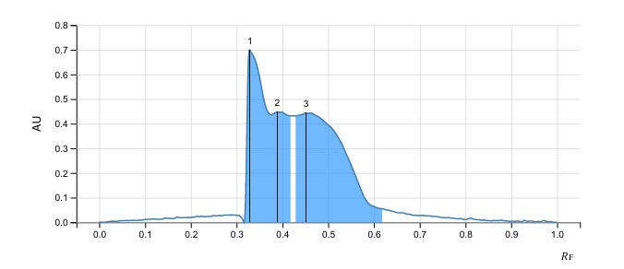
Fig. no. 9 - HPTLC densitometric chromatogram of the methanolic extract of Picrorhiza kurroa (Katurohini) recorded at 254 nm, showing characteristic resolved peaks in the Rf region of approximately 0.329–0.452.

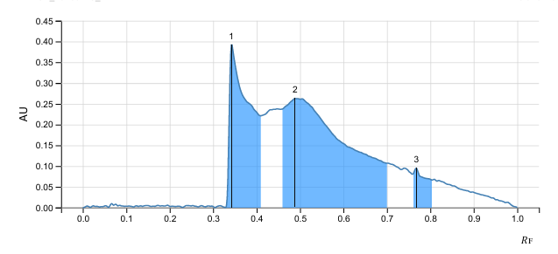
Fig. no. 10 - HPTLC densitometric chromatogram of the methanolic extract of Picrorhiza kurroa (Katurohini) recorded at 366 nm, showing characteristic resolved peaks in the Rf region of approximately 0.342-0.768.

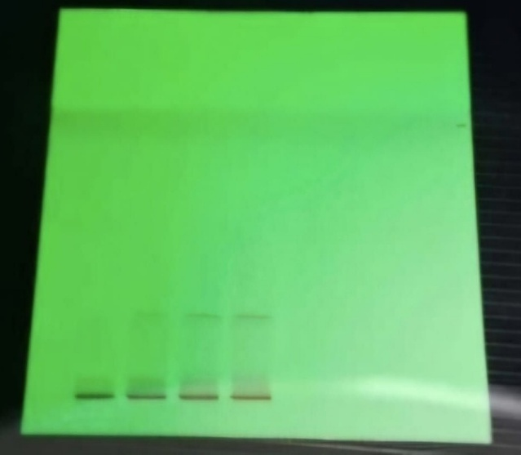
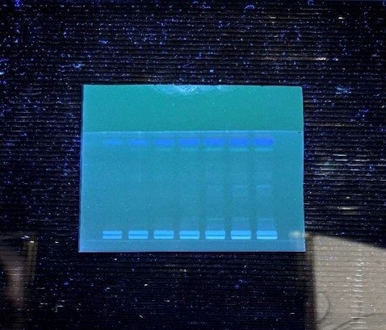
Figure No. 11: HPTLC fingerprint profile of methanolic extract of Picrorhiza kurroa under UV light at 366 nm.

Figure No. 12: HPTLC fingerprint profile of methanolic extract of Picrorhiza kurroa under UV light at 254 nm.

- DISCUSSION
The present study established comprehensive pharmacognostical, physicochemical, phytochemical, and chromatographic standards for the authentication and quality evaluation of Picrorhiza kurroa Royle ex Benth. rhizome. Standardization of crude herbal drugs is essential to ensure their identity, purity, quality, safety, and batch-to-batch consistency. The World Health Organization (WHO) has emphasized that pharmacognostical, physicochemical, and chromatographic evaluations constitute the fundamental criteria for the quality control and authentication of medicinal plant materials (World Health Organization, 2011).
4.1 Pharmacognostical Evaluation
Macroscopic and organoleptic examination represents an important preliminary step in the identification and authentication of crude herbal drugs. In the present investigation, the rhizome of Katurohini (Picrorhiza kurroa Royle ex Benth.) was cylindrical, straight to slightly curved, hard and brittle, with a greyish-brown to dark-brown rough surface marked by longitudinal wrinkles and circular root scars. The rhizome exhibited a short, uneven fracture with a dark to blackish fractured surface and pale vascular tissues, along with a characteristic pleasant odour and distinctly bitter taste. These findings were largely consistent with previously reported characteristics, wherein the rhizome was described as cylindrical, straight to slightly curved, yellowish-brown, with pleasant odour, bitter taste and short fracture (Mall et al., 2016). Similar observations of brownish, cylindrical and slightly curved rhizomes with rough surface, longitudinal wrinkles and short fracture have also been reported (Meena et al., 2010). The difference in external colour may be attributable to variation in geographical origin, maturity, drying or storage conditions. The additional observations of circular root scars, attached root remnants and growing buds were not specifically reported in these studies and may represent supplementary morphological characters.
The transverse section showed a compact cork layer, broad parenchymatous cortex, phloem, narrow wavy cambium, secondary xylem with thick-walled vessels, tracheids and fibres, and central parenchymatous pith. These findings corresponded well with previously reported anatomical features including cork, cork cambium, primary cortex, phloem, sieve cells, xylem vessels and central pith (Mall et al., 2016). Similarly, 8–12 layers of cork, radially arranged cortical cells, ovate vascular bundles between cortex and pith, central parenchymatous pith and starch grains in cortical and pith parenchyma have been reported (Meena et al., 2010). Thus, the fundamental anatomical organization observed in the present study supports the previously described anatomical characteristics of the rhizome, while the detailed observation of vessel thickening, fibres and cambial organization provides additional descriptive information.
Powder microscopy revealed cork fragments, parenchymatous cells containing starch grains, thick-walled fibres, tracheids, lignified vessels and compound starch grains. These findings showed considerable agreement with previously reported powder-microscopic features, including parenchymatous cells containing starch grains, cork fragments, pitted vessels and tracheids (Meena et al., 2010). However, the absence of starch grains was reported in another pharmacognostical investigation (Mall et al., 2016), representing a notable difference from the present observation. Such variation may be associated with differences in plant material, maturity, processing, geographical origin or microscopic preparation. Overall, the macroscopic, organoleptic and microscopic characteristics observed in the present investigation demonstrate substantial concordance with published pharmacognostical descriptions and provide useful diagnostic characteristics for authentication and quality evaluation of Katurohini rhizome.
4.2 Physicochemical Evaluation
Physicochemical parameters are important quality-control indices for evaluating the purity and quality of medicinal plant materials. In the present investigation, no foreign matter was detected in the rhizome of Katurohini (Picrorhiza kurroa Royle ex Benth.), indicating good purity of the crude drug. The alcohol-soluble extractive value (32.81%) and water-soluble extractive value (36.28%) were within the prescribed API limits, indicating the presence of extractable constituents in the rhizome. The total ash value (2.98%) was well below the specified limit of 7.0%, while the loss on drying (4.12%) was within the prescribed limit of 10.0%, indicating relatively low moisture content. The pH of the 10% aqueous solution was found to be 4.2; however, no specific API limit was available for this parameter.
Comparable physicochemical characteristics have been reported in previous investigations of P. kurroa. One study reported foreign matter (1.142%), total ash (3.8%), alcohol-soluble extractive (22.42%), water-soluble extractive (42.63%) and moisture content (12.95%), with the reported physicochemical parameters compared against API standards (Mall et al., 2016). Another investigation reported a pH of 4.84 for a 10% aqueous solution, along with loss on drying (8.96%), total ash (5.92%), water-soluble extractive (33.10%) and alcohol-soluble extractive (25.40%) [2]. The pH observed in the present study (4.2) was therefore slightly lower than the previously reported value of 4.84 (Meena et al., 2010). Similarly, variations were observed in the quantitative values of ash, extractive values and loss on drying when compared with earlier reports. Such differences may be attributable to variations in geographical origin, maturity of the rhizome, harvesting conditions, drying procedures, storage conditions and methodological factors. Overall, the physicochemical profile of the present sample complied with the applicable API limits and provides useful quality-control data for the evaluation of P. kurroa rhizome (API, Government of India, 1999).
4.3 Preliminary Phytochemical Screening
Preliminary phytochemical screening provides an initial assessment of the major classes of phytoconstituents present in medicinal plant materials. In the present investigation, aqueous and ethanol extracts of Katurohini (Picrorhiza kurroa Royle ex Benth.) showed positive reactions for flavonoids, phenolic compounds, glycosides, terpenoids and steroids, whereas alkaloids, proteins and amino acids, tannins, carbohydrates and saponins were not detected under the experimental conditions employed.
The positive reaction for glycosides in both extracts is consistent with previous phytochemical investigations of P. kurroa rhizome (Rathee et al., 2016). Although the rhizome is known to contain iridoid glycosides, the qualitative test used in the present study does not permit identification of individual compounds. Therefore, the finding indicates the presence of glycosidic constituents rather than direct confirmation of picroside-I, picroside-II or kutkoside. These compounds have been independently isolated and characterized from P. kurroa (Basu et al., 1970; Kitagawa et al., 1971).
Phenolic compounds detected in both extracts were in agreement with previous findings. The positive reactions for terpenoids and steroids were also broadly consistent with reports of sterols/triterpenes and cucurbitacin-type constituents in P. kurroa (Rathee et al., 2016).
Flavonoids were detected in both extracts, differing from an earlier study in which they were not detected (Rathee et al., 2016), but agreeing with another investigation reporting flavonoids along with phenols, steroids and terpenoids in aqueous and ethanol extracts (Nisar et al., 2022). Such variation may result from differences in extraction solvent, extract concentration, plant material, geographical origin and analytical methodology.
The absence of alkaloids, proteins and amino acids, tannins, carbohydrates and saponins was also reported in previous phytochemical screening (Rathee et al., 2016). However, qualitative screening is method-dependent, and negative reactions should not be interpreted as definitive absence of these constituents. Overall, the present phytochemical profile shows agreement with reported characteristics of P. kurroa, particularly for glycosidic, phenolic and terpenoid/sterol-type constituents, with some variation in flavonoid detection.
4.4 HPTLC Fingerprint Analysis
HPTLC fingerprinting is a useful analytical approach for generating characteristic chromatographic profiles and supporting the quality evaluation and standardization of medicinal plant materials. In the present investigation, the methanolic extract of Katurohini (Picrorhiza kurroa Royle ex Benth.) produced well-resolved chromatographic profiles at 254 and 366 nm. At 254 nm, multiple peaks were observed with Rf values ranging from 0.319 to 0.502, while at 366 nm, fluorescent peaks were observed in the range of 0.318–0.768. The consistent chromatographic pattern across different application volumes indicates reproducible separation under the optimized conditions.
The present chromatographic profile showed similarity in certain Rf regions with previously reported HPTLC investigations of P. kurroa. A previous chemoprofiling study of methanolic rhizome extracts reported picroside-II at an Rf of approximately 0.38 using chloroform:methanol:formic acid (8:2:0.1, v/v/v) as the mobile phase (Rehman et al., 2014). In the present study, peaks were observed in the lower Rf region, including 0.318–0.353. However, because the mobile-phase composition differed, these peaks cannot be directly assigned to picroside-II solely on the basis of Rf values.
An HPTLC method developed for simultaneous quantification of picroside-I and picroside-II in P. kurroa using chloroform:methanol (82:18, v/v) reported Rf values of 0.60 and 0.43 for picroside-I and picroside-II, respectively; their identities were confirmed through comparison with authentic standards (Singh et al., 2005). The present chromatogram showed a peak at Rf 0.432 and additional peaks in the 0.44–0.50 region. Although the Rf 0.432 is close to the previously reported picroside-II region, definitive identification of this peak was not attempted in the present investigation because authentic reference standards were not used.
Another validated HPTLC study using chloroform:methanol (88:12, v/v) on silica gel 60 F254 plates established simultaneous determination of picroside-I and picroside-II in P. kurroa at 254 nm (Tiwari et al., 2012). The differences in Rf values between the present investigation and previous studies may be attributed primarily to variations in mobile-phase composition, chromatographic conditions, sample preparation and plant material. Overall, the present HPTLC analysis generated a reproducible and characteristic fingerprint profile of the methanolic extract of P. kurroa, providing useful analytical data for preliminary authentication and quality evaluation of the crude drug.
5. SIGNIFICANCE OF THE STUDY
The present investigation generates comprehensive pharmacognostical, physicochemical, phytochemical, and chromatographic data for the rhizome of Picrorhiza kurroa Royle ex Benth. The integration of these parameters provides a scientific framework for the authentication and quality evaluation of the crude drug. Such standardized baseline data are valuable for pharmacopoeial standardization, detection of adulteration and substitution, quality assessment of herbal raw materials, and batch-to-batch standardization of herbal and phytopharmaceutical formulations. Furthermore, the HPTLC fingerprint profile generated from the methanolic extract may serve as a reproducible analytical reference for future pharmacognostical, phytochemical, quality-control, and formulation-based investigations involving Picrorhiza kurroa.
6. CONCLUSION
The present study generated comprehensive pharmacognostical, physicochemical, phytochemical, and HPTLC fingerprint data for the rhizome of Picrorhiza kurroa Royle ex Benth. Characteristic macroscopic, microscopic, and powder microscopic features provided reliable diagnostic parameters for authentication of the crude drug, while physicochemical evaluation generated important quality-control parameters for assessment of its purity and quality. The observed values for foreign matter, extractive values, total ash, moisture content, and pH provide useful baseline data for the physicochemical standardization of the rhizome.
Preliminary phytochemical screening of the aqueous and ethanolic extract demonstrated the presence of various secondary metabolites, indicating the presence of diverse bioactive constituents. The reproducible HPTLC fingerprint profile of the methanolic extract generated characteristic chromatographic patterns that may serve as an analytical reference for routine authentication, quality evaluation, and standardization of Picrorhiza kurroa. Collectively, the pharmacognostical, physicochemical, phytochemical, and chromatographic findings provide scientifically documented baseline data that may contribute to quality assurance, standardization, detection of adulteration, and future phytochemical, pharmacological, and herbal formulation research involving Picrorhiza kurroa.
Declaration of AI Use

This manuscript was prepared through the intellectual contributions of the author(s) to the study design, data analysis, interpretation of results, and scholarly content. Grammarly and ChatGPT were used solely to assist with grammatical refinement and reference formatting during manuscript revision. The author(s) accept full responsibility for the accuracy, integrity, and final content of the manuscript.
References
- POWO (2026). “Plants of the World Online. Facilitated by the Royal Botanic Gardens, Kew. Published on the Internet; https://powo.science.kew.org/
- K. Shitiz, S. Pandit, R.S. Chauhan, H. Sood, Picrosides content in the rhizomes of Picrorhiza kurroa Royle ex Benth. Traded for herbal drugs in the markets of North India, Int. J. Med. Arom. Plants. 3 (2013) 226-233.
- Chettri, E. Sharma, S.D. Lama, S. Himalaya, Non-timber forest produces utilization, distribution and status in a trekking corridor of Sikkim, India, Lyonia. 8 (2005) 89-101.
- Rasool S, Khan MH, Hamid S, Sultan PS, Qazi P, Butt T. An overview and economical importance of few selected endangered medicinal plants grown in Jammu and Kashmir region of India. Ann Phytomed. 2016 Jul 1;5:27-37.
- Kar A. Pharmaocgnosy and Pharmacobiotechnology (Revised-Expanded Second Edition). New Age International Limted Publishres New Delhi. 2007:196 197.
- Kumari I, Kaurav H, Chaudhar G. Ethnobotanical Significance of Picrorhiza kurroa (Kutki), a Threatened Species. Int J Res Rev. 2021;8: 363-368.
- J.N. Sah, V.K. Varshney, Chemical constituents of Picrorhiza genus: A review, Am. J. Essent. Oils Nat. Prod. 1 (2013) 22-37.
- P.R. Thani, A comprehensive review on Picrorhiza kurroa Royle ex Benth, J. Pharmacog, Phytochem. 10 (2021) 307-313.
- S. Akbar, Picrorhiza kurroa Royle ex Benth. (Plantaginaceae). Handbook of 200 Medicinal Plants, Springer, Cham, 2020, pp. 1409-1417.
- T.S. Mehra, R. Raina, R.C. Rana, P. Chandra, P.K. Pandey, Elite chemo-types of a critically endangered medicinal plant Picrorhiza kurroa Royle ex Benth from Indian Western Himalaya, J. Pharmacog. Phytochem. 6 (2017) 1679-1682.
- Sharma N. Picrorhiza kurroa. In: Himalayan Medicinal Plants: Advances in Botany, Production & Research. Academic Press; 2021. p. 67–83.
- Parihar V, Behera B. A Comprehensive Review on Ayurvedic and Pharmacological Aspects of Picrorhiza kurroa Royle ex Benth. International Journal of Pharmacy and Biological Sciences. 2025;15(2):39–53. DOI: 10.5281/zenodo.15372645.
- Government of India, Ministry of Health and Family Welfare, Department of AYUSH. The Ayurvedic Pharmacopoeia of India. Part I, Vol. II. & Part I, Vol. IX. New Delhi: Government of India; 1999.
- World Health Organization. Quality Control Methods for Herbal Materials. Geneva: WHO; 2011.
- Mall AK, Chaubey S, Tiwari RC, Kour G. Pharmacognostical Study of Kutaki (Picrorhiza kurroa Royle ex Benth.). International Journal of Research in Ayurveda and Pharmacy. 2016;7(Suppl 4):36–40.
- Meena AK, Rao MM, Krishna CM, Komalpreet, Kumar KN, Padhi MM, Ramesh Babu. Evaluation of Pharmacognostic and Physicochemical Parameters of Picrorrhiza kurroa Royle ex Benth. International Journal of Ayurvedic Medicine. 2010;1(1):41–47.
- Rathee D, Rathee P, Rathee S, Rathee D. Phytochemical screening and antimicrobial activity of Picrorrhiza kurroa, an Indian traditional plant used to treat chronic diarrhea. Arabian Journal of Chemistry. 2016;9(Suppl 2):S1307–S1313. doi:10.1016/j.arabjc.2012.02.009.
- Nisar J, Shah SMA, Akram M, Ayaz S, Rashid A. Phytochemical screening, antioxidant, and inhibition activity of Picrorhiza kurroa against α-amylase and α-glucosidase. Dose Response. 2022;20(2):15593258221095960. doi:10.1177/15593258221095960.
- Basu K, Dasgupta B, Ghosal S. Structure of kutkin, the bitter glucoside of Picrorhiza kurroa Royle ex Benth. The Journal of Organic Chemistry. 1970;35(9):3159–3161. doi:10.1021/jo00834a071.
- Kitagawa I, Hino K, Nishimura T, Iwata E, Yosioka I. On the constituents of Picrorhiza kurrooa. (1). The structure of picroside I, a bitter principle of the subterranean part. Chemical and Pharmaceutical Bulletin. 1971;19(12):2534–2544. doi:10.1248/cpb.19.2534.
- Rehman HU, Ahmad J, Chester K, Tamboli ET, Ahmad S. Chemoprofiling and tissue culture studies on Picrorhiza kurroa Royle ex Benth. for production of picroside II. Ann Phytomed. 2014;3(2):70-77.
- Singh N, Gupta AP, Singh B, Kaul VK. Quantification of Picroside-I and Picroside-II in Picrorhiza kurroa by HPTLC. Journal of Liquid Chromatography & Related Technologies. 2005;28(11):1679–1691. doi:10.1081/JLC-200060439.
- Tiwari SS, Pandey MM, Srivastava S, Rawat AKS. TLC densitometric quantification of picrosides (picroside-I and picroside-II) in Picrorhiza kurroa and its substitute Picrorhiza scrophulariiflora and their antioxidant studies. Biomedical Chromatography. 2012;26(1):61–68. doi:10.1002/bmc.1626.

