Original Research Article

Lectotypification of Fimbristylis subtrabeculata (Cyperaceae), an endemic species of India

Abstract
Fimbristylis subtrabeculata C.B. Clarke is an endemic Indian species of Cyperaceae described from material collected from the Nilgiri Hills. During a revisionary study of the genus Fimbristylis Vahl in India, it was observed that the name F. subtrabeculata had not been typified. The protologue and available original material were critically examined, and relevant herbarium specimens were traced from CAL, BM and K. Among the available original material, the specimen collected by J.S. Gamble from Pykara, Nilgiri Hills, in May 1886 and preserved at CAL under barcode CAL0000001761 was found to be the best-preserved specimen and to agree with the diagnostic features indicated in the protologue. This specimen is therefore designated here as the lectotype of Fimbristylis subtrabeculata C.B. Clarke in accordance with the provisions of the International Code of Nomenclature for algae, fungi, and plants. The available duplicate specimens at BM and K are treated as isolectotypes. Notes are also provided on the distinction of F. subtrabeculata from morphologically similar taxa, particularly with reference to nutlet characters. The lectotypification clarifies the application of the name and provides a stable nomenclatural basis for future taxonomic and floristic studies of Fimbristylis in India.
Key words: Cyperaceae; Abildgaardieae; Fimbristylis; Lectotype.
1. INTRODUCTION
Cyperaceae is the third largest monocotyledonous family; it comprises 95 genera and approximately 5687 species, has a cosmopolitan distribution (Larridon, 2022) and has been resolved as monophyletic (Goetghebeur, 1998; Bruhl, 1995). In India the family represented by 610 species belonging to 32 genera (Mao & al., 2020). The genus Fimbristylis Vahl belong to the tribe Abildgaardieae Lye under subfamily Cyperoideae (Cyperaceae) and is characterized style base jointed with the ovary, with a distinct border line at its base, usually swollen or fimbriate or sometimes with both the characters at base, leaf sheath with a short fringe of hairs or none, style base caducous. The genus Fimbristylis Vahl has 320 species (POWO, 2026) and is distributed widely in pantropical and warm temperate regions of the world with the highest concentration of species in tropical Asia. It is represented by 128 taxa in India (Mao et al., 2020).
Recent molecular and phylogenomic studies have reinforced a stable suprageneric framework for Cyperaceae and support the placement of the Fimbristylis clade within tribe Abildgaardieae, providing a contemporary systematic context for species-level taxonomic work in the genus (Muasya et al., 2009; Larridon et al., 2021). Recent descriptions of Fimbristylis species from India, including Kerala, also demonstrate continuing taxonomic work in the genus and emphasize detailed comparison of morphology, distribution, ecology, and allied taxa (Narayanan et al., 2023).
Typification studies in Fimbristylis have likewise shown that historical names may require reassessment of protologues, specimen annotations, and distributed original material before a lectotype can be selected, underscoring the nomenclatural value of critically evaluating herbarium collections (Dey & Halder, 2015; Halder & Dey, 2016).
2. MATERIAL AND METHODS
During the revisionary study on the genus Fimbristylis in India, it was found that the Fimbristylis subtrabeculata C.B. Clarke are yet to be typified. Consulted and communicated with the various herbaria where the C.B. Clarke collections are said to be deposited, such as BM, K, B, BO, BR, C, CAL, DD, FI, G, M, MANCH, NMW, NY, OXF and U. In the present communication, the aforementioned species is typified in accordance with the provisions of the International Code of Nomenclature for algae, fungi, and plants (Turland et al., 2025). An explanatory note is provided to justify the need for the lectotypification.
3. results and discussion

Taxonomic treatment and lectotypification
Fimbristylis subtrabeculata C.B. Clarke, Fl. Brit. India 6: 633. 1893.
Lectotype (designated here): INDIA, Tamil Nadu, Nilgiri District, Nilghiri Hills, Pykara, alt. 5600 ft., May 1886, J.S. Gamble 17330 (CAL [CAL0000001761, Fig. 1!]; isolectotypes: BM [BM014605445, digital image!], K [K000974112, digital image!]).

Distribution: — Endemic to India (Karnataka, Kerala, Maharashtra, Tamil Nadu).
While describing Fimbristylis subtrabeculata, C.B. Clarke (1893) cited “Nilghiri Hills, Pykara, alt, 5600 ft., Gamble” and did not provide any collection number. Based on the details mentioned in the protologue, a total of three specimens have been traced in three herbaria BM (BM014605445), CAL (CAL0000001761), K (K000974112), all of these specimens were collected by Gamble in May, 1886 from the type locality. The CAL specimen (CAL0000001761) is the best preserved original material, representing better morphological characters and matches all the characters described in the protologue. Hence, the specimen CAL0000001761 is selected here as the lectotype of Fimbristylis subtrabeculata C.B. Clarke according to the Art. 9.3, 9.12 of ICN (Turland et al., 2025).
The selection of CAL0000001761 is consistent with previous typification work in Fimbristylis, where lectotype choice has been based on careful comparison of original material with protologue characters, specimen annotations, and the available set of syntypes or duplicates (Dey & Halder, 2015; Halder & Dey, 2016). In the present case, the comparatively complete preservation of the CAL sheet and its agreement with Clarke’s diagnosis provide a reasonable basis for selecting it from the traced original material (Dey & Halder, 2015; Halder & Dey, 2016).
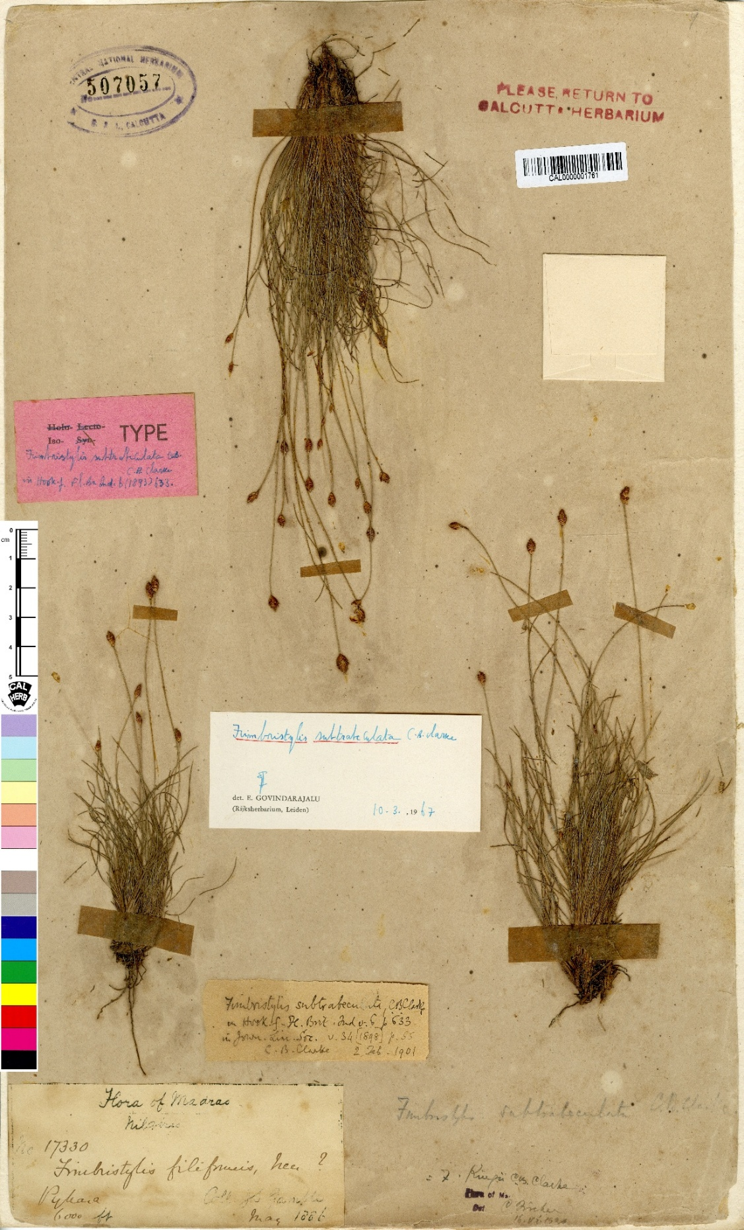
Fig. 1. Lectotype of Fimbristylis subtrabeculata C.B. Clarke (CAL barcode no. CAL0000001761) [Central National Herbarium (CAL), Botanical Survey of India, Howrah].
Clarke has also mentioned in the note “This may be F. subbulbosa, Boeck. Cyp. Nov. ii. 39 (non Flora xli. 598) from description; but Boeck. says this is allied to F. juncea Roem. & Sch. with 2-fid style (sometimes 3-fid).” and the specimen BM014605445 bear hand written annotations by C.B. Clarke states that “Gamble has sent his Cyperaceae to Boeckeler who (in his Cyper. Novae left 2 (1890) Supple) has described them and he has this (I think) under another (new) name-but the book is not here.”
The historical comparison with F. subbulbosa can therefore be interpreted in the context of Boeckeler’s original treatment (Boeckeler, 1890), whereas the lectotypification decision itself remains dependent on the original material associated with F. subtrabeculata and the relevant provisions of the ICN (Turland et al., 2025).
Based on the protologue of F. subbulbosa Boeck. states that the nutlet (achene) shows “compresso-biconvexa, vertice rotundato-obtusa mutica, granulate subtilissimeque cellulose-punctata alba” (compressed-biconvex, rounded-obtuse and awnless at the apex, granulate and very finely cellular-punctate, white) which is completely distinct from the F. subtrabeculata (nut trigonous, outermost cells transversely oblong white not vertically superimposed in regular series; nut thus not longitudinally striate but irregularly conspicuously trabeculate) but it is matching with the F. polytrichoides (Retz.) R.Br., Although F. subtrabeculata is often confused with F. kingii due to morphological similarities, resulting in frequent misidentifications in many herbaria, microscopic observation clearly differentiates the two based on nutlet characteristics trigonous, obovoid, obtuse at apex, shortly stipitate, outer most cells small, subquadrate, lax, subpapillose, 1.4 mm long and 1 mm wide, stramineous in F. kingii and the outermost cells transversely oblong white, irregularly conspicuously trabeculate, yellow-creamy white, 1.2 mm long and 1 mm wide in F. subtrabeculata and the presence of micro-hairs. (Yarrayya et al., 2023).
Nutlet characters can provide diagnostically useful evidence within Fimbristylis; for example, differences in the number of vertical surface rows have been used to separate F. alboviridis from F. dichotoma (Kumar & Bharati, 2020). Recent species-level taxonomic work in Fimbristylis has likewise emphasized comparisons with allied taxa using morphology, distribution, and ecology (Narayanan et al., 2023).
Recent lectotypification work in the genus has also combined nomenclatural assessment with detailed reproductive morphology and comparison of specimens from recent collections (Majumder et al., 2026). Accordingly, the nutlet shape, epidermal-cell arrangement, surface sculpturing, and colour differences reported here can be treated as corroborative morphological evidence for distinguishing F. subtrabeculata from allied taxa, while the nomenclatural conclusion remains anchored to the selected original material and the protologue (Kumar & Bharati, 2020; Majumder et al., 2026).

4. Conclusion
The present study designates CAL0000001761 as the lectotype of Fimbristylis subtrabeculata C.B. Clarke based on its agreement with the protologue and its status as well-preserved original material. The specimens at BM and K are recognized as isolectotypes. This lectotypification helps stabilize the application of the name and supports more reliable identification of the species in future taxonomic, floristic and herbarium-based studies. The comparative notes on nutlet morphology further assist in distinguishing F. subtrabeculata from closely allied or frequently confused taxa.

Declaration of AI Use

This manuscript was prepared through the intellectual contributions of the author(s) to the study design, data analysis, interpretation of results, and scholarly content. Grammarly and ChatGPT were used solely to assist with grammatical refinement and reference formatting during manuscript revision. The author(s) accept full responsibility for the accuracy, integrity, and final content of the manuscript.

Competing interests

Authors have declared that no competing interests exist.

REFERENCES
Boeckeler, O. (1890). Heft II. Cyperaceae novae. 39. Varel a.d. Jade. Druek Von Boeitscadelo. Vogt. https://doi.org/10.5962/bhl.title.51622
Bruhl, J.J. (1995). Sedge genera of the world: relationships and a new classification of the Cyperaceae, in Austr. Syst. Bot. 8: 125‒305. https://doi.org/10.1071/SB9950125
Clarke, C.B. (1893 & 1894). Cyperaceae. In: J.D. Hooker, Flora of British India 6: 585‒672. 1893 et 6: 673‒748. 1894. London. https://doi.org/10.5962/bhl.title.678
Dey, S., & Halder, S. (2015). Typifications in the genus Fimbristylis (Cyperaceae). I. Annales Botanici Fennici, 52(3–4), 224–232. https://doi.org/10.5735/085.052.0315
Goetghebeur, P. (1998). Cyperaceae. In: The Families and Genera of Vascular Plants, edited by Kubitzki K (Springer-Verlag) Berlin, Germany 4: 141‒190. https://doi.org/10.1007/978-3-662-03531-3_15
Halder, S., & Dey, S. (2016). Typifications in the genus Fimbristylis (Cyperaceae), II. Novon: A Journal for Botanical Nomenclature, 24(4), 354–361. https://doi.org/10.3417/2015018
Kumar, A., & Bharati, K. A. (2020). Second-step lectotypification of Fimbristylis alboviridis (Cyperaceae). Phytotaxa, 442(1), 41–42. https://doi.org/10.11646/phytotaxa.442.1.7
Larridon, I. (2022). A linear classification of Cyperaceae, Kew bulletin 77: 309–315. https://doi.org/10.1007/s12225-022-10010-x
Larridon, I., Zuntini, A. R., Léveillé-Bourret, É., Barrett, R. L., Starr, J. R., Muasya, A. M., Villaverde, T., Bauters, K., Brewer, G. E., Bruhl, J. J., Costa, S. M., Elliott, T. L., Epitawalage, N., Escudero, M., Fairlie, I., Goetghebeur, P., Hipp, A. L., Jiménez-Mejías, P., Sabino Kikuchi, I. A. B., … Baker, W. J. (2021). A new classification of Cyperaceae (Poales) supported by phylogenomic data. Journal of Systematics and Evolution, 59(4), 852–895. https://doi.org/10.1111/jse.12757
Majumder, S., Rajak, P., & Ghosh, A. (2026). Typification of the name Fimbristylis argentea (≡ Scirpus argenteus, Cyperaceae) and notes on its synonyms and reproductive morphology. Phytotaxa, 763(1), 27–40. https://doi.org/10.11646/phytotaxa.763.1.3
Mao, A.A. & Dash, S.S. (2020). Flowering Plants of India; An Annotated Checklist: Monocotyledons. Botanical Survey of India, Kolkata. https://www.ipni.org/p/20029002-1
Muasya, A. M., Simpson, D. A., Verboom, G. A., Goetghebeur, P., Naczi, R. F. C., Chase, M. W., & Smets, E. (2009). Phylogeny of Cyperaceae based on DNA sequence data: Current progress and future prospects. The Botanical Review, 75(1), 2–21. https://doi.org/10.1007/s12229-008-9019-3
Narayanan, M. K. R., Sunil, C. N., Thankappan, S., Sanilkumar, M. G., Rijuraj, M. P., & Simi, M. S. (2023). Fimbristylis jaleeliana, a new species of Cyperaceae from Kerala, India. Phytotaxa, 626(3), 208–212. https://doi.org/10.11646/phytotaxa.626.3.7
POWO (2026). Plants of the World Online. Facilitated by the Royal Botanic Gardens, Kew. Published on the Internet; https://powo.science.kew.org/ (accessed 27 May 2026). https://powo.science.kew.org/
Turland, N.J., Wiersema, J.H., Barrie, F.R., Gandhi, K.N., Gravendyck, J., Greuter, W., Hawksworth, D.L., Herendeen, P.S., Klopper, R.R., Knapp, S., Kusber, W.H., Li, D-Z., May, T.W., Monro, A.M., Prado, J., Price, M.J., Smith, G.F. & Senoret, J.C.Z. (Eds.). (2025). International Code of Nomenclature for algae, fungi and plants (Madrid Code) accepted by the Twentieth International Botanical Congress, Madrid, Spain, July 2024. Regnum Vegetabile 162. The University of Chicago Press, Chicago. https://doi.org/10.7208/chicago/9780226839479.001.0001.
Yarrayya, K. & Ratna Kumar, P.K. (2023). On the confusion in the identity of Fimbristylis kingii and F. subtrabeculata. International Journal of tropical agriculture. 41: (1-2) 77-80. https://bsi.gov.in/bu-scientist-profile/en?rcu=137

