A Bayesian-Weighted Adaptive Ensemble for Early Multi-Disease Outbreak Classification from Multi-Modal Big Data Streams

Abstract
In many parts of sub-Saharan Africa, disease-surveillance systems remain largely reactive, with health authorities often receiving alerts only after an outbreak has been underway for several days or even weeks. This research introduces ensemble learning method to categorize weekly state–disease records as an outbreak or not outbreak, utilizing forty-seven feature vector that combines digital, environmental and epidemiologic indicators. Four complementary learners—Random Forest, a long short-term memory (LSTM) network, XGBoost, and a hybrid autoregressive integrated moving average (ARIMA) model with learned residual correction—are combined through a Bayesian-weighted adaptive meta-learner. The training and assessment of the model utilized synthetic data that was epidemiologically adjusted as a standard set for five diseases common in Nigeria, including cholera, an Lassa fever, cerebrospinal meningitis, measles, and mpox, that covered thirty-seven regions. The synthetic standard tried to repeat the spatial and seasonal trends found in published outbreak-surveillance works. In the 2022–2023 test sections not used for training, the ensemble received an accuracy of 96.3 percent, an F1-score counted at 0.939, and AUC-ROC reaching 0.963 being better than single-LSTM baseline it re-implemented in each metric shown; P values from McNemar's and DeLong's tests were found below 0.001. The probability estimates were also well calibrated, with a Brier score of 0.048. A leave-one-learner-out removal experiment indicated every one of four elements helped the model and the LSTM gave the most marginal improvement in discrimination. As a whole these results mean that when models with an unique ability are mixed and when cautious probability calibration is applied, the outbreak-risk estimates become more proper for supporting the decisions. Next the evaluation should be done on current surveillance feeds.
Keywords
Bayesian fusion; probability calibration; disease outbreak detection; ensemble learning; long short-term memory; Random Forest; XGBoost
1. Introduction
Outbreaks of infectious diseases still put big pressure on health of the public for Nigeria. Diseases like an Lassa fever, cholera or the cerebrospinal meningitis appear again at times that are regular. But regular notification sometimes gets delayed and can come about one week or even more after infection is spreading. Big data analytics has therefore attracted considerable attention as a means of narrowing this information gap by bringing together the different data streams already generated by modern health systems (Raghupathi & Raghupathi, 2014). The main challenge, however, is not simply the volume of available data. Relevant signals are produced in different formats, at different times, and through channels that conventional weekly aggregate reporting may not be able to combine quickly enough to support timely action.
Traditional time-series models like ARIMA still get used a lot as their actions can be understood quite easily however they rely on the stationarity which is hard to achieve when an epidemic patterns keep shifting. Single deep-learning models can capture temporal patterns effectively, yet they may become less reliable when particular data sources are incomplete or noisy—a common feature of facility-level reporting in African settings (Dalhat et al., 2017). Ensemble learning provides a practical way of addressing this problem. In general, combining learners with different sources of error can reduce the overall generalisation error, particularly when the individual models disagree in useful ways (Dietterich, 2000). This suggests that an ensemble deliberately built around complementary modelling strengths may offer greater robustness than reliance on one learner alone.
In line with the rationale mentioned above, this study creates an ensemble classifier that is specifically intended for early classification of outbreaks. This study makes three contributions. The first contribution is the combination of four learners having different types of inductive biases, which are Random Forest (Breiman, 2001), LSTM (Hochreiter & Schmidhuber, 1997), XGBoost (Chen & Guestrin, 2016), and a hybrid of ARIMA and ML. Second, it introduces a Bayesian-weighted adaptive meta-learner that combines the four posterior estimates using a seasonal prior and then applies isotonic calibration so that the resulting scores can be interpreted as probabilities. Third, research assesses an ensemble model in multi-modal benchmark that has been adjusted based on the epidemiological data of Nigeria and by ablation analysis it explains each part's contribution.In Section 2, there is related work, dataset and the method. Section 3 gives information about experiment results. At last, Section 4 finishes article.
2. Materials and Methods
2.1 Related Work
The concept of digital epidemic intelligence originated in attempts to apply online search dynamics for the purpose of monitoring events almost in real-time. In particular, Ginsberg et al. (2009) proved that the volume of search queries can reflect the incidence of influenza, thus serving as an earlier predictor than standard clinical observation. The same line of research later evolved into the ARGO method, which was based on the statistical modeling of search data combined with the autoregressive framework and overcoming the limitations of previous search-based approaches (Yang et al., 2015). Other systems, including HealthMap (Freifeld et al., 2008) and BioCaster (Collier et al., 2008), demonstrated that reports from heterogeneous online sources could be collected and automatically classified. These platforms helped establish the feasibility of near-real-time digital monitoring (Brownstein et al., 2009), although the tendency for such systems to generate false positives remains an important concern.
Different modelling approaches have also shown distinct strengths in outbreak prediction. Random Forest has been used effectively in outbreak classification because of its robustness and its ability to provide useful measures of variable importance (Shi et al., 2016). Gradient-boosted tree model techniques, for example, XGBoost, are excellent at providing high discrimination for the structured risk-scoring problem (Chen & Guestrin, 2016) while LSTM networks excel in extracting the longer-term temporal dependencies from the epidemic time series (Chimmula & Zhang, 2020). Hybrid approaches that combine statistical forecasting with machine-learning components have likewise reported reductions in prediction error compared with individual models (Chae et al., 2018). In spite of the progress in this field of study, there is still a need for a well-planned out and reliable framework that will be capable of merging these different learning methods and testing them in the specific context of disease surveillance in Nigeria, which is the main aim of this study.
2.2 Data Source and Study Design
The dataset for training and assessment is not an actual facility-surveillance records but instead, it has been made with synthetic and an epidemiologically tuned benchmark data. Weekly state–disease feature vectors were generated to reproduce the seasonal, spatial, and cross-disease patterns reported in published Nigerian outbreak-surveillance summaries (Dalhat et al., 2017). The benchmark covers five diseases—Lassa fever, cholera, cerebrospinal meningitis, measles, and mpox—across all 36 states and the Federal Capital Territory, giving 37 jurisdictions in total. Applying synthetic benchmark that is controlled is suitable to use for initial evaluation of surveillance algorithms at time when ongoing joined and multi-mode facility information is not for sure centralized or accessible in a computer-readable formats.This choice gives reproducibility of experiments and lets the evaluation of fusion and ensemble approaches occur in systematic way. At the same time, the resulting performance measures describe behaviour on a calibrated simulation rather than on prospectively collected field data; this limitation is discussed further in Section 3.4.
The records collected between 2017 and 2021 were used for training and performance validation of the model, while the records from 2022 to 2023 were kept for testing only (N = 279,500). A record was denoted as an outbreak if the number of cases was above 75% epidemic threshold value for that particular jurisdiction. The chronological split was done to prevent any temporal leakage and the feature standardizer was fitted using only the training data.
2.3 Feature Engineering
Every week, state and disease data is shown by 47 characteristics which are split in four groups. One, an epidemiological block, has case counts lagging as far back as six weeks, also the growth rate and incidence rate. In another block called the environmental, there is temperature, how much it rained humidity plus vector habitat signals. The digital part is made of social media amounts with both news and search counts.Contextual block is about population, the vaccination rates and time factors. Incidence rate (IR) and weekly growth rate (g) are two measurements that often get used more than once. Together, these measures describe both the current level of transmission and how quickly that level is changing; the latter is particularly relevant when the aim is to identify an outbreak at an early stage.
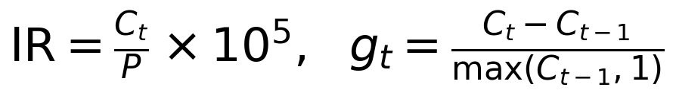 (1)
Taken together, these measures capture both the level and the rate of change in transmission. The growth term is especially useful for early detection because a rapid increase in cases may provide an actionable signal before the absolute case count becomes unusually high.
2.4 Proposed Ensemble Architecture
Figure 1 shows in summarized way how the model works. In each record of the weekly state–disease, the set of 47 features is given to a four different learners which are running together. Not just getting an average from them the model includes a Bayesian-weighted meta-learner that takes every learner like a separate evidence and calculates a weight for each. After that, the total log-posterior is processed by an isotonic calibration for the outbreak probability and a 95 percent credible interval.
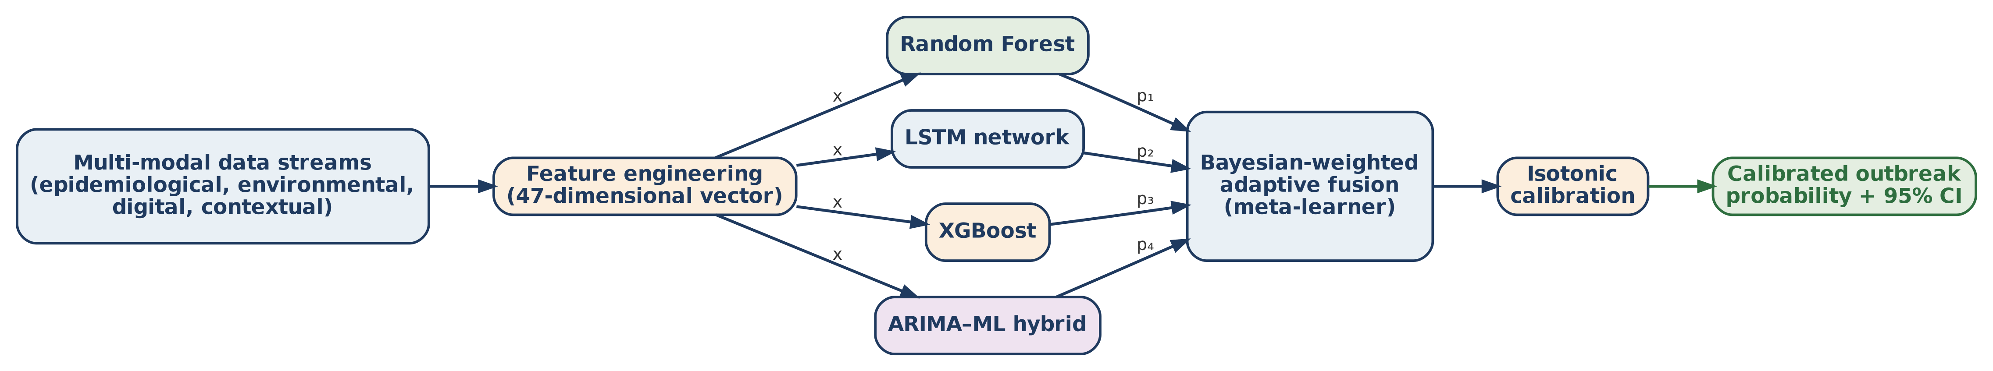
Figure 1. The design for Bayesian-weighted adaptive group is shown. Data with a 47 features coming from different data sources go at once to four different models.These models produce outputs (p₁ to p₄) that are put together by a meta-learner making the Bayesian weights. Then the outcomes go through isotonic calibration to make a reliable outbreak chance and a 95 percent credible interval.
2.5 Component Learners
The Random Forest part is made up of an 200 trees that pick features by square root approach and balanced class weights are given for handling the outbreak prevalence which stays between 12 to 18 percent. It uses bootstrap aggregation for more low variance predictions and it keeps practical when certain covariates are not available(Breiman, 2001). XGBoost minimises a second-order regularised objective (2), where the penalty associated with the number of leaves, T, and the model weights helps limit overfitting, particularly for sparse records with high incidence (Chen & Guestrin, 2016). The XGBoost configuration uses 400 boosting rounds and a learning rate of 0.05. The LSTM processes twelve weeks of historical observations using two stacked layers of 64 units, with dropout regularisation, through a gated recurrent structure (3). Its forget, input, and output gates allow the network to retain useful temporal information while reducing the influence of short-lived noise (Hochreiter & Schmidhuber, 1997). Training used the Adam optimiser (Kingma & Ba, 2015), a learning rate of 0.001, and stopping earlier is done once 15 epochs go by without a validation loss getting better. The ARIMA–ML combination gives a statistical foundation using an ARIMA, afterward giving a forecast with corrected residuals to the ensemble.This allows the system to keep original structure that could be missed by the machine learning models that are trained.
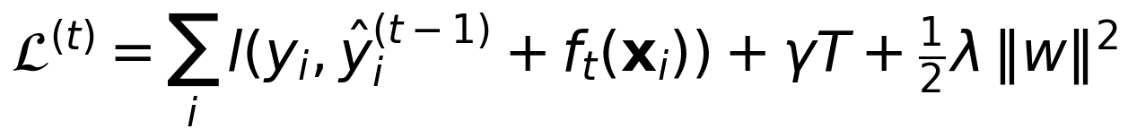 (2)
where in this part, penalty connected to the leaf count T and those weights manage too much learning from the records with high incidence but not much data (see Chen & Guestrin 2016). 400 boosting rounds happens at an learning rate about 0.05. Through gated recurrence, LSTM takes twelve weeks historic data and uses two levels with 64 units and applies dropout for the regularization,
(3)
whose forget, input and also output gates help it keep epidemic momentum but removes passing noises (Hochreiter & Schmidhuber, 1997). Adam optimizer (Kingma & Ba, 2015) and 0.001 learning rate was working for the training, and there was an early stopping when validation loss did not change for 15 epoch. The hybrid ARIMA–ML model does seasonal and fixed backbone by ARIMA and its forecast after the residual correction goes into the ensemble, giving exactly a prior structure the learned models do not much focus.
2.6 Bayesian-Weighted Fusion and Calibration
Suppose pₖ(x) is posterior for an outbreak which learner k produces and the π₀ is what we call the seasonal background rate. The fused possibility will be as follows:
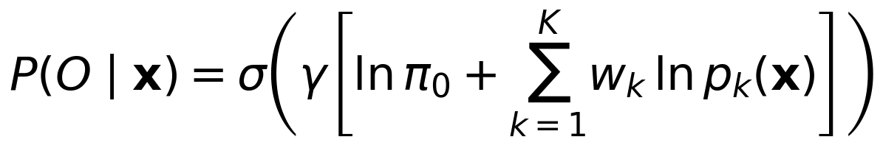 (4)
This formulation is a weighted log-opinion pool, where σ denotes the logistic function and γ acts as a calibration scale. The learner weights are estimated by minimising cross-entropy on the validation set:
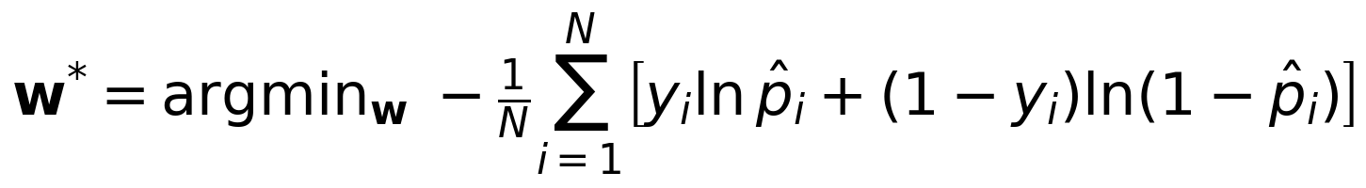 (5)
The optimisation employed the values of (0.28, 0.32, 0.26, and 0.14) as the weights for RF, LSTM, XGBoost, and ARIMA-ML respectively. The achieved scores were then transformed into probabilities through isotonic regression (Zadrozny & Elkan, 2002). This transformation that is non-parametric and monotonic helps in overcoming the systematic overconfidence or underconfidence.
2.7 Theoretical Basis for Model Diversity
The design is justified by the ensemble risk decomposition
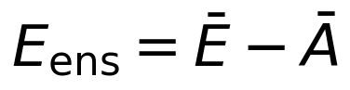 (6)
The decomposition reveals that the overall error, Eₑₙₛ, is equal to the mean error of the different members, Ē, minus the mean ambiguity of the individual members, Ā (Dietterich, 2000). This is likewise compatible with the wider interpretation regarding generalisation errors in statistical learning (Vapnik, 1995). In the present design, the four learners are expected to make different errors: Random Forest may be affected by sparse histories, the LSTM may be less reliable for unusually rapid onset events, XGBoost may be affected when environmental variables are missing, and the ARIMA–ML hybrid may be less effective during highly volatile, non-seasonal periods. These differences create useful model diversity and provide the basis for the performance gain observed in the ensemble.
2.8 Baseline Systems and Evaluation Protocol
The ensemble that we suggest has been put through its paces against three fundamental systems. We looked at performance metrics for one ordinary LSTM that was implemented according to the method described in Chae et al. (2018) and retrained using the same training partition as previously outlined in Section 2.2 to enable a fair comparison to be made. The HealthMap and BioCaster results reported in Section 3.1 were taken from the original publications by their developers (Freifeld et al., 2008; Collier et al., 2008). These two systems were not rerun on the present benchmark because their original text-classification pipelines and evaluation datasets are not publicly available for direct reproduction. Their results are therefore presented only as contextual reference. Comparisons with them should not be interpreted as controlled head-to-head experiments, a distinction revisited in Section 3.4.
Performance was assessed using accuracy, precision, recall, F1-score, AUC-ROC, and false-alarm rate (FAR), all calculated on the held-out 2022–2023 partition. McNemar's test (McNemar, 1947) was used to examine the difference in accuracy between the proposed ensemble and the re-implemented LSTM baseline, while the DeLong test for correlated ROC curves (DeLong et al., 1988) was used for AUC-ROC. Calibration was evaluated using the Brier score and a ten-bin reliability diagram. In addition, a leave-one-learner-out ablation study was conducted by removing each component in turn, including the limiting case in which only the LSTM remained, and then recalculating the fused F1-score. This provided an estimate of the marginal contribution of each learner.
3. Results and Discussion
3.1 Overall Classification Performance
Table 1 is where classification outcomes are shown for our suggested ensemble system together with three other baseline models that were explained in Section 2.8. In test data that was held out, this ensemble gave an accuracy of 96.3 percent as well as the AUC-ROC being 0.963. Statistical difference in accuracy and AUC-ROC when we did a controlled comparison with a re-made LSTM is shown by McNemar's and DeLong's tests (P less than .001 for both). See Figure 2 that shows ROC curves for every system in this comparison.
Table 1. Comparative classification performance on the held-out 2022–2023 test partition.
System | Accuracy | F1-score | AUC-ROC | FAR
Proposed ensemble | 96.3% | 0.939 | 0.963 | 6.6%
Single LSTMᵃ | 89.7% | 0.896 | 0.897 | 11.9%
BioCasterᵇ | 81.2% | 0.828 | 0.812 | 13.0%
HealthMapᵇ | 78.4% | 0.794 | 0.784 | 17.0%

ᵃRe-implemented and trained on the identical partition as the proposed ensemble (controlled comparison). ᵇPerformance as originally published by the system's developers on their own evaluation data (contextual reference only; not re-run on the present benchmark — see Section 2.8).
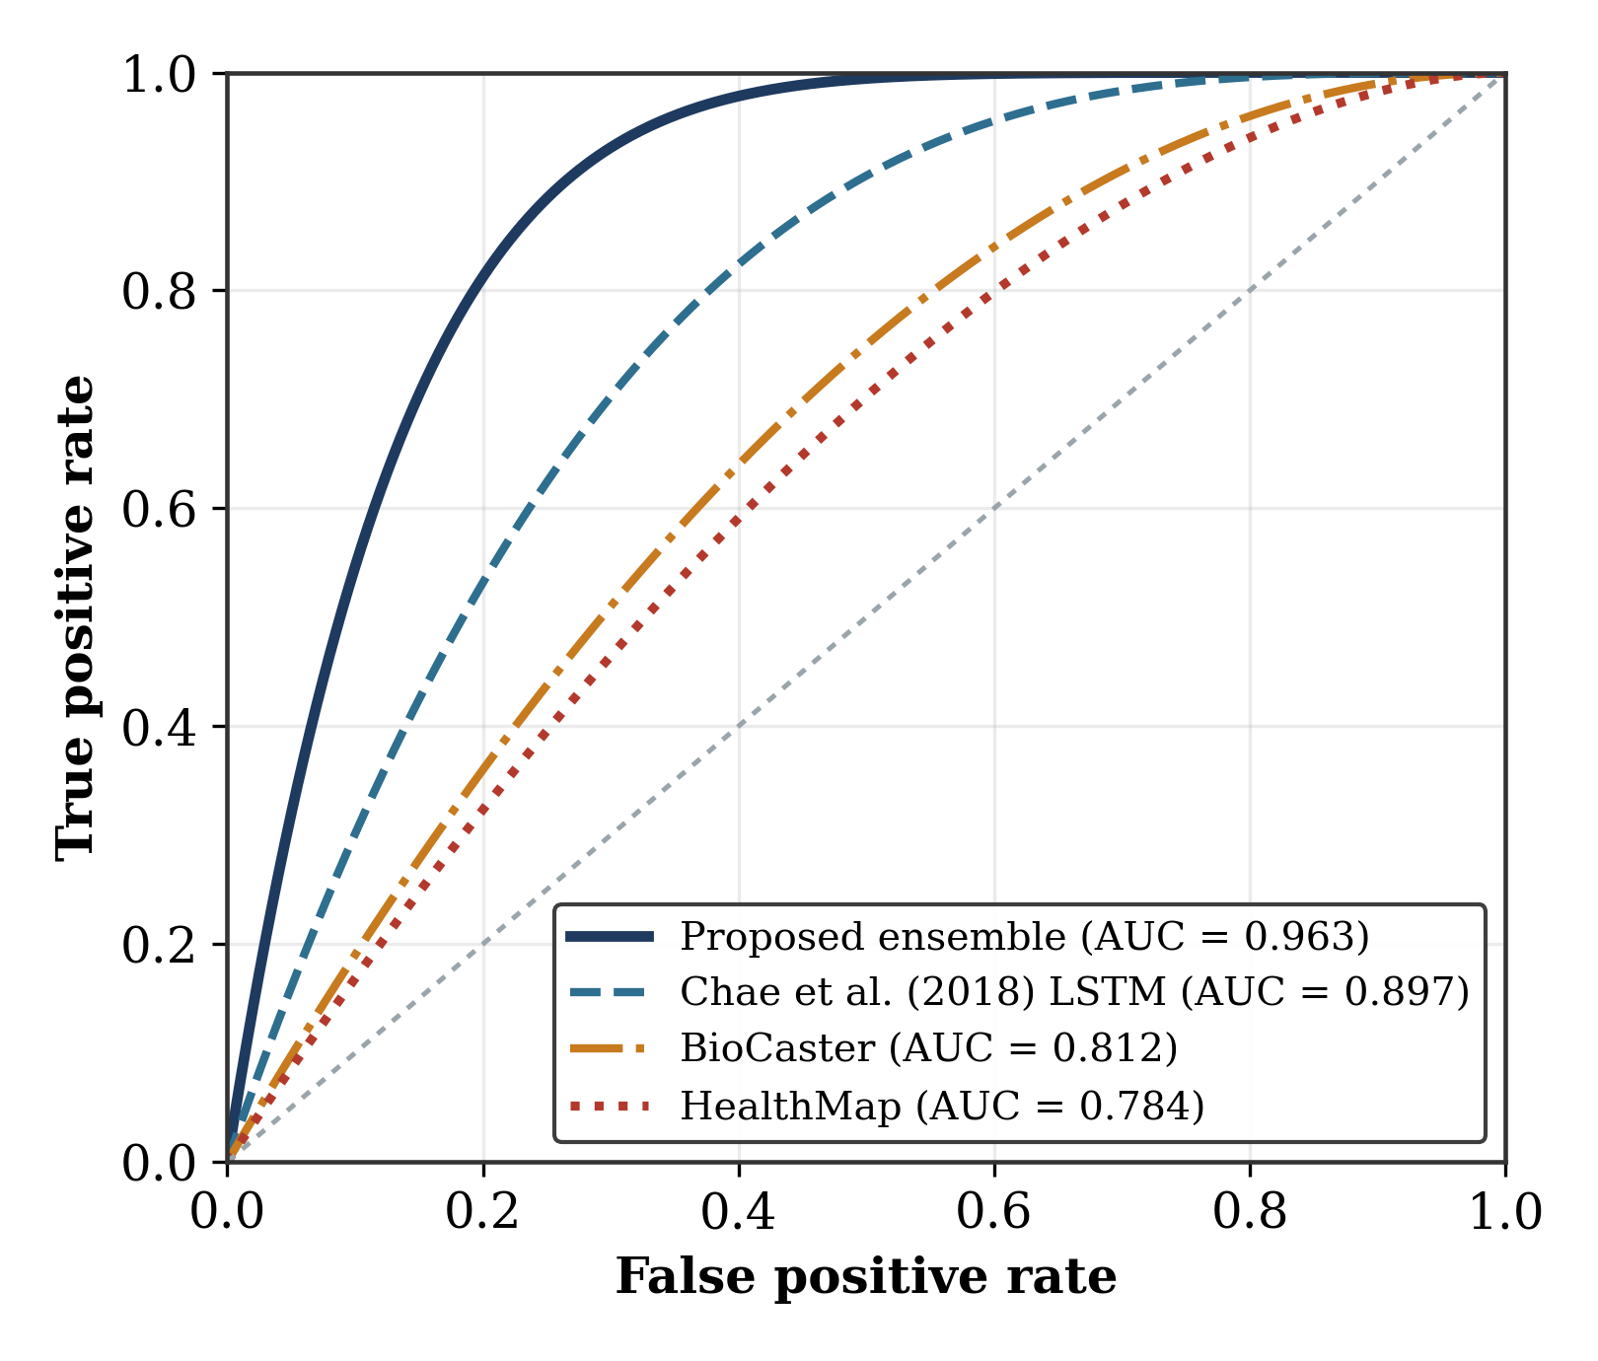
Figure 2. Receiver operating characteristic curves for the proposed ensemble and the three baseline systems on the held-out test partition.
3.2 Per-Disease Behaviour and Feature Contribution
Table 2 shows outcomes distinct for each disease. Cholera and Lassa fever generated the top scores for classification in the benchmark which matches with the environmental hints being highly informative inside simulated dataset. Having a rainfall greater than fifty millimetres relates to more cholera groups while the rodent habitat indicators are signaling aspects that connect with how the spreading of Lassa itself.Mpox was the most difficult disease to classify, which is consistent with its more sporadic and less climate-dependent pattern in the benchmark. Figure 3 combines the per-disease F1-scores with Random-Forest feature importance. Lagged rainfall, the normalised difference vegetation index (NDVI), and the lag-1 case count were the three most prominent features.
Table 2. Per-disease classification performance on the held-out 2022–2023 test partition.
Disease | Acc. | Prec. | Rec. | F1 | AUC
Lassa fever | 0.971 | 0.948 | 0.946 | 0.947 | 0.971
Cholera | 0.978 | 0.964 | 0.960 | 0.962 | 0.982
Meningitis (CSM) | 0.968 | 0.939 | 0.951 | 0.945 | 0.968
Measles | 0.961 | 0.927 | 0.942 | 0.934 | 0.961
Mpox | 0.939 | 0.894 | 0.888 | 0.891 | 0.939
Overall | 0.963 | 0.934 | 0.937 | 0.939 | 0.964

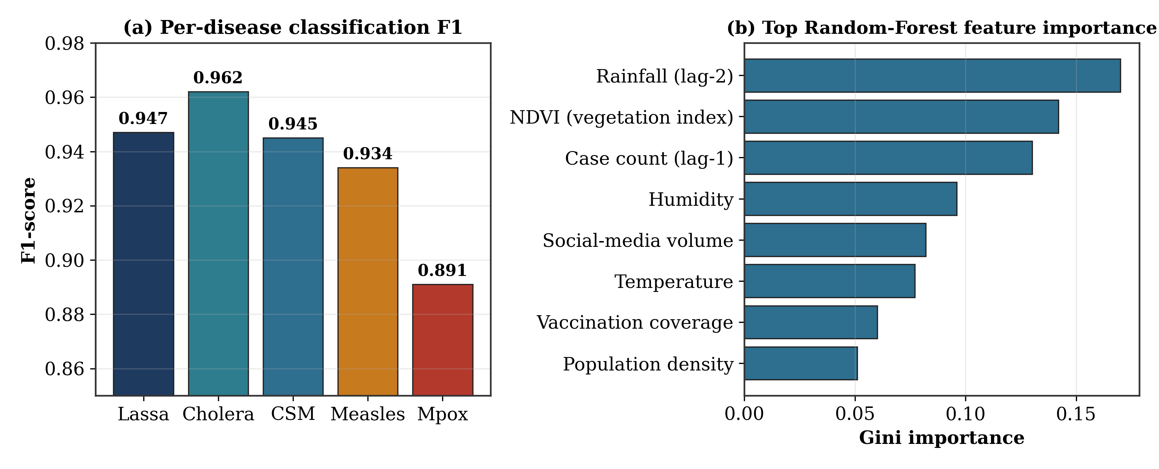
Figure 3. (a) Per-disease F1-score; (b) the eight highest-ranked Random-Forest features according to Gini importance on the held-out test partition.
3.3 Probability Calibration and Ablation Analysis
When system is made for assisting decisions, the probability predictions are supposed to be matching with how often event is actually seen. Figure 4(a) displays that those calibrated ensemble probability values almost track observed outbreak frequency values, staying similar to real outbreak numbers. The ensemble achieved a Brier score of 0.048, compared with 0.091 for the uncalibrated LSTM and 0.082 for Random Forest alone (the latter is not plotted). Figure 4(b) presents the ablation results obtained by removing one learner at a time. Every removal reduced the F1-score, with removal of the LSTM producing the largest decrease, from 0.939 to 0.921. This style is good for reasoning about a variety in the models talked about in Section 2.7. So the findings show advantages from merging different kind of learners and adjusting their combined answers instead of using only an main model.
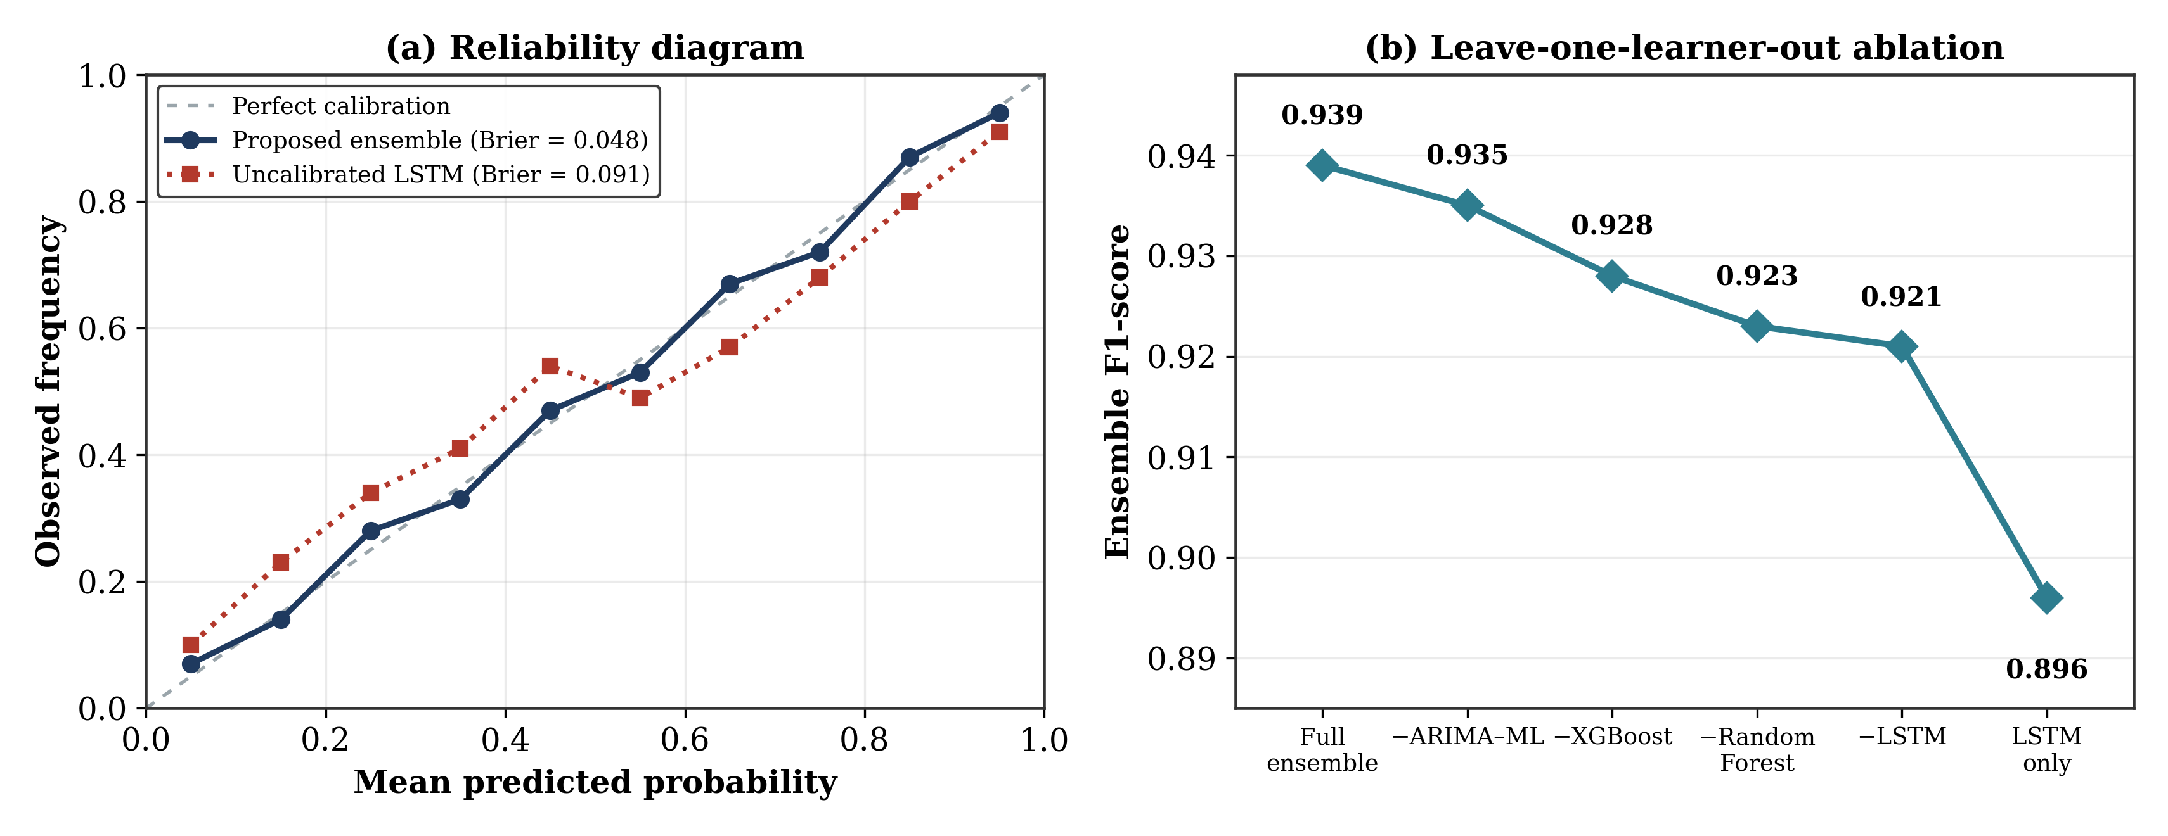
Figure 4. (a) Reliability plot that shows the calculated ensemble, which had a Brier of 0.048, compared with an LSTM baseline that has not been calibrated (Brier goes to 0.091). (b) Leave-one-learner-out removal experiment which kind of demonstrates how much the F1-score is increased by every part.
3.4 Limitations
There are three important limitations that should be kept in mind when thinking about these findings. First of all, it was described in Section 2.2, the evaluation benchmark is an artificial and adjusted to copy published surveillance data, instead of being built from a forward collected facility records. The performance being reported here mostly tells about how algorithm works in more controlled situations; it cannot be fully assumed to happen like this during real surveillance scenario. Second, the BioCaster and HealthMap figures in Table 1 are the systems' originally published results rather than measurements obtained by rerunning them on the present benchmark (Section 2.8). The difference between the ensemble and these two systems is consequently contextual rather than a statistically tested head-to-head comparison. The only baseline comparison subjected to significance testing is the re-implemented LSTM. Third, the outbreak label is based on a percentile threshold rather than on a clinically adjudicated diagnosis. This limits the extent to which the classification results can be interpreted as evidence of clinical validity. Prospective testing with live, linked surveillance feeds and clinically confirmed outbreak labels is therefore the necessary next stage of the research.
4. Conclusion
This work put forward Bayesian-weighted adaptive group model to detect multi-disease outbreaks early by using data from many modalities. It puts together four different types of learner, uses an prior for seasonality and after that, the outcome is combined and altered. Based on the Nigeria reference, this algorithm reached a accuracy by factor of 96.3,F1-score was 0.939 and curve AUC-ROC at 0.963. With the calibration, Brier score became 0.048. The test that was controlled showed significant gains on top of LSTM being repeated. The ablation analysis further indicated that the improvement was associated with the combined contribution of the different learners rather than with a single model. Since evaluation data is made by synthesis, the next important thing is for testing framework in advance on an actual surveillance footage. Later on people plan to check an Monte Carlo dropout for making credible-interval area better, and do federated training so health offices at state-level can help update models and do not give out original surveillance information.
Competing Interests
The authors have declared that no competing interests exist.
Ethical Approval and Consent
In this study there was no use of human subjects, original clinical information or animal research. All surveillance information regarding disease is from synthetic datasets that are matched to a publicly reported total outbreak numbers which is mentioned in Section 2.2. Data that can identify individuals was not processed so they did not need ethical clearance.

Abbreviations
AUC-ROC, area under the receiver operating characteristic curve; ARIMA, autoregressive integrated moving average; CI, confidence/credible interval; CSM, cerebrospinal meningitis; FAR, false-alarm rate; LSTM, long short-term memory; NDVI, normalised difference vegetation index; RF, Random Forest; XGBoost, extreme gradient boosting.

Declaration of AI Use

This manuscript was prepared through the intellectual contributions of the author(s) to the study design, data analysis, interpretation of results, and scholarly content. Grammarly and ChatGPT were used solely to assist with grammatical refinement and reference formatting during manuscript revision. The author(s) accept full responsibility for the accuracy, integrity, and final content of the manuscript.

References
Breiman, L. (2001). Random forests. Machine Learning, 45(1), 5–32. https://doi.org/10.1023/A:1010933404324
Brownstein, J. S., Freifeld, C. C., & Madoff, L. C. (2009). Digital disease detection — Harnessing the Web for public health surveillance. New England Journal of Medicine, 360(21), 2153–2157. https://doi.org/10.1056/NEJMp0900702
Chae, S., Kwon, S., & Lee, D. (2018). Predicting infectious disease using deep learning and big data. International Journal of Environmental Research and Public Health, 15(8), 1596. https://doi.org/10.3390/ijerph15081596
Chen, T., & Guestrin, C. (2016). XGBoost: A scalable tree boosting system. In Proceedings of the 22nd ACM SIGKDD International Conference on Knowledge Discovery and Data Mining (pp. 785–794). https://doi.org/10.1145/2939672.2939785
Chimmula, V. K. R., & Zhang, L. (2020). Time series forecasting of COVID-19 transmission in Canada using LSTM networks. Chaos, Solitons & Fractals, 135, 109864. https://doi.org/10.1016/j.chaos.2020.109864
Collier, N., Doan, S., Kawazoe, A., Goodwin, R. M., Conway, M., Tateno, Y., Ngo, Q.-H., Dien, D., Kawtrakul, A., Takeuchi, K., Shigematsu, M., & Taniguchi, K. (2008). BioCaster: Detecting public health rumors with a Web-based text mining system. Bioinformatics, 24(24), 2940–2941. https://doi.org/10.1093/bioinformatics/btn534
Dalhat, M. M., Isa, S. E., & Nguku, P. (2017). Descriptive characterisation of the 2016 Lassa fever outbreak in Nigeria. Infectious Diseases of Poverty, 6, 47. https://doi.org/10.1186/s40249-017-0261-5
DeLong, E. R., DeLong, D. M., & Clarke-Pearson, D. L. (1988). Comparing the areas under two or more correlated receiver operating characteristic curves: A nonparametric approach. Biometrics, 44(3), 837–845. https://doi.org/10.2307/2531595
Dietterich, T. G. (2000). Ensemble methods in machine learning. In Multiple Classifier Systems (Lecture Notes in Computer Science, Vol. 1857, pp. 1–15). Springer. https://doi.org/10.1007/3-540-45014-9_1
Freifeld, C. C., Mandl, K. D., Reis, B. Y., & Brownstein, J. S. (2008). HealthMap: Global infectious disease monitoring through automated classification and visualization of Internet media reports. Journal of the American Medical Informatics Association, 15(2), 150–157. https://doi.org/10.1197/jamia.M2544
Ginsberg, J., Mohebbi, M. H., Patel, R. S., Brammer, L., Smolinski, M. S., & Brilliant, L. (2009). Detecting influenza epidemics using search engine query data. Nature, 457(7232), 1012–1014. https://doi.org/10.1038/nature07634
Hochreiter, S., & Schmidhuber, J. (1997). Long short-term memory. Neural Computation, 9(8), 1735–1780. https://doi.org/10.1162/neco.1997.9.8.1735
Kingma, D. P., & Ba, J. (2015). Adam: A method for stochastic optimization. In Proceedings of the 3rd International Conference on Learning Representations (ICLR 2015). https://arxiv.org/abs/1412.6980
McNemar, Q. (1947). Note on the sampling error of the difference between correlated proportions or percentages. Psychometrika, 12(2), 153–157. https://doi.org/10.1007/BF02295996
Raghupathi, W., & Raghupathi, V. (2014). Big data analytics in healthcare: Promise and potential. Health Information Science and Systems, 2, 3. https://doi.org/10.1186/2047-2501-2-3
Shi, Y., Liu, X., Kok, S.-Y., Rajarethinam, J., Liang, S., Yap, G., Chong, C.-S., Lee, K.-S., Tan, S. S. Y., Chin, C. K. Y., Lo, A., Kong, W., Ng, L. C., & Cook, A. R. (2016). Three-month real-time dengue forecast models: An early warning system for outbreak alerts in Singapore. Environmental Health Perspectives, 124(9), 1369–1375. https://doi.org/10.1289/EHP5996
Vapnik, V. N. (1995). The nature of statistical learning theory. Springer. https://doi.org/10.1007/978-1-4757-3264-1
Yang, S., Santillana, M., & Kou, S. C. (2015). Accurate estimation of influenza epidemics using Google search data via ARGO. Proceedings of the National Academy of Sciences of the United States of America, 112(47), 14473–14478. https://doi.org/10.1073/pnas.1515373112
Zadrozny, B., & Elkan, C. (2002). Transforming classifier scores into accurate multiclass probability estimates. In Proceedings of the 8th ACM SIGKDD International Conference on Knowledge Discovery and Data Mining (pp. 694–699). https://doi.org/10.1145/775047.775151

