Original Research Article

Optimization of Osmotic Dehydration Conditions for Pineapple Cubes Using Response Surface Methodology

ABSTRACT
Pineapple is a widely consumed tropical and subtropical non-citrus fruit because of its pleasant flavor, refreshing balance of sweetness and acidity, and high vitamin C content. In this study, Response Surface Methodology (RSM) was applied to investigate the effects of soaking temperature (32-48°C), immersion time (40-141 min.) and sucrose solution concentration (42-58°B) on water loss, weight reduction and solid gain during the osmotic dehydration of pineapple cubes. The experiment was conducted at the Department of Postharvest Technology, Advanced Center for Agricultural Research and Education (ACARE), Yezin Agricultural University (YAU), Myanmar. Osmotic dehydration was used as a processing method to improve product quality and extend shelf life. A constant sample-to-solution ratio of 1:5 was maintained throughout the osmotic dehydration. Quadratic regression models were developed to describe the effects of the process variables on water loss, weight reduction and solid gain of pineapple cubes. The developed quadratic models for all responses were statistically significant (P<0.001). Immersion time and sucrose solution concentration showed greater effects on water loss than soaking temperature. For solid gain, immersion time and sucrose solution concentration were also found to be the most significant factors. The osmotic dehydration was optimized by considering water loss, weight reduction and solid gain simultaneously. The optimum conditions were determined as a soaking temperature of 45°C, an immersion time of 119 min. and a sucrose solution concentration of 55°B. Under these optimum conditions, the water loss, weight reduction and solid gain were 22.30%, 10.70% and 14.58%, respectively.
Keywords: Optimization; Osmotic dehydration; Pineapple; Response surface methodology
- INTRODUCTION

Pineapple (Ananas comosus) belongs to the Bromeliaceae family and originated in South America. It is one of the most important tropical fruits in the world and third ranks in production after banana and citrus fruits (Bartholomew, Paull and Rorbach, 2003). Pineapple is also known as the “queen of fruits” because of its pleasant flavor and taste (Chaudhary, Kumar, Singh, Kumar, Kumar and Vipul Chaudhary, 2019). Fresh pineapple contains approximately 81.2–86.2% moisture, 13–19% total solids and 2–3% fiber. It is also a good source of vitamin C and contains antioxidants such as flavonoids and phenolic compounds. The main sugars found in pineapple are sucrose, glucose and fructose. Other components, including lipids and nitrogenous compounds, are also present (Ramallo and Mascheroni, 2012). Due to its high moisture content, fresh pineapple has a relatively short storage life and can easily deteriorate. To overcome this problem, processing technology is necessary. Pineapple can be processed into different value-added products such as concentrated juice, jam, syrup, wine and dried pineapple. Food processing can help reduce food losses and waste, extend the shelf life of food products and improve their availability. It can also contribute to food security, increase income and make processed products available throughout the year (Mogeni, 2025).
Osmotic dehydration (OD) is a food preservation method used to reduce the moisture content and water activity of food. In this process, food is immersed in a concentrated solution, which promotes the movement of water from the food into the surrounding solution. Compared with some other dehydration methods, osmotic dehydration can better maintain the sensory and nutritional qualities of food products (Ozdemir, Ozen, Dock and Floros, 2008). Since the process does not require very high temperatures, it can help reduce the loss of heat-sensitive to food components (Yadav and Singh, 2014).
Response surface methodology (RSM) is a statistical and mathematical technique used to study the relationship between several process variables and their responses. It can also be used to predict and optimize process conditions when several factors affect the response at the same time (Prabhakaran, Basha, Kannadasan and Aravinthan, 2010). The application of RSM generally includes experimental design, selection of suitable levels of process variables, development of mathematical models and optimization of the responses. RSM has been widely used in food processing for process optimization and product improvement. It can reduce the number of experiments required and therefore save both experimental time and materials. Second-order polynomial models and desirability functions can also be applied to determine suitable operating conditions. Thus, RSM can provide useful information about process variables and their interactions using a relatively small number of experiments (Khuri and Mukhopadhyay, 2010).
The objectives of this study are to investigate the effects of soaking temperature, immersion time and sucrose solution concentration on water loss, weight reduction and solid gain during the osmotic dehydration of pineapple cubes and to determine the optimum condition of soaking temperature, immersion time and sucrose solution concentration using response surface methodology in order to maximize water loss and weight reduction while minimizing solid gain.

2. MATERIALS AND METHODS
2.1 Materials
The uniform fully matured pineapples were harvested 165 days after flowering and obtained from Seik Khaung Village, Hsihseng Township, Southern Shan State. For each experimental run, a 100 g portion of pineapple cubes was used for the osmotic dehydration processes.

2.2 Preparation of Osmotic Solution
The osmotic solutions (42-58 °B) were prepared by dissolving the required amount of food-grade fresh refined sugar in distilled water on a weight-to-weight (w/w) basis. The sample-to-solution ratio was maintained at 1:5. The total soluble solids (°B) content of each prepared solution were measured using a digital refractometer.

2.3 Osmotic Dehydration of Pineapple Cubes
The pineapples were peeled and cut into cubes (15 × 15 × 15) mm³ (Kumar, Begum, Hoque, Hussain and Srivastava, 2021). The prepared samples were subjected to osmotic dehydration according to the experimental conditions (Table 2). During the osmotic dehydration the required temperature was maintained using a constant-temperature water bath. A sample-to-solution ratio of 1:5 was used throughout the experiment to minimize changes in the concentration of the osmotic solution. Fresh osmotic syrup was used for each experimental run. The osmotically dehydrated samples were then withdrawn, rinsed quickly in water, blotted gently with a tissue paper in order to remove the free water present on the surface. After osmotic dehydration, the samples were removed from the solution and quickly rinsed with water. The excess water on the surface of the samples was gently removed using tissue paper. The samples were then dried in a hot-air oven at 70 °C for 18 hr. to determine the dry matter content. After oven drying, the samples were cooled in a desiccator and then packed in low-density polyethylene (LDPE). All experiments were carried out in duplicate, and the average values were used for subsequent calculations.

2.4 Determination of Rate of Mass Transfer
2.4.1 Determination of Water Loss
The mass transfer parameters i.e. water loss (WL), weight reduction (WR) and solid gain (SG) were calculated by the equations given by Sridevi and Genitha.
$\text{Water Loss (WL\%) }=\frac{\text{\{}\text{(W}\text{o}\text{- W}\text{t}\text{) + (S}\text{t}\text{ – S}\text{o}\text{)\}}}{\text{W}\text{o}}×100$ (Sridevi and Genitha, 2012)

Where, Wo = the initial weight (g)
W_{t} = the weight taken after osmotic dehydration at any time (g)
S_{o} = the initial dry matter (g)
S_{t} = the dry matter of after osmotic dehydration for any time (g)

2.4.2 Determination of Weight Reduction
$\text{Weight Reduction (WR\%)}=\frac{\text{(M}\text{o}\text{-M) }}{\text{M}\text{o}}×100$ (Sridevi and Genitha, 2012)

Where, Mo = initial mass of sample (g)
M = mass of sample after dehydration (g)

2.4.3 Determination of Solid Gain

$\text{Solid Gain (SG\%) }=\frac{\text{(S}\text{t }\text{- S}\text{o}\text{) }}{\text{W}\text{o}}×100$ (Sridevi and Genitha, 2012)
Where,
S_{o} = the initial dry matter (g)
S_{t} = the dry matter of after osmotic dehydration for any time
W_{o} = the initial weight (g)

2.5 Statistical Analysis and Optimization
The effects of three independent variables, namely soaking temperature, immersion time and sucrose solution concentration, on water loss, weight reduction and solid gain were investigated. The optimization was performed using Design-Expert software (Version 12.0, Stat-Ease Inc., Minneapolis, MN, USA) based on a Central Composite Rotatable Design (CCRD) with three factors at five levels. The factorial levels were set at 35-45 °C for soaking temperature, 60-120 min for immersion time and 45-55 °B for sucrose solution concentration. The design also included axial (±α) points, which extended the experimental ranges to 32-48 °C, 40-141 min. and 42-58 °B for soaking temperature, immersion time and sucrose solution concentration, respectively (Table 1). A total of twenty experimental runs were generated using the CCRD and conducted in random order (Table 2). Water loss, weight reduction and solid gain were considered as the response variables. The experimental data were fitted to a second-order polynomial regression model using the least-squares method to predict each response (Y). The quadratic polynomial equation used for the model was expressed as:
Y = a₀ + a₁A + a₂B + a₃C + a₁₁A² + a₂₂B² + a₃₃C² + a₁₂AB + a₁₃AC + a₂₃BC + ε
where Y represents the response variables, including water loss, weight reduction and solid gain; a₀ is the intercept; and A, B and C represent the independent variables.
The model was used to evaluate the linear, quadratic and interaction effects of the independent variables on each response. Multiple regression analysis was performed to determine the effects of the process variables on the responses. A quadratic model containing linear, squared and interaction terms was initially fitted to the experimental data. Analysis of variance (ANOVA) was used to evaluate the statistical significance of the model terms, and terms with a probability value (P-value) of less than 0.05 were considered statistically significant. The adequacy of the developed models was evaluated using the coefficient of determination (R²), adjusted R² and predicted R². After fitting the models, residual analysis was also performed to examine the assumptions associated with ANOVA. The desirability function approach was used to determine the optimum processing conditions by maximizing water loss and weight reduction while minimizing solid gain. The fitted response surfaces and optimization results were generated using Design-Expert software. Validation experiments were conducted separately from the CCRD experimental runs using the predicted optimum processing conditions. The observed values for water loss, weight reduction and solid gain were compared with their corresponding predicted values to evaluate the adequacy of the developed quadratic models.

Table 1: Process Variables and their levels of experimental design
Symbol  (Factor Levels) | Independent Variables | Coded Levels
Symbol  (Factor Levels) | Independent Variables | -α | -1 | 0 | 1 | +α
X₁ | Soaking temperature (℃) | 32 | 35 | 40 | 45 | 48
X₂ | Immersion time (min.) | 40 | 60 | 90 | 120 | 141
X₃ | Sucrose solution Concentration (ºB) | 42 | 45 | 50 | 55 | 58

Table 2: Observed values of dependent variables for different runs of optimization process
 | Coded Values |  |  | Actual Values
Run No. | X₁ | X₂ | X₃ | X₁ | X₂ | X₃
1 | (0) | (0) | (0) | 40 | 90 | 50
2 | (0) | (0) | (0) | 40 | 90 | 50
3 | (0) | (0) | (0) | 40 | 90 | 50
4 | (0) | (0) | (0) | 40 | 90 | 50
5 | (0) | (0) | (0) | 40 | 90 | 50
6 | (0) | (0) | (0) | 40 | 90 | 50
7 | (–1) | (–1) | (–1) | 35 | 120 | 45
8 | (0) | (– α) | (– α) | 40 | 90 | 42
9 | (0) | (0) | (0) | 40 | 40 | 50
10 | (α) | (0) | (0) | 48 | 90 | 50
11 | (–1) | (+1) | (+1) | 35 | 60 | 55
12 | (+1) | (+1) | (+1) | 45 | 120 | 55
13 | (–1) | (-1) | (-1) | 35 | 60 | 45
14 | (– α) | (0) | (0) | 32 | 90 | 50
15 | (+1) | (+1) | (+1) | 45 | 60 | 55
16 | (0) | (0) | (0) | 40 | 141 | 50
17 | (0) | (α) | (α) | 40 | 90 | 58
18 | (–1) | (+1) | (+1) | 35 | 120 | 55
19 | (+1) | (–1) | (–1) | 45 | 120 | 45
20 | (+1) | (–1) | (–1) | 45 | 60 | 45

3. Results and Discussion
3.1 Effect of Temperature, Time and Concentration on Water Loss
The water loss ranged from 10.50% to 24.10% using osmotic dehydration process (Table 3). Table. 4 gives the regression analysis of the developed process model and response, where in, the quadratic model was significant (P<0.001). This implies that soaking temperature, immersion time and sucrose solution concentration significantly influence the water loss (WL). Sucrose solution concentration and soaking temperature also have a positive and significant effect in water loss. Thus, it increases the water loss with increased process time and sucrose solution concentration. Mundada et al. And Jain et al. had also reported the same result for water loss of pomegranate arils and papaya cubes respectively. Contreras and Smyrl (1981) reported that increasing the osmotic solution concentration, immersion time, and temperature promoted water removal from apple rings during osmotic concentration. It was found that the sucrose solution concentration and immersion time have a highly significant effect (P<0.001) on values of water loss, weight reduction and solid gain of the osmotically dehydrated pineapple cubes and it was clear from the results that sucrose solution concentration positively affected on water loss. As the concentration of sucrose solution increases, its water loss rate increase. The lack of fit was non-significant (P=0.05) this indicate that the models adequately represent the experimental data. The value of R² = 0.9684 indicate that 96.84% of variability in water loss is explained by model (Table 4). The coefficient of variation (CV=7.19%) showed a good precision and reliability. The quadratic equation describing relationship between soaking temperature, immersion time and sucrose solution concentration is as given below.
WL = 11.82 + 0.906 A +3.53 B+ 2.12 C + 0.049 AB - 0.324 AC + 0.676 BC + 0.421 A² + 2.18 B ² +1.28 C ²
Where, WL= water loss, A = soaking temperature (°C), B = immersion time(min.),
C= sucrose solution concentration (°B)
Figure 1 (a) shows the effects of soaking temperature and immersion time at a fixed sucrose solution concentration of 50°B. Water loss generally increased with increasing immersion time, while soaking temperature showed a smaller effect. Figure 1 (b) illustrates the effects of soaking temperature and sucrose concentration at a fixed immersion time of 90 min. Higher water loss was observed with increasing sucrose solution concentration, whereas the effect of temperature was less pronounced. Figure 1 (c) shows the effects of immersion time and sucrose solution concentration at a fixed temperature of 40 °C. Water loss increased markedly with both immersion time and sucrose concentration, with higher values occurring at the higher levels of these factors.
Numerical optimization was conducted within the factorial design region (35-45°C), (60-120 min.) and 45-55 (°B) while the axial (±α) point (32-48°C), (40-41 min.) and (42-58°B) are used to estimate the quadratic model in CCRD. Desirability function approach was employed to get an optimum osmotic dehydration condition for maximum water loss, the most suitable solution has a desirability value of 0.74 at a temperature 45 ºC, and immersion time 119 min. and sucrose solution concentration 55 ºB with predicted water loss 22.25 %, as described in Table 5. The optimized conditions have been validated and the resulting water loss (22.30%) was found to be in excellent agreement with the predicted value, with a deviation of just 0.22 % (Table 6).

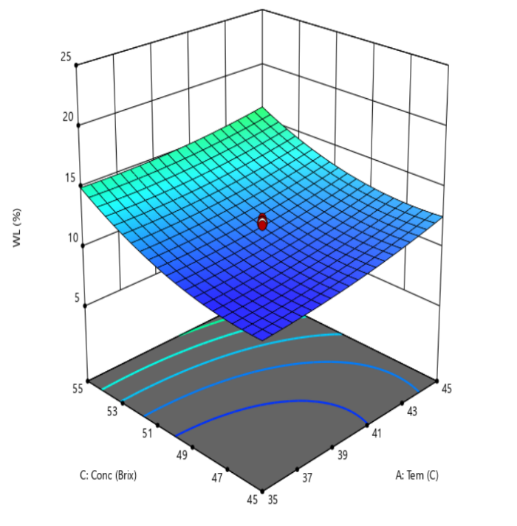
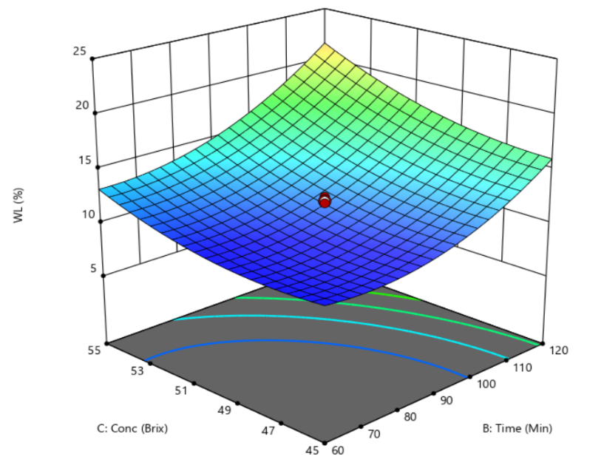
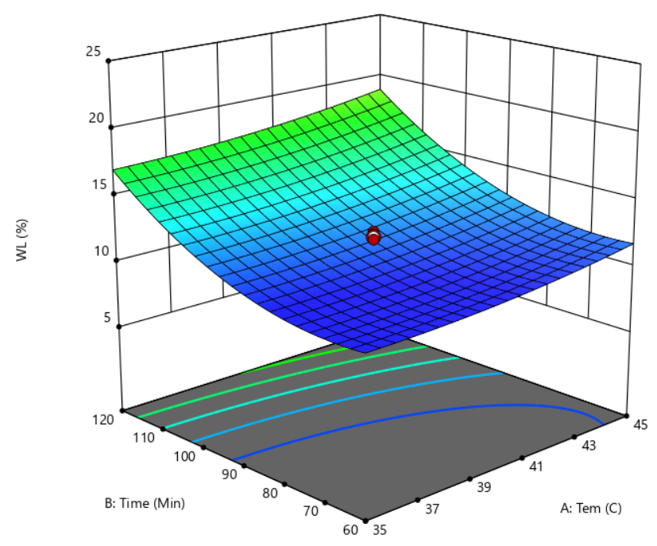

Figure (1) Response surfaces for water loss (WL) in the osmotic dehydration of pineapple cubes as a function of (a) soaking temperature and immersion time at a fixed concentration of 50 °B (b) sucrose solution concentration and temperature at a fixed time of 90 min. (c) sucrose solution concentration and time at a fixed temperature of 40 ℃

3.3 Effect of Temperature, Time and Concentration on Weight Reduction (WR)
The weight reduction of osmotically dehydrated pineapple cubes ranged from 3.2% to 11.31% (Table 3). The regression analysis of the developed process model and response (Table 4). The quadratic model was significant (P<0.001), indicating that soaking temperature, immersion time and sucrose solution concentration significantly affected weight reduction. The magnitude of coefficient estimate indicates the maximum positive effect of soaking temperature followed by immersion time and sucrose solution concentration on weight reduction. It gives increased weight reduction with increase of immersion time and sucrose solution concentration. The considerable influence of processing time on weight reduction observed in the present study can be explained by the progressive removal of water from pineapple tissue during immersion. Khanom et al. (2014) reported rapid water loss, sugar gain, and weight reduction during the first four hours of osmotic dehydration of pineapple, demonstrating that immersion time strongly influences mass transfer and consequently the reduction in sample weight. Sucrose solution concentration also significantly affected weight reduction in the present study.
It was also found that both soaking time and sucrose solution concentration have highly significant effects (P< 0.001) on values of weight reduction. The non-significant lack of fit (P = 0.05) indicated that the model adequately represented the experimental data. The high coefficient of determination (R² = 0.9934) indicated that 99.34 % of the variability in weight reduction was explained by the model. The low coefficient of variation (CV = 4.81%) also indicated good precision and reliability of the experimental results (Table 4). The relationship between soaking temperature, immersion time and sucrose solution concentration were described by the following second-order polynomial equation in terms of actual factors:
WR = 4.58 + 0.284 A +2.17 B+ 1.57 C + 0.028 AB - 0.026 AC + 0.276 BC + 0.0964 A ² +
1.09 B ² +0.834 C ²
Where, WR = weight reduction (%), A= soaking temperature (°C), B= immersion time (min). C=sucrose solution concentration (°B)
Figure 2 (a) shows the effects of soaking temperature and immersion time at a fixed sucrose concentration of 50°B. Weight reduction generally increased with increasing immersion time, while soaking temperature had a smaller effect. Figure 2 (b) illustrates the effects of soaking temperature and sucrose solution concentration at a fixed immersion time of 90 min., showing that weight reduction increased mainly with increasing sucrose solution concentration. Figure 2 (c) presents the effects of immersion time and sucrose concentration at a fixed temperature of 40°C. Higher weight reduction was observed at longer immersion times and higher sucrose solution concentrations Similar effects of processing conditions on mass transfer during osmotic dehydration of pineapple have been reported in previous studies (Rastogi and Raghavarao, 2004; Lombard et al., 2008; Sridevi and Genitha, 2012).
The optimum osmotic dehydration conditions for maximizing weight reduction were performed using the desirability function methodology. The best solution was found with a desirability value of 0.74 at a soaking temperature of 45 °C and immersion time 119 min and sucrose solution concentration 55 ºB, with a predicted weight reduction of 10.68 % (Table 6). Validation experiments conducted under the optimized conditions produced a weight
reduction of 10.70 %, which closely agreed with the predicted value, with a difference of only 0.19 % (Table 6).
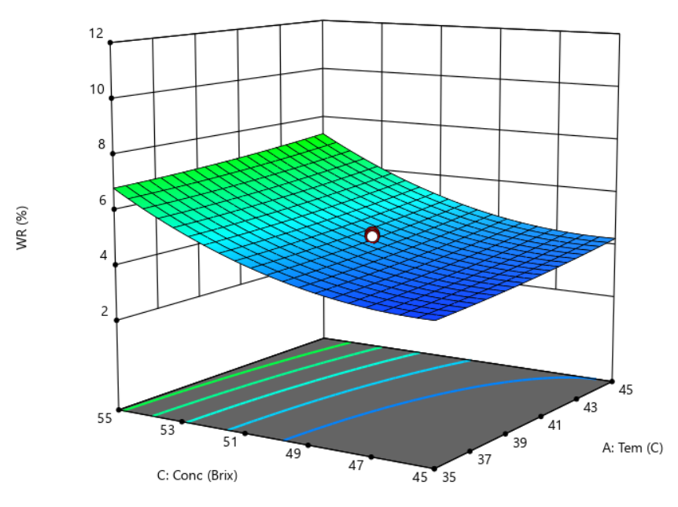
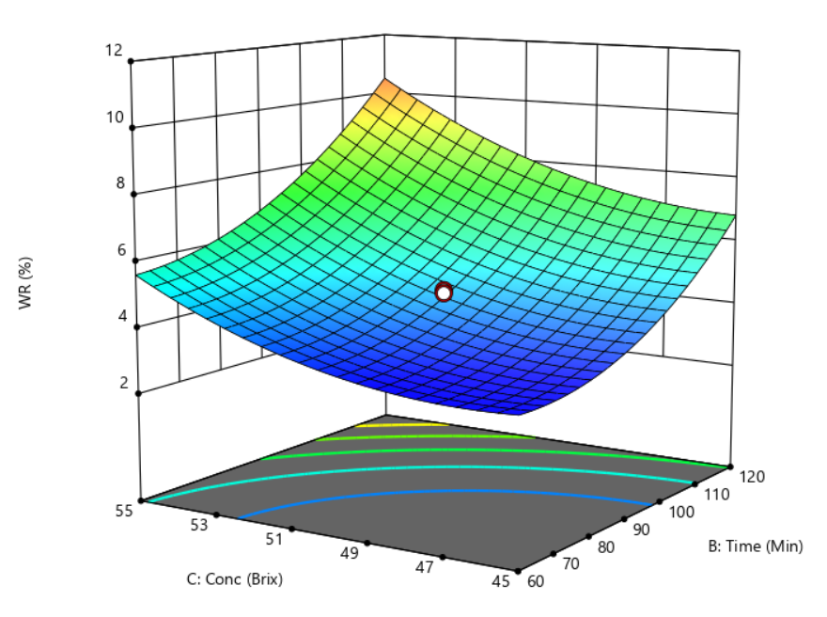
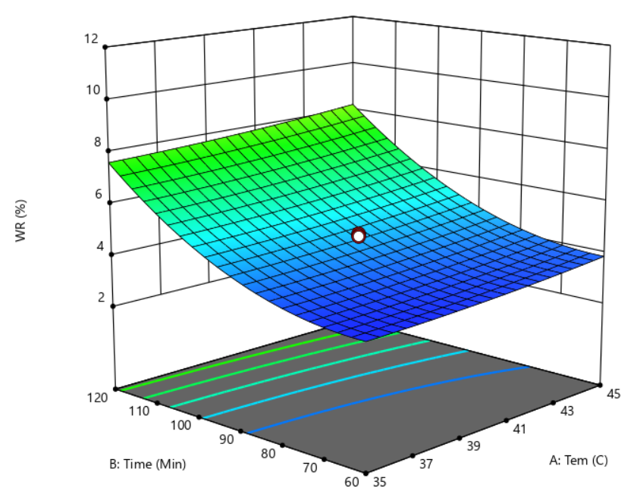

Figure (2) Response surfaces for weight reduction (WR) in the osmotic dehydration of pineapple cubes as a function of (a) soaking temperature and immersion time at a fixed concentration of 50 °B (b) sucrose solution concentration and temperature at a fixed time of 90 min. (c) sucrose solution concentration and time at a fixed temperature of 40 ℃

3.4 Effect of Temperature, Time and Concentration on Solid Gain (SG)
In this study, the solid gain obtained from osmotic dehydration process from 7.52% to 16.5%, as shown in Table 3. The regression analysis of the developed process model and response is presented in Table 4. The quadratic model was significant (P <0.001), indicating that soaking temperature, immersion time and sucrose solution concentration significantly affected solid gain. The magnitude of coefficient estimate indicates the maximum positive effect of soaking temperature followed by immersion time and sucrose solution concentration on solid gain. It gives increased solid gain with increase of immersion time and sucrose solution concentration. The predominant effect of immersion time observed in the present study was in close agreement with Haque et al. (2019), who reported that process time had the greatest contribution to solid gain, followed by solute concentration and temperature during the osmotic dehydration of green chili. They also reported that solid gain increased with increasing process time, osmotic solution concentration, and temperature. Manivannan and Rajasimman (2011) similarly reported that the effects of temperature and processing time on solid gain were more pronounced during osmotic dehydration of beetroot. Furthermore, Eren and Kaymak-Ertekin (2007) demonstrated significant effects of processing variables on solid gain and successfully described solid gain using a second-order polynomial model.
It was also found that both soaking time and sucrose solution concentration have highly significant effects (P <0.001) on values of solid gain of the osmotically dehydrated pineapple cubes. The non-significant lack of fit (P=0.05) indicated that the model adequately represented the experimental data. The high coefficient of determination (R²=0.9592) indicated that 95.92% of the variability in solid gain was explained by the model. The low coefficient of variation (CV=7.59%) also indicated good precision and reliability of the experimental results (Table 4). The relationship between soaking temperature, immersion time and sucrose solution concentration were described by the following second-order polynomial equation in terms of actual factors:
SG = 8.14 + 0.465 A +2.27 B+ 1.12 C – 0.078 AB – 0.223 AC + 0.553 BC + 0.318 A ² + 1.57 B ² + 0.754 C ²
Where, SG= solid gain (%), A= solution temperature (°C), B= immersion time (min.)
C= sucrose solution concentration (°B)
​ Figure 3 (a) shows the effects of soaking temperature and immersion time at a fixed sucrose concentration of 50 °B. Solid gain was mainly influenced by immersion time, while soaking temperature showed a smaller effect. Figure 3 (b) illustrates the effects of soaking temperature and sucrose solution concentration at a fixed immersion time of 90 min., showing a greater effect of sucrose solution concentration than temperature on solid gain. Figure 3 (c) presents the effects of immersion time and sucrose solution concentration at a fixed temperature of 40°C. According to ANOVA results, which showed that immersion time and sucrose solution concentration had greater effects on solid gain than soaking temperature. The increase in solid gain may be attributed to greater solute penetration into the pineapple tissue with longer immersion time and higher sucrose concentration. Similar effects of processing conditions on solid uptake during osmotic dehydration of pineapple have been reported by Meena et al. (2022).
The optimum osmotic dehydration conditions for minimizing solid gain were performed using the desirability function methodology. The best solution was found with a desirability value of 0.74 at a soaking temperature of 45°C, immersion time 119 min. and sucrose solution concentration 55ºB, with a predicted solid gain of 14.6% (Table 6). Validation experiments conducted under the optimized conditions produced a solid gain of 14.58 %, which closely agreed with the predicted value, with a difference of only 0.14 % (Table 6)

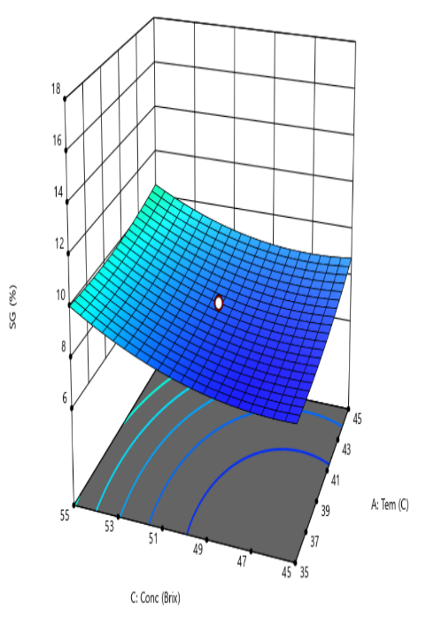
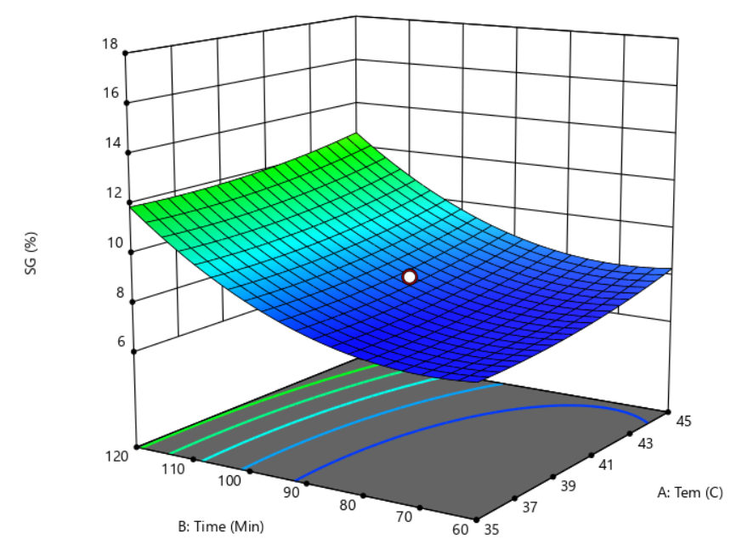
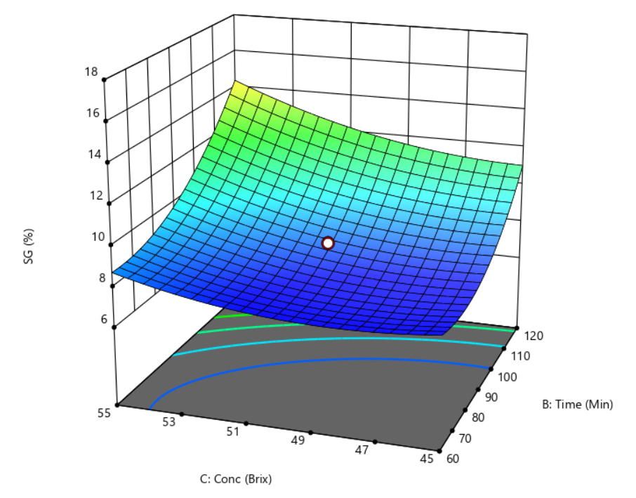
.

Figure (3) Response surfaces for Solid Gain (SG) in the osmotic dehydration of pineapple cubes as a function of (a) soaking temperature and immersion time at a fixed concentration of 50 °B (b) sucrose solution concentration and temperature at a fixed time of 90 min. (c) sucrose solution concentration and time at a fixed temperature of 40 ℃

Table 3. Effect of different osmotic dehydration conditions and responses of osmotically dehydrated pineapple cubes according to central composite rotatable design

Run No. | Independent Variables |  |  | Dependent Variables
Run No. | Factor A  Temperature (℃) | Factor B  Time (min.) | Factor C  Conc:  (˚B) | Water Loss  (%) | Weight Reduction  (%) | Solid Gain  (%)
1 | 40 | 90 | 50 | 12.10 | 4.70 | 8.50
2 | 40 | 90 | 50 | 12.50 | 4.30 | 8.60
3 | 40 | 90 | 50 | 11.60 | 4.80 | 7.60
4 | 40 | 90 | 50 | 12.30 | 4.50 | 8.60
5 | 40 | 90 | 50 | 10.70 | 4.70 | 8.60
6 | 40 | 90 | 50 | 11.90 | 4.50 | 7.80
7 | 35 | 120 | 45 | 16.00 | 6.78 | 11.20
8 | 40 | 90 | 42 | 10.58 | 4.10 | 7.59
9 | 40 | 40 | 50 | 10.67 | 3.80 | 7.59
10 | 48 | 90 | 50 | 14.40 | 5.59 | 9.50
11 | 35 | 60 | 55 | 13.99 | 5.70 | 9.48
12 | 45 | 120 | 55 | 22.50 | 10.70 | 14.9
13 | 35 | 60 | 45 | 10.50 | 3.20 | 7.90
14 | 32 | 90 | 50 | 10.50 | 3.90 | 7.52
15 | 45 | 60 | 55 | 14.10 | 5.90 | 9.70
16 | 40 | 141 | 50 | 24.10 | 11.31 | 16.50
17 | 40 | 90 | 58 | 19.20 | 9.56 | 11.90
18 | 35 | 120 | 55 | 21.00 | 10.49 | 14.50
19 | 45 | 120 | 45 | 17.60 | 7.20 | 12.00
20 | 45 | 60 | 45 | 13.10 | 3.40 | 11.15
Table 4. Analysis of variance for the fit of experimental data to the quadratic model
Factors | Water loss (%) | Weight reduction (%) | Solid gain (%)
Model F- value | 34.07*** | 168.52*** | 26.14***
Model P- value | < 0.001 | <0 .001 | < 0.001
Lack of Fit (P value) | 0.070^{ns} | . 0.082^{ns} | 0.060^{ns}
R² | 0.9684 | 0.9876 | 0.9225
Adjusted R² value | 0.9400 | 0.9832 | 0.9853
CV % | 7.14 | 4.81 | 7.59
* - significant at probability level at 5% level; ** - significant at probability level at 1% level; *** - significant at probability level at .01% level; ns - non-significant R² = coefficient of determination; CV % = coefficient of variation

Table 5. Goal and important factor and response variables for determining optimum osmotic dehydration conditions
Factor/response | Goal | Importance | Lower limit | Upper limit | Optimum value
Factor
Temperature (°C) | In range | +++ | 35 | 45 | 45
Immersion time (min) | In range | +++ | 60 | 120 | 119
Concentration (ºB) | In range | +++ | 45 | 55 | 55
Response
Water loss (%) | Maximum | +++ | 10.5 | 24.2 | 22.25
Weight reduction (%) | Maximum | +++ | 3.2 | 11.31 | 10.68
Solid Gain (%) | Minimum | +++ | 7.52 | 16.5 | 14.60
Desirability |  |  |  |  | 0.74
Table 6. Comparison of predicted and observed values for response variables
Independent Variables (Process Parameter) | Optimum Conditions
Temperature (°C) | 45
Immersion time (min.) | 119
Concentration (B) | 55
 | Predicted Value | Observed Value | Difference
Water loss (%) | 22.25 | 22.30 | 0.22
Weight reduction (%) | 10.68 | 10.70 | 0.19
Solid gain (%) | 14.60 | 14.58 | 0.14

3.5 Optimization of the Osmotic Dehydration Process
The osmotic dehydration process was optimized by maximizing water loss (WL) and weight reduction (WR) while minimizing solid gain (SG). Higher WL and WR indicate effective water and mass removal, whereas lower SG is desirable to minimize excessive solute uptake and maintain product quality. Numerical optimization using the desirability function showed that the optimum condition was solution temperature of 45°C and immersion time of 119 min. and sucrose solution concentration of 55 °B with a desirability value of 0.74 (Table. 5). According to Harrington (1965), a desirability value ranging from 0.40 - 0.60 show acceptable but poor satisfaction, 0.60 – 0.80 represents a good satisfaction, while a value of 1.00 indicate the excellent satisfaction. At these conditions, the maximum WL, WR and minimum SG were obtained, showing predicted values of 22.25 %, 10.68 % and 14.60 %, respectively (Table. 6).

4. CONCLUSION
The osmotic dehydration process of pineapple cubes was successfully investigated and optimized using (RSM). The effects of three independent process variables, namely soaking temperature (35-45°C), immersion time (60-120 min.), and sucrose solution concentration (45-55 °B), on water loss (WL), weight reduction (WR), and solid gain (SG) were evaluated. The results showed that soaking temperature, immersion time, and sucrose solution concentration influenced the mass transfer during osmotic dehydration and consequently affected WL, WR, and SG. Among these factors, immersion time and sucrose concentration had a greater influence on the responses, particularly on water removal and solid uptake, while soaking temperature also contributed to the osmotic dehydration process.
Numerical optimization was performed with the objective of maximizing water loss and weight reduction while minimizing solid gain. The selected optimum conditions were approximately soaking temperature (45°C), immersion time (119 min.), and sucrose solution concentration (55°B). Under these conditions, the predicted responses were 22.261% WL, 10.682% WR, and 14.612% SG, with an overall desirability value of 0.74. Therefore, RSM was effective for evaluating the effects of the process variables and determining suitable operating conditions for the osmotic dehydration of pineapple cubes.

Declaration of AI Use

This manuscript was prepared through the intellectual contributions of the author(s) to the study design, data analysis, interpretation of results, and scholarly content. Grammarly and ChatGPT were used solely to assist with grammatical refinement and reference formatting during manuscript revision. The author(s) accept full responsibility for the accuracy, integrity, and final content of the manuscript.

Competing interests
Authors have declared that no competing interests exist.
References
Bartholomew, D. P., Paull, R. E., & Rohrbach, K. G. (2003). The pineapple: botany, production and uses (pp. x+-301).
Chaudhary, V., & Kumar, V. (2019). Sunil; S. Chandra, Samsher, BR Singh. Effects on drying characteristics of osmotic dehydrated pineapple (Ananas comosus) slices using different drying temperatures. South Asian Journal of Food Technology and Environment, 5(1), 778-784.
Contreras, J. E., & Smyrl, T. G. (1981). An evaluation of osmotic concentration of apple rings using corn syrup solids solutions. Canadian Institute of Food Science and Technology Journal, 14(4), 310-314.
Eren, I., & Kaymak-Ertekin, F. (2007). Optimization of osmotic dehydration of potato using response surface methodology. Journal of food engineering, 79(1), 344-352.
Haque, M. R., Hosain, M. M., Awal, M. S., & Kamal, M. M. (2019). Optimization of process variables affecting osmotic dehydration of green chili in sucrose solution by response surface methodology. American Journal of Food Science and Technology, 7(3), 79-85.
Harrington, E. C. (1965). The desirability function. Industrial quality control, 21(10), 494-498.
Khanom, S. A. A., Rahman, M. M., & Uddin, M. B. (2014). Influence of concentration of sugar on mass transfer of pineapple slices during osmotic dehydration. Journal of the Bangladesh Agricultural University, 12(1), 221-226.
Khuri, A. I., & Mukhopadhyay, S. (2010). Response surface methodology. Wiley interdisciplinary reviews: Computational statistics, 2(2), 128-149.
Kumar, A., Begum, A., Hoque, M., Hussain, S., & Srivastava, B. (2021). Textural degradation, drying and rehydration behaviour of ohmically treated pineapple cubes. LWT, 142, 110988.
Lombard, G. E., Oliveira, J. C., Fito, P., & Andrés, A. (2008). Osmotic dehydration of pineapple as a pre-treatment for further drying. Journal of food engineering, 85(2), 277-284.
Manivannan, P., & Rajasimman, M. (2011). Optimization of process parameters for the osmotic dehydration of beetroot in sugar solution. Journal of Food Process Engineering, 34(3), 804-825.
Meena, N., Prince, M. V., & Sreeja, R. (2022). Optimization of process parameters for ultrasound‐assisted osmotic dehydration of pineapple slices using response surface methodology. Journal of Food Processing and Preservation, 46(9), e16507.
Mogeni, H. S., & MOGENI, C. N. (2025). Value Addition in Pineapples: Enhancing Local Economies and Sustainability through Canning, Juicing, and Agro-Processing. Juicing, and Agro-Processing (May 06, 2025).
Mundada, M., Singh, B., & Maske, S. (2010). Optimisation of processing variables affecting the osmotic dehydration of pomegranate arils. International Journal of Food Science and Technology, 45(8), 1732-1738.
Ozdemir, M., Ozen, B. F., Dock, L. L., & Floros, J. D. (2008). Optimization of osmotic dehydration of diced green peppers by response surface methodology. LWT-Food Science and Technology, 41(10), 2044-2050.
Prabhakaran, D., Basha, C. A., Kannadasan, T., & Aravinthan, P. (2010). Removal of hydroquinone from water by electrocoagulation using flow cell and optimization by response surface methodology. Journal of Environmental Science and Health Part A, 45(4), 400-412.
Ramallo, L. A., & Mascheroni, R. H. (2012). Quality evaluation of pineapple fruit during drying process. Food and bioproducts processing, 90(2), 275-283.
Rastogi, N. K., & Raghavarao, K. S. M. S. (2004). Mass transfer during osmotic dehydration of pineapple: considering Fickian diffusion in cubical configuration. LWT-Food Science and Technology, 37(1), 43-47.
Silveira, E. T., Rahman, M. S., & Buckle, K. A. (1996). Osmotic dehydration of pineapple: kinetics and product quality. Food Research International, 29(3-4), 227-233.
Sridevi, M., & Genitha, E. T. (2012). Optimization of osmotic dehydration process of pineapple by response surface methodology. Journal of Food Processing & Technology, 3(8), 1-7.
Yadav, A. K., & Singh, S. V. (2014). Osmotic dehydration of fruits and vegetables: a review. Journal of food science and technology, 51(9), 1654-1673.

