A Metaheuristic Optimisation Framework for Solving Integrated Unit Commitment and Economic Dispatch Problems in Thermal Power Generation Systems
Abstract
Unit commitment and economic dispatch are coupled short term scheduling problems that determine which thermal generating units should operate and how the committed demand should be allocated among them. Their integration produces a mixed discrete and continuous optimisation problem with nonconvex cost characteristics, minimum up and down time restrictions, startup costs, generation limits and spinning reserve requirements. This paper develops a metaheuristic optimisation framework that separates the binary scheduling search from continuous dispatch while preserving their cost coupling. A priority seeded, repair assisted binary particle swarm optimisation layer is proposed for commitment decisions, and an embedded lambda iteration routine determines the least cost economic dispatch for every feasible commitment pattern. Constraint repair is used before penalty evaluation to reduce wasted search effort in infeasible regions. The framework is formulated for quadratic thermal fuel costs and time dependent hot and cold startup costs. A proof of concept numerical validation is performed on the standard 10 unit, 24 hour thermal benchmark with a 10% spinning reserve requirement. To isolate implementation correctness from stochastic search variability, the published reference commitment schedule is evaluated through the proposed dispatch and cost engine. The framework reproduces a daily fuel cost of $559,847.69 and startup cost of $4,090.00, giving a total operating cost of $563,937.69. This agrees with the best reported benchmark value of approximately $563,938 and satisfies hourly power balance, capacity and reserve requirements. The results establish a transparent and reproducible basis for implementing the full stochastic solver. Repeated independent metaheuristic runs on larger systems are identified as the necessary next stage before comparative claims about search superiority are made.
Keywords: unit commitment; economic dispatch; thermal generation; metaheuristic optimisation; binary particle swarm optimisation; lambda iteration; spinning reserve

1. Introduction
Short term operation of a thermal power system requires two closely related decisions. The first is unit commitment, which determines the on or off status of each generating unit over the scheduling horizon. The second is economic dispatch, which allocates the required production among the units that have already been committed. Treating these decisions independently can create technically feasible but economically poor schedules because the commitment pattern determines which fuel cost curves and startup costs are available to the dispatch problem. The integrated unit commitment and economic dispatch problem therefore seeks the least cost combination of discrete status decisions and continuous power outputs while meeting demand and operating constraints [1], [2].
The integrated problem is computationally difficult for three reasons. First, the number of possible commitment patterns grows exponentially with the number of units and scheduling periods. Second, minimum up time, minimum down time, startup cost and reserve constraints couple decisions across time. Third, economic dispatch introduces continuous generator outputs that must satisfy the power balance equation and unit limits at every period. Classical mixed integer linear programming formulations have become highly effective for practical thermal unit commitment, especially when the nonlinear cost structure is appropriately linearised [3], [4]. Nevertheless, population based and hybrid metaheuristics remain attractive where the model contains nonlinear, discontinuous, nonconvex or difficult to linearise operating characteristics, or when flexible problem specific search rules are required [5] to [10].
Particle swarm optimisation is particularly relevant to this class of problem because its search mechanism is simple, population based and readily adapted to binary decision variables. Early studies combined binary and real coded swarms for unit commitment and dispatch [6], while improved binary particle swarm methods incorporated priority lists and repair rules to handle spinning reserve and temporal constraints [7], [8]. Other metaheuristics, including binary neighbourhood field optimisation, have demonstrated that explicit feasibility repair and embedded lambda dispatch can substantially improve the effectiveness of discrete search [9]. More recent work continues to apply binary metaheuristics to coupled commitment and dispatch problems, including systems with renewable generation and emission objectives [13].
The central methodological issue is not merely selecting a metaheuristic. The main difficulty lies in designing a complete solution architecture in which binary encoding, feasibility restoration, startup cost accounting, continuous dispatch and fitness calculation are mutually consistent. A search algorithm can appear to converge while still producing misleading results if reserve, initial conditions, temporal constraints or startup categories are implemented incorrectly. This paper therefore focuses on an integrated and auditable framework rather than proposing another nature inspired metaphor.
The contributions of the paper are fourfold. First, a unified mathematical formulation is presented for thermal unit commitment and economic dispatch with quadratic fuel cost, hot and cold startup cost, minimum up and down times and spinning reserve. Second, a priority seeded, repair assisted binary particle swarm architecture is developed to search the commitment space while an exact lambda based dispatch routine solves the continuous subproblem. Third, the constraint handling order is made explicit so that infeasible schedules are repaired before penalties are applied. Fourth, a deterministic benchmark verification is used to demonstrate that the dispatch, startup cost and reserve calculations reproduce the established 10 unit benchmark result. The paper deliberately separates model verification from claims about stochastic search performance, which require repeated independent runs.

2. Related Work and Research Gap
Thermal unit commitment has been studied with priority lists, dynamic programming, Lagrangian relaxation, mixed integer programming and metaheuristic methods. The genetic algorithm of Kazarlis, Bakirtzis and Petridis established a widely used 10 unit benchmark and showed that problem specific operators can make evolutionary search practical for commitment scheduling [2]. Later deterministic formulations reduced the number of binary variables and strengthened the mixed integer representation of startup and temporal constraints [3], [4]. These advances mean that MILP is a strong reference method for many conventional UC models and should not be displaced merely because a metaheuristic is easy to implement.
Metaheuristic methods remain useful when the scheduling model is difficult to linearise or when a flexible hybrid architecture is desired. Ting, Rao and Loo combined binary PSO for commitment with real coded PSO for dispatch [6]. Zhao, Guo, Bai and Cao developed an improved PSO that modified information sharing and mutation for the UC problem [7]. Yuan, Nie, Su, Wang and Yuan integrated binary PSO with lambda iteration, a priority list and repair strategies for reserve and minimum up and down time constraints [8]. Türkay and Zeybekoğlu similarly enhanced binary PSO for unit status decisions and classical PSO for dispatch [10]. These studies established a recurring design principle: discrete UC search benefits when economic dispatch is solved as a nested subproblem rather than represented by unrestricted continuous variables inside the same binary chromosome.
Wu and Chow proposed binary neighbourhood field optimisation combined with lambda iteration, constraint repair, unit substitution and local fine tuning [9]. Their comparison on the standard 10 unit benchmark reported a best cost of $563,938, compared with $565,825 for a genetic algorithm, $564,551 for evolutionary programming, $563,977 for differential evolution and $563,954 for an improved PSO. The result is important because it shows that the quality of repair and local improvement can be as important as the global search operator itself. More recent research has investigated search space reduction for thermal UC [11] and integrated binary metaheuristics for dynamic commitment and economic emission dispatch [13].
Economic dispatch has also remained an active metaheuristic research area. Visutarrom and Chiang reviewed more than one hundred ED studies and emphasised the diversity of test cases and solution repair mechanisms [12]. Wang and Xiong provided a recent survey and a large comparative analysis of metaheuristics for multi area economic dispatch, demonstrating that algorithm performance is problem dependent and should be assessed statistically across multiple cases [14], [15]. Recent thermal ED comparisons likewise show that repeated trials, robustness measures and clearly specified constraints are necessary for credible metaheuristic evaluation [16].
The research gap addressed here is architectural and reproducibility oriented. Many studies emphasise the headline metaheuristic but provide less attention to the sequence in which commitment feasibility, reserve, temporal logic, startup classification and economic dispatch are enforced. For integrated UC and ED, these implementation details determine the fitness landscape seen by the optimiser. The proposed framework therefore treats constraint repair and embedded dispatch as first class components of the algorithm and uses an established benchmark optimum to verify the deterministic evaluation engine before stochastic performance is assessed.

3. Mathematical Formulation of the Integrated UC and ED Problem
Consider N thermal generating units scheduled over T hourly periods. Let u(i,t) be a binary variable equal to 1 when unit i is committed at hour t and 0 otherwise. Let P(i,t) denote the dispatched real power of unit i at hour t. The objective is to minimise total production and startup cost over the scheduling horizon. Shutdown cost may be added directly where such data are available, but it is set to zero in the benchmark used in this study, consistent with the standard 10 unit case.

3.1 Fuel and startup cost
(1)
where a_i, b_i and c_i are the quadratic fuel cost coefficients. The integrated objective is
 | (2)
where y(i,t) identifies a startup transition from off to on. The startup cost depends on the number of consecutive hours for which the unit was off before the transition. A hot startup cost is applied when the offline duration is within the unit specific hot start window; otherwise the cold startup cost is used [2], [9].

3.2 System power balance
 | (3)
D_t is the forecast system demand. The equality must hold at every hour in the lossless benchmark formulation.

3.3 Generator output limits
(4)
This condition links the continuous dispatch to the binary commitment status. A decommitted unit has zero output, while a committed unit must operate within its minimum and maximum limits.

3.4 Spinning reserve
 | (5)
R_t is the required spinning reserve. In the benchmark, reserve is fixed at 10% of hourly demand. This is a capacity adequacy constraint, not an energy dispatch requirement, so reserve is not added to actual production.

3.5 Minimum up and minimum down time
If a unit is started, it must remain online for at least MUT_i hours. If it is shut down, it must remain offline for at least MDT_i hours. These restrictions are evaluated using both the schedule and the initial state before the first scheduling hour. In implementation, the time counter of every unit is updated sequentially so that a proposed status transition is accepted only after the required residence time in the current state has elapsed.

3.6 Optional ramping extension
(6)
Ramp limits are included here as an extension because they are important in practical thermal scheduling and are treated in recent large scale UC studies [11]. They are not activated in the classical 10 unit benchmark used for the validation reported below, which preserves comparability with the published reference result.

4. Proposed Metaheuristic Optimisation Framework
The proposed solution architecture is a priority seeded, repair assisted binary particle swarm optimisation framework with embedded lambda dispatch, abbreviated PSRA BPSO LD. The binary layer searches the commitment matrix, while the continuous economic dispatch problem is solved exactly for each repaired feasible schedule. This decomposition avoids asking the swarm to learn both binary status logic and generator loading simultaneously.
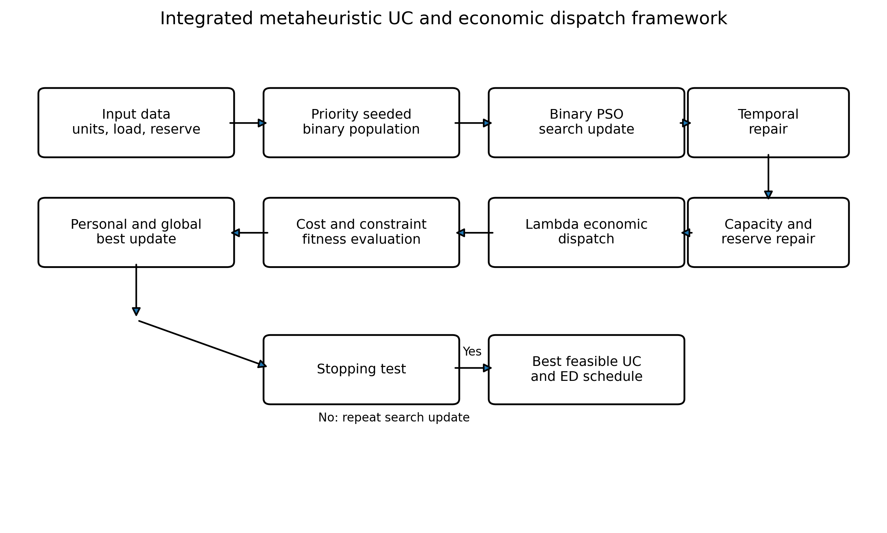
Figure 1. Proposed integrated framework for unit commitment and economic dispatch.

4.1 Binary particle representation
Each particle contains an N by T binary commitment matrix. The element x(i,t) equals 1 if unit i is scheduled online at hour t. The initial population combines priority seeded schedules with diversified random schedules. The priority seed ranks units by an average production cost index and commits sufficient capacity to satisfy demand plus reserve. Random perturbations are then applied to selected hours and units to preserve population diversity.

4.2 Binary PSO search update
(7)
(8)
(9)
The velocity is therefore interpreted as the propensity for a binary state to be active rather than as a physical displacement. The inertia weight w controls persistence, while c1 and c2 weight individual and social learning. A linearly decreasing inertia weight can be used to favour exploration early in the search and refinement later.

4.3 Constraint repair
Direct penalty methods are inefficient for this problem because a randomly generated 240 bit schedule is very likely to violate several constraints simultaneously. The proposed framework therefore applies deterministic repair before fitness evaluation. The repair sequence is important. Temporal repair is first used to correct minimum up and down time violations with reference to each unit initial condition. Capacity repair then commits additional units if online maximum capacity is below demand plus reserve. Redundant high cost units are subsequently decommitted when this can be done without violating reserve or temporal limits. The temporal check is repeated after any capacity change because adding or removing a unit can create a new intertemporal violation.
This strategy follows the broader insight from improved binary PSO and neighbourhood field methods that problem specific repair can substantially reduce the portion of the search spent on infeasible schedules [8], [9]. A residual penalty is retained for any violation that survives repair, preventing an infeasible particle from being selected as the global best.

4.4 Embedded economic dispatch
Once a feasible commitment vector is available for hour t, the dispatch subproblem is convex for the quadratic benchmark cost curves. For an unconstrained committed unit, the equal incremental cost condition is
(10)
(11)
Lambda is iteratively adjusted until the sum of the clipped generator outputs equals hourly demand. When a computed output exceeds a generator limit, that unit is fixed at the corresponding bound and the remaining demand is redistributed among the other committed units. The dispatch routine therefore returns both the least cost hourly production vector and its fuel cost for the commitment pattern.

4.5 Fitness evaluation and elitism
(12)
The violation terms are zero for a fully repaired feasible particle. Large penalty coefficients are used only as a safeguard. Personal best and global best particles are updated using feasible total operating cost. Elitism preserves the current global best from one iteration to the next. A practical implementation should also retain a hash of previously evaluated commitment schedules so that repeated particles do not trigger unnecessary dispatch calculations.

4.6 Algorithmic procedure
- Input generator cost and operating data, hourly demand, reserve requirements, initial states and algorithm parameters.
- Construct at least one priority seeded schedule and generate the remaining binary particles with controlled random diversification.
- Apply temporal, capacity and reserve repair to every particle.
- For each repaired hourly commitment, solve economic dispatch by lambda iteration and calculate fuel and startup cost.
- Update particle personal best and the global best feasible schedule.
- Update velocity and binary state using the sigmoid transfer rule, then repeat repair and fitness evaluation.
- Terminate at the iteration limit or after a specified number of iterations without improvement, and return the best feasible commitment and dispatch schedule.

5. Benchmark System and Validation Design
The framework is verified using the standard 10 unit thermal system introduced in the classical genetic algorithm study [2] and reproduced in later UC research [9], [11]. The scheduling horizon is 24 hours. System demand varies from 700 MW to 1500 MW, and spinning reserve is 10% of hourly demand. The total daily energy requirement is 27,100 MWh. The benchmark contains heterogeneous base, intermediate and peaking units with different production costs, capacity limits, minimum up and down times and startup costs.
Table 1. Thermal unit capacity and quadratic fuel cost data.
Unit | Pmin (MW) | Pmax (MW) | a ($/h) | b ($/MWh) | c ($/MW²h)
1 | 150 | 455 | 1000 | 16.19 | 0.00048
2 | 150 | 455 | 970 | 17.26 | 0.00031
3 | 20 | 130 | 700 | 16.60 | 0.00200
4 | 20 | 130 | 680 | 16.50 | 0.00211
5 | 25 | 162 | 450 | 19.70 | 0.00398
6 | 20 | 80 | 370 | 22.26 | 0.00712
7 | 25 | 85 | 480 | 27.74 | 0.00079
8 | 10 | 55 | 660 | 25.92 | 0.00413
9 | 10 | 55 | 665 | 27.27 | 0.00222
10 | 10 | 55 | 670 | 27.79 | 0.00173

Table 2. Thermal unit temporal and startup data.
Unit | MUT (h) | MDT (h) | Hot start ($) | Cold start ($) | Cold time (h) | Initial state (h)
1 | 8 | 8 | 4500 | 9000 | 5 | 8
2 | 8 | 8 | 5000 | 10000 | 5 | 8
3 | 5 | 5 | 550 | 1100 | 4 | -5
4 | 5 | 5 | 560 | 1120 | 4 | -5
5 | 6 | 6 | 900 | 1800 | 4 | -6
6 | 3 | 3 | 170 | 340 | 2 | -3
7 | 3 | 3 | 260 | 520 | 2 | -3
8 | 1 | 1 | 30 | 60 | 0 | -1
9 | 1 | 1 | 30 | 60 | 0 | -1
10 | 1 | 1 | 30 | 60 | 0 | -1

5.1 Demand and reserve profile
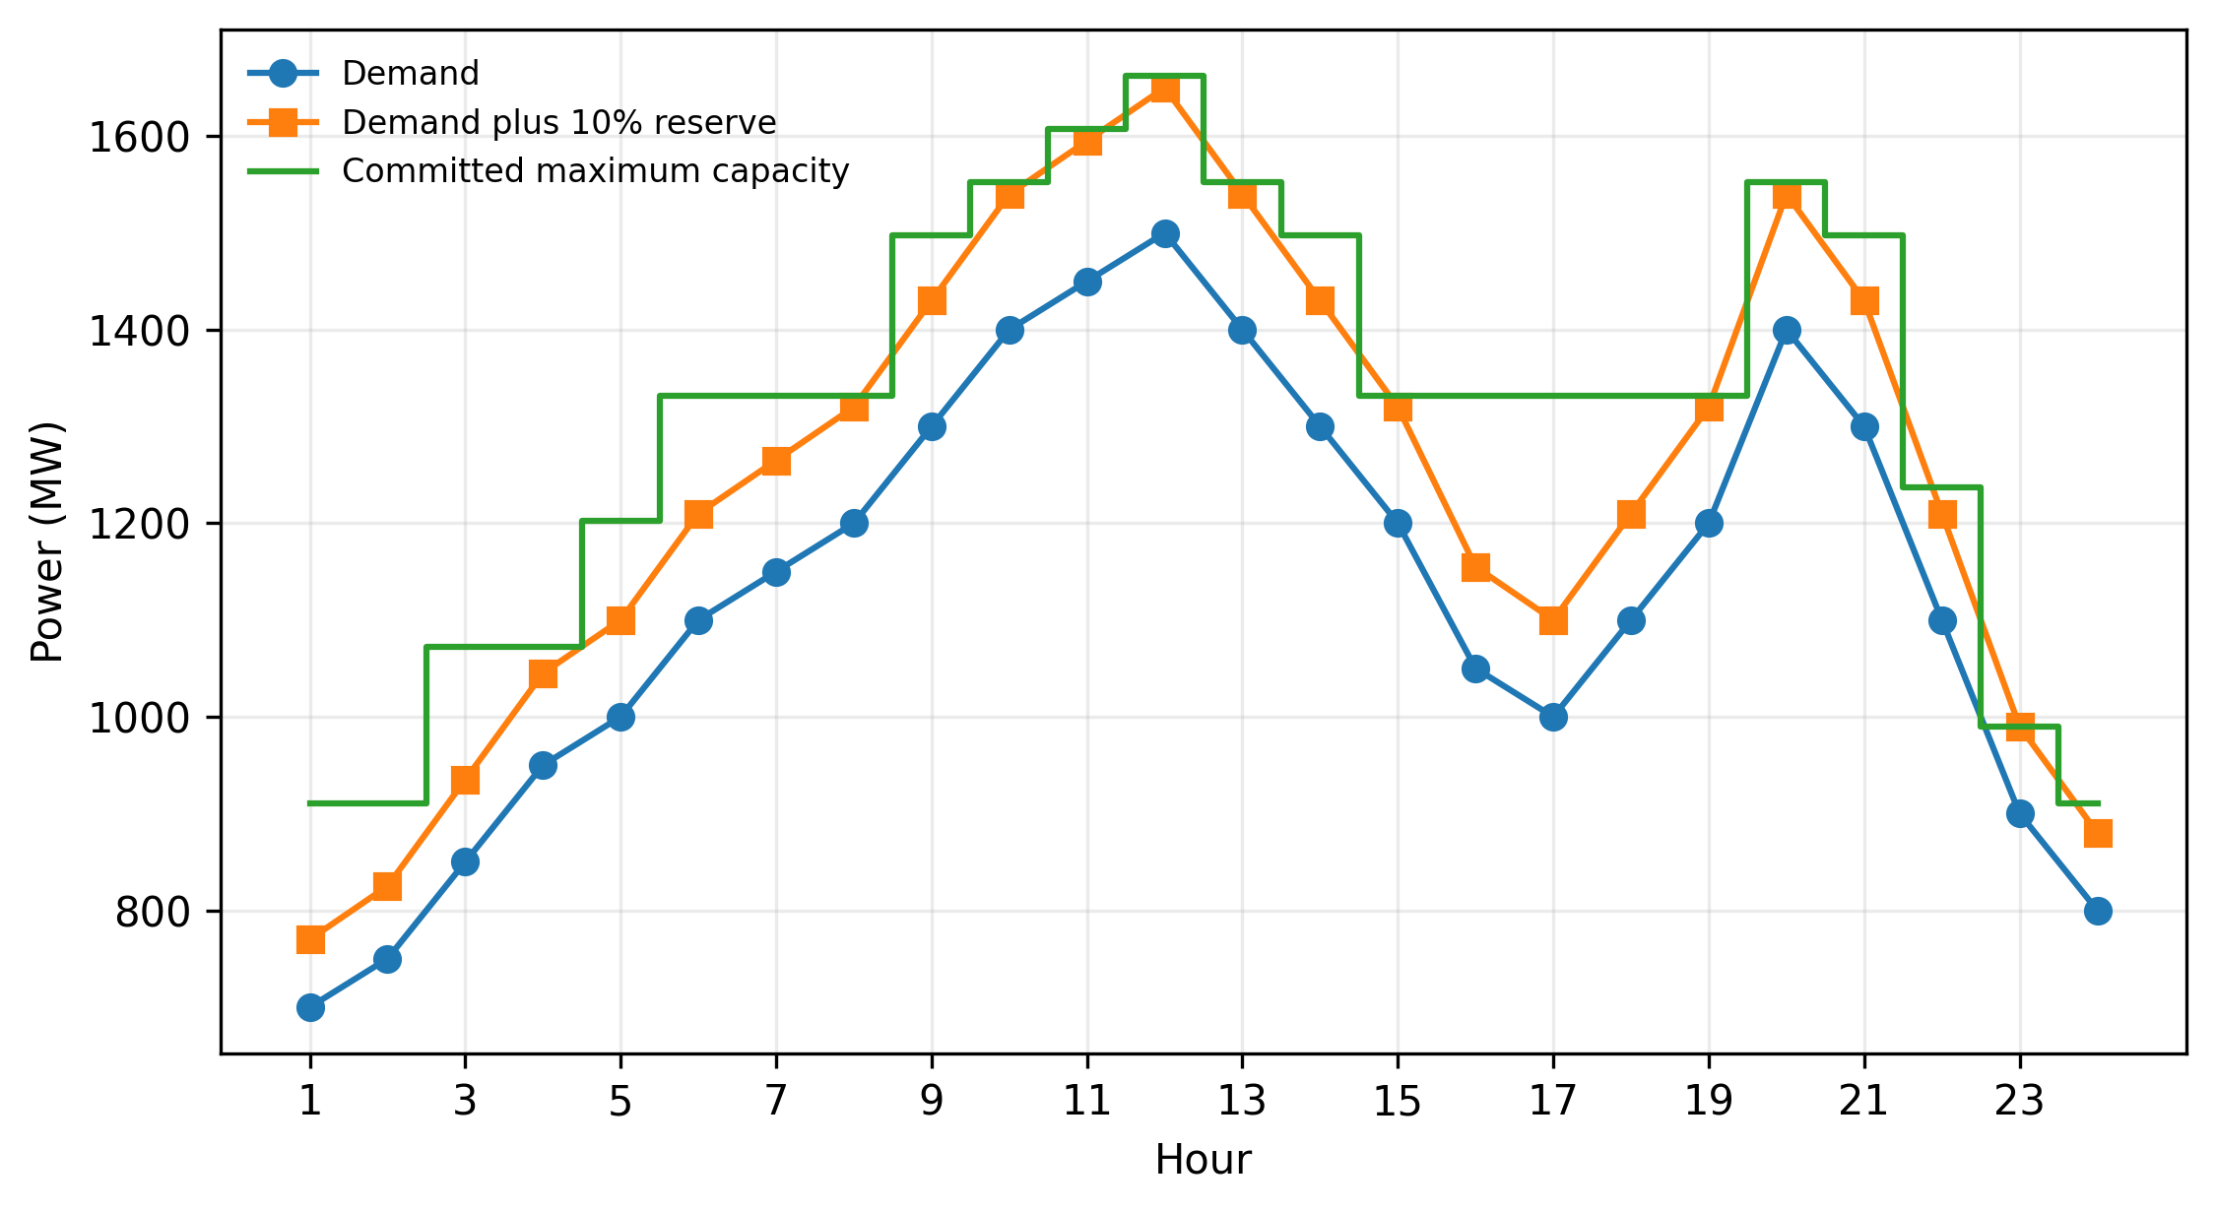
Figure 2. Hourly demand, reserve requirement and committed maximum capacity for the reference schedule.
Figure 2 shows the hourly load and the corresponding demand plus reserve threshold. The reference commitment increases online capacity around the morning and midday peaks and removes high cost peaking units as load falls. Hour 12 has the maximum demand of 1500 MW, while hours 1 and 24 represent low demand conditions.

5.2 Algorithm parameters for full stochastic implementation
Table 3. Recommended parameters for implementing PSRA BPSO LD.
Parameter | Value | Role
Population size | 30 | Provides moderate diversity without excessive dispatch evaluations
Maximum iterations | 100 | Initial implementation setting; should be sensitivity tested
Inertia weight | 0.9 to 0.4 | Linear decrease from exploration to exploitation
Cognitive coefficient c1 | 2.0 | Standard PSO learning weight
Social coefficient c2 | 2.0 | Standard PSO learning weight
Reserve requirement | 10% of demand | Standard benchmark condition
Dispatch tolerance | 1e-6 MW | Power balance termination criterion

5.3 Scope of numerical validation
The present numerical experiment is deliberately a deterministic verification of the integrated evaluation engine. The published reference commitment pattern associated with the best known 10 unit result is passed through the startup cost, reserve and lambda dispatch modules. Agreement with the established benchmark cost demonstrates that the continuous dispatch and cost accounting are internally consistent. This test does not by itself demonstrate that a randomly initialised BPSO will discover the same schedule. A publication claiming search superiority should therefore add repeated independent stochastic runs, report best, mean, worst and standard deviation values, and compare computational effort using a common stopping budget.

6. Results

6.1 Reference unit commitment schedule
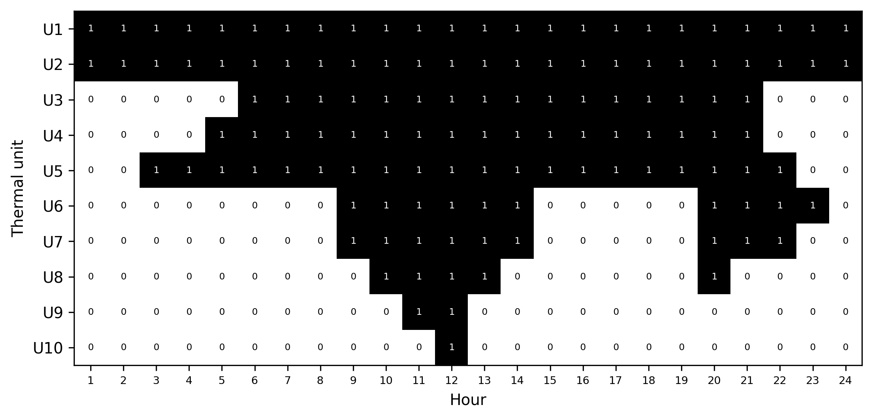
Figure 3. Verified 24 hour commitment pattern for the standard 10 unit benchmark.
The commitment structure in Figure 3 is economically interpretable. Units 1 and 2 remain online throughout the day because they combine large capacity with comparatively low incremental production cost and long minimum up and down times. Intermediate units are introduced as demand rises, while the short minimum time peaking units are used around the highest load hours. All ten units are committed at hour 12 to satisfy the 1500 MW load and 150 MW reserve requirement. At the lowest load hours, only the two large base units are required.

6.2 Economic dispatch and operating cost
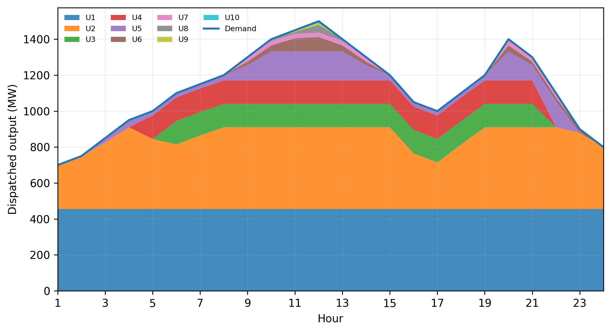
Figure 4. Economic dispatch of the committed thermal units across the 24 hour horizon.
The embedded lambda routine dispatches the committed units to exactly meet the 27,100 MWh daily energy requirement. The computed fuel cost is $559,847.69. Time dependent startups add $4,090.00, giving a total daily operating cost of $563,937.69, equivalent to $20.81 per MWh of supplied energy. The result agrees, after rounding, with the $563,938 best cost reported for the 10 unit benchmark by Wu and Chow [9].
Table 4. Deterministic benchmark validation summary.
Metric | Validated value
Daily energy supplied | 27,100 MWh
Fuel cost | $559,847.69
Startup cost | $4,090.00
Total operating cost | $563,937.69
Average operating cost | $20.81/MWh
Maximum hourly demand | 1500 MW
Minimum hourly demand | 700 MW
Minimum reserve margin | 90 MW

6.3 Reserve adequacy
The online maximum capacity satisfies the 10% spinning reserve requirement in every hour. The tightest reserve condition occurs at hour 23, where the available margin is 90 MW against a required reserve of 90 MW. This confirms that reserve is evaluated as available committed capacity rather than incorrectly added to dispatched production.

6.4 Comparison with published metaheuristic results
Table 5. Published 10 unit best cost comparison using values compiled by Wu and Chow [9].
Method | Best cost ($) | Gap from validation (%)
GA | 565,825.00 | 0.3347
EP | 564,551.00 | 0.1088
SA | 565,828.00 | 0.3352
DE | 563,977.00 | 0.0070
IPSO | 563,954.00 | 0.0029
IQEA | 563,977.00 | 0.0070
QBPSO | 563,977.00 | 0.0070
BNFO | 563,938.00 | 0.0001
Present validation | 563,937.69 | 0.0000

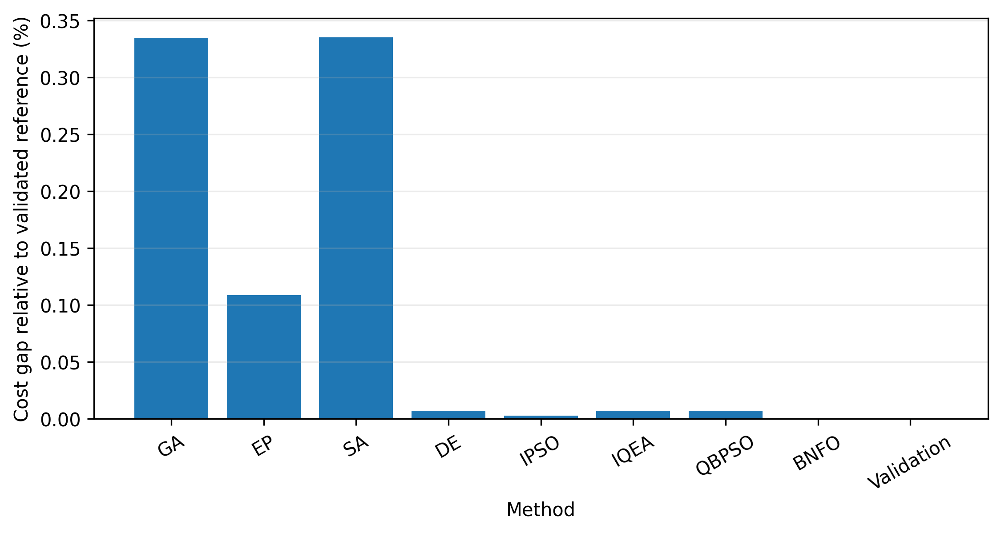
Figure 5. Relative cost gaps for selected published 10 unit benchmark results.
The comparison should be interpreted carefully. The present value is a deterministic reproduction of the reference optimum, whereas the other values are outputs reported for stochastic algorithms under their respective experimental conditions. It is therefore valid to use the table as a benchmark consistency check, but not as evidence that the proposed PSO search is statistically superior. The reproduction error relative to the rounded BNFO value is less than one dollar per day and is attributable to the published result being reported to the nearest dollar.

6.5 Selected hourly dispatch values
Table 6. Selected hourly commitment and cost results.
Hour | Load (MW) | Commitment U1...U10 | Fuel cost ($/h) | Startup ($) | Total ($/h)
1 | 700 | 1100000000 | 13683.13 | 0 | 13683.13
6 | 1100 | 1111100000 | 22387.04 | 1100 | 23487.04
12 | 1500 | 1111111111 | 33890.16 | 60 | 33950.16
18 | 1100 | 1111100000 | 22387.04 | 0 | 22387.04
24 | 800 | 1100000000 | 15427.42 | 0 | 15427.42

7. Discussion
The validation demonstrates the importance of separating the UC and ED layers while maintaining a common cost function. For a fixed feasible commitment schedule, the quadratic ED subproblem can be solved efficiently and deterministically. This reduces the stochastic search dimension because the metaheuristic does not need to optimise every generator output directly. The binary optimiser only determines which units are available, and the embedded dispatch routine computes the least cost loading for that availability pattern. Similar decompositions have been used successfully in improved BPSO and BNFO studies [8], [9].
A second observation concerns constraint handling. Minimum up and down times are not independent hourly restrictions. They are temporal state constraints affected by the initial status of each unit. Likewise, reserve depends on committed maximum capacity and is conceptually distinct from dispatched power. Treating these rules through structured repair has two advantages. It improves the likelihood that particles represent physically meaningful schedules, and it prevents the objective function from being dominated by arbitrary penalty magnitudes. The remaining penalty terms can then be reserved for unusual cases that cannot be repaired without creating another violation.
The third observation is that headline differences among mature algorithms on the 10 unit benchmark are small. The best DE, IPSO, IQEA, QBPSO and BNFO values reported by Wu and Chow are separated by only tens of dollars on a daily cost exceeding half a million dollars [9]. This makes statistical methodology essential. A new metaheuristic should not be declared superior from one favourable run. Repeated trials, common function evaluation budgets, nonparametric statistical tests and larger systems are needed to distinguish genuine search improvement from random variation. Recent comparative reviews of economic dispatch reinforce this point [14], [15].
For practical thermal systems, the proposed framework can be extended without altering its basic architecture. Ramp rates can be included in the dispatch and repair modules. Valve point loading can be treated using a nonconvex dispatch solver rather than classical lambda iteration. Prohibited operating zones, emission objectives and transmission losses can be added to the continuous subproblem. Renewable generation and uncertainty can be accommodated by scenario based or robust variants, while the binary commitment layer remains responsible for thermal availability. The integrated binary metaheuristic study of Syama and colleagues illustrates the continuing relevance of this architecture in hybrid systems [13].

8. Limitations and Further Experimental Requirements
This study is a framework development and benchmark verification paper. It has three important limitations. First, the numerical validation evaluates a published reference commitment schedule and verifies the integrated cost engine; it does not establish the probability with which the proposed BPSO discovers that schedule from random initialisation. Second, the standard 10 unit case omits transmission losses and ramp constraints and therefore represents a simplified thermal scheduling environment. Third, computational time is not compared because runtime values from different papers, software versions and processor generations are not directly comparable.
Before journal submission as a performance paper, the implementation should be executed in at least 30 independent runs on the 10, 20, 40, 60, 80 and 100 unit variants. Best, mean, median, worst, standard deviation and success rate should be reported. All algorithms should use an equal function evaluation budget, and Wilcoxon or Friedman based tests should be used for pairwise or multiple algorithm comparisons. An ablation study should compare plain BPSO, BPSO with repair, BPSO with priority seeding, and the complete framework so that the contribution of each mechanism is visible. A MILP solution should also be included as a deterministic reference on cases that remain computationally tractable.

9. Conclusion
This paper formulated an integrated metaheuristic framework for thermal unit commitment and economic dispatch. The proposed PSRA BPSO LD architecture assigns the discrete scheduling task to binary particle swarm optimisation, applies explicit temporal and reserve repair, and solves the continuous dispatch subproblem by lambda iteration. This structure reduces the effective search burden and makes constraint handling transparent. Deterministic verification on the standard 10 unit, 24 hour benchmark reproduced a total operating cost of $563,937.69, comprising $559,847.69 in fuel cost and $4,090.00 in startup cost, while satisfying demand and the 10% spinning reserve requirement. The value agrees with the established best benchmark result to rounding precision. The main contribution at this stage is therefore a verified and reproducible solution architecture. The next step is a full stochastic evaluation on larger systems with repeated runs, statistical testing, ramp constraints and comparison with strong MILP baselines.
Declaration of AI Use

This manuscript was prepared through the combined contributions of all author(s), including contributions to the study design, data, content development, results, interpretation, and related scholarly work. The author(s) acknowledge the use of Grammarly and ChatGPT to assist with grammar checking, language refinement, reference formatting. These AI-assisted tools were not used as authors and did not replace the intellectual contributions or scholarly judgment of the author(s). All AI-assisted outputs, including content, references, and interpretations, were carefully reviewed, revised, verified, and approved by the author(s). The author(s) accept full responsibility for the accuracy, integrity, and final content of the manuscript.

References
[1] A. J. Wood, B. F. Wollenberg, and G. B. Sheblé, Power Generation, Operation, and Control, 3rd ed. Hoboken, NJ, USA: Wiley, 2013.
[2] S. A. Kazarlis, A. G. Bakirtzis, and V. Petridis, “A genetic algorithm solution to the unit commitment problem,” IEEE Transactions on Power Systems, vol. 11, no. 1, pp. 83–92, 1996, doi: 10.1109/59.485989.
[3] M. Carrión and J. M. Arroyo, “A computationally efficient mixed-integer linear formulation for the thermal unit commitment problem,” IEEE Transactions on Power Systems, vol. 21, no. 3, pp. 1371–1378, 2006, doi: 10.1109/TPWRS.2006.876672.
[4] G. Morales-España, J. M. Latorre, and A. Ramos, “Tight and compact MILP formulation for the thermal unit commitment problem,” IEEE Transactions on Power Systems, vol. 28, no. 4, pp. 4897–4908, 2013, doi: 10.1109/TPWRS.2013.2251373.
[5] J. Kennedy and R. Eberhart, “Particle swarm optimization,” in Proceedings of the IEEE International Conference on Neural Networks, Perth, Australia, 1995, vol. 4, pp. 1942–1948, doi: 10.1109/ICNN.1995.488968.
[6] T. O. Ting, M. V. C. Rao, and C. K. Loo, “A novel approach for unit commitment problem via an effective hybrid particle swarm optimization,” IEEE Transactions on Power Systems, vol. 21, no. 1, pp. 411–418, 2006, doi: 10.1109/TPWRS.2005.860907.
[7] B. Zhao, C. X. Guo, B. R. Bai, and Y. J. Cao, “An improved particle swarm optimization algorithm for unit commitment,” International Journal of Electrical Power & Energy Systems, vol. 28, no. 7, pp. 482–490, 2006, doi: 10.1016/j.ijepes.2006.02.011.
[8] X. Yuan, H. Nie, A. Su, L. Wang, and Y. Yuan, “An improved binary particle swarm optimization for unit commitment problem,” Expert Systems with Applications, vol. 36, no. 4, pp. 8049–8055, 2009, doi: 10.1016/j.eswa.2008.10.047.
[9] Z. Wu and T. W. S. Chow, “Binary neighbourhood field optimisation for unit commitment problems,” IET Generation, Transmission & Distribution, vol. 7, no. 3, pp. 298–308, 2013, doi: 10.1049/iet-gtd.2012.0096.
[10] B. E. Türkay and Y. Zeybekoğlu, “A new approach for solving the unit commitment problem by enhanced particle swarm optimization,” IFAC Proceedings Volumes, vol. 45, no. 21, pp. 73–78, 2012, doi: 10.3182/20120902-4-FR-2032.00015.
[11] L. M. de Oliveira, I. C. da Silva Junior, and R. Abritta, “A space reduction heuristic for thermal unit commitment considering ramp constraints and large-scale generation systems,” Energies, vol. 16, no. 14, art. 5370, 2023, doi: 10.3390/en16145370.
[12] T. Visutarrom and T. C. Chiang, “Economic dispatch using metaheuristics: Algorithms, problems, and solutions,” Applied Soft Computing, vol. 150, art. 110891, 2024, doi: 10.1016/j.asoc.2023.110891.
[13] S. Syama, J. Ramprabhakar, R. Anand, and J. M. Guerrero, “An integrated binary metaheuristic approach in dynamic unit commitment and economic emission dispatch for hybrid energy systems,” Scientific Reports, vol. 14, art. 23964, 2024, doi: 10.1038/s41598-024-75743-0.
[14] Y. Wang and G. Xiong, “Metaheuristic optimization algorithms for multi-area economic dispatch of power systems: Part I—a comprehensive survey,” Artificial Intelligence Review, vol. 58, art. 98, 2025, doi: 10.1007/s10462-024-11070-0.
[15] Y. Wang and G. Xiong, “Metaheuristic optimization algorithms for multi-area economic dispatch of power systems: Part II—a comparative study,” Artificial Intelligence Review, vol. 58, art. 132, 2025, doi: 10.1007/s10462-025-11125-w.
[16] C. Patiño-Cataño, R. I. Bolaños, J. A. Guzmán-Henao, L. F. Grisales-Noreña, and O. D. Montoya, “Economic dispatch of thermal generators via bio-inspired optimization techniques,” Statistics, Optimization & Information Computing, vol. 14, no. 6, pp. 3244–3266, 2025, doi: 10.19139/soic-2310-5070-2812.

