Effects of Different Storage Materials in Maize (Zea mays L.) Seed Quality at Hawassa Agricultural Research Center, Sidama Regional State of Ethiopia

Abstract
A study was conducted at Hawassa Agricultural Research Center warehouse and Seed Technology Laboratory during 2021/22 to evaluate the effects of different storage materials on the quality of maize seed. Seeds of the BH 546 maize variety were stored in three types of packaging materials: polypropylene bags, jute sacks, and hermetic (PICS) bags. Seed samples were collected at monthly intervals from April 2021 to February 2022. The experiment was arranged in a Complete Block Design (CBD) with four replications, involving combinations of three storage materials and six storage periods (1–6 months). Seed quality parameters were evaluated following the standard procedures of the International Seed Testing Association (ISTA). The collected data were statistically analyzed using the Generalized Linear Model (GLM) procedure of SAS. The analysis of variance showed that storage materials had a significant (P ≤ 0.05) effect on maize seed germination and weevil infestation. After six months of storage, seeds kept in PICS bags exhibited the lowest weevil infestation (0.31%) and storage temperature (19°C), along with the highest germination percentage (90%). In contrast, seeds stored in polypropylene bags showed comparatively poorer quality performance, characterized by higher weevil infestation and lower germination. The findings demonstrated that hermetic storage, particularly the Purdue Improved Crop Storage (PICS) bag, was effective in maintaining maize seed quality during prolonged storage by limiting insect infestation and mold development. Therefore, hermetic storage technology can be recommended as an effective method for preserving maize seed quality during storage
KeyWords: Germination, Hermetic bag, Maize seed quality, storage

Introduction
Maize (Zea mays L.) is one of the most widely cultivated and economically important cereal crop globally, with particular significance in Eastern and Southern Africa. The crop has numerous uses, including human consumption, preparation of alcoholic and non-alcoholic beverages, and the production of fuel and construction materials. It also serves as a raw material for some medicinal products, such as glucose, and is grown for ornamental purposes (Keweti, 2017).
Maize is particularly important in tropical and subtropical regions, where it serves as a major staple crop and contributes substantially to household and national food security. Its production is influenced by various environmental and socioeconomic factors, including rainfall, temperature, soil properties, irrigation facilities, prevailing climatic conditions, and market demand. Where suitable conditions exist, maize can be produced more than once within a year.
The introduction of maize into Ethiopia is generally believed to have occurred during the seventeenth or eighteenth century. Since then, the crop has become an important component of the Ethiopian cereal production system and is cultivated across a broad range of agro ecological environments, approximately from 500 to 2,400 meters above sea level (Yibrah and Dereje, 2015). In the 2020 cropping season, maize occupied about 2,110,209.61 hectares of land in Ethiopia and produced an estimated 72,349,551.02 quintals (CSA, 2020). In addition, USAID (2019) reported that Ethiopia produced approximately 7.3 million metric tons of maize from 2.32 million hectares in 2019.
Although maize is widely produced and plays an important role in Ethiopia's food system, its productivity remains below the global average. The average maize yield in Ethiopia was approximately 2.9 tons ha⁻¹ in 2020 (CSA, 2020), compared with a global average of about 6.1 tons ha⁻¹ (FAOSTAT, 2015). The relatively low productivity of maize is caused by several production constraints, including unfavorable environmental conditions, agronomic limitations, diseases, and insect pests. Among these constraints, insect pests are particularly important because they can cause significant damage both before and after harvest.
Postharvest insect infestation is a major factor contributing to the deterioration and loss of stored maize. Tefera et al. (2011) indicated that insect pests are responsible for considerable maize grain damage and postharvest losses. In Africa, postharvest insect pests contribute substantially to maize losses and may cause considerable reductions in grain weight during storage (Peter et al., 2020). Such losses not only reduce the quantity of available grain but can also negatively affect its nutritional, physiological, and market quality. Appropriate storage technologies are therefore necessary to minimize losses and maintain the quality of maize seed.
Seed quality is also closely associated with both the length of the storage period and the packaging material used. As storage duration increases, maize seeds gradually undergo physiological deterioration, which can reduce germination percentage, seed vigor, and overall viability. The rate of deterioration is strongly affected by storage conditions, particularly moisture and oxygen availability. Packaging materials capable of limiting the movement of moisture and oxygen can therefore slow down seed deterioration and extend the period during which seeds remain suitable for planting.
Hermetic storage technology provides an alternative approach for maintaining the quality of stored agricultural commodities. Hermetic bags are produced from multilayer polymer materials with high barrier properties that create an airtight storage environment. By limiting the exchange of oxygen and moisture, these bags can suppress insect development and help protect stored grains and seeds without relying on chemical pesticides. Consequently, hermetic storage may provide an effective and environmentally friendly option for maintaining maize seed quality during storage.
Therefore, this study was conducted to assess the effects of different storage materials and storage periods on the physiological and physical quality of maize (Zea mays L.) seed and to identify suitable storage materials for maintaining seed quality during storage.

Materials and Methods
Description of the study area
The study was carried out at the seed storage warehouse and seed laboratory of Hawassa Agricultural Research Center (HARC), located in the North Zone of Sidama Regional State, Ethiopia. The research center is situated at an elevation of approximately 1,700 meters above sea level (m.a.s.l.) within the Rift Valley agro-ecological zone. Geographically, it is located between 7°03′ and 7°04′ N latitude and 38°30′ and 38°31′ E longitude, approximately 273 km south of Addis Ababa.
Experimental Design
The experiment was conducted using a factorial arrangement involving two factors: storage material and storage duration. The treatments were arranged in a Completely Randomized Design (CRD) with three replications. The storage material factor consisted of three types of packaging materials: Polypropylene bag (PPB), which was used as the control, Purdue Improved Crop Storage (PICS) bag, and jute sack. The storage duration was evaluated at monthly intervals, beginning at the start of the experiment (0 month) and continuing through the subsequent storage periods. Seed samples were collected at one-month intervals to assess changes in seed quality throughout the storage period.
Experimental Materials
The experimental material consisted of BH-546 maize seed harvested in November 2019. The seed was obtained from the maize research program of Wondo Genet Agricultural Research Center, Hawassa maize Research sub center. Before storage, the seed was thoroughly cleaned to remove foreign materials and impurities. The cleaned seed was then packaged in three different storage materials: Purdue Improved Crop Storage (PICS) bags, polypropylene (PP) bags, and jute sacks. The packaged seeds were stored under ambient environmental conditions for the duration of the experiment

Sampling Method
A total of 90 BH-546 maize seed samples were collected periodically throughout the experiment. Sampling was conducted at the beginning of storage (0 month) and subsequently at one-month intervals up to six months (0, 1, 2, 3, 4, 5, and 6 months). Samples were obtained from different positions within each storage material, namely the top, middle, and bottom portions of the stored seed mass, to ensure representative sampling. The samples collected at the beginning of the experiment were considered the initial or control samples. A grain sampling spear was inserted vertically into the seed mass to the maximum possible depth at the designated sampling positions, and the required samples were carefully withdrawn for laboratory analysis.

Data Collection
Seed samples were initially collected from each storage material at the beginning of the experiment and thereafter at monthly intervals. Sampling was performed from the top, middle, and bottom sections of each storage material using a grain sampling spear. The collected samples were analyzed for moisture content, germination percentage, seed purity, 1,000-seed weight, and weevil infestation or associated weight loss.
Moisture content: Seed moisture content was determined using a digital moisture tester.
The measurements were taken from samples collected at the respective storage intervals.
Seed purity: Physical purity analysis was conducted following the procedures recommended by the International Seed Testing Association (ISTA). The analysis determined the proportions of pure seed, inert matter, and other seeds present in each sample.
Temperature and relative humidity: Temperature and relative humidity were monitored for both the internal storage environment and the surrounding external environment. Measurements were taken at the beginning and end of the experiment using a portable Quick Enquiry 4 digital thermo-hygrometer (Hanna, HI8564).
Seed Damage: Seed damage data were obtained by using a conventional “count and weight” method. Thousand seed were randomly taken from initial to last storage periods from each of the storage types and the number of damaged and un-damaged seed was obtained using a hand lens by searching for the presence of hole on the seeds. The percentage of damaged seed was calculated according to the methods used by (Wambugu, et al., 2009) as follows:
$Insect-damage seed (\%)=(\frac{Number of insect-damaged seed}{Total number of seed})X100$
Seed Weight loss: Percent of seed weight loss was determined by counting damaged and undamaged seed then weighing them according to the weighing and count method (Ngatia, 2011). A 30 gram sieved maize sample was taken, and the damaged and undamaged maize samples were separated and weighed separately. Weight loss percent was calculated using the following equation as described by (Demissie et al., 2008).
$$Weight Loss(\%)=\frac{\left(WUNxND\right)-\left(WNDxNU\right)}{WUx\left(ND+NU\right)}X100$$
Where: WUN= Weight (gram) of undamaged kernels,
WDN= Weight (gram) of damaged kernels, W_{U}
ND= number of Damaged
NU= Number of undamaged
Germination Percentage
The study used sand germination method in which seeds are tested for germination using clean, moist sand. Seed germination percentage is the proportion in a specific sample that successfully sprout and grown into healthy seedling under favorable condition. Seed Germination Percentage (SGP): judged by the appearance of the radicle, which was counted daily up to 7 days. At the final count, the number of normal and abnormal seedlings produced was assessed. Germination test was measured based on the standard procedures of ISTA (2006) as follows:
$$Germination(\%)=\frac{Number of seeds germinated}{Number of seeds tested}X100$$
Data Analysis
All collected datas were analyzed using the generalized liner model (GLM) procedure of statistics analysis system (SAS Version 2014). Pair wise comparison of means was performed using Least Significant Difference (LSD) method to determine significant variations among the means. The results obtained were expressed as mean ± standard deviation and P < 0.05 was considered as statistical significance for all tests.

Results and Discussion
The initial temperature and relative humidity during loading the storages was 19 °C and 83% respectively. At the final six month temperature was 27°C and relative humidity 49%. Relative humidity ranged from 48% to 83% whereas temperature ranged between 19 ºC and 27 ºC. The minimum relative humidity was recorded in May, 2022 and the maximum in April, 2022. The minimum temperature was observed in April, 2022 and the maximum in May 2022.
Table1. Influence of storage material and storage period on germination (%) of maize seed during storage at seed quality control center.
Treatment | Seed germination (%)
Treatment | 1st month | 2nd month | 3rd month | 4th month | 5th month | 6th month
Polypropylene bag | 94.7±0.5ab | 90.7±4.1ab | 90.7±1.9ab | 76±7.1d | 56±10.4e | 36±13.9f
PICS bag | 97.5±1.3a | 94.7±1.7ab | 92.2±0.9a | 91.2±2.1ab | 91.2±2.9ab | 89.7±4.3abc
Jute sacks | 95±0.82ab | 90±3.7cb | 87.5±2.2ab | 82±3.2cd | 59.75±6.4e | 38±9.4f
LSD(=0.05) | 7.98
CV, % | 6.96
Note: Mean values ± standard deviation of three replicates within each column sharing similar letters were not significantly different by LSD test at P≤0.05, CV: Coefficient of variation, LSD: least significant different.

Effect of storage material with storage period on germination percentage
The germination ability of stored maize was significantly affected by the interaction of storage methods and storage time. There were significant different (P<0.05) among the storage materials during the storage periods. Furthermore, there were highly significant differences (P ≤ 0.01) among the storage periods. The highest 98.0% germination percentage was recorded at the initial month of the storage period. For storage period, at 4, 5 and 6 months the values for germination percentage were 83, 69 and 54%, respectively. The highest value 97.5% of germination percentage was recorded in Hermetic bag followed by sack 95 and polyethylene bag 94.7%, respectively. This finding is in agreement with Negassa et al., (2021) who also stated the highest 98.0% of germination percentage recorded during the initial one month of storage.
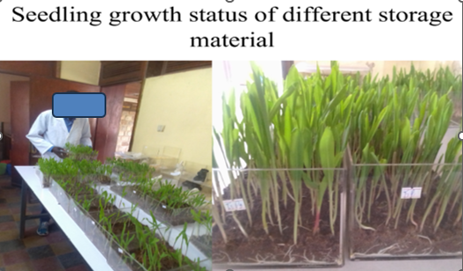
Figure 1: Seedling growth status of different storage material at Hawassa Agricultural Research Center seed laboratory.
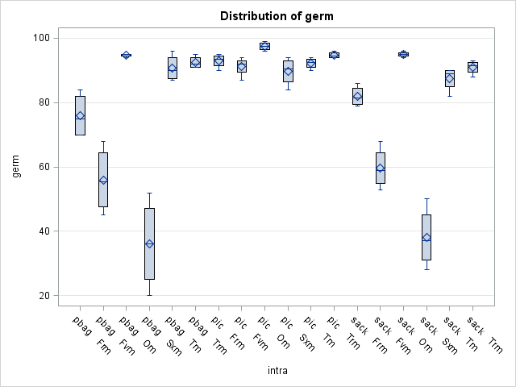
Figure 2: Effect of storage material with storage period on germination percentage

As figure 2 shown seeds stored in PICS bag has exhibited the highest germination through the entire storage periods among the treatment employed in this experiment whereas the other treatments has shown less germination percentage. This has resulted due to insect pest infestation which reduces the ability of germination of seeds; it is inversely proportional to total insect population. But, non-hermetic storage allows the stored seed with the dynamic atmosphere, which results high insect infestation and low seed germination. While hermetic storage bag, restrict interaction of grain with external biotic and abiotic factors thus had low insect population and managed to preserve the ability of seed germination (Mvumi and Chigoverah 2018).

Effect of storage material with storage period on weevil infestation
Storage materials in maize production largely impact grain quality, insect infestation, and moisture retention. Hermetic bags have prevented pest damage and maintain seed viability for months. On the other hand, traditional Polypropylene bag and jute sacks often lead to weight loss, fungal growth, and mycotoxin contamination.

Table2. Influence of storage material and storage period on weevil infestation (%) of maize seed during storage at seed quality control center.
Treatment | Seed weevil infestation (%)
Treatment | 1st month | 2nd month | 3rd month | 4th month | 5th month | 6th month
Polypropylene bag | 1.56± | 3.56±de | 7.11±dce | 11.37±c | 38.19±b | 65±a
PICS bag | 0.31±e | 0.900±e | 0.925±e | 1.97±e | 2.06±e | 2.15±de
Jute sacks | 1.67± | 3.66±de | 5.25±dce | 9.17±dc | 33.84±b | 58.25±a
LSD(=0.05) | 7.03
CV, % | 36
Note: Mean values ± standard deviation of three replicates within each column sharing similar letters were not significantly different by LSD test at P≤0.05, CV: Coefficient of variation, LSD: least significant different.

Effect of storage material with storage period on seed damage and weight loss
The first two months of storage periods slight seed damage was recorded and seed damage increased to 4.34, 8.5, 29.37 and 41.8% at 3rd, 4th, 5th and 6th months of storage respectively. From 3rd to 6th month’s storage the damage due to weevil infestation were 7.11, 11.37, 38.19 and 65% for polyethylene bag, 5.25, 9.17, 33.84 and 58.25% for jute sack, 0.92, 1.97, 2.06 and 2.15% for Hermetic bag, respectively. There was significantly different (p<0.05) highest weevil damage occurred by polyethylene bag 65, sack 58.25 and hermetic bag 2.15 percentage. Likewise, (Befikadu, et al., 2012) reported 11.50 and 10.75% percentage of kernel damage for Gombisa (gotera) and sack respectively after 2 months of storage. Similarly, Waktole and Amsalu (2012), reported that mean grain damage and weight losses caused by the pests under traditional storage practices were 64.50 and 58.85%, respectively.

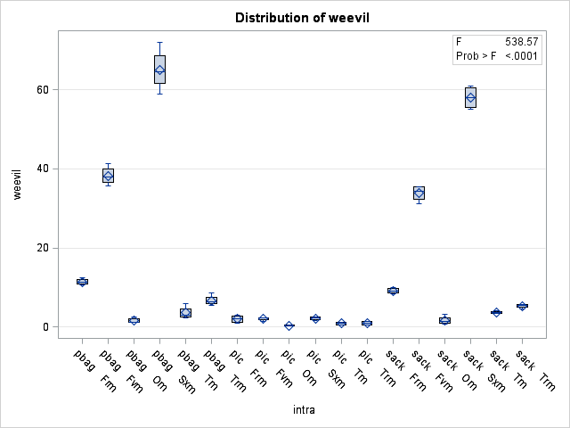
Figure 2: Effect of storage material with storage period on weevil infestation
As shown in the figure 2 above the percentage of damaged grains was zero at initial and increased significantly to 2.15% in PICS, 58.25% in jute sack and 65% in polyethylene bag, respectively in the six months. The infestation of all insect pests were significantly different (p<0.05) with storage periods. Therefore, as time period increased marginal means of weevil infestation also increase for both sacks and plastic bag. The hermetic storage at any periodic time of storage is better than polypropylene bag for reducing the post-harvest loss of maize grain, especially reduction of the infestation of insect pest.

Summary and Conclusion
There was significant interaction between storage materials by storage period (P≤0.01) for seed germination percentage. Seed stored in Hermetic bags have showed the highest germination percentage at six months of storage (90%). Whereas (38%) and (36%) for jute sacks and polyethylene bag respectively. Maize seed which was stored for less than four to six months had shown better seed germination but variations were observed among the storage types studied. As seed stored for longer period, it has shown low germination percentage, weight loss and increasing seed damage. With extended storage, there was an increasing pattern in seed temperature, moisture content, weight loss, and damaged grains.
The highest germination percentage of maize was recorded from hermetic bags as compared to the other storage materials. Similarly, based on the storage period the germination percentage of the seeds was also found to be lowest for the seed stored with polyethylene bags and jute sacks having 36 and 38% germination percentage respectively. The seed quality in different storage materials found to decrease with increase in time interval. Thus, the seeds stored in Hermetic bags have showed the highest germination percentage and maintained the quality of seed. Based on the conditions under which the study was conducted, it could be concluded that the two storage materials (jute sack and polyethylene bag) are not good for storing maize seed in Hawassa. This is because the methods did not give adequate protection to the maize as they were exposed to weevil attack. Hermetic bag was ideal to store maize seed for longer periods of time maintaining its quality.
Recommendation
-Hermetic bags were found to be ideal for storing maize seed in the study area, therefore proper scaling up of this technology is essential to ensure quality maize seed production in the study area.

Declaration of AI Use

This manuscript was prepared through the intellectual contributions of the author(s) to the study design, data analysis, interpretation of results, and scholarly content. Grammarly and ChatGPT were used solely to assist with grammatical refinement and reference formatting during manuscript revision. The author(s) accept full responsibility for the accuracy, integrity, and final content of the manuscript.

References
Befikadu, D., Waktole S., Solomon A., Geremew B. and Sethu, M. R. 2012. “Influence of Agro-
ecologies, Traditional Storage Containers and Major Insect Pests on Stored Maize
(Zea mays L.) In Selected Woredas of Jimma Zone”, Asian Journal of Plant Sciences,
vol.11 no.5, pp. 226-234.
CSA.(2020). Central Statistical Agency of the federal democratic republic of Ethiopia report
Demissie, G., Tefera, T., & Nigatu, L. (2008). Efficacy of Silicosec, filter cake and wood ash
against the maize weevil, Sitophilus zeamais Motschulsky (Coleoptera:
Curculionidae) on three maize genotypes. Pest Management Journal of Ethiopia, 12,
49–58.
FAOSTAT. (2015).Food and Agriculture Organization Statistical Database:
http//faostat.fao.org.
Hanna Instruments. (n.d.). HI 8564 Portable Thermo-Hygrometer Instruction Manual.
Woonsocket, RI: Author.
International Seed Testing Association. (2006). International Rules for Seed Testing.
Bassersdorf, Switzerland: ISTA
Tefera, T., Kanampiu, F., De Groote, H., Hellin, J., Mugo, S., Kimenju, S., Beyene, Y.,
Boddupalli, P.M., Shiferaw, B., Banziger, M., (2011)a. The metal silo: an effective
grain storage technology for reducing post-harvest insect and pathogen losses in
maize while improving smallholder farmers’ food security in developing countries.
Crop Prot. 30, 240e245.
Keweti M (2017) seed system and quality estimation of Maize (ZEA MAYS L.) in Humid
Tropics of Southern Ethiopia. International Journal of Development Research Vol.
07, Issue, 03, pp.12057-12073, ISSN: 2230-9926.
Mvumi, B.M., Chigoverah, A.A., 2018. Hermetic storage technology for handling of dry
agricultural commodities: Practice, challenges, opportunities, research, and
prospects in Zimbabwe. Proceedings of the 12th International Working Conference
on Stored Product Protection (IWCSPP) : in Berlin, Germany, October 7-11, 2018 ;
Volume 2, Julius-Kühn-Archiv. https://doi.org/10.5073/jka.2018.463.121
Negasa Fufa, Solomon Abera and Girma Demissie. 2019. Effect of Gombisa, Sack and Hermetic Bag
Storage Structures on Insect Infestation to the Stored Maize Grain (Zea mays L.): The Case
of West Shawa Zone, Bako, Ethiopia. Int.J.Curr.Res.Aca.Rev. 7(2), 37-45. doi:
https://doi.org/10.20546/ijcrar.2019.702.005
Ngatia.M. (2011). Comparison of three methods of weight loss determination on maize stored in two
farmer environments under natural infestation. Journal of Stored Products and Postharvest
Research Vol. 2(13), pp. 254 – 260

Peter K, Christine C, Protus M and Simon M., (2020) Postharvest Storage Practices of Maize in

Rift Valley and Lower Eastern Regions of Kenya: A Cross-Sectional Study.

International Journal of Microbiology # 2020, Article ID 6109214,

https://doi.org/10.1155/2020/6109214
SAS Institute Inc. (2014). SAS® 9.4 [Software]. Cary, NC: SAS Institute Inc.
USAID, (2019). The role of smallholder farmers and agro-ecological distribution in Ethiopian
maize production. Addis Ababa: USAID Ethiopia.
Waktole and Amsalu (2012)Storage pests of maize and their status in Jimma Zone, Ethiopia, African
Journal of Agricultural Research 7(28), pp. 4056-4060, DOI: 10.5897/AJAR11.1123,
Wambugu PW, Mathenge PW, Auma EO, Rheenen HA (2009) Efficacy of traditional maize
(Zea maysnL.) seed storage methods in Western Kenya. African Journal of Food
Agriculture Nutrition and Development 9: 1110- 1128.
Yibrah B. ad Dereje A, (2015) baseline Information on Maize (Zea mays L.) Postharvest Loss
Assessment. Postharvest Loss Assessment Survey-in Ethiopia.

