Short Research Article

Testing the Assumptions of Geometric Brownian Motion Using Nairobi Securities Exchange Returns

ABSTRACT
Aims: To evaluate whether weekly and monthly stock returns from the Nairobi Securities Exchange (NSE) satisfy the core assumptions of the Geometric Brownian Motion (GBM) model: stationarity, normality, and independence.
Study Design: Quantitative time-series analysis.
Place and Duration of Study: Nairobi Securities Exchange, Kenya (historical data spanning 2016 - 2024).
Methodology: Logarithmic returns ( $R_{t}= \frac{{\ln{S}}_{t}}{{\ln{S}}_{t-1}}$ ) were computed from weekly and monthly closing prices. Stationarity was tested using time-series plots and the Augmented Dickey-Fuller (ADF) test. Normality was assessed via histograms, Q-Q plots, and the Shapiro-Wilk test. Independence was evaluated using the Ljung-Box test and Hurst exponent analysis(Suganthi & Jayalalitha, 2019).
Results: Both weekly and monthly returns were stationary (ADF p-value = 0.01). Monthly returns satisfied normality (Shapiro-Wilk p = 0.07754), while weekly returns did not (p = 3.471 × ${10}^{-11}$). Both series satisfied the independence assumption (Ljung-Box p = 0.3687 for weekly; p = 0.9342 for monthly).
Conclusion: Monthly NSE returns conform better to GBM assumptions than weekly returns. The findings support the selective use of monthly data when applying GBM in emerging markets and underscore the importance of assumption validation before forecasting applications (Quayesam et al., 2024).
Keywords: Geometric Brownian Motion, stock returns, stationarity, normality, independence, Nairobi Securities Exchange, emerging markets, Hurst exponent
1. INTRODUCTION
The Geometric Brownian Motion (GBM) model is one of the most widely used stochastic processes in financial mathematics for modeling stock price dynamics (Suganthi & Jayalalitha, 2019). It is defined by the stochastic differential equation:
$$dS_{t}=μS_{t}dt+σS_{t}dW_{t}$$
where logarithmic returns are assumed to be stationary, independent, and normally distributed (Quayesam et al., 2024).
However, real financial markets often exhibit volatility clustering, fat tails, and serial dependence that may violate these ideal assumptions. Such deviations are particularly common in emerging markets (Mettle et al., 2014). The Nairobi Securities Exchange (NSE), established in 1954, plays a vital role in Kenya’s economy. Nevertheless, it operates under several challenges including liquidity constraints, frequent policy changes, and vulnerability to external economic shocks (Dabafinance, 2024; Philita, 2018).
Validating the underlying assumptions of stochastic models is therefore essential before their application in real market conditions. Despite the popularity of the GBM model, limited empirical studies have examined its suitability in the East African context. This study empirically tests whether stock returns from the Nairobi Securities Exchange satisfy the core GBM assumptions of stationarity, normality, and independence using both weekly and monthly data.
2. MATERIAL AND METHODS
2.1 Data
Weekly and monthly closing stock prices from the NSE were collected and transformed into logarithmic returns ( $R_{t}= \frac{{\ln{S}}_{t}}{{\ln{S}}_{t-1}}$).
2.2 Geometric Brownian Motion Model
The GBM model assumes constant drift ($μ$) and volatility ($σ$), with logarithmic returns being stationary, independent, and normally distributed (Suganthi & Jayalalitha, 2019).
2.3 Statistical Tests
Stationarity was assessed using time-series plots and the Augmented Dickey-Fuller (ADF) test. Normality was examined using histograms, Q-Q plots, and the Shapiro-Wilk test. Independence was evaluated using the Ljung-Box test and Hurst exponent analysis (Quayesam et al., 2024).
3. RESULTS AND DISCUSSION
3.1 Stationarity
Stationarity of the return series is a fundamental assumption of the Geometric Brownian Motion model, as it ensures that the statistical properties of returns do not change over time. Visual inspection of the time-series plots for both weekly and monthly logarithmic returns showed that the data points fluctuated randomly around a constant mean of zero. There were no visible long-term upward or downward trends, suggesting that the series are mean-reverting and potentially stationary.
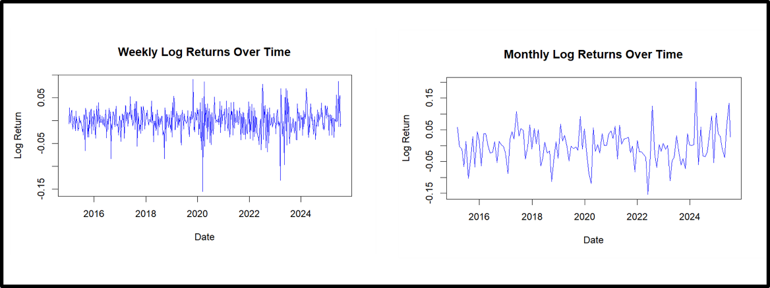
Figure 1. Time series plots of weekly and monthly logarithmic returns for the NSE.

To confirm this observation statistically, the Augmented Dickey-Fuller (ADF) test was conducted. The null hypothesis of the test states that the series contains a unit root and is non-stationary. The test results are presented below:
Table 1. Augmented Dickey-Fuller test for NSE returns
Time Series | Dickey-Fuller Statistic | Lag Order | p-value
Weekly Log Returns | -7.3637 | 8 | 0.01
Monthly Log Returns | -4.3877 | 4 | 0.01

Both p-values were 0.01, which is well below the 5% significance level. Therefore, the null hypothesis of non-stationarity was strongly rejected for both weekly and monthly returns. This confirms that the return series are stationary, satisfying one of the key assumptions of the GBM model.

3.2 Normality
The normality assumption is critical for the GBM model because it underpins the use of standard statistical inference and Monte Carlo simulation techniques. The histograms of the returns revealed notable differences between the two frequencies. The weekly returns displayed a sharp peak (high kurtosis) and extended heavy tails (leptokurtosis), indicating a higher likelihood of extreme positive and negative returns than would be expected under a normal distribution. In contrast, the monthly returns exhibited a more symmetrical, bell-shaped distribution that closely resembled a normal curve.

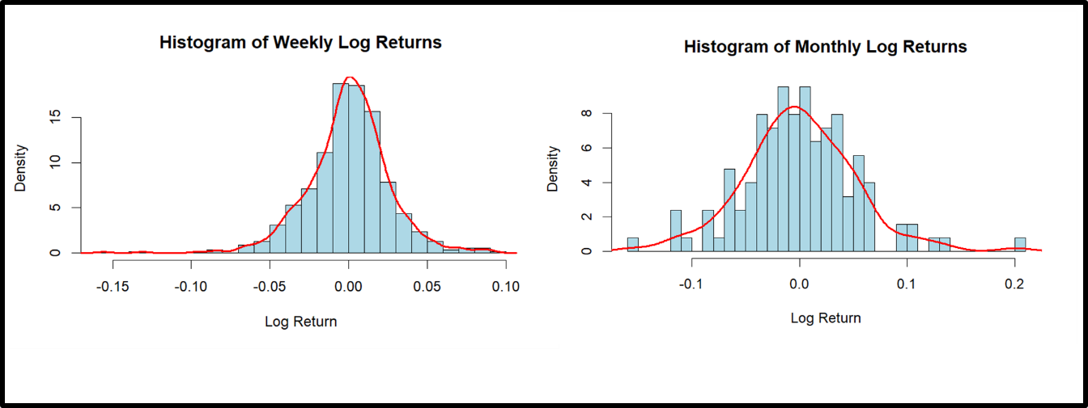
Figure 2. Histograms of weekly and monthly logarithmic returns for the NSE.
The Q-Q plots reinforced these observations. Weekly returns deviated markedly from the theoretical normal line in the tails, while monthly returns aligned closely with the straight line.
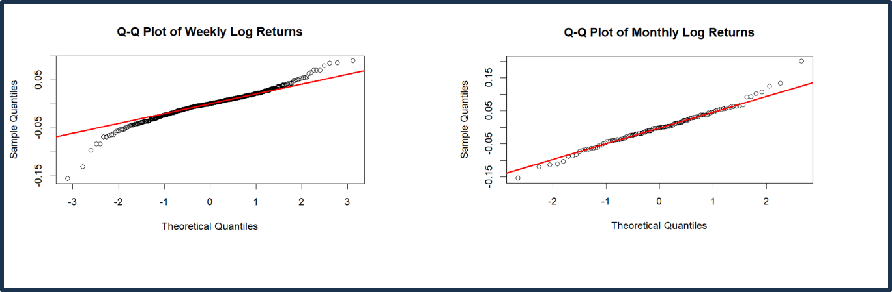
Figure 3. Q-Q plots of weekly and monthly logarithmic returns for the NSE.

The Shapiro-Wilk test confirmed the visual findings:
Table 2. Shapiro-Wilk Test for NSE returns
Returns | W Statistic | p-value
Weekly | 0.95935 | 3.471 × 10^{-11}
Monthly | 0.98122 | 0.07754

The test strongly rejected the null hypothesis of normality for weekly returns (p < 0.001) but failed to reject it for monthly returns (p = 0.07754 > 0.05).
3.3 Independence
Table 3. Ljung-Box Test for NSE returns
Time Series | X-squared | df | p-value
Weekly | 21.491 | 20 | 0.3687
Monthly | 11.435 | 20 | 0.9342

Discussion:
The combined visual and statistical analysis reveals important frequency-dependent behaviour in NSE returns. Monthly returns fully satisfy all three core assumptions of the Geometric Brownian Motion model. Weekly returns, however, significantly violate the normality assumption due to pronounced leptokurtosis and heavy tails. This pattern is clearly illustrated by the histograms and Q-Q plots.
The time series plots confirm mean reversion and support the stationarity assumption. In addition, the Ljung-Box test shows no significant serial correlation, which supports the independence assumption for both weekly and monthly returns. These findings are consistent with previous studies conducted in other African emerging markets (Quayesam et al., 2024).
Such studies have shown that higher-frequency data tend to deviate more from normality because of thin trading, news shocks, and market microstructure effects (Mettle et al., 2014; Nkemnole, 2019). The relatively better performance of monthly returns also aligns with findings reported by Toby and Agbam (2021).
Overall, the results suggest that monthly returns from the NSE are more suitable for Geometric Brownian Motion modelling than weekly returns. The standard GBM model therefore performs better when applied to monthly data in this market. For weekly data, more advanced approaches such as regime-switching GBM or jump-diffusion models may be necessary to better account for the observed deviations from normality.
These findings have practical implications for investors, portfolio managers, and financial analysts operating in the Kenyan capital market. They indicate that using the standard GBM model with weekly data without proper adjustments may result in underestimation of extreme risks and less reliable forecasts. The study therefore emphasizes the need for thorough validation of model assumptions before applying stochastic processes in emerging markets like the NSE.The combined visual and statistical analysis reveals important frequency-dependent behaviour in NSE returns. Monthly returns fully satisfy all three core assumptions of the Geometric Brownian Motion model. Weekly returns, however, significantly violate the normality assumption due to pronounced leptokurtosis and heavy tails. This pattern is clearly illustrated by the histograms and Q-Q plots.
The time series plots confirm mean reversion and support the stationarity assumption. In addition, the Ljung-Box test shows no significant serial correlation, which supports the independence assumption for both weekly and monthly returns. These findings are consistent with previous studies conducted in other African emerging markets (Quayesam et al., 2024).
Such studies have shown that higher-frequency data tend to deviate more from normality because of thin trading, news shocks, and market microstructure effects (Mettle et al., 2014; Nkemnole, 2019). The relatively better performance of monthly returns also aligns with findings reported by Toby and Agbam (2021).
Overall, the results suggest that monthly returns from the NSE are more suitable for Geometric Brownian Motion modelling than weekly returns. The standard GBM model therefore performs better when applied to monthly data in this market. For weekly data, more advanced approaches such as regime-switching GBM or jump-diffusion models may be necessary to better account for the observed deviations from normality.
These findings have practical implications for investors, portfolio managers, and financial analysts operating in the Kenyan capital market. They indicate that using the standard GBM model with weekly data without proper adjustments may result in underestimation of extreme risks and less reliable forecasts. The study therefore emphasizes the need for thorough validation of model assumptions before applying stochastic processes in emerging markets like the NSE.
4. CONCLUSION
Monthly NSE stock returns are more appropriate for Geometric Brownian Motion modelling than weekly returns. The findings demonstrate that monthly returns satisfy all three core assumptions of the GBM model, namely stationarity, normality, and independence. In contrast, weekly returns violate the normality assumption mainly due to heavy tails and leptokurtosis.
These results highlight the importance of validating model assumptions before applying stochastic processes in emerging markets (Quayesam et al., 2024). Analysts and investors using GBM for stock price forecasting on the NSE are therefore advised to prefer monthly frequency data for more reliable outcomes. Applying the standard GBM model to weekly returns without necessary adjustments may lead to inaccurate forecasts and underestimation of risks.
This study contributes to the limited empirical literature on the applicability of the GBM model in the East African context. It provides useful insights for researchers, practitioners, and policymakers interested in financial modeling within frontier markets.
Future research should explore advanced stochastic extensions such as regime-switching models or jump-diffusion processes to better address the limitations observed in higher-frequency data. Comparative studies across different African markets would also help strengthen the generalizability of these findings.
Consent
Not applicable.
Ethical Approval
Not applicable.

References
- Brătian, V., Acu, A., Mihaiu, D. M., & Șerban, R. A. (2021). Efficient or Fractal Market Hypothesis? A Stock Indexes Entropy Analysis. Mathematics, 9(22), 2973.
- Boateng Kwadwo Prempeh, E., Osei, A., & Antwi, S. (2022). Determining the return volatility of the Ghana Stock Exchange using exponential GARCH model. Journal of Economics and Financial Analysis, 6(1), 45-68.
- Dabafinance. (2024). The Largest Stock Exchanges in Africa. Retrieved from https://dabafinance.com
- Karangwa, I. (2008). Comparing South African financial markets behaviour to the Geometric Brownian motion process. University of the Witwatersrand.
- Lidén, J. (2018). Stock Price Predictions using a Geometric Brownian Motion. KTH Royal Institute of Technology.
- Marathe, R. R., & Ryan, S. M. (2005). On the validity of the geometric Brownian motion assumption. The Engineering Economist, 50(2), 159-192.
- Mensah, E. T. (2023). Simulating stock prices using geometric Brownian motion. Journal of Finance and Investment Analysis.
- Mettle, F. O., Quaye, E. N. B., & Laryea, R. A. (2014). A methodology for stochastic analysis of share prices. SpringerPlus, 3(1), 1-13.
- Nkemnole, B. (2019). Estimation of Geometric Brownian Motion Model for Stock Prices: A Case of Nigerian Stock Exchange. Journal of Economics and Financial Sciences, 12(2), 45-58.
- Philita, G. (2018). Effects of Portfolio Diversification on Financial Performance of Commercial Banks in Kenya. University of Nairobi.
- Quayesam, D. L., Lotsi, A., & Mettle, F. O. (2024). Modeling Stock Price Dynamics on the Ghana Stock Exchange Using Geometric Brownian Motion. arXiv preprint arXiv:2403.13192.
- Suganthi, K., & Jayalalitha, G. (2019). Geometric Brownian Motion in stock prices. Journal of Physics: Conference Series, 1377(1), 012016.
- Toby, A. J., & Agbam, S. A. (2021). Stochastic Forecasting of Stock Prices in Nigeria Using Geometric Brownian Motion. International Journal of Finance and Banking Research, 7(3), 78-92.
- Remillard, B., & Rubenthaler, S. (2023). Option pricing and hedging for regime-switching geometric Brownian motion models. arXiv preprint.
- Yan, Y., et al. (2025). Bayesian Inference of Geometric Brownian Motion with Jumps. Model Assisted Statistics and Applications.
- Antwi, O., et al. (2020). Jump Diffusion Modeling of Stock Prices on the Ghana Stock Exchange. Journal of Mathematical Finance, 10(4), 567-589.
- Agbam, A. S. A. (2021). Stock Prices Prediction Using Geometric Brownian Motion: Evidence from the Nigerian Stock Exchange. African Journal of Economic Review.
- Sonkavde, G., et al. (2023). Empirical Mode Decomposition on Ghana Stock Exchange Indices. Computational Economics.
- Straja, S. (1997). Limitations of Geometric Brownian Motion in Financial Modeling. Journal of Risk Management.
- Akurugu, A., et al. (2022). Bayesian Switching Volatility Models for Emerging African Markets. Journal of Financial Econometrics.

