Original Research Article

Quinoline-Based Aromatic Aldehydes as Novel Inhibitors of Plasmodium falciparum Transketolase: An In-Silico Study

Abstracts
Background: The emergence of drug-resistant Plasmodium falciparum strains, especially those showing resistance to artemisinin-based combination therapies (ACTs), highlights the critical demand for new antimalarial compounds that target different biochemical pathways.
Objectives: This study explores the inhibitory potential of quinoline-derived aromatic aldehydes against Plasmodium falciparum transketolase, a key enzyme in the pentose phosphate pathway that plays a vital role in parasite nucleotide synthesis and redox homeostasis, through in-silico assessment.
Methodology: A combination of ligand-based and structure-based drug design strategies was employed. Drug-likeness, pharmacokinetic, and toxicological properties were assessed using qualitative drug estimation and ADMET profiling. Molecular docking was used to determine binding affinities, while binding free energies were calculated using molecular mechanics. The stability of binding interactions was further examined using molecular dynamics simulations.
Results: Molecular docking studies identified 3,4,5-trimethoxybenzaldehyde (A3) and 2-nitrobenzaldehyde (A6) having the highest binding affinity with Plasmodium falciparum transketolase (-8.3 kcal/mol and -8.2 kcal/mol respectively), outperforming reference drug Oxythiamine. MM-PBSA analysis further confirmed Compound A6 as the thermodynamically most favorable complex, exhibiting superior overall binding free energy (ΔG_bind) driven by significant van der Waals and covalent contributions. Pharmacokinetic evaluations, including drug-likeness and ADMET profiling, indicated favorable drug-like properties and low toxicity across all the compounds. Molecular dynamics simulations over 100 ns further validated Compounds A3 (7-(3,4,5-trimethoxyphenyl) chromenoquinoline) and A6 (7-(2-nitrophenyl) chromenoquinolinone) as the most stable complexes with Plasmodium falciparum transketolase, recording average RMSD of 0.24–0.25 nm, RMSF of 0.12–0.14 nm, radius of gyration of 2.85–2.93 nm, and consistent hydrogen bond persistence throughout the trajectory.
Conclusion: Compared to the reference drug oxythiamine, both compounds demonstrated superior conformational stability and active site complementarity, reinforcing their potential as credible antimalarial lead candidates
Keywords: Antimalarial resistance; plasmodium falciparum transketolase; oxythiamine; Chromenoquinoline; ligand-based drug design; structure-based drug design.

1.1 Introduction
Malaria remains one of the most devastating infectious diseases globally, caused by Plasmodium parasites transmitted to humans through bites of infected female Anopheles mosquitoes. These vectors thrive predominantly in tropical and subtropical regions where environmental conditions support their spread [32]. According to World Health Organization (WHO) 2025 data, approximately 282 million malaria cases and 610,000 deaths were recorded worldwide, reinforcing the disease's continued threat to global public health. Africa bears the heaviest burden, accounting for about 213 million of these cases. Four sub-Saharan African nations — Nigeria (26.6%), the Democratic Republic of Congo (12.3%), Uganda (5.1%), and Mozambique (4.1%) — together accounted for nearly half of all malaria-related deaths globally, reflecting the disproportionate regional impact of this disease.
Significant progress was achieved between 2000 and 2015, with global malaria cases declining by 37% and deaths dropping by 60% [31]. This was largely driven by expanded vector control measures such as insecticide-treated bed nets and indoor residual spraying, widespread adoption of artemisinin-based combination therapies (ACTs), and improved diagnostic tools. However, this momentum has considerably slowed since 2015 [2]. The WHO Global Malaria Report recorded 241 million cases in 2020, up from 227 million in 2019, suggesting a worrying reversal of earlier gains. Factors such as emerging drug resistance, fragile health systems, climate variability, and ongoing conflicts in endemic regions continue to undermine progress [25]. The Global Burden of Disease 2023 analysis similarly identified malaria as a leading cause of infectious disease morbidity and mortality in low-income countries, underscoring the persistent urgency for new and effective intervention strategies [15].
One emerging and promising area in antimalarial drug development is the exploitation of the pentose phosphate pathway (PPP), particularly through inhibition of the enzyme transketolase, this enzyme is thiamine diphosphate (ThDP)-dependent that plays a central role in nucleotide synthesis and redox balance within the parasite both of which are critical for its survival and replication inside host erythrocytes [13]. Recent research has recognized transketolase as a metabolic vulnerability in Plasmodium falciparum that can be therapeutically exploited [22]. Since this enzyme operates within a pathway distinct from those targeted by existing antimalarials, inhibiting it offers a viable strategy for circumventing established drug resistance mechanisms, making it an attractive target for novel drug design.
Thiamine analogs, structurally similar to the ThDP cofactor, have demonstrated the ability to inhibit ThDP-dependent enzymes, making them early candidates for targeting transketolase [6]. Oxythiamine, for example, has shown inhibitory activity within the PPP by competing with thiamine for enzyme binding. However, its clinical usefulness is significantly limited by adverse effects including nephrotoxicity, a short half-life, and broader toxicity concerns, rendering it unsuitable for long-term therapeutic use [33]. These shortcomings have prompted a shift in research focus toward identifying alternative thiamine analogs that retain strong inhibitory potential while offering safer pharmacokinetic and toxicological profiles, a key motivation behind the investigation of quinoline-based compounds in this study.
Quinoline alkaloids are naturally occurring compounds predominantly sourced from plants of the genus Cinchona, members of the Rubiaceae family [5]. The bark of several Cinchona species including; C. officinalis, C. ledgeriana, C. calisaya, and C. succirubra is particularly rich in these biologically active alkaloids, among them quinine, quinidine, cinchonine, and cinchonidine. These compounds have long held significant pharmaceutical importance, most notably in the historical treatment of malaria [17].
Beyond antimalarial activity, quinoline alkaloids exhibit a broad range of pharmacological properties, including anti-inflammatory, antimicrobial, anticancer, and cardiovascular effects, making them valuable scaffolds in medicinal chemistry and drug development [12]. Their heterocyclic structural framework contributes to diverse biological interactions, and they have been extensively studied for multiple therapeutic applications [20]. Despite this wealth of pharmacological data, studies specifically exploring their antimalarial potential particularly through enzyme-targeted mechanisms remain relatively limited, representing a significant gap this study aims to address.
The functionalization of aromatic aldehyde onto the quinoline scaffold further enhances its therapeutic potential. Aromatic aldehydes introduce hydrogen-bonding capabilities and distinct electronic properties that can significantly influence how a ligand interacts with its protein target [24]. These structural features make quinoline-derived aromatic aldehydes particularly attractive as candidate inhibitors of Plasmodium falciparum transketolase. Selective interactions with amino acid residues surrounding the enzyme's cofactor-binding or regulatory regions could contribute to stronger binding affinity and greater target specificity key attributes for an effective and selective antimalarial agent.
The persistence of malaria as a global health crisis coupled with the increasing threat of drug resistance indicate a need for new therapeutic strategies. Transketolase in the PPP plays a significant role in the parasite proliferation and redox balance making a potential drug target and the promising pharmacological profile of quinoline-derived aromatic aldehydes collectively justify a computational evaluation into these compounds as potential antimalarial leads. Therefore, this study employed a rigorous in-silico approach to evaluate these compounds against Plasmodium falciparum transketolase.
2.0 Methodology

2.1 Preparation of Ligands
Ten aromatic aldehyde quinoline-based compounds were selected for evaluation as potential antimalarial agents in this in-silico study. These compounds include 3-hydroxybenzaldehyde, 4-hydroxybenzaldehyde, 3,4,5-trimethoxybenzaldehyde, 3-pyridylcarboxaldehyde, p-tolylbenzaldehyde, 2-nitrobenzaldehyde, 4-hydroxy-3-methoxyphenyl, 4-dimethylaminobenzaldehyde, 3,4-dimethoxybenzaldehyde, and 2,4-dihydroxybenzaldehyde which were presented with A1 -10 respectively (Fig 1). These Compounds were purposefully selected through a deliberate structure-activity rationale aimed at identifying the most promising inhibitor scaffolds against the target while maintaining drug-likeness and safety compatibility [20]. Their two-dimensional (2D) structures were drawn using ChemDraw Ultra version 12.0 and subsequently converted into three-dimensional (3D) conformations using Chem3D Ultra version 12.0. Energy minimization was then performed on each ligand to stabilize its structure, and the optimized conformations were saved in Protein Data Bank (.pdb) format. OpenBerbal version 1.5.4 was used to convert the ligand files into the AutoDock-compatible PDBQT format. Oxythiamine, which served as the reference drug, was retrieved from the PubChem database and optimized in 3D using OpenBerbal version 1.5.4 [7].

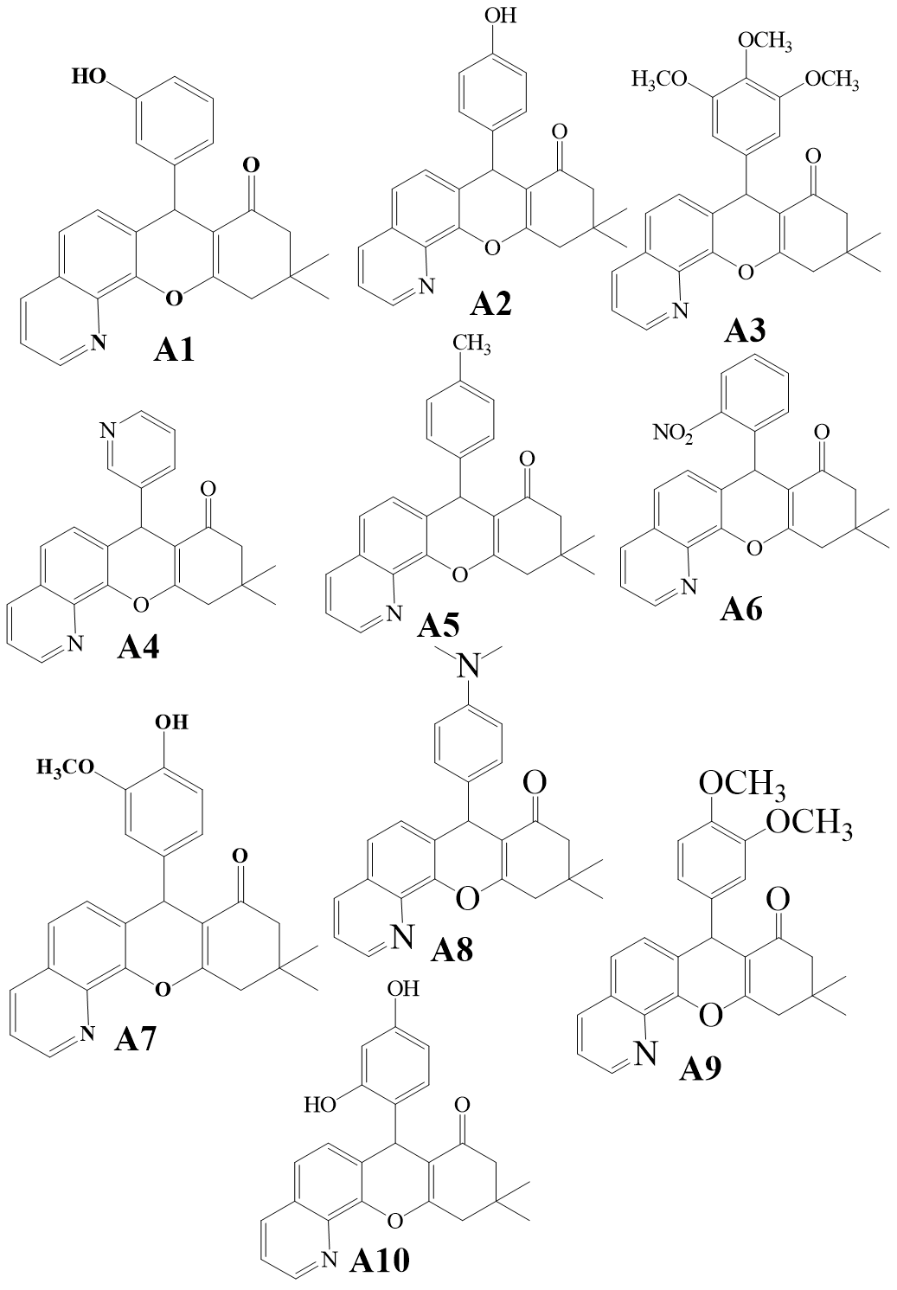
Fig i: Structures of Chromenoquinolinone derivatives drawn using ChemDraw Software

2.2 Preparation of Target Protein
Structural information on Plasmodium falciparum transketolase was obtained from the RCSB Protein Data Bank (https://www.rcsb.org) (Fig 2). The three-dimensional crystal structure of the enzyme (PDB ID: 9TME), resolved at 1.81 Å, was selected as the receptor for this study, with particular attention to its domain A and C regions. The protein structure was processed and optimized using Biovia Discovery Studio 2021 to eliminate any unintended interactions that could compromise the virtual screening process [18, 25]. Water molecules, co-crystallized ligands, and redundant chains were removed, retaining only chains A and C. All compounds were subsequently converted to PDBQT format using AutodockTools 1.5.7 to facilitate interaction studies with the target protein.
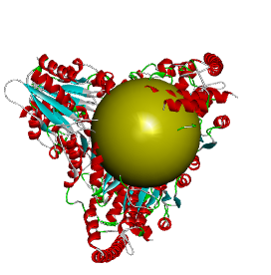
Fig ii: 3D structure of Plasmodium falciparum transketolase. (Source: Protein data bank)

2.3 Molecular Docking Validation
To ensure the reliability and accuracy of the docking protocol, validation was carried out by re-docking the co-crystallized ligand, oxythiamine, into the active site of P. falciparum transketolase using AutoDock Vina executed through the Perl command prompt environment [1]. The re-docked pose was compared with the experimentally observed binding conformation, and the resulting binding scores and structural alignment confirmed that AutoDock Vina, when integrated with Perl scripting, is capable of producing accurate and reproducible docking results. This validated approach demonstrates that the AutoDock Vina–Perl combination provides a reliable and robust framework for predicting ligand binding interactions, minimizing false positives and negatives, and ensuring dependable predictions of potential drug efficacy throughout the virtual screening process.

2.3.1 Molecular Docking
Molecular docking was performed to evaluate binding interactions between the selected aromatic aldehyde quinoline derivatives and P. falciparum transketolase, using AutoDock Vina executed through the Perl command prompt environment. Perl scripting was utilized to automate docking commands and streamline the ligand screening process. All ligand structures were prepared in PDBQT format using OpenBabel 1.5.4, with proper assignment of atom types and torsional bonds.
A docking configuration file was prepared to define the grid box parameters around the enzyme's active binding pocket. The grid box coordinates were set at X = −44.896, Y = 10.0, and Z = −48.573, with a grid spacing of 1 Å, ensuring adequate coverage of the catalytic site residues responsible for substrate binding. Docking simulations were conducted at an exhaustiveness level of 8, allowing sufficient exploration of ligand conformational space to identify optimal binding poses. Batch docking of multiple ligands was automated through Perl scripting, which also facilitated the organization and efficient processing of output files.
Following docking, the best binding conformations were selected based on the lowest binding energy values and favorable interactions with key active site residues. Visualization and interaction analysis were subsequently performed to examine hydrogen bonding, hydrophobic contacts, and π–π stacking interactions between the ligands and the transketolase binding pocket using Discovery Studio Software [18].

2.4 Physicochemical, Pharmacokinetic, and Toxicological Assessment

2.4.1 Drug-Likeness Properties
Drug-likeness assessment was conducted using the Quantitative Estimate of Drug-likeness (QED) approach via ADMETLab 3.0. QED offers a more comprehensive and nuanced evaluation of drug-likeness compared to the conventional Lipinski Rule of Five (Ro5) [20]. While the Ro5 applies a set of binary cutoff thresholds — molecular weight ≤500 Da, LogP ≤5, hydrogen bond donors ≤5, and hydrogen bond acceptors ≤10 — QED integrates multiple molecular descriptors into a single continuous score ranging from 0 to 1, where values from 0.6 to 1 indicate greater drug-likeness. This makes QED a more sensitive and informative metric, as it captures the overall desirability of a compound's physicochemical profile rather than simply flagging rule violations. Parameters evaluated included molecular weight, lipophilicity (LogP), rotatable bonds, hydrogen bond donors and acceptors, and other features relevant to oral bioavailability and suitability for human administration.
2.4.2 ADMET Prediction
A thorough assessment of Absorption, Distribution, Metabolism, Excretion, and Toxicity (ADMET) properties was conducted for all candidate compounds using ADMETLab 3.0. SMILES notations for each ligand were generated by converting the 3D structures drawn in ChemDraw using Open Babel and entered into the platform for analysis [11]. Key parameters evaluated included Caco-2 permeability, human intestinal absorption, P-glycoprotein inhibition, cytochrome P450 enzyme inhibition, acute oral toxicity, Ames toxicity, carcinogenicity, hepatotoxicity, nephrotoxicity, human ether-a-go-go related gene (hERG) inhibition, half-life (t½), and total clearance [28]. These parameters collectively provided a comprehensive picture of each compound's pharmacokinetic behavior and safety profile, which are critical considerations in early-stage drug development.

2.5 Molecular Mechanics (MM-PBSA)
Binding free energy calculations were carried out using the Prime MM-PBSA tool within Maestro version 12.5. This method decomposes the total binding free energy into individual energy contributions — including electrostatic interactions, van der Waals forces, covalent interaction, and solvation energies — providing detailed insight into the thermodynamic basis of ligand binding. The binding free energy (ΔG_bind) was calculated using the equation:
ΔG_bind = ΔE_MM + ΔG_GP + ΔG_SA
where ΔE_MM represents the molecular mechanical energy (sum of electrostatic, van der Waals, hydrogen bond, and torsional angle energies), ΔG_PB is the polar solvation energy, and ΔG_SA is the nonpolar solvation energy. The results provided quantitative insights into the relative binding stability of each ligand at the transketolase active site [3].

2.6 Molecular Dynamics (MD) Simulation
Molecular dynamics simulations were performed to assess the structural stability, conformational dynamics, and interaction behavior of the protein-ligand complexes under physiological conditions [8]. Simulations were carried out using GROMACS version 2022, with protein and ligand topologies generated using the CHARMM36 force field and CGenFF parameters. Each complex was placed in a dodecahedron simulation box filled with SPC water molecules and neutralized with counterions using the GROMACS genion tool.
Energy minimization was first performed using steepest descent and conjugate gradient algorithms until the maximum force fell below 100 kJ/mol/nm. The system was then equilibrated in two phases: NVT ensemble equilibration from 0 to 300 K over 100 picoseconds using the Verlet algorithm with a 2fs time step, followed by NPT ensemble equilibration using the Berendsen algorithm under the same time step for 100 ps [18]. Production MD simulations were subsequently run for 100 nanoseconds for each protein-ligand complex.
Post-simulation analyses were performed using Xmgrace, focusing on Root Mean Square Deviation (RMSD), Root Mean Square Fluctuation (RMSF), Radius of Gyration (RoG), and Intermolecular Hydrogen Bonds [22]. These parameters collectively offered a detailed understanding of the dynamic stability and interaction mechanisms of the complexes throughout the simulation period.
3.0 Results
Table 1: This table is showing Molecular Docking Results of 9TME and Chromenoquinoline derivatives from Perl cmd (Autodockvina)
Ligands | Chemical name | Binding Energy (Perl)  (Kcal/mol) | H-Bond  Interaction
Reference drug | Oxythiamine | -5.2 | A: SER 456  A: PHE 639  C: PHE 639  C: SER 642
A1 | 3-hydroxylphenyl derivative of Chromenoquinolinone | -7.8 | A: ASP 627
A2 | 4-hydroxyphenyl derivatives of Chromenoquinolinone | -7.8 | A: LYS 595  A: ASN 491  A: ASN 493
A3 | 3,4,5-trimethoxyphenyl derivatives of Chromenoquinolinone | -8.3 | A: GLY 30  A: LEU 268  A : HIS 266
A4 | 3-Pyridyl derivatives of Chromenoquinolinone | -7.6 | C: LYS 595
A5 | p-Toyl derivatives of Chromenoquinolinone | -8.0 | Nil
Ligands | Compound Name | Binding Energy (Perl)(K/mol) | Hydrogen-Bond Interaction
A6 | 2-nitrophenyl derivatives of Chromenoquinolinone | -8.2 | C: ARG 361  C: HIS 465  C: ARG 524  C: ARG 524
A7 | 4-hydroxy-3-methoxyphenyl  derivative of Chromenoquinolinone | -7.9 | Nil
A8 | 4-(dimethylamino)phenyl derivatives of Chromenoquinolinone | -7.9 | Nil
A9 | 3,4-dimethoxyphenyl derivatives of Chromenoquinolinone | -8.1 | Nil
A10 | 2,4-dihydroxylphenyl derivatives of Chromenoquinolinone | -8.0 | A: SER 488  A: ARG 487

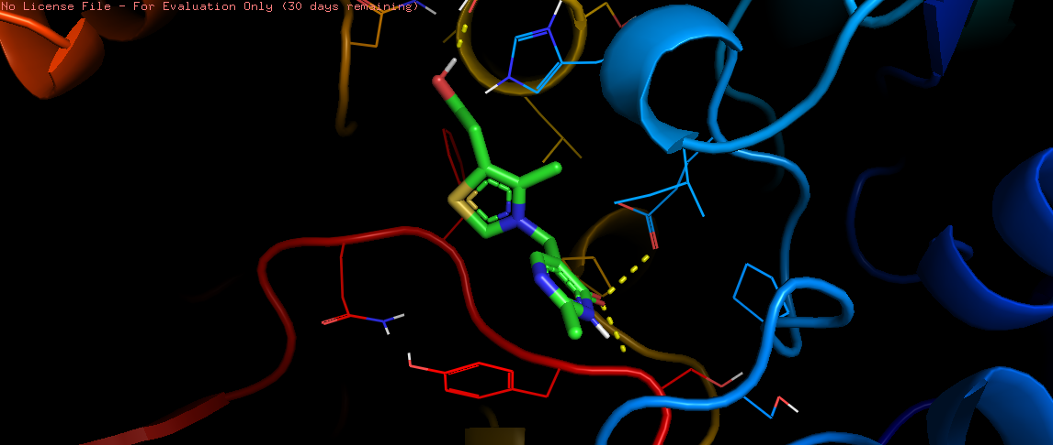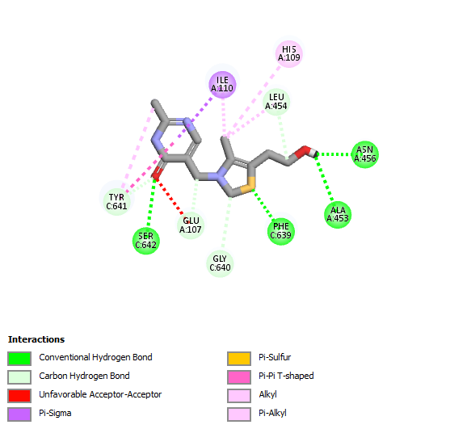
Figure 3: Molecular Interaction between 9TME_Oxythiamine visualized using Discovery Studio

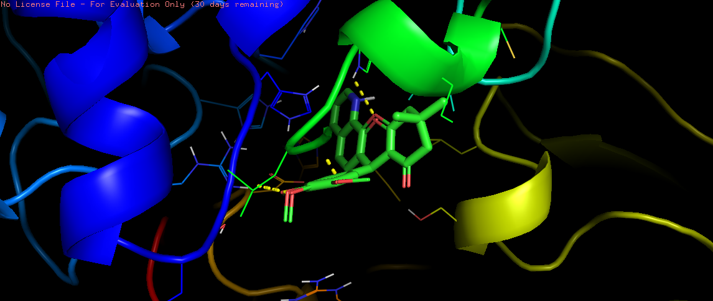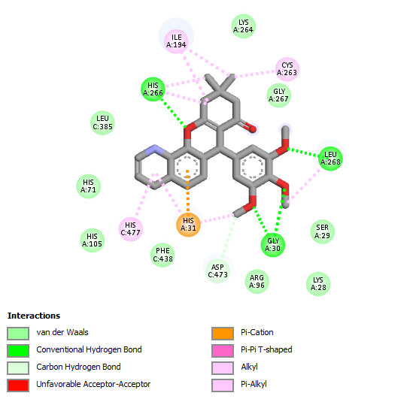
Figure 4: Molecular Interaction between 9TME_Trimethoxyphenyl visualized using Discovery Studio

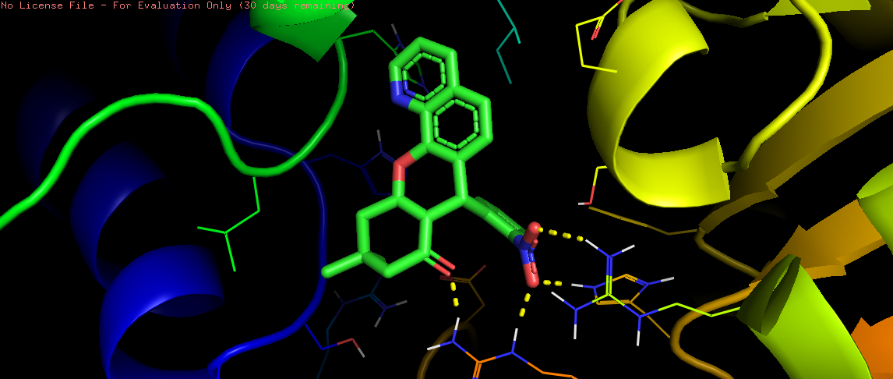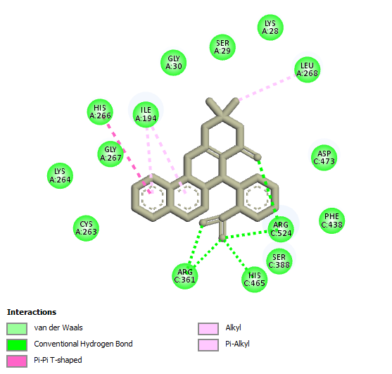
Figure 5: Molecular Interaction between 9TME_Nitrophenyl visualized using Discovery Studio

Ligands | MM-PBSA  ΔG  Bind Electrostatic Energy (Kcal/mol) | MM-PBSA  ΔG  Bind Covalent bond (Kcal/mol) | MM-PBSA  ΔG  Bind VanderWaal Forces  (Kcal/mol) | MM-PBSA  ΔG  Bind Polar Solvation (Kcal/mol) | MM-PBSA  ΔG  Overall Binding Energy (Kcal/mol)
Oxythiamine | -52.63 | -0.02 | -0.12 | 52.74 | -0.02
Compound A3 (Trimethoxylphenyl) | -0.07 | -0.02 | -0.20 | 0.29 | -0.01
Compound A6 (Nitrophenyl) | -3.03 | -2.81 | -23.92 | 18.00 | -11.76
Table 2: Table showing the binding free energies of oxythiamine, compound A3 and A6

Ligands | Drug ability | Absorption and  Distribution |  |  |  | Metabolism |  |  |  |  | Excretion and Toxicity
Compound Identifier | QED SCORE | Caco2  permeability | BBB | Human Intestinal  Absorption | P-glycoprotein  Inhibitor | CYP2D6 | CYP3A4 | CYP1A2 | CYPC19 | CYP2C9 |  | Half-life | Total Clearance | Nephrotoxicity | Acute oral toxicity | AMES toxicity | Carcinogenicity | HERG inhibitor | Hematoxicity
A1 | 0.646 | M | G | G | G | G | R | G | R | R |  | 0.6 | M | M | M | M | M | G | G
A2 | 0.534 | M | G | G | G | G | M | G | R | R |  | 0.7 | M | M | M | M | M | G | G
A3 | 0.646 | G | M | G | G | G | R | G | M | M |  | 0.7 | G | G | M | G | M | G | M
A4 | 0.629 | G | G | G | G | G | R | G | M | M |  | 0.5 | M | M | M | M | M | G | M
A5 | 0.551 | G | G | G | R | G | R | G | R | R |  | 0.5 | G | M | G | M | M | G | M
A6 | 0.646 | G | G | G | G | G | R | G | M | R |  | 0.6 | G | R | M | R | M | G | M
A7 | 0.430 | G | G | G | G | G | R | G | R | M |  | 0.8 | G | M | M | M | M | G | M
A8 | 0.574 | G | G | G | R | G | R | G | M | R |  | 0.4 | G | M | R | G | M | G | M
A9 | 0.572 | G | G | G | R | G | R | G | R | R |  | 0.7 | M | M | R | G | M | G | M
A10 | 0.646 | G | G | G | G | G | M | G | R | R |  | 0.7 | G | R | M | G | M | G | G
M-Medium
R- Poor
G- Good
Table 3: ADMET properties for the Chromenoquinoline derivatives. (Note: Good means low risk prediction, medium means medium risk prediction, poor means the compound needs further investigation or optimization.)

MD Parameter | Oxythiamine | Compound A3 | Compound A6
RMSD (nm) | 0.23 | 0.24 | 0.25
RMSF (nm) | 0.13 | 0.14 | 0.12
Radius of Gyration (nm) | 2.90 | 2.85 | 2.93
H-bonds (count) | 1.8 | 1.2 | 1.0
SASA (nm²) | 290 | 280 | 272
Table 4: Average Values of RMSD, RMSF, RoG, and H-Bonds Oxythiamine, Compound A3 a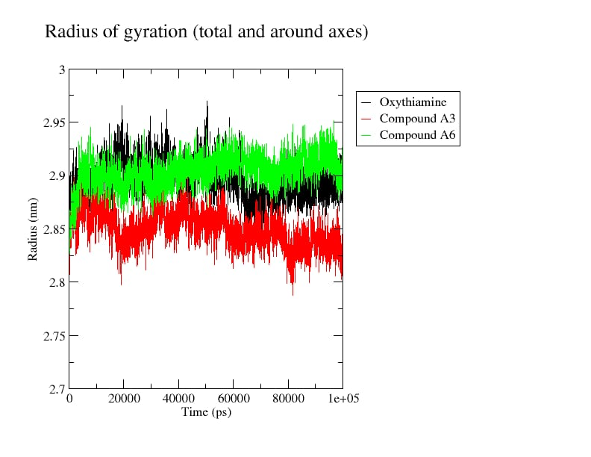

Figure 6: Radius of gyration of Plasmodium flaciparum transketolase complex with Oxythiamine and Compound A3, A6

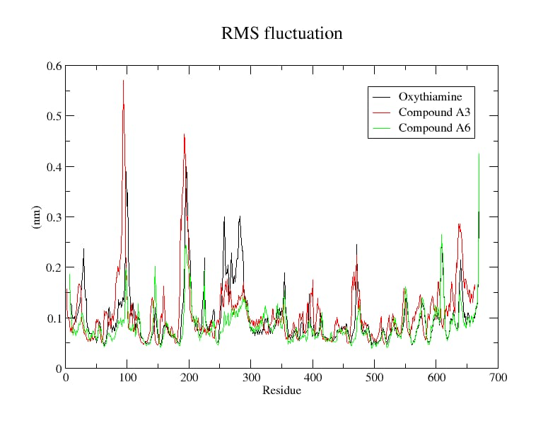
Figure 7: Residue fluctuation of Plasmodium flaciparum transketolase complex with Oxythiamine and Compound A3, A6
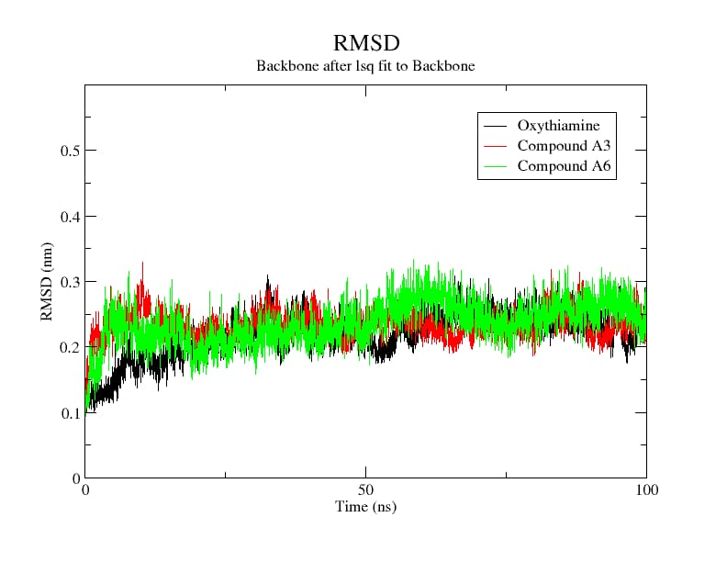

Figure 8: The Conformational stability of Plasmodium flaciparum transketolase complex with Oxythiamine and Compound A3, A6

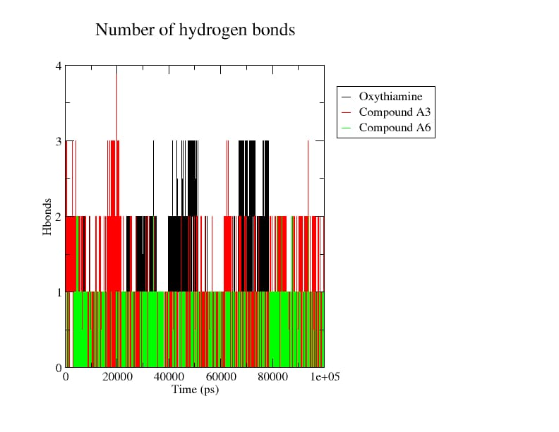
Figure 9: Hydrogen Bond Interactions of Plasmodium flaciparum transketolase complex with Oxythiamine and Compound A3, A6

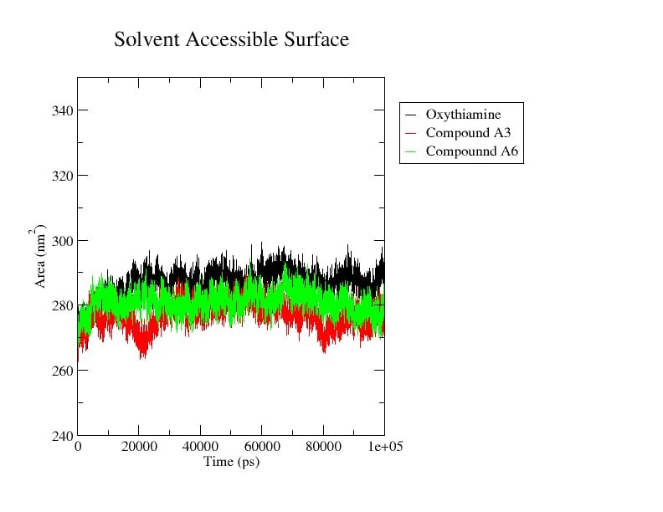

Fig 10: Solvent Accessible Surface Area of Plasmodium flaciparum transketolase complex with Oxythiamine and Compound A3, A6

DISCUSSION
The 3D structure of Plasmodium falciparum transketolase was gotten from protein data bank. The protein was tested for 10 different quinoline-based aromatic aldehydes derivatives. Molecular docking analysis provided critical insights into the binding interactions between Plasmodium falciparum transketolase (PDB ID: 9TME) and ten aromatic aldehyde quinoline derivatives, alongside the reference drug oxythiamine, with results stated in Table 1. Oxythiamine recorded a binding affinity of −5.2 kcal/mol. These comparatively weaker binding energies are consistent with its known pharmacological limitations, including nephrotoxicity and carcinogenicity, which further restrict its clinical utility as a direct antimalarial agent.
Notably, two compounds demonstrated significantly superior binding affinities: 7-(3,4,5-trimethoxyphenyl)-10,11-dihydro-7H-chromenquinolin-8(9H)-one (Common Name: 3,4,5-trimethoxyphenyl derivatives of Chromenoquinoline) and 7-(2-nitrophenyl)-10,11-dihydro-7H-chromeno[3,2-h] quinolin-8(9H)-one (Common Name: 2-Nitrophenyl derivatives of Chromenoquinoline), scoring −8.3 kcal/mol and −8.2 kcal/mol respectively (Table 1). These compounds engaged key catalytic residues — Gly30, Leu268, His266, Arg316, and Arg524 — through hydrogen bonding, while additional alkyl interactions with Cys263, Ile194, and Ile19 further reinforced their binding stability within the active site. These multi-point interactions suggest a strong complementarity between the ligands and the enzyme's binding pocket, indicative of favorable selectivity and potency. The higher binding affinities compared to oxythiamine position these two compounds as promising lead candidates for further antimalarial drug development targeting P. falciparum transketolase.
The visualization of these lead compounds (A3 and A6) was done using Biovia discovery studio software. Oxythiamine engaged the active site of P. falciparum transketolase through conventional hydrogen bonds with Tyr C641, Glu A107, and Ser C642, supplemented by unfavorable acceptor-acceptor contacts and Pi-sigma interactions with Ile A110 and Leu A454 (Figure 3). The limited interaction profile and presence of unfavorable contacts are consistent with its weak binding affinity (−5.2 kcal/mol), corroborating its poor clinical efficacy.
This compound established robust conventional hydrogen bonds with Gly A30, Leu A268, His A266, and Arg A96, alongside van der Waals contacts and Pi-alkyl interactions with His A477, Phe C438, and Asp C473 (Figure 4). This extensive multi-residue engagement within the catalytic pocket suggests strong binding complementarity and favorable selectivity toward the transketolase active site.
The nitrophenyl derivative demonstrated stable binding through conventional hydrogen bonds with Arg C524 and His A269, Pi-Pi T-shaped interactions with Ile A194, and broad van der Waals contacts with Gly A30, Leu A268, Cys A263, and Phe C438 (Fig 5). These diverse non-covalent interactions reinforce its high binding affinity, suggesting strong inhibitory potential against P. falciparum transketolase this support Seo et al. (2016) findings [21].
MM-PBSA calculations was done and this provides quantitative insights into the thermodynamic contributions governing ligand binding stated in Table 2. Compound A6 (Nitrophenyl) demonstrated the most favorable overall binding free energy of −11.76 kcal/mol, driven predominantly by significant van der Waals contributions (−23.92 kcal/mol) and covalent interactions (−2.81 kcal/mol), partially offset by polar solvation energy (18.00 kcal/mol). This energetic profile suggests strong hydrophobic complementarity within the transketolase active site. Compound A3 recorded a modest overall binding energy of −0.01 kcal/mol, while oxythiamine yielded −0.02 kcal/mol, with its large electrostatic contribution (−52.63 kcal/mol) almost entirely cancelled by unfavorable polar solvation (52.74 kcal/mol), reflecting thermodynamically inefficient binding. These findings further validate A6 as the superior lead candidate [18, 14].
The drug-likeness of all ten-aromatic aldehyde quinoline derivatives (A1–A10) was assessed using the Quantitative Estimate of Drug-likeness (QED) scoring system (Table 2), which provides a more holistic and continuous measure of molecular desirability compared to the binary thresholds of Lipinski's Rule of Five. QED scores range from 0 to 1, with values approaching 1 reflecting more favorable drug-like characteristics. As presented in Table 3, the compounds recorded QED scores between 0.430 and 0.646. Compounds A1, A3, A6, and A10 achieved the highest score of 0.646, indicating strong drug-likeness, while A7 recorded the lowest score of 0.430 [8, 29]. Overall, the majority of compounds demonstrated acceptable drug-likeness profiles, supporting their suitability for further pharmacological development.
The absorption, distribution, metabolism, excretion, and toxicity (ADMET) properties of all compounds were evaluated using ADMETLab 3.0, with results stated in Table 2.
Most compounds demonstrated good human intestinal absorption and blood-brain barrier (BBB) permeability. Compounds A3–A10 exhibited good Caco-2 permeability, while A1 and A2 showed moderate permeability, suggesting slightly reduced passive uptake. The majority of compounds showed good P-glycoprotein inhibition, indicating a reduced likelihood of drug efflux and enhanced intracellular retention., favorable attributes for sustained antimalarial activity. Notably, A5, A8, and A9 showed reduced P-glycoprotein inhibition, which may slightly limit their intracellular accumulation.
All ten compounds showed good CYP3A4 non-inhibition, suggesting a low propensity for metabolic drug-drug interactions involving this critical enzyme. CYP2D6 inhibition was absent across all compounds, indicating metabolic safety. However, CYP1A2 and CYP2C19 inhibition was observed across several compounds, warranting consideration in co-therapy scenarios. CYP2C9 inhibition was similarly flagged in most compounds and should be monitored during further development.
Half-life values across the compounds ranged from 0.4 to 0.8 hours, reflecting relatively rapid clearance and reducing risks of bioaccumulation. Total clearance was good for A3, A5, A6, A8, A9, and A10, while A1, A2, A4, and A7 showed moderate clearance. Notably, A3 and A10 demonstrated the most favorable overall excretion profiles.
Toxicologically, A3 emerged as the standout compound, exhibiting good nephrotoxicity and acute oral toxicity profiles, with no carcinogenic risk, the only compound to achieve this combination. A6 and A10 showed reduced nephrotoxicity ratings and require cautious monitoring. AMES toxicity was moderate across all compounds, while most compounds were predicted to have a favourable hERG inhibition-risk profile, suggesting a low predicted risk of hERG-related cardiac liability. Hematotoxicity profiles were generally favorable, with most compounds rated as good. Compared to oxythiamine which is associated with nephrotoxicity, poor clearance, and carcinogenicity the aromatic aldehyde quinoline derivatives collectively demonstrate markedly superior pharmacokinetic and safety profiles.
The lead compounds, A3 (7-(3,4,5-trimethoxyphenyl)-10,11-dihydro-7H-chromeno[3,2-h] quinolin-8(9H)-one) and A6 (7-(2-nitrophenyl)-10,11-dihydro-7H-chromeno[3,2-h] quinolin-8(9H)-one) stand out as the most promising lead candidates, combining the highest binding affinities from molecular docking with favorable ADMET characteristics, making them a promising candidates for further experimental validation and antimalarial drug development.
To gain a comprehensive and time-resolved understanding of the structural stability, conformational flexibility, and dynamic behavior of the protein-ligand complexes under physiological conditions, molecular dynamics simulations were conducted over an extended 100 ns trajectory.
RMSD analysis revealed that all three complexes achieved equilibration and maintained stable conformations throughout the simulation period. Compounds A3 and A6 recorded average RMSD values of 0.24 nm and 0.25 nm respectively (Table 3), reflecting dynamic yet stable binding conformations within the transketolase active site. Oxythiamine, despite recording a slightly lower average RMSD of 0.23 nm, exhibited intermittent conformational fluctuations (Figure 7) during early simulation stages, suggesting less consistent structural adaptation to the binding pocket compared to the test compounds [9].
RMSF analysis assessing per-residue flexibility revealed that Compound A6 demonstrated the lowest average fluctuation of 0.12 nm, indicating that its binding induces greater rigidity and stabilization of active site residues a highly desirable property for a potent enzyme inhibitor [14]. Compound A3 recorded an average RMSF of 0.14 nm, while oxythiamine showed 0.13 nm. The localized peaks observed around residues 90–100 and 190–200 are attributable to inherently flexible loop regions distant from the catalytic site, and do not compromise the overall binding stability of A3 and A6.
Radius of Gyration (RoG) values reflect the overall compactness of the protein-ligand complexes. Compound A3 recorded the lowest average RoG of 2.85 nm, indicating that its binding promotes a more compact and structurally stable protein conformation relative to oxythiamine (2.90 nm) and A6 (2.93 nm) [14]. The consistently stable RoG trajectories observed for both A3 and A6 throughout the simulation confirm that neither compound induces significant unfolding or structural distortion of the transketolase enzyme, further supporting their compatibility with the target.
Hydrogen bond analysis demonstrated that oxythiamine maintained an average of 1.8 hydrogen bonds throughout the simulation. However, this did not translate to superior binding stability, as hydrogen bond counts for oxythiamine fluctuated considerably across the trajectory. Compounds A3 and A6 maintained consistent hydrogen bond counts of 1.2 and 1.0 respectively, with sustained persistence throughout the 100 ns period. The consistency of these interactions is more therapeutically significant than sheer count, as stable persistent hydrogen bonding reflects stronger and more reliable protein-ligand complementarity under physiological conditions [23].
Solvent Accessible Surface Area (SASA) analysis further reinforced the superiority of A3 and A6. Both compounds recorded lower average SASA values of 280 nm² and 272 nm² respectively, compared to oxythiamine's 290 nm². Lower SASA values indicate that the protein adopts a more closed, compact conformation upon ligand binding, reflecting deeper and more favorable burial of the compounds within the active site [26]. This suggests that A3 and A6 engage the transketolase binding pocket more effectively, limiting solvent exposure and enhancing binding stability characteristics strongly associated with potent enzyme inhibition.
Collectively, the MD simulation data establish that Compounds A3 and A6 form stable, persistent, and energetically favorable complexes with P. falciparum transketolase throughout the entire simulation period. Their superior compactness, consistent active site stabilization, and lower solvent exposure compared to oxythiamine position them as structurally robust and pharmacodynamically promising antimalarial lead candidates worthy of further experimental investigation.

CONCLUSION
This study successfully identified Compounds A3 (7-(3,4,5-trimethoxyphenyl)-10,11-dihydro-7H-chromeno[3,2-h]quinolin-8(9H)-one) and A6 (7-(2-nitrophenyl)-10,11-dihydro-7H-chromeno[3,2-h]quinolin-8(9H)-one) as promising Plasmodium falciparum transketolase inhibitors through comprehensive in-silico evaluation. These compounds demonstrated high binding affinities, favorable ADMET profiles, and stable molecular dynamics trajectories compared to the reference drug oxythiamine. MM-GBSA analysis further validated A6 as the thermodynamically most stable complex, driven by significant van der Waals and covalent energy contributions. These results suggest the pentose phosphate pathway as a viable antimalarial drug target and position quinoline-derived aromatic aldehydes as credible lead candidates warranting further experimental validation and preclinical investigation.
Declaration of AI Use

This manuscript was prepared through the intellectual contributions of the author(s) to the study design, data analysis, interpretation of results, and scholarly content. Grammarly and ChatGPT were used solely to assist with grammatical refinement and reference formatting during manuscript revision. The author(s) accept full responsibility for the accuracy, integrity, and final content of the manuscript.

COMPETING INTERESTS
Authors have declared that no competing interests exist.

COMPETING INTERESTS DISCLAIMER:
Authors have declared that they have no known competing financial interests OR non-financial interests OR personal relationships that could have appeared to influence the work reported in this paper.

References

- Agbedahunsi, J. M., Cyril-Olutayo, M. C., Fadare, R. Y., Ogundolie, F. A., Salaria, D., Rolta, R., and Fadare, O. A. (2025). Computational study of phytochemicals from Khaya grandifoliola (WELW) as potential inhibitors of the Plasmodium falciparum transketolase and putative antimalarial agents. In Silico Pharmacology, 13(2), 87.
- AlRawashdeh S, Chandrasekaran S and Barakat KH (2023). Structural analysis of hERG channel blockers and the implications for drug design. Journal of Molecular Graphics and Modelling. 2023;120: 108405.
- Ajao, F. O., Ehigie, A. F., Odunitan, T. T., Atanda, O. E., Ayoola, P. B., and Olaniyan, L. W. (2024). Computational exploration of Psidii guajavae folium bioactive compounds as novel DPP-IV inhibitors for type 2 diabetes mellitus intervention. European Journal of Pharmaceutical and Medical Research. ISSN: 2394-3211
- Alharbi, B. F., and Ahmed, M. A. (2026). Malaria in the 21st Century: Global Disease Burden, Epidemiological Insights, and Strategic Control Approaches. Biology, 15(7), 575.
- Aslam, S., Jabeen, T., Ahmad, M., and AL-Huqail, A. A. (2023). Cinchona. In Essentials of medicinal and aromatic crops (pp. 221-248). Cham: Springer International Publishing.
- Atanda, O. E., Ehigie, A. F., Adisa, T. A., Olaniyan, L. W. B., Odunitan, T. T., Fadare, O. A., and Adesina, A. O. (2025). Computational Evaluation of Some Schiff-Bases of Phenylisocytosine as Potent Inhibitors of Plasmodium falciparum Transketolase in Anti-Malarial Drug Discovery. International Journal of Biochemistry Research and Review, 34(4), 280-301.
- Atanda, O. E., Olaniyan, L. W. B., Fadare, O. A., Ehigie, A. F., Adisa, T. A., Odunitan, T. T., Alabi, O. T., Omonijo, B. A., Aloba, G. O., and Ehigie, L. O. (2024). In-silico evaluation of phenylisocytosine and its analogs as potent inhibitors of Plasmodium falciparum transketolase: A strategic approach in anti-malarial drug discovery. International Journal of Biochemistry Research and Review, 33(6), 616–636. https://doi.org/10.9734/ijbcrr/2024/v33i694
- Boateng R. A, Tastan B. Ö., and Musyoka T.M. (2020). Characterisation of plasmodial transketolases and identification of potential inhibitors: An In-silico study. Malaria journal. 2020;19:1-19.
- Cino, E. A., Choy, W. Y., and Karttunen, M. (2016). Characterization of the free state ensemble of the CoRNR box motif by molecular dynamics simulations. The Journal of Physical Chemistry B, 120(6), 1060-1068.
- Costliow ZA (2018). Identification and characterization of thiamine biosynthesis, transport, and regulation elements among bacteroides species (Doctoral dissertation, University of Illinois at Urbana Champaign)
- Ehigie L. O., Ojeniyi F. D., Rashidat A., Igbeneghu C., Sulaimon N., and Ehigie A. F (2022). Molecular Docking and Molecular Dynamics Simulation to Investigate Protein-Ligand Binding of Potential Drug Candidates from Vernonia Amygdalina Against Wilms’tumor 1 (Wt1) Protein. European Journal of Biomedical; 9(8):499-514. Issn 2349-8870
- Elebiju, O. F., Ajani, O. O., Oduselu, G. O., Ogunnupebi, T. A., and Adebiyi, E. (2023). Recent advances in functionalized quinoline scaffolds and hybrids—Exceptional pharmacophore in therapeutic medicine. Frontiers in Chemistry, 10, 1074331.
- Fathoni, I., Ho, T. C., Chan, A. H., Leeper, F. J., Matuschewski, K., and Saliba, K. J. (2024). Identification and characterization of thiamine analogs with antiplasmodial activity. Antimicrobial Agents and Chemotherapy, 68(12), e01096-24.
- Fakuade A.A., Adetunji I.H., Adesina A.O., Olabiyi E.A., Ojo O.V., Muraina R.O. (2026). Computational identification and validation of novel inhibitors targeting LLM Staphylococcus genes aureus for antimicrobial drug development. ChemClass Journal, 10(2), 50-63
- Feng, L., Mo, G., Liu, Z., and Liu, Q. (2025). Global, regional, national burden, trends and health inequality of neglected tropical diseases and malaria from 1990 to 2021. BMC Infectious Diseases, 25(1), 1649.
- Guha, R., and Bender, A. (Eds.). (2011). Computational approaches in cheminformatics and bioinformatics. John Wiley & Sons.
- Hariyanti, H., Rachmat M., Yeyet C. S., and Neng F. K. (2022) "A review: Pharmacological activities of quinoline alkaloid of Cinchona sp." Biointerface Research in Applied Chemistry 13, no. 4 (2022): 3.
- Ishola, A. A., Adedirin, O., Joshi, T., and Chandra, S. (2021). QSAR modeling and pharmacoinformatics of SARS coronavirus 3C-like protease inhibitors. Computers in biology and medicine, 134, 104483.
- Jejurikar, B. L., and Rohane, S. H. (2021). Drug designing in discovery studio. Asian Journal of Research in Chemistry, 14(2), 135-138.
- Jia, D., Liu, C., Liu, W., Fu, J., Chen, X., and Wang, H. Y. (2025). Evaluation of binding, affinity and metabolic regulatory activity of a transketolase inhibitor. In Methods in Enzymology (Vol. 722, pp. 51-72). Academic Press.
- Kesari, P., Pratap, S., Dhankhar, P., Dalal, V., Mishra, M., Singh, P. K., and Kumar, P. (2020). Structural characterization and in-silico analysis of Momordica charantia 7S globulin for stability and ACE inhibition. Scientific reports, 10(1), 1160.
- Mallappa, Chahar, M., Choudhary, N., Yadav, K. K., Qasim, M. T., Zairov, R., and Jangir, M. (2025). Recent advances in the synthesis of nitrogen-containing heterocyclic compounds via multicomponent reaction and their emerging biological applications: a review. Journal of the Iranian Chemical Society, 22(1), 1-33.
- Mitiku, T., and Abebe, B. (2024). Molecular machinery of malaria infection: insights into Host-parasite interactions and therapeutic targets. Asian Journal of Research in Biosciences, 6(1), 79-95.
- Omotara, B. S., Solanki, P. R., Manica, A. K., Ajala, C. F., Junaid, I. O., Anifowose, L. O., and Oyedele, A. Q. K. (2026). Unveiling KRAS G12D inhibition: from molecular dynamics to therapeutic strategies. Journal of Biomolecular Structure and Dynamics, 44(11), 5129-5152.
- Olasunkanmi, A. A., Adegbola, P. I., & Afuye, O. O. (2026). Rhus longipes Engl. Leaf Extract Reduces Hyperglycaemia and Modulates NF-κB, GLUT-4 and Glucose-6-Phosphatase in Streptozotocin-induced Diabetic Rats. Asian Journal of Research in Biosciences, 8(2), 166-175.
- Orogun, Y., Fadare, O., Bajepade, T., Raimi, O., and Ogunlana, O. (2025). Plasmodium falciparum Transketolase as a Drug Target in Malaria: A Review of Current Research and Future Perspectives. NIPES JSTR SPECIAL ISSUE, 7(1), 1913-1918.
- Ogunyemi, O. M., Macaulay, O. S., Gyebi, G. A., Ogunyemi, M. M., Agunloye, M. O., and Olaiya, C. O. (2026). Binding interaction of acetylcholinesterase with steroidal pregnanes: insight from machine learning and atomistic simulation. Journal of Biomolecular Structure and Dynamics, 44(10), 4725-4751.
- Patel, P. J., Chudasma, K., Chaudhary, H. R., Rana, S., and Patel, D. M. (2026). Design, green synthesis, and characterization of benzo [h] pyrimido [4, 5-b] quinoline-8, 10 (7 H, 9 H)-dione derivatives: insights from ADMET, molecular docking, and DFT studies. Research on Chemical Intermediates, 52(2), 1493-1515.
- Pawar, S. S., and Rohane, S. H. (2021). Review on discovery studio: An important tool for molecular docking. Asian Journal of Research in Chemistry, 14(1), 1-3.
- Seo, M. H., Park, J., Kim, E., Hohng, S., and Kim, H. S. (2014). Protein conformational dynamics dictate the binding affinity for a ligand. Nature communications, 5(1): 1-7.
- Sharma, M., Akhter, M. S., Roy, S., and Srejon, R. (2025). Future issues in global health: challenges and conundrums. International Journal of Environmental Research and Public Health, 22(3), 325
- Shukla, R., and Tripathi, T. (2020). Molecular dynamics simulation of protein and protein–ligand complexes. In Computer aided drug design (pp. 133–161).
- Sukhachev, V. S., Dmitriev, A. V., Ivanov, S. M., Savosina, P. I., Druzhilovskiy, D. S., Filimonov, D. A., and Poroikov, V. V. (2024). Assessment of the efficiency of selecting promising compounds during virtual screening based on various estimations of drug-likeness. Pharmaceutical Chemistry Journal, 58(9), 1388-1396.
- Thellier, M., Gemegah, A.A.J., and Tantaoui, I. Global Fight against Malaria: Goals and Achievements 1900–2022. J. Clin. Med. 2024, 13, 5680.
- Weiss, D.J., Dzianach, P.A., Saddler, A., Lubinda, J., Browne, A., McPhail, M., umisha, S.F., Sanna, F., Gelaw, Y., Kiss, J.B (2025). Mapping the global prevalence, incidence, and mortality of Plasmodium falciparum and Plasmodium vivax malaria, 2000–22: A spatial and temporal modelling study. Lancet 2025, 405, 979–990.
- Zambare, K. K., Thalkari, A. B., and Tour, N. S. (2019). A review on pathophysiology of malaria: a overview of etiology, life cycle of malarial parasite, clinical signs, diagnosis and complications. Asian Journal of Research in Pharmaceutical Science, 9(3), 226.
- Zhang, F., Masania, J., Anwar, A., Xue, M., Zehnder, D., Kanji, H., and Thornalley, P. J. (2016). The uremic toxin oxythiamine causes functional thiamine deficiency in end-stage renal disease by inhibiting transketolase activity. Kidney international, 90(2), 396-403.
- Zhang A, Meng K, Liu Y, Pan Y, Qu W, Chen D and Xie S (2020). Absorption, distribution, metabolism, and excretion of nanocarriers in vivo and their influences. Advances in Colloid and Interface Science. 2020;284: 102261.

