CASE STUDY

SCRUB TYPHUS WITH MULTIPLE ORGAN DYSFUNCTION AND THROMBOCYTOPENIA – A CASE STUDY

Abstract
Background:
Orientia tsutsugamushi is the causative agent of scrub typhus, an acute infectious zoonotic disease. Scrub typhus-related multi-organ dysfunction has a high death rate and is difficult to identify. There has only been one documented instance of scrub typhus with immunological thrombocytopenia and multi-organ failure syndrome. In this paper, we describe the diagnosis and course of treatment for a case of scrub typhus with thrombocytopenia and multi-organ failure syndrome.
Case report: A 57-year-old male patient walked into the casualty with complaints of fever, cough with expectoration, headache, and dyspnea for one week. Relevant investigations showed very low platelet levels (38000 10⁹/L) and creatinine of 1.8 mg/dl. From other investigations, it was found that the patient had hepatic dysfunction, encephalopathy, and acute kidney injury. Further investigations to rule out scrub typhus, malaria, and dengue were sent. During the course in hospital, the patient's respiratory status deteriorated, and in the meantime, the clinical suspicion for scrub typhus was reported as positive. The patient was treated with IV and oral medication. At the time of discharge, the patient was clinically improved, hemodynamically stable, with an improving sensorium, and had recovered renal and hepatic functions.
Conclusion: We report a case of tsutsugamushi disease with multi-organ dysfunction syndrome and thrombocytopenia, which resolved after treatment and extensive care.
Keywords: Scrub typhus, multi-organ dysfunction syndrome, thrombocytopenia

Introduction
Scrub typhus, also known as tsutsugamushi disease, is an acute zoonotic infection caused by the intracellular bacterium Orientia tsutsugamushi [1]. Humans contract it through the biting of infected larval trombiculid mites, also referred to as chiggers. Humans are accidental hosts, while rodents serve as important natural reservoirs. Traditionally linked to the "Tsutsugamushi triangle," which stretches from Japan and far-eastern Russia to northern Australia and westward to India and Pakistan, scrub typhus is a significant public health issue in the Asia-Pacific area. [2]. The infection can occur in various environments, including agricultural fields, grasslands, forests, and mountainous regions, making individuals involved in farming and other outdoor activities more susceptible. Following the bite of an infected chigger, O. tsutsugamushi enters the body and may produce a localised inflammatory lesion that can develop into a characteristic eschar. The incubation period is usually 5–20 days, after which patients commonly develop acute high-grade fever, headache, myalgia, malaise, rash, lymphadenopathy, and sometimes cough or gastrointestinal symptoms [5, 7]. An eschar is an important diagnostic clue, but it may be absent, making clinical recognition difficult. Because the initial presentation can resemble other bacterial, viral, parasitic, and rickettsial infections, diagnosis may frequently be delayed.
The severity of scrub typhus ranges from a mild febrile illness to severe, life-threatening multi-system disease. A common laboratory condition, thrombocytopenia can worsen in extreme circumstances. The major pathological mechanism involves infection and inflammation of vascular endothelial cells, resulting in disseminated vasculitis, increased vascular permeability, and impaired tissue perfusion. Consequently, severe disease may involve multiple organs, including the liver, kidneys, lungs, brain, cardiovascular system, and haematological system. In severe cases, the condition can lead to several serious complications, including liver and kidney problems, fluid buildup in the lungs that may cause difficulty breathing or respiratory failure, inflammation of the brain and surrounding tissues (meningoencephalitis), abnormal blood clotting (DIC), a very low platelet count, and, in the most severe cases, failure of multiple organs (MODS) [3, 4]. One of the most dangerous side effects of severe scrub typhus is multiple organ dysfunction syndrome (MODS). It occurs when two or more vital organs become impaired because of the infection. Widespread inflammation, damage to blood vessels, abnormalities in blood clotting, and reduced blood flow to tissues can all contribute to progressive organ damage.
Early diagnosis and prompt treatment are therefore very important, especially in patients with unexplained fever, low platelet counts, rash, an eschar, or rapidly worsening organ function. Treatment mainly involves starting effective antibiotics as early as possible, with doxycycline and macrolide being commonly used. Depending on the patient's condition and local treatment practices, other antibiotics such as chloramphenicol, rifampicin, and certain quinolones may also be considered [6]. Patients with severe scrub typhus and MODS require not only appropriate antimicrobial treatment but also supportive care to manage complications involving the lungs, kidneys, liver, blood, and cardiovascular system.

Case presentation
A 57-year-old male patient walked into the casualty with complaints of fever, cough with expectoration, headache, and dyspnea for 1 week. At the time of admission, the patient was unconscious, and blood pressure was 112/70 mmHg, tachycardia and RR were 22, temperature was 99°F, and GRBS was 173. Relevant investigations were done and found that the platelet levels/counts were very low i.e., 38000 cells/cumm, creatinine was 1.8mg/dl and urea level was 156mg/dl, uric acid – 9.6mg/dl, T Protein –
5.7g/dl, SGOT – 120 U/L, SGPT – 90U/L, Alkaline PO4 – 165U/L, CRP – 52.4mg/dl. Since the platelet count was very low, further investigations were done. was told to check for malaria, dengue, and scrub typhus. Cardiac, nephrology, neurology, and general physician references were given. As per the investigations recommended by the physician, further laboratory parameters were monitored and evaluated. Albumin level was 2.2 g/dl. T bilirubin – 1.4 mg/dl, D bilirubin – 0.2 mg/dl, and CRP was increased to 73.7 mg/L. SGOP was increased to 130, creatinine was 4.2, and GGPT was increased to 181. Urine analysis showed positive for sugar, albumin, pus cells, and RBC. PT INR T – 19.17, C – 13.92, INR – 1.42, and ferritin was 1824. From all the investigations it was found that the patient had hepatic dysfunction, encephalopathy, and AKI. The patient was started on treatment with IV antibiotics, IV fluids, and inotropes. Fluid resuscitation and appropriate fluid management were undertaken in view of acute kidney injury. During the ICU stay, the patient developed recurrent episodes of atrial fibrillation, which were considered in the context of underlying severe sepsis. A working diagnosis of myocarditis with septic shock and multiple organ dysfunction was considered, and the patient was managed with appropriate pharmacological therapy.

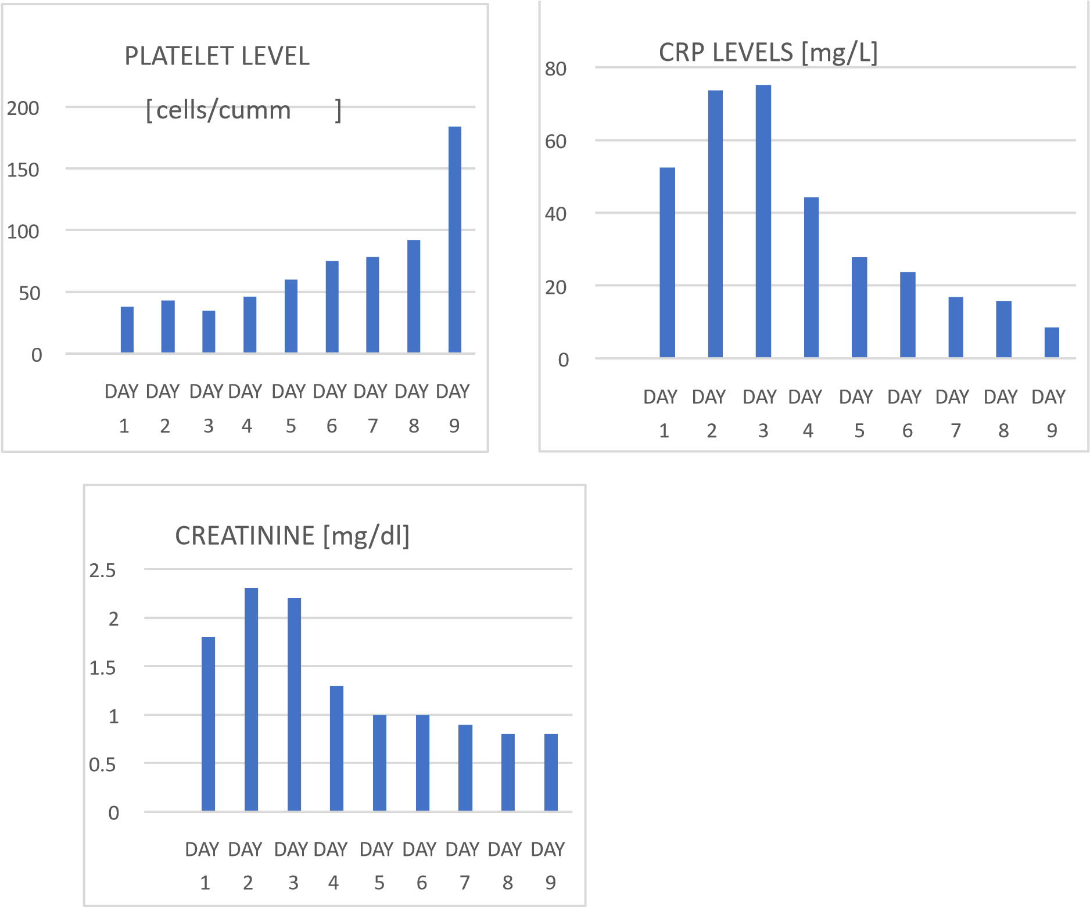
Fig 1- Trends in platelet count, C-reactive protein (CRP), and serum creatinine levels during the course of hospitalization

On the third day, there was deterioration in the patient’s respiratory status with decreased urine output. Thus, bi-level positive airway pressure (BiPAP) non-invasive ventilation was administered to the patient. Platelet level was 46000 cells/cumm.
However, there was no improvement in the breathing status. Hence, the patient was intubated and was put on a ventilator, and even his creatinine level spiked to 2.8 mg/dl. In the meantime, scrub typhus antibody clinical data were positive. However, dengue and malaria markers were negative. At this junction INJ. DOXYCYCLINE was added to the treatment regimen, and TAB AZITHROMYCIN 500 mg and TAB RIFAXIMIN
550 mg were started and continued for 5 days. Over the course of treatment, the patient’s hemodynamic status improved with normalisation of blood pressure and improvement in oxygenation and sensorium. Following the clinical improvement, he was successfully extubated and subsequently maintained on face mask oxygen. The patient's platelet level improved to 109000 10⁹/L, and the CRP level decreased to 44.2 mg/L. The patient continued to have intermittent episodes of pulmonary oedema and atrial fibrillation, which were managed conservatively with appropriate pharmacological treatment and supportive measures. With continued improvement in vital parameters and overall clinical status, the patient was shifted from the ICU to the ward. The patient was still receiving supportive care and IV antibiotics. There was progressive improvement in organ function, and the CRP level decreased to 8.5 mg/L. The acute kidney injury completely resolved. Liver function showed a recovering trend, with bilirubin and liver enzymes showing a downward trend. The clinical features of sepsis resolved, with stabilisation and normalisation of blood pressure. Hyperglycemia was managed, and the patient was initiated on oral antidiabetic medication. At the time of discharge, the patient was clinically improved, hemodynamically stable, with an improving sensorium, and recovered renal and hepatic functions. The patient was discharged with oral antibiotic medications and cardiac medications.

Discussion
Scrub typhus is one of the confirmed aetiologies of acute febrile illness [8, 9]. Multiple organ failure is seen in around one-third of scrub typhus patients that are admitted [10]. Hepatitis, thrombocytopenia, myocarditis with significant left ventricular dysfunction, and renal failure were all present in our patient. Scrub typhus-related multi-organ dysfunction has a significant death rate. Clinicians find it difficult to diagnose scrub typhus, and the rate of incorrect diagnoses rises as more organs are impacted. Clinicians' ignorance of the intricacy of scrub typhus's clinical presentations is one of the primary causes of misdiagnosis [11, 12]. One of the most crucial clinical signs for the diagnosis of scrub typhus is eschar [13]. Eschar, fever, and MODS were the primary clinical symptoms used to diagnose this illness, and doxycycline treatment proved to be successful. Scrub typhus severity and prognosis are determined by a few risk factors. A growing body of research has shown a strong correlation between the infecting genotype and the prevalence of eschars and rash in scrub typhus [14]. Scrub typhus can result in MODS and thrombocytopenia. The mechanism of thrombocytopenia linked to MODS has been shown in earlier research to be thrombotic microangiopathic syndrome [15,16]. A series of pathological changes such as thrombotic thrombocytopenic purpura (TTP), secondary thrombotic microangiopathy (TMA), and DIC may occur [15]. However, to the best of our knowledge, only one case of scrub typhus with thrombocytopenia and MODS has been reported thus far [17]. The early use of antibiotics is very important to avoid life-threatening scrub typhus, and a range of efficacious antibiotics are usually available for clinicians. In this regard, the effective antibiotics against scrub typhus are doxycycline, chloramphenicol, tetracycline, and azithromycin. Additionally, azithromycin may have the same effect yet be more acceptable than doxycycline [18]. However, because of the low-certainty data and the possibility of developing resistance in undetected tuberculosis, randomized controlled studies recommended against using rifampicin as a first-line therapy option [19]. There is a wealth of literature summarizing the symptoms of scrub typhus's secondary multiple organ involvement, as previously mentioned. It typically manifests as an acute febrile sickness with a high fever, headache, cough, and malaise. The presence of an eschar at the mite bite site is the most distinctive clinical sign of scrub typhus. This instance emphasizes even more how crucial intensive care is when dealing with a tropical infection, which can have a positive outcome. Scrub typhus with thrombocytopenia and MODS advanced quickly in this particular instance. Our skilled physicians made a diagnosis based on laboratory results and medical history information. This patient healed quickly and the anticipated therapeutic outcome was realized because of prompt therapy.

Conclusion
Scrub typhus is a serious infectious disease that can progress quickly and lead to complications such as thrombocytopenia and multiple organ dysfunction syndrome (MODS). This case highlights how severe scrub typhus can affect several organs, including the kidneys, liver, lungs, brain, and heart, making early diagnosis and management challenging. The patient developed significant thrombocytopenia, acute kidney injury, liver dysfunction, encephalopathy, respiratory complications, and cardiac involvement during the illness.
The positive scrub typhus test, along with the patient's clinical findings, helped confirm the diagnosis and allowed doxycycline-based treatment to be started promptly. Along with antimicrobial therapy, careful supportive management, including respiratory support, fluid and cardiovascular management, and regular monitoring of organ functions, played an important role in the patient's recovery. Gradually the patient's oxygenation, mental status, kidney and liver functions, and hemodynamic condition improved, allowing for discharge in a clinically stable condition. This case highlights the importance of early diagnosis, timely antimicrobial treatment, continuous monitoring, and appropriate supportive care in patients with severe scrub typhus. Maintaining a high level of suspicion in patients with unexplained fever, thrombocytopenia, and rapidly developing organ dysfunction can help ensure early treatment and improve clinical outcomes.

Declaration of AI Use

This manuscript was prepared through the intellectual contributions of the author(s) to the study design, data analysis, interpretation of results, and scholarly content. Grammarly and ChatGPT were used solely to assist with grammatical refinement and reference formatting during manuscript revision. The author(s) accept full responsibility for the accuracy, integrity, and final content of the manuscript.

COMPETING INTERESTS DISCLAIMER:
Authors have declared that they have no known competing financial interests OR non-financial interests OR personal relationships that could have appeared to influence the work reported in this paper.

Reference
- Lee BJ, Chen CY, Hu SY, et al. Otalgia and eschar in the external auditory canal in scrub typhus complicated by acute respiratory distress syndrome and multiple organ failure. BMC Infect Dis. 2011;11:79.
- McCrumb FR, Stockard JL, Robinson CR, et al. Leptospirosis in Malaya. I. Sporadic cases among military and civilian personnel. Am J Trop Med Hyg. 1957;6:238-56.
- Carcillo JA, Podd B, Aneja R, et al. Pathophysiology of pediatric multiple organ dysfunction syndrome. Pediatr Crit Care Med. 2017;18(3 Suppl 1):S32-45. doi:10.1097/PCC.0000000000001052.
- Saugel B, Phillip V, Moessmer G, et al. Argatroban therapy for heparin-induced thrombocytopenia in ICU patients with multiple organ dysfunction syndrome: a retrospective study. Crit Care. 2010;14:R90.
- Rajapakse S, Rodrigo C, Fernando D. Scrub typhus: pathophysiology, clinical manifestations and prognosis. Asian Pac J Trop Med. 2012;5:261-4. doi:10.1016/S19957645(12)60036-4.
- Lu CT, Wang LS, Hsueh PR. Scrub typhus and antibiotic-resistant Orientia tsutsugamushi. Expert Rev Anti Infect Ther. 2021;19:1519-27. doi:10.1080/14787210.2021.1941869.
- Rajapakse S, Weeratunga P, Sivayoganathan S, et al. Clinical manifestations of scrub typhus. Trans R Soc Trop Med Hyg. 2017;111:43-54.
- Ittyachen AM, Ramachandran R. Study of acute febrile illness: a 10-year descriptive study and a proposed algorithm from a tertiary care referral hospital in rural Kerala in southern India. Trop Doct. 2015;45:114-7. doi:10.1177/0049475514566264.
- Acestor N, Cooksey R, Newton PN, et al. Mapping the aetiology of non-malarial febrile illness in Southeast Asia through a systematic review—terra incognita impairing treatment policies. PLoS One. 2012;7:e44269. doi:10.1371/journal.pone.0044269.
- Mahajan SK. Scrub typhus. J Assoc Physicians India. 2005;53:954-8.
- Jamil MD, Hussain M, Lyngdoh M, et al. Scrub typhus meningoencephalitis, a diagnostic challenge for clinicians: a hospital based study from North-East India. J Neurosci Rural Pract. 2015;6:488-93. doi:10.4103/0976-3147.169769.
- Sharma SR, Masaraf H, Lynrah KG, et al. Tsutsugamushi disease (scrub typhus) meningoencephalitis in north eastern India: a prospective study. Ann Med Health Sci Res. 2015;5:163-7.
- Arun Babu T, Vijayadevagaran V, Ananthakrishnan S. Characteristics of pediatric scrub typhus eschar in South Indian children. Pediatr Dermatol. 2017;34:124-7. doi:10.1111/pde.13048.
- Blacksell SD, Bryant NJ, Paris DH, et al. Scrub typhus serologic testing with the indirect immunofluorescence method as a diagnostic gold standard: a lack of consensus leads to a lot of confusion. Clin Infect Dis. 2007;44:391-401.
- Nguyen TC, Carcillo JA. Bench-to-bedside review: thrombocytopenia-associated multiple organ failure—a newly appreciated syndrome in the critically ill. Crit Care. 2006;10:235.
- Nguyen TC, Cruz MA, Carcillo JA. Thrombocytopenia-associated multiple organ failure and acute kidney injury. Crit Care Clin. 2015;31:661-74.
- Ittyachen AM, Abraham SP, Krishnamoorthy S, et al. Immune thrombocytopenia with multi-organ dysfunction syndrome as a rare presentation of scrub typhus: a case report. BMC Res Notes. 2017;10:496.
- Wee I, Lo A, Rodrigo C. Drug treatment of scrub typhus: a systematic review and metaanalysis of controlled clinical trials. Trans R Soc Trop Med Hyg. 2017;111:336-44.
- El Sayed I, Liu Q, Wee I, Hine P. Antibiotics for treating scrub typhus. Cochrane Database Syst Rev. 2018;9:CD002150. doi:10.1002/14651858.CD002150.pub2.

