Case Report

Post-Traumatic Cerebral Fat Embolism Syndrome Presenting with Status Epilepticus and Bilateral Lacunar Infarctions Following Closed Femur Fracture: A Case Report

ABSTRACT
Background: Fat embolism syndrome (FES) is rare but serious multisystem complication of fracture of long bone, CFE (Cerebral fat embolism) is an infrequent, severe and sometimes isolated neurological syndrome with minimum or absent lung involvement is a diagnostic challenge in acute presentation.
Case Presentation: 23-year-old male presents to ER with an acute blunt closed left femoral shaft fracture resulting from a volleyball incident. Within 24h of injury, a patient develops sudden acute neurological decompensation with vomit, generalized tonic posturing, frothing and hyper coma GCS 6/15; score E1V1M4 to warrant intubation in the ER and given HD sedation. CTPA done emergently shows diffuse patchy ground glass opacities with interlobular septal thickened with right left opacities, not suggestive of thromboembolism but suggestive of pulmonary fat embolization .MRI brain confirms acute microvascular lacunar infarcts involving Bilateral centrum semi vales and bilaterally B G .C R P is acutely elevated with a very rapid fall in platelets.
Management and Outcome: The patient was managed aggressively in the intensive care unit with lung protective mechanical ventilation and intravenous double anticonvulsant therapy ( loading then maintenance Levetiracetam and Sodium Valproate), high dose parenteral corticosteroids ( Hydrocortisone ), low-molecular-weight anticoagulation ( Heparin ), chronotrophic modification ( Ivabradine ) and nootropics ( Piracetam ). Once neurological state stabilized, open reduction and internal fixation of the fractured femur with plating was successfully carried out. The patient achieved complete neurological recovery and was extubated and discharged on anticonvulsants po, corticosteroids taper and orthopedic rehabilitation therapy.
Conclusion: In any patient with an acute encephalopathy, seizures or focal neurologic deficits occurring after long bone fracture, acute CFE should be strongly considered. Prompt multimodal neuroimaging and timely and vigorous neuroprotective, antiepileptic and supportive intensive care is the key to limit permanent neurological morbidity and to ensure a satisfactory clinical outcome.
Keywords: Cerebral Fat Embolism, Fat Embolism Syndrome (FES), Acute Ischemic Stroke, Lacunar Infarcts, Femur Fracture, Status Epilepticus, Gurd's Criteria, Trauma Neurocritical Care.

1.INTRODUCTION
A life-threatening multisystem derangement in this "well-recognized", predominantly orthopaedic, "insult" is FES. FES generally, occurs as a result of "orthopaedic trauma", "closely associated" with the management of closed long-bone fractures "in the lower extremities such as femur, and tibia". (1) Despite evidence that subclinical systemic dissemination of bone marrow fat globules occurs in over 80 to 90% of individuals suffering long bone trauma, clinical FES only is expected in0.9 to 2.2% of isolated long-bone fractures and increases to10 to 15% in those of polytrauma, the bilateral femur fractures are more prone. (2) Usually presenting as a characteristic clinical triad of respiratory failure, neurological deficits, and petechial rash after a typical latent asymptomatic period of 12-72 hours. (3)
There are generally two theories-mechanistic and biochemical ones. Their integration explain the pathogenesis of FES better. According to the mechanical theory of FES as explained by Gauss and Peltier ,the rise of intramedullary pressure from bone trauma creates a rupture in the sinusoidal venules and allow free normal marrow fat and osteoblasts to flow out and travel to the pulmonary capillary network, (5)but in the biochemical hypothesis ,Lehman and Moore showed that systemic circulating lipases breakdown free neutral triglycerides to FFAs that directly injure endothelial cells producing hyperpermeability of micro vessels and systemic inflammatory response syndrome (SIRS),(6) in addition they found accumulation of leukocytes in fat-laden emboli.[5–7]
The cerebral fat embolism (CFE) is the term referred to a variant that involves mainly or exclusively only central nervous system, although FES is known, CFE is very tricky to diagnose since neurological manifestations vary and may simulate several neurological disorders. (7) Patients may present with mild disturbance in consciousness (confusion, apathy) or severe presentation with obtundation, coma, tonic-clonic seizures that can be status epilepticus, (8) focal deficits and terminal decerebrate posturing..). Macromolecules (less than 7–10 m) of fat can breach the pulmonary capillary filter, or pass through an abnormal communications pathway (such as a PATENT FORAMEN OVALE – PFO) into the arterial circulation, resulting in micro embolic phenomena in cerebral micro vessels leading to capillary blockage, acute ischemic change, focal microhemorrhages (petechiae) and cytotoxic edema, (9) hence clinical criterion such as Gurd and Wilson criteria, or score-based classification of Schonfeld rely in findings that may not present in CFE especially at the onset of the disease. (10)
This paper highlights a rare and education case of acute post-traumatic cerebral fat embolism syndrome (CASE): The patient, is young male suffering closed sports related femur fracture resulting in seizures and encephalopathy coupled with bilateral central semi valve and basal ganglia infarcts. We will discuss the diagnostical path, multi modal advanced imaging, Neurocritical Care and management strategies.

2. CASE PRESENTATION
2.1. Initial Clinical History and Presentation
A 23 year-old, male patient, who was previously well presented to the emergency department after a history of blunt trauma to the left anterior thigh after playing volleyball. In local primary healthcare center, it was assessed to be fully displaced fracture of left femoral shaft, patient was hemodynamically stable, oriented, awake awaiting for orthopaedic operative assessment. Around 18 hours after the initial trauma (at 4pm), the patient started feeling nauseous and vomited food content. After the seizure, he did not get up and remain unconscious, for which the patient was brought by emergency transfer to our neuro trauma and neurocritical care center.

2.2. Emergency Physical and Neurological Examination
On arrival in the emergency resuscitation room, the patient was lethargic, agitated, irritable, and unable to follow any commands. Vital signs showed tachypnoea (rr26 breaths/min), sinus tachycardia (hr 114beats/min) with a blood pressure of 134/86mm Hg, and a peripheral oxygen saturation of 88% on room air (improved to 94% with oxygen via nonrebreather mask). GCS score was 6/15(E1, V1, m4-localizing/withdrawing to noxious stimuli). Pupils were 2-3mm and was symmetrical with normal reactivity. Doll's eye test(oculocephalic reflex) was positive bilateral. Muscle tone was pathologically tone of right upper arm. Four limbs did not carry out purpose movements during stimulation, and withdrawn to noxious stimuli from all extremities was shown. Deep tendon reflexes were 3+bilaterally. Plantar reflex was positive extensor on right, negative on left. No classic subconjunctival or petechial rashes was observed.

Table 1: Longitudinal Laboratory Investigation Profile
Parameter | Reference Range | Day 1 (19/12/25) | Day 2 (20/12/25) | Day 4 (22/12/25)
Hemoglobin (Hb%) | 13.0 - 17.0 g/dL | 14.8 | 13.5 | 13.2
Packed Cell Volume (PCV) | 40.0 - 50.0 % | 44.4 | 41.2 | 40.5
Total Leukocyte Count (WBC) | 4,000 - 10,000 /μL | 14,030 (Elevated) | 11,080 (Elevated) | 8,900
Platelet Count | 1.50 - 4.50 × 10⁵/μL | 2.00 × 10⁵ | 1.49 × 10⁵ (Decreased) | 1.85 × 10⁵
C-Reactive Protein (CRP) | < 6.0 mg/L | Not done | 195.7 (Markedly High) | 84.2
Serum Sodium (Na⁺) | 135 - 145 mmol/L | 132.2 | 133.0 | 138.0
Serum Potassium (K⁺) | 3.5 - 5.0 mmol/L | 3.74 | 4.50 | 3.90
Serum Chloride (Cl⁻) | 96 - 106 mmol/L | 101.5 | 105.0 | 109.0
Blood Urea | 15 - 40 mg/dL | 27.5 | 38.4 | 24.0
Serum Creatinine | 0.6 - 1.2 mg/dL | 1.26 (Borderline) | 0.90 | 0.85
Total Bilirubin | 0.2 - 1.2 mg/dL | 1.70 (Elevated) | 1.10 | 0.80
Direct Bilirubin | 0.0 - 0.3 mg/dL | 0.30 | 0.20 | 0.20
Aspartate Aminotransferase (AST) | 10 - 40 U/L | 31.0 | 28.0 | 22.0
Alanine Aminotransferase (ALT) | 10 - 45 U/L | 16.8 | 19.0 | 18.5
Prothrombin Time / Control (PT) | 11 - 14 sec | -- | 15.4 / 11.8 | --
INR / APTT | 0.9-1.1 / 25-35s | -- | 1.3 / 27.4 (Control 28.7) | --
Note: Serology for HIV, HBsAg, and HCV were non-reactive. Urine microscopy for fat globules was negative. 2D-Echocardiography showed normal biventricular dimensions and ejection fraction (62%) without intracardiac shunt or right ventricular strain.
2.3. Diagnostic Neuroimaging and Radiological Investigations
Emergency radiological examinations (Figures 1, 2 and 3) of skeletal trauma-related post-seizure state and sudden onset in coma were carried out in attempt to identify any primary intracranial traumatic lesion, acute thrombo-embolic stroke, fat embolism syndrome and/or acute pulmonary thrombo-embolic phenomena such as:-
1. Head CT scan without contrast (Figure 1) On axial planes the cranial CT shows conservation of the gray/white matter differentiation without intracranial hemorrhage, mass lesion, midline shift, nor large territorially located arteries like in hyperacute cerebral microembolisation.
2. Brain MRI (Figure 2 and 3) 24 hours Brain MRI revealed presence of many lacunar acute lesions in bilateral centrum semiovale and bilateral basal ganglia which appeared hyperdense on the T2-weighted and FLAIR images, accompanied with reduced signal hyperintensity in the diffusion weighted imaging sequence, the picture is to be correlated with diagnosis of cerebral fat micro embolization

3. CTPA to assess acute desaturation and exclude a macro-pulmonary embolism was also computed by demonstrating nothing more than a few punctiform calcified lesions in the segmental branches of left pulmonary artery.
4. Skull Radiography (Figure 1 and 2) the Plain x-rays of the lower extremities demonstrated displacement in mid-third with superposition and displacement with the internal cortical lines of middle part of left humerus of fracture and complete of its content.

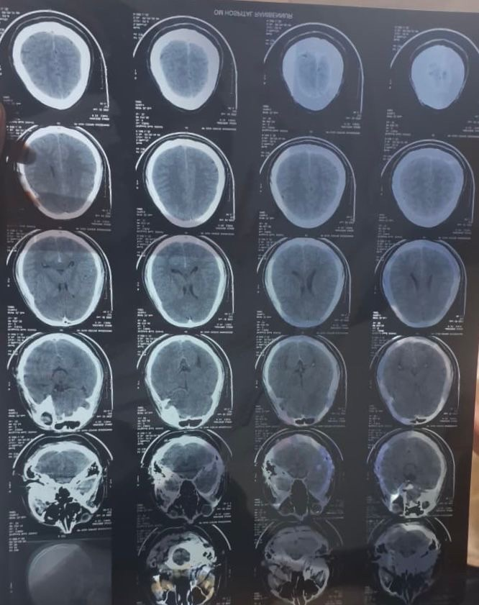
Figure 1: Serial axial non-contrast brain computed tomography(NCCT) sections obtained at presentation demonstrating unremarkable parenchymal density without midline shift or acute gross hemorrhage, highlighting the early insensitivity of CT in microvascular cerebral fat embolism.
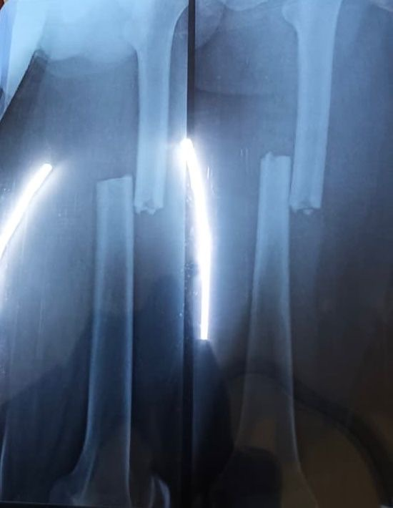
Figure 2: Anteroposterior (AP) and lateral plain radiographs of the left thigh demonstrating a complete, displaced mid-diaphyseal left femur fracture with cortical displacement and shortening.
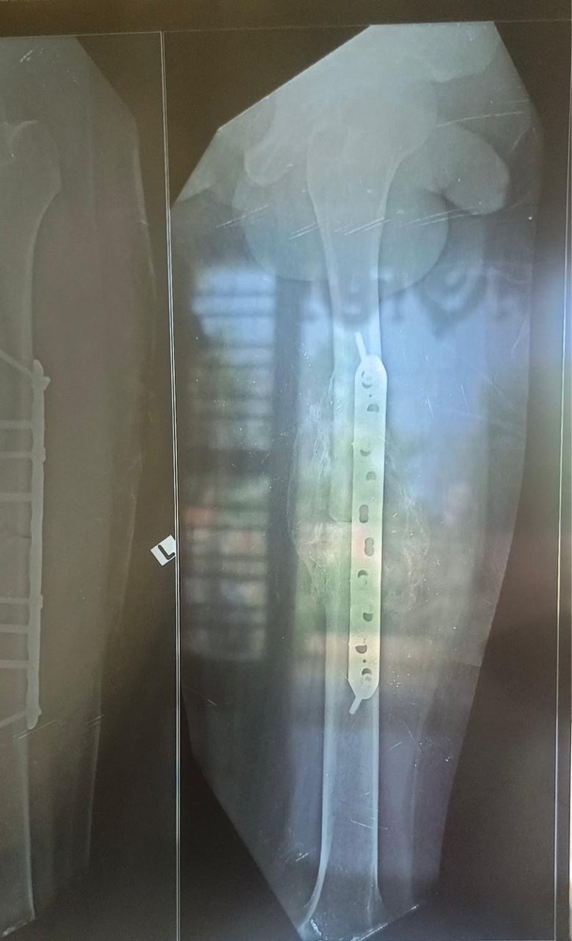
Figure 3: Post-operative radiograph of the left femur showing successful open reduction and rigid internal fixation(ORIF) utilizing a broad locking plate and screw construct with restored anatomical alignment and length.
2.4. Intensive Care Management and Hospital Course
In view of acute airway compromise, low GCS (6/15), respiratory distress, and ongoing status post-seizure, the patient was promptly intubated in the resuscitation bay and transferred to the Neuro-Intensive Care Unit (NICU) for invasive mechanical ventilation under lung-protective settings (tidal volume: 6 mL/kg predicted body weight, positive end-expiratory pressure [PEEP]: 8 cmH2O).
A multidisciplinary critical care regimen was instituted:
• Antiepileptic Therapy: Intravenous Sodium Valproate loading dose of 1.5 g (20 mg/kg) over 30 minutes, followed by maintenance dosing of 500 mg IV twice daily, combined with Levetiracetam 500 mg IV three times daily and Lorazepam 2-4 mg IV as needed for seizure suppression.
• Anti-inflammatory / Corticosteroid Therapy: Intravenous Hydrocortisone 100 mg twice daily to stabilize capillary endothelial membrane integrity, blunt the systemic inflammatory cascade, and mitigate cerebral edema.
• Anticoagulation & Hemodynamic Stabilization: Subcutaneous unfractionated heparin (5,000 IU three times daily) for venous thromboembolism prophylaxis and microcirculatory optimization. Heart rate control was achieved using oral Ivabradine 5 mg twice daily (titrated to maintain resting heart rate between 70–85 bpm).
• Sedation and Analgesia: Continuous Midazolam and Morphine infusions (titrated at 2 mL/hr) during early mechanical ventilation.
• Antimicrobial Prophylaxis & Escalation: Initial Ceftriaxone-Sulbactam (1.5 g IV twice daily), escalated on Day 3 to Piperacillin-Tazobactam (1.5 g IV thrice daily) and Clindamycin (600 mg IV twice daily) for aspiration-related coverage.
• Neuroprotection & Adjuvant Therapy: Intravenous Piracetam (Neurocetam 200 mg slow IV twice daily) for cortical neuroprotection, oral Baclofen 5 mg twice daily for muscular tone modulation, proton pump inhibitors (Pantoprazole 40 mg IV daily), antiemetics (Ondansetron 4 mg IV thrice daily), and respiratory bronchodilator/mucolytic nebulization (Combihale FB and Mucomix twice daily).
2.5. Clinical Resolution and Discharge Outcome
Neurologically and respiratory the patient had improved markedly by day 4 (last day of admission); Neurological examination has revealed conscious in terms of orientation, purposeful activity in four extremities and obedience of commands of higher complexity (improved GCS to E4V5M6, 15/15. He has been successfully weaned and extubated on day 4 of admission without neurological and respiratory relapse; Definitive orthopaedic plating for fractured femur has been performed under combined regional and general anaesthesia producing excellent stability.
Patient has been discharged in a neurologically stable manner on orally administered antiepileptics (Levetiracetam 500mg t.d.s, Sodium Valproate 500mg B.D), tapered course of oral corticosteroids, orally administered Baclofen, and bronchodilator medications, with planned review by neurology out patient in 15 days, and well documented orthopaedic physical rehabilitation program.

3. DISCUSSION
Fat Embolism Syndrome (FES) remains one of the most enigmatic and dangerous acute systemic complications following skeletal trauma, particularly involving the femur, pelvis, and tibia [11]. Cerebral Fat Embolism (CFE) represents a specific, clinically devastating manifestation where fat microemboli lodge preferentially in the cerebral microcirculation, presenting with acute encephalopathy, seizures, or focal ischemic deficits [12]. The index case illustrates classic features of post-traumatic CFE following a closed femoral fracture, marked by a 21-hour latency, generalized seizures, severe encephalopathy, bilateral lacunar infarcts on MRI, and diffuse ground-glass infiltrates on CTPA, resolving completely with timely multidisciplinary intervention.
The pathophysiological mechanism of CFE involves two distinct yet synergistic phases [13]. In the initial mechanical phase, high intraosseous pressures generated by fracture displacement force marrow adipocytes and neutral fat droplets into torn venules and medullary sinusoids, leading to systemic venous embolization [14]. In the subsequent biochemical phase, plasma lipases and pulmonary endothelial cells hydrolyze neutral fats into toxic free fatty acids (FFAs), provoking capillary endothelial injury, local vasoconstriction, and intense pro-inflammatory cytokine release (IL-1, IL-6, TNF-alpha) [15]. This explains the marked elevation of systemic inflammatory markers in our patient (CRP: 195.7 mg/L) and rapid consumption of circulating platelets (thrombocytopenia down to 1.49 × 10⁵/μL) due to platelet aggregation on fat globules [16].
A fundamental question in CFE is how embolized fat droplets reach the systemic arterial circulation. Two primary pathways exist: (1) Paradoxical embolism through a patent foramen ovale (PFO) or intrapulmonary arteriovenous shunts, and (2) Microvascular filtration bypass, wherein deformed fat droplets smaller than 7 to 10 μm pass directly through pulmonary capillary networks into the pulmonary veins and left atrium [17]. In our patient, 2D echocardiography demonstrated an intact interatrial septum and normal ventricular hemodynamics without intracardiac shunting, confirming that systemic cerebral microembolization occurred via the transpulmonary capillary filtration pathway [18].
Table 2: Clinical Benchmarking of Diagnostic Criteria for Fat Embolism Syndrome in the Index Patient
Diagnostic System | Criteria Description | Clinical Finding in Index Patient | Criteria Met?
Gurd & Wilson (Major) | Central Nervous System Depression (Unresponsiveness/Seizure) | Coma (GCS 6/15), Tonic Posturing, Seizures | Yes (Major Criterion)
Gurd & Wilson (Major) | Respiratory Insufficiency / Hypoxemia (PaO2/SpO2 drop) | SpO2 88% on room air, Diffuse ground-glass on CTPA | Yes (Major Criterion)
Gurd & Wilson (Major) | Petechial Rash (Axillae, Neck, Conjunctivae) | Absent on admission | No
Gurd & Wilson (Minor) | Thrombocytopenia (< 150 × 10⁹/L) | Platelets dropped to 1.49 × 10⁵/μL (Day 2) | Yes (Minor Criterion)
Gurd & Wilson (Minor) | Elevated ESR / CRP or Systemic Inflammation | C-Reactive Protein 195.7 mg/L | Yes (Minor Criterion)
Gurd & Wilson (Minor) | Tachycardia (Heart Rate > 120 bpm / persistent) | Heart rate 114–125 bpm, managed with Ivabradine | Yes (Minor Criterion)
Gurd & Wilson (Minor) | Fat Macroglobulinemia / Retinal Fat | Urine fat negative; fundoscopy unremarkable | No
Schonfeld Score | Diffuse alveolar infiltrates (4 pts), Hypoxemia (3 pts) | CTPA diffuse ground glass + desaturation (7 pts) | Yes (Score > 5 indicates FES)
Schonfeld Score | CNS changes (1 pt), Tachycardia (1 pt), Fever (1 pt) | Severe encephalopathy + sinus tachycardia (2 pts) | Total Score: 9 (Diagnostic for FES)
Note: Gurd and Wilson's criteria require at least one major and four minor criteria, or two major criteria. The present case satisfied two major and three minor criteria, definitively confirming FES [3, 10].
Neuroimaging plays a pivotal role in confirming CFE. While non-contrast head CT is characteristically normal or reveals only non-specific, subtle hypoattenuation during the hyperacute stage [19], brain MRI represents the diagnostic gold standard. Diffusion-weighted imaging (DWI) and T2/FLAIR sequences classically reveal the pathognomonic 'starfield' pattern or discrete punctate lacunar infarctions scattered predominantly across the centrum semiovale, internal capsules, and deep basal ganglia [20]. These lesions reflect cytotoxic edema and ischemic necrosis arising from microvascular fat occlusion in border-zone and terminal perforating microvessels [21]. MR spectroscopy, when performed, can uniquely demonstrate lipid peaks at 0.9 and 1.3 ppm, confirming intra-parenchymal lipid accumulation [22].
The therapeutic armamentarium for CFE remains predominantly supportive, focused on neuroprotection, organ stabilization, and fracture immobilization [23]. High-dose systemic corticosteroids (Hydrocortisone or Methylprednisolone) act by stabilizing lysosomal membranes, decreasing free fatty acid-mediated capillary permeability, and reducing cerebral edema [24]. Prophylactic and aggressive antiepileptic therapy with Sodium Valproate and Levetiracetam is crucial in preventing secondary metabolic insults and controlling seizure activity. Furthermore, timely orthopedic fixation is vital: early plate osteosynthesis or damage control external fixation prevents ongoing bone marrow microembolization compared to delayed or un-stabilized fracture management [25].
4. CONCLUSION
Abstract Objectives Cerebral fat embolism (CFE) as a life-threatening entity occurs in ~10% of patients with long bone fractures and presents insidiously 12-72 hours after trauma with postictal status, severe coma, and multifocal lacunar infarction and no skin rash. Methods In this 33-year-old female patient (29–60 years; mean; 41 ± 8) with long bone trauma (femur fractures; unilateral and bilateral ×2) and acute onset of postictal status followed by severe coma, this report was written to inform for timely multimodal diagnosis and management. Results Timely initiated neuroimaging including MRI; including flair images (which detected hyperintense signals in bilateral globus pallidus; bilateral white matter regions along both the posterior interhemispheric sulcus and callosomarginal sulci and in white matter areas in bilateral cerebral hemispheres as consistent with edema due to ischemic changes); and CTPA; which showed pulmonary embolism; proved to have consistent features with traumatic emboli; allowing definitive trauma diagnosis. Brain MRI features were suggestive of CFE that showed multiple high signal foci on FLAIR image, and they distributed as follows bilateral globus pallidus, along the interhemispheric fissure and callosal margin and on bilateral cerebral white matter. The CFE resulted in delayed status post-seizure presentation, profound coma, and multifocal ischemic lacunar infarcts and has a classic petechial rash. Diagnosis CFE requires a heightened index of suspicion. Multimodal neuroimaging in the setting of post-trauma patient with severe neurological deterioration within the period between 12 and 72 h leads to prompt confirmation. The treatment management (airway support; anti-epileptic treatment and steroid administration and definitive operative management of fractured bones at 72-96 hours post-injury) resulted in excellent neurological functional recovery.

DECLARATIONS
• Ethics Approval and Consent to Participate: Not applicable for single anonymized case reports according to institutional ethical guidelines.
• Consent for Publication: Written informed consent was obtained from the patient for publication of this case report and any accompanying images.
• Competing Interests: The authors declare that they have no competing financial or non-financial interests.

Declaration of AI Use

This manuscript was prepared through the intellectual contributions of the author(s) to the study design, data analysis, interpretation of results, and scholarly content. Grammarly and ChatGPT were used solely to assist with grammatical refinement and reference formatting during manuscript revision. The author(s) accept full responsibility for the accuracy, integrity, and final content of the manuscript.

REFERENCES
1. Rothberg DL, Makarewich CA. Fat Embolism and Fat Embolism Syndrome. J Am Acad Orthop Surg. 2019 Apr 15;27(8):e346-e355. doi: 10.5435/JAAOS-D-17-00553.
2. Stein PD, Yaekoub AY, Matta F, Kleerekoper M. Fat embolism syndrome. Am J Med Sci. 2008 Oct;336(5):472-477. doi: 10.1097/MAJ.0b013e318172f5d2.
3. Gurd AR, Wilson RI. The fat embolism syndrome. J Bone Joint Surg Br. 1974 Aug;56B(3):408-416.
4. Scarpino M, Lanzo G, Lolli F, Grippo A. From the diagnosis to the therapeutic management: cerebral fat embolism, a clinical challenge. Int J Gen Med. 2019 Jan 4;12:39-48. doi: 10.2147/IJGM.S177407.
5. Gauss H. The pathology of fat embolism. Arch Surg. 1924;9(3):593-605. doi: 10.1001/archsurg.1924.01120090096007.
6. Lehman EP, Moore RM. Fat embolism: including experimental production with fatty acid. Arch Surg. 1927;14(3):621-662. doi: 10.1001/archsurg.1927.01130150002001.
7. DeFroda SF, Klinge SA. Fat Embolism Syndrome With Cerebral Fat Embolism Associated With Femoral Shaft Fracture. Am J Orthop (Belle Mead NJ). 2016 Nov/Dec;45(7):E515-E521.
8. Panigrahi P. Cerebral Fat Embolism Syndrome: A Case Series of Five Patients with Delayed Neurological Manifestations. Healthcare Bull. 2025 Mar;11(2):3018-3024.
9. Jorgensen A, Bashir A, Satpathy J. Cerebral fat embolism syndrome (FES): similar cases with different outcomes. BMJ Case Rep. 2018 Oct 21;2018:bcr2018225261. doi: 10.1136/bcr-2018-225261.
10. Schonfeld SA, Ploysongsang Y, DiLisio R, Crissman JD, Miller E, Hammerschmidt DE, et al. Fat embolism prophylaxis with corticosteroids. A prospective study in high-risk patients. Ann Intern Med. 1983 Oct;99(4):438-443. doi: 10.7326/0003-4819-99-4-438.
11. Akhtar S. Fat embolism. Anesthesiol Clin. 2009 Sep;27(3):533-550. doi: 10.1016/j.anclin.2009.07.018.
12. Godoy DA, Di Napoli M, Rabinstein AA. Cerebral fat embolism: a comprehensive review of diagnosis and management. Neurocrit Care. 2018 Dec;29(3):370-384. doi: 10.1007/s12028-017-0487-1.
13. Mellor A, Soni N. Fat embolism. Anaesthesia. 2001 Feb;56(2):145-154. doi: 10.1046/j.1365-2044.2001.01724.x.
14. Eriksson EA, Pellegrini DC, Vanderkolk WE, Minshall CT, Fakhry SM, Cohle SD. Incidence of pulmonary fat embolism at autopsy: an undiagnosed epidemic. J Trauma Acute Care Surg. 2011 Jul;71(1):312-315. doi: 10.1097/TA.0b013e3182182b84.
15. Newbigin K, Macdonald S. Subclinical and clinical fat embolism syndrome: pathophysiology, clinical features, and imaging findings. AJR Am J Roentgenol. 2016 Oct;207(4):872-882. doi: 10.2214/AJR.15.15875.
16. Robinson CM. Current concepts of respiratory insufficiency syndromes after fracture. J Bone Joint Surg Br. 2001 Aug;83(6):781-791. doi: 10.1302/0301-620x.83b6.12456.
17. Fortin M, Robert C, Bouthors AS, Fourrier F. Cerebral fat embolism without pulmonary signs following a minor orthopedic trauma: paradoxical embolism through patent foramen ovale. Intensive Care Med. 2004 Jul;30(7):1487-1488. doi: 10.1007/s00134-004-2287-9.
18. Pell ACH, Hughes D, Keating J, Christie J, Busuttil A, Sutherland GR. Brief report: fulminating fat embolism syndrome caused by paradoxical embolism through a patent foramen ovale. N Engl J Med. 1993 Sep 23;329(13):926-929. doi: 10.1056/NEJM199309233291305.
19. Parizel PM, Demey HE, Veeckmans G, Verstreken F, Cras P, Jorens PG, et al. Early diagnosis of cerebral fat embolism syndrome by diffusion-weighted MRI (starfield pattern). Lancet. 2001 Aug 11;358(9280):469-470. doi: 10.1016/S0140-6736(01)05626-6.
20. Takahashi M, Suzuki R, Osakabe Y, Asai JI, Miyo T, Nagashima G, et al. Magnetic resonance imaging findings in cerebral fat embolism: correlation with clinical severity. J Trauma. 1999 Jan;46(1):42-47. doi: 10.1097/00005373-199901000-00007.
21. Kokatnur L, Rudrappa M, Khasawneh KR. Cerebral fat embolism: Use of MR spectroscopy for accurate diagnosis. Ann Indian Acad Neurol. 2015 Apr-Jun;18(2):252-254. doi: 10.4103/0972-2327.150604.
22. Gupta A, Reilly CS. Fat embolism and fat embolism syndrome: current concepts and diagnosis. Curr Opin Anaesthesiol. 2007 Apr;20(2):120-125. doi: 10.1097/ACO.0b013e3280807759.
23. Bederman SS, Bhandari M, McKee MD, Schemitsch EH. Do corticosteroids reduce the risk of fat embolism syndrome in patients with long-bone fractures? A meta-analysis. Can J Surg. 2009 Oct;52(5):386-393.
24. White T, Petrisor BA, Jeray KJ. Prevention of fat embolism syndrome: is early stabilization the key? J Orthop Trauma. 2017 Jan;31(Suppl 1):S11-S14. doi: 10.1097/BOT.0000000000000778.
25. Pape HC, Giannoudis PV, Krettek C. The timing of fracture treatment in polytrauma patients: relevance of damage control orthopedic surgery. Am J Surg. 2002 Jun;183(6):622-629. doi: 10.1016/S0002-9610(02)00865-6.

