Case Report

Hypertensive Encephalopathy Secondary to Post-Mumps Glomerulonephritis in an Adolescent Male: A Rare Case Report

ABSTRACT
Aims: To report the extreme rare and lethal condition of paediatric emergency presented as severe hypertensive encephalopathy with status epilepticus and hypertensive crisis owing to post-mumps AGN in 15-year-old adolescent male
Presentation of Case: An previously healthy 15 years adolescent boy presented with history of low to moderately febrile illness of 7 days duration in a remittent pattern , with history of progressively aggravating diffuse throbbing type headache for 3 days, with recurrent non-bilious vomiting (5-6 times/day), blurring of vision and two episodes of generalised tonic clonic seizures with upward gaze, generalized stiffness of limbs, froth at the mouth and post ictal confusion at two discrete times. History of preceding bilateral painful parotid swelling (Mumps parotitis) 5-6 days prior which regressed spontaneously. Child was brought in the ED and found to be hypertensive crisis with recorded BP 180/104 mm of Hg, (> 99th Centile + 30mm of Hg), sinus bradycardia (52-55 per minutes, Cushing’s reflex). Examination revealed moderate periorbital & facial puffiness with no peripheral oedema. Emergency MDCT brain ordered to rule out ICH and it returned normal showing clear brain parenchyma. Investigation yielded microscopic haematuria (17-19 RBCs/HPF, 2+blood or urine dipstick), proteinuria, rise of inflammatory markers (CRP: 6.50 mg/L), positive Mumps IgM titres (1:160), positive Widal titers (O:1:160 ;H:1:80) with normal renal indices(Cr; 0.76 mg/dL; urea; 18mg / dl). Renal artery Dopler was done to rule out renovascular stenosis, which showed normal waveforms and resistive indices. Child was admitted to Paediatric intensive care unit (PICU) and treated with IV Labetalol started as IV drip at 0.25 mg/kg/hr, Mannitol infusion, Loading and Maintenance dose levetiracetam (20 mg/kg/d), Injection Furosemide and Injection Ceftriaxone Empirical. The patient slowly responded with stabilised blood pressure over a period of 48-72 hrand was gradually changed over to Tab Amlodipine (5mg once daily), and discharged with complete recovery neurologically as well as hemodynamically.
Discussion: Post-streptococcal glomerulonephritis (PSGN) accounts for overwhelming majority of post-infectious glomerulonephritis in paediatrics. Nevertheless, rare no streptococcal viral causes, as the mumps paramyxovirus, are still found and cause considerable clinical illness. The mumps virus is known for its renal tropism and tendency to induce immune-complex deposition, which leads to endocapillary proliferation, fluid sequestration, a sudden abrupt expansion of intravascular volume, and volume overload. Hypertension of sufficient intensity to overcome the limits of cerebral vascular autoregulation may trigger a hypertensive state or hypertensive encephalopathy.
Hypertensive encephalopathy develops after the cerebral blood flow is increased sufficiently so as to result in a disturbance of neural function. In the later instances, increased blood flow is believed to cause loss of integrity of cerebral capillary tight junctions with development of vasogenic oedema that ultimately precipitates either fatal cerebral herniation or infarction.
Conclusion: Post-mumps poststreptococcal Acute Glomerulonephritis needs to be kept on the high differential in patients with abrupt-onset hypertension crisis, seizure disorder, or encephalopathy with recent parotitis. Immediate PICU stabilization, adequate neuroprotection, gentle but controlled BP drop with an IV drip, followed by an initiation on oral calcium channel blockers results in a fine clinical and neurologic response.
Keywords: Hypertensive encephalopathy; Mumps glomerulonephritis; Pediatric hypertensive emergency; Seizures; Labetalol; Parotitis; Case report.
1. INTRODUCTION
Hypertension is an increasingly recognized clinical phenomenon in paediatric patients, however; actual acute hypertensive emergencies constitute less than 0.5% to 1% of all paediatric emergency department encounters [1,2]. A hypertensive emergency is clinically defined as severe marked elevation of systolic and/or diastolic blood pressure (usually > than 95th percentile plus 30 mmHg or Stage 2 hypertension) coupled with acute end-organ damage from central nervous, cardiovascular, or renal arterial involvement that can threaten life and requires immediate medical intervention [2,3]. In the paediatric population, over 80-90% of severe hypertensive crises are secondary with acute and chronic renal parenchymal and renovascular diseases as the majority underlying causes [3,4]. Hypertension-induced Cerebral oedema is a severe but rare consequence of paediatric hypertensive emergencies.
However, if present it represents the most alarming neurologic risk of a severe hypertension episode in children [4,5]. In hypertension-induced cerebral oedema, abrupt over-pressure to arterial BP overwhelms the myogenic and neurologic regulatory mechanisms controlling cerebral arterial vasotonic, provoking progressive forced arteriolar vasodilation with excessive perfusion; damage of barrier integrity; and consequent transudation of plasma contents with formation of diffuse or focally delineated oedematous areas within the white or grey matter (necrotic-oedematous changes) [5,6]. A hypertensive encephalopathy typically culminates in severe frontal Headache; protracted vomiting; visual disturbances (blurred vision, scotomas, temporary cortical blindness); decreased level of consciousness (delirium or stupor); hemiparesis; or even grand mal epilepsy [6,7]. Post-infectious glomerulonephritis has classically the been the single most prevalent disorder with in the causes of nephrotic syndrome or volume overload and a hypertension that are a major source of cases with acute PIGN on the face of the globe [7,8]. Whether the streptococcus group A beta-haemolytic (GAS) bacteria [7,8,9] responsible for Acute Post-Streptococcal Glomerulonephritis (APSGN) can be seen rarely for other non-streptococcal aetiology [9,10] or not, and at the present era most other viral aetiologies can result in acute GN, among those the mumps parainfluenza [9,10] paramyxovirus remains as a very uncommon but well known, albeit seldom cited cause of the acute immune -complex glomerulonephritis and of volume overload- dependent acute nephritic and/or of a hypertensive crises [9,10]. Although the characteristic signs of mumps virus are swelling of the salivary gland (parotitis), orchitis, pancreatitis and aseptic meningitis; the virus itself might invade the renal tubular and glomerular epithelial cells and precipitate deposition of the circulating complexes, triggering by the means of inflammation a diffuse endocapillary hyperplasia, an acute and overwhelming load of fluids (oedema) that ultimately result in abrupt malignant acceleration of hypertension [8,10]. Because mumps-associated GN is exceedingly rare and it may clinically resemble other similar viral causes of acute CNS involvement such as viral meningoencephalitis or primary seizure disorders [9,10], a delay in diagnosis may place these patients at risk for severe neurological sequelae. Case Report: We report herein a fully- documented case of a 15-year-old adolescent male who developed hypertensive encephalopathy; hypertensive emergency [ Blood Pressure = 180/104 mm Hg]; generalized seizures; precipitated by a Post-Mumps Acute Glomerulonephritis [1,2]; we outline his multi-organ support; comprehensive workup; investigations; and successful critical PICU management.
2. PRESENTATION OF CASE
2.1 Patient History and Chief Complaints
An adolescent male, aged 15 years, hailing from Davangere, Karnataka, India, had presented to Paediatric Emergency and PICU at S. S. Institute of Medical Sciences & Research Centre (SSIMS & RC) with acute onset of neurological and constitutional symptoms: Intermittent low to moderate grade fever for 7 days gradually in onset, associated with chills (without rigors). Intermittent diffuse throbbing headache for 3 days gradually progressive and partially relieving with simple analgesics. Recurrent non projectile non bilious vomiting (5 to 6 episodes in a day) with ingested particles for the past 3 days. Acute onset blurred vision since this morning. Two episodes of generalized tonic clonic convulsions occurred today (one at 2.20PM described as a stare attack which was followed by sudden onset bilateral upper limb and lower limb stiffening followed by alternate clonic jerking, frothing at the mouth, post ictal confusion and it aborted spontaneously after 5minutes, and another seizure occurred in the PICU around 11.45PM).
2.2 Past, Family, and Developmental History
Close collateral History given by parents indicates recent 5-6 days history of bilateral tender parotid enlargement (Mumps parotitis) before the emergence of neurological symptoms, which had resolved by itself without specific antiviral treatment. There was no prior history of sore throat, impetigo, gross dark-red/cola-coloured urine, dysuria, ear discharge, chest pain, palpitations, recent trauma (other than mild non-concussive fall over head 5 months ago with complete uneventful recovery). Birth history: Full-term by LSCS (lower segment C-section), birth weighs 3.2 kg, no neonatal ICU admission. Immunization was adequate as per national immunization schedule (NIS). Family History: No chronic HTN, Renal disorder, Epilepsy, but maternal hypothyroidism is diagnosed for 6 months. Development and schooling: - normal for his age as he is a10th standard student.
2.3 Physical and Systemic Examination at Admission
On arrival at the pediatric emergency triage, the patient was conscious, oriented to time, place, and person, but appeared drowsy and distressed with severe cephalalgia. Anthropometric assessment showed a height of 167 cm (50th–75th percentile), body weight of 50 kg (25th–50th percentile), and Body Mass Index (BMI) of 17.9 kg/m² (25th–50th percentile). Vital signs revealed severe Stage 2 hypertensive emergency with associated Cushing's bradycardia: VITAL SIGNS: BP 180/104 right upper limb (>99th percentile +30 mm Hg, Stage 2 severe hypertension); Four -limb BP was drawn that revealed a normal correlation of blood pressures. Right Upper Limb 185/102 mmHg, Left Upper Limb 185/110 mmHg, Right Lower Limb 187 /106 mmHg, Left Lower Limb 185/110mmHg; this was normal as it rules out aortic coarctation. HR 52-55 beats /min (sinus bradycardia) RR 18-20 breath/min. Regular, non-laboured, SPO2 was 98 % on room air.
Temp 97.4 –98.0 F (Afebrile on entry, fever spike to 100.2F at 04 :00 am on Day2). GENERAL SURVEY: Significant facial and periorbital puffiness (+) Pallor, cyanosis, clubbing, icterus, generalized lymphadenopathy and peripheral pedal oedema were denied.
Systemic examinations revealed:
Central Nervous System (CNS): Glasgow Coma Scale (GCS) on admission: 14/15 or 15/15. Speech and intellectual functions are normal. Cranial nerves I-XII are intact. Conjugate eye movement is adequate to full range without nystagmus or diplopia. Direct fundoscopic examination, carried out by ophthalmologist: lenses clear, optic discs well demarcated, normal arteriovenous ratio (2:3), foveal reflex present on both sides. No signs of papilledema, haemorrhage or exudates. Motor systems: all muscle groups equally well built, no wasting. Grade of motor power is 5/5 on all extremities and no weakness in any of the muscle groups. Normal motor tone. Deep tendon reflexes are present and brisk (2+). Bilateral plantar response is flexor. Meningeal signs are not present (Kernig’s: 0/4 Brudzinski’s 0/4; neck moves freely). Cardiovascular System (CVS): S1 and S2 are audible and normal. No heart murmurs, gallops or rub. Respiratory System (RS): trachea is central. Breath sounds are bilateral and vesicular. No abnormal sounds such as wheezes or crepitations are heard in any zone. Abdomen (P/A): Abdomen is soft, not tender, not distended, no hepato- splenomegaly. No abdominal bruits were heard.
2.4 Laboratory Investigations
Baseline and serial emergency haematological, biochemical, serological, and urine investigations was performed on admission and while in ICU:
Parameter / Investigation | Patient Result | Reference Range | Clinical Significance
Hemoglobin (Hb) | 12.3 – 12.5 g/dL | 13.0 – 18.0 g/dL | Mild normocytic anemia
Total Leukocyte Count (TLC) | 10,740 – 11,300 cells/mm³ | 4,000 – 11,000 cells/mm³ | Mild leukocytosis / reactive
Neutrophils / Lymphocytes | 76% / 18–20% | 34–75% / 20–45% | Neutrophil predominance
Platelet Count | 2.63 Lakhs/mm³ | 1.5 – 4.5 Lakhs/mm³ | Adequate / normal morphology
Erythrocyte Sedimentation Rate (ESR) | 20 mm/hr | Up to 22 mm/hr | Normal Westergren ESR
C-Reactive Protein (CRP) | 6.50 mg/L | < 5.0 mg/L | Mildly elevated inflammatory marker
Blood Urea | 18.0 mg/dL | 10.8 – 38.4 mg/dL | Normal renal clearance
Serum Creatinine | 0.76 mg/dL | 0.55 – 1.02 mg/dL | Normal baseline renal function
Serum Sodium (Na+) | 137.6 mmol/L | 133 – 152 mmol/L | Eunatremic
Serum Potassium (K+) | 4.2 mmol/L | 3.5 – 5.5 mmol/L | Normokalemic
Serum Chloride (Cl-) | 107.6 mmol/L | 96 – 106 mmol/L | Mildly elevated
Serum Calcium (Ca++) | 8.96 mg/dL | 8.8 – 10.6 mg/dL | Normal ionized calcium
Liver Function (AST / ALT / ALP) | 20.0 / 7.8 / 277.3 U/L | < 50 / < 35 / 74–390 U/L | Normal hepatic enzymes
Serum Bilirubin (Total / Direct) | 0.9 / 0.2 mg/dL | 0.3–1.2 / <0.2 mg/dL | Normal
Total Serum Protein / Albumin | 6.2 g/dL / 3.4 g/dL | 6.6–8.3 / 3.5–5.2 g/dL | Mild hypoproteinemia
Coagulation (PT / INR / APTT) | 13.9s (C:11.8) / 1.1 / 30.6s | 10.3–14.3s / 0.9–1.3 / 25–35s | Normal coagulation profile
Arterial Blood Gas (ABG: pH / pCO2 / HCO3 / Lac) | 7.39 / 39 mmHg / 23.6 mmol/L / 0.7 | 7.35–7.45 / 35–45 / 22–26 / <2.0 | Normal acid-base, no lactic acidosis
Thyroid Profile (T3 / T4 / TSH) | 1.11 ng/mL / 10.03 µg/dL / 1.88 µIU/mL | 0.8–2.0 / 5.9–13.2 / 0.5–4.3 | Euthyroid status
Lipid Profile (Total Chol / TGL / HDL / LDL) | 95 / 65 / 31 / 57 mg/dL | <200 / <150 / >40 / <100 | Normal lipid panel
Urinalysis: RBCs | 17–19 cells/HPF (Blood 2+) | 0 – 2 cells/HPF (Negative) | Active microscopic hematuria
Urinalysis: Protein / Sugar / Leucocytes | Trace / Negative / 3–4 cells/HPF | Negative / Negative / 0–5 | Mild proteinuria, no pyuria
Mumps Serology (IgM) | Positive | Negative | Confirmatory for recent mumps
Widal Agglutination Test | O: 1:160, H: 1:80, AH/BH: 1:40 | < 1:80 | Co-reactivity / endemic titer
Table 1. Comprehensive Hematological, Biochemical, and Urinalysis Profile of the Patient.
2.5 Radiodiagnostic and Electrocardiographic Evaluations
• Non-Contrast Computed Tomography (MDCT) of Brain: Axial scan from vertex to foramen magnum Plain axial scan from vertex to foramen magnum showed normal brain parenchyma with absence of any hyperdense intraparenchymal haemorrhage, subarachnoid haemorrhage, mass effect and any midline shift. Ventricles and basal cisterns were unremarkable. Paranasal sinuses Paranasal sinuses - Mucosal thickening of maxillary and anterior ethmoid sinuses which is normal with mild sinusitis.
• Chest Radiography (AP View): Clear bilateral lung fields, central trachea, normal cardiothoracic ratio, and clear costophrenic angles.
• 12-Lead Electrocardiogram (ECG): Normal sinus rhythm at 75 bpm, normal PR interval (150 ms), normal QRS duration (70 ms), QTc 410/457 ms, with rightward axis (113°).
• Ultrasonography (USG) of Abdomen and Pelvis: Normal hepatic parenchyma (13.2 cm), spleen (11.0 cm), and normal renal morphology (Right Kidney: 8.8 × 4.1 cm; Left Kidney: 8.3 × 4.0 cm; follow-up: RK 9.0 × 4.1 cm, LK 9.4 × 4.7 cm) with intact corticomedullary differentiation and absence of hydronephrosis or calculi. Mild physiological free fluid was noted in dependent interloop pelvic spaces.
• Bilateral Renal Arterial Color Doppler Sonography: Complete duplex scan revealed patent bilateral main renal arteries and their branch branches without haemodynamically important Stenosis. Normal colour Spectral Wave Pattern and no any stenosis is seen. (Table 2)

Vascular Anatomical Level | Right PSV (cm/s) | Right Resistive Index (RI) | Left PSV (cm/s) | Left Resistive Index (RI)
Renal Artery at Origin | 57.9 – 58.0 | 0.60 – 0.70 | 88.0 – 90.0 | 0.60
Renal Artery at Hilum | 41.3 – 59.0 | 0.50 – 0.60 | 52.0 – 90.0 | 0.50 – 0.60
Upper Segmental Artery | 43.0 – 50.0 | 0.60 – 0.70 | 51.0 – 60.0 | 0.50 – 0.60
Interpolar Artery | 47.0 – 51.0 | 0.50 – 0.90 | 47.0 – 59.0 | 0.50
Lower Segmental Artery | 38.0 – 72.0 | 0.50 | 52.0 – 60.0 | 0.40 – 0.50
Arcuate Artery | 59.0 | 0.50 | 45.0 | 0.40
Abdominal Aorta PSV | 78.0 cm/s (Normal) | — | 78.0 cm/s (Normal) | —
Renal-Aortic Ratio (RAR) | < 3.5 (Normal) | — | < 3.5 (Normal) | —
Table 2. Bilateral Renal Arterial Color Doppler Sonography Velocimetric and Resistive Parameters.
2.6 Therapeutic Management and Clinical Course
The patient was admitted directly to the Pediatric Intensive Care Unit (PICU) under continuous cardiorespiratory, arterial pressure, and neurological monitoring:
1. Hypertensive Crisis Management: Given severe Stage 2 hypertension with encephalopathy and seizure activity, continuous intravenous Labetalol was initiated at 0.25 mg/kg/hr with strict hemodynamic goals to reduce the Mean Arterial Pressure (MAP: 130 mmHg) by no more than 25% over the initial 6–8 hours to avoid watershed cerebral infarction. Blood pressure successfully decreased from 180/104 mmHg to 146/96 mmHg (MAP ~112 mmHg) on Day 2, and further to 130/80–124/76 mmHg by Day 3–4.
2. Anticonvulsant Therapy: Acute seizure control was achieved with intravenous Lorazepam (0.1 mg/kg stat). A loading dose of intravenous Levetiracetam (1.0 g IV stat) was administered, followed by maintenance therapy at 500 mg IV twice daily (20 mg/kg/day). No further seizure episodes occurred after the first 24 hours of PICU admission.
3. Anti-Edema and Diuretic Measures: Intravenous Mannitol 20% (100 mL IV TID, 2 mL/kg) was administered for 48 hours for cerebral decongestion. Intravenous Furosemide (Lasix, 20 mg IV BD) was added to promote natriuresis, relieve volume overload, and facilitate facial puffiness resolution.
4. Antimicrobial and Supportive Therapy: Intravenous Ceftriaxone (1.5 g IV BD; 100 mg/kg/day) and intravenous Pantoprazole (40 mg IV OD) were given. Empirical intravenous Acyclovir (500 mg/m²/day) was initiated initially to cover viral meningoencephalitis and discontinued after normal CT and afebrile course. Fluid restriction was maintained (calculated as Insensible Water Loss [400 mL/m²/day × 1.23 m² = 492 mL] + previous day urine output).
5. Transition to Oral Antihypertensives: On Day 3 (27/07/2026), with blood pressure stable at 130/90 mmHg and absence of active encephalopathy, IV Labetalol was tapered by 50% every 4–6 hours while initiating oral Amlodipine (5 mg PO OD at bedtime). By Day 4 (28/07/2026), IV infusions were fully discontinued. The patient was neurologically intact, headache-free, maintaining a normal BP of 120/78 mmHg, and was successfully discharged on oral amlodipine and levetiracetam with close outpatient nephrology follow-up.

2.7 Clinical and Diagnostic Documentation (Figures)
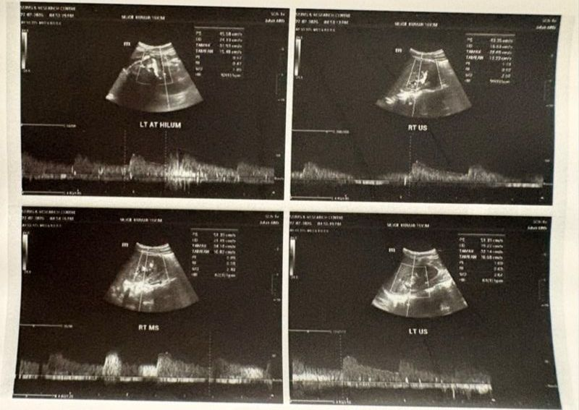
Figure 1: Bilateral Renal Arterial Color Doppler Sonography depicting left and right main and hilar renal artery waveforms, confirming patent vascular lumens, normal peak systolic velocities (PSV), and absence of renal artery stenosis.
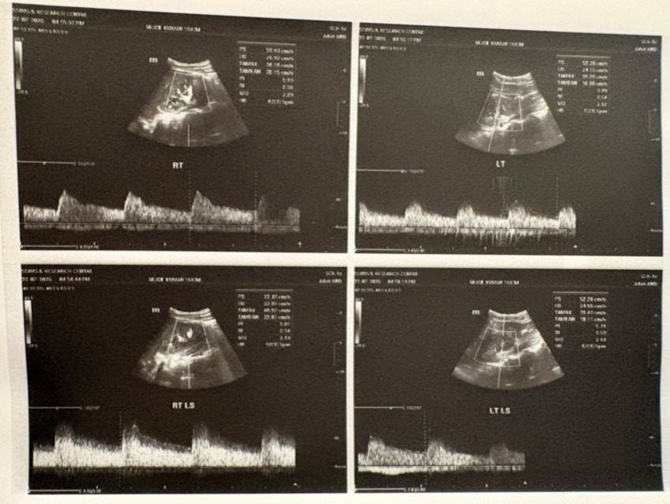
Figure 2: Spectral Doppler ultrasound examination of bilateral upper, interpolar, and lower segmental renal arteries demonstrating normal intrarenal arterial resistive indices (RI: 0.5–0.7) and preserved diastolic flow.
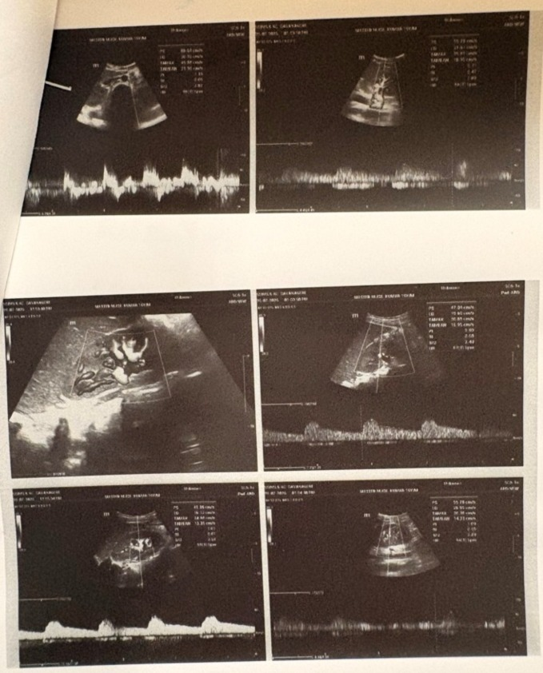
Figure 3: Color Doppler interrogation of renal parenchyma and hilar vasculature demonstrating symmetrical perfusion without focal perfusion defects, vascular cutoff, or turbulent flow.
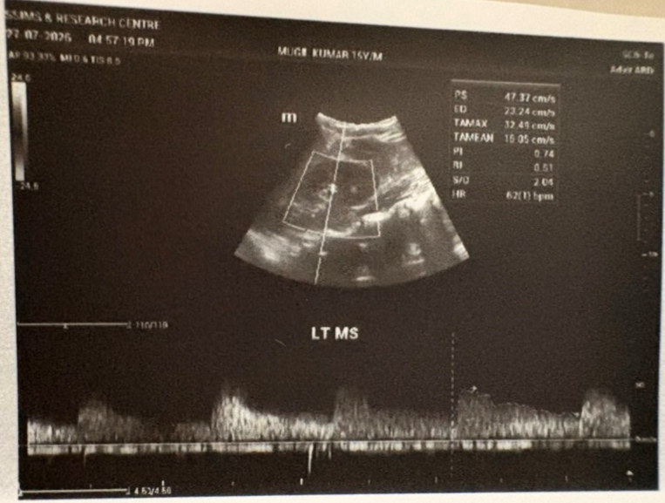
Figure 4: Detailed spectral waveform analysis of the left mid-segmental renal artery (LT MS) showing normal systolic acceleration time and normal resistive index (RI 0.51).
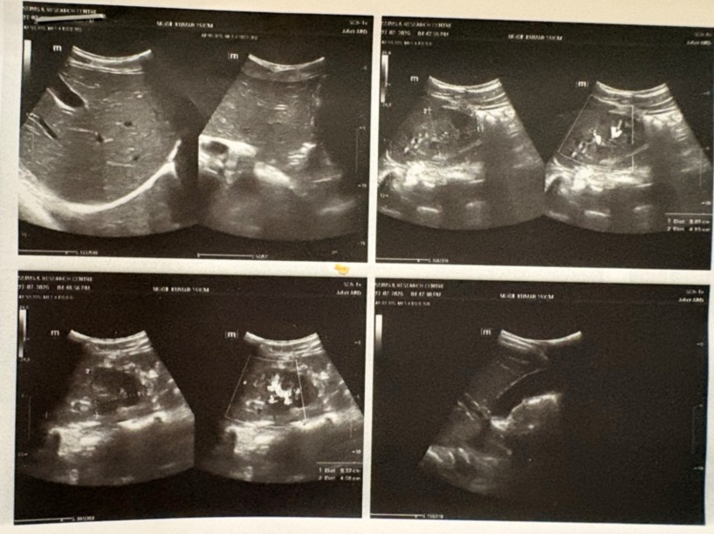
Figure 5: High-resolution B-mode and color Doppler ultrasonography of the liver, gallbladder, spleen, and bilateral kidneys, demonstrating normal renal dimensions and mild physiological inter-loop free fluid.
Discharge medications and post-discharge plan: The patient was discharged in stable and neurologically intact state on oral Syrup Glycerol 20 ml (thrice daily, 1-1-1 for three days) for residual cephalalgia, orally on maintenance anti-hypertensives (Tablet Amlodipine 5 mg OD 0-0-1 at bed time) and anticonvulsants (oral Levetiracetam. Full course of intra-venous Ceftriaxone was completed. The family was advised strict routine-monitoring of home blood pressure with log book (to be checked twice weekly), restriction of fluid & dietary salt, in addition to reporting to the nearest emergency on appearance of danger signals (severe head-ache, visual disturbances, repetition of vomiting, periorbital/facial puffiness & any seizure activity). Follow-up was planned on 1-week in OPD of Paediatric Nephrology / Unit 2 after which on 8-week. The primary intention was to review the home bp log, examine ASO titer result reports and also for a planned evaluation with repeated serum C3 complement estimation level on 8-weeks follow- up for immunological resolution and possible option for elective renal biopsy.
3. DISCUSSION
Hypertensive encephalopathy in children is a medical emergency that requires timely recognition and judicious management [11,12]. PIGN is the traditionally most common cause of acute volume-dependent hypertension in children, with PSGN comprising >85–90% of regional Epidemiological Registry based reports [12,13]. Conversely non-streptococcal GN induced by virus including non-mumps paramyxovirus is rather infrequent (1–3% of all cases of PIGN in published series) [13,14]. The pathophysiology of mumps -associated GN entails several complicated direct and indirect immuno-pathological mechanisms [14,15]. Mumps virus is characterized by having high glandular epithelium trophism and it may directly infiltrate the renal tubular and glomerular endothelial cells through its viraemic dissemination [15,16]. Apart from viral direct injury the circulating immune complexes (CICs) are formed, promoting activation of the classical complement pathway, contributing to endocapillary proliferative glomerulonephritis and triggering neutrophil accumulation in the glomeruli mesangium [16,17]. This cascade finally induces acute impairment of glomerular filtration rate (GFR) with vigorous subsequent renal sodium and water retention, resulting in tremendous expansion of functional ECF volume, leading to malignant hypertension [17,18]. Hypertensive encephalopathy appears as dysfunction of auto-regulation of CBF [18,19]. In normal state during pressure rises cerebral arterioles constrict and maintain CBF almost unchanged over a range up to about 60–120 mmHg in adolescent patient when auto-regulation limit is exceeded. Then, through vasodilation of cerebral arterioles with consequent excessive hyperaemia brain perfusion pressure causes endothelial injury, opening of tight junction barrier and plasma derived macromolecules leak across into the interstitial space producing perivascular oedema or diffusion into the entire interstitium and resulting in the vasogenic oedema [20,21]. This hyper perfusion often provokes clonic-tonic seizures, transient visual scotoma, heavy emesis, or coma [22,23]. Early diagnosis in the ER setting is differentiated from viral meningoencephalitis based on history and physical signs [10,23]. History of prodromal febrile illness associated with parotid swelling, headache, emesis or convulsion in the patient previously infected with mumps could suggest mumps meningoencephalitis. In our case, MDCT brain performed upon suspected meningitis, did not show any signs of structural damage or haemorrhage. Examination of ocular fundi ruled out the presence of a primary optic neuritis and papilledema.
Conclusively blood pressure normalized after its management and all cerebral signs and symptoms were resolved, the hypertensive crisis was undoubtedly cause of the syndrome [23,24]. Appropriate, gradual blood pressure lowering using continuous infusion is central to the management of childhood hypertension associated with encephalopathy [21,24]. Abrupt reduction to normal pressures carries a significant risk of inducing cerebral ischemia and may lead to long-term neurological damage [24,25]. The goal of treatment of hypertensive encephalopathy is to rapidly achieve a sustained 20–25% reduction in mean arterial pressure without causing any cerebral hypoperfusion [21,25]. Continuous intravenous labetalol was found to be more efficacious. Labetalol has both alpha- and beta-adrenergic blocker properties and it is the favoured choice for paediatric hypertensive emergencies. For Our patient, infusion rate 0.25 mg/kg/min of intravenous labetalol managed the MAP lowering by about 20–25% in 6–8 hours without significant reflex tachycardia or excessive hypotension. Intravenous Mannitol helped in neuroprotection and IV Levetiracetam was provided to treat seizures rapidly. Intravenous diuretic (furosemide) to combat excessive fluid overload was useful, and eventually, oral amlodipine maintenance was employed [24,25].
4. CONCLUSION
This case describes a remarkably uncommon, life-threatening scenario with a diagnosis of hypertensive encephalopathy and status epilepticus secondary to post-mumps acute poststreptococcal glomerulonephritis in the setting of a child. Vigilance must be present for acute glomerulonephritis and hypertensive emergency in children who present with rapid onset seizures, headache, and encephalopathy following viral infection. Timely continuous IV labetalol titration, judicious volume support with loop diuretics, neuroprotection with anti-oedema, anticonvulsant therapy, and phased discontinuation of oral calcium channel blockers can result in resolution of symptoms, prevention of neurologic injury, and rapid clinical recovery.
ETHICAL APPROVAL AND CONSENT
Written and informed consent from patient’s legally assigned guardians (parents) to publish this case report including associated diagnosis image/data was obtained. Institutional ethical committee approval was obtained as required by local institution and the Declaration of Helsinki.
COMPETING INTERESTS
The authors have not competing interests nor financial conflicts associated to this case report publication.

Declaration of AI Use

This manuscript was prepared through the intellectual contributions of the author(s) to the study design, data analysis, interpretation of results, and scholarly content. Grammarly and ChatGPT were used solely to assist with grammatical refinement and reference formatting during manuscript revision. The author(s) accept full responsibility for the accuracy, integrity, and final content of the manuscript.
REFERENCES
1. Flynn JT, Kaelber DC, Baker-Smith CM, Blowey D, Carroll AE, Daniels SR, et al. Clinical practice guideline for screening and management of high blood pressure in children and adolescents. Pediatrics. 2017;140(3):e20171904.
2. Yang WC, Wu HP. Clinical characteristics and outcomes of pediatric hypertensive emergencies in the emergency department. Pediatr Neonatol. 2020;61(3):284-290.
3. Patel NH, Flynn JT. Pediatric hypertensive emergencies and urgencies: Evaluation and therapeutic approach. Curr Hypertens Rep. 2021;23(4):22.
4. Seeman T, Hamdani G, Mitsnefes M. Hypertensive crisis in children and adolescents. Pediatr Nephrol. 2023;38(1):31-41.
5. Hauser JA, Schneider J, Latal B, Bernet V. Neurological manifestations of severe hypertension in pediatric intensive care: A systematic review. Eur J Pediatr. 2022;181(4):1455-1466.
6. Fugate JE, Rabinstein AA. Posterior reversible encephalopathy syndrome and hypertensive encephalopathy: Pathophysiological mechanisms and clinical spectrum. Lancet Neurol. 2015;14(9):914-925.
7. Rodriguez-Iturbe B, Musser JM. The current state of poststreptococcal and postinfectious glomerulonephritis. J Am Soc Nephrol. 2008;19(10):1855-1864.
8. Kher KK. Acute glomerular diseases in children: Etiological paradigms and clinical management. Open Urol Nephrol J. 2015;8(1):104-116.
9. Kabakus N, Aydinoglu H, Yekeler H, Arslan IN. Fatal mumps nephritis and myocarditis: A rare presentation in a child. J Trop Pediatr. 1999;45(6):358-360.
10. Shah GS, Yadav SP. Clinical profile and outcome of acute glomerulonephritis in a tertiary care centre in Eastern Nepal. J Nepal Paediatr Soc. 2015;35(2):123-128.
11. Al-Eisa A, Al-Hunayyan A, Al-Otaibi N. Hypertensive encephalopathy in pediatric acute post-infectious glomerulonephritis. Med Princ Pract. 2019;28(2):189-194.
12. Tizki S, Boujnan M, Sabry A, Zouhairi O. Acute post-streptococcal glomerulonephritis in children: Clinical presentation, complications, and outcome in a developing country. Cureus. 2025;17(10):e94210.
13. Anochie I, Eke F, Okpere A. Childhood acute glomerulonephritis in developing nations: Changing patterns and diagnostic pitfalls. West Afr J Med. 2009;28(4):241-246.
14. Stevens J, Herberg JA, Levin M. Infectious diseases and the kidney in children. In: Avner ED, Harmon WE, Niaudet P, Yoshikawa N, Emma F, Goldstein SL, editors. Pediatric Nephrology. 7th ed. Berlin, Heidelberg: Springer; 2016. p. 1609-1654.
15. Utz JP, Houk VN, Alling DW. Clinical and laboratory studies of mumps: IV. Viruria and abnormal renal function in clinical mumps. N Engl J Med. 1964;270(24):1283-1286.
16. Nussinovitch M, Volovitz B, Varsano I. Complications of mumps requiring hospitalization in children. Eur J Pediatr. 1995;154(9):732-734.
17. Ocheke IE, Okolo SN, Bode-Thomas F. Pediatric acute kidney injury and hypertensive crisis in post-infectious glomerulonephritis. Ann Afr Med. 2010;9(4):234-239.
18. Armas-Guzman M, Kaelber DC, Vupputuri S. Severe pediatric hypertension: Epidemiology, target organ damage, and therapeutic controversies. Curr Pediatr Rep. 2022;10(2):45-56.
19. Immink RV, van Montfrans GA, Stam J, Karemaker JM, Diamant M, van Lieshout JJ. Dynamic cerebral autoregulation in acute hypertensive encephalopathy. Circulation. 2004;110(15):2241-2245.
20. Fisher ND, Vaidya A. Hypertensive emergencies: Neurovascular mechanisms, cerebral autoregulatory failure, and management principles. Cardiol Clin. 2021;39(3):479-489.
21. Constantinou A, Koliou E, Chalia M, Pitsilos G. Pharmacological management of acute severe hypertension in the pediatric intensive care unit: A comprehensive review. Front Pediatr. 2021;9:740115.
22. Bartynski WS. Posterior reversible encephalopathy syndrome, part 1: Fundamental imaging and pathophysiologic mechanisms. AJNR Am J Neuroradiol. 2008;29(6):1036-1042.
23. Hladky JP, Lejeune JP, Vinchon M. Neurological presentations of acute glomerulonephritis and hypertensive crises in children. Child Nerv Syst. 2018;34(5):829-835.
24. Sethna CB, Leisman D, Vanevski M. Management of severe hypertension in the pediatric emergency and intensive care settings. Pediatr Nephrol. 2020;35(10):1825-1837.
25. Dionne JM, Abitbol CL, Flynn JT. Antihypertensive therapy for severe hypertension in children and adolescents: Systematic approach to intravenous titration and oral transition. Pediatr Nephrol. 2012;27(4):517-527.

