Case Report

Cutaneous Sarcoidosis Arising in an Area of Notalgia Paresthetica Revealing Systemic Disease

.
ABSTRACT
Aims: To report the first observed case, to our knowledge, of cutaneous sarcoidosis arising within an area of long-standing notalgia paresthetica, and to highlight how this presentation unmasked previously unrecognized systemic sarcoidosis.
Presentation of Case: A 48-year-old man with notalgia paresthetica evolving for more than 10 years presented with the progressive appearance of multiple asymptomatic orange-to-salmon papules, 2 to 5 mm in diameter, arising over the hyperpigmented area affected by notalgia paresthetica, as well as on the neck, upper trunk, and axillary folds. Dermoscopy showed orange-yellow structureless areas with a few linear and arborizing vessels. Serum angiotensin-converting enzyme and calcium levels were within normal limits. A skin biopsy revealed non-caseating epithelioid cell granulomas with multinucleated giant cells; periodic acid-Schiff and Ziehl-Neelsen stains were negative. Systemic evaluation disclosed interstitial pulmonary involvement with mediastinal lymphadenopathy, establishing a diagnosis of systemic sarcoidosis.
Discussion: Cutaneous sarcoidosis may localize to sites of prior cutaneous injury through Koebner-like or isotopic mechanisms. Chronic neuropathic itch, repetitive scratching, and neurogenic inflammation associated with notalgia paresthetica may have contributed to lesion localization, although a causal relationship cannot be established. Histopathology remained central to the diagnosis and appropriately prompted the systemic evaluation that revealed occult disease.
Conclusion: New or changing lesions arising within a notalgia paresthetica field warrant biopsy and systemic evaluation, as they may unmask occult systemic sarcoidosis.
Keywords: Sarcoidosis; cutaneous sarcoidosis; notalgia paresthetica; granuloma; dermoscopy; case report.

1. Introduction
Sarcoidosis is a multisystem granulomatous disorder that can affect virtually any organ, and its diagnosis relies on a compatible clinical and radiologic presentation, histologic evidence of non-caseating granulomas, and exclusion of alternative causes (Sève et al., 2021). Cutaneous manifestations are among the most frequent extrapulmonary features of sarcoidosis and may represent the initial manifestation of systemic disease (Sève et al., 2021).
Notalgia paresthetica is a chronic cutaneous neuropathy characterized by localized pruritus and dysesthesias of the upper back, often accompanied by burning, numbness, tingling, tenderness, or hyperpigmentation (Robinson et al., 2023). To our knowledge, the occurrence of cutaneous sarcoidosis arising in an area of notalgia paresthetica has not previously been described in the literature. The present case therefore expands the recognized clinical contexts in which cutaneous sarcoidosis may emerge and, in doing so, unmasked previously unrecognized systemic disease.

2. Presentation of Case
A 48-year-old man with a history of notalgia paresthetica evolving for more than 10 years presented with the progressive appearance of multiple small papules arising over the hyperpigmented area affected by notalgia paresthetica (Fig. 1). The lesions were asymptomatic, with no associated pruritus or pain. Similar papules were also noted on the trunk and within the axillary folds. The patient did not report any pulmonary, gastrointestinal, ocular, articular, or neurologic symptoms.
Physical examination revealed numerous small, well-demarcated, rounded hemispherical papules in a Fitzpatrick skin phototype IV patient. The lesions measured 2 to 5 mm in diameter and were orange to salmon-colored, with a smooth surface and soft consistency. They were distributed over the neck, upper trunk (Fig. 2), bilateral axillary folds (Fig. 3), and within the area affected by notalgia paresthetica. No mucosal or adnexal involvement was observed. The remainder of the physical examination was unremarkable.
Dermoscopy of the papules demonstrated orange-yellow structureless areas consistent with granulomatous infiltrates, associated with a few linear and arborizing vessels (Fig. 4). Laboratory investigations, including serum angiotensin-converting enzyme and calcium levels, were within normal limits (Table 1).
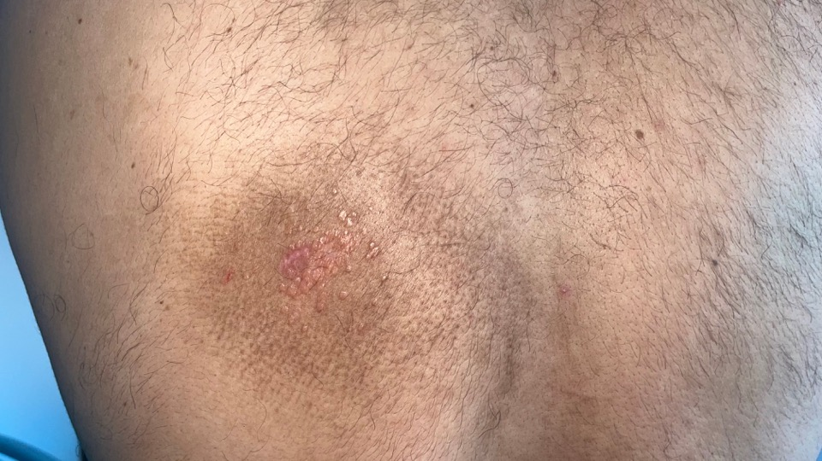
Fig. 1. Multiple small orange-to-salmon colored papules arising within a hyperpigmented area affected by long-standing notalgia paresthetica on the left scapular region.
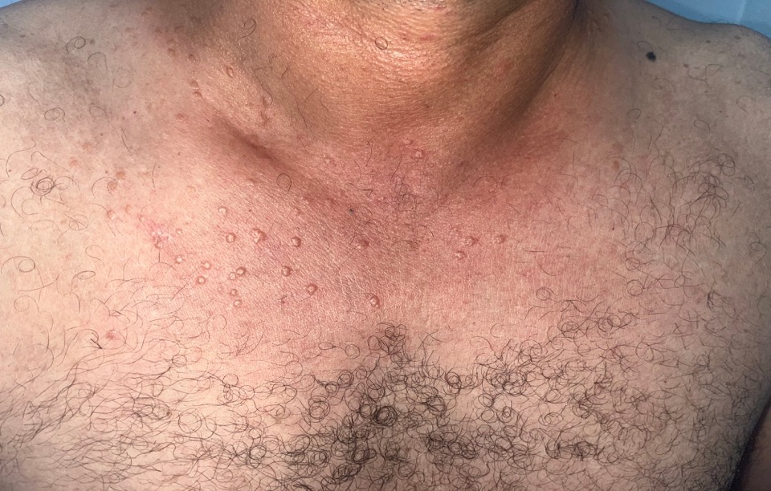
Fig. 2. Multiple small, well-demarcated orange-to-salmon colored papules distributed over the upper trunk.
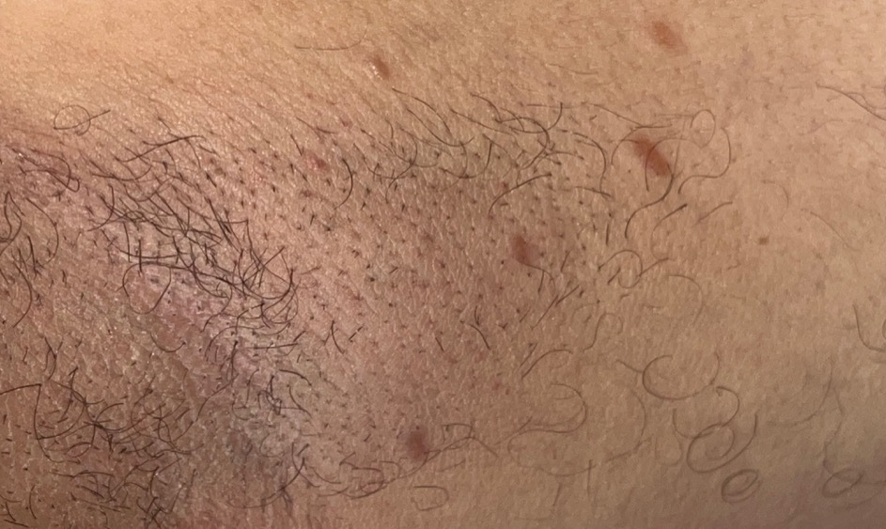
Fig. 3. Multiple orange-to-salmon colored papules located within the right axillary fold, showing a smooth surface and well-defined borders.
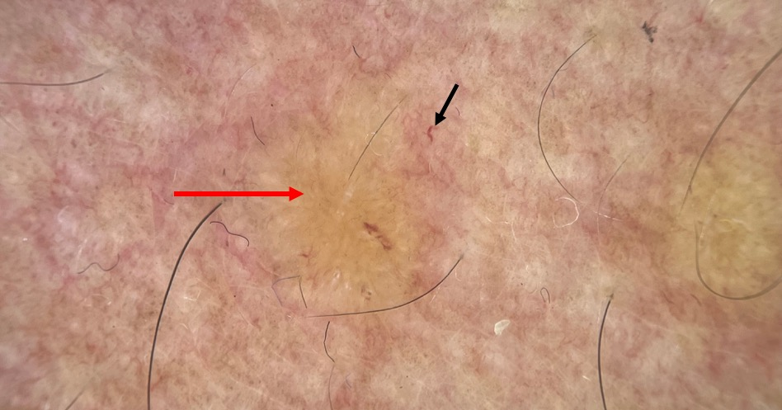
Fig. 4. Dermoscopic examination of a papular lesion showing a well-defined orange-yellow structureless area corresponding to granulomatous infiltrates (red arrow), associated with fine vessels (black arrow).
A skin biopsy was performed and revealed epithelioid cell granulomas with multinucleated giant cells, without caseous necrosis (Fig. 5). Periodic acid-Schiff and Ziehl-Neelsen stains were negative. These findings were consistent with cutaneous sarcoidosis.
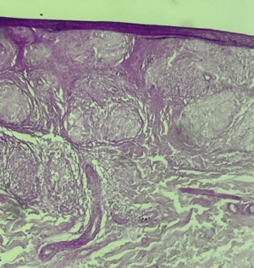
Fig. 5. Histopathologic examination showing multiple well-formed non-caseating epithelioid granulomas with multinucleated giant cells within the superficial dermis, consistent with cutaneous sarcoidosis (hematoxylin and eosin, original magnification ×40).
Because of these findings, a systemic evaluation was performed. Chest imaging revealed interstitial pulmonary involvement associated with mediastinal lymphadenopathy. Further investigations did not reveal any ophthalmologic, cardiac, or osseous involvement. A diagnosis of systemic sarcoidosis with pulmonary involvement was therefore established. The patient was treated with high-potency topical corticosteroids. After six months of follow-up, clinical improvement was noted, with flattening of the papular lesions.
Table 1. Laboratory investigations and reference ranges in our patient.
Parameter | Result | Reference range
Hemoglobin | 15.3 g/dL | 13–17 g/dL
White blood cell count | 7700/mm³ | 4000–10,000/mm³
Neutrophil count | 4800/mm³ | 1500–7500/mm³
Lymphocyte count | 1700/mm³ | 1000–4000/mm³
Monocyte count | 600/mm³ | 200–1000/mm³
Eosinophil count | 500/mm³ | 0–500/mm³
Platelet count | 205,000/mm³ | 150,000–400,000/mm³
Erythrocyte sedimentation rate | 5 mm/h | <20 mm/h
Sodium | 141 mmol/L | 135–145 mmol/L
Potassium | 3.82 mmol/L | 3.5–5.0 mmol/L
Serum bicarbonate | 27 mmol/L | 22–29 mmol/L
Total protein | 75 g/L | 64–83 g/L
Urea | 0.21 g/L | 0.15–0.45 g/L
Creatinine | 9 mg/L | 7–13 mg/L
Aspartate aminotransferase | 19 U/L | <40 U/L
Alanine aminotransferase | 14 U/L | <41 U/L
Calcium | 96 mg/L | 84–102 mg/L
Phosphorus | 30 mg/L | 25–45 mg/L
Angiotensin-converting enzyme | 30 U/L | 8–52 U/L

3. Discussion
This case illustrates an unusual association between long-standing notalgia paresthetica and cutaneous sarcoidosis, with subsequent discovery of pulmonary involvement. Sarcoidosis is a multisystem granulomatous disorder that can affect virtually any organ, and cutaneous manifestations may represent the initial clue to underlying systemic disease (Sève et al., 2021).
Notalgia paresthetica is generally considered a sensory neuropathy related to thoracic nerve involvement, and its chronic localized symptoms can delay recognition of a superimposed dermatosis (Robinson et al., 2023).
Cutaneous sarcoidosis has been reported to arise in sites of prior skin trauma, including scars and tattoos, sometimes described as a Koebner-like or isotopic response (Martires et al., 2015). In our patient, the appearance of papules within a chronic notalgia paresthetica area raises the possibility that local cutaneous vulnerability, repetitive scratching, or neurogenic inflammation may have contributed to lesion localization, although a causal relationship cannot be established. Dermoscopy may provide helpful clues in cutaneous sarcoidosis, including translucent orange globular areas, linear vessels, and white scar-like structures, which can support suspicion before biopsy (Liu et al., 2023).
Histopathology is central to the diagnosis of sarcoidosis because the disease is characterized by non-necrotizing granulomas, but these findings are not pathognomonic and must be interpreted in the context of the clinical picture and the differential diagnosis of other granulomatous dermatoses (Tana et al., 2021). In our patient, skin biopsy confirmed cutaneous sarcoidosis and appropriately prompted systemic evaluation, which revealed pulmonary and mediastinal involvement.
This case highlights the importance of considering biopsy in persistent or changing lesions occurring within areas affected by notalgia paresthetica, as they may reveal cutaneous sarcoidosis and uncover otherwise unrecognized systemic disease. Chronic neuropathic itch can lead to persistent scratching, post-inflammatory change, and delayed recognition of a second process superimposed on the original syndrome. Areas affected by notalgia paresthetica may therefore conceal cutaneous sarcoidosis, and any new or progressive lesion in this setting should prompt biopsy and systemic evaluation.

4. Conclusion
Cutaneous sarcoidosis developed within a long-standing patch of notalgia paresthetica and led to the diagnosis of previously unrecognized systemic sarcoidosis with pulmonary involvement, an association not previously reported. This case expands the range of sarcoidosis presentations and reinforces the need to look beyond neuropathic itch when the morphology changes. New or changing lesions within a chronic neuropathic itch field warrant biopsy and systemic evaluation, as they may unmask occult systemic disease.

Competing Interests
Authors have declared that no competing interests exist. No financial or personal relationships with individuals or organizations that could inappropriately influence this work are reported. No funding or financial support was received for this work.

Consent
All authors declare that written informed consent was obtained from the patient for publication of this case report and the accompanying images. A copy of the written consent is available for review by the Editorial office / Chief Editor / Editorial Board members of this journal.

Ethical Approval
All authors hereby declare that all procedures have been performed in accordance with the ethical standards laid down in the 1964 Declaration of Helsinki and its later amendments.

Declaration of AI Use

This manuscript was prepared through the intellectual contributions of the author(s) to the study design, data analysis, interpretation of results, and scholarly content. Grammarly and ChatGPT were used solely to assist with grammatical refinement and reference formatting during manuscript revision. The author(s) accept full responsibility for the accuracy, integrity, and final content of the manuscript.

References
Liu, M., Chen, H., & Xu, F. (2023). Dermoscopy of cutaneous sarcoidosis: A cross-sectional study. Anais Brasileiros de Dermatologia, 98(6), 750–754. https://doi.org/10.1016/j.abd.2022.12.006
Martires, K., Shvartsbeyn, M., Brinster, N., Ramachandran, S., & Franks, A. G., Jr. (2015). Sarcoidosis. Dermatology Online Journal, 21(11), 13030/qt5d3306f8. https://doi.org/10.5070/D32112029526
Robinson, C., Downs, E., De la Caridad Gomez, Y., Chen, L., Meltzer, R., & Nedorost, S. (2023). Notalgia paresthetica review: Update on presentation, pathophysiology, and treatment. Clinics and Practice, 13(1), 315–325. https://doi.org/10.3390/clinpract13010029
Sève, P., Pacheco, Y., Durupt, F., Jamilloux, Y., Gerfaud-Valentin, M., Isaac, S., Boussel, L., Calender, A., Androdias, G., Valeyre, D., & El Jammal, T. (2021). Sarcoidosis: A clinical overview from symptoms to diagnosis. Cells, 10(4), 766. https://doi.org/10.3390/cells10040766
Tana, C., Donatiello, I., Caputo, A., Tana, M., Naccarelli, T., Mantini, C., Ricci, F., Ticinesi, A., Meschi, T., Cipollone, F., & Giamberardino, M. A. (2021). Clinical features, histopathology and differential diagnosis of sarcoidosis. Cells, 11(1), 59. https://doi.org/10.3390/cells11010059

