Case Report

Atypical Posterior Reversible Encephalopathy Syndrome in the Delayed Postpartum Period Following Caesarean Section: A Case Report

Abstract
Posterior reversible encephalopathy syndrome is a clinicoradiological neurological disorder characterized by acute neurological symptoms and vasogenic brain edema, most commonly involving the posterior cerebral regions. It is associated with several precipitating conditions, including hypertensive disorders of pregnancy and the postpartum state. This case report describes a 22-year-old primigravida who presented on the thirteenth postoperative day following lower-segment caesarean section with severe occipital headache, giddiness, repeated bilious vomiting, and one episode of generalized tonic–clonic seizure with postictal stupor. On admission, she had severe hypertension with a blood pressure of 180/80 mmHg, while neurological examination showed no focal deficit or meningeal signs. Laboratory evaluation showed transient renal dysfunction and neutrophilic leukocytosis. Magnetic resonance imaging of the brain revealed bilateral parieto-occipital T2/FLAIR hyperintensities with additional involvement of the right temporal lobe, left frontal lobe, and posterior limb of the left internal capsule, consistent with posterior reversible encephalopathy syndrome. Magnetic resonance venography excluded cerebral venous thrombosis. The patient was managed with blood pressure control, anticonvulsant therapy, supportive treatment, and multidisciplinary monitoring. Her headache and vomiting resolved, seizures did not recur, renal function improved, and she was discharged in stable neurological condition. This case highlights the need to consider posterior reversible encephalopathy syndrome in postpartum women presenting with severe headache, vomiting, hypertension, or seizure, even beyond the immediate puerperal period.

INTRODUCTION:
Posterior Reversible Encephalopathy Syndrome: A Review Posterior reversible encephalopathy syndrome (PRES) is a clinic-radiologic neurologic condition that is seen with acute neurological dysfunction with reversible vasogenic brain edema typically in the posterior part (parietooccipital) of the brain (1). The typical symptoms observed in this condition include seizures, headache, visual dysfunction, altered mental status, and focal neurologic abnormalities. This condition presents with bilateral hyperintense lesion at T2 and FLAIR images (1,2). It has got good prognosis when recognized in time and treated accordingly, and can also cause intracranial haemorrhages, cerebral infarction, irreversible neurologic deficits, or even death if it has not been recognised timely (1,3). The pathophysiology is not precisely delineated. It is thought to include insufficient cerebral autoregulation, endothelial injury leading to blood brain barrier breakdown, and responsible for vasogenic edema. (2,4) There is a broad spectrum of obstetric pathologies that predispose women to PRES and among the more common precipitating factors, and hypertension related to pregnancy (such as pre-eclampsia and eclampsia) have a higher association in young women. (1,3) While most cases occur during the late pregnancy and up to early postpartum periods, an increasing number of cases of postpartum PRES has occurred with the need for appropriate consideration to an early diagnosis. (6) Because computed tomography may be normal early in the illness, it is preferred the modalities MRI, of computed tomography (3), of conventional tomographic section imaging; computed tomography (2). A vasogenic cerebral edema in a characteristic form has been located in bilateral parts, most prominently parieto-occipital; but frontal, temporalo, gangli, truncus, cerebeli and capsuloide as atypial forms can appear (5). Complete clinical and imaging improvement is generally expected with rapid blood pressure treatment, control of seizure, and cause specific treatment (1, 3).

CASE PRESENTATION:
A 22-year old female, a primigravida, with complaints of occipital headache since 1 day, giddiness since morning and bilious vomiting (7-8 episodes) since 1 day, admitted to Department of General Medicine. She also had a single generalised tonic clonic seizure at about 7 AM in the morning of admission. The patient was on 13th post-operative day following lower-segment caesarean section (LSCS). As per the attendants, she was doing apparently well until 1 day back when she developed sudden onset occipital headache which spread to the neck. This was followed by several episodes of bilious vomitting without haemoptysis, giddiness and a generalised seizure which involved upper and lower limb, with upward rolling of eye and tongue bite, and postictal stupor. There was no history of involuntary passage of urine, constipation or incontinence, fever or loose motion or earache or tinntus or recent head injury or postpartum haemorrhage over and above that expected after LsCS, as the woman reported no bleeding at all from the vagina. There was no past history suggestive of epilepsy, hypertension chronic and any other diabetic, renal disease, autoimmune condition or CNS illness. Her antenatal and intranatal periods were apparently uncomplicated and LSCS were uneventful without any noted complications. On arrival to the emergency department, she was conscious but lethargic post the seizure episode. On general examination, she had pallor with no cyanosis, clubbing, icterus, lymphadenopathy and pedal edema. Pulse was 94bpm with BP of 180/80mmHg, her temperature was normal. Cardiovascular examination revealed first and second heart sounds are normal without any murmurs. Respiratory examination was equal air entries on both the lung fields with normal vesicular breath sounds and no added sounds. Abdomen was soft with well healed post operative LSCS wound with no hepatomegaly or guarding. Neurological examination revealed E4V5M6, pupils were 3mm in size bilaterally reacting equally to light, bilateral plantar flexor responses, no focal neurological deficit and no meningeal signs. Fundus was not showing any papilledema or hypertensive retinopathy. ophthalmic check was normal.
Routine Investigations - to look for possible metabolic, infectious and hematologic causes of acute symptomatic seizures; haematological investigations, blood urea, BUN, serum creatinine and other biochemistry, liver functions tests and urine routine study were done. – Haematological Investigations on admission revealed H.G. Of 12.7 g/dl, Total leukocyte count: 11410 cell/mm, Predominance: 90% Neuts, PLT: 3.72 10 / mm, E.S.R.: 62mm /hour; haematocrit: 38.7%; RBC count: 4.3million/mm. Biochemical investigation revealed blood urea of 39.7 mg/dl, serum creatinine 1.76 mg/dl, Sodium; 139.0 mmol/L, Potassium: 3.45 mmol/L, chloride: 110.93mmol/L;Calcium:8.29 mg/dl, Total protein: 5.2 g/dl, Albumin: 2.8g/dl, Globuiln;2.4g/ dl, Total bilirubin; 1.0 mg/dl;Direct.0.2 mg/dl; SGOT;29u/L; SGPT:17 u/L; ALP; 204.4 u/L. - coagulation study-P.T., A.P.T.T.,I.N.R were within normal limits. - Serological study for- HIV- non- reactive for Hep. B sAg- non-reactive Peripheral blood- itshowed normocytic normochromic blood picture with neutrophilic leukocytosis. Urine- 3-5 leukocyte/H.P.F., 1-2RBC / H.P.F., no any urine cast and crystal was present. Serial investigations in post operative-Serial investigations were also repeated - the blood urea improved gradually from 39.7mg/dl to 18.2 mg/ dl. The creatinine levels came down to 0.95 mg/ dl. Haematological parameters - H.G at discharge: 10.6 g/ dl, total leukcocyte count: 8470 cell/ mm; platelets :2.17 10 /mm, haematocrit: 31.8%, neutrophils: 74%, Lymphocytes: 19% and monocytes: 7%
In the context of severe postpartum hypertension presenting as acute seizure, neuroimaging was obtained urgently. Brain magnetic resonance imaging (MRI) revealed bilaterally nearly symmetric T2-weighted and fluid attenuated inversion recovery (FLAIR) hyperintense foci involving the bilaterlo parieto-occipital regions, right temporal lobe, left frontal lobe and left internal capsule posterior limb consistent with the diagnosis of Posterior Reversible Encephalopathy Syndrome (PRES). There was incidental 5.1x1.1x3.0 cm in dimension sized, csf intensity broad-based lesion in the right parasagittal frontal region compatible with arachnoid cyst. Basal ganglia, thalami, brainstem, cerebellum, ventricular system, basal cisterns, Cortical sulci and sellar structures showed no abnormalities. Non-contrast MRA demonstrated hypoplastic right transverse sinus, whereas others were normal with absence of Cerebral Venous Thrombosis was therefore excluded as a part of differential diagnosis in patients with postpartum seizure.
The final diagnosis of postpartum posterior reversible encephalopathy syndrome after a lower-segment caesarean section was then made based on typical clinical feature, severe postpartum hypertension and MRI appearances. The patient was admitted for intensive neuro-monitoring and referred for multi- disciplinary management comprising Departments of General Medicine, Neurology, Obstetrics and Gynaecology, and Ophthalmology. The patient received management including anti-hypertensives for aggressive control of the BP, anticonvulsants to prevent seizures, i.v. Fluids, symptomatic treatment in the form of antiemetics and analgesics and supportive measures.
The BP, Neurological functions, urine out-put and other biochemical parameters were closely monitored throughout the stay in hospital. On each post-operative day clinical monitoring, BP normalized; Headache and vomiting completely improved and seizures did not recur, the neurological examination remained unremarkable with no lateralising signs development and the Renal function improved with in few day s and on the sixth day of the treatment, on the sixth postoperative day the patient was discharged home in a satisfactory condition.
Overall, her progress on conservative management. On discharge, the patient was conscious, oriented, well ambulating, hemodynamically stable and normal neurologically. She was discharged on an oral antihypertensive, anticonvulsant, analgesic and on a supportive drug regimen with counsel on close BP monitoring, compliance, awareness on reappearance of neurological symptoms and the patient was scheduled for follow up in general medical outdoor clinic. Close obstetric and neurologic surveillance was recommended on an elective basis to follow her recovery and avert possible recurrence.

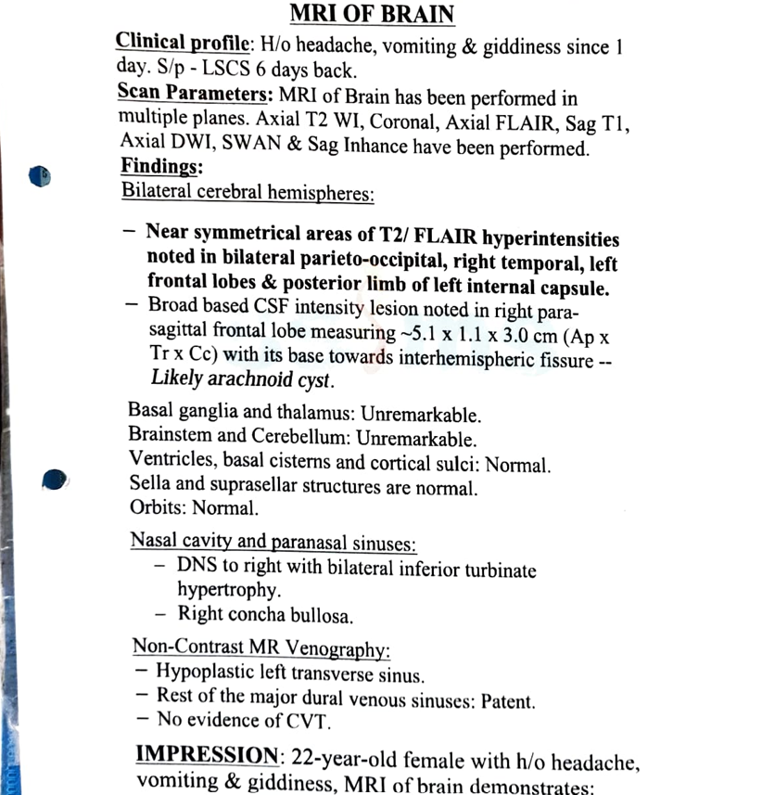
Table 1. Timeline of Clinical Events
Day 0 | Lower Segment Caesarean Section (LSCS) performed; postoperative period was uneventful.
Postoperative Day 12 | Developed severe occipital headache, giddiness, and 7–8 episodes of bilious vomiting.
Postoperative Day 13 (Admission Day) | Experienced one episode of generalized tonic–clonic seizure with tongue bite and postictal confusion. Admitted with blood pressure of 180/80 mmHg. Clinical examination and laboratory investigations were performed.
Hospital Day 1 | MRI brain and MR venography performed, confirming Posterior Reversible Encephalopathy Syndrome (PRES) and excluding cerebral venous thrombosis. Antihypertensive therapy, anticonvulsants, and supportive treatment initiated.
Hospital Days 2–4 | Clinical condition improved with normalization of blood pressure, resolution of headache and vomiting, no recurrence of seizures, and improvement in laboratory parameters.
Discharge Day | Discharged in stable condition with oral antihypertensive and anticonvulsant medications. Advised regular neurological and obstetric follow-up.

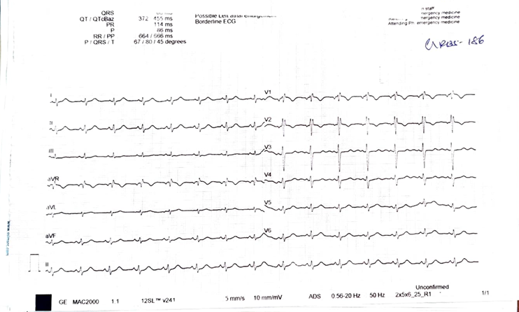
Figure 1: MRI brain demonstrating bilateral parieto-occipital T2/FLAIR hyperintensities with additional involvement of the right temporal lobe, left frontal lobe, and posterior limb of the left internal capsule, suggestive of posterior reversible encephalopathy syndrome.

Figure 2: Twelve-lead electrocardiogram demonstrating the patient's cardiac electrical activity during hospital evaluation.

DISCUSSION:
Posterior reversible encephalopathy syndrome (PRES) is clinic radiologic potentially reversible syndrome which manifests as commonly headache, seizure, altered mental status and vision impairment. Nausea and vomiting are also characteristic. Significant triggering events include hypertensive disorders, renal failure, autoimmune disorders and cytotoxic drugs, pre-eclampsia and eclampsia and all pregnancy-related events.(7,8) The precise underlying pathobiology of PRES is, however, complex and not fully elucidated.1 Cerebral autoregulatory compromise and endothelial damage are, however, thought to play primary roles leading to impairment of blood-brain barrier integrity and vasogenic edema.(8) Endothelial dysfunction resulting from a pregnancy related hypertensive state possibly worsens capillary permeability and so causes cerebral swelling.(9) The current case is clinically significant in that neurological symptoms appeared 13 days postpartum after LSCS, rather than during pregnancy or peripartum period. Postpartum PRES has been documented with pre–eclampsia and eclampsia but can have differing presentation. (9,10) A recent 2025 case report also stated that PRES should be considered in partum women who present with profound neurological symptoms, irrespective of characteristic signs of pre–eclampsia. (10) Our patient showed the characteristic severe throbbing headache centered in the occiput with repetitive vomiting, dizziness, a generalized tonic-clonic seizure, and significant hypertension of 180/80 mmHg, which is representative of the described clinical picture for PRES. During an extensive prospective descriptive study of typical and atypical PRES cases, headache, altered mentality, seizures, visual symptoms, nausea and vomiting were most common. (7) A seizure is an interesting feature of PRES as this can sometimes be the most striking or initial neurological sign. (11) However, the differential diagnosis of a seizure in a woman who has recently given birth needs to cover a range of possibilities, including but not limited to: eclampsia, cerebral venous sinus thrombosis, intracranial haemorrhage, ischemic cerebral stroke, metabolic causes, and primary epilepsy. (12) Therefore, diagnosis by clinical examination alone can sometimes not be possible. MRI of the brain was vital in this present patient for reaching the diagnosis of PRES, shows bilateral parieto-occipital T2/FLAIR hyperintensities. There was additional frontal and temporo-occipital lobe as well as posterior limb of the left internal capsule on MRI of the brain. The classical PRES distribution involves both parieto-occipital lobes but in the present case it involves both frontal and temporo-occipital lobes plus posterior limb of the left internal capsule. (7,8) Atypical pattern of MR imaging involvement in PRES: In a single center series of 556 patients MR imaging abnormalities are also described in non- parieto-occipital locations such as basal ganglia, cerebral lobes (frontal and temporal), brainstem, thalamus, cerebellum and deep White matter. Atypical lesions can potentially mimic different diseases and mislead diagnosis (7) Therefore, the existence of frontal and temporal lobe involvement in our patient is of particular interest. Recent literature have reported uncommon forms of PRES following the puerperium and outside the traditional parieto-occipital locations. (10) For visualization of vasogenic edema, T2 weighted and FLAIR imaging are most important, whereas diffusion weighted imaging and calculation of apparent diffusion coefficients (ADC) can differentiate vasogenic from irreparable cytotoxic edema and infarction. (8,13) Laboratory abnormalities found in our patient were transient renal dysfunction, mild anemia, hypoalbuminemia, and initially, neutrophilic leucocytosis. Elevated serum creatinine which improved during hospital admission indicated transient or reversible renal insufficiency. In fact, renal damage and dysfunction are common features in PRES associated with loss of cerebral vascular autoregulation. (7,8) Improvement of renal function along with neurologic recovery after therapy of the PRES further pointed out the reversible systemic nature of the disorder in our patient and a functional loss. The management of PRES has the aims of quick identification and management of precipitating cause, and delicate blood pressure control, management of seizures, and support. (8,11) Treatment of PRES is not pharmacologic in targeted action; but is on an individual basis that is guided by the underlying cause and severity of the neurological presentation. The management of hypertensive patient does not seek to acutely control but gradually reduce the blood pressure to prevent cerebral hypoperfusion. (11) Early detection of severe hypertension and typical MRI findings resulted in immediate initiation of antihypertensive and anticonvulsant medication, in the case of our patient. The patient thereafter demonstrated a consistent progressive improvement in both the clinical and laboratory results, i.e. Absence of vomiting and headache, cessation of seizure activity, normal neurologic examination, and amelioration of renal function. This satisfactory response is consistent with the usually reversible character of PRES, once its cause is recognised and appropriate treatment provided. (7,11) PRES has a good prognosis with the possibility of intracranial hemorrhage, cerebral infarction, a permanent neurological deficit, or death being seen in more severe cases. A delay in initiating treatment and the presence of large vasogenic edema may have a risk of an irreversible insult. (7) Hence one should not take 'reversible' to imply any mildness with respect to the seriousness of the syndrome. Main clinical point, Our case highlight a rare presentation of PRES. The delayed postpartum presentation, on day 13 postoperative, generalized seizure, severe hypertension and atypical MRI involvement (beyond Classique parieto-occipital areas), support the rarity of this condition in the postpartum period. Recent postpartum case reports has called for an early consideration of PRES in women presenting with a neurological manifestation after delivery. Our case suggest that PRES should be still a consideration in postpartum women several days after caesarian section with neurological manifestations. (9,10,12) Another key lesson is that postpartum headache and vomiting should never be presumed to be the result of simple benign postpartum processes. In the setting of persistent or severe headache - particularly if accompanied by hypertension, vomiting, visual disturbances, confusion or seizure - neurologic examination should occur with speed and brain imaging of the appropriate type. (10,12) While early MR imaging is key to establishing a diagnosis, it simultaneously helps to distinguish PRES from other potentially lethal partum neurologic syndromes. In summary, this case serves as a reminder to maintain a high degree of clinical suspicion for postpartum PRES, pursue rapid neuroimaging in such instances, rule out other important mimics including cerebral venous thrombosis, and provide prompt management of the blood-pressure elevations and the seizures. The patients return to full clinical recovery with aggressive, early intervention emphasizes the need for prompt recognition of this treatable neurologial emergency prior to the onset of irreparable brain damage.

CONCLUSION:
This report brings forth an important and probably reversible etiology of this common obstetric catastrophe-posterior reversible encephalopathy syndrome, which every anaesthesiologist who deals with these patients would not miss if presenting with headache with vomiting, hypertension, seizures and disturbed sensorium on first few days of puerperium. PRES should be a diagnosis of consideration when these features develop on 13 th postoperative day on 40 th week on the background of uneventful lscs on the 40 th week and diffuse type on the bilateral hemispheres, including parieto-occipital lobe, frontal lobe, temporal lobe as well as bilateral internal capsules. MR imaging followed by MR venography helped us in the early diagnosis and rule out cerebral venous thrombosis, and timely control of the blood-pressure, antiepileptic treatment, supportive treatment gave complete neurological recovery without sequelae.

LIMITATIONS:
We must acknowledge several limitations in the present case report. First, we present only one patient and, consequently, the clinical manifestations and the auspicious outcome should not be automatically applied to all patients with postpartum posterior reversible encephalopathy syndrome (PRES). Second, despite the patient showing classic radiographic appearances, she responded clinically to the treatment, but subsequent neuroimaging studies confirming full radiological resolution were not available in the patient's records. Third, it is not possible to evaluate the independent contribution of each postpartum and hypertensive element in the pathogenesis of PRES in a single patient. Last, the lack of long-term neurological follow-up does not allow the evaluation of the risk of recurrence in this patient and her prognosis in the distant future.

CONSENT FOR PUBLICATION:
Written informed consent for publication of the patient’s clinical information and anonymized clinical images was obtained from the patient’s parent/legal guardian.

ETHICS APPROVAL:
According to institutional policy, ethics committee approval was not required for publication of this single case report. Written informed consent for publication was obtained from the patient’s parent/ legal guardian.

Declaration of AI Use

This manuscript was prepared through the intellectual contributions of the author(s) to the study design, data analysis, interpretation of results, and scholarly content. Grammarly and ChatGPT were used solely to assist with grammatical refinement and reference formatting during manuscript revision. The author(s) accept full responsibility for the accuracy, integrity, and final content of the manuscript.

REFERENCE:
- Hinduja A. Posterior reversible encephalopathy syndrome: clinical features and outcome. Frontiers in neurology. 2020 Feb 14;11:71.
- Anderson RC, Patel V, Sheikh-Bahaei N, Liu CS, Rajamohan AG, Shiroishi MS, Kim PE, Go JL, Lerner A, Acharya J. Posterior reversible encephalopathy syndrome (PRES): pathophysiology and neuro-imaging. Frontiers in Neurology. 2020 Jun 16;11:490386.
- Triplett JD, Kutlubaev MA, Kermode AG, Hardy T. Posterior reversible encephalopathy syndrome (PRES): diagnosis and management. Practical neurology. 2022 Jun;22(3):183-9.
- Yuya A, Yosuke O, Azusa S, Naoya F, Sachiko O. Posterior Reversible Encephalopathy Syndrome: A Review of the Literature. Internal Medicine. 2022 Jan 15;61(2):135-41.
- Li K, Yang Y, Guo D, Sun D, Li C. Clinical and MRI features of posterior reversible encephalopathy syndrome with atypical regions: a descriptive study with a large sample size. Frontiers in Neurology. 2020 Mar 24;11:194.
- Vuong AD, Pham XT, Nguyen PN. Posterior reversible encephalopathy syndrome (PRES) on the second postpartum day: learning experience from a case report and literature review. International journal of emergency medicine. 2024 Sep 9;17(1):118.
- Li K, Yang Y, Guo D, Sun D, Li C. Clinical and MRI features of posterior reversible encephalopathy syndrome with atypical regions: a descriptive study with a large sample size. Front Neurol. 2020;11:194. doi:10.3389/fneur.2020.00194.
- Anderson RC, Patel V, Sheikh-Bahaei N, Liu CSJ, Rajamohan AG, Shiroishi MS, et al. Posterior reversible encephalopathy syndrome (PRES): pathophysiology and neuro-imaging. Front Neurol. 2020;11:463. doi:10.3389/fneur.2020.00463.
- Vuong ADB, Pham XTT, Nguyen PN. Posterior reversible encephalopathy syndrome (PRES) on the second postpartum day: learning experience from a case report and literature review. Int J Emerg Med. 2024;17:118. doi:10.1186/s12245-024-00707-0.
- Kouam Djembi AL, Labaisse MA, Warlop T, Kamdem VB. Posterior reversible encephalopathy syndrome in the postpartum period: a rare entity with atypical presentation. Cureus. 2025;17(4):e82728. doi:10.7759/cureus.82728.
- Ullah K, Shah HH, Tariq M, Oduoye MO. Early onset of posterior reversible encephalopathy syndrome (PRES) following postpartum eclampsia—a case report. Clin Case Rep. 2024;12(8):e9346. doi:10.1002/ccr3.9346.
- Mapari SA, Shrivastava D, Bedi GN, Pradeep U. Unveiling the hidden culprit of posterior reversible encephalopathy syndrome superimposing postpartum eclampsia: a rare case. Cureus. 2024;16(3):e57006. doi:10.7759/cureus.57006.
- Sheikh-Bahaei N, Acharya J, Rajamohan A, Kim PE. Advanced imaging techniques in diagnosis of posterior reversible encephalopathy syndrome (PRES). Front Neurol. 2020;11:165. doi:10.3389/fneur.2020.00165.

