Original Research Article

Geomorphic classification and evaluation of selected soils of West Coast Plains and Hills Zone of Kerala, India

ABSTRACT

This study characterised and classified soils in Kavummandam, Kottattara, and Vengappalli villages of Vaittiri Tehsil, Wayanad District, Kerala, under the National Soil Mapping Programme. High-resolution Resourcesat LISS-IV imagery, geographical information system techniques, field observations, and laboratory analyses were integrated to delineate physiographic units, identify soil series, assess selected chemical properties, and evaluate land capability. Five soil series—Padivayal, Nedumbala, Kottanad, Madakkimala, and Muttil—were identified and mapped. Padivayal was dominant, occupying 48.98% of the surveyed area, followed by Nedumbala (25.13%) and Kottanad (14.11%). Very deep soils (>100 cm) covered 96.48% of the total geographical area. Hillside slopes constituted 74.11% of the landscape, and plantations represented 74.97% of land use, whereas agriculture occupied 21.50%. Moderate erosion affected 74.11% of the area. The soils were strongly to moderately acidic, with pH values of 4.51–5.98, surface-soil organic carbon contents of 1.08–2.81%, low electrical conductivity (0.02–0.09 dS m⁻¹), low exchangeable sodium percentage (0.30–2.92%), and cation exchange capacity ranging from 6.69 to 18.26 cmol(p⁺) kg⁻¹. Land capability assessment placed 48.98% of the area in Class VI and 25.13% in Class IV. The resulting spatial soil database can support site-specific land-use planning, soil and water conservation, fertility management, and sustainable agricultural development in the surveyed villages.

Keywords: Geomorphic classification, soil resource inventory, soil series, land capability, soil erosion, remote sensing, geographic information system, soil acidity

1. INTRODUCTION

Soil is a critical natural resource for agriculture because it provides the foundation for plant growth, nutrient cycling, water regulation, and ecosystem sustainability. Soil characterisation provides basic information on soil properties that result from several soil-forming processes operating within a particular area. Soil properties are continuously influenced by land use, with substantial consequences for productivity and sustainability (Seema et al., 2020; Joseph et al., 2023). Therefore, knowledge of the effects of land use on soil properties is indispensable for sustainable agricultural production and the maintenance of soil health. Soil classification, in turn, organises existing knowledge, facilitates the transfer of experience and technology between locations, and enables comparisons among soil properties. A reliable database of soil properties and related site characteristics is essential for advising current and potential land users on appropriate land-use practices. Recognising the importance of precise soil information, large-scale initiatives now seek to create village-level soil databases to support digital agriculture and sustainable intensification (Ardak et al., 2010). The resulting spatial soil information assists farmers, planners, and researchers in optimising productivity while maintaining long-term soil health and environmental sustainability (Lal & Stewart, 2010; Kumar et al., 2016).
Recent work further indicates that GIS-based integration of soil observations with spatial data layers can strengthen the organisation and interpretation of soil-fertility information for site-specific management decisions (Lanki & Onwu, 2024).
Soil-resource mapping is important because it provides valuable information on soil formation, the spatial distribution of soil properties, and the soil types present, thereby supporting the implementation of sustainable land-use management (Pereira et al., 2017). Historically, the earliest soil maps were produced in the mid-eighteenth century to identify homogeneous areas with similar soil attributes for appropriate land management (Minasny & McBratney, 2016). Soil survey and mapping have therefore evolved from the preparation of simple resource inventories into comprehensive decision-support frameworks that integrate field observations, laboratory analyses, and spatial modelling. This article examines the concepts, methodologies, technological advances, and applications of soil survey and mapping and highlights their role in sustainable land-resource management and climate-resilient agriculture.
Recent soil-classification research has also shown that satellite imagery and digital elevation data can support terrain-unit delineation and the interpretation of morphological and physicochemical variation among pedons (Girdekar et al., 2024). Contemporary reviews emphasise that digital soil mapping requires careful integration of field and laboratory observations with relevant environmental covariates, while the selected mapping approach and validation procedure influence the reliability of spatial predictions (Adeniyi et al., 2024; Mgohele et al., 2024).
However, village-scale soil-resource information integrating high-resolution LISS-IV imagery, detailed field observations, laboratory analyses, and land capability evaluation remains limited for Kavummandam, Kottattara, and Vengappalli villages. This information gap constrains the availability of spatially explicit evidence for soil-series delineation, erosion assessment, and land-use planning in this part of Vaittiri Tehsil.
This study undertook a land-resource inventory through a detailed soil survey at a scale of 1:10,000 in the West Coast Plains and Hills agro-climatic zone, specifically within Vaittiri Tehsil of Wayanad District, Kerala. The work was carried out under the National Soil Mapping Programme (NSMP), an initiative of the Soil and Land Use Survey of India (SLUSI). The primary objective of the NSMP is to establish a comprehensive scientific database on India’s soils and land-use patterns. Village-level soil data were generated using remote sensing, GIS, and mapping techniques. Such a database supports watershed-based soil and water conservation planning and the protection of finite soil resources. Ultimately, this initiative aims to promote sustainable crop production by integrating soil-resource information into agricultural planning and management.
Accordingly, the objective of this study was to characterise and classify the soils of the three selected villages, delineate soil series and mapping units at a scale of 1:10,000 using remote-sensing, GIS, field-survey, and laboratory data, and evaluate their land capability for site-specific land-use and soil-management planning.

2. MATERIALS AND METHODS

The study area comprised Kavummandam, Kottattara, and Vengappalli villages of Vaittiri Tehsil, Wayanad District, and was located between 11º 36′ 19″ and 11º 42′ 00″ N latitude and 75º 57′ 28″ and 76º 05′ 32″ E longitude (Fig. 1). It was selected because it lies in a rural part of Kerala within the Western Ghats. The major land-use/land-cover categories identified in the study area were agriculture, plantations, forest, water bodies, habitation, and other miscellaneous land. A detailed soil survey was conducted using the “On-Screen Interpretation Technique” with high-resolution (5.8 m) LISS-IV data from the Resourcesat-1 and/or Resourcesat-2 satellites, Survey of India topographical sheets, and field observations at a scale of 1:10,000. The geology and physiography of the area were identified and delineated. On-screen interpretation of the satellite data was undertaken to separate probable soil units on the basis of image elements, namely colour, tone, texture, size, shape, site, and association. A satellite-data interpretation key was developed by recording reflectance characteristics, and codes for the probable soil units were prepared.
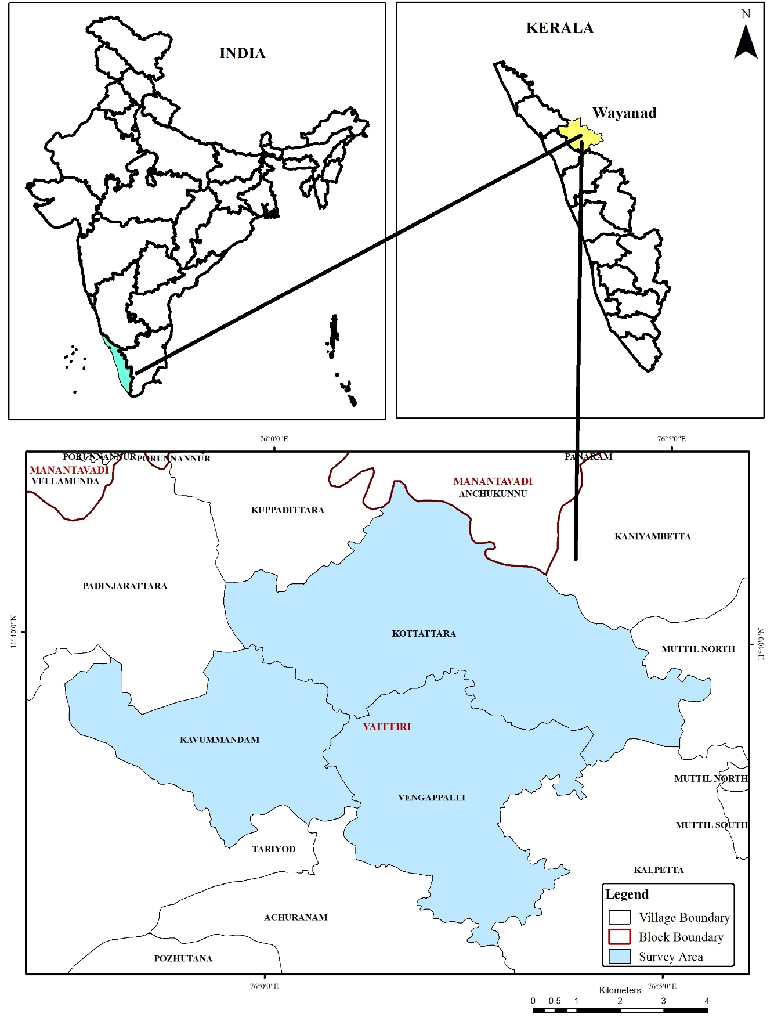
Fig. 1. Location map of study area

Soil mapping was conducted through field ground-truthing by traversing the area and examining soil profiles, auger bores, and shallow pits, as required, according to the physiographic heterogeneity of the landscape. Soil profiles were exposed to d5 depth (>100 cm) or to the depth of the parent material, whichever occurred first, and were examined in detail to record soil morphology. Shallow pits and auger bores were examined to confirm the extent of soil-unit boundaries. The morphological descriptions of these profiles were recorded in the field according to the guidelines of the Soil Survey Manual developed by the All India Soil & Land Use Survey Organization (1970).
The collected soil samples from the selected profiles were analysed for routine physical and chemical properties. Soil reaction (pH) and electrical conductivity (EC) were determined using the procedures described by Jackson (1973). Organic carbon content was estimated using the wet-digestion method of Walkley and Black (1934). Cation exchange capacity (CEC) was determined by a centrifuge-extraction procedure using neutral normal ammonium acetate (Thomas, 1982). Exchangeable sodium percentage (ESP) was determined by dividing the amount of exchangeable sodium by the cation exchange capacity. On the basis of physiography–soil relationships, five soil series—Padivayal, Nedumbala, Kottanad, Madakkimala, and Muttil—were identified and mapped in the survey area (Table 1).

Table 1. Morphological, Physical, and Taxonomic Characteristics of Soil Series in the Study Area
Series | Parent material | Physiography | Slope | Drainage | Texture | Structure | Consistency | Soil taxonomy
Kottanad (KT5) | Gneiss | Broad valley | Very gently(1-3%) to Gently(3-5%) | Poorly | Sandy clay loam | Moderate medium subangular blocky | Slightly hard (dry), friable (moist), slightly sticky and slightly plastic (wet) | Fine, Mixed, Isohyperthermic, Typic Endoaquepts
Madakkimala (MA5) | Gneiss | Narrow hill valleys | Gently(3-5%) | Poorly | Clay loam | Moderate medium subangular blocky | Hard (dry), firm (moist), sticky and plastic (wet) | Fine loamy, Mixed, Isohyperthermic, Fluvaquentic Endoaquepts
Muttil (MT5) | Gneiss | Broad valley | Very gently(1-3%) | Poorly | Sandy loam | Weak fine granular | Soft (dry), very friable (moist), non-sticky and non-plastic (wet) | Fine loamy, Mixed, Isohyperthermic, Typic Endoaquepts
Nedumbala (NB5) | Gneiss | Hills side slopes | Strongly(10-15%) to Moderately steep (15-25%) | Moderately well | Sandy clay loam | Moderate medium subangular blocky | Slightly hard (dry), friable (moist), slightly | Fine, Mixed, Isohyperthermic, Typic Hapludalfs
Padivayal (PD5) | Gneiss | Hills side slopes | Steep(25-33%) to Very steep(33-50%) | Moderately well | Clay loam | Moderate medium angular blocky | Hard (dry), firm (moist), sticky and plastic (wet) | Very fine, Mixed, Isohyperthermic, Ruptic Ultic Dystrudepts

3. RESULTS AND DISCUSSION

Interpretation of the satellite data, validated through ground-truthing, revealed three major physiographic units in the study area. On the basis of physiography–soil relationships, five soil series were identified and mapped. The Padivayal series was dominant, covering 3,419 ha and accounting for 48.98% of the total surveyed area. It was followed by the Nedumbala series, with 1,754 ha (25.13%); the Kottanad series, with 985 ha (14.11%); the Madakkimala series, with 482 ha (6.91%); and the Muttil series, with 94 ha (1.35%) (Fig. 2). These spatial patterns are consistent with digital soil-mapping approaches in which field observations are integrated with environmental covariates, terrain attributes, and remotely sensed information to predict soil classes and improve the reliability of soil-resource inventories (McBratney et al., 2003; Grunwald, 2009; Mulder et al., 2011).
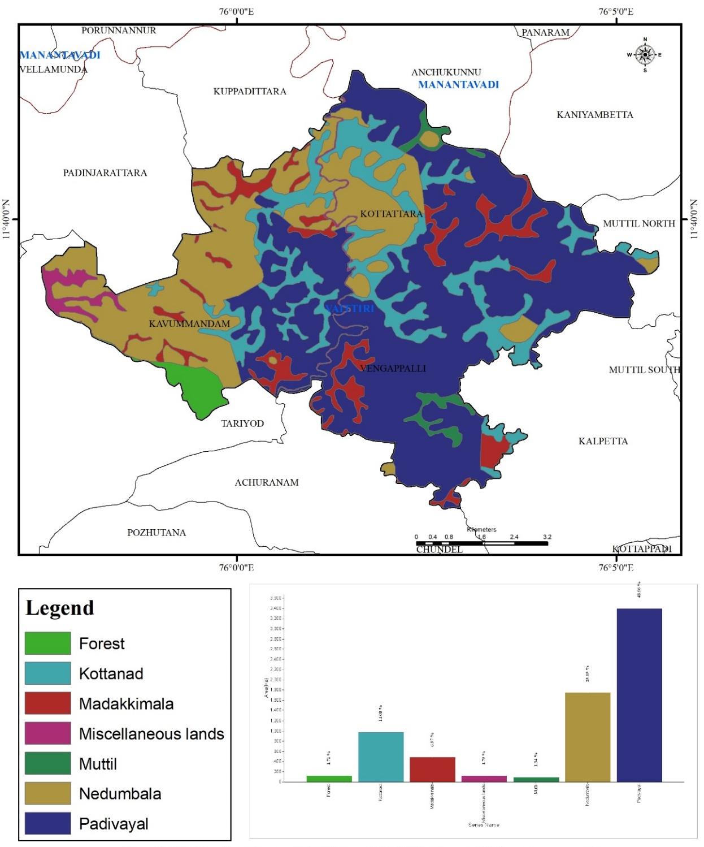
Fig. 2. Spatial distribution of identified soil series of study area
Based on slope, soil type, erosion intensity, and surface conditions, the physiographic units of the study area were further classified into 13 soil-mapping units (Fig. 3). Of these, PD5hG2P (1,877.4 ha) and PD5hH2P (1,455.0 ha) covered the largest areas, followed by the units associated with the Nedumbala soil series. In contrast, the Madakkimala and Muttil soil series occupied relatively smaller areas (Table 2). These units show that the soils of Kavummandam, Kottattara, and Vengappalli villages are highly variable and strongly influenced by the undulating topography, whereas the Padivayal and Kottanad mapping units reflect their adaptation to the prevailing geomorphic conditions. Subdivision of the landscape into soil-mapping units is useful because land evaluation depends on combined terrain–soil relationships rather than on individual soil attributes, particularly in heterogeneous hill environments (Rossiter, 1996; McBratney et al., 2003; Mulder et al., 2011).
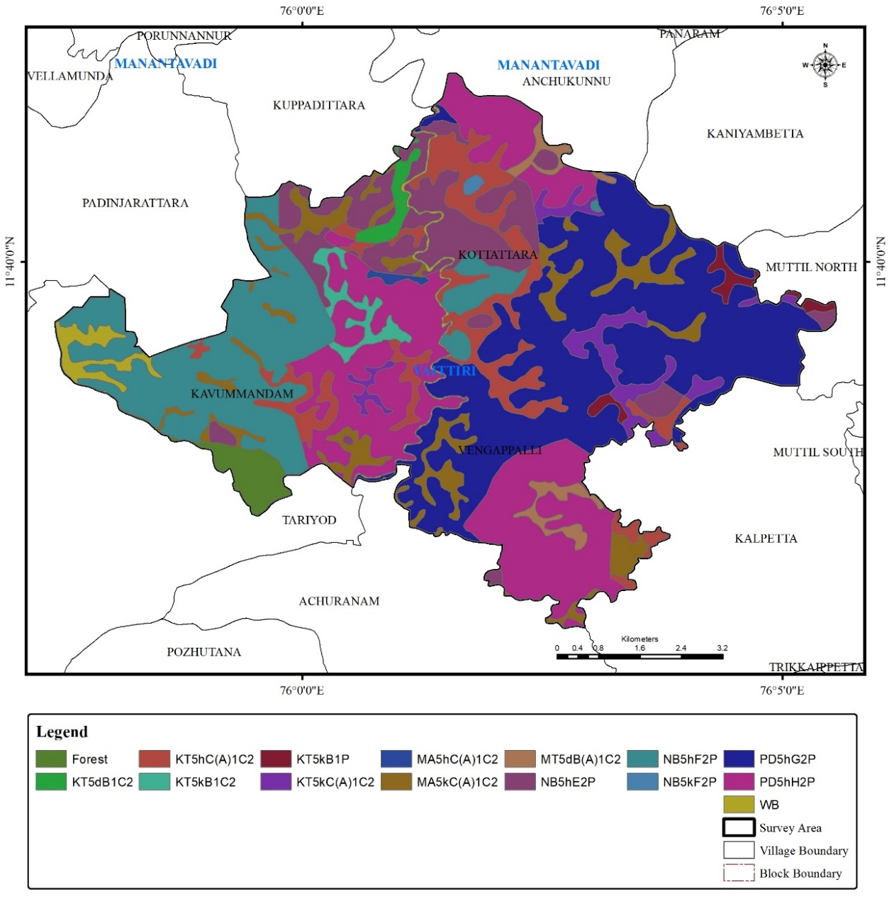
Fig. 3. Spatial distribution of soil mapping unit of study area.
Table 2. Area-wise distribution of soil mapping units within different soil series
Soil series | Soil Mapping unit | Area (ha)
Kottanad | KT5dB1C2 | 65.5
Kottanad | KT5hC(A)1C2 | 559.2
Kottanad | KT5kB1C2 | 85.3
Kottanad | KT5kB1P | 70.3
Kottanad | KT5kC(A)1C2 | 203.0
Madakkimala | MA5kC(A)1C2 | 454.0
Madakkimala | MA5hC(A)1C2 | 15.6
Muttil | MT5dB(A)1C2 | 101.5
Nedumbala | NB5hE2P | 677.3
Nedumbala | NB5hF2P | 1086.4
Nedumbala | NB5kF2P | 10.1
Padivayal | PD5hG2P | 1877.4
Padivayal | PD5hH2P | 1455.0
Miscellaneous | - | 203.8

The study area, covering 6,734 ha (96.48% of the total geographical area), was predominantly characterised by very deep soils exceeding 100 cm in depth (Fig. 4). The analysis indicates that nearly 100% of the cultivated land in the study area falls within the very deep soil category, providing favourable conditions for crop growth and root development. The remaining area comprises miscellaneous and forest land, which are categorised as non-agricultural land. The predominance of very deep soils is agronomically important because deeper rooting zones can improve water storage and root exploration; however, their practical suitability must still be interpreted in conjunction with slope, erosion risk, and chemical constraints (Rossiter, 1996; Oldfield et al., 2019).
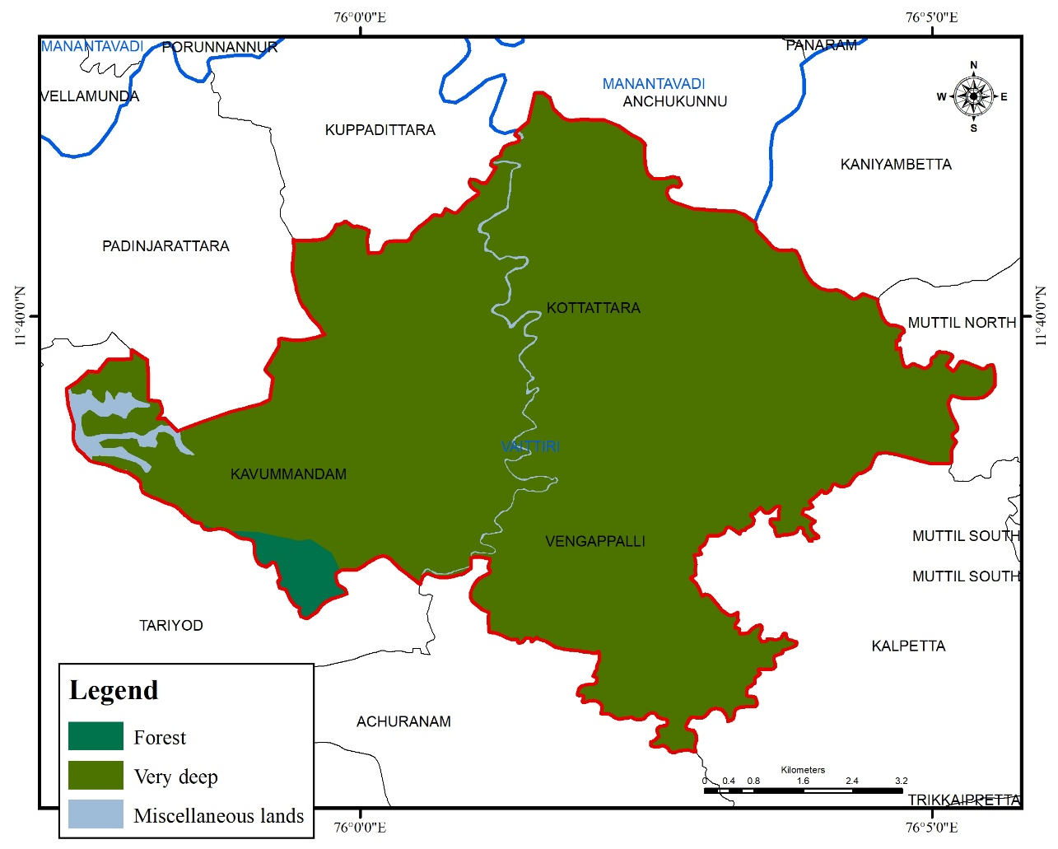
Fig. 4. Spatial distribution of soil depth classes in the study area.
The spatial distribution of erosion shows that soil erosion is a major land-degradation problem in the study area. Maps of the soil-erosion classes revealed that 74.11% of the area was affected by moderate erosion, whereas comparatively smaller areas fell within the none-to-slight erosion category (22.36%) (Fig. 5). This pattern further confirms the importance of erosion as a land-degradation constraint in the study area. The observation is important because water erosion is widely recognised as a major soil-degradation process that can remove nutrient-rich surface soil, reduce organic matter, and weaken long-term land productivity if conservation measures are not adopted (Panagos et al., 2015; Borrelli et al., 2017).
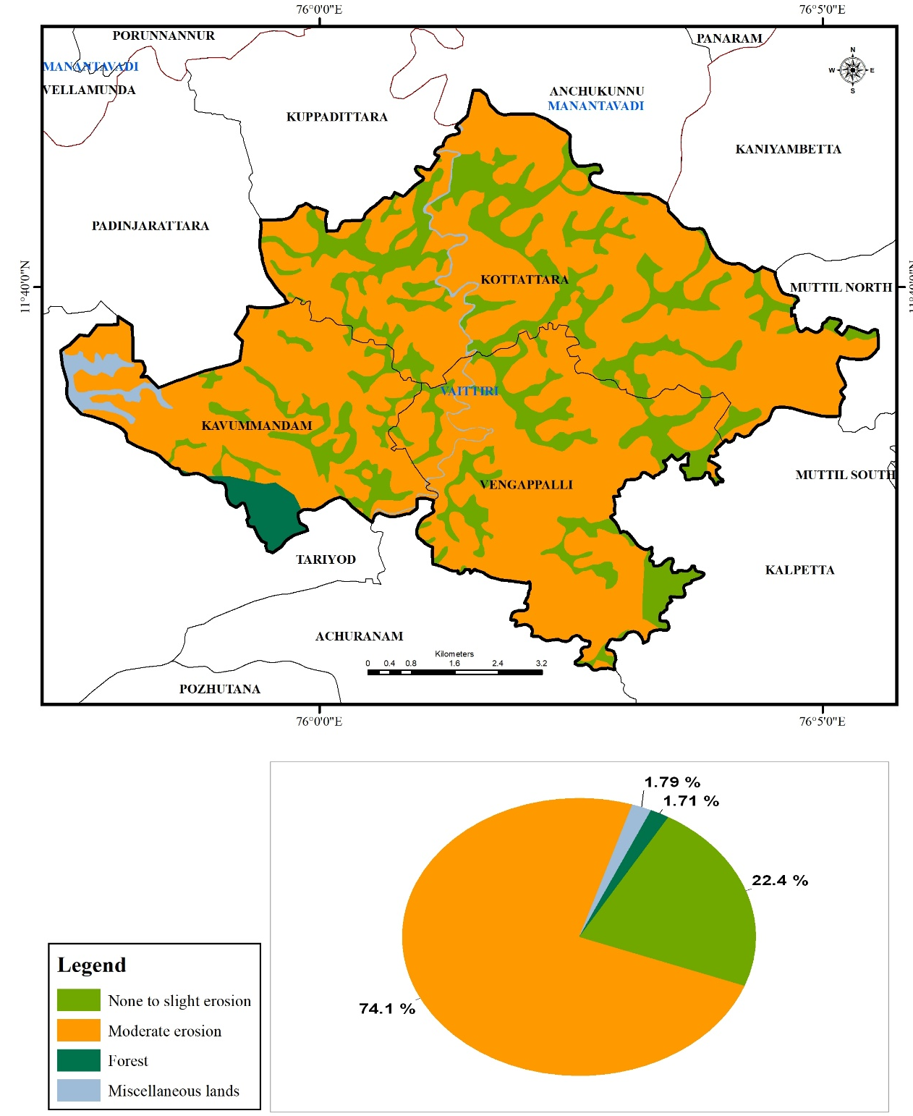
Fig. 5. Spatial distribution of soil erosion classes in the study area.

The study area was classified into seven slope classes: very gently sloping, gently terraced sloping, moderately steep sloping, strongly sloping, steep sloping, very gently terraced sloping, and very steep sloping. The largest proportion, 1,933 ha (27.69%), was classified as steeply sloping (25–33%), followed by 1,486 ha (21.29%) under very steep slopes (33–50%) and 1,261 ha (18.07%) under gently terraced slopes (0–5%) (Fig. 6).
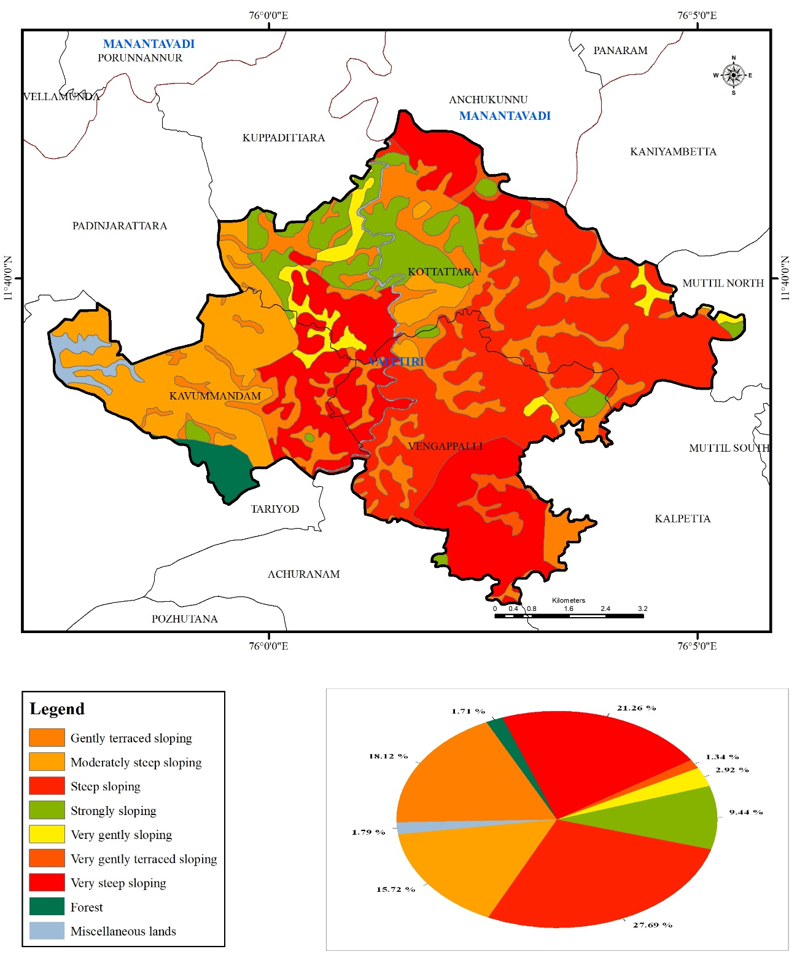
Fig. 6. Spatial distribution of soil slope classes in the study area.
Collectively, these findings show that very deep gneiss-derived soils occur mainly on steep slopes affected by moderate erosion, indicating that plantation management should be supported by appropriate soil and water conservation measures. Land capability classification (LCC) showed that 3,419 ha (48.98%) of the surveyed area fell within Class VI, representing land suitable for pasture and forestry with limitations (Fig. 7), whereas 1,754 ha (25.13%) was categorised as Class IV, indicating land suitable for occasional cultivation under cropping systems that account for major limitations. Only 22.40% fell within the comparatively productive Class II category. These lands support crop growth and production with slight to moderate limitations and are among the more productive agricultural lands within the study area. A similar result was reported by Seema et al. (2020).
The dominance of steep and very steep slopes explains the large proportion of land placed in restrictive capability classes, because slope gradient and erosion hazard are key criteria in land evaluation and suitability assessment (Rossiter, 1996; Panagos et al., 2015; Borrelli et al., 2017).
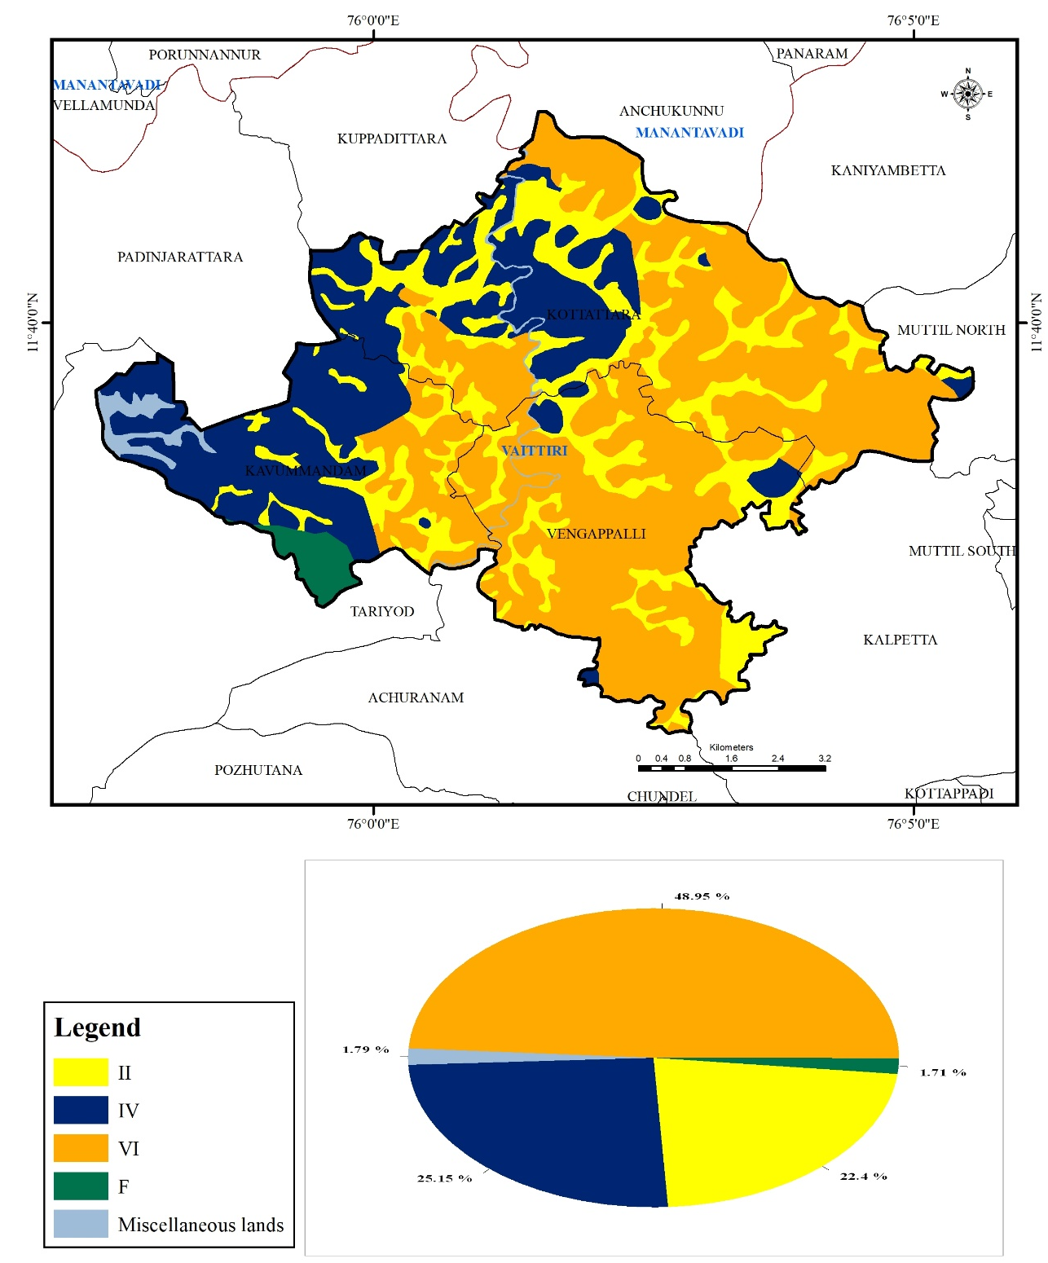
Fig. 7. Spatial distribution of Land Capability Classes (LCC) in the study area

The soil pH results indicate that all mapping units were strongly to moderately acidic. Surface-soil pH ranged from 4.51 to 5.80, whereas subsurface pH ranged from 4.55 to 5.98 (Table 3). The lowest surface pH was observed in Kottanad (4.51–4.67), indicating strongly acidic conditions, whereas Padivayal (5.50–5.80) had comparatively less acidic surface soils. Soil electrical conductivity (EC) values were very low (0.02–0.09 dS m⁻¹) in both surface and subsurface soils. Surface-soil organic carbon (OC) ranged from 1.08% to 2.81%, with the highest values recorded in Madakkimala (2.68–2.81%) and Padivayal (2.54–2.67%). Subsurface-soil OC decreased markedly in most soil series, except Madakkimala. Exchangeable sodium percentage (ESP) was uniformly low, ranging from 0.30% to 2.92%, and remained well below the threshold for sodic soils (ESP >15%). The highest surface ESP was observed in Kottappadi (2.92%), whereas the lowest was recorded in Nedumbala (0.44%). Cation exchange capacity (CEC) ranged from 6.69 to 17.72 cmol(p⁺) kg⁻¹ in surface soils and from 7.50 to 18.26 cmol(p⁺) kg⁻¹ in subsurface soils. The highest CEC was recorded in Muttil, followed by Kottanad and Nedumbala. These findings are consistent with those of Pragnya et al. (2023) and Devdas et al. (2021). The acidic reaction of the mapping units is consistent with humid landscapes, where intense weathering and leaching commonly lower soil pH, while the high organic carbon and low ESP values indicate limited sodicity risk and potentially favourable nutrient retention under appropriate management (Slessarev et al., 2016; Ramos et al., 2018; Oldfield et al., 2019).
Table 3. Chemical properties of soil series of study area
Soil series | Soil pH |  | Soil EC (dS m⁻¹) |  | Soil organic carbin (%) |  | Soil ESP (%) |  | Soil CEC (cmol(p⁺) kg⁻¹)
Soil series | Surface | Sub-surface | Surface | Sub-surface | Surface | Sub-surface | Surface | Sub-surface | Surface | Sub-surface
Kottanad | 4.51-4.67 | 5.05-5.16 | 0.07 | 0.09 | 2.48-2.76 | 0.98-1.09 | 1.14 | 0.74 | 14.7 | 11.76
Kottappadi | 4.82-5.12 | 5.54-5.72 | 0.09 | 0.04 | 1.55-1.86 | 0.6-0.70 | 2.92 | 0.49 | 10.43 | 9.7
Madakkimala | 5.2-5.32 | 5.31-5.41 | 0.02 | 0.02 | 2.68-2.81 | 3.0-3.20 | 0.65 | 0.3 | 6.69 | 7.82
Muttil | 4.86-5.01 | 5.91-5.98 | 0.04 | 0.02 | 1.08-1.21 | 0.65-0.81 | 0.64 | 0.61 | 17.72 | 18.26
Nedumbala | 4.78-4.84 | 4.55-4.61 | 0.04 | 0.02 | 1.31-1.42 | 1.01-1.06 | 0.44 | 0.6 | 14.9 | 9.43
Padivayal | 5.5-5.8 | 4.64-4.9 | 0.08 | 0.04 | 2.54-2.67 | 0.88-0.96 | 0.68 | 0.43 | 11.7 | 7.5

CONCLUSIONS

The detailed soil survey delineated five soil series across Kavummandam, Kottattara, and Vengappalli villages, with Padivayal and Nedumbala accounting for the largest proportions of the mapped area. Most soils were very deep; however, the prevalence of steep to very steep slopes and moderate erosion substantially constrained land use. The soils were strongly to moderately acidic, non-saline, and non-sodic, with moderate cation exchange capacity and variable organic carbon contents. Land capability classification placed nearly half of the surveyed area in Class VI, indicating that regular cultivation is restricted and that permanent vegetation, plantation, pasture, or forestry uses require appropriate conservation management. Smaller areas classified as Classes IV and II offer comparatively greater scope for cultivation, subject to their identified limitations. By integrating remote-sensing data, GIS, field observations, and laboratory analyses, the study generated a spatially explicit soil resource database. This database provides a practical basis for site-specific land-use planning, erosion control, soil-fertility management, and watershed-based conservation within the surveyed villages.

LIMITATIONS
The study was confined to three villages and assessed selected soil physical, morphological, and chemical attributes. Seasonal variability and uncertainty in the delineated mapping units were not evaluated. Future surveys should document sampling intensity, validate map accuracy independently, reconcile tabulated data, and assess temporal variation to strengthen the reliability and wider applicability of the findings.

Declaration of AI Use

This manuscript was prepared through the combined contributions of all author(s), including contributions to the study design, data, content development, results, interpretation, and related scholarly work. The author(s) acknowledge the use of Grammarly and ChatGPT to assist with grammar checking, language refinement, reference formatting. These AI-assisted tools were not used as authors and did not replace the intellectual contributions or scholarly judgment of the author(s). All AI-assisted outputs, including content, references, and interpretations, were carefully reviewed, revised, verified, and approved by the author(s). The author(s) accept full responsibility for the accuracy, integrity, and final content of the manuscript.

Competing interests

Authors have declared that no competing interests exist.

References

Adeniyi, O. D., Bature, H., & Mearker, M. (2024). A systematic review on digital soil mapping approaches in lowland areas. Land, 13(3), Article 379. https://doi.org/10.3390/land13030379
All India Soil and Land Use Survey Organization. (1970). Soil survey manual (Rev. ed.).
Ardak, S. A., Nagaraju, M. S. S., Prasad, J., Srivastava, R., & Barthwal, A. K. (2010). Characterization and evaluation of land resources in Khapri village of Nagpur district, Maharashtra, using high-resolution satellite data and GIS. Agropedology, 20(1), 7–18. https://isslup.in/wp-content/uploads/2018/09/Characterization-and-evaluation-of-land-resources-in.pdf
Borrelli, P., Robinson, D. A., Fleischer, L. R., Lugato, E., Ballabio, C., Alewell, C., Meusburger, K., Modugno, S., Schütt, B., Ferro, V., Bagarello, V., Van Oost, K., Montanarella, L., & Panagos, P. (2017). An assessment of the global impact of 21st century land use change on soil erosion. Nature Communications, 8, Article 2013. https://doi.org/10.1038/s41467-017-02142-7
Devdas, D., Srivastava, L. K., & Mishra, V. N. (2021). Characterization and classification of different soil type of Gariyaband district of Chhattisgarh. International Journal of Current Microbiology and Applied Sciences, 10(2), 1667–1677. https://doi.org/10.20546/ijcmas.2021.1002.197
Girdekar, S. B., Vaidya, P. H., Shinde, G. U., & Patil, N. M. (2024). Characterization and classification of soils of Jalna district of Marathwada region by using remote sensing and GIS techniques. International Journal of Plant & Soil Science, 36(12), 208–224. https://doi.org/10.9734/ijpss/2024/v36i125195
Grunwald, S. (2009). Multi-criteria characterization of recent digital soil mapping and modeling approaches. Geoderma, 152(3–4), 195–207. https://doi.org/10.1016/j.geoderma.2009.06.003
Jackson, M. L. (1973). Soil chemical analysis. Prentice-Hall of India.
Joseph, A. W. M., Nath, K., Wadodkar, M., Meena, R. L., Mahendra, A. C., Seetharaman, R., Shivakumar, R., & Sureshkumar, P. (2023). Generation of detailed soil information for the Virudhunagar aspirational district of Tamil Nadu using remote sensing and GIS techniques for developmental planning. Agropedology, 33(1), 1–12. https://doi.org/10.47114/j.agroped.2023.jun1
Kumar, Y. S., Gahlod, N. S., & Arya, V. S. (2016). Geospatial technology in soil resource inventory and land capability assessment for sustainable development—Wayanad district, Kerala. Journal of Soil and Water Conservation, 15(3), 218–225. https://epubs.icar.org.in/index.php/JSWC/article/view/108476
Lal, R., & Stewart, B. A. (Eds.). (2010). Food security and soil quality. CRC Press. https://doi.org/10.1201/EBK1439800577
Lanki, A. D., & Onwu, C. A. (2024). Geographic information system (GIS) application in soil fertility management: A review. Journal of Global Agriculture and Ecology, 16(2), 29–40. https://doi.org/10.56557/jogae/2024/v16i28592
McBratney, A. B., Mendonça Santos, M. L., & Minasny, B. (2003). On digital soil mapping. Geoderma, 117(1–2), 3–52. https://doi.org/10.1016/S0016-7061(03)00223-4
Mgohele, R. N., Massawe, B. H. J., Shitindi, M. J., Sanga, H. G., & Omar, M. M. (2024). Prediction of soil texture using remote sensing data: A systematic review. Frontiers in Remote Sensing, 5, Article 1461537. https://doi.org/10.3389/frsen.2024.1461537
Minasny, B., & McBratney, A. B. (2016). Digital soil mapping: A brief history and some lessons. Geoderma, 264, 301–311. https://doi.org/10.1016/j.geoderma.2015.07.017
Mulder, V. L., de Bruin, S., Schaepman, M. E., & Mayr, T. R. (2011). The use of remote sensing in soil and terrain mapping: A review. Geoderma, 162(1–2), 1–19. https://doi.org/10.1016/j.geoderma.2010.12.018
Oldfield, E. E., Bradford, M. A., & Wood, S. A. (2019). Global meta-analysis of the relationship between soil organic matter and crop yields. SOIL, 5, 15–32. https://doi.org/10.5194/soil-5-15-2019
Panagos, P., Borrelli, P., Poesen, J., Ballabio, C., Lugato, E., Meusburger, K., Montanarella, L., & Alewell, C. (2015). The new assessment of soil loss by water erosion in Europe. Environmental Science & Policy, 54, 438–447. https://doi.org/10.1016/j.envsci.2015.08.012
Pereira, P., Brevik, E. C., Muñoz-Rojas, M., Miller, B. A., Smetanova, A., Depellegrin, D., & Cerdà, A. (2017). Soil mapping and processes modeling for sustainable land management. In P. Pereira, E. C. Brevik, M. Muñoz-Rojas, & B. A. Miller (Eds.), Soil mapping and process modeling for sustainable land use management (pp. 29–60). Elsevier. https://doi.org/10.1016/B978-0-12-805200-6.00002-5
Pragnya, M., Prasad, M. R., Jayasree, G., & Reddy, I. V. S. (2023). Characterization and classification of oil palm growing soils of Khammam and Bhadradri Kothagudem districts of Telangana. Biological Forum—An International Journal, 15(9), 932–937. https://www.researchtrend.net/bfij/characterization-and-classification-of-oil-palm-growing-soils-of-khammam-and-bhadradri-kothagudem-districts-of-telangana-7563
Ramos, F. T., Dores, E. F. C., Weber, O. L. D. S., Beber, D. C., Campelo, J. H., Jr., & Maia, J. C. S. (2018). Soil organic matter doubles the cation exchange capacity of tropical soil under no-till farming in Brazil. Journal of the Science of Food and Agriculture, 98(9), 3595–3602. https://doi.org/10.1002/jsfa.8881
Rossiter, D. G. (1996). A theoretical framework for land evaluation. Geoderma, 72(3–4), 165–190. https://doi.org/10.1016/0016-7061(96)00031-6
Seema, Ghosh, A. K., & Yadav, S. (2020). Characterization and fertility assessment of soils of Chandauli district of eastern Uttar Pradesh for sustainable land use planning. The Indian Journal of Agricultural Sciences, 90(8), 1521–1527. https://doi.org/10.56093/ijas.v90i8.105954
Slessarev, E. W., Lin, Y., Bingham, N. L., Johnson, J. E., Dai, Y., Schimel, J. P., & Chadwick, O. A. (2016). Water balance creates a threshold in soil pH at the global scale. Nature, 540, 567–569. https://doi.org/10.1038/nature20139
Thomas, G. W. (1982). Exchangeable cations. In A. L. Page, R. H. Miller, & D. R. Keeney (Eds.), Methods of soil analysis: Part 2. Chemical and microbiological properties (2nd ed., Agronomy Monograph No. 9, pp. 159–165). American Society of Agronomy; Soil Science Society of America. https://doi.org/10.2134/agronmonogr9.2.2ed.c9
Walkley, A., & Black, I. A. (1934). An examination of the Degtjareff method for determining soil organic matter and a proposed modification of the chromic acid titration method. Soil Science, 37(1), 29–38. https://doi.org/10.1097/00010694-193401000-00003

