Original Research Article

Allelopathic Effect of Rice Straw Extract and its Potential use as a Bioherbicide

.

ABSTRACT

Rice straw contains allelochemicals that may contribute to sustainable weed management by suppressing weed growth and development. This study evaluated the allelopathic effect of rice straw extract from the Myanmar rice variety Paw San Yin (Oryza sativa L.) on lettuce (Lactuca sativa L.), four weed species, and two rice varieties under laboratory conditions at the Experiment and Lecture Building (II), Department of Agronomy, Yezin Agricultural University, Nay Pyi Taw, Myanmar, during May–September 2025. Two experiments were conducted in a randomised complete block design (RCBD) with four and five replications, respectively. Experiment I (May–July 2025) involved lettuce treated with aqueous rice straw extracts at 0, 10, 30, 50, and 100 g L⁻¹. Experiment II (July–September 2025) included barnyard grass (Echinochloa crus-galli (L.) P. Beauv.), red sprangletop (Leptochloa chinensis (L.) Nees), long-fruited primrose willow (Ludwigia octovalvis (Jacq.) P.H.Raven), sessile joyweed (Alternanthera sessilis (L.) R.Br. ex-DC.), and two rice varieties (Sin Thu Kha and Paw San Yin), treated with 0, 50, 100, and 150 g L⁻¹ extract concentrations. Germination percentage, shoot length (mm), root length (mm), fresh weight (mg), and dry weight (mg) were recorded. The results showed that rice straw extract significantly inhibited seed germination, seedling growth, fresh and dry weights of seedlings in a concentration-dependent manner. Complete inhibition of lettuce growth was observed at 100 g L⁻¹. In Experiment II, broadleaf weeds were more sensitive than grasses, with complete suppression of L. octovalvis and A. sessilis at higher concentrations. Root growth was more strongly inhibited by the allelochemicals in rice straw than shoot growth across all species. The extract also exhibited noticeable autotoxic effects on both rice varieties. Overall, the findings demonstrated that rice straw extract possesses strong allelopathic activity and has potential as a natural bioherbicide for weed management.

Keywords: Allelopathy, rice straw extract, weed suppression, autotoxicity, sustainable weed management

1. INTRODUCTION

Rice is one of the most important staple food crops consumed by nearly 4 billion people worldwide and is cultivated under diverse ecological conditions (Gaballah et al., 2021; Minten et al., 2025). The crop is especially significant in Asia, which accounts for the largest share of global rice production and consumption (Aravind et al., 2015). Globally, Myanmar is one of the world’s leading rice-exporting countries and has been ranked as the fifth-largest rice exporter, highlighting the economic importance of rice production to the country (Minten et al., 2025). Despite its importance, rice productivity is often limited by a range of biotic and abiotic factors, including weeds, insect pests, plant diseases, drought, nutrient deficiencies, and other environmental stresses. Among these constraints, weeds are considered among the most severe biotic factors affecting rice production (Rahaman et al., 2021), often causing greater yield losses than other agricultural pests such as insects, rodents, and plant diseases (Abouziena & Haggag, 2016). Weed infestation is regarded as one of the major causes of low crop yields throughout the world and can cause a 50–60% reduction in grain yield under puddled conditions and up to 91% yield reduction under non-puddled conditions (Ali & Sankaran, 1984). Normally, rice yield losses range from 15–20%, but in severe cases the losses can exceed 50 % depending on weed species and infestation intensity (International Rice Research Institute, 2006). In Myanmar, weed infestation can reduce rice grain yield by 26–62% depending on rice variety, weed intensity, and cultivation conditions (Kyu, 1993; Thura, 2010).

In most Southeast Asian countries, Echinochloa crass-galli and Monochoria vaginalis are predominant weeds in paddy fields. Echinochloa crass-galli (grass), Cyperus iria (sedge), Ludwigia octovalis, and Gratiola spp. (broadleaf weeds) were predominant weed species found in the experimental fields of Central Agricultural Research Institute, Yezin (Soe, 2003). Several weed control methods, including physical, chemical, and biological approaches, are commonly used in rice cultivation. Physical methods such as hand weeding are labour-intensive and often limited by labour shortages. Moreover, the use of synthetic herbicides can lead to environmental pollution, toxic residues in food, and the emergence of herbicide-resistant weed species (Asaduzzaman et al., 2010). In Asian rice production, herbicide use has increased over the past two decades, mainly due to rising labour costs and the availability and effectiveness of herbicides. This trend has been further intensified by the shift from labour-intensive transplanted rice systems to labour-saving direct-seeded rice systems, which increase weed pressure and promote problems such as weedy rice (red rice) infestation (Naylor, 1996). Furthermore, excessive herbicide application can increase chemical expenditures, contaminate groundwater resources via leaching and runoff, and present significant challenges for irrigation water recycling (Poudyal & Cregg, 2019). Therefore, integrating crop allelopathy with existing agronomic practices has been suggested as a sustainable and innovative strategy for agricultural production (Li et al., 2020).
Recent literature on rice-derived materials indicates that rice residues contain biologically active constituents relevant to weed management, while autotoxic effects on rice and the need for practical validation should also be considered (Yadav et al., 2021; Delana et al., 2025; Mai & Xuan, 2025).

Allelopathy refers to the ability of plants to influence the growth of neighbouring plants through the release of chemical substances into the environment, either by inhibiting or stimulating their development. The term “allelopathy” was first introduced by Hans Molisch to describe the positive and negative chemical interactions occurring among plants and microorganisms (Molisch, 1937). Allelochemicals often exhibit selectivity similar to that of synthetic herbicides (Weston, 1996). Allelopathy in crop plants, particularly rice, has been identified as a potential eco-friendly approach for weed suppression in sustainable agriculture (Putnam & Tang, 1986; Wu et al., 2000; Wu et al., 2001). Allelopathic rice varieties produce and release allelochemicals that limit weed development and establishment, and may be included as a component of an integrated weed management approach (Serra Serra et al., 2021).

Several studies have demonstrated the allelopathic potential of rice cultivars against various weed species. In a large-scale field experiment, Dilday et al. (1991) screened 5,000 rice accessions and identified approximately 191 that showed clear allelopathic activity against duck salad (Heteranthera limosa). Similar weed-suppressing effects have also been confirmed against other problematic weeds, such as barnyard grass (Echinochloa crus-galli) and Monochoria vaginalis (Lee et al., 2004; Olofsdotter et al., 1997). For instance, Rahaman et al. (2021) reported significant variation in the inhibitory effects of different rice varieties, in which shoot growth of barnyard grass was reduced by up to 51.90% under the sandwich method, highlighting the strong allelopathic potential of rice and the variability among cultivars. Several rice cultivars have also been reported to exhibit allelopathic activity against lettuce and barnyard grass (Azmi et al., 2000; Mazid et al., 2018). In addition, allelopathic rice varieties such as Huagan-3 in China and Rondo in the United States have been developed for their weed-suppressive potential (Gealy & Yan, 2012; Kong et al., 2011). Furthermore, rice straw-derived materials have been shown to exert strong inhibitory effects on weed growth. Balderas and Osillos (2023) reported that rice straw filtrates and finely cut straw residues suppressed seed germination, seedling emergence, growth, and dry matter production of Echinochloa crus-galli and Ludwigia octovalvis, indicating the allelopathic potential of rice straw. Allelochemicals may directly interfere with physiological functions of weeds, including seed germination, root and shoot growth, and symbiotic relationships (Scavo et al., 2019). Numerous phytotoxic compounds belonging to different chemical classes, including fatty acids, benzoxazinoids, indoles, phenolic acids, phenylalkanoic acids, and terpenoids, have been identified in rice straw extracts (Belz, 2007). These compounds have been reported to suppress paddy weed growth and improve rice yield (Xuan et al., 2005). The major allelochemicals identified in allelopathic rice cultivars are tricin and momilactone B (Kato-Noguchi & Ino, 2003). The inhibitory effects of allelochemicals on plant growth are highly species-dependent, with significant variation in germination and seedling response among different target weeds. Experimental studies have shown that both grass and broadleaf weeds may respond differently to the same allelochemical exposure; some species are strongly inhibited while others show partial tolerance or stimulation (Li et al., 2020; Panasiuk et al., 1986).
Recent mechanistic evidence further shows that allelopathic rice can deploy distinct metabolite- and rhizosheath-associated responses against quinclorac-susceptible and -resistant barnyardgrass (Li et al., 2026).

Aromatic rice is an important rice group in Myanmar because of its distinctive aroma, desirable eating quality, and high consumer preference. Several aromatic rice varieties, including Paw San Yin, Paw San Gyi, Paw San Latt, and Paw San Taung Pyan, are cultivated in Myanmar. Among these, Paw San Yin is an important variety with desirable grain quality and a strong aroma, which contribute to its high consumer preference (Aye et al., 2019). Rice straw is an abundant by-product of rice production in Myanmar. It is commonly used as livestock feed, incorporated into the soil, or burned after harvest. However, its potential use for weed management through allelopathy has received little attention in Myanmar. To our knowledge, there is limited information on the allelopathic effects of rice straw extracts from Myanmar rice varieties, particularly Paw San Yin, on the growth of different weed species. This lack of information highlights the need to investigate the allelopathic potential of Paw San Yin rice straw. Paw San Yin was selected for this study because it is a high-quality, aromatic rice variety commonly cultivated in Myanmar, and its straw is readily available in the Yezin area of Nay Pyi Taw, where the study was conducted. In this study, lettuce (Lactuca sativa L.) was selected as a model plant because it is sensitive to allelopathic effects and is widely used in laboratory bioassays due to its high germination rate and rapid growth (Wang et al., 2022). The present study evaluated the effects of Paw San Yin rice straw extracts on the germination and seedling growth of lettuce and on the growth of selected weed species and two rice varieties to assess their potential for sustainable weed management.
2. material and methods

2.1 Collection of plant material

Rice straw of the Paw San Yin variety was collected from the Rice Division, Department of Agricultural Research, Yezin, Nay Pyi Taw, Myanmar. Paw San Yin, a well-known aromatic rice variety of Myanmar, is widely cultivated in the Ayeyarwady Delta region (Khin Than Nwe & Tin Tin Myint, 2004). The straw was shade-dried for 14 days, chopped into small pieces, and ground into fine powder.
2.2 Extraction of rice straw
Rice straw aqueous extracts were prepared by soaking 10, 30, 50, 100, and 150 g of rice straw powder in 1 L of distilled water. The mixtures were kept under dark conditions at room temperature for 48 hours to facilitate extraction. After 48 hours, these mixtures were filtered through muslin cloth to obtain the crude aqueous extracts. Prior to the bioassay experiments, the filtrates were stored in a refrigerator at 14°C.

2.3 Bioassay

2.3.1 Experiment I: Allelopathic Effect of Rice Straw Extract on Lettuce

The experiment was arranged in a randomised complete block design (RCBD) with four replications. Treatments consisted of distilled water (control) and rice straw extracts at concentrations of 10, 30, 50, and 100 g L⁻¹. Twenty-five lettuce seeds (Lactuca sativa L.) were placed in 9-cm Petri dishes lined with filter paper. The seeds were then treated with the respective extracts. The Petri dishes were maintained in a growth chamber at 27°C for 10 days.

2.3.2 Experiment II: Allelopathic Effect of Rice Straw Extract on Weed Species and Rice Varieties

The second experiment was conducted using the same extraction procedure as in Experiment I. Treatments consisted of distilled water (control), 50, 100, and 150 g L⁻¹ rice straw extracts arranged in an RCBD with five replications. The tested weed species included two grass weeds: barnyard grass (E. crus-galli), red sprangletop (L. chinensis), and two broadleaf weeds: long-fruited primrose willow (L. octovalvis), and sessile joyweed (A. sessilis). To evaluate autotoxicity, two rice varieties, Sin Thu Kha (a widely cultivated rice variety in Myanmar) and Paw San Yin (Oryza sativa L.), were used. Twenty-five pre-germinated seeds of each species were placed in Petri dishes containing filter paper moistened with the respective extract solutions and incubated at 27°C for 10 days.

2.4 Data Collection

Germination (%) was recorded daily for 10 days. Seeds were considered germinated when the radicle exceeded 2 mm in length. At 10 days after sowing, ten randomly selected seedlings from each treatment were used to measure the shoot and root lengths of the seedlings. Fresh weight was determined immediately after harvesting, while dry weight was measured after oven-drying at 70°C for 48 h.

2.4.1 Germination percentage
Germination percentage is an estimate of the viability of seeds. Germinated seeds were counted every 24 h for 10 days, and germination percentage was calculated according to the formula described by International Seed Testing Association (ISTA, 1996).
Germination (%) = $\frac{\text{Number of seed germinated} }{\text{Number of seed tested}}$ x 100
2.4.2 Inhibition percentages
The inhibition percentages for germination, root length, shoot length, and seedling growth were calculated according to the following equations, respectively.
$$\text{Inhibition of germination (\%) }\text{ =}\text{100 -}\left(\frac{\text{E2}}{\text{E1}}\right)\text{X100}$$
Where,
I = (%) inhibition
E1 = Response of control plant
E2 = Response of treatment plant (Batish et al., 2006; Khang et al., 2023)
Inhibition (%) of shoot length = $\frac{\text{(}\text{Control shoot length-treated shoot length)}}{\text{Control shoot length}}$ x 100%

Inhibition (%) of root length = $\frac{\text{(Control root length-treated root length}\text{)}}{\text{Control root length}}$ x 100%
(Khang et al., 2023)

2.5 Statistical Analysis

All data collected for the different parameters were analysed using Statistix version (8.0), and the treatment means were compared using the least significant difference (LSD) test at the 5% level (Gomez & Gomez, 1984).
3. results and discussion

3.1 Experiment I: The growth-inhibitory effect of rice straw extracts on lettuce under laboratory conditions and isolation of growth-inhibitory substances in rice straw extracts

3.1.1 Germination (%)

The effect of rice straw extract on the germination (%) of lettuce is presented in Table 1. There were highly significant differences in germination (%) among the different extract concentrations. Notably, complete inhibition of seed germination occurred at the highest concentration, 100 g L⁻¹ (T5), highlighting the strong phytotoxic potential of the rice straw extract. These results may be due to the inhibitory effect of rice straw extract on seed germination through the release of phenolic allelochemicals. The highest germination percentages were recorded in the untreated control (T1) and 10 g L⁻¹ (T2), followed by 30 g L⁻¹ (T3) (40%) and 50 g L⁻¹ (T4) (35%). No germination was observed at 100 g L⁻¹ (T5). However, no significant difference was found between T3 and T4. Among the rice straw extract treatments (T1–T5), complete inhibition of lettuce seed germination was observed at 100 g L⁻¹ (T5). Germination percentage progressively declined with increasing rice straw extract concentration, indicating a concentration-dependent inhibitory effect. This response may be attributed to allelochemicals present in the rice straw extract, which may interfere with physiological processes involved in seed germination. In addition, allelochemicals released from rice stem extracts can enter the internal tissues of seeds and inhibit germination, suggesting that rice straw extracts may similarly release toxic allelochemicals (p-hydroxybenzoic, p-coumaric, ferulic, syringic, and vanillic acids) that interfere with seed germination (Li et al., 2024). Allelochemicals can change the components of phytohormones or cause imbalances among them, which disrupt normal plant growth and development (Cheng & Cheng, 2015). Consequently, these allelochemicals may interfere with essential physiological and biochemical processes involved in seed germination and early seedling development. Similar findings have been reported, with inhibitory effects of rice-derived allelochemicals on cress (Lepidium sativum), lettuce, and barnyard grass being observed (Chung et al., 2001b; Kato-Noguchi & Ino, 2005). Likewise, Xiao et al. (2020) demonstrated that rice straw extracts significantly suppressed lettuce seed germination, supporting the results of the present study.

Table 1. Germination %, shoot and root length (mm), fresh and dry weight (mg) of Lactuca sativa as affected by different concentrations of rice straw extract
Treatment | Germination % | Shoot length (mm) | Root length (mm) | Fresh weight (mg) | Dry weight (mg)
T1 control | 96.00 a | 27.78 ab | 53.94 b | 22.70 b | 0.80 a
T2 (10 gL⁻¹) | 93.00 a | 29.58 a | 76.85 a | 30.13 a | 0.85 a
T3 (30 gL⁻¹) | 40.00 b | 26.30 b | 21.95 c | 16.85 c | 0.75 a
T4 (50 gL⁻¹) | 35.00 b | 13.64 c | 13.37 d | 5.18 d | 0.45 b
T5 (100 gL⁻¹) | 0.00 c | 0.00 d | 0.00 e | 0.00 e | 0.00 c
LSD _{0.05} | 11.89 | 2.53 | 8.47 | 4.18 | 0.17
P value | < .001 | < .001 | < .001 | < .001 | < .001
CV % | 14.62 | 8.42 | 16.54 | 18.14 | 19.48
In a column, means sharing the same letters are not significantly different.
T1 = Control (Distilled water) T3 = Rice straw extract (30 g L⁻¹)
T2 = Rice straw extract (10 g L⁻¹) T4 = Rice straw extract (50 g L⁻¹)
T5 = Rice straw extract (100 g L⁻¹)
3.1. 2 Shoot and root length
The effects of different concentrations of rice straw extract on lettuce shoot and root length are presented in Table 1. For shoot length in lettuce seedlings, there were highly significant differences among different concentrations. Rice straw extract at 100 g L⁻¹ (T5) completely inhibited lettuce germination; therefore, shoot and root lengths were not recorded (Plate 1). Among the treatments that successfully germinated, the minimum shoot length (13.64 mm) was observed at 50 g L⁻¹ (T4). In contrast, the maximum shoot lengths were recorded at 10 g L⁻¹ (T2) (29.58 mm), the control (27.78 mm), and 30 g L⁻¹ (T3) (26.30 mm). The control showed no significant difference from either T2 or T3, whereas T2 and T3 differed significantly from each other. The enhanced shoot growth observed at 10 g L⁻¹ (T2) suggests a stimulatory effect of rice straw extract at a low concentration, which may be attributed to hormesis. This phenomenon describes the ability of compounds to inhibit growth at high doses while stimulating growth at low doses (Duke et al., 2006). Similarly, Anuar et al. (2015) reported that rice straw extract from the MR220 CL2 variety significantly stimulated radicle length and fresh weight of the test plants (barnyard grass) at a concentration of 50 g L⁻¹. Shoot length began to decrease at 50 g L⁻¹, and the reduction became more pronounced with increasing concentrations of the rice straw extract, indicating a concentration-dependent effect on shoot length. These results suggested that Paw San Yin rice straw extract exhibited a phytotoxic effect and might have contained growth-inhibitory substances with allelopathic activity that reduced shoot length. For root length, there were highly significant differences among different concentrations of rice straw extract. Rice straw extract at 100 g L⁻¹ (T5) completely inhibited the lettuce root growth. The longest root length (76.85 mm) was observed at 10 g L⁻¹ (T2), followed by the control (T1) at 53.94 mm. Root length decreased sharply to 21.95 mm and 13.37 mm at 30 g L⁻¹ (T3) and 50 g L⁻¹ (T4), respectively (Table 1). Root length showed a pronounced reduction in T3. This reduction may have been attributed to inhibitory substances present in the rice straw extract, which may have interfered with root development and restricted root elongation.
3.1.3 Fresh and dry weight
The effects of rice straw extract on the fresh and dry weight of lettuce are presented in Table 1. Fresh and dry weights showed highly significant differences among different concentrations. There was no germination at the highest concentration of 100 g L⁻¹ (T5); therefore, fresh and dry weights could not be measured. The maximum fresh weight (30.13 mg) occurred at 10 g L⁻¹ (T2), followed by 22.27 mg in the control (T1). In contrast, fresh weight decreased markedly to 16.85 mg at 30 g L⁻¹ (T3) and 5.91 mg at 50 g L⁻¹ (T4), respectively. The maximum dry weight (0.85 mg) occurred at 10 g L⁻¹ (T2), followed by control (T1) and 30 g L⁻¹ (T3), which were not statistically different from each other. A notable decrease in dry weight (0.45 mg) occurred at 50 g L⁻¹ (T4).
Fresh weight showed significant differences among all treatments, while dry weight differed significantly from T4 onward. The reductions in fresh and dry weight might have been attributed to the presence of growth-inhibitory substances in the rice straw extract. Ahn et al. (2005) reported comparable results, showing that allelopathic rice germplasm suppressed the growth of Echinochloa crus-galli, leading to significant reductions in dry biomass, leaf area, and plant height. Similarly, Seyyednejad et al. (2010) speculated that water hull extracts of 11 rice cultivars inhibited germination, dry weight, and root length of Silybum marianum. The ground straw substantially inhibited the fresh and dry weights of shoot biomass by up to 89.6% in broad-leaved weeds and by up to 86.6% in narrow-leaved weeds (El-Shahawy et al., 2006).
3.1.4 Inhibition (%) of shoot and root length
Rice straw extract at 50 g L⁻¹ (T4) reduced the shoot and root lengths of lettuce seedlings by 51.03% and 75.22%, respectively, compared with the control (Fig.1). Remarkably, root growth inhibition reached 59.01% even at the lower concentration of 30 g L⁻¹ (T3), indicating a high sensitivity of root tissues to the rice straw extract. At 100 g L⁻¹ (T5), the extract completely inhibited both shoot and root growth of lettuce. This may be due to the greater vulnerability of root tissues caused by direct exposure to the extract and the high sensitivity of actively dividing root meristem cells. The progressive reduction in shoot and root length with increasing extract concentration suggested a concentration-dependent phytotoxic effect of the rice straw extract.
Similarly, aqueous methanol extracts of rice plants were also found to inhibit the germination and growth of lettuce and barnyard grass (Ahn & Chung, 2000; Chung et al., 2001a, 2001b). Furthermore, the allelopathic effect of rice on paddy weeds exhibited a greater inhibitory effect on root growth than on shoot growth (He & Lin, 2001). This observation is consistent with previous studies reporting that allelochemicals commonly inhibit coleoptile elongation and suppress seedling growth, particularly affecting shoot and root development (Kruse et al., 2000; Li et al., 2024). In addition, Weir et al. (2004) reported that inhibition of the photosynthetic rate and disruption of respiration, ATP synthesis, and amino acid metabolism were major physiological and biochemical mechanisms that might be mediated by allelochemicals.
Aqueous extracts of rice plants have been reported to inhibit the growth of several plant species, including lettuce, with pronounced effects on root growth (Chou & Lin, 1976; Takeuchi et al., 2001). Applying rice straw extract at different concentrations inhibited seed germination as well as seedling root and shoot growth in both broad-leaved and grass species. The affected plants included crop species such as wheat (Triticum aestivum L. cv.), radish (Raphanus sativus L.), and jute (Corchorus olitorius L.), as well as the weed species barnyard grass (Echinochloa crus-galli) (El-Shahawy et al., 2006). Likewise, Chon and Kim (2004) demonstrated that the extracts of barley, oats, rice, and wheat significantly reduced root growth of alfalfa (Medicago sativa L.), barnyard grass, and Eclipta (Eclipta prostrata L.).
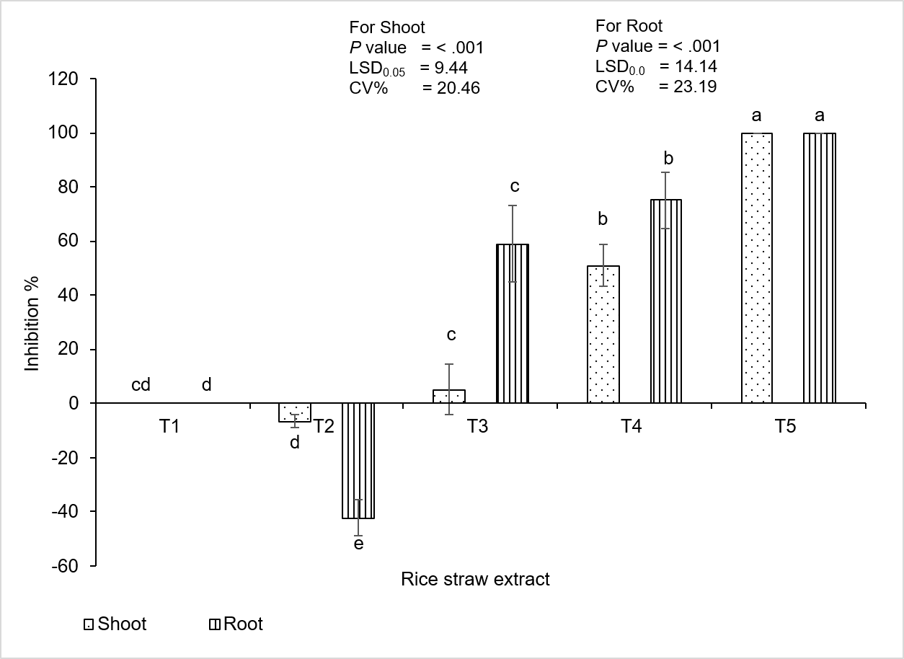
T1 = Control (Distilled water) T3 = Rice straw extract (30 g L⁻¹)
T2 = Rice straw extract (10 g L⁻¹) T4 = Rice straw extract (50 g L⁻¹)
T5 = Rice straw extract (100 g L⁻¹)
Fig. 1. Inhibition% of shoot and root length of lettuce as affected by different concentrations of rice straw extract
Mean ± S.E.M = Mean values ± Standard error of means of four replications
3.2 Experiment II: Evaluation of the growth inhibition effect of rice straw extract on tested weed species and two rice varieties under laboratory conditions
3.2.1 Shoot and root length
The effects of rice straw extract on four tested weed species (Barnyard grass, Red sprangletop, Long-fruited primrose willow, Sessile joy weed) and two rice varieties (Paw San Yin and Sin Thu Kha) are shown in Table 2. There were highly significant differences in shoot and root lengths among all tested plant species in response to different concentrations of rice straw extract.
In barnyard grass, the maximum shoot length of 44.02 mm was observed in the control (T1) treatment, followed by 36.09 mm at 50 g L⁻¹ (T2) and 23.36 mm at 100 g L⁻¹ (T3). The minimum shoot length (16.54 mm) was observed at a concentration of 150 g L⁻¹ (T4). As the concentration of rice straw extract increased, the shoot length gradually decreased (Plate 2). This result indicates that the highest concentration of rice straw extract had the strongest inhibitory effect on the growth of barnyard grass. The inhibitory effects may be attributed to the action of allelopathic substances. Earlier studies have shown that allelochemicals can interfere with plant growth at various stages, including seed germination, seedling development, dry matter production, and biochemical functions, resulting in reduced overall plant performance (Otusanya & Ilori, 2014).
For root length in barnyard grass, there were highly significant differences among different concentrations of rice straw extract. The maximum root length (28.78 mm) was observed in the T1 control. The rice straw extract concentration of 50 g L⁻¹ and 100 g L⁻¹ significantly reduced the root length of barnyard grass to 7.78 mm and 2.96 mm, respectively. The concentration of 150 g L⁻¹ rice straw extract significantly restricted the root length of barnyard grass to 0.06 mm. These results clearly demonstrated that root growth was highly sensitive to increasing concentrations of rice straw extract. Similar inhibitory effects of rice straw extracts from rice cultivars Basmati 386, Govind, and Kalanamak on seed germination and seedling growth of Chenopodium album L., Echinochloa crus-galli, Phalaris minor, and Solanum nigrum were reported by Rajput et al. (2010). Furthermore, Chung et al. (2001b) identified several phenolic compounds, including p-hydroxybenzoic acid, p-coumaric acid, and ferulic acid, in highly allelopathic rice cultivars and reported that p-hydroxybenzoic acid exerted the strongest inhibitory effect on barnyard grass. Previous studies by Olofsdotter et al. (1995) and Gealy et al. (2000) also confirmed that rice straw is rich in allelopathic compounds such as ferulic acid. Chung et al. (2003) further emphasised that allelochemicals present in rice hulls, leaves, and straw could potentially serve as natural herbicides by suppressing seed germination and seedling growth. These results support the previous report by Ismail et al. (2007), which showed that allelopathic effects of the rice varieties Manik and Makmuer markedly inhibited the root elongation of E. crus-galli, with reductions of more than 80% and 75%, respectively.
In red sprangletop, there were highly significant differences among different concentrations of rice straw extract. The maximum shoot length occurred in the control (T1), followed by 2.82 mm at 50 g L⁻¹ (T2) and 2.48 mm at 100 g L⁻¹ (T3); however, there was no significant difference between T2 and T3. Moreover, the minimum shoot length (1.54 mm) was observed at 150 g L⁻¹ (T4) (Plate 2). The observed result may be attributed to the allelochemicals present in rice straw residues. Ho et al. (2021) reported that rice by-products reduced seed and seedling survival of Echinochloa crus-galli, Leptochloa chinensis, and Fimbristylis miliacea. Ho et al. (2021) reported that rice-derived compounds such as phenolic acids, coumarin, and ergosterol peroxide exhibited strong suppressive effects on several grass weeds and contributed to prolonged weed inhibition.
For root length in red sprangletop, there were highly significant differences among different concentrations of rice straw extract. The maximum root length of red sprangletop (11.3 mm) was observed in the control (T1) treatment, followed by 4.40 mm and 4.06 mm at 50 g L⁻¹ (T2) and 100 g L⁻¹ (T3), respectively; however, no significant difference was observed between T2 and T3. The minimum root length (3.78 mm) was recorded at the highest concentration, 150 g L⁻¹ (T4), and it was significantly different from the other treatments. The inhibitory effect of rice straw extract on red sprangletop may be attributed to the presence of allelopathic chemical compounds in the extract. Similar results were reported by Le et al. (2024), who found that N-trans-cinnamoyltyramine (NTCT), an allelochemical isolated from rice, significantly inhibited the growth of red sprangletop in a concentration-dependent manner. Their study showed that shoot and root growth were strongly suppressed at concentrations of 2.4 μM and above, whereas no inhibitory effect was observed at 0.024 μM. At 24 μM, shoot and root growth were reduced by 87.8% and 92.3%, respectively. The findings of the present study therefore suggest that rice straw extract possesses strong allelopathic potential against red sprangletop, particularly at higher concentrations, and that root growth is more sensitive to allelochemical stress than shoot growth.
In long-fruited primrose willow, the rice straw extract significantly inhibited both shoot and root growth. There were highly significant differences among different concentrations of rice straw extract. The maximum shoot length (4.84 mm) of long- fruited primrose willow was observed in the control (T1) treatment, followed by (3.74 mm) at 50 g L⁻¹ (T2) and (1.18 mm) at 100 g L⁻¹ (T3), representing highly significant differences between treatments. The maximum root length (2.16 mm) was observed in the control (T1) treatment, followed by 0.51 mm at T2 and 0.15 mm at 100 g L⁻¹ (T3), respectively. Complete reductions in shoot and root length were observed at the highest concentration of 150 g L⁻¹ (T4) (Plate 2). Similarly, Barnes and Putnam (1983) reported that rye residues exerted strong suppressive effects on annual broadleaf weeds, supporting the greater sensitivity of broadleaf weed species observed in the present study.
In sessile joyweed, the highest shoot and root lengths, 16.92 mm and 16.74 mm, respectively, were recorded in the control (T1) treatment, followed by 50 g L⁻¹ (T2) with shoot and root lengths of (13.70 mm) and (4.85 mm), respectively. The rice straw extract concentration of 100 g L⁻¹ (T3) markedly reduced shoot and root lengths to 0.18 mm and 0.07 mm. At the highest concentration 150 g L⁻¹ (T4), no seed germination was observed; therefore, shoot and root lengths could not be measured, indicating complete inhibition of seedling growth (Plate 2). These results are in agreement with those reported by Afridi et al. (2013), who found that rice straw extract completely inhibited the growth and development of several plant species, including Gossypium hirsutum L., Ipomoea batatas (L.) Lam., Rumex dentatus L., and Convolvulus arvensis L. More broadly, previous research has shown that allelopathic rice cultivars can suppress both monocot and dicot weeds, although the degree of inhibition varies among species (Olofsdotter et al., 2002), supporting the differential sensitivity observed among the weed species in the present study.
The effects of rice straw extract on the shoot and root lengths of Sin Thu Kha and Paw San Yin rice varieties are also presented in Table 2. For the Sin Thu Kha rice variety, the longest shoot and root lengths, 41.28 mm and 52.36 mm, respectively, were observed in the control treatment, followed by 30.28 mm for shoot length and 15.24 mm for root length at 50 g L⁻¹ (T2). At a concentration of 100 g L⁻¹ (T3), the shoot and root lengths were reduced to (11.40 mm) and (0.80 mm), respectively. The minimum shoot and root lengths, 9.56 mm and 0.70 mm, respectively, were recorded at 150 g L⁻¹ (T4) (Plate 2).
For the Paw San Yin variety, the maximum shoot and root lengths of 57.84 mm and 42.20 mm, respectively, were recorded in the control (T1) treatment. These values decreased to 41.88 mm for shoot length and 17.48 mm for root length at 50 g L⁻¹ (T2). Further reduction was observed at 100 g L⁻¹ (T3), where the shoot and root lengths declined to 22.52 mm and 4.64 mm, respectively. The minimum shoot and root lengths, 15.96 mm and 1.84 mm, respectively, were recorded at 150 g L⁻¹ (T4), indicating a concentration-dependent inhibitory effect of rice straw extract on seedling growth (Plate 2). Rice straw decomposition can release phytotoxic compounds that negatively affect rice growth, resulting in reduced seed germination and suppressed seedling development in both the same and different rice varieties. Chung et al. (2001b) reported that rice straw extracts significantly inhibited radicle elongation in rice (Oryza sativa L.), confirming the presence of more autotoxic allelochemicals at higher concentrations. This phenomenon is particularly important in continuous rice monocropping systems, where repeated incorporation of rice residues into soil leads to the accumulation of inhibitory substances that contribute to autotoxic stress (Chi et al., 2013).

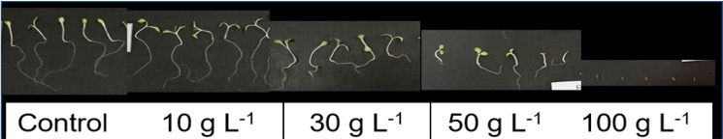
Plate .1. Shoot and root length of Lettuce as affected by different concentrations of rice straw extract

Echinochloa crus-galli
Leptochloa chinensis
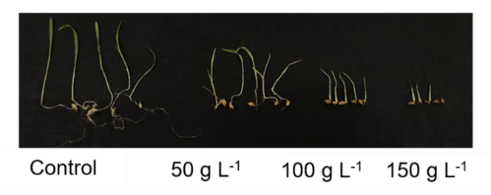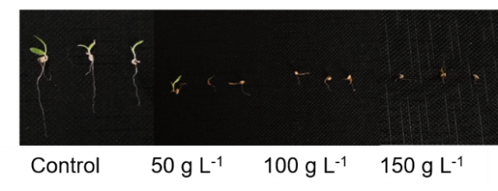
Aletenanthera sessilis
Ludwigia octovalis
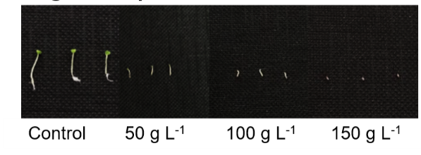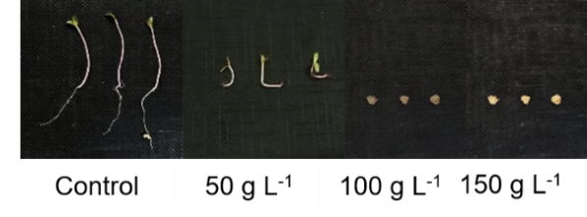
Oryza sativa
Oryza sativa
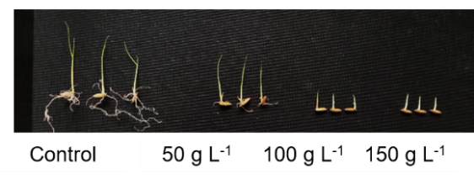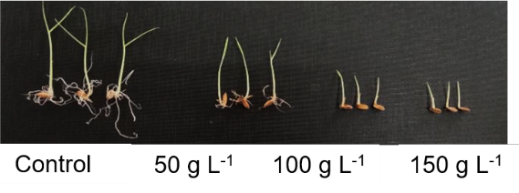

Plate. 2. Shoot and root length of six tested plants as affected by different concentrations of rice straw extract

Table .2. Shoot and Root length (mm) of Barnyard grass, Red sprangletop, Long-fruited primrose willow, Sessile joy weed, Sin Thu Kha and Paw San Yin as affected by different concentration of rice straw extract
Treatment | Barnyard grass |  | Red sprangletop |  | Long-fruited primrose willow |  | Sessile joy weed |  | Sin Thu Kha |  | Paw San Yin
Treatment | Shoot length | Root length | Shoot length | Root length | Shoot length | Root length | Shoot length | Root length | Shoot length | Root length | Shoot length | Root length
T1 Control | 44.02 a | 28.78 a | 5.06 a | 11.36 a | 4.84 a | 2.16 a | 16.92 a | 16.74 a | 41.28 a | 52.36 a | 57.84 a | 42.20 a
T2 (50 g L⁻¹) | 36.09 b | 7.78 b | 2.82 b | 4.40 b | 3.74 b | 0.51 b | 13.70 b | 4.85 b | 30.28 b | 15.24 b | 41.88 b | 17.48 b
T3 (100 g L⁻¹) | 23.36 c | 2.96 c | 2.48 b | 4.06 b | 1.18 c | 0.15 c | 0.18 c | 0.07 c | 11.40 c | 0.80 c | 22.52 c | 4.64 c
T4 (150 g L⁻¹) | 16.54 d | 0.06 d | 1.54 c | 3.78 b | 0.00 d | 0.00 c | 0.00 c | 0.00 c | 9.56 c | 0.70 c | 15.96 d | 1.84 c
LSD _{0.05} | 5.25 | 0.75 | 0.88 | 1.01 | 0.86 | 0.20 | 1.45 | 1.86 | 2.79 | 6.21 | 3.9 | 2.98
P value | < .001 | <.001 | < .001 | < .001 | < .001 | <.001 | < .001 | < .001 | < .001 | < .001 | < .001 | < .001
CV % | 12.7 | 5.52 | 21.49 | 12.38 | 25.51 | 20.40 | 13.79 | 25.07 | 8.74 | 26.37 | 8.19 | 13.06
In a column, means sharing the same letters are not significantly different.
T1= Control (Distilled water), T2 = Rice straw extract (50 g L⁻¹), T3 = Rice straw extract (100 g L⁻¹), T4 = Rice straw extract (150 g L⁻¹)

3.2.2 Fresh and dry weight
The effects of rice straw extract on the fresh and dry weight of six tested plants are shown in Table 3. Significant differences were observed among treatments for both parameters. In barnyard grass, the highest fresh weight (12.60 mg) and dry weight (1.48 mg) were recorded in the control treatment (T1), which was statistically similar to T2 for fresh weight. As the concentration of rice straw extract increased, both fresh and dry weights decreased progressively. The lowest fresh weight (8.49 mg) and dry weight (1.17 mg) were observed in T4, indicating the strongest inhibitory effect. These reductions suggest growth suppression by rice straw extract, likely due to the presence of allelochemicals. Anuar et al. (2015) reported that rice straw extracts from MR220 CL2, MR263, and MR253 significantly reduced the fresh weight of E. crus-galli by 10.42%, 39.58%, and 40.62%, respectively, at 100 g L⁻¹. Chung et al. (2006) also identified 5 of 99 rice varieties that inhibited germination or dry-weight accumulation of barnyard grass by 50%, with momilactone A and B levels associated with the greatest inhibition. The inhibitory effect of phenolic acids on barnyard grass dry weight varied depending on the type of compound and concentration applied. Higher concentrations generally produced greater suppression, indicating concentration-dependent allelopathic activity. Among the tested compounds, p-hydroxybenzoic acid showed the strongest inhibitory effect, reducing total seedling dry weight by 77% at 10⁻³ M, whereas vanillic acid showed only 1% inhibition at the same concentration (Chung et al., 2003).
In red sprangletop, the highest fresh weight (0.92 mg) and dry weight (0.13 mg) were recorded in the control (T1) treatment, followed by T2, with 0.57 mg fresh weight and 0.09 mg dry weight; these values were statistically different from the T1 treatment. The lowest fresh weight (0.50 mg) and dry weight (0.06 mg) were observed at 150 g L⁻¹ (T4), indicating the strongest inhibitory effect. The results of the present study are consistent with findings reported for the rice cultivar OM 5930, where rice-derived crystallised by-products and rice extracts showed strong suppressive effects on red sprangletop (Ho et al., 2021).
The effects of the treatments on fresh and dry weight of long-fruited primrose willow are presented in Table 3. Significant differences were observed among the treatments for both fresh and dry weight. The highest fresh weight (0.39 mg) and dry weight (0.04 mg) were recorded in the control treatment (T1), which were significantly different from the other treatments. Fresh weight gradually decreased to 0.20 mg at 50 g L⁻¹ (T2) and 0.06 mg at 100 g L⁻¹ (T3). At the highest treatment concentration of 150 g L⁻¹ (T4), no germination occurred; therefore, fresh weight could not be recorded. Similarly, dry weight decreased from 0.04 mg in the control to 0.02 mg at 50 g L⁻¹ (T2) and 100 g L⁻¹ (T3), and no dry weight accumulation was observed in 150 g L⁻¹ (T4). The study demonstrated that all rice straw extracts successfully decreased the fresh biomass of G. hirsutum, I. batatas, R. dentatus, and C. arvensis relative to the control group. This suppression is likely due to the extracts facilitating the release of potent allelochemicals that negatively affected the test species.
The present study showed that rice straw extract significantly inhibited the growth of long-fruited primrose willow, particularly at higher concentrations, at which complete suppression of shoot growth, root growth, and dry weight was observed. Similar findings were reported by Alam et al. (2018), who stated that rice extracts suppressed the seedling growth of broadleaf weeds due to the presence of allelochemicals that interfere with physiological and biochemical processes. Rice residues (leaves, straw, hull) are known to contain allelochemicals. Balderas and Osillos (2023) reported that increasing concentrations of Oryza sativa L. fine cuttings reduced the growth of Ludwigia octovalvis.
The effect of rice straw extract on the fresh and dry weights of sessile joyweed are presented in Table 3. There were highly significant differences among treatment concentrations. The highest fresh weight (6.20 mg) and dry weight (0.33 mg) were recorded in the control treatment (T1), which were significantly different from all extract-treated treatments. Rice straw extract at 50 g L⁻¹ (T2) reduced the fresh and dry weights to 2.20 mg and 0.14 mg, respectively. At 100 g L⁻¹ (T3), the fresh and dry weights were further reduced to 0.04 mg and 0.01 mg, respectively. At the highest concentration, 150 g L⁻¹ (T4), no germination occurred; therefore, fresh and dry weights could not be recorded. The progressive reduction in the fresh and dry weights of sessile joy weed with increasing concentrations of rice straw extract indicates a strong allelopathic effect on weed growth. The complete inhibition observed at T4 suggests that the highest concentration of rice straw extract contained sufficient allelochemicals to completely suppress seed germination and subsequent biomass accumulation. The reduction in fresh weight may be associated with decreased water uptake and impaired cell expansion, whereas the reduction in dry weight reflects the inhibition of overall plant growth and dry matter accumulation.
The results of the present study demonstrated that rice straw extract significantly reduced the fresh and dry weights of Alternanthera sessilis, and complete inhibition was observed at higher concentrations. The reduction in biomass indicates the strong allelopathic potential of rice straw extracts against broadleaf weeds. Similar findings were reported by Ho et al. (2021), who stated that rice by-products suppressed the growth and survival of weed seedlings through allelochemical activity. In the present study, complete inhibition of fresh and dry weights at 100 g L⁻¹ (T3) and 150 g L⁻¹ (T4) suggests that Alternanthera sessilis was highly sensitive to the allelochemicals released from rice straw. Chon and Kim (2004) also reported that rice-derived allelochemicals exhibited herbicidal activity against broadleaf and grassy weeds. Therefore, the present findings confirm that rice straw extract possesses strong allelopathic activity and could be used as a potential eco-friendly weed management strategy against broadleaf weeds such as Alternanthera sessilis.
The fresh and dry weights of Sin Thu Kha rice seedlings were significantly affected by different concentrations of rice straw extract. The highest fresh weight (53.86 mg) and dry weight (14.47 mg) were recorded in the control treatment (T1), whereas the lowest fresh weight (31.56 mg) and dry weight (9.00 mg) were observed in 150 g L⁻¹ (T4). Fresh weight decreased progressively from 53.86 mg in the control (T1) to 43.39 mg at 50 g L⁻¹ (T2) and 33.22 mg at 100 g L⁻¹ (T3). Similarly, dry weight declined from 14.47 mg in the control (T1) to 12.06 mg at 50 g L⁻¹ (T2) and 9.56 mg at 100 g L⁻¹ (T3). Statistical analysis showed that T1 differed significantly from all other treatments, while 100 g L⁻¹ (T3) and 150 g L⁻¹ (T4) were statistically similar for both fresh and dry weight. The fresh and dry weights of Paw San Yin seedlings were significantly influenced by different treatment concentrations. The highest fresh weight (71.75 mg) and dry weight (20.90 mg) were recorded in the control treatment (T1), while the lowest fresh weight (43.34 mg) and dry weight (12.56 mg) were observed at the highest concentration, T4. Fresh weight gradually decreased from 71.75 mg in the control to 56.48 mg, 49.04 mg, and 43.34 mg with increasing treatment concentration. A similar trend was observed for dry weight, which declined from 20.90 mg in the control to 16.61 mg, 14.43 mg, and 12.56 mg at T2, T3, and T4, respectively.
Overall, both fresh and dry weights of all tested plants decreased progressively with increasing concentrations of rice straw extract. This reduction may be associated with increasing concentrations of allelopathic substances, which can interfere with root development, water and nutrient uptake, cell division, and biomass accumulation. The greater reduction at higher concentrations indicates a concentration-dependent allelopathic effect of rice straw extract on plant growth. The reduction in biomass of both weed species and rice varieties also suggests that the extract can suppress weeds but may cause autotoxic effects on rice at higher concentrations.
Autotoxicity occurs when a plant releases toxic chemical substances into the environment that inhibit the germination and growth of conspecific plants (Miller, 1996). Chou and Lin (1976) reported that decomposing rice straw released phytotoxic compounds that significantly inhibited rice seedling growth in a dose-dependent manner, with the inhibitory effect increasing as the amount of incorporated straw increased. Therefore, the autotoxic effects observed in the present study may be associated with phenolic compounds released during rice straw decomposition, including ferulic acid, p-coumaric acid, and p-hydroxyphenylacetic acid, which have been reported to inhibit rice growth under decomposing soil conditions (Chou & Lin, 1976).

Table 3. Fresh weight and Dry weight (mg) of Barnyard grass, Red sprangletop, Long-fruited primrose willow, Sessile joy weed, Sin Thu Kha and Paw San Yin as affected by different concentration of rice straw extract
Treatment | Barnyard grass |  | Red sprangletop |  | Long-fruited primrose willow |  | Sessile joy weed |  | Sin Thu Kha |  | Paw San Yin
Treatment | Fresh weight | Dry weight | Fresh weight | Dry weight | Fresh weight | Dry weight | Fresh weight | Dry weight | Fresh weight | Dry weight | Fresh weight | Dry weight
T1 Control | 12.60 a | 1.48 a | 0.92 a | 0.13 a | 0.39 a | 0.04 a | 6.20 a | 0.33 a | 53.86 a | 14.47 a | 71.75 a | 20.90 a
T2 (50 g L⁻¹) | 12.10 a | 1.32 b | 0.57 b | 0.09 b | 0.20 b | 0.02 b | 2.20 b | 0.14 b | 43.39 b | 12.06 b | 56.48 b | 16.61 b
T3 (100 g L⁻¹) | 10.61 b | 1.24 bc | 0.54 b | 0.07 c | 0.06 c | 0.02 b | 0.04 c | 0.01 c | 33.22 c | 9.56 c | 49.04 c | 14.43 c
T4 (150 g L⁻¹) | 8.49 c | 1.17 c | 0.50 b | 0.06 c | 0.00 c | 0.00 c | 0.00 c | 0.00 c | 31.56 c | 9.00 c | 43.34 d | 12.56 d
LSD _{0.05} | 1.36 | 0.08 | 0.13 | 0.01 | 0.07 | 0.046 | 0.84 | 0.02 | 4.53 | 0.56 | 5.67 | 1.8
P value | < .001 | < .001 | < .001 | < .001 | < .001 | < .001 | < .001 | < .001 | < .001 | < .001 | < .001 | < .001
CV % | 9.05 | 4.38 | 14.75 | 10.46 | 29.35 | 18.63 | 28.93 | 11.5 | 8.11 | 3.62 | 7.46 | 8.18
In a column, means sharing the same letters are not significantly different.
T1= Control (Distilled water), T2 = Rice straw extract (50 g L⁻¹), T3 = Rice straw extract (100 g L⁻¹), T4 = Rice straw extract (150 g L⁻¹)

3.2.3 Inhibition (%) of shoot and root length
The inhibition percentage of rice straw extract on the shoot length of six tested plants is presented in Figure 2. The shoot growth of barnyard grass was suppressed by 47.18% and 62.41% at concentrations of 100 and 150 g L⁻¹, respectively. In contrast, the shoot length of red sprangletop was inhibited by 51.09% at 100 g L⁻¹ (T3) and by 69.60% at 150 g L⁻¹ (T4). Notably, both grass species showed more than 50% inhibition of shoot growth at the highest concentration of 150 g L⁻¹, indicating that rice straw extract effectively suppressed shoot growth of grass weeds at higher concentrations. This greater inhibition at 150 g L⁻¹ may be associated with the stronger allelopathic activity of the rice straw extract at higher concentrations, resulting in greater interference with shoot growth.
As shown in Figure 2, more than 75% inhibition was observed in broadleaf weeds at an extract concentration of 100 g L⁻¹ (T3). The inhibitory effect increased with concentration, and complete inhibition of both long-fruited primrose willow and sessile joyweed was recorded at 150 g L⁻¹ (T4). The greater susceptibility of broadleaf weeds may be associated with differences in their physiological and biochemical characteristics, which could influence their response to rice-derived allelochemicals. The results of this study agree with those of Singh et al. (2003), who demonstrated that allelochemicals released from Oryza sativa L. (rice) suppressed the growth of long-fruited primrose-willow, resulting in reduced plant height. Dilday et al. (1994) reported that allelochemicals present in rice straw suppressed the growth of Heteranthera limosa (Sw.) Willd. under field conditions. This finding supports the view that rice residues, including leaves, straw, and hulls, contain allelochemicals with significant allelopathic activity. In addition, rice cultivars with high allelopathic potential have been shown to suppress several paddy weeds, including barnyard grass, oval-leaf pondweed (Monochoria vaginalis), redstem (Erodium cicutarium), and duck salad (Heteranthera limosa) (Dilday et al., 2001; Takeuchi et al., 2001).
Autotoxic effects were also observed in the two rice varieties tested. At a concentration of 100 g L⁻¹ (T3), shoot length inhibition exceeded 50% in both Sin Thu Kha and Paw San Yin. Furthermore, at the highest concentration of 150 g L⁻¹ (T4), shoot length inhibition exceeded 70% in both varieties. This inhibitory effect may be attributed to the presence of several secondary metabolites in rice straw, including phenolic acids, flavones, and terpenoids, many of which are recognised as potent autotoxins (Chi et al., 2013). Similarly, Chung et al. (2001b) demonstrated that rice straw extracts markedly reduced radicle growth in rice (Oryza sativa L.), providing evidence for the presence of autotoxic allelochemicals.
The percentage inhibition of root length by rice straw extract in six tested plants is presented in Figure 3. Root-length inhibition differed highly significantly among the different concentrations. Root length in all tested plants was inhibited by more than 50% at the lowest concentration of 50 g L⁻¹ (T2).
In barnyard grass, root inhibition was evident from 50 g L⁻¹ onward and became more pronounced as the concentration increased. Root growth inhibition reached 89.74% at 100 g L⁻¹ rice straw extract and increased to 99.79%, representing nearly complete inhibition, at the highest concentration of 150 g L⁻¹ (T4). The inhibition of radicle growth may be attributed to the allelochemicals present in rice straw, particularly phenolic compounds known to suppress root elongation. Similarly, the radicle length of E. crus-galli was significantly inhibited by 82.28% at a concentration of 100 g L⁻¹ (Anuar et al., 2015). This finding agrees with the present result, in which barnyard grass root growth was strongly inhibited at a similar concentration, indicating the high sensitivity of its developing roots to rice straw extract.
In red sprangletop, root length inhibition increased with increasing rice straw extract concentration, reaching 60.86%, 63.66%, and 66.49% at 50, 100, and 150 g L⁻¹, respectively. The 150 g L⁻¹ rice straw extract treatment showed significantly higher inhibition than the 50 g L⁻¹ treatment, while the 50 and 100 g L⁻¹ treatments were statistically similar. The increasing inhibition at higher concentrations suggests that red sprangletop root growth was increasingly affected by rice straw extract, although the similar responses at 50 and 100 g L⁻¹ indicate that the inhibitory effect did not increase proportionally across all concentrations.
Root growth of broadleaf weeds was strongly inhibited, with inhibition exceeding 70% even at the lowest concentration of 50 g L⁻¹. At the highest concentration of 150 g L⁻¹, the root growth of both broadleaf weeds, namely long-fruited primrose willow and sessile joyweed, was completely inhibited. The pronounced root response suggests that broadleaf weeds were highly susceptible to rice straw extract, particularly during early root development. This sensitivity may be related to the direct exposure of developing roots to water-soluble allelochemicals, which can interfere with cell division and elongation.
At a concentration of 50 g L⁻¹, the root length of Sin Thu Kha was inhibited by 71.08%, while Paw San Yin showed 58.52% inhibition. At 100 g L⁻¹, root length inhibition increased markedly, reaching 98.34% in Sin Thu Kha and 88.71% in Paw San Yin. Moreover, rice straw extract at 150 g L⁻¹ inhibited root growth by 98.66% in Sin Thu Kha and 95.64% in Paw San Yin. The marked inhibition of root growth in both rice varieties suggests that rice seedlings were highly responsive to rice straw extract, with the inhibitory effect becoming stronger as the extract concentration increased. This response may be associated with the presence of allelopathic substances in rice straw.
This may be because rice straw contains several secondary metabolites, including phenolic acids, flavones, and terpenoids, many of which are recognised as potent autotoxins (Chi et al., 2013). Among these, phenolic compounds such as ferulic acid, p-coumaric acid, and o-hydroxy phenyl acetic acid have been identified in decomposing rice residues in soil environments. Their phytotoxic strength generally follows the order: ferulic acid > p-coumaric acid > o-hydroxyphenylacetic acid (Chi et al., 2013). In addition, ferulic acid has been shown to interfere with key physiological processes in plants, including water uptake, leaf expansion, root elongation, and nutrient absorption, thereby contributing to overall growth suppression (Chi et al., 2013). Autotoxicity, a specific form of intraspecific allelopathy, plays an important role in regulating plant growth and influencing plant community dynamics. In the present study, exposure to 50 ppm ferulic acid resulted in a 50% reduction in rice root length, demonstrating a strong inhibitory effect on root development. This observation aligns with previous findings that ferulic acid acts as a major autotoxic compound responsible for growth inhibition and physiological disruption in rice seedlings (Chi et al., 2013).
The six tested plant species (four weed species and two rice varieties) exhibited different sensitivities to rice straw extract under laboratory conditions. More than 50% growth inhibition of all tested plants was observed at 50 g L⁻¹ for root growth and at 150 g L⁻¹ for shoot growth, indicating that root growth was more sensitive to rice straw extract than shoot growth.
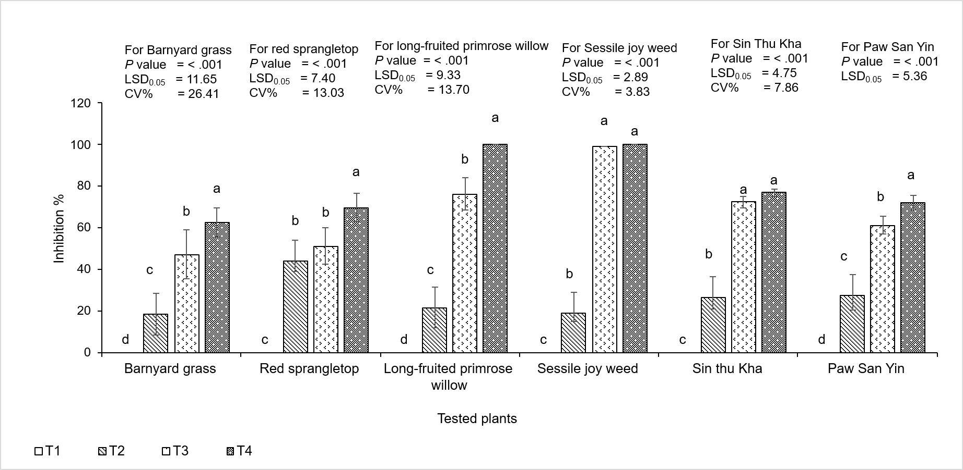
T1 = Control (Distilled water) T3 = Rice straw extract (100 g L⁻¹)
T2 = Rice straw extract (50 g L⁻¹) T4 = Rice straw extract (150 g L⁻¹)

Fig. 2. Inhibition% of shoot length of six tested plants as affected by different concentrations of rice straw extract
Mean ± S.E.M = Mean values ± Standard error of means of five replications

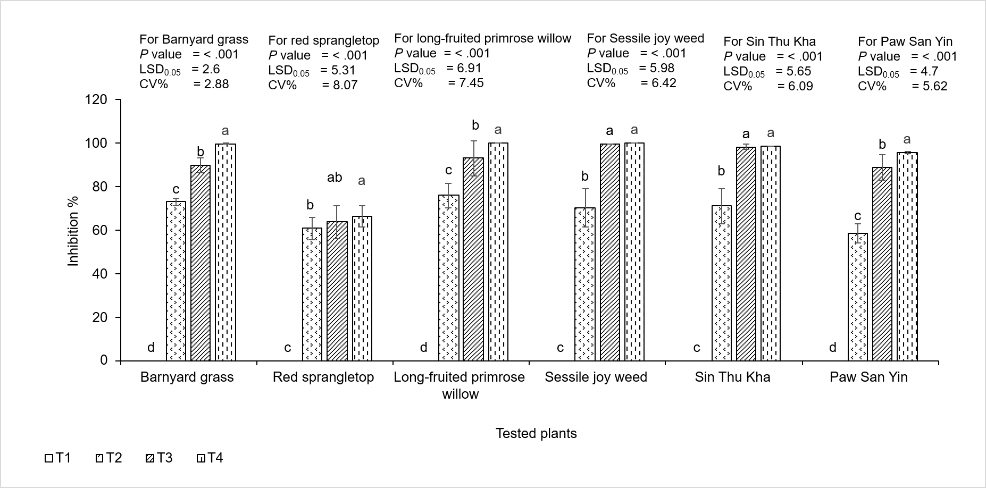
T1 = Control (Distilled water) T3 = Rice straw extract (100 g L⁻¹)
T2 = Rice straw extract (50 g L⁻¹) T4 = Rice straw extract (150 g L⁻¹)
Fig.3. Inhibition% of root length of six tested plants as affected by different concentrations of rice straw extract
Mean ± S.E.M = Mean values ± Standard error of means of five replications

4. Conclusion

The present study demonstrated that rice straw extract exhibits strong allelopathic activity against lettuce, weed species, and rice seedlings in a concentration-dependent manner. Complete inhibition of lettuce seed germination was observed at 100 g L⁻¹, whereas complete inhibition of broadleaf weed growth was recorded at 150 g L⁻¹. At the highest rice straw extract concentration, grasses and rice seedlings exhibited more than 50% growth inhibition, confirming the strong phytotoxic potential of the extract. Overall, the findings highlight that rice straw extract has potential as a natural weed-suppressive agent due to its strong inhibitory effects on plant growth and biomass accumulation. The results indicate the need for further studies to isolate and identify the active allelochemicals in rice straw and to assess their potential application as environmentally friendly tools for sustainable weed management under greenhouse and field conditions.

Limitations of the study
The present study was conducted under controlled laboratory conditions; therefore, the observed allelopathic effects may differ under field conditions due to environmental factors and interactions in the soil. In addition, although several allelochemicals were detected in the rice straw extract, their individual contributions to the observed inhibitory effects were not investigated. Further field studies and detailed chemical investigations are therefore needed to confirm the practical applicability and underlying mechanisms of Paw San Yin rice straw extract for weed control.

Declaration of AI Use
This manuscript was prepared through the intellectual contributions of the author(s) to the study design, data analysis, interpretation of results, and scholarly content. Grammarly and ChatGPT were used solely to assist with grammatical refinement and reference formatting during manuscript revision. The author(s) accept full responsibility for the accuracy, integrity, and final content of the manuscript.
REFERENCES

Abouziena, H. F., & Haggag, W. M. (2016). Weed control in clean agriculture: A review. Planta Daninha, 34(2), 377–392. https://doi.org/10.1590/S0100-83582016340200019
Afridi, R. A., Khan, M. A., Hussain, Z., Saleem, S., Khan, S., Afridi, K., & Ali, M. (2013). Allelopathic effects of rice straw extract on different crops and weeds. ARPN Journal of Agricultural and Biological Science, 8(5), 411–418. https://www.arpnjournals.com/jabs/volume_05_2013.htm
Ahn, J. K., & Chung, I. M. (2000). Allelopathic potential of rice hulls on germination and seedling growth of barnyardgrass. Agronomy Journal, 92(6), 1162–1167. https://doi.org/10.2134/agronj2000.9261162x
Ahn, J. K., Hahn, S. J., Kim, J. T., Khanh, T. D., & Chung, I. M. (2005). Evaluation of allelopathic potential among rice (Oryza sativa L.) germplasm for control of Echinochloa crus-galli P. Beauv in the field. Crop Protection, 24(5), 413–419. https://doi.org/10.1016/j.cropro.2004.09.009
Alam, M. A., Hakim, M. A., Juraimi, A. S., Rafii, M. Y., Hasan, M. M., & Aslani, F. (2018). Potential allelopathic effects of rice plant aqueous extracts on germination and seedling growth of some rice field common weeds. Italian Journal of Agronomy, 13(2), 1066. https://doi.org/10.4081/ija.2018.1066
Ali, A., & Sankaran, S. (1984). Crop-weed competition in direct-seeded flooded and rainfed bunded rice. International Rice Research Newsletter, 9(2), 22.
Anuar, F. D. K., Ismail, B. S., & Ahmad, W. J. W. (2015). Allelopathy effect of rice straw on the germination and growth of Echinochloa crus-galli (L.) P. Beauv. AIP Conference Proceedings, 1678, 020014. https://doi.org/10.1063/1.4931199
Aravind, J., Kahani, F., & Hittalmani, S. (2015). Inter specific indica-japonica drought tolerant rice genotypes for aerobic condition. Journal of Rice Research, 3(4), 154. https://doi.org/10.4172/2375-4338.1000154
Asaduzzaman, M., Islam, M. M., & Sultana, S. (2010). Allelopathy and allelochemicals in rice weed management. Bangladesh Research Publications Journal, 4(1), 1–14. https://researchoutput.csu.edu.au/en/publications/allelopathy-and-allelochemicals-in-rice-weed-management/
Aye, H. N., Khaing, A. A., Tun, P. T., Htun, T. M., & Win, K. K. (2019). Grain quality of Paw San varieties from Pathein, Pyapon and Shwebo townships. Journal of Agricultural Research, 6(2), 111–118. https://meral.edu.mm/records/4
Azmi, M., Abdullah, M. Z., & Fujii, Y. (2000). Exploratory study on allelopathic effect of selected Malaysian rice varieties and rice field weed species. Journal of Tropical Agriculture and Food Science, 28, 39–54.
Balderas, B. B., & Osillos, P. L. (2023). Allelopathic effect of Oryza sativa L. (rice) straw on Echinochloa crus-galli L. (barnyard grass) and Ludwigia octovalvis (primrose-willow). International Journal of Biosciences, 23(1), 115–131. https://doi.org/10.12692/ijb/23.1.115-131
Barnes, J. P., & Putnam, A. R. (1983). Rye residues contribute weed suppression in no-tillage cropping systems. Journal of Chemical Ecology, 9(8), 1045–1057. https://doi.org/10.1007/BF00982210
Batish, D. R., Singh, H. P., Rana, N., & Kohli, R. K. (2006). Assessment of allelopathic interference of Chenopodium album through its leachates, debris extracts, rhizosphere and amended soil. Archives of Agronomy and Soil Science, 52(6), 705–715. https://doi.org/10.1080/03650340601037119
Belz, R. G. (2007). Allelopathy in crop/weed interactions—An update. Pest Management Science, 63(4), 308–326. https://doi.org/10.1002/ps.1320
Cheng, F., & Cheng, Z. (2015). Research progress on the use of plant allelopathy in agriculture and the physiological and ecological mechanisms of allelopathy. Frontiers in Plant Science, 6, 1020. https://doi.org/10.3389/fpls.2015.01020
Chi, W.-C., Chen, Y.-A., Hsiung, Y.-C., Fu, S.-F., Chou, C.-H., Trinh, N. N., Chen, Y.-C., & Huang, H.-J. (2013). Autotoxicity mechanism of Oryza sativa: Transcriptome response in rice roots exposed to ferulic acid. BMC Genomics, 14, 351. https://doi.org/10.1186/1471-2164-14-351
Chon, S.-U., & Kim, Y.-M. (2004). Herbicidal potential and quantification of suspected allelochemicals from four grass crop extracts. Journal of Agronomy and Crop Science, 190(2), 145–150. https://doi.org/10.1111/j.1439-037X.2004.00088.x
Chou, C.-H., & Lin, H.-J. (1976). Autointoxication mechanism of Oryza sativa I. Phytotoxic effects of decomposing rice residues in soil. Journal of Chemical Ecology, 2(3), 353–367. https://doi.org/10.1007/BF00988282
Chung, I. M., Ahn, J. K., & Yun, S. J. (2001a). Assessment of allelopathic potential of barnyard grass (Echinochloa crus-galli) on rice (Oryza sativa L.) cultivars. Crop Protection, 20(10), 921–928. https://doi.org/10.1016/S0261-2194(01)00046-1
Chung, I. M., Ahn, J. K., & Yun, S. J. (2001b). Identification of allelopathic compounds from rice (Oryza sativa L.) straw and their biological activity. Canadian Journal of Plant Science, 81(4), 815–819. https://doi.org/10.4141/P00-191
Chung, I. M., Kim, J. T., & Kim, S.-H. (2006). Evaluation of allelopathic potential and quantification of momilactone A, B from rice hull extracts and assessment of inhibitory bioactivity on paddy field weeds. Journal of Agricultural and Food Chemistry, 54(7), 2527–2536. https://doi.org/10.1021/jf052796x
Chung, I. M., Kim, K. H., Ahn, J. K., Lee, S. B., Kim, S. H., & Hahn, S. J. (2003). Comparison of allelopathic potential of rice leaves, straw, and hull extracts on barnyardgrass. Agronomy Journal, 95(4), 1063–1070. https://doi.org/10.2134/agronj2003.1063
Delana, A., Nurjanah, U., Setyowati, N., Sudjatmiko, S., & Husna, M. (2025). Autotoxicity of rice straw extract on germination, growth, and yield of rice (Oryza sativa L.). Asian Journal of Advances in Agricultural Research, 25(8), 1–14. https://doi.org/10.9734/ajaar/2025/v25i8656
Dilday, R. H., Lin, J., & Yan, W. (1994). Identification of allelopathy in the USDA-ARS rice germplasm collection. Australian Journal of Experimental Agriculture, 34(7), 907–910. https://doi.org/10.1071/EA9940907
Dilday, R. H., Mattice, J. D., Moldenhauer, K. A., & Yan, W. (2001). Allelopathic potential in rice germplasm against ducksalad, redstem and barnyard grass. Journal of Crop Production, 4(2), 287–301. https://doi.org/10.1300/J144v04n02_11
Dilday, R. H., Nastasi, P., Lin, J., & Smith, R. J., Jr. (1991). Allelopathic activity in rice (Oryza sativa L.) against ducksalad [Heteranthera limosa (Sw.) Willd.]. In J. D. Hanson, M. J. Shaffer, D. A. Ball, & C. V. Cole (Eds.), Sustainable agriculture for the Great Plains: Symposium proceedings (pp. 193–201). U.S. Department of Agriculture, Agricultural Research Service.
Duke, S. O., Cedergreen, N., Velini, E. D., & Belz, R. G. (2006). Hormesis: Is it an important factor in herbicide use and allelopathy? Outlooks on Pest Management, 17(1), 29–33. https://doi.org/10.1564/16feb10
El-Shahawy, T. A., El-Rokiek, K. G., Sharara, F. A., & Khalaf, K. A. (2006). New approach to use rice straw waste for weed control. I. Efficacy of rice straw extract against broad and narrow leaved weeds in cucumber (Cucumis sativa L.). International Journal of Agriculture & Biology, 8(2), 262–268. https://agris.fao.org/search/en/providers/122650/records/647246da53aa8c8963048dd0
Gaballah, M. M., Metwally, A. M., Skalicky, M., Hassan, M. M., Brestic, M., El Sabagh, A., & Fayed, A. M. (2021). Genetic diversity of selected rice genotypes under water stress conditions. Plants, 10(1), 27. https://doi.org/10.3390/plants10010027
Gealy, D. R., Saldain, N. E., & Talbert, R. E. (2000). Emergence of red rice (Oryza sativa) ecotypes under dry-seeded rice (Oryza sativa) culture. Weed Technology, 14(2), 406–412. https://doi.org/10.1614/0890-037X(2000)014%5B0406:EORROS%5D2.0.CO;2
Gealy, D. R., & Yan, W. (2012). Weed suppression potential of ‘Rondo’ and other indica rice germplasm lines. Weed Technology, 26(3), 517–524. https://doi.org/10.1614/WT-D-11-00141.1
Gomez, K. A., & Gomez, A. A. (1984). Statistical procedures for agricultural research (2nd ed.). John Wiley & Sons. https://opac.narc.gov.np/opac_css/index.php?id=802&lvl=notice_display
He, H.-Q., & Lin, W.-X. (2001). Studies on allelopathic physiobiochemical characteristics of rice. Chinese Journal of Eco-Agriculture, 9(3), 56–57.
Ho, T. L., Nguyen, C. T., Vu, D. C., Nguyen, T. T. C., Nguyen, V. Q., & Smeda, R. J. (2021). Rice by-products reduce seed and seedlings survival of Echinochloa crus-galli, Leptochloa chinensis and Fymbristylis miliacea. Agronomy, 11(4), 776. https://doi.org/10.3390/agronomy11040776
International Rice Research Institute. (2006). Bringing hope, improving lives: Strategic plan 2007–2015. International Rice Research Institute. https://books.irri.org/RT5_4_content.pdf
International Seed Testing Association. (1996). International rules for seed testing 1996. International Seed Testing Association. (Seed Science and Technology, 24, Suppl.). https://worldveg.tind.io/record/23705?ln=en
Ismail, B. S., Rezaul Karim, S. M., & Abdullah, M. Z. (2007). The allelopathic potential of several rice varieties on barnyard grass (Echinochloa crus-galli L. Beauv.). Journal of Tropical Agriculture and Food Science, 35(1), 173–182.
Kato-Noguchi, H., & Ino, T. (2003). Rice seedlings release momilactone B into the environment. Phytochemistry, 63(5), 551–554. https://doi.org/10.1016/S0031-9422(03)00194-8
Kato-Noguchi, H., & Ino, T. (2005). Possible involvement of momilactone B in rice allelopathy. Journal of Plant Physiology, 162(6), 718–721. https://doi.org/10.1016/j.jplph.2004.11.009
Khang, D. T., Quy, T. N., Dam, N. P., Tuan, N. T., Men, T. T., Van Ay, N., & Thuy, N. T. (2023). Isolation and purification of potential weed inhibitors from Mimosa pigra L. Heliyon, 9(7), e18205. https://doi.org/10.1016/j.heliyon.2023.e18205
Khin Than Nwe, & Tin Tin Myint. (2004). Aspects of quality rice improvement in Myanmar. Ministry of Agriculture and Irrigation.
Kong, C.-H., Chen, X.-H., Hu, F., & Zhang, S.-Z. (2011). Breeding of commercially acceptable allelopathic rice cultivars in China. Pest Management Science, 67(9), 1100–1106. https://doi.org/10.1002/ps.2154
Kruse, M., Strandberg, M., & Strandberg, B. (2000). Ecological effects of allelopathic plants: A review (NERI Technical Report No. 315). National Environmental Research Institute. https://pure.au.dk/portal/en/publications/ecological-effects-of-allelopathic-plants-a-review/
Kyu, M. M. (1993). Analysis of rice-weed competition and evaluation of weed management practices in rice [Master’s thesis, Institute of Agriculture, Yezin].
Le, V. V., Nguyen, A. V., Luu, D. T., Fritschi, F. B., Nguyen, C. T., & Ho, T. L. (2024). Inhibitory effects of N-trans-cinnamoyltyramine on growth of invasive weeds and weedy rice. Plant-Environment Interactions, 5(6), e70017. https://doi.org/10.1002/pei3.70017
Lee, S. B., Ku, Y. C., Kim, K. H., Hahn, S. J., & Chung, I. M. (2004). Allelopathic potential of rice germplasm against barnyardgrass. Allelopathy Journal, 13(1), 17–28.
Li, B., Wu, W., Shen, W., Xiong, F., & Wang, K. (2024). Allelochemicals released from rice straw inhibit wheat seed germination and seedling growth. Agronomy, 14(10), 2376. https://doi.org/10.3390/agronomy14102376
Li, S., Yan, Q., Tong, J., Li, Y., Bai, L., & Peng, Q. (2026). Distinct defence mechanisms of allelopathic rice against quinclorac-susceptible and -resistant barnyardgrass: Involvement of specific metabolites and rhizosheath microbiota. Plant Biotechnology Journal, 24(6), 3876–3896. https://doi.org/10.1111/pbi.70611
Li, Y., Jian, X., Li, Y., Zeng, X., Xu, L., Khan, M. U., & Lin, W. (2020). OsPAL2-1 mediates allelopathic interactions between rice and specific microorganisms in the rhizosphere ecosystem. Frontiers in Microbiology, 11, 1411. https://doi.org/10.3389/fmicb.2020.01411
Mai, N. P., & Xuan, T. D. (2025). A review on the utility potential of rice derived products in weed management. Weed Research, 65(1), e12678. https://doi.org/10.1111/wre.12678
Mazid, M. S., Juraimi, A. S., Rafii, M. Y., Hanafi, M. M., Hakim, M. A., & Ferdous, J. (2018). Evaluation of selected rice accessions for allelopathic potential against barnyard grass. Allelopathy Journal, 43(2), 159–174. https://doi.org/10.26651/allelo.j/2018-43-2-1138
Miller, D. A. (1996). Allelopathy in forage crop systems. Agronomy Journal, 88(6), 854–859. https://doi.org/10.2134/agronj1996.00021962003600060003x
Minten, B., Aung, Z. W., Htar, M. T., & Masias, I. (2025). Global rice price declines and expected effects on monsoon paddy farming: Insights from key informants (Myanmar SSP Research Note No. 121). International Food Policy Research Institute. https://hdl.handle.net/10568/175338
Molisch, H. (1937). Der Einfluss einer Pflanze auf die andere, Allelopathie. Gustav Fischer. https://goobi-viewer.univie.ac.at/viewer/resolver?urn=urn%3Anbn%3Aat%3Aat-ubw%3Ag-65317
Naylor, R. L. (Ed.). (1996). Herbicides in Asian rice: Transitions in weed management. International Rice Research Institute. https://agris.fao.org/search/en/providers/122535/records/65dde1100f3e94b9e5c695b4
Olofsdotter, M., Jensen, L. B., & Courtois, B. (2002). Improving crop competitive ability using allelopathy—An example from rice. Plant Breeding, 121(1), 1–9. https://doi.org/10.1046/j.1439-0523.2002.00662.x
Olofsdotter, M., Navarez, D., & Moody, K. (1995). Allelopathic potential in rice (Oryza sativa L.) germplasm. Annals of Applied Biology, 127(3), 543–560. https://doi.org/10.1111/j.1744-7348.1995.tb07611.x
Olofsdotter, M., Navarez, D., & Rebulanan, M. (1997). Rice allelopathy—Where are we and how far can we get? In Proceedings of the Brighton Crop Protection Conference—Weeds (Vol. 1, pp. 99–104). British Crop Protection Council. https://researchprofiles.ku.dk/da/publications/rice-allelopathy-where-are-we-and-how-far-can-we-get/
Otusanya, O. O., & Ilori, O. J. (2014). Studies on the allelopathic effects of Tithonia rotundifolia on the germination and seedling growth of some legumes and cereals. International Journal of Biology, 6(1), 38–47. https://doi.org/10.5539/ijb.v6n1p38
Panasiuk, O., Bills, D. D., & Leather, G. R. (1986). Allelopathic influence of Sorghum bicolor on weeds during germination and early development of seedlings. Journal of Chemical Ecology, 12(6), 1533–1543. https://doi.org/10.1007/BF01012370
Poudyal, S., & Cregg, B. M. (2019). Irrigating nursery crops with recycled run-off: A review of the potential impact of pesticides on plant growth and physiology. HortTechnology, 29(6), 716–729. https://doi.org/10.21273/HORTTECH04302-19
Putnam, A. R., & Tang, C.-S. (1986). Allelopathy: State of the science. In A. R. Putnam & C.-S. Tang (Eds.), The science of allelopathy (pp. 1–19). John Wiley & Sons.
Rahaman, F., Juraimi, A. S., Rafii, M. Y., Uddin, M. K., Hassan, L., Chowdhury, A. K., & Bashar, H. M. K. (2021). Allelopathic effect of selected rice (Oryza sativa) varieties against barnyard grass (Echinochloa cruss-gulli). Plants, 10(10), 2017. https://doi.org/10.3390/plants10102017
Rajput, P., Sarika, Pandey, N. C., & Rao, P. B. (2010). Bioherbicidal potential of paddy straw extracts on germination, growth and protein of four weeds. Proceedings of the National Academy of Sciences, India Section B: Biological Sciences, 80, 60–67.
Scavo, A., Abbate, C., & Mauromicale, G. (2019). Plant allelochemicals: Agronomic, nutritional and ecological relevance in the soil system. Plant and Soil, 442(1–2), 23–48. https://doi.org/10.1007/s11104-019-04190-y
Serra Serra, N., Shanmuganathan, R., & Becker, C. (2021). Allelopathy in rice: A story of momilactones, kin recognition, and weed management. Journal of Experimental Botany, 72(11), 4022–4037. https://doi.org/10.1093/jxb/erab084
Seyyednejad, S. M., Koochak, H., Najafabade, F. P., & Kolahi, M. (2010). Allelopathic effect of aquatic hull extract of rice (Oryza sativa L.) on growth of Silybum marianum and Echinochloa crus-galli. African Journal of Agricultural Research, 5(16), 2222–2226. https://doi.org/10.5897/AJAR.9000029
Singh, H. P., Batish, D. R., & Kohli, R. K. (2003). Allelopathic interactions and allelochemicals: New possibilities for sustainable weed management. Critical Reviews in Plant Sciences, 22(3–4), 239–311. https://doi.org/10.1080/713610858
Soe, T. T. (2003). Weed-nitrogen fertilizer interaction on two cultivars in wet-seeded rice [Master of Agricultural Science thesis, Yezin Agricultural University].
Takeuchi, Y., Kawaguchi, S., & Yoneyama, K. (2001). Inhibitory and promotive allelopathy in rice (Oryza sativa L.). Weed Biology and Management, 1(3), 147–156. https://doi.org/10.1046/j.1445-6664.2001.00031.x
Thura, S. (2010). Evaluation of weed management practices in the System of Rice Intensification (SRI) [Master’s thesis, Yezin Agricultural University]. https://sri.ciifad.cornell.edu/research/theses.html
Wang, K., Wang, T., Ren, C., Dou, P., Miao, Z., Liu, X., Huang, D., & Wang, K. (2022). Aqueous extracts of three herbs allelopathically inhibit lettuce germination but promote seedling growth at low concentrations. Plants, 11(4), 486. https://doi.org/10.3390/plants11040486
Weir, T. L., Park, S.-W., & Vivanco, J. M. (2004). Biochemical and physiological mechanisms mediated by allelochemicals. Current Opinion in Plant Biology, 7(4), 472–479. https://doi.org/10.1016/j.pbi.2004.05.007
Weston, L. A. (1996). Utilization of allelopathy for weed management in agroecosystems. Agronomy Journal, 88(6), 860–866. https://doi.org/10.2134/agronj1996.00021962003600060004x
Wu, H., Haig, T., Pratley, J., Lemerle, D., & An, M. (2000). Distribution and exudation of allelochemicals in wheat Triticum aestivum. Journal of Chemical Ecology, 26(9), 2141–2154. https://doi.org/10.1023/A:1005520500110
Wu, H., Pratley, J., Lemerle, D., & Haig, T. (2001). Allelopathy in wheat (Triticum aestivum). Annals of Applied Biology, 139(1), 1–9. https://doi.org/10.1111/j.1744-7348.2001.tb00124.x
Xiao, Z., Zou, T., Lu, S., & Xu, Z. (2020). Soil microorganisms interacting with residue-derived allelochemicals effects on seed germination. Saudi Journal of Biological Sciences, 27(4), 1057–1065. https://doi.org/10.1016/j.sjbs.2020.01.013
Xuan, T. D., Shinkichi, T., Khanh, T. D., & Chung, I. M. (2005). Biological control of weeds and plant pathogens in paddy rice by exploiting plant allelopathy: An overview. Crop Protection, 24(3), 197–206. https://doi.org/10.1016/j.cropro.2004.08.004
Yadav, N., Diwan, A., Sharma, M. K., Ajmal, G., & Kumawat, M. K. (2021). Biological activity of rice straw-derived materials: An overview. Uttar Pradesh Journal of Zoology, 42(24), 1256–1264. https://doi.org/10.56557/upjoz/2021/v42i243243

