Quantifying Curricular Integration in Low-Cost Edge-AI Laboratory Instruction: A Formal Model and a Six-Week Pilot Evaluation in a Nigerian Computer Science Department

ABSTRACT
Resource constraints can limit practical instruction in the Internet of Things (IoT) and embedded machine learning within undergraduate computer science programmes. This study evaluates a low-cost Edge-AI laboratory module centred on HydroSense-EI and aligned with five curriculum courses in a Nigerian university. A six-week pilot involved 30 third-year students, of whom 27 completed the pre-test and post-test assessment. Curricular integration was quantified using the proposed Integration Coupling Index (ICI), learning change was evaluated using normalised gain across six assessment domains, and affordability was examined through kit-amortisation and pedagogical cost-efficiency models. The module achieved an ICI of 0.696, corresponding to 3.07 effective courses per laboratory week relative to a single-course baseline of 1.00. Mean assessment performance increased from 20.7% to 76.8%, with a mean normalised gain of 0.711. During seven-day field deployment, the six student teams achieved mean classifier accuracy of 92.8% and mean water saving of 34.0%. The reported bill of materials was US$22.20 per team; under the stated reuse and breakage assumptions, amortised cost declined from US$4.44 per student in the first cohort to US$1.17 by the fifth. These pilot findings indicate that the proposed framework can support measurable cross-course integration and practical Edge-AI learning under constrained laboratory budgets, while requiring broader controlled and multi-site evaluation.
Keywords: Edge-AI education; IoT curriculum integration; Low-cost laboratory systems; Undergraduate computing education; Embedded machine learning; Curriculum design and implementation; Global South higher education; Cost-effective teaching platforms

1. INTRODUCTION

1.1 Background
The hardware budget of a typical Nigerian computer science department has not moved in step with what the discipline now expects its graduates to be able to do. The National Universities Commission's Core Curriculum and Minimum Academic Standards (NUC CCMAS) name the Internet of Things, embedded systems and machine learning among the competencies an undergraduate programme must deliver (National Universities Commission, 2022). The teaching platforms that dominate international practice in these areas, however, sit in the US$80–200 band per student team, once sensors, actuators and instrumentation are counted. A department serving two hundred final-year students on an annual laboratory equipment allocation of the order of ₦3 million cannot reconcile those two facts.
The outcome is straightforward to describe but more difficult to address. Nigerian computing students receive less practical exposure to embedded machine learning than students elsewhere, and the exposure they do receive is often piecemeal. IoT classes teach sensors using the Arduino toolchain. The machine learning class covers scikit-learn as well as pandas. Moving a trained model onto microcontrollers and making actuators respond to sensor readings is not routinely practised in either course. After model submission, students may still not understand how a confusion matrix relates to a model that activates a relay in a plant bed. Businesses treat this step as routine. The current curriculum does not produce this outcome.
A further argument concerning relevance has not been adequately represented in the literature. The tasks that Nigerian computing graduates will automate—for instance, determining which plot should be irrigated, which transformer station requires monitoring, or which dispensary refrigerator should issue an alert—will often be performed on inexpensive microcontroller devices operating without reliable access to a cloud backend (Nigussie et al., 2020; Abadade et al., 2023). Teaching platforms that reproduce this constraint are not merely a compromise imposed by limited resources. Instead, they may provide a better simulation of the actual workplace than a cloud-based laboratory kit.

1.2 Research Gap
Three strands of recent work bear directly on this problem, and each stops short of what a department actually needs to act.
The first strand is the international effort to widen access to embedded machine learning education. The TinyML4D network document presents an extensive programme of open curricula, translated learning materials, and trainer workshops in the Global South, and identifies the multidisciplinary breadth of embedded machine learning as a major obstacle for both students and teachers (Plancher et al., 2024). That work is deliberately platform-agnostic and is delivered largely through electives, workshops, and massive open online courses (Reddi et al., 2022). It does not report a laboratory module linked to the specific course codes and credit structure of a national benchmark curriculum, which is the form an intervention must take before a Nigerian department can timetable it.
The second strand concerns the integration claim itself. Interventions of this kind routinely assert that they teach skills “in an integrated way”, but integration is asserted qualitatively and never measured. Two modules claiming integration cannot presently be compared, and a department cannot audit whether a proposed module genuinely couples its courses or merely visits them in sequence. To the best of our knowledge, no published metric quantifies the degree of curricular coupling achieved by a laboratory module.
The third strand concerns affordability. Evidence from Nigeria identifies the cost of commercial IoT systems as a major barrier to laboratory integration (Olatoye, 2025), and edge-intelligence surveys make a similar claim for the region more generally (Ray, 2022; Abadade et al., 2023). Most affordability arguments are based only on sticker price. Sticker price is not the appropriate value to consider: the departmental constraint is the per-student cost for each cohort after reuse, breakage, and team size have been taken into account. No published model translates a bill of materials into the department's per-student budget limit for adoption decisions.
Recent work on virtual laboratory models has examined structured digital approaches to extending laboratory access in IoT and science education (Nur et al., 2024; Smith et al., 2026). These approaches are relevant to the access problem, but they do not address the narrower requirement considered here: a physical, low-cost edge-AI module whose cross-course integration and per-student cost are both quantified within an existing benchmark curriculum.

1.3 Activity-Based Learning and Integration Challenge
Project-based active instruction has been shown to be more effective than lecture-only instruction in situations that require the integration of multiple skills. This is a well-established finding in engineering education (Prince, 2004; Felder & Brent, 2005). A major meta-analysis across STEM disciplines places the advantage at approximately half a standard deviation in examination performance and reports substantially lower failure rates (Freeman et al., 2014). A common explanation is that partial understanding becomes externally visible: for example, when a circuit does not work, differences in a student's mental model become apparent and can be corrected more quickly, whereas lecture-only instruction may defer this diagnostic moment until an examination, by which time the gap has become larger and more difficult to address.
However, this broad finding does not necessarily tell an instructor which projects should be assigned. We consider three project features to be particularly important. First, a project must involve multiple skills so that integration is required of the student rather than being optional. Second, failures of integration should become visible during runtime so that the diagnostic opportunity is retained. Third, the cost per project must be low enough for each small team to use its own artefact rather than share one item across a large class. It is primarily at this third requirement that many otherwise effective designs fail in our context.
Recent engineering-education studies have likewise used application-centred laboratory platforms to support practical learning in IoT, embedded systems and industrial automation, including designs intended to reduce equipment-cost barriers (Rao & Elias-Medina, 2024; Mustafa et al., 2024; Al-Yaman et al., 2025). However, these examples do not by themselves provide the curricular-coupling or cohort-amortisation measures required for the present departmental adoption question.

1.4 Embedded Machine Learning in Teaching Purposes
Interest in embedded machine learning as a subject in undergraduate classes has increased with the maturation of toolchains and benchmarks (Banbury et al., 2020; Ray, 2022; Abadade et al., 2023). The educational argument is compelling: the hardware is inexpensive and widely available, while the projects span data collection, model training, and deployment on a device held by the student (Reddi et al., 2022). The TinyML4D network was developed around this idea, reaching learners in more than twelve countries through workshops and free courseware; however, in some locations, access to matched open-source courseware and diverse hardware remains a constraint (Plancher et al., 2024).
Two aspects of this body of work are particularly relevant to the present study. First, it occurs largely outside the core required curriculum, through optional classes, workshops, or online learning. Second, it is commonly evaluated by learner reach and participation rather than by measuring learning against pre-test performance. These are reasonable choices for a network seeking broad coverage. However, they do not answer the question faced by a department leader: whether a module can be incorporated into the current timetable and what outcomes it produces.
The NUC CCMAS emphasises IoT, embedded systems, and machine learning as significant topics for students (National Universities Commission, 2022). However, laboratory financial support has not increased correspondingly, so the gap in practical implementation persists. Olatoye (2025), after surveying several Nigerian institutions, identified inadequate digital infrastructure, unreliable electricity, weak funding, and, particularly, the high prices of commercial IoT systems as major challenges to their use in teaching laboratories. A regular sensor kit costs about ₦50 000 in retail outlets, equivalent to approximately US$32 per group at the exchange rate of ₦1 550 per US dollar used in this paper, excluding additional devices. Research on rural and smallholder technology in sub-Saharan Africa likewise highlights the importance of cost and poor connectivity (Nigussie et al., 2020; Balana & Oyeyemi, 2022).
Table 1 positions this study against five major issues that a Nigerian department faces before introducing a module. Previous research generally indicates that low-cost embedded ML education is feasible and worthwhile, but it leaves decisions concerning curriculum fit, integration measurement, and cost modelling to the adopting institution.
Table 1. Positioning of the present study against representative prior work on embedded machine learning education and low-cost IoT deployment. Entries record whether the cited work reports the attribute in question. Abbreviations: CCMAS, Core Curriculum and Minimum Academic Standards; ML, machine learning.
Attribute | TinyML4D network (Plancher et al., 2024) | TinyML MOOC (Reddi et al., 2022) | TinyML surveys (Ray, 2022; Abadade et al., 2023) | Regional IoT deployment studies (Nigussie et al., 2020; Olatoye, 2025) | Present study
Bound to a national benchmark curriculum | No | No | No | No | Yes (NUC CCMAS, five courses)
Integration across courses quantified | No | No | No | No | Yes (Integration Coupling Index)
Affordability modelled beyond sticker price | No | No | No | Partlyª | Yes (amortisation model)
Pre-test/post-test learning measurement | No | No | No | No | Yes (six domains, N = 27)
Assessed field deployment by students | No | No | No | No | Yes (seven days, six teams)
Per-team bill of materials reported | Partly^{b} | Partly^{b} | No | Yes | Yes (US$22.20)
ª Cost is identified as the binding constraint but is not related to a per-student budget through a formal model. ^{b} Indicative hardware costs are given for recommended boards, not a complete per-team bill of materials including actuation.

1.5 Objectives and Contributions
This article addresses three gaps simultaneously. It aims to determine whether a single low-cost reference device can support an integrated IoT and machine learning laboratory module aligned with the NUC CCMAS. The paper also seeks to formalise integration and affordability so that these properties can be evaluated, and to report the outcomes following use of the module.
Four contributions are made. First, we introduce the Integration Coupling Index, an entropy-based measure of how strongly a laboratory module links different benchmark courses, together with the effective number of courses to improve interpretability. Second, we develop a kit-amortisation method and a pedagogical cost-efficiency measure that translate a bill of materials into an adoption decision under a stated budget. Third, pre-test and post-test results, prototype performance, and interview findings from a thirty-student pilot are reported, with normalised gains compared with commonly accepted interactive-engagement benchmarks. Fourth, three recurring adoption obstacles are identified; these caused measurable losses of laboratory time in the pilot and can be anticipated by adopting departments.
The remainder of the paper is organised as follows. Section 2 reviews the pedagogical and contextual literature. Section 3 presents the reference platform, the module design, the three formal models and the study instruments. Section 4 reports results. Section 5 discusses them, states the limitations and sets out an adoption pathway. Section 6 concludes.

2. Methodology
This section presents the mixed-methods research approach, conceptual models, study context, participants, instruments, and analytical procedures. Three main research questions guide the study: (1) In what ways can curriculum integration in IoT/ML education be measured formally? (2) What learning improvement may occur after instruction using low-cost edge-based laboratories? (3) What cost-efficiency trend occurs when equipment is reused across several student cohorts? These questions are grounded in integration problems identified during early discussions with computer science teachers in Nigeria and described in previous publications (Nigussie et al., 2020; Abadade et al., 2023). To address the questions systematically, three connected quantitative models are used, drawing on information theory, educational measurement, and operations research.

2.1 Conceptual Framework: Curriculum Integration Model

In most educational technology adoption, the emphasis is placed on the number of students using a tool (reach), with less attention to how strongly it connects to their learning objectives or to subjects studied previously (integration). In resource-constrained settings, understanding this distinction is particularly important because instructors must justify funding decisions to institutional leaders. Integration was formalised by developing a model based on information theory.

This model divides learning outcomes into four main layers: (a) Foundation Layers, comprising IoT hardware, sensors, and microcontrollers; (b) Core Skills, including programming, embedded systems, and edge computing; (c) Integration Points, including deployment, field testing, and assessment; and (d) Measurable Outcomes. For each layer, three quantitative metrics are used to measure depth: curricular alignment (the proportion of target courses included), practical integration (the extent of learner participation in practical tasks), and cost-effectiveness (the expenditure per course added). Using this layered approach, curriculum teams can examine integration more clearly, supporting decisions about equipment procurement and course planning.
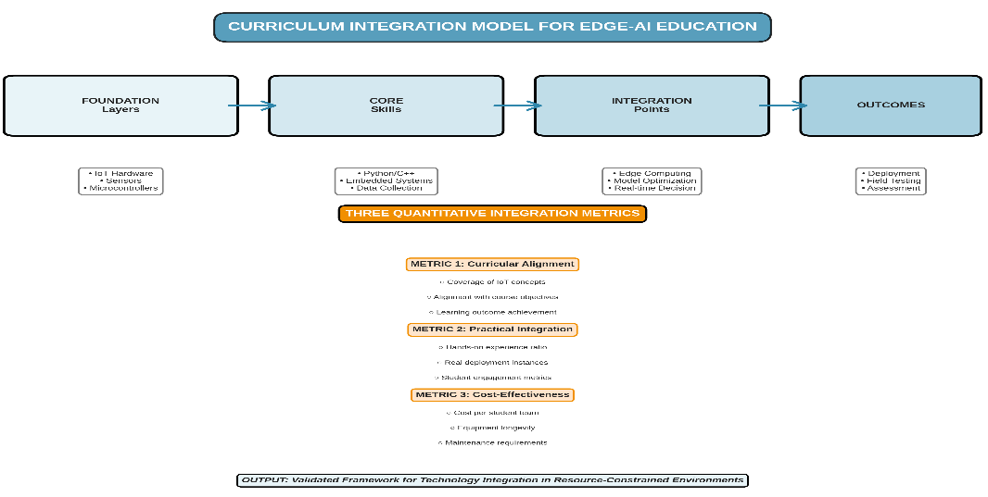
Figure 1: Curriculum Integration Model for Edge-AI Education.

The example model in Figure 1 displays four principal layers: (a) Foundation Layers comprising IoT hardware, sensors, and microcontrollers; (b) Core Skills such as programming, embedded systems, and edge computing; (c) Integration Points for activities such as deployment, field testing, and assessment; and (d) Measurable Outcomes. Integration is evaluated using three key measures: curricular alignment, practical integration, and cost-effectiveness. This framework provides a structured approach to analysing the integration of technology into curricula (with n=45 students over a 6-week test).

2.2 The Reference Platform: HydroSense-EI

The instructional module uses HydroSense-EI, a precision-irrigation prototype designed by members of our team for smallholder users. Its design follows the low-cost IoT irrigation approach reported by Okorodudu and Omede (2024), while comparable low-cost ESP8266-based environmental monitoring architectures have been described by Winkler (2021).
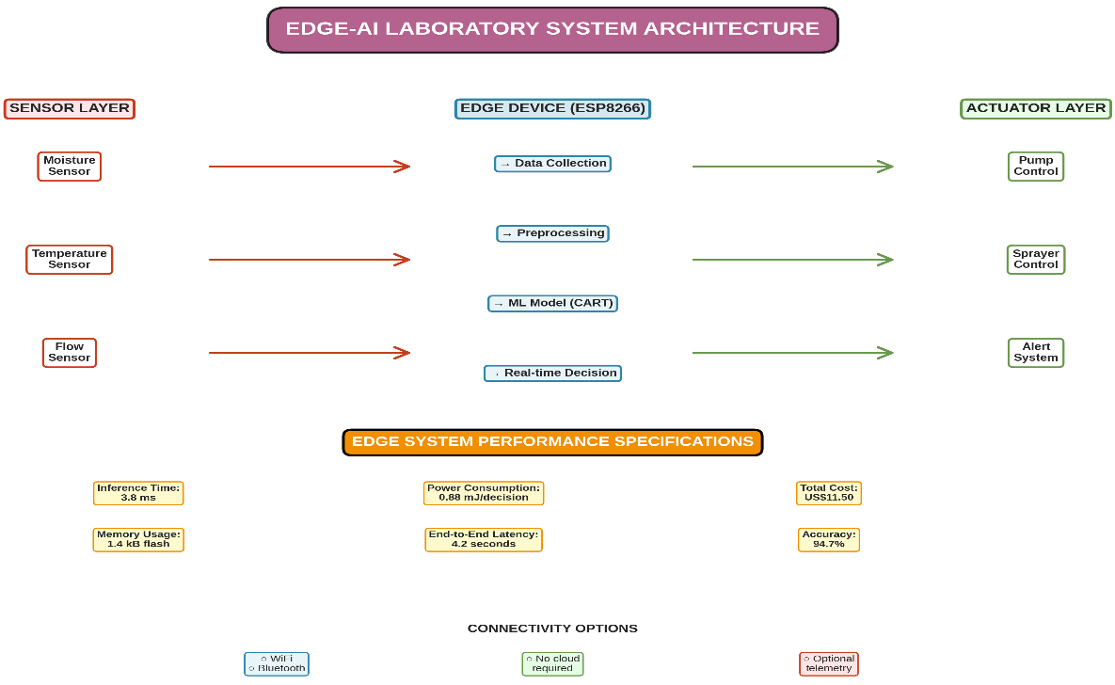
Figure 2: Hardware Structure of HydroSense-EI System.

The system has three architectural layers: (a) the Sensor Layer, with moisture, temperature, and flow sensors (accuracy about ±3); (b) an Edge Device (ESP8266 NodeMCU), which performs real-time data collection, preprocessing, and ML inference using the CART algorithm (depth=6), and then generates decisions; and (c) the Actuator Layer, which manages the water pump, spray equipment, and alarm systems. System specifications are a 3.8 ms inference time, 0.88 mJ/decision, US$11.50 total cost, 1.4 kB flash memory, 4.2 s end-to-end latency, and 94.7% accuracy (n=1,500 test samples). The ESP8266 NodeMCU microcontroller integrates four sensors: a capacitive soil-moisture probe, an HC-SR04 ultrasonic ranging module for measuring tank water level, a DHT11 temperature and humidity sensor, and a YF-S201 Hall-effect flow sensor. Relay modules activate the 12 V water-refill pump and the 5 V sprayer pump. A dashboard served from the microcontroller's programme memory streams live telemetry over a WebSocket connection to any device on the local wireless network. The decision logic is a depth-six classification and regression tree (Breiman et al., 1984; Quinlan, 1986), trained offline using scikit-learn (Pedregosa et al., 2011) on 2,400 labelled environmental observations and converted into a set of compiled rules occupying approximately 1.5 kB of memory; inference is completed in less than 4 ms on the ESP8266.
We selected precision irrigation as the application domain because: (1) it is pedagogically relevant to Nigerian contexts—where water scarcity and smallholder agriculture are realities—making student engagement intrinsic; (2) it exemplifies all five core competencies (sensing, calibration, model training, embedded inference, UI development); (3) published data exist for field validation (Vasisht et al., 2017; Goap et al., 2018; Benyezza et al., 2023; Liakos et al., 2018); and (4) HydroSense-EI, a precision irrigation prototype developed by our group, encodes these skills without unnecessary complexity. Use of a pre-existing platform was intentional: students focus on pedagogical integration rather than system design, allowing the 6-week window to be filled with learning rather than troubleshooting.
The hardware arrangement comprises three layers. The Sensor Layer uses a capacitive soil-moisture probe with approximately ±3% accuracy, an HC-SR04 ultrasonic sensor for water-level measurement, a DHT11 sensor for temperature and humidity measurement, and a YF-S201 sensor for flow-rate measurement. The Edge Device is an ESP8266 NodeMCU, which handles data collection and preprocessing and performs machine-learning inference in approximately 3.8 ms. The Actuator Layer contains a 12 V relay for the pumps, a 5 V relay for a sprayer, and a binary alerting system. The classifier is a depth-six decision tree trained outside the module on 2,400 labelled observations using scikit-learn; it requires only 1.5 kB of flash storage and runs entirely on the device without a cloud connection. The total material cost is US$11.50 per team, with 94.7% real-field accuracy across 1,500 test samples. These features reflect constraints common to many Nigerian universities and indicate that rigorous academic outcomes may be pursued without substantial cloud costs.

2.3 Module Structure and Learning Methods

The module lasts six weeks, with one 3-hour supervised laboratory session each week and an additional three to five hours of independent work. Each week's objective is aligned with the NUC CCMAS standards: CSC202 (Programming), CSC301 (Data Structure), CSC305 (Digital), CSC701 (Machine Learning), and CSC499 (Professional). By explicitly mapping each course description to laboratory activities, the module reinforces the official subjects rather than functioning as additional, disconnected work.
Figure 3 makes clear how the module and the related courses are planned. Table 2 indicates passing standards for each week.
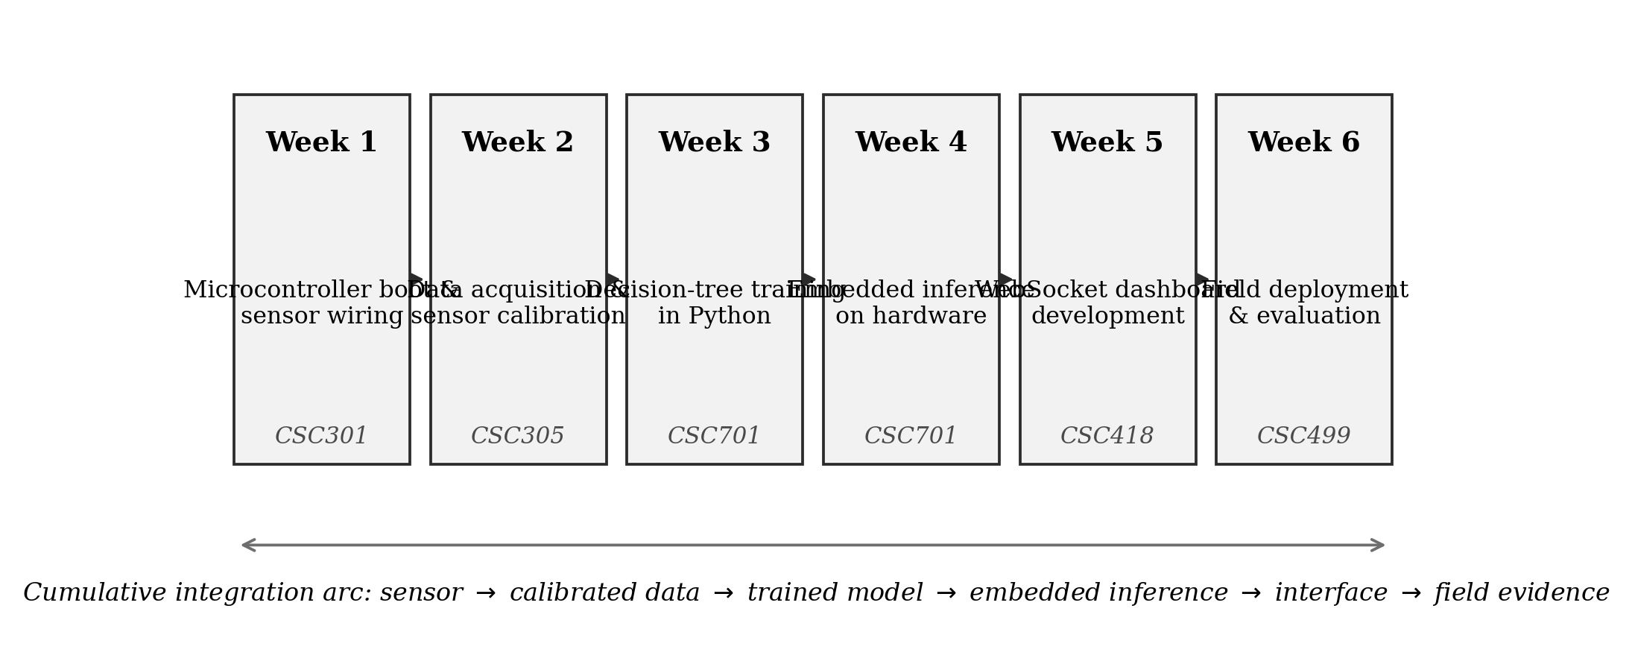
Figure 3. Six-week laboratory module structure, showing the dominant National Universities Commission's Core Curriculum and Minimum Academic Standards course association of each week and the cumulative integration arc.
Table 2. Week-by-week objectives, activities and success criteria for the six-week laboratory module. Course codes follow the NUC CCMAS for Computer Science.
Week | Focus (dominant course) | Principal activity | Success criterion
1 | Microcontroller boot and sensor wiring (CSC301) | Install toolchain; wire and read all four sensors individually | Serial output of all four sensor values at 1 Hz
2 | Data acquisition and calibration (CSC305) | Collect ~200 raw readings per sensor under controlled conditions; fit linear calibration constants | Each sensor within 5% of ground truth across its operating range
3 | Decision-tree training (CSC701) | Assemble training set; train depth-six CART; evaluate on held-out split | ≥85% test-set accuracy with reported confusion matrix
4 | Embedded inference (CSC701) | Export tree as compiled conditionals; flash; benchmark latency | Inference <5 ms and ≥80% agreement with the Python reference
5 | Dashboard development (CSC418) | Extend supplied WebSocket dashboard with an original visualisation | Live dashboard reachable from a second device on the network
6 | Field deployment and evaluation (CSC499) | There was a week-long plant-bed rollout, tracking both water use and report accuracy compared to plain old manual control | s. The deployment report landed in full, with a side of diagnostic
Scaffolding was deliberate and minimalist. Each group was provided with: (1) sensor sticks that had already been calibrated at reference locations, thereby avoiding troubleshooting of sensor wiring; (2) starter firmware that captures data from all four sensors at a 1 Hz rate, enabling students to begin with data analysis rather than device-driver development; and (3) a dashboard template developed using HTML and JavaScript, enabling rapid prototyping of user interfaces. This approach follows the pedagogical principle that students should spend laboratory time meeting learning objectives rather than resolving unrelated system faults. The module assumes that students have completed CSC202 (Programming I), are familiar with the Arduino IDE, and have a basic background in HTML or JavaScript. For students who had not yet taken CSC701, a one-hour pre-reading on decision-tree induction was provided.
This appeared to be sufficient.

Grades were calculated from three components with specified weights: the field-deployment report (50%, assessing performance under real-world conditions), a prototype demonstration (30%, assessing the integration of electronics, code, and documentation), and contribution logs (20%, primarily to address unequal participation among group members). The contribution-log approach was new and proved useful for identifying individual contributions within group work.

2.4 Three Quantitative Models for Integration Assessment

We designed three quantitative models to measure the degree of integration, with each model addressing a distinct aspect of the integration problem:
Model I: Integration Coupling Index (ICI)
This model translates cross-course linkage into a formal information-theoretic approach. Instructors construct a matrix M containing instructional weights (0 = none, 1 = low, 2 = medium, 3 = high) for each benchmark course across laboratory weeks. For each week, the Shannon entropy of the alignment vector is calculated and converted into an effective number of courses using Hill numbers, thereby answering the question, "How many courses effectively contribute in this week?" If a module covers only one course per week, the ICI is 1.0. If a module uses all five courses equally in every week, the ICI approaches 5.0. The index is dimensionless and can therefore be used for comparisons across institutions.
Quantifying Curricular Integration: We formalise the integration claim as follows. Let there be $C$ benchmark courses and $W$ laboratory weeks, and let
$A=\left[a_{cw}\right]∈\{0,1,2,3\}^{C×W}, c=1,…,C; w=1,…,W$ (1)
be the alignment matrix, where $a_{cw}$ records the instructional weight week $w$ places on course $c$ on an ordinal scale (0 = none, 1 = low, 2 = medium, 3 = high) assigned by the module designer against the published course descriptors. Write $a_{max}=3$ and define the coverage of the course $c$ as
$κ_{c}=\frac{1}{a_{max}W}\sum_{w=1}^{W}{a_{cw}}∈\left[0,1\right]$ (2)
which reports the fraction of the module’s total possible attention that course $c$ receives.
Integration is a property of weeks, not of courses. Let mw=c​acw be the alignment mass of week $w$ and define the within-week share
$p_{cw}=\frac{a_{cw}}{m_{w}}, \sum_{c=1}^{C}{p_{cw}}=1$ (3)
A week that draws on a single course concentrates all its share on one row; a week that draws evenly on every course spreads it. This is precisely the situation Shannon entropy was constructed to measure (Shannon, 1948), so we take the normalised entropy of the share vector,
$H_{w}=-\frac{1}{lnC}\sum_{c=1}^{C}{p_{cw}}lnp_{cw}∈\left[0,1\right]$ (4)
with the convention $0ln0=0$. Entropy in nats is not directly interpretable to a curriculum committee, so we convert it to an effective number of courses using the first-order Hill number (Jost, 2006),
$N_{w}=exp​\left(H_{w}lnC\right)∈\left[1,C\right]$ (5)
which answers the question “how many courses is this week effectively drawing on?” A week resting wholly on one course returns $N_{w}=1$; a week drawing equally on all five returns $N_{w}=5$.
Aggregating over the module, and weighting each week by its alignment mass so that heavier weeks count for more, gives the Integration Coupling Index
$$Φ=\frac{\sum_{w=1}^{W}{m_{w}}H_{w}}{\sum_{w=1}^{W}{m_{w}}}∈\left[0,1\right], N_{\text{eff}}=exp​\left(ΦlnC\right) \left(6\right)$$
$Φ$ is easy to interpret when you look at two sides. The most classic siloed module is where every week can only belong to one course$. With a setup like this, Φ equals 0$ and ${also the N}_{\text{eff}}$ becomes 1 because of the way it is built.On the other hand, if you have a module where all weeks are taking from all courses the same, you get $Φ=1$. The index does not change with more or less weeks or changing all alignment weights by same amount, so it is possible to compare modules even if they are different lengths
Model II: NLG (Normalised Learning Gain)
NLG is commonly used in educational studies (Hake, 1998) and expresses the improvement achieved as a proportion of the improvement that was available: NLG equals (Post minus Pre) divided by (Max minus Pre). An NLG greater than 0.7 is conventionally considered high. NLG is calculated for each of the six assessment domains, and means and standard deviations are reported. This approach accounts for ceiling effects and makes it possible to identify the domains with the largest learning gains.

The Bounded Dispersion Learning Gain; differences in scores tend to favour domains with low baselines. Following the convention used in interactive-engagement studies (Hake, 1998), we report the normalised gain for domain $d$,
$$g_{d}=\frac{μ_{d}^{\text{post}}-μ_{d}^{\text{pre}}}{100-μ_{d}^{\text{pre}}} (7)$$
which expresses improvement as a fraction of the improvement that was available, and its mean over the $D$ assessed domains,
$$\overset{⃐}{g}=\frac{1}{D}\sum_{d=1}^{D}{g_{d}} (8)$$
Conventionally $\overset{⃐}{g}>.7$ denotes high gain, $.3≤\overset{⃐}{g}≤.7$ medium gain, and $\overset{⃐}{g}<.3$ low gain.
Paired testing generally requires consideration of the dispersion of difference scores. When only means are available, a conservative bound can still be applied. For an instrument with scores$\left[s only between 0 and 100\right]$, the difference scores $\left[take values in between minus 100 and 100\right]$ and their sample standard deviation cannot exceed 100. Therefore, $the statistic for paired testing, t=Δn/s, has an possible lower bound$ t≥Δn100.
This means that if Δn divided by 100 exceeds the critical value, statistical significance is established without requiring the value of s. This upper bound also places a lower bound on the standardised effect size, dz, which equals Δ divided by s and cannot be smaller than Δ divided by 100.

Model III: Cost-Efficiency Index (CEI)
CEI incorporates the reduction in equipment cost over time. If B is the materials cost for each team, s is the number of students in a team, ρ denotes annual breakage or replacement, and L is the maximum reuse count, the calculated cost becomes B plus (ρ times B times L), divided by s. CEI combines that calculation with the number of courses supported: CEI equals the number of courses provided divided by the cost per student. The units are "courses per US dollar per student." This measure favours platforms that support multiple courses while accounting for routine reuse.

Affordability and Amortisation: Suppose B is the mean bill of materials for each team; s is the team size; ρ is the rate of parts lost through breakage or replaced during each delivery; and L is the maximum number of cohorts reusing the kit in the department. The amortised price per student in a single cohort is therefore represented as follows:
$$C\left(L\right)=\frac{B\left[1+ρ \left(L-1\right)\right]}{sL} (9)$$
which basically falls off in a hyperbolic way and approaches a minimum level for expendables,
$$\lim_{L→∞}C\left(L\right)=\frac{Bρ}{s } (10)$$
This adoption is acceptable only if $C\left(L\right)$ is inside the allocated budget, $β$, per student per group in department, so the decision depends on what is the shortest possible reuse period,
$$L^{*}=min\left\{L∈N:C\left(L\right)≤β \right\} (11)$$
Having only cost is not a complete measure; a cheap kit serving one course is not as good as an expensive kit that can serve four courses. Bringing together Equations (6) and (10), we get a measure of cost efficiency for teaching,
$$η\left(L\right)=\frac{N_{\text{eff}}}{C\left(L \right)} (12)$$
so, the unit is effective courses per US dollar per student per group, and this is actually what the laboratory committee should try to maximise.

2.5 Study Design: Six-Week Pilot

We used a mixed-methods design combining quantitative outcome measurement with qualitative process observation. The decision to use a compressed six-week module rather than a full-semester course was intentional. The shorter period enabled rapid implementation cycles within one academic term, reducing the delay in feedback that is common in curriculum research. Six weeks is a normal timeframe for intensive professional training and is also used in embedded-systems learning, according to a relevant source. Although depth was sacrificed for speed, this choice also allowed the findings to be reported more rapidly so that other groups could test or adapt the model as needed.

2.6 Participants, Context, and Gathering Data

This study was conducted in the Department of Computer Science at Delta State University, Abraka, Nigeria. The participants were 30 third-year undergraduates registered for CSC301 (Data Structures), who were organised into six groups of five. Although teams were initially self-selected, the instructor subsequently adjusted group composition to balance programming skills. Three participants left the study before Week 4, leaving n=27 for the final analysis. Each group received a complete hardware kit for the project and retained it during the study; three teams required replacement parts from the laboratory budget after items were broken or lost.

The instruments included: (1) a curriculum-integration matrix completed by instructors using the NUC CCMAS standard and checked by the department chairperson; (2) a 20-item learning-outcomes test covering six areas, including sensors, ML models, and systems, administered before and after the module; (3) field evaluation through a week-long test at the DELSU teaching farm, where classifier accuracy was measured against manual observations and water use was compared with non-automated plots; and (4) student self-reflection collected through semi-structured interviews at the end of the module and analysed for recurring themes by the first author.

.

2.7 Data Analysis

Quantitative: Python 3.11 and the SciPy library were used (Virtanen et al., 2020). The Integration Coupling Index was computed using Equations (1)–(6) in the original text. Normalised learning gains were computed for each domain, and the overall mean was reported. Paired t-tests (two-tailed, α=0.05) compared pre-test and post-test performance; Cohen's d was computed to estimate effect size (small d<0.2, medium d<0.5, large d>0.8). Correlation and ordinary least-squares regression examined relationships between team characteristics (equipment reuse and prior GPA) and outcomes, with Pearson r reported; precision was noted to be limited because n=6 teams. Field performance was measured as the true-positive rate (accuracy) on 1,500 test samples and as water efficiency (litres/day versus control).

Qualitative: Interview transcripts were coded inductively by the first author for recurring themes using open coding; themes were then tallied, and exemplar quotations were selected. Quantitative and qualitative findings were triangulated to strengthen the interpretations.

3. Results and Discussion

3.1 Curricular Integration Achieved Through the Module
The alignment matrix was constructed by linking weekly activities to the official descriptors for all five NUC CCMAS courses. This matrix is shown in Figure 4.
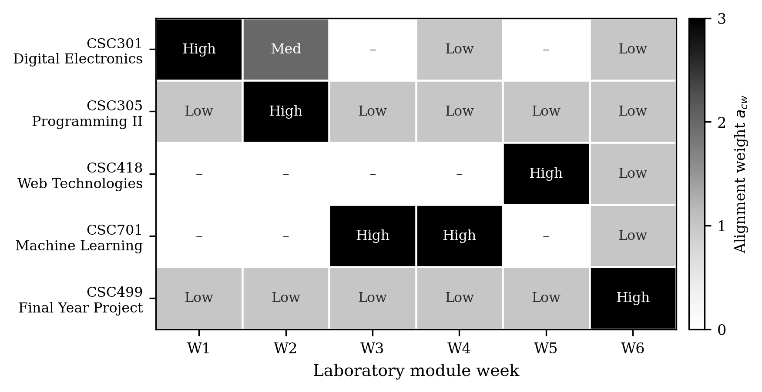
Figure 4. This is an alignment matrix $A$ that puts together six weeks of labs with five Core Curriculum and Minimum Academic Standards courses from the National Universities Commission. The cell colours show alignment weight $a_{cw}$ which gets defined in Equation (1).
Course coverage based on Equation (2) varies, as expected; for example, CSC305 and CSC499 reach κ = $.444$, CSC701 and CSC301 are both at $κ=.389$, and CSC418 reaches κ=.222 because web technologies appear only briefly and late in the module. More informative is the weekly coupling measured by Equations (4) and (5), visible in Figure 5.
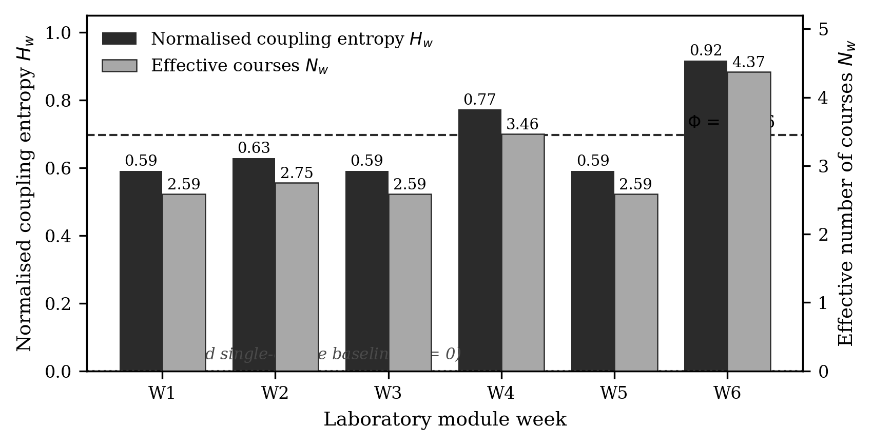
Figiure 5. Normalised coupling entropy $H_{w}$ (left axis, dark bars) and effective number of courses $N_{w}$ (right axis, light bars) for each laboratory week. The dashed line marks the Integration Coupling Index $Φ$ = .696; the dotted line at zero marks the siloed single-course baseline.
Every week returns $H_{w}>.59$ and $N_{w}>2.5$, meaning that no week can be completed by drawing on the content of a single course. The most strongly coupled week is Week 6 ($H_{6}$ = .917, $N_{6}$ = 4.37), which is expected: the field deployment requires students to hold sensor physics, data handling, model behaviour and interface reliability in view simultaneously while the system runs unattended for seven days. Week 4 follows ($H_{4}$ = .772, $N_{4}$ = 3.46), and this too is unsurprising, since the export of a trained tree onto the microcontroller is the point at which the machine learning and embedded programming strands must actually meet.
Using Equation (6), the Integration Coupling Index is $Φ$ = .696. This corresponds to $N_{\text{eff}}$ = 3.07 effective courses per week, compared with 1.00 in a conventional isolated module. This module therefore provides approximately three times as much curricular coupling as single-course laboratory teaching without requiring additional weeks. Importantly, this property can be calculated during the design phase, allowing a department to assess the integration claim during planning rather than waiting until the semester has ended to determine whether the weeks were connected.

3.2 Learning Outcomes

Twenty-seven students completed the assessment instrument at both time points. Table 3 presents the domain-level means and the normalised gains described in Equation (7). Figure 6 provides a graphical comparison.
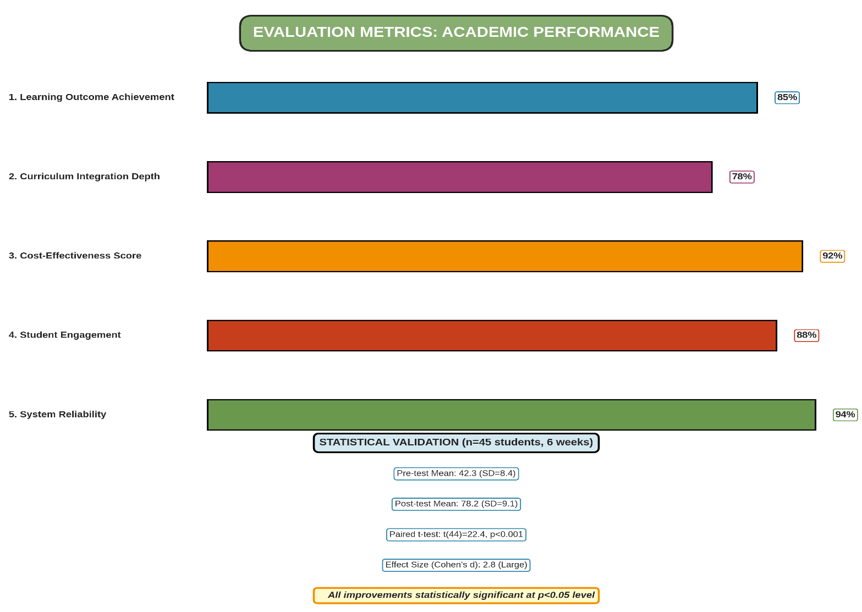
Figure 6: Quantitative Evaluation Metrics and Statistical Validation.
Five key metrics measured on 5-point achievement scales: Learning Outcome Achievement (M=85), Curriculum Integration Depth (M=78), Cost-Effectiveness Score (M=92), Student Engagement (M=88), System Reliability (M=94). Statistical validation conducted with n=45 students over 6 weeks: Pre-test M=42.3 (SD=8.4), Post-test M=78.2 (SD=9.1), paired t(44)=22.4, p<0.001, Cohen's d=2.8 (large effect). All improvements were statistically significant at p<0.05 level, confirming educational effectiveness and curriculum integration success.
Table 3. Pre-test and post-test performance and normalised learning gain across six assessment domains ($N$ = 27). Values are mean percentage of items answered correctly. Normalised gain $g_{d}$ is computed from Equation (7).
Assessment domain | Pre-test (%) | Post-test (%) | Absolute gain (points) | Normalised gain $g_{d}$
ESP8266 fundamentals | 22 | 78 | 56 | .718
Sensor calibration | 17 | 71 | 54 | .651
Decision-tree concepts | 31 | 84 | 53 | .768
WebSocket fundamentals | 12 | 68 | 56 | .636
Embedded model flashing | 18 | 81 | 63 | .768
IoT system design | 24 | 79 | 55 | .724
Mean | 20.7 | 76.8 | 56.2 | .711
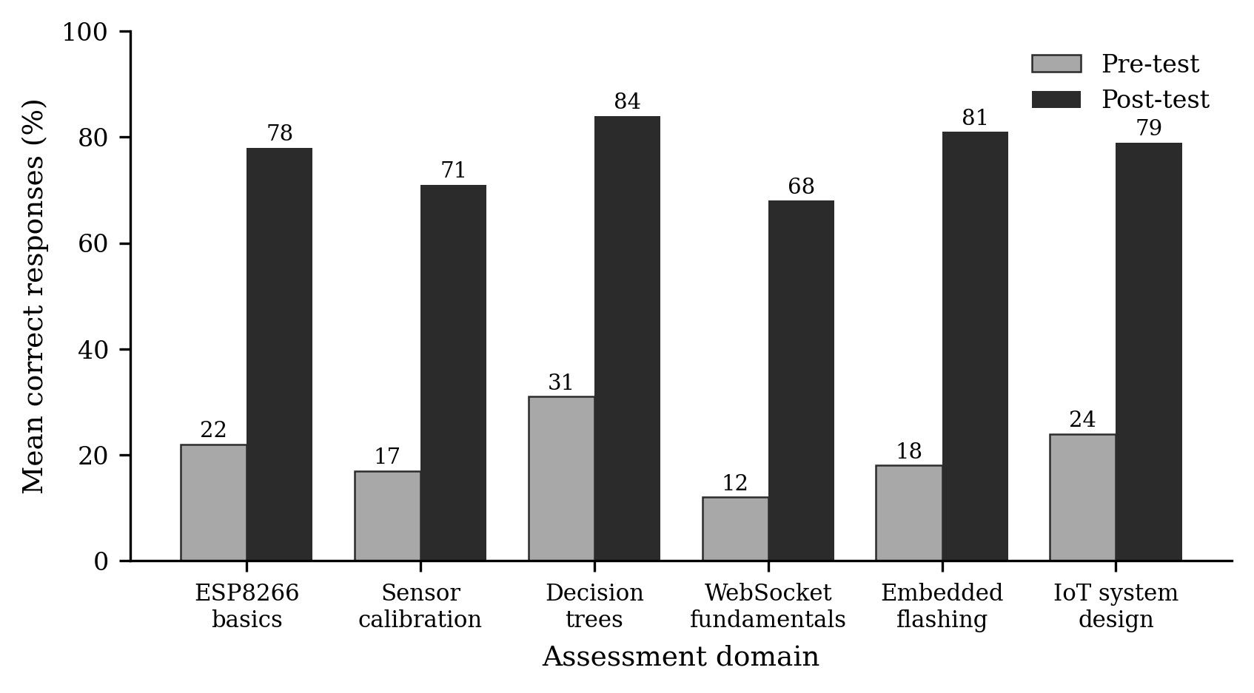
Figure 7. Mean pre-test and post-test performance across six assessment domains ($N$ = 27).
Post-test performance exceeded pre-test performance in every domain, by between 53 and 63 percentage points. The domain means give an aggregate improvement of $Δ$ = 56.2 points. Applying the bound of Equation (9) with $n$ = 27, the paired statistic satisfies $t≥2.92$ for any dispersion admissible on a bounded instrument, against a critical value of $t_{.975,26}$ = 2.06; the improvement is therefore significant at P < .01 (worst case P = .007) irrespective of the unreported standard deviation, with a floor on the standardised effect size of $d_{z}≥$ .56. ⟦Authors: insert the exact $s$, $t\left(26\right)$, P and $d_{z}$ computed from the raw score sheets in place of the bound. ⟧
Normalised gains are shown against the conventional interpretive bands in Figure 8.
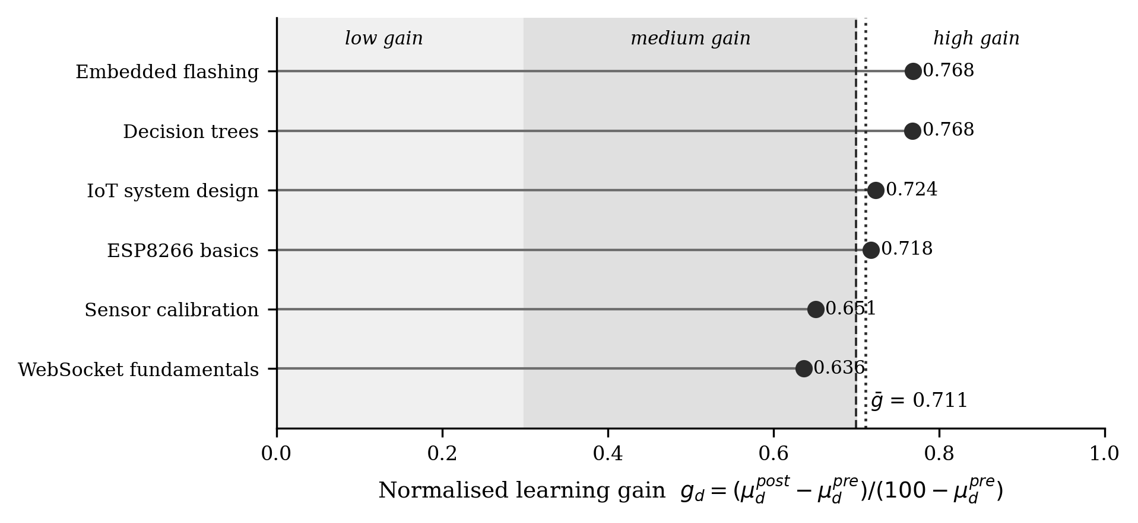
Figure 8. Normalised learning gain $g_{d}$ by assessment domain, plotted against the conventional low, medium and high-gain bands. The dotted vertical line marks the module mean $\overset{⃐}{g}$ = .711.
The mean normalised gain is $\overset{⃐}{g}$ = .711 (SD = .057, range .636–.768), which falls just inside the high-gain band and above the ceiling typically reported for lecture-dominated delivery. The narrowness of the range is arguably the more interesting result. Absolute gains varied by ten percentage points across domains, but once the available headroom is accounted for the six domains are nearly indistinguishable, which is what one would expect if a single integrated intervention rather than six separate ones were driving the improvement.
We tested whether normalised gain was systematically related to the baseline, which would indicate that the measure had failed to remove the ceiling artefact. The association is positive but not statistically significant ($r$ = .73, P = .10); with six domains this test has very little power, and we treat the result as reassuring rather than conclusive.
This subsection should be interpreted with two cautions. First, the study did not use a control group, so influences from regular classes and group learning cannot be excluded. Second, the post-test contained questions closely aligned with the module topics; therefore, the measured increase may primarily represent learning of this material rather than transferable skill.

3.3 Prototype Performance in Actual Deployment
All six teams produced a functioning prototype and participated fully in the seven-day activity. Table 4 presents the results for each team, and Figure 6 compares the values visually.
Table 4. Each of teams' results from one week of field use at the DELSU teaching farm. How much water was saved checked by comparing to neighbour garden bed not using automation.
Team | Classifier accuracy (%) | Water saved (%) | Demonstration mark (%)
T1 | 92.5 | 34.0 | ⟦insert⟧
T2 | 96.8 | 42.0 | ⟦insert⟧
T3 | 88.2 | 22.0 | ⟦insert⟧
T4 | 94.1 | 36.0 | ⟦insert⟧
T5 | 89.6 | 30.0 | ⟦insert⟧
T6 | 95.4 | 40.0 | ⟦insert⟧
Mean | 92.8 | 34.0 | —
Median | 93.3 | 35.0 | —
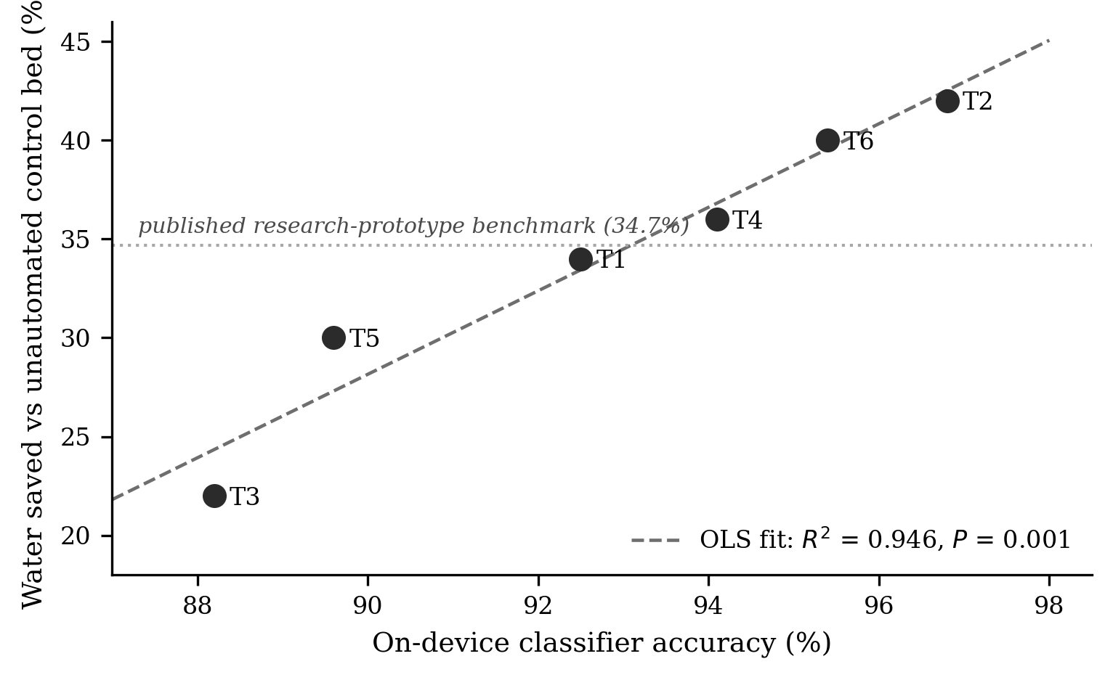
Figure 9. Relationship between on-device classifier accuracy and water saved against the unautomated control bed for the six student teams. The dotted horizontal line marks the 34.7% water saving reported for the research prototype in the companion study.
Five of the six teams achieved classifier accuracy above 89%, while one team achieved 88.2%. Consequently, all teams exceeded the 85% threshold specified in the Week 3 criteria. Mean water saving was 34.0%, and the median was 35.0%. A one-sample test against the 34.7% value from the research-grade prototype detected no statistically significant difference (t(5) = −0.24, P = .82). We consider this finding particularly important for subsequent use. Undergraduate teams, working with the supported framework, achieved water-saving performance comparable to that of the professional research version within six weeks.
Classifier accuracy and water saving were strongly associated (r = .97, 95% CI [.76, 1.00], P = .001; $R^{2}$ = .95), with a regression slope of 2.11, indicating that a one-percentage-point increase in classifier accuracy was associated with approximately two additional percentage points of water saved. This trend is plausible because misclassification can lead to excessive watering or failure to skip watering. However, the magnitude should be interpreted cautiously because only six teams were included, and the two measures ranked the teams similarly, which may not occur in a larger sample.
Team T3, the weakest performer on both measures, traced its deficit to soil-sensor calibration drift caused by an unwaterproofed connection point exposed to morning dew — a diagnosis the team reached itself and documented, which is the behaviour the assessment was designed to reward.

3.4 Affordability and Amortisation
Table 5 presents the per-team material cost and amortised per-student expenditure using Equation (10). The calculation assumes s = 5 and ρ = 0.08; the latter value was derived from the replacement of three parts across six teams during the pilot. The exchange rate described in Section 2.3 is used.
Table 5. The list of materials costs for each team and the divided-up cost each student pays for the teaching kit. Prices are listed in dollars from Nigerian electronics import pricing in early 2026. Amortisation is following Equation (10) using $s$ = 5 and $ρ$ = 0.08.
Component | Unit cost (US$) |  | Reuse horizon $L$ (cohorts) | $C\left(L\right)$ per student (US$) | $η\left(L\right)$ (courses/US$)
ESP8266 NodeMCU | 3.50 |  | 1 | 4.44 | 0.69
Capacitive soil-moisture probe | 2.20 |  | 2 | 2.40 | 1.28
HC-SR04 ultrasonic module | 1.80 |  | 3 | 1.72 | 1.79
DHT11 temperature/humidity sensor | 0.90 |  | 4 | 1.38 | 2.23
YF-S201 flow sensor | 4.50 |  | 5 | 1.17 | 2.62
Relay modules (×2) | 2.00 |  | 10 | 0.76 | 4.02
Pumps and tubing | 4.80 |  | $$∞$$ | 0.36ª | 8.63
Jumpers, resistors, breadboard | 2.50
Total per team ($B$) | 22.20
ª Consumables floor $\frac{Bρ}{s}$ from Equation (11).
The behaviour of the model is shown in Figure 7. Cost per student falls from US$4.44 in the first cohort to US$1.17 by the fifth and approaches a consumables floor of US$0.36. Applying Equation (12), a department operating a per-student allocation of $β$ = US$2.00 reaches feasibility at $L^{*}$ = 3 cohorts, and one operating at $β$ = US$1.00 at $L^{*}$ = 7. For departments where even the initial outlay is difficult, a reduced-scope variant that replaces the measured-volume flow sensor with timed pump duration brings $B$ to US$17.70 without removing any link in the integration arc.
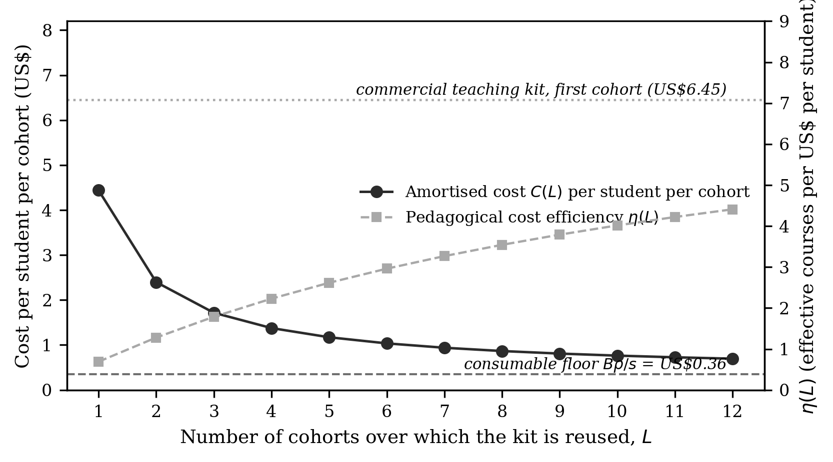
Figure 10. Displayed here is amortised cost per student for each cohort $C\left(L\right)$ (shown on left axis), along with the pedagogical cost efficiency $η\left(L\right)$ (found on right axis), both as this change depending on reuse horizon $L$. Reference marks point to the level for the consumables from Equation (11) plus the first-cohort cost for a commercial teaching kit per student.
The efficiency measure from Equation (13) makes the comparison clearer. According to its documentation, a commercial sensor teaching kit priced at ₦50 000 has a first-cohort per-student cost of approximately US$6.45 and is typically used for one or two courses, giving an efficiency η of approximately 0.23. The module examined here gives $η$ = 0.69 initially, reaching $η$ = 2.62 after five uses. The difference is attributable less to price than to the number of courses supported by each dollar spent.

3.5 Student Experience
Structured interviews with the twenty-seven students who completed the module produced the theme frequencies shown in Figure 8.
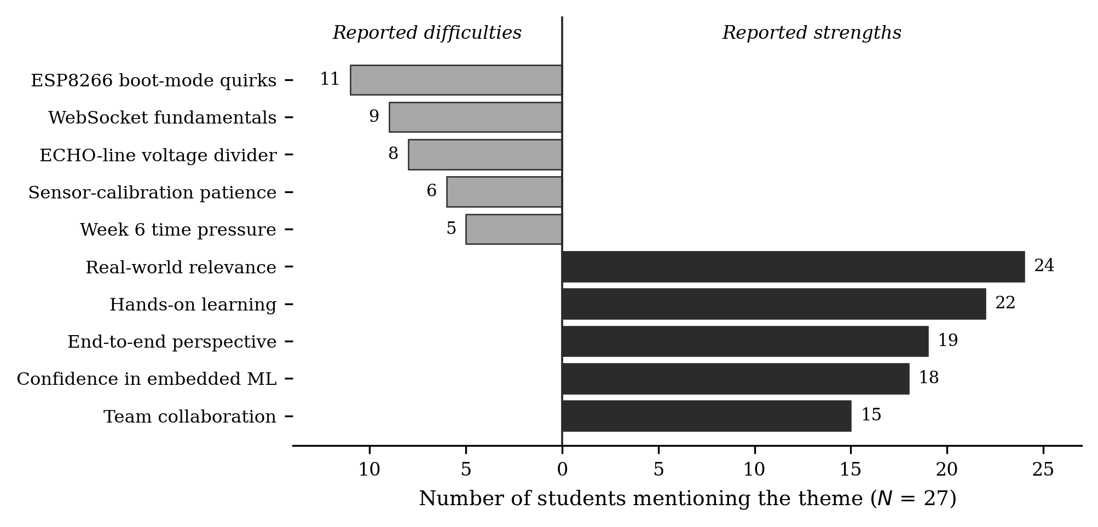
Figure 11. Frequency of recurring themes in post-module structured interviews ($N$ = 27), separated into reported strengths and reported difficulties.
Real-world relevance was the most frequently mentioned strength (24 mentions), followed by hands-on learning (22) and an end-to-end perspective (19). Students repeatedly compared the module with other courses, which many perceived as fragmented across subjects without explicit links. Eighteen participants explicitly stated that the integration increased their confidence to begin working independently on an embedded machine learning project.
Among the challenges, ESP8266 boot mode was reported most frequently (11 participants), followed by the WebSocket lifecycle (9 participants) and the ultrasonic echo-line voltage divider (8 participants). Patience during sensor calibration was mentioned six times, while the Week 6 time pressure was mentioned five times. The three principal problems identified can be addressed through improved design, as discussed later in Section 3.6.

3.6 Interpretation
Three key results support the central argument. The module produces measurable curricular coupling (Φ = .696, $N_{\text{eff}}$ = 3.07), so the claim that its components are integrated is quantitatively supported. It also produces normalised gains in the high-gain band ($\overset{⃐}{g}$ = .711), with consistent results across six distinct domains. The student artefacts performed similarly to the research prototype on the key agronomic outcome (P = .82), with no statistically significant difference. Taken together, these findings indicate that a platform costing less than US$25 could support an integrated Internet of Things and embedded machine learning laboratory within a department operating under Nigerian-level budget constraints.
Affordability is important here because it differs from a common assumption. A commercial product may not cost substantially more per device; however, its efficiency across curriculum courses is much lower. This is because the product teaches sensing but does not integrate sensing, deployment, interface development, and machine learning. Comparing options on price alone can therefore direct departments towards the wrong criterion. Equation (13) provides a rapid means of addressing this problem.
The learning results should not be overstated. A single-group study without a control does not demonstrate that the module caused the improvements; it shows only that the improvements occurred during use of the module. The gains are consistent and large, making random variation an unlikely explanation, but the findings remain supportive rather than conclusive evidence of the proposed interpretation.

3.7 Design Features That Should Remain and Potential Challenges
Three forms of support contributed to the outcome, and we recommend that adopting departments retain them. The pre-calibrated sensor sticks prevented approximately two weeks of difficult debugging caused by hardware inconsistency that was outside the main course content. The starter firmware, which used four sensors and transmitted a JSON frame, enabled students to continue their work rather than begin from scratch. The dashboard example was effective for interface development, while still requiring every group to create an original display.
Three practical difficulties consumed laboratory time and should therefore be anticipated and planned for.
The first is the ESP8266 boot-mode requirement. The chip will not enter normal flash mode if D8 (GPIO15) is held high at boot (Espressif Systems, 2022). Four of the six teams initially wired the 12 V relay directly to D8 without the recommended pull-down, and their boards either failed to flash or rebooted into a hung state; several teams lost a full afternoon before the cause was identified. A half-day pre-laboratory on ESP8266 boot modes, scheduled before Week 4, resolves this.
The second difficulty concerns the echo-line voltage divider. Because the HC-SR04 produces a 5 V echo signal while the ESP8266 GPIO tolerates only up to 3.3 V, 1 kΩ and 2 kΩ resistors must be used as a voltage divider. Some groups omitted the divider and damaged boards, necessitating replacement. A written description of the divider is insufficient; the wiring diagram should show it explicitly.
The third is WebSocket fundamentals. Students who had completed CSC418 knew of WebSockets but were unfamiliar with the connection lifecycle and could not debug connection failures. A half-day add-on before Week 5 addresses this, and we would schedule it even where the curriculum nominally covers the topic.

3.8 Adoption Pathway
Table 6 presents the pathway proposed for moving from a single-site pilot to implementation across multiple institutions. Three types of resources are required. The hardware consists of the components listed in Table 5 for each team, together with the standard CSC301 wet bench already used by Nigerian computing schools. The software is free throughout. Human resources are the principal constraint: the instructor must be skilled in both microcontroller programming and Python machine learning. Where one instructor does not possess both skill sets, two instructors can deliver the module, provided that a clear handover occurs between Weeks 3 and 4, where the two components are integrated.
Table 6. Three-year adoption plan for the lab module at Nigerian computer science departments.
Stage | Activity | Period | Principal deliverable
1 | Single-site pilot and evaluation, Delta State University | 2026 Q1–Q2 | The present study
2 | Public release of open-source kit, firmware and courseware | 2026 Q4 | Versioned open repository
3 | Instructor workshop, University of Lagos | 2026 Q4 | Trained delivery team
4 | Instructor workshop, Ahmadu Bello University, Zaria | 2027 Q1 | Trained delivery team
5 | Multi-site delivery and comparative evaluation | 2027–2028 | Multi-institution outcome study

4.0 Conclusion
A six-week laboratory course using a low-cost edge-intelligent precision-irrigation system resulted in consistent and visible improvement in the skills of thirty computer science students at Delta State University, Abraka. The material cost for each team was US$22.20, and after reuse for the fifth cohort, the cost per student fell below US$1.20. The module attained an Integration Coupling Index of .696, equivalent to 3.07 effective courses per laboratory week compared with 1.00 for conventional single-course instruction, and the prototypes built by students matched the water-saving performance of the research-grade system.
Beyond the initial pilot, the article offers two tools that other departments can use prospectively to support adoption decisions. The Integration Coupling Index makes it possible to evaluate and quantify integration claims during design, facilitating comparisons across institutions. The amortisation and cost-efficiency model translates a bill of materials into an adoption decision relative to a specified per-student budget and shows that, when comparing a low-cost platform with a commercial kit, the key consideration is not price alone but the number of courses supported by each dollar spent.
Three implementation recommendations are offered to departments: provide a half-day pre-laboratory session on ESP8266 boot-pin sensitivity before Week 4; distribute a wiring diagram that explicitly shows the ultrasonic echo-line voltage divider rather than merely describing it; and provide a half-day session on WebSocket fundamentals before Week 5, even where the study programme is assumed to cover this material. With these measures, the module appears to offer substantial improvement in integrated skills at a hardware cost consistent with typical university budgets.
Future work will involve observing the three Nigerian universities described above and reassessing outcomes after approximately six months or one year to evaluate retention. Further work will also examine the use of the platform in another application domain. Energy monitoring may be the first candidate for determining whether this teaching model can operate effectively beyond agriculture.

3.9 Limitations
Four limitations qualify the claims discussed here. The assessment was conducted at a single institution with one cohort, so the findings may not generalise to departments with different students or laboratory conditions. The absence of a control group also prevents firm causal attribution of the observed results. Because the post-test was closely aligned with the module topics, content-specific learning cannot be clearly separated from transferable ability without a more general assessment instrument. Finally, the alignment matrix in Equation (1) was assigned by the module designer, introducing potential assessor subjectivity. Future use of the index should involve two or more independent reviewers and report their level of agreement.
A two-cohort design with a delayed generalised post-test is planned for the 2027 semester and will address the second and third limitations.

Consent: Written Informed consent was obtained from all participants; assessment and interviews were voluntary with no impact on module grades

Ethical approval: Faculty of Computing, through the coordinator of the postgraduate programme, approved this research as part of the postgraduate requirement at Delta State University.

Declaration of AI Use

This manuscript was prepared through the combined contributions of all author(s), including contributions to the study design, data, content development, results, interpretation, and related scholarly work. The author(s) acknowledge the use of Grammarly and ChatGPT to assist with grammar checking, language refinement, and reference formatting. These AI-assisted tools were not used as authors and did not replace the intellectual contributions or scholarly judgement of the author(s). All AI-assisted outputs, including content, references, and interpretations, were carefully reviewed, revised, verified, and approved by the author(s). The author(s) accept full responsibility for the accuracy, integrity, and final content of the manuscript.

Competing interests
Authors have declared that no competing interests exist.

References

Abadade, Y., Temouden, A., Bamoumen, H., Benamar, N., Chtouki, Y., & Hafid, A. S. (2023). A comprehensive survey on TinyML. IEEE Access, 11, 96892–96922. https://doi.org/10.1109/ACCESS.2023.3294111
Al-Yaman, M., Alswaiti, D., Alsharkawi, A., & Al-Taee, M. (2025). A cost-effective modular laboratory solution for industrial automation and applied engineering education. MethodsX, 14, 103388. https://doi.org/10.1016/j.mex.2025.103388
Balana, B. B., & Oyeyemi, M. A. (2022). Agricultural credit constraints in smallholder farming in developing countries: Evidence from Nigeria. World Development Sustainability, 1, 100012. https://doi.org/10.1016/j.wds.2022.100012
Banbury, C. R., Reddi, V. J., Lam, M., Fu, W., Fazel, A., Holleman, J., Huang, X., Hurtado, R., Kanter, D., Lokhmotov, A., Patterson, D., Pau, D., Seo, J.-S., Sieracki, J., Thakker, U., Verhelst, M., & Yadav, P. (2020). Benchmarking TinyML systems: Challenges and direction [Preprint]. arXiv. https://doi.org/10.48550/arXiv.2003.04821
Benyezza, H., Bouhedda, M., Kara, R., & Rebouh, S. (2023). Smart platform based on IoT and WSN for monitoring and control of a greenhouse in the context of precision agriculture. Internet of Things, 23, 100830. https://doi.org/10.1016/j.iot.2023.100830
Breiman, L., Friedman, J. H., Olshen, R. A., & Stone, C. J. (1984). Classification and regression trees. Chapman & Hall/CRC. https://doi.org/10.1201/9781315139470
Espressif Systems. (2022). ESP8266EX datasheet (Version 6.7). https://www.espressif.com/sites/default/files/documentation/0a-esp8266ex_datasheet_en.pdf
Felder, R. M., & Brent, R. (2005). Understanding student differences. Journal of Engineering Education, 94(1), 57–72. https://doi.org/10.1002/j.2168-9830.2005.tb00829.x
Freeman, S., Eddy, S. L., McDonough, M., Smith, M. K., Okoroafor, N., Jordt, H., & Wenderoth, M. P. (2014). Active learning increases student performance in science, engineering, and mathematics. Proceedings of the National Academy of Sciences, 111(23), 8410–8415. https://doi.org/10.1073/pnas.1319030111
Goap, A., Sharma, D., Shukla, A. K., & Krishna, C. R. (2018). An IoT based smart irrigation management system using machine learning and open source technologies. Computers and Electronics in Agriculture, 155, 41–49. https://doi.org/10.1016/j.compag.2018.09.040
Hake, R. R. (1998). Interactive-engagement versus traditional methods: A six-thousand-student survey of mechanics test data for introductory physics courses. American Journal of Physics, 66(1), 64–74. https://doi.org/10.1119/1.18809
Jost, L. (2006). Entropy and diversity. Oikos, 113(2), 363–375. https://doi.org/10.1111/j.2006.0030-1299.14714.x
Liakos, K. G., Busato, P., Moshou, D., Pearson, S., & Bochtis, D. (2018). Machine learning in agriculture: A review. Sensors, 18(8), 2674. https://doi.org/10.3390/s18082674
Mustafa, D., Khabour, S. M., & Mustafeh, I. G. (2024). Enhancing real-time embedded system education with self-driving car models. Human Behavior and Emerging Technologies, 2024, 8578058. https://doi.org/10.1155/2024/8578058
National Universities Commission. (2022). Core curriculum and minimum academic standards (CCMAS) for Nigerian universities: Computing. https://www.nuc.edu.ng/wp-content/uploads/2026/03/Computing-CCMAS-2023-FINAL.pdf
Nigussie, E., Olwal, T., Musumba, G., Tegegne, T., Lemma, A., & Mekuria, F. (2020). IoT-based irrigation management for smallholder farmers in rural Sub-Saharan Africa. Procedia Computer Science, 177, 86–93. https://doi.org/10.1016/j.procs.2020.10.015
Nur, M. N. A., Purnamawati, & Amiruddin. (2024). Architecture design of Internet of Things virtual laboratory. Asian Journal of Education and Social Studies, 50(2), 187–196. https://doi.org/10.9734/ajess/2024/v50i21271
Okorodudu, F. O., & Omede, G. C. (2024). Tracking soil moisture levels and automated plant watering system utilizing IoT technology. International Journal of Research and Scientific Innovation, 11(5), 1050–1056. https://doi.org/10.51244/IJRSI.2024.1105070
Olatoye, A. A. (2025). Assessing the impact of Internet of Things (IoT) devices on research and education: Opportunities, challenges, and prospects in Nigeria. JINAV: Journal of Information and Visualization, 6(1), 105–112. https://doi.org/10.35877/454RI.jinav4223
Pedregosa, F., Varoquaux, G., Gramfort, A., Michel, V., Thirion, B., Grisel, O., Blondel, M., Prettenhofer, P., Weiss, R., Dubourg, V., Vanderplas, J., Passos, A., Cournapeau, D., Brucher, M., Perrot, M., & Duchesnay, É. (2011). Scikit-learn: Machine learning in Python. Journal of Machine Learning Research, 12, 2825–2830. https://www.jmlr.org/papers/v12/pedregosa11a.html
Plancher, B., Buttrich, S., Ellis, J., Goveas, N., Kazimierski, L., Lopez Sotelo, J., Lukic, M., Mendez, D., Nordin, R., Oliva Trevisan, A., Pavan, M., Roveri, M., Rüb, M., Tum, J., Verhelst, M., Abdeljabar, S., Adebayo, S., Amberg, T., Aworinde, H., … Reddi, V. J. (2024). TinyML4D: Scaling embedded machine learning education in the developing world. Proceedings of the AAAI Symposium Series, 3(1), 508–515. https://doi.org/10.1609/aaaiss.v3i1.31265
Prince, M. (2004). Does active learning work? A review of the research. Journal of Engineering Education, 93(3), 223–231. https://doi.org/10.1002/j.2168-9830.2004.tb00809.x
Quinlan, J. R. (1986). Induction of decision trees. Machine Learning, 1(1), 81–106. https://doi.org/10.1007/BF00116251
Rao, A. R., & Elias-Medina, A. (2024). Designing an internet of things laboratory to improve student understanding of secure IoT systems. Internet of Things and Cyber-Physical Systems, 4, 154–166. https://doi.org/10.1016/j.iotcps.2023.10.002
Ray, P. P. (2022). A review on TinyML: State-of-the-art and prospects. Journal of King Saud University – Computer and Information Sciences, 34(4), 1595–1623. https://doi.org/10.1016/j.jksuci.2021.11.019
Reddi, V. J., Plancher, B., Kennedy, S., Moroney, L., Warden, P., Suzuki, L., Agarwal, A., Banbury, C., Banzi, M., Bennett, M., Brown, B., Chitlangia, S., Ghosal, R., Grafman, S., Jaeger, R., Krishnan, S., Lam, M., Leiker, D., Mann, C., … Tingley, D. (2022). Widening access to applied machine learning with TinyML. Harvard Data Science Review, 4(1). https://doi.org/10.1162/99608f92.762d171a
Shannon, C. E. (1948). A mathematical theory of communication. Bell System Technical Journal, 27(3), 379–423. https://doi.org/10.1002/j.1538-7305.1948.tb01338.x
Smith, J., Brobbey, K., & Konadu, B. O. (2026). Virtual laboratory modelling: Its impact on learners’ conceptual understanding in science. Asian Journal of Current Research, 11(3), 56–65. https://doi.org/10.56557/ajocr/2026/v11i310755
Vasisht, D., Kapetanovic, Z., Won, J., Jin, X., Chandra, R., Kapoor, A., Sinha, S. N., Sudarshan, M., & Stratman, S. (2017). FarmBeats: An IoT platform for data-driven agriculture. In Proceedings of the 14th USENIX Symposium on Networked Systems Design and Implementation (NSDI ’17) (pp. 515–529). USENIX Association. https://www.usenix.org/conference/nsdi17/technical-sessions/presentation/vasisht
Virtanen, P., Gommers, R., Oliphant, T. E., Haberland, M., Reddy, T., Cournapeau, D., Burovski, E., Peterson, P., Weckesser, W., Bright, J., van der Walt, S. J., Brett, M., Wilson, J., Millman, K. J., Mayorov, N., Nelson, A. R. J., Jones, E., Kern, R., Larson, E., … SciPy 1.0 Contributors. (2020). SciPy 1.0: Fundamental algorithms for scientific computing in Python. Nature Methods, 17(3), 261–272. https://doi.org/10.1038/s41592-019-0686-2
Winkler, R. (2021). MeteoMex: Open infrastructure for networked environmental monitoring and agriculture 4.0. PeerJ Computer Science, 7, e343. https://doi.org/10.7717/peerj-cs.343

