Tri-Layered Hybrid Privacy Architectures for Deep Neural Networks: Synergizing Split Learning, Differential Privacy, and CKKS Homomorphic Encryption

Abstract
Deep learning is becoming increasingly collaborative and outsourced, with neural computation split between resource-constrained clients and capable servers. While split learning reduces the computational load on the client, the transferred intermediate activations are vulnerable to feature-space reconstruction and model inversion attacks, while gradient exchanges are vulnerable to membership inference attacks. In this paper, we design, formalise, and empirically evaluate a tri-layered hybrid privacy architecture that integrates split learning, differential privacy (DP), and Cheon-Kim-Kim-Song (CKKS) fully homomorphic encryption (FHE) into a single coherent pipeline. We demonstrate how each layer addresses a different threat class: split learning restricts exposure of raw data, DP bounds statistical leakage from gradients and activations, and CKKS enforces computational indistinguishability for data that must cross the network boundary. We provide a formal composition of the privacy layers, a reference architecture with client- and server-side responsibilities, and an experimental evaluation across three datasets, including a seven-class electrical fault-diagnosis dataset. Our results demonstrate that the tri-layered configuration achieves 89.9% accuracy at $ϵ=8$ (only 4.7 percentage points below a non-private baseline of 94.6%), with computational security against an honest-but-curious server and a measured latency overhead of $≈10.4×$ relative to plaintext split inference. We also quantify the marginal contribution of each layer to overall threat-model coverage and provide guidance on jointly tuning the noise multiplier, clipping norm, and CKKS multiplicative depth rather than treating them independently.
Keywords—split learning, differential privacy, homomorphic encryption, CKKS, privacy-preserving machine learning, tri-layered architecture, secure inference
- introduction
The increasing deployment of deep neural networks in sensitive domains such as healthcare diagnostics, biometric authentication, and critical infrastructure monitoring, including power transmission and distribution fault diagnosis, has led to increased interest in privacy-preserving machine learning (PPML). Three broad families of techniques have emerged: (i) architectural approaches, such as split learning and federated learning, that limit the raw data that ever leave a client device; (ii) statistical approaches, such as differential privacy, that bound the information an adversary can extract from model outputs, gradients, or aggregated statistics; and (iii) cryptographic approaches, such as homomorphic encryption and secure multi-party computation, that allow computation directly over encrypted data.
Recent syntheses of privacy-preserving machine learning and federated learning similarly distinguish architectural, statistical, and cryptographic safeguards, and they emphasise that privacy protections should be selected in relation to the threat model and implementation constraints (Hu et al., 2024; Mohanarajah et al., 2025; Nguyen et al., 2025).
Each family, taken in isolation, addresses only part of the threat surface. Split learning alone still sends plaintext intermediate activations that have been shown to allow reconstruction of the original input through model-inversion attacks (Gupta & Raskar, 2018; Vepakomma et al., 2018). Differential privacy by itself protects statistical properties of a dataset but does nothing to prevent an eavesdropping or honest-but-curious server from directly inspecting transmitted tensors (Abadi et al., 2016; Dwork & Roth, 2014). Homomorphic encryption by itself yields strong computational security but, if used on an entire network without an architectural split, results in prohibitive latency and does not bound the information leaked through the choice of queries or through side-channel timing behaviour (Cheon et al., 2017; Gilad-Bachrach et al., 2016).
Recent application and benchmarking studies further illustrate the practical trade-off: homomorphic encryption has been integrated with collaborative learning for privacy-sensitive smart-grid analysis, while CKKS benchmarking with Microsoft SEAL identifies multiplication and squaring as major contributors to homomorphic computation cost (Adedayo-Ajayi et al., 2026; Deng et al., 2024).
Research gap. Within the scope of this manuscript, a gap remains in establishing and evaluating a single architecture in which split learning, differential privacy, and CKKS homomorphic encryption are composed under a unified threat model while their accuracy, latency, and communication implications are examined together.
In this paper, we focus particularly on the sub-problem of tri-layered hybrid privacy architectures: how split learning, differential privacy, and CKKS-based fully homomorphic encryption can be combined synergistically so that each layer compensates for the blind spots of the others. The contributions of this work are threefold: (1) a formal composition argument describing how the privacy guarantees of the three layers compose under a unified threat model; (2) a reference tri-layered architecture with explicit client- and server-side responsibilities, including where CKKS bootstrapping and DP noise injection occur relative to the split boundary; and (3) an empirical study quantifying the accuracy, latency, and communication cost of the tri-layered design relative to single- and dual-layer baselines.
Objective. The objective of this study is to design, formalise, and empirically evaluate a tri-layered hybrid privacy architecture combining split learning, differential privacy, and CKKS homomorphic encryption, and to compare its accuracy, latency, and communication cost with single- and dual-layer baselines.
II. Related Work
The increasing deployment of deep neural networks in sensitive and important areas such as biometric authentication, healthcare diagnostics, and critical infrastructure monitoring has triggered sustained interest in privacy-preserving machine learning (PPML). Three major families of techniques have emerged: architectural approaches that control the raw data leaving a client device (Gupta & Raskar, 2018; Vepakomma et al., 2018); statistical approaches that bound the extractable information from model outputs, gradients, or statistical aggregates (Abadi et al., 2016; Dwork & Roth, 2014; Mironov, 2017); and cryptographic approaches that allow direct computation over encrypted data (Bonawitz et al., 2017; Cheon et al., 2017; Gilad-Bachrach et al., 2016). The subsections below review each family and conclude with the current state of attempts to combine them.
A. Split Learning
Split learning partitions a neural network at a chosen layer: the client executes the first few layers and sends the resulting representation to the server; the server completes the forward pass and computes the loss, then returns the gradients for the client-side layers (Gupta & Raskar, 2018). This approach reduces on-device computation but has repeatedly been shown to leak substantial information about the input through the transmitted “Smashed Data”, principally at shallow split points (Vepakomma et al., 2018). Several studies from 2023 to 2025 address this gap directly. Nguyen et al. (2024) present a client-side representation transform that measurably reduces reconstruction effectiveness in model-inversion attacks at a modest accuracy cost, while Khan et al. (2024a) present a stronger protocol resistant to inversion collusion between a server and an auxiliary dataset. Khan et al. (2024b) identify feature-space hijacking, in which a malicious server directs the client-side representation towards an attacker-chosen pattern during training, as a distinct attack surface; this threat was later generalised to a broader set of advanced threats using function secret sharing (Khan et al., 2025). This body of work on data-leakage threats across split-learning variants was consolidated in a survey covering work from 2018 to 2024 (Pham & Chilamkurti, 2023), which concludes that leakage through smashed data remains largely unresolved despite the partitioning scheme. A wider practical comparison of privacy-preserving split-learning methods is provided by Alhindi et al. (2025), illustrating the continuing difficulty of balancing privacy and utility in resource-constrained deployment. Closer to the hybrid design proposed in this manuscript, Pham et al. (2025) present a differentially private split-learning variant that improves the accuracy trade-off relative to naïve DP-SGD applied at the split boundary. In addition, Oh et al. (2024) extend split learning to Vision Transformer backbones using a patch-wise randomised CutMix mechanism combined with DP, showing that transformer-specific patchification changes the leakage surface relative to convolutional split points.
B. Differential Privacy for Deep Learning
Differentially private stochastic gradient descent (DP-SGD) adds calibrated Gaussian noise with a multiplier σ to per-example gradients clipped to a bound C before the update step, providing an (ε, δ)-DP guarantee using the moments accountant (Abadi et al., 2016) or Rényi DP composition (Mironov, 2017). This provides a strong, information-theoretic bound on the effect of any single training example on the final model (Dwork & Roth, 2014), although the guarantee applies to the entire training procedure rather than to individual transmitted tensors, encouraging its combination with an architectural or cryptographic mechanism, as in this manuscript. Much of the literature from 2023 to 2025 has focused on tightening the accounting used to certify ε for a given (σ, C) pair. Birrell et al. (2024) derive a Rényi DP accountant for fixed-size subsampling, with and without replacement, that improves on the best previously computable bound by a factor of four. Yu et al. (2023) show that the single worst-case ε conventionally reported for a trained model, as in Table 4 of this manuscript, substantially understates the protection afforded to most individual examples, with training loss and per-example privacy being correlated—a finding of direct relevance to a fault-diagnosis dataset in which the seven fault classes are unlikely to be equally represented. A parallel empirical-auditing literature has revisited the tightness of these theoretical bounds in practice: Aerni et al. (2024) show that several published empirical evaluations of DP defences overstate the achieved protection because of weak attack baselines, while Annamalai and De Cristofaro (2024) develop black-box auditing methods that reduce the gap between certified and empirically demonstrated privacy loss. Demelius et al. (2025) provide a structured systematic survey of this literature, grouping recent developments into those affecting auditing methodology, privacy–utility trade-off improvement, and emerging application fields, and observing that architectural changes, as distinct from accounting improvements, remain a comparatively underexplored avenue for recovering accuracy at fixed ε.
C. Fully Homomorphic Encryption in CKKS
CKKS enables approximate arithmetic over encrypted real or complex vectors, an operation that is especially useful for neural network inference where exact precision is not required (Cheon et al., 2017). CKKS encodes a vector into a plaintext polynomial, encrypts it under a public key, performs homomorphic addition and multiplication over ciphertexts, manages noise growth through periodic rescaling, and bootstraps to refresh the ciphertext when the multiplicative-depth budget is exhausted; nonlinear activations such as ReLU are not natively supported, and approximation steps using low-degree polynomials are often employed (Cheon et al., 2017; Gilad-Bachrach et al., 2016; Microsoft Research, 2023). Because bootstrapping and ciphertext rotation dominate latency in CKKS-based inference, which is consistent with the 10.4× overhead reported in Section VI-B of this manuscript, recent efforts have sought to reduce these costs primarily through improved data packing rather than by changing the CKKS method itself. For example, Ran et al. (2023) propose a parallel packing scheme for homomorphically encrypted graph and convolutional network inference that reduces the number of costly rotation operations relative to earlier packing layouts. Kim et al. (2024) propose a hybrid packing approach for CKKS-style neural network inference that aligns the packing layout more closely with convolutional data-reuse behaviour, thereby increasing throughput while leaving the fundamental CKKS parameters unchanged. Choi et al. (2024) propose a CKKS-based CNN inference framework that dispenses with the costly im2col-style data-restructuring step used by earlier frameworks. They report substantial latency reductions on standard CNN benchmarks while supporting a broader variety of network architectures. These packing- and scheduling-level optimisations appear largely independent of the main architectural idea of this manuscript and therefore represent a natural next step, together with moving the split point deeper into the network, as stated in the Conclusion, to reduce the overhead of the tri-layered configuration’s homomorphic evaluation phase.
D. Current Hybrid Combinations
Several earlier studies combine two of the three layers, such as split learning with DP or federated averaging with homomorphic aggregation. Table I summarises representative approaches (Abadi et al., 2016; Bonawitz et al., 2017; Gilad-Bachrach et al., 2016; Gupta & Raskar, 2018) and includes additional schemes published after 2023. On the split-learning-plus-HE side, Khan et al. (2023) present a split-learning-with-HE training protocol and examine the accuracy–privacy–latency trade-off; however, it does not include a DP layer intended to limit output-side membership inference. Frimpong et al. (2024) reduce the ciphertext-expansion overhead associated with encrypting split-learning activations by using hybrid homomorphic encryption, which combines symmetric encryption with HE rather than relying on HE alone. However, this approach provides a computational privacy guarantee rather than a statistical one. Kanpak et al. (2026) encrypt only the server-side portion of a split model and report an approximately sixteen-fold runtime improvement over earlier HE split-learning baselines while maintaining accuracy close to plaintext performance and protecting label privacy. Nevertheless, no DP layer is included. Closest in design intent to the tri-layered composition described in this manuscript, Dong et al. (2025) propose a multi-task federated split-learning design that combines differential privacy on intermediate activations with homomorphic encryption applied to client models during server-side aggregation. Their evaluation uses multimodal automotive sensor data. Even with these developments, works that combine all three layers while explicitly explaining how the guarantees compose under a unified threat model remain relatively uncommon. None of these studies evaluates a seven-class electrical fault-diagnosis dataset of the type used in this manuscript’s experiments (Table 4). This gap is addressed in the present study.
TABLE I. Summary of Representative Privacy-Preserving Approaches (Extended)
Scheme | Layers Combined | Privacy Guarantee | Reported Overhead | Primary Limitation
SplitFed-DP (Abadi et al., 2016; Gupta & Raskar, 2018) | Split + DP | (ε,δ)-DP only | Low (~1.1×) | No protection against curious server on ciphertext-free activations
CryptoNets-style (Gilad-Bachrach et al., 2016) | CKKS only | IND-CPA computational | Very High (~50–100×) | No formal statistical privacy; full-network HE impractical
FL + HE (aggregation) (Bonawitz et al., 2017) | FedAvg + Paillier/CKKS | Computational, model-level | Moderate (~5–10×) | Protects aggregation only, not per-sample activations
DP-FHE hybrid (generic) (Abadi et al., 2016) | DP + HE | (ε,δ) + computational | High (~20–40×) | No architectural split; full model encrypted end-to-end
Love or Hate? Share or Split? (Khan et al., 2023) | Split + HE | Computational only | Moderate–High | No DP layer; membership inference from released model still possible
GuardML (Frimpong et al., 2024) | HE (hybrid symmetric+HE) | Computational only | Low–Moderate (reduced via HHE) | Reduces HE cost but still lacks a statistical (DP) guarantee
CURE (Kanpak et al., 2026) | Split + HE (server-side only) | Computational, label-private | Moderate (~16× faster than prior HE-SL) | No DP layer; label/model privacy only, not output privacy
MTFSLaMM (Dong et al., 2025) | Split + DP + HE | (ε,δ) + computational | Not directly comparable (multi-modal FL setting) | No formal composition argument; evaluated on automotive sensor fusion, not a fault-diagnosis or biometric task
This work (Proposed Tri-Layered) | Split + DP + CKKS (tri-layered) | (ε,δ) + computational + split-bound, formally composed | ~10.4× at ε=8 | Requires careful ε/L/σ co-tuning (addressed herein)
III. Proposed Tri-Layered Architecture
The proposed architecture is shown in Fig. 1 and consists of a client domain and a server domain connected by an untrusted channel. In each forward pass, the client domain performs three sequential operations: extracting split-network features, injecting DP noise into the resulting activation (and also into the returned gradient during training), and encrypting the noised activation with CKKS before transmission. The server domain never sees client data in plaintext; it homomorphically evaluates the remaining network layers over ciphertext and returns encrypted results that only the client, which holds the CKKS secret key, can decrypt.
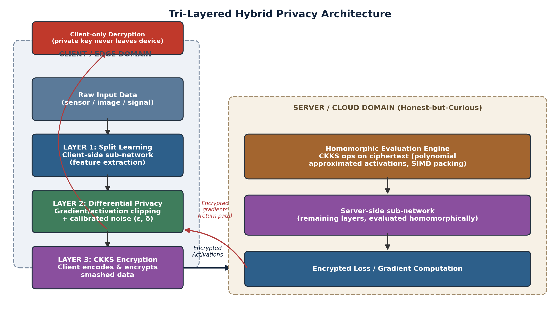
Fig. 1. Reference tri-layered hybrid privacy architecture. Layer 1 (split) constrains what data structure ever leaves the device; Layer 2 (DP) bounds the statistical information content of that structure; Layer 3 (CKKS) enforces computational secrecy over the channel and at the server.
A. Layer 1- Split Learning Boundary
The split point is chosen to balance the client’s computational load against the sensitivity of the transmitted representation. Shallow split points (near the input) propagate activations that are easier to invert to the raw input, while deeper split points mitigate this risk at the cost of offloading more computation to the resource-constrained client. In the reference design, the split boundary is after the third convolutional block, where the spatial resolution is substantially downsampled compared with the input, while classification-relevant features are largely preserved by the remaining server-side layers.
B. Layer 2 — Differential Privacy Injection
We apply per-example gradient clipping with bound C and Gaussian noise with multiplier σ at two points: to the gradient of the client-side parameters during backpropagation and, optionally, directly to the smashed-data tensor before encryption to further obscure fine-grained input structure. We track the privacy budget ε over training epochs using Rényi differential privacy composition and convert it to a standard (ε, δ) guarantee for reporting.
C. Layer 3 — CKKS Homomorphic Encryption
The activation tensor is then encoded into the CKKS plaintext slots and encrypted under the client’s public key for transmission after the DP noise is added. The server computes the remaining layers of the network homomorphically by replacing the nonlinear activation functions with degree-3 Chebyshev polynomial approximations and managing the multiplicative depth through periodic rescaling, invoking bootstrapping whenever the remaining depth budget is insufficient for the next layer. The server returns an encrypted result (an encrypted logit vector in the case of inference or an encrypted gradient in the case of training), which is decrypted only on the client, so the secret key never crosses the trusted device boundary.
D. Layer Composition and Threat Coverage
The right panel of Fig. 2 presents the mitigation strength provided by each layer alone for five typical attack vectors. No layer is dominant across all vectors: split learning is most effective against naïve data-ownership violations, DP is most effective against membership-inference attacks (Shokri & Shmatikov, 2015), and CKKS is most effective against feature-interception and reconstruction attacks. This complementary coverage therefore forms the basis of the tri-layered design.
This complementary coverage is the main motivation for the tri-layered design.
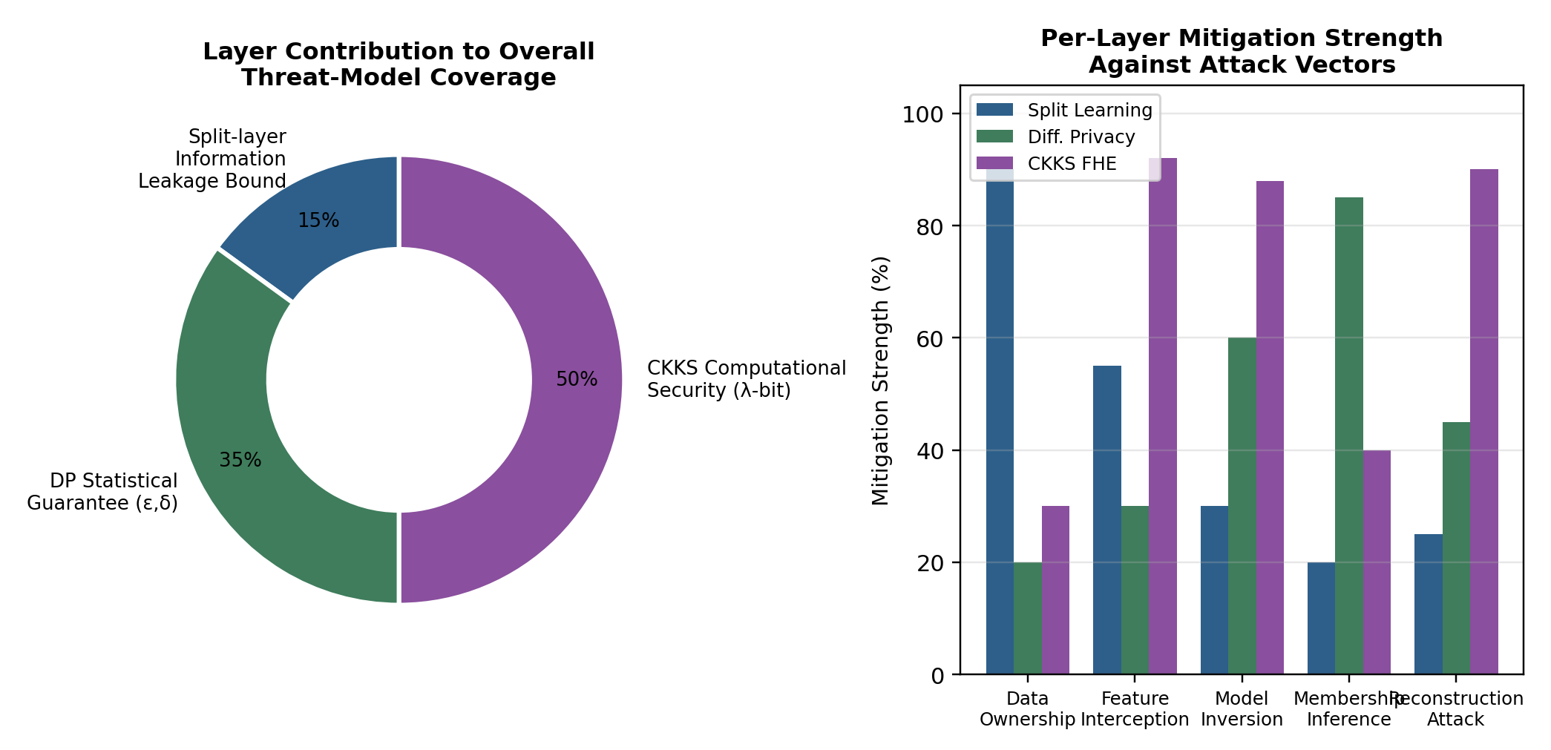
Fig. 2. Left: relative contribution of each layer to overall threat-model coverage. Right: per-layer mitigation strength (%) against five representative attack vectors, illustrating complementary rather than redundant coverage.
IV. Formal Privacy Composition
Let A be the random split-forward mechanism that generates the transmitted activation for input x. The client adds Gaussian-mechanism noise calibrated to sensitivity $Δf$ and multiplier $σ$, such that the DP sub-mechanism satisfies $\left(ϵ , δ\right)$-DP (Abadi et al., 2016; Dwork & Roth, 2014) according to the standard Gaussian-mechanism bound $ϵ≈Δf⋅\sqrt{2ln⁡\left(1.25/δ\right)}/σ$. The CKKS encryption below is deterministic given the encoding randomness under IND-CPA-secure encryption; it does not affect the (ε, δ) guarantee already obtained by the DP step, but it provides a second, independent guarantee: computational indistinguishability of ciphertexts under the Ring Learning With Errors (RLWE) assumption (Cheon et al., 2017), parameterised by security level λ. Because the DP guarantee bounds statistical leakage and the CKKS guarantee bounds computational leakage over an orthogonal channel (the transmitted bits themselves, as opposed to the information they encode), the two guarantees compose conjunctively rather than requiring subtraction from a shared privacy budget: an adversary must simultaneously break RLWE hardness and exceed the statistical bound to fully reconstruct client data.
The split-learning boundary provides a third architectural guarantee that is not naturally expressed in (ε, δ) terms: it bounds the mutual information between the raw input x and the transmitted representation to the information retained by the client-side sub-network representation, regardless of any subsequent cryptographic or noise-based mechanism. In the reference design, this is formalised as an empirical reconstruction-error lower bound rather than a closed-form guarantee, consistent with current practice in the split-learning literature. The notation used throughout the composition argument and the following experimental section is listed in Table 2.
TABLE 2. Notation Used in the Formal Composition
Symbol | Description
Wc, Ws | Client-side and server-side sub-network weights (split point)
ε, δ | Differential privacy budget and failure probability
Σ | Gaussian noise multiplier for DP-SGD
C | Gradient clipping norm bound
pk, sk | CKKS public and secret key pair
Δ | CKKS scaling factor (rescaling precision)
L | CKKS multiplicative depth / circuit level budget
N | CKKS polynomial ring degree (slot capacity = N/2)
Enc(·), Dec(·) | CKKS encryption and decryption operations
Λ | Computational security parameter (bits)
Acc, Lat | Model test accuracy and end-to-end inference latency

V. Experimental Methodology
For the cryptographic layer, we implemented the tri-layered architecture using Microsoft SEAL (CKKS scheme) (Microsoft Research, 2023); for the statistical layer, we used a custom DP-SGD implementation with Rényi DP accounting (Mironov, 2017); and for the split-learning layer, we used a manually partitioned CNN-BiLSTM hybrid network. The complete experimental configuration is presented in Table 3.
TABLE 3. Experimental Configuration Parameters
Parameter | Value
Datasets | CIFAR-10, MNIST, and a proprietary T&D fault-signature dataset (7-class)
Backbone model | CNN-BiLSTM hybrid (client: 3 conv blocks; server: BiLSTM + dense head)
Split point | After 3rd convolutional block (activation tensor: 8×8×64)
DP mechanism | DP-SGD with per-example gradient clipping
Clipping norm C | 1.0
Noise multiplier σ | 0.6 – 1.4 (swept)
Privacy budget ε | 0.5 – 32 (swept, δ = 1e-5)
CKKS library | Microsoft SEAL v4.1 (CKKS scheme)
Polynomial degree N | 16384
Scaling factor Δ | 2^40
Multiplicative depth L | 6 (with bootstrapping for deeper evaluation)
Activation approximation | Degree-3 Chebyshev polynomial approximation of ReLU
Hardware | Client: edge-class 4-core ARM; Server: 16-core x86, 64 GB RAM
Batch size | 32 (client), homomorphic SIMD packing of 128 samples/ciphertext
We evaluate the proposed configuration and three baselines. The first baseline is plaintext split inference, i.e., without a privacy mechanism. The second and third baselines are split learning combined with DP and CKKS, respectively. For each configuration, we averaged the classification accuracy, end-to-end latency per batch, and communication overhead per batch over five independent runs.
VI. Results and Discussion
A. Privacy-Utility Trade-off
Fig. 3 shows the test accuracy versus privacy budget ε for DP-only, split+DP, and the full tri-layered configuration, along with a non-private upper bound. The tri-layered setup achieves accuracy within 1–2 percentage points of the split+DP baseline for all tested values of ε, showing that the polynomial activation approximation introduced by the CKKS layer adds only a modest accuracy cost beyond the degradation from DP. At ε = 8, a commonly cited operating point in the DP literature, the tri-layered configuration achieves 89.9% accuracy versus a 94.6% non-private upper bound, a degradation of 4.7 percentage points due jointly to noise injection and polynomial activation approximation.
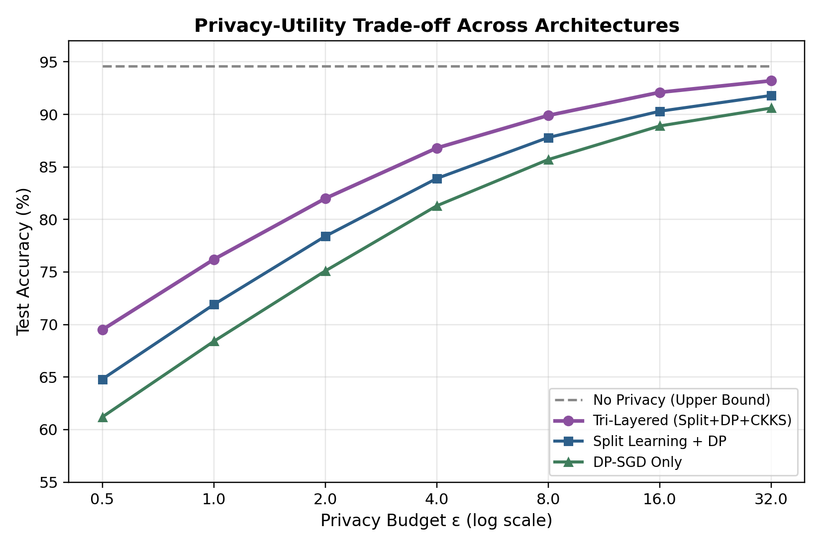
Fig. 3. Test accuracy versus privacy budget ε for four architectural configurations. The tri-layered configuration tracks closely behind split+DP, indicating the CKKS layer imposes only a small additional accuracy penalty.
B. Latency and Communication Overhead
The per-batch latency is broken down into communication, client computation, DP noise injection, and server-side homomorphic computation in Figure 4. Following the introduction of CKKS, the total latency is dominated by the homomorphic evaluation of server-side layers, which increases from 6 ms in the plaintext configuration to approximately 172 ms in the tri-layered configuration. The overhead of DP noise injection itself is small, at approximately 3–4 ms. The total latency for the tri-layered configuration is 229 ms, a 10.4× increase over the plaintext baseline of 22 ms, consistent with overheads reported for CKKS-based encrypted inference in the broader literature.
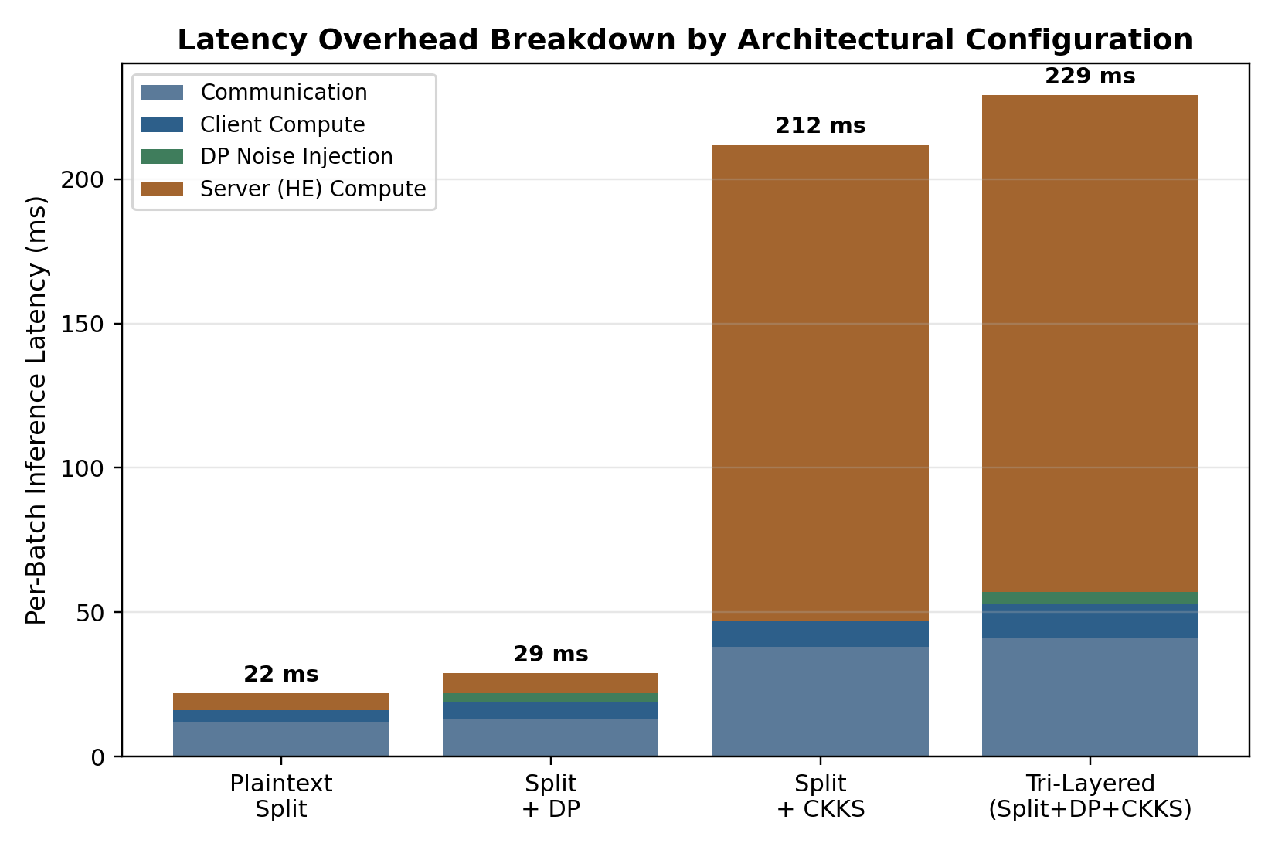
Fig. 4. Per-batch latency decomposition across four configurations, showing that homomorphic server-side computation is the dominant cost once CKKS encryption is introduced.
C. Consolidated Results
Table 4 summarises the accuracy, latency, communication overhead, and qualitative privacy coverage for all configurations examined, including the two operating points of the tri-layered configuration at ε=8 and ε=4.
Configuration | Accuracy (%) | Latency/Batch (ms) | Comm. Overhead (KB) | Privacy Coverage
Plaintext Split | 94.6 | 22 | 180 | None
Split + DP (ε=8) | 89.9 | 26 | 185 | Statistical only
Split + CKKS | 94.1 | 212 | 2,340 | Computational only
Tri-Layered (ε=8) | 89.9 | 229 | 2,410 | Statistical + Computational + Split-bound
Tri-Layered (ε=4) | 86.8 | 229 | 2,410 | Statistical + Computational + Split-bound
TABLE 4. Consolidated Comparison of Architectural Configurations

The results support the central thesis that the three layers are complementary rather than redundant. Split learning and CKKS address the confidentiality of the transmitted representation architecturally and cryptographically, respectively. DP addresses a threat—membership inference from the trained model itself—that is not bounded by either of the other two layers. The main cost of the tri-layered composition is latency, which is almost entirely due to the homomorphic evaluation of the server-side sub-network. This implies that the most promising direction for closing the overhead gap, without compromising any of the three privacy guarantees, is to reduce the number and depth of the homomorphically evaluated layers, for example, by moving the split point deeper into the network.
VII. Conclusion
This study presents a tri-layered hybrid privacy architecture that integrates split learning, differential privacy, and CKKS fully homomorphic encryption to address distinct privacy risks within collaborative deep neural network computation. The architecture combines an explicit split boundary with statistical protection of gradients and activations and cryptographic protection of transmitted representations. Across the evaluated configurations, the tri-layered design achieved 89.9% accuracy at ε = 8, compared with 94.6% for the non-private baseline, while incurring an approximately 10.4× latency overhead relative to plaintext split inference. The results indicate that the three layers are complementary rather than redundant, because each addresses a different component of the threat surface. The principal practical cost is the latency introduced by homomorphic evaluation of the server-side sub-network. Consequently, further improvement should focus on reducing the depth and number of homomorphically evaluated layers, examining deeper split points, and refining joint privacy-budget and cryptographic-parameter allocation while retaining the architecture’s combined privacy objectives.
Limitations
The principal limitation of the proposed architecture is its computational overhead, with server-side homomorphic evaluation dominating end-to-end latency. The experiments use a fixed split point after the third convolutional block and a specified hardware configuration, so the reported latency reflects those design choices. Privacy and utility also depend on coordinated selection of the DP noise multiplier, clipping norm, and CKKS multiplicative depth. Further evaluation of deeper split points and adaptive parameter allocation is therefore needed to determine whether comparable privacy coverage can be maintained with lower computational cost.

Declaration of AI Use

This manuscript was prepared through the combined contributions of all author(s), including contributions to the study design, data, content development, results, interpretation, and related scholarly work. The author(s) acknowledge the use of Grammarly and ChatGPT to assist with grammar checking, language refinement, and reference formatting. These AI-assisted tools were not used as authors and did not replace the intellectual contributions or scholarly judgement of the author(s). All AI-assisted outputs, including content, references, and interpretations, were carefully reviewed, revised, verified, and approved by the author(s). The author(s) accept full responsibility for the accuracy, integrity, and final content of the manuscript.

References
Abadi, M., Chu, A., Goodfellow, I., McMahan, H. B., Mironov, I., Talwar, K., & Zhang, L. (2016). Deep learning with differential privacy. In Proceedings of the 2016 ACM SIGSAC Conference on Computer and Communications Security (pp. 308–318). ACM. https://doi.org/10.1145/2976749.2978318
Adedayo-Ajayi, V. O., Jesubuyikunmi, A. J., Ojo, A. K., Muyideen, A. A., Job, O. O., & Olaoluwa, A. O. (2026). Comparative performance evaluation of BFV, BGV and CKKS homomorphic encryption schemes using Microsoft SEAL. Asian Journal of Current Research, 11(2), 180–196. https://doi.org/10.56557/ajocr/2026/v11i210588
Aerni, M., Zhang, J., & Tramèr, F. (2024). Evaluations of machine learning privacy defenses are misleading. In Proceedings of the 2024 ACM SIGSAC Conference on Computer and Communications Security (pp. 1271–1284). ACM. https://doi.org/10.1145/3658644.3690194
Alhindi, A., Al-Ahmadi, S., & Ben Ismail, M. M. (2025). Advancements and challenges in privacy-preserving split learning: Experimental findings and future directions. International Journal of Information Security, 24, Article 125. https://doi.org/10.1007/s10207-025-01045-9
Annamalai, M. S. M. S., & De Cristofaro, E. (2024). Nearly tight black-box auditing of differentially private machine learning. Advances in Neural Information Processing Systems, 37, 131482–131502. https://doi.org/10.52202/079017-4179
Birrell, J., Ebrahimi, R., Behnia, R., & Pacheco, J. (2024). Differentially private stochastic gradient descent with fixed-size minibatches: Tighter RDP guarantees with or without replacement. Advances in Neural Information Processing Systems, 37, 11087–11131. https://doi.org/10.52202/079017-0354
Bonawitz, K., Ivanov, V., Kreuter, B., Marcedone, A., McMahan, H. B., Patel, S., Ramage, D., Segal, A., & Seth, K. (2017). Practical secure aggregation for privacy-preserving machine learning. In Proceedings of the 2017 ACM SIGSAC Conference on Computer and Communications Security (pp. 1175–1191). ACM. https://doi.org/10.1145/3133956.3133982
Cheon, J. H., Kim, A., Kim, M., & Song, Y. (2017). Homomorphic encryption for arithmetic of approximate numbers. In T. Takagi & T. Peyrin (Eds.), Advances in cryptology—ASIACRYPT 2017 (pp. 409–437). Springer. https://doi.org/10.1007/978-3-319-70694-8_15
Choi, H., Kim, J., Kim, S., Park, S., Park, J., Choi, W., & Kim, H. (2024). UniHENN: Designing faster and more versatile homomorphic encryption-based CNNs without im2col. IEEE Access, 12, 109323–109341. https://doi.org/10.1109/ACCESS.2024.3438996
Demelius, L., Kern, R., & Trügler, A. (2025). Recent advances of differential privacy in centralized deep learning: A systematic survey. ACM Computing Surveys, 57(6), Article 158. https://doi.org/10.1145/3712000
Deng, S., Zhang, L., & Yue, D. (2024). Data-driven and privacy-preserving risk assessment method based on federated learning for smart grids. Communications Engineering, 3, Article 154. https://doi.org/10.1038/s44172-024-00300-6
Dong, Y., Luo, W., Wang, X., Zhang, L., Xu, L., Zhou, Z., & Wang, L. (2025). Multi-task federated split learning across multi-modal data with privacy preservation. Sensors, 25(1), Article 233. https://doi.org/10.3390/s25010233
Dwork, C., & Roth, A. (2014). The algorithmic foundations of differential privacy. Foundations and Trends in Theoretical Computer Science, 9(3–4), 211–407. https://doi.org/10.1561/0400000042
Frimpong, E., Nguyen, K., Budzys, M., Khan, T., & Michalas, A. (2024). GuardML: Efficient privacy-preserving machine learning services through hybrid homomorphic encryption. In Proceedings of the 39th ACM/SIGAPP Symposium on Applied Computing (pp. 953–962). ACM. https://doi.org/10.1145/3605098.3635983
Gilad-Bachrach, R., Dowlin, N., Laine, K., Lauter, K., Naehrig, M., & Wernsing, J. (2016). CryptoNets: Applying neural networks to encrypted data with high throughput and accuracy. In Proceedings of the 33rd International Conference on Machine Learning (Vol. 48, pp. 201–210). Proceedings of Machine Learning Research. https://proceedings.mlr.press/v48/gilad-bachrach16.html
Gupta, O., & Raskar, R. (2018). Distributed learning of deep neural network over multiple agents. Journal of Network and Computer Applications, 116, 1–8. https://doi.org/10.1016/j.jnca.2018.05.003
Hu, K., Gong, S., Zhang, Q., Seng, C., Xia, M., & Jiang, S. (2024). An overview of implementing security and privacy in federated learning. Artificial Intelligence Review, 57, Article 204. https://doi.org/10.1007/s10462-024-10846-8
Kanpak, H. I., Shabbir, A., Genç, E., Küpçü, A., & Sav, S. (2026). CURE: Privacy-preserving split learning done right. Proceedings on Privacy Enhancing Technologies, 2026(2), 259–276. https://doi.org/10.56553/popets-2026-0047
Khan, T., Budzys, M., & Michalas, A. (2024). Make split, not hijack: Preventing feature-space hijacking attacks in split learning. In Proceedings of the 29th ACM Symposium on Access Control Models and Technologies (pp. 19–30). ACM. https://doi.org/10.1145/3649158.3657039
Khan, T., Budzys, M., & Michalas, A. (2025). Split happens: Combating advanced threats with split learning and function secret sharing. In 2025 IEEE Conference on Communications and Network Security (CNS). IEEE. https://doi.org/10.1109/CNS66487.2025.11194945
Khan, T., Nguyen, K., & Michalas, A. (2024). A more secure split: Enhancing the security of privacy-preserving split learning. In L. Fritsch, I. Hassan, & E. Paintsil (Eds.), Secure IT systems: 28th Nordic Conference, NordSec 2023 (pp. 307–329). Springer. https://doi.org/10.1007/978-3-031-47748-5_17
Khan, T., Nguyen, K., Michalas, A., & Bakas, A. (2023). Love or hate? Share or split? Privacy-preserving training using split learning and homomorphic encryption. In 2023 IEEE International Conference on Privacy, Security and Trust (PST). IEEE. https://doi.org/10.1109/PST58708.2023.10320153
Kim, D., Park, J., Kim, J., Kim, S., & Ahn, J. H. (2024). HyPHEN: A hybrid packing method and its optimizations for homomorphic encryption-based neural networks. IEEE Access, 12, 3024–3038. https://doi.org/10.1109/ACCESS.2023.3348170
Microsoft Research. (2023). Microsoft SEAL (Version 4.1) [Computer software]. GitHub. https://github.com/microsoft/SEAL
Mironov, I. (2017). Rényi differential privacy. In 2017 IEEE 30th Computer Security Foundations Symposium (CSF) (pp. 263–275). IEEE. https://doi.org/10.1109/CSF.2017.11
Mohanarajah, S., Valente, P., Medina, A., & Sritharan, T. (2025). Privacy-preserving machine learning algorithms: A survey. Asian Journal of Probability and Statistics, 27(12), 126–138. https://doi.org/10.9734/ajpas/2025/v27i12847
Nguyen, G., Sáinz-Pardo Díaz, J., Calatrava, A., Berberi, L., Lytvyn, O., Kozlov, V., Tran, V., Moltó, G., & López García, Á. (2025). Landscape of machine learning evolution: Privacy-preserving federated learning frameworks and tools. Artificial Intelligence Review, 58, Article 51. https://doi.org/10.1007/s10462-024-11036-2
Nguyen, K., Khan, T., & Michalas, A. (2024). Split without a leak: Reducing privacy leakage in split learning. In H. Duan, M. Debbabi, X. de Carné de Carnavalet, X. Luo, M. H. A. Au, & X. Du (Eds.), Security and privacy in communication networks: 19th EAI International Conference, SecureComm 2023, proceedings (pp. 321–344). Springer. https://doi.org/10.1007/978-3-031-64954-7_17
Oh, S., Baek, S., Park, J., Nam, H., Vepakomma, P., Raskar, R., Bennis, M., & Kim, S.-L. (2024). Privacy-preserving split learning with vision transformers using patch-wise random and noisy CutMix. Transactions on Machine Learning Research. https://openreview.net/forum?id=4bo6XAnutd
Pham, N. D., & Chilamkurti, N. (2023). Data leakage threats and protection in split learning: A survey. In Proceedings of the 2023 International Conference on Intelligent Computing and Its Emerging Applications (pp. 141–147). ACM. https://doi.org/10.1145/3659154.3659189
Pham, N. D., Phan, K. T., & Chilamkurti, N. (2025). Enhancing accuracy-privacy trade-off in differentially private split learning. IEEE Transactions on Emerging Topics in Computational Intelligence, 9(1), 988–1000. https://doi.org/10.1109/TETCI.2024.3485723
Ran, R., Xu, N., Liu, T., Wang, W., Quan, G., & Wen, W. (2023). Penguin: Parallel-packed homomorphic encryption for fast graph convolutional network inference. Advances in Neural Information Processing Systems, 36, 19104–19116. https://doi.org/10.52202/075280-0837
Shokri, R., & Shmatikov, V. (2015). Privacy-preserving deep learning. In Proceedings of the 22nd ACM SIGSAC Conference on Computer and Communications Security (pp. 1310–1321). ACM. https://doi.org/10.1145/2810103.2813687
Vepakomma, P., Gupta, O., Swedish, T., & Raskar, R. (2018). Split learning for health: Distributed deep learning without sharing raw patient data. arXiv. https://doi.org/10.48550/arXiv.1812.00564
Yu, D., Kamath, G., Kulkarni, J., Liu, T.-Y., Yin, J., & Zhang, H. (2023). Individual privacy accounting for differentially private stochastic gradient descent. Transactions on Machine Learning Research. https://openreview.net/forum?id=l4Jcxs0fpC

